Name of Journal: World Journal of Gastroenterology
Manuscript NO: 77080
Manuscript Type: SCIENTOMETRICS

Global research trends in the field of liver cirrhosis from 2011 to 2020: A visualised and bibliometric study

Gan PL et al. Liver cirrhosis from 2011 to 2020

Pei-Ling Gan, Shu Huang, Xiao Pan, Hui-Fang Xia, Xin-Yi Zeng, Wen-Sen Ren, Xian Zhou, Mu-Han Lv, Xiao-Wei Tang

Pei-Ling Gan, Xiao Pan, Hui-Fang Xia, Xin-Yi Zeng, Wen-Sen Ren, Xian Zhou, Mu-Han Lv, Xiao-Wei Tang, Department of Gastroenterology, The Affiliated Hospital of Southwest Medical University, Luzhou 646099, Sichuan Province, China

Pei-Ling Gan, Xiao Pan, Hui-Fang Xia, Xin-Yi Zeng, Wen-Sen Ren, Xian Zhou, Mu-Han Lv, Xiao-Wei Tang, Department of Gastroenterology, Nuclear Medicine and Molecular Imaging Key Laboratory of Sichuan Province, Luzhou 646000, Sichuan Province, China

Shu Huang, Department of Gastroenterology, The People’s Hospital of Lianshui, Huaian 223400, Jiangsu Province, China

Author contributions: Gan PL, Huang S and Pan X contributed equally to this work; Gan PL, Zhou X, Lv MH and Tang XW designed the research study; Gan PL, Huang S, Pan X, Xia HF and Zeng XY performed the research; Pan X and Ren WS contributed analytic tools; Gan PL, Huang S and Pan X analyzed the data and wrote the manuscript; All authors have read and approve the final manuscript.

Corresponding author: Xiao-Wei Tang, MD, PhD, Doctor, Department of Gastroenterology, The Affiliated Hospital of Southwest Medical University, No. 25 Taiping Street, Jiangyang Region, Luzhou 646099, China. solitude5834@hotmail.com

Received: April 14, 2022
Revised: June 17, 2022
Accepted: August 6, 2022
Published online: September 7, 2022

Abstract
BACKGROUND
Liver cirrhosis is the leading cause of liver-related mortality worldwide. It is currently a global health challenge.

AIM
This research intended to explore and analyse research trends and frontiers in this field during the last 10 years, providing new inspiration for clinical decision-making and scientific research.

METHODS
Publications on hepatic cirrhosis research were retrieved from the Web of Science Core Collection on April 4, 2021. Bibliometric visualisation was conducted through VOSviewer and CiteSpace.

RESULTS
The analytic research was based on original articles and reviews. A total of 7775 records of hepatic cirrhosis published from 2011 to 2020 were retrieved. In the past ten years, the number of related annual publications has increased significantly, especially in the United States and China. All publications were distributed among 109 countries. The United States contributed the most (21.95%) and was consistently the leading driving force, with a solid academic reputation in this area. The University of Barcelona distributed the most related articles (177 articles) and was cited the most frequently. The Journal of Hepatology ranked third in the top 10 journals, which has the highest impact factor (impact factor 2019 = 20.582). Jasmohan S. Bajaj was the most productive author (72 articles). Burst keywords (e.g., sofosbuvir, burden, care, sarcopenia, chronic liver failure, human gut microbiome, and nonalcoholic fatty liver disease) and a succession of reference citation bursts have provided clues about research frontiers in recent years.

CONCLUSION
This study identified developing trends in the evolution of liver cirrhosis to provide new inspiration for researchers.

Key Words: Liver cirrhosis; Bibliometric research; Research frontiers; VOSviewer; CiteSpace; Visualization

©The Author(s) 2022. Published by Baishideng Publishing Group Inc. All rights reserved.

Citation: Gan PL, Huang S, Pan X, Xia HF, Zeng XY, Ren WS, Zhou X, Lv MH, Tang XW. Global research trends in the field of liver cirrhosis from 2011 to 2020: A visualised and bibliometric study. World J Gastroenterol 2022; 28(33): 4909-4919
URL: https://www.wjgnet.com/1007-9327/full/v28/i33/4909.htm
DOI: https://dx.doi.org/10.3748/wjg.v28.i33.4909

Core Tip: This research explored and analyzed research trends and frontiers in this field during the last 10 years, further providing new inspiration for scientific research. We found sarcopenia, human gut microbiome, and nonalcoholic fatty liver disease are of particular interest in studies of cirrhosis. Treatment of diseases that cause cirrhosis, such as hepatitis C, is also a hot topic.
INTRODUCTION
Liver cirrhosis is a common clinical chronic progressive disease with high mortality caused by one or more factors. It is the fifth leading cause of adult deaths, the top cause of liver-related death worldwide^{[1]}, and the eighth of the primary diseases in economic cost^{[2]}. Cirrhosis is a heterogeneous disease classified into two prognosis stages: compensated cirrhosis and decompensated cirrhosis^{[3]}. In the early stage, due to the essential liver compensatory function, there are no visible symptoms. Later, the primary symptoms are liver function impairment and portal hypertension, and multiple systems are affected. Ascites, upper gastrointestinal haemorrhage, secondary infection, hepatic encephalopathy, canceration, and other complications are common in the late stage. Thus, cirrhosis is a high-burden treatment option for patients, health care systems, and the government.
Bibliometric research is a quantitative analytic method that employs mathematics and statistics to determine scientific activity^{[4]}. It can help researchers identify the research focus and trends of a particular subject. In addition, the research results may be beneficial to future research.
Professor Chen (Drexel University) created CiteSpace V, a Java-based information visualisation program for bibliometric analysis. Researchers may assess a discipline's evolution and identify frontier trends intuitively by providing numerous data in the form of knowledge maps^{[5]}. CiteSpace has recently been used for bibliometric analysis in various fields; however, there is yet to be a bibliometric analysis of cirrhosis. In this study, we first used CiteSpace V to analyse articles on liver cirrhosis from 2011 to 2020 utilizing the Web of Science Core Collection (WoSCC) database, providing new inspiration for clinical decision-making and scientific research.

MATERIALS AND METHODS
Data collection and search strategy
Data were retrieved from the WoSCC on a single day, April 4, 2021. WoSCC offers extensive citation index information for over 8000 influential and famous journals globally. It is a comprehensive database, notably in natural science and medicine. The following were included in the search strategy: title = “cirrhosis,” database selected = Web of Science Core Collection, time span = 2011–2020. Only original articles and reviews were included. We obtained 7775 records for this study. A flowchart representing the retrieval strategies is shown in Supplementary Figure 1. In addition, high-quality references were retrieved and cited by the Reference Citation Analysis (https://www.referencecitationanalysis.com/) database.

Analysis tool
For bibliometric analysis, Microsoft Excel 2016, VOSviewer, and CiteSpace were chosen. Information on authors, journals, institutions, and countries may be integrated with these computer systems. Parameters such as article count, impact factor (IF), centrality, and occurrence/citation burst were utilized in this article. Productivity was measured by the number of articles published and was used to identify productive individuals or groups. The IF was obtained using Journal Citation Reports (JCR). The IF is a recognized metric for assessing a journal's impact worldwide. The IF in this study was based on JCR (2019). The network visualisation maps were constructed using VOSviewer to examine the cooperative relationships between countries and institutions with highly cocited references. Coauthorship analysis identifies research output. We selected “countries” and “organizations” as the unit of analysis. CiteSpace V adopts a time slicing technique to create a timeline of network models and integrates these individual networks to produce an overview network for the systematic analysis of the relevant publications. In this study, we utilized CiteSpace V to conduct a cocitation analysis of the references and clusters. After that, a timeline view of cocited references was built. As a result, we were able to clarify the origin and period of certain clustering fields^{[6]}. These parameters help identify potential collaborative relationships in the field of liver cirrhosis. Furthermore, an occurrence burst denotes a word that appears often over a specific period, whereas a citation burst denotes a reference that is referenced frequently during a specific period^{[7]}. Keywords and references with the highest citation bursts were selected to demonstrate research hot spots and frontiers because they can identify whether relevant scholars have paid extensive attention to these areas in a specific period^{[5]}.

RESULTS
Publication output and temporal trend
A total of 7775 publications satisfied the search criteria. Table 1 lists the top-10 cited articles in descending order based on the number of citations. Figure 1A depicts the global distribution of yearly publications on cirrhosis research from 2011 to 2020. The overall worldwide publishing trend rose from 520 to 955 between 2011 and 2020. However, during the periods of 2015-2017 and 2019-2020, the number of publications showed a modest decrease. The annual publication trends of the top 10 academic output countries are presented in Figure 1B. The number of publications on cirrhosis published by the United States and China has increased remarkably within the last decade.

Distribution by country and institution
All of the publications come from 109 countries and 6902 institutions. The distribution of countries/regions that published no fewer than 100 papers is shown in Supplementary Figure 2. Table 2 contains detailed information on the top 10 countries. The United States had the most publications (1707 publications), followed by China (1672 publications) and Japan (711 publications). Among the top 10 countries, France exhibits high academic quality, and its citation/article ratio (46.67) was far greater than that of other listed countries.
Using VOSviewer, we constructed a network visualisation map for liver cirrhosis research publications to assess international collaborations. Collaborations between countries and institutions are depicted in Supplementary Figure 3. Nodes with higher co-occurrence were classified as the same colour. Nodes with similar colours formed one cluster, indicating that they had closer cooperative relationships. The width of the lines describes the magnitude of the collaboration. As shown, the United States had the highest total link strength, suggesting that it cooperated most with other countries worldwide. The country that collaborated the most with the United States was China. The most productive institutions are listed in Table 3. The University of Barcelona (177 publications) ranked first, followed by Virginia Commonwealth University (120 publications) and University College London (119 publications). The cluster coloured in green was led by the University of Barcelona, collaborating most with Virginia Commonwealth University. Furthermore, three of the top 10 institutions are in the United States, two are in China, and two are in Italy, suggesting that these three countries have many outstanding research groups in this field.

Distribution by journals and authors
Liver cirrhosis research articles were published in 1511 journals. The number of articles in the top 10 journals ranged from 119 to 259, accounting for 22.73% of the total (1767) (Supplementary Table 1). Among these journals, Liver International contributed the highest number of publications on cirrhosis research (259 publications, IF 2019 = 5.175), followed by Hepatology (242 publications, IF 2019 = 14.679) and Journal of Hepatology (212 publications, IF 2019 = 20.582). Journal of Hepatology had the highest IF, and its citation/article ratio (68.30) was far more than that of other listed journals. The most frequently cited journal was Hepatology (14922 citations). The following most frequently cited journals were Journal of Hepatology (14479 citations) and Liver International (5721 citations).
A total of 35653 authors contributed to the overall output. The most productive authors are listed in Supplementary Table 2. Jasmohan S. Bajaj published 72 articles, ranking first in the number of publications, followed by M. Eric Gershwin (70 articles) and Qi Xingshun (61 articles). Pere Gines had the highest citation/article ratio (89.27), followed by Paolo Angeli (74.07) and Guadalupe Garcia-Tsao (69.13).

Analysis of keywords
Figure 2 shows the top 25 keywords with the strongest occurrence burst. The occurrence burst, which demonstrated a sharp rise over a certain period, referred to frontier disciplines and dynamic changes in a particular field. Hot topics were represented by keywords whose occurrence burst lasted until 2020. The most recent burst keywords were “sofosbuvir” (2016–2020), “burden” (2017–2020), “care” (2017–2020), “sarcopenia” (2018–2020), “chronic liver failure” (2018–2019), “human gut microbiome” (2018–2020), “nonalcoholic fatty liver disease (NAFLD)” (2018–2020), “American association” (2018–2020), and “ma” (2018–2020).

Analysis of references
In bibliometric research, reference analysis is an important indication. The pieces of literature with the strongest citation burst are considered to be the knowledge fundamentals of the research frontiers. Clusters along horizontal timelines are depicted in Figure 3, which is a timeline visualisation in CiteSpace. From left to right, each cluster is presented. The publication time legend is displayed at the top. The clusters were arranged vertically and in declining order of size. The largest cluster is presented at the top. Cocitation linkages are shown by the stained curves. Large-sized nodes were especially concerning since they were highly cited. The most cited references in a given year are displayed under each timeline. Clusters were numbered from 0. Cluster #0 was the largest cluster. As shown in the timeline overview, the largest cluster in this study was #0 acute kidney injury, indicating a significant research interest and direction in recent years. This was followed by #1 hepatitis C, #2 clonal selection theory, #3 hepatic encephalopathy, #4 Liver cirrhosis, and #5 variceal bleeding. Some clusters remained active until 2020. Figure 4 depicts cirrhosis-related references with the strongest citation burst during the last 10 years. Citation bursts until the end of 2020 were led by de Franchis et al (2015), who had the strongest burst (40.22), followed by Garcia-Tsao et al (2017), Tsochatzis et al (2014), Vilstrup et al (2014), Mokdad et al (2014), Albillos et al (2014), Jalan et al (2014), and Heimbach et al (2018).

DISCUSSION
Liver cirrhosis is a chronic disease with high mortality and is a serious public health problem, afflicting more than 160 million people globally in 2017^{[8]}. The most common cause is chronic viral hepatitis, specifically hepatitis B virus (HBV) and hepatitis C virus (HCV)^{[3,9]}. Previous studies have shown that the prevalence of liver cirrhosis varies by region. East Asia has the most significant prevalence of liver cirrhosis. In contrast, Southern Latin America has the lowest incidence of 12.1%^{[9]}. Furthermore, the worldwide incidence of liver cirrhosis is increasing continuously, and it ranks eighth in terms of economic cost among significant diseases^{[2]}, even though various public health measures have been implemented. As a result, to better comprehend the advanced research hotspots in the field of cirrhosis, a study is necessary.
From the retrieved data, we can easily conclude that the general research trend of liver cirrhosis has been growing, especially in China and the United States. Eight of the top 10 countries that most produce related research were developed countries, while 2 were developing countries. The United States had the most publications, followed by China and Japan, and India ranked last. In 2017, among individuals with prevalent liver cirrhosis worldwide, HBV infection accounted for approximately 28.72%. East Asia has the highest prevalence of liver cirrhosis. China had the world's greatest number of patients. Therefore, China and India rank among the top 10 countries in terms of the occurrence of liver cirrhosis and may be relevant for these potential causes. However, in terms of citations per article, although China temporarily ranked in the top position in number of articles, it still has a long way to go to improve the overall quality of articles. China must continue to increase research in this area and strengthen collaborations with other countries. In contrast, although only a few French articles were published, they were of high academic quality.
Nine of the top 10 institutions were universities, suggesting that universities are the most common research groups. Three of the top 10 institutions were from the United States (Virginia Commonwealth University, Mayo Clinic, and University of California, Davis); thus, the United States is the main domain in the field. Two of the top 10 institutions were from China (Capital Medical University and Zhejiang University), and two institutions were from Italy (the University of Padua and University of Milan). According to the findings of this analysis, the three countries have numerous great research groups in this area.
In this study, we found some great research works from some excellent authors. They made significant contributions to this discipline. For example, Guadalupe Garcia-Tsao ranked 7th among the top 10 authors, and her practice guideline of portal hypertensive bleeding in cirrhosis also ranked among the top 10^{[10]}. Her study effort provides academic researchers and clinical professionals with a better and deeper understanding of risk stratification, diagnosis, and management of portal hypertensive bleeding in liver cirrhosis. Moreau et al^{[11]} analysed data from patients with cirrhosis and acute decompensation (AD) to establish diagnostic criteria for acute-on-chronic liver failure (ACLF), which he discovered was distinct from AD. In addition, his research demonstrated that ACLF mortality is linked to loss of organ function and high leukocyte counts and that ACLF is particularly severe in individuals with no prior history of AD.
CiteSpace V was used to detect keyword bursts in this study. These statistics are potentially valuable in forecasting research frontiers. The keywords “sofosbuvir,” “burden,” “care,” “sarcopenia,” “chronic liver failure,” “human gut microbiome,” and the “NAFLD” are expected to appear often in the following years, indicating emerging trends. The top five cirrhosis frontiers are as follows: (1) Sarcopenia: The skeletal muscle is the body's largest organ, and atrophy comes from a change in the balance of protein production and degradation towards protein breakdown. Primary sarcopenia is a loss of skeletal muscle strength, mass, or physical function owing to ageing, whereas secondary sarcopenia is recognized as a loss of skeletal muscle strength, mass, or physical function due to underlying disorders. Liver cirrhosis is one of the representational disorders that might be complicated with secondary sarcopenia. In patients with cirrhosis, muscle mass loss worsens as their liver reserve deteriorates. Sarcopenia and frailty have a negative impact on clinical outcomes and prognosis. It has been convincingly demonstrated that patients with cirrhosis, sarcopenia, and frailty have a lower quality of life and survival, more cirrhotic complications and infections, and poorer outcomes following liver transplant surgery^{[12-14]}. As a result, emphasis must be placed on early detection, active diagnosis, and treatment. Consequently, further investigations in the context of assessment criteria for sarcopenia and frailty are warranted to deepen our current knowledge of sarcopenia and frailty in patients with cirrhosis; (2) Chronic liver failure: ACLF, a clinical syndrome in patients with chronic liver disease, is more often discussed clinically. It is associated with multiple organ failure and increased short-term mortality. It is a significant cause of mortality in people with cirrhosis. Although the precise causative mechanism is unknown, systemic inflammation plays a critical role in its pathogenesis, and the strength of this inflammatory response paralleled the severity of ACLF. Aside from organ failure and a very high risk of short-term death, patients with ACLF exhibited other characteristics that separated them from non-ACLF patients. They were, for example, younger, had more alcoholic cirrhosis and less HCV-related cirrhosis, and mainly had a higher frequency of active alcoholism and severe bacterial infections^{[11]}. More research for new findings into the mechanisms underlying ACLF, risk prediction models, therapeutic targets, and liver transplantation for ACLF is needed; (3) Sofosbuvir: An oral nucleotide analogue inhibitor of the HCV-specific NS5B polymerase has been approved to treat chronic HCV infection. A study showed that ledipasvir-sofosbuvir for eight weeks was associated with a high rate of sustained virologic response among previously untreated patients with HCV genotype 1 infection without cirrhosis^{[15]}. A recent article published in The Lancet Gastroenterology & Hepatology stated that ravidasvir plus sofosbuvir was effective in patients with chronic HCV infection. Furthermore, by offering a new affordable, simple, and efficacious public health tool for large-scale implementation, this treatment has the potential to eradicate HCV-related morbidity and mortality^{[16]}; (4) Human gut microbiome: The function of gut microbiota in human health and disease has recently received much attention. Several chronic illnesses have been linked to the gut microbiota, such as obesity^{[17-19]}, inflammatory bowel disease^{[20]}, diabetes mellitus^{[21]}, and NAFLD^{[22]}. Through the hepatic portal and bile secretion systems, the liver interacts directly with the gut. Enteric dysbiosis, namely, the translocation of bacteria and their products over the gut epithelial barrier, is involved in the development of liver cirrhosis. However, the phylogenetic and functional composition alterations in the human gut microbiota associated with this progression remain obscure^{[23]}. Furthermore, research suggests that microbiome manipulation to eliminate manganese and reduce GABA levels in the gut might provide a novel therapeutic approach for treating hepatic encephalopathy^{[24]}. In addition, novel probiotics may be helpful in the prevention of the aggravation of liver cirrhosis. More broadly, microbiome manipulation may offer up new pathways for the treatment of liver cirrhosis. A combination of microbial genes distinguishes patients with liver cirrhosis from healthy individuals with high specificity. This might pave the way for a novel method of monitoring and preventing liver cirrhosis; and (5) NAFLD: NAFLD is a progressive liver disease spectrum encompassing simple steatosis, nonalcoholic steatohepatitis (NASH), fibrosis, and, eventually, cirrhosis. NAFLD is closely associated with characteristics of metabolic syndrome such as abdominal obesity, insulin resistance, glucose intolerance or type 2 diabetes (T2DM), and atherogenic dyslipidaemia^{[25]}. Over the last few decades, people's lifestyles have become more sedentary, and dietary habits have changed, leading to an increase in the prevalence of obesity and insulin resistance^{[26,27]}. In light of this, NAFLD quickly became the most common cause of abnormal liver biochemistry in both developed and developing countries. Several prior epidemiological studies have identified a strong association between NAFLD and an elevated risk of developing T2DM. In addition, patients with NAFLD, whether adults or adolescents, have several risk factors for cardiovascular disease. A notable minority proportion of NAFLD patients proceed to a more severe disease characterized by NASH and fibrosis and cirrhosis or, in some circumstances, progress to hepatocellular carcinoma^{[28]}. The mechanisms linking NAFLD to the diseases mentioned above and the current pharmacological treatments for NAFLD need to be further explored.
The articles with the strongest citation burst are potentially valuable for exploring research frontiers. In this study, #0 acute kidney injury was the largest cluster, and #3 hepatic encephalopathy remained active until the most recent publication year for a cited reference. References with the top three citation bursts were as follows: (1) de Franchis et al^{[29]} contributed to the writing of expanding consensus in portal hypertension, further elaborating the stratifying risk and individualizing care for portal hypertension; (2) Garcia-Tsao et al^{[10]} coauthored a practice guideline and elaborated the risk stratification, diagnosis, and management of portal hypertensive bleeding in cirrhosis; and (3) Tsochatzis et al^{[30]} reviewed the current understanding of cirrhosis as a dynamic process and outlined therapeutic options for preventing and treating complications of cirrhosis based on the subclassification in clinical stages. Meanwhile, we proposed a new concept for managing patients with cirrhosis and the challenge in the 21st century.

Limitations
To the best of our knowledge, this study was the first bibliometric analysis of cirrhosis in the past ten years. This study, however, has certain limitations. First, we considered the WoSCC database a reputable and reliable service for publications and citations; hence, we extracted data only from it. This may restrict the coverage of all available articles and result in a reduced number of documents included in the analysis. Second, the search method may also have been insufficient because we only searched for publications with the phrase "cirrhosis," which may have resulted in a paucity of papers due to other terminology. Finally, we analysed the data selectively. We mainly utilized a quantitative analysis approach, while little emphasis has been paid to the qualitative aspects of this study. As a result, certain critical points and details may have been missed. All of the considerations mentioned above may lead to bias in the results. Hence, the results should be interpreted with caution.

CONCLUSION
This study might aid researchers in identifying new trends in cirrhosis from 2011 to 2020, thus, providing new inspiration for scientific research.

ARTICLE HIGHLIGHTS
Research background
Liver cirrhosis is a common clinical chronic progressive disease with high mortality caused by one or more factors.

Research motivation
Identifying new trends in cirrhosis from 2011 to 2020, thus, providing new inspiration for scientific research.

Research objectives
This research intended to explore and analyse research trends and frontiers in this field of cirrhosis during the last 10 years.

Research methods
Using VOSviewer and CiteSpace, assess a discipline's evolution and identify frontier trends intuitively by knowledge maps.

Research results
The general research trend of liver cirrhosis has been growing, especially in China and the United States. The keywords “sofosbuvir,” “burden,” “care,” “sarcopenia,” “chronic liver failure,” “human gut microbiome,” and the “NAFLD” are expected to appear often in the following years, indicating emerging trends. The top five cirrhosis frontiers are Sarcopenia, Chronic liver failure, Sofosbuvir, Human gut microbiome and Nonalcoholic fatty liver disease.

Research conclusions
This study identified developing trends in the evolution of liver cirrhosis to provide new inspiration for researchers.

Research perspectives
The top five cirrhosis frontiers are sarcopenia, chronic liver failure, sofosbuvir, human gut microbiome and nonalcoholic fatty liver disease.

REFERENCES
1 GBD 2017 Causes of Death Collaborators. Global, regional, and national age-sex-specific mortality for 282 causes of death in 195 countries and territories, 1980-2017: a systematic analysis for the Global Burden of Disease Study 2017. Lancet 2018; 392: 1736-1788 [PMID: 30496103 DOI: 10.1016/S0140-6736(18)32203-7]
2 Scaglione S, Kliethermes S, Cao G, Shoham D, Durazo R, Luke A, Volk ML. The Epidemiology of Cirrhosis in the United States: A Population-based Study. J Clin Gastroenterol 2015; 49: 690-696 [PMID: 25291348 DOI: 10.1097/MCG.0000000000000208]
3 Westbrook RH, Dusheiko G. Natural history of hepatitis C. J Hepatol 2014; 61: S58-S68 [PMID: 25443346 DOI: 10.1016/j.jhep.2014.07.012]
4 Oelrich B, Peters R, Jung K. A bibliometric evaluation of publications in urological journals among European Union countries between 2000-2005. Eur Urol 2007; 52: 1238-1248 [PMID: 17673361 DOI: 10.1016/j.eururo.2007.06.050]
5 Chen C. CiteSpace II: Detecting and visualizing emerging trends and transient patterns in scientific literature. 2006; 57: 359-377 [DOI: 10.1002/asi.20317]
6 Chen C, Dubin R, Kim MC. Emerging trends and new developments in regenerative medicine: a scientometric update (2000 - 2014). Expert Opin Biol Ther 2014; 14: 1295-1317 [PMID: 25077605 DOI: 10.1517/14712598.2014.920813]
7 Chen C, Hu Z, Liu S, Tseng H. Emerging trends in regenerative medicine: a scientometric analysis in CiteSpace. Expert Opin Biol Ther 2012; 12: 593-608 [PMID: 22443895 DOI: 10.1517/14712598.2012.674507]
8 Liu Z, Jiang Y, Yuan H, Fang Q, Cai N, Suo C, Jin L, Zhang T, Chen X. The trends in incidence of primary liver cancer caused by specific etiologies: Results from the Global Burden of Disease Study 2016 and implications for liver cancer prevention. J Hepatol 2019; 70: 674-683 [PMID: 30543829 DOI: 10.1016/j.jhep.2018.12.001]
9 de Carvalho JR, Villela-Nogueira CA, Perez RM, Portugal FB, Flor LS, Campos MR, Schramm JMA. Burden of Chronic Viral Hepatitis and Liver Cirrhosis in Brazil - the Brazilian Global Burden of Disease Study. Ann Hepatol 2017; 16: 893-900 [PMID: 29055917 DOI: 10.5604/01.3001.0010.5280]
10 Garcia-Tsao G, Abraldes JG, Berzigotti A, Bosch J. Portal hypertensive bleeding in cirrhosis: Risk stratification, diagnosis, and management: 2016 practice guidance by the American Association for the study of liver diseases. Hepatology 2017; 65: 310-335 [PMID: 27786365 DOI: 10.1002/hep.28906]
11 Moreau R, Jalan R, Gines P, Pavesi M, Angeli P, Cordoba J, Durand F, Gustot T, Saliba F, Domenicali M, Gerbes A, Wendon J, Alessandria C, Laleman W, Zeuzem S, Trebicka J, Bernardi M, Arroyo V; CANONIC Study Investigators of the EASL–CLIF Consortium. Acute-on-chronic liver failure is a distinct syndrome that develops in patients with acute decompensation of cirrhosis. Gastroenterology 2013; 144: 1426-1437, 1437.e1-1437.e9 [PMID: 23474284 DOI: 10.1053/j.gastro.2013.02.042]
12 European Association for the Study of the Liver. EASL Clinical Practice Guidelines on nutrition in chronic liver disease. J Hepatol 2019; 70: 172-193 [PMID: 30144956 DOI: 10.1016/j.jhep.2018.06.024]
13 Ebadi M, Montano-Loza AJ. Sarcopenia and Frailty in the Prognosis of Patients on the Liver Transplant Waiting List. Liver Transpl 2019; 25: 7-9 [PMID: 30472786 DOI: 10.1002/lt.25386]
14 Sinclair M, Gow PJ, Grossmann M, Angus PW. Review article: sarcopenia in cirrhosis--aetiology, implications and potential therapeutic interventions. Aliment Pharmacol Ther 2016; 43: 765-777 [PMID: 26847265 DOI: 10.1111/apt.13549]
15 Kowdley KV, Gordon SC, Reddy KR, Rossaro L, Bernstein DE, Lawitz E, Shiffman ML, Schiff E, Ghalib R, Ryan M, Rustgi V, Chojkier M, Herring R, Di Bisceglie AM, Pockros PJ, Subramanian GM, An D, Svarovskaia E, Hyland RH, Pang PS, Symonds WT, McHutchison JG, Muir AJ, Pound D, Fried MW; ION-3 Investigators. Ledipasvir and sofosbuvir for 8 or 12 weeks for chronic HCV without cirrhosis. N Engl J Med 2014; 370: 1879-1888 [PMID: 24720702 DOI: 10.1056/NEJMoa1402355]
16 Andrieux-Meyer I, Tan SS, Thanprasertsuk S, Salvadori N, Menétrey C, Simon F, Cressey TR, Said HRHM, Hassan MRA, Omar H, Tee HP, Chan WK, Kumar S, Thongsawat S, Thetket K, Avihingsanon A, Khemnark S, Yerly S, Ngo-Giang-Huong N, Siva S, Swanson A, Goyal V, Bompart F, Pécoul B, Murad S. Efficacy and safety of ravidasvir plus sofosbuvir in patients with chronic hepatitis C infection without cirrhosis or with compensated cirrhosis (STORM-C-1): interim analysis of a two-stage, open-label, multicentre, single arm, phase 2/3 trial. Lancet Gastroenterol Hepatol 2021; 6: 448-458 [PMID: 33865507 DOI: 10.1016/S2468-1253(21)00031-5]
17 Ley RE, Turnbaugh PJ, Klein S, Gordon JI. Microbial ecology: human gut microbes associated with obesity. Nature 2006; 444: 1022-1023 [PMID: 17183309 DOI: 10.1038/4441022a]
18 Turnbaugh PJ, Hamady M, Yatsunenko T, Cantarel BL, Duncan A, Ley RE, Sogin ML, Jones WJ, Roe BA, Affourtit JP, Egholm M, Henrissat B, Heath AC, Knight R, Gordon JI. A core gut microbiome in obese and lean twins. Nature 2009; 457: 480-484 [PMID: 19043404 DOI: 10.1038/nature07540]
19 Turnbaugh PJ, Ley RE, Mahowald MA, Magrini V, Mardis ER, Gordon JI. An obesity-associated gut microbiome with increased capacity for energy harvest. Nature 2006; 444: 1027-1031 [PMID: 17183312 DOI: 10.1038/nature05414]
20 Garrett WS, Gallini CA, Yatsunenko T, Michaud M, DuBois A, Delaney ML, Punit S, Karlsson M, Bry L, Glickman JN, Gordon JI, Onderdonk AB, Glimcher LH. Enterobacteriaceae act in concert with the gut microbiota to induce spontaneous and maternally transmitted colitis. Cell Host Microbe 2010; 8: 292-300 [PMID: 20833380 DOI: 10.1016/j.chom.2010.08.004]
21 Qin J, Li Y, Cai Z, Li S, Zhu J, Zhang F, Liang S, Zhang W, Guan Y, Shen D, Peng Y, Zhang D, Jie Z, Wu W, Qin Y, Xue W, Li J, Han L, Lu D, Wu P, Dai Y, Sun X, Li Z, Tang A, Zhong S, Li X, Chen W, Xu R, Wang M, Feng Q, Gong M, Yu J, Zhang Y, Zhang M, Hansen T, Sanchez G, Raes J, Falony G, Okuda S, Almeida M, LeChatelier E, Renault P, Pons N, Batto JM, Zhang Z, Chen H, Yang R, Zheng W, Li S, Yang H, Wang J, Ehrlich SD, Nielsen R, Pedersen O, Kristiansen K, Wang J. A metagenome-wide association study of gut microbiota in type 2 diabetes. Nature 2012; 490: 55-60 [PMID: 23023125 DOI: 10.1038/nature11450]
22 Yan AW, Fouts DE, Brandl J, Stärkel P, Torralba M, Schott E, Tsukamoto H, Nelson KE, Brenner DA, Schnabl B. Enteric dysbiosis associated with a mouse model of alcoholic liver disease. Hepatology 2011; 53: 96-105 [PMID: 21254165 DOI: 10.1002/hep.24018]
23 Gill SR, Pop M, Deboy RT, Eckburg PB, Turnbaugh PJ, Samuel BS, Gordon JI, Relman DA, Fraser-Liggett CM, Nelson KE. Metagenomic analysis of the human distal gut microbiome. Science 2006; 312: 1355-1359 [PMID: 16741115 DOI: 10.1126/science.1124234]
24 Qin N, Yang F, Li A, Prifti E, Chen Y, Shao L, Guo J, Le Chatelier E, Yao J, Wu L, Zhou J, Ni S, Liu L, Pons N, Batto JM, Kennedy SP, Leonard P, Yuan C, Ding W, Chen Y, Hu X, Zheng B, Qian G, Xu W, Ehrlich SD, Zheng S, Li L. Alterations of the human gut microbiome in liver cirrhosis. Nature 2014; 513: 59-64 [PMID: 25079328 DOI: 10.1038/nature13568]
25 de Alwis NM, Day CP. Non-alcoholic fatty liver disease: the mist gradually clears. J Hepatol 2008; 48 Suppl 1: S104-S112 [PMID: 18304679 DOI: 10.1016/j.jhep.2008.01.009]
26 Ratziu V, Bellentani S, Cortez-Pinto H, Day C, Marchesini G. A position statement on NAFLD/NASH based on the EASL 2009 special conference. J Hepatol 2010; 53: 372-384 [PMID: 20494470 DOI: 10.1016/j.jhep.2010.04.008]
27 Das K, Das K, Mukherjee PS, Ghosh A, Ghosh S, Mridha AR, Dhibar T, Bhattacharya B, Bhattacharya D, Manna B, Dhali GK, Santra A, Chowdhury A. Nonobese population in a developing country has a high prevalence of nonalcoholic fatty liver and significant liver disease. Hepatology 2010; 51: 1593-1602 [PMID: 20222092 DOI: 10.1002/hep.23567]
28 Anstee QM, Targher G, Day CP. Progression of NAFLD to diabetes mellitus, cardiovascular disease or cirrhosis. Nat Rev Gastroenterol Hepatol 2013; 10: 330-344 [PMID: 23507799 DOI: 10.1038/nrgastro.2013.41]
29 de Franchis R; Baveno VI Faculty. Expanding consensus in portal hypertension: Report of the Baveno VI Consensus Workshop: Stratifying risk and individualizing care for portal hypertension. J Hepatol 2015; 63: 743-752 [PMID: 26047908 DOI: 10.1016/j.jhep.2015.05.022]
30 Tsochatzis EA, Bosch J, Burroughs AK. Liver cirrhosis. Lancet 2014; 383: 1749-1761 [PMID: 24480518 DOI: 10.1016/S0140-6736(14)60121-5]

Footnotes
Conflict-of-interest statement: We declared that no conflicts of interest or financial ties to disclose.

PRISMA 2009 Checklist statement: The authors have read the PRISMA 2009 Checklist, and the manuscript was prepared and revised according to the PRISMA 2009 Checklist.

Open-Access: This article is an open-access article that was selected by an in-house editor and fully peer-reviewed by external reviewers. It is distributed in accordance with the Creative Commons Attribution NonCommercial (CC BY-NC 4.0) license, which permits others to distribute, remix, adapt, build upon this work non-commercially, and license their derivative works on different terms, provided the original work is properly cited and the use is non-commercial. See: https://creativecommons.org/Licenses/by-nc/4.0/

Provenance and peer review: Unsolicited article; Externally peer reviewed.
Peer-review model: Single blind

Peer-review started: April 14, 2022
First decision: June 10, 2022
Article in press: August 6, 2022

Specialty type: Gastroenterology and hepatology
Country/Territory of origin: China
Peer-review report’s scientific quality classification
Grade A (Excellent): 0
Grade B (Very good): B, B, B
Grade C (Good): 0
Grade D (Fair): 0
Grade E (Poor): 0

P-Reviewer: El-Shabrawi MH, Egypt; Fernandes SA, Brazil; Silva LD, Brazil S-Editor: Zhang H L-Editor: A P-Editor: Yuan YY

Figure Legends
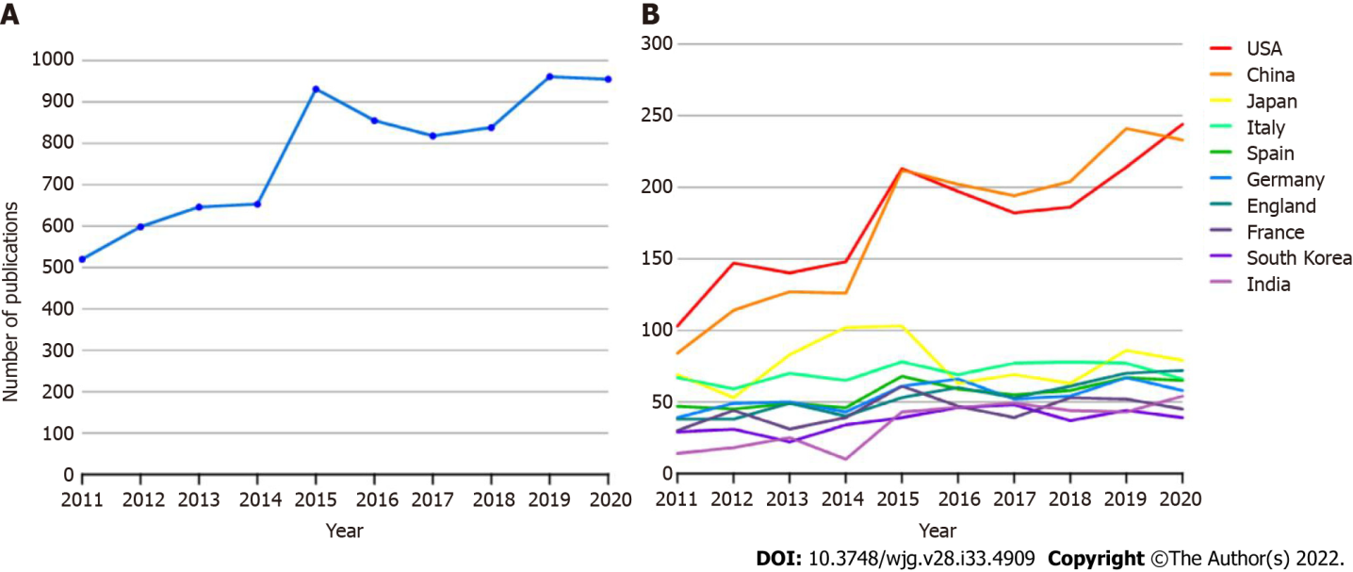
Figure 1 Trends in the number of publications and analysis of countries in the field of cirrhosis. A: The annual worldwide publication output; B: The annual publication output for the top 10 countries.
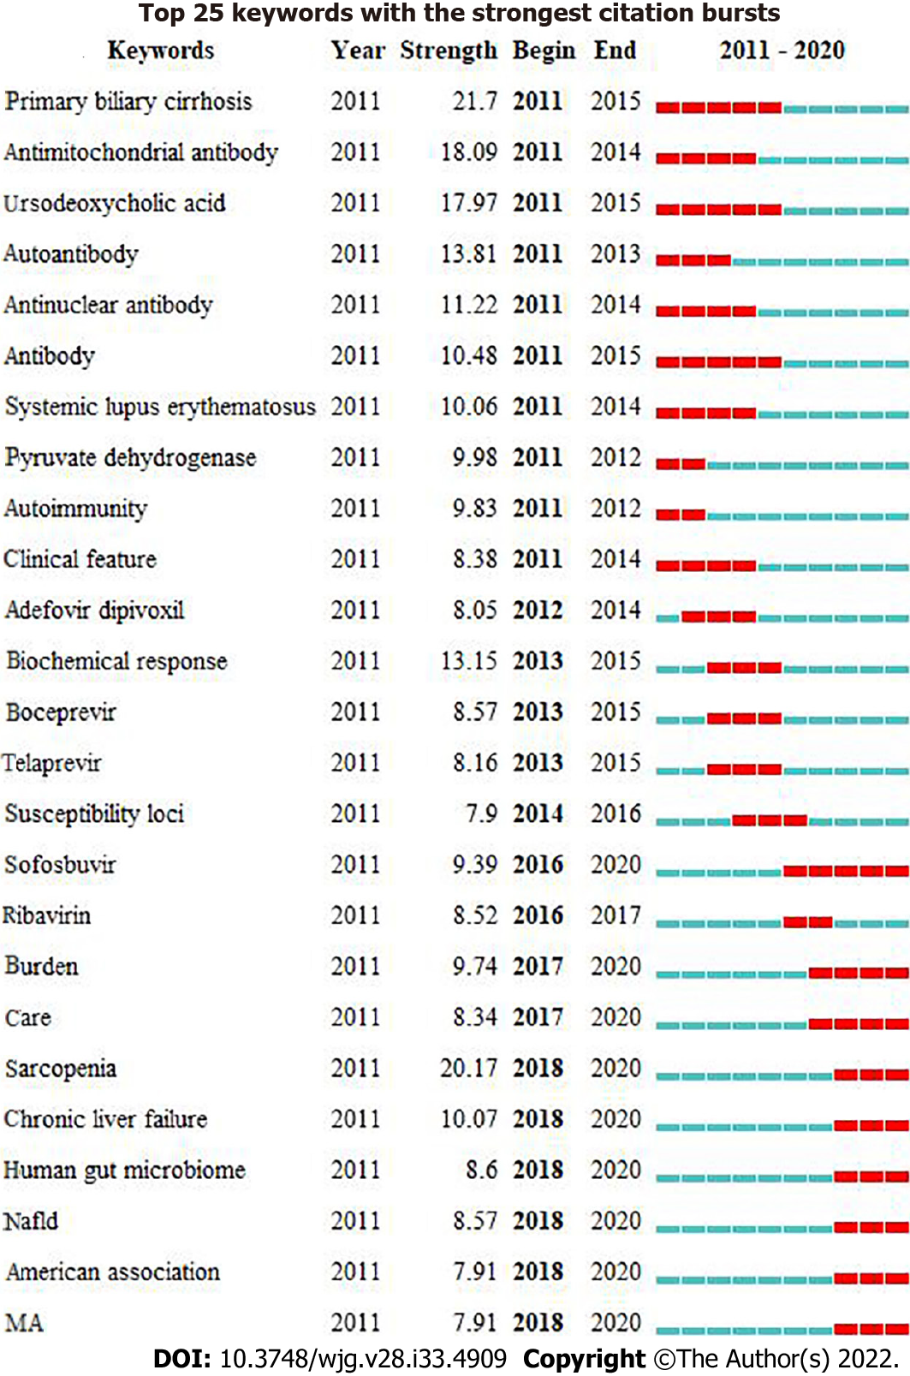
Figure 2 Keywords with the strongest occurrence burst on cirrhosis research.
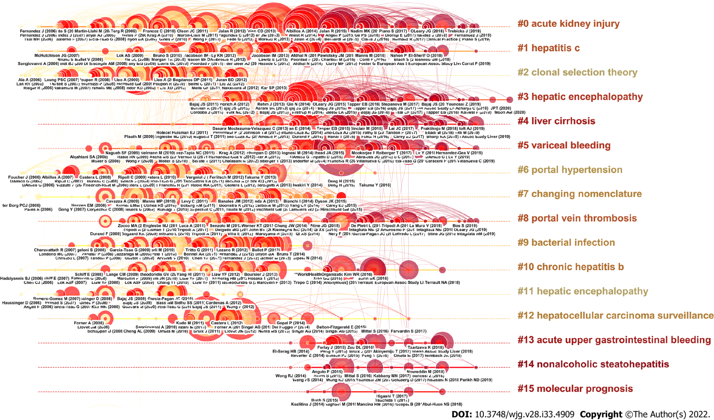
Figure 3 A timeline visualization of the largest clusters.
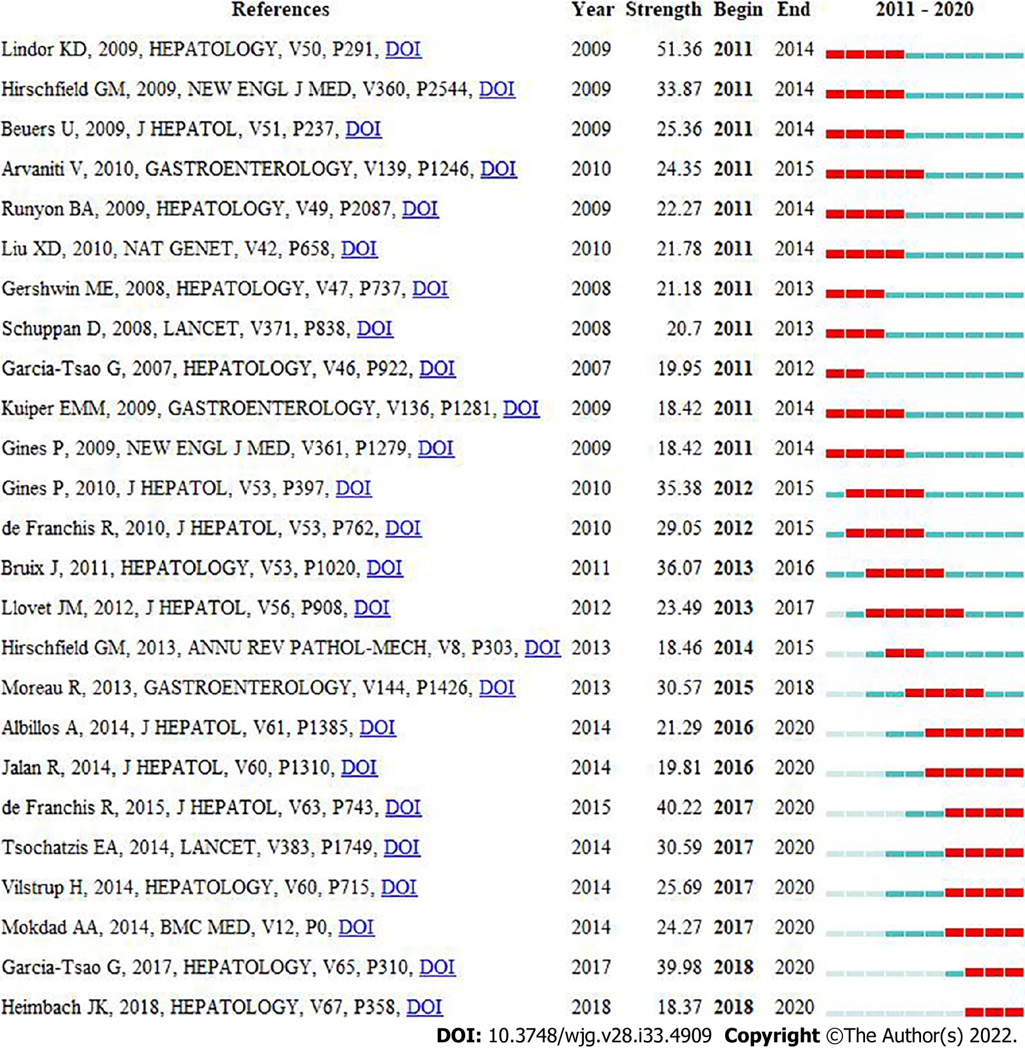
Figure 4 References with the strongest citation burst on cirrhosis research.
Table 1 The top 10 cited articles of Web of Science Core Collection bibliometrics in cirrhosis research field
Rank | First author | Journal | Title | Number of citations (WoSCC) | Type of articles
1 | Moreau R | Gastroenterology 2013; 144(7): 1426-1437, 1437.e1-9 | Acute-on-chronic liver failure is a distinct syndrome that develops in patients with acute decompensation of cirrhosis | 1113 | Retrospective study
2 | Marcellin P | Lancet 2013; 381(9865): 468-475 | Regression of cirrhosis during treatment with tenofovir disoproxil fumarate for chronic hepatitis B: a 5-year open-label follow-up study | 946 | Randomized controlled trial
3 | Kowdley KV | N Engl J Med 2014; 370(20): 1879-1888 | Ledipasvir and Sofosbuvir for 8 or 12 weeks for chronic HCV without cirrhosis | 872 | Prospective study
4 | Qin N | Nature 2014; 513(7516): 59-64 | Alterations of the human gut microbiome in liver cirrhosis | 793 | Retrospective study
5 | Anstee QM | Nat Rev Gastroenterol Hepatol 2013; 10(6): 330-344 | Progression of NAFLD to diabetes mellitus, cardiovascular disease or cirrhosis | 758 | Review
6 | Tsochatzis EA | Lancet 2014; 383(9930): 1749-1761 | Liver cirrhosis | 686 | Review
7 | Poordad F | N Engl J Med 2014; 370(21): 1973-1982 | ABT-450/r-Ombitasvir and Dasabuvir with Ribavirin for hepatitis C with cirrhosis | 675 | Randomized controlled trial
8 | Garcia-Tsao G | Hepatology 2017; 65(1): 310-335 | Portal hypertensive bleeding in cirrhosis: risk stratification, diagnosis, and management: 2016 Practice Guidance by the American Association for the Study of Liver Diseases | 539 | Practice guideline
9 | Conti F | J Hepatol 2016; 65(4): 727-733 | Early occurrence and recurrence of hepatocellular carcinoma in HCV-related cirrhosis treated with direct-acting antivirals | 495 | Prospective study
10 | Chen Y | Hepatology 2011; 54(2): 562-572 | Characterization of fecal microbial communities in patients with liver cirrhosis | 450 | Randomized controlled trial
WoSCC: Web of Science Core Collection.
Table 2 The top 10 countries that published articles on cirrhosis research
Rank | Country | Number of articles | Number of citations | Citations per article
1 | United States | 1707 | 46238 | 27.09
2 | China | 1672 | 19452 | 11.63
3 | Japan | 711 | 11215 | 15.77
4 | Italy | 651 | 22183 | 34.08
5 | Spain | 486 | 19497 | 40.12
6 | Germany | 477 | 12862 | 26.96
7 | England | 458 | 19842 | 43.32
8 | France | 391 | 18247 | 46.67
9 | South Korea | 310 | 5077 | 16.38
10 | India | 302 | 3661 | 12.12
Table 3 The top 10 institutions that published articles on cirrhosis research
Rank | Institutions | Number of articles | Number of citations | Country
1 | University of Barcelona | 177 | 11087 | Spain
2 | Virginia Commonwealth University | 120 | 5826 | United States
3 | University College London | 119 | 5134 | England
4 | Mayo Clinic | 117 | 4074 | USA
5 | University of Padua | 111 | 5430 | Italy
6 | Capital Medical University | 109 | 646 | China
7 | University of California, Davis | 102 | 4515 | USA
8 | Zhejiang University | 102 | 2404 | China
9 | University of Copenhagen | 99 | 1521 | Denmark
10 | University of Milan | 98 | 5108 | Italy

Published by Baishideng Publishing Group Inc
7041 Koll Center Parkway, Suite 160, Pleasanton, CA 94566, USA
Telephone: +1-925-3991568
E-mail: bpgoffice@wjgnet.com
Help Desk: https://www.f6publishing.com/helpdesk
https://www.wjgnet.com

© 2022 Baishideng Publishing Group Inc. All rights reserved.

