Name of Journal: World Journal of Gastrointestinal Oncology
ESPS Manuscript NO: 21318
Manuscript Type: Case Report

Rectal neuroendocrine tumor with uncommon metastatic spread: A case report and review of literature

Tsoukalas N et al. An uncommon metastatic rectal neuroendocrine tumor

Nikolaos Tsoukalas, Michalis Galanopoulos, Maria Tolia, Maria Kiakou, Georgios Nakos, Aristoula Papakostidi, Georgios Koumakis

Nikolaos Tsoukalas, Maria Kiakou, Department of Medical Oncology, 401 General Military Hospital, 11525 Athens, Greece

Nikolaos Tsoukalas, Maria Tolia, Aristoula Papakostidi, Georgios Koumakis, Second Department of Medical Oncology, “Agios Savvas” Anticancer Hospital, 11522 Athens, Greece

Michalis Galanopoulos, Department of Gastroenterology, 401 General Military Hospital, 11525 Athens, Greece

Georgios Nakos, Department of Pathology, 401 General Military Hospital, 11525 Athens, Greece

Author contributions: Tsoukalas N and Galanopoulos M contributed equally to this work; all authors contributed to this work.

Institutional review board statement: The patient involved in this study passed away prior to the time of preparation of the manuscript. Data presented are anonymized and there is negligible risk of subject identification of any harm to the patient or his family.

Informed consent statement: The patient involved in this study passed away prior to the time of preparation of the manuscript. Data presented are anonymized and there is negligible risk of subject identification of any harm to the patient or his family.

Conflict-of-interest statement: The authors have no conflict of interest to declare.

Open-Access: This article is an open-access article which was selected by an in-house editor and fully peer-reviewed by external reviewers. It is distributed in accordance with the Creative Commons Attribution Non Commercial (CC BY-NC 4.0) license, which permits others to distribute, remix, adapt, build upon this work non-commercially, and license their derivative works on different terms, provided the original work is properly cited and the use is non-commercial. See: http://creativecommons.org/licenses/by-nc/4.0/

Correspondence to: Nikolaos Tsoukalas, MD, MSc, PhD, Medical Oncologist, MSc in Bioinformatics, Consultant in Department of Medical Oncology, 401 General Military Hospital, Kanellopoyloy 6, 11525 Athens, Greece. tsoukn@yahoo.gr
Telephone: +30-697-7366056

Received: July 5, 2015
Peer-review started: July 10, 2015
First decision: September 30, 2015
Revised: November 18, 2015
Accepted: December 7, 2015
Article in press:
Published online:

Abstract
Neuroendocrine tumors of the gastrointestinal tract are rare neoplasms. Rectal neuroendocrine tumors consist approximately the 5%-14% of all neuroendocrine neoplasms in Europe. These tumors are diagnosed in relatively young patients, with a mean age at diagnosis of 56 years. Distant metastases from rectal neuroendocrine tumors are not very common. Herein we describe a case of a rectal neuroendocrine tumor which metastasized to the lung, mediastinum and orbit. This case underscores the importance of early identification and optimal management to improve patient’s prognosis. Therefore, the clinical significance of this case is the necessity of physicians’ awareness and education regarding neuroendocrine tumors’ diagnosis and management.

Key words: Neuroendocrine tumor; Rectum; Rectal neuroendocrine neoplasm; Uncommon metastatic spread; Rectal neuroendocrine tumor

© The Author(s) 2015. Published by Baishideng Publishing Group Inc. All rights reserved.

Core tip: Rectal neuroendocrine tumors consist approximately 5%-14% of all neuroendocrine neoplasms in Europe. Distant metastases from rectal neuroendocrine tumors are not very common. Herein we describe a case of a rectal neuroendocrine tumor with an uncommon natural history as well as a review of the literature. The present case underscores the importance of early identification and management of these tumors.

Tsoukalas N, Galanopoulos M, Tolia M, Kiakou M, Nakos G, Papakostidi A, Koumakis G. Rectal neuroendocrine tumor with uncommon metastatic spread: A case report and review of literature. World J Gastrointest Oncol 2015; In press
INTRODUCTION
The gastrointestinal tract has the largest component of neuroendocrine cells. In spite of this, neuroendocrine tumors of the colon and rectum are rare entities, with a reported incidence ranging from 0.3% to 3.9% of all colorectal malignancies^{[1]}. Τhe introduction of more sensitive diagnostic tools (e.g., immunohistochemical stains) and an overall increased awareness among physicians, have largely contributed to the rising incidence of neuroendocrine tumors^{[2]}. Here we describe an interesting case of a rare neuroendocrine neoplasm of the rectum with an uncommon natural history.

CASE REPORT
A 54-year-old man with free medical or family history came to our hospital reporting rectal bleeding in May 2005. Colonoscopy demonstrated a rectal polypoid mass, 15 mm in diameter, located 6cm from the anus. Biopsies were taken and histopathology evaluation showed an adenocarcinoma which invaded submucosa. An extensive work up with computed tomography (CT) scans was negative for distant metastases but there was an infiltration of pericolic fat. After that, the patient underwent low anterior resection of the rectum and the mesorectum. The histopathological examination of the dissected specimen showed a grade 2 adenocarcinoma with infiltration of pericolic fat and regional lymph nodes (stage C1 Astler-Coller). Adjuvant chemotherapy with 6 cycles of FOLFOX4 was administered without radiotherapy.
Two years later, during the scheduled follow-up, the CT scans revealed a mass in the lower left lobe of the lung, which was surgically resected and the pathology showed a neuroendocrine tumor with well differentiation. The review of both histologic specimens (paraffin tube of rectum and lung specimens, Figures 1 and 2) showed that there were medium to large tumor cells, displaying a trabecular growth pattern with nuclear pleomorphism, hyperchromasia and prominent nucleoli. Tumor cells were often spreading individually infiltrating. No lymphovascular invasion was detectable. There were a few punctate foci of necrosis. The tumor cells invaded perirectal tissues and 2 regional lymph nodes were infiltrated. Pathologic staging was pT3N1M1 and the clinical stage IV. Moreover, the immunohistochemistry analysis revealed positivity, in both specimens, for CK18, CK20, chromogranin, synaptophysin, CD56 and Ki-67, while CK7 and TTF1 were negative. Synaptophysin and chromogranin showed a diffuse positive staining of the tumor cells. These findings led to the conclusion that the primary tumor was that in the rectum and it was a neuroendocrine neoplasm well differentiated. In particular, Ki-67 was 8%-9% and the tumour was classified as well differentiated neuroendocrine tumor, intermediate grade (G2 NET). At that time patient refused to receive any further treatment.
One year later the planned follow up showed a mass in the mediastinum. The octreoscan that followed showed increased uptake in the same anatomic region (Figure 3). Subsequently, the patient underwent radiotherapy (44 Gy) for the mass in the mediastinum. Moreover, the patient developed a mass in the left orbit, something that was discovered after a bilateral visual impairment and was treated with stereotactic radiosurgery (Cyber-Knife 18 Gy). Despite the medical advices patient refused to receive any systemic treatment. At the same period of time new lesions in left lung, mediastinum, adrenals and scalp were found. The patient was administered chemotherapy with the regiment Cisplatin 75 mg/m² d1 plus Etoposide 100 mg/m² d1-d3. Unfortunately, patient died after 4 cycles of chemotherapy due to uncontrolled systemic infection.

DISCUSSION
Rectal neuroendocrine neoplasms are usually small; polypoid lesions located in the mid-rectum, 5 to 10 cm from the anal verge and are submucosal in location, mainly discovered incidentally on routine surveillance endoscopies. If there are any symptoms, they include rectal bleeding, pain (as happened in our case) and change in bowel habits. However, 50% of patients are asymptomatic^{[3]}.
They belong to a heterogeneous group of tumours, which all present a common phenotype with immunoreactivity for markers such as chromogranin A and synaptophysin^{[4,5]}. Neuron-specific enolase (NSE) and CD56 are frequently expressed in GEP-NETs, but are not specific. At present, immunohistochemistry for Ki-67 (MIB-1) is mandatory to grade the tumor according to the 2010 World Health Organization (WHO) classification and divides the tumors into NET G1, NET G2 and poorly differentiated neuroendocrine carcinoma (NEC G3)^{[4]}.
Prognostic factors for metastases are tumor size, depth of invasion, and lymph node involvement of the rectal NETs. These factors may be assessed by transrectal ultrasound, if feasible, and pelvic MRI. One study revealed that metastases emerged in only 2% of tumors not bigger than 2 cm, which had not infiltrated the muscularis propria, compared to 48% of those infiltrating the muscularis layer^{[6]}. Although neuroendocrine tumours metastasize in 50%-75% of patients with the most common sites being lymph nodes, liver, and bones, metastases to the orbits, as happened in our case, have only rarely been reported (about 32 cases until 2006) and are believed to occur through hematogeneous spread^{[7]}. Orbital neuroendocrine tumors tend to arise from the gastrointestinal tract, whereas bronchial neuroendocrine tumors show a propensity to uveal metastasis and typically present with a mass or diplopia while visual failure is unusual^{[8]}, characteristics that verified in our case.
Obviously, metastatic disease at diagnosis will suggest a worse prognosis despite the available treatment options. In fact, surgery may have a palliative role to the complications associated with an advanced rectal tumour mass^{[9]}. Adjuvant therapy for well differentiated tumours after surgery is not considered, although an argument exists for applying chemotherapy in non-differentiated tumours with incomplete resection^{[3]}. Well differentiated neuroendocrine tumors is an uncommon indication for systemic chemotherapy^{[10]}. When used for progressive disease, streptozotocin combined with 5-fluorouracil with or without doxorubicin is most often applied even though the response rate is < 25%^{[4]}. The effectiveness of systemic chemo-regimens is optimal in poorly-differentiated tumours and the combination of cisplatin or carboplatin and etoposide have showed satisfactory results^{[4]}. Newer anti-angiogenesis or mTOR inhibitors may be used as well as peptide receptor radionuclide therapy peptide (PRRT) in patients with advanced or metastatic disease^{[4,11]}. Additionally, more chemotherapy regimens such as temozolomide and capecitabine are under clinical investigation for patients with advanced or metastatic neuroendocrine neoplasms^{[12]}.
In conclusion, rectal neuroendocrine tumors are rare and cases with distant metastases are even rarer. This case underscores the necessity of physicians’ awareness and education regarding neuroendocrine tumors’ diagnosis and management.

COMMENTS
Case characteristics
A 54-year-old man with rectal bleeding.

Clinical diagnosis
A rectal polypoid mass, 15 mm in diameter.

Differential diagnosis
Rectal neuroendocrine tumor; Non-neoplastic polyp; Lung neuroendocrine tumor.

Laboratory diagnosis
A well differentiated rectal neuroendocrine tumor (G2 NET) with metastases to left lung, mediastinum and left orbit.

Imaging diagnosis
Computed tomography scans revealed masses in the lower left lobe of the lung, in the mediastinum and in the left orbit.

Pathological diagnosis
The histopathological examination showed a well differentiated rectal G2 NET.

Treatment
Chemotherapy with 6 cycles of FOLFOX4 at the beginning and then regimen Cisplatin 75 mg/m² d1 plus Etoposide 100 mg/m² d1-d3.

Peer-review
This is an interesting case report describing a potentially malignant behavior of a primary neuroendocrine tumor of the rectum.
REFERENCES
1 Christiano AB, Gullo CE, Palmejani MA, Marques AM, Barbosa AP, Basso MP, de Lima LG, Netinho JG. Neuroendocrine tumor of the anal canal. GE J Port Gastrenterol 2012; 19: 267-269 [DOI: 10.1016/j.jpg.2011.06.002]
2 Saclarides TJ, Szeluga D, Staren ED. Neuroendocrine cancers of the colon and rectum. Results of a ten-year experience. Dis Colon Rectum 1994; 37: 635-642 [PMID: 8026228 DOI: 10.1007/bf02054405]
3 Ramage JK, Goretzki PE, Manfredi R, Komminoth P, Ferone D, Hyrdel R, Kaltsas G, Kelestimur F, Kvols L, Scoazec JY, Garcia MI, Caplin ME. Consensus guidelines for the management of patients with digestive neuroendocrine tumours: well-differentiated colon and rectum tumour/carcinoma. Neuroendocrinology 2008; 87: 31-39 [PMID: 18097130 DOI: 10.1159/000111036]
4 Öberg K, Knigge U, Kwekkeboom D, Perren A. Neuroendocrine gastro-entero-pancreatic tumors: ESMO Clinical Practice Guidelines for diagnosis, treatment and follow-up. Ann Oncol 2012; 23 Suppl 7: vii124-vii130 [PMID: 22997445 DOI: 10.1093/annonc/mds295]
5 Simon SR, Fox K. Neuroendocrine carcinoma of the colon. Correct diagnosis is important. J Clin Gastroenterol 1993; 17: 304-307 [PMID: 8308216 DOI: 10.1097/00004836-199312000-00008]
6 Naunheim KS, Zeitels J, Kaplan EL, Sugimoto J, Shen KL, Lee CH, Straus FH. Rectal carcinoid tumors--treatment and prognosis. Surgery 1983; 94: 670-676 [PMID: 6623366]
7 Peixoto RD, Lim HJ, Cheung WY. Neuroendocrine tumor metastatic to the orbit treated with radiotherapy. World J Gastrointest Oncol 2013; 5: 177-180 [PMID: 24009814 DOI: 10.4251/wjgo.v5.i8.177]
8 Mehta JS, Abou-Rayyah Y, Rose GE. Orbital carcinoid metastases. Ophthalmology 2006; 113: 466-472 [PMID: 16458966 DOI: 10.1016/j.ophtha.2005.10.051]
9 Schindl M, Niederle B, Häfner M, Teleky B, Längle F, Kaserer K, Schöfl R. Stage-dependent therapy of rectal carcinoid tumors. World J Surg 1998; 22: 628-633; discussion 634 [PMID: 9597939 DOI: 10.1007/s002689900445]
10 Rosenberg JM, Welch JP. Carcinoid tumors of the colon. A study of 72 patients. Am J Surg 1985; 149: 775-779 [PMID: 2409828 DOI: 10.1016/s0002-9610(85)80184-7]
11 Teunissen JJ, Kwekkeboom DJ, de Jong M, Esser JP, Valkema R, Krenning EP. Endocrine tumours of the gastrointestinal tract. Peptide receptor radionuclide therapy. Best Pract Res Clin Gastroenterol 2005; 19: 595-616 [PMID: 16183530 DOI: 10.1016/j.bpg.2005.04.001]
12 Koumarianou A, Kaltsas G, Kulke MH, Oberg K, Strosberg JR, Spada F, Galdy S, Barberis M, Fumagalli C, Berruti A, Fazio N. Temozolomide in Advanced Neuroendocrine Neoplasms: Pharmacological and Clinical Aspects. Neuroendocrinology 2015; 101: 274-288 [PMID: 25924937 DOI: 10.1159/000430816]

P-Reviewer: Freeman HJ, Kir G, Lakatos PL, Paraskevas KI, Scheidbach H S-Editor: Ji FF L-Editor: E-Editor:

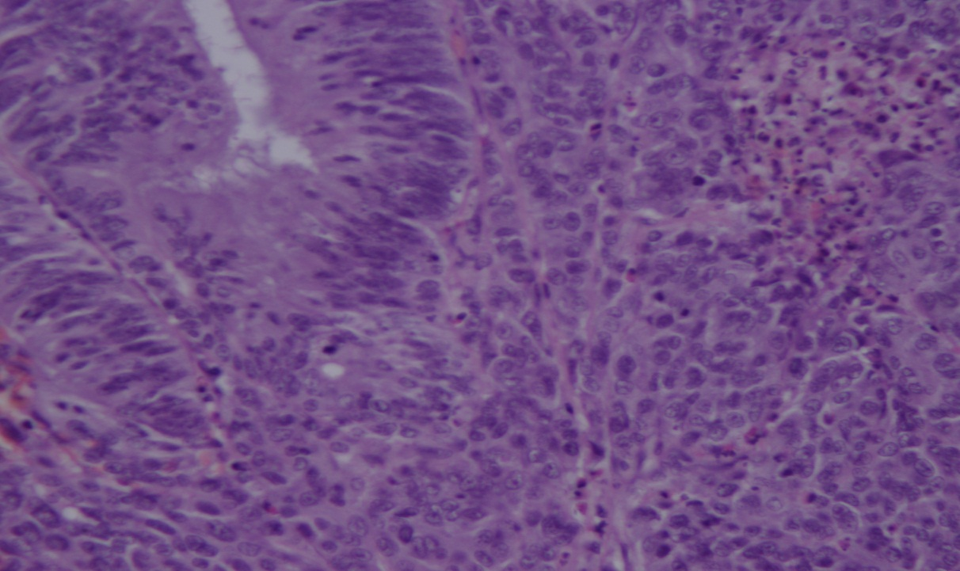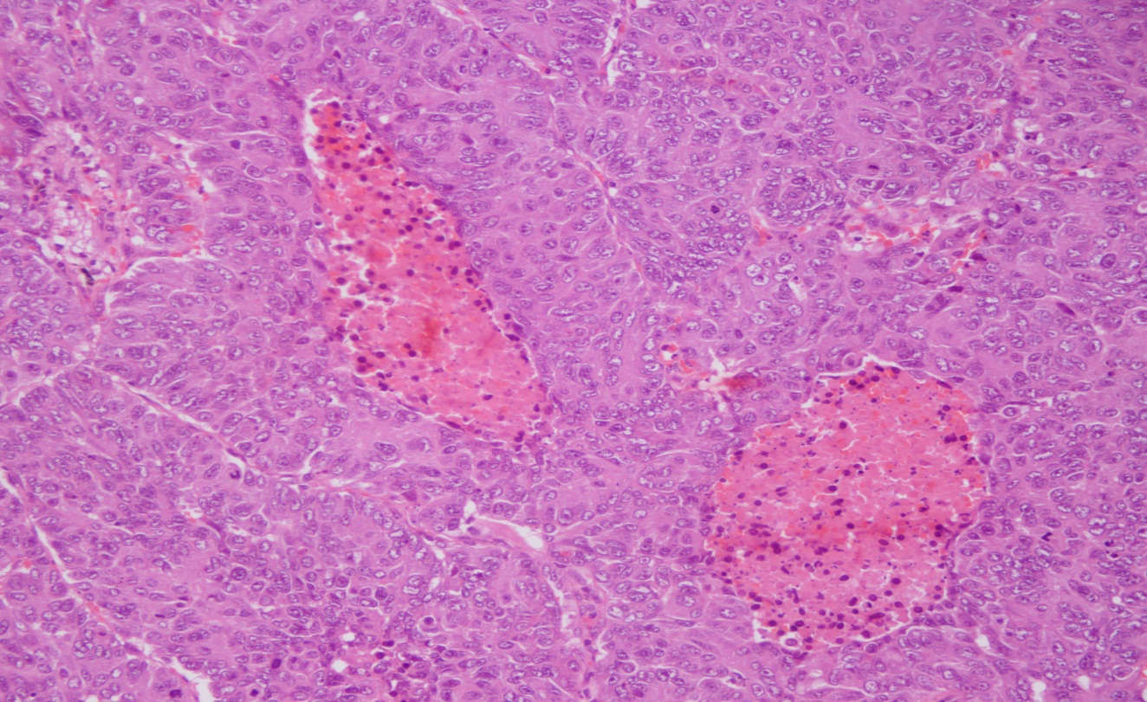
A B
Figure 1 Biopsy of the rectal tumour (A) and lung tumour (B).

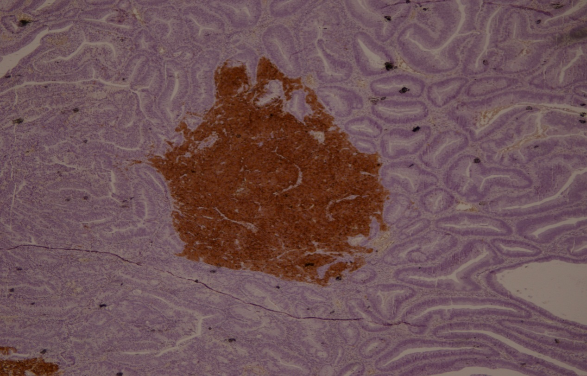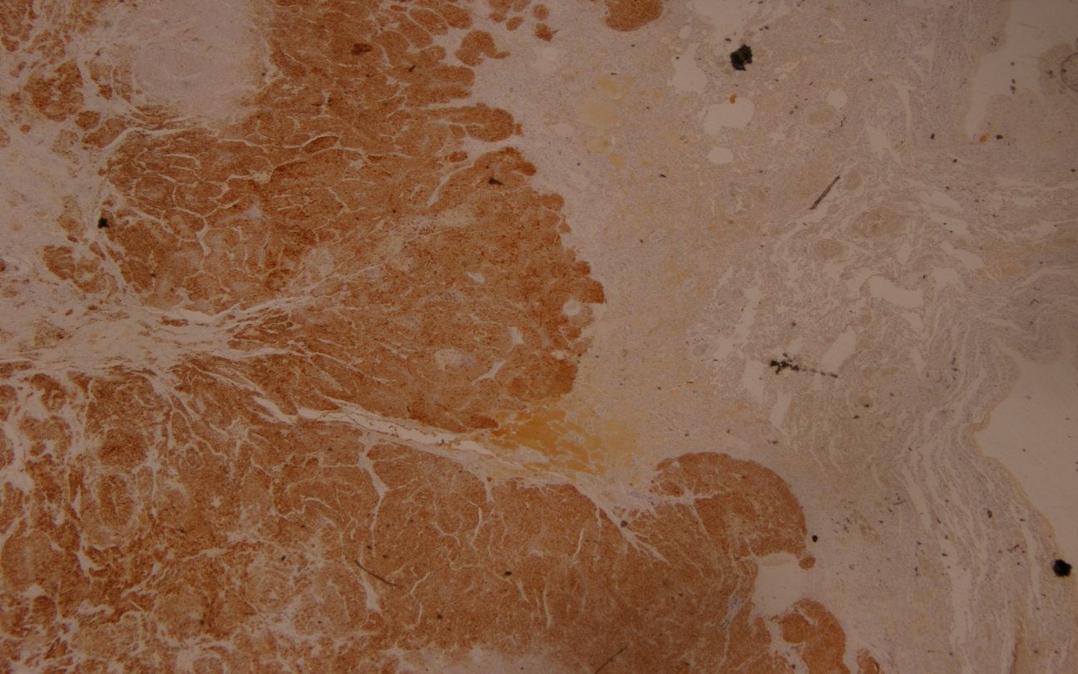
A B
Figure 2 Immunohistochemical positivity for CD56 (rectum) (A) and CD56 (lung) (B).

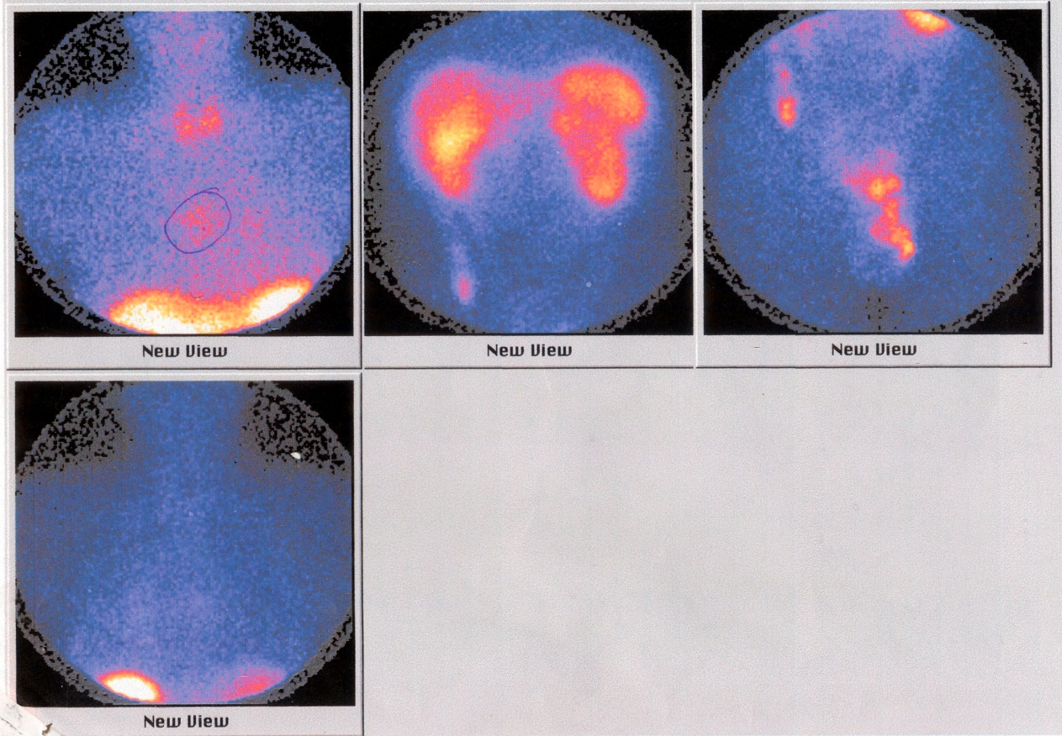

Figure 3 Octreoscan.

