Name of journal: World Journal of Gastroenterology
ESPS Manuscript NO: 10785
Columns: META-ANALYSIS

Efficacy and safety of gemcitabine-based combination chemotherapy in advanced biliary tract cancer: A meta-analysis

Liu H et al. Gemcitabine chemotherapy in biliary tract cancer

Heng Liu, Qi-Di Zhang, Zheng-Hong Li, Qing-Qing Zhang, Lun-Gen Lu

Heng Liu, Qi-Di Zhang, Zheng-Hong Li, Qing-Qing Zhang, Lun-Gen Lu, Department of Gastroenterology, Shanghai First People’s Hospital, Shanghai Jiao Tong University School of Medicine, Shanghai 200080, China

Author contributions: Lu LG and Liu H designed research; Liu H, Zhang QQ and Li ZH searched the databases, Liu H, Zhang QD and Lu LG performed data extraction; Liu H analyzed data; Liu H and Lu LG wrote the paper.

Correspondence to: Lun-Gen Lu, MD, Professor, Chief, Department of Gastroenterology, Shanghai First People’s Hospital, Shanghai Jiao Tong University School of Medicine, No. 100 Haining Road, Hongkou District, Shanghai 200080, China. lungenlu1965@163.com
Telephone: +86-21-63240090 Fax: +86-21-63241377

Received: April 19, 2014 Revised: June 12, 2014
Accepted: July 11, 2014

Published online:

Abstract
AIM: To investigate the efficacy and safety of gemcitabine (Gem)-based combination chemotherapy compared with other regimens for the treatment of advanced biliary tract cancer (BTC).

METHODS: Clinical trials were identified by searching scientific literature databases (PubMed, EMBASE and the Cochrane Library) for studies published between 1975 and 2013. Two reviewers independently evaluated the relevant studies and manually searched references from these reports to locate additional eligible studies. The disease response rate (DRR), disease control rate (DCR), progression-free survival (PFS), overall survival (OS) and the grade 3-4 toxicities were evaluated by a meta-analysis. Odds-ratios (ORs) of the DRR, DCR, grade 3-4 toxicities and mean difference (MD) of both PFS and OS were calculated and used for statistical analysis.

RESULTS: Seven randomized trials with a total of 858 patients were selected and included in the final analysis. The studies were divided into two subgroups based on the chemotherapy regimen types, including Gem monotherapy and non-Gem-based chemotherapy. The overall analyses revealed that the patients treated with Gem-based combination chemotherapy had a significantly higher DRR [OR = 1.69, 95% confidence interval (CI): 1.17-2.43; P = 0.005], a longer PFS (MD = 1.95, 95%CI: 0.90-3.00; P = 0.0003) and a longer OS (MD = 1.85, 95%CI: 0.26-3.44; P = 0.02). A higher incidence of grade 3-4 hematological toxicities, including leukopenia (OR = 2.98, 95%CI: 1.44-6.20; P = 0.003), anemia (OR = 2.96, 95%CI: 1.79-4.92; P < 0.0001) and neutropenia (OR = 2.80, 95%CI: 1.39-5.64; P = 0.004) was found in the Gem-based combination chemotherapy group compared with the Gem monotherapy and non-Gem-based chemotherapy groups.

CONCLUSION: Gem-based combination chemotherapy provides a modest improvement in survival but is associated with more toxicity compared with Gem monotherapy and non-Gem-based chemotherapy. Gem-based combination chemotherapy may be a potential first-line treatment of choice for advanced BTC.

© 2014 Baishideng Publishing Group Inc. All rights reserved.

Key words: Biliary tract cancer; Gemcitabine; Combination chemotherapy; Randomized trial; Meta-analysis

Core tip: To investigate the efficacy and safety of gemcitabine (Gem)-based combination chemotherapy for the treatment of advanced biliary tract cancer, the authors analyzed the potential impact of Gem-based combination chemotherapy and other regimens on the outcomes and toxicities of the patients using meta-analysis methodologies. Meta-analysis showed that compared with Gem monotherapy and non-Gem-based chemotherapy, Gem-based combination chemotherapy provided a modest improvement in survival but was associated with more toxicity.

Liu H, Zhang QD, Zhang QQ, Li ZH, Lu LG. Efficacy and safety of gemcitabine-based combination chemotherapy in advanced biliary tract cancer: A meta-analysis. World J Gastroenterol 2014; In press
INTRODUCTION
Biliary tract cancer (BTC) refers to tumors that develop in the bile ducts and gall bladder and includes cholangiocarcinoma and gallbladder carcinomas^{[1]}. BTC is a heterogeneous group of relatively rare tumors that account for ~3% of all gastrointestinal malignancies^{[1]} and is the second most common primary hepatic tumor^{[2]}. Globally, hepatobiliary malignancies account for 13% of cancer-related deaths; 10%-20% of these deaths are attributable to BTC^{[3]}. Epidemiologic studies have indicated that the incidence of BTC has increased rapidly worldwide in previous decades, particularly in Asian countries^{[1,4,5]}. Despite advances in the diagnosis, staging and surgical management of BTC during the past decade, patients with BTC often have a reported 5-yr survival rate that approaches only 15%^{[4]} and an overall median survival of only 6.3 mo^{[6]}. Surgical resection may be the only potentially curative therapeutic option. Unfortunately, due to the late clinical presentation, most BTC patients are diagnosed at an advanced stage when surgical resection is not feasible and treatment options are limited^{[5]}. Hence, chemotherapeutic treatment is usually recommended for patients with unresectable advanced BTC or for patients who relapse subsequent to surgery^{[7]}.
Gemcitabine (Gem) emerged as a treatment for pancreatic cancer and has been explored as a treatment for advanced biliary cancer since 1998^{[8]}. To improve the clinical efficacy, systemically administered Gem is often combined with a second cytotoxic agent, such as platinum analogs, fluoropyrimidine, or a targeted cytotoxic agent. The results from several phase II studies suggest that Gem, alone or in combination with other agents, has been relatively effective for treating BTC^{[5,9]}. However, most of these studies were small, single-arm and nonrandomized trials. Therefore, the role of Gem-based chemotherapy for patients with advanced BTC has not been clearly established. Until 2010, data from the largest randomized biliary tract trial to date indicated that the overall survival was significantly higher in the Gem and cisplatin arms of the trial versus the Gem single-agent treatment (11.7 mo vs 8.1 mo)^{[10]}. Based on these results, Gem combined with cisplatin was established as the new standard of therapy for advanced, unresectable BTC^{[7]}. Since that time, several randomized trials^{[11-14]} comparing Gem-based combination chemotherapy with other regimens have been published. However, the results of these trials were conflicting, which has made the role of Gem-based combination chemotherapy controversial. Using these data, we conducted a meta-analysis to evaluate the efficacy and safety of Gem-based combination chemotherapy in advanced BTC treatment. The aim of this study was to assess whether Gem-based combination chemotherapy improves BTC prognosis compared with other treatment regimens.

MATERIAL AND METHODS
Search methods
PubMed, EMBASE and the Cochrane Library were systematically searched using the following combination of search terms: “biliary tract cancer”, “gallbladder carcinoma”, “cholangiocarcinoma” and “gemcitabine”. The search was performed in August 2013 and updated in November 2013 to identify relevant publications between 1975 and 2013; there were no language restrictions. All potentially relevant studies were retrieved, and their references were evaluated to identify additional eligible studies.

Inclusion and exclusion criteria
Studies were eligible for inclusion in the meta-analysis if they met all of the following criteria: (1) advanced BTC patients (with unresectable or metastatic cancer); (2) Gem-based combination chemotherapy at any line; (3) reported disease response rate (DRR), disease control rate (DCR), progression-free survival (PFS), overall survival (OS) and toxicities; and (4) structured as randomized controlled trials. Non-randomized trials and studies that repeated existing research were excluded to avoid clinical heterogeneity between studies.
Date extraction and quality assessment
Two independent reviewers (Liu H and Zhang QD) extracted the data from the eligible studies. A third reviewer (Lu LG) was consulted to resolve any disagreements. The following data were extracted from the included studies: first author’s name, year of publication, number of patients enrolled in each treatment group, patient age (median and range), proportion of male participants, treatment regimens, numbers and rates of DRR, DCR, PFS, and OS and numbers and rates of each type of grade 3–4 toxicity.
Study quality was assessed with Jadad scores^{[15]} using the following criteria: quality of randomization, quality of allocation concealment, quality of double-blinding, and quality of withdrawals and dropouts in the study description. The studies scored one point for each criterion met. Additional points were given for each of the following conditions that were met: randomization sequence method was described by computer or randomized number, method of allocation concealment was described and was appropriate, or a detailed description of proper double blinding methods was provided. Based on these criteria, high-quality studies scored a total of at least four points.

Statistical analysis
Pooled odds ratios (ORs) with 95% confidence intervals (CIs) were calculated for the DRR and the DCR using Review Manger 5.2 software (Copenhagen: The Nordic Cochrane Centre, The Cochrane Collaboration, 2012). The mean differences (MDs) with 95%CIs were calculated for the DRR and the DCR. Statistical heterogeneity among studies was assessed using Cochran’s Q-test and the I² statistic^{[16]}. A P-value < 0.10 for the Q-test or an I² > 50% indicated study heterogeneity; in either case, a DerSimonian-Laird random-effects model was used. Otherwise, a Mantel-Haenszel fixed-effects method was used. If heterogeneity was found, a sensitivity analysis was performed to identify the potential sources of heterogeneity. Egger’s test and Begg’s test were used to measure potential publication bias. Statistical significance was indicated by a two-sided P < 0.05. We used subgroup analyses to compare the efficacy and safety of gemcitabine-based combination chemotherapy with Gem monotherapy and non-Gem-based chemotherapy.

RESULTS
Literature search and selection flow
The study selection flow is depicted in Figure 1. Initially, 452 records were identified from PubMed, EMBASE and the Cochrane Library. After the initial review of the titles and abstracts, 111 relevant clinical trials were retrieved for detailed assessment, including 10 randomized trials. As the scheme depicts, seven studies^{[10-14,17,18]} met our inclusion criteria and were included in the quantitative synthesis, while the other three studies^{[19-21]} were excluded.

Characteristics and quality of selected studies
Table 1 summarizes the characteristics of the included studies. Four different Gem-combination chemotherapy regimens were involved in the studies: Gem and cisplatin^{[10,11,18]}, Gem and S-1^{[12,13]}, Gem and oxaliplatin^{[17]} and Gem and mitomycin C^{[14]}. The effects of Gem-combination chemotherapy were compared with Gem monotherapy in three studies^{[10,12,18]} and with other chemotherapy regimens in the remaining four studies^{[11,13,14,17]}. The seven trials provided data from a total of 858 patients (mean: 123 patients; range: 51 to 410). Males accounted for 17.9%-66% of all subjects, and the median patient age ranged from 47 to 75 yr. All patients enrolled in the included studies had the following characteristics: histologically confirmed advanced local or metastatic biliary tract cancer not amenable to surgical resection; no previous chemotherapy; Eastern Cooperative Oncology Group Performance Status scores between 0 and 2; and adequate liver, renal and hematopoietic functions.
The details of grade 3-4 toxicity assessment are shown in Table 2 and include leukopenia, neutropenia, anemia, thrombocytopenia, increased alanine aminotransferase (ALT) level, nausea, vomiting, anorexia and diarrhea.
All seven eligible studies^{[10-14,17,18]} were randomized, and two studies^{[13,14]} described the method of randomization with definite descriptions. Allocation concealment was performed using a proprietary algorithm in one of the trials^{[13]}. None of the trials reported double-blind procedures. Each trial included in the meta-analysis provided a detailed description of the number of and reasons for patient withdrawals and dropouts. Finally, two studies scored 4 points or above (Table 3).

DRR
The DRRs were reported in all studies and ranged from 9.4%–36.4% without significant inter-study heterogeneity (Q = 6.69, df = 6, P = 0.35; I² = 10%). The pooled OR of the DRR estimated by the fixed-effects model was 1.69 (95%CI: 1.17-2.43). The overall analysis revealed that the patients treated with Gem-based combinations achieved significantly higher DRR compared with the patients who had not received this combination chemotherapy (P = 0.005, Figure 2A). A subgroup analysis indicated that the DRR was significantly higher for the patients treated with Gem-based combination chemotherapy compared with the patients treated with Gem alone (OR = 1.97, 95%CI: 1.20-3.21, P = 0.007; Figure 2A). The OR for the non-Gem-based chemotherapy subgroup was 1.39 (95%CI: 0.82-2.40), which was not statistically significant (P = 0.24; Figure 2A).

DCR
The DCR in the studies ranged from 21.4%-86.0%. Significant heterogeneity was detected between the studies (Q = 16.57, df = 6, P = 0.01; I² = 64%); therefore, a random-effects model was used for the meta-analysis of the DCR. The total OR for the DCR was 1.65 (95%CI: 0.91-3.00, P = 0.10, Figure 2B). The results of the subgroup analyses indicated that the patients treated with Gem-based combinations had significantly higher DCRs compared with the patients treated with Gem alone (OR = 1.82, 95%CI: 1.18-2.81, P = 0.007; Figure 2B). The DCR of the non-Gem-based chemotherapy subgroup was lower compared with the Gem-based combination chemotherapy group (OR = 1.48, 95%CI: 0.43-5.07), but the difference was not significant (P = 0.007; Figure 2A).

PFS
The median PFS of the included studies ranged from 3.5-8.5 mo. After data pooling, significant heterogeneity was observed among the studies (Q = 396.07, df = 6, P < 0.00001; I² = 98%); therefore, a random-effects model was used for the meta-analysis of the median PFS. The overall MD for the PFS was 1.95 (95%CI: 0.90-3.00; P = 0.0003, Figure 2C), which suggests that Gem-based combination chemotherapy significantly improved patient PFS. A subgroup analysis also revealed that the PFS was significantly longer for the patients treated with Gem-based combination chemotherapy compared with the patients treated with Gem alone (MD = 2.21, 95%CI: 1.31-3.12; P < 0.00001; Figure 2C). The MD for the non-Gem-based chemotherapy subgroup was 1.78 (95%CI: -0.39-3.96), but no significant differences were found (P = 0.11; Figure 2C).

OS
The median OS ranged from 4.6–12.5 mo. Significant heterogeneity was detected between the studies (Q = 386.00, df = 6, P < 0.00001; I² = 98%); therefore, a random-effects model was used for the meta-analysis of OS. The overall MD for the OS was 1.85 (95%CI: 0.26-3.44; P = 0.02, Figure 2D), which indicated that Gem-based combination chemotherapy significantly prolonged the overall survival time. A subgroup analysis revealed that the OS was significantly longer for the patients treated with Gem-based combination therapy compared with the patients treated with Gem alone (MD = 2.38, 95%CI: 0.92-3.84; P = 0.001; Figure 2D). The OS of the Gem-based combination chemotherapy group was longer compared with the non-Gem-based chemotherapy group (MD = 1.51, 95%CI: -1.37-4.38), but no significant differences were found (P = 0.30; Figure 2D).

Toxicities
The results of the meta-analysis of the main toxicities are presented in Figures 3A-3E. The ORs for grade 3-4 hematological toxicities analyzed in this study were higher in the Gem-based combination chemotherapy group compared with the Gem monotherapy and non-Gem-based chemotherapy groups. The incidence of leukopenia (OR = 2.98, 95%CI: 1.44-6.20; P = 0.003), anemia (OR = 2.96, 95%CI: 1.79-4.92; P < 0.0001) and neutropenia (OR = 2.80, 95%CI: 1.39-5.64; P = 0.004) were all significantly different between the treatment groups, while no significant differences were noted for thrombocytopenia (OR = 1.71; 95%CI: 0.75-3.89; P = 0.20). No significant difference in the increased ALT level (OR = 0.87; 95%CI: 0.58-1.30; P = 0.49) was found between the treatment groups.
In the subgroup analysis, the ORs were 1.82-7.01 for leukopenia, 1.96-7.04 for anemia, 1.78-4.63 for neutropenia, 1.13-2.79 for thrombocytopenia and 0.76-1.11 for the increased ALT level. There were significant differences in leukopenia (P = 0.01), anemia (P = 0.03) and neutropenia (P = 0.005), but not thrombocytopenia or the increased ALT level, between the Gem-based combination chemotherapy group and the Gem monotherapy group. The ORs of leukopenia (OR = 7.17; P = 0.02) and anemia (OR = 7.04; P = 0.0001) in the Gem-based combination chemotherapy group were over seven times those in the non-Gem-based chemotherapy subgroup; no significant differences were observed for the other toxicities.

Sources of heterogeneity and sensitivity analysis
Because significant heterogeneity was detected among the studies for the DCR, PFS and OS, we performed a sensitivity analysis to explore the heterogeneity by omitting one study at a time and calculating pooled ORs for the remainder of the studies. The study by Kang et al^{[11]} may have been the key contributor to the inter-study heterogeneity in the DCR meta-analysis. No heterogeneity was observed after excluding this study (Q = 9.26, df = 5, P = 0.10; I² = 46%); the pooled OR for the DCR was 2.03 (95%CI: 1.21-3.40). The direction and magnitude of the pooled OR for the PFS and the pooled MD for the OS did not vary markedly with the removal of any study, which indicated good reliability (data not shown).

Publication bias
Egger’s test was used to investigate potential publication bias; there was no evidence of bias for the DRR (P = 1.000), DCR (P = 0.230), PFS (P = 0.548), or OS (P = 1.000). Additionally, publication bias was not indicated by Begg’s funnel plot (Figure 4).

DISCUSSION
BTC is a heterogeneous group of relatively rare tumors, which often have extremely poor prognoses. Most patients present with locally advanced or metastatic disease and are candidates for surgical resection; as a result, many patients must rely on palliative chemotherapy as the only treatment option. During the last decade, several randomized controlled clinical trials have evaluated gemcitabine in combination with various agents in an attempt to improve the prognosis of advanced BTC. In this meta-analysis, we systematically evaluated the efficacy and safety of Gem-based combination chemotherapy in the treatment of advanced BTC. Our findings suggest that patients treated with Gem-based combination chemotherapy may experience better survival outcomes compared with patients not treated with this combination. However, Gem-combination chemotherapy regimens were not identical in all included studies; thus, our findings must be considered in light of this limitation.
Our overall analysis revealed that the patients treated with Gem-based combination chemotherapy had a significantly greater DRR (OR = 1.69) as well as a longer PFS (MD = 1.95) and OS (MD = 1.85) compared with the patients not treated with this combination. Heterogeneity among the studies may be a reason for the lack of statistically significant data related to the DCR. Furthermore, the subgroup analysis revealed that the treatment with Gem-based combination chemotherapy was associated with significantly better DRR, DCR, PFS and OS outcomes compared with the treatment with Gem alone. Our findings are consistent with those of Eckel et al^{[22]}, who conducted a meta-analysis of chemotherapy trials for advanced BTC treatment and reported that Gem-based combination chemotherapy (Gem-cisplatin or Gem-oxaliplatin) was associated with the highest DRRs and tumor control rates. However, Eckel’s meta-analysis was not restricted to randomized trials. Recently, another meta-analysis by Yang et al^{[23]} included 3 randomized trials; the results of this study indicated that the patients with advanced BTC who were treated with Gem-based combination chemotherapy (Gem plus platinum agents) experienced better survival outcomes compared with the patients not treated with this chemotherapy combination. However, the analysis involved studies that evaluated Gem plus platinum chemotherapy; thus, new treatments, such as Gem plus S-1, were not included. A review published by Serrano et al^{[24]} also suggested that gemcitabine alone or in combination with other agents showed a better response rate that correlated with the time to progression. Additionally, regimens that contained two drugs induced higher response rates compared with single agent treatments. In our study, the subgroup analysis also indicated that Gem-based combination chemotherapy provides some major benefit over non-Gem-based chemotherapy, but the result was not significant. The consistency between our findings and previous analyses further supports the use of Gem-based combination chemotherapy as a first-line treatment for advanced BTC.
We also assessed the five most common toxicities related to the chemotherapeutic treatment of advanced BTC, which are leukopenia, neutropenia, anemia, thrombocytopenia and an increased ALT level. The analysis indicated that the incidence of grade 3-4 hematological toxicities, including leukopenia, neutropenia and anemia, were significantly higher following Gem-based combination chemotherapy than following Gem monotherapy and non-Gem-based chemotherapy. There was no significant difference in the rates of thrombocytopenia or the increased ALT level. Furthermore, a subgroup analysis showed that the ORs of leukopenia, neutropenia and anemia after treatment with Gem-based combination chemotherapy were almost twice those of Gem monotherapy. Additionally, the ORs of leukopenia and neutropenia in the Gem-based combination chemotherapy were more than seven times those of the non-Gem-based chemotherapy. The results presented here suggest that Gem-based combination chemotherapy induced more toxicity compared with Gem alone or non-Gem-based chemotherapy. However, all severe hematological toxicities (grade 3 or 4) are infrequent and reversible, and these results are consistent with a previous study^{[24]}.
Several limitations of our meta-analysis should be mentioned. First, only randomized trials were selected; thus, the total included sample size was small (7 studies). Additionally, our selections may have been subjected to some bias, although we observed none. Second, our data are based on the published data for which the patient outcomes according to the type of BTC were not available. This may limit our capacity to fully explore the effects of Gem-based combination chemotherapy in different types of BTC. Another limitation was that the included studies did not have homogenous characteristics with respect to the regimens used for Gem-based combination chemotherapy or the competing regimen. Furthermore, the patient demographics between the included studies were different. Due to the limitations mentioned above, the results of this meta-analysis should be interpreted with care.
In conclusion, the results of our meta-analysis of randomized trials suggest that the treatment of advanced BTC with Gem-based combination chemotherapy is associated with significantly better survival outcomes compared with treatment with Gem alone or non-Gem-based chemotherapy. Major hematological toxicities associated with Gem-based combination chemotherapy were generally manageable and acceptable. Therefore, Gem-based combination chemotherapy should be considered a standard first-line treatment for advanced BTC. In the future, larger multicenter randomized controlled trials should be designed to examine the efficacy and safety of Gem-based combination chemotherapy.

COMMENTS
Background
Biliary tract cancer (BTC) is a heterogeneous group of relatively rare tumors that often have extremely poor prognoses. Gemcitabine (Gem) is the treatment of choice for patients with advanced BTC. The results from several phase II studies suggest that Gem, alone or in combination with other agents, has been relatively effective for treating BTC. However, most of these studies were small, single-arm and nonrandomized trials.
Research frontiers
The data from the largest randomized trial to date indicated that the overall survival of BTC patient was significantly higher in the Gem and cisplatin arm versus the Gem single-agent arm. Since that time, several randomized trials comparing Gem-based combination chemotherapy with other regimens have been published. However, the results of these trials were conflicting, which has made the role of Gem-based combination chemotherapy controversial.
Innovations and breakthroughs
Based on this meta-analysis, Gem-based combination chemotherapy was superior in disease response rate, progression-free survival and overall survival to the radiation therapy group or chemotherapy group alone. Similar results were indicated in the subgroup analyses. Gem-based combination chemotherapy group had significantly more grade 3-4 treatment-related hematologic and non-hematologic toxicities than Gem alone or non-Gem-based chemotherapy. These findings were not presented clearly in previous systematic reviews.
Applications
The results of our meta-analysis of randomized trials suggest that Gem-based combination chemotherapy can improve the prognosis of patients with advanced BTC although it may also increase the treatment-related toxicity.
Peer review
This is a well written manuscript analyzing therapeutic management of advanced biliary tract cancer. In this manuscript, the authors compared the efficacy and safety of Gem-based combination chemotherapy with Gem alone or non-Gem-based chemotherapy. The data were well collected, and analyzed.

REFERENCES
1 Geynisman DM, Catenacci DV. Toward personalized treatment of advanced biliary tract cancers. Discov Med 2012; 14: 41-57 [PMID: 22846202]
2 Lazaridis KN, Gores GJ. Cholangiocarcinoma. Gastroenterology 2005; 128: 1655-1667 [PMID: 15887157 DOI: 10.1053/j.gastro.2005.03.040]
3 Rizvi S, Gores GJ. Pathogenesis, diagnosis, and management of cholangiocarcinoma. Gastroenterology 2013; 145: 1215-1229 [PMID: 24140396 DOI: 10.1053/j.gastro.2013.10.013]
4 Siegel R, Naishadham D, Jemal A. Cancer statistics, 2012. CA Cancer J Clin 2012; 62: 10-29 [PMID: 22237781 DOI: 10.3322/caac.20138]
5 Ciombor KK, Goff LW. Advances in the management of biliary tract cancers. Clin Adv Hematol Oncol 2013; 11: 28-34 [PMID: 23416860]
6 Yang JD, Kim B, Sanderson SO, Sauver JS, Yawn BP, Larson JJ, Therneau TM, Roberts LR, Gores GJ, Kim WR. Biliary tract cancers in Olmsted County, Minnesota, 1976-2008. Am J Gastroenterol 2012; 107: 1256-1262 [PMID: 22751468 DOI: 10.1038/ajg.2012.173]
7 Khan SA, Davidson BR, Goldin RD, Heaton N, Karani J, Pereira SP, Rosenberg WM, Tait P, Taylor-Robinson SD, Thillainayagam AV, Thomas HC, Wasan H. Guidelines for the diagnosis and treatment of cholangiocarcinoma: an update. Gut 2012; 61: 1657-1669 [PMID: 22895392 DOI: 10.1136/gutjnl-2011-301748]
8 Castro MP. Efficacy of gemcitabine in the treatment of patients with gallbladder carcinoma: a case report. Cancer 1998; 82: 639-641 [PMID: 9477094 DOI: 10.1002/(SICI)1097-0142(19980215)82:4<639::AID-CNCR4>3.0.CO;2-G]
9 Valle JW. Advances in the treatment of metastatic or unresectable biliary tract cancer. Ann Oncol 2010; 21 Suppl 7: vii345-vii348 [PMID: 20943640 DOI: 10.1093/annonc/mdq420]
10 Valle J, Wasan H, Palmer DH, Cunningham D, Anthoney A, Maraveyas A, Madhusudan S, Iveson T, Hughes S, Pereira SP, Roughton M, Bridgewater J. Cisplatin plus gemcitabine versus gemcitabine for biliary tract cancer. N Engl J Med 2010; 362: 1273-1281 [PMID: 20375404 DOI: 10.1056/NEJMoa0908721]
11 Kang MJ, Lee JL, Kim TW, Lee SS, Ahn S, Park do H, Lee SS, Seo DW, Lee SK, Kim MH. Randomized phase II trial of S-1 and cisplatin versus gemcitabine and cisplatin in patients with advanced biliary tract adenocarcinoma. Acta Oncol 2012; 51: 860-866 [PMID: 22559158 DOI: 10.3109/0284186X.2012.682628]
12 Sasaki T, Isayama H, Nakai Y, Ito Y, Yasuda I, Toda N, Kogure H, Hanada K, Maguchi H, Sasahira N, Kamada H, Mukai T, Okabe Y, Hasebe O, Maetani I, Koike K. A randomized phase II study of gemcitabine and S-1 combination therapy versus gemcitabine monotherapy for advanced biliary tract cancer. Cancer Chemother Pharmacol 2013; 71: 973-979 [PMID: 23355041 DOI: 10.1007/s00280-013-2090-4]
13 Morizane C, Okusaka T, Mizusawa J, Takashima A, Ueno M, Ikeda M, Hamamoto Y, Ishii H, Boku N, Furuse J. Randomized phase II study of gemcitabine plus S-1 versus S-1 in advanced biliary tract cancer: a Japan Clinical Oncology Group trial (JCOG 0805). Cancer Sci 2013; 104: 1211-1216 [PMID: 23763511 DOI: 10.1111/cas.12218]
14 Kornek GV, Schuell B, Laengle F, Gruenberger T, Penz M, Karall K, Depisch D, Lang F, Scheithauer W. Mitomycin C in combination with capecitabine or biweekly high-dose gemcitabine in patients with advanced biliary tract cancer: a randomised phase II trial. Ann Oncol 2004; 15: 478-483 [PMID: 14998852 DOI: 10.1093/annonc/mdh096]
15 Jadad AR, Moore RA, Carroll D, Jenkinson C, Reynolds DJ, Gavaghan DJ, McQuay HJ. Assessing the quality of reports of randomized clinical trials: is blinding necessary? Control Clin Trials 1996; 17: 1-12 [PMID: 8721797 DOI: 10.1016/0197-2456(95)00134-4]
16 Higgins JP, Thompson SG, Deeks JJ, Altman DG. Measuring inconsistency in meta-analyses. BMJ 2003; 327: 557-560 [PMID: 12958120 DOI: 10.1136/bmj.327.7414.557]
17 Sharma A, Dwary AD, Mohanti BK, Deo SV, Pal S, Sreenivas V, Raina V, Shukla NK, Thulkar S, Garg P, Chaudhary SP. Best supportive care compared with chemotherapy for unresectable gall bladder cancer: a randomized controlled study. J Clin Oncol 2010; 28: 4581-4586 [PMID: 20855823 DOI: 10.1200/JCO.2010.29.3605]
18 Okusaka T, Nakachi K, Fukutomi A, Mizuno N, Ohkawa S, Funakoshi A, Nagino M, Kondo S, Nagaoka S, Funai J, Koshiji M, Nambu Y, Furuse J, Miyazaki M, Nimura Y. Gemcitabine alone or in combination with cisplatin in patients with biliary tract cancer: a comparative multicentre study in Japan. Br J Cancer 2010; 103: 469-474 [PMID: 20628385 DOI: 10.1038/sj.bjc.6605779]
19 Valle JW, Wasan H, Johnson P, Jones E, Dixon L, Swindell R, Baka S, Maraveyas A, Corrie P, Falk S, Gollins S, Lofts F, Evans L, Meyer T, Anthoney A, Iveson T, Highley M, Osborne R, Bridgewater J. Gemcitabine alone or in combination with cisplatin in patients with advanced or metastatic cholangiocarcinomas or other biliary tract tumours: a multicentre randomised phase II study - The UK ABC-01 Study. Br J Cancer 2009; 101: 621-627 [PMID: 19672264 DOI: 10.1038/sj.bjc.6605211]
20 Lee J, Park SH, Chang HM, Kim JS, Choi HJ, Lee MA, Jang JS, Jeung HC, Kang JH, Lee HW, Shin DB, Kang HJ, Sun JM, Park JO, Park YS, Kang WK, Lim HY. Gemcitabine and oxaliplatin with or without erlotinib in advanced biliary-tract cancer: a multicentre, open-label, randomised, phase 3 study. Lancet Oncol 2012; 13: 181-188 [PMID: 22192731 DOI: 10.1016/S1470-2045(11)70301-1]
21 Neoptolemos JP, Moore MJ, Cox TF, Valle JW, Palmer DH, McDonald AC, Carter R, Tebbutt NC, Dervenis C, Smith D, Glimelius B, Charnley RM, Lacaine F, Scarfe AG, Middleton MR, Anthoney A, Ghaneh P, Halloran CM, Lerch MM, Oláh A, Rawcliffe CL, Verbeke CS, Campbell F, Büchler MW. Effect of adjuvant chemotherapy with fluorouracil plus folinic acid or gemcitabine vs observation on survival in patients with resected periampullary adenocarcinoma: the ESPAC-3 periampullary cancer randomized trial. JAMA 2012; 308: 147-156 [PMID: 22782416 DOI: 10.1001/jama.2012.7352]
22 Eckel F, Schmid RM. Chemotherapy in advanced biliary tract carcinoma: a pooled analysis of clinical trials. Br J Cancer 2007; 96: 896-902 [PMID: 17325704 DOI: 10.1038/sj.bjc.6603648]
23 Yang R, Wang B, Chen YJ, Li HB, Hu JB, Zou SQ. Efficacy of gemcitabine plus platinum agents for biliary tract cancers: a meta-analysis. Anticancer Drugs 2013; 24: 871-877 [PMID: 23799294 DOI: 10.1097/CAD.0b013e3283637292]
24 Serrano A, Gerson R. Chemotherapy with gemcitabine in advanced biliary tract carcinoma. Rev Recent Clin Trials 2008; 3: 70-78 [PMID: 18474016 DOI: 10.2174/157488708783330512]

P- Reviewers:
S- Editor: Nan J L- Editor: E- Editor:

Table 1 Characteristics of the selected studies
Studies | Year | Treatment | n | Male (%) | Age (yr, range) | DRR (%) | DCR (%) | PFS (mo) | OS (mo)
Valle et al^{[10]} | 2010 | GEM + CIS | 204 | 52.9 | 63.9 (32.8-81.9) | 21.6 | 81.4 | 8 | 11.7
 |  | GEM | 206 | 52.4 | 63.2 (23.4-84.8) | 15.5 | 71.8 | 5 | 8
Okusaka et al^{[18]} | 2010 | GEM + CIS | 41 | 43.9 | 65 (43-80) | 19.5 | 68.3 | 5.8 | 11.2
 |  | GEM | 42 | 50 | 66.5 (49-78) | 11.9 | 50 | 3.7 | 7.7
Sasaki et al^{[12]} | 2013 | GEM + S-1 | 30 | 53.3 | 68 (47-83) | 20 | 70 | 5.6 | 8.9
 |  | GEM | 32 | 66.7 | 75 (55-86) | 9.4 | 62.5 | 4.3 | 9.2
Kornek et al^{[14]} | 2004 | GEM + MMC | 25 | 32 | 67 (44-75) | 21.7 | 60.9 | 4.2 | 6.7
 |  | MMC + CAPE | 26 | 38.5 | 65 (45-75) | 33.3 | 70.8 | 5.3 | 9.3
Sharma et al^{[17]} | 2010 | GEM + OX | 26 | 19.2 | 49 | 30.7 | 68.7 | 8.5 | 9.5
 |  | FUFA | 28 | 17.9 | 47 | 14.3 | 21.4 | 3.5 | 4.6
Kang et al^{[11]} | 2012 | GEM + CIS | 49 | 63.3 | 59 (32-77) | 19.6 | 71.7 | 5.7 | 10.1
 |  | S-1 + CIS | 48 | 64.6 | 60 (36-77) | 23.8 | 85.7 | 5.4 | 9.9
Morizane et al^{[13]} | 2013 | GEM + S-1 | 50 | 54 | 66 (39-78) | 36.4 | 59.1 | 7.1 | 12.5
 |  | S-1 | 51 | 47.1 | 62.5 (49-79) | 17.4 | 39.1 | 4.2 | 9

GEM: Gemcitabine; MMC: Mitomycin C; CAPE: Capecitabine; CIS: Cisplatin; OX: Oxaliplatin; FUFA: Fluorouracil-folinic acid; DRR: Disease response rate; DCR: Disease control rate; PFS: Progression-free survival; OS: Overall survival.
Table 2 Grade 3 or 4 toxicity of the selected studies
Studies | Treatment | Leukopenia | Neutropenia | Anemia | Thrombocytopenia | Increased ALT level | Nausea | Vomiting | Anorexia | Diarrhea
Valle et al^{[10]} | GEM + CIS | 15.7 | 25.3 | 7.6 | 8.6 | 9.6 | 4 | 5.1 | 3 | NR
 | GEM | 9.5 | 16.6 | 3 | 6.5 | 17.1 | 3.5 | 5.5 | 2.5 | NR
Okusaka et al^{[18]} | GEM + CIS | 29.3 | 56.1 | 36.6 | 39 | 24.4 | 0 | 0 | 0 | 2.4
 | GEM | 19 | 38.1 | 16.6 | 7.2 | 16.7 | 0 | 0 | 2.8 | 0
Sasaki et al^{[12]} | GEM + S-1 | 33 | 33 | 10 | 7 | 3 | 3 | 0 | 3 | 0
 | GEM | 19 | 22 | 6 | 6 | 0 | 0 | 0 | 6 | 0
Kornek et al ^{[14]} | GEM + MMC | 17 | 13 | 0 | 13 | 40 | 44 | NR | NR | 28
 | MMC + CAPE | 17 | 17 | 0 | 17 | 45 | 42 | NR | NR | 28
Sharma et al^{[17]} | GEM + OX | 38.5 | 38.5 | 38.5 | 10 | 15.4 | NR | 7.7 | NR | NR
 | FUFA | 7.1 | 7.1 | 7.1 | 2 | 0 | NR | 7.1 | NR | NR
Kang et al^{[11]} | GEM + CIS | 24.4 | 49 | 22.4 | 22.4 | 4.1 | 4.1 | 4.1 | 0 | 0
 | S-1 + CIS | 0 | 31.8 | 2.3 | 4.5 | 0 | 2.1 | 0 | 0 | 4.3
Morizane et al^{[13]} | GEM + S-1 | 29.4 | 60.7 | 11.8 | 11.8 | 13.7 | 2 | 2 | 7.8 | 2
 | S-1 | 2 | 4 | 4 | 4 | 12 | 4 | 0 | 6 | 6
The data is present as percent. GEM: Gemcitabine; MMC: Mitomycin C; CAPE: Capecitabine; CIS: Cisplatin; OX: Oxaliplatin; FUFA: Fluorouracil-folinic acid; DRR: Disease response rate; DCR: Disease control rate; PFS: Progression-free survival; OS: Overall survival; NR: No record; ALT: Alanine aminotransferase.

Table 3 Jadad scores of the included studies
Studies | Randomization | Concealed  allocation | Double-blind | Complete  description
Valle et al^{[10]} | 1 | 1 | 0 | 1
Okusaka et al^{[18]} | 1 | 1 | 0 | 1
Sasaki et al^{[12]} | 1 | 1 | 0 | 1
Kornek et al^{[14]} | 2 | 1 | 0 | 1
Sharm et al^{[17]} | 1 | 1 | 0 | 1
Kang et al^{[11]} | 1 | 1 | 0 | 1
Morizane et al^{[13]} | 2 | 2 | 0 | 1

Figure Legends
Figure 1 Flow diagram of the literature search and the study selection process. GEM: Gemcitabine.

Figure 2 Forest plot of the effects of gemcitabine-based combination chemotherapy in patients with biliary tract cancer. A: Disease response rate; B: Disease control rate; C: Progression-free survival; D: Overall survival. Gem: Gemcitabine monotherapy; Gem-based: Gemcitabine-based combination chemotherapy; non-Gem-based: Non-Gemcitabine-based chemotherapy.

Figure 3 Forest plot of the main toxicities of gemcitabine-based combination chemotherapy in patients with biliary tract cancer. A: Leukopenia; B: Anemia; C: Neutropenia; D: Thrombocytopenia; E: Increased ALT level. Gem: Gem monotherapy; Gem-based: Gemcitabine-based combination chemotherapy; non-Gem-based: Non-Gemcitabine-based chemotherapy; ALT: Alanine aminotransferase.

Figure 4 Begg’s funnel plot for the assessment of publication bias.

Figure 1

Figure 2A
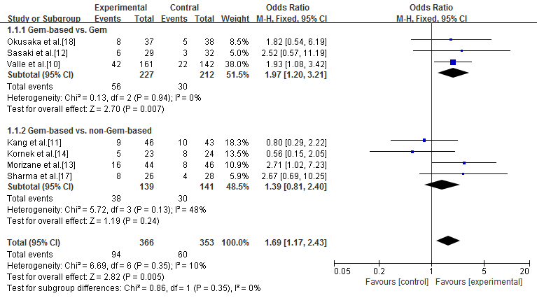

Figure 2B
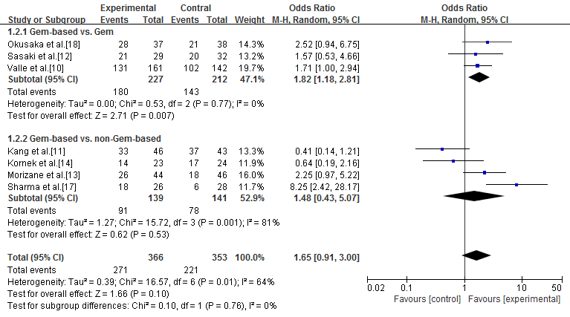

Figure 2C
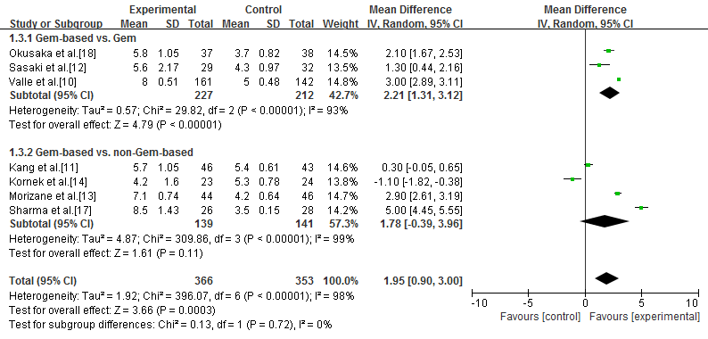

Figure 2D
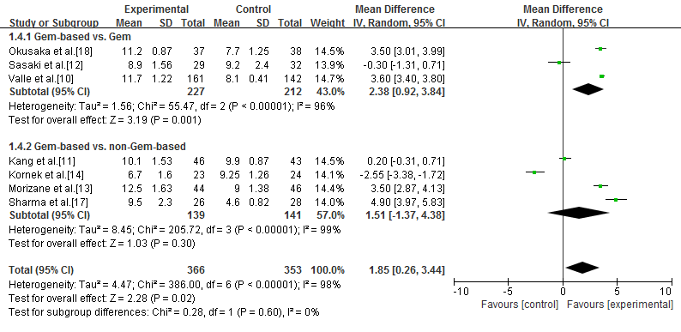

Figure 3A
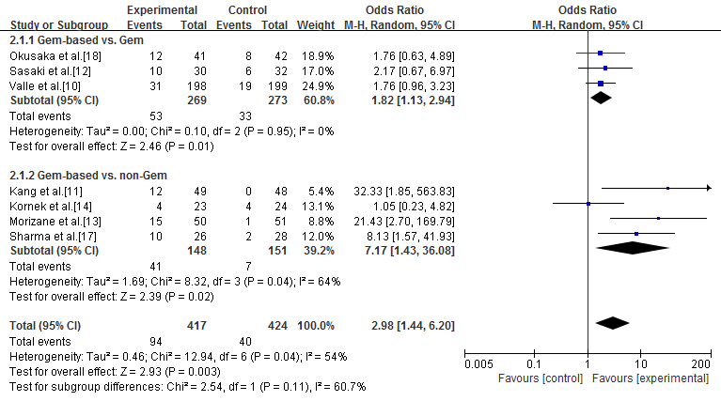

Figure 3B
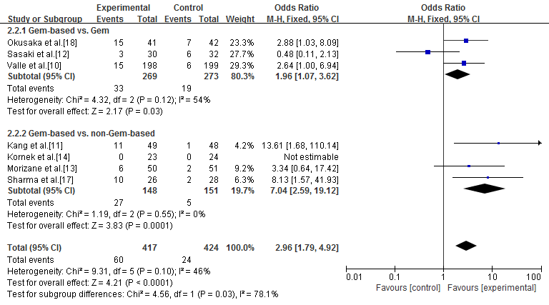

Figure 3C
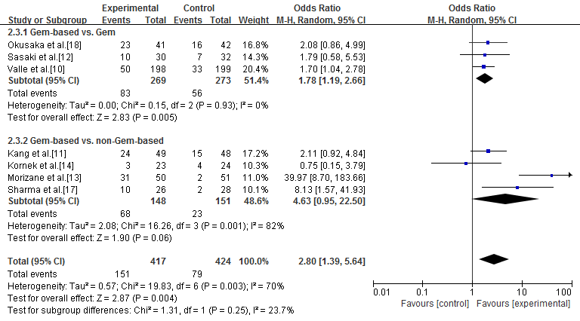

Figure 3D
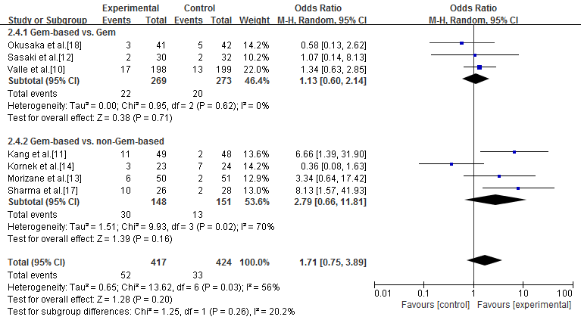

Figure 3E
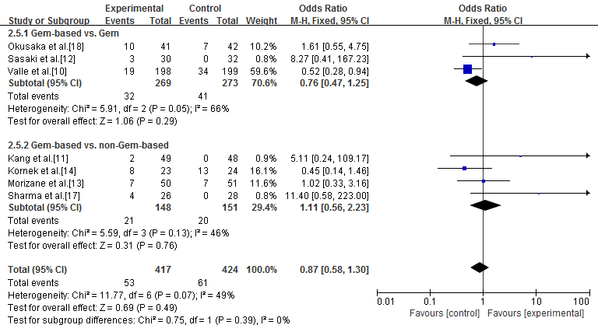

Figure 4
