Name of Journal: World Journal of Gastrointestinal Oncology
Manuscript NO: 58748
Manuscript Type: META-ANALYSIS

Prognostic impact of at least 12 lymph nodes after neoadjuvant therapy in rectal cancer: A meta-analysis

Tan L et al. Rectal cancer prognosis upon dissecting 12 lymph nodes

Ling Tan, Zi-Lin Liu, Zhou Ma, Zhou He, Lin-Han Tang, Yi-Lei Liu, Jiang-Wei Xiao

Ling Tan, Zi-Lin Liu, Zhou Ma, Zhou He, Lin-Han Tang, Yi-Lei Liu, Jiang-Wei Xiao, Department of Gastrointestinal Surgery, Clinical Medical College and The First Affiliated Hospital of Chengdu Medical College, Chengdu 610500, Sichuan Province, China

Author contributions: Tan L and Liu ZL performed data acquisition, analysis, and interpretation, and drafted the manuscript; Ma Z, He Z, Tang LH, and Liu YL contributed to data interpretation and revised the manuscript; Xiao JW contributed to study conception and design, and critical revision of the manuscript; all authors approved the final version of the submitted manuscript.

Supported by the National Natural Science Foundation of China, No. 81070378 and 81270561; and Special Research Fund for The First Affiliated Hospital of Chengdu Medical College, No. CYFY2019YB08.

Corresponding author: Jiang-Wei Xiao, MD, PhD, Postdoc, Professor, Surgeon, Surgical Oncologist, Teacher, Department of Gastrointestinal Surgery, Clinical Medical College and The First Affiliated Hospital of Chengdu Medical College, No. 278 Zhongduan Baoguang Avenue, Xindu District, Chengdu 610500, Sichuan Province, China. xiaojiangwei2018@163.com

Received: August 5, 2020
Revised: September 28, 2020
Accepted: October 20, 2020
Published online: December 15, 2020

Abstract
BACKGROUND
The number of dissected lymph nodes (LNs) in rectal cancer after neoadjuvant therapy has a controversial effect on the prognosis.

AIM
To investigate the prognostic impact of the number of LN dissected in rectal cancer patients after neoadjuvant therapy.

METHODS
We performed a systematic review and searched PubMed, Embase (Ovid), Medline (Ovid), Web of Science, and Cochrane Library from January 1, 2000 until January 1, 2020. Two reviewers examined all the publications independently and extracted the relevant data. Articles were eligible for inclusion if they compared the number of LNs in rectal cancer specimens resected after neoadjuvant treatment (LNs ≥ 12 vs LNs < 12). The primary endpoints were the overall survival (OS) and disease-free survival (DFS).

RESULTS
Nine articles were included in the meta-analyses. Statistical analysis revealed a statistically significant difference in OS [hazard ratio (HR) = 0.76, 95% confidence interval (CI): 0.66-0.88, I² = 12.2%, P = 0.336], DFS (HR = 0.76, 95%CI: 0.63-0.92, I² = 68.4%, P = 0.013), and distant recurrence (DR) (HR = 0.63, 95%CI: 0.48-0.93, I² = 30.5%, P = 0.237) between the LNs ≥ 12 and LNs < 12 groups, but local recurrence (HR = 0.67, 95%CI: 0.38-1.16, I² = 0%, P = 0.348) showed no statistical difference. Moreover, subgroup analysis of LN negative patients revealed a statistically significant difference in DFS (HR = 0.67, 95%CI: 0.52-0.88, I² = 0%, P = 0.565) between the LNs ≥ 12 and LNs < 12 groups.

CONCLUSION
Although neoadjuvant therapy reduces LN production in rectal cancer, our data indicate that dissecting at least 12 LNs after neoadjuvant therapy may improve the patients’ OS, DFS, and DR.

Key Words: Rectal cancer; Neoadjuvant therapy; Lymph node; Prognostic; Overall survival; Meta-analysis

Citation: Tan L, Liu ZL, Ma Z, He Z, Tang LH, Liu YL, Xiao JW. Prognostic impact of at least 12 lymph nodes after neoadjuvant therapy in rectal cancer: A meta-analysis. World J Gastrointest Oncol 2020; 12(12): 1443-1455
URL: https://www.wjgnet.com/1948-5204/full/v12/i12/1443.htm
DOI: https://dx.doi.org/10.4251/wjgo.v12.i12.1443

Core Tip: After neoadjuvant treatment of rectal cancer, the lymph node (LN) output is significantly reduced. There is no consensus on the relationship between the number of LNs resected and the prognosis of rectal cancer after neoadjuvant treatment. This is the first meta-analysis to compare the impact of the number of LNs on the prognosis of rectal cancer after neoadjuvant treatment. We studied the effects of resection of at least 12 LNs and less than 12 LNs after neoadjuvant treatment of rectal cancer on overall survival, disease-free survival, distant recurrence, and local recurrence.

INTRODUCTION
Colorectal cancer is ranked third and second among global cancer morbidity and mortality, respectively. The incidence rate of colorectal cancer is third in men and fourth in women^{[1]}. In 2018, 43030 new cases of rectal cancer were diagnosed in the United States^{[2]}.
According to both the International Union Against Cancer (UICC) and American Joint Commission on Cancer (AJCC), a minimum of 12 lymph nodes (LNs) should be obtained from surgical specimens to stage a colorectal cancer^{[3,4]}. Today, the standard of care for patients with locally advanced rectal cancer is neoadjuvant chemoradiation therapy (CRT), followed by total mesorectal excision (TME)^{[5,6]}. However, many studies have reported a significant decrease in the number of LNs retrieved from patients with rectal cancer who have received preoperative chemoradiation^{[7-12]}. For example, a meta-analysis reported an average reduction of 3.9 LNs in neoadjuvant CRT compared with no neoadjuvant CRT^{[12]}. Therefore, it remains controversial whether 12 or more resected LNs should be recommended by the UICC or AJCC after many neoadjuvant treatments for rectal cancer.
In the past 20 years, neoadjuvant therapy has been widely applied in rectal cancer. An increasing number of scholars have focused on the influence of the number of resected LNs after neoadjuvant therapy on the prognosis of rectal cancer. Presently, resecting more than 12 LNs or fewer than 12 LNs after neoadjuvant treatment for rectal cancer is controversial for prognosis.
Given the prognostic impact of the number of LNs, we performed a first series of meta-analyses to compare the prognostic impact of surgical resection of greater than 12 vs fewer than 12 LNs in patients with rectal cancer after neoadjuvant treatment.

MATERIALS AND METHODS
Search strategy and inclusion criteria
For this systematic review, we adhered to the Meta-analysis of Observational Studies guidelines^{[13]} and the Preferred Reporting Items for Systematic Reviews and Meta-Analysis statement^{[14]}. A systematic search was performed based on the following databases: PubMed, Embase (Ovid), Medline (Ovid), Web of Science, and Cochrane Library from January 1, 2000 to January 1, 2020. We used “rectal cancer”, “neoadjuvant therapy”, “preoperative radiotherapy”, “preoperative chemotherapy”, “lymph nodes” and corresponding free words to search the literature in the above databases. Regardless of the type of study, the articles were eligible for inclusion if they compared the number of LNs in rectal cancer specimens resected after neoadjuvant treatment (LNs ≥ 12 vs LNs < 12).
First, all the identified titles and abstracts were examined by two independent reviewers (Tan L and Liu ZL). Next, the same two reviewers independently examined the full text of potentially relevant articles. In the event of disagreement, a third reviewer (Ma Z) was consulted and the relevant articles were discussed until a consensus was reached.

Data extraction and quality assessment
The following relevant information was extracted from all the included publications: First author, year of publication, country, number of patients, age, tumor grade, neoadjuvant therapy, surgery, years of follow-up, and outcome type. The main outcomes were the overall survival (OS) and disease-free survival (DFS) differences between the LNs ≥ 12 and LNs < 12 groups in patients after neoadjuvant therapy. The secondary outcomes were the distant recurrence (DR) and local recurrence (LR) differences between the LNs ≥ 12 and LNs < 12 groups in patients after neoadjuvant therapy. Therefore, if available, the following data were extracted: Hazard ratios (HRs), 95% confidence intervals (CIs), and P values of OS, DFS, DR, and LR. When the literature did not report HRs, only OS and DFS Kaplan-Meier curves and Engauge Digitizer (version 10.8) were used to determine the survival rate at the corresponding time points on the curve, followed by the HR calculation table^{[15]}. We took the countdown if the HR reported in the literature was LNs < 12 vs LNs ≥ 12. All the data were independently extracted by two authors (Tan L and Liu ZL) and compared for consistency.
The quality of the included studies was assessed using the Newcastle-Ottawa Scale (NOS), with a maximum of nine points per study. Publication bias was assessed by visual inspection of the symmetry of the funnel plot. Since we considered that DFS heterogeneity was derived from patients with positive LNs, we performed subgroup analysis of the DFS of LN negative patients based on LNs ≥ 12 vs LNs < 12.

Statistical analysis
We used the Stata (version 15.3) Meta package for meta-analysis^{[16]}. Binary outcome data are reported as HRs with 95%CIs using the Mantel–Haenszel method. Weighted mean differences were calculated for the effect size of continuous variables. Heterogeneity was assessed using I² statistics, with values above 50% considered considerable heterogeneity. An a priori decision to use the random-effects model was made to account for the assumed considerable heterogeneity between the studies.

RESULTS
After removing duplicates, our computer-aided search yielded 11871 publications from PubMed, Medline (Ovid), Embase (Ovid), Web of Science, and Cochrane Library (Figure 1). In total, nine publications and 4494 patients with rectal cancer were eligible for inclusion. Table 1 indicates the characteristics of the included studies. Seven^{[17-23]} of the nine studies (3840 patients) reported the main endpoint of OS; five^{[17,19-21,24]} of the nine studies (1811 patients) reported the endpoint of DFS; three^{[17,23,25]} of nine studies (953 patients) reported the endpoint of DR; two^{[17,25]} of the nine studies (716 patients) reported the endpoint of LR. The NOS scores of the nine studies ranged from eight to nine (Figure 2). The literature collected was considered to be qualified.

Primary endpoints
OS for LNs ≥ 12 vs LNs < 12: Seven of the nine included studies reported OS data based on at least 12 LNs vs fewer than 12 LNs; the HRs and 95%CIs of these studies and the summary HRs are shown in Figure 3A. The total summary estimated HR was 0.76 (95%CI: 0.66-0.88, P = 0.336). Heterogeneity tests showed that the trials did not have heterogeneity (I² = 12.2%, P = 0.336).

DFS for LNs ≥ 12 vs LNs < 12: Among the nine studies collected, five reported DFS data based on at least 12 LNs and fewer than 12 LNs; the 95%CIs and HRs for each study and the summary HRs are shown in Figure 3B. The total summary estimated HR was 0.76 (95%CI: 0.63-0.92, P = 0.013). Heterogeneity tests showed that the trials had significant heterogeneity (I² = 68.4%, P = 0.013).

Secondary endpoints
DR for LNs ≥ 12 vs LNs < 12: Three of the nine included studies reported DR data based on LN ≥ 12 vs LN < 12; the 95%CIs and HRs for each study and the summary HRs are shown in Figure 3C. The total summary estimated HR was 0.67 (95%CI: 0.48-0.93, P = 0.237). Heterogeneity tests showed that the trials had no significant heterogeneity (I² = 30.5%, P = 0.237).

LR for LNs ≥ 12 vs LNs < 12: Two of the nine included studies reported LR data based on LN ≥ 12 vs LN < 12. The total summary estimated HR was 0.67 (95%CI: 0.38-1.16, P = 0.348), with no statistical significance.

Sensitivity analysis
Sensitivity analysis showed that any deletion of a set of data had no effect on the results (Figure 4). We considered heterogeneity in patients with LN positivity. So, we conducted subgroup analysis of LN negative patients; the HRs and 95%CIs for each study and the summary HRs are shown in Figure 5. The total summary estimated HR was 0.67 (95%CI: 0.52-0.88), and no heterogeneity was found.

Publication bias
Publication bias was assessed by visual examination of the symmetry of the funnel plot. Our funnel plot showed no publication bias (Figure 6).

DISCUSSION
The AJCC and College of American Pathologists recommend examination of a minimum of 12 LNs to stage rectal cancer accurately. Sampling of 12 LNs may not be achievable in patients who have received neoadjuvant chemoradiation therapy^{[4,26]}. Therefore, it remains controversial whether 12 LNs can be used as an accurate staging index for rectal cancer patients who have received preoperative neoadjuvant chemoradiation therapy. The mean number of LNs retrieved from rectal cancers treated with neoadjuvant therapy is significantly lower than that from rectal cancers treated by surgery alone^{[8,9]}. The number of LNs needed to stage neoadjuvant-treated cases accurately is unknown. In patients receiving neoadjuvant radiotherapy and chemotherapy, the number of LN dissections needs to reach 12. Is this requirement suitable as a risk factor to evaluate the prognosis of patients with rectal tumors? Is it possible that the number of evaluated LN dissections is fewer than 12 because neoadjuvant radiotherapy and chemotherapy will lead to a decrease in the number of LN dissections? To confirm whether the number of LN dissections to judge the prognosis of rectal cancer patients who received neoadjuvant radiotherapy and chemotherapy is still applicable to 12, we performed this meta-analysis study.
The main finding of the present study is that, among patients with rectal cancer, dissecting at least 12 LNs after neoadjuvant treatment improved OS and DR compared with dissecting fewer than 12 LNs. In this study, we confirmed that at least 12 LNs should be dissected in rectal cancer patients after neoadjuvant radiotherapy and chemotherapy to evaluate the prognosis of patients well, and the number of LNs dissectedwas closely related to the improvement in the survival rate of rectal cancer patients. Additionally, for subgroup analysis, the DFS of LN negative patients with greater than 12 LNs resected was better than that of patients with fewer than 12 LNs dissected. These data suggest that surgical resection of at least 12 LNs after neoadjuvant treatment of rectal cancer improves prognosis.
Most scholars agree that the LN yield affects the prognosis of rectal cancer. Presently, they have studied the effect of resection of 12 LNs on the prognosis. At the same time, many scholars have studied the effect of different numbers of LNs resected on the prognosis of patients with neoadjuvant therapy for rectal cancer. We summarize the literature on the effect of different LN numbers on the prognosis in the last 10 years (Table 2). Yeo et al^{[27]} showed that at least 8.5 LNs removed from rectal cancer surgery after neoadjuvant therapy could significantly improve the 5-year OS. La Torre et al^{[19]}, Tsai et al^{[28]}, and Han et al^{[21]} found that at least 6, 7, and 8 LNs resected after neoadjuvant treatment could improve the prognosis. Pitto et al^{[29]} found that at least 10 to 20 LNs resected after neoadjuvant radiotherapy improved the 5-year OS compared with fewer than 9 and more than 20. The above studies indicated that the small number of LNs dissected after neoadjuvant therapy is not a sign of a good tumor response to neoadjuvant therapy, and a relatively large number of LNs is still needed to be dissected to ensure a good prognosis.
The prognostic impact of resecting more than 12 LNs and fewer than 12 LNs after neoadjuvant treatment for rectal cancer is controversial. For example, Dev et al^{[30]} found that resecting fewer than 12 LNs in rectal cancer patients undergoing neoadjuvant radiotherapy should be considered a better prognostic factor, but Wang et al^{[31]} and Lykke et al^{[18]} believed that resecting at least 12 LNs is an independent and favorable prognostic factor for rectal cancer after neoadjuvant therapy. Moreover, Khan et al^{[32]} and La Torre et al^{[19]} believed that at least 12 LNs dissected after neoadjuvant treatment of rectal cancer do not affect the prognosis. Our meta-analysis combining the available data showed that resection of at least 12 LNs after neoadjuvant therapy improves the prognosis.
The LN harvest is influenced by several factors, including the patient’s anatomic and pathologic workup, surgical dissection technique, and use of methylene blue and neoadjuvant treatment^{[12,33-36]}. Pathological techniques are considered a factor that affects the LN yield due to improper specimen analysis and processing. Factors associated with patients, such as advanced age and obesity, are associated with lower LN yields^{[9,34,37,38]}. Standard TME should be performed to help achieve optimal tumor resection. The injection of methylene blue solution into the inferior mesenteric artery is an effective and simple way to increase the LN harvest in the histopathological examination of the TME of rectal specimens^{[39]}, especially those receiving neoadjuvant therapy^{[40-42]}. Presently, the use of neoadjuvant radiotherapy and chemotherapy is the standard treatment for rectal cancer in many European countries, leading to fewer LN tests^{[43]}. If 12 LNs are considered the number needed for the accurate staging of stage II tumors, only 20% of cases treated with neoadjuvant therapy had adequate LN sampling^{[9]}. To date, the number of dissected LNs needed to stage neoadjuvant-treated cases accurately is unknown. Additionally, the clinical significance of this information is unknown in the neoadjuvant setting because postoperative therapy is indicated in all patients who receive preoperative therapy regardless of the surgical pathology results. Therefore, technical measures are needed to improve the postoperative LN detection rate in patients with rectal cancer after neoadjuvant radiotherapy and chemotherapy. For example, standard TME in combination with the injection of methylene blue into the inferior mesenteric artery can be used to increase LN yield after neoadjuvant therapy. At the same time, the application of nano-carbon lymphatic tracer technology can also effectively improve the detection rate of postoperative LNs in patients with rectal cancer.
In recent decades, the therapeutic effect of rectal cancer has made great progress with the development of laparoscopic technology and medical devices. Murphy et al^{[44]} found that the 5-year relative survival of rectal cancer improved significantly from 1992-1996 to 2010-2014. The emergence of neoadjuvant therapy, especially neoadjuvant radiotherapy and chemotherapy, significantly reduced the local recurrence rate and tumor staging of patients^{[45,46]}. Neoadjuvant radiotherapy and chemotherapy have been regarded as the standard treatments for locally advanced rectal cancer, and the side effects of neoadjuvant radiotherapy and chemotherapy cannot be ignored, such as chronic sexual dysfunction^{[47]} and diarrhea^{[48,49]}. Some patients with high-risk diseases may need more intensive treatment, while others may have severe side effects due to the use of current protocols^{[50]}. The criteria for the inclusion of patients with rectal cancer to undergo neoadjuvant radiotherapy and chemotherapy need to be further optimized, and multidisciplinary team discussion is warranted to determine whether a patient should receive neoadjuvant therapy for rectal cancer.
This meta-analysis was mostly limited by its inclusion of cohort study data only; no randomized controlled study was included. Cohort studies are prone to introduce bias, and two of these studies did have OS results. The HR data in four studies could not be extracted directly and were calculated from Kaplan-Meier curves, a calculation process that may cause errors. Additionally, this study only analyzed the prognosis of patients in the LNs ≥ 12 and LNs < 12 groups after neoadjuvant therapy. Insufficient data existed to analyze the effect of other LN numbers on the prognosis. Differences in surgical treatment reported in the literature, as well as different surgical procedures, may influence the LN yield, which may lead to bias.

CONCLUSION
Although neoadjuvant therapy reduces the production of LNs in rectal cancer, our data indicate that dissecting at least 12 LNs after neoadjuvant therapy may improve the patients’ OS, DFS, and DR.

ARTICLE HIGHLIGHTS
Research background
Neoadjuvant therapy significantly reduces the number of yielded lymph nodes (LNs) for rectal cancer, and the number of dissected LNs in rectal cancer after neoadjuvant therapy has a controversial effect on the prognosis.

Research motivation
Studies have shown that the number of LNs after rectal cancer is significantly reduced after neoadjuvant therapy. Some scholars have found that less than 12 LNs in rectal cancer patients receiving neoadjuvant radiotherapy should be considered as a better prognostic factor. However, others believe that dissecting at least 12 LNs is an independent and favorable prognostic factors for rectal cancer after neoadjuvant therapy. Therefore, it is necessary to conduct a meta-analysis to systematically and comprehensively study the influence of the number of LNs retrieved after neoadjuvant treatment on the survival outcome of patients with rectal cancer.

Research objectives
To evaluate the effect of LN production in rectal cancer after neoadjuvant treatment on survival through meta-analysis.

Research methods
The meta-analysis methods were adopted to realize the objectives.

Research results
Nine articles were included in the meta-analyses. Statistical analysis revealed a statistically significant difference in overall survival (OS) [hazard ratio (HR) = 0.76, 95% confidence interval (CI) = 0.66-0.88, I² = 12.2%, P = 0.336], disease-free survival (DFS) (HR = 0.76, 95%CI: 0.63-0.92, I² = 68.4%, P = 0.013), and distant recurrence (DR) (HR = 0.63, 95%CI: 0.48-0.93, I² = 30.5%, P = 0.237) between the LNs ≥ 12 and LNs < 12 groups, but local recurrence (HR = 0.67, 95%CI: 0.38-1.16, I² = 0%, P = 0.348) showed no statistical difference. Moreover, subgroup analysis of LN negative patients revealed a statistically significant difference in DFS (HR = 0.67, 0.95%CI: 0.52-0.88, I² = 0%, P = 0.565) between the LNs ≥ 12 and LNs < 12 groups.

Research conclusions
This meta-analysis confirmed that dissecting at least 12 LNs after neoadjuvant therapy may improve the patients’ OS, DFS, and DR.

Research perspectives
Some limitations in this analysis should be handled carefully. The most important limitation is that the included studies are all retrospective. Because some potential deviations are difficult to adjust, further careful design and large-scale randomized controlled trial experiments are needed to determine the effect of the number of anatomical LNs on the prognosis of rectal cancer after neoadjuvant treatment. In addition, because neoadjuvant therapy reduces LN yield, further research is needed on the impact of different LN numbers on prognosis, such as 6 LNs, 7 LNs, and 8 LNs.

REFERENCES
1 Bray F, Ferlay J, Soerjomataram I, Siegel RL, Torre LA, Jemal A. Global cancer statistics 2018: GLOBOCAN estimates of incidence and mortality worldwide for 36 cancers in 185 countries. CA Cancer J Clin 2018; 68: 394-424 [PMID: 30207593 DOI: 10.3322/caac.21492]
2 Siegel RL, Miller KD, Jemal A. Cancer statistics, 2018. CA Cancer J Clin 2018; 68: 7-30 [PMID: 29313949 DOI: 10.3322/caac.21442]
3 Greene FL. The American Joint Committee on Cancer: updating the strategies in cancer staging. Bull Am Coll Surg 2002; 87: 13-15 [PMID: 17387902]
4 Sobin LH. TNM classification: clarification of number of regional lymph nodes for pN0. Br J Cancer 2001; 85: 780 [PMID: 11531267 DOI: 10.1054/bjoc.2001.1996]
5 Gollins S, Moran B, Adams R, Cunningham C, Bach S, Myint AS, Renehan A, Karandikar S, Goh V, Prezzi D, Langman G, Ahmedzai S, Geh I. Association of Coloproctology of Great Britain & Ireland (ACPGBI): Guidelines for the Management of Cancer of the Colon, Rectum and Anus (2017) - Multidisciplinary Management. Colorectal Dis 2017; 19 Suppl 1: 37-66 [PMID: 28632307 DOI: 10.1111/codi.13705]
6 Glynne-Jones R, Wyrwicz L, Tiret E, Brown G, Rödel C, Cervantes A, Arnold D; ESMO Guidelines Committee. Rectal cancer: ESMO Clinical Practice Guidelines for diagnosis, treatment and follow-up. Ann Oncol 2018; 29: iv263 [PMID: 29741565 DOI: 10.1093/annonc/mdy161]
7 Sermier A, Gervaz P, Egger JF, Dao M, Allal AS, Bonet M, Morel P. Lymph node retrieval in abdominoperineal surgical specimen is radiation time-dependent. World J Surg Oncol 2006; 4: 29 [PMID: 16749931 DOI: 10.1186/1477-7819-4-29]
8 Wichmann MW, Müller C, Meyer G, Strauss T, Hornung HM, Lau-Werner U, Angele MK, Schildberg FW. Effect of preoperative radiochemotherapy on lymph node retrieval after resection of rectal cancer. Arch Surg 2002; 137: 206-210 [PMID: 11822961 DOI: 10.1001/archsurg.137.2.206]
9 Baxter NN, Morris AM, Rothenberger DA, Tepper JE. Impact of preoperative radiation for rectal cancer on subsequent lymph node evaluation: a population-based analysis. Int J Radiat Oncol Biol Phys 2005; 61: 426-431 [PMID: 15667963 DOI: 10.1016/j.ijrobp.2004.06.259]
10 Nagtegaal ID, van de Velde CJ, van der Worp E, Kapiteijn E, Quirke P, van Krieken JH; Cooperative Clinical Investigators of the Dutch Colorectal Cancer Group. Macroscopic evaluation of rectal cancer resection specimen: clinical significance of the pathologist in quality control. J Clin Oncol 2002; 20: 1729-1734 [PMID: 11919228 DOI: 10.1200/jco.2002.07.010]
11 Rullier A, Laurent C, Capdepont M, Vendrely V, Belleannée G, Bioulac-Sage P, Rullier E. Lymph nodes after preoperative chemoradiotherapy for rectal carcinoma: number, status, and impact on survival. Am J Surg Pathol 2008; 32: 45-50 [PMID: 18162769 DOI: 10.1097/PAS.0b013e3180dc92ab]
12 Mechera R, Schuster T, Rosenberg R, Speich B. Lymph node yield after rectal resection in patients treated with neoadjuvant radiation for rectal cancer: A systematic review and meta-analysis. Eur J Cancer 2017; 72: 84-94 [PMID: 28027520 DOI: 10.1016/j.ejca.2016.10.031]
13 Stroup DF, Berlin JA, Morton SC, Olkin I, Williamson GD, Rennie D, Moher D, Becker BJ, Sipe TA, Thacker SB. Meta-analysis of observational studies in epidemiology: a proposal for reporting. Meta-analysis Of Observational Studies in Epidemiology (MOOSE) group. JAMA 2000; 283: 2008-2012 [PMID: 10789670 DOI: 10.1001/jama.283.15.2008]
14 Moher D, Liberati A, Tetzlaff J, Altman DG; PRISMA Group. Preferred reporting items for systematic reviews and meta-analyses: the PRISMA statement. BMJ 2009; 339: b2535 [PMID: 19622551 DOI: 10.1136/bmj.b2535]
15 Tierney JF, Stewart LA, Ghersi D, Burdett S, Sydes MR. Practical methods for incorporating summary time-to-event data into meta-analysis. Trials 2007; 8: 16 [PMID: 17555582 DOI: 10.1186/1745-6215-8-16]
16 Nyaga VN, Arbyn M, Aerts M. Metaprop: a Stata command to perform meta-analysis of binomial data. Arch Public Health 2014; 72: 39 [PMID: 25810908 DOI: 10.1186/2049-3258-72-39]
17 Wang Y, Zhou M, Yang J, Sun X, Zou W, Zhang Z, Zhang J, Shen L, Yang L, Zhang Z. Increased lymph node yield indicates improved survival in locally advanced rectal cancer treated with neoadjuvant chemoradiotherapy. Cancer Med 2019; 8: 4615-4625 [PMID: 31250569 DOI: 10.1002/cam4.2372]
18 Lykke J, Jess P, Roikjaer O; Danish Colorectal Cancer Group. Increased Lymph Node Yield Is Associated With Improved Survival in Rectal Cancer Irrespective of Neoadjuvant Treatment: Results From a National Cohort Study. Dis Colon Rectum 2015; 58: 823-830 [PMID: 26252843 DOI: 10.1097/DCR.0000000000000429]
19 La Torre M, Mazzuca F, Ferri M, Mari FS, Botticelli A, Pilozzi E, Lorenzon L, Osti MF, Marchetti P, Enrici RM, Ziparo V. The importance of lymph node retrieval and lymph node ratio following preoperative chemoradiation of rectal cancer. Colorectal Dis 2013; 15: e382-e388 [PMID: 23581854 DOI: 10.1111/codi.12242]
20 Kim WR, Han YD, Cho MS, Hur H, Min BS, Lee KY, Kim NK. Oncologic Impact of Fewer Than 12 Lymph Nodes in Patients Who Underwent Neoadjuvant Chemoradiation Followed by Total Mesorectal Excision for Locally Advanced Rectal Cancer. Medicine (Baltimore) 2015; 94: e1133 [PMID: 26181550 DOI: 10.1097/MD.0000000000001133]
21 Han J, Noh GT, Yeo SA, Cheong C, Cho MS, Hur H, Min BS, Lee KY, Kim NK. The number of retrieved lymph nodes needed for accurate staging differs based on the presence of preoperative chemoradiation for rectal cancer. Medicine (Baltimore) 2016; 95: e4891 [PMID: 27661032 DOI: 10.1097/MD.0000000000004891]
22 Doll D, Gertler R, Maak M, Friederichs J, Becker K, Geinitz H, Kriner M, Nekarda H, Siewert JR, Rosenberg R. Reduced lymph node yield in rectal carcinoma specimen after neoadjuvant radiochemotherapy has no prognostic relevance. World J Surg 2009; 33: 340-347 [PMID: 19034566 DOI: 10.1007/s00268-008-9838-8]
23 de Campos-Lobato LF, Stocchi L, de Sousa JB, Buta M, Lavery IC, Fazio VW, Dietz DW, Kalady MF. Less than 12 nodes in the surgical specimen after total mesorectal excision following neoadjuvant chemoradiation: it means more than you think! Ann Surg Oncol 2013; 20: 3398-3406 [PMID: 23812804 DOI: 10.1245/s10434-013-3010-x]
24 Kim HJ, Jo JS, Lee SY, Kim CH, Kim YJ, Kim HR. Low Lymph Node Retrieval After Preoperative Chemoradiation for Rectal Cancer is Associated with Improved Prognosis in Patients with a Good Tumor Response. Ann Surg Oncol 2015; 22: 2075-2081 [PMID: 25395150 DOI: 10.1245/s10434-014-4235-z]
25 Klos CL, Shellito PC, Rattner DW, Hodin RA, Cusack JC, Bordeianou L, Sylla P, Hong TS, Blaszkowsky L, Ryan DP, Lauwers GY, Chang Y, Berger DL. The effect of neoadjuvant chemoradiation therapy on the prognostic value of lymph nodes after rectal cancer surgery. Am J Surg 2010; 200: 440-445 [PMID: 20887837 DOI: 10.1016/j.amjsurg.2010.03.013]
26 Bostwick DG, Grignon DJ, Hammond ME, Amin MB, Cohen M, Crawford D, Gospadarowicz M, Kaplan RS, Miller DS, Montironi R, Pajak TF, Pollack A, Srigley JR, Yarbro JW. Prognostic factors in prostate cancer. College of American Pathologists Consensus Statement 1999. Arch Pathol Lab Med 2000; 124: 995-1000 [PMID: 10888774]
27 Yeo CS, Syn N, Liu H, Fong SS. A lower cut-off for lymph node harvest predicts for poorer overall survival after rectal surgery post neoadjuvant chemoradiotherapy. World J Surg Oncol 2020; 18: 58 [PMID: 32197615 DOI: 10.1186/s12957-020-01833-8]
28 Tsai CJ, Crane CH, Skibber JM, Rodriguez-Bigas MA, Chang GJ, Feig BW, Eng C, Krishnan S, Maru DM, Das P. Number of lymph nodes examined and prognosis among pathologically lymph node-negative patients after preoperative chemoradiation therapy for rectal adenocarcinoma. Cancer 2011; 117: 3713-3722 [PMID: 21328329 DOI: 10.1002/cncr.25973]
29 Pitto F, Zoppoli G, Scabini S, Romairone E, Fiocca R, Ballestrero A, Sparavigna M, Malaspina L, Valle L, Grillo F, Mastracci L. Lymph node number, surface area and lymph node ratio are important prognostic indicators in neoadjuvant chemoradiotherapy treated rectal cancer. J Clin Pathol 2020; 73: 162-166 [PMID: 31554678 DOI: 10.1136/jclinpath-2019-206139]
30 Dev K, Shivran N, Gurawalia J, Pandey A, Kumar S, Kurpad V, Nayak S, Arjunan R. Less Than 12 Lymph Nodes in The Surgical Specimen after Neo-Adjuvant Chemo-Radiotherapy in Rectal Cancer: Five Years Survival Analysis. Eur J Surg Oncol 2020; 46: e78 [DOI: 10.1016/j.ejso.2019.11.179]
31 Wang Y, Zhou M, Yang L, Zhang J, Deng W, Shen L, Yao Y, Liang L, Zhang Z. Prognostic value of lymph node yield in locally advanced rectal cancer with neoadjuvant chemoradiotherapy. J Clin Oncol 2018; 36: e15680 [DOI: 10.1200/JCO.2018.36.15_suppl.e15680]
32 Khan M, Hakeem A, Scott N, Botterill I. Significance of the lymph node count after neo-adjuvant treatment for rectal cancer. Gut 2015; 64: A542 [DOI: 10.1136/gutjnl-2015-309861.1187]
33 Thorn CC, Woodcock NP, Scott N, Verbeke C, Scott SB, Ambrose NS. What factors affect lymph node yield in surgery for rectal cancer? Colorectal Dis 2004; 6: 356-361 [PMID: 15335370 DOI: 10.1111/j.1463-1318.2004.00670.x]
34 Miller ED, Robb BW, Cummings OW, Johnstone PA. The effects of preoperative chemoradiotherapy on lymph node sampling in rectal cancer. Dis Colon Rectum 2012; 55: 1002-1007 [PMID: 22874609 DOI: 10.1097/DCR.0b013e3182536d70]
35 Mekenkamp LJ, van Krieken JH, Marijnen CA, van de Velde CJ, Nagtegaal ID; Pathology Review Committee and the Co-operative Clinical Investigators. Lymph node retrieval in rectal cancer is dependent on many factors--the role of the tumor, the patient, the surgeon, the radiotherapist, and the pathologist. Am J Surg Pathol 2009; 33: 1547-1553 [PMID: 19661781 DOI: 10.1097/PAS.0b013e3181b2e01f]
36 Liu J, Huang P, Zheng Z, Chen T, Wei H. Modified methylene blue injection improves lymph node harvest in rectal cancer. ANZ J Surg 2017; 87: 247-251 [PMID: 25331064 DOI: 10.1111/ans.12889]
37 Shen SS, Haupt BX, Ro JY, Zhu J, Bailey HR, Schwartz MR. Number of lymph nodes examined and associated clinicopathologic factors in colorectal carcinoma. Arch Pathol Lab Med 2009; 133: 781-786 [PMID: 19415953]
38 Görög D, Nagy P, Péter A, Perner F. Influence of obesity on lymph node recovery from rectal resection specimens. Pathol Oncol Res 2003; 9: 180-183 [PMID: 14530812 DOI: 10.1007/bf03033734]
39 Klepšytė E, Samalavičius NE. Injection of methylene blue solution into the inferior mesenteric artery of resected rectal specimens for rectal cancer as a method for increasing the lymph node harvest. Tech Coloproctol 2012; 16: 207-211 [PMID: 22426928 DOI: 10.1007/s10151-012-0816-7]
40 Borowski DW, Banky B, Banerjee AK, Agarwal AK, Tabaqchali MA, Garg DK, Hobday C, Hegab M, Gill TS. Intra-arterial methylene blue injection into ex vivo colorectal cancer specimens improves lymph node staging accuracy: a randomized controlled trial. Colorectal Dis 2014; 16: 681-689 [PMID: 24911342 DOI: 10.1111/codi.12681]
41 Münster M, Hanisch U, Tuffaha M, Kube R, Ptok H. Ex Vivo Intra-arterial Methylene Blue Injection in Rectal Cancer Specimens Increases the Lymph-Node Harvest, Especially After Preoperative Radiation. World J Surg 2016; 40: 463-470 [PMID: 26310202 DOI: 10.1007/s00268-015-3230-2]
42 Reima H, Saar H, Innos K, Soplepmann J. Methylene blue ex vivo staining of resected colorectal cancer specimens to enhance lymph node retrieval: a randomised controlled trial. Conference: 8th Congress of the Baltic Association of Surgeons; 2015; Estonia. Eesti Arst 2015; 94: 77
43 Marijnen CA, Nagtegaal ID, Klein Kranenbarg E, Hermans J, van de Velde CJ, Leer JW, van Krieken JH; Pathology Review Committee and the Cooperative Clinical Investigators. No downstaging after short-term preoperative radiotherapy in rectal cancer patients. J Clin Oncol 2001; 19: 1976-1984 [PMID: 11283130 DOI: 10.1200/jco.2001.19.7.1976]
44 Murphy CC, Wallace K, Sandler RS, Baron JA. Racial Disparities in Incidence of Young-Onset Colorectal Cancer and Patient Survival. Gastroenterology 2019; 156: 958-965 [PMID: 30521807 DOI: 10.1053/j.gastro.2018.11.060]
45 Abraha I, Aristei C, Palumbo I, Lupattelli M, Trastulli S, Cirocchi R, De Florio R, Valentini V. Preoperative radiotherapy and curative surgery for the management of localised rectal carcinoma. Cochrane Database Syst Rev 2018; 10: CD002102 [PMID: 30284239 DOI: 10.1002/14651858.CD002102.pub3]
46 Pettersson D, Lörinc E, Holm T, Iversen H, Cedermark B, Glimelius B, Martling A. Tumour regression in the randomized Stockholm III Trial of radiotherapy regimens for rectal cancer. Br J Surg 2015; 102: 972-978 [PMID: 26095256 DOI: 10.1002/bjs.9811]
47 Hendren SK, O'Connor BI, Liu M, Asano T, Cohen Z, Swallow CJ, Macrae HM, Gryfe R, McLeod RS. Prevalence of male and female sexual dysfunction is high following surgery for rectal cancer. Ann Surg 2005; 242: 212-223 [PMID: 16041212 DOI: 10.1097/01.sla.0000171299.43954.ce]
48 Sauer R, Becker H, Hohenberger W, Rödel C, Wittekind C, Fietkau R, Martus P, Tschmelitsch J, Hager E, Hess CF, Karstens JH, Liersch T, Schmidberger H, Raab R; German Rectal Cancer Study Group. Preoperative versus postoperative chemoradiotherapy for rectal cancer. N Engl J Med 2004; 351: 1731-1740 [PMID: 15496622 DOI: 10.1056/NEJMoa040694]
49 Ansari N, Solomon MJ, Fisher RJ, Mackay J, Burmeister B, Ackland S, Heriot A, Joseph D, McLachlan SA, McClure B, Ngan SY. Acute Adverse Events and Postoperative Complications in a Randomized Trial of Preoperative Short-course Radiotherapy Versus Long-course Chemoradiotherapy for T3 Adenocarcinoma of the Rectum: Trans-Tasman Radiation Oncology Group Trial (TROG 01.04). Ann Surg 2017; 265: 882-888 [PMID: 27631775 DOI: 10.1097/SLA.0000000000001987]
50 Rana N, Chakravarthy AB, Kachnic LA. Neoadjuvant Treatment for Locally Advanced Rectal Cancer: New Concepts in Clinical Trial Design. Curr Treat Options Oncol 2017; 18: 13 [PMID: 28281215 DOI: 10.1007/s11864-017-0454-4]

Footnotes
Conflict-of-interest statement: All the authors declare that they have no conflict of interest to disclose.

PRISMA 2009 Checklist statement: The authors have read the PRISMA 2009 Checklist, and the manuscript was prepared and revised according to the PRISMA 2009 Checklist.

Open-Access: This article is an open-access article that was selected by an in-house editor and fully peer-reviewed by external reviewers. It is distributed in accordance with the Creative Commons Attribution NonCommercial (CC BY-NC 4.0) license, which permits others to distribute, remix, adapt, build upon this work non-commercially, and license their derivative works on different terms, provided the original work is properly cited and the use is non-commercial. See: http://creativecommons.org/Licenses/by-nc/4.0/

Manuscript source: Unsolicited manuscript

Peer-review started: August 5, 2020
First decision: September 24, 2020
Article in press: October 20, 2020

Specialty type: Oncology
Country/Territory of origin: China
Peer-review report’s scientific quality classification
Grade A (Excellent): 0
Grade B (Very good): B, B
Grade C (Good): C
Grade D (Fair): 0
Grade E (Poor): 0

P-Reviewer: Grundmann R, Uhlmann D S-Editor: Chen XF L-Editor: Wang TQ P-Editor: Li JH

Figure Legends
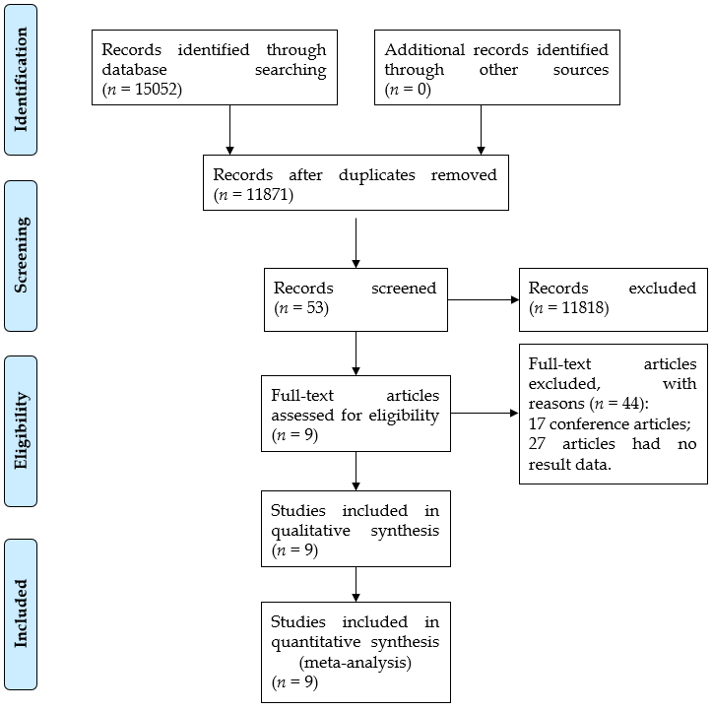
Figure 1 Flowchart of search strategy and study selection.

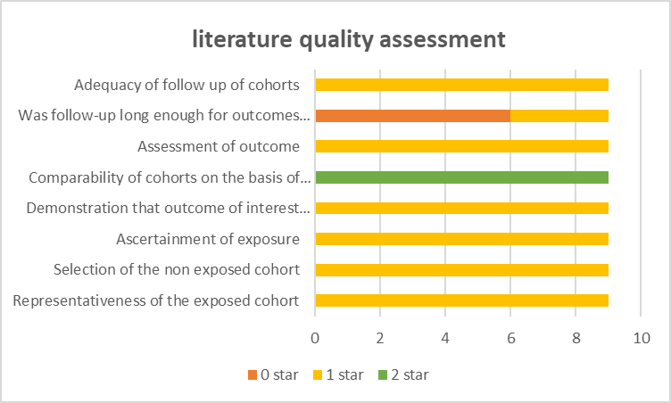
Figure 2 Literature quality assessment based on the Newcastle-Ottawa Scale.

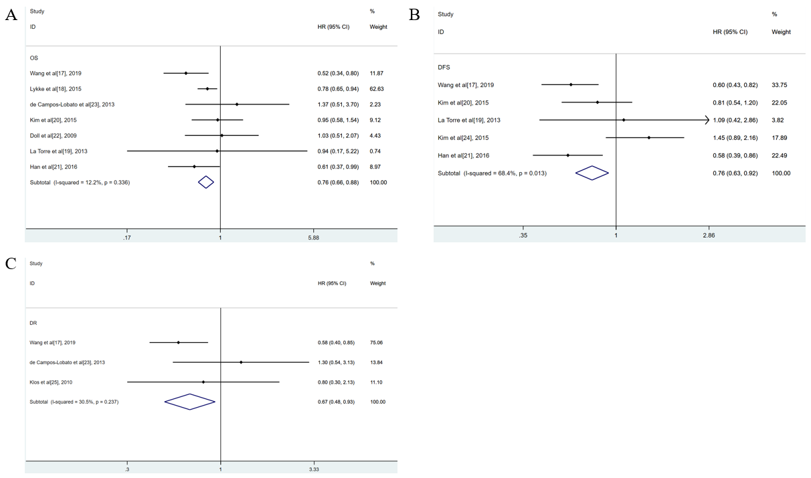
Figure 3 Forest plots for the meta-analyses. A: Overall survival; B: Disease-free survival; C: Distant recurrence. HR: Hazard ratio; CI: Confidence interval; OS: Overall survival; DFS: Disease-free survival; DR: Distant recurrence.

Figure 4 Sensitivity map for the meta-analysis of disease-free survival. CI: Confidence interval.

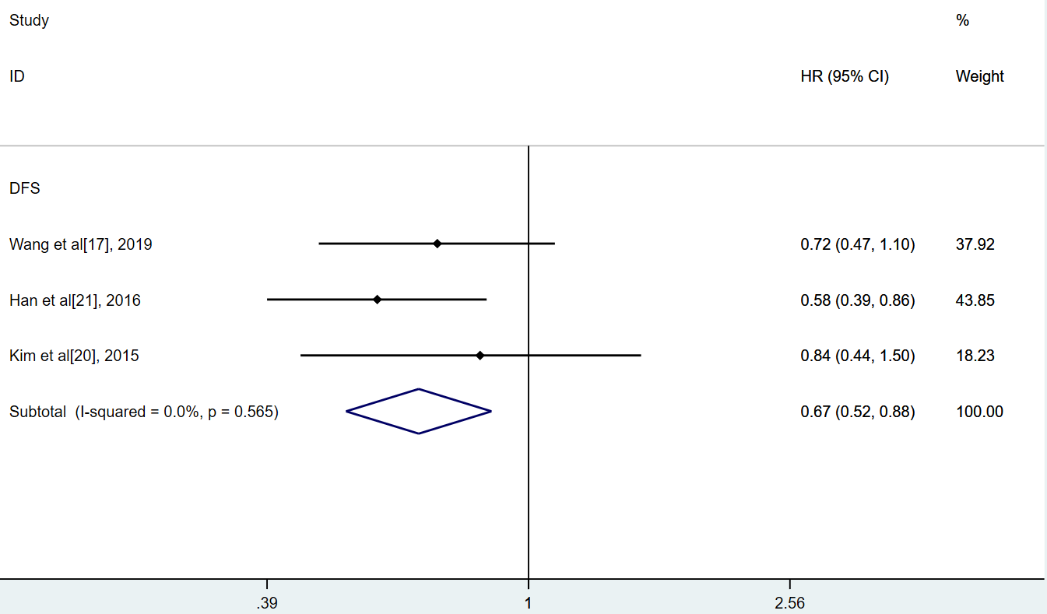
Figure 5 Forest plot for the meta-analysis of disease-free survival in the subgroup of lymph node negative patients. HR: Hazard ratio; CI: Confidence interval; DFS: Disease-free survival.

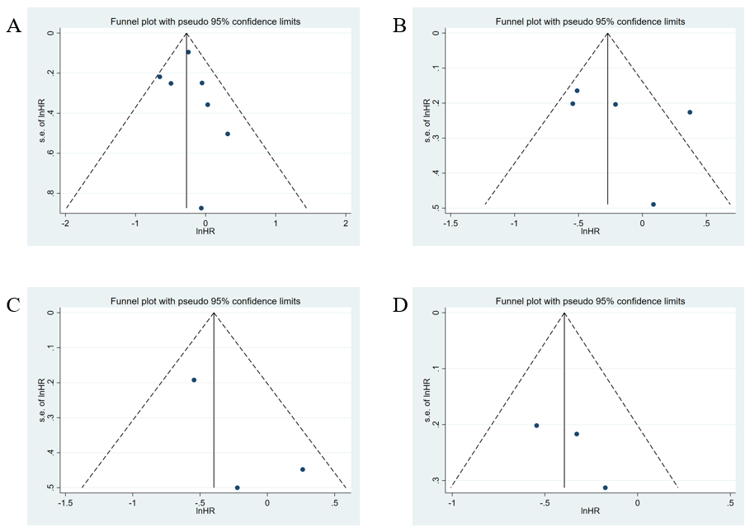
Figure 6 Funnel plot of publication bias in the meta-analysis. A: Overall survival; B: Disease-free survival; C: Distant recurrence; D: Disease-free survival in lymph node negative patients. HR: Hazard ratio.

Table 1 Characteristics of studies included in the meta-analysis
Ref. | Country | n | Age (yr) | Stage | Treatment | Surgery | Year of follow-up | Outcome
Wang et al^{[17]}, 2019 | China | 495 | < 50: 160; > 50: 335 | I-IV | Neoadjuvant treatment (RT 45-55 Gy + capecitabine) | AR, APR, Hartmann | No report | OS, DFS, LR, DR
Lykke et al^{[18]}, 2015 | Denmark | 2123 | 60-75 | I-IV | Neoadjuvant treatment | TME | No report | OS
de Campos-Lobato et al^{[23]}, 2013 | United States | 237 | 57 (49-66) | II-III | Neoadjuvant treatment | LAR, APR | 55 (36-77) mo | OS, DR, LR
Kim et al^{[20]}, 2015 | South Korea | 302 | 39-73 | I-IV | Neoadjuvant treatment (IV 5-FU leucovorin or oral 5-FU based) | LAR, APR, CAA | 57 mo | OS, DFS
Doll et al^{[22]}, 2009 | Germany | 102 | 18-75 | I-IV | Neoadjuvant diochemotherapy (RT 45 Gy + 5-FU) | (L)AR, Miles | No reports | OS
La Torre et al^{[19]}, 2013 | Italy | 123 | 67.9 (27-91) | I-IV | Neoadjuvant diochemotherapy (RT 45 Gy + 5-FU) | LAR, APR | 50 (9–120) mo | OS, DFS
Kim et al^{[24]}, 2015 | South Korea | 433 | 62 ± 11.1 | I-IV | Perioperative chemoradiation (45.0–50.4 Gy + 5-FU and leucovorin) | TME | 41.2 mo | DFS
Han et al^{[21]}, 2016 | South Korea | 458 | 60 (22-99) | I-III | Neoadjuvant treatment (RT 45–50.4 Gy + 5-FU) | TME | 52 mo | OS, DFS
Klos et al^{[25]}, 2010 | United States | 221 | 53 ± 13 | - | neoadjuvant treatment (RT 45.0–50.4 Gy + 5-FU) | TME | 36 (21.6-63.6) mo | LR, DR
OS: Overall survival; DFS: Disease-free survival; DR: Distant recurrence; LR: Local recurrence; RT: Radiotherapy; 5-FU: 5-Fluorouracil; TME: Total mesolectal excision; APR: Abdominoperineal resection; LAR: Low anterior resection; CAA: Coloanal anastomosis; AR: Anterior resection.

Table 2 Prognosis of different lymph node yield after neoadjuvant therapy for rectal cancer
Ref. | n | Treatment | Number of LNs compared | OS (HR or percent) | DFS (HR or percent)
Yeo et al^{[27]}, 2020 | 94 | Neoadjuvant CRT (RT 45 Gy + capecitabine) | LNs ≥ 8.5 vs LNs < 8.5 | HR: 0.31 (95%CI: 0.15-0.64, P < 0.001) | -
 |  |  | LNs ≥ 16.5 vs LNs < 16.5 | - | HR: 0.46 (95%CI: 0.17-1.27, P = 0.13)
La Torre et al^{[19]}, 2013 | 123 | Neoadjuvant CRT (RT 45 Gy + 5-FU) | LNs ≥ 6 vs LNs < 6 | 5-yr OS: 84% vs 75% (P = 0.03) | 5-yr DFS: 83% vs 75% (P = 0.03)
Tsai et al^{[28]}, 2011 | 372 | Neoadjuvant CRT (RT 45 Gy + 5-FU and/or capecitabine) | LNs > 7 vs LNs ≤ 7 | 5-yr OS: 86.9% vs 81% (P = 0.067) | -
Han et al^{[21]}, 2016 | 458 | Neoadjuvant CRT (RT 45–50.4 Gy + 5-FU) | LNs ≥ 8 vs LNs < 8 | HR: 0.5 (95%CI: 0.2-0.9, P = 0.002) | HR: 0.6 (95%CI: 0.4-1.1, P = 0.042)
Pitto et al^{[29]}, 2020 | 104 | Neoadjuvant RT (RT 45 Gy + capecitabine) | LNs: 10-20 vs LNs ≤ 9 and ≥ 20 | - | HR: 0.313 (95%CI: 0.1-0.99, P = 0.049)
OS: Overall survival; DFS: Disease-free survival; LNs: Lymph nodes; HR: Hazard ratio; CRT: Chemoradiation therapy; RT: Radiotherapy; 5-FU: 5-Fuorouracil; CI: Confidence interval.

