Name of Journal: World Journal of Gastroenterology
Manuscript NO: 87556
Manuscript Type: ORIGINAL ARTICLE

Basic Study
Curcumin alleviated dextran sulfate sodium-induced colitis by recovering memory Th/Tfh subset balance

Zheng LX et al. Cur regulated memory Th/Tfh subset

Lin-Xin Zheng, Kai-En Guo, Jia-Qi Huang, Miao-Hua Liu, Bai-Ling Deng, Duan-Yong Liu, Bu-Gao Zhou, Wen Zhou, You-Bao Zhong, Hai-Mei Zhao

Lin-Xin Zheng, Kai-En Guo, Jia-Qi Huang, Miao-Hua Liu, Department of Postgraduate, Jiangxi University of Chinese Medicine, Nanchang 330004, Jiangxi Province, China

Bai-Ling Deng, Hai-Mei Zhao, College of Traditional Chinese Medicine, Jiangxi University of Chinese Medicine, Nanchang 330004, Jiangxi Province, China

Duan-Yong Liu, Bu-Gao Zhou, Formula-Pattern Research Center, Jiangxi University of Chinese Medicine, Nanchang 330004, Jiangxi Province, China

Wen Zhou, Nanchang Medical College, Nanchang 330052, Jiangxi Province, China

You-Bao Zhong, Laboratory Animal Research Center for Science and Technology, Jiangxi University of Chinese Medicine, Nanchang 330004, Jiangxi Province, China

Author contributions: Zheng LX, Guo KE, Huang JQ, Liu MH, Deng BL, Liu DY, and Zhou BG performed the experiments; Zhou W and Zhao HM contributed reagents/materials/analytical tools; Zhao HM, Liu DY, and Zhong YB analyzed the data; Zheng LX, Guo KE, and Zhong YB wrote the paper; Zhou W, Zhong YB, and Zhao HM designed the experiments.

Supported by the National Natural Science Foundation of China, No. 81760808 and No. 82260863; Scientific and Technological Project of Education Department of Jiangxi Province, No. GJJ181582; Jiangxi University of Chinese Medicine Science and Technology Innovation Team Development Program, No. CXTD22008; and Key Laboratory of Pharmacodynamics and Quality Evaluation on anti-Inflammatory Chinese Herbs, Jiangxi Administration of Traditional Chinese Medicine, No. 202208.

Corresponding author: Wen Zhou, MD, Associate Professor, Nanchang Medical College, No. 689 Huiren Road, Nanchang 330052, Jiangxi Province, China. zw1103380809@163.com

Received: August 16, 2023
Revised: August 26, 2023
Accepted: September 7, 2023
Published online:

Abstract
BACKGROUND
Restoration of immune homeostasis by targeting the balance between memory T helper (mTh) cells and memory follicular T helper (mTfh) cells is a potential therapeutic strategy against ulcerative colitis (UC). Because of its anti-inflammatory and immunomodulatory properties, curcumin (Cur) is a promising drug for UC treatment. However, fewer studies have demonstrated whether Cur can modulate the mTh/mTfh subset balance in mice with colitis.

AIM
To explore the potential mechanism underlying Cur-mediated alleviation of colitis induced by dextran sulfate sodium (DSS) in mice by regulating the mTh and mTfh immune homeostasis.

METHODS
Balb/c mice were administered 3% and 2% DSS to establish the UC model and treated with Cur (200 mg/kg/d) by gavage on days 11-17. On the 18th d, all mice were anesthetized and euthanized, and the colonic length, colonic weight, and colonic weight index were evaluated. Histomorphological changes in the mouse colon were observed through hematoxylin-eosin staining. Levels of Th/mTh and Tfh/mTfh cell subsets in the spleen were detected through flow cytometry. Western blotting was performed to detect SOCS-1, SOCS-3, STAT3, p-STAT3, JAK1, p-JAK1, and NF-κB p65 protein expression levels in colon tissues.

RESULTS
Cur effectively mitigates DSS-induced colitis, facilitates the restoration of mouse weight and colonic length, and diminishes the colonic weight and colonic weight index. Simultaneously, it hinders ulcer development and inflammatory cell infiltration in the colonic mucous membrane. While the percentage of Th1, mTh1, Th7, mTh7, Th17, mTh17, Tfh1, mTfh1, Tfh7, mTfh7, Tfh17, and mTfh17 cells decreased after Cur treatment of the mice for 7 d, and the frequency of mTh10, Th10, mTfh10, and Tfh10 cells in the mouse spleen increased. Further studies revealed that Cur administration prominently decreased the SOCS-1, SOCS-3, STAT3, p-STAT3, JAK1, p-JAK1, and NF-κB p65 protein expression levels in the colon tissue.

CONCLUSION
Cur regulated the mTh/mTfh cell homeostasis to reduce DSS-induced colonic pathological damage, potentially by suppressing the JAK1/STAT3/SOCS signaling pathway.

Key Words: Curcumin; Ulcerative colitis; Memory T helper; Memory follicular T helper; JAK1/STAT3/SOCS

Zheng LX, Guo KE, Huang JQ, Liu MH, Deng BL, Liu DY, Zhou BG, Zhou W, Zhong YB, Zhao HM. Curcumin alleviated dextran sulfate sodium-induced colitis by recovering memory Th/Tfh subset balance. World J Gastroenterol 2023; In press

Core Tip: Memory T cells (mTh) are formed by the differentiation of initial T cells following antigenic stimulation and have a long lifespan. The dysfunction and out-of-balance of mTh and their subsets destroy immune homeostasis to induce autoimmune diseases including inflammatory bowel disease. Finding new drugs for inflammatory bowel disease (IBD) treatment from natural plant medicine and traditional Chinese medicine is a research hotspot. Cur can regulate memory B cells and other immune cells to effectively treat experimental colitis. However, whether Cur can regulate mTh cell- and mfTh cell-mediated homeostasis to treat IBD remains unclear. We here indicated that Cur regulates the mTh/memory follicular T helper cell homeostasis to reduce dextran sulfate sodium-induced colonic pathological injury, which may be achieved by inhibiting the JAK1/STAT3/SOCS signaling pathway.

INTRODUCTION
As a common and traditional drug and food additive, turmeric (Curcuma longa L) is widely used for thousand years. It has been largely cultivated in China, India, and Arabia. Being among the main active ingredients of turmeric, curcumin (Cur) is used in various applications and is closely related to our daily lives^{[1]}. Cur is currently among the world’s largest-selling natural food colorings and is recognized by the World Health Organization as an international food additive, often used as a culinary spice, food flavoring agent, and coloring agent^{[2]}. Cur, as an active polyphenol extracted from Traditional Chinese medicine Curcuma longa (turmeric)^{[3]}, was popularly used as medicine and food to treat ulcer-like diseases including inflammatory bowel disease (IBD) and gastric ulcer. According to many clinical studies, Cur has a wide range of pharmacological effects such as anti-inflammatory^{[3]}, antioxidant, and immunomodulatory effects, and has a good safety profile for immune diseases such as IBD [including Crohn’s disease and ulcerative colitis (UC)] and systemic lupus erythematosus^{[4-6]}. Recent UC treatment with Cur in clinical practices revealed that patients are well tolerated Cur without any post-Cur intervention severe side effects^{[3,7,8]}. Animal experiments have demonstrated that Cur remarkably enhanced survival, increased body weight, and improved diarrhea and rectal bleeding, thereby effectively treating dextran sulfate sodium (DSS)-induced colitis in mice^{[9]}. Many of our previous study results have indicated that Cur can effectively improve DSS-induced colonic pathological injury by regulating memory T cells, memory B cells, and Breg differentiation and function; inhibiting IL-1β, IL-6, IL-33, CCL-2, IFN-γ, and TNF-α, production; and promoting the secretion of IL-4, IL-10, IL-13, and IgA. All of these were probably achieved by regulating the Bcl-6-Syk-BLNK signaling pathway and inhibiting the TLR/MyD88 pathway^{[10-12]}. The aforementioned studies have indicated that Cur can regulate memory immune cells to treat experimental colitis. In the immune system, initial T cells differentiate into memory T cells after receiving antigenic stimulation. These memory T cells have a long lifespan. When an organism is first attacked by foreign substances, the body has a small number of activated memory T cells, which then trigger an antigenic response^{[13]}. When the secondary antigenic response is activated, even in the absence of foreign stimuli, memory T cells are activated, respond rapidly, and continue to differentiate and promote cytokine expression. Memory T cells can differentiate into Th cells and Tfh cells, with most of these helper cells in the peripheral circulation being memory T helper (mTh) cells and memory follicular T helper (mTfh) cells^{[14,15]}. During the induction of immunity, a part of memory T lymphocytes rapidly evolves into effector T cells such as Th1, Tfh1, Th7, and Tfh7, releasing numerous inflammatory factors such as IL-1, IL-7, IL-17, and TNF-α, which are involved in mediating tissue damage. Another type of memory T cells rapidly transforms into anti-inflammatory cells such as Treg, Th10, and Tfh10, enhancing the protection of the organism^{[16]}. When the balance between the two is disrupted, homeostasis is altered, inducing autoimmune diseases, including IBD^{[17]}. UC is a type of IBD, characterized by autoimmune pathology that primarily affects the rectum and sigmoid colon. Clinical manifestations of IBD include abdominal pain, diarrhea, mucopurulent stools, and varying degrees of systemic and extraintestinal symptoms, such as weakness, weight loss, fever, and vomiting^{[18,19]}. Although UC pathogenesis is unknown, disturbances in immune function and systemic immune homeostasis within the intestinal mucosa are believed to be key contributing factors to IBD development^{[20]}.
However, the regulatory effects of Cur on colonic mucosa damage by modulating the balance of mTh and mTfh cell subsets, including mTh1, mTh7, mTh10, and mTh17 as well as mTfh1, mTfh7, mTfh10, and mTfh17 subsets, remain to be elucidated. Therefore, we evaluated the efficacy and possible action mechanisms of Cur in UC treatment by using a mouse model of DSS-induced UC. Flow cytometry and other experimental methods were used to investigate the differentiation and function of mTh/mTfh cell subsets.

MATERIALS AND METHODS
Drugs
Cur was provided by Chengdu Purifa Technology Development Co., Ltd. (relative molecular mass: 368.39, purity: 98%, No. 458377), and DSS (M.W.36000-50000, No. 160110) was purchased from MP Biomedicals (Irvine, CA, United States).

Mice
Forty SPF-grade male Balb/c mice (age: 6-9 wk, weight: 21 g ± 1 g) were purchased from Hunan Silaike Jingda Experimental Animal Co. Ltd (Changsha, Hunan Province, China) [Animal Certificate No: SCXK (Xiang) 2019-0004]. These mice were placed in the barrier of the Laboratory Animal Science and Technology Center at the Jiangxi University of Chinese Medicine for 7 d for adaptation. When in the barrier, they were subjected to consistent temperature and humidity conditions and had unrestricted access to food and water. The animal study protocol (identification code: JZLLSC2021-17-9; date of approval: May 9, 2021) was approved by the Institutional Animal Care and Use Committee of Jiangxi University of Chinese Medicine. The mice were randomly allocated to the I control group, Ctrl + Cur group, DSS group, or DSS + Cur group at the end of adaptive feeding.

DSS-induced colitis
Following adaptive feeding, the DSS and DSS + Cur groups were given 3% DSS solution to drink freely for 6 d, followed by sterile drinking water for 6 d and 2% DSS solution for 6 d (Figure 1A). During this period, the control and Ctrl + Cur groups drank standard drinking water. An occult blood (OB) test paper was used to evaluate the situation of intestinal hemorrhage. An OB score equal to or greater than 2 (positive fecal OB) indicated bleeding in the colonic mucosa and the formation of ulcers. Thus, the colitis model was successfully replicated.

Treatment protocols
The first 3% DSS administration was counted as the first day, and the Ctrl + Cur group was gavaged with Cur solution (200 mg/kg/d). The DSS + Cur group was administered the same Cur dose from the 11th d, and the control and DSS groups received the same volume of saline for 7 consecutive days (Figure 1A). The body weight, fecal character, and bleeding in the mouse stool were evaluated and recorded daily to evaluate the disease activity index (DAI).

Sample collection
After the last administration was completed, all mice were fasted without access to water. After 10 h of fasting was completed, the mice were weighed on the morning of the 18th d. Subsequently, pentobarbital sodium (20 mg/kg) was administered intraperitoneally to induce anesthesia before euthanizing the mice. The spleen and colon were collected from the euthanized mice on an ice platform. The spleen was placed in a 2-mL Eppendorf (EP) tube containing 0.5 mL of 1640 medium and stored at 4 °C for subsequent use. The colon was separated, placed on an ice platform, and photographed, and its length was measured. The intestinal contents were cleaned, washed with phosphate-buffered saline, aspirated, and weighed. Approximately 1 cm of the colon (2 cm below the ileocecal region) was placed in a 2-mL EP tube containing 4% paraformaldehyde. The remaining part was placed in a lyophilization tube and stored at -80 °C in the refrigerator for subsequent experiments.

Macroscopic observation and DAI
During the experiment, the general conditions of the mice were observed and recorded daily at the same period: Body weight, mental status, activity, fecal consistency, and OB score. The DAI was assessed during the treatment period according to the following criteria: Body weight (no significant reduction, 0; 1%-5% decrease, 1; 6%-10% decrease, 2; 11%-20% decrease, 3; and a decrease of > 20%, 4), consistency of stools [normal stools, 0; loose stools (dry), 2; and loose stools or diarrhea (watery stools), 4], and presence of bleeding (absence of bleeding, 0; OB detection in stool, 2; visible blood in the stool, 3; and anal bleeding, 4)^{[21]}.

Histopathological observation
After the mouse colon tissues were soaked and fixed, they were placed in a 4% paraformaldehyde solution for 72 h. A 3-4 mm length of colonic tissue was cut and placed in ethanol for stepwise dehydration, followed by xylene for dehydration and clearing and liquid paraffin for soaking and embedding. The sections were then further cut into 4-μm posterior slices, rehydrated, and stained with hematoxylin-eosin (HE). The stained sections were histopathologically examined under a light microscope (Lecia, Wetzlar, Germany). A double-blind approach was used to score the pathological damage: (1) Degree of inflammatory cell infiltration (none 0, mild 1, moderate 2, and more severe 3); (2) degree of tissue damage (none 0, damage to mucosa 1, damage to mucosa and mucosa 2, and already transmural 3); and (3) tissue regeneration (normal tissue or complete regeneration 0, almost complete regeneration 1, and crypt regeneration 2).

Flow cytometry
To identify immune cell populations in mouse spleen, a 1640 culture medium (Procell Life, Wuhan, Hubei Province, China) was added to the spleen samples. The samples were placed on ice for grinding, passed through a 70-μm cell strainer, and continued to be washed with a 1640 culture medium. The samples were immediately centrifuged at 500 g for 5 min, and the supernatant was discarded. After the samples were washed and resuspended, 2-3 mL of lysis buffer (BD Biosciences, Franklin Lakes, NJ, United States) was added to each sample and incubated in the dark for 15 min for erythrocyte removals. These single-cell suspensions were first added to the Leukocyte Activation Cocktail (BD Biosciences, Franklin Lakes, NJ, United States) and incubated at room temperature for 2.5 h with light protection. Then, an Fcγ receptor-blocking monoclonal antibody (CD16/32; BioLegend, San Diego, CA, United States) was added to the cell suspensions and incubated at 4 °C for 15 min. The cells were assessed for surface antigens, shielded from light, and labeled with BV510 rat anti-mouse CD4 (NO. 563106), AF647 rat anti-mouse CCR7 (NO. 560766), FITC rat anti-mouse CXCR5 (NO. 560577), PE rat anti-mouse CXCR3 (NO. 562152), PE-Cy7 rat anti-mouse IL-10 (NO. 505026), and BV421 rat anti-mouse IL-7R (NO. 566377) antibodies. After the Cytofix/Cytoperm Fixation/Permeabilization Kit (BD Biosciences, Franklin Lakes, NJ, United States) was applied, intracellular antigens were detected by incubating the cells with PE rat anti-mouse IL-17A antibody (NO. 506904) and shielded from light. All of the aforementioned flow cytometry antibodies were obtained from BD Biosciences. Gates were established for the quadrant markers based on negative populations and isotype controls. Data were analyzed using FlowJo software V10 (TreeStar, Ashland, Oregon, United States).

Western blotting
Western blotting was performed to evaluate JAK1, p-JAK1, STAT3, p-STAT3, SOCS-1, SOCS-3, and NF-κB p65 protein levels in colon tissue. First, 100 mg of colon tissue was accurately weighed, cut into small pieces, and added to 1000 μL of radio immunoprecipitation assay buffer. The mixture was homogenized with a tissue homogenizer (Xinzhi Biotechnology Co., Ningbo, Zhejiang Province, China) and incubated at 4 °C for 30 min. The lysed sample was centrifuged at 13000 rpm for 10 min, and the resulting supernatant was used to determine the total protein content in the tissue. Subsequently, the protein concentration was quantified through the bicinchoninic acid (BCA) assay. Polyacrylamide gel electrophoresis was performed to extract equivalent protein quantities from the colonic mucosa samples. The extracted proteins were subsequently transferred onto PVDF membranes, treated with a 5% solution of bovine serum albumin for 2 h at room temperature, and incubated overnight at 4°C with primary antibodies, including JAK1 (Abcam, ab32101, 1:1000), p-JAK1 (Abcam, ab32101, 1:1000), STAT3 (Abcam, ab131103, 1:1000), p-STAT3 (Abcam, ab194732, 1:1000), SOCS-1 (Abcam, ab9870, 1:1000), SOCS-3 (Abcam, ab16030, 1:1000), NF-κB p65 (Abcam, ab16502, 1:1000), and tubulin (Abcam, ab7291, 1:5000). After the membranes were washed, the secondary antibody goat anti-rabbit lgG (HRP) (Abcam, ab205718, 1:10000) was added, and the membranes were incubated at room temperature for 1 h. Finally, the membranes were transferred to a gel imager (Bio-Rad, Hercules, California, United States) for exposure and imaging. For semi-quantitative analysis, the target protein grayscale values were analyzed using Image J software.

Statistical analysis
All data were analyzed using GraphPad Prism software version 8.0. The data were expressed as mean ± SD. One-way analysis of variance was performed between multiple groups, followed by Tukey’s test for multiple comparisons. Statistical significance was determined for differences at P < 0.05 or P < 0.01.

RESULTS
Cur effectively alleviates DSS-induced UC mice
The symptoms in animal models of DSS-induced IBD are similar to those of clinical cases. The symptoms include abdominal pain, diarrhea, blood in the stool, weight loss, and depression. After the autopsy was performed, the colon became shorter and heavier, and multiple bleeding spots were observed in the intestine^{[22]}. In this study, weight changes, DAI, and general signs of the mice were noted during the experimental cycle to evaluate the therapeutic effect of Cur on colitis in mice. The mice in the model group exhibited a dull coat after DSS induction, were mentally dull and less active, and liked to gather and huddle. The body weight (Figure 1B) of the mice decreased, colon length shortened (Figure 1D and F), colonic weight increased (Figure 1G), the ratio of the colonic weight/colonic length (Figure 1H) and the colonic weight index (Figure 1I) increased (P < 0.05 or P < 0.01). When the DAI results (Figure 1C) were compared, from days 1 to 17, the DAI scores of the model group were notably higher than those of the control group. The aforementioned results suggest that the mice exhibit significant UC symptoms after DSS induction. Surprisingly, these manifestations changed significantly after Cur treatment. The colonic length (Figure 1D and F) in the DSS + Cur group was restored after Cur treatment, and the colonic weight (Figure 1G), the ratio of the colonic weight/colonic length (Figure 1H) and Colonic weight index (Figure 1I) in this group were notedly lower than those in the DSS group (P < 0.05 or P < 0.01). After the drug was administered from days 12 to 17, the DAI score (Figure 1B) sharply lowered in the DSS + Cur group than in the DSS group, while the body weight (Figure 1B) regained gradually.
The histological pathological sections of DSS-induced UC mice mostly exhibited increased plasma cells in the mucosal lamina propria, inflammatory cell infiltration, progressive crypt destruction, and increased vesicular ulcers^{[23]}. HE staining exhibited that the epithelial tissue of the colonic mucosa was intact in the control and Ctrl + Cur groups, and the crypt structure was clear, without congestion and edema. The epithelial tissue of the colonic mucosa in the DSS group was absent, congested, and edematous. Multiple ulcers were observed. The mucosa and crypt structures were severely damaged. Inflammatory cell infiltration appeared (Figure 1E). The pathological injury score (Figure 1J) was remarkably higher in the DSS group than in all groups. This is because Cur effectively reverses DSS-induced colonic tissue damage. A small amount of congestion and edema was observed in the DSS + Cur group, with epithelial tissue repair, less pronounced ulcers (Figure 1E), and a reduced pathological damage score (Figure 1J). The aforementioned data indicate that Cur effectively relieved the clinical symptoms of DSS-induced colitis mice, restored colonic epithelial tissues, and accelerated ulcer healing.

Cur regulated CD4⁺ Th cell subpopulation in UC mice
Memory CD4⁺ T helper cells are a highly heterogeneous group of cells mainly involved in the adaptive immune response, aiding in the clearing of pathogens and constituting a crucial defense mechanism of the body against microbial pathogens and toxins^{[24]}. When activated by T cell receptors, these cells differentiate into specific mTh lineages such as Th1, Th7, Th17, and Th10. Aberrant activation and differentiation of these Th-cell subpopulations have a critical impact on UC development^{[25]}. In this study, Th cells were labeled by gating CD4⁺ cells (Figures 2-4; Figure 5A and B) and effector memory T cell (CD4⁺CCR7⁻T) (Figures 2-4; Figure 5B and C) According to the results, the CD4⁺ IL-10⁺ (Th10) (Figure 4D and E) and CD4⁺ CCR7⁻IL-10⁺ (mTh10) (Figure 4H and I) cell levels significantly decreased (P < 0.05 or P < 0.01) in the spleen of the DDS group. By contrast, the CD4⁺ CXCR3⁺ (Th1) (Figure 2D and E), CD4⁺ CCR7⁻CXCR3⁺ (mTh1) (Figure 2H and I), CD4⁺ IL-7R⁺ (Th7) (Figure 3D and E), CD4⁺ CCR7⁻ IL-7R⁺ (mTh7) (Figure 3H and I), CD4⁺ IL-17A⁺ (Th17) (Figure 5D and E), and CD4⁺ CCR7⁻IL-17A⁺ (mTh17) (Figure 5H and I) cell levels increased (P < 0.05 or P < 0.01). After treatment with Cur, Th1/mTh1, Th7/mTh7, and Th17/mTh17 cell levels in the UC mouse spleen were effectively downregulated (P < 0.05 or P < 0.01), whereas Th10/mTh10 cell levels were upregulated (P < 0.01). These results suggest that Cur can effectively regulate the balance among Th cell subsets in UC mice.
According to most experts, Tfh cell-mediated immune dysfunction is widely accepted to significantly contribute to the onset, progression, and recovery of UC^{[26,27]}. To investigate whether abnormal cell expression and dysfunctional balance between Th and Tfh cell subpopulations in UC mice are closely related to UC pathogenesis. we determined the expression levels of Tfh1/mTfh1, Tfh7/mTfh7, Tfh10/mTfh10, and Tfh17/mTfh17 cells in each group. The results revealed that the CD4⁺ CXCR5⁺ IL-10⁺ (Tfh10) (Figure 4F and G) and CD4⁺ CCR7⁻CXCR5⁺ IL-10⁺ (mTfh10) (Figure 4J and K) cell levels were downregulated in the spleen of mice with DSS-induced colitis (P < 0.05 or P < 0.01). By contrast, CD4⁺ CXCR5⁺ CXCR3⁺ (Tfh1) (Figure 2F and G), CD4⁺ CCR7⁻CXCR5⁺ CXCR3⁺ (mTfh1) (Figure 2J and K), CD4⁺ CXCR5⁺ IL-7R⁺ (Tfh7) (Figure 3F and G), CD4⁺ CCR7⁻CXCR5⁺ IL-7R⁺ (mTfh7) (Figure 3J and K), CD4⁺ CXCR5⁺ IL-17A⁺ (Tfh17) (Figure 5F and G), and CD4⁺ CCR7⁻CXCR5⁺ IL-17A⁺ (mTfh17) (Figure 5J and K) cell levels were remarkably increased (P < 0.05 or P < 0.01). Surprisingly, Cur treatment successfully reversed this result. The flow cytometry results of the Cur group exhibited a significant rebound in the proportion of Tfh10 and mTfh10 cells, followed by a decrease in the proportion of Tfh1/mTfh1, Tfh7/mTfh7, and Tfh17/mTfh17 cells.
The aforementioned results revealed that Cur treatment effectively regulated mTh/mTfh intercellular overexpression and differentiation in UC mice and promoted the establishment of immune homeostasis.

Cur inhibits the JAK1/STAT3/SOCS signaling pathway in UC mice
The JAK1/STAT3/SOCS signaling pathway is involved in cell development, differentiation, proliferation, and apoptosis and can participate in the inflammatory response in autoimmune diseases by influencing the differentiation of memory T cells, including mTh and mTfh^{[28-30]}. The study findings indicate that SOCS-1 (Figure 6A and I) and SOCS-3 (Figure 6A and J) protein levels were noticeably reduced in the DSS group compared with the control group (P < 0.05 or P < 0.01). By contrast, p-STAT3 (Figure 6A and I), STAT3 (Figure 6A and I), JAK1 (Figure 6A and B), p-JAK1 (Figure 6A and C), and NF-κB p65 (Figure 6A and H) protein expression levels and the ratio of p-JAK/JAK (Figure 6A and D) were significantly increased (P < 0.05 or P < 0.01). Following treatment with Cur, SOCS-1 (Figure 6A and I), and SOCS-3 (Figure 6A and J) protein expression levels obviously increased (P < 0.01), whereas p-STAT3 (Figure 6A and I), STAT3 (Figure 6A and I), JAK1 (Figure 6A and B), p-JAK1 (Figure 6A and C), and NF-κB p65 (Figure 6A and H) protein expression levels and the ratio of p-JAK/JAK (Figure 6A and D) were downregulated (P < 0.05 or P < 0.01) in the colon tissues of mice.

DISCUSSION
The mouse model of DSS-induced UC exhibits pathogenesis characteristics closely resembling those of human UC patients. Thus, this is a well-established experimental UC model widely used for developing novel therapeutic interventions against UC. We here found that mTh and mTfh cells exhibited significant abnormalities, as observed through increased levels of mTh1/mTfh1, mTh7/mTfh7, and mTh17/mTfh17 cells, decreased levels of mTh10/mTfh10 cells, and their evolving into an imbalance in the effector Th and Tfh cell levels. This indicated that the disruption of the balance of Th/Tfh immune cells and immune homeostasis are pivotal players in the pathogenesis of DSS-induced colitis, which is consistent with the results of Zhong et al^{[31]}, Xue et al^{[32]}, Zhu et al^{[33]}, and Xiao et al^{[34]}. Cur effectively regulated the balance between total Th/Tfh cells and mTh/mTfh cells, and their subsets. The mTh1/mTfh1 (Th1/Tfh1), mTh7/mTfh7 (Th7/Tfh7), and mTh17/mTfh17 (Th17/Tfh17) cell levels decreased. For example, the expression level of CXCR3, a biomarker of Th1 and mTh1 cells, decreased in the two cells. Additionally, a reduction in IL-7 and IL-17A production was noted, which could be attributable to suppressed activation that leads to differentiation from memory to effector phenotypes^{[35]}. Meanwhile, the levels of IL-10-secreting mTh10/mTfh10 and Th10/Tfh10 cells noticeably increased, and this increase plays a role in suppressing inflammation development^{[36]}; similar results were observed in the present study. Second, the levels of mTh/mTfh cells were also effectively suppressed or restored, thus maintaining immune homeostasis and enhancing the adaptive immune response^{[37]}. Our study findings align with the notion that Cur exerts a therapeutic effect on DSS-induced colitis by effectively ameliorating its pathological state in mice^{[12]}. In our study, Cur significantly increased mouse body weight and colonic length, whereas markedly reduced the DAI score, colonic weight, colonic weight/colonic length, and colon weight index in mice with colitis. It also improved the pathological damage to the colon while significantly decreasing the pathological damage score. Notably, in our study, Cur exhibited remarkable effectiveness in mitigating DSS-induced colitis in the mice while simultaneously exerting a modulatory influence on mTh/mTfh cells. These indications suggest that Cur effectively addresses DSS-induced colitis in mice, potentially by modulating the mTh/mTfh cell-mediated immune homeostasis. However, the probable mechanism underlying the Cur-modulated balance of the mTh/mTfh cells and their subsets must be explored.
We emphatically examined the changes in the JAK1/STAT3/SOCS signaling pathway in mouse colon tissues through western blotting. Without treatment, JAK1 and STAT3 proteins were activated and the downstream protein SOCS was inhibited in the mice with colitis, indicating that this signaling pathway was activated and closely related to the pathogenesis of DSS-induced colitis. In the presence of various cytokine stimuli, the JAK1/STAT3/SOCS pathway has a crucial regulatory role in the development, differentiation, proliferation, apoptosis, and functionality of immune cells such as memory T cells and memory follicular T cells^{[38,39]}. Upon stimulation with certain hetero antigens, specific cytokines upregulate SOCS-1 and SOCS-3 gene expression. Consequently, these gene products inhibit the JAK1/STAT3 pathway and decrease the levels of inflammatory factors and apoptosis-inducing genes, thereby creating a negative feedback loop that aids in sustaining the body’s immune homeostasis^{[40]}. The JAK1/STAT3/SOCS pathway mainly regulates the differentiation of T cells, including mTh/mTfh cells and other memory T cell subsets^{[41]}. Initial CD4⁺ T cells can activate STAT3 and induce RORγt expression in the presence of low IL-6 concentrations, thus contributing to Th17 cell differentiation^{[42]}. IL-6 can also indirectly promote Th17 cell differentiation by activating STAT3, inhibiting T-bet and Treg expression, and reducing Th1 cell differentiation^{[43-45]}. Furthermore, increasing evidence has shown that SOCS-1/SOCS-3 gene overexpression can inhibit Th1, Th2, and Th17 cell differentiation^{[46-48]}. When Cur was administered, JAK1 and STAT3 protein expression was inhibited and SOCS protein levels increased, which indicated that Cur can effectively inhibit the activation of this signaling pathway. Combined with the results of the aforementioned efficacy evaluation, we inferred that the ability of Cur to effectively treat mouse colitis and to inhibit the JAK1/STAT3/SOCS signaling pathway are closely related.
Based on the aforementioned inferences, the present results thus offer us many vital hints. First, Cur can promote the differentiation of mTh10/mTfh10 to Th10/Tfh10 to increase IL-10 Levels by inhibiting this JAK1/STAT3/SOCS signaling pathway, while inhibiting the differentiation of mTh1/mTfh1 to Th1/Tfh1, mTh7/mTfh7 to Th7/Tfh7, and mTh17/mTfh17 to Th17/Tfh17, thus regulating the balance between different Th/Tfh cell subpopulations. Finally, it decreases the secretion of pro-inflammatory cytokines such as INF-γ, IL-7, and IL-17A, ultimately maintaining the body’s immune homeostasis^{[24,49]}. Second, Cur may also regulate the crosstalk between Th and Tfh, mTh and mTfh cells by inhibiting the activation of the JAK1/STAT3/SOCS signaling pathway; the Th and Tfh, mTh, and mTfh cells may undergo interconversion^{[50]}. In summary, Cur can effectively treat DSS-induced colitis by preserving the immune homeostasis mediated by mTh/mTfh cells and their subsets, which is possibly realized by inhibiting the JAK1/STAT3/SOCS signaling pathway. We are here to provide a shred of indirect evidence. However, we believe that Cur-mediated regulation of this signaling pathway creates the environment and conditions for the transformation, communication, and dialog between mTfh and mTh cells. In our future work, we intend to use flow cytometry or other methods to induce and isolate mTh and mTfh cells, and then use Cur intervention to evaluate their differentiation levels. We will also use lentiviral transfection to overexpress or under express the JAK1 gene and use inhibitors or agonists to accurately evaluate whether Cur can interfere with the JAK1/STAT3/SOCS signaling pathway to interfere with the crosstalk between mTh and mTfh cells, which would be very interesting work.

CONCLUSION
Cur regulated the mTh/mTfh cell homeostasis to reduce DSS-induced colonic pathological damage, potentially by suppressing the JAK1/STAT3/SOCS signaling pathway.

ARTICLE HIGHLIGHTS
Research background
Maintaining immune homeostasis by targeting memory immune cells is a crucial treatment strategy for autoimmune diseases. Discovering new drugs from natural plant medicine and traditional Chinese medicine to treat inflammatory bowel disease (IBD) is a research hotspot. Many researches had shown that curcumin (Cur) can effectively treat patients and animals with ulcerative colitis (UC). Although Cur can regulate the function of immune cells to alleviate UC in mice, whether Cur can regulate the memory T helper (mTh) cell- and memory follicular T helper (mTfh) cell-mediated homeostasis to treat IBD remains unknown.

Research motivation
To further widen the category of the immunopharmacological action of Cur and supply increasing scientific evidence for promoting the clinical application of Cur in IBD treatment.

Research objectives
To explore the potential mechanism underlying Cur-mediated alleviation of dextran sulfate sodium (DSS)-induced colonic pathological damage by observing changes in mTh and mTfh cells and their subsets and function.

Research methods
DSS was used to induce experimental colitis, and colitis was treated with Cur for 7 consecutive days. The therapeutic effect of Cur was evaluated through macroscopic and microscopic observations. The levels of mTh and mTfh cells and their subsets were detected through flow cytometry. SOCS-1, SOCS-3, STAT3, p-STAT3, JAK1, p-JAK1, and NF-κB p65 protein expression levels were measured through Western blotting.

Research results
Cur effectively alleviates DSS-induced colitis in mice, promotes the recovery of mouse weight and colonic length, and reduces colonic weight and the colonic weight index. Meanwhile, Cur inhibits ulcer formation and inflammatory cell infiltration in the colonic mucosa. The percentage of Th1, mTh1, Th7, mTh7, Th17, mTh17, Tfh1, mTfh1, Tfh7, mTfh7, Tfh17, and mTfh17 cells decreased after the mice with colitis were treated with Cur for 7 d, whereas the frequency of mTh10, Th10, mTfh10, and Tfh10 cells in the spleen of these mice increased. Additional studies revealed that the SOCS-1, SOCS-3, STAT3, p-STAT3, JAK1, p-JAK1, and NF-κB p65 protein expression levels significantly decreased in the colon tissue after Cur administration.

Research conclusions
Cur effectively alleviated DSS-induced colitis in mice by regulating mTh/Tfh cells, which was potentially realized by inhibiting the JAK1/STAT3/SOCS signaling pathway.

Research perspectives
Cur is a commonly used food additive and the main effective constituent of traditional Chinese medicine. Cur regulates the immune homeostasis mediated by memory T and B cells. This is a very promising and significant effect of Cur that can be used to develop the value of Cur as a healthcare product for preventing many chronic and recurrent diseases.

REFERENCES
1 Liu S, Liu J, He L, Liu L, Cheng B, Zhou F, Cao D, He Y. A Comprehensive Review on the Benefits and Problems of Curcumin with Respect to Human Health. Molecules 2022; 27 [PMID: 35889273 DOI: 10.3390/molecules27144400]
2 Xiang DB, Zhang KQ, Zeng YL, Yan QZ, Shi Z, Tuo QH, Lin LM, Xia BH, Wu P, Liao DF. Curcumin: From a controversial "panacea" to effective antineoplastic products. Medicine (Baltimore) 2020; 99: e18467 [PMID: 31914018 DOI: 10.1097/MD.0000000000018467]
3 Yin J, Wei L, Wang N, Li X, Miao M. Efficacy and safety of adjuvant curcumin therapy in ulcerative colitis: A systematic review and meta-analysis. J Ethnopharmacol 2022; 289: 115041 [PMID: 35091013 DOI: 10.1016/j.jep.2022.115041]
4 Zeng L, Yang T, Yang K, Yu G, Li J, Xiang W, Chen H. Curcumin and Curcuma longa Extract in the Treatment of 10 Types of Autoimmune Diseases: A Systematic Review and Meta-Analysis of 31 Randomized Controlled Trials. Front Immunol 2022; 13: 896476 [PMID: 35979355 DOI: 10.3389/fimmu.2022.896476]
5 Sarawi WS, Alhusaini AM, Fadda LM, Alomar HA, Albaker AB, Aljrboa AS, Alotaibi AM, Hasan IH, Mahmoud AM. Curcumin and Nano-Curcumin Mitigate Copper Neurotoxicity by Modulating Oxidative Stress, Inflammation, and Akt/GSK-3β Signaling. Molecules 2021; 26 [PMID: 34577062 DOI: 10.3390/molecules26185591]
6 Cui X, Lin L, Sun X, Wang L, Shen R. Curcumin Protects against Renal Ischemia/Reperfusion Injury by Regulating Oxidative Stress and Inflammatory Response. Evid Based Complement Alternat Med 2021; 2021: 8490772 [PMID: 34812266 DOI: 10.1155/2021/8490772]
7 Memarzia A, Khazdair MR, Behrouz S, Gholamnezhad Z, Jafarnezhad M, Saadat S, Boskabady MH. Experimental and clinical reports on anti-inflammatory, antioxidant, and immunomodulatory effects of Curcuma longa and curcumin, an updated and comprehensive review. Biofactors 2021; 47: 311-350 [PMID: 33606322 DOI: 10.1002/biof.1716]
8 Zheng T, Wang X, Chen Z, He A, Zheng Z, Liu G. Efficacy of adjuvant curcumin therapy in ulcerative colitis: A meta-analysis of randomized controlled trials. J Gastroenterol Hepatol 2020; 35: 722-729 [PMID: 31696975 DOI: 10.1111/jgh.14911]
9 Zhang L, Xue H, Zhao G, Qiao C, Sun X, Pang C, Zhang D. Curcumin and resveratrol suppress dextran sulfate sodium-induced colitis in mice. Mol Med Rep 2019; 19: 3053-3060 [PMID: 30816479 DOI: 10.3892/mmr.2019.9974]
10 Wei SY, Wu TT, Huang JQ, Kang ZP, Wang MX, Zhong YB, Ge W, Zhou BG, Zhao HM, Wang HY, Liu DY. Curcumin alleviates experimental colitis via a potential mechanism involving memory B cells and Bcl-6-Syk-BLNK signaling. World J Gastroenterol 2022; 28: 5865-5880 [PMID: 36353208 DOI: 10.3748/wjg.v28.i40.5865]
11 Huang J, Wu T, Zhong Y, Huang J, Kang Z, Zhou B, Zhao H, Liu D. Effect of curcumin on regulatory B cells in chronic colitis mice involving TLR/MyD88 signaling pathway. Phytother Res 2023; 37: 731-742 [PMID: 36196887 DOI: 10.1002/ptr.7656]
12 Zhong YB, Kang ZP, Wang MX, Long J, Wang HY, Huang JQ, Wei SY, Zhou W, Zhao HM, Liu DY. Curcumin ameliorated dextran sulfate sodium-induced colitis via regulating the homeostasis of DCs and Treg and improving the composition of the gut microbiota. J Function Foods 2021; 86: 104716 [DOI: 10.1016/j.jff.2021.104716]
13 Corrado M, Pearce EL. Targeting memory T cell metabolism to improve immunity. J Clin Invest 2022; 132 [PMID: 34981777 DOI: 10.1172/JCI148546]
14 Duan X, Sun P, Lan Y, Shen C, Zhang X, Hou S, Chen J, Ma B, Xia Y, Su C. (1)IFN-α Modulates Memory Tfh Cells and Memory B Cells in Mice, Following Recombinant FMDV Adenoviral Challenge. Front Immunol 2020; 11: 701 [PMID: 32411135 DOI: 10.3389/fimmu.2020.00701]
15 Foucher ED, Blanchard S, Preisser L, Descamps P, Ifrah N, Delneste Y, Jeannin P. IL-34- and M-CSF-induced macrophages switch memory T cells into Th17 cells via membrane IL-1α. Eur J Immunol 2015; 45: 1092-1102 [PMID: 25545357 DOI: 10.1002/eji.201444606]
16 Xiao QP, Zhong YB, Kang ZP, Huang JQ, Fang WY, Wei SY, Long J, Li SS, Zhao HM, Liu DY. Curcumin regulates the homeostasis of Th17/Treg and improves the composition of gut microbiota in type 2 diabetic mice with colitis. Phytother Res 2022; 36: 1708-1723 [PMID: 35234309 DOI: 10.1002/ptr.7404]
17 Long Y, Zhao X, Xia C, Li X, Fan C, Liu C, Wang C. Upregulated IL-17A secretion and CCR6 co-expression in Treg subsets are related to the imbalance of Treg/Th17 cells in active UC patients. Scand J Immunol 2020; 91: e12842 [PMID: 31660620 DOI: 10.1111/sji.12842]
18 Zhang L, Yu L, Wei Y. Oral Administration of Cryptotanshinone-Encapsulated Nanoparticles for the Amelioration of Ulcerative Colitis. Cell Mol Bioeng 2022; 15: 129-136 [PMID: 35096188 DOI: 10.1007/s12195-021-00711-x]
19 Li C, Zhu F, Wang S, Wang J, Wu B. Danggui Buxue Decoction Ameliorates Inflammatory Bowel Disease by Improving Inflammation and Rebuilding Intestinal Mucosal Barrier. Evid Based Complement Alternat Med 2021; 2021: 8853141 [PMID: 33531923 DOI: 10.1155/2021/8853141]
20 Peng W, Zhao X, Li X. Helicobacter bilis Contributes to the Occurrence of Inflammatory Bowel Disease by Inducing Host Immune Disorders. Biomed Res Int 2022; 2022: 1837850 [PMID: 35983246 DOI: 10.1155/2022/1837850]
21 Zhou XL, Yang J, Qu XJ, Meng J, Miao RR, Cui SX. M10, a Myricetin-3-O-b-D-Lactose Sodium Salt, Prevents Ulcerative Colitis Through Inhibiting Necroptosis in Mice. Front Pharmacol 2020; 11: 557312 [PMID: 33041798 DOI: 10.3389/fphar.2020.557312]
22 Yang HJ, Jeong SJ, Ryu MS, Ha G, Jeong DY, Park YM, Lee HY, Bae JS. Protective effect of traditional Korean fermented soybean foods (doenjang) on a dextran sulfate sodium-induced colitis mouse model. Food Funct 2022; 13: 8616-8626 [PMID: 35894596 DOI: 10.1039/d2fo01347a]
23 Cheng Y, Li J, Zhang X, Li Y, Shi X, Shi R, Mao T, Kou F, Shi L. Protective Effect of Qingchang Wenzhong Decoction on Colitis and Colitis-Related Carcinogenesis by Regulating Inflammation and Intestinal Fibrosis. J Inflamm Res 2023; 16: 1479-1495 [PMID: 37056910 DOI: 10.2147/JIR.S402395]
24 Basu A, Ramamoorthi G, Albert G, Gallen C, Beyer A, Snyder C, Koski G, Disis ML, Czerniecki BJ, Kodumudi K. Differentiation and Regulation of T(H) Cells: A Balancing Act for Cancer Immunotherapy. Front Immunol 2021; 12: 669474 [PMID: 34012451 DOI: 10.3389/fimmu.2021.669474]
25 Zhu J, Paul WE. CD4 T cells: fates, functions, and faults. Blood 2008; 112: 1557-1569 [PMID: 18725574 DOI: 10.1182/blood-2008-05-078154]
26 Law H, Venturi V, Kelleher A, Munier CML. Tfh Cells in Health and Immunity: Potential Targets for Systems Biology Approaches to Vaccination. Int J Mol Sci 2020; 21 [PMID: 33198297 DOI: 10.3390/ijms21228524]
27 Gu-Trantien C, Migliori E, Buisseret L, de Wind A, Brohée S, Garaud S, Noël G, Dang Chi VL, Lodewyckx JN, Naveaux C, Duvillier H, Goriely S, Larsimont D, Willard-Gallo K. CXCL13-producing TFH cells link immune suppression and adaptive memory in human breast cancer. JCI Insight 2017; 2 [PMID: 28570278 DOI: 10.1172/jci.insight.91487]
28 Andoh A, Shioya M, Nishida A, Bamba S, Tsujikawa T, Kim-Mitsuyama S, Fujiyama Y. Expression of IL-24, an activator of the JAK1/STAT3/SOCS3 cascade, is enhanced in inflammatory bowel disease. J Immunol 2009; 183: 687-695 [PMID: 19535621 DOI: 10.4049/jimmunol.0804169]
29 Zongfei J, Rongyi C, Xiaomeng C, Lili M, Lingying M, Xiufang K, Xiaomin D, Zhuojun Z, Huiyong C, Ying S, Lindi J. In vitro IL-6/IL-6R Trans-Signaling in Fibroblasts Releases Cytokines That May Be Linked to the Pathogenesis of IgG4-Related Disease. Front Immunol 2020; 11: 1272 [PMID: 32733444 DOI: 10.3389/fimmu.2020.01272]
30 Fukuta M, Suzuki K, Kojima S, Yabe Y, Suzuki K, Iida K, Yamada H, Makino S, Iwata A, Tanaka S, Iwamoto T, Suto A, Nakagomi D, Wakashin H, Maezawa Y, Maezawa Y, Takemoto M, Asanuma K, Nakajima H. Suppressor of cytokine signalling 3 (SOCS3) expressed in podocytes attenuates glomerulonephritis and suppresses autoantibody production in an imiquimod-induced lupus model. Lupus Sci Med 2021; 8 [PMID: 34016718 DOI: 10.1136/lupus-2020-000426]
31 Zhong Y, Liu W, Xiong Y, Li Y, Wan Q, Zhou W, Zhao H, Xiao Q, Liu D. Astragaloside Ⅳ alleviates ulcerative colitis by regulating the balance of Th17/Treg cells. Phytomedicine 2022; 104: 154287 [PMID: 35752072 DOI: 10.1016/j.phymed.2022.154287]
32 Xue G, Zhong Y, Hua L, Zhong M, Liu X, Chen X, Gao D, Zhou N. Aberrant alteration of follicular T helper cells in ulcerative colitis patients and its correlations with interleukin-21 and B cell subsets. Medicine (Baltimore) 2019; 98: e14757 [PMID: 30855475 DOI: 10.1097/MD.0000000000014757]
33 Zhu Q, Zheng P, Zhou J, Chen X, Feng Y, Wang W, Zhou F, He Q. Andrographolide affects Th1/Th2/Th17 responses of peripheral blood mononuclear cells from ulcerative colitis patients. Mol Med Rep 2018; 18: 622-626 [PMID: 29749556 DOI: 10.3892/mmr.2018.8992]
34 Xiao J, Wang J, Chen Y, Zhou Z, Gao C, Guo Z. Sauchinone ameliorates intestinal inflammation and promotes Th17 cell production of IL-10 via Blimp-1. Biochem Biophys Res Commun 2020; 522: 435-441 [PMID: 31771884 DOI: 10.1016/j.bbrc.2019.11.122]
35 Jeger-Madiot R, Vaineau R, Heredia M, Tchitchek N, Bertrand L, Pereira M, Konza O, Gouritin B, Hoareau-Coudert B, Corneau A, Blanc C, Savier E, Buffet P, Six A, Klatzmann D, Moris A, Graff-Dubois S. Naive and memory CD4(+) T cell subsets can contribute to the generation of human Tfh cells. iScience 2022; 25: 103566 [PMID: 34984326 DOI: 10.1016/j.isci.2021.103566]
36 Liu XK, Zhao HM, Wang HY, Ge W, Zhong YB, Long J, Liu DY. Regulatory Effect of Sishen Pill on Tfh Cells in Mice With Experimental Colitis. Front Physiol 2020; 11: 589 [PMID: 32581849 DOI: 10.3389/fphys.2020.00589]
37 Tsai LM, Yu D. Follicular helper T-cell memory: establishing new frontiers during antibody response. Immunol Cell Biol 2014; 92: 57-63 [PMID: 24189164 DOI: 10.1038/icb.2013.68]
38 Chetoui N, Boisvert M, Gendron S, Aoudjit F. Interleukin-7 promotes the survival of human CD4+ effector/memory T cells by up-regulating Bcl-2 proteins and activating the JAK/STAT signalling pathway. Immunology 2010; 130: 418-426 [PMID: 20465565 DOI: 10.1111/j.1365-2567.2009.03244.x]
39 Betts BC, Bastian D, Iamsawat S, Nguyen H, Heinrichs JL, Wu Y, Daenthanasanmak A, Veerapathran A, O'Mahony A, Walton K, Reff J, Horna P, Sagatys EM, Lee MC, Singer J, Chang YJ, Liu C, Pidala J, Anasetti C, Yu XZ. Targeting JAK2 reduces GVHD and xenograft rejection through regulation of T cell differentiation. Proc Natl Acad Sci U S A 2018; 115: 1582-1587 [PMID: 29382747 DOI: 10.1073/pnas.1712452115]
40 Kopalli SR, Annamneedi VP, Koppula S. Potential Natural Biomolecules Targeting JAK/STAT/SOCS Signaling in the Management of Atopic Dermatitis. Molecules 2022; 27 [PMID: 35889539 DOI: 10.3390/molecules27144660]
41 Vahed H, Agrawal A, Srivastava R, Prakash S, Coulon PA, Roy S, BenMohamed L. Unique Type I Interferon, Expansion/Survival Cytokines, and JAK/STAT Gene Signatures of Multifunctional Herpes Simplex Virus-Specific Effector Memory CD8(+) T(EM) Cells Are Associated with Asymptomatic Herpes in Humans. J Virol 2019; 93 [PMID: 30487281 DOI: 10.1128/JVI.01882-18]
42 Tang Z, Wang Y, Xing R, Zeng S, Di J, Xing F. Deltex-1 is indispensible for the IL-6 and TGF-β treatment-triggered differentiation of Th17 cells. Cell Immunol 2020; 356: 104176 [PMID: 32736174 DOI: 10.1016/j.cellimm.2020.104176]
43 Yang Y, Xu J, Niu Y, Bromberg JS, Ding Y. T-bet and eomesodermin play critical roles in directing T cell differentiation to Th1 versus Th17. J Immunol 2008; 181: 8700-8710 [PMID: 19050290 DOI: 10.4049/jimmunol.181.12.8700]
44 Serada S, Fujimoto M, Mihara M, Koike N, Ohsugi Y, Nomura S, Yoshida H, Nishikawa T, Terabe F, Ohkawara T, Takahashi T, Ripley B, Kimura A, Kishimoto T, Naka T. IL-6 blockade inhibits the induction of myelin antigen-specific Th17 cells and Th1 cells in experimental autoimmune encephalomyelitis. Proc Natl Acad Sci U S A 2008; 105: 9041-9046 [PMID: 18577591 DOI: 10.1073/pnas.0802218105]
45 Aqel SI, Kraus EE, Jena N, Kumari V, Granitto MC, Mao L, Farinas MF, Zhao EY, Perottino G, Pei W, Lovett-Racke AE, Racke MK, Fuchs JR, Li C, Yang Y. Novel small molecule IL-6 inhibitor suppresses autoreactive Th17 development and promotes T(reg) development. Clin Exp Immunol 2019; 196: 215-225 [PMID: 30615197 DOI: 10.1111/cei.13258]
46 Liao SX, Chen J, Zhang LY, Zhang J, Sun PP, Ou-Yang Y. Effects of SOCS1-overexpressing dendritic cells on Th17- and Treg-related cytokines in COPD mice. BMC Pulm Med 2022; 22: 145 [PMID: 35428280 DOI: 10.1186/s12890-022-01931-1]
47 Bachus H, McLaughlin E, Lewis C, Papillion AM, Benveniste EN, Hill DD, Rosenberg AF, Ballesteros-Tato A, León B. IL-6 prevents Th2 cell polarization by promoting SOCS3-dependent suppression of IL-2 signaling. Cell Mol Immunol 2023; 20: 651-665 [PMID: 37046042 DOI: 10.1038/s41423-023-01012-1]
48 Shao YY, Zhou YM, Hu M, Li JZ, Chen CJ, Wang YJ, Shi XY, Wang WJ, Zhang TT. The Anti-Allergic Rhinitis Effect of Traditional Chinese Medicine of Shenqi by Regulating Mast Cell Degranulation and Th1/Th2 Cytokine Balance. Molecules 2017; 22 [PMID: 28327534 DOI: 10.3390/molecules22030504]
49 Wang Q, Li J, Yu TS, Liu Y, Li K, Liu S, Liu Y, Feng Q, Zhang L, Li GS, Shao LL, Peng J, Hou M, Liu XG. Disrupted balance of CD4(+) T-cell subsets in bone marrow of patients with primary immune thrombocytopenia. Int J Biol Sci 2019; 15: 2798-2814 [PMID: 31853219 DOI: 10.7150/ijbs.33779]
50 Crotty S. Do Memory CD4 T Cells Keep Their Cell-Type Programming: Plasticity versus Fate Commitment? Complexities of Interpretation due to the Heterogeneity of Memory CD4 T Cells, Including T Follicular Helper Cells. Cold Spring Harb Perspect Biol 2018; 10 [PMID: 28432129 DOI: 10.1101/cshperspect.a032102]

Footnotes
Institutional animal care and use committee statement: All procedures involving animals were reviewed and approved by the Experimental Animal Science and Technology Center of Jiangxi University of Traditional Chinese Medicine (Approval No. JZLLSC2021-196).

Conflict-of-interest statement: The authors declare no conflicts of interest.

Data sharing statement: The data presented in this study are available from the corresponding author upon reasonable request.

ARRIVE guidelines statement: The authors have read the ARRIVE Guidelines, and the manuscript was prepared and revised according to the ARRIVE Guidelines.

Open-Access: This article is an open-access article that was selected by an in-house editor and fully peer-reviewed by external reviewers. It is distributed in accordance with the Creative Commons Attribution NonCommercial (CC BY-NC 4.0) license, which permits others to distribute, remix, adapt, build upon this work non-commercially, and license their derivative works on different terms, provided the original work is properly cited and the use is non-commercial. See: https://creativecommons.org/Licenses/by-nc/4.0/

Provenance and peer review: Unsolicited article; Externally peer reviewed.
Peer-review model: Single blind

Peer-review started: August 16, 2023
First decision: August 25, 2023
Article in press:

Specialty type: Pharmacology and pharmacy
Country/Territory of origin: China
Peer-review report’s scientific quality classification
Grade A (Excellent): 0
Grade B (Very good): B, B
Grade C (Good): 0
Grade D (Fair): 0
Grade E (Poor): 0

P-Reviewer: Balbaa ME, Egypt; Song XY, China S-Editor: Chen YL L-Editor: A P-Editor:
Figure Legends
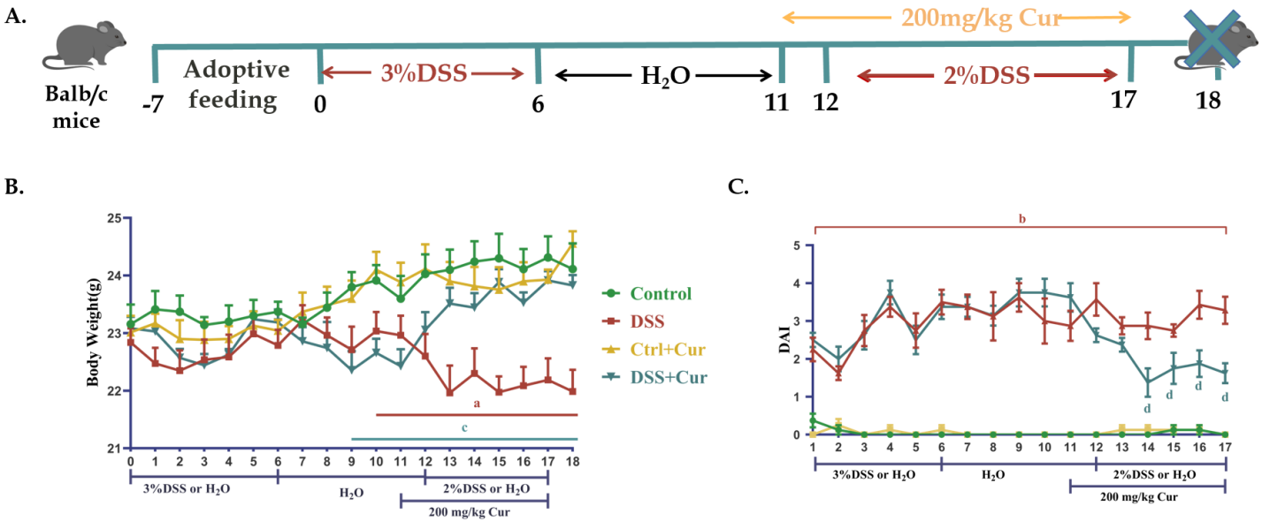
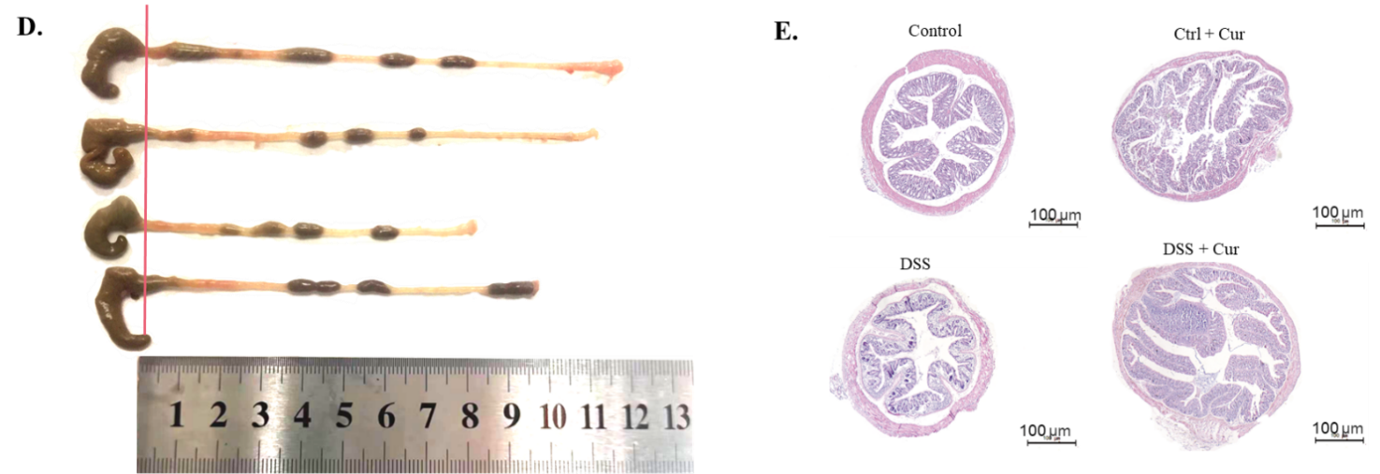
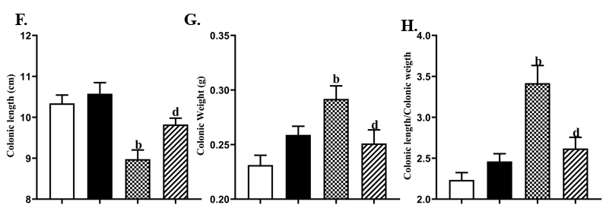
Figure 1 Curcumin effectively improved the symptoms of dextran sulfate sodium-induced ulcerative colitis mice. A: Dextran sulfate sodium (DSS)-induced ulcerative colitis model replication and Cur administration; B: Body weight changes of mice from days 0 to 18; C: Disease activity indexes of mice in each group from days 0 to 18; D: Specific colonic lengths of mice in each group; E: Pathological sections of the colon of each group of mice (HE staining, 50 × magnification; scale bar = 100 μm); F: The colonic length of mice in each group on day 18; G: Colon weights of mice in each group on day 18; H: The colonic length/colonic weight of mice in each group on day 18; I: The colonic weight index of mice in each group on day 18; J: Pathological injury scores of mice in each group. Data are expressed as the mean ± SD (n = 8). The differences were statistically significant when compared with the Ctrl group (ªP < 0.05, ^{b}P < 0.01). Differences were statistically significant with the DSS group (^{c}P < 0.05, ^{d}P < 0.01). Cur: Curcumin; DSS: Dextran sulfate sodium.
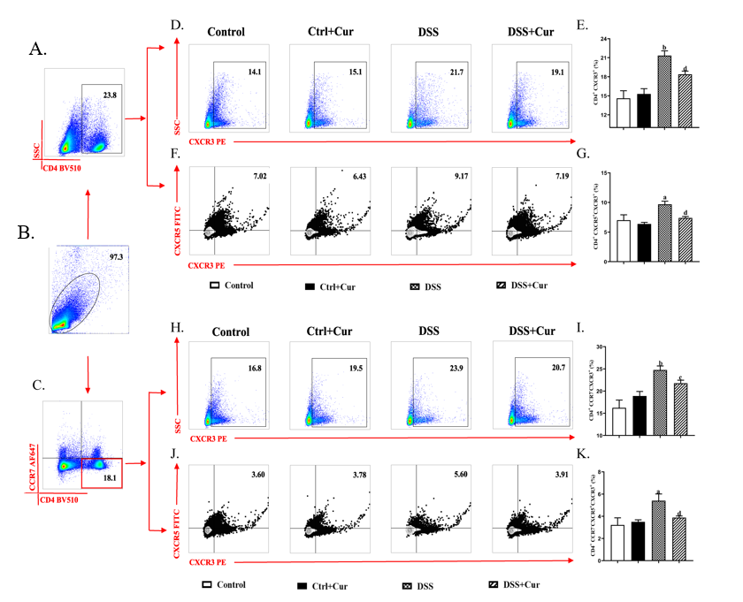
Figure 2 Memory T helper 1/memory follicular T helper 1 cell subpopulation levels in ulcerative colitis mice. A: Typical flow cytometry patterns of CD4⁺ cells; B: Typical flow cytometry patterns were observed in the spleen; C: Typical flow cytometry patterns and histograms of CD4⁺ CCR7⁻ cells; D and E: Typical flow cytometry patterns and histograms of CD4⁺ CXCR3⁺ (Th1) cells; F and G: CD4⁺ CXCR5⁺ CXCR3⁺ (Tfh1) cells; H and I: CD4⁺ CCR7⁻CXCR3⁺ (mTh1) cells; J and K: CD4⁺ CCR7⁻ CXCR5⁺ CXCR3⁺ (mTfh1) cells. Data are expressed as the mean ± SD (n = 8). The differences were statistically significant when compared with the Ctrl group (ªP < 0.05, ^{b}P < 0.01). Differences were statistically significant with the dextran sulfate sodium group (^{c}P < 0.05, ^{d}P < 0.01). Cur: Curcumin; DSS: Dextran sulfate sodium.

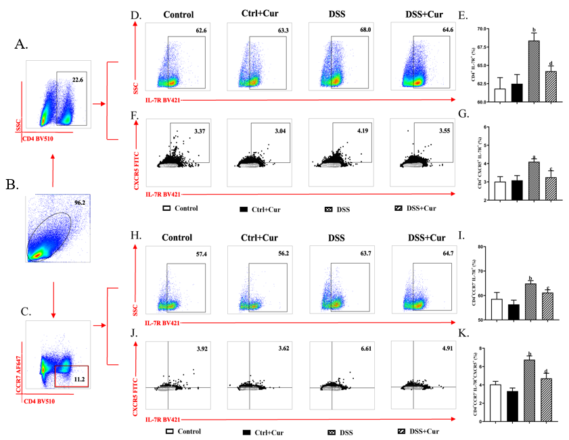
Figure 3 Memory T helper 7/memory follicular T helper 7 cell subpopulation levels in ulcerative colitis mice. A: Typical flow cytometry patterns of the spleen CD4⁺ cells in the spleen; B: Typical flow cytometry patterns were observed in the spleen; C: Typical flow cytometry patterns and histograms in the spleen of CD4⁺ CCR7⁻ cells; D and E: CD4⁺ IL-7R⁺ (Th7) cells; F and G: CD4⁺ CXCR5⁺ IL-7R⁺ (Tfh7) cells; H and I: CD4⁺ CCR7⁻IL-7R⁺ (mTh7) cells; J and K: CD4⁺ CCR7⁻CXCR5⁺ IL-7R⁺ (mTfh7) cells. Data are expressed as the mean ± SD (n = 8). The differences were statistically significant when compared with the Ctrl group (ªP < 0.05, ^{b}P < 0.01). Differences were statistically significant with the dextran sulfate sodium group (^{c}P < 0.05, ^{d}P < 0.01). DSS: Dextran sulfate sodium. Cur: Curcumin; DSS: Dextran sulfate sodium.

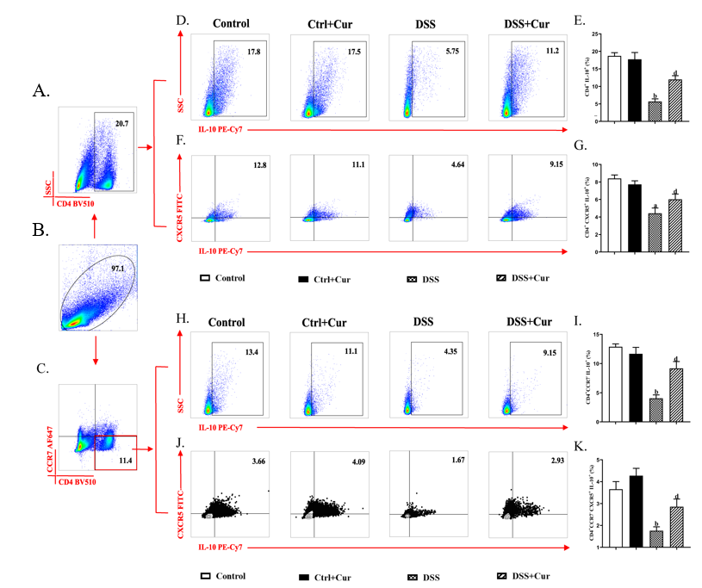
Figure 4 Memory T helper 10/memory follicular T helper 10 cell subpopulation levels in ulcerative colitis mice. A: Typical flow cytometry patterns of the spleen CD4⁺ cells; B: Typical flow cytometry patterns were observed in the spleen; C: Typical flow cytometry patterns and histograms in the spleen of CD4⁺ CCR7⁻ cells; D and E: CD4⁺ IL-10⁺ (Th10) cells; F and G: CD4⁺ CXCR5⁺ IL-10⁺ (Tfh10) cells; H and I: CD4⁺ CCR7⁻IL-10⁺ (mTh10) cells; J and K: CD4⁺ CCR7⁻CXCR5⁺ IL-10⁺ (mTfh10) cells. Data are expressed as the mean ± SD (n = 8). The differences were statistically significant when compared with the Ctrl group (ªP < 0.05, ^{b}P < 0.01). Differences were statistically significant with the dextran sulfate sodium group (^{c}P < 0.05, ^{d}P < 0.01). Cur: Curcumin; DSS: Dextran sulfate sodium.

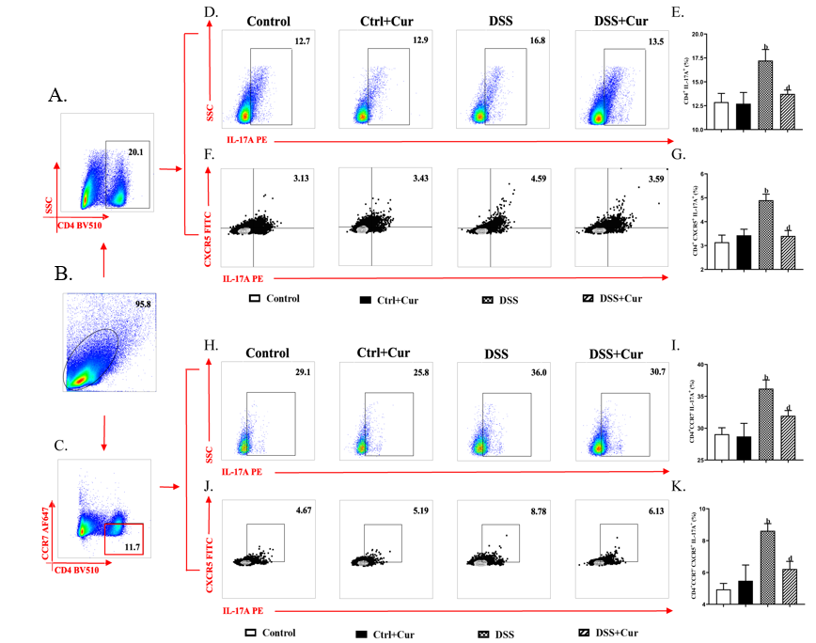
Figure 5 Memory T helper 17/memory follicular T helper 17 cell subpopulation levels in ulcerative colitis mice. A: Typical flow cytometry patterns of the spleen CD4⁺ cells; B: Typical flow cytometry patterns were observed in the spleen; C: Typical flow cytometry patterns and histograms in the spleen of CD4⁺ CCR7⁻ cells; D and E: CD4⁺ IL-17A⁺ (Th17) cells; F and G: CD4⁺ CXCR5⁺ IL-17A⁺ (Tfh17) cells; H and I: CD4⁺ CCR7⁻IL-17A⁺ (mTh17) cells; J and K: CD4⁺ CCR7⁻CXCR5⁺ IL-17A⁺ (mTfh17) cells. Data are expressed as the mean ± SD (n = 8). The differences were statistically significant when compared with the Ctrl group (ªP < 0.05, ^{b}P < 0.01). Differences were statistically significant with the dextran sulfate sodium group (^{c}P < 0.05, ^{d}P < 0.01). Cur: Curcumin; DSS: Dextran sulfate sodium.

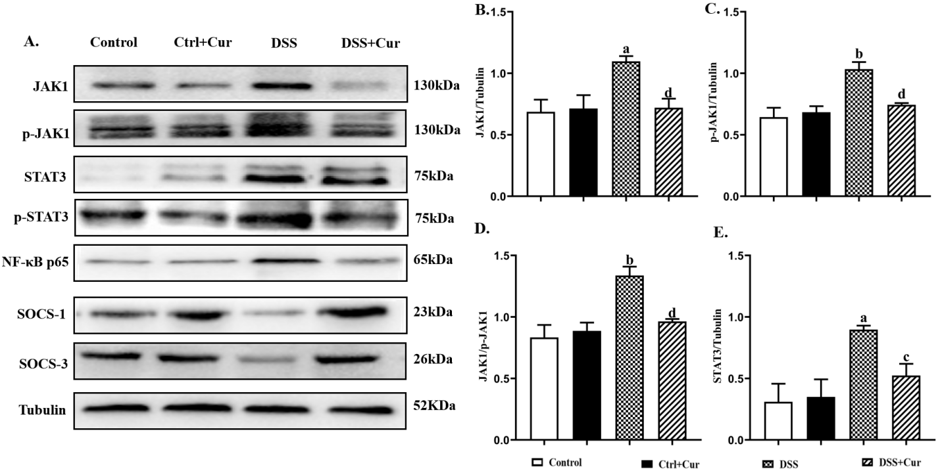
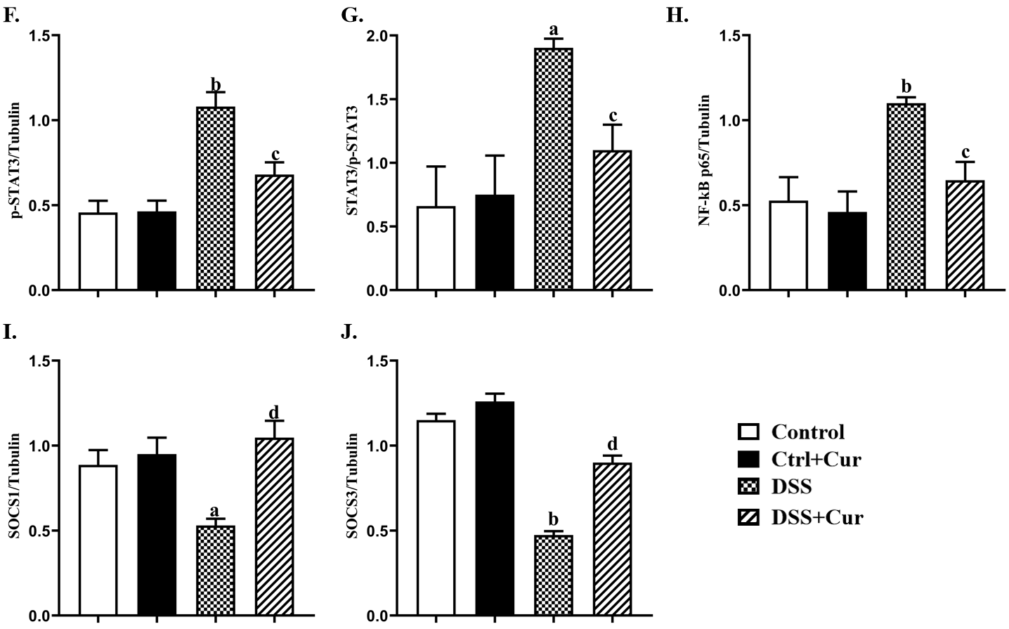
Figure 6 Curcumin inhibits JAK1/STAT3/SOCS signaling pathway-related proteins in ulcerative colitis mice. A: Western blotting of the major proteins in the JAK1/STAT3/SOCS signaling pathway, such as JAK1, p-JAK1, STAT3, p-STAT3, NF-κB p65, SOCS-1, and SOCS-3. Tubulin served as the reference protein in this study; B-J: Quantitative evaluations of JAK1 (B), p-JAK1 (C), JAK1/p-JAK1 (D), STAT3 (E), p-STAT3 (F), STAT3/p-STAT3 (G), NF-κB p65 (H), SOCS-1 (I), and SOCS-3 (J). Data of each group are expressed as the mean ± SD. The differences were statistically significant when compared with the Ctrl group (ªP < 0.05, ^{b}P < 0.01). Differences were statistically significant with the dextran sulfate sodium group (^{c}P < 0.05, ^{d}P < 0.01). Cur: Curcumin; DSS: Dextran sulfate sodium.

