Name of Journal: World Journal of Clinical Cases
Manuscript NO: 72765
Manuscript Type: CASE REPORT

Liver transplantation for late-onset ornithine transcarbamylase deficiency: A case report

Fu XH et al. Liver transplantation for ornithine transcarbamylase deficiency

Xiao-Hui Fu, Yu-Hui Hu, Jian-Xiang Liao, Li Chen, Zhan-Qi Hu, Jia-Lun Wen, Shu-Li Chen

Xiao-Hui Fu, Yu-Hui Hu, Shu-Li Chen, Department of Inherited Metabolic Disorders, The Affiliated Hospital of China Medical University and Shenzhen Children’s Hospital, Shenzhen 518038, Guangdong Province, China

Jian-Xiang Liao, Li Chen, Zhan-Qi Hu, Jia-Lun Wen, Department of Neurology, The Affiliated Hospital of China Medical University and Shenzhen Children’s Hospital, Shenzhen 518038, Guangdong Province, China

Author contributions: Hu YH, Liao JX, Chen L, Hu ZQ and Wen JL were responsible for the treatment and management of the patient; Fu XH and Chen SL collected the patient’s clinical data and wrote the paper; all authors were involved in writing the manuscript and read and approved the final manuscript.

Supported by the Sanming Project of Medicine in Shenzhen, No. SZSM201812005.

Corresponding author: Shu-Li Chen, PhD, Chief Doctor, Department of Inherited Metabolic Disorders, The Affiliated Hospital of China Medical University and Shenzhen Children’s Hospital, No. 7019 Yitian Road, Futian District, Shenzhen 518038, Guangdong Province, China. 13008803656@163.com

Received: October 28, 2021
Revised: January 10, 2022
Accepted: April 22, 2022
Published online:

Abstract
BACKGROUND
Ornithine transcarbamylase deficiency (OTCD) is an X-linked inherited disorder and characterized by marked elevation of blood ammonia. The goal of treatment is to minimize the neurological damage caused by hyperammonemia. OTCD can be cured by liver transplantation (LT). Post-transplant patients can discontinue anti- hyperammonemia agents and consume a regular diet without the risk of developing hyperammonemia. The neurological damage caused by hyperammonemia is almost irreversible.

CASE SUMMARY
An 11.7-year-old boy presented with headache, vomiting, and altered consciousness. The patient was diagnosed with late-onset OTCD. After nitrogen scavenging treatment and a protein-free diet, ammonia levels were reduced to normal on the third day of admission. Nevertheless, the patient remained in a moderate coma. After discussion, LT was performed. Following LT, the patient’s blood ammonia and biochemical indicators stabilized in the normal range, he regained consciousness, and his nervous system function significantly recovered. Two months after LT, blood amino acids and urine organic acids were normal, and brain magnetic resonance imaging showed a decrease in subcortical lesions.

CONCLUSION
LT can significantly improve partial neurological impairment caused by late-onset OTCD hyperammonemic encephalopathy, and LT can be actively considered when early drug therapy is ineffective.

Key Words: Ornithine transcarbamylase deficiency; Urea cycle disorder; Hyperammonemic encephalopathy; Liver transplantation; Case report

Fu XH, Hu YH, Liao JX, Chen L, Hu ZQ, Wen JL, Chen SL. Liver transplantation for late-onset ornithine transcarbamylase deficiency: A case report. World J Clin Cases 2022; In press

Core Tip: There are differing views on the timing of liver transplantation (LT) for ornithine transcarbamylase deficiency (OTCD) and whether it makes sense to perform LT in a patient with severe neurological impairment. We report a case of late-onset OTCD with severe neurological impairment, whose nervous system function recovered after LT. In late-onset OTCD patients with severe neurological impairment, LT can be considered.

INTRODUCTION
Ornithine transcarbamylase deficiency (OTCD) is the most common urea cycle disorder, with an incidence of approximately 1/56500 to 1/80000 reported in the literature[1-4]. The 2019 Urea Cycle Disorders Diagnosis and Management guidelines recommend liver transplantation (LT) for patients with severe urea cycle disorders who do not have severe neurological impairment and have stable metabolic status[5]. Opinions regarding LT for children with pre-existing severe brain damage differ as LT does not restore pre-existing neurological damage and due to the high risk of LT in children with acute encephalopathy; there is no experience regarding the extent to which neurological damage can be restored after surgery[5]. We report a patient with late-onset OTCD with good neurological recovery after LT.

CASE PRESENTATION
Chief complaints
An 11.7-year-old boy was admitted to our hospital due to headache, vomiting and altered mental status.

History of present illness
Two days before admission, the patient complained of a headache without obvious inducement, accompanied by vomiting 25 times. The headache did not improve with cold medication. He became unconscious 12 h before admission, and relevant tests were completed at a referring hospital. His blood ammonia was > 500 µmol/L. He was referred to our hospital for further treatment.

History of past illness
The patient was the product of a first pregnancy and first birth (G1P1) mother, and delivered by cesarean section at term with a birth weight of 3.0 kg. His perinatal condition was unremarkable, with no history of asphyxia. He was generally healthy and developed normally for a child of the same age. Prior to this episode, the family was not aware that the patient had OTCD.

Personal and family history
The patient had no significant family history. No patients in the family had OTCD or symptoms associated with the disease.

Physical examination
On physical examination, he was in a moderate comatose state [Glasgow coma score (GSC) 6] and was unresponsive to sound. His eyes could not be closed, the pupils were equally large and round, about 3 mm in diameter, and light reflex was delayed. There were no significant abnormalities on cardiopulmonary or abdominal examinations. Muscle strength in the limbs could not be tested, muscle tone was normal, and all pathological signs were negative.

Laboratory examinations
Laboratory tests showed a significantly elevated blood ammonia level (Table 1). Liver function and coagulation times were abnormal. Blood tandem mass spectrometry showed moderately elevated glutamine. Citrulline and arginine were in the normal range. Urine organic acid gas phase mass spectrometry showed that uracil and orotic acid levels were elevated. Blood ammonia levels during the first week of admission are shown in Figure 1. During the remainder rest of his hospital stay, levels were in the normal range.
Whole exome gene testing revealed the OTC gene exon2 hemizygote variant c.119G > A (p.R40H), inherited from his mother. The missense mutation was located in the well-studied exon functional domain without benign variation [Pathogenic moderate (PM) 1]. The frequencies of all normal population databases (dsSNP, 1000 genomes) were less than 0.0005 (PM2). This is a variant with different amino acid changes at the same locus reported in the literature as pathogenic variants (PM5). Pathogenic missense mutations of this gene are common, and benign missense mutations are rare [Pathogenic supporting (PP) 2]. The literature reported that variant to caused impaired gene function as show by in vitro functional assays [Pathogenic strong (PS) 3]. In summary, according to American College of Medical Genetics (ACMG)guidelines, this variant is likely pathogenic (PM1 + PM2 + PM5 + PP2 + PS3).

Imaging examinations
Brain magnetic resonance imaging (MRI) revealed that large patches of symmetrical high signal shadows on T2 weighted imaging (T2WI) and fluid attenuated inversion recovery in the cerebral hemispheres, and diffusion WI (DWI) revealed a significant high signal, more pronounced in the bilateral dorsal thalamus, caudate nucleus, lenticular nucleus, insula, cingulate gyrus and frontal lobe into the cortex at the falx.

FINAL DIAGNOSIS
Hyperammonemic encephalopathy and ornithine transcarbamylase deficiency.

TREATMENT
After admission, the patient underwent continuous hemodiafiltration (Disposable hemodialysate filter and supporting pipeline, Prismaflex M100 set, Gambro Industries, Meyzieu, France; blood flow velocity 150-300 mL/min, replacement velocity 1000-2500 mL/h, dialysis velocity 1500-5000 mL/h) to lower the blood ammonia level. The impairment of consciousness worsened, and the repeat blood ammonia level was 511.72 µmol/L. Within a few hours, he fell into a severe coma (GSC 3) and developed central respiratory failure. We immediately provided ventilation, reduced intracranial pressure (mannitol and hypertonic sodium), nitrogen scavenger agents including sodium benzoate and arginine, antibiotics to inhibit ammonia production by intestinal bacteria, along with multiple nutritional support treatments.
On day 3, blood ammonia decreased to normal and was maintained in the normal range for the remainder of the hospital stay. The continuous hemodiafiltration parameters (blood flow velocity 120 mL /min, replacement velocity 500 mL/h, dialysis velocity 2500 mL/h) were gradually adjusted downwards. On day 6, the patient discontinued hemodiafiltration. On day 7, the patient’s consciousness changed from deep coma to moderate coma. On day 12, the patient was weaned from the ventilator; however, he remained in a moderate coma.
On day 31, modified piggyback orthotopic LT (anastomosis of the donor inferior vena cava to the recipient inferior vena cava) was performed, the donor was deceased. Postoperatively, the patient was treated with tacrolimus, sodium mescaline, and methylprednisolone. On day 35 (day 4 after surgery), the patient was conscious (opened eyes autonomously, obeyed commands, verbal response was “T”). A repeat brain MRI more than 2 mo after transplantation showed that the previous subcortical lesions had largely disappeared; however, hydrocephalus was worse (Figure 2). He was discharged after 3 mo and underwent abdominal ventricular drainage at another hospital.

OUTCOME AND FOLLOW-UP
At follow-up, 6 mo after surgery, he could sit, squat, and walk smoothly on his own. He could say simple superlatives, and his command execution rate was approximately 30%. He showed poor emotional control and a greater temper to his parents; however, he was gentler to strangers and his brother.

DISCUSSION
OTCD can develop at any age. Depending on the time of onset, OTCD can be divided into the neonatal-onset type and the late-onset type (age of onset > 28 d)^{[6]}. Patients with neonatal onset usually present in the first few hours and days after birth with severe disease and high mortality. The clinical presentation of late-onset disease varies widely, with no specific clinical manifestations before initial onset. Acute onset of late-onset OTCD can be induced by infection, prolonged fasting, or fatigue. The outcome for conservative treatment is poor in patients with hyperammonemia crisis, and 5-year survival is approximately 45%^{[7]}.
Outcomes in urea cycle disorders are related to blood ammonia levels and the duration of the coma. According to a European questionnaire, patients with blood ammonia levels > 300 μmol/L or peak blood ammonia levels > 480 μmol/L during the first episode suffered neurological dysfunction^{[8]}. Although patients with late-onset OTCD generally have better outcomes than those with neonatal onset, there is a higher incidence of residual neurological damage, and the mortality rate for late-onset OTCD with coma on the first episode is high. In a follow-up study that included 90 OTCD cases, 18 patients had coma as their first presentation and 6 of them died^{[9]}. Among 16 genetically confirmed cases of late-onset OTCD reported in the Chinese literature^{[10]}, nine died shortly after hospital admission, suggesting the disease’s aggressive nature at acute onset. In our case, the patient was physically fit and had normal development before the presentation. Headache and vomiting were the primary manifestations; these symptoms were not taken seriously until the onset of unconsciousness, which delayed the treatment. Although blood ammonia levels reduced to the normal range after aggressive treatment, neurological damage did not improve with the normalization of blood ammonia. The patient was in a moderate coma before LT.
OTCD is treated with a low-protein diet and long-term oral ammonia-lowering medications. LT is the radical treatment for OTCD. After LT, patients no longer need to restrict their diet or take nitrogen scavenging agents^{[5]}. Statistics on LT in patients with urea circulation disorders show that the 5-year survival rate of patients after LT can exceed 90%^{[11,12]}. There is no consensus regarding the indications or timing of LT. It is now believed that LT should be performed in all patients with neonatal onset to prevent neurological damage^{[13]}. The indications and timing of LT for late-onset OTCD must be determined by the clinical symptoms, including poor drug efficacy, recurrent episodes of hyperammonemia, growth retardation, and inability to strictly control the diet^{[14]}. Although post-transplant patients require long-term immunosuppressive drugs, there is evidence that OTCD patients who underwent LT have a better quality of life than those who did not and no longer risked death due to sudden-onset hyperammonemia^{[11,15]}.
The present patient had an acute onset, a long duration of hyperammonemia, severe brain damage, and was in a moderate coma before LT. Therefore, the optimal time window for LT was missed, and the choice of LT and the extent to which the patient would recover from neurological damage after transplantation were a concern for his physicians and parents. Most LTs for OTCD patients are carried out in the context of stable metabolism, and there are few reports of LT in patients with severe neurological injury. Nevertheless, given the patient’s inability to regain consciousness, we performed LT, and he was conscious 4 d later. After LT, he did not take nitrogen scavenging agents, and blood ammonia, liver, and kidney function biochemistry were maintained in the normal range at regular follow-up. Kawagishi et al^{[16]} reported a patient who underwent LT for recurrent hyperammonemia due to late-onset OTCD, and blood ammonia was maintained in the normal range without further nitrogen scavenging agents after surgery. Nevertheless, at 16 mo after surgery showed no change in subcortical lesions. Brain MRI in our patient was repeated about 2 mo after surgery, and suggested a significant reduction in abnormal cranial signals compared with the previous MRI, indicating that LT was effective in the treatment of this patient, However, brain MRI showed that hydrocephalus had progressed and brain atrophy was present, suggesting that some neurological damage may not be reversed after LT.
Several studies have shown that LT could be used as a radical treatment which significantly improves the quality of life^{[11,17]}. However, it is not clear whether LT is beneficial for OTCD patients who already have severe neurological damage. This case report suggests that LT can be attempted in children with late-onset OTCD, even if severe neurological impairment is already present. Neurological recovery after LT in this patient was unexpected; the recovery of higher functions such as emotional control and spatial thinking require long-term rehabilitation training and psychotherapy, and its effects need to be observed during follow-up.

CONCLUSION
In summary, patients with late-onset OTCD and acute hyperammonemic encephalopathy are at high risk, and LT can significantly improve the neurological damage caused by this disease. As a radical cure for OTCD, LT should be considered more aggressively.

REFERENCES
1 Wilcken B. Problems in the management of urea cycle disorders. Mol Genet Metab 2004; 81 Suppl 1: S86-S91 [PMID: 15050980 DOI: 10.1016/j.ymgme.2003.10.016]
2 Summar ML, Koelker S, Freedenberg D, Le Mons C, Haberle J, Lee HS, Kirmse B, European registry and network for intoxication type metabolic diseases (E-IMD). The incidence of urea cycle disorders. Mol Genet Metab 2013; 110: 179-180. Available from: http://rarediseasesnetwork.epi.usf.edu/ucdc/ [PMID: 23972786 DOI: 10.1016/j.ymgme.2013.07.008]
3 Dionisi-Vici C, Rizzo C, Burlina AB, Caruso U, Sabetta G, Uziel G, Abeni D. Inborn errors of metabolism in the Italian pediatric population: a national retrospective survey. J Pediatr 2002; 140: 321-327 [PMID: 11953730 DOI: 10.1067/mpd.2002.122394]
4 Kido J, Nakamura K, Mitsubuchi H, Ohura T, Takayanagi M, Matsuo M, Yoshino M, Shigematsu Y, Yorifuji T, Kasahara M, Horikawa R, Endo F. Long-term outcome and intervention of urea cycle disorders in Japan. J Inherit Metab Dis 2012; 35: 777-785 [PMID: 22167275 DOI: 10.1007/s10545-011-9427-0]
5 Häberle J, Burlina A, Chakrapani A, Dixon M, Karall D, Lindner M, Mandel H, Martinelli D, Pintos-Morell G, Santer R, Skouma A, Servais A, Tal G, Rubio V, Huemer M, Dionisi-Vici C. Suggested guidelines for the diagnosis and management of urea cycle disorders: First revision. J Inherit Metab Dis 2019; 42: 1192-1230 [PMID: 30982989 DOI: 10.1002/jimd.12100]
6 Division of genetics and metabolism, Child diseases and health care branch, Chinese association for maternal and child health. Consensus on diagnosis and treatment of ornithine trans-carbamylase deficiency. Zhejiang Daxue Xuebao Yixueban 2020; 49: 539-547 [PMID: 33210478 DOI: 10.3785/j.issn.1008-9292.2020.04.11]
7 Wakiya T, Sanada Y, Mizuta K, Umehara M, Urahasi T, Egami S, Hishikawa S, Fujiwara T, Sakuma Y, Hyodo M, Murayama K, Hakamada K, Yasuda Y, Kawarasaki H. Living donor liver transplantation for ornithine transcarbamylase deficiency. Pediatr Transplant 2011; 15: 390-395 [PMID: 21585627 DOI: 10.1111/j.1399-3046.2011.01494.x]
8 Enns GM. Neurologic damage and neurocognitive dysfunction in urea cycle disorders. Semin Pediatr Neurol 2008; 15: 132-139 [PMID: 18708004 DOI: 10.1016/j.spen.2008.05.007]
9 Brassier A, Gobin S, Arnoux JB, Valayannopoulos V, Habarou F, Kossorotoff M, Servais A, Barbier V, Dubois S, Touati G, Barouki R, Lesage F, Dupic L, Bonnefont JP, Ottolenghi C, De Lonlay P. Long-term outcomes in Ornithine Transcarbamylase deficiency: a series of 90 patients. Orphanet J Rare Dis 2015; 10: 58 [PMID: 25958381 DOI: 10.1186/s13023-015-0266-1]
10 Sun Y, Li XM, Zhang TX, Li DL, Ji KQ, Yan CZ, Zhao YY. Clinical research of two cases of late-onset ornithine carbamoyltransferase deficiency. Zhonghua Shenjingke Zazhi 2019; 52: 399-405 [DOI: 10.3760/cma.j.issn.1006-7876.2019.05.007]
11 Morioka D, Kasahara M, Takada Y, Shirouzu Y, Taira K, Sakamoto S, Uryuhara K, Egawa H, Shimada H, Tanaka K. Current role of liver transplantation for the treatment of urea cycle disorders: a review of the worldwide English literature and 13 cases at Kyoto University. Liver Transpl 2005; 11: 1332-1342 [PMID: 16237708 DOI: 10.1002/Lt.20587]
12 Molema F, Martinelli D, Hörster F, Kölker S, Tangeraas T, de Koning B, Dionisi-Vici C, Williams M; additional individual contributors of MetabERN. Liver and/or kidney transplantation in amino and organic acid-related inborn errors of metabolism: An overview on European data. J Inherit Metab Dis 2021; 44: 593-605 [PMID: 32996606 DOI: 10.1002/jimd.12318]
13 Kido J, Matsumoto S, Mitsubuchi H, Endo F, Nakamura K. Early liver transplantation in neonatal-onset and moderate urea cycle disorders may lead to normal neurodevelopment. Metab Brain Dis 2018; 33: 1517-1523 [PMID: 29948653 DOI: 10.1007/s11011-018-0259-6]
14 Wakiya T, Sanada Y, Urahashi T, Ihara Y, Yamada N, Okada N, Ushijima K, Otomo S, Sakamoto K, Murayama K, Takayanagi M, Hakamada K, Yasuda Y, Mizuta K. Impact of enzyme activity assay on indication in liver transplantation for ornithine transcarbamylase deficiency. Mol Genet Metab 2012; 105: 404-407 [PMID: 22264779 DOI: 10.1016/j.ymgme.2011.12.019]
15 Foschi FG, Morelli MC, Savini S, Dall'Aglio AC, Lanzi A, Cescon M, Ercolani G, Cucchetti A, Pinna AD, Stefanini GF. Urea cycle disorders: a case report of a successful treatment with liver transplant and a literature review. World J Gastroenterol 2015; 21: 4063-4068 [PMID: 25852294 DOI: 10.3748/wjg.v21.i13.4063]
16 Kawagishi N, Satoh K, Enomoto Y, Akamatsu Y, Sekiguchi S, Satoh A, Fujimori K, Takasago Y, Ito T, Ohura T, Satomi S. Improved quality of life and unchanged magnetic resonance brain imaging after living donor liver transplantation for late-onset ornithine transcarbamylase deficiency: report of a case. Surg Today 2005; 35: 1087-1091 [PMID: 16341494 DOI: 10.1007/s00595-005-3071-y]
17 Kasahara M, Sakamoto S, Horikawa R, Koji U, Mizuta K, Shinkai M, Takahito Y, Taguchi T, Inomata Y, Uemoto S, Tatsuo K, Kato S. Living donor liver transplantation for pediatric patients with metabolic disorders: the Japanese multicenter registry. Pediatr Transplant 2014; 18: 6-15 [PMID: 24283623 DOI: 10.1111/petr.12196]

Footnotes
Informed consent statement: Informed written consent was obtained from the patient for the publication of this report and any accompanying images.

Conflict-of-interest statement: The authors declare that they have no conflict of interest.

CARE Checklist (2016) statement: The authors have read the CARE Checklist (2016), and the manuscript was prepared and revised according to the CARE Checklist (2016).

Open-Access: This article is an open-access article that was selected by an in-house editor and fully peer-reviewed by external reviewers. It is distributed in accordance with the Creative Commons Attribution NonCommercial (CC BY-NC 4.0) license, which permits others to distribute, remix, adapt, build upon this work non-commercially, and license their derivative works on different terms, provided the original work is properly cited and the use is non-commercial. See: https://creativecommons.org/Licenses/by-nc/4.0/

Provenance and peer review: Unsolicited article; Externally peer reviewed.
Peer-review model: Single blind

Peer-review started: October 28, 2021
First decision: December 27, 2021
Article in press:

Specialty type: Genetics and heredity
Country/Territory of origin: China
Peer-review report’s scientific quality classification
Grade A (Excellent): 0
Grade B (Very good): 0
Grade C (Good): C, C
Grade D (Fair): D
Grade E (Poor): 0

P-Reviewer: Enosawa S, Japan; Topal U, Turkey S-Editor: Guo XR L-Editor: Webster JR P-Editor: Guo XR

Figure Legends
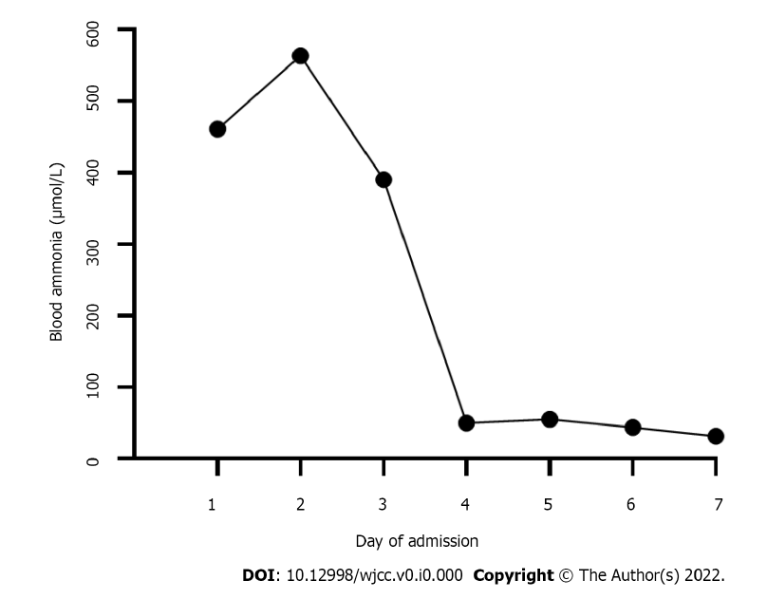
Figure 1 Blood ammonia changes during the first week of admission.
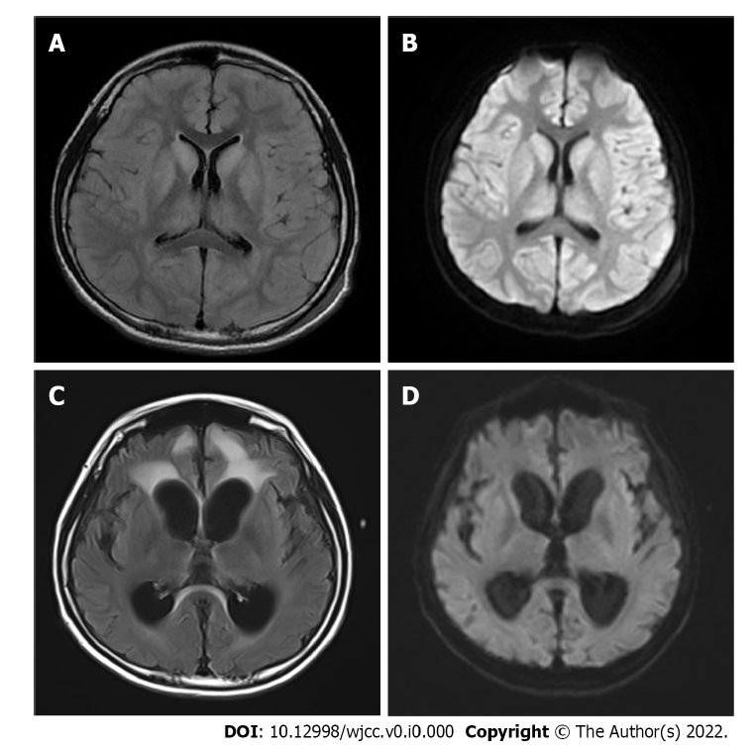
Figure 2 Brain magnetic resonance imaging. A: On admission, brain magnetic resonance imaging (MRI), T2 fluid attenuated inversion recovery (FLAIR) imaging showed a large symmetrical high signal, more pronounced in the bilateral dorsal thalamus, caudate nucleus, lenticular nucleus, insula, cingulate gyrus and frontal lobe into the cortex at the falx; B: On admission, a high signal was observed on diffusion weighted imaging (DWI) of bilateral dorsal thalamus, caudate nucleus, lenticular nucleus, insula, frontal lobe into the cortex at the falx; C: Two months after liver transplantation (LT), brain MRI, T2 FLAIR imaging showed that the cerebral sulcus fissure was widened and deepened bilaterally in the cerebral hemispheres, and the cortex was atrophied, with a patchy high signal in the frontal lobes bilaterally; D: Two months after LT, brain MRI, DWI did not show any significant abnormal signal, and the abnormal signal in the original bilateral cerebral hemispheric cortex, dorsal thalamus, basal ganglia area, insula, cingulate gyrus, and frontal and temporal lobes was no longer obvious.

Table 1 Laboratory data
Parameter | On admission | After LT | Reference range
Blood ammonia, µmol/L | 461.2 ↑ | 51.2 | 14-65
Blood lactic acid, mmol/L | 4.47 ↑ | 0.78 | 0.5-2.2
APTT, s | 37.3 | 24.1 | 26.1-40.7
PT, s | 23.1 ↑ | 12.6 | 9.3-12.9
INR | 2.030 ↑ | 1.10 | 0.72-1.15
Fibrinogen, g/L | 1.88 | 2.36 | 1.57-3.93
ALT, U/L | 73 ↑ | 44 ↑ | 0-40
AST, U/L | 50 ↑ | 31 | 0-40
ALP, U/L | 564 ↑ | 126 | 40-500
GGT, U/L | 15 | 107 ↑ | 0-50
TBIL, µmol/L | 30.8 ↑ | 4.0 | 0.9-17.1
IBIL, µmol/L | 25.6 ↑ | 1.8 | 2-17
Albumin, g/L | 45.5 | 41.9 | 35-55
Serum creatinine, µmol/L | 63.5 | 42.3 | 64-104
Serum uric acid, µmol/L | 442.90 ↑ | 365.6 | 90-420
Ceruloplasmin | 24.4 | absent | 22-322
Blood amino acids
Glutamine, µmol/L | 66.28 ↑ | 15.83 | 1.0-55.0
Citrulline, µmol/L | 14.7 | 14.19 | 5.50-45.00
Arginine, µmol/L | 13.57 | 5.38 | 1.00-70.00
Urine organic acid
Uracil, mmol/molCr | 29.4 ↑ | 0.0 | 0.0-8.0
Urinary orotic acid, mmol/molCr | 123.3 ↑ | 0.0 | 0.0-2.0
↑: Higher than the reference value; LT: Liver transplantation; APTT: Activated partial thromboplastin time; PT: Prothrombin time; INR: International normalized ratio; ALT: Alanine aminotransaminase; AST: Aspartate aminotransferase; ALP: Alkaline phosphatase; GGT: γ-glutamyl transpeptidase; TBIL: Total bilirubin; IBIL: Indirect bilirubin.

