Name of journal: World Journal of Gastroenterology
ESPS Manuscript NO: 14304
Columns: ORIGINAL ARTICLE
Basic Study
Gambogic acid induces apoptosis and inhibits colorectal tumor growth via mitochondrial pathways

Huang GM et al. Anti-cancer effect of gambogic acid

Guang-Ming Huang, Yu Sun, Xin Ge, Xin Wan, Chun-Bo Li

Guang-Ming Huang, Yu Sun, Xin Ge, Xin Wan, Chun-Bo Li, Department of General Surgery, Heilongjiang Provincial Hospital, Harbin 150036, Heilongjiang Province, China

Author contributions: Huang GM and Sun Y contributed equally to this work; Huang GM, Sun Y and Ge X designed the research; Huang GM, Wan X and Li CB performed the research; Sun Y analyzed the data; Huang GM, Sun Y and Ge X wrote the manuscript.

Ethics approval: The study was reviewed and approved by the Heilongjiang Provincial Hospital Institutional Review Board.

Institutional animal care and use committee: All procedures involving animals were reviewed and approved by the Ethics Committee of Heilongjiang Province’s Hospital (IACUC protocol number: 2008-010).

Conflict-of-interest: The authors have no conflict of interest to declare.

Data sharing: No additional data are available.

Open-Access: This article is an open-access article which was selected by an in-house editor and fully peer-reviewed by external reviewers. It is distributed in accordance with the Creative Commons Attribution Non Commercial (CC BY-NC 4.0) license, which permits others to distribute, remix, adapt, build upon this work non-commercially, and license their derivative works on different terms, provided the original work is properly cited and the use is non-commercial. See: http://creativecommons.org/licenses/by-nc/4.0/

Correspondence to: Xin Ge, MD, Department of General Surgery, Heilongjiang Provincial Hospital, 82 Zhongshan Road, Harbin 150036, Heilongjiang Province, China. gexin628@163.com

Telephone: +86-451-87131193
Fax: +86-451-87131195
Received: September 28, 2014
Peer-review started: September 29, 2014
First decision: October 29, 2014
Revised: November 22, 2014
Accepted: January 30, 2015

Article in press:
Published online:

Abstract
AIM: To investigate the effect of gambogic acid (GA) on apoptosis in the HT-29 human colon cancer cell line.

METHODS: H-29 human colon cancer cells were used for in vitro experiments in this study. Relative cell viability was assessed using MTT assays. Cell apoptosis was detected by terminal deoxynucleotidyl transferase dUTP nick end labeling and Hoechst 33342 staining, and quantified by flow cytometry. Cellular ultrastructure was observed under transmission electron microscopy. Real-time PCR and Western blot analyses were used to evaluate gene and protein expression levels. For in vivo experiments, BALB/c nude mice received subcutaneous injections of HT-29 cells in the right armpit. When well-established xenografts were palpable with a tumor size of 75 mm³, mice were randomly assigned to a vehicle (negative) control, positive control or GA treatment group (n = 6 each). The animals in the treatment group received one of three dosages of GA (in saline; 5, 10 or 20 mg/kg) via the caudal vein twice weekly, whereas animals in the negative and positive control groups were given equal volumes of 0.9% saline or 10 mg/kg docetaxel, respectively, via the caudal vein once weekly.

RESULTS: The cell viability assay showed that GA inhibits proliferation of HT-29 cells in a dose- and time-dependent manner after treatment with GA (0.00, 0.31, 0.62, 1.25, 2.50, 5.00 or 10.00 µmol/L) for 24, 48 and 72 h. After 48 h, the percentage of apoptotic cells with 0.00, 1.25, 2.50 and 5.00 µmol/L GA was 1.4% ± 0.3%, 9.8% ± 1.2%, 25.7% ± 3.3% and 49.3% ± 5.8%, respectively. Ultrastructural analysis of HT-29 cells treated for 48 h with of 2.5µmol/L GA revealed apoptotic bodies and condensed and fragmented nuclei. Levels of caspase-8, -9 and -3 mRNA were significantly increased after treatment with GA (1.25, 2.50 or 5.00 µmol/L) for 48 h (all P < 0.05). Protein levels of apoptosis-related factors Fas, FasL, FADD, cytochrome c, and Apaf-1 were increased in GA-treated cells, whereas levels of pro-caspase-8, -9 and -3 were significantly decreased (all P < 0.05). Furthermore, GA signiﬁcantly and dose-dependently inhibited the growth of HT-29 tumors in a mouse xenograft model (P < 0.05).

CONCLUSION: GA inhibits HT-29 proliferation via induction of apoptosis. The anti-cancer effects are likely mediated by death receptor (extrinsic) and mitochondrial (intrinsic) pathways.

Key words: Apoptosis; Death receptor pathway; Flow cytometry; Gambogic acid; Hoechst 33342; HT-29 cells; Mitochondrial pathway; MTT; Terminal deoxynucleotidyl transferase dUTP nick end labeling

© The Author(s) 2015. Published by Baishideng Publishing Group Inc. All rights reserved.

Core tip: This study evaluated the effects of gambogic acid on colon cancer cells. Treatment of a human colon cancer cell line with gambogic acid inhibited proliferation via induction of apoptosis. Moreover, the growth of colon cancer cell xenograft tumors in mice was reduced by injections of gambogic acid. These anti-cancer effects were likely mediated through death receptor and mitochondrial pathways.

Huang GM, Sun Y, Ge X, Wan X, Li CB. Gambogic acid induces apoptosis and inhibits colorectal tumor growth via mitochondrial pathways. World J Gastroenterol 2015; In press

INTRODUCTION
Colorectal cancer is the third leading cause of cancer and the fourth leading cause of cancer-related deaths worldwide^{[1,2]}. Morbidity and mortality from colorectal cancer are increasing with continuing urbanization of the population. Apart from genetic causes, life and environmental factors determine the relative risk of the occurrence and development of colon cancer. Although the diagnostics for colon cancer have greatly improved, the molecular mechanisms of the disease are poorly understood^{[3,4]}. Treatment of colon cancer includes surgery, chemotherapy, and radiotherapy, or a combination of these treatments^{[5]}. Chemotherapy is an effective treatment for colon cancer, but traditional chemotherapy has many serious side effects, including significant pain. At present, approximately half of the patients with a primary tumor can be cured by surgery, depending on the tumor location^{[6]}.
Gambogic acid (GA) is the major active ingredient in gamboge, which is extracted from various Garcinia species, including Garcinia hanburyi Hook f. (Tenghuang)^{[7]}. GA has various biologic activities, such as anti-pyretic, analgesic, anti-inflammatory^{[7]}, autophagic^{[8]} and anti-tumor activities^{[8–10]}. Some research studies have shown that GA can inhibit the growth of many tumor cells both in vitro and in vivo, including cells in lung cancer^{[11,12]}, liver cancer^{[13,14]}, breast cancer^{[15–17]}, gastric cancer^{[18,19]}, pancreatic cancer^{[20]}, leukemia^{[21–23]}, melanoma^{[24]}, and glioblastoma^{[25]}. GA is currently being investigated in clinical trials in China^{[25-27]}. However, the effect of GA on the growth of human colon cancer cells remains unclear.
Apoptosis is the most important pathway for the anti-tumor effects of many compounds. GA has been shown to induce apoptosis by increasing nuclear condensation and DNA fragmentation^{[28,29]}, elevating levels of Bax and decreasing levels of Bcl-2^{[29,30]}, activating caspase-8, -9 and -3^{[31-33]}, suppressing NF-κB^{[33,34]}, and inhibiting matrix metalloproteinase-2 and -9^{[35]} both in vitro and in vivo^{[22,36]}. The aim of this study was to investigate the potential anti-cancer effects of GA on human colon cancer cells and identify the related molecular mechanisms.

MATERIALS AND METHODS
Chemicals and reagents
GA and 3-(4,5-dimethylthiazol-2-yl)-2, 5-diphenyltetrazolium bromide (MTT) were purchased from Sigma-Aldrich (St. Louis, MO, United States). Terminal deoxynucleotidyl transferase dUTP nick end labeling (TUNEL) and Hoechst 33342 staining kits were obtained from Beyotime Institute of Biotechnology (Haimen, China). Annexin V/propidium iodide (PI) was purchased from Biosea (Beijing, China). Real-time (RT)-PCR primers were purchased from Genscript Corp. (Piscataway, NJ, United States). M-MLV reverse transcriptase and reagents for RT-PCR were purchased from Promega Corp. (Madison, WI, United States). Antibodies against Fas, Fas ligand (FasL), Fas-associated with death domain protein (FADD), caspase-8, cytochrome c, apoptotic protease activating factor (Apaf)-1, caspase-9, caspase-3, GAPDH, and β-actin were obtained from Cell Signaling Technology Inc. (Danvers, MA, United States). Trizol and fluorescence-conjugated secondary antibodies were obtained from Invitrogen (of Thermo Fisher Scientific, Waltham, MA, United States). Other chemicals were purchased at the highest purity grade.

Cell culture
HT-29 human colon cancer cells were purchased from American Type Culture Collection (Manassas, VA, United States). The cells were cultured in complete RPMI-1640 medium (Hyclone of GE Healthcare, Little Chalfont, Buckinghamshire, United Kingdom) supplemented with 10% heat-inactivated bovine serum (Gibco of Thermo Fisher Scientific, Waltham, MA, United States), 100 U/mL penicillin, and 100 µg/mL streptomycin at 37 °C with 5% CO₂ in a humidified atmosphere.

MTT assay of cell proliferation
HT-29 cells were seeded into a 96-well culture plate at 5000 cells/well for 16 h for attachment. The cells were then treated with GA (0.00, 0.31, 0.62, 1.25, 2.50 5.00, or 10.00 µmol/L) for 24, 48 or 72 h. MTT dye was added to each well at 37°C and incubated for 4 h. The supernatant was then removed and the purple-colored formazan precipitates were dissolved in 150 µL of dimethyl sulfoxide and absorbance at 490 nm was measured on a multi-well plate reader. The background absorbance (medium without the cells) was subtracted. Percent viability was calculated using the formula: [(drug-treated group/control group) × 100]. Each assay was repeated three times, and the final results are expressed as mean ± SE.

Apoptotic cell detection by TUNEL and Hoechst 33342 staining
For TUNEL staining, HT-29 cells were incubated with GA (0.00, 1.25, 2.50 or 5.00 µmol/L) for 48 h in 96-well plates; the attached cells were then washed with PBS and fixed in freshly prepared 4% formaldehyde for 30 min. The cells were then washed twice with PBS and incubated with digoxigenin-conjugated dUTP in a terminal deoxynucleotidyl transferase-catalyzed reaction for 1 h at 37 °C in a humidified atmosphere. After the cells were immersed in stop/wash buffer for 10 min at room temperature and washed with PBS, they were incubated with anti-digoxigenin antibody-conjugated peroxidase for 30 min. Apoptotic cells with condensed and fragmented nuclei were stained brown after incubation with 3, 3′-diaminobenzidine for 5 min.
For Hoechst 33342 staining, HT-29 cells cultured on glass coverslips in 6-well plates were treated and fixed as described above. After rinsing twice with PBS, the cells were incubated in Hoechst 33342 staining solution for 5 min. Cells were washed twice with PBS and mounted using an antifade mounting medium. Apoptosis was detected by ﬂuorescence microscopy.

Cellular ultrastructure analysis by transmission electron microscopy
HT-29 cells were incubated for 48 h with 0.0 or 2.5 µmol/L GA, and harvested with trypsin, centrifuged, and washed with PBS. Cell samples were fixed in 2.5% (v/v) glutaraldehyde in 0.1 mol/L phosphate buffer (pH 7.4), post-fixed in 2% (w/v) buffered osmium tetroxide for 2 h, and dehydrated in ethanol. Specimens were embedded in Epon (Sigma-Aldrich), and thin sections were cut using an ultramicrotome and double stained with uranyl acetate and lead citrate.

Apoptosis quantification by flow cytometry
After incubation with GA (0.00, 1.25, 2.50 or 5.00 µmol/L) for 48 h, HT-29 cells were collected with trypsin, centrifuged, washed with PBS, stained with Annexin V-FITC and propidium iodide (PI) according to the manufacturer’s protocol, and then analyzed using a FACScan flow cytometer (Becton, Dickinson and Company, Franklin Lakes, NJ, United States). Quantification was conducted from histogram plots, where early apoptotic cells stained with Annexin V-FITC are presented in the lower right quadrant and late apoptotic cells stained with both Annexin V-FITC and PI are presented in the upper right quadrant.

RNA isolation and quantitative RT-PCR analysis
Total RNA was extracted using Trizol and the concentration and purity were determined by measuring the optical density. RNA from each sample (1 µg) was used to generate cDNA using M-MLV reverse transcriptase according to manufacturer’s specifications. After an initial denaturation step at 95 °C for 10 min using SYBR Green PCR Master Mix (Applied Biosystems of Thermo Fisher Scientific, Waltham, MA, United States), RT-PCR was cycled between 95 °C for 15 s and 60 °C for 1 min for 40 cycles. Amplification was performed using a 7500 Fast Real-Time PCR System (Applied Biosystems) and products were routinely checked using dissociation curve software. Transcript quantities were compared by the relative Ct method, and the amount of caspase-8, -9 and -3 were normalized to the endogenous control (GAPDH). The relative value to the control sample was given by 2-∆∆CT. RT-PCR primer sequences were as follows: caspase-8, (forward) 5′-GCCTCCCTCAAGTTCCT-3′, (reverse) 5′-CCTGGAGTCTCTGGAATAACA-3′; caspase-9, (forward) 5′-CGAACTAACAGGCAAGCAGC-3′, (reverse) 5′-ACCTCACCAAATCCTCCAGAAC-3′; caspase-3, (forward) 5′-TGGTTCATCCAGTCGCTTTG-3′, (reverse) 5′-CATTCTGTTGCCACCTTTCG-3′.

Western blot analysis
Following treatment with GA (0.00, 1.25, 2.50 or 5.00 µmol/L) for 48 h, HT-29 cells were washed twice with ice-cold PBS and collected in lysis buffer. The supernatant was collected by centrifuging at 13500 rpm for 20 min. Total protein concentration was quantified using a Bradford assay, and 120 µg of protein from each sample was separated on 10%, 12%, and 15% SDS-PAGE gels, and transferred onto nitrocellulose membranes. The nitrocellulose membranes were blocked with 5% non-fat milk powder (w/v) at room temperature for 2 h, then incubated with primary antibodies against Fas (1:500), FasL (1:500), FADD (1:500), caspase-8 (1:500), cytochrome c (1:500), Apaf-1 (1:500), caspase-9 (1:500), caspase-3 (1:500), GAPDH (1:1000), or β-actin (1:500), at 4 °C overnight. After washing, the membranes were incubated with fluorescence-conjugated secondary antibody (1:10000 anti-rabbit or anti-mouse; Invitrogen) at room temperature for 50 min. β-actin was used as an internal control to monitor protein loading and transfer of proteins from the gel to the membrane. Western blot bands were quantified using the Odyssey infrared imaging system (LI-COR Biosciences, Lincoln, NE, United States). All results are representative of three independent experiments.

Xenograft assays in nude mice
Five-week-old BALB/c nude mice (n = 30) used for in vivo experiments were purchased from Vital River Laboratories (Beijing, China). The animal experimental protocol was approved by the ethics committee of Heilongjiang Province’s Hospital (protocol number: 2008-010). The mice were housed in independent venting cases in a specific-pathogen free animal facility, with 6 mice in each case. The room temperature was keep at 20-25 ºC, humidity at 40%-70%, with a 12 h /12 h light/dark cycle. All animal procedures were in accordance with the Animal Research: Reporting of In Vivo Experiment guidelines. HT-29 cells (2 × 10⁶ cells/mouse) were implanted by subcutaneous injection into the right armpit of the mice. When well-established HT-29 xenografts were palpable with a tumor size of 75 mm³, mice were randomized into control and treatment groups, each containing 6 animals. All animals were checked twice a day. The animals in the GA group received caudal vein injections of GA (in saline; 5, 10 or 20 mg/kg) twice weekly for four weeks, whereas animals in negative and positive groups were given injections of the same volume of 0.9% saline and 10 mg/kg docetaxel, respectively, once weekly (0.1 mL/10 g).
All animals were weighed twice weekly, and mortality was monitored during the experimental period to assess toxicity of the treatments. Tumor volume was also measured twice weekly and calculated as: 0.5 × ab^{2[24,37]}, where a and b refer to the longer and shorter dimensions, respectively. Relative tumor volume (RTV) was calculated according to the equation: Vt/V0, where V0 is the tumor volume and Vt is the tumor volume at day t. At the end of the experiment, all mice were euthanized and the subcutaneous tumors were weighed. The inhibition ratio of tumor weight (IR_{TW}) was calculated as: [(tumor weight of treatment group/tumor weight of saline group) × 100]. There were no animal deaths during the experiment and all tumor-implanted animals were humanely euthanized at the end of the experiment by overdose of pentobarbital (50 mg/kg; i.p.). The criteria for the humane endpoint were a tumor size > 20 mm in diameter with its weight more than 10% of the animal’s body weight and/or the presence of ulceration, necrosis, or infection.

Statistical analysis
All statistical analyses were performed using SPSS software (Chicago, IL, United States). One-way analysis of variance (ANOVA) was used for comparison among groups, and a two-way ANOVA was used for comparing two independent variables among groups followed by a Tukey’s post hoc test. Data are shown as mean ± SE; P < 0.05 was considered to be significant.

RESULTS
GA-induced morphologic changes and anti-proliferation of HT-29 cells
HT-29 cellular morphology was observed and examined under a phase contrast microscope. Control cells showed normal morphology with typical polygonal and cobblestone monolayer appearance, plump cell body, clear cell boundary, and transparent cytoplasm (data not shown). In the presence of GA, HT-29 cells appeared round with small wrinkles and broken debris, suggesting GA-induced toxicity.
Proliferation of HT-29 cells was assessed using the MTT assay (Figure 1). GA inhibited proliferation of HT-29 cells in a dose- and time-dependent manner, which was significant for concentrations of GA ≥ 0.62 µmol/L at all times points (P < 0.05).

GA-induced apoptosis of HT-29 cells
Treatment of GT-29 cells with GA-induced apoptosis as observed by TUNEL (Figure 2A) and Hoechst 33342 (Figure 2B) staining. Apoptotic HT-29 cells displayed round and shrunken cell bodies with condensed and fragmented nuclei. transmission electron microscopy investigation revealed that HT-29 cells treated for 48 h with 2.5 µmol/L GA showed an abnormal subcellular morphology (Figure 3). The nuclear/cytoplasmic ratio was decreased, cells and nucleoli were shrunken, microvilli appeared on the cell membrane surface, apoptotic bodies appeared around the nuclear membrane, the nucleus was condensed and fragmented, the electron density deepened, and vacuolization in the cytoplasm became obvious.
Flow cytometric analysis was conducted to quantify GA-induced apoptosis; representative results are shown in Figure 4A. As shown in Figure 4B, only a small number of apoptotic cells (lower and upper right quadrants) was detected in the control group. Apoptosis rates for 48 h treatment with 1.25, 2.50 and 5.00 µmol/L GA were 9.8% ± 1.2%, 25.7% ± 3.3% and 49.3% ± 5.8%, respectively, which were significantly higher than in the control condition (1.4% ± 0.3%; all P < 0.05).

GA increases mRNA expression of caspase-8, -9 and -3
The expression levels of caspase-8, -9 and -3 mRNA in HT-29 cells were significantly increased after treatment with GA for 48 h as assessed by quantitative RT-PCR (all P < 0.05) (Figure 5).

GA effects on the death receptor and mitochondrial pathways in HT-29 cells
To further elucidate the molecular mechanism of GA-induced apoptosis in HT-29 cells, we examined the expression of proteins in the death receptor (extrinsic) and mitochondrial (intrinsic) apoptotic pathways. HT-29 cells treated for 48 h with GA expressed significantly higher levels of Fas, FasL, FADD, Apaf-1, and cytochrome c (P < 0.05) (Figure 6A–E). At the same time, levels of pro-caspase-8, -9 -3 were significantly decreased (P < 0.05) (Figure 6F–H).

GA signiﬁcantly inhibited growth of HT-29 tumors in a nude mouse xenograft model
The potential anti-tumor effect of GA in vivo was assessed using a human tumor xenograft mouse model. Compared with tumor growth in saline-treated mice, there was a dose-dependent decrease in tumor volume in mice treated with GA for the entire period of observation (Figure 7). Furthermore, there was a decrease in tumor weight on day 29 when the mice were euthanized, as evidenced by an increase in the IR_{TW}. GA was well tolerated at doses up to 20 mg/kg, with no signs of toxicity in this xenograft tumor model; loss of body weight after treatment was less than 10% in all treatment groups (data not shown).

DISCUSSION
This study demonstrates a dose- and time-dependent anti-proliferative effect of GA on human colon cancer cells in vitro and in an in vivo model. GA-induced apoptosis was previously reported in some other cell types, with relatively low toxicity and minimal side effects in normal cells^{[31,38,39]}. As a physiologic mechanism, apoptosis kills cancer cells without imposing damage to normal cells or surrounding tissues^{[40]}. Thus, inducing apoptosis in cancer cells has been a key mechanism for cancer treatment^{[41]}.
Apoptosis is a form of programmed cell death that typically leads to caspase activation via two major routes, the extrinsic death receptor and the intrinsic mitochondrial pathways^{[42]}. Fas (CD95 or APO-1)^{[43]} is a 36-kDa cell surface protein that belongs to the death receptor family, and has a pivotal role in apoptosis of breast^{[44]}, hepatocellular^{[45,46]}, colorectal^{[47,48]} and nasopharyngeal^{[49]} cancer cells via activation by its natural ligand, FasL. The death-inducing signaling complex (DISC) is rapidly formed after Fas stimulation, which consists of oligomerized Fas, FADD and pro-caspase-8. After binding to the DISC, pro-caspase-8 homodimers undergo a conformational change, and autocatalytic processing induces the generation of active caspase-8, leading to the activation of caspase-3. This caspase cascade leads to DNA damage and cell apoptosis^{[50-54]}. In our study, we observed GA-induced increases in Fas, FasL, FADD, caspase-8 and caspase-3 expression, indicating that GA triggers apoptosis via the death receptor pathway.
Many factors, such as environmental, stimulus and drugs, can induce mitochondrial dysfunction, leading to apoptosis via intrinsic pathways. Cytochrome c is released from dysfunctional mitochondria and accumulates in the cytoplasm where it binds to Apaf-1; pro-caspase-9 binds to Apaf-1 oligomers and leads to the formation of the apoptosome, followed by caspase-3 activation^{[55-57]}. GA inhibits proliferation and induces apoptosis in many carcinoma cells via mitochondrial-dependent pathways^{[29-33]}. Our data also show that GA induces upregulation of cytochrome c and Apaf-1, while downregulating pro-caspase-9 and -3. This result further supports an apoptotic effect of GA on HT-29 cells via the mitochondrial pathway.
GA has been long used for its anti-pyretic, analgesic and anti-inflammatory effects. However, the effect of GA on the growth of human colon cancer cells is still not very clear. From our tests, we can conclude that the death receptor and mitochondrial pathways are involved in the anti-tumor effect of GA in HT-29 cells. Our results, together with other studies, will provide a reference for clinical trials, though further studies are necessary.

comments
Background
Colorectal cancer is the third leading cause of cancer and the fourth leading cause of cancer-related deaths worldwide. Chemotherapy is an effective treatment for colon cancer, but traditional chemotherapy has many serious side effects, including significant pain.

Research frontiers
Gambogic acid (GA) is the major active ingredient in gamboge, extracted from various Garcinia species, including Garcinia hanburyi Hook f. (Tenghuang). GA has various biologic activities, including anti-pyretic, analgesic, anti-inflammatory, autophagic and anti-tumor activities. However, little is known regarding the effect of GA on the growth of human colon cancer cells.

Innovations and breakthroughs
This study is the first to report the effects of GA on the human colon cancer cell line HT-29. We observed a dose- and time-dependent anti-proliferative effect of GA on the cells. GA-induced apoptosis of HT-29 cells may be mediated by activation of the death receptor and mitochondrial pathways, as observed by increased expression of apoptosis-related proteins. In vivo, GA signiﬁcantly inhibited the growth of HT-29 tumors in a nude mouse xenograft model.

Applications
The results of this study suggest that GA inhibits HT-29 proliferation via induction of apoptosis and that the effects may be mediated by death receptor and mitochondrial pathways. The results will provide a reference for clinical trials, though further studies are necessary.

Terminology
Apoptosis is a programmed cell death process that cells undergo in response to certain signals.

Peer-review
This is a nice piece of work, where authors report GA inhibits HT-29 proliferation via induction of apoptosis and these effects are possibly mediated by death receptor (extrinsic) and mitochondrial (intrinsic) pathways.

References
1 Mone A, Mocharla R, Avery A, Francois F. Issues in Screening and Surveillance Colonoscopy. 2013. Available from: URL: http://www.doc88.com/p-8052917955462.html
2 Haggar FA, Boushey RP. Colorectal cancer epidemiology: incidence, mortality, survival, and risk factors. Clin Colon Rectal Surg 2009; 22: 191-197 [PMID: 21037809 DOI: 10.1055/s-0029-1242458]
3 Wang X, Lu N, Yang Q, Gong D, Lin C, Zhang S, Xi M, Gao Y, Wei L, Guo Q, You Q. Studies on chemical modification and biology of a natural product, gambogic acid (III): determination of the essential pharmacophore for biological activity. Eur J Med Chem 2011; 46: 1280-1290 [PMID: 21334116 DOI: 10.1016/j.ejmech.2011.01.051]
4 Markowitz SD, Bertagnolli MM. Molecular origins of cancer: Molecular basis of colorectal cancer. N Engl J Med 2009; 361: 2449-2460 [PMID: 20018966 DOI: 10.1056/NEJMra0804588]
5 Barni S, Venturini M, Beretta GD, Gori S, Molino A, Carnaghi C, Labianca R, Sgarbi S, Simoni L, Maiello E. Agreement between oncology guidelines and clinical practice in Italy: the 'right' program. A project of the Italian Association of Medical Oncology (AIOM). Ann Oncol 2007; 18 Suppl 6: vi179-vi184 [PMID: 17591818 DOI: 10.1093/annonc/mdm252]
6 Zanetti R, Falcini F, Simonato L, Vercelli M. Survival of cancer patients in Italy in the nineties: the importance of population based data. Epidemiol Prev 2001; 25: 1-8 [PMID: 11695194]
7 Panthong A, Norkaew P, Kanjanapothi D, Taesotikul T, Anantachoke N, Reutrakul V. Anti-inflammatory, analgesic and antipyretic activities of the extract of gamboge from Garcinia hanburyi Hook f. J Ethnopharmacol 2007; 111: 335-340 [PMID: 17360136 DOI: 10.1016/j.jep.2006.11.038]
8 Zhang H, Lei Y, Yuan P, Li L, Luo C, Gao R, Tian J, Feng Z, Nice EC, Sun J. ROS-mediated autophagy induced by dysregulation of lipid metabolism plays a protective role in colorectal cancer cells treated with gambogic acid. PLoS One 2014; 9: e96418 [PMID: 24810758 DOI: 10.1371/journal.pone.0096418]
9 Kasibhatla S, Jessen KA, Maliartchouk S, Wang JY, English NM, Drewe J, Qiu L, Archer SP, Ponce AE, Sirisoma N, Jiang S, Zhang HZ, Gehlsen KR, Cai SX, Green DR, Tseng B. A role for transferrin receptor in triggering apoptosis when targeted with gambogic acid. Proc Natl Acad Sci USA 2005; 102: 12095-12100 [PMID: 16103367 DOI: 10.1073/pnas.0406731102]
10 Gu H, Wang X, Rao S, Wang J, Zhao J, Ren FL, Mu R, Yang Y, Qi Q, Liu W, Lu N, Ling H, You Q, Guo Q. Gambogic acid mediates apoptosis as a p53 inducer through down-regulation of mdm2 in wild-type p53-expressing cancer cells. Mol Cancer Ther 2008; 7: 3298-3305 [PMID: 18852133 DOI: 10.1158/1535-7163]
11 Li R, Chen Y, Zhao F, Liu Y, Wen L, Zeng LL. [Effects of gambogic acid on the regulation of steroid receptor coactivator-3 in A549 cells]. Zhonghua Zhong Liu Za Zhi 2009; 31: 810-814 [PMID: 20137343 DOI: 10.3760/cma.j.issn.0253-3766.2009.11.003]
12 Cai D, Shames DS, Raso MG, Xie Y, Kim YH, Pollack JR, Girard L, Sullivan JP, Gao B, Peyton M, Nanjundan M, Byers L, Heymach J, Mills G, Gazdar AF, Wistuba I, Kodadek T, Minna JD. Steroid receptor coactivator-3 expression in lung cancer and its role in the regulation of cancer cell survival and proliferation. Cancer Res 2010; 70: 6477-6485 [PMID: 20663904 DOI: 10.1158/0008-5472.CAN-10-0005]
13 Nie F, Zhang X, Qi Q, Yang L, Yang Y, Liu W, Lu N, Wu Z, You Q, Guo Q. Reactive oxygen species accumulation contributes to gambogic acid-induced apoptosis in human hepatoma SMMC-7721 cells. Toxicology 2009; 260: 60-67 [PMID: 19464570 DOI: 10.1016/j.tox.2009.03.010]
14 Yang Y, Yang L, You QD, Nie FF, Gu HY, Zhao L, Wang XT, Guo QL. Differential apoptotic induction of gambogic acid, a novel anticancer natural product, on hepatoma cells and normal hepatocytes. Cancer Lett 2007; 256: 259-266 [PMID: 17693016 DOI: 10.1016/j.canlet.2007.06.014]
15 Gu H, Rao S, Zhao J, Wang J, Mu R, Rong J, Tao L, Qi Q, You Q, Guo Q. Gambogic acid reduced bcl-2 expression via p53 in human breast MCF-7 cancer cells. J Cancer Res Clin Oncol 2009; 135: 1777-1782 [PMID: 19582475 DOI: 10.1007/s00432-009-0624-2]
16 Rong JJ, Hu R, Qi Q, Gu HY, Zhao Q, Wang J, Mu R, You QD, Guo QL. Gambogic acid down-regulates MDM2 oncogene and induces p21(Waf1/CIP1) expression independent of p53. Cancer Lett 2009; 284: 102-112 [PMID: 19428175 DOI: 10.1016/j.canlet.2009.04.011]
17 Saeed LM, Mahmood M, Pyrek SJ, Fahmi T, Xu Y, Mustafa T, Nima ZA, Bratton SM, Casciano D, Dervishi E, Radominska-Pandya A, Biris AS. Single-walled carbon nanotube and graphene nanodelivery of gambogic acid increases its cytotoxicity in breast and pancreatic cancer cells. J Appl Toxicol 2014; 34: 1188-1199 [PMID: 25220893 DOI: 10.1002/jat.3018]
18 Zhao L, Guo QL, You QD, Wu ZQ, Gu HY. Gambogic acid induces apoptosis and regulates expressions of Bax and Bcl-2 protein in human gastric carcinoma MGC-803 cells. Biol Pharm Bull 2004; 27: 998-1003 [PMID: 15256729 DOI: 10.1248/bpb.27.998]
19 Yu J, Guo QL, You QD, Zhao L, Gu HY, Yang Y, Zhang HW, Tan Z, Wang X. Gambogic acid-induced G2/M phase cell-cycle arrest via disturbing CDK7-mediated phosphorylation of CDC2/p34 in human gastric carcinoma BGC-823 cells. Carcinogenesis 2007; 28: 632-638 [PMID: 17012222 DOI: 10.1093/carcin/bgl168]
20 Wang C, Zhang H, Chen B, Yin H, Wang W. Study of the enhanced anticancer efficacy of gambogic acid on Capan-1 pancreatic cancer cells when mediated via magnetic Fe3O4 nanoparticles. Int J Nanomedicine 2011; 6: 1929-1935 [PMID: 21931488 DOI: 10.2147/IJN.S24707]
21 Li R, Chen Y, Zeng LL, Shu WX, Zhao F, Wen L, Liu Y. Gambogic acid induces G0/G1 arrest and apoptosis involving inhibition of SRC-3 and inactivation of Akt pathway in K562 leukemia cells. Toxicology 2009; 262: 98-105 [PMID: 19433130 DOI: 10.1016/j.tox.2009.04.059]
22 Pandey MK, Sung B, Ahn KS, Kunnumakkara AB, Chaturvedi MM, Aggarwal BB. Gambogic acid, a novel ligand for transferrin receptor, potentiates TNF-induced apoptosis through modulation of the nuclear factor-kappaB signaling pathway. Blood 2007; 110: 3517-3525 [PMID: 17673602 DOI: 10.1182/blood-2007-03-079616]
23 Chen Y, Hui H, Li Z, Wang HM, You QD, Lu N. Gambogic acid induces growth inhibition and differentiation via upregulation of p21waf1/cip1 expression in acute myeloid leukemia cells. J Asian Nat Prod Res 2014; 16: 1000-1008 [PMID: 24835506 DOI: 10.1080/10286020.2014.918108]
24 Zhao J, Qi Q, Yang Y, Gu HY, Lu N, Liu W, Wang W, Qiang L, Zhang LB, You QD, Guo QL. Inhibition of alpha(4) integrin mediated adhesion was involved in the reduction of B16-F10 melanoma cells lung colonization in C57BL/6 mice treated with gambogic acid. Eur J Pharmacol 2008; 589: 127-131 [PMID: 18539272 DOI: 10.1016/j.ejphar.2008.04.063]
25 Qiang L, Yang Y, You QD, Ma YJ, Yang L, Nie FF, Gu HY, Zhao L, Lu N, Qi Q, Liu W, Wang XT, Guo QL. Inhibition of glioblastoma growth and angiogenesis by gambogic acid: an in vitro and in vivo study. Biochem Pharmacol 2008; 75: 1083-1092 [PMID: 18070617 DOI: 10.1016/j.bcp.2007.10.033]
26 Wu ZQ, Guo QL, You QD, Zhao L, Gu HY. Gambogic acid inhibits proliferation of human lung carcinoma SPC-A1 cells in vivo and in vitro and represses telomerase activity and telomerase reverse transcriptase mRNA expression in the cells. Biol Pharm Bull 2004; 27: 1769-1774 [PMID: 15516720 DOI: 10.1248/bpb.27.1769]
27 Qi Q, Gu H, Yang Y, Lu N, Zhao J, Liu W, Ling H, You QD, Wang X, Guo Q. Involvement of matrix metalloproteinase 2 and 9 in gambogic acid induced suppression of MDA-MB-435 human breast carcinoma cell lung metastasis. J Mol Med (Berl) 2008; 86: 1367-1377 [PMID: 18777017 DOI: 10.1007/s00109-008-0398-z]
28 Lee PN, Ho WS. Antiproliferative activity of gambogic acid isolated from Garcinia hanburyi in Hep3B and Huh7 cancer cells. Oncol Rep 2013; 29: 1744-1750 [PMID: 23426995 DOI: 10.3892/or.2013.2291]
29 Hahnvajanawong C, Boonyanugomol W, Nasomyon T, Loilome W, Namwat N, Anantachoke N, Tassaneeyakul W, Sripa B, Namwat W, Reutrakul V. Apoptotic activity of caged xanthones from Garcinia hanburyi in cholangiocarcinoma cell lines. World J Gastroenterol 2010; 16: 2235-2243 [PMID: 20458760]
30 Liu W, Guo QL, You QD, Zhao L, Gu HY, Yuan ST. Anticancer effect and apoptosis induction of gambogic acid in human gastric cancer line BGC-823. World J Gastroenterol 2005; 11: 3655-3659 [PMID: 15968715 DOI: http: ]
31 Rahman MA, Kim NH, Huh SO. Cytotoxic effect of gambogic acid on SH-SY5Y neuroblastoma cells is mediated by intrinsic caspase-dependent signaling pathway. Mol Cell Biochem 2013; 377: 187-196 [PMID: 23404459 DOI: 10.1007/s11010-013-1584-z]
32 Zhao W, You CC, Zhuang JP, Zu JN, Chi ZY, Xu GP, Yan JL. Viability inhibition effect of gambogic acid combined with cisplatin on osteosarcoma cells via mitochondria-independent apoptotic pathway. Mol Cell Biochem 2013; 382: 243-252 [PMID: 23812885 DOI: 10.1007/s11010-013-1740-5]
33 Wang LH, Li Y, Yang SN, Wang FY, Hou Y, Cui W, Chen K, Cao Q, Wang S, Zhang TY, Wang ZZ, Xiao W, Yang JY, Wu CF. Gambogic acid synergistically potentiates cisplatin-induced apoptosis in non-small-cell lung cancer through suppressing NF-κB and MAPK/HO-1 signalling. Br J Cancer 2014; 110: 341-352 [PMID: 24300974 DOI: 10.1038/bjc.2013.752]
34 Ishaq M, Khan MA, Sharma K, Sharma G, Dutta RK, Majumdar S. Gambogic acid induced oxidative stress dependent caspase activation regulates both apoptosis and autophagy by targeting various key molecules (NF-κB, Beclin-1, p62 and NBR1) in human bladder cancer cells. Biochim Biophys Acta 2014; 1840: 3374-3384 [PMID: 25218692 DOI: 10.1016/j.bbagen.2014.08.019]
35 Qi Q, Lu N, Li C, Zhao J, Liu W, You Q, Guo Q. Involvement of RECK in gambogic acid induced anti-invasive effect in A549 human lung carcinoma cells. Mol Carcinog 2014; Epub ahead of print [PMID: 24532189 DOI: 10.1002/mc.22138]
36 He D, Xu Q, Yan M, Zhang P, Zhou X, Zhang Z, Duan W, Zhong L, Ye D, Chen W. The NF-kappa B inhibitor, celastrol, could enhance the anti-cancer effect of gambogic acid on oral squamous cell carcinoma. BMC Cancer 2009; 9: 343 [PMID: 19778460 DOI: 10.1186/1471-2407-9-343]
37 Wang J, Liu W, Zhao Q, Qi Q, Lu N, Yang Y, Nei FF, Rong JJ, You QD, Guo QL. Synergistic effect of 5-fluorouracil with gambogic acid on BGC-823 human gastric carcinoma. Toxicology 2009; 256: 135-140 [PMID: 19084572 DOI: 10.1016/j.tox.2008.11.014]
38 Li Q, Cheng H, Zhu G, Yang L, Zhou A, Wang X, Fang N, Xia L, Su J, Wang M, Peng D, Xu Q. Gambogenic acid inhibits proliferation of A549 cells through apoptosis-inducing and cell cycle arresting. Biol Pharm Bull 2010; 33: 415-420 [PMID: 20190402]
39 Xu J, Zhou M, Ouyang J, Wang J, Zhang Q, Xu Y, Xu Y, Zhang Q, Xu X, Zeng H. Gambogic acid induces mitochondria-dependent apoptosis by modulation of Bcl-2 and Bax in mantle cell lymphoma JeKo-1 cells. Chin J Cancer Res 2013; 25: 183-191 [PMID: 23592899 DOI: 10.3978/j.issn.1000-9604.2013.02.06]
40 Evan GI, Vousden KH. Proliferation, cell cycle and apoptosis in cancer. Nature 2001; 411: 342-348 [PMID: 11357141 DOI: 10.1038/35077213]
41 Kaufmann SH, Earnshaw WC. Induction of apoptosis by cancer chemotherapy. Exp Cell Res 2000; 256: 42-49 [PMID: 10739650 DOI: 10.1006/excr.2000.4838]
42 Lockshin RA, Zakeri Z. Cell death in health and disease. J Cell Mol Med 2007; 11: 1214-1224 [PMID: 18031301 DOI: 10.1111/j.1582-4934.2007.00150.x]
43 Krammer PH, Arnold R, Lavrik IN. Life and death in peripheral T cells. Nat Rev Immunol 2007; 7: 532-542 [PMID: 17589543 DOI: 10.1038/nri2115]
44 Liu Q, Tan Q, Zheng Y, Chen K, Qian C, Li N, Wang Q, Cao X. Blockade of Fas signaling in breast cancer cells suppresses tumor growth and metastasis via disruption of Fas signaling-initiated cancer-related inflammation. J Biol Chem 2014; 289: 11522-11535 [PMID: 24627480 DOI: 10.1074/jbc.M113.525014]
45 Fukuzawa K, Takahashi K, Furuta K, Tagaya T, Ishikawa T, Wada K, Omoto Y, Koji T, Kakumu S. Expression of fas/fas ligand (fasL) and its involvement in infiltrating lymphocytes in hepatocellular carcinoma (HCC). J Gastroenterol 2001; 36: 681-688 [PMID: 11686478 DOI: 10.1007/s005350170031]
46 Zhang YQ, Xiao CX, Lin BY, Shi Y, Liu YP, Liu JJ, Guleng B, Ren JL. Silencing of Pokemon enhances caspase-dependent apoptosis via fas- and mitochondria-mediated pathways in hepatocellular carcinoma cells. PLoS One 2013; 8: e68981 [PMID: 23874836 DOI: 10.1371/journal.pone.0068981]
47 Watanapokasin R, Jarinthanan F, Nakamura Y, Sawasjirakij N, Jaratrungtawee A, Suksamrarn S. Effects of α-mangostin on apoptosis induction of human colon cancer. World J Gastroenterol 2011; 17: 2086-2095 [PMID: 21547127 DOI: 10.3748/wjg.v17.i16.2086]
48 Kwan HY, Yang Z, Fong WF, Hu YM, Yu ZL, Hsiao WL. The anticancer effect of oridonin is mediated by fatty acid synthase suppression in human colorectal cancer cells. J Gastroenterol 2013; 48: 182-192 [PMID: 22722903 DOI: 10.1007/s00535-012-0612-1]
49 Yang GD, Huang TJ, Peng LX, Yang CF, Liu RY, Huang HB, Chu QQ, Yang HJ, Huang JL, Zhu ZY, Qian CN, Huang BJ. Epstein-Barr Virus_Encoded LMP1 upregulates microRNA-21 to promote the resistance of nasopharyngeal carcinoma cells to cisplatin-induced Apoptosis by suppressing PDCD4 and Fas-L. PLoS One 2013; 8: e78355 [PMID: 24194922 DOI: 10.1371/journal.pone.0078355]
50 Ashkenazi A. Targeting the extrinsic apoptosis pathway in cancer. Cytokine Growth Factor Rev 2008; 19: 325-331 [PMID: 18495520 DOI: 10.1016/j.cytogfr.2008.04.001]
51 Golks A, Brenner D, Fritsch C, Krammer PH, Lavrik IN. c-FLIPR, a new regulator of death receptor-induced apoptosis. J Biol Chem 2005; 280: 14507-14513 [PMID: 15701649 DOI: 10.1074/jbc.M414425200]
52 Sprick MR, Rieser E, Stahl H, Grosse-Wilde A, Weigand MA, Walczak H. Caspase-10 is recruited to and activated at the native TRAIL and CD95 death-inducing signalling complexes in a FADD-dependent manner but can not functionally substitute caspase-8. EMBO J 2002; 21: 4520-4530 [PMID: 12198154 DOI: 10.1093/emboj/cdf441]
53 Muzio M, Chinnaiyan AM, Kischkel FC, O'Rourke K, Shevchenko A, Ni J, Scaffidi C, Bretz JD, Zhang M, Gentz R, Mann M, Krammer PH, Peter ME, Dixit VM. FLICE, a novel FADD-homologous ICE/CED-3-like protease, is recruited to the CD95 (Fas/APO-1) death--inducing signaling complex. Cell 1996; 85: 817-827 [PMID: 8681377 DOI: 10.1016/S0092-8674(00)81266-0]
54 Chang DW, Xing Z, Capacio VL, Peter ME, Yang X. Interdimer processing mechanism of procaspase-8 activation. EMBO J 2003; 22: 4132-4142 [PMID: 12912912 DOI: 10.1093/emboj/cdg414]
55 Lee HJ, Lee HJ, Lee EO, Ko SG, Bae HS, Kim CH, Ahn KS, Lu J, Kim SH. Mitochondria-cytochrome C-caspase-9 cascade mediates isorhamnetin-induced apoptosis. Cancer Lett 2008; 270: 342-353 [PMID: 18617322 DOI: 10.1016/j.canlet.2008.05.040]
56 Oltvai ZN, Milliman CL, Korsmeyer SJ. Bcl-2 heterodimerizes in vivo with a conserved homolog, Bax, that accelerates programmed cell death. Cell 1993; 74: 609-619 [PMID: 8358790 DOI: 10.1016/0092-8674(93)90509-O]
57 Mantena SK, Baliga MS, Katiyar SK. Grape seed proanthocyanidins induce apoptosis and inhibit metastasis of highly metastatic breast carcinoma cells. Carcinogenesis 2006; 27: 1682-1691 [PMID: 16597645 DOI: 10.1093/carcin/bgl030]

P-Reviewer: Li YY, Murtaza I S-Editor: Ma YJ L-Editor: E-Editor:

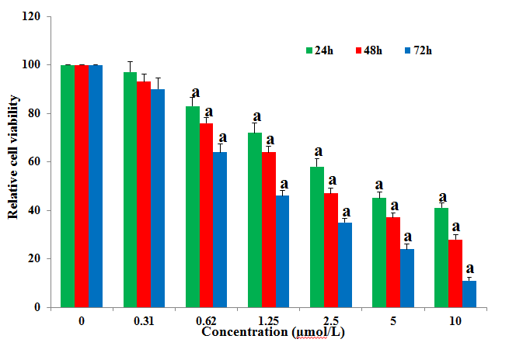
Figure 1 Gambogic acid-induced anti-proliferation of HT-29 cells. Relative cell viability (%) was evaluated by MTT assay after treatment for 24, 48 and 72 h. All data were normalized to 0 µmol/L, which was considered as 100%. ªP < 0.05 vs 0 µmol/L.

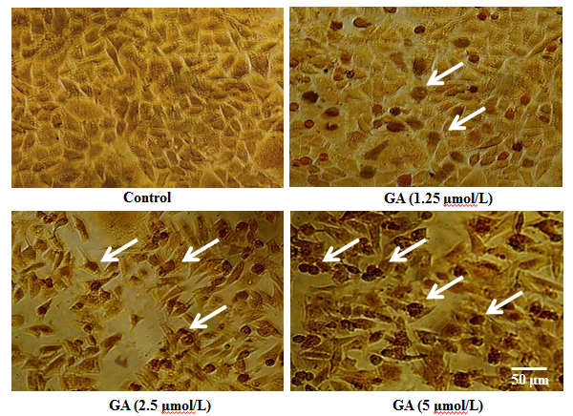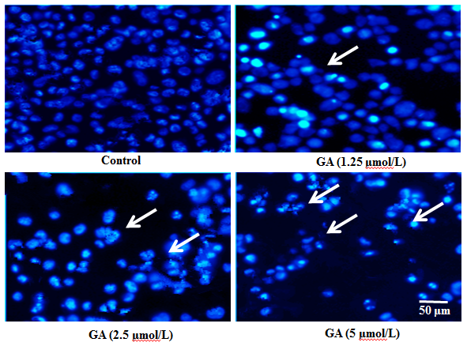
A B
Figure 2 Gambogic acid-induced apoptosis. Apoptotic HT-29 cells (arrows) were observed by A: Terminal deoxynucleotidyl transferase dUTP nick end labeling; and B: Hoechst 33342 staining after treatment with gambogic acid (GA) for 48 h.

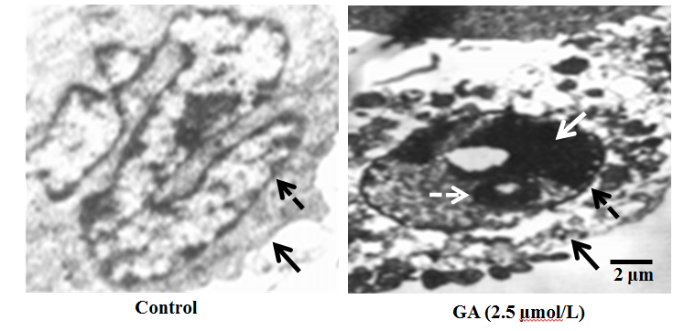
Figure 3 Ultrastructure of HT-29 cells. Transmission electron microscopy revealed ultrastructural changes in HT-29 cells after treatment with 2.5 µmol/L gambogic acid (GA) for 48 h; dashed black arrow shows the nuclear membrane; black arrow shows the cellular membrane; dashed white arrow shows the apoptotic body; and the white arrow shows the condensed nucleus.

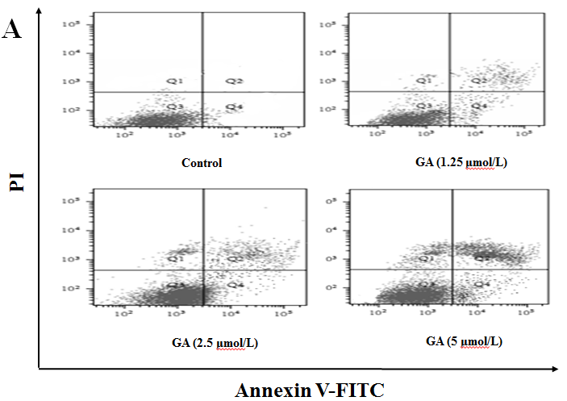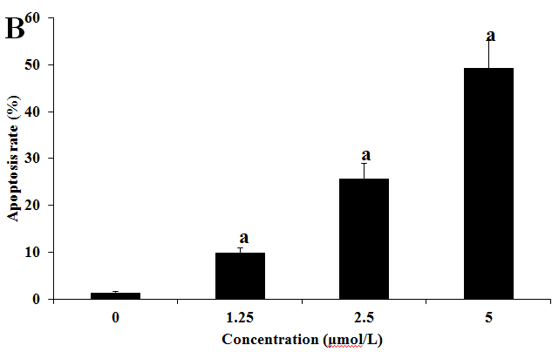
Figure 4 Quantification of gambogic acid-induced apoptosis by flow cytometry. A: HT-29 cells were treated for 48 h and sorted by flow cytometry to detect early (FITC-stained, lower right quadrant) and late [FITC- and propidium iodide (PI)-stained, upper right quadrant] apoptotic cells; B: The experiment was repeated three times and the average percentage of apoptotic cells (mean ± SE) is shown. ªP < 0.05 vs 0 µmol/L. GA: gambogic acid.

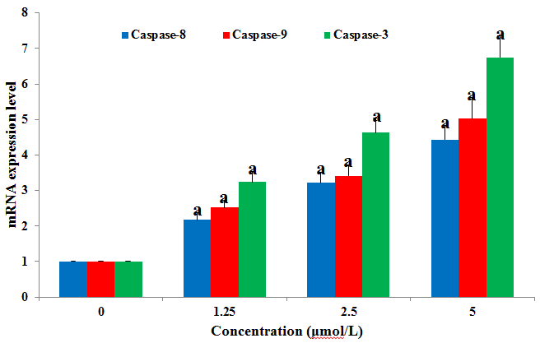
Figure 5 Gambogic acid increases the expression of caspase-9, -8 and -3 mRNA in HT-29 cells. HT-29 cells were treated for 48 h and mRNA expression was analyzed by quantitative real-time PCR. Expression levels were normalized to GAPDH and are relative to 0 µmol/L. ªP < 0.05 vs 0 µmol/L.

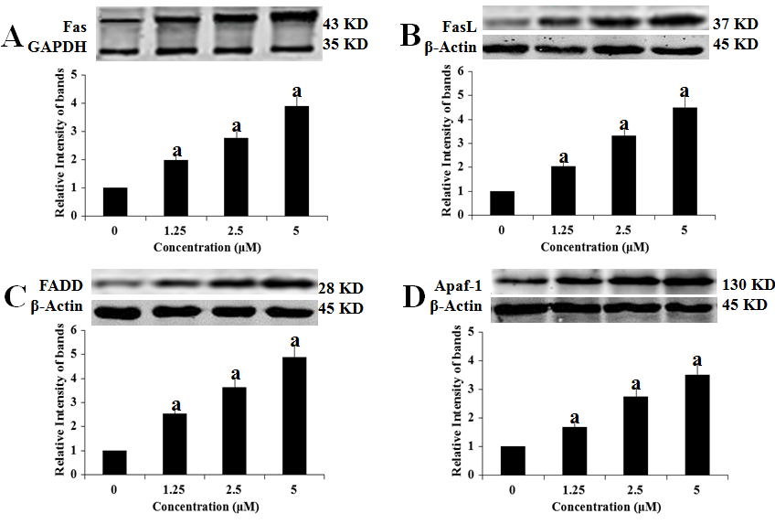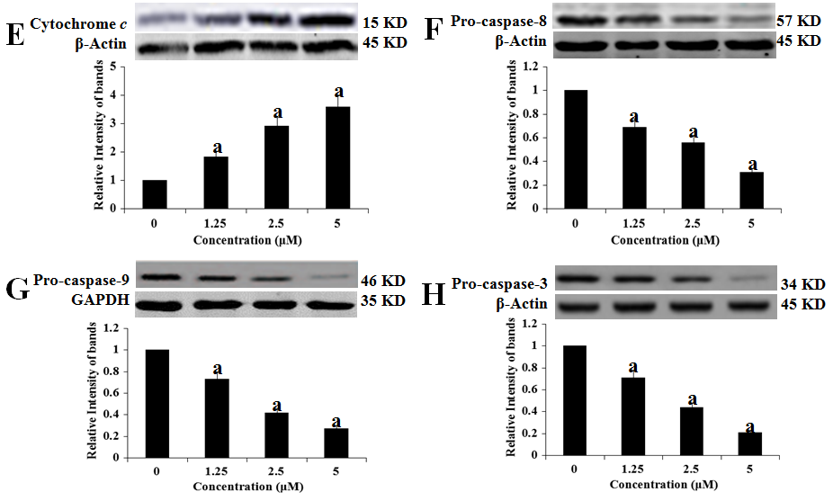
Figure 6 Effects of gambogic acid on the expression of apoptosis-related factors in HT-29 cells. HT-29 cells were treated with gambogic acid (GA) for 48 h and Western blotting was performed to measure levels of fas receptor (A); fas ligand (FasL) (B); FADD (C); apaf-1 (D); cytochrome c (E); pro-caspase-8 (F); pro-caspase-9 (G); and pro-caspase-3 (H). Data are reported as the mean ± SE of at least three experiments. ªP < 0.05 vs 0 µmol/L.

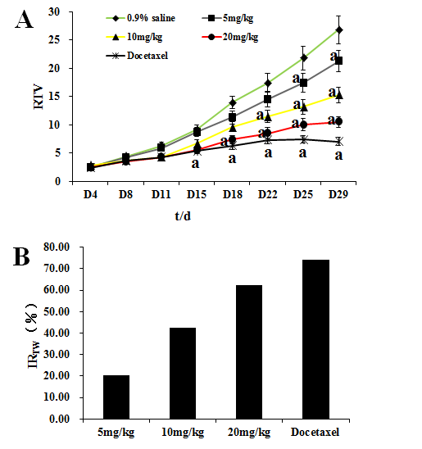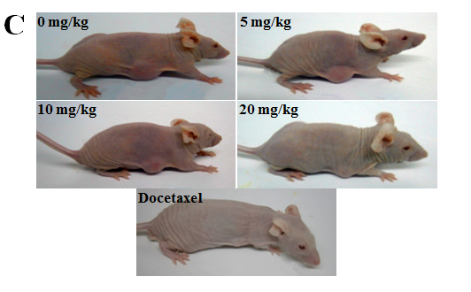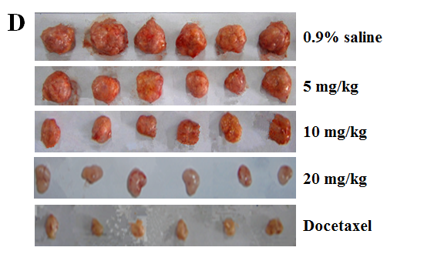
Figure 7 Gambogic acid inhibits the proliferation of HT-29 cells in BALB/c nude mice. A: Relative tumor volume (RTV) (mean ± SE) over the 29 d experiment; B: Inhibition ratio of tumor weight (IR_{TW}) from subcutaneously implanted HT-29 cells; Representative photographs of nude mice (C) and tumor samples (D) from the saline-, gambogic acid-, and docetaxel-treated groups. ªP < 0.05 vs saline.

