Name of Journal: World Journal of Gastroenterology
Manuscript NO: 54632
Manuscript Type: CASE REPORT

Multifocal gastrointestinal epithelioid angiosarcomas diagnosed by endoscopic mucosal resection: A case report

Chen YW et al. Multifocal gastrointestinal epithelioid angiosarcomas

You-Wei Chen, Jie Dong, Wan-Yuan Chen, Yi-Ning Dai

You-Wei Chen, Jie Dong, Department of Gastroenterology, Zhejiang Provincial People’s Hospital, People’s Hospital of Hangzhou Medical College, Hangzhou 310014, Zhejiang Province, China

Wan-Yuan Chen, Department of Pathology, Zhejiang Provincial People’s Hospital, People’s Hospital of Hangzhou Medical College, Hangzhou 310014, Zhejiang Province, China

Yi-Ning Dai, Department of Infectious Diseases, Zhejiang Provincial People's Hospital, Hangzhou 310014, Zhejiang Province, China

Author contributions: Chen YW was the patient’s doctor, who performed the gastroscopy, colonoscopy and endoscopic mucosal resection; Dong J was responsible for collecting medical history of the patient and drafting the paper; Chen WY was a pathologist who provided the pathological results; Dai YN reviewed the literature and revised the manuscript; all authors issued final approval for the version to be submitted.

Corresponding author: Yi-Ning Dai, MD, Chief Physician, Department of Infectious Diseases, Zhejiang Provincial People’s Hospital, No. 158, Shangtang Road, Hangzhou 310014, Zhejiang Province, China. daiyn@zju.edu.cn

Received: April 7, 2020
Revised: May 9, 2020
Accepted: July 15, 2020
Published online:

Abstract
BACKGROUND
Epithelioid angiosarcoma is a vascular neoplasm that is among the most aggressive subtypes of sarcomas. Its involvement in the gastrointestinal tract is rare. We here report a case of multifocal gastrointestinal epithelioid angiosarcomas presenting with gastrointestinal bleeding.

CASE SUMMARY
A 77-year-old woman was admitted because of melena and dizziness for three months. Gastroscopy and colonoscopy were performed, revealing a centrally ulcerated hemorrhagic polypoid lesion in the gastric body and multiple polypoid lesions with blood clots and hemorrhagic tendency in the colon. Histopathological examination of routine endoscopic biopsy samples showed inflammation in the gastric mucosa and tubular adenomas in the colon. The polypoid lesions were removed by endoscopic mucosal resection. Immunohistochemistry suggested a final diagnosis of epithelioid angiosarcomas. The patient refused chemotherapy and died after three months.

CONCLUSION
Epithelioid angiosarcomas are characterized by highly vascular nature and tendency to cause gastrointestinal bleeding. Efforts to obtain histological findings using endoscopic mucosal resection are of great importance.

Key words: Epithelioid angiosarcoma; Gastrointestinal tract; Endoscopic mucosal resection; Polypoid lesion; Immunohistochemistry; Case report

Chen YW, Dong J, Chen WY, Dai YN. Multifocal gastrointestinal epithelioid angiosarcomas diagnosed by endoscopic mucosal resection: A case report. World J Gastroenterol 2020; In press

Core tip: Gastrointestinal epithelioid angiosarcoma is extremely rare, which is only described in individual case reports and case series. Most reported cases appeared as centrally ulcerated, hemorrhagic, highly erythematous or purpuric nodules. Histopathology is the golden standard for diagnosis. Endoscopic biopsy often obtains insufficient specimens, while endoscopic mucosal resection of suspected lesions is satisfactory for histopathological examination. We here report a case of gastrointestinal bleeding which was finally diagnosed as multifocal epithelioid angiosarcomas in the gastrointestinal tract.

INTRODUCTION
Epithelioid angiosarcoma is a sporadic, highly aggressive malignancy that originates from a variety of locations, most commonly from the skin and soft tissue^{[1]}. This type of tumor occasionally occurs in the liver, spleen, ovary, breast and adrenal gland^{[2]}. Primary gastrointestinal angiosarcoma is extremely rare^{[3,4]}. Here, we present a case of multifocal epithelioid angiosarcomas involved in the gastrointestinal tract.

CASE PRESENTATION
Chief complaints
A previous healthy 77-year-old woman presented with a 3-mo history of melena and dizziness and was admitted to our hospital.

Physical and accessory examinations
The physical examination was unremarkable except for pale conjunctiva. Her hemoglobin level was 65 g/L. The platelet count, coagulation function, and blood biochemistry were within normal limits. The antinuclear antibody titre was 1:1000, while the anti-SSA (Ro60) antibodies were weakly positive. Autoimmune diseases were ruled out by rheumatologists because there were no related symptoms. Abdominal computed tomography angiography revealed nothing remarkable.

Endoscopy and histopathology
Gastroscopy demonstrated a centrally ulcerated haemorrhagic polypoid lesion in the gastric body (Figure 1A). Colonoscopy revealed multiple polypoid lesions with blood clots and hemorrhagic tendency in the ileocecum, ascending colon, transverse colon and sigmoid colon (Figure 1B-D). Routine endoscopic biopsies showed inflammatory infiltration in the gastric mucosa and tubular adenomas with low-grade intraepithelial neoplasia and local eosinophilic changes in the colon. Nevertheless, the pathologic findings did not conform to the endoscopic appearance of the foci. Subsequently, the lesions were resected en bloc by endoscopic mucosal resection for further diagnosis.
Microscopically, hematoxylin and eosin staining showed areas of epithelioid cells with abundant eosinophilic cytoplasm, which was morphologically similar to undifferentiated carcinoma or poorly differentiated adenocarcinoma (Figure 2). Immunohistochemical staining (Figure 3) demonstrated that the tumor cells were positive for pan-cytokeratin (AE1/AE3), CD31, CD34, EMA, vimentin and Ki67 (60% positive) and negative for hepatocytes, S100, CD117, DOG1, CD56, SYN, CgA, LCA, desmin or ALK. The final pathological diagnosis was epithelioid angiosarcoma.

Positron emission tomography/computed tomography
To determine whether distant metastasis occurred, additional F-18 ﬂuorodeoxyglucose positron emission tomography/computed tomography (PET/CT) was performed. PET/CT showed tubular hypermetabolic lesions in the colon, suggesting malignancy. Furthermore, numerous hypermetabolic hilar and mediastinal lymph nodes, as well as multiple node-like foci with active F-18 ﬂuorodeoxyglucose metabolism in the bones, were observed, revealing lymphatic and osseous metastasis (Figure 4).

FINAL DIAGNOSIS
Multifocal gastrointestinal epithelioid angiosarcomas with lymphatic and osseous metastasis.

OUTCOME AND FOLLOW-UP
The patient refused chemotherapy and died after three months due to gastrointestinal bleeding.

DISCUSSION
Angiosarcomas may arise in any part of the body, but commonly occur in skin and superficial soft tissues, with its predilection sites in the head and neck^{[5]}. Epithelioid angiosarcoma of the gastrointestinal tract is an extremely rare neoplasm, which is only described in individual case reports and case series^{[6-9]}, with a lack of demographic morbidity data. According to literatures, vascular tumors of the stomach constitute only 0.9%-3.3% of all gastric cancers^{[10]}, while colorectal angiosarcomas represent less than 0.001% of all colorectal neoplasms^{[11]}.
Epithelioid angiosarcoma is characterized by an extremely aggressive course, leading to a very poor prognosis^{[12]}. Even for localized disease, patients without any therapy had a 0% survival rate at 2 years^{[5]}. Due to the infiltrative nature of this neoplasm, recurrence and metastasis are frequent after surgical resection, even for localized disease. Cytotoxic chemotherapy can be effective in a subset of patients for a limited period, but metastatic angiosarcomas remain incurable and even fatal^{[5]}. Targeted therapy with tyrosine kinase inhibitors usually resulted in significant responses, but these tumors are prone to developing resistance^{[5]}.
In most cases of gastrointestinal angiosarcoma, the symptoms are nonspecific, including abdominal pain, weight loss and anorexia. Overt bleeding with melena or hematochezia is less common. The patient in the present report had positive antinuclear antibody and anti-SSA, which might be secondary to the tumor. Nevertheless, until now, there is no evidence that the positivity of autoimmune antibodies has association with angiosarcomas. Further studies are needed to clarify their relationships.
Almost all reported lesions that occurred in the gastrointestinal tract appeared endoscopically as centrally ulcerated, hemorrhagic, highly erythematous or purpuric nodules/masses^{[13]}. Endoscopy with direct visualization and biopsy is crucial for diagnosis. However, endoscopic biopsy often obtains insufficient specimens and leads to the possibility of a missed diagnosis^{[14]}, similar to this case. It is well known that invasive carcinomas are likely to be covered by normal epithelium or intraepithelial neoplasm. Consequently, findings of the biopsy on their surface usually do not reflect the invasive components. Possible efforts to obtain additional histopathological findings must be made. In the present case, en bloc endoscopic mucosal resection of the suspected lesions in the colon was satisfactory for the histopathological examination. Due to the confirmation of malignant angiosarcomas, the patient refused to have another large-scale biopsy of the gastric lesion, in which the endoscopic performance was similar and typical.
Epithelioid angiosarcoma mimics carcinoma morphologically and contains numerous vasoformative structures. Because of the high architectural and cytological variability, pathological diagnosis is difficult. Immunoreactivity for endothelial and epithelial cell markers can confirm the diagnosis. This innate characteristic of epithelioid angiosarcoma corresponds to the tendency of gastrointestinal bleeding. PET/CT has been reported to detect primary uterine and pulmonary epithelioid angiosarcoma^{[15,16]} and is of great value in identifying metastases.

CONCLUSION
We report a case of gastrointestinal bleeding that was finally diagnosed as multifocal epithelioid angiosarcomas involved in the gastrointestinal tract. The endoscopic characteristics of the lesions were highlighted and corresponded to the propensity of gastrointestinal bleeding. En bloc endoscopic mucosal resection contributed to the final histopathological diagnosis.

References
1 Young RJ, Brown NJ, Reed MW, Hughes D, Woll PJ. Angiosarcoma. Lancet Oncol 2010; 11: 983-991 [PMID: 20537949 DOI: 10.1016/S1470-2045(10)70023-1]
2 Chou JW, Cheng KS, Chen SF. Primary hepatic angiosarcoma with multifocal metastases in the gastrointestinal tract. Endoscopy 2013; 45 Suppl 2 UCTN: E319-E320 [PMID: 24008486 DOI: 10.1055/s-0033-1344574]
3 Zhai ZZ, Wang L, Zuo XL. A Rare Cause of Gastrointestinal Bleeding in a Patient With a History of Alcoholic Cirrhosis. Gastroenterology 2019; 156: e6-e8 [PMID: 30240671 DOI: 10.1053/j.gastro.2018.09.030]
4 Louie J, Tejaswi S, Matsukuma K. Colonic Angiosarcoma: A Rare Gastrointestinal Malignancy. Clin Gastroenterol Hepatol 2020; 18: e75 [PMID: 30981006 DOI: 10.1016/j.cgh.2019.04.019]
5 Florou V, Wilky BA. Current and Future Directions for Angiosarcoma Therapy. Curr Treat Options Oncol 2018; 19: 14 [PMID: 29520447 DOI: 10.1007/s11864-018-0531-3]
6 Jayaraman V, Wilkinson MN, Nagula S, Siebel M, Bucobo JC, Zee S, Buscaglia JM. Primary jejunal angiosarcoma: an extremely rare tumor diagnosed by means of anterograde spiral enteroscopy. Endoscopy 2011; 43 Suppl 2 UCTN: E219-E220 [PMID: 21590614 DOI: 10.1055/s-0030-1256397]
7 Leong J, Rascon MA, Kaushik N. Multifocal angiosarcoma of the gastrointestinal tract. Endoscopy 2008; 40 Suppl 2: E252-E253 [PMID: 18991227 DOI: 10.1055/s-2008-1077645]
8 Coumaros D, Tsesmeli N. Epithelioid angiosarcoma in the duodenal bulb. Endoscopy 2009; 41 Suppl 2: E232 [PMID: 19757369 DOI: 10.1055/s-0029-1214480]
9 Al Ali J, Ko HH, Owen D, Steinbrecher UP. Epithelioid angiosarcoma of the small bowel. Gastrointest Endosc 2006; 64: 1018-1021 [PMID: 17140922 DOI: 10.1016/j.gie.2006.04.020]
10 Tai CM, Hung CM, Lee TC, Chang HC, Wang HP. Primary gastric angiosarcoma presenting as an asymptomatic gastric submucosal tumor. J Formos Med Assoc 2007; 106: 961-964 [PMID: 18063519 DOI: 10.1016/S0929-6646(08)60068-6]
11 Al Beteddini OS, Brenez D, Firket C, Algaba R, Tabech A. Colonic angiosarcoma: A case report and review of literature. Int J Surg Case Rep 2013; 4: 208-211 [PMID: 23279809 DOI: 10.1016/j.ijscr.2012.11.021]
12 Grewal JS, Daniel AR, Carson EJ, Catanzaro AT, Shehab TM, Tworek JA. Rapidly progressive metastatic multicentric epithelioid angiosarcoma of the small bowel: a case report and a review of literature. Int J Colorectal Dis 2008; 23: 745-756 [PMID: 18080128 DOI: 10.1007/s00384-007-0420-x]
13 Saad A, Cappell MS, Amin M. Endoscopic findings with GI angiosarcoma correspond with the propensity of these vascular tumors to cause GI bleeding: two case reports and review of the literature. Dig Dis Sci 2013; 58: 1797-1801 [PMID: 23400736 DOI: 10.1007/s10620-013-2582-4]
14 Lee CK, Chung IK, Lee SH, Kim SP, Lee SH, Lee TH, Kim HS, Park SH, Kim SJ, Lee JH, Cho HD, Oh MH. Is endoscopic forceps biopsy enough for a definitive diagnosis of gastric epithelial neoplasia? J Gastroenterol Hepatol 2010; 25: 1507-1513 [PMID: 20796147 DOI: 10.1111/j.1440-1746.2010.006367.x]
15 Treglia G, Cardillo G, Graziano P. A rare case of primary pulmonary epithelioid angiosarcoma detected by (18)F-FDG PET/CT. Clin Nucl Med 2014; 39: 450-452 [PMID: 23657141 DOI: 10.1097/RLU.0b013e318292f3b3]
16 Hwang JP, Lim SM. Uterine Epithelioid Angiosarcoma on F-18 FDG PET/CT. Nucl Med Mol Imaging 2013; 47: 134-137 [PMID: 24900095 DOI: 10.1007/s13139-013-0191-y]

Footnotes
Informed consent statement: Informed written consent was obtained from the patient for publication of this report and any accompanying images.

Conflict-of-interest statement: The authors have declared that no conflict of interests exists.

CARE Checklist (2016) statement: The authors have read the CARE Checklist (2016), and the manuscript was prepared and revised according to the CARE Checklist (2016).

Open-Access: This article is an open-access article that was selected by an in-house editor and fully peer-reviewed by external reviewers. It is distributed in accordance with the Creative Commons Attribution NonCommercial (CC BY-NC 4.0) license, which permits others to distribute, remix, adapt, build upon this work non-commercially, and license their derivative works on different terms, provided the original work is properly cited and the use is non-commercial. See: http://creativecommons.org/licenses/by-nc/4.0/

Manuscript source: Unsolicited manuscript

Peer-review started: April 7, 2020
First decision: April 29, 2020
Article in press:

Specialty type: Gastroenterology and hepatology
Country/Territory of origin: China
Peer-review report’s scientific quality classification
Grade A (Excellent): 0
Grade B (Very good): 0
Grade C (Good): C, C
Grade D (Fair): 0
Grade E (Poor): 0

P-Reviewer: Perrotti S, Zhang YX S-Editor: Zhang L L-Editor: MedE-Ma JY E-Editor:

Figure Legends
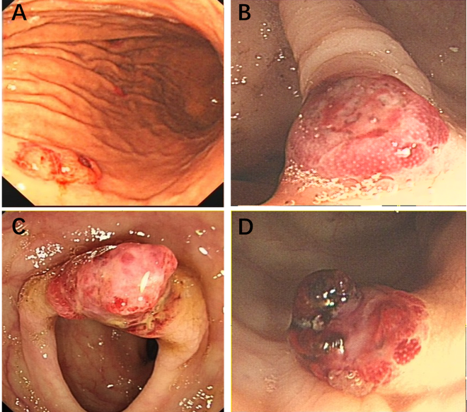
Figure 1 Endoscopy. A: Gastroscopy revealed a 0.5 cm × 0.6 cm centrally ulcerated polypoid lesion in the gastric body; B: A 0.8 cm × 0.8 cm polypoid lesion in the ascending colon; C: A 1.2 cm × 1.0 cm hyperaemic mass in the transverse colon; and D: A 0.8 cm × 0.8 cm polypoid nodule with hemorrhagic tendency and blood clots in the sigmoid colon.

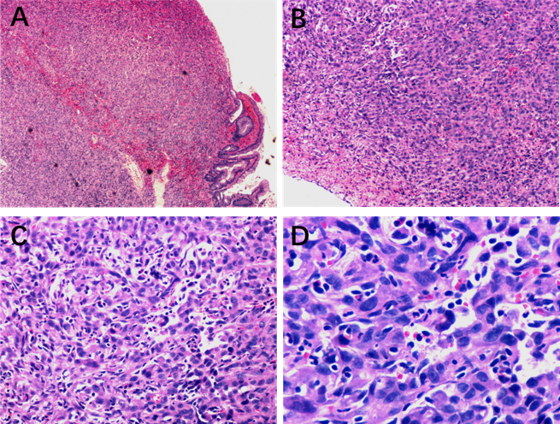
Figure 2 Histopathological findings. Poorly differentiated neoplasms consisting of large cells with pleomorphic nuclei and abundant eosinophilic cytoplasm were observed. A: Haematoxylin and eosin (HE) staining section × 40; B: HE staining section (× 100); C: HE staining section (× 200); and D: HE staining section (× 400).

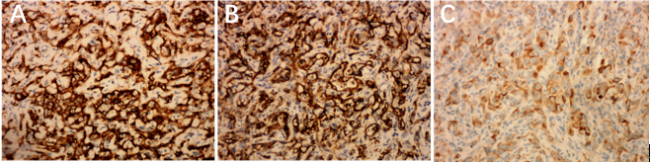
Figure 3 Immunohistochemical staining. A: Immunostaining for CD31; B: Immunostaining for CD34; and C: Immunostaining for pan-cytokeratin.

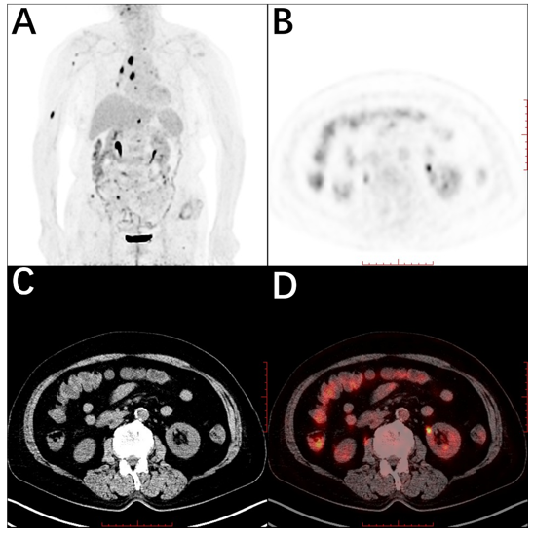
Figure 4 Whole-body maximum intensity projection 18F- ﬂuorodeoxyglucose and positron emission tomography image. A: Remarkably increased ﬂuorodeoxyglucose metabolism in the colon and mediastinal lymph nodes, as well as the right humerus; B: Positron emission tomography; C: Computed tomography; and D: Positron emission tomography/computed tomography in axial projection showed multiple tubular hypermetabolic lesions in the colon.

