Name of Journal: World Journal of Gastrointestinal Surgery
Manuscript NO: 87648
Manuscript Type: CASE REPORT

Gastric inflammatory myofibroblastic tumor, a rare mesenchymal neoplasm: A case report

Fernandez Rodriguez M et al. Gastric inflammatory myofibroblastic tumor

Manuel Fernandez Rodriguez, Pedro Joaquin Artuñedo Pe, Alejandro Callejas Diaz, Gala Silvestre Egea, Cristián Grillo Marín, Eva Iglesias Garcia, Jose Luis Lucena de La Poza

Manuel Fernandez Rodriguez, Pedro Joaquin Artuñedo Pe, Cristián Grillo Marín, Eva Iglesias Garcia, Jose Luis Lucena de La Poza, Department of General and Digestive Surgery, Hospital Universitario Puerta de Hierro, Majadahonda, Madrid 28222, Spain

Alejandro Callejas Diaz, Department of Internal Medicine, Hospital Universitario Puerta de Hierro, Majadahonda, Madrid 28222, Spain

Gala Silvestre Egea, Department of Pathologycal Anatomy, Hospital Universitario Puerta de Hierro, Majadahonda, Madrid 28222, Spain

Author contributions: Fernandez Rodriguez M, Artuñedo Pe P and Lucena de La Poza JL contributed to manuscript writing and editing; Silvestre Egea G provided the images of the anatomopathological study; all authors have read and approved the final manuscript.

Corresponding author: Manuel Fernandez Rodriguez, MD, Surgeon, Department of General and Digestive Surgery, Hospital Universitario Puerta de Hierro, Majadahonda, Calle Joaquin Rodrigo No. 1, Madrid 28222, Spain. man.fer.rod.96@gmail.com

Received: August 20, 2023
Revised: September 14, 2023
Accepted: September 27, 2023
Published online:

Abstract
BACKGROUND
The inflammatory myofibroblastic tumor (IMT) is a rare mesenquimal tumor of doubtful biological behaviour. It’s characterised for affecting mainly children and young adults, although it can appear at any age, being the lungs the primary affected organ (in children it represents 20% of all primary pulmonary tumors).

CASE SUMMARY
We present the case of a 45 year old woman, with a computed tomography (CT) finding of injury on the anterior surface of the fundus /gastric body and a solid perigastric injury of 12 mm in the ecoendoscopy. The case is presented in the tumor committee deciding to perform a laparoscopic wedge resection. The histological diagnosis was a IMT. The diagnosis is based on imaging tests like the abdominal CT, abdominal ecography and the ecoendoscopy but to confirm the diagnosis a pathological study is necessary.

CONCLUSION
Due to the unpredictable nature of this tumor, surgical resection is the best therapeutic option.

Key Words: Inflammatory myofibroblastic tumor; Gastric; Wedge resection; ALK-mutation; Case report

Fernandez Rodriguez M, Artuñedo Pe PJ, Callejas Diaz A, Silvestre Egea G, Grillo Marín C, Iglesias Garcia E, Lucena de La Poza JL. Gastric inflammatory myofibroblastic tumor, a rare mesenchymal neoplasm: A case report. World J Gastrointest Surg 2023; In press

Core Tip: The inflammatory myofibroblastic tumor is a rare mesenquimal tumor of doubtful biological behaviour. It’s characterised for affecting mainly children and young adults, although it can appear at any age, being the lungs the primary affected organ. The unusual thing about the case is the gastric location of the tumor (the majority are pulmonary) and the unpredictable nature of this tumor. That is why the surgical resection is the best therapeutic option.

INTRODUCTION
The inflammatory myofibroblastic tumor (IMT) is a rare mesenquimal tumor of doubtful biological behaviour^{[1]}. Previously known as inflammatory pseudotumor, plasmatic cell granulome, inflammatory miofibroblastoma and inflammatory miofibrohistiocityc proliferation, it’s characterised for affecting mainly children and young adults, although it can appear at any age, being the lungs the primary affected organ (in children it represents 20% of all primary pulmonary tumors)^{[2]}.

CASE PRESENTATION
Chief complaints
We present the case of a 45 year old woman who requested a follow-up in our center for a second opinión after discovery of injuries that could relate to a peritoneal carcinomatosis in other center.

History of present illness
She was examined in another center given her clinic of difuse abdominal pain of long evolution without association with any other clinical manifestation, identifying in a computed tomography (CT) a “nodular isodense image, at omental level, adyacent to the anterior right abdominal wall, without discarding infiltration of the anterior right abdominal rectum. Increase in density and trabeculation of the mesenteric fat and inespecific micronodular images, findings which could relate to a peritoneal carcinomatosis”.

Personal and family history
She has a history of venous insuficiency and cronic gastritis, cesarean and adenoidectomy. She denied family history of malignant tumours.

Physical examination
On physical examination, the vital signs were as follows: Body temperature, 36.8°C; blood pressure, 121/70 mmHg; heart rate, 89 beats per min; respiratory rate: 17 breaths per min. Furthermore, the patient did not have abdominal pain, but minimal ascitites in flanks was found.

Laboratory examinations
Levels of serum tumour markers were normal [carcinoembryonic antigen < 0.5 ng/mL (0.0-3.0), carbohydrate antigen (CA) 125 14.0 U/mL (0.0-35.0), CA 19-9 5.0 U/mL (0.0-40.0), CA 15-3 14.9 U/mL (0.0-28.0)]. No abnormality was found in routine blood analyses.

Imaging examinations
A gastroscopy is requested evidencing a gastric submucous injury of 1 cm in lesser curvature and a biopsy is performed. The anatomopatological diagnosis was superficial cronic gastritis not observing an intestinal metaplasia.
Subsequently, a positron emission tomography CT is performed with the following results: “Decrease in the size of the nodular image in greater omentum, with a mild affinity for FDG. Improvement of the ascitis and the trabeculation of the omental and mesenteric fat. Hepatic injury without metabolic translation”.

Further diagnostic work-up
A core needle biopsy is performed of the omental injury observing fibrous tissue with no tumoral infiltration and tumor markers are requested, which come out negative.
The control CT evidences “resolution of previous peritoneal affectation with persistence and stability of a left subdiafragmatic nodulary injury on the anterior surface of the fundus /gastric body” (Figure 1). A gastric Ecoendoscopy is requested identifying a solid perigastric injury of 12 mm with indeterminate endosonographic appearance. A biopsy is performed on 3 occasions, without obtaining a representative sample.

MULTIDISCIPLINARY EXPERT CONSULTATION
The case is presented in the tumor committee deciding to perform an exploratory laparoscopy.

FINAL DIAGNOSIS
The pathology study reported a “mesenquimal injury of 1.3 cm growing in the muscular layer of the gastric wall, which is in contact with the resection margin. It’s sparsely celular, mainly constituted by fibrous tissue predominantly colagenised, with presence of spindle-shaped cells without significant atypia. Presence of psammomatous calcifications is also observed. The inmunophenotype of the tumor is: CK AE1-AE3+, Actina 1A4+ muy focal, ALK1-, Actina HHF35-, desmina-, caldesmon-, calponina-, CD34-, CKIT-, S100-” (Figure 2). Being the final diagnosis a IMT.

TREATMENT
We perform an exploratory laparoscopy. During the intervention, an injury of aproximately 2 cm is identified on the anterior gastric face, and a wedge resection of the injury is performed. The patient evolves favourably and is discharged to the second postoperative day.

OUTCOME AND FOLLOW-UP
At 1 mo postoperatively, the patient was still alive. Given these findings, the case is presented again to the multidisciplinar committee, which decides to carry out an annual Ecoendoscopy and toracic CT to examine the pulmonar nodule.

DISCUSSION
The IMT is rare tumor, predominantly located in the lungs but can also be found in the retroperitoneum, mesentery, head, neck and stomach. The latter case, presented by our patient, is extremely rare, with very few described in literature (Table 1).
It is characterized by local recurrence but rarely incurs in distant metastasis^{[3]}. Risk factors for the development of IMT have not been established, but cases have been described which suggest association with Virus Epstein bar, genetic alterations like the reorganisation of the anaplastic lymphoma kinase (ALK) gene in the 2p23 cromosome or alterations of the inmune system^{[3,4]}. They are usually asymptomatic or present inespecific symptoms like abdominal pain, toracic pain, and up to 30% develop a constitutional syndrome^{[1,2]}.
The diagnosis is based on imaging tests like the abdominal TC, abdominal ecography and the ecoendoscopy^{[5]}.
The differential diagnosis includes gastrointestinal stroma tumor, fibroid inflammatory polyp, single fibrous tumor or peripheral nerve tumors, amongst others^{[6]}.
Confirmation diagnosis is obtained with histological examination, which evidences proliferations of myofibroblasts, lymphoplasmacytic infiltrate, and a myxoid stroma^{[5]}.
Fifty-six percent of IMT present reorganisation of gene ALK. These patients present a higher risk of local recurrence but not distant metastasis (negative ALK), which suggests that reactivity to the ALK could be a protective factor^{[3]}.

CONCLUSION
Due to the unpredictable nature of this tumor, surgical resection is the best therapeutic option. Regarding gastric IMTs, depending on the tumor’s location, options go from a wedge resection to a partial gastrectomy^{[1-3]}. Patients which cannot undergo surgical interventions, can be treated with a combination of radiotherapy and chemotherapy. Patients with metastatic tumors or local advanced tumors resistent to conventional chemotherapy can be treated with Crizotinib if they present a mutation of ALK or Larotrectinib o Entrectinib, if they present mutations in the gene TRK^{[2]}.
The recurrence rate in the first year after surgery is of 15%-37%, therefore clinical and radiological follow-ups are indicated, without finding in the literature a defined periodicity for them^{[3,4]}.

REFERENCES
1 París-Sans M, Domènech-Calvet J, Raga-Carceller E, Sabench-Pereferrer F, Del Castillo-Déjardin D. Gastric inflammatory myofibroblastic tumour as a rare cause of biliary duct obstruction. Cir Esp 2016; 94: 188-190 [PMID: 26384976 DOI: 10.1016/j.ciresp.2015.06.008]
2 UpToDate. Uncommon sarcoma subtypes. Jul 31, 2023. [cited 20 May 2023]. Available from: https://medilib.ir/uptodate/show/114329
3 Cheng B, Yang C, Liu Z, Liu L, Zhou L. Primary gastric inflammatory myofibroblastic tumor: A case report. Medicine (Baltimore) 2018; 97: e13423 [PMID: 30557996 DOI: 10.1097/MD.0000000000013423]
4 Bjelovic M, Micev M, Spica B, Babic T, Gunjic D, Djuric A, Pesko P. Primary inflammatory myofibroblastic tumor of the stomach in an adult woman: a case report and review of the literature. World J Surg Oncol 2013; 11: 35 [PMID: 23374227 DOI: 10.1186/1477-7819-11-35]
5 Shi H, Wei L, Sun L, Guo A. Primary gastric inflammatory myofibroblastic tumor: a clinicopathologic and immunohistochemical study of 5 cases. Pathol Res Pract 2010; 206: 287-291 [PMID: 20304564 DOI: 10.1016/j.prp.2009.09.002]
6 Katakwar A, Gedam BS, Mukewar S, Agasti A. Primary gastric inflammatory myofibroblastic tumor in an adult-case report with brief review. Indian J Surg Oncol 2014; 5: 66-70 [PMID: 24669167 DOI: 10.1007/s13193-014-0296-5]
7 Leon CJ, Castillo J, Mebold J, Cortez L, Felmer R. Inflammatory myofibroblastic tumor of the stomach: an unusual complication after gastrectomy. Gastrointest Endosc 2006; 63: 347-349 [PMID: 16427957 DOI: 10.1016/j.gie.2005.09.026]
8 Park SH, Kim JH, Min BW, Song TJ, Son GS, Kim SJ, Lee SW, Chung HH, Lee JH, Um JW. Exophytic inflammatory myofibroblastic tumor of the stomach in an adult woman: a rare cause of hemoperitoneum. World J Gastroenterol 2008; 14: 136-139 [PMID: 18176977 DOI: 10.3748/wjg.14.136]
9 Jadhav M, Harvi R, Patil R, Kittur S. Inflammatory Myofibroblastic Tumor of the Stomach Presenting as an Exophytic Mass - A Diagnostic Dilemma. Turk Patoloji Derg 2019; 35: 151-156 [PMID: 28272683 DOI: 10.5146/tjpath.2017.01388]
10 Qiu JF, Shi YJ, Fang L, Wang HF, Zhang MC. High fever as an initial symptom of primary gastric inflammatory myofibroblastic tumor in an adult woman. Int J Clin Exp Med 2014; 7: 1468-1473 [PMID: 24995114]
11 Kim KA, Park CM, Lee JH, Cha SH, Park SW, Hong SJ, Seol HY, Cha IH, Mok YJ, Kim YS. Inflammatory myofibroblastic tumor of the stomach with peritoneal dissemination in a young adult: imaging findings. Abdom Imaging 2004; 29: 9-11 [PMID: 15160745 DOI: 10.1007/s00261-003-0085-z]
12 Albayrak F, Dursun H, Albayrak Y, Altas S, Uyanik A, Yildirim R. Inflammatory myofibroblastic tumor of the stomach in an adult woman: a rare intermittent cause of gastric outlet obstruction. Tumori 2010; 96: 492-495 [PMID: 20845815 DOI: 10.1177/030089161009600320]
Footnotes
Informed consent statement: Informed written consent was obtained from the patient for publication of this report and any accompanying images.

Conflict-of-interest statement: The authors declare that they have no conflict of interest to disclose.

CARE Checklist (2016) statement: The authors have read the CARE Checklist (2016), and the manuscript was prepared and revised according to the CARE Checklist (2016).

Open-Access: This article is an open-access article that was selected by an in-house editor and fully peer-reviewed by external reviewers. It is distributed in accordance with the Creative Commons Attribution NonCommercial (CC BY-NC 4.0) license, which permits others to distribute, remix, adapt, build upon this work non-commercially, and license their derivative works on different terms, provided the original work is properly cited and the use is non-commercial. See: https://creativecommons.org/Licenses/by-nc/4.0/

Provenance and peer review: Unsolicited article; Externally peer reviewed.

Peer-review model: Single blind

Peer-review started: August 20, 2023
First decision: September 4, 2023
Article in press:

Specialty type: Gastroenterology and hepatology
Country/Territory of origin: Spain
Peer-review report’s scientific quality classification
Grade A (Excellent): 0
Grade B (Very good): 0
Grade C (Good): C, C
Grade D (Fair): 0
Grade E (Poor): 0

P-Reviewer: Kumar M, India; liu QQ, China S-Editor: Lin C L-Editor: P-Editor:
Figure Legends
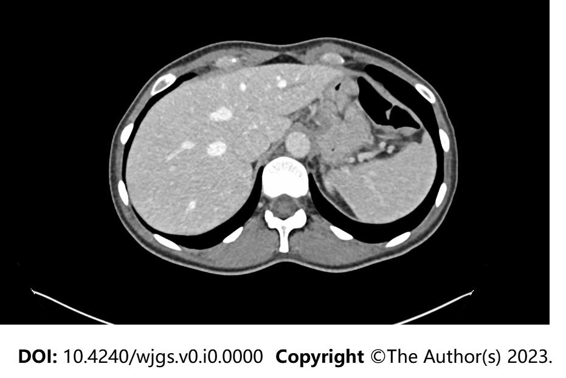
Figure 1 Nodulary injury on the anterior surface of the fundus/gastric body.

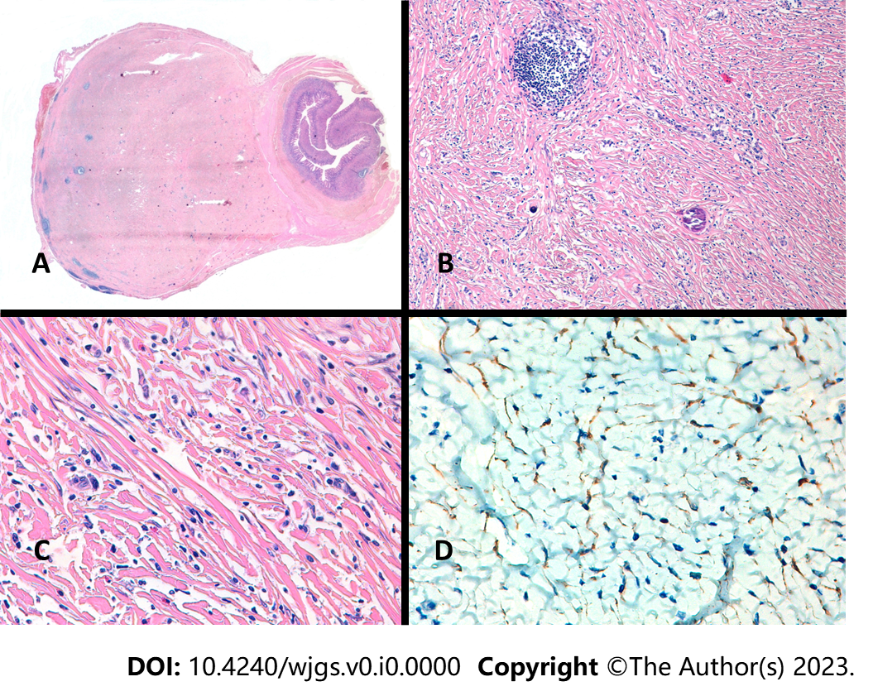
Figure 2 Histopathological analysis and immunohistochemical examination of the resected specimen. A: Panoramic image of the lesion; B: Mesenquimal injury and psamomatous calcifications; C: Mesenquimal lesion with infiltrate of eosinophils, plasma cells and masts cells; D: Positive expression of Cytokeratins AE1-AE3.

Table 1 Clinicopathological characteristics of inflammatory myofibroblastic tumors in adults, described in the literature
Ref. | Sex/age | Presenting symptoms | Tumor localization in the stomach | Tumor size (cm) | Mitosis | Histologic pattern | Treatment | Follow-up
París-Sans et al^{[1]} | M/88 | AP, vomiting, jaundice | GDJ | 4 | / | Proliferation of spindle-shaped mesenchymal cells mixed with lymphocytes | PG | /
Cheng et al^{[3]} | W/52 | AP | Antrum (exophytic) | 4.3 | 0-1 | Proliferation of fusiform cells | DG | 6 mo
Bjelovic et al^{[4]} | W/43 | AP, nausea | Distal Stomach | 6 | 1-2 | Hypercellular spindle cell proliferation with vague fascicular areas | DG | 2 yr
Shi et al^{[5]} | M/36 | AP, AM | Antrum, LC | 4.5 | 1-2 | Myxoid hypocellular with some fascicular areas | PG | 5 yr (NED)
Shi et al^{[5]} | M/42 | AP, UGH, AM, | Upper body, GC | 8 | 1-2 | Fascicular with some myxoid areas | PG | Recurrence at 12 mo
Shi et al^{[5]} | M/40 | AM | Upper body, AW | 6.3 | 1-2 | Myxoid hypocellular with some fascicular areas | PG | 3 yr (NED)
Shi et al^{[5]} | M/45 | AP, AM | Angle | 5.5 | 1-2 | Myxoid hypocellular with some fascicular areas | PG | 2.6 yr (NED)
Shi et al^{[5]} | W/45 | AP, AM | Lower body, PW | 5.8 | 1-2 | Fascicular with some myxoid and sclerotic areas | PG | 4 yr (NED)
Katakwar et al^{[6]} | M/45 | AP | AW | 5 | 1-2 | Hypocellular, collagenized, myofibroblatic cells | DG | Recurrence at 1 mo
Leon et al^{[7]} | W/50 | Vomiting, weight loss | PW | 7 | 1-2 | Patternless round and spindle cell proliferation | PG | 2 yr (NED)
Park et al^{[8]} | W/55 | AP, hematoperitoneum | Upper body, GC | 8 | 1-2 | Vague fascicular proliferation | Gastric wedge resection | /
Jadhav et al^{[9]} | M/18 | AM, weight loss | LC | 9 | 1-2 | Pleomorphic cells, spindle-shaped to stellate cells arranged in a background of myxoid | Excision | 5 yr
Qiu et al^{[10]} | W/61 | Fever | LC | 3 | / | Spindle cells with inflammatory infiltrate of neutrophils, eosinophils, lymphocytes, and plasma cells. | DG | 3 mo (NED)
Kim et al^{[11]} | M/25 | AM | GEJ | 8 | / | / | / | /
Albayrak^{[12]} et al | W/56 | Nausea, vomiting, UGH | Cardia | 11 | 1-2 | Granulation-type and storiform spindle cell proliferation | PG | 8 mo (NED)
Our Study | W/ 45 | AP | AW (exophytic) | 1.3 | / | Spindle/stellate cells with inflammatory cells | Gastric wedge resection | 1 mo
AP: Abdominal pain; AM: Abdominal mass; UGH: Upper gastrointestinal hemorrhage; LC: Lesser curvature of the stomach; GC: Greater curvature of the stomach; AW: Anterior wall of the stomach; PW: Posterior wall of the stomach; C: Cardia; PG: Partial gastrectomy; DG: Distal gastrectomy; NED: No evidence of disease; GDJ: Gastroduodenal junction; GEJ: Gastroesophagus junction; M: Male; F: Female.

