Name of journal: World Journal of Gastroenterology
Manuscript NO: 35806
Manuscript type: CASE REPORT

Rescue case of low birth weight infant with acute hepatic failure

Okada N et al. Low weight infant with hepatic failure

Noriki Okada, Yukihiro Sanada, Taizen Urahashi, Yoshiyuki Ihara, Naoya Yamada, Yuta Hirata, Takumi Katano, Kentaro Ushijima, Shinya Otomo, Shujiro Fujita, Koichi Mizuta

Noriki Okada, Yukihiro Sanada, Taizen Urahashi, Yoshiyuki Ihara, Naoya Yamada, Yuta Hirata, Takumi Katano, Koichi Mizuta, Department of Transplant Surgery, Jichi Medical University, Shimotsuke 3290498, Japan

Kentaro Ushijima, Department of Clinical Pharmacology, Jichi Medical University, Shimotsuke 3290498, Japan

Shinya Otomo, Department of Pharmacy, Jichi Medical University, Shimotsuke 3290498, Japan

Shujiro Fujita, Department of Pediatrics, Yokohama City University School of Medicine, Yokohama 2360004, Japan

ORCID number: Noriki Okada (0000-0001-5655-625X); Yukihiro Sanada (0000-0003-2456-0400); Taizen Urahashi (0000-0002-6229-090X); Yoshiyuki Ihara (0000-0002-0028-0634); Naoya Yamada (0000-0003-0111-028X); Yuta Hirata, (0000-0002-2728-2648); Takumi Katano (0000-0001-7649-7090); Kentaro Ushijima (0000-0003-2637-3916); Shinya Otomo (0000-0002-4857-0278); Shujiro Fujita (0000-0003-1790-3823); Koichi Mizuta (0000-0003-4270-4834).

Author contributions: Okada N contributed to the conception of the manuscript; Sanada Y, Urahashi T, Ihara Y, Yamada N, Hirata Y, Katano T, Ushijima K, Otomo S and Fujita S performed the treatment and collected data; Okada N drafted the manuscript; Mizuta K reviewed the manuscript; all authors read and approved the final manuscript.

Institutional review board statement: This study was reviewed and approved by the Ethics Committees of Jichi Medical University (15-106).

Informed consent statement: The patient involved in this study gave informed consent, authorized use and disclosure of protected health information.

Conflict-of-interest statement: The authors have no competing interests to disclose.

Open-Access: This article is an open-access article which was selected by an in-house editor and fully peer-reviewed by external reviewers. It is distributed in accordance with the Creative Commons Attribution Non Commercial (CC BY-NC 4.0) license, which permits others to distribute, remix, adapt, build upon this work non-commercially, and license their derivative works on different terms, provided the original work is properly cited and the use is non-commercial. See: http://creativecommons.org/licenses/by-nc/4.0/

Manuscript source: Unsolicited Manuscript

Correspondence to: Noriki Okada, MD, PhD, Department of Transplant Surgery, Jichi Medical University, 3311-1 Yakushiji, Shimotsuke 3290498, Japan. r0906no@jichi.ac.jp
Telephone: +81-285-587069
Fax: +81-285-587069

Received: August 8, 2017
Peer-review started: August 9, 2017
First decision: August 30, 2017
Revised: September 13, 2017
Accepted: September 26, 2017
Article in press:
Published online:

Abstract
We report a case involving a rescued low birth weight infant (LBWI) with acute liver failure. Case: The patient was 1594 g and 32^{3/7} gestational wk at birth. At the age of 11 d, she developed acute liver failure due to gestational alloimmune liver disease. Exchange transfusion and high-dose gamma globulin therapy were initiated, and body weight increased with enteral nutrition. Exchange transfusion was performed a total of 33 times prior to living donor liver transplantation (LDLT). Her liver dysfunction could not be treated by medications alone. At 55 d old and a body weight of 2946 g, she underwent LDLT using an S2 monosegment graft from her mother. Three years have passed with no reports of intellectual disability or liver dysfunction. LBWIs with acute liver failure may be rescued by LDLT after body weight has increased to over 2500 g.

Key words: Liver transplantation; Acute liver failure; Low birth weight infant; Transplantable body weight; Monosegment graft

© The Author(s) 2017. Published by Baishideng Publishing Group Inc. All rights reserved.

Core tips: We report a case involving a rescued low birth weight infant (LBWI) with acute liver failure. The patient was 1594 g at birth. At the age of 11 d, she developed acute liver failure due to gestational alloimmune liver disease. Medications were initiated, and body weight increased with enteral nutrition. Her liver dysfunction could not be treated by medications alone. At 55 d old with a body weight of 2946 g, she underwent living-donor liver transplantation (LDLT) using an S2 monosegment graft. Conclusion: LBWIs with acute liver failure may be rescued by LDLT after body weight has increased to over 2500 g.

Okada N, Sanada Y, Urahashi T, Ihara Y, Yamada N, Hirata Y, Katano T, Ushijima K, Otomo S, Fujita S, Mizuta K. Rescue case of low birth weight infant with acute hepatic failure. World J Gastroenterol 2017; In press

INTRODUCTION
Neonatal acute hepatic failure is a rare but serious disease^{[1]}. Reports have indicated that the cause of neonatal acute hepatic failure is most frequently gestational alloimmune liver disease (GALD), but in rare cases, it can be metabolic disorder, viral infection, or mitochondrial disorder, among other possibilities^{[2]}. The initial treatment for neonatal acute liver failure is apheresis and medication while the cause of hepatic failure is determined. If hepatic recovery has not been achieved with medication alone, liver transplantation is indicated^{[1,3]}. However, the living donor liver transplantation (LDLT) procedure for neonatal recipients is challenging due to the size mismatch between the liver graft and the body of the recipient. Moreover, management during the perioperative period is also challenging^{[4]}. LDLT is particularly difficult for low birth weight infants (LBWIs) for the reasons discussed above. In such cases, LDLT can result in recovery if the body weight of the infant can be increased by nutritional management^{[5]}. However, few reports have discussed LDLT for neonatal recipients with low body weights^{[6]}. Herein, we report a case involving a rescued LBWI with acute liver failure and discuss the limitation of body weight as an indicator for neonatal LDLT.

CASE REPORT
The patient was born at 32^{3/7} gestational wk because of fetal distress. Her birth weight was 1594 g (Figures 1 and 2). Immediately after birth, hypoglycemia and hypotension appeared. A daily administration of hydrocortisone and continuous administration of dopamine hydrochloride were started at the age of 1 day. At the age of 11 d, coagulation dysfunction and an elevated serum ferritin level due to acute liver failure were observed (ferritin 2865 ng/mL, total bilirubin 12.5 mg/dL, PT-INR 4.57). The patient’s older sister was highly suspected of GALD by clinical course and pathological findings and underwent LDLT at 13 d of age. GALD was highly suspected in this case after excluding the possibility of metabolic disorder or infectious disease. The patient did not undergo magnetic resonance imaging or salivary grand biopsy for GALD diagnosis. We explained the high recurrence rate of GALD in siblings to her parents; however, the parents gave birth to a baby in another hospital without informing us. Starting at 11 d of age, exchange transfusion and medication therapy using high-dose gamma globulin and deferoxamine were initiated. The patient’s body weight had been gradually increased with enteral nutrition using commercially available nutrients, administered 8 times per day via a gastric tube. She then recovered from hypotension, and the continuous administration of dopamine hydrochloride was finished. Exchange transfusion was performed a total of 33 times prior to LDLT. The patient was transported to our hospital at 44 d of age; at that time, her body weight was 2525 g. We speculated that her target body weight for LDLT would be over 2500 g based on the estimated graft volume. Computed tomography scan revealed a markedly atrophied liver (resected liver was 78 g). Laboratory data showed repeated coagulopathy and hyperbilirubinemia with daily exchange transfusion and a pediatric end-stage liver disease (PELD) score of 15.8 (T-bil 5.09 mg/dL, PT-INR 1.91, Albumin 3.4 g/dL). A liver biopsy revealed a marked loss of hepatocytes. The remaining hepatocytes were multinucleated, and there was widespread fibrosis around Glisson’s sheath and in the parenchymal area (F3-4) (Figure 2 F and G). Thus, her liver dysfunction could not be successfully treated via medications alone, and she was judged to be indicated for liver transplantation at that time. We tried to perform LDLT at 45 d of age, but before LDLT, she went into shock following hemothorax due to failure of catheter insertion with injury of the right subclavian artery. After the recovery period, she underwent LDLT at 55 d of age using an S2 monosegment graft from her mother (107 g, graft-recipient weight ratio (GRWR) 3.6%, Figure 2 A). The body weight of the patient at LDLT was 2946 g. At the time of LDLT, the PELD score of the patient was 21.9 (T-bil 13.74 mg/dL, PT-INR 2.12, Albumin 3.7 g/dL). The operation duration was 13 h and 37 min and bleeding was 700 mL [238 mL/recipient body weight (kg)]. A transverse incision was created, and the liver was resected with temporary bypass of the portal vein. The resected liver was 78 g (Figure 2 E). The recipient’s right hepatic artery (2.0 mm) was anastomosed to the graft’s left hepatic artery (2.5 mm) via a dorsal position of the portal vein anastomosis using a microsurgical technique. The graft-to-recipient distance ratio (GRDR) was 2.4 (58/24). Biliary reconstruction was performed using a Roux-en-Y hepaticojejunostomy. The abdominal wound could not be closed because respiratory failure occurred due to abdominal compartment syndrome (Figure2 B and C). Intraoperative water balance was +1645 mL [558 mL/recipient body weight (kg)]. After LDLT, continuous hemodiafiltration (CHDF) had been performed for systemic edema, removing water as long as blood pressure and portal vein flow remained steady. Respiratory failure due to abdominal compartment syndrome and lung edema gradually improved. Thus, on postoperative day (POD) 5, the abdominal skin of the patient was closed without closing the abdominal fascia (Figure 2D). Tacrolimus and methylprednisolone were used as the standard postoperative immunosuppression therapy regimen. Acute rejection occurred on POD 17, so steroid pulse therapy was initiated. After steroid pulse therapy, liver enzyme, PT-INR and T-bil were nearly normalized. Respiratory failure due to large-for-size graft syndrome had been prolonged; however, it gradually improved, and she was extubated on POD 81. Cytomegalovirus infection and catheter infection occurred several times and were treated using antivirus or antibiotic drugs. The patient showed difficulty eating sufficient meals and required habilitation to eating. She was discharged on POD 225. Vessel complications did not occur. Three years have passed since LDLT, with no reports of intellectual disability or liver dysfunction.

DISCUSSION
Liver transplantation for a small recipient
We rescued a case involving an LBWI with acute liver failure; however, few reports to date describe such a case (Table 1). To our knowledge, the lightest LDLT recipient had a body weight of 2.4 kg at the time of LDLT^{[7]}, and the youngest LDLT recipient in Japan was 9 d of age^{[8-10]}. For deceased donor liver transplantation, the smallest reported recipient was 2 kg, and the youngest was 7 d of age^{[11]}. No consensus has been reached regarding the safe lower limit of body weight for small recipients. A recent UNOS database analysis of infants weighting less than 5 kg revealed one-year patient and graft survival rates of 77.7% and 66.1%, respectively^{[12]}. A recent Japanese study reported an improved survival rate of 90.1% in an infant recipient within 3 mo^{[7]}. Recipients who were within 3 mo of age also showed a higher rate of biliary complications^{[7]}. However, our case did not have biliary complications. The problems we experienced in the described case were related to the following: (1) large-for-size graft syndrome^{[4]}; (2) the transplantable body weight of the recipient; and (3) vessel reconstruction difficulties^{[13]}. Challenges in managing transplantation for LBWIs with acute liver failure are nearly always due to the low body weight and fragility of the recipient.

The lower limit of the recipient’s body weight for living donor liver transplantation
In liver transplantation, the transplantable body weight of a neonatal recipient is limited by graft size. If the GRWR is greater than 4.0%, the risk of abdominal compartment syndrome and insufficient blood supply in relation to a large-for-size graft are increased; the recipient abdomen cannot be closed, or massive hepatocyte necrosis may occur in the transplanted graft^{[8,10,14,15]}. In pediatric LDLT, particularly in cases for which the recipient’s body weight is less than 6 kg, monosegment grafts or hyper-reduced left lateral grafts have been transplanted^{[4]}. A total of 268 pediatric patients underwent LDLT 275 times between May 2001 and December 2015 at Jichi Medical University Hospital. These transplantation procedures involved 196 left lateral segment grafts, with a median graft weight of 230 g (range, 138-382 g). Monosegment grafts were transplanted in 13 cases (including 9, 3, and 1 cases involving S2, reduced S2, and S3 monosegment grafts, respectively); in these cases, the median graft weight was 124 g (range, 93-180 g). A hyper-reduced left lateral segment graft was transplanted in 1 case, and the graft volume was 172 g. The smallest graft that we have transplanted was 93 g, and the median GRWR was 3.6% (2.4%-4.2%). A previous study reported hyper-reduced left lateral segment graft weights of 72-189 g, with most graft weights being 100-150 g^{[7]}. The lower limit of the smallest graft volume from a living donor is approximately 100 g^{[10]}. Given this graft weight, transplantable recipient body weights of 2500 g or more will result in a GRWR of 4.0% or less. Based on this estimation, 2500 g is a reasonable body weight for such recipients.

The specific peritransplant management of living donor liver transplantation for low birth weight infant
In our experience, the body weights of the described patient were increased by enteral nutrition and became greater than 2500 g at 44 d of age. Another case of increased body weight by enteral nutrition was reported, and the body weight increased to greater than 2500 g at 41 d of age^{[5]}. Despite the existence of acute liver failure, the body weights of the patients increased to over 2500 g via enteral nutrition while exchange transfusions were performed. Thus, in cases of acute liver failure, body weight may be increased with enteral nutrition if appropriate medication therapy that includes apheresis, such as exchange transfusion or plasmapheresis, is performed.
At times, it is impossible to close the abdominal fascia of the recipient during LDLT due to abdominal compartment syndrome. In this case, the abdominal fascia could not be closed during LDLT; instead, the case required secondary skin closure. In cases involving pediatric LDLT patients, apheresis and dialysis are reportedly effective^{[16]}. Aggressive water removal using CHDF was required in this case. Thus, even if LDLT for an LBWI with acute liver failure is successfully performed after an increase in body weight, circulation and respiratory management are challenging due to volume overload. Under these circumstances, aggressive water removal using CHDF and secondary abdominal closure approaches are useful and important tools for successful postoperative management.

Hepatic arterial reconstruction during living donor liver transplantation
Vessel reconstruction in cases similar to the described case is difficult due to the high GRDR between the hepatic vein and the portal vein bifurcation and to diameter mismatch for the hepatic artery between the graft and the recipient^{[13]}. Hepatic artery reconstruction by the dorsal approach of portal vein anastomosis has been reported to help reduce the risk of hepatic artery complications among small recipients if the GRDR is over 2.4^{[13]}. At times, the hepatic arteries of such recipients are thin. The hepatic artery of this case was not thin; however, the GRDR was 2.4, and the hepatic artery was anastomosed by a dorsal approach. In our experience of 13 cases of LDLT using monosegment grafts, the thinnest artery among the recipients was 1.2 mm, with 3 cases involving hepatic arteries of less than 1.5 mm. The graft-to-recipient diameter ratio was 0.67: 1.67. In addition, the dorsal position was selected for hepatic artery anastomotic approaches in 7 cases (53.8%), and the branch patch technique was selected in 5 cases (38.5%). Hepatic artery complications after LDLT occurred in 3 cases, although interventional radiology was sufficient for achieving recovery in all 3 cases.
We rescued a case of LBWI with acute liver failure by performing LDLT. In cases involving LBWIs with acute liver failure, infants may be rescued by LDLT after their body weights have been increased to over 2500 g via repeated exchange transfusions and enteral nutrition.

COMMENTS
Case characteristics
The patient was 1594 g, 32^{3/7} gestational wk at birth and immediately after birth, hypoglycemia and hypotension appeared.

Clinical diagnosis
At the age of 11 d, coagulation dysfunction and an elevated serum ferritin level due to acute liver failure were observed.

Differential diagnosis
The case was highly suspected of gestational alloimmune liver disease and differential diagnosis was metabolic disorder, infectious disease and Neimann-Pick disease type C.

Laboratory diagnosis
Laboratory data showed repeated coagulopathy and hyperbilirubinemia with daily exchange transfusion and a pediatric end-stage liver disease score of 15.8.

Imaging diagnosis
Computed tomography scan revealed a markedly atrophied liver.

Pathological diagnosis
A liver biopsy revealed a marked loss of hepatocytes and the remaining hepatocytes were multinucleated, and there was widespread fibrosis around Glisson’s sheath and in the parenchymal area (F3-4).

Treatment
The case underwent living donor liver transplantation at 55 d of age using an S2 monosegment graft from her mother (107 g).

Related reports
Kasahara M et al and Mizuta K et al reported the living donor liver transplantation for small recipient (Exp Clin Transplant 2014; 12 Suppl 1:1-4, Am J Transplant 2010; 10: 2547-2552).

Term explanation
Low birth weight infant (LBWI) is defined as a birth weight of a infant of 2499 g or less regarding of gestational age.

Experiences and lessons
In cases involving LBWI with acute liver failure, infants may be rescued by living donor liver transplantation after their body weights have been increased to over 2500 g.

Peer-review
The authors presented an interesting case with LBWIs (1594g, 323/7 wk) with acute liver failure.

REFERENCES
1 Taylor SA, Whitington PF. Neonatal acute liver failure. Liver Transpl 2016; 22: 677-685 [PMID: 26946058 DOI: 10.1002/lt.24433]
2 Bitar R, Thwaites R, Davison S, Rajwal S, McClean P. Liver Failure in Early Infancy: Aetiology, Presentation, and Outcome. J Pediatr Gastroenterol Nutr 2017; 64: 70-75 [PMID: 27007398 DOI: 10.1097/MPG.0000000000001202]
3 Lopriore E, Mearin ML, Oepkes D, Devlieger R, Whitington PF. Neonatal hemochromatosis: management, outcome, and prevention. Prenat Diagn 2013; 33: 1221-1225 [PMID: 24030714 DOI: 10.1002/pd.4232]
4 Yamada N, Sanada Y, Hirata Y, Okada N, Wakiya T, Ihara Y, Miki A, Kaneda Y, Sasanuma H, Urahashi T, Sakuma Y, Yasuda Y, Mizuta K. Selection of living donor liver grafts for patients weighing 6kg or less. Liver Transpl 2015; 21: 233-238 [PMID: 25422258 DOI: 10.1002/lt.24048]
5 Koura U, Horikawa S, Okabe M, Kawasaki Y, Makimoto M, Mizuta K, Yoshida T. Successful treatment of hemochromatosis with renal tubular dysgenesis in a preterm infant. Clin Case Rep 2015; 3: 690-693 [PMID: 26331014 DOI: 10.1002/ccr3.306]
6 Alawi K, Mitros FA, Bishop WP, Rayhill S, Wu Y. A reduced segment II/III graft for neonatal liver failure with absence of detectable hepatocytes. A case report and literature review. Pediatr Transplant 2011; 15: e60-e63 [PMID: 20059724 DOI: 10.1111/j.1399-3046.2009.01276.x]
7 Kasahara M, Sakamoto S, Sasaki K, Uchida H, Kitajima T, Shigeta T, Narumoto S, Hirata Y, Fukuda A. Living donor liver transplantation during the first 3 months of life. Liver Transpl 2017; 23: 1051-1057 [PMID: 28220684 DOI: 10.1002/lt.24743]
8 Kasahara M, Sakamoto S, Umeshita K, Uemoto S. Effect of graft size matching on pediatric living-donor liver transplantation in Japan. Exp Clin Transplant 2014; 12 Suppl 1: 1-4 [PMID: 24635782 DOI: 10.6002/ect.25Liver.L5]
9 Umeshita K, Inomata Y, Furukawa H, Kasahara M, Kawasaki S, Kobayashi E, Kokudo N, Sakisaka S, Shimada M, Tanaka E, Uemoto S; Japanese Liver Transplantation Society. Liver transplantation in Japan: Registry by the Japanese Liver Transplantation Society. Hepatol Res 2016; 46: 1171-1186 [PMID: 26887781 DOI: 10.1111/hepr.12676]
10 Mizuta K, Yasuda Y, Egami S, Sanada Y, Wakiya T, Urahashi T, Umehara M, Hishikawa S, Hayashida M, Hyodo M, Sakuma Y, Fujiwara T, Ushijima K, Sakamoto K, Kawarasaki H. Living donor liver transplantation for neonates using segment 2 monosubsegment graft. Am J Transplant 2010; 10: 2547-2552 [PMID: 20977646 DOI: 10.1111/j.1600-6143.2010.03274.x]
11 Grabhorn E, Richter A, Fischer L, Ganschow R. Emergency liver transplantation in neonates with acute liver failure: long-term follow-up. Transplantation 2008; 86: 932-936 [PMID: 18852658 DOI: 10.1097/TP.0b013e318186d64a]
12 Arnon R, Annunziato R, Miloh T, Sogawa H, Nostrand KV, Florman S, Suchy F, Kerkar N. Liver transplantation in children weighing 5 kg or less: analysis of the UNOS database. Pediatr Transplant 2011; 15: 650-658 [PMID: 21797956 DOI: 10.1111/j.1399-3046.2011.01549.x]
13 Sanada Y, Hishikawa S, Okada N, Yamada N, Katano T, Hirata Y, Ihara Y, Urahashi T, Mizuta K. Dorsal approach plus branch patch technique is the preferred method for liver transplanting small babies with monosegmental grafts. Langenbecks Arch Surg 2017; 402: 123-133 [PMID: 27456678 DOI: 10.1007/s00423-016-1479-z]
14 Ogawa K, Kasahara M, Sakamoto S, Ito T, Taira K, Oike F, Ueda M, Egawa H, Takada Y, Uemoto S. Living donor liver transplantation with reduced monosegments for neonates and small infants. Transplantation 2007; 83: 1337-1340 [PMID: 17519783 DOI: 10.1097/01.tp.0000263340.82489.18]
15 Kasahara M, Uryuhara K, Kaihara S, Kozaki K, Fujimoto Y, Ogura Y, Ogawa K, Oike F, Ueda M, Egawa H, Tanaka K. Monosegmental living donor liver transplantation. Transplant Proc 2003; 35: 1425-1426 [PMID: 12826178 DOI: 10.1016/S0041-1345(03)00445-7]
16 Sanada Y, Mizuta K, Urahashi T, Ihara Y, Wakiya T, Okada N, Yamada N, Koinuma T, Koyama K, Tanaka S, Misawa K, Wada M, Nunomiya S, Yasuda Y, Kawarasaki H. Role of apheresis and dialysis in pediatric living donor liver transplantation: a single center retrospective study. Ther Apher Dial 2012; 16: 368-375 [PMID: 22817126 DOI: 10.1111/j.1744-9987.2012.01079.x]

P-Reviewer: Hashimoto K, Xu X, Quintero J S-Editor: Chen K L-Editor: E-Editor:
Specialty type: Gastroenterology and hepatology
Country of origin: Japan
Peer-review report classification
Grade A (Excellent): 0
Grade B (Very good): B
Grade C (Good): C
Grade D (Fair): D
Grade E (Poor): 0

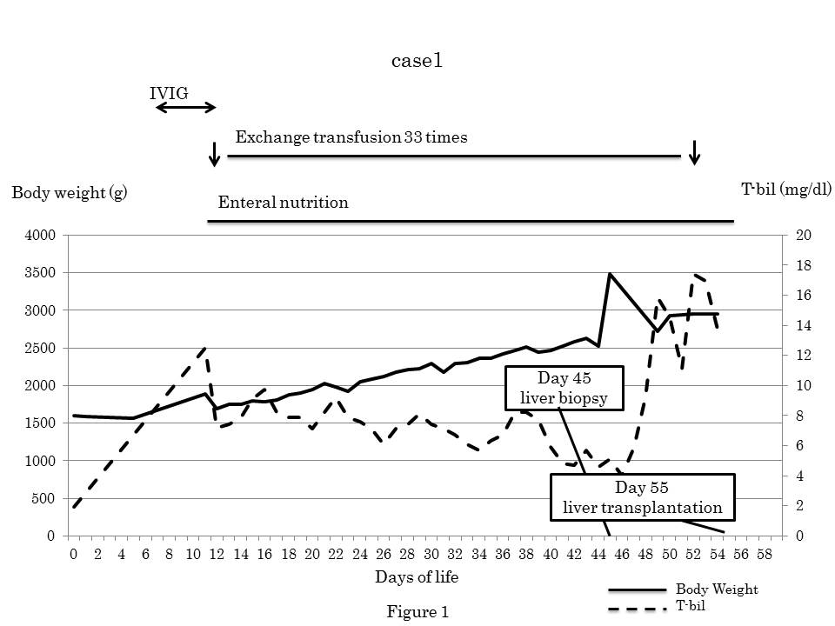
Figure 1 The preoperative treatment and changes in body weight and total bilirubin. The patient was able to gain weight due to the use of internal medication and enteral nutrition.

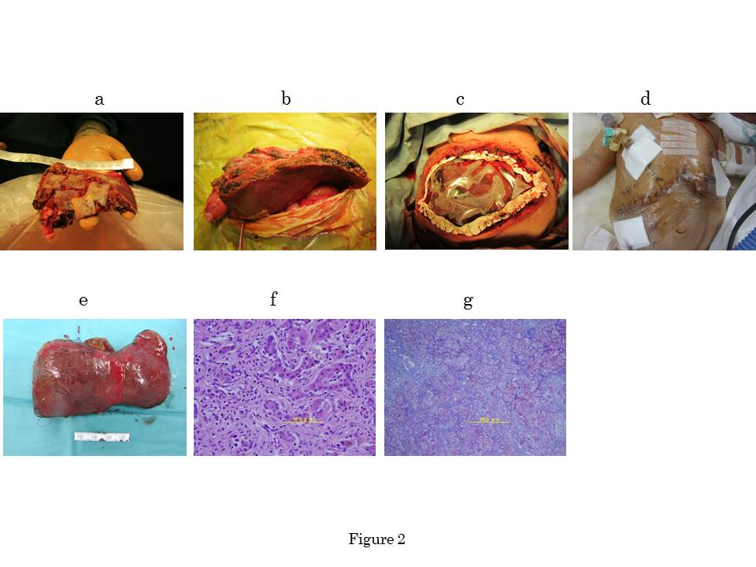
Figure 2 Images. A: The S2 monosegment graft (107 g) on the back table; B: An image obtained after reperfusion, the graft was too large to close the abdominal fascia; C: The abdominal fascia could not be closed at the time of living donor liver transplantation (LDLT), excess water was removed by continuous hemodiafiltration after LDLT; D: Secondary skin closure was performed on postoperative day 5; E: The resected liver was 78 g; F: Hematoxylin and eosin staining revealed a marked lack of hepatocytes and the presence of multinucleated hepatocytes; G: Azan staining revealed widespread fibrosis around Glisson’s sheath and the parenchymal area (F3-4).

Table 1 Problems and management for low birth weight infant with acute liver failure
 | Problems | Management
Pre-LT | Low body weight  Liver failure  Donor | Enteral nutrition targeting to over 2500 g  Apheresis (exchange transfusion, plasmapheresis)  Informed consent
LT | Large-for-size graft syndrome  Hepatic artery reconstruction  Abdominal compartment syndrome | Monosegment graft  Brunch patch, dorsal approach  Skin closure  Open management→secondary skin closure
Post-LT | Fluid overload  Respiratory failure | Aggressive water removal using CHDF
CHDF: Continuous hemodiafiltration.

