Name of journal: World Journal of Gastroenterology
ESPS Manuscript NO: 24726
Manuscript Type: ORIGINAL ARTICLE

Basic Study
¹²⁵I-labeled anti-bFGF monoclonal antibody inhibits growth of hepatocellular carcinoma

Hu PH et al. ¹²⁵I-bFGF mAb inhibits HCC

Peng-Hui Hu, Lan-Hong Pan, Patrick Ting-Yat Wong, Wen-Hui Chen, Yan-Qing Yang, Hong Wang, Jun-Jian Xiang, Meng Xu

Peng-Hui Hu, Lan-Hong Pan, Wen-Hui Chen, Meng Xu, Department of Oncology, the First Affiliated Hospital of Jinan University, Guangzhou 510632, Guangdong Province, China

Patrick Ting-Yat Wong, Department of Endocrinology and Metabolism, The First Affiliated Hospital of Jinan University, Guangzhou 510632, Guangdong Province, China

Yan-Qing Yang, Hong Wang, Jun-Jian Xiang, Guangdong Province Key Laboratory of Molecular Immunology and Antibody Engineering, Jinan University, Guangzhou 510632, Guangdong Province, China

Author contributions: Hu PH and Pan LH contributed equally to this work; Xu M designed and supervised the research; Hu PH and Pan LH conducted experiments; Wong PTY, Chen WH and Yang YQ analyzed the data; Wang H and Xiang JJ discussed the results; Hu PH and Pan LH co-wrote the manuscript and prepared all figures; all the authors have read and approved the paper to be published.

Supported by the National Natural Science Foundation of China, No. 81273814; and Guangdong Province Key Scientific Research Grant, No. 2013A022100031.

Institutional review board statement: The study was reviewed and approved by the Institutional Review Board of the First Affiliated Hospital of Jinan University, Guangzhou, China.

Institutional animal care and use committee statement: All procedures involving animals were reviewed and approved by the Institutional Animal Care and Use Committee of the Laboratory Animal Center of Jinan University (IACUC protocol number: 20150305001).

Conflict-of-interest statement: The authors declare no potential conflicts of interest related to this paper.

Data sharing statement: No additional data are available.

Open-Access: This article is an open-access article which was selected by an in-house editor and fully peer-reviewed by external reviewers. It is distributed in accordance with the Creative Commons Attribution Non Commercial (CC BY-NC 4.0) license, which permits others to distribute, remix, adapt, build upon this work non-commercially, and license their derivative works on different terms, provided the original work is properly cited and the use is non-commercial. See: http://creativecommons.org/licenses/by-nc/4.0/

Correspondence to: Meng Xu, MD, PhD, Department of Oncology, the First Affiliated Hospital, Jinan University, No. 613 Huangpu Avenue West, Guangzhou 510632, Guangdong Province, China. xumengjinan@yahoo.com
Telephone: +86-20-38688908
Fax: +86-20-38688000

Received: February 2, 2016
Peer-review started: February 3, 2016
First decision: March 7, 2016
Revised: March 14, 2016
Accepted: March 30, 2016
Article in press:
Published online:

Abstract
AIM: To investigate the inhibitory efficacy of ¹²⁵I-labeled anti-basic fibroblast growth factor (bFGF) monoclonal antibody (mAb) in hepatocellular carcinoma (HCC).

METHODS: bFGF mAb was prepared by using the 1G9B9 hybridoma cell line with hybridization technology and extracted from ascites fluid through a Protein G Sepharose affinity column. Labeling with ¹²⁵I through the chloramine-T method, bFGF mAb was further purified by Sephadex G-25 column. Gamma radiation counter GC-1200 detected radioactivity of ¹²⁵I-bFGF mAb. The murine H22 HCC xenograft model was established and randomized to interventions with control (phosphate-buffered saline), ¹²⁵I-bFGF mAb, ¹²⁵I plus bFGF mAb, bFGF mAb or ¹²⁵I. The ratios of tumor inhibition were then calculated. Expression of bFGF, fibroblast growth factor receptor (FGFR), platelet-derived growth factor and vascular endothelial growth factor (VEGF) mRNA was determined by quantitative reverse transcriptase real-time polymerase chain reaction.

RESULTS: The purified bFGF mAb solution was 8.145 mg/mL with a titer of 1: 2 560000 could be stored at −20 °C. After coupling, ¹²⁵I-bFGF mAb was used at 1: 1 280 000 dilution, stored at 4 °C, and its specific radioactivity was 37 MBq/mg. The corresponding tumor weight in the control, ¹²⁵I, bFGF mAb, ¹²⁵I plus bFGF mAb and ¹²⁵I-bFGF mAb groups was 1.88 ± 0.25, 1.625 ± 0.21, 1.5 ± 0.18, 1.41 ± 0.16 and 0.98 ± 0.11 g, respectively. The tumor inhibition ratio in the ¹²⁵I, bFGF mAb, ¹²⁵I plus bFGF mAb and ¹²⁵I-bFGF mAb groups was 13.6, 20.2, 25.1 and 47.9%, respectively. Growth of HCC xenografts was inhibited significantly more in the ¹²⁵I-bFGF mAb group than in the other groups (P < 0.05). Expression of bFGF and FGFR mRNA in the ¹²⁵I-bFGF mAb group was significantly decreased in comparison with other groups (P < 0.05). Groups under interventions revealed increased expression of VEGF mRNA (except for ¹²⁵I group), compared with the control group.

CONCLUSION: ¹²⁵I-bFGF mAb inhibits growth of HCC xenografts. The coupling effect of ¹²⁵I-bFGF mAb is more effective than the concomitant use of ¹²⁵I and bFGF mAb.

Key words: Basic fibroblast growth factor; ¹²⁵Iodine; Monoclonal antibody; Hepatocellular carcinoma; Fibroblast growth factor receptor; Vascular endothelial growth factor

© The Author(s) 2016. Published by Baishideng Publishing Group Inc. All rights reserved.

Core tip: The aim of this study was to investigate the inhibitory efficacy of ¹²⁵I-basic fibroblast growth factor (bFGF) monoclonal antibody (mAb) in mice with hepatocellular carcinoma (HCC). ¹²⁵I-bFGF mAb inhibited the growth of HCC xenografts (P < 0.05). The combination of ¹²⁵I and bFGF mAb was more effective than the concomitant use of ¹²⁵I and bFGF mAb alone. ¹²⁵I-bFGF mAb also significantly reduced the expression of bFGF and FGFR mRNA (P < 0.05). Moreover, ¹²⁵I-bFGF mAb downregulated platelet-derived growth factor mRNA and upregulated vascular endothelial growth factor mRNA.

Hu PH, Pan LH, Wong PTY, Chen WH, Yang YQ, Wang H, Xiang JJ, Xu M. ¹²⁵I-labeled anti-bFGF monoclonal antibody inhibits growth of hepatocellular carcinoma. World J Gastroenterol 2016; In press

INTRODUCTION
Hepatocellular carcinoma (HCC) ranks among the most common cancers worldwide. It is the third leading cause of cancer death, with about 700000 cases diagnosed annually^{[1]}. It is characterized by rapid progression, metastasis and recurrence. Surgical resection and liver transplantation are traditional therapeutic approaches for HCC. Liver transplantation offers many benefits for HCC, but shortage of donor organs and high costs constrain its application. New therapeutic methods such as radiofrequency ablation, transcatheter arterial chemoembolization, local hyperthermia and targeted therapy can also be beneficial to the patients with HCC^{[2-4]}.
HCC is one of the most vascularized solid tumors, angiogenesis plays a pivotal role in its development, progression and metastasis. Basic fibroblast growth factor (bFGF) is one of the most prominent angiogenesis-promoting agents and closely correlates with tumor angiogenesis^{[5]}. Previous studies have revealed that bFGF stimulates proliferation of human HCC cell lines^{[6]}, and the serum bFGF levels in patients with HCC are significantly higher than those in healthy volunteers^{[7]}. Such increasing serum bFGF levels correlate closely with HCC invasion and recurrence^{[8,9]}. These studies indicate that specific targeting of bFGF may provide a novel therapeutic strategy for HCC.
bFGF monoclonal antibody (mAb) can specifically bind to bFGF and block its growth-stimulating activity. In our previous studies, we found that bFGF mAb combined with S-1 (gimeracil and oteracil potassium) synergistically inhibited Lewis-transplanted lung cancer, which was related to the inhibition of proliferation and angiogenesis^{[10]}. Combination of bFGF mAb and radiotherapy exerts a synergistic inhibitory effect on the growth of B16-transplanted melanoma tumors as it increases the radiosensitivity of tumor cells by reducing the expression of bFGF, decreasing angiogenesis and promoting apoptosis^{[11]}. bFGF mAb also inhibits the proliferation of MCF-7/ADM breast cancer cells and reverses multidrug resistance. The phenomenon may be associated with downregulation of P-glycoprotein and increased intracellular concentration of chemotherapeutic drugs^{[12]}.
¹²⁵I radiotherapy enhances DNA damage, and consequently, induces liver cancer cell apoptosis and improves overall survival in HCC^{[13]}. The use of radionuclide labels on mAbs enhances the specificity of their targeting, and increases the accuracy of evaluating therapeutic response^{[14]}. Thus, coupling bFGF mAb with ¹²⁵I was used in the present study. Our previous study demonstrated that the half-life of ¹²⁵I-bFGF mAb was 81.6–90.3 h and the radioactive counts were highly detected in the liver tissue of mice^{[15]}. Therefore, ¹²⁵I-bFGF mAb may be an attractive therapeutic modality for HCC. In this study, we aimed to investigate the feasibility and therapeutic efficacy of ¹²⁵I-bFGF mAb in HCC.

MATERIALS AND METHODS
Production of bFGF mAb
We prepared the 1G9B9 hybridoma cell line, which was developed in our laboratory with hybridization technology and can secrete mAbs against bFGF. After injecting 10⁵ hybridoma cells into each BABL/c mice with incomplete Freund’s adjuvant (Sigma–Aldrich, St Louis, MO, United States), ascites was formed in mice 7 d later. The ascites fluid was extracted, purified twice in ammonium sulfate and Protein G Sepharose affinity column (General Electric, Fairfield, CT, United States). bFGF mAb was identified by SDS-PAGE. The concentration and titer of purified bFGF mAb stock solution were assayed by BCA standard assay kit (Pierce, Rockford, IL, United States) and indirectly by ELISA, respectively. Finally, bFGF mAb stock solution was cryopreserved at −20 °C.

Production of ¹²⁵I-bFGF mAb
bFGF mAb was labeled with ¹²⁵I (Amersham Biosciences) by using the chloramine-T method. Afterwards, ¹²⁵I-bFGF mAb was purified by Sephadex G-25 column (Pharmacia) in PBS (0.05 mol/L, pH 7.5) at room temperature. The labeling efficiency and titer of ¹²⁵I-bFGF mAb were tested by paper chromatography and indirectly by ELISA, respectively. In order to investigate the stability and storage temperature of ¹²⁵I-bFGF mAb, assays for radiochemical purity of ¹²⁵I-bFGF mAb were performed using a gamma radiation counter GC-1200 (Zhongjia Photoelectric Instrument Company) in 1–8 d with variable temperatures. The radioactive counts of quality controlled samples (0.5, 5.0 and 50.0 ng/mL) were tested by gamma radiation counter GC-1200 in six replicates in three different days so as to evaluate the accuracy of the assay. The intra-day coefficient of variation (CV) and inter-day CV were also calculated.

Establishment of murine H22 HCC xenograft model
We adjusted the concentration of H22 hepatoma cells to 2.5 × 10⁶/mL during the logarithmic growth phase. Each C57BL/6 mouse was injected with 0.2 mL of cells in the armpit of the right front limb. After the tumor diameters grew to 7–8 mm, Kalium jodatum was eaten by mice for 3 d to inhibit the function of thyroid gland absorbing ¹²⁵I before treatment. Twenty-five mice were randomized into five groups: control (phosphate-buffered saline; PBS), ¹²⁵I, bFGF mAb, ¹²⁵I plus bFGF mAb and ¹²⁵I-bFGF mAb. The injection doses for each group per mouse were 0.2 mL PBS, 7.4 MBq Na¹²⁵I, 200 μg bFGF mAb, 7.4 MBq Na¹²⁵I plus 200 μg bFGF mAb, and 37 MBq/mg ¹²⁵I-bFGF mAb 200 μg, respectively. The drug was given once every 3 d, five times in total (15 d). After sacrificing the mice and tumor dissection, the volume and weight of the tumor were measured and the ratio of tumor inhibition was calculated.

Quantification of bFGF, FGFR, VEGF and PDGF mRNA expression by quantitative reverse transcriptase real-time polymerase chain reaction
Expression of bFGF, vascular endothelial growth factor (VEGF), fibroblast growth factor receptor (FGFR), and platelet-derived growth factor (PDGF) mRNA was measured by quantitative reverse transcriptase real-time polymerase chain reaction (qRT-PCR). β-actin was used as an internal reference gene. Total RNA was extracted by TRIzol reagent (Invitrogen, Carlsbad, CA, United States). The concentration and quality of the extracted RNA were detected on the measured absorbance at 260 nm and a ratio of (A260/A280). cDNA was synthesized using Transcript High Fidelity cDNA Synthesis Kit (Fermentas). The primers of DNA sequences were as follows: bFGF (5'-TAT TTC TTT GGC TGC TAC TTG-3' and 5'-TCC AGC ATT TCG GTG TTG-3'); FGFR (5'-CCT CGT TTG GAG ACG BCT TCA-3' and 5'-GAG CAA AGG GTG TGT GGA CTC T-3'); VEGF (5'-GAA TGT GAT TGC TTT CCT GGG TA-3' and 5'-AGT AAA AGT GGC TGT GGT GGT CCT GA-3'); PDGF (5'-GAG ATA GAC TCC GTA GGG GCT GA-3' and 5'-GAG CAA AGG GTG TGT GGA CTC T-3'); β-actin (5'-CAA GAT CAT TGC TCC TCC TGA-3' and 5'-AGT CCG CCT AGA AGC ATT TG-3'). Using Light Cycler 480 SYBR Green I Master Mix (Roche), qPCR was performed according to the qPCR protocol. Conditions used for the qPCR amplification were shown as follows: 95 °C for 5 min, 55 cycles; 94 °C for 10 s, 62 °C for 15 s, 72 °C for 10 s, and 65 °C for 1 min. Melting curves were analyzed to detect the specificity of qPCR products. The expressions of bFGF, VEGF, FGFR and PDGF mRNA were analyzed by Mx Pro QPCR software version 3.0 and the housekeeping gene β-actin was used as a normalized target gene.

Animal care and use statement
All procedures involving animals were reviewed and approved by the Institutional Animal Care and Use Committee of the Laboratory Animal Center of Jinan University. The animal protocol in our experiment was designed to minimize pain and discomfort to the mice. The mice were acclimatized to laboratory conditions (23 °C, 12 h/12 h light/dark, 50% humidity, ad libitum access to food and water) for 2 wk prior to experimentation. Intragastric administration was carried out with conscious mice, using straight gavage needles appropriate for the animal size (15–17 g body weight: 22 gauge, 2.54 cm length, and 1.25 mm ball diameter). All mice were euthanized by barbiturate overdose (intravenous injection, 150 mg/kg pentobarbital sodium) for HCC xenograft collection.

Statistical analysis
The descriptive data were given as mean and standard deviation. The results were analyzed by SPSS version 16.0 with a t test. P < 0.05 was considered to be statistically significant.

RESULTS
Product of bFGF mAb
The ascites was produced after 1G9B9 hybrid tumor cells were injected into the abdominal cavity of mice for 7–12 d. Each mouse provided 1.8–2.2 mL ascites fluid and 30 mL was finally obtained. From the SDS-PAGE picture of purified bFGF mAb, only two bFGF mAb chains were observed and there was no non-specific chain which indicted high purity of bFGF mAb. The molecular weight of the heavy chain was about 50 ku while the light chain was about 25 ku (Figure 1). The titer and concentration of purified bFGF mAb solution were 1: 2 560 000 and 8.145 mg/mL, respectively (Figure 1).

Product of ¹²⁵I-bFGF mAb
The optimal labeling conditions for the chloramine-T method in our study consisted of chloramine-T 50 μg, Na¹²⁵I 3.7 MBq, Na₂S₂O₅ 100 μg, bFGF mAb 100 μg, with a reaction time of 45 s. Gamma radiation counter GC-1200 was used to test the radioactivity of the multiple collected tubes. From tubes 1–19, the radioactive counts were close to zero. Starting from tube 20, the radioactivity counts increased to a peak in tube 30. Subsequently, the counts began to decline and reached zero again in tube 46 (Figure 2). Formation of the radioactive peak indicated successful preparation of ¹²⁵I-bFGF mAb. The remaining liquid was abandoned. The labeling efficiency of ¹²⁵I-bFGF mAb was ≥ 90%, which was tested by paper chromatography. The purity of ¹²⁵I-bFGF mAb became ≥ 98% after purified by Sephadex G-25 column. The titer was 1: 1 280 000, which implicated no decrease in immunoreactivity (Figure 2). ¹²⁵I-bFGF mAb was prone to denaturation at room temperature and iodine removal at −20 °C. ¹²⁵I-bFGF mAb was stably maintained when stored at 4°C as the level of radiochemical purity remained ≥ 90% over 6 d. The intra-day CV of quality controlled samples (0.5, 5.0 and 50.0 ng/mL) at the radioactive counts were 0.8, 1.3 and 6.8%, respectively, and the inter-day CV was 4.8, 3.7 and 8.5%, respectively. The specific radioactivity of the ¹²⁵I-bFGF mAb used in this study was 37 MBq/mg.

Inhibitory efficacy of ¹²⁵I-bFGF mAb on HCC
The corresponding volume and weight of tumor in the control, ¹²⁵I, bFGF mAb, ¹²⁵I plus bFGF mAb and ¹²⁵I-bFGF mAb groups were 9968.45 ± 430, 8987 ± 360.3, 8216.91 ± 301, 7926.67 ± 329 and 6210 ± 298 mm³, and 1.88 ± 0.25, 1.625 ± 0.21, 1.5 ± 0.18, 1.41 ± 0.16 and 0.98 ± 0.11 g. When compared with the control group, the tumor inhibition ratio in the ¹²⁵I, bFGF mAb, ¹²⁵I plus bFGF mAb, and ¹²⁵I-bFGF mAb groups was 13.6, 20.2, 25.1 and 47.9%, respectively (Figure 3). ¹²⁵I-bFGF mAb effectively inhibited the growth of HCC (P < 0.05), and the tumor inhibition ratio of the ¹²⁵I-bFGF mAb group was higher than in the other groups.

Quantitative changes in bFGF, FGFR, VEGF and PDGF mRNA expression
qRT-PCR amplification and melt curves of β-actin, bFGF, FGFR, VEGF and PDGF are shown in Figure 4. Expression of these genes entered the plateau of amplification. All the samples were amplified with a single product and there was no non-specific amplification. According to the relative quantitative method of 2^{−ΔΔCt}, the relative expression of bFGF and FGFR mRNA decreased significantly in the ¹²⁵I-bFGF mAb group when compared with other treatment groups (P < 0.05). In groups with interventions, expression of PDGF mRNA decreased while VEGF mRNA was higher (except for ¹²⁵I group) than in the control group (Figure 4).

DISCUSSION
bFGF is an 18 ku non-glycosylated polypeptide consisting of 146 amino acids, which was first isolated and purified from bovine pituitary and brain. It is involved in cell migration and differentiation, as a driving force of motogenesis and angiogenesis^{[5]}. bFGF upsets the balance of cell cycle progression and apoptosis^{[16]}. By activating protein kinase B, it enhances proliferation of HCC cells via the phosphoinositide 3-kinase pathway^{[17]}. Growth of HCC was able to be inhibited by human sulfatase 1, a bFGF-stimulated signaling blocker^{[16]}. Moreover, it was previously demonstrated that a novel mAb to FGF-2 alone, without radiolabeling, effectively inhibits growth of HCC xenografts^{[18]}.
Our result showed that ¹²⁵I-bFGF mAb significantly inhibited growth of HCC xenografts more than other interventions did (P < 0.05), and the inhibition ratio of the ¹²⁵I-bFGF mAb group (47.9%) was higher than that of the ¹²⁵I plus bFGF mAb group (25.1%). Combination of ¹²⁵I and bFGF mAb was more effective than concomitant use of ¹²⁵I and bFGF mAb in the treatment of HCC. The use of radionuclide labels on mAbs enhances the specificity of their targeting cells^{[14]}. Such augmented specificity and accuracy could allow ¹²⁵I-bFGF mAb to yield greater efficacy in treating mice with HCC, compared with concomitant use of ¹²⁵I and bFGF mAb. Among patients with HCC, the serum levels of bFGF were increased and elevated bFGF independently predicted poor disease-free survival preoperatively^{[8]}. It is tempting to consider ¹²⁵I-bFGF mAb as a potential clinical option for HCC therapy in the future.
¹²⁵I-bFGF mAb reduced levels of FGFR and PDGF in our study. FGFR plays a pivotal role in HCC differentiation, proliferation, invasiveness and resistance to chemotherapy^{[19-21]}. FGFR is highly expressed in HCC and associated with short overall survival^{[22]}. A humanized monoclonal antibody to FGFR was reported to inhibit tumor growth in HCC xenograft models^{[23]}. In contrast, PDGF, as a proangiogenic factor, contributes to vessel maturation^{[24]}. PDGF also aids proliferation and metastasis of HCC^{[25]}. Upregulation of PDGF and PDGF receptors is associated with chemoresistance of gemcitabine and poor prognosis in patients with HCC^{[26,27]}. ¹²⁵I-bFGF mAb is also a promising agent in tackling liver cancer by decreasing both FGF and PDGF. There is a possibility that ¹²⁵I-bFGF mAb enhances therapeutic efficacy of gemcitabine when both agents are indicated in patients with HCC, and requires further investigation.
Our results showed that expression of VEGF was higher in mice treated with ¹²⁵I-bFGF mAb, ¹²⁵I plus bFGF mAb or bFGF mAb in spite of the improved tumor inhibition ratios and decreased levels of bFGF, FGFR and PDGF. Previously, increased expression of bFGF was observed in xenotransplanted squamous cell carcinoma after anti-VEGF treatment^{[28]}. Antiangiogenic therapy may impair vessel formation but improves vascular function as well as tissue oxygenation^{[29]}. Such vessel normalization may become a compensatory reaction of the tumor, caused by depletion of VEGF. This promotes increased oxygenation, resulting in the observed increased bFGF^{[28]}. In our study, when anti-bFGF was applied to a murine model of HCC, VEGF was increased. We suggest that blockade of VEGF elevates bFGF, and vice versa. We speculate that vessel normalization also takes place even when anti-bFGF (an antiangiogenic agent) is used and VEGF is increased by improved tissue oxygenation. Bevacizumab was the first VEGF inhibitor approved by the US Food and Drug Administration. It is a potent inhibitor of vascular endothelial growth factor A that has demonstrated modest antitumor activity across a broad range of malignancies when combined with chemotherapy^{[30]}. However, some patients are insensitive to bevacizumab. One study found that VEGF/bFGF ratio correlated more closely with sensitivity to bevacizumab than with VEGF alone^{[31]}. Our experiment showed the increased expression of VEGF in ¹²⁵I-bFGF mAb treated HCC group. Therefore, we raised the hypotheses when ¹²⁵I-bFGF mAb combine with VEGF mAb may be conducive to enhance sensitivity to bevacizumab and improve the therapeutic efficacy in the therapy of HCC. To provide support for this concept, we intend to combine ¹²⁵I-bFGF mAb and bevacizumab in the treatment of HCC in our future study.
A recent study also found that using gefinitib-resistant cell lines shows elevated expression of FGFR1 and bFGF, moreover, inhibition of either bFGF or FGFR1 by siRNA or FGFR inhibitor (PD173074) restored gefitinib sensitivity, suggesting an FGFR autocrine loop activation as a mechanism of acquired resistance to epithelial growth factor receptor-tyrosine kinase inhibitors (EGFR-TKIs) in non-small cell lung cancer^{[32]}. Since ¹²⁵I-bFGF mAb can decrease the bFGF and FGFR significantly, combination of ¹²⁵I-bFGF mAb and EGFR-TKIs might enhance the therapeutic value of EGFR-TKIs.
In conclusion, ¹²⁵I-bFGF mAb effectively inhibited the growth of HCC xenografts; significantly reduced expression of bFGF and FGFR; and upregulated VEGF expression. Combined ¹²⁵I and bFGF mAb was more effective than concomitant use of ¹²⁵I and bFGF mAb in the treatment of HCC.

COMMENTS
Background
Hepatocellular carcinoma (HCC) is the sixth most common cancer worldwide and the third leading cause of cancer-related death. In clinical practice, the majority of HCC patients are diagnosed at an inoperable stage, resulting in a low long-term survival rate and poor prognosis. Since basic fibroblast growth factor (bFGF) is one of the most prominent angiogenesis-related factors, angiogenesis plays an important role in HCC progression. In order to improve clinical therapeutic efficacy of HCC, the authors investigated the biological inhibition efficacy of ¹²⁵I-labeled bFGF monoclonal antibody (mAb) in mice with HCC and hope that their finding could serve as significant information for clinicians and HCC patients in selecting individualized treatment strategies in the near future.

Research frontiers
Targeted therapy is the main treatment approaches for patients with advanced HCC. New targeted drugs such as sorafenib and sunitinib have improved clinical efficacy. However, the drug resistance and side effects of sorafenib and sunitinib constrain the clinical application. Therefore, it is necessary to investigate alternative targeting drugs, such as mAb to bFGF, for patients with advanced HCC.

Innovations and breakthroughs
This is believed to be the first study to label bFGF mAb with ¹²⁵I in the treatment of HCC. The study revealed that ¹²⁵I-bFGF mAb inhibited growth of HCC xenografts, and it was more effective than the concomitant use of ¹²⁵I and bFGF mAb. The authors also found that ¹²⁵I-bFGF mAb reduced expression of bFGF and decreased expression of FGF receptor and platelet-derived growth factor.

Applications
This study found that ¹²⁵I-bFGF mAb inhibited growth of HCC xenografts, suggesting that it could be used to tackle liver cancer. More trials are warranted to provide evidence for further applications. ¹²⁵I-bFGF mAb inhibited expression of bFGF and FGF receptor significantly, while vascular endothelial growth factor (VEGF) expression was upregulated. Therefore, combination treatment of HCC with VEGF mAb is worthy of further investigation.

Terminology
bFGF mAb is a target drug that can specifically bind to bFGF and block its growth-stimulating activity. It is widely used in laboratory research, and it can significantly inhibit growth of human HCC cell lines in vitro and in vivo. Therefore, bFGF mAb could be a promising drug in the treatment of liver cancer.

Peer-review
Well done for designing this project and accomplishing it. This is an interesting study researched the inhibitory efficacy of ¹²⁵I-bFGF mAb in hepatocellular carcinoma (HCC). The results shown that ¹²⁵I-bFGF mAb inhibits growth of HCC xenografts and more effective than the concomitant use of ¹²⁵I and bFGF mAb. ¹²⁵I-bFGF mAb may be a potential clinical option for HCC therapy in the future.

REFERENCES
1 Forner A, Llovet JM, Bruix J. Hepatocellular carcinoma. Lancet 2012; 379: 1245-1255 [PMID: 22353262 DOI: 10.1016/S0140-6736(11)61347-0]
2 Song do S, Nam SW, Bae SH, Kim JD, Jang JW, Song MJ, Lee SW, Kim HY, Lee YJ, Chun HJ, You YK, Choi JY, Yoon SK. Outcome of transarterial chemoembolization-based multi-modal treatment in patients with unresectable hepatocellular carcinoma. World J Gastroenterol 2015; 21: 2395-2404 [PMID: 25741147 DOI: 10.3748/wjg.v21.i8.2395]
3 Wang XP, Xu M, Gao HF, Zhao JF, Xu KC. Intraperitoneal perfusion of cytokine-induced killer cells with local hyperthermia for advanced hepatocellular carcinoma. World J Gastroenterol 2013; 19: 2956-2962 [PMID: 23704829 DOI: 10.3748/wjg.v19.i19.2956]
4 Park JG, Park SY, Lee HW. Complete remission of advanced hepatocellular carcinoma by radiofrequency ablation after sorafenib therapy. World J Gastroenterol 2015; 21: 2568-2572 [PMID: 25741170 DOI: 10.3748/wjg.v21.i8.2568]
5 Okada-Ban M, Thiery JP, Jouanneau J. Fibroblast growth factor-2. Int J Biochem Cell Biol 2000; 32: 263-267 [PMID: 10716624]
6 Ogasawara S, Yano H, Iemura A, Hisaka T, Kojiro M. Expressions of basic fibroblast growth factor and its receptors and their relationship to proliferation of human hepatocellular carcinoma cell lines. Hepatology 1996; 24: 198-205 [PMID: 8707262 DOI: 10.1053/jhep.1996.v24.pm0008707262]
7 Tsunematsu H, Tatsumi T, Kohga K, Yamamoto M, Aketa H, Miyagi T, Hosui A, Hiramatsu N, Kanto T, Hayashi N, Takehara T. Fibroblast growth factor-2 enhances NK sensitivity of hepatocellular carcinoma cells. Int J Cancer 2012; 130: 356-364 [PMID: 21351090 DOI: 10.1002/ijc.26003]
8 Poon RT, Ng IO, Lau C, Yu WC, Fan ST, Wong J. Correlation of serum basic fibroblast growth factor levels with clinicopathologic features and postoperative recurrence in hepatocellular carcinoma. Am J Surg 2001; 182: 298-304 [PMID: 11587697]
9 Gao Y, Zheng DY, Cui Z, Ma Y, Liu YZ, Zhang W. Predictive value of quantitative contrast-enhanced ultrasound in hepatocellular carcinoma recurrence after ablation. World J Gastroenterol 2015; 21: 10418-10426 [PMID: 26420968 DOI: 10.3748/wjg.v21.i36.10418]
10 Zhang GJ, Xu M, Zhao JF, Wang H, Xiang JJ, Deng N, Zeng SB, Wang PP. Synergistic inhibitory effects of bFGF monoclonal antibody and S-1 against proliferation of lung cancer Lewis cells and angiogenesis of transplanted tumors. Chin J Cancer Biother 2011; 18: 280-284
11 Zheng SB, Xu M, Pan LH, Xiang JJ, Deng N, Li D, Wang PP. Synergistic inhibitory effects of bFGF monoclonal antibody combined with radio therapy on B16-transplanted tumors in mice. Chin J Cancer Biother 2011; 18: 175-180
12 Chen WH, Xu M, Du CC, Zhao JF, Pan LH, Li HC, Xiang JJ, Deng N. Molecular mechanism of reversal effect of monoclonal antibody to basic fibroblast growth factor mediated expression of P-glycoprotein on multiple drug resistance in adriamycin-resistant human breast cancer cell line MCF-7/ADM. Basic Res 2013; 33: 8-14
13 Chen K, Chen G, Wang H, Li H, Xiao J, Duan X, He J, He K, Xiang G. Increased survival in hepatocellular carcinoma with iodine-125 implantation plus radiofrequency ablation: a prospective randomized controlled trial. J Hepatol 2014; 61: 1304-1311 [PMID: 25064436 DOI: 10.1016/j.jhep.2014.07.026]
14 Tolmachev V, Orlova A, Andersson K. Methods for radiolabelling of monoclonal antibodies. Methods Mol Biol 2014; 1060: 309-330 [PMID: 24037848 DOI: 10.1007/978-1-62703-586-6_16]
15 Pan LH, Xu M, Zheng SB, Chen WH, Li HC, Sheng LH, Zhu XH, Xiang JJ, Deng N. Study on pharmacokinetics of Monoclonal antibody to basic fibroblast growth factor in mice. Zhongguo Yaolixue Tongbao 2011; 27: 1582-1585
16 Xu G, Ji W, Su Y, Xu Y, Yan Y, Shen S, Li X, Sun B, Qian H, Chen L, Fu X, Wu M, Su C. Sulfatase 1 (hSulf-1) reverses basic fibroblast growth factor-stimulated signaling and inhibits growth of hepatocellular carcinoma in animal model. Oncotarget 2014; 5: 5029-5039 [PMID: 24970807 DOI: 10.18632/oncotarget.2078]
17 Sun B, Xu H, Zhang G, Zhu Y, Sun H, Hou G. Basic fibroblast growth factor upregulates survivin expression in hepatocellular carcinoma cells via a protein kinase B-dependent pathway. Oncol Rep 2013; 30: 385-390 [PMID: 23677479 DOI: 10.3892/or.2013.2479]
18 Wang L, Park H, Chhim S, Ding Y, Jiang W, Queen C, Kim KJ. A novel monoclonal antibody to fibroblast growth factor 2 effectively inhibits growth of hepatocellular carcinoma xenografts. Mol Cancer Ther 2012; 11: 864-872 [PMID: 22351746 DOI: 10.1158/1535-7163.MCT-11-0813]
19 Dienstmann R, Rodon J, Prat A, Perez-Garcia J, Adamo B, Felip E, Cortes J, Iafrate AJ, Nuciforo P, Tabernero J. Genomic aberrations in the FGFR pathway: opportunities for targeted therapies in solid tumors. Ann Oncol 2014; 25: 552-563 [PMID: 24265351 DOI: 10.1093/annonc/mdt419]
20 Wang J, Li J, Wang X, Zheng C, Ma W. Downregulation of microRNA-214 and overexpression of FGFR-1 contribute to hepatocellular carcinoma metastasis. Biochem Biophys Res Commun 2013; 439: 47-53 [PMID: 23962428 DOI: 10.1016/j.bbrc.2013.08.032]
21 Cheng AL, Shen YC, Zhu AX. Targeting fibroblast growth factor receptor signaling in hepatocellular carcinoma. Oncology 2011; 81: 372-380 [PMID: 22269894 DOI: 10.1159/000335472]
22 Lee HJ, Kang HJ, Kim KM, Yu ES, Kim KH, Kim SM, Kim TW, Shim JH, Lim YS, Lee HC, Chung YH, Lee YS. Fibroblast growth factor receptor isotype expression and its association with overall survival in patients with hepatocellular carcinoma. Clin Mol Hepatol 2015; 21: 60-70 [PMID: 25834803 DOI: 10.3350/cmh.2015.21.1.60]
23 Bumbaca D, Wong A, Drake E, Reyes AE, Lin BC, Stephan JP, Desnoyers L, Shen BQ, Dennis MS. Highly specific off-target binding identified and eliminated during the humanization of an antibody against FGF receptor 4. MAbs 2011; 3: 376-386 [PMID: 21540647]
24 Hellberg C, Ostman A, Heldin CH. PDGF and vessel maturation. Recent Results Cancer Res 2010; 180: 103-114 [PMID: 20033380 DOI: 10.1007/978-3-540-78281-0_7]
25 Lu Y, Lin N, Chen Z, Xu R. Hypoxia-induced secretion of platelet-derived growth factor-BB by hepatocellular carcinoma cells increases activated hepatic stellate cell proliferation, migration and expression of vascular endothelial growth factor-A. Mol Med Rep 2015; 11: 691-697 [PMID: 25333351 DOI: 10.3892/mmr.2014.2689]
26 Wu Q, Wang R, Yang Q, Hou X, Chen S, Hou Y, Chen C, Yang Y, Miele L, Sarkar FH, Chen Y, Wang Z. Chemoresistance to gemcitabine in hepatoma cells induces epithelial-mesenchymal transition and involves activation of PDGF-D pathway. Oncotarget 2013; 4: 1999-2009 [PMID: 24158561 DOI: 10.18632/oncotarget.1471]
27 Wei T, Zhang LN, Lv Y, Ma XY, Zhi L, Liu C, Ma F, Zhang XF. Overexpression of platelet-derived growth factor receptor alpha promotes tumor progression and indicates poor prognosis in hepatocellular carcinoma. Oncotarget 2014; 5: 10307-10317 [PMID: 25333264 DOI: 10.18632/oncotarget.2537]
28 Fruth K, Weber S, Okcu Y, Noppens R, Klein KU, Joest E, Hedrich J, Thilemann S, Pogorzelski B, Koutsimpelas D, Fischer S, Muennemann K, Affolter A, Heinrich UR, Brochhausen C, Schmidtmann I, Mann WJ, Schmidberger H, Schreiber LM, Brieger J. Increased basic fibroblast growth factor release and proliferation in xenotransplanted squamous cell carcinoma after combined irradiation/anti-vascular endothelial growth factor treatment. Oncol Rep 2012; 27: 1573-1579 [PMID: 22294154 DOI: 10.3892/or.2012.1654]
29 Winkler F, Kozin SV, Tong RT, Chae SS, Booth MF, Garkavtsev I, Xu L, Hicklin DJ, Fukumura D, di Tomaso E, Munn LL, Jain RK. Kinetics of vascular normalization by VEGFR2 blockade governs brain tumor response to radiation: role of oxygenation, angiopoietin-1, and matrix metalloproteinases. Cancer Cell 2004; 6: 553-563 [PMID: 15607960 DOI: 10.1016/j.ccr.2004.10.011]
30 Shah MA. The development of bevacizumab in noncolorectal gastrointestinal malignancies: gastroesophageal, pancreatic, and hepatocellular carcinoma. Clin Adv Hematol Oncol 2014; 12: 239-246 [PMID: 25003353]
31 Yamashita-Kashima Y, Fujimoto-Ouchi K, Yorozu K, Kurasawa M, Yanagisawa M, Yasuno H, Mori K. Biomarkers for antitumor activity of bevacizumab in gastric cancer models. BMC Cancer 2012; 12: 37 [PMID: 22273502 DOI: 10.1186/1471-2407-12-37]
32 Terai H, Soejima K, Yasuda H, Nakayama S, Hamamoto J, Arai D, Ishioka K, Ohgino K, Ikemura S, Sato T, Yoda S, Satomi R, Naoki K, Betsuyaku T. Activation of the FGF2-FGFR1 autocrine pathway: a novel mechanism of acquired resistance to gefitinib in NSCLC. Mol Cancer Res 2013; 11: 759-767 [PMID: 23536707 DOI: 10.1158/1541-7786.MCR-12-0652]

P-Reviewer: Giakoustidis A S-Editor: Yuan Qi L-Editor: E-Editor:

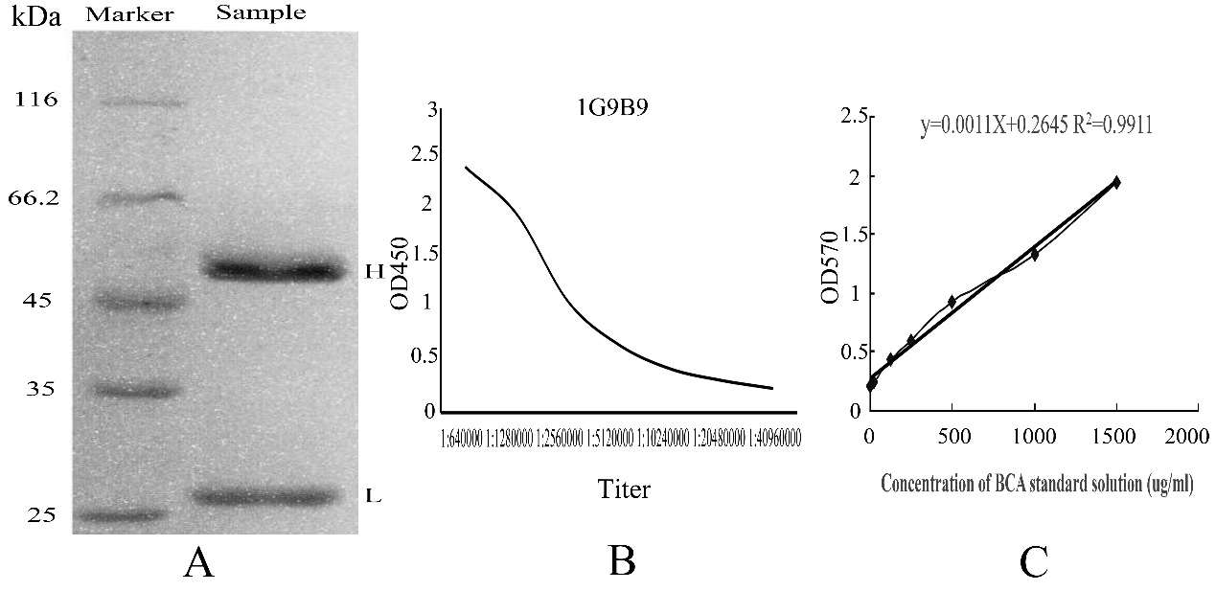
Figure 1 Characterization of anti-bFGF mAb. A: SDS-PAGE of purified bFGF mAb (H: heavy chain; L: light chain); B: Titer of purified bFGF mAb stock solution tested by indirect ELISA; C: Concentration of purified bFGF mAb stock solution assayed by BCA standard assay kit. (Standard curve: Y = 0.0011x + 0.2645; Relevancy: R² = 0.9911).

Figure 2 Radioactivity and titer of purified ¹²⁵I-bFGF mAb. A: Product peak of purified ¹²⁵I-bFGF mAb tested by gamma radiation counter GC-1200; B: Titer of purified ¹²⁵I-bFGF mAb stock solution assayed by indirect ELISA.

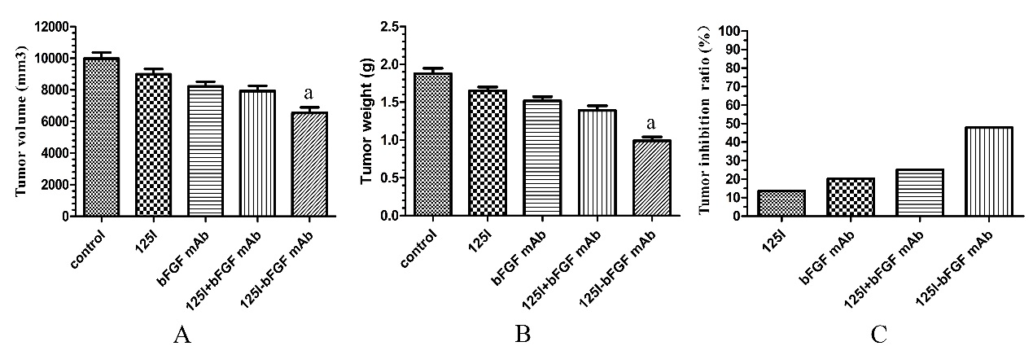
Figure 3 Therapeutic efficacy of ¹²⁵I-bFGF mAb in mice with H22 HCC. A: Tumor volume of H22 HCC; B: Tumor weight of H22 HCC; C: Tumor inhibition ratios of experimental groups; ªP < 0.05, ¹²⁵I-bFGF mAb group vs other groups (control, ¹²⁵I, bFGF mAb and ¹²⁵I plus bFGF mAb).

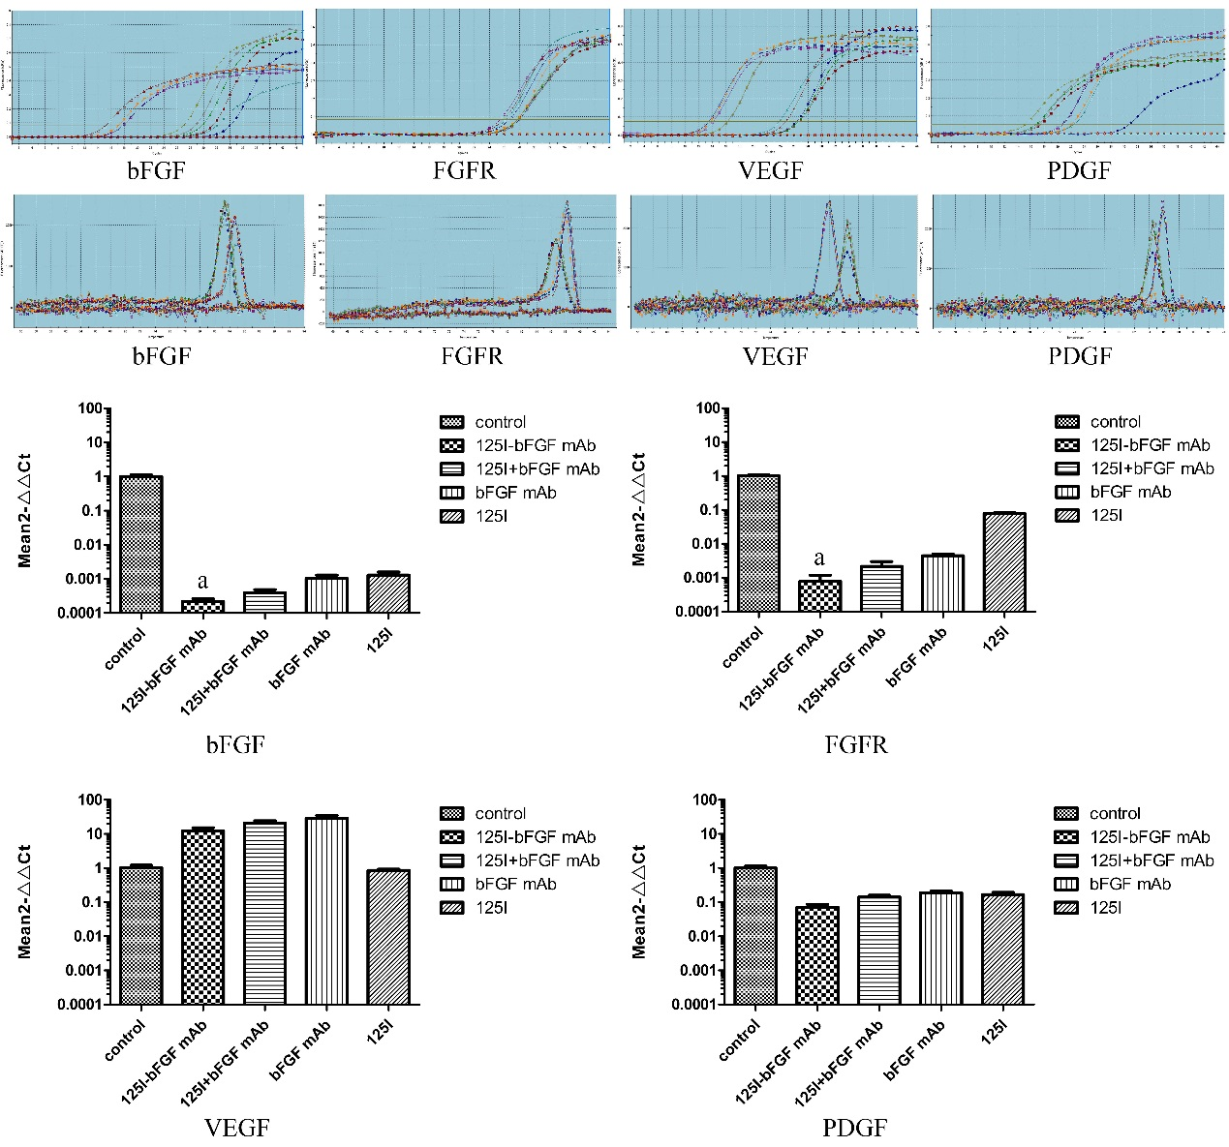
Figure 4 qRT-PCR amplification curves, melt curves and expression of bFGF, FGFR, VEGF and PDGF mRNA. ªP < 0.05, ¹²⁵I-bFGF mAb group vs other groups (control, ¹²⁵I, bFGF mAb and ¹²⁵I plus bFGF mAb).

