Name of Journal: World Journal of Clinical Cases
Manuscript NO: 77404
Manuscript Type: CASE REPORT

Monitored anesthesia care for craniotomy in a patient with Eisenmenger syndrome: A case report

Ri HS et al. MAC in Eisenmenger syndrome

Hyun-Su Ri, Younghoon Jeon

Hyun-Su Ri, Younghoon Jeon, Department of Anesthesiology and Pain Medicine, School of Medicine, Kyungpook National University, Daegu 41944, South Korea

Younghoon Jeon, Department of Anesthesiology and Pain Medicine, School of Dentistry, Kyungpook National University, Daegu 41944, South Korea

Author contributions: Ri HS and Jeon Y designed the study; Ri HS drafted the manuscript; Ri HS and Jeon Y reviewed the literature and edited the manuscript; all authors agreed to be accountable for all aspects of the work, and issued final approval for the version to be submitted.

Corresponding author: Younghoon Jeon, MD, PhD, Professor, Department of Anesthesiology and Pain Medicine, School of Dentistry, Kyungpook National University, 130 Dongduck-ro, Jung-gu, Daegu 41944, South Korea. jeon68@gmail.com

Received: May 3, 2022
Revised: June 14, 2022
Accepted: August 21, 2022
Published online: September 26, 2022

Abstract
BACKGROUND
Eisenmenger syndrome (ES) is an uncorrected congenital cardiac defect with a left-to-right shunt, leading to pulmonary arterial hypertension. Patients with ES are susceptible to hemodynamic alterations during noncardiac surgery with general anesthesia, which increases perioperative morbidity and mortality. Monitored anesthesia care (MAC) is often used during minor procedures in patients with cardiac disease. However, few reports on MAC in patients with ES exist.

CASE SUMMARY
A 49-year-old man was admitted for a severe headache lasting 30 d. He had been diagnosed with a large perimembranous ventricular septal defect (VSD) with bidirectional shunt flow and pulmonary arterial hypertension 10 years ago. A round mass in the right frontal lobe was revealed by Magnetic resonance imaging. Stereotactic aspiration using a neuronavigation system was performed under MAC. The patient was stayed in the hospital for 5 d, and discharged without complications.

CONCLUSION
MAC may be effective for craniotomy in patients with ES.

Key Words: Eisenmenger syndrome; Pulmonary hypertension; Sedation; Anesthesia; Craniotomy; Case report

©The Author(s) 2022. Published by Baishideng Publishing Group Inc. All rights reserved.

Citation: Ri HS, Jeon Y. Monitored anesthesia care for craniotomy in a patient with Eisenmenger syndrome: A case report. World J Clin Cases 2022; 10(27): 9859-9864
URL: https://www.wjgnet.com/2307-8960/full/v10/i27/9859.htm
DOI: https://dx.doi.org/10.12998/wjcc.v10.i27.9859

Core Tip: Monitored anesthesia care (MAC) is often used during minor procedures in patients with cardiac disease. However, there are few reports on MAC in patients with Eisenmenger syndrome (ES). We report a case of MAC using dexmedetomidine and remifentanil for craniotomy in a patient with ES.

INTRODUCTION
Eisenmenger syndrome (ES) is an advanced form of pulmonary arterial hypertension caused by congenital heart disease^{[1]}. ES is characterized by irreversible severe pulmonary hypertension and a left-to-right shunt. When pulmonary artery pressure reaches the systemic level, ES cannot be resolved^{[1]}. As the life expectancy of patients with ES has improved in recent decades, the number of adult patients undergoing noncardiac surgery has steadily increased^{[2,3]}. Patients with ES undergoing noncardiac surgery are at high risk for fatal or life-threatening complications during the perioperative period^{[4-8]}; perioperative systemic inflammatory response, hypoxemia, or hypercapnia and activation of the sympathetic nervous system can lead to deterioration of pulmonary hypertension and right heart failure in patients with ES^{[9-11]}. Therefore, anesthetic management of patients with ES is challenging, and comprehensive, evidence-based guidelines for anesthetic management are needed^{[12]}. Monitored anesthesia care (MAC) is an anesthetic technique that provides conscious sedation with a local anesthetic and sedative for minor surgeries, including cardiovascular interventions and craniotomy. Herein, we report the case of a patient with ES who underwent MAC for craniotomy for a brain abscess.

CASE PRESENTATION
Chief complaints
A 49-year-old man (170 cm, 48.4 kg) was admitted for a severe headache.

History of present illness
The headache lasted for 30 d.

History of past illness
He had been diagnosed with a large perimembranous ventricular septal defect (VSD) with bidirectional shunt flow and pulmonary arterial hypertension 10 years ago. He had exertional dyspnea and heart function classified as New York Heart Association Class Ⅲ and was on medications, including bosentan, furosemide, and spironolactone.

Personal and family history
He was on medications, including bosentan, furosemide, and spironolactone.

Physical examination
He had exertional dyspnea and heart function classified as New York Heart Association Class Ⅲ.

Laboratory examinations
Preoperative blood laboratory assessments, such as complete blood count and liver and kidney tests, were unremarkable.

Imaging examinations
Electrocardiography (ECG) revealed sinus rhythm with left ventricular hypertrophy. Cardiac catheterization demonstrated a pulmonary artery pressure of 101/62 mmHg, pulmonary vascular resistance of 15.1 Woods units, and cardiac output of 3.44 L/min. Echocardiography revealed a large VSD (18 mm) with bidirectional shunt flow, a D-shaped left ventricle with normal systolic ejection function (56%), right ventricular hypertrophy with preserved right ventricular contractibility, and resting pulmonary hypertension with trivial tricuspid regurgitation. Magnetic resonance imaging revealed a round mass in the right frontal lobe, which was suspected to be a brain abscess (Figure 1).

FINAL DIAGNOSIS
We suspected that the patient had a brain abscess in the area of the right frontal lobe.

TREATMENT
The patient was scheduled to undergo stereotactic aspiration using a neuronavigation system (StealthStation® S7, Medtronic, Inc., Louisville, CO, United States) under MAC. Premedication was not administered. Standard monitoring included ECG, pulse oximetry, invasive blood pressure measurement, and esophageal stethoscope temperature measurement.
Before induction of MAC, a 20 G catheter was inserted into the left radial artery, and arterial blood gas analysis on room air showed a pH of 7.49, partial pressure of carbon dioxide (PaCO₂) of 30 mmHg, partial pressure of oxygen (PaO₂) of 53 mmHg, bicarbonate ion (HCO₃-) concentration of 22.1 mmol/L, and oxygen saturation (SaO₂) of 89.9%. Cardiac output (CO), stroke volume (SV), and stroke volume variation (SVV) were continuously measured using a FloTrac®/Vigileo device (Edwards Lifesciences, Irvine, CA, United States). CO, SV, and SVV were 6.1 L/min, 100 mL/beat, and 5%, respectively. Oxygen was provided at 20 L/min with a fraction of inspired oxygen (FiO2) of 0.95 using a high-flow nasal cannula (HFNC) (Flo EasyTM, Westmed, Inc., Tucson, AZ, United States) during the perioperative period. MAC was induced with dexmedetomidine at a loading dose of 1 μg/kg for 30 min. After infiltration of 2% lidocaine into the insertion site, a central venous catheter was inserted into the right internal jugular vein. During the procedure, remifentanil and dexmedetomidine were infused at the rate of 0.02 μg/kg/min and 0.8-1.2 μg/kg/h, respectively. To manage the pulmonary hypertension, remodulin was infused intravenously at a rate of 0.01 μg/kg/min. The patient was placed in the supine position on a horseshoe headrest. Local anesthesia at the incision site was induced with 0.5% bupivacaine with 1:200000 epinephrine, and craniotomy was performed. Stereotactic aspiration was performed, and 20 mL of yellow discharge was extracted. During surgery, the heart rate was 60-80 beats/min, spot oxygen saturation was 97%-99%, mean arterial pressure was 99-86 mmHg, and body temperature was 36.6 °C. CO, SV, and SVV were 4.6-6.1 L/min, 69-100 mL/beat, and 5%-9%, respectively. Arterial blood gas analysis showed that pH, PaCO₂, PaO₂, HCO₃⁻, and SaO₂ were 7.42, 42.0 mmHg, 94.0 mmHg, 27.2 mmol/L, and 97.0%, respectively. The surgery lasted for 60 min, and the patient tolerated the surgery without dysrhythmia or hemodynamic changes. After discontinuation of MAC, the patient was conscious and transferred to the surgical intensive care unit (ICU).
In the surgical ICU, oxygen was provided at a rate of 4 L/min via a facemask.

OUTCOME AND FOLLOW-UP
The patient cooperated well. The patient was transferred to the ward on postoperative day 3, and 2 d later, he was discharged without complications. The timeline of this case is shown in Table 1.

DISCUSSION
ES is defined as an untreated congenital cardiac defect with a left-to-right shunt that results in elevation of pulmonary arterial pressure at a systemic level^{[13]}. The main anesthetic goals in patients with ES are as follows: (1) Maintain euvolemia; (2) optimize systematic vascular resistance; and (3) avoid the elements that increase pulmonary vascular resistance (pain, hypoxia, and hypercapnia)^{[3,14,15]}.
MAC with sedation has been implemented in anesthesia management of patients with ES, even for minor surgical procedures. The major concerns in MAC are (1) hypoxia and hypercarbia due to oversedation and lack of adequate airway support, and (2) potential agitation and uncontrollable behaviors due to the paradoxical reaction of sedative agents^{[13]}.
Dexmedetomidine, an alpha-2 adrenoreceptor agonist, has sedative and analgesic effects. It can induce sedation without respiratory depression and could, therefore, be a good choice to sedate patients with Eisenmenger features, while avoiding hypoxemia or hypercapnia. Intravenous anesthetics, such as propofol, have myocardial depression and respiratory inhibition effects, which can cause problems in patients with severe pulmonary arterial hypertension. Dexmedetomidine is less likely to cause paradoxical reactions than other anesthetics, such as benzodiazepines. The disadvantage of dexmedetomidine is the slow time of action. However, neuronavigation preparation took 30 min; therefore, it was used without inconvenience.
Although the use of opioids can cause respiratory depression and chest wall rigidity, we used a minimal dose of remifentanil while providing oxygen through an HFNC and adjusting it as needed. This was because intraoperative pain could not be sufficiently controlled with dexmedetomidine alone. HFNC is a recent noninvasive technique that provides heated and humidified gas. HFNC was applied to patients with pulmonary arterial hypertension to avoid hypoxia and hypercarbia, thereby decreasing the need for intubation^{[16]}. In this case, HFNC with 0.95% FiO2 was performed, and the intraoperative vital signs were stable.
FloTrac®/Vigileo is a minimally invasive hemodynamic monitoring device that can be used via the radial artery^{[17]}. Advanced hemodynamic variables (CO, SV, and SVV) were monitored, but systemic vascular resistance was not. Monitoring of advanced hemodynamic variables allowed the patient to remain stable without the use of vasoactive agents. A pulmonary artery catheter could be used; however, it is difficult to place it appropriately in patients with pulmonary hypertension without sedation and poses a risk of fatal complications.

CONCLUSION
MAC with dexmedetomidine and remifentanil may be effective for craniotomy in patients with ES. Supplementing oxygen via HFNC is advisable to avoid hypoxia.

REFERENCES
1 Jung JW. Pulmonary arterial hypertension of congenital heart diseases: from reversible pulmonary hypertension to Eisenmenger syndrome. Korean Circ J 2007; 37: 287-297 [DOI: 10.4070/kcj.2007.37.7.287]
2 Park HY, Lee HD, Kwak HJ, Lee JY, Kim HS. Anesthetic management for a patient with Eisenmenger syndrome undergoing dacryocystorhinostomy: A case report. Anesth Pain Med 2010; 5: 56-59 [DOI: 10.17085/apm.2018.13.2.173]
3 Bala R, Pirkad A, Saini S, Banerjee A. Anesthetic management of a patient with Eisenmenger syndrome: what next when one technique fails? Anaesth Pain Intensive Care 2016; 20: 327-329 [DOI: 10.35975/apic.v25i6.1712]
4 Deljou A, Sabov M, Kane GC, Frantz RP, DuBrock HM, Martin DP, Schroeder DR, Johnson MQ, Weingarten TN, Sprung J. Outcomes After Noncardiac Surgery for Patients with Pulmonary Hypertension: A Historical Cohort Study. J Cardiothorac Vasc Anesth 2020; 34: 1506-1513 [PMID: 31791851 DOI: 10.1053/j.jvca.2019.10.059]
5 Smilowitz NR, Armanious A, Bangalore S, Ramakrishna H, Berger JS. Cardiovascular Outcomes of Patients With Pulmonary Hypertension Undergoing Noncardiac Surgery. Am J Cardiol 2019; 123: 1532-1537 [PMID: 30777322 DOI: 10.1016/j.amjcard.2019.02.006]
6 Disselkamp M, Adkins D, Pandey S, Coz Yataco AO. Physiologic Approach to Mechanical Ventilation in Right Ventricular Failure. Ann Am Thorac Soc 2018; 15: 383-389 [PMID: 29493338 DOI: 10.1513/AnnalsATS.201707-533CC]
7 Kaw R, Pasupuleti V, Deshpande A, Hamieh T, Walker E, Minai OA. Pulmonary hypertension: an important predictor of outcomes in patients undergoing non-cardiac surgery. Respir Med 2011; 105: 619-624 [PMID: 21195595 DOI: 10.1016/j.rmed.2010.12.006]
8 Ramakrishna G, Sprung J, Ravi BS, Chandrasekaran K, McGoon MD. Impact of pulmonary hypertension on the outcomes of noncardiac surgery: predictors of perioperative morbidity and mortality. J Am Coll Cardiol 2005; 45: 1691-1699 [PMID: 15893189 DOI: 10.1016/j.jacc.2005.02.055]
9 Forrest P. Anaesthesia and right ventricular failure. Anaesth Intensive Care 2009; 37: 370-385 [PMID: 19499856 DOI: 10.1177/0310057X0903700314]
10 Vongpatanasin W, Brickner ME, Hillis LD, Lange RA. The Eisenmenger syndrome in adults. Ann Intern Med 1998; 128: 745-755 [PMID: 9556469 DOI: 10.7326/0003-4819-128-9-199805010-00008]
11 Raines DE, Liberthson RR, Murray JR. Anesthetic management and outcome following noncardiac surgery in nonparturients with Eisenmenger's physiology. J Clin Anesth 1996; 8: 341-347 [PMID: 8832442 DOI: 10.1016/0952-8180(96)00084-0]
12 Seo JS, So KY, Kim SH. Perioperative anesthetic considerations in patients with pulmonary hypertension undergoing non-cardiac and non-obstetric surgeries. Med Biol Sci Eng 2019; 2: 31-39 [DOI: 10.30579/mbse.2019.2.2.31]
13 Bennett J. Anaesthesia recommendations for Eisenmenger syndrome. Anästh Intensivmed 2021; 62: S173-S182 [DOI: 10.19224/ai2021.s173]
14 Kopka A, McMenemin IM, Serpell MG, Quasim I. Anaesthesia for cholecystectomy in two non-parturients with Eisenmenger's syndrome. Acta Anaesthesiol Scand 2004; 48: 782-786 [PMID: 15196113 DOI: 10.1111/j.1399-6516.2004.00405.x]
15 Burbridge MA, Brodt J, Jaffe RA. Ventriculoperitoneal Shunt Insertion Under Monitored Anesthesia Care in a Patient With Severe Pulmonary Hypertension. A A Case Rep 2016; 7: 27-29 [PMID: 27224039 DOI: 10.1213/XAA.0000000000000329]
16 Gupta B, Kerai S, Kakkar K, Gupta L. Role of High-flow Nasal Oxygen Therapy in Cases with Pulmonary Hypertension in an Intensive Care Unit Setting. Indian J Crit Care Med 2019; 23: 458-461 [PMID: 31749554 DOI: 10.5005/jp-journals-10071-23264]
17 Botsch A, Firstenberg MS. Comment on the Edwards FloTrac™/Vigileo versus pulmonary artery catheter study: What is really going on with this patient? Int J Crit Illn Inj Sci 2017; 7: 183-184 [PMID: 28971035 DOI: 10.4103/IJCIIS.IJCIIS_44_17]

Footnotes
Informed consent statement: Informed written consent was obtained from the patient for publication of this report and any accompanying images.

Conflict-of-interest statement: The authors declare no conflicts of interest.

CARE Checklist (2016) statement: The authors have read the CARE Checklist (2016), and the manuscript was prepared and revised according to the CARE Checklist (2016).

Open-Access: This article is an open-access article that was selected by an in-house editor and fully peer-reviewed by external reviewers. It is distributed in accordance with the Creative Commons Attribution NonCommercial (CC BY-NC 4.0) license, which permits others to distribute, remix, adapt, build upon this work non-commercially, and license their derivative works on different terms, provided the original work is properly cited and the use is non-commercial. See: https://creativecommons.org/Licenses/by-nc/4.0/

Provenance and peer review: Unsolicited article; Externally peer reviewed.
Peer-review model: Single blind

Peer-review started: May 3, 2022
First decision: June 8, 2022
Article in press: August 21, 2022

Specialty type: Anesthesiology
Country/Territory of origin: South Korea
Peer-review report’s scientific quality classification
Grade A (Excellent): 0
Grade B (Very good): B, B
Grade C (Good): 0
Grade D (Fair): 0
Grade E (Poor): 0

P-Reviewer: Gupta A, India; Wang XQ, China S-Editor: Chen YL L-Editor: A P-Editor: Chen YL

Figure Legends
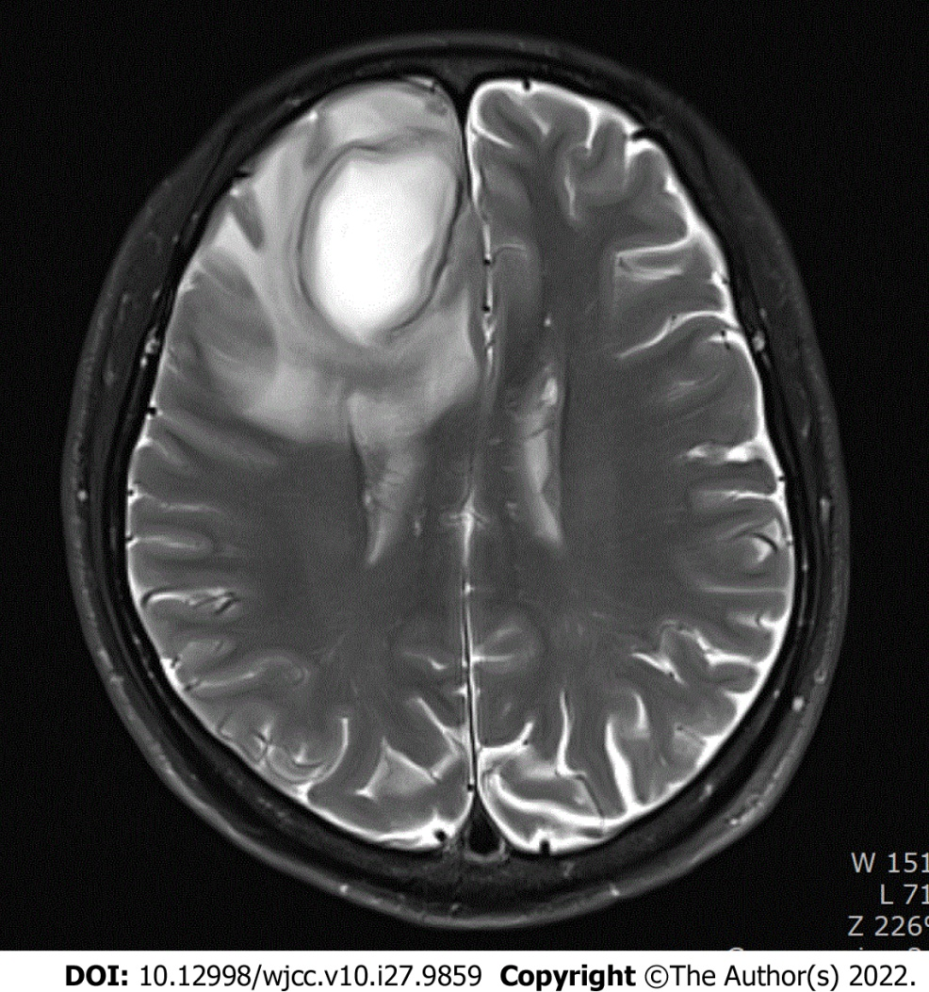
Figure 1 Magnetic resonance imaging finding. Magnetic resonance imaging revealed a round mass in the right frontal lobe, which was suspected to be a brain abscess.
Table 1 Case report timeline
Item |  | Timeline
Preoperative | 1 | Admission for a severe headache lasting 30 d
 | 2 | Past history-Large perimembranous VSD with bidirectional shunt flow and pulmonary arterial hypertension 10 years ago
 | 3 | MRI-A round mass in the right frontal lobe
 | 4 | Plan-craniotomy under MAC
Perioperative | 5 | Arterial cannulation and arterial blood gas analysis
 | 6 | Advanced hemodynamic monitoring-CO, SV, SVV
 | 7 | Oxygen supply-high-flow nasal cannula
 | 8 | MAC induction with dexmedetomidine loading
 | 9 | Central venous catheterization
 | 10 | Remifentanil, remodulin infusion
 | 11 | Neuronavigation system set
 | 12 | Craniotomy and stereotactic aspiration
Postoperative | 13 | ICU for 3 d
 | 14 | Discharge on POD 5
MRI: Magnetic resonance imaging; MAC: Monitored anesthesia care; CO: Cardiac output; SV: Stroke volume; SVV: Stroke volume variation; ICU: Intensive care unit; POD: Postoperative day; VSD: Ventricular septal defect.

Published by Baishideng Publishing Group Inc
7041 Koll Center Parkway, Suite 160, Pleasanton, CA 94566, USA
Telephone: +1-925-3991568
E-mail: bpgoffice@wjgnet.com
Help Desk: https://www.f6publishing.com/helpdesk
https://www.wjgnet.com

© 2022 Baishideng Publishing Group Inc. All rights reserved.

