Name of Journal: World Journal of Gastrointestinal Oncology
Manuscript NO: 86515
Manuscript Type: ORIGINAL ARTICLE

Basic Study
Long non-coding RNA CDKN2B-AS1 promotes hepatocellular carcinoma progression via E2F transcription factor 1/G protein subunit alpha Z axis

Tao ZG et al. LncRNA CDKN2B-AS1 promotes HCC progression

Zhi-Gang Tao, Yu-Xiao Yuan, Guo-Wei Wang

Zhi-Gang Tao, Department of Radiology, Hangzhou Cancer Hospital, Hangzhou 310000, Zhejiang Province, China

Yu-Xiao Yuan, Guo-Wei Wang, Department of Radiology, Hangzhou Xixi Hospital, Hangzhou 310012, Zhejiang Province, China

Author contributions: Wang GW conceptualized the study; Tao ZG and Yuan YX performed the experiments, analyzed the data, and drafted the manuscript; and all authors have read and approved the final manuscript.

Corresponding author: Guo-Wei Wang, MD, MM, Attending Doctor, Department of Radiology, Hangzhou Xixi Hospital, No. 2 Hengbu Street, Xihu District, Hangzhou 310012, Zhejiang Province, China. wanguowei6987@126.com

Received: June 23, 2023
Revised: September 12, 2023
Accepted: October 11, 2023
Published online: November 15, 2023

Abstract
BACKGROUND
A series of long non-coding RNAs (lncRNAs) have been reported to play a crucial role in cancer biology. Some previous studies report that lncRNA CDKN2B-AS1 is involved in some human malignancies. However, its role in hepatocellular carcinoma (HCC) has not been fully deciphered.

AIM
To decipher the role of CDKN2B-AS1 in the progression of HCC.

METHODS
CDKN2B-AS1 expression in HCC was detected by quantitative real-time polymerase chain reaction. The malignant phenotypes of Li-7 and SNU-182 cells were detected by the CCK-8 method, EdU method, and flow cytometry, respectively. RNA immunoprecipitation was executed to confirm the interaction between CDKN2B-AS1 and E2F transcription factor 1 (E2F1). Luciferase reporter assay and chromatin immunoprecipitation were performed to verify the binding of E2F1 to the promoter of G protein subunit alpha Z (GNAZ). E2F1 and GNAZ were detected by western blot in HCC cells.

RESULTS
In HCC tissues, CDKN2B-AS1 was upregulated. Depletion of CDKN2B-AS1 inhibited the proliferation of HCC cells, and the depletion of CDKN2B-AS1 also induced cell cycle arrest and apoptosis. CDKN2B-AS1 could interact with E2F1. Depletion of CDKN2B-AS1 inhibited the binding of E2F1 to the GNAZ promoter region. Overexpression of E2F1 reversed the biological effects of depletion of CDKN2B-AS1 on the malignant behaviors of HCC cells.

CONCLUSION
CDKN2B-AS1 recruits E2F1 to facilitate GNAZ transcription to promote HCC progression.

Key Words: Hepatocellular carcinoma; CDKN2B-AS1; E2F transcription factor 1; G protein subunit alpha Z; Proliferation

©The Author(s) 2023. Published by Baishideng Publishing Group Inc. All rights reserved.

Citation: Tao ZG, Yuan YX, Wang GW. Long non-coding RNA CDKN2B-AS1 promotes hepatocellular carcinoma progression via E2F transcription factor 1/G protein subunit alpha Z axis. World J Gastrointest Oncol 2023; 15(11): 1974-1987
URL: https://www.wjgnet.com/1948-5204/full/v15/i11/1974.htm
DOI: https://dx.doi.org/10.4251/wjgo.v15.i11.1974

Core Tip: The high expression of long non-coding RNAs CDKN2B-AS1 in hepatocellular carcinoma (HCC) predicts poor prognosis of the patients, as it facilitates some malignant biological behaviors of HCC cells, including enhanced viability, proliferation, cell cycle progression, and anti-apoptosis ability. This study reveals one mechanism of CDKN2B-AS1 promoting HCC progression, which is the interaction between CDKN2B-AS1 and E2F transcription factor 1 in HCC cells to promote the expression of the oncogene G protein subunit alpha Z.

INTRODUCTION
The morbidity and mortality of hepatocellular carcinoma (HCC) patients maintain a high level^{[1]}. Surgical resection can be relatively helpful in treating patients with early-stage HCC^{[2]}. Nevertheless, the early symptoms of HCC are inconspicuous, and most patients are diagnosed only when the tumor has progressed beyond treatment by surgical resection, in situ liver transplantation, etc.^{[3,4]}. In addition, even with early and effective diagnosis and treatment, HCC patients are prone to suffer from recurrence and have adverse prognosis^{[5]}.
Long non-coding RNAs (lncRNAs) can exert their biological effects in cell biology by interacting with microRNAs, ncRNAs, and proteins^{[6,7]}. Reportedly, lncRNAs play a key regulatory role in HCC by acting as oncogenes or tumor suppressors^{[8,9]}. Some studies have reported that dysregulation of lncRNA participates in HCC progression. Specifically, lncRNA-PDPK2P is highly expressed in HCC tissues, and it facilitates HCC progression via modulating the PDK1/AKT/caspase 3 axis^{[10]}. Another study reports that lncRNA uc.134 is a tumor-suppressive lncRNA, and it mediates the ubiquitination of LATS1 to repress the expression of oncogene LATS1^{[11]}. High expression of lncRNA CDKN2B-AS1 (CDKN2B-AS1) predicts poor prognosis of HCC patients^{[12]}; additionally, CDKN2B-AS1 can promote the malignancy of HCC cells via modulating miR-424-5p^{[13]}. Nonetheless, the mechanism of CDKN2B-AS1 in modulating HCC progression is not fully explained.
Sustaining cell growth is one of the fundamental hallmarks of carcinogenesis and it results from dysregulation of cell cycle progression. E2F transcription factors are a large family of transcription modulators and are key regulators of the cell cycle; E2F transcription factor 1 (E2F1), a member of the E2F family, is found to interact with SET7/9 to promote HCC progression^{[14]}. G protein subunit alpha Z (GNAZ) is a member of the unique GI/o subfamily encoding GαŽ^{[10]}. GNAZ overexpression promotes the malignancy of HCC cells^{[11]}. In this work, we aim to study the expression characteristics and functions of CDKN2B-AS1 in HCC and the potential mechanisms and confirm that CDKN2B-AS1 can facilitate disease progression by regulating the E2F1/GNAZ axis.

MATERIALS AND METHODS
Clinical samples
Fifty-five patients diagnosed with HCC at Hangzhou Cancer Hospital who received hepatectomy were included in this study. Surgical tissue specimens were placed in liquid nitrogen for storage. All of the patients were not treated by anti-cancer treatment before surgery. The work was approved by the Ethics Committee of Hangzhou Cancer Hospital.

Cell culture
Li-7, Huh-7, SK-HEP-1, and SNU-387 cell lines (Shanghai Institute of Cell Research), and immortalized liver epithelial cells THLE-2 (ATCC) were cultured in RPMI-1640 medium (Thermo Fisher Scientific) [containing 10% foetal bovine serum (Gibco), 100 U/mL penicillin and 100 mg/mL streptomycin (Invitrogen)]. Culture condition: 5% CO₂, 37 °C, saturated humidity.

Quantitative real-time polymerase chain reaction
RNAiso Plus kit (Takara) and PrimeScriptTM RT Reagent Kit (Takara) were applied for RNA extraction and cDNA synthesis. Quantitative real-time polymerase chain reaction (qRT-PCR) was performed with SYBR Premix Ex TaqTM II Kit (Takara). For the sequences of primers, please check Table 1.

Cell transfection
Two CDKN2B-AS1 small interfering RNAs (siRNAs), E2F1 overexpression plasmid (oe-E2F1), and controls [siRNA control (si-NC), plasmid (NC)] were created by GenePharma Co., Ltd. When the Li-7 and SNU-182 cells grew to a density of 50%-60%, cells were transfected using Lipofectamine® 2000 (Invitrogen). Briefly, the cells were cultured with serum-free medium for 24 h. Next, the transfection reagent was mixed with serum-free medium and vectors/oligonucleotides, and incubated for 8 h. Next, the cells were mixed with the transfection reagent containing vectors/oligonucleotides, and incubated for 12 h. Subsequently, the cells were cultured with a complete medium with serum, and 24 h later, the cells were collected, and qPCR was applied for validation of the transfection efficacy.

MTT assay
Li-7 and SNU-182 cells were inoculated in 96-well plates (5 × 10³ cells/well). MTT reagent (5 mg/mL; Sigma) was added (20 μL per well) after the cells were cultured overnight and then incubated for 4 h at 37 °C. Then, dimethyl sulfoxide (DMSO; Sigma) was added (150 μL per well) and the cells were shaken at low speed for 15 min to fully dissolve the crystals. Next, the absorbance [optical density (OD)] value finally was measured at 450 nm light wavelength with a microplate reader. Then the growth curve of the cells was plotted according to the OD value.

EdU assay
The transfected Li-7 and SNU-182 cells were taken and inoculated on 24-well plates at 1.5 × 10⁵ cells per well. EdU solution (RiboBio, Guangzhou, China) (50 μM) was added, and then the cells were incubator (2h, at 37 °C). Li-7 and SNU-182 cells were fixed in phosphate-buffered saline (PBS) containing 4% paraformaldehyde (Sigma) for 30 min. After washing with PBS, the cells were stained with 1 × Apollo staining solution and DAPI (Solarbio) (protected from light, room temperature, 20 min). After PBS washing, the EdU-positive cells were observed under fluorescence microscopy. At least three visual fields were captured, and the cells were counted. The percentage of proliferating cells (%) = EdU positive cells/DAPI positive cells × 100 %.

Flow cytometry
To assess the cell cycle, 1 × 10⁷ Li-7 and SNU-182 cells were fixed in ethanol and placed at -20 °C for 24 h. After washing twice with PBS, Li-7, and SNU-182 cells were resuspended in 100 μL RNase A (BD Bioscience) and incubated (at 37 °C for 30 min). Then Li-7 and SNU-182 cells were stained with 400 μL of propidium iodide (PI) (50 μg/mL; BD Biosciences) (5 min at 4 °C in the dark). Finally, a FACScan flow cytometer (BD Bioscience) was utilized to sort the cells.
For apoptosis analysis, 1 × 10⁶ Li-7 and SNU-182 single cell suspensions (in 1 mL PBS) were centrifuged (400 × g, 5 min, 4 °C). Li-7 and SNU-182 cells were then resuspended and marked with 10 μL of Annexin V-fluorescein isothiocyanate and 10 μL of PI (BD Biosciences) (protected from light, 30 min, 4 °C). Finally, apoptosis was detected by flow cytometry within 1 h.

Nucleocytoplasmic separation
The PARIS™ kit (Ambion, Austin, TX) was utilized in this assay. Briefly, 5 × 10⁶ Li-7 and SNU-182 cells were re-suspended in 0.5 mL resuspension buffer and next homogenization was performed. After centrifugation (400 × g, 15 min), the supernatant was collected (cytoplasmic fraction). The pellet was then dissolved in a mixture of PBS (0.3 mL), nuclear isolation buffer (0.3 mL), and RNase-free H₂O (0.3 mL) (on ice, 20 min), and then centrifugation was performed (nuclear fraction). Next, qRT-PCR was performed.

RNA immunoprecipitation
Li-7 and SNU-182 cells (5 × 10⁶ cells) were fixed with 0.3% formaldehyde. Then Li-7 and SNU-182 cells were resuspended in RIPA buffer (Sigma) and incubated on ice with shaking for 30 min. Cell lysates were incubated with 5 μg of anti-E2F1 antibody (ab288369, Abcam) or anti-immunoglobulin (Ig)G antibody conjugated to magnetic beads (ab150077, Abcam) (4 °C, 8 h). The beads were washed with RIPA buffer, followed by elution, reverse cross-linking, and subsequent RNA extraction. Finally, qPCR was conducted^{[15]}.

Western blot
The bicinchoninic acid protein assay kit (Beyotime) was used to detect the protein concentration of the samples. Protein samples were mixed with loading buffer and separated by sodium-dodecyl sulfate gel electrophoresis, and the proteins were transferred onto polyvinylidene fluoride membranes (Millipore) by electrotransfer. After blocking, the membranes were incubated with primary anti-E2F1 antibody (ab288369, 1:1000), anti-GNAZ antibody (ab154846, 1:1000), and anti-GAPDH antibody (ab9485, 1:1000) (4 °C, 8 h), then incubated with secondary antibody (ab205718, 1:5000) (room temperature, 1 h). All of the antibodies were obtained from Abcam. An enhanced chemiluminescence kit (Promega) was finally used to develop the blot on the membrane under an imaging device.

Dual-luciferase reporter assay
The PROMO database was utilized to show the potential E2F1 binding motif in the GNAZ promoter. The wild type and mutated recombinant vectors containing the predicted sequence were co-transfected into Li-7 and SNU-182 cells with the E2F1 overexpression plasmid or its negative control. At 48 h after transfection, luciferase activity was assessed with the kit (Promega). Firefly luciferase activity was used to show the binding intensity between E2F1 and GNAZ promoter, with Renilla luciferase activity as the internal reference.

Chromatin immunoprecipitation
An EZ-CHIPTM Chromatin Immunoprecipitation Kit (Millipore) was used for this assay. Transfected Li-7 and SNU-182 cells (1 × 10⁷ cells) were then taken and cultured (24 h, 37 °C). Cells were fixed with 10% formaldehyde for 10 min and then terminated with glycine. Cells were then collected and centrifuged to obtain cell precipitates. Subsequently, cells were lysed by adding cell lysis solution (Sigma) and centrifuged to obtain cell nuclear precipitates. Then sonication was performed and the sonically sheared cell nuclear lysates were incubated with control IgG antibody or E2F1 antibody, respectively, at 4 °C overnight. Afterward, the DNA bound to the E2F1 transcription factor was centrifuged and eluted using a fresh elution buffer, and the DNA was then extracted. qRT-PCR was conducted with the purified DNA.

Statistical analysis
Data of all experiments (performed in triplicate) were expressed as mean ± SD, and analyzed by SPSS 20.0 (IBM), with independent samples t-test or one-way ANOVA. P < 0.05 signified statistical significance.

RESULTS
CDKN2B-AS1 is upregulated in HCC and high CDKN2B-AS1 expression hints poor prognosis
First of all, we investigate the expression characteristics and clinical significance of CDKN2B-AS1 in HCC. StarBase database suggested that CDKN2B-AS1 expression was higher in HCC samples than (vs paracancerous samples) (Figure 1A). Subsequent qPCR assays indicated that, in HCC samples, CDKN2B-AS1 was remarkably overexpressed (vs paracancerous tissues) (Figure 1B). Consistently, the expression level of CDKN2B-AS1 was promoted in cancer cell lines (vs normal hepatic epithelial cell line THLE-2) (Figure 1C). In addition, by analysis of the data in the GEPIA database, it was known that high CDKN2B-AS1 expression predicted a shorter survival time of patients (Figure 1D).

Depletion of CDKN2B-AS1 markedly inhibited the malignancy of HCC cells
Next, we explored the biological function of CDKN2B-AS1 in modulating the malignant biological behaviors of HCC cells. Since CDKN2B-AS1 expression was most aberrantly expressed in Li-7 and SNU-182 cells, they were chosen for further investigation. As shown, transfection of CDKN2B-AS1 siRNA significantly reduced CDKN2B-AS1 expression in Li-7 and SNU-182 cells (Figures 2A and B). Functional assays showed depletion of CDKN2B-AS1 significantly suppressed Li-7 and SNU-182 cell viability (Figures 2C and D). Furthermore, by flow cytometry analysis, we found that the knockdown of CDKN2B-AS1 resulted in Li-7 and SNU-182 cells being blocked in the G0/G1 phase and promoted apoptosis (Figures 2E and F). In conclusion, these data unveiled that CDKN2B-AS1 enhanced the malignancy of HCC cells.

CDKN2B-AS1 interacts with E2F1
Subsequently, we tried to explore the downstream mechanism of CDKN2B-AS1. The results of nucleoplasmic separation experiments showed that most CDKN2B-AS1 transcripts were present in the nuclei of Li-7 and SNU-182 cells (Figure 3A), this suggested that CDKN2B-AS1 probably exerts its biological function at the transcriptional level. Through the RIP experiment, we found that compared with the IgG group, CDKN2B-AS1 was remarkably enriched by anti-E2F1 antibody (Figure 3B). Subsequently, the qRT-PCR analysis demonstrated that transfection with CDKN2B-AS1 siRNA significantly reduced E2F1 mRNA expression in the cells (Figure 3C). Immunoblotting showed that depletion of CDKN2B-AS1 significantly inhibited the expression level of E2F1 protein in Li-7 and SNU-182 cells (Figure 3D).

CDKN2B-AS1 promotes GNAZ transcription by recruiting E2F1
Finally, we tried to screen out the downstream effects modulated by CDKN2B-AS1/E2F1. PROMO database implied that E2F1 could bind to the GNAZ promoter sequence (Figure 4A). StarBase database showed that high GNAZ expression hinted at shorter overall survival in HCC patients (Figure 4B); besides, GNAZ expression level was positively correlated with either E2F1 expression or CDKN2B-AS1 expression in HCC tissue samples (Figures 4C and D). Moreover, the binding sequence was mutated and a luciferase reporter assay was conducted. The results unveiled that site 3 was a specific site for the binding of E2F1 protein to the GNAZ promoter (Figure 4E). Chromatin immunoprecipitation analysis demonstrated that the depletion of CDKN2B-AS1 decreased the binding between E2F1 and GNAZ (Figure 4F). As expected, CDKN2B-AS1 knockdown significantly inhibited E2F1 and GNAZ expression in Li-7 and SNU-182 cells, which was reversed by E2F1 overexpression (Figures 4G and H).

CDKN2B-AS1 regulates the proliferation, cell cycle, and apoptosis of HCC cells through the E2F1/GNAZ axis
To decipher the role of the CDKN2B-AS1/E2F1/GNAZ axis, we co-transfected si-NC, CDKN2B-AS1 siRNA, and CDKN2B-AS1 siRNA + E2F1 overexpression plasmid into Li-7 and SNU-182 cells. As shown, depletion of CDKN2B-AS1 markedly inhibited the growth of Li-7 and SNU-182 cells, while E2F1 overexpression reversed this effect (Figures 5A and B). Similarly, E2F1 overexpression counteracted the suppressive and promotive effects of CDKN2B-AS1 depletion on cell cycle progression and apoptosis of Li-7 and SNU-182 cells (Figures 5C and D).

DISCUSSION
LncRNAs are one of the hot spots in cancer research nowadays^{[16]}. Although lncRNAs lack protein-coding capabilities, many studies in the last decade have shown that they are important in regulating gene expression and protein function: In the nucleus, lncRNA participates in histone modification, mediate DNA methylation, affect chromatin remodeling, and regulate the variable splicing of mRNA; in the cytoplasm, lncRNA acts as an functional element to regulate the translation of mRNA, or decoys miRNA as molecular sponge, or directly interacts with protein to affect its biological activity and subcellular location^{[17,18]}. In HCC, many lncRNAs have been identified and their associations with HCC have been reported^{[15,19,20]}. For example, lncRNA HAND2-AS1 promotes self-renewal of HCC cells through BMP signaling^{[21]}. LncRNA-SNHG7 expression level is linked with the pathological and prognostic characteristics of patients with HCC^{[22]}. In addition, CDKN2B-AS1 has been validated to play carcinogenic roles in some malignancies including lung carcinoma^{[23]}, ovarian carcinoma^{[24]}, laryngeal squamous cell carcinoma^{[25]}, cervical carcinoma^{[26]} and HCC^{[13,27]}. Here, our data suggested that, in HCC, the expression level of CDKN2B-AS1 was increased, and it hinted at an adverse prognosis. In vitro assays confirmed that depletion of CDKN2B-AS1 inhibited the malignancy of HCC cells. These demonstrations are consistent with previous reports, which show CDKN2B-AS1 as an oncogene in HCC^{[27]}.
E2F1, a part of the E2F family of transcription factors, is recognized as an important promoter for cell entry into the S phase, and a non-negligible modulator in physiological and pathological processes^{[28]}. E2F1 is aberrantly expressed in a variety of human malignancies and acts as a pro-oncogene^{[29]}. For example, E2F1 promotes bladder carcinoma cell proliferation by binding to the promoter of RAD54L^{[30]}. In HCC, E2F1 is also aberrantly expressed, and it promotes the malignancy of HCC cells by regulating DDX11 transcription and activating PI3K/AKT/mTOR signaling^{[31]}. Some recent studies report that lncRNAs synergistically work with E2F1 to modulate gene transcription. For example, lncRNA NR-104098, interacted with E2F1, suppresses EZH2 transcription, suppressing acute myeloid leukemia progression^{[32]}. Here, we found that CDKN2B-AS1 interacted with E2F1. Further studies confirmed that GNAZ was a transcriptional target of E2F1. Importantly, the knockdown of CDKN2B-AS1 attenuated the recruitment of E2F1 to GNAZ. Furthermore, rescue experiments confirmed that E2F1 mediated the carcinogenic effect of CDKN2B-AS1.
G protein-coupled receptors (GPCRs) are crucial in the transduction of a variety of signaling and are considered attractive targets for the treatment of many diseases^{[33]}. GNAZ is one of the notable members of the GPCR family^{[11]}. High GNAZ expression leads to a surge in leukocyte and lymphocyte counts in patients with laparoscopic lymphoma, thereby reducing overall patient survival^{[34]}. Notably, GNAZ expression level is reported to be associated with unsatisfactory prognosis of HCC patients, and GNAZ overexpression leads to enhanced aggressiveness of the cells^{[11]}. In this study, our data showed that CDKN2B-AS1 promoted GNAZ transcription by enhancing the binding of E2F1 in the GNAZ promoter, facilitating HCC cell proliferation and inhibiting apoptosis.
Nevertheless, there are some shortcomings in the present work. Firstly, in vivo experiments are required to further validate the tumor-promoting properties of CDKN2B-AS1 in HCC. In addition, knockout rather than knockdown of the CDKN2B-AS1 in HCC cell lines or induced pluripotent stem cell derived hepatocytes should be performed to validate the functions of this gene as a more authentic and objective evidence. Also, it would be interesting to explore whether CDKN2B-AS1 depletion will affect other malignant biological behaviors of HCC such as chemosensitivity and radiosensitivity. Furthermore, the other downstream targets of the CDKN2B-AS1/E2F1 axis should be explored, and this will further clarify the mechanism by which CDKN2B-AS1 modulates the phenotypes of HCC. Last but not least, more tissue samples from HCC patients should be collected to analyze the clinical significance of CDKN2B-AS1 and to evaluate the potential of CDKN2B-AS1 as a biomarker.

CONCLUSION
CDKN2B-AS1 expression was upregulated in HCC and hinted at poor prognosis in the patients. We confirmed that CDKN2B-AS1 promoted GNAZ transcription through the recruitment of E2F1, thereby promoting the malignancy of HCC cells.

ARTICLE HIGHLIGHTS
Research background
Long non-coding RNAs (lncRNAs) have been implicated in cancer biology, with lncRNA CDKN2B-AS1 being reported to associate with several human cancers, though its role in hepatocellular carcinoma (HCC) remains unclear.

Research motivation
The motivation behind this research is to better understand the mechanisms underlying the development and progression of HCC, and to explore whether CDKN2B-AS1 could serve as a potential therapeutic target for HCC.

Research objectives
This study aims to investigate the role of the lncRNA CDKN2B-AS1 in HCC progression.

Research methods
This study investigated the role of CDKN2B-AS1 in HCC progression by measuring its expression in HCC using quantitative real-time polymerase chain reaction. Effects on proliferation, cell cycle, and apoptosis of Li-7 and SNU-182 cells were then assessed using the CCK-8 assay, the EdU assay, and flow cytometry. RNA immunoprecipitation was performed to verify the interaction between CDKN2B-AS1 and E2F transcription factor 1 (E2F1). The binding of E2F1 to the promoter of G protein subunit alpha Z (GNAZ) was confirmed using luciferase reporter assay and Chromatin immunoprecipitation. And western blot was utilized to confirm the expression of E2F1 and GNAZ in HCC cells.

Research results
Upregulation of CDKN2B-AS1 was identified in HCC tissues. Inhibited proliferation, induced cell cycle arrest as well as apoptosis were detected in HCC cells with silenced CDKN2B-AS1. In addition, CDKN2B-AS1 was found to interact with E2F1, and its depletion significantly inhibited the binding of E2F1 to the GNAZ promoter region. It has also been found that these effects caused by CDKN2B-AS1 knockdown, can be reversed by E2F1 overexpression.

Research conclusions
In conclusion, the promotion of HCC progression is facilitated by CDKN2B-AS1 recruiting E2F1 to enhance GNAZ transcription.

Research perspectives
This research suggests that CDKN2B-AS1 may serve as a potential therapeutic target for HCC. Further research could investigate the effectiveness of CDKN2B-AS1 inhibition as a treatment for HCC. Additionally, this study provides a better understanding of the mechanisms underlying HCC progression and could inform the development of new diagnostic and treatment approaches for this disease.

REFERENCES
1 McGlynn KA, Petrick JL, El-Serag HB. Epidemiology of Hepatocellular Carcinoma. Hepatology 2021; 73 Suppl 1: 4-13 [PMID: 32319693 DOI: 10.1002/hep.31288]
2 Morse MA, Sun W, Kim R, He AR, Abada PB, Mynderse M, Finn RS. The Role of Angiogenesis in Hepatocellular Carcinoma. Clin Cancer Res 2019; 25: 912-920 [PMID: 30274981 DOI: 10.1158/1078-0432.CCR-18-1254]
3 Yi PS, Li Y, Yan S, Wu B, Lan C, Li JS. Surgery combined with post-operative trancatheter arterial chemoembolization improves survival of intermediate hepatocellular carcinoma. Scand J Gastroenterol 2019; 54: 240-245 [PMID: 30880503 DOI: 10.1080/00365521.2019.1577487]
4 Greten TF, Lai CW, Li G, Staveley-O'Carroll KF. Targeted and Immune-Based Therapies for Hepatocellular Carcinoma. Gastroenterology 2019; 156: 510-524 [PMID: 30287171 DOI: 10.1053/j.gastro.2018.09.051]
5 Mullath A, Krishna M. Hepatocellular carcinoma - time to take the ticket. World J Gastrointest Surg 2019; 11: 287-295 [PMID: 31367276 DOI: 10.4240/wjgs.v11.i6.287]
6 Liao K, Xu J, Yang W, You X, Zhong Q, Wang X. The research progress of LncRNA involved in the regulation of inflammatory diseases. Mol Immunol 2018; 101: 182-188 [PMID: 30007227 DOI: 10.1016/j.molimm.2018.05.030]
7 Wang JY, Yang Y, Ma Y, Wang F, Xue A, Zhu J, Yang H, Chen Q, Chen M, Ye L, Wu H, Zhang Q. Potential regulatory role of lncRNA-miRNA-mRNA axis in osteosarcoma. Biomed Pharmacother 2020; 121: 109627 [PMID: 31810120 DOI: 10.1016/j.biopha.2019.109627]
8 Esposito R, Bosch N, Lanzós A, Polidori T, Pulido-Quetglas C, Johnson R. Hacking the Cancer Genome: Profiling Therapeutically Actionable Long Non-coding RNAs Using CRISPR-Cas9 Screening. Cancer Cell 2019; 35: 545-557 [PMID: 30827888 DOI: 10.1016/j.ccell.2019.01.019]
9 Li Y, Jiang T, Zhou W, Li J, Li X, Wang Q, Jin X, Yin J, Chen L, Zhang Y, Xu J, Li X. Pan-cancer characterization of immune-related lncRNAs identifies potential oncogenic biomarkers. Nat Commun 2020; 11: 1000 [PMID: 32081859 DOI: 10.1038/s41467-020-14802-2]
10 Vancura P, Abdelhadi S, Csicsely E, Baba K, Tosini G, Iuvone PM, Spessert R. Gnaz couples the circadian and dopaminergic system to G protein-mediated signaling in mouse photoreceptors. PLoS One 2017; 12: e0187411 [PMID: 29088301 DOI: 10.1371/journal.pone.0187411]
11 Tian F, Cai D. Overexpressed GNAZ predicts poor outcome and promotes G0/G1 cell cycle progression in hepatocellular carcinoma. Gene 2022; 807: 145964 [PMID: 34530087 DOI: 10.1016/j.gene.2021.145964]
12 Sui J, Miao Y, Han J, Nan H, Shen B, Zhang X, Zhang Y, Wu Y, Wu W, Liu T, Xu S, Yang S, Yin L, Pu Y, Liang G. Systematic analyses of a novel lncRNA-associated signature as the prognostic biomarker for Hepatocellular Carcinoma. Cancer Med 2018; 7: 3240-3256 [PMID: 29761859 DOI: 10.1002/cam4.1541]
13 Shen X, Li Y, He F, Kong J. LncRNA CDKN2B-AS1 Promotes Cell Viability, Migration, and Invasion of Hepatocellular Carcinoma via Sponging miR-424-5p. Cancer Manag Res 2020; 12: 6807-6819 [PMID: 32801906 DOI: 10.2147/CMAR.S240000]
14 Gu Y, Wang X, Liu H, Li G, Yu W, Ma Q. SET7/9 promotes hepatocellular carcinoma progression through regulation of E2F1. Oncol Rep 2018; 40: 1863-1874 [PMID: 30106440 DOI: 10.3892/or.2018.6621]
15 Lv E, Sheng J, Yu C, Rao D, Huang W. LncRNA influence sequential steps of hepatocellular carcinoma metastasis. Biomed Pharmacother 2021; 136: 111224 [PMID: 33450489 DOI: 10.1016/j.biopha.2021.111224]
16 Charles Richard JL, Eichhorn PJA. Platforms for Investigating LncRNA Functions. SLAS Technol 2018; 23: 493-506 [PMID: 29945466 DOI: 10.1177/2472630318780639]
17 Ma Y, Zhang J, Wen L, Lin A. Membrane-lipid associated lncRNA: A new regulator in cancer signaling. Cancer Lett 2018; 419: 27-29 [PMID: 29330108 DOI: 10.1016/j.canlet.2018.01.008]
18 Rajagopal T, Talluri S, Akshaya RL, Dunna NR. HOTAIR LncRNA: A novel oncogenic propellant in human cancer. Clin Chim Acta 2020; 503: 1-18 [PMID: 31901481 DOI: 10.1016/j.cca.2019.12.028]
19 Yang Y, Chen Q, Piao HY, Wang B, Zhu GQ, Chen EB, Xiao K, Zhou ZJ, Shi GM, Shi YH, Wu WZ, Fan J, Zhou J, Dai Z. HNRNPAB-regulated lncRNA-ELF209 inhibits the malignancy of hepatocellular carcinoma. Int J Cancer 2020; 146: 169-180 [PMID: 31090062 DOI: 10.1002/ijc.32409]
20 Qi W, Li Z, Xia L, Dai J, Zhang Q, Wu C, Xu S. LncRNA GABPB1-AS1 and GABPB1 regulate oxidative stress during erastin-induced ferroptosis in HepG2 hepatocellular carcinoma cells. Sci Rep 2019; 9: 16185 [PMID: 31700067 DOI: 10.1038/s41598-019-52837-8]
21 Wang Y, Zhu P, Luo J, Wang J, Liu Z, Wu W, Du Y, Ye B, Wang D, He L, Ren W, Wang J, Sun X, Chen R, Tian Y, Fan Z. LncRNA HAND2-AS1 promotes liver cancer stem cell self-renewal via BMP signaling. EMBO J 2019; 38: e101110 [PMID: 31334575 DOI: 10.15252/embj.2018101110]
22 Shen A, Ma J, Hu X, Cui X. High expression of lncRNA-SNHG7 is associated with poor prognosis in hepatocellular carcinoma. Oncol Lett 2020; 19: 3959-3963 [PMID: 32382340 DOI: 10.3892/ol.2020.11490]
23 Wang G, Xu G, Wang W. Long Noncoding RNA CDKN2B-AS1 Facilitates Lung Cancer Development Through Regulating miR-378b/NR2C2. Onco Targets Ther 2020; 13: 10641-10649 [PMID: 33116641 DOI: 10.2147/OTT.S261973]
24 Xu C, Zhai J, Fu Y. LncRNA CDKN2B-AS1 promotes the progression of ovarian cancer by miR-143-3p/SMAD3 axis and predicts a poor prognosis. Neoplasma 2020; 67: 782-793 [PMID: 32305052 DOI: 10.4149/neo_2020_190617N515]
25 Cui X, Yu T, Shang J, Xiao D, Wang X. Long Non-Coding RNA CDKN2B-AS1 Facilitates Laryngeal Squamous Cell Cancer Through Regulating miR-497/CDK6 Pathway. Onco Targets Ther 2019; 12: 8853-8862 [PMID: 31754305 DOI: 10.2147/OTT.S221620]
26 Zhang Y, Zhao L, Yang S, Cen Y, Zhu T, Wang L, Xia L, Liu Y, Zou J, Xu J, Li Y, Cheng X, Lu W, Wang X, Xie X. CircCDKN2B-AS1 interacts with IMP3 to stabilize hexokinase 2 mRNA and facilitate cervical squamous cell carcinoma aerobic glycolysis progression. J Exp Clin Cancer Res 2020; 39: 281 [PMID: 33308298 DOI: 10.1186/s13046-020-01793-7]
27 Huang Y, Xiang B, Liu Y, Wang Y, Kan H. LncRNA CDKN2B-AS1 promotes tumor growth and metastasis of human hepatocellular carcinoma by targeting let-7c-5p/NAP1L1 axis. Cancer Lett 2018; 437: 56-66 [PMID: 30165194 DOI: 10.1016/j.canlet.2018.08.024]
28 Denechaud PD, Fajas L, Giralt A. E2F1, a Novel Regulator of Metabolism. Front Endocrinol (Lausanne) 2017; 8: 311 [PMID: 29176962 DOI: 10.3389/fendo.2017.00311]
29 Shen C, Li J, Chang S, Che G. Advancement of E2F1 in Common Tumors. Zhongguo Fei Ai Za Zhi 2020; 23: 921-926 [PMID: 33070516 DOI: 10.3779/j.issn.1009-3419.2020.101.32]
30 Mun JY, Baek SW, Park WY, Kim WT, Kim SK, Roh YG, Jeong MS, Yang GE, Lee JH, Chung JW, Choi YH, Chu IS, Leem SH. E2F1 Promotes Progression of Bladder Cancer by Modulating RAD54L Involved in Homologous Recombination Repair. Int J Mol Sci 2020; 21 [PMID: 33261027 DOI: 10.3390/ijms21239025]
31 Yu Y, Zhao D, Li K, Cai Y, Xu P, Li R, Li J, Chen X, Chen P, Cui G. E2F1 mediated DDX11 transcriptional activation promotes hepatocellular carcinoma progression through PI3K/AKT/mTOR pathway. Cell Death Dis 2020; 11: 273 [PMID: 32332880 DOI: 10.1038/s41419-020-2478-0]
32 Feng Y, Hu S, Li L, Zhang S, Liu J, Xu X, Zhang M, Du T, Du Y, Peng X, Chen F. LncRNA NR-104098 Inhibits AML Proliferation and Induces Differentiation Through Repressing EZH2 Transcription by Interacting With E2F1. Front Cell Dev Biol 2020; 8: 142 [PMID: 32296698 DOI: 10.3389/fcell.2020.00142]
33 Wein MN, Foretz M, Fisher DE, Xavier RJ, Kronenberg HM. Salt-Inducible Kinases: Physiology, Regulation by cAMP, and Therapeutic Potential. Trends Endocrinol Metab 2018; 29: 723-735 [PMID: 30150136 DOI: 10.1016/j.tem.2018.08.004]
34 Mundt F, Merrien M, Nygren L, Sutton LA, Christensson B, Wahlin BE, Rosenquist R, Sander B, Wasik AM. Expression of GNAZ, encoding the Gα(z) protein, predicts survival in mantle cell lymphoma. Br J Haematol 2019; 185: 708-712 [PMID: 30788840 DOI: 10.1111/bjh.15810]

Footnotes
Institutional review board statement: The study was reviewed and approved by Ethics Committee of Hangzhou Cancer Hospital.

Informed consent statement: The surgical tissues and cells used in this study were not involved in the patients’ privacy information, so the informed consent was waived by the Ethics Committee of Hangzhou Cancer Hospital.

Conflict-of-interest statement: All the authors report no relevant conflicts of interest for this article.

Data sharing statement: No additional data are available.

Open-Access: This article is an open-access article that was selected by an in-house editor and fully peer-reviewed by external reviewers. It is distributed in accordance with the Creative Commons Attribution NonCommercial (CC BY-NC 4.0) license, which permits others to distribute, remix, adapt, build upon this work non-commercially, and license their derivative works on different terms, provided the original work is properly cited and the use is non-commercial. See: https://creativecommons.org/Licenses/by-nc/4.0/

Provenance and peer review: Unsolicited article; Externally peer reviewed.
Peer-review model: Single blind

Peer-review started: June 23, 2023
First decision: August 30, 2023
Article in press: October 11, 2023

Specialty type: Gastroenterology and hepatology
Country/Territory of origin: China
Peer-review report’s scientific quality classification
Grade A (Excellent): A
Grade B (Very good): B, B
Grade C (Good): 0
Grade D (Fair): 0
Grade E (Poor): 0

P-Reviewer: Demir FB, Turkey; Sahin TT, Turkey; Sanal MG, India S-Editor: Wang JJ L-Editor: A P-Editor: Yuan YY

Figure Legends
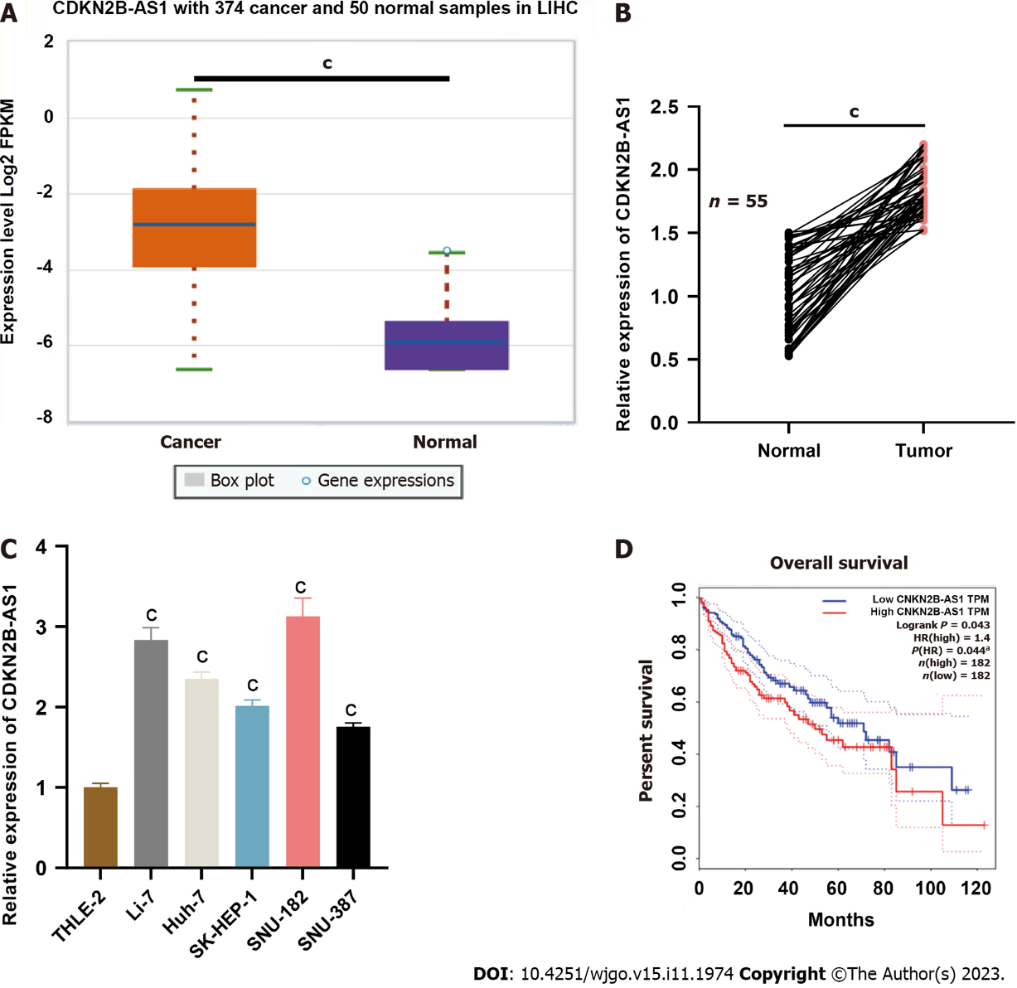
Figure 1 CDKN2B-AS1 expression pattern and prognostic value in hepatocellular carcinoma. A: Box plot showing log2-transformed gene expression levels of CDKN2B-AS1 in 374 hepatocellular carcinoma (HCC) cancer patients (orange box) compared with that in 50 normal counterparts (purple box), provided by the StarBase database; B: The relative transcriptional expression level of CDKN2B-AS1 in HCC tumor tissue samples and in paired normal tissue samples detected by quantitative real-time polymerase chain reaction (n = 55 in both groups). Each dot represents one patient, and two samples connected by a line are considered a pair; C: Bar chart showing the relative transcriptional expression levels of CDKN2B-AS1 in HCC cell lines (Li-7, Huh-7, SK-HEP-1, SNU-182, SNU-387) compared to that in THLE-2 cells; D: Overall survival plot of HCC patients grouped by CDKN2B-AS1 expressions (high vs low). Red line represents the high expression group and blue line represents the low expression group. ^{c}P < 0.001. HR: hazards ratio.

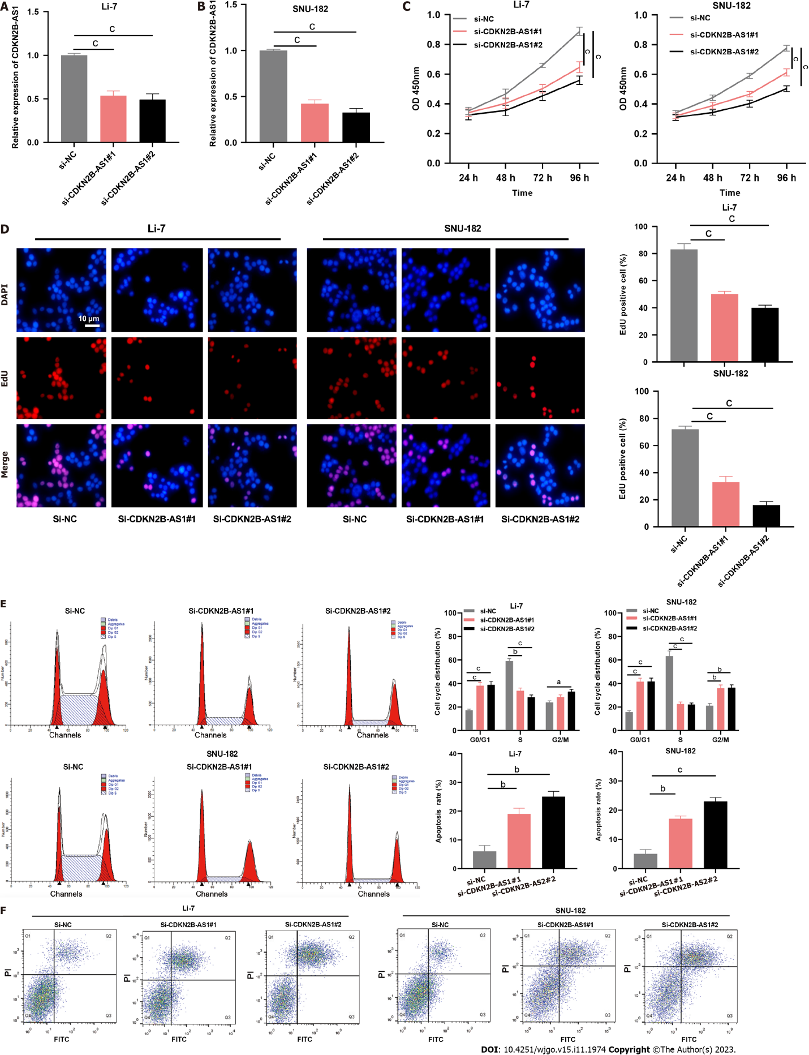
Figure 2 Depletion of CDKN2B-AS1 significantly inhibited the malignancy of hepatocellular carcinoma cells. A and B: Bar charts that demonstrate the validation results of transfection efficiency after silencing CDKN2B-AS1 in Li-7 (A) and SNU-182 (B) cell lines, which were evaluated by quantitative real-time polymerase chain reaction; C: Line graphs showing proliferation changes in Li-7 (left) and SNU-182 (right) cells after CDKN2B-AS1 knockdown at different time points (24 h, 48 h, 72 h, 96 h); D: Images from EdU assay showing changes in DNA synthesis in Li-7 and SNU-182 cells after CDKN2B-AS1 knockdown. Bar charts summarize the quantitative results of EdU positive cells%; E and F: Flow cytometry results that reveal the effect of silencing of CDKN2B-AS1 on Li-7 and SNU-182 cell cycle (E) and apoptosis (F), E: (Left panel) cell cycle analysis results, the first and last peaks in red indicate G0-G1, G2-M stage, respectively, and the middle part indicates S stage; (right panel) bar charts summarizing cell cycle distribution%; F: (Left panel) dot plot diagrams showing apoptotic cell population changes in CDKN2B-AS1 silenced cells; (right panel) Bar charts summarizing apoptosis rate%. ªP < 0.05, ^{b}P < 0.01 and ^{c}P < 0.001. PI: Propidium iodide.

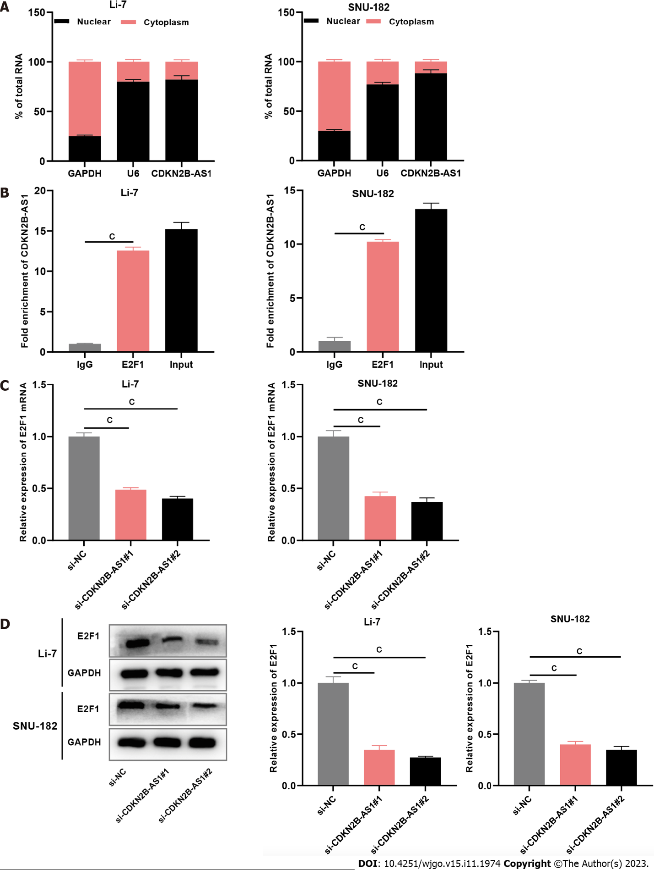
Figure 3 CDKN2B-AS1 interacts with transcription factor E2F transcription factor 1. A: Bar charts showing CDKN2B-AS1, U6, and GAPDH expressions in the nucleus faction (black part of the column) and cytoplasm fraction (pink part of the column) of Li-7 (left chart) and SNU-182 (right chart) cells detected by subcellular grading assay; B: Bar charts showing the fold enrichment of CDKN2B-AS1 from immunoglobulin G, E2F transcription factor 1 (E2F1), and total input, separately, in Li-7 and SNU-182 cells detected by RNA immunoprecipitation assays; C and D: Bar charts showing the expression levels of E2F1 in Li-7 and SNU-182 cells, after depletion of CDKN2B-AS1, examined by quantitative real-time polymerase chain reaction (C) and western blot assays (D). ^{c}P < 0.001. E2F1: E2F transcription factor 1.

Figure 4 CDKN2B-AS1 promotes transcription of G protein subunit alpha Z by recruiting transcription factor E2F transcription factor 1. A: Illustration of predicted binding site of E2F transcription factor 1 (E2F1) on the G protein subunit alpha Z (GNAZ) promoter sequence generated from the PROMO database; B: Overall survival plot of hepatocellular carcinoma (HCC) patients grouped by GNAK expressions (high vs low). Red line represents the high expression group and blue line represents the low expression group; C and D: Correlation analyses between expressions of E2F1 and GNAZ (C), and expressions of CDKN2B-AS1 and GNAZ (D), respectively, in HCC tissues from StarBase database. P < 0.05 indicates a significant correlation; E: Dual-luciferase reporter gene assays were conducted to predict the specific site of binding of E2F1 protein to the GNAZ promoter. Bar charts summarize the luciferase activity in Li-7 and SNU-182 cell lines overexpressed with E2F1 with wild type and mutated form of GNAZ (MUT1, MUT2, MUT1/2); F: Bar charts showing the fold enrichment of GNAZ promoter from immunoglobulin G and E2F1, separately, in CDKN2B-AS1 silenced Li-7 and SNU-182 cells, detected by Chromatin immunoprecipitation experiments; G and H: Bar charts showing the expression levels of E2F1 and GNAZ in Li-7 and SNU-182 cells, after depletion of CDKN2B-AS1, examined by quantitative real-time polymerase chain reaction (G) and western blot assays (H). ^{b}P < 0.01, ^{c}P < 0.001. E2F1: E2F transcription factor 1; GNAZ: G protein subunit alpha Z; IgG: Immunoglobulin G.

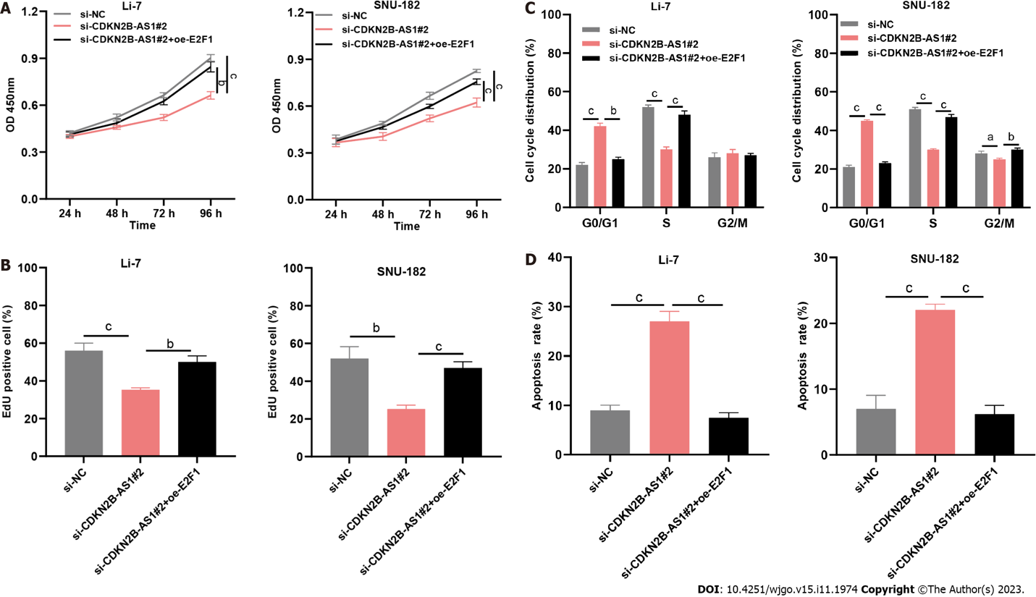
Figure 5 CDKN2B-AS1 regulates the malignancy of hepatocellular carcinoma cells through the E2F transcription factor 1/G protein subunit alpha Z axis. A: Line graphs showing proliferation changes in Li-7 (left) and SNU-182 (right) cells with si-CDKN2B-AS1, or si-CDKN2B-AS1 + oe-E2F transcription factor 1 (E2F1), at different time points (24 h, 48 h, 72 h, 96 h); B: Bar charts summarize the quantitative results of EdU positive cells% showing changes in DNA synthesis in Li-7 and SNU-182 cells with si-CDKN2B-AS1, or si-CDKN2B-AS1 + oe-E2F1; C and D: Bar charts summarizing cell cycle distribution% (C) and apoptosis rate% (D) that reveal the effect of si-CDKN2B-AS1, or si-CDKN2B-AS1 + oe-E2F1 on Li-7 and SNU-182 cell cycle and apoptosis, respectively. ªP < 0.05, ^{b}P < 0.01, ^{c}P < 0.001. E2F1: E2F transcription factor 1.

Table 1 Primer sequences
Name | Primer sequences
CDKN2B-AS1 | Forward: 5’-AGGAGGCTGAATGTCAGTTTT-3’
 | Reverse: 5’-AGCGGTTTAGTTTAATTTCGCTT-3’
E2F1 | Forward: 5’-GGACCUGGAAACUGACCAUTT-3’
 | Reverse: 5’-GACCACCUGAUGAAUAUCUTT-3’
GNAZ | Forward: 5’-GGTCTACATCCAACGTCAGTTC-3’
 | Reverse: 5’-TCTGTCACTGCGTCAAACAC-3’
GAPDH | Forward: 5’-TCTTCACCACCATGGAGAAG-3’
 | Reverse: 5’-GCAGAGATGATGACCCTTTTG-3’
U6 | Forward: 5’-GCTTCGGCAGCACATATACTAAAAT-3’
 | Reverse: 5’-CGCTTCACGAATTTGCGTGTCAT-3’
E2F1: E2F transcription factor 1; GNAZ: G protein subunit alpha Z.

Published by Baishideng Publishing Group Inc
7041 Koll Center Parkway, Suite 160, Pleasanton, CA 94566, USA
Telephone: +1-925-3991568
E-mail: bpgoffice@wjgnet.com
Help Desk: https://www.f6publishing.com/helpdesk
https://www.wjgnet.com

© 2023 Baishideng Publishing Group Inc. All rights reserved.

