Name of journal: World Journal of Gastroenterology
Manuscript NO: 33826
Manuscript Type: ORIGINAL ARTICLE

Retrospective Study
Serous pancreatic neoplasia, data and review

Dietrich CF et al. Serous pancreatic neoplasia

Christoph F Dietrich, Yi Dong, Christian Jenssen, Ciaravino Valentina, Michael Hocke, Wen-Ping Wang, Eike Burmester, Kathleen Moeller, Nathan S S Atkinson, Paola Capelli, Mirko D’Onofrio

Christoph F Dietrich, Medizinische Klinik 2, Caritas-Krankenhaus Bad Mergentheim, 97980 Bad Mergentheim, Germany

Christoph F Dietrich, Ultrasound Department, First Affiliated Hospital of Zhengzhou University, Zhengzhou 450052, Henan Province, China

Yi Dong, Wen-Ping Wang, Department of Ultrasound, Zhongshan Hospital, Fudan University, Shanghai 200032, China

Christian Jenssen, Department of Internal Medicine, Krankenhaus Märkisch Oderland Strausberg/Wriezen, 15344 Straussberg, Germany

Ciaravino Valentina Department of Radiology, G.B Rossi University Hospital, University of Verona, 37129 Verona, Italy

Michael Hocke Department of Internal Medicine 2, Helios Hospital Meiningen GmbH, 98617 Meiningen, Germany

Eike Burmester, Department of Internal Medicine I, Sana Kliniken, 23560 Luebeck, Germany

Kathleen Moeller, Sana Klinikum Lichtenberg, 10365 Berlin, Germany

Nathan S S Atkinson Translational Gastroenterology Unit, Oxford University Hospitals NHS Foundation Trust, Oxford OX3 9DU, United Kingdom

Paola Capelli, Department of Pathology, G.B Rossi University Hospital, University of Verona, 37134 Verona, Italy

Mirko D’Onofrio, Department of Radiology, GB Rossi University Hospital, University of Verona, 37134 Verona, Italy

Author contributions: Dietrich CF is accepting full responsibility for the conduct of the study, he and all others had access to the data, all had control of the decision to publish; all authos planning the study, conducting the study, collecting and/or interpreting data, drafting the manuscript, and critical revision of the manuscript for important intellectual content Statistical analysis; each author made a statement that they approved the final draft submitted.

Conflict-of-interest statement: No potential conflicts of interest relevant to this article were reported.

Data sharing statement: Each author gives permission to the graphic designers to alter the visual aspect of figures, tables, or graphs.

Open-Access: This article is an open-access article which was selected by an in-house editor and fully peer-reviewed by external reviewers. It is distributed in accordance with the Creative Commons Attribution Non Commercial (CC BY-NC 4.0) license, which permits others to distribute, remix, adapt, build upon this work non-commercially, and license their derivative works on different terms, provided the original work is properly cited and the use is non-commercial. See: http://creativecommons.org/licenses/by-nc/4.0/

Manuscript source: Invited manuscript

Correspondence to: Christoph F Dietrich, MD, PhD, MBA, Professor of Medicine, Chief, Medizinische Klinik 2, Caritas Krankenhaus Bad Mergentheim Uhlandstr 7, 97980 Bad Mergentheim, Germany. christoph.dietrich@ckbm.de
Telephone: +49-7931-582201
Fax: 49-7931-582290

Received: March 5, 2017
Peer-review started: March 7, 2017
First decision: April 11, 2017
Revised: June 8, 2017
Accepted: July 22, 2017
Article in press:
Published online:

Abstract
AIM
To describe the imaging features of serous neoplasms of the pancreas using ultrasound, endoscopic ultrasound, computed tomography and magnetic resonance imaging.

METHODS
This multicenter international collaboration enhances a literature review to date, reporting features of 287 histologically confirmed cases of serous pancreatic cystic neoplasms (SPN).

RESULTS
Female predominance is seen with most SPN presenting asymptomatically in the 5th through 7th decade. Mean lesion size was 38.7 mm, 98% were single, 44.2% cystic, 46% mixed cystic and solid, and 94% hypoechoic on B-mode ultrasound. Vascular patterns and contrast-enhancement profiles are described as hypervascular and hyperenhancing.

CONCLUSION
The described ultrasound features can aid differentiation of SPN from other neoplastic lesions under most circumstances.

Key words: Guideline; Cancer; Ultrasound; Endoscopic ultrasound; Elastography

© The Author(s) 2017. Published by Baishideng Publishing Group Inc. All rights reserved.

Core tip: Serous pancreatic cystic neoplasms are infrequent neoplasms of the pancreas. Ultrasound features including single cystic or mixed cystic and solid hypoechoic lesions, hypervascular and hyperenhancing profiles as described can aid differentiation from other neoplastic lesions under most circumstances.

Dietrich CF, Dong Y, Jenssen C, Ciaravino V, Hocke M, Wang WP, Burmester E, Möller K, Atkinson NS, Capelli P, D’Onofrio M. Serous pancreatic neoplasia, data and review. World J Gastroenterol 2017; In press

INTRODUCTION
Pancreatic ductal adenocarcinoma (PDAC) is the most common malignancy of the pancreas, accounting for about 90% of malignant pancreatic neoplasms. The most important imaging diagnosis to differentiate from PDAC are neuroendocrine tumours^{[1,2]}. Most pancreatic cystic neoplasms are mucin producing including intraductal pancreatic mucinous neoplasia (IPMN) and mucinous cystic neoplasia (MCN)^{[3]}. Other important pancreatic lesions to differentiate include metastases (e.g., of renal cell cancer), lymphoma and ectopic spleen. Comparatively less is known about serous pancreatic neoplasia (SPN) which is a rare (less than 1%-2% of pancreatic neoplasia) and predominantly cystic appearing tumor of the pancreas. Critically SPN is considered benign in comparison to the majority of other common cystic tumors and all solid tumors of the pancreas. SPN has been previously termed serous pancreatic cystic neoplasia (SPCN) and serous pancreatic cystadenoma (SPCA)^{[4]}. Approximately 75% of SPNs are found in women at an average age of 50-60 years, however SPN may also be found in much younger patients^{[5]}. Typically located in the body-tail of the pancreas and solitary, the majority are detected incidentally^{[4,6-8]}. In the largest series published to date (n = 2622), 61% of patients were asymptomatic and 27% reported non-specific abdominal complaints, whilst only 9% presented with pancreatobiliary symptoms, and 9% with other symptoms^{[5]}.
Histopathologically, SPNs are cyst-forming epithelial neoplasms composed of cuboidal, glycogen-rich, epithelial cells, without cellular atypia. The cyst content is defined as “clear watery”. SPNs lack the genetic alterations typical of PDAC, pancreatic neuroendocrine tumors, and mucinous cystic neoplasms of the pancreas (MCN and IPMN). Rather, they are characterized by molecular alterations of the von-Hippel-Lindau (VHL) gene and overexpression of vascular endothelial factor (VEGF), glucose transporter 1 (GLUT-1), and other markers of clear-cell tumorogenesis (HIF1-α, CAIX)^{[9]}. VHL patients have a high prevalence of pancreatic lesions (unclassified benign cysts, neuroendocrine tumors, SPN) and often multiple tumors in the gland. A systematic review found SPN in 11% of VHL patients^{[10]}. However, the majority of SPNs are sporadic.
Most serous neoplasms are benign and defined as serous cystadenomas (SCAs). More aggressive subtypes occur, demonstrated in a series of 257 resected SCAs; 5.1% of SPNs were locally aggressive, with invasion of surrounding structures or vasculature or direct extension into peripancreatic lymph nodes, while 0.8% were frankly malignant, given the presence of metastases^{[5]}. Another series of 193 SPNs reported infiltration of adjacent organs and structures in 3% of cases, but called into question the term “malignancy” for cases of very large SPNs^{[11]}. Rare cases of synchronous or metachronous hepatic SPNs may represent multifocal occurrence rather than metastatic spread^{[9]}. Frankly malignant behavior with metastases seems to be very rare. In a multinational study of 2622 patients with SPNs, only 3 serous cystadenocarcinomas (SCACs) were recorded (0.1%)^{[8]}. Therefore, SCAC is represented predominantly by a few sporadic case reports in the recent literature. Follow-up studies have not demonstrated proof of an adenoma-carcinoma sequence in SPN^{[8,9,11-15]}.
The growth rate of SPNs is variably reported. In the largest series (n = 2622) it was found to be only 4 mm/year, and size was stable or decreased in as many as 63% of patients^{[8]}. This was supported by another series (n = 214), where the doubling time was estimated at approximately 12 years, and was independent of tumour size^{[14]}. In contrast, in another case series (n = 106) growth rate was reported to vary by tumor size, with the fastest growth (20 mm/year) observed in tumors ≥ 40 mm, compared to tumors < 40 mm (increasing 12 mm/year)^{[16]}. Finally, a fourth series (n = 145) found the fastest growth 7-10 years after diagnosis (60 mm/year) compared to the first 7 years (10 mm/year). Oligocystic or macrocystic appearance, a history of other tumors, and patient age were all significant predictors of more rapid tumor growth^{[13]}.
Diagnosis of SPN primarily is based on imaging [computed tomography (CT); magnetic resonance tomography, magnetic resonance imaging (MRI); ultrasound, ultrasound (US); endoscopic ultrasound (EUS)]. The classical microcystic SPN consists of innumerable very small cysts separated by thin, vessel-containing fibrous septae. Cysts may be microscopic or measure up to 10 mm. These features cause a honeycomb or sponge-like appearance with hypervascularity and distinct, sometimes lobulated, margins. Pertinent negatives include communication with the pancreatic duct, vascularized mural nodules, and a hypervascular capsule on contrast-enhanced imaging, whilst a central scar is visible in a third of cases and may contain calcifications^{[17-25]}. Pitfalls may arise from several factors: the macro- and oligo-cystic types of SPN can appear similar to pseudocysts or MCN. Rarely the solid form of SPN may be confused with other hypervascular well-circumscribed pancreatic tumors, in particular neuroendocrine tumors and solid pseudopapillary neoplasms^{[18,19,26-28]}. In contrast to the mentioned reports, an atypical appearance on CT was found in 61.1% of cases in a study of 72 confirmed SPNs^{[28]}.
A correct diagnosis of SPN is challenging. The pre-operative diagnosis was wrong in 63% of resected cases in a Japanese series^{[12]}, and in a large multinational study the indication for surgery was an uncertainty of diagnosis in 60% of cases^{[8]}. To date, no large series describing typical and atypical US- and EUS-features of SPNs has been reported.
The aim of this retrospective study was to describe the imaging features of serous neoplasms of the pancreas using US, EUS, CT and MRI. The frequency of atypical imaging aspects by different imaging modalities will be estimated and the most common atypical features will be reported, particularly of US which is often the initial imaging modality employed.

MATERIALS AND METHODS

Patients
An international multicenter retrospective data collection of 287 histologically confirmed cases of SPNs was performed. The cohort was not uniform according to the resection criteria. No other exclusion criteria have been defined.

Examination technique
Conventional ultrasound and contrast enhanced ultrasound (CEUS) were performed in all patients with one of six ultrasound systems: Philips iU22 unit (Philips Bothell, WA, United States; C5-1 convex array probes, 1-5MHz), or LOGIQ E9 (GE Healthcare, Milwaukee, WI, United States; C1-5 convex array probes, 1-5MHz) or Hitachi (Hi vision EUB-6500, Preirus, Ascendus; C715 convex array probes, 1-5MHz), or SIEMENS (Acuson Sequoia or S2000), or Toshiba (Aplio platinum 500; Aplio CV, convex array probes 3-6 MHz). CEUS was performed using contrast harmonic real-time imaging at a low MI 0.05 - 0.30. The ultrasound contrast agent Sonovue was used at a dose of 1.5 - 2.4 mL, immediately followed by an injection of 10 mL sodium chloride solution. Images were recorded for 3 minutes after contrast agent injection.
Contrast enhanced endoscopic ultrasound was performed using longitudinal echoendoscopes EG-3870 UTK and Hitachi platforms (Hitachi HI vision EUB-6500, Hitachi Preirus, Hitachi Ascendus)^{[29-32]}.

Imaging Evaluation (TUS, EUS, CEUS, ceEUS)
After identification of the pancreatic lesion by conventional B-mode US or EUS, contrast enhanced imaging was immediately performed. All examinations were interpreted according to the 2011 EFSUMB guidelines^{[1]}. CEUS features of pancreatic lesions were compared to the surrounding normal pancreatic parenchyma.

Final diagnoses, treatment and clinical follow up
Most patients (n = 249, 86.7%) were diagnosed as SPNs by post-operative histopathology. 31 (10.8%) cases were confirmed by EUS FNA and 7 (2.5%) by transabdominal (percutanous) ultrasound-guided core needle biopsy (18-gauge 20-cm single-use biopsy needles; Temno, Germany, or BioPince, Pflugbeil, Germany). Clinical follow-up for a minimum of 12 mo was established for all patients with SPN diagnosed by biopsy. Additional information on outcome data was not requested.

Statistical analysis
Statistical analyses were performed using SPSS Statistics 17.0 (SPSS Inc., Chicago, IL, United States). The χ² test and Fisher’s exact test were used to compare categorical parameters between the groups. Continuous parameters were presented as the mean ± SD, and Student’s t test was used. A P value of less than 0.05 was considered statistically significant.

RESULTS

Epidemiology
The average age of included patients was 57.3 ± 14.2 years (18 - 85 years). Fifty-eight patients were male and 229 were female (Table 1).

Conventional ultrasound
On conventional B mode ultrasound (BMUS) most SPN lesions (n = 113, 39.3%) were detected in the head/neck of the pancreas. Most SPN lesions (97.9%) were single, though 6 (2.1%) patients had multiple lesions, and most lesions (97.9%) were hypoechoic on BMUS. With colour Doppler imaging (CDI), macrovessels were detected in 20.6% of lesions, among which the typical ‘spoke wheel’ appearance was identified in 35.6% of lesions (Table 2).

CEUS
Transabdominal contrast enhanced ultrasound was performed in 173 (60.3%) lesions. After contrast agent injection, most SPN lesions displayed hyper- (36.5%) or isoenhancement (61.8%) in the arterial phase. During the late phase, most SPN lesions were hyper-enchancing (22.5%) or iso-enhancing (74.9%) (Table 3).

EUS and contrast enhanced endoscopic ultrasound
Endoscopic ultrasound (EUS) was performed in 61 patients diagnosed with SPN. Using CDI, macrovessels were detected in all 61 cases. Contrast enhanced endoscopic ultrasound (CE-EUS) was performed in 54 SPN lesions, demonstrating hyper-enhancement in all cases (Table 4).

DISCUSSION
SPNs are less frequent than common pancreatic tumors such as solid ductal adenocarcinoma and cystic IPMN but recent estimates suggest SCAs represent about 20% of all cystic pancreatic lesions^{[33,34]}. SPN typically present as a solitary multilocular microcystic lesion with a honeycomb architecture due to the presence of multiple microcysts. Thin walls and multiple thin septa orient toward the centre/scar of the lesion, without communication with the main pancreatic duct. In typical cases an imaging diagnosis can be made confidently. However, atypical presentations are commonly encountered in everyday clinical practice. Specifically, extremely microcystic SPNs are considered rare, resembling a solid lesion in conventional US, but in fact a solid component was seen in the 55.7% of cases in our multicentre study. After contrast administration, these solid SPNs may resemble hypervascular solid lesions with homogeneous hyperenhancement, making differentiation from neuroendocrine neoplasms as difficult as it is crucial^{[35,36]}. MRI may reveal a lesion’s true cystic nature^{[37]}. The macrocystic variant must be differentiated from other macrocystic pancreatic lesions, such as mucinous cystic neoplasms, side-branch and mixed type IPMNs, solid tumors (either adenocarcinomas or neuroendocrine) with cystic degeneration, and lymphangiomas^{[38-40]}.

Epidemiology
The mostly asymptomatic SPN is often a solitary lesion with multilocular cysts predominantly in the corpus and tail of the pancreas. SPNs are usually diagnosed in females in the 5th to 7th decade (female to male ratio 2-3:1) but with improved imaging methods the neoplasia may be diagnosed much earlier^{[3]}. Multiple lesions, including involvement of the entire organ, have been observed in patients with Von Hippel–Lindau disease (vHLD)^{[6,7,10,23]}. SPNs may present up to 20% of cystic pancreatic lesions^{[3,33,41]}.

Clinical symptoms
Sporadic and benign SPN are most often an incidental finding without symptoms; jaundice is particularly uncommon. In our series only 5.2% of SPN presented with symptoms. During the course of the disease, symptoms may be caused by growth of the lesion. The main pancreatic duct and or common bile duct may become entrapped in the lesion, especially if large in dimension. The reported growth rate has been estimated at 4 mm per year^{[39]}.

Pathology
The solitary well demarcated and multicystic SPN is a multilobular cyst forming epithelial neoplasia with a somewhat “honeycomb” architecture (Figure 1) without communication with the pancreatic duct.
Histologically, monostratified cuboidal, glycogen rich epithelial cells typically without mitoses are observed. Centrally located fibrous tissue (a so called “scar”) with or without calcifications can be found, similar to focal nodular hyperplasia of the liver; therefore the lesion has been referred to as “FNH of the pancreas”^{[4]}. SPNs are typically hypervascular lesions, where septa are characterized by abundant subepithelial micro- and macro-vessels^{[6,7]}.

Size of single cysts
According to the size of the cysts, SPNs can be classified as real solid lesions (< 5%), pseudo-solid SPNs (cysts only detectable by microscopic evaluation), microcystic (< 10 mm), oligocystic (< 20 mm), and macrocystic appearance (30%)^{[4, 6, 7,42,43]}. The cystic appearance can be described by thin multiple septa oriented toward the center of the lesion. Mixed forms (microcystic and macrocystic) are typical in large SPNs. Macrocystic giant SPNs are more commonly located in the pancreatic head, and a male preponderance was observed. The macrocystic variant may be indistinguishable from other macrocystic tumors of the pancreas^{[44]}.

Malignant transformation
SPN is typically a benign neoplasia but in a series of 257 resected SPN, local expansion (5.1%) and malignant transformation with metastases (0.8%) have been described^{[5]}. Therefore, follow-up is recommended by means of ultrasound or MRI. Surgical treatment is recommended only for symptomatic patients or patients with growing lesions, usually larger than 4 cm^{[16]}.

Imaging

Ultrasound: Sonographically, SPN is a typically lobular cyst forming isoechoic neoplasia with centrally oriented thin walls (thin septae) without communication with the main pancreatic duct. A central hypoechoic spot (central fibrovascular scar) is characteristic^{[3,45-47]}. In the case of depictable cysts the content is anechoic. SPNs are typically hypervascular lesions since the septa are composed by abundant subepithelial micro- and macro-vessels^{[6, 7]} (Figure 2 and 3).
As has been shown in a prospective study (n=12) using CE-EUS, hypervascularity, sharp delineation, fibrotic strands and typical vessel architecture are the predominant features of serous microcystic adenoma^{[47]}.
Solid SPNs may mimic neuroendocrine tumours, renal metastases, intrapancreatic accessory spleens and other hypervascular pancreatic tumours^{[35, 36, 45, 48]}. Solid and pseudosolid SPNs are typically hypervascular and, therefore, hyperenhancing using CEUS^{[45,48,49,50]}.

Endoscopic ultrasound: Endoscopic ultrasound is an accurate imaging modality to diagnose and exclude neoplasia of the pancreas^{[1,51-53]}. The features are the same as described for conventional ultrasound^{[54]}. SPN do not communicate with the main pancreatic duct but may show proximal duct dilatation due to compression, whereas IPMN usually showed distal or whole pancreatic duct dilatation^{[50,55]}. Contrast enhanced endoscopic ultrasound (CE-EUS) has been proven to be of value for many indications^{[29-32,56-60]}. In our study EUS was able to detect macrovessels and hypervascularity by CDI contrast-enhanced imaging in 100% of cases, whereas percutaneous US with CDI delineated macrovessels only in 20.6% of cases.

Endoscopic ultrasound fine needle aspiration: Endoscopic ultrasound fine needle aspiration (EUS-FNA) of SPN should target the largest cyst for fluid analysis^{[61,62]}. The cyst fluid is watery (non-viscous) and colorless^{[63]}. The cellularity is low with few cuboidal glycogen positive and mucin negative epithelial cells. CEA levels are usually but not always low (< 20 ng/mL). In the majority of cases, aspirated fluid will be hypocellular with few groups of bland cuboidal epithelial cells embedded in granular debris^{[64-67]}. Round to cuboid serous epithelial cells with clear cytoplasma and small, round nuclei forming loose clusters or monolayered sheets are identified in only 20%-25% of cases^{[64,66,68]}. Positive α-inhibin immunocytochemistry may enhance the diagnostic accuracy of EUS-FNA in SPN^{[66]}. Promising cyst fluid markers with high sensitivity and specificity for SPN include VEGF-A and a molecular assay for KRAS, GNAS and VHL mutations. In one study, VEGF-A was markedly elevated in SPN when compared to pseudocysts and mucinous neoplastic cysts^{[69,70]}. The presence of KRAS and GNAS mutations is highly specific for IPMN and is never observed in SPN, whereas VHL deletions are found in almost all SPN^{[69,71-74]}.

Core biopsy: In solid and pseudosolid lesion we prefer histological evaluation which allows definite diagnosis^{[51, 52, 75]}.

MRI: The MRI features of SPNs are also represented by a typical lobular “honeycomb” shaped contour and architecture with thin walls less than 2 mm, in contrast to other cystic neoplasia of the pancreas. SPNs are homogeneously hypointense on T1-weighted MRI sequences. The cystic nature of the lesion can be easly demonstrated by a typical hyperintense signal on T2-weighted images. The hyperintense cysts are surrounded by hypointense septa and sometimes by a hypointense (pathognomonic) central scar. The central scar is a less sensitive (15%) but specific sign of SPN^{[39,45,76-79]}.
In contrast to endoscopic ultrasound, the individual vessels cannot be displayed but contrast enhanced MRI using gadolinium chelates also reveal the hypervascular nature by diffuse hyperenhancement in pseudosolid SPN However also in pseudosolid SPN, MRI remains highly accurate in showing the cystic nature of the lesion on T2-weighted images^{[50]}. The macrocystic types present features similar to other macrocystic tumors of the pancreas, but the lobulated contours, together with the absence of wall enhancement and wall thickness less than 2 mm, should suggest the correct diagnosis^{[39,46,76,79]}.

CT: CT is sometimes helpful for detection of SPN but should in general not be used for the evaluation and differential diagnosis of cystic pancreatic lesions. CT might be helpful in the visualization of a centrally located calcified scar. SPN may mimic a hypervascular lesion^{[17,39,46]}.

Differential diagnosis
The presence of a unilocular lobulated cyst located in the pancreatic head with anechoic fluid and wall thickness less than 2 mm are indicative of SPN using all imaging methods and should be considered as a unilocular macrocystic serous cystadenoma, until otherwise proven^{[80]}.

Pancreatitis: A clinical history of pancreatitis is crucial for differentiating pseudocysts. Imaging findings of pancreatitis derived pseudocysts include signs of inflammation in the acute setting, calcifications, thin-walled duct dilation, pancreaticolithiasis, and atrophy and typical dilation of the pancreatic duct^{[39,51,81,82]}. Solid SPNs are often misdiagnosed as chronic (focal) pancreatitis, which is important to know.

IPMN: Side branch or mixed type IPMN typically communicate with the pancreatic duct system and therefore can be differentiated from non-communicating SPN and MCN.

MCN: MCN are also most common in females and they do not communicate with the pancreatic duct, but are usually located in the pancreatic tail^{[83]}. The complex internal architecture of MCNs including septa and mural nodules can be best visualized using EUS and contrast enhanced EUS, but cMRI may be also helpful. In EUS-FNA, mucin and evaluation of the CEA level is important^{[39]}. Peripherally located eggshell calcifications are a specific sign of MCN^{[84]}. Other rare differential diagnoses include solid papillary neoplasia and lymphoepithelial cysts^{[39]}.
In conclusion, serous pancreatic neoplasms are an important differential of cystic, mixed and solid pancreatic lesions, with a generally benign course. This large series of histologically proven cases demonstrates the typical demographic, structural, vascular and contrast enhancement features which can distinguish these lesions from more common pathologies.

COMMENTS
Background
Serous pancreatic cystic neoplasms are infrequent neoplasms of the pancreas. A correct diagnosis of pancreatic cystic neoplasms (SPN) is challenging. To date, no large series describing typical and atypical ultrasound (US)- and endoscopic ultrasound (EUS) -features of SPNs have been reported.

Research frontiers
The aim of this retrospective study was to describe typical and atypical imaging features of serous neoplasms of the pancreas using US, EUS, computed tomography and MRI.

Innovations and breakthroughs
This multicenter international collaboration reports on imaging features in one of the largest series of 287 histologically confirmed cases of SPN.

Applications
Ultrasound B-mode descriptors and contrast enhanced ultrasound describing the vascular pattern and enhancement features are helpful to differentiate SPN from other neoplastic cystic lesions.

Peer-review
Very interesting study about the serous pancreatic neoplasia. No comments.

REFERENCES
1 Piscaglia F, Nolsøe C, Dietrich CF, Cosgrove DO, Gilja OH, Bachmann Nielsen M, Albrecht T, Barozzi L, Bertolotto M, Catalano O, Claudon M, Clevert DA, Correas JM, D'Onofrio M, Drudi FM, Eyding J, Giovannini M, Hocke M, Ignee A, Jung EM, Klauser AS, Lassau N, Leen E, Mathis G, Saftoiu A, Seidel G, Sidhu PS, ter Haar G, Timmerman D, Weskott HP. The EFSUMB Guidelines and Recommendations on the Clinical Practice of Contrast Enhanced Ultrasound (CEUS): update 2011 on non-hepatic applications. Ultraschall Med 2012; 33: 33-59 [PMID: 21874631 DOI: 10.1055/s-0031-1281676]
2 D'Onofrio M, Barbi E, Dietrich CF, Kitano M, Numata K, Sofuni A, Principe F, Gallotti A, Zamboni GA, Mucelli RP. Pancreatic multicenter ultrasound study (PAMUS). Eur J Radiol 2012; 81: 630-638 [PMID: 21466935 DOI: http://dx.doi.org/10.1016/j.ejrad.2011.01.053]
3 Beyer-Enke SA, Hocke M, Ignee A, Braden B, Dietrich CF. Contrast enhanced transabdominal ultrasound in the characterisation of pancreatic lesions with cystic appearance. JOP 2010; 11: 427-433 [PMID: 20818109]
4 Dietrich CF, Barreiros AP, Jenssen C. Zystische, neuroendokrine und andere seltene Pankreastumoren. In: Dietrich CF, editor Endosonographie: Thieme Verlag, 2008: 287-331
5 Khashab MA, Shin EJ, Amateau S, Canto MI, Hruban RH, Fishman EK, Cameron JL, Edil BH, Wolfgang CL, Schulick RD, Giday S. Tumor size and location correlate with behavior of pancreatic serous cystic neoplasms. Am J Gastroenterol2011; 106: 1521-1526 [PMID: 21468008 DOI: 10.1038/ajg.2011.117]
6 Bosmann FT. World Health Organization, International Agency for Research on Cancer (2010) WHO classification of tumours of the digestive system. International Agency for Research on Cancer, Lyon.
7 Hruban RH, Pitman MB. Armed Forces Institute of Pathology, American Registry of Pathology (2007) Tumours of the pancreas. Armed Forces Institute of Pathology, Washington, DC.
8 Jais B, Rebours V, Malleo G, Salvia R, Fontana M, Maggino L, Bassi C, Manfredi R, Moran R, Lennon AM, Zaheer A, Wolfgang C, Hruban R, Marchegiani G, Fernández Del Castillo C, Brugge W, Ha Y, Kim MH, Oh D, Hirai I, Kimura W, Jang JY, Kim SW, Jung W, Kang H, Song SY, Kang CM, Lee WJ, Crippa S, Falconi M, Gomatos I, Neoptolemos J, Milanetto AC, Sperti C, Ricci C, Casadei R, Bissolati M, Balzano G, Frigerio I, Girelli R, Delhaye M, Bernier B, Wang H, Jang KT, Song DH, Huggett MT, Oppong KW, Pererva L, Kopchak KV, Del Chiaro M, Segersvard R, Lee LS, Conwell D, Osvaldt A, Campos V, Aguero Garcete G, Napoleon B, Matsumoto I, Shinzeki M, Bolado F, Fernandez JM, Keane MG, Pereira SP, Acuna IA, Vaquero EC, Angiolini MR, Zerbi A, Tang J, Leong RW, Faccinetto A, Morana G, Petrone MC, Arcidiacono PG, Moon JH, Choi HJ, Gill RS, Pavey D, Ouaïssi M, Sastre B, Spandre M, De Angelis CG, Rios-Vives MA, Concepcion-Martin M, Ikeura T, Okazaki K, Frulloni L, Messina O, Lévy P. Serous cystic neoplasm of the pancreas: a multinational study of 2622 patients under the auspices of the International Association of Pancreatology and European Pancreatic Club (European Study Group on Cystic Tumors of the Pancreas). Gut 2016; 65: 305-312 [PMID: 26045140 DOI: 10.1136/gutjnl-2015-309638]
9 Reid MD, Choi H, Balci S, Akkas G, Adsay V. Serous cystic neoplasms of the pancreas: clinicopathologic and molecular characteristics. Semin Diagn Pathol 2014; 31: 475-483 [PMID: 25441309 DOI: 10.1053/j.semdp.2014.08.009]
10 Charlesworth M, Verbeke CS, Falk GA, Walsh M, Smith AM, Morris-Stiff G. Pancreatic lesions in von Hippel-Lindau disease? A systematic review and meta-synthesis of the literature. J Gastrointest Surg 2012; 16: 1422-1428 [PMID: 22370733 DOI: 10.1007/s11605-012-1847-0]
11 Reid MD, Choi HJ, Memis B, Krasinskas AM, Jang KT, Akkas G, Maithel SK, Sarmiento JM, Kooby DA, Basturk O, Adsay V. Serous Neoplasms of the Pancreas: A Clinicopathologic Analysis of 193 Cases and Literature Review With New Insights on Macrocystic and Solid Variants and Critical Reappraisal of So-called "Serous Cystadenocarcinoma". Am J Surg Pathol 2015; 39: 1597-1610 [PMID: 26559376 DOI: 10.1097/PAS.0000000000000559]
12 Kimura W, Moriya T, Hirai I, Hanada K, Abe H, Yanagisawa A, Fukushima N, Ohike N, Shimizu M, Hatori T, Fujita N, Maguchi H, Shimizu Y, Yamao K, Sasaki T, Naito Y, Tanno S, Tobita K, Tanaka M. Multicenter study of serous cystic neoplasm of the Japan pancreas society. Pancreas 2012; 41: 380-387 [PMID: 22415666 DOI: 10.1097/MPA.0b013e31822a27db]
13 Malleo G, Bassi C, Rossini R, Manfredi R, Butturini G, Massignani M, Paini M, Pederzoli P, Salvia R. Growth pattern of serous cystic neoplasms of the pancreas: observational study with long-term magnetic resonance surveillance and recommendations for treatment. Gut 2012; 61: 746-751 [PMID: 21940725 DOI: 10.1136/gutjnl-2011-300297]
14 El-Hayek KM, Brown N, O'Rourke C, Falk G, Morris-Stiff G, Walsh RM. Rate of growth of pancreatic serous cystadenoma as an indication for resection. Surgery 2013; 154: 794-800; discussion 800-2 [PMID: 24074417 DOI: 10.1016/j.surg.2013.07.005]
15 Pelaez-Luna MC, Moctezuma-Velázquez C, Hernández-Calleros J, Uscanga-Domínguez LF. Serous Cystadenomas Follow a Benign and Asymptomatic Course and Do Not Present a Significant Size Change During Follow-Up. Rev Invest Clin2015; 67: 344-349 [PMID: 26950738]
16 Tseng JF, Warshaw AL, Sahani DV, Lauwers GY, Rattner DW, Fernandez-del Castillo C. Serous cystadenoma of the pancreas: tumor growth rates and recommendations for treatment. Ann Surg 2005; 242: 413-419; discussion 419-421 [PMID: 16135927]
17 Procacci C, Biasiutti C, Carbognin G, Accordini S, Bicego E, Guarise A, Spoto E, Andreis IA, De Marco R, Megibow AJ. Characterization of cystic tumors of the pancreas: CT accuracy. J Comput Assist Tomogr 1999; 23: 906-912 [PMID: 10589565]
18 Kim HJ, Lee DH, Ko YT, Lim JW, Kim HC, Kim KW. CT of serous cystadenoma of the pancreas and mimicking masses. AJR Am J Roentgenol 2008; 190: 406-412 [PMID: 18212226 DOI: 10.2214/AJR.07.2808]
19 Lee SE, Kwon Y, Jang JY, Kim YH, Hwang DW, Kim MA, Kim SH, Kim SW. The morphological classification of a serous cystic tumor (SCT) of the pancreas and evaluation of the preoperative diagnostic accuracy of computed tomography.Ann Surg Oncol 2008; 15: 2089-2095 [PMID: 18478300 DOI: 10.1245/s10434-008-9959-1]
20 Shah AA, Sainani NI, Kambadakone AR, Shah ZK, Deshpande V, Hahn PF, Sahani DV. Predictive value of multi-detector computed tomography for accurate diagnosis of serous cystadenoma: radiologic-pathologic correlation. World J Gastroenterol 2009; 15: 2739-2747 [PMID: 19522024]
21 Chen F, Liang JY, Zhao QY, Wang LY, Li J, Deng Z, Jiang TA. Differentiation of branch duct intraductal papillary mucinous neoplasms from serous cystadenomas of the pancreas using contrast-enhanced sonography. J Ultrasound Med2014; 33: 449-455 [PMID: 24567456 DOI: 10.7863/ultra.33.3.449]
22 Chu LC, Singhi AD, Hruban RH, Fishman EK. Characterization of pancreatic serous cystadenoma on dual-phase multidetector computed tomography. J Comput Assist Tomogr 2014; 38: 258-263 [PMID: 24632937 DOI: 10.1097/RCT.10.1097/RCT.0b013e3182ab1556]
23 Graziani R, Mautone S, Vigo M, Manfredi R, Opocher G, Falconi M. Spectrum of magnetic resonance imaging findings in pancreatic and other abdominal manifestations of Von Hippel-Lindau disease in a series of 23 patients: a pictorial review. JOP 2014; 15: 1-18 [PMID: 24413778 DOI: 10.6092/1590-8577/1757]
24 Manfredi R, Ventriglia A, Mantovani W, Mehrabi S, Boninsegna E, Zamboni G, Salvia R, Pozzi Mucelli R. Mucinous cystic neoplasms and serous cystadenomas arising in the body-tail of the pancreas: MR imaging characterization. Eur Radiol2015; 25: 940-949 [PMID: 25417125 DOI: 10.1007/s00330-014-3493-2]
25 Jenssen C, Kahl S. Management of Incidental Pancreatic Cystic Lesions. Viszeralmedizin 2015; 31: 14-24 [PMID: 26288611 DOI: 10.1159/000375282]
26 Ishigami K, Nishie A, Asayama Y, Ushijima Y, Takayama Y, Fujita N, Takahata S, Ohtsuka T, Ito T, Igarashi H, Ikari S, Metz CM, Honda H. Imaging pitfalls of pancreatic serous cystic neoplasm and its potential mimickers. World J Radiol 2014;6: 36-47 [PMID: 24765239 DOI: 10.4329/wjr.v6.i3.36]
27 Choi JY, Kim MJ, Lee JY, Lim JS, Chung JJ, Kim KW, Yoo HS. Typical and atypical manifestations of serous cystadenoma of the pancreas: imaging findings with pathologic correlation. AJR Am J Roentgenol 2009; 193: 136-142 [PMID: 19542405 DOI: 10.2214/AJR.08.1309]
28 Sun HY, Kim SH, Kim MA, Lee JY, Han JK, Choi BI. CT imaging spectrum of pancreatic serous tumors: based on new pathologic classification. Eur J Radiol 2010; 75: e45-e55 [PMID: 20056368 DOI: 10.1016/j.ejrad.2009.11.017]
29 Dietrich CF, Dong Y, Froehlich E, Hocke M. Dynamic contrast-enhanced endoscopic ultrasound: A quantification method. Endosc Ultrasound 2016; 6: 12-20 [PMID: 27824025 DOI: 10.4103/2303-9027.193595]
30 Hocke M, Ignee A, Dietrich C. Role of contrast-enhanced endoscopic ultrasound in lymph nodes. Endosc Ultrasound 2017; 6: 4-11 [PMID: 28218194 DOI: 10.4103/2303-9027.190929]
31 Fusaroli P, Saftoiu A, Dietrich CF. Contrast-enhanced endoscopic ultrasound: Why do we need it? A foreword. Endosc Ultrasound 2016; 5: 349-350 [PMID: 27824026 DOI: 10.4103/2303-9027.193596]
32 Ignee A, Atkinson NS, Schuessler G, Dietrich CF. Ultrasound contrast agents. Endosc Ultrasound 2016; 5: 355-362 [PMID: 27824024 DOI: 10.4103/2303-9027.193594]
33 Adsay NV. Cystic neoplasia of the pancreas: pathology and biology. J Gastrointest Surg 2008; 12: 401-404 [PMID: 17957438 DOI: 10.1007/s11605-007-0348-z]
34 Adsay NV, Klimstra DS, Compton CC. Cystic lesions of the pancreas. Introduction. Semin Diagn Pathol 2000; 17: 1-6 [PMID: 10721802]
35 Braden B, Jenssen C, D'Onofrio M, Hocke M, Will U, Möller K, Ignee A, Dong Y, Cui XW, Sãftoiu A, Dietrich CF. B-mode and contrast-enhancement characteristics of small nonincidental neuroendocrine pancreatic tumors. Endosc Ultrasound2017; 6: 49-54 [PMID: 28218201 DOI: 10.4103/2303-9027.200213]
36 Dietrich CF, Sahai AV, D'Onofrio M, Will U, Arcidiacono PG, Petrone MC, Hocke M, Braden B, Burmester E, Möller K, Săftoiu A, Ignee A, Cui XW, Iordache S, Potthoff A, Iglesias-Garcia J, Fusaroli P, Dong Y, Jenssen C. Differential diagnosis of small solid pancreatic lesions. Gastrointest Endosc 2016; 84: 933-940 [PMID: 27155592 DOI: 10.1016/j.gie.2016.04.034]
37 Lu X, Zhang S, Ma C, Peng C, Lv Y, Zou X. The diagnostic value of EUS in pancreatic cystic neoplasms compared with CT and MRI. Endosc Ultrasound 2015; 4: 324-329 [PMID: 26643701 DOI: 10.4103/2303-9027.170425]
38 Sahani DV, Kambadakone A, Macari M, Takahashi N, Chari S, Fernandez-del Castillo C. Diagnosis and management of cystic pancreatic lesions. AJR Am J Roentgenol 2013; 200: 343-354 [PMID: 23345356 DOI: 10.2214/AJR.12.8862]
39 Sahani DV, Kadavigere R, Saokar A, Fernandez-del Castillo C, Brugge WR, Hahn PF. Cystic pancreatic lesions: a simple imaging-based classification system for guiding management. Radiographics 2005; 25: 1471-1484 [PMID: 16284129 DOI: 10.1148/rg.256045161]
40 Dong Y, Wang WP, Mao F, Fan M, Ignee A, Serra C, Sparchez Z, Sporea I, Braden B, Dietrich CF. Contrast enhanced ultrasound features of hepatic cystadenoma and hepatic cystadenocarcinoma. Scand J Gastroenterol 2017; 52: 365-372 [PMID: 27887203 DOI: 10.1080/00365521.2016.1259652]
41 Del Chiaro M, Verbeke C, Salvia R, Klöppel G, Werner J, McKay C, Friess H, Manfredi R, Van Cutsem E, Löhr M, Segersvärd R; European Study Group on Cystic Tumours of the Pancreas. European experts consensus statement on cystic tumours of the pancreas. Dig Liver Dis 2013; 45: 703-711 [PMID: 23415799 DOI: 10.1016/j.dld.2013.01.010]
42 Kishida Y, Matsubayashi H, Okamura Y, Uesaka K, Sasaki K, Sawai H, Imai K, Ono H. A case of solid-type serous cystadenoma mimicking neuroendocrine tumor of the pancreas. J Dig Dis 2014; 15: 211-215 [PMID: 24387314 DOI: 10.1111/1751-2980.12128]
43 Perez-Ordonez B, Naseem A, Lieberman PH, Klimstra DS. Solid serous adenoma of the pancreas. The solid variant of serous cystadenoma? Am J Surg Pathol 1996; 20: 1401-1405 [PMID: 8898845]
44 Khurana B, Mortelé KJ, Glickman J, Silverman SG, Ros PR. Macrocystic serous adenoma of the pancreas: radiologic-pathologic correlation. AJR Am J Roentgenol 2003; 181: 119-123 [PMID: 12818841 DOI: 10.2214/ajr.181.1.1810119]
45 Martínez-Noguera A, D'Onofrio M. Ultrasonography of the pancreas. 1. Conventional imaging. Abdom Imaging 2007; 32: 136-149 [PMID: 16897275 DOI: 10.1007/s00261-006-9079-y]
46 Kim YH, Saini S, Sahani D, Hahn PF, Mueller PR, Auh YH. Imaging diagnosis of cystic pancreatic lesions: pseudocyst versus nonpseudocyst. Radiographics 2005; 25: 671-685 [PMID: 15888617 DOI: 10.1148/rg.253045104]
47 Dietrich CF, Ignee A, Braden B, Barreiros AP, Ott M, Hocke M. Improved differentiation of pancreatic tumors using contrast-enhanced endoscopic ultrasound. Clin Gastroenterol Hepatol 2008; 6: 590-597.e1 [PMID: 18455699 DOI: 10.1016/j.cgh.2008.02.030]
48 D'Onofrio M, Zamboni G, Faccioli N, Capelli P, Pozzi Mucelli R. Ultrasonography of the pancreas. 4. Contrast-enhanced imaging. Abdom Imaging 2007; 32: 171-181 [PMID: 16838218 DOI: 10.1007/s00261-006-9010-6]
49 Dietrich CF, Hocke M, Gallotti A, D`Onofrio M. Solid pancreatic tumors. In: D´Onofrio M, editor Ultrasonography of the pancreas. Berlin, Heidelberg, New York: Springer, 2012: 93-110
50 Capelli P, Martini PT, D`Onofrio M, Morana G, De Robertis R, Luchini C, Canestrini S, Gobbo S, Mucelli RP. Serous Neoplasms. In: D`Onofrio M, Capelli P, Pederzoli P, editors. Imaging and Pathology of Pancreatic Neoplasms. Milan Heidelberg New York: Springer: 277-310
51 Dietrich CF, Jenssen C. [Evidence based endoscopic ultrasound]. Z Gastroenterol 2011; 49: 599-621 [PMID: 21544753 DOI: 10.1055/s-0029-1246021]
52 Dietrich CF, Hocke M, Jenssen C. [Interventional endosonography]. Ultraschall Med 2011; 32: 8-22, quiz 23-quiz 25 [PMID: 21305436 DOI: 10.1055/s-0029-1246017]
53 Hijioka S, Hara K, Mizuno N, Imaoka H, Bhatia V, Yamao K. Morphological differentiation and follow-up of pancreatic cystic neoplasms using endoscopic ultrasound. Endosc Ultrasound 2015; 4: 312-318 [PMID: 26643699 DOI: 10.4103/2303-9027.170423]
54 Bounds BC, Brugge WR. EUS diagnosis of cystic lesions of the pancreas. Int J Gastrointest Cancer 2001; 30: 27-31 [PMID: 12489578 DOI: 10.1385/IJGC:30:1-2:027]
55 Bhutani MS. Role of endoscopic ultrasound for pancreatic cystic lesions: Past, present, and future! Endosc Ultrasound 2015; 4: 273-275 [PMID: 26643692 DOI: 10.4103/2303-9027.170400]
56 Seicean A, Jinga M. Harmonic contrast-enhanced endoscopic ultrasound fine-needle aspiration: Fact or fiction? Endosc Ultrasound 2017; 6: 31-36 [PMID: 28218198 DOI: 10.4103/2303-9027.196917]
57 Serrani M, Lisotti A, Caletti G, Fusaroli P. Role of contrast harmonic-endoscopic ultrasound in pancreatic cystic lesions. Endosc Ultrasound 2017; 6: 25-30 [PMID: 28218197 DOI: 10.4103/2303-9027.190931]
58 Yoo J, Yan LH, Siddiqui AA. Can contrast harmonic endoscopic ultrasonography replace endoscopic ultrasonography-guided fine-needle aspiration in patients with solid pancreatic lesions? An American perspective. Endosc Ultrasound 2017;6: 1-3 [PMID: 28218193 DOI: 10.4103/2303-9027.190930]
59 Ignee A, Jenssen C, Cui XW, Schuessler G, Dietrich CF. Intracavitary contrast-enhanced ultrasound in abscess drainage - feasibility and clinical value. Scand J Gastroenterol 2016; 51: 41-47
60 Choi JH, Seo DW. The Expanding Role of Contrast-Enhanced Endoscopic Ultrasound in Pancreatobiliary Disease. Gut Liver 2015; 9: 707-713
61 Yoon WJ, Brugge WR. The safety of endoscopic ultrasound-guided fine-needle aspiration of pancreatic cystic lesions. Endosc Ultrasound 2015; 4: 289-292 [PMID: 26643695 DOI: 10.4103/2303-9027.170408]
62 Alkaade S, Chahla E, Levy M. Role of endoscopic ultrasound-guided fine-needle aspiration cytology, viscosity, and carcinoembryonic antigen in pancreatic cyst fluid. Endosc Ultrasound 2015; 4: 299-303 [PMID: 26643697 DOI: 10.4103/2303-9027.170417]
63 Al-Haddad M. Role of emerging molecular markers in pancreatic cyst fluid. Endosc Ultrasound 2015; 4: 276-283 [PMID: 26643693 DOI: 10.4103/2303-9027.170402]
64 Belsley NA, Pitman MB, Lauwers GY, Brugge WR, Deshpande V. Serous cystadenoma of the pancreas: limitations and pitfalls of endoscopic ultrasound-guided fine-needle aspiration biopsy. Cancer 2008; 114: 102-110 [PMID: 18260088 DOI: 10.1002/cncr.23346]
65 Collins BT. Serous cystadenoma of the pancreas with endoscopic ultrasound fine needle aspiration biopsy and surgical correlation. Acta Cytol 2013; 57: 241-251 [PMID: 23635954 DOI: 10.1159/000346911]
66 Salomao M, Remotti H, Allendorf JD, Poneros JM, Sethi A, Gonda TA, Saqi A. Fine-needle aspirations of pancreatic serous cystadenomas: improving diagnostic yield with cell blocks and α-inhibin immunohistochemistry. Cancer Cytopathol2014; 122: 33-39 [PMID: 23939868 DOI: 10.1002/cncy.21347]
67 Villa NA, Berzosa M, Wallace MB, Raijman I. Endoscopic ultrasound-guided fine needle aspiration: The wet suction technique. Endosc Ultrasound 2016; 5: 17-20 [PMID: 26879162 DOI: 10.4103/2303-9027.175877]
68 Huang P, Staerkel G, Sneige N, Gong Y. Fine-needle aspiration of pancreatic serous cystadenoma: cytologic features and diagnostic pitfalls. Cancer 2006; 108: 239-249 [PMID: 16691573 DOI: 10.1002/cncr.21911]
69 Yip-Schneider MT, Wu H, Dumas RP, Hancock BA, Agaram N, Radovich M, Schmidt CM. Vascular endothelial growth factor, a novel and highly accurate pancreatic fluid biomarker for serous pancreatic cysts. J Am Coll Surg 2014; 218: 608-617 [PMID: 24491241 DOI: 10.1016/j.jamcollsurg.2013.12.019]
70 Cho MK, Choi JH, Seo DW. Endoscopic ultrasound-guided ablation therapy for pancreatic cysts. Endosc Ultrasound 2015; 4: 293-298 [PMID: 26643696 DOI: 10.4103/2303-9027.170414]
71 Singhi AD, Nikiforova MN, Fasanella KE, McGrath KM, Pai RK, Ohori NP, Bartholow TL, Brand RE, Chennat JS, Lu X, Papachristou GI, Slivka A, Zeh HJ, Zureikat AH, Lee KK, Tsung A, Mantha GS, Khalid A. Preoperative GNAS and KRAS testing in the diagnosis of pancreatic mucinous cysts. Clin Cancer Res 2014; 20: 4381-4389 [PMID: 24938521 DOI: 10.1158/1078-0432.CCR-14-0513]
72 Frampton AE, Stebbing J, Gall TM, Silver B, Jiao LR, Krell J. Activating mutations of GNAS and KRAS in cystic fluid can help detect intraductal papillary mucinous neoplasms of the pancreas. Expert Rev Mol Diagn 2015; 15: 325-328 [PMID: 25656048 DOI: 10.1586/14737159.2015.1002771]
73 Springer S, Wang Y, Dal Molin M, Masica DL, Jiao Y, Kinde I, Blackford A, Raman SP, Wolfgang CL, Tomita T, Niknafs N, Douville C, Ptak J, Dobbyn L, Allen PJ, Klimstra DS, Schattner MA, Schmidt CM, Yip-Schneider M, Cummings OW, Brand RE, Zeh HJ, Singhi AD, Scarpa A, Salvia R, Malleo G, Zamboni G, Falconi M, Jang JY, Kim SW, Kwon W, Hong SM, Song KB, Kim SC, Swan N, Murphy J, Geoghegan J, Brugge W, Fernandez-Del Castillo C, Mino-Kenudson M, Schulick R, Edil BH, Adsay V, Paulino J, van Hooft J, Yachida S, Nara S, Hiraoka N, Yamao K, Hijioka S, van der Merwe S, Goggins M, Canto MI, Ahuja N, Hirose K, Makary M, Weiss MJ, Cameron J, Pittman M, Eshleman JR, Diaz LA Jr, Papadopoulos N, Kinzler KW, Karchin R, Hruban RH, Vogelstein B, Lennon AM. A combination of molecular markers and clinical features improve the classification of pancreatic cysts. Gastroenterology 2015; 149: 1501-1510 [PMID: 26253305 DOI: 10.1053/j.gastro.2015.07.041]
74 Kadayifci A, Atar M, Wang JL, Forcione DG, Casey BW, Pitman MB, Brugge WR. Value of adding GNAS testing to pancreatic cyst fluid KRAS and carcinoembryonic antigen analysis for the diagnosis of intraductal papillary mucinous neoplasms. Dig Endosc 2017; 29: 111-117 [PMID: 27514845 DOI: 10.1111/den.12710]
75 Adler DG, Witt B, Chadwick B, Wells J, Taylor LJ, Dimaio C, Schmidt R. Pathologic evaluation of a new endoscopic ultrasound needle designed to obtain core tissue samples: A pilot study. Endosc Ultrasound 2016; 5: 178-183 [PMID: 27386475 DOI: 10.4103/2303-9027.183976]
76 Lewin M, Hoeffel C, Azizi L, Lacombe C, Monnier-Cholley L, Raynal M, Arrivé L, Tubiana JM. [Imaging of incidental cystic lesions of the pancreas]. J Radiol 2008; 89: 197-207 [PMID: 18354350]
77 Box JC, Douglas HO. Management of cystic neoplasms of the pancreas. Am Surg 2000; 66: 495-501 [PMID: 10824753]
78 Fernández-del Castillo C, Warshaw AL. Current management of cystic neoplasms of the pancreas. Adv Surg 2000; 34: 237-248 [PMID: 10997221]
79 D'Onofrio M, Gallotti A, Pozzi Mucelli R. Imaging techniques in pancreatic tumors. Expert Rev Med Devices 2010; 7: 257-273 [PMID: 20214430 DOI: 10.1586/erd.09.67]
80 Cohen-Scali F, Vilgrain V, Brancatelli G, Hammel P, Vullierme MP, Sauvanet A, Menu Y. Discrimination of unilocular macrocystic serous cystadenoma from pancreatic pseudocyst and mucinous cystadenoma with CT: initial observations.Radiology 2003; 228: 727-733 [PMID: 12954892 DOI: 10.1148/radiol.2283020973]
81 Tanaka M. Intraductal papillary mucinous neoplasm of the pancreas: diagnosis and treatment. Pancreas 2004; 28: 282-288 [PMID: 15084972]
82 Sugiyama M, Atomi Y, Kuroda A. Two types of mucin-producing cystic tumors of the pancreas: diagnosis and treatment. Surgery 1997; 122: 617-625 [PMID: 9308621]
83 Warshaw AL, Compton CC, Lewandrowski K, Cardenosa G, Mueller PR. Cystic tumors of the pancreas. New clinical, radiologic, and pathologic observations in 67 patients. Ann Surg 1990; 212: 432-443; discussion 444-445 [PMID: 2171441]
84 Loftus EV Jr, Olivares-Pakzad BA, Batts KP, Adkins MC, Stephens DH, Sarr MG, DiMagno EP. Intraductal papillary-mucinous tumors of the pancreas: clinicopathologic features, outcome, and nomenclature. Members of the Pancreas Clinic, and Pancreatic Surgeons of Mayo Clinic. Gastroenterology 1996; 110: 1909-1918 [PMID: 8964418]

P-Reviewer: Lowenberg M, Reich K S-Editor: Qi Y L-Editor: E-Editor:
Specialty type: Gastroenterology and hepatology
Country of origin: Germany
Peer-review report classification
Grade A (Excellent): 0
Grade B (Very good): B, B
Grade C (Good): 0
Grade D (Fair): 0
Grade E (Poor): 0

Fig 1-a
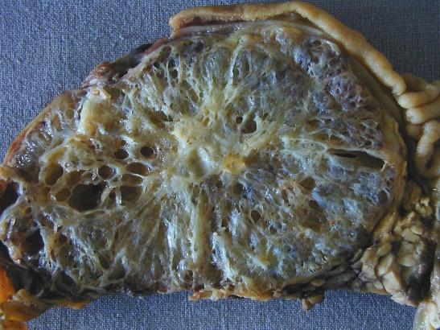
Fig 1-b

Figure 1 Macro- and micro-pathology (histology, cytology) of microcystic pancreatic adenoma. A: Typical microcystic appearance of serous cystadenoma with “honeycomb” architecture, and central scar with small calcification; B: Histology demonstrates the typical single layer of clear cuboidal epithelial cells lining the cysts.

Fig 2
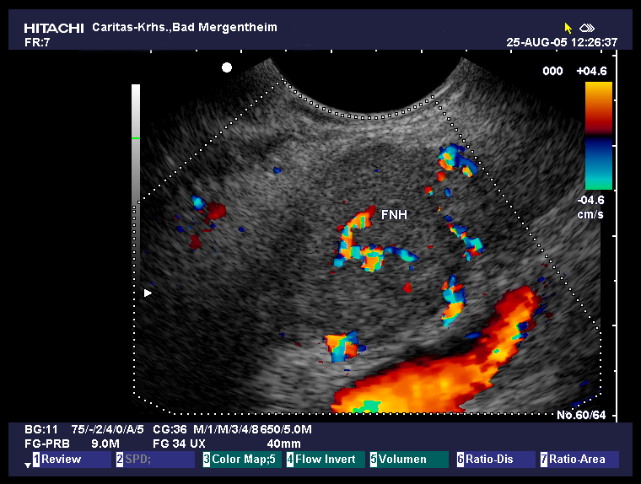

Figure 2 Typical microcystic serous pancreatic neoplasia using colour Doppler imaging. Note the centrally located artery.

Fig 3-a
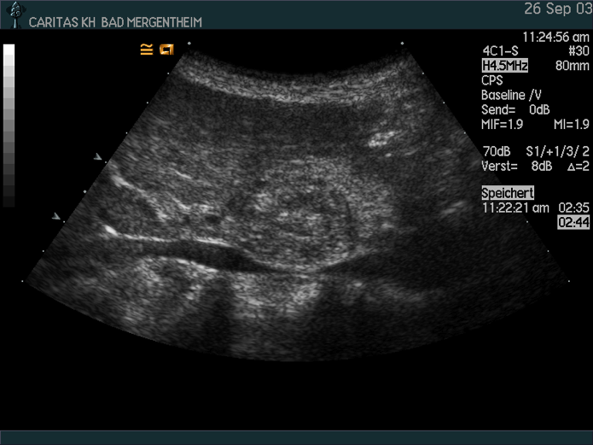
Fig 3-b
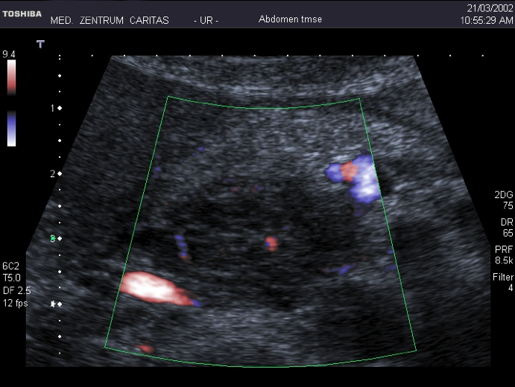
Fig 3-c
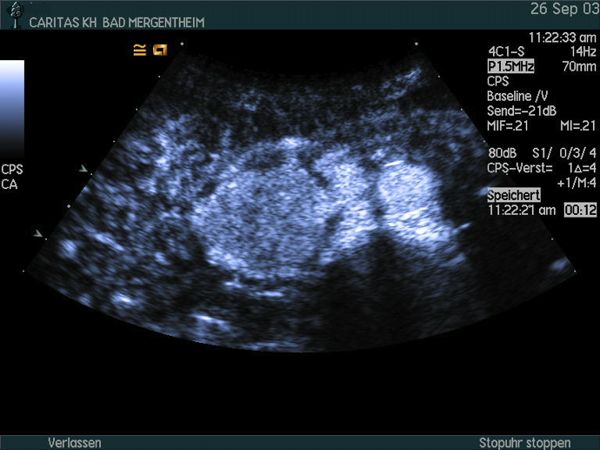
Fig 3-d
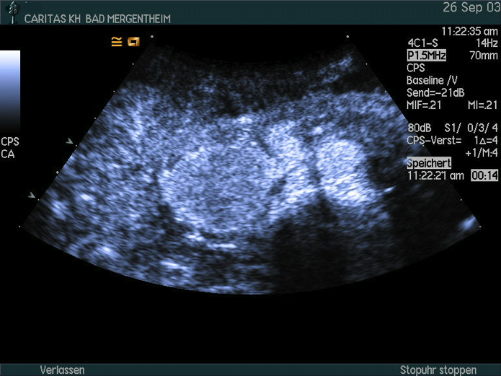

Figure 3 Typical microcystic serous pancreatic neoplasia using B-mode (A), CDI (B), and CEUS (C, D). Note the centrally located artery and the typical hyperenhancement.

Fig 4
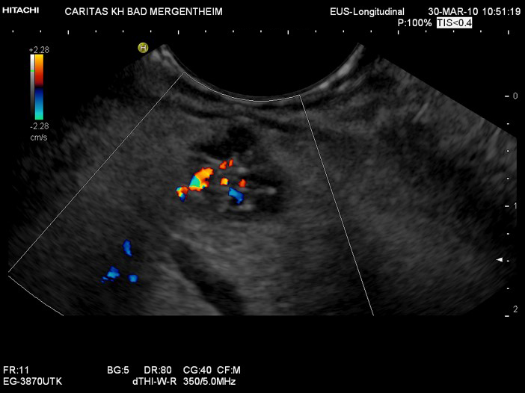

Figure 4 Typical oligocystic serous pancreatic neoplasia using endoscopic ultrasound.

Fig 5-a
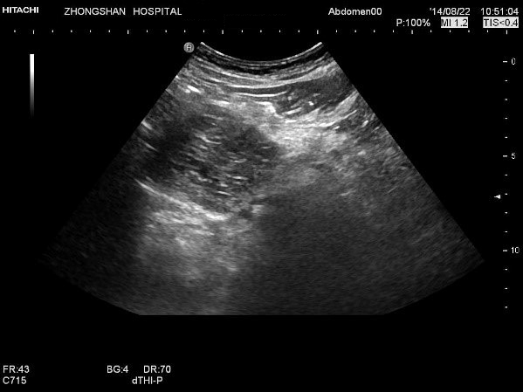
Fig 5-b
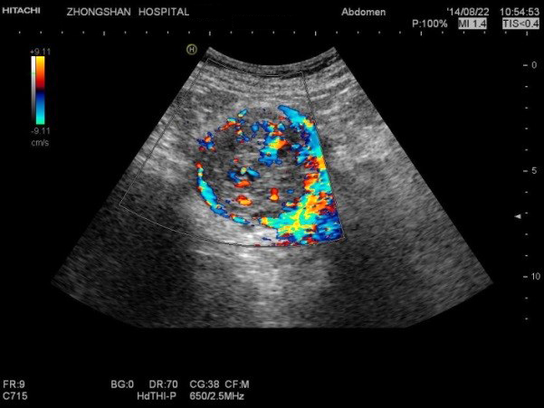
Fig 5-c
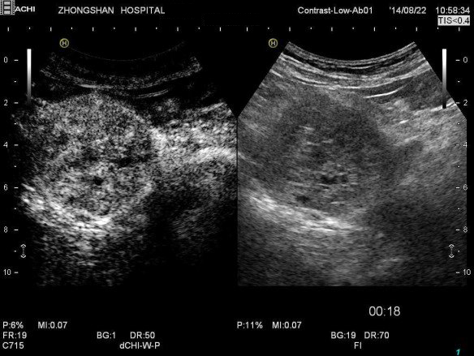
Fig 5-d
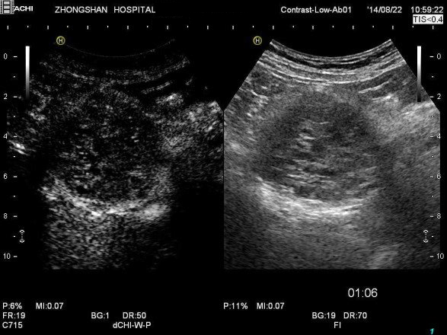
Fig 5-e
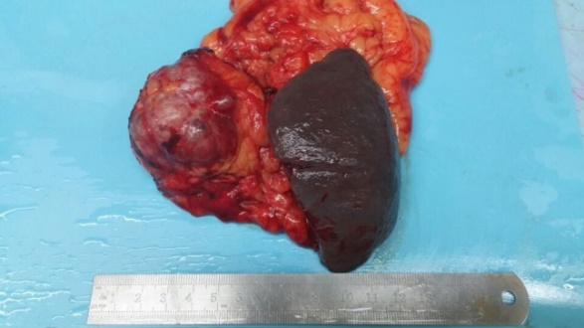
Fig 5-f
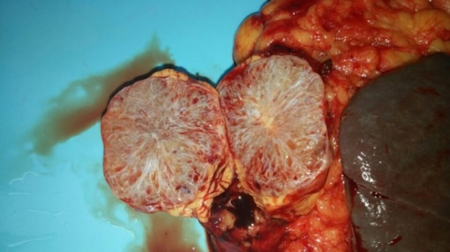

Figure 5 Histopathologically proven serous microcystic serous pancreatic neoplasia. A: A solid-cystic lesion was detected in the head of pancreas with B-mode ultrasound; B: Multiple interlesional color flow signals were detected using colour Doppler imaging; C: Contrast enhanced ultrasound showed the lesion to hyperenhance in the arterial phase; and D: isoenhance in the late phase; E, F: Surgical pathology shows the typical honeycomb structure.

Fig 6-a
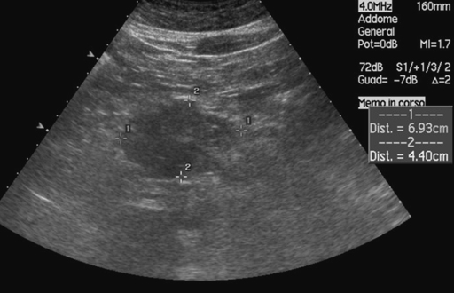
Fig 6-b
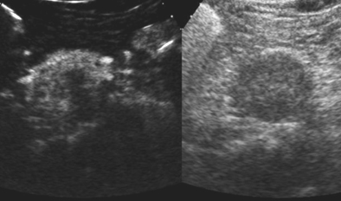
Fig 6-c
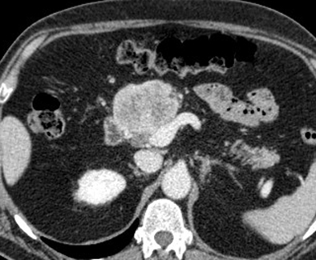

Figure 6 Pseudo-solid serous pancreatic neoplasia, histologically demonstrated to have a microcystic structure. A: B-mode ultrasound shows a solid hypoecoic mass in the neck of the pancreas; B: CEUS shows the lesion to hyperenhance with a hypoechoic defect in the center; C: CT shows the lesion as solid and inhomogeneously hyperenhancing.

Fig 7-a
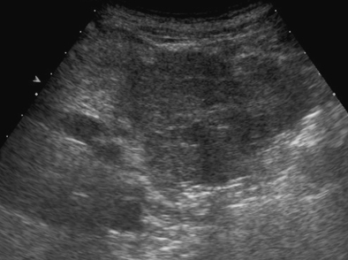
Fig 7-b
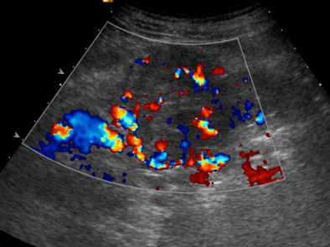
Fig 7-c
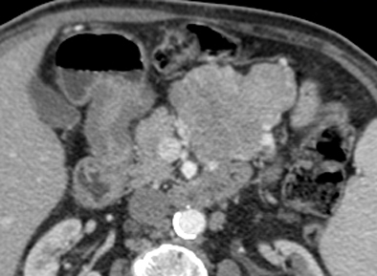
Fig 7-d
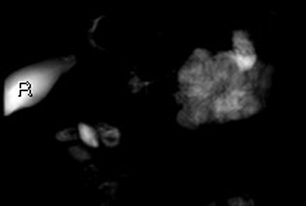

Figure 7 Large pseudosolid serous pancreatic neoplasia. A: With B-mode ultrasound a huge mass is visible appearing solid and inhomogeneously hypoechoic; B: Doppler shows large arterial vessels within the mass; C: With CT the lesion appears pseudosolid with inhomogeneous slight enhancement; D: MRI clearly shows the cystic nature of the mass with microcystic appearance.

Fig 8-a
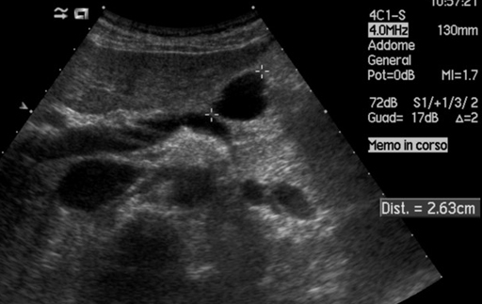
Fig 8-b
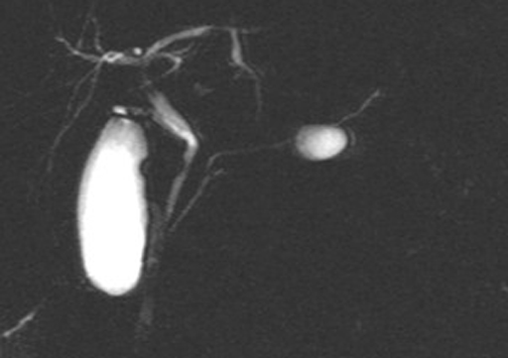

Figure 8 Unilocular serous pancreatic neoplasia. A: B-mode ultrasound shows a cyst in the body of the pancreas; B: MRI shows small cystic lesions in the body of the pancreas not communicating with the main pancreatic duct.

Table 1 Baseline characteristics of serous pancreatic neoplasia patients
Characteristic | SPN patients  (n = 287)
Age (yr)
Mean ± SD | 57.3 ± 14.2
Range | 18 - 85
Female/Male | 229/58
Symptoms
Pancreatitis | 5
Weight loss | 9
Anemia | 1
Incidental finding | 272
Histological results
Surgery | 249
EUS FNA (22G) | 31
TUS-Bx (18 G) | 7
SPN: Serous pancreatic neoplasia; EUS: Endoscopic ultrasound; FNA: Fine needle biopsy; TUS-Bx: Transabdominal biopsy.

Table 2 Conventional B mode ultrasound findings of serous pancreatic neoplasia n (%)

Characteristic | SPN lesions  (n = 287)
Location
Head/neck | 113 (39.3)
Body | 89 (31.0)
Tail | 85 (29.6)
Size of lesions (mm)
Mean ± SD | 38.7 ± 26.2
Range | 4 - 160
Number of lesions
Single | 281 (97.9)
Multiple | 6 (2.1)
B mode aspect
Microcystic mix | 31 (10.8)
Macrocystic | 96 (33.4)
Solid and cystic | 133 (46.3)
Solid | 27 (9.4)
B mode echogenicity
Anechoic | 10 (3.4)
Hypoechoic | 271 (94.4)
Hyperechoic | 6 (2.2)
CDI vessel detectable
Avascular | 228 (79.4)
Macrovessels detectable | 59 (20.6)
CDI vascular pattern (n = 59 with macrovessels)
Central artery | 26 (44.1)
Typical spoke wheel appearance | 21 (35.6)
No specifics | 12 (20.3)
SPN: Serous pancreatic neoplasia; CDI: Color Doppler imaging.

Table 3 Contrast enhanced ultrasound imaging features of serous pancreatic neoplasia lesions n (%)
Characteristic | SPN lesions  (n = 173)
Arterial phase
Hyperenhancement | 63 (36.5)
Isoenhancement | 107 (61.8)
Hypoenhancement | 3 (1.7)
Late phase
Hyperenhancement | 39 (22.5)
Isoenhancement | 129 (74.6)
Hypoenhancement | 5 (2.9)
CEUS: Contrast enhanced ultrasound; SPN: Serous pancreatic neoplasia.

Table 4 Endoscopic ultrasound and contrast enhanced endoscopic ultrasound imaging features of serous pancreatic neoplasia lesions n (%)
Characteristic | SPN lesions  (n = 61)
EUS
Anechoic | 2 (3.3)
Hypoechoic | 56 (91.8)
Isoechoic | 3 (4.9)
EUS-CDI vessel detectable
Avascular | 0
Macrovessels detectable | 61 (100)
EUS-CDI vascular pattern (n = 61)
Central artery | 26 (42.6)
Typical spoke wheel appearance | 15 (24.6)
No specifics | 20 (32.8)
CE-EUS (n = 54)
Hyperenhancement | 54 (100)
Isoenhancement | 0
Hypoenhancement | 0
Final EUS-Diagnosis
“Eyecatcher” | 49 (80.3)
Typical SCA | 5 (8.2)
Unclear macrocyst | 6 (9.8)
EUS: Endoscopic ultrasound; EUS-CDI: Endoscopic endoscopic color Doppler Imaging; CE-EUS: Contrast enhanced endoscopic ultrasound; SPN: Serous pancreatic neoplasia; SCA: Serous cystadenomas.

