Name of Journal: World Journal of Critical Care Medicine
Manuscript NO: 65408
Manuscript Type: MINIREVIEWS

Extracorporeal membrane oxygenation and inhaled sedation in coronavirus disease 2019-related acute respiratory distress syndrome

Bellgardt M et al. ECMO with inhalative sedation and C-ARDS

Martin Bellgardt, Dennis Özcelik, Andreas Friedrich Christoph Breuer-Kaiser, Claudia Steinfort, Thomas Georg Karl Breuer, Thomas Peter Weber, Jennifer Herzog-Niescery

Martin Bellgardt, Andreas Friedrich Christoph Breuer-Kaiser, Thomas Peter Weber, Jennifer Herzog-Niescery, Anesthesia and Intensive Care Medicine, St. Josef-Hospital, University Hospital of Ruhr-University of Bochum, Bochum 44791, Germany

Dennis Özcelik, Chemistry | Biology | Pharmacy Information Center, ETH Zürich, Zürich 8093, Switzerland

Claudia Steinfort, General and Visceral Surgery, St. Josef-Hospital, University Hospital of Ruhr-University of Bochum, Bochum 44791, Germany

Thomas Georg Karl Breuer, Internal Medicine/Intensive Care, St. Josef-Hospital, University Hospital of Ruhr-University of Bochum, Bochum 44791, Germany

Author contributions: Bellgardt M designed and conceptualized this work; Bellgardt M, Özcelik D, and Herzog-Niescery J conducted the literature review and information retrieval and contributed to critical revision for important intellectual content; All authors wrote, read, and approved the final manuscript.

Corresponding author: Martin Bellgardt, MD, Academic Research, Senior Scientist, Staff Physician, Anesthesia and Intensive Care Medicine, St. Josef-Hospital, University Hospital of Ruhr-University of Bochum, Gudrunstr. 56, Bochum 44791, Germany. martin. bellgardt@rub.de

Received: March 8, 2021
Revised: May 24, 2021
Accepted: August 23, 2021
Published online:

Abstract
Coronavirus disease 2019 (COVID-19) related acute respiratory distress syndrome (ARDS) is a severe complication of infection with severe acute respiratory syndrome coronavirus 2, and the primary cause of death in the current pandemic. Critically ill patients often undergo extracorporeal membrane oxygenation (ECMO) therapy as the last resort over an extended period. ECMO therapy requires sedation of the patient, which is usually achieved by intravenous administration of sedatives. The shortage of intravenous sedative drugs due to the ongoing pandemic, and attempts to improve treatment outcome for COVID-19 patients, drove the application of inhaled sedation as a promising alternative for sedation during ECMO therapy. Administration of volatile anesthetics requires an appropriate delivery. Commercially available ones are the anesthetic gas reflection systems AnaConDa® and MIRUSTM, and each should be combined with a gas scavenging system. In this review, we describe respiratory management in COVID-19 patients and the procedures for inhaled sedation during ECMO therapy of COVID-19 related ARDS. We focus particularly on the technical details of administration of volatile anesthetics. Furthermore, we describe the advantages of inhaled sedation and volatile anesthetics, and we discuss the limitations as well as the requirements for safe application in the clinical setting.

Key Words: Extracorporeal membrane oxygenation; COVID-19; Acute respiratory distress syndrome; Critical care; Volatile anesthetics; Inhaled sedation

Bellgardt M, Özcelik D, Breuer-Kaiser AFC, Steinfort C, Breuer TGK, Weber TP, Herzog-Niescery J. Extracorporeal membrane oxygenation and inhaled sedation in coronavirus disease 2019-related acute respiratory distress syndrome. World J Crit Care Med 2021; In press

Core Tip: This article summarizes the use of inhaled sedation for extracorporeal membrane oxygenation in patients suffering from coronavirus disease 2019 related acute respiratory distress syndrome, including a description of respiratory management, the technical aspects, and requirements for delivery of volatile anesthetics. The article closes with important future considerations for inhaled sedation in critically ill coronavirus disease 2019 patients undergoing extracorporeal membrane oxygenation therapy.

INTRODUCTION
The ongoing pandemic is caused by the severe acute respiratory syndrome coronavirus-2 (SARS-CoV-2) that triggers a variety of symptoms in the human host. One major complication of infection with SARS-CoV-2 is the acute respiratory distress syndrome (ARDS). COVID-19 related ARDS is a severe condition associated with high mortality and is the primary cause of death among COVID-19 patients. Treatment of this condition is mainly supportive and requires considerable resources, but effective coordination enables the health care system to cope with the influx of critically ill patients^{[1]}.
If respiratory failure occurs in COVID-19 patients despite all efforts, extracorporeal membrane oxygenation (ECMO) treatment over an extended period is the last remaining therapeutic option^{[2]}. Since the outcome of this treatment is poor, better prevention and treatment are urgently needed.
ECMO therapy requires sedation of the patient, often via high doses of intravenous sedatives such as midazolam, ketamine, or propofol in combination with an opioid and neuromuscular blocking agent. The ongoing pandemic is exhausting supplies of these drugs, so alternative approaches have to be considered^{[3]}. One practical alternative approach is inhaled sedation with volatile anesthetics, such as isoflurane, sevoflurane, or desflurane^{[4,5]}.
Beside the low costs, volatile anesthetics are associated with faster onset and offset of sedation and thus allow efficient control of administration. Application of these drugs does not rely on electronic infusion pumps, which have become scarce during the pandemic. In addition, volatile anesthetics cause fewer hallucinations and lower opioid needs than intravenous anesthetics. Moreover, a recent study suggests that inhaled sedation could be associated with a better outcome than intravenous sedation^{[6]}. In particular, sevoflurane yielded superior outcomes than other anesthetics^{[7,8]}. Nonetheless, the application of inhaled sedation faces limitations. Most critical care units lack proper delivery and gas scavenging systems for limiting pollution with volatile anesthetics^{[9]}. Further, health care professionals require special training to administer appropriately the anesthetics and to recognize contraindications, such as malignant hyperthermia.
In this review, we summarize the requirements for inhaled sedation in COVID-19 patients under ECMO therapy, and we highlight the technical aspects of administration of volatile anesthetics.

RESPIRATORY MANAGEMENT IN COVID-19 PATIENTS
Continuous monitoring of oxygen saturation in the patient is necessary, since a drop in saturation indicates a severe progression of COVID-19. If oxygen levels fall, respiratory management is required, but spontaneous breathing should be maintained as long as possible and reasonable. A number of approaches to support spontaneous breathing is available and has been comprehensively summarized elsewhere^{[10]}. A schematic overview of the strategy for respiratory management in COVID-19 patients is presented in Figure 1.
The use of nasal cannula is the first method of choice; however, the fraction of inspired oxygen (FiO₂) is limited to 0.3 to 0.4. If insufficient, high flow nasal cannula produces a high flow and continuous positive airway pressure, capable of achieving higher FiO₂. This can be further supported by shifting the patient in a prone position^{[11]}. The last resort of noninvasive intervention for respiratory management is the use of bilevel positive airway pressure and pressure support ventilation. These measures are capable of providing high FiO₂ and can be combined with placing the patient in prone position for further support. It should be mentioned that these measures require high quality masks for respiration to prevent pressure injuries on the skin or the nose of the patient.
Severe hypoxia, which is associated with COVID-19 related ARDS, impairs consciousness, vigilance, or compliance. For instance, impaired compliance of the patient can hinder the use of facial masks, leading to a dramatic drop in oxygen saturation. Consequently, severe hypoxia requires invasive measures, e.g., endotracheal intubation. The decision to initiate this invasive intervention has to be made with the patient, or the relatives if necessary, and requires an open discussion on respiratory management. After intubation, a bronchoscopy or a thoracic drainage system should be considered, and the patient should be placed in prone position to support breathing. The specific type of invasive intervention depends on ventilation pressure and lung compliance.
If the partial pressure of oxygen/FiO₂ ratio drops below 150 mmHg, the patient should be placed in prone position for more than 12 h^{[12]}. Individual measures can be taken to manage severe hypoxia, such as application of inhaled nitric oxide, muscle relaxants, or recruitment maneuver. If respiratory function remains poor (i.e. lower than 20 mL/mbar, partial pressure of oxygen/FiO₂ ratio less than 80 mmHg, or pH less than 7.25) despite prone positioning, veno-venous ECMO is the last resort to save the life of the patient^{[13,14]}.
Deploying an ECMO system can only be considered if all other approaches are unsuccessful and if there are no contraindications^{[15]}. ECMO therapy can cause adverse events and suboptimal responses, in particular in COVID-19 patients who are predisposed to bleeding and thrombotic complications^{[16]}. Such events could suggest withdrawal of ECMO therapy. Furthermore, a recent study reported an in-hospital mortality of 37.4% for patients with severe COVID-19 related ARDS 90 d after the initiation of ECMO therapy^{[17]}. This highlights the importance of an open discussion with the patient and relatives at an early stage in order to clarify treatment goals, expectations, and possible outcomes as well as to obtain consent from the patient regarding continuation or discontinuation of therapy^{[18]}.
During ECMO therapy, patients with ARDS in prone position should be kept in at least light sedation, corresponding to a Richmond Agitation-Sedation Scale of ≥ 2^{[12]}. Sedation is associated with side effects such as delirium, respiratory depression, and immunosuppression. Further, deep sedation is a risk factor for COVID-19 patients and is associated with poorer outcome. Thus, sedation must be monitored carefully. Processed electroencephalogram monitoring is a very useful approach to assess anesthesia and to recognize burst suppression. In case of inhaled sedation, measurement of the end-tidal gas concentration or the corresponding minimum alveolar concentration is a recommended approach. If Richmond Agitation-Sedation Scale increases during ECMO therapy, intravenous sedation is necessary to stabilize the depth of sedation.

ADMINISTRATION OF VOLATILE ANESTHETICS DURING ARDS THERAPY
The prerequisite for using the Anaesthetic Conserving Device (ACD) AnaConDa® (Sedana Medical AB, Danderyd, Sweden) or the MIRUSTM system (TIM, Koblenz, Germany) depends on several clinical parameters (see Figure 1). If lung compliance is acceptable, and CO₂ can be reduced sufficiently, both types of systems are able to maintain spontaneous breathing^{[19-21]}. However, if lung compliance is poor, reduction of dead space and active humidification is necessary, which can be facilitated by inhaled sedation via a circle breathing system^{[22,23]}.
The AnaConDa® system is capable of achieving adequate sedation with isoflurane or sevoflurane. In addition to isoflurane and sevoflurane, the MIRUS system can also apply desflurane.

ADMINISTRATION OF VOLATILE ANESTHETICS DURING ECMO THERAPY
The pathophysiological basis for COVID-19 related ARDS is the altered blood-air barrier. The diffusion distance for adequate gas exchange in the lung alveoli is impaired by inflammation, edema, and accumulated mucus. These impairments severely limit O₂ uptake and CO₂ release. However, volatile anesthetics are still able to establish an effective concentration in the blood stream under ARDS conditions, provided the necessary concentration gradient is maintained^{[24,25]}. Volatile anesthetics show superior diffusion properties than O₂ and CO₂, which can be attributed to the lipophilic nature of the anesthetic gas. Only if both the tubus and the bronchial system are completely clogged, intravenous sedation is necessary.
The ECMO system itself can be used for administration of volatile anesthetics^{[26,27]}. This requires installation of a vaporizer into the oxygen tube and connection of a pipe for exhaust gas removal to the outlet and the negative pressure device. The inhaled and exhaled portion of the anesthetic gas must be carefully monitored in order to determine the depth of sedation and to detect possible leakage. Since leakage can easily lead to pollution of the intensive care unit (ICU), a proper scavenging system is crucial. Nonetheless, it must be noted that these scavengers can create high back pressure that increases the risk for gas embolism. Another important technical aspect to take into consideration is the type of membrane oxygenator. Transmembrane passage of the anesthetic gas is facilitated only via hollow-fiber membrane oxygenators, which are made of polypropylene. If the oxygenators are made of poly-(4-methyl-1-pentene), they do not permit transmembrane passage. In this case, volatile anesthetics have to be administered via an anesthetic gas reflection system.
One major anesthetic gas reflection system is the AnaConDa® system, which is commercially available as a larger version, i.e. ACD-100, and a smaller version, i.e. ACD-50 (which is also known as AnaConDa®-S) (Figure 2). The other major gas reflection system is the MIRUSTM system (Figures 3 and 4). Recent studies showed that the AnaConDa® systems can be used successfully for sedation of ARDS patients during ECMO therapy^{[20,28,29]}. Similarly, a study using the MIRUSTM system demonstrated successful application of inhaled sedation for ECMO therapy in patients with COVID-19 related ARDS^{[30]}.
The CO₂ signal has no effect on the performance; nonetheless, a CO₂ pressure of at least 10 mmHg is an indication for an open and managed airway and is associated with a higher survival rate^{[31, 32]}. Consequently, the authors call for a minimum of 10 mmHg as standard for the AnaConDa® system. If this minimum cannot be maintained by adjusting the ventilation, the level of sedation must be monitored carefully and, if necessary, complemented by intravenous sedation of the patient.
By contrast, the MIRUSTM system requires an end-tidal CO₂ pressure of at least 15 mmHg. If the end-tidal CO₂ pressure drops below 12 mmHg, the MIRUSTM system stops administering the anesthetic, indicated by a red alert. This could result in the inadvertent awakening of the patient, which would then require intravenous sedation to restore anesthesia.
The most recent MIRUSTM systems (starting from version 2.0 onward) indicate a tidal volume of less than 200 mL by a yellow alert (Figure 5). During ECMO therapy, the minimum respiratory minute volume falls frequently below the minimum tidal volume of the MIRUSTM system. The yellow alert can be acknowledged in order to continue administration; however, this procedure is associated with the risk of overdosing with the anesthetic. In case of isoflurane, the MIRUSTM system displays a higher gas concentration under ECMO therapy. Hence, a concentration of more than 2% can be displayed, although it does not correspond to the actual end-tidal values. Because higher effective concentrations are required for the same MAC with sevoflurane and desflurane, this effect is not as pronounced with these gases. Nevertheless, the operator should choose the lowest wash-in speed (i.e. the setting “tortoise”) for all of three anesthetics isoflurane, sevoflurane, and desflurane (Figure 5).
An important consideration for the application of anesthetic gas reflection systems is the volume of a breath that does not participate in gas exchange, i.e. the dead space. The volumetric dead space of the MIRUSTM system is 100 mL^{[19]}, whereas the volumetric dead space for the AnaConDa® system ACD-100 is 100 mL and 50 mL for the ACD-50^{[23]}. However, the ECMO system eliminates CO₂ effectively. Thus, volumetric and reflective dead space of the anesthetic gas reflection systems are irrelevant for ECMO therapy.
Another alternative device for administration of volatile anesthetics is the circle breathing system. Usage of this system has been reported during the ongoing SARS-CoV-2 pandemic. However, to the best of our knowledge, the deployment of a circle breathing system in conjunction of ECMO therapy in the ICU has not been described in literature.

CONSUMPTION OF VOLATILE ANESTHETICS IN COVID-19 RELATED ARDS THERAPY USING ECMO
The SARS-CoV-2 pandemic is estimated to be one of the most expensive natural disasters in recorded history^{[33]}. Besides economic repercussions due to the containment measures, adequate treatment of patients causes a substantial financial strain for the global health care systems. ECMO, in particular, is a very expensive procedure, and thus the reduction of associated costs is highly desirable. Treatment of COVID-19 related ARDS requires larger amounts of sedatives than treatment of non-COVID-19 patients. Consequently, treatment of COVID-19 patients, who undergo invasive mechanical ventilation without ECMO therapy, demands a large consumption of anesthetics. However, administration of volatile anesthetics with the AnaConDa® systems ACD-100 or ACD-50 during ECMO therapy is very cost-effective, as the low respiratory minute volume yields a usage of only 1 mL/h to 3 mL/h. The consumption of volatile anesthetics by the MIRUSTM system is in a comparable range and is estimated to be 3 mL/h to 5 mL/h (unpublished data).
Besides consumption, a certain amount of anesthetic gas is lost in the delivery system, i.e. at the exhalation outlet of the ventilator or at the oxygenator of the ECMO device. The exhalation outlet has the advantage that the gas flow can conduct viral particles and hence reduces the risk of infection for the health care personnel^{[34,35]}. The oxygenator was used initially for intraoperative delivery of the anesthetic gas but modern reflection systems require containment of volatile anesthetics. For instance, the oxygenator of the Cardiohelp System (Getinge Group, Gothenburg, Sweden) does not leak anesthetic gas, according to the manufacturer and independent researchers^{[26]}. While the loss of anesthetic gas via the oxygenator is theoretically still possible, instruments in the ICUs usually lack such device.

HYGIENE MEASURES FOR COVID-19 RELATED ARDS
Respiratory management has also to take into account the SARS-CoV-2 infection. Hence, tracheotomy is often avoided if the patient shows a high viral load. Nevertheless, tracheostomy is suggested to improve the outcome of COVID-19 patients, in particular, if the intervention is performed between day 13 and day 17 post intubation^{[36]}.
The handling of medical devices and instruments requires strict hygiene measures. Firstly, a closed suction system is mandatory (Figures 2 and 3). Secondly, the tube has to be clamped off prior to disconnect it from heat and moisture exchanger filters.
Here, the MIRUSTM system has an advantage since the heat and moisture exchanger filters are integrated in the device, so that the controller and measuring units remain in a clean and safe distance. By contrast, the AnaConDa® systems measure the concentration of the anesthetics in close proximity to the patient and hence are exposed to a high risk of contamination. However, the water trap at the gas monitor is sealed, which prevents intrusion of viral pathogens.
In order to connect either the MIRUSTM or the AnaConDa® system to the vacuum connection on the ICUs, a suitable gas flow conduction system is required. The CleanAirTM system (TIM, Koblenz, Germany) is recommended for gas flow conduction, because it is independent of the reflector (Figure 6). It operates well under vacuum, is sealed off the environment, and thus eliminates the risk of disseminating viral particles in the air^{[35]}.

OCCUPATIONAL ANESTHETIC GAS EXPOSURE WHILE USING ECMO THERAPY
The use of volatile anesthetics is beneficial for the treatment of patients with SARS-CoV-2 infection, but the exposure of health care professionals to waste anesthetic gas is a concern. Poor air-conditioning in ICUs and inconsistent international limits for anesthetic gas concentrations amplify the problem. The United States National Institute of Occupational Safety and Health defined an exposure limit of 2 ppm for isoflurane, sevoflurane, and desflurane, but other countries use higher exposure limits^{[35,38]}. Most studies on air pollution report gas concentrations of less than 2 ppm while using MIRUSTM or AnaConDa® systems in mechanically ventilated patients; nonetheless, these studies use an air-conditioning system with at least six air exchanges per hour and a scavenging system (e.g., vacuum-based open reservoir gas scavenging systems or adsorbers with activated charcoal)^{[35,38,39]}.
To the best of our knowledge, there are no studies focusing on occupational gas exposure by inhalational sedation in patients undergoing ECMO therapy. Nevertheless, Meiser and colleagues observed that gas consumption during isoflurane sedation via AnaConDa® was exceptionally low, and they concluded that the sweep gas of the oxygenator did not contain the volatile anesthetic^{[20]}. Our group measured the air pollution using photoacoustic gas monitoring in a similar setting (single room, isoflurane via AnaConDa®, vacuum-based scavenging system, air-conditioning with 11 air exchanges per hour) and detected concentrations of approximately 0.5 ppm to 2 ppm (unpublished data). Obviously, a proper application of all systems must be ensured as well as “good workplace practice”, including leak testing of the respirator and training of health care professionals. The conformity between the applied systems and respirators is of particular importance, as problems may occur even without active suction.

OUTCOME OF ECMO THERAPY
ECMO therapy is associated with high mortality and hence is deemed as the last resort after all other possible interventions failed. In case of COVID-19 related ARDS, the mortality 90 d post ECMO initiation is very high^{[17]}. Besides the high mortality, ECMO therapy is also associated with a number of long-term effects, which are known from ICU survivors.
Postintensive care syndrome describes the impairments in physical function as well as cognitive and mental health that ICU survivors experience. The aftermaths of influenza A H1N1 or SARS showed that this syndrome can persist for years and hamper recovery^{[40]}. In addition, a substantial portion of ICU survivors suffers from post-traumatic stress disorder. The data on ECMO survivors is sparse, but a limited number of studies demonstrated that these patients show impaired recovery, chronic pain, and mental illness, including post-traumatic stress disorder for up to 3 years after hospitalization^{[41-44]}. Only very few studies suggest that ECMO treatment had no effect on ARDS patients after initiation of therapy^{[45]}. Consequently, the authors of this article emphasize that indication for ECMO therapy must considered very carefully.
The application of inhaled sedation for ECMO treatment has a number of advantages. For instance, the supply of volatile anesthetics is currently not limited, in contrast to intravenous anesthetics. Volatile anesthetics are also less hallucinogenic, and patients require less opiates during inhaled sedation than during intravenous sedation. If applied properly, volatile anesthetics allow easier control of the depth of sedation of the patient, even if gas exchange is severely limited by COVID-19 related ARDS. Furthermore, the volumetric and reflective dead space of the delivery systems as well as CO₂ retention are negligible for ECMO therapy. So far, few studies reported the successful application of isoflurane and sevoflurane for ECMO therapy^{[6-8]}. The application of volatile anesthetics depends on adequate delivery and gas scavenging systems, which are not established in all ICUs^{[9]}; however, the lack of electronic infusion pumps for intravenous sedatives due to the SARS-CoV-2 pandemic could be an incentive to equip ICUs with such hardware.
Currently, the application of volatile anesthetics for inhaled sedation during ECMO treatment is still not widely established. Consequently, the health care personnel lacks the adequate training for application of this procedure as well as for recognizing contraindications of which malignant hyperthermia is the most notable one.

CONCLUSION
In COVID-19 related ARDS, inhaled sedation demonstrated many advantages, including spontaneous breathing and deep sedation in prone position. Inhaled sedation also allows safe monitoring of sedation depth via measurement of the anesthetic gas. In addition, veno-venous ECMO avoids problems concerning dead space and CO₂ increase, as sometimes seen during inhaled sedation via AnaConDa® or MIRUSTM. Further, inhaled sedation allows administration of isoflurane, which shows favorable properties, especially in light of the shortage of intravenous sedatives. This procedure, however, requires preparation and training. Hence, medical professionals should use the time of moderate occupancy rates in the ICUs accordingly.

REFERENCES
1 Liu Y, Li J, Feng Y. Critical care response to a hospital outbreak of the 2019-nCoV infection in Shenzhen, China. Crit Care 2020; 24: 56 [PMID: 32070391 DOI: 10.1186/s13054-020-2786-x]
2 Mang S, Kalenka A, Broman LM, Supady A, Swol J, Danziger G, Becker A, Hörsch SI, Mertke T, Kaiser R, Bracht H, Zotzmann V, Seiler F, Bals R, Taccone FS, Moerer O, Lorusso R, Bělohlávek J, Muellenbach RM, Lepper PM; COVEC-Study Group. Extracorporeal life support in COVID-19-related acute respiratory distress syndrome: A EuroELSO international survey. Artif Organs 2021; 45: 495-505 [PMID: 33590542 DOI: 10.1111/aor.13940]
3 Ammar MA, Sacha GL, Welch SC, Bass SN, Kane-Gill SL, Duggal A, Ammar AA. Sedation, Analgesia, and Paralysis in COVID-19 Patients in the Setting of Drug Shortages. J Intensive Care Med 2021; 36: 157-174 [PMID: 32844730 DOI: 10.1177/0885066620951426]
4 Orser BA, Wang DS, Lu WY. Sedating ventilated COVID-19 patients with inhalational anesthetic drugs. EBioMedicine 2020; 55: 102770 [PMID: 32344199 DOI: 10.1016/j.ebiom.2020.102770]
5 Suleiman A, Qaswal AB, Alnouti M, Yousef Md, Suleiman B, Jarbeh ME, Alshawabkeh G, Bsisu I, Santarisi A, Ababneh M. Sedating Mechanically Ventilated COVID-19 Patients with Volatile Anesthetics: Insights on the Last-Minute Potential Weapons. Sci Pharm 2021; 89 [DOI: 10.3390/scipharm89010006]
6 Bellgardt M, Bomberg H, Herzog-Niescery J, Dasch B, Vogelsang H, Weber TP, Steinfort C, Uhl W, Wagenpfeil S, Volk T, Meiser A. Survival after long-term isoflurane sedation as opposed to intravenous sedation in critically ill surgical patients: Retrospective analysis. Eur J Anaesthesiol 2016; 33: 6-13 [PMID: 25793760 DOI: 10.1097/EJA.0000000000000252]
7 Jabaudon M, Boucher P, Imhoff E, Chabanne R, Faure JS, Roszyk L, Thibault S, Blondonnet R, Clairefond G, Guérin R, Perbet S, Cayot S, Godet T, Pereira B, Sapin V, Bazin JE, Futier E, Constantin JM. Sevoflurane for Sedation in Acute Respiratory Distress Syndrome. A Randomized Controlled Pilot Study. Am J Respir Crit Care Med 2017; 195: 792-800 [PMID: 27611637 DOI: 10.1164/rccm.201604-0686OC]
8 Nieuwenhuijs-Moeke GJ, Jainandunsing JS, Struys MMRF. Sevoflurane, a sigh of relief in COVID-19? Br J Anaesth 2020; 125: 118-121 [PMID: 32416995 DOI: 10.1016/j.bja.2020.04.076]
9 Jerath A, Parotto M, Wasowicz M, Ferguson ND. Volatile Anesthetics. Is a New Player Emerging in Critical Care Sedation? Am J Respir Crit Care Med 2016; 193: 1202-1212 [PMID: 27002466 DOI: 10.1164/rccm.201512-2435CP]
10 Kichloo A, Kumar A, Amir R, Aljadah M, Farooqi N, Albosta M, Singh J, Jamal S, El-Amir Z, Kichloo A, Lone N. Utilization of extracorporeal membrane oxygenation during the COVID-19 pandemic. World J Crit Care Med 2021; 10: 1-11 [PMID: 33505868 DOI: 10.5492/wjccm.v10.i1.1]
11 Bamford P, Bentley A, Dean J, Whitmore D, Wilson-Baig N. ICS guidance for prone positioning of the conscious COVID patient. Int Care Soc 2020. [cited 8 March 2021]. Available from: https://emcrit.org/wp-content/uploads/2020/04/2020-04-12-Guidance-for-conscious-proning.pdf
12 Deutsche Gesellschaft für Anästhesiologie & Intensivmedizin. S3-Leitlinie Invasive Beatmung und Einsatz extrakorporaler Verfahren bei akuter respiratorischer Insuffizienz. 2017. AWMF Leitlinien-Register Nr 001/021. [cited 12 August 2021]. Available from: https://www.awmf.org/leitlinien/detail/ll/001-021.html
13 Makdisi G, Wang IW. Extra Corporeal Membrane Oxygenation (ECMO) review of a lifesaving technology. J Thorac Dis 2015; 7: E166-E176 [PMID: 26380745 DOI: 10.3978/j.issn.2072-1439.2015.07.17]
14 Biancari F, Mariscalco G, Dalén M, Settembre N, Welp H, Perrotti A, Wiebe K, Leo E, Loforte A, Chocron S, Pacini D, Juvonen T, Broman LM, Perna DD, Yusuff H, Harvey C, Mongardon N, Maureira JP, Levy B, Falk L, Ruggieri VG, Zipfel S, Folliguet T, Fiore A. Six-Month Survival After Extracorporeal Membrane Oxygenation for Severe COVID-19. J Cardiothorac Vasc Anesth 2021 [PMID: 33573928 DOI: 10.1053/j.jvca.2021.01.027]
15 Murugappan KR, Walsh DP, Mittel A, Sontag D, Shaefi S. Veno-venous extracorporeal membrane oxygenation allocation in the COVID-19 pandemic. J Crit Care 2021; 61: 221-226 [PMID: 33220575 DOI: 10.1016/j.jcrc.2020.11.004]
16 Connors JM, Levy JH. COVID-19 and its implications for thrombosis and anticoagulation. Blood 2020; 135: 2033-2040 [PMID: 32339221 DOI: 10.1182/blood.2020006000]
17 Barbaro RP, MacLaren G, Boonstra PS, Iwashyna TJ, Slutsky AS, Fan E, Bartlett RH, Tonna JE, Hyslop R, Fanning JJ, Rycus PT, Hyer SJ, Anders MM, Agerstrand CL, Hryniewicz K, Diaz R, Lorusso R, Combes A, Brodie D; Extracorporeal Life Support Organization. Extracorporeal membrane oxygenation support in COVID-19: an international cohort study of the Extracorporeal Life Support Organization registry. Lancet 2020; 396: 1071-1078 [PMID: 32987008 DOI: 10.1016/S0140-6736(20)32008-0]
18 Young MJ, Brown SE, Truog RD, Halpern SD. Rationing in the intensive care unit: to disclose or disguise? Crit Care Med 2012; 40: 261-266 [PMID: 21926611 DOI: 10.1097/CCM.0b013e31822d750d]
19 Bellgardt M, Drees D, Vinnikov V, Procopiuc L, Meiser A, Bomberg H, Gude P, Vogelsang H, Weber TP, Herzog-Niescery J. Use of the MIRUS™ system for general anaesthesia during surgery: a comparison of isoflurane, sevoflurane and desflurane. J Clin Monit Comput 2018; 32: 623-627 [PMID: 29633099 DOI: 10.1007/s10877-018-0138-z]
20 Meiser A, Bomberg H, Lepper PM, Trudzinski FC, Volk T, Groesdonk HV. Inhaled Sedation in Patients With Acute Respiratory Distress Syndrome Undergoing Extracorporeal Membrane Oxygenation. Anesth Analg 2017; 125: 1235-1239 [PMID: 28301417 DOI: 10.1213/ANE.0000000000001915]
21 Meiser A, Groesdonk HV, Bonnekessel S, Volk T, Bomberg H. Inhalation Sedation in Subjects With ARDS Undergoing Continuous Lateral Rotational Therapy. Respir Care 2018; 63: 441-447 [PMID: 29233852 DOI: 10.4187/respcare.05751]
22 Tempia A, Olivei MC, Calza E, Lambert H, Scotti L, Orlando E, Livigni S, Guglielmotti E. The anesthetic conserving device compared with conventional circle system used under different flow conditions for inhaled anesthesia. Anesth Analg 2003; 96: 1056-1061, table of contents [PMID: 12651660 DOI: 10.1213/01.ane.0000050558.89090.95]
23 Farrell R, Oomen G, Carey P. A technical review of the history, development and performance of the anaesthetic conserving device "AnaConDa" for delivering volatile anaesthetic in intensive and post-operative critical care. J Clin Monit Comput 2018; 32: 595-604 [PMID: 29388094 DOI: 10.1007/s10877-017-0097-9]
24 Meyer H. Zur Theorie der Alkoholnarkose. Archiv für Experimentelle Pathologie und Pharmakologie 1899; 42: 109-18 [DOI: 10.1007/bf01834479]
25 Thunberg T, Ernest Overton. Skandinavisches Archiv Für Physiologie 1934; 70: 1-9. [DOI: 10.1111/j.1748-1716.1934.tb01105.x]
26 Philipp A, Wiesenack C, Behr R, Schmid FX, Birnbaum DE. High risk of intraoperative awareness during cardiopulmonary bypass with isoflurane administration via diffusion membrane oxygenators. Perfusion 2002; 17: 175-178 [PMID: 12017384 DOI: 10.11/0267659102pf566oa]
27 Nigro Neto C, De Simone F, Cassara L, Dos Santos Silva CG, Marãnhao Cardoso TA, Carco F, Zangrillo A, Landoni G. Tricks, tips, and literature review on the adapted vaporize system to deliver volatile agents during cardiopulmonary bypass. Ann Card Anaesth 2016; 19: 240-244 [PMID: 27052063 DOI: 10.4103/0971-9784.179592]
28 Scherer C, Kupka D, Stocker TJ, Joskowiak D, Scheuplein H, Schönegger CM, Born F, Stremmel C, Lüsebrink E, Stark K, Orban M, Petzold T, Peterss S, Hausleiter J, Hagl C, Massberg S, Orban M. Isoflurane Sedation in Patients Undergoing Venoarterial Extracorporeal Membrane Oxygenation Treatment for Cardiogenic Shock-An Observational Propensity-Matched Study. Crit Care Explor 2020; 2: e0086 [PMID: 32259109 DOI: 10.1097/CCE.0000000000000086]
29 Rand A, Zahn PK, Schildhauer TA, Waydhas C, Hamsen U. Inhalative sedation with small tidal volumes under venovenous ECMO. J Artif Organs 2018; 21: 201-205 [PMID: 29508167 DOI: 10.1007/s10047-018-1030-9]
30 Flinspach AN, Zacharowski K, Ioanna D, Adam EH. Volatile Isoflurane in Critically Ill Coronavirus Disease 2019 Patients-A Case Series and Systematic Review. Crit Care Explor 2020; 2: e0256 [PMID: 33134946 DOI: 10.1097/CCE.0000000000000256]
31 Sandroni C, De Santis P, D'Arrigo S. Capnography during cardiac arrest. Resuscitation 2018; 132: 73-77 [PMID: 30142399 DOI: 10.1016/j.resuscitation.2018.08.018]
32 Siobal MS. Monitoring Exhaled Carbon Dioxide. Respir Care 2016; 61: 1397-1416 [PMID: 27601718 DOI: 10.4187/respcare.04919]
33 Cutler DM, Summers LH. The COVID-19 Pandemic and the $16 Trillion Virus. JAMA 2020; 324: 1495-1496 [PMID: 33044484 DOI: 10.1001/jama.2020.19759]
34 Herzog-Niescery J, Seipp HM, Weber TP, Bellgardt M. Inhaled anesthetic agent sedation in the ICU and trace gas concentrations: a review. J Clin Monit Comput 2018; 32: 667-675 [PMID: 28861655 DOI: 10.1007/s10877-017-0055-6]
35 Herzog-Niescery J, Vogelsang H, Gude P, Seipp HM, Uhl W, Weber TP, Bellgardt M. Environmental safety: Air pollution while using MIRUS™ for short-term sedation in the ICU. Acta Anaesthesiol Scand 2019; 63: 86-92 [PMID: 30088264 DOI: 10.1111/aas.13222]
36 Wiesenack C, Wiesner G, Keyl C, Gruber M, Philipp A, Ritzka M, Prasser C, Taeger K. In vivo uptake and elimination of isoflurane by different membrane oxygenators during cardiopulmonary bypass. Anesthesiology 2002; 97: 133-138 [PMID: 12131114 DOI: 10.1097/00000542-200207000-00019]
37 Takhar A, Surda P, Ahmad I, Amin N, Arora A, Camporota L, Denniston P, El-Boghdadly K, Kvassay M, Macekova D, Munk M, Ranford D, Rabcan J, Tornari C, Wyncoll D, Zaitseva E, Hart N, Tricklebank S. Timing of Tracheostomy for Prolonged Respiratory Wean in Critically Ill Coronavirus Disease 2019 Patients: A Machine Learning Approach. Crit Care Explor 2020; 2: e0279 [PMID: 33225305 DOI: 10.1097/CCE.0000000000000279]
38 National Institute of Occupational Safety and Health. NIOSH Pocket Guide to Chemical Hazards. Washington, DC, USA: Government Printing Office. 1994. [cited 12 August 2021]. Available from: https://www.cdc.gov/niosh/npg/default.html
39 González-Rodríguez R, Muñoz Martínez A, Galan Serrano J, Moral García MV. Health worker exposure risk during inhalation sedation with sevoflurane using the (AnaConDa®) anaesthetic conserving device. Rev Esp Anestesiol Reanim 2014; 61: 133-139 [PMID: 24439525 DOI: 10.1016/j.redar.2013.11.011]
40 Sackey PV, Martling CR, Granath F, Radell PJ. Prolonged isoflurane sedation of intensive care unit patients with the Anesthetic Conserving Device. Crit Care Med 2004; 32: 2241-2246 [PMID: 15640636 DOI: 10.1097/01.ccm.0000145951.76082.77]
41 Mayer KP, Jolley SE, Etchill EW, Fakhri S, Hoffman J, Sevin CM, Zwischenberger JB, Rove JY; the Outcomes and Recovery After COVID-19 Leading to ECMO (ORACLE) Group. Long-term recovery of survivors of coronavirus disease (COVID-19) treated with extracorporeal membrane oxygenation: The next imperative. JTCVS Open 2021; 5: 163-168. [PMID: 34173554 DOI: 10.1016/j.xjon.2020.11.006]
42 Harley O, Reynolds C, Nair P, Buscher H. Long-Term Survival, Posttraumatic Stress, and Quality of Life post Extracorporeal Membrane Oxygenation. ASAIO J 2020; 66: 909-914 [PMID: 32740351 DOI: 10.1097/MAT.0000000000001095]
43 Stoll C, Haller M, Briegel J, Meier M, Manert W, Hummel T, Heyduck M, Lenhart A, Polasek J, Bullinger M, Schelling G. [Health-related quality of life. Long-term survival in patients with ARDS following extracorporeal membrane oxygenation (ECMO)]. Anaesthesist 1998; 47: 24-29 [PMID: 9530443 DOI: 10.1007/s001010050518]
44 Roll MA, Kuys S, Walsh JR, Tronstad O, Ziegenfuss MD, Mullany DV. Long-Term Survival and Health-Related Quality of Life in Adults After Extra Corporeal Membrane Oxygenation. Heart Lung Circ 2019; 28: 1090-1098 [PMID: 30054124 DOI: 10.1016/j.hlc.2018.06.1044]
45 Mikkelsen ME, Shull WH, Biester RC, Taichman DB, Lynch S, Demissie E, Hansen-Flaschen J, Christie JD. Cognitive, mood and quality of life impairments in a select population of ARDS survivors. Respirology 2009; 14: 76-82 [PMID: 19144052 DOI: 10.1111/j.1440-1843.2008.01419.x]

Footnotes
Conflict-of-interest statement: There is no conflict of interest associated with any of the authors of this manuscript.

Open-Access: This article is an open-access article that was selected by an in-house editor and fully peer-reviewed by external reviewers. It is distributed in accordance with the Creative Commons Attribution NonCommercial (CC BY-NC 4.0) license, which permits others to distribute, remix, adapt, build upon this work non-commercially, and license their derivative works on different terms, provided the original work is properly cited and the use is non-commercial. See: http://creativecommons.org/Licenses/by-nc/4.0/

Manuscript source: Invited manuscript

Peer-review started: March 8, 2021
First decision: May 13, 2021
Article in press:

Specialty type: Critical care medicine
Country/Territory of origin: Germany
Peer-review report’s scientific quality classification
Grade A (Excellent): 0
Grade B (Very good): B, B
Grade C (Good): 0
Grade D (Fair): D
Grade E (Poor): 0

P-Reviewer: Atogebania JW, Deng L, Zhu C S-Editor: Wang LL L-Editor: Filipodia P-Editor:

Figure Legends
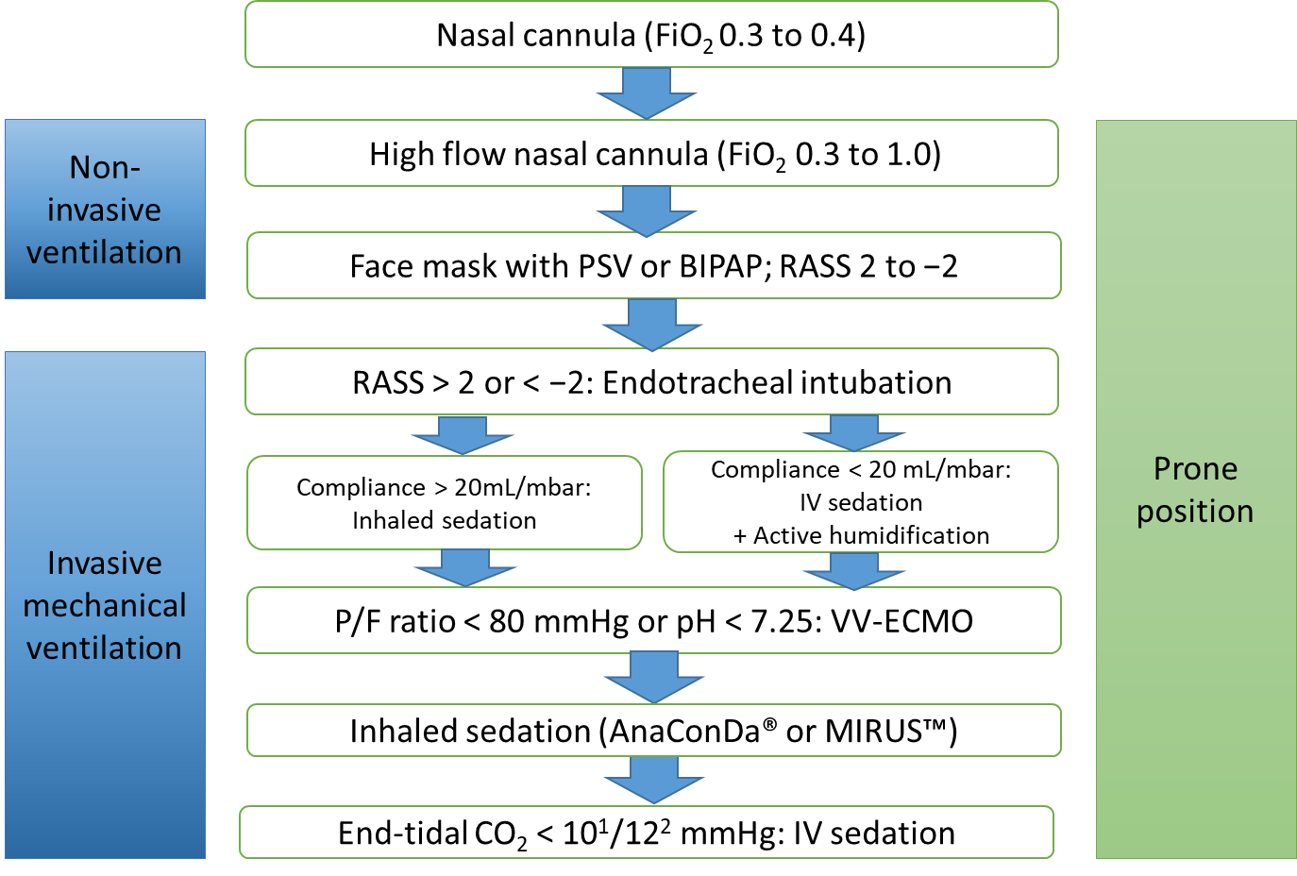
Figure 1 Overview of respiratory management of coronavirus disease 2019 related acute respiratory distress syndrome and inhaled sedation. ¹AnaConDa®; ²MIRUSTM. RASS: Richmond Agitation-Sedation Scale; PSV: Pressure support ventilation; BIPAP: Bilevel positive airway pressure; FiO₂: Fraction of inspired oxygen; PaO₂: Partial pressure of oxygen; P/F-ratio: PaO₂/FiO₂; VV-ECMO: Veno-venous ECMO.
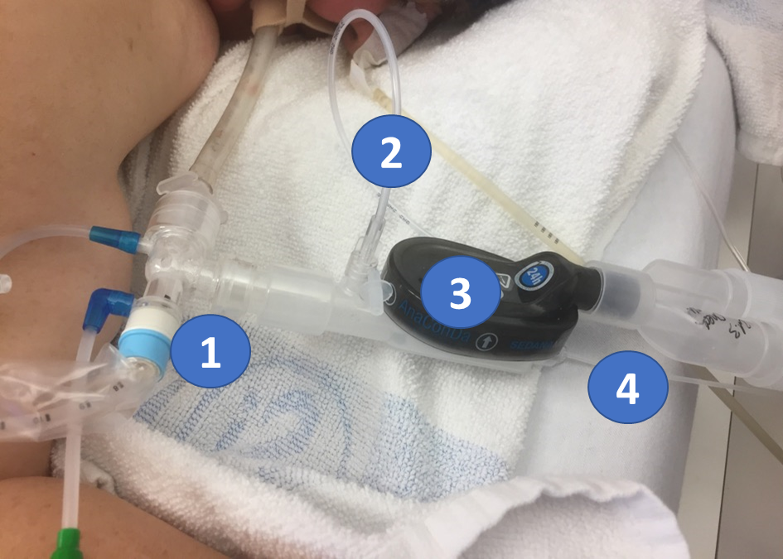
Figure 2 AnaConDa-S® system set up in prone position. ¹Closed loop suction system; ²Port to monitor the volatile anesthetic and CO₂; ³AnaConDa®-S with anesthesia gas reflector, bacterial and viral filter, and heat and moisture exchanger; ⁴Evaporator with liquid line from syringe pump and liquid isoflurane or sevoflurane.
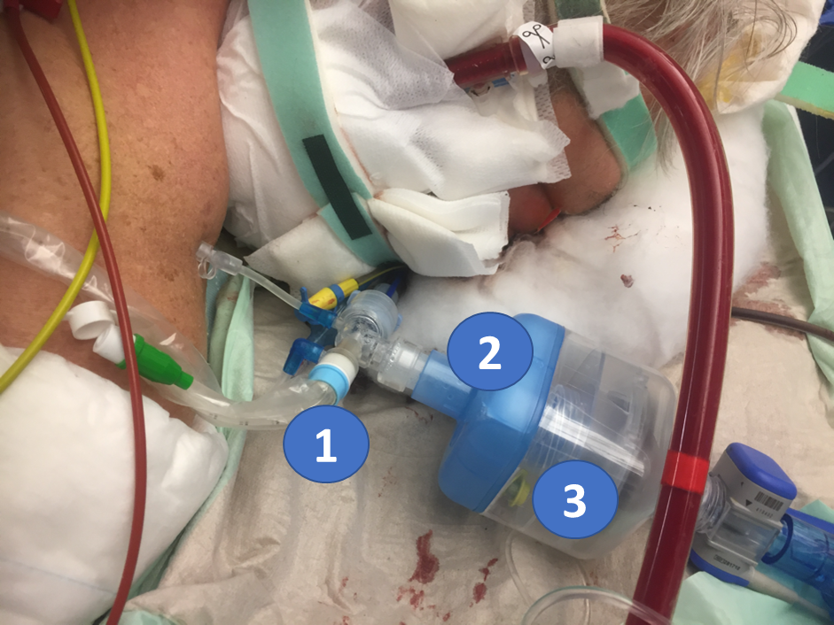
Figure 3 MIRUSTM setup in prone position and veno-venous-extracorporeal membrane oxygenation therapy. ¹Closed suction system; ²Bacterial and viral filter and heat and moisture exchanger; ³MIRUSTM reflector.
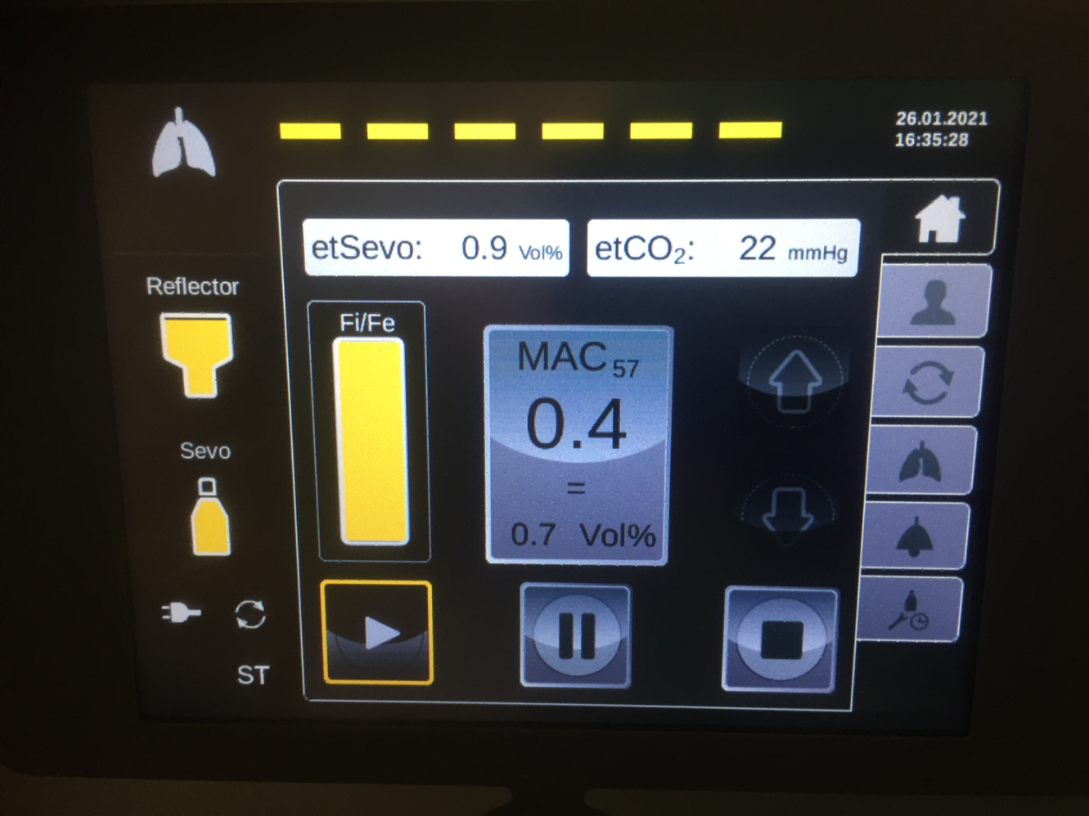
Figure 4 Display of the MIRUSTM sevoflurane controller. The display shows the setting under normal operation.
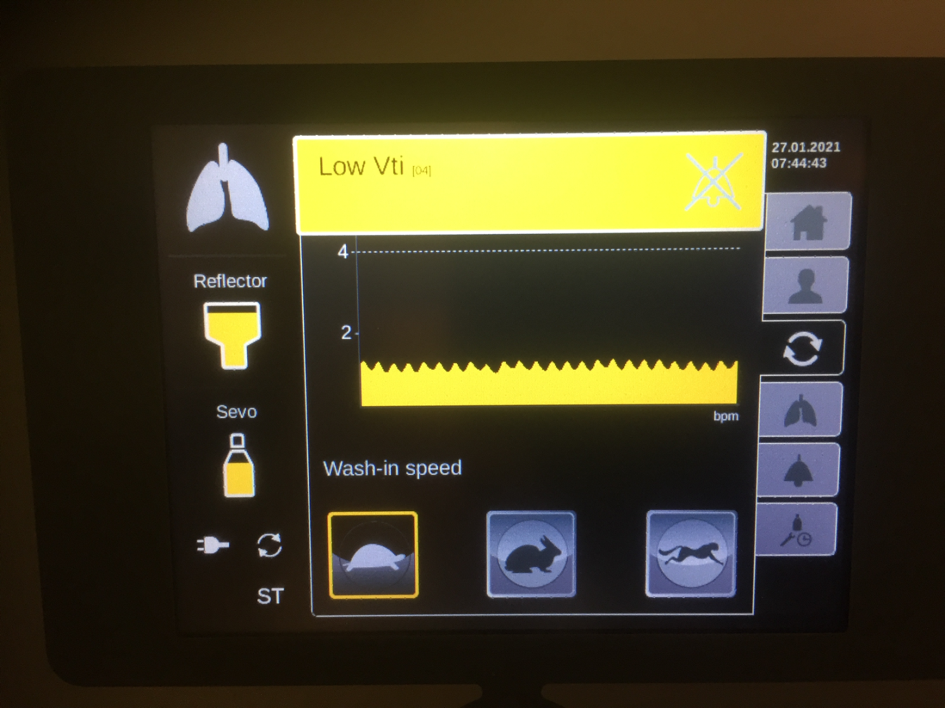
Figure 5 Display of the MIRUSTM controller. Yellow alarm refers to a low tidal volume. In this case, the wash-in speed “tortoise” should be selected.
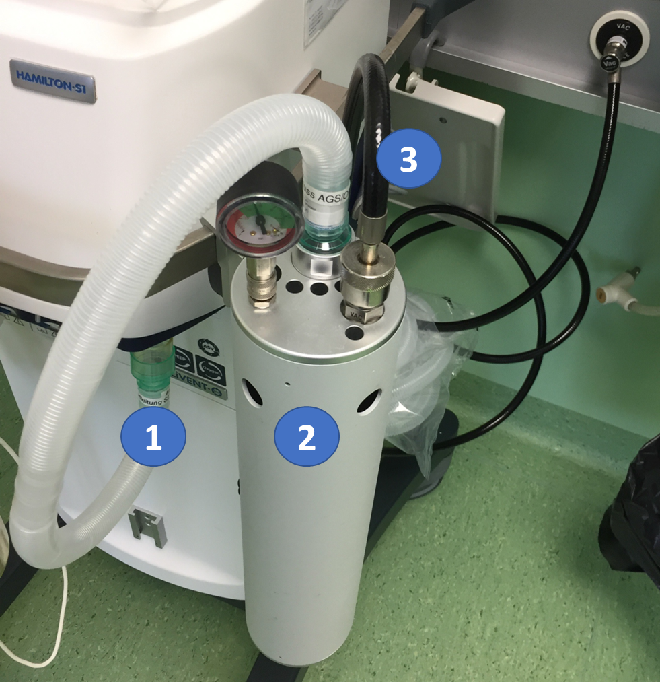
Figure 6 Example of a vacuum-based gas scavenging system (CleanAirTM system). ¹Expiration port of the ventilator; ²Open reservoir scavenging system; ³Vacuum line.

