Name of Journal: World Journal of Clinical Cases
Manuscript NO: 71670
Manuscript Type: CASE REPORT

Successful living donor liver transplantation with a graft-to-recipient weight ratio of 0.41 without portal flow modulation: A case report

Kim SH. Extreme-small-for-size graft liver transplantation

Seong Hoon Kim

Seong Hoon Kim, Center for Liver Cancer, National Cancer Center, Goyang 10408, Gyeonggi-do, South Korea

Author contributions: Kim SH conceived and designed the analysis, collected the data, performed the analysis, and wrote the paper.

Corresponding author: Seong Hoon Kim, MD, PhD, Chief Doctor, Professor, Senior Scientist, Surgeon, Center for Liver Cancer, National Cancer Center, 323 Ilsan-ro, Ilsandong-gu, Goyang 10408, Gyeonggi-do, South Korea. kshlj@hanmail.net

Received: September 17, 2021
Revised: November 12, 2021
Accepted: April 22, 2022
Published online: June 6, 2022

Abstract
BACKGROUND
There have been numerous efforts to lower the limit of minimum graft size to meet the metabolic demand of recipients in adult-to-adult living donor liver transplantation (LDLT). We experienced a successful case of LDLT using a very-small-for-size graft without portal flow modulation such as splenectomy or portocaval shunt.

CASE SUMMARY
A 49-year-old man (weighing 91 kg) suffering hepatocellular carcinoma accompanied with hepatitis B virus related cirrhosis underwent LDLT. The one and only voluntary donor was his 17-year-old daughter whose body weight was 50 kg with a body mass index (BMI) of 18.3. The procured right liver graft was 411 g with a real graft-to-recipient weight ratio (GRWR) of 0.41%, the smallest to be reported in the literature. Both the recipient and donor had an uneventful recovery and were discharged on days 15 and 8, respectively, with normal liver function. The father and daughter have had no complication so far and are still in good health with normal liver function 81 mo after LDLT.

CONCLUSION
Satisfactory outcomes can be achieved in LDLT with a GRWR as low as 0.41% even without using portal flow modulation in highly selected patients.

Key Words: Small-for-size graft; Living donor liver transplantation; Graft-to-recipient weight ratio; Case report

©The Author(s) 2022. Published by Baishideng Publishing Group Inc. All rights reserved.

Citation: Kim SH. Successful living donor liver transplantation with a graft-to-recipient weight ratio of 0.41 without portal flow modulation: A case report. World J Clin Cases 2022; 10(16): 5414-5419
URL: https://www.wjgnet.com/2307-8960/full/v10/i16/5414.htm
DOI: https://dx.doi.org/10.12998/wjcc.v10.i16.5414

Core Tip: Satisfactory outcomes was achieved in living donor liver transplantation with a graft-to-recipient weight ratio as low as 0.41%, the smallest to be reported in the literature, even without using portal flow modulation in a highly selected patient.

INTRODUCTION
How small is too small in terms of a graft-to-recipient weight ratio (GRWR)? The graft size is one of the most critical factors to consider in adult-to-adult living donor liver transplantation (LDLT), and small-for-size syndrome can reportedly occur in patients receiving a small-for-size graft (SFSG) unless the grafts meet the metabolic demands of the recipients^{[1]}. Traditionally, a GRWR ≥ 0.8% has been recommended to improve the graft survival and prevent the early graft dysfunction^{[2]}. However, there is no clear evidence on whether SFSG (GRWR < 0.8) is dangerous for LDLT recipients. The minimum graft size still remains to be defined. In the current era of LDLT performed worldwide, selecting and making SFSGs suitable for recipients can be the last resort to the deteriorating patients who have no other donor candidate.
Herein described is a case of a 49-year-old man who showed long-term favorable clinical outcomes after LDLT using a right liver graft with a GRWR of 0.41. We present the case in accordance with the CARE reporting checklist.

CASE PRESENTATION
Chief complaints
A 49-year-old man was referred to the author’s institution for evaluation of LDLT for hepatocellular carcinoma (1 nodule, 2.5 cm in diameter) and hepatitis B virus-related liver cirrhosis.

History of present illness
Hepatocellular carcinoma (1 nodule, 2.5 cm in diameter) and hepatitis B virus-related liver cirrhosis.

Personal and family history
There were no history of smoking or drinking, and no family history of cancers.

Physical examination
The patient’s height was 183 cm and his weight was 99 kg with a body mass index of 29.5. His body surface area was calculated to be 2.2 m².

Laboratory examinations
The patient’s liver function was not severely impaired [Child-Pugh A class and model for end-stage liver disease (MELD) score 10]. The platelet count was reduced to 68 per microliter of blood.

Imaging examinations
Preoperative computed tomographic (CT) volumetry showed the volume of this area to be 553.2 mL; expected graft-to-recipient weight ratio (GRWR) was 0.55; and expected graft-to-standard liver volume (GV/SLV) was 27.5%.

FINAL DIAGNOSIS
Hepatocellular carcinoma (1 nodule, 2.5 cm in diameter) and hepatitis B virus-related liver cirrhosis.

TREATMENT
The only donor available for LDLT was his daughter. The donor and recipient had the same blood group and the LDLT were approved by KONOS (Korean Network for Organ Sharing). The LDLT was conducted on December 15, 2014. All the main procedures were performed by one surgeon (Seong Hoon Kim). He performed donor hepatectomy, bench procedure, recipient hepatectomy, and graft implantation. In recipient hepatectomy, a junior surgeon opened the abdomen and mobilized both lobes of the liver while the surgeon completed donor hepatectomy and bench procedure. Then he came over to the recipient operating room. He performed the hilar dissection and complete mobilization of the liver from the inferior vena cava. Donor surgery was performed as previously reported^{[5]}. The intraoperative wedge biopsy specimen revealed 5% of macrovesicular steatosis. Operation time was 170 min with minimal blood loss. The real weight of the resected right liver was 411 g, which was much smaller than the preoperatively predicted value by CT volumetry. The real GRWR was 0.41 and GV/SLV was 20.4%, which surely implied a very-small-for-size graft.
During bench preparation, two sizable tributaries (V5 and V8) of the middle hepatic vein were reconstructed using a cryopreserved iliac vein graft. In the recipient, eversion thrombectomy was performed for partial bland thrombosis in the main portal vein following total hepatectomy. After the anastomoses of the hepatic vein and portal vein, the reperfusion revealed neither severe congestion of the small graft nor uncontrollable bleeding from the cut surface of the graft. So, no additional modulation was done intraoperatively. The donor’s single right hepatic artery 1.5 mm in diameter was anastomosed with the recipient’s right hepatic artery 2 mm in diameter. Doppler ultrasonography showed good vascular flows in all the vessels reconstructed in the graft. The graft was finally transplanted with a duct-to-duct biliary reconstruction. The cold ischemia time was 75 min; warm ischemia time was 25 min; and anhepatic stage was 102 min. Operation time was 8 h and 8 min. Blood loss was 4000 mL.

OUTCOME AND FOLLOW-UP
After LDLT, the patient recovered with improving laboratory findings with time. On the day before LDLT, the AST level was 50 U/L and the ALT level was 46 U/L. On postoperative day (POD) 1, these levels were 68 U/L and 76 U/L, respectively; on POD 3, 33 U/L and 41 U/L, respectively; on POD 15, 28 U/L and 27 U/L, respectively. The serum total bilirubin level that had been 1.4 mg/dL just before LDLT was elevated to 6.7 mg/dL on POD 1 but gradually decreased to 1.6 mg/dL on POD 7, and then was 0.4 mg/dL on POD 15 at discharge. The international normalized ratio was 1.19 before LDLT, but it increased to 2.32 on POD 1. The ratio was 1.68 on POD 3 and 1.43 on POD 7. The ratio recovered to 1.01 on POD 15.
Routine follow-up computerized tomography (CT) on POD 9 showed no abnormal findings except for V8 occlusion and slight right pleural effusion. The postoperative course was not eventful. There had been no signs of small-for-size syndrome such as prolonged ascites, jaundice, and hyperammonemia. The recipient was discharged without complications with normal liver function from the hospital on POD 15, and the donor checked out on day 8 safe and sound.
A follow-up CT scan showed sufficient liver regeneration in the recipient (Figure 1). It has been 6 years and 9 mo since the LDLT and both the donor and recipient are still in good conditions with normal liver function, having full satisfaction with the outcomes that they got from this LDLT.

DISCUSSION
This is the smallest GRWR ever reported in LDLT even without portal flow modulation. And it had shown favorable long-term clinical outcomes. Actually, the patient was recommended to receive dual liver grafts at another hospital due to a low GRWR. There have been many efforts made to use the SFSG that was defined as having a GRWR < 0.8. A decade ago, there was a report that the lower limit of GRWR can be safely reduced to 0.6% in adult-to-adult LDLT in combination with portal inflow modulation^{[6]}. The threshold of GRWR was further reduced to 0.58 with hemi-portocaval shunt^{[7]}. Furthermore, the record had already been broken so that a successful LDLT using a right lateral segment with a GRWR of 0.47 was reported by virtue of splenectomy and mesocaval shunt^{[8]}. There was an interesting report that a 60-year-old woman received a whole liver graft with an estimated GRWR of 0.46% from a 10-year-old child deceased donor with splenectomy in order to prevent the potential risk of developing small-for-size syndrome. However, the actual GRWR was 0.8^{[9]}.
On the contrary, there were also several studies without portal inflow modulation, suggesting that it would be difﬁcult to deny a living donor candidate the opportunity to donate one’s partial liver solely based on the graft size in terms of GRWR. Two retrospective studies found no significant differences in both the incidence of SFSS and graft survival between GRWR < 0.8% and GRWR ≥ 0.8%^{[10,11]}.
All the previous reports had it that the GRWR could be lowered to below 0.8%. However, the lower limit still remains unanswered as of now. The safety limit of SFSG can be closely related to the factors of the donor, recipient, and surgical technique^{[12]}. Therefore, the good outcomes of this LDLT with a GRWR of 0.41 could be attributed to the following reasons: (1) The donor was young without significant hepatic steatosis or other parenchymal disease; (2) The patient’s condition was not so bad at the time of LDLT, being reflected by a low MELD score. And he had no other underlying disease except for liver cirrhosis of Child-Pugh A class; (3) The graft had no long ischemic time, and the graft implantation resulted in no derangements in the vascular inflow and outflow, which could be corroborated by the observation that the AST and ALT levels were maintained at less than 100 U/L throughout hospital stay; and (4) The patient had no postoperative morbidity such as infection, rejection, and vascular or biliary complication. Any complication may tip the balance of patient recovery especially in patients with SFSG.
On the other hand, if serious liver congestion or cut surface bleeding had developed after reperfusion or the small-for-size syndrome had happened postoperatively and the liver function had become worse, portal flow modulation would have been considered to reduce the graft damage. Portal flow modulation is not without untoward events. Portocaval shunt may lead to excessive diversion of portal flow, leading to graft failure. Splenic artery embolization or ligation could cause a massive splenic colliquation. Further experiences and studies might be needed to determine the indication and optimal time. Therefore, we do not do portal flow modulation routinely during operation just solely in terms of GRWR.
Although this very small graft has not sufficiently been corroborated in many patients, at least it could be used as an example of extending the indication in patients awaiting transplant. The major concern is what the selection criteria are, therefore further refined studies need to be done. In clinical practice, selection of patients eligible for SFSG LDLT to achieve the best outcome and survival should be evaluated by close integration with surgical expertise, clinical (age, performance status, and MELD score) parameters, and careful patient monitoring on an individual basis.

CONCLUSION
In conclusion, satisfactory outcomes can be achieved in LDLT with a GRWR as low as 0.41% even without using portal flow modulation in highly selected patients.

REFERENCES
1 Dahm F, Georgiev P, Clavien PA. Small-for-size syndrome after partial liver transplantation: definition, mechanisms of disease and clinical implications. Am J Transplant 2005; 5: 2605-2610. [PMID: 16212618 DOI:10.1111/j.1600-6143.2005.01081.x]
2 Kiuchi T, Kasahara M, Uryuhara K, Inomata Y, Uemoto S, Asonuma K, Egawa H, Fujita S, Hayashi M, Tanaka K. Impact of graft size mismatching on graft prognosis in liver transplantation from living donors. Transplantation 1999; 67: 321-327 [PMID: 10075602 DOI: 10.1097/00007890-199901270-00024]
3 Du Bois D, Du Bois EF. A formula to estimate the approximate surface area if height and weight be known. 1916. Nutrition 1989; 5: 303-311 [PMID: 2520314]
4 Vauthey JN, Abdalla EK, Doherty DA, Gertsch P, Fenstermacher MJ, Loyer EM, Lerut J, Materne R, Wang X, Encarnacion A, Herron D, Mathey C, Ferrari G, Charnsangavej C, Do KA, Denys A. Body surface area and body weight predict total liver volume in Western adults. Liver Transpl 2002; 8: 233-240 [PMID: 11910568 DOI: 10.1053/jlts.2002.31654]
5 Kim SH, Kim YK. Living donor right hepatectomy using the hanging maneuver by Glisson's approach under the upper midline incision. World J Surg 2012; 36: 401-406 [PMID: 22127424 DOI: 10.1007/s00268-011-1340-z]
6 Kaido T, Mori A, Ogura Y, Hata K, Yoshizawa A, Iida T, Yagi S, Uemoto S. Lower limit of the graft-to-recipient weight ratio can be safely reduced to 0.6% in adult-to-adult living donor liver transplantation in combination with portal pressure control. Transplant Proc 2011; 43: 2391-2393 [PMID: 21839274 DOI: 10.1016/j.transproceed.2011.05.037]
7 Huang JW, Yan LN, Chen ZY, Wu H, Lu Q, Xu YL, Prasoon P, Zeng Y. Hemi-portocaval shunt: a simple salvage maneuver for small-for-size graft during living donor liver transplantation: a case report. Chin Med J (Engl) 2011; 124: 2231-2233 [PMID: 21933633]
8 Kokai H, Sato Y, Yamamoto S, Oya H, Nakatsuka H, Watanabe T, Takizawa K, Hatakeyama K. Successful super-small-for-size graft liver transplantation by decompression of portal hypertension via splenectomy and construction of a mesocaval shunt: a case report. Transplant Proc 2008; 40: 2825-2827 [PMID: 18929872 DOI: 10.1016/j.transproceed.2008.08.080]
9 Feng AC, Liao CY, Fan HL, Chen TW, Hsieh CB. A successful child-to-adult deceased donor liver transplantation: a case report and literature review. Ann Transplant 2015; 20: 21-24 [PMID: 25582243 DOI: 10.12659/AOT.893101]
10 Hill MJ, Hughes M, Jie T, Cohen M, Lake J, Payne WD, Humar A. Graft weight/recipient weight ratio: how well does it predict outcome after partial liver transplants? Liver Transpl 2009; 15: 1056-1062 [PMID: 19718640 DOI: 10.1002/lt.21846]
11 Moon JI, Kwon CH, Joh JW, Jung GO, Choi GS, Park JB, Kim JM, Shin M, Kim SJ, Lee SK. Safety of small-for-size grafts in adult-to-adult living donor liver transplantation using the right lobe. Liver Transpl 2010; 16: 864-869 [PMID: 20583075 DOI: 10.1002/lt.22094]
12 Kiuchi T, Tanaka K, Ito T, Oike F, Ogura Y, Fujimoto Y, Ogawa K. Small-for-size graft in living donor liver transplantation: how far should we go? Liver Transpl 2003; 9: S29-S35 [PMID: 12942476 DOI: 10.1053/jlts.2003.50198]

Footnotes
Informed consent statement: Written informed consent was obtained from the patient for publication of this case report.

Conflict-of-interest statement: The author of this manuscript has no conflicts of interest to disclose.

CARE Checklist (2016) statement: I present the case in accordance with the CARE reporting checklist.

Open-Access: This article is an open-access article that was selected by an in-house editor and fully peer-reviewed by external reviewers. It is distributed in accordance with the Creative Commons Attribution NonCommercial (CC BY-NC 4.0) license, which permits others to distribute, remix, adapt, build upon this work non-commercially, and license their derivative works on different terms, provided the original work is properly cited and the use is non-commercial. See: https://creativecommons.org/Licenses/by-nc/4.0/

Provenance and peer review: Unsolicited article; Externally peer reviewed.
Peer-review model: Single blind

Peer-review started: September 17, 2021
First decision: November 7, 2021
Article in press: April 22, 2022

Specialty type: Transplantation
Country/Territory of origin: South Korea
Peer-review report’s scientific quality classification
Grade A (Excellent): 0
Grade B (Very good): B
Grade C (Good): 0
Grade D (Fair): D
Grade E (Poor): 0

P-Reviewer: Karaca CA, Turkey; Sugawara Y, Japan S-Editor: Xing YX L-Editor: Wang TQ P-Editor: Xing YX

Figure Legends
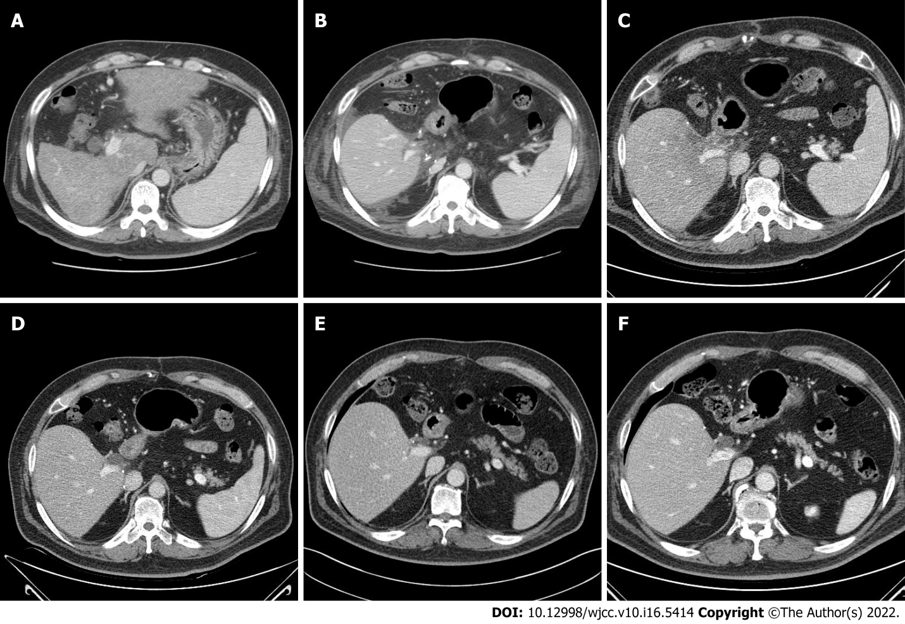
Figure 1 Computed tomography images. A: Pretransplant day 3; B: Postoperative day 9; C: Postoperative month 3; D: Postoperative month 15; E: Postoperative month 35; and F: Postoperative month 76.

Published by Baishideng Publishing Group Inc
7041 Koll Center Parkway, Suite 160, Pleasanton, CA 94566, USA
Telephone: +1-925-3991568
E-mail: bpgoffice@wjgnet.com
Help Desk: https://www.f6publishing.com/helpdesk
https://www.wjgnet.com

© 2022 Baishideng Publishing Group Inc. All rights reserved.

