Name of Journal: World Journal of Clinical Cases
Manuscript NO: 59493
Manuscript Type: CASE REPORT

Multiple well-differentiated retroperitoneal liposarcomas with different patterns of appearance on computed tomography: A case report

Xie TH et al. Multiple PRPLS with different CT images

Tian-Hao Xie, Xiang-Xiang Ren, Yan Fu, Si-Ning Ha, Li-Tao Liu, Xiao-Shi Jin

Tian-Hao Xie, Xiang-Xiang Ren, Si-Ning Ha, Li-Tao Liu, Xiao-Shi Jin, Department of General Surgery, Affiliated Hospital of Hebei University, Baoding 071000, Hebei Province, China

Yan Fu, Department of Ophthalmology, Baoding First Central Hospital, Baoding 071000, Hebei Province, China

Author contributions: Xie TH, Ren XX, and Jin XS made substantial contributions to the conception and design of the case report; Xie TH and Jin XS were responsible for the manuscript; Xie TH, Ren XX, Fu Y, Liu LT, and Ha SN collected the samples and confirmed data accuracy; Xie TH, Ren XX, and Fu Y participated in drafting the manuscript; Xie TH, Ha SN, Liu LT, and Jin XS made substantial revisions to the manuscript; all of the authors read and approved the final manuscript.

Supported by Science Technology Plan of Baoding Municipal Department of Science and Technology, No. 1951ZF091

Corresponding author: Xiao-Shi Jin, MD, PhD, Professor, Department of General Surgery, Affiliated Hospital of Hebei University, No. 212 East Yuhua Road, Baoding 071000, Hebei Province, China. doctorjinxiaoshi@126.com

Received: September 14, 2020
Revised: December 18, 2020
Accepted: January 6, 2021
Published online: March 6, 2021

Abstract
BACKGROUND
Primary retroperitoneal liposarcoma (PRPLS) is a rare soft tissue tumor with nonspecific clinical symptoms; it has different computed tomography (CT) image features according to pathological types. Some patients with a single tumor have been previously reported in the literature. We present an exceptional case of a PRPLS patient with multiple large tumors exhibiting different patterns of appearance on CT and confirmed as atypical lipomatous tumor/well-differentiated liposarcoma by postoperative pathology.

CASE SUMMARY
A 64-year-old man presented with abdominal distension for 1 year. The patient was diagnosed with PRPLS based on physical examination, laparotomy, ultrasonography, CT scan, and surgery. Both of the tumors were completely resected through surgery and confirmed as atypical lipomatous tumor/well-differentiated liposarcoma by postoperative pathology. The postoperative course was uneventful without recurrence or metastasis, as demonstrated by abdominal-pelvic CT during an 18 mo follow-up.

CONCLUSION
Multiple large Well-differentiated liposarcomas with different patterns of appearance on CT image can occur simultaneously in the same patient, to which more attention should be paid to make an effective differential diagnosis.

Key Words: Retroperitoneal liposarcoma; Soft tissue tumor; Complete resection; Recurrence; Case report

©The Author(s) 2021. Published by Baishideng Publishing Group Inc. All rights reserved.

Xie TH, Ren XX, Fu Y, Ha SN, Liu LT, Jin XS. Multiple retroperitoneal well-differentiated liposarcomas with different patterns of appearance on computed tomography: A case report. World J Clin Cases 2021; 9(7): 1661-1667 URL: https://www.wjgnet.com/2307-8960/full/v9/i7/1661.htm DOI: https://dx.doi.org/10.12998/wjcc.v9.i7.1661

Core Tip: Primary retroperitoneal liposarcoma (PRPLS) is a rare soft tissue tumor with nonspecific clinical symptoms; it has different computed tomography (CT) image features according to pathological types. We present an exceptional case of a PRPLS patient with multiple large tumors exhibiting different patterns of appearance on CT and confirmed as atypical lipomatous tumor/well-differentiated liposarcoma by postoperative pathology. This suggested that more attention should be paid to an effective differential diagnosis of PRPLS with different patterns of appearance on CT.

INTRODUCTION
Primary retroperitoneal liposarcoma (PRPLS) originates from soft tissue in the retroperitoneum and is rarely observed clinically^{[1-4]}. Since the clinical symptoms are usually nonspecific and its anatomical location is the retroperitoneal space, reaching an early definitive diagnosis of PRPLS is usually difficult^{[5]}. Complete resection by surgery is the main mode of treatment for this disease^{[6]}. Owing to the complex pathology of this disease, the effectiveness of chemoradiotherapy is limited^{[7,8]}. The prognosis of this disease depends on the pathological type; however, all types are linked to a high local recurrence rate^{[9,10]}. Therefore, it is important to promptly detect the disease, administer appropriate treatment, and regularly monitor the disease progression after operation^{[10,11]}. Herein, we report a case with multiple PRPLS managed at our hospital and review the currently literature on this disease.

CASE PRESENTATION
Chief complaints
A 64-year-old man was referred to the Department of General Surgery, Affiliated Hospital of Hebei University (Baoding, China) in July 2018, with a complaint of abdominal distension for 1 year.

History of present illness
Apart from abdominal distension, the patient was asymptomatic, without distinct medical, surgical, or medication history.

Physical examination
A physical examination revealed the presence of abdominal bulge with a flexible mass (dimensions: 24 cm × 20 cm) located in the abdomen. This mass had a regular shape, clear boundary, and was palpable with a rubbery medium-hard texture. There was no pain upon application of pressure on the mass.

Laboratory examinations
The laboratory examinations, including the assessment of tumor markers (alpha fetoprotein, carcinoembryonic antigen, carbohydrate antigen (CA) 125, CA15-3, CA19-9, and CA72-4), as well as routine blood, urine, and stool tests, did not reveal abnormalities.

Imaging examinations
Ultrasound examination showed a solid hypoechoic mass (dimensions: 18.5 cm × 15.5 cm × 8.8 cm) in the right middle abdomen. The upper and lower margins reached the subcostal region, and the subumbilicus, respectively. The boundary was clear, the morphology was irregular, and the internal echo was not uniform. Marked echo interheterogenicity was observed in the center, and blood flow signals were detected around and within it through color Doppler flow imaging; in the lower abdomen, there were several echo groups with strong echo intensity, and the boundary was unclear. The dimensions of the largest mass in the right and left lower abdomen were approximately 8.3 cm × 5.0 cm and 7.9 cm × 4.4 cm, respectively; both had a vague boundary and an irregular shape (Figure 1).
Abdominal-pelvic computed tomography (CT) revealed multiple low-density masses in the abdominal cavity. The dimensions of the largest mass in the left abdominal cavity were approximately 14.7 cm × 13.2 cm, and the mass had a clear boundary and convoluted vascular course. After performing contrast-enhanced scans, the mass did not exhibit significant enhancement with a -65 HU value. Another mixed-density mass was observed in the right abdominal cavity, with dimensions of approximately 15.4 cm × 10.6 cm; following contrast-enhanced scans, its CT values during the three phases were approximately 28/31/50 HU (Figure 2).

FINAL DIAGNOSIS
PRPLS was diagnosed based on the reported clinical symptoms, auxiliary examination, and postoperative pathology.

TREATMENT
During surgery, we observed that both tumors were located in the retroperitoneal space near the mesenteric root with a clear limit out of the surrounding tissue. One tumor (35 cm × 22 cm × 20 cm) on the right side of the retroperitoneum had a lobulated shape. The other tumor (25 cm × 18 cm × 17 cm) on the left side of the retroperitoneum had a regular shape (Figure 3). Both tumors had been identified as atypical lipomatous tumor/well-differentiated liposarcoma by postoperative pathology. Moreover, microscopically, they were characterized by a leaf-like pattern aggregate of mature adipocytes separated by fibrous septa (Figure 4).

OUTCOME AND FOLLOW-UP
The patient recovered smoothly without severe complications. There was no recurrence or metastasis found by the abdominal-pelvic CT during the follow-up at 3, 6, 12, and 18 mo.

DISCUSSION
Liposarcoma originates from primitive mesenchymal cells and usually occurs in the retroperitoneum, with approximately 35% of cases arising from perinephric fat^{[1]}. PRPLS accounts for approximately 45% of soft tissue sarcoma cases^{[2,3]} with a prevalence of 0.3-0.4 cases per 100000 inhabitants^{[4]}. According to the morphological characteristics and cytogenetic variation, PRPLS is categorized by the World Health Organization into five subtypes: Well-differentiated; dedifferentiated; myxoid; pleomorphic; and mixed-type^{[12]}. The first two types are the most common in PRPLS^{[13]}, while the rarer subtypes (i.e., myxoid and pleomorphic) occur less often in the retroperitoneum^{[14]}.
Owing to the special position of PRPLS, the patients do not have obvious clinical manifestations in the early stages of the disease. Moreover, the tumors are often detected only after they are palpable in the abdomen. Since PRPLS has no characteristic symptoms, the complaints of patients commonly relate to discomfort, bellyache, bloating, and direct invasion or compression of other adjacent organs (e.g., the stomach, intestines, kidney, bladder, or great vessels). In this case, the patient presented with a complaint of abdominal bloating.
There are no significant laboratory abnormalities observed in the early stages^{[5]}. The preferred diagnostic method for PRPLS is examination through CT^{[15]}, which is also the essential reference standard in tumor staging and preoperative evaluation^{[7,15]}. The typical CT imaging of PRPLS includes legibility of low-density tissue as fat component with large size and non-enhancement during the arterial phase. In a small number of cases, the kidney is usually displaced by mass compression or surrounded by the mass. This report shows two different patterns of appearance of PRPLS on CT, which have the same pathological type: Atypical lipomatous tumor/well-differentiated liposarcoma. One was observed in the left abdominal cavity, and demonstrated a fat-like density with a -65 HU value, a clear boundary, and a convoluted vascular course. Moreover, it had no significant enhancement after contrast-enhanced scanning. The other larger mass was a mixed-density mass observed in the right abdominal cavity, after contrast-enhanced scanning; its CT values during the three phases were approximately 28/31/50 HU.
In some cases, PRPLS was detected accidentally during a regular health checkup by ultrasound and color Doppler, which are preferred imaging methods to distinguish vascular lesions and soft tissue sarcoma because they can provide detailed information about vascular anatomy^{[16,17]}. Recently, with the development of contrast-enhanced ultrasound technique that can effectively diagnose abdominal parenchymal diseases and vascular lesions in real time and without the use of ionizing radiation^{[18-21]}, it may provide a new perspective and possibility for researchers on the diagnosis of PRPLS.
At present, surgical treatment remains one of the primary modes of therapy for PRPLS^{[6]}. However, for patients who underwent macroscopically complete resection of PRPLS, a high recurrence rate remains following operation^{[9]}. PRPLS grows in a special location; hence, the tumor often has a large volume at the time of diagnosis. Enlargement of the tumor in the retroperitoneal space may drastically change the normal anatomy of the surrounding organs and great vessels through compression. This effect poses difficulties to surgons regarding the protection of the important organs and great vessels during surgery^{[22,23]}.
PRPLS is rarely confirmed with metastasis through the lymph gland. Thus, it is not essential to perform regional lymphadenectomy. The recurrence rate can be reduced by completely removing the tumor and the surrounding suspicious adipose tissue^{[24]}. In patients in whom the tumor has invaded adjacent organs or cannot be easily separated from great vessels, combined devisceration is an effective approach to reducing the risk of intraoperative hemorrhage and increasing the possibility of intact excision^{[24]}.
Postoperative recurrence of PRPLS, especially local recurrence, is relatively common. Previous studies have shown that the 5-, 8-, and 10-year crude cumulative incidences of local recurrence were 25.9%, 31.3%, and 35%^{[10]}. Different treatment policies influence the local recurrence outcomes of well-differentiated and dedifferentiated PRPLS without impacting overall survival, whereas deaths are related to locoregional recurrences^{[10]}. Resection of recurrent tumors is associated with prolonged patient survival^{[11]}.
Given that the possibility of cure after recurrence is low, a relatively conservative approach is taken for the resection of recurrent PRPLS after an extended primary procedure. The goal is to excise the recurrent tumor directly invading organs, rather than performing a wider excision, as performed for PRPLS^{[25]}.

CONCLUSION
PRPLS is a group of rare diseases, and associated with high recurrence rates, thus, surgical treatment and careful long-term clinical follow-up are warranted. It is a remarkable fact that multiple large well-differentiated liposarcomas with different patterns of appearance on CT image can occur simultaneously in the same patient, to which more attention should be paid to make an effective differential diagnosis.

REFERENCES
1 Hasegawa T, Seki K, Hasegawa F, Matsuno Y, Shimodo T, Hirose T, Sano T, Hirohashi S. Dedifferentiated liposarcoma of retroperitoneum and mesentery: varied growth patterns and histological grades--a clinicopathologic study of 32 cases. Hum Pathol 2000; 31: 717-727 [PMID: 10872666 DOI: 10.1053/hupa.2000.8222]
2 Linch M, Miah AB, Thway K, Judson IR, Benson C. Systemic treatment of soft-tissue sarcoma-gold standard and novel therapies. Nat Rev Clin Oncol 2014; 11: 187-202 [PMID: 24642677 DOI: 10.1038/nrclinonc.2014.26]
3 Siegel RL, Miller KD, Jemal A. Cancer statistics, 2016. CA Cancer J Clin 2016; 66: 7-30 [PMID: 26742998 DOI: 10.3322/caac.21332]
4 Mettlin C, Priore R, Rao U, Gamble D, Lane W, Murphy P. Results of the national soft-tissue sarcoma registry. J Surg Oncol 1982; 19: 224-227 [PMID: 7078175 DOI: 10.1002/jso.2930190410]
5 Yang J, Zhao Y, Zheng CH, Wang Q, Pang XY, Wang T, Ma JJ. Huge retroperitoneal liposarcoma with renal involvement requires nephrectomy: A case report and literature review. Mol Clin Oncol 2016;5: 607-609 [PMID: 27900096 DOI: 10.3892/mco.2016.1017]
6 Garcia-Ortega DY, Villa-Zepeda O, Martinez-Said H, Cuellar-Hübbe M, Luna-Ortiz K. Oncology outcomes in Retroperitoneal sarcomas: Prognostic factors in a Retrospective Cohort study. Int J Surg 2016; 32: 45-49 [PMID: 27268726 DOI: 10.1016/j.ijsu.2016.06.001]
7 Nathenson MJ, Barysauskas CM, Nathenson RA, Regine WF, Hanna N, Sausville E. Surgical resection for recurrent retroperitoneal leiomyosarcoma and liposarcoma. World J Surg Oncol 2018; 16: 203 [PMID: 30309356 DOI: 10.1186/s12957-018-1505-4]
8 Datta J, Ecker BL, Neuwirth MG, Geha RC, Fraker DL, Roses RE, Karakousis GC. Contemporary reappraisal of the efficacy of adjuvant chemotherapy in resected retroperitoneal sarcoma: Evidence from a nationwide clinical oncology database and review of the literature. Surg Oncol 2017; 26: 117-124 [PMID: 28577717 DOI: 10.1016/j.suronc.2017.01.008]
9 Gyorki DE, Choong PFM, Slavin J, Henderson MA. Importance of preoperative diagnosis for management of patients with suspected retroperitoneal sarcoma. ANZ J Surg 2018; 88: 274-277 [PMID: 28768365 DOI: 10.1111/ans.14125]
10 Gronchi A, Strauss DC, Miceli R, Bonvalot S, Swallow CJ, Hohenberger P, Van Coevorden F, Rutkowski P, Callegaro D, Hayes AJ, Honoré C, Fairweather M, Cannell A, Jakob J, Haas RL, Szacht M, Fiore M, Casali PG, Pollock RE, Raut CP. Variability in Patterns of Recurrence After Resection of Primary Retroperitoneal Sarcoma (RPS): A Report on 1007 Patients From the Multi-institutional Collaborative RPS Working Group. Ann Surg 2016; 263: 1002-1009 [PMID: 26727100 DOI: 10.1097/SLA.0000000000001447]
11 Fairweather M, Gonzalez RJ, Strauss D, Raut CP. Current principles of surgery for retroperitoneal sarcomas. J Surg Oncol 2018; 117: 33-41 [PMID: 29315649 DOI: 10.1002/jso.24919]
12 Fletcher CD. The evolving classification of soft tissue tumours - an update based on the new 2013 WHO classification. Histopathology 2014; 64: 2-11 [PMID: 24164390 DOI: 10.1111/his.12267]
13 van Houdt WJ, Zaidi S, Messiou C, Thway K, Strauss DC, Jones RL. Treatment of retroperitoneal sarcoma: current standards and new developments. CurrOpin Oncol 2017; 29: 260-267 [PMID: 28509807 DOI: 10.1097/CCO.0000000000000377]
14 Vijay A, Ram L. Retroperitoneal liposarcoma: a comprehensive review. Am J Clin Oncol 2015; 38: 213-219 [PMID: 24136142 DOI: 10.1097/COC.0b013e31829b5667]
15 Messiou C, Moskovic E, Vanel D,Morosi C, Benchimol R, Strauss D, Miah A, Douis H, van Houdt W, Bonvalot S. Primary retroperitoneal soft tissue sarcoma: Imaging appearances, pitfalls and diagnostic algorithm. Eur J Surg Oncol 2017; 43: 1191-1198 [PMID: 28057392 DOI: 10.1016/j.ejso.2016.10.032]
16 Corvino A, Catalano O, Corvino F, Sandomenico F, Setola SV, Petrillo A. Superficial temporal artery pseudoaneurysm: what is the role of ultrasound? J Ultrasound 2016; 19: 197-201 [PMID: 27635165 DOI: 10.1007/s40477-016-0211-8]
17 Corvino A, Sandomenico F, Corvino F, Campanino MR, Verde F, Giurazza F, Tafuri D, Catalano O. Utility of a gel stand-off pad in the detection of Doppler signal on focal nodular lesions of the skin. J Ultrasound 2020; 23: 45-53 [PMID: 30927249 DOI: 10.1007/s40477-019-00376-3]
18 Corvino A, Catalano O, de Magistris G, Corvino F, Giurazza F, Raffaella N, Vallone G. Usefulness of doppler techniques in the diagnosis of peripheral iatrogenic pseudoaneurysms secondary to minimally invasive interventional and surgical procedures: imaging findings and diagnostic performance study. J Ultrasound 2020; 23: 563-573 [PMID: 32436181 DOI: 10.1007/s40477-020-00475-6]
19 Corvino A, Sandomenico F, Setola SV, Corvino F, Pinto F, Catalano O. Added value of contrast-enhanced ultrasound (CEUS) with Sonovue® in the diagnosis of inferior epigastric artery pseudoaneurysm: report of a case and review of literature. J Ultrasound 2019; 22: 485-489 [PMID: 31327113 DOI: 10.1007/s40477-019-00398-x]
20 Corvino A, Catalano O, Corvino F, Sandomenico F, Petrillo A. Diagnostic Performance and Confidence of Contrast-Enhanced Ultrasound in the Differential Diagnosis of Cystic and Cysticlike Liver Lesions. AJR Am J Roentgenol 2017; 209: W119-W127 [PMID: 28639831 DOI: 10.2214/AJR.16.17062]
21 Corvino A, Sandomenico F, Setola SV, Corvino F, Tafuri D, Catalano O. Morphological and dynamic evaluation of complex cystic focal liver lesions by contrast-enhanced ultrasound: current state of the art. J Ultrasound 2019; 22: 251-259 [PMID: 31087277 DOI: 10.1007/s40477-019-00385-2]
22 Strauss DC, Hayes AJ, Thway K, Moskovic EC, Fisher C, Thomas JM. Surgical management of primary retroperitoneal sarcoma. Br J Surg 2010; 97: 698-706 [PMID: 20306527 DOI: 10.1002/bjs.6994]
23 Rutkowski P, Trepka S, Ptaszynski K, Kołodziejczyk M. Surgery quality and tumor status impact on survival and local control of resectable liposarcomas of extremities or the trunk wall. Clin OrthopRelat Res 2013; 471: 860-870 [PMID: 22972658 DOI: 10.1007/s11999-012-2592-0]
24 Bonvalot S, Miceli R, Berselli M, Causeret S, Colombo C, Mariani L, Bouzaiene H, Le Péchoux C, Casali PG, Le Cesne A, Fiore M, Gronchi A. Aggressive surgery in retroperitoneal soft tissue sarcoma carried out at high-volume centers is safe and is associated with improved local control. Ann Surg Oncol 2010; 17: 1507-1514 [PMID: 20393803 DOI: 10.1245/s10434-010-1057-5]
25 MacNeill AJ, Miceli R, Strauss DC, Bonvalot S, Hohenberger P, Van Coevorden F, Rutkowski P, Callegaro D, Hayes AJ, Honoré C, Fairweather M, Cannell A, Jakob J, Haas RL, Szacht M, Fiore M, Casali PG, Pollock RE, Raut CP, Gronchi A, Swallow CJ. Post-relapse outcomes after primary extended resection of retroperitoneal sarcoma: A report from the Trans-Atlantic RPS Working Group. Cancer 2017; 123: 1971-1978 [PMID: 28152173 DOI: 10.1002/cncr.30572]

Footnotes
Informed consent statement: Written consent for publication was acquired from the patient, and the signed consent form will be provided upon request.

Conflict-of-interest statement: The authors report no conflicts of interest.

CARE Checklist (2016) statement: The authors have read the CARE Checklist (2016), and the manuscript was prepared and revised according to the CARE Checklist (2016).

Open-Access: This article is an open-access article that was selected by an in-house editor and fully peer-reviewed by external reviewers. It is distributed in accordance with the Creative Commons Attribution NonCommercial (CC BY-NC 4.0) license, which permits others to distribute, remix, adapt, build upon this work non-commercially, and license their derivative works on different terms, provided the original work is properly cited and the use is non-commercial. See: http://creativecommons.org/Licenses/by-nc/4.0/

Manuscript source: Unsolicited manuscript

Peer-review started: September 14, 2020
First decision: December 14, 2020
Article in press: January 6, 2021

Specialty type: Medicine, research and experimental
Country/Territory of origin: China
Peer-review report’s scientific quality classification
Grade A (Excellent): 0
Grade B (Very good): B
Grade C (Good): C
Grade D (Fair): 0
Grade E (Poor): 0

P-Reviewer: Corvino A, Kimura Y S-Editor: Fan JR L-Editor: Wang TQ P-Editor: Zhang YL
Figure Legends
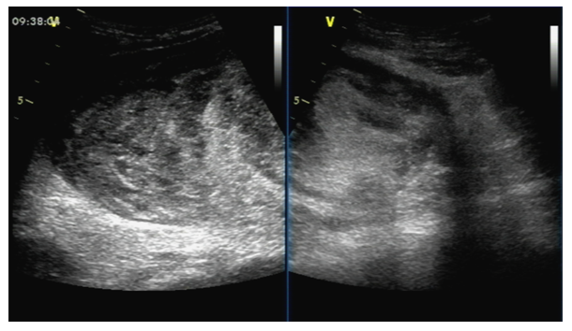
Figure 1 Ultrasound examination showing multiple solid masses with unclear boundaries, irregular shapes, and nonuniform internal echoes.

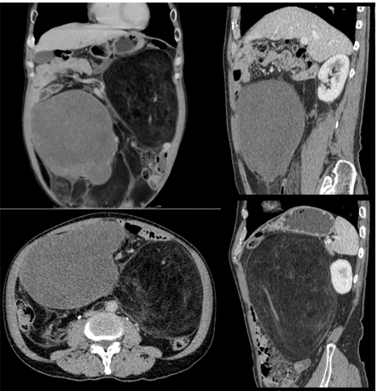
Figure 2 Abdominal-pelvic computed tomography showing two masses. The left one exhibited a fat-like density with a -65 HU value, a clear boundary, and a convoluted vascular course, and contrast-enhanced scanning did not show significant enhancement; the right one had a mixed density, and contrast-enhanced scanning yielded the following computed tomography values during the three phases: 28/31/50 HU.
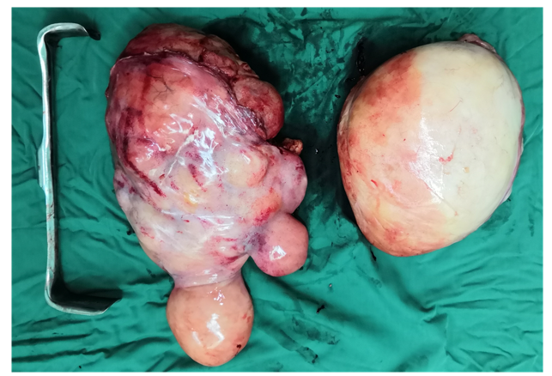
Figure 3 Surgically removed specimens measuring 35 cm × 22 cm × 20 cm with a lobulated shape (left) and measuring 25 cm × 18 cm × 17 cm with a regular shape (right).
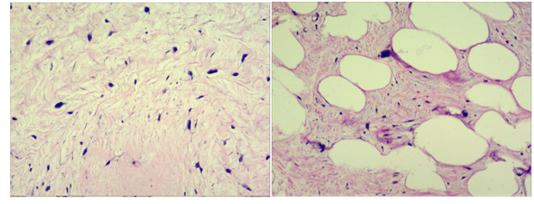
Figure 4 A lipoma-like lesion characterized by a leaf-like pattern aggregate of mature adipocytes separated by fibrous septa. This was classified as atypical lipomatous tumor/well-differentiated liposarcoma (hematoxylin and eosin staining: × 100 and × 400).

Published by Baishideng Publishing Group Inc
7041 Koll Center Parkway, Suite 160, Pleasanton, CA 94566, USA
Telephone: +1-925-3991568
E-mail: bpgoffice@wjgnet.com
Help Desk: https://www.f6publishing.com/helpdesk
https://www.wjgnet.com

© 2021 Baishideng Publishing Group Inc. All rights reserved.

