Name of Journal: World Journal of Clinical Cases
Manuscript NO: 70926
Manuscript Type: CASE REPORT

Surgery for hepatocellular carcinoma with tumor thrombosis in inferior vena cava: A case report

Zhang ZY et al. HCC with tumor thrombosis

Zun-Yi Zhang, Er-Lei Zhang, Bi-Xiang Zhang, Wei Zhang

Zun-Yi Zhang, Er-Lei Zhang, Bi-Xiang Zhang, Wei Zhang, Research Laboratory and Hepatic Surgery Center, Department of Hepatic Surgery, Tongji Hospital, Tongji Medical College, Huazhong University of Science and Technology, Wuhan 430000, Hubei Province, China

Author contributions: Zhang ZY performed the majority of the writing and prepared the figures and tables; Zhang EL and Zhang BX performed data and writing accusation; Zhang W designed the outline of this paper.

Supported by the National Natural Science Foundation of China, No. 81802767 and No. 81860117.

Corresponding author: Wei Zhang, MD, Assistant Professor, Research Laboratory and Hepatic Surgery Center, Department of Hepatic Surgery, Tongji Hospital, Tongji Medical College, Huazhong University of Science and Technology, No. 1095 Jiefang Road, Wuhan 430000, Hubei Province, China. weizhangtjh@hust.edu.cn

Received: August 19, 2021
Revised: September 25, 2021
Accepted: November 14, 2021
Published online:

Abstract
BACKGROUND
Hepatocellular carcinoma (HCC) accompanied by a tumor thrombus is very common. However, the treatment strategy is controversial and varies by the location of the thrombus.

CASE SUMMARY
We report herein a case of HCC with a tumor thrombus in the suprahepatic inferior vena cava (IVC), which was successfully treated by hepatectomy combined with thrombectomy following sorafenib chemotherapy. A 47-year-old woman with chronic hepatitis was diagnosed with HCC. Computed tomography and magnetic resonance imaging showed that the tumor lesion was located in the right half of the liver, and a tumor thrombus was detected in the suprahepatic IVC near the right atrium. After multi-departmental discussion and patient informed consent, right major hepatectomy and total removal of the tumor thrombus were successfully performed under cardiopulmonary bypass. There were no serious complications after surgery. Following sorafenib treatment, no recurrence has been detected so far (11 mo later).

CONCLUSION
Surgical treatment followed by adjuvant sorafenib therapy might be an acceptable choice for HCC patients with tumor thrombosis in the IVC.

Key Words: Hepatocellular carcinoma; Tumor thrombosis; Inferior vena cava; Hepatectomy; Thrombectomy; Sorafenib; Cardiopulmonary bypass; Case report

Zhang ZY, Zhang EL, Zhang BX, Zhang W. Surgery for hepatocellular carcinoma with tumor thrombosis in inferior vena cava: A case report. World J Clin Cases 2021; In press

Core Tip: Hepatocellular carcinoma (HCC) is the most common type of liver cancer with a high mortality rate worldwide. For HCC patients with tumor thrombosis in the inferior vena cava (IVC), in addition to tumor progression, acute pulmonary embolism induced by tumor thrombosis is also a vital factor decreasing patient survival. Once a pulmonary embolism occurs, there is no effective therapy, and the patients usually die. Therefore, in Asia-Pacific regions such as China, Japan and South Korea, surgical treatment is recommended in highly selected patients, which might provide better survival outcomes than other treatments. Here, we report a case of a resectable HCC patient with tumor thrombosis in the IVC who was treated successfully by liver resection, tumor thrombosis removal and systemic treatment.

INTRODUCTION
Hepatocellular carcinoma (HCC) is the most common type of liver cancer with a high mortality rate worldwide. The percentage of HCC patients with vascular invasion at the time of initial diagnosis is 10%-40%^{[1-3]}. The median survival time (MST) has been reported to be only 3-10.1 mo without any treatment^{[4]}. According to the American Association for the Study of Liver Disease (AASLD)/Barcelona Clinic for Liver Cancer (BCLC) staging system and treatment guidelines, HCC associated with vascular invasion or bile duct invasion is regarded as an advanced stage of disease^{[1]}. The only suggested treatment for such patients is systemic treatment, such as with sorafenib or lenvatinib.
However, the efficacy of these treatments is not satisfactory. Especially for HCC patients with tumor thrombosis in the inferior vena cava (IVC), in addition to tumor progression, acute pulmonary embolism induced by tumor thrombosis is also a vital factor decreasing patient survival. Once a pulmonary embolism occurs, there is no effective therapy, and most patients die. Therefore, in Asia-Pacific regions such as China, Japan and South Korea, surgical treatment is recommended in highly selected patients, which might provide better survival outcomes than other treatments^{[5,6]}.
Here, we report a case of a resectable HCC patient with tumor thrombosis in the IVC who was treated successfully by liver resection, tumor thrombosis removal and sorafenib treatment.

CASE PRESENTATION
Chief complaints
A 47-year-old woman with hepatitis B virus-associated chronic hepatitis without obvious complaining was diagnosed with HCC at the clinic.

History of present illness
This patient did not have any obvious complaint. She came to our clinic and ask for regular examination.

History of past illness
This patient had hepatitis B infection for a long time.

Personal and family history
No special personal and family history.

Physical examination
Physical examination showed no positive results.

Laboratory examinations
The patient’s alpha fetoprotein (AFP) was 105.5 ng/mL. The protein induced by vitamin K absence/agonist-II (PIVKA-II) was 77505 mAU/mL. The indocyanine green retention rate at 15 min (ICGR15) was 5.4%. The Child-Pugh Score was A with 5 points.

Imaging examinations
Computed tomography (CT) and magnetic resonance imaging (MRI) scans showed a solitary tumor 14 cm × 12 cm in diameter located in the right half of the liver (Figure 1A and C). In addition, tumor thrombosis was detected in the IVC flattened to the right atrium, nearly 2 cm in diameter (Figure 1B and D-F). The upper side of the tumor thrombosis extended beyond the diaphragm but did not extend into the right atrium. Distant metastasis and intrahepatic metastasis was not observed.

Further diagnostic work-up
After three-dimensional reconstruction using CT scanning (Figure 2), the left remnant liver volume (RLV) was determined to be 781.16 mL. The standard liver volume (SLV), which was calculated in accordance with the patient’s body surface area, was 1034 mL according to Urata’s formula^{[7]}. Thus, her RLV was over SLV × 50%. According to Western guidelines, such as the AASLD/BCLC, hepatectomy is not recommended in cases with vascular invasion^{[8]}. However, according to the 2019 Chinese clinical guidelines for the management of HCC, resection might be a possible choice because the tumor and thrombosis were resectable and her RLV was sufficient^{[5]}.

FINAL DIAGNOSIS
Based on the AFP and PIVKA-II tests and CT/MRI scanning results, the patient was diagnosed with HCC and tumor thrombosis in the IVC.

TREATMENT
After multidisciplinary discussion, two treatment schemes were proposed. One of the treatment options was to completely remove the tumor and thrombus together followed by sorafenib or lenvatinib molecular targeted therapy. The other was transarterial chemoembolization (TACE) combined with radiotherapy and molecular targeted therapy. We discussed in detail the advantages and disadvantages of the two treatments with the patient. In the end, this patient and her family members selected the first treatment strategy.
Accordingly, a right hemihepatectomy and total removal of the tumor thrombus from the IVC were performed. Surgery was performed through a subcostal incision with xiphoid extension and median sternotomy. There was no ascites or metastasis observed. Because the thrombus was flattened to the right atrium, total hepatic vascular exclusion (THVE) and cardiopulmonary bypass (CPB) were performed before the removal of the tumor and tumor thrombus. Normothermic CPB was chosen to minimize the ischemic damage to the heart caused by intraoperative hypotension. CPB was established with cannulation of the femoral artery, suprahepatic vena cava and infrahepatic vena cava for drainage and the administration of heparin (25000 units).
Then, THVE was performed. First, the right hepatic pedicle was transected to stop the inflow to the right liver. Next, the right atrium, infrahepatic vena cava, and hepatoduodenal ligament were clamped. The time for clamping of the hepatoduodenal ligament should never exceed 15 min; if it does, the clamping should be stopped for 5 min. The suprahepatic vena cava was incised, and the tumor thrombus and the right liver were removed in succession (Figure 3A and B). The IVC wall was then sutured closed in a simple continuous pattern. The THVE time was 40 min and the CPB time was 73 min. The total surgical time was 382 min. The intraoperative blood loss was 10000 mL.

OUTCOME AND FOLLOW-UP
The postoperative recovery was uneventful. The patient was discharged on postoperative day 14. The pathological results confirmed that the lesions in the liver and the thrombus in the IVC were poorly differentiated HCC (Figure 3C and D). Microinvasion of the vessels into the peritumoral tissues was detected. No satellite lesions or tumor cells near the surgical margin were detected. Before discharge from our hospital, this patient began taking sorafenib (400 mg per day).
One month later, this patient underwent digital subtraction angiography (DSA) to check her liver. No recurrence was found. Every two months, she returned to our clinic to recheck her tumor biomarkers (AFP, PIVKA-II) and to undergo radiology tomography (ultrasonography, MRI or CT) (Figure 4). So far, she has survived for 11 mo after the surgery, and no recurrence has been detected.

DISCUSSION
The percentage of HCC cases with vascular invasion at the initial time of diagnosis is high. However, the incidence of HCC with a tumor thrombus in the IVC is relatively lower, from 1% to 4%^{[9-12]}. The treatment strategy for HCC patients associated with vascular invasion remains controversial. According to the existing guidelines, such as AASLD/BCLC, tumor thrombosis in the vessels is a contraindication for liver resection. Conservative treatment or molecular targeted therapy is recommended. However, according to some treatment guidelines^{[5,13]}, liver resection might be an acceptable choice for selected patients. Furthermore, most of the research has focused on the treatment of portal vein tumor thrombosis (PVTT). Once the tumor thrombus has extended to the main portal vein or superior mesenteric vein, hepatectomy would no longer be suggested^{[4,13]}.
Recently, a study from Japan showed that liver resection for selected patients with tumor thrombus in hepatic vein could provide a longer median overall survival time (2.87 years vs 1.10 years) compared with nonresection therapies, including TACE, radiotherapy, sorafenib, or conservative treatment^{[14]}. As an curative treatment option or bridging therapy, transaterial radioemblization (TARE) has been used in HCC patients with BCLC stage A to C patients^{[15]}. And good outcomes without significant adverse events have also been reported when compared conservative TACE. In BCLC stage C patients, TARE showed median overall survivals ranging from 6-10 mo which might be very similar to patients who received sorafenib treatment^{[16]}. Due to the lack of significant macroembolic effect causing liver decompensation, PVTT is no longer contraindication for TARE treatment^{[17]}. As we have discussed before, the prognosis for HCC with tumor thrombus in vessel varied based on the extension and location in the vessel^{[18]}. The prognosis of HCC patients with tumor thrombus in portal vein system was different with patients with tumor thrombus in hepatic vein system. Actually, the prognosis of patients with main PVTT (OS ranging from 4-7 mo) was worse when compared with patients with segmentary or lobar PVTT (OS ranging from 7-13 mo)^{[4]}. So the prognosis for HCC patients followed TARE treatment in BCLC C stage should be evaluated based on the location and extension status. However, to date, well designed clinical trial focused on the comparison of the prognosis in HCC patients with tumor thrombus in hepatic vein system after different treatment including TACE, TARE, surgery or conservative treament was rare. So which treatment should be selected according to the extent of tumor thrombus in the hepatic vein system is still uncertain.
In China, local ablation therapies, such as RFA, TACE, surgical therapy, or systemic therapy, are all recommended for HCC patients with vascular invasion. Compared with tumor thrombosis in the portal vein, tumor thrombosis in the IVC or right atrium is accompanied by a high risk of sudden death because of pulmonary embolism or heart failure^{[19,20]}. Surgical resection combined with postoperative molecular targeted therapy might benefit resectable patients with tumor thrombi in the IVC. Therefore, according to our experience, resection of the tumor and tumor thrombosis might be an acceptable choice, although the risk of intraoperative and postoperative complications is high.
One of the problems associated with the surgical treatment of HCC patients with tumor thrombi in the IVC or right atrium is the high operative risk. In our case, procedures including THVE, CPB, and hypothermic cardiocirculatory arrest were used to minimize surgical stress. CPB and hypothermic cardiocirculation could preserve the intraoperative circulation and minimize the damage caused by ischemia-reperfusion^{[11]}. In our case, no functional damage to the heart or liver was detected during the recovery term after the operation.
THVE is one of the most commonly used techniques in hepatectomy and can minimize bleeding during surgery^{[21]}. However, in our case, the volume of blood lost during the surgery was very high. The coagulation dysfunction caused by CPB might be one of the potential reasons. Moreover, cirrhosis might be another possible reason. Nearly 80% of HCC patients in China have cirrhosis^{[22]}. The cirrhotic state could damage coagulation function and change the anatomical structure in the liver. Then, it could eventually increase the difficulty of surgery and bleeding and decrease the functional reserve^{[23]}.
ICGR15 is one technique used before surgery to evaluate hepatic functional reserve. It can partially evaluate the cirrhosis state. Major resection should not be performed if the ICGR15 exceeds 20%^{[13]}. In this case, the ICGR15 was 5.4%, which meets the standard for major hepatectomy. However, coagulation dysfunction still emerged, especially after the administration of heparin. The volume of diffused blood oozing from the surgical surface exceeded our expectations.
The other problem associated with the surgical treatment of HCC patients with tumor thrombi in the IVC is the high rate of recurrence. According to some retrospective studies, patients with tumor thrombi in only the hepatic vein had a better prognosis than those with tumor thrombi in the IVC. The MST after surgery in patients with only hepatic vein tumor thrombus was 3.95-5.27 years. The median time to recurrence (TTR) was 0.4-1.06 years^{[24,25]}. Once the tumor thrombus extends into the IVC, the MST and TTR could be shortened to only 1.39-1.6 years and 0.25 years, respectively^{[25]}. In some reports, no patients with tumor thrombi invading the IVC survived for more than 2 years after surgery^{[24]}. The major factor shortening their survival time is early distant organ metastasis, especially lung metastasis accompanied by or without metastasis to other organs. Therefore, based on our experience, the control of intrahepatic recurrence and distant metastasis should be prioritized. In this case, one month after the surgery, the patient returned to our center and underwent DSA, and no recurrence sites were detected in the liver or lungs. Her serum tumor markers were found to be reduced to within the normal range. To control recurrences, sorafenib treatment was recommended for this patient.
Sorafenib is an oral multikinase inhibitor that blocks the activity of protein kinases associated with angiogenesis and metastasis. Sorafenib has become a standard treatment for HCC patients with vascular invasion^{[5,26]}. According to the results of the STORM study (http://clinicaltrials.gov/ct2/show/NCT00692770), sorafenib as an adjuvant treatment after resection or ablation showed no benefits for survival or recurrence^{[27]}. However, that study did not include patients with vascular invasion or distant metastasis. According to the SHARP trial, the median survival in the subgroup with MVI disease was 8.1 mo with sorafenib and 4.9 mo with placebo^{[26]}. Several recent retrospective studies from China demonstrated that sorafenib could reduce recurrence and prolong the survival rate in patients with a high risk of recurrence after surgery^{[28,29]}. Therefore, sorafenib might be useful in decreasing the risk of recurrence in patients with tumor thrombi after surgery. In this case, we recommended sorafenib treatment after recovery from surgery. At the time of writing, no sign of recurrence had been detected in this patient.

CONCLUSION
In conclusion, we report a case of advanced HCC that was treated with hepatectomy and thrombectomy. During the surgery, CPB, THVE and hypothermic cardiocirculation were used. After the surgery, sorafenib was administered as an adjuvant treatment. This treatment strategy was selected after discussion by a multidisciplinary department. After the surgery, this patient showed good outcomes. Therefore, hepatectomy and thrombectomy with adjuvant sorafenib treatment might be an acceptable choice for selected HCC patients with tumor thrombosis in the IVC.

REFERENCES
1 Forner A, Llovet JM, Bruix J. Hepatocellular carcinoma. Lancet 2012; 379: 1245-1255 [PMID: 22353262 DOI: 10.1016/S0140-6736(11)61347-0]
2 Shi J, Lai EC, Li N, Guo WX, Xue J, Lau WY, Wu MC, Cheng SQ. Surgical treatment of hepatocellular carcinoma with portal vein tumor thrombus. Ann Surg Oncol 2010; 17: 2073-2080 [PMID: 20131013 DOI: 10.1245/s10434-010-0940-4]
3 Chen XP, Qiu FZ, Wu ZD, Zhang ZW, Huang ZY, Chen YF, Zhang BX, He SQ, Zhang WG. Effects of location and extension of portal vein tumor thrombus on long-term outcomes of surgical treatment for hepatocellular carcinoma. Ann Surg Oncol 2006; 13: 940-946 [PMID: 16788755 DOI: 10.1245/ASO.2006.08.007]
4 Shuqun C, Mengchao W, Han C, Feng S, Jiahe Y, Guanghui D, Wenming C, Peijun W, Yuxiang Z. Tumor thrombus types influence the prognosis of hepatocellular carcinoma with the tumor thrombi in the portal vein. Hepatogastroenterology 2007; 54: 499-502 [PMID: 17523307 DOI: 10.1016/j.physe.2005.12.132]
5 Xie DY, Ren ZG, Zhou J, Fan J, Gao Q. 2019 Chinese clinical guidelines for the management of hepatocellular carcinoma: updates and insights. Hepatobiliary Surg Nutr 2020; 9: 452-463 [PMID: 32832496 DOI: 10.21037/hbsn-20-480]
6 Ikeda M, Mitsunaga S, Shimizu S, Ohno I, Takahashi H, Okuyama H, Kuwahara A, Okusaka T. Current status of hepatocellular carcinoma in Japan. Chin Clin Oncol 2013; 2: 40 [PMID: 25841919 DOI: 10.3978/j.issn.2304-3865.2013.09.01]
7 Urata K, Kawasaki S, Matsunami H, Hashikura Y, Ikegami T, Ishizone S, Momose Y, Komiyama A, Makuuchi M. Calculation of child and adult standard liver volume for liver transplantation. Hepatology 1995; 21: 1317-1321 [PMID: 7737637 DOI: 10.1002/hep.1840210515]
8 Forner A, Reig M, Bruix J. Hepatocellular carcinoma. Lancet 2018; 391: 1301-1314 [PMID: 29307467 DOI: 10.1016/S0140-6736(18)30010-2]
9 Pandya H, Shah C, Lakhani J, Patel M. Intra-atrial tumour thrombus secondary to hepatocellular carcinoma. Australas Med J 2013; 6: 321-324 [PMID: 23837079 DOI: 10.4066/AMJ.2013.1635]
10 Mukai K, Shinkai T, Tominaga K, Shimosato Y. The incidence of secondary tumors of the heart and pericardium: a 10-year study. Jpn J Clin Oncol 1988; 18: 195-201 [PMID: 3411785]
11 Ohta M, Nakanishi C, Kawagishi N, Hara Y, Maida K, Kashiwadate T, Miyazawa K, Yoshida S, Miyagi S, Hayatsu Y, Kawamoto S, Matsuda Y, Okada Y, Saiki Y, Ohuchi N. Surgical resection of recurrent extrahepatic hepatocellular carcinoma with tumor thrombus extending into the right atrium under cardiopulmonary bypass: a case report and review of the literature. Surg Case Rep 2016; 2: 110 [PMID: 27726114 DOI: 10.1186/s40792-016-0241-7]
12 Kokudo T, Hasegawa K, Matsuyama Y, Takayama T, Izumi N, Kadoya M, Kudo M, Kubo S, Sakamoto M, Nakashima O, Kumada T, Kokudo N; Liver Cancer Study Group of Japan. Liver resection for hepatocellular carcinoma associated with hepatic vein invasion: A Japanese nationwide survey. Hepatology 2017; 66: 510-517 [PMID: 28437844 DOI: 10.1002/hep.29225]
13 Kudo M, Kitano M, Sakurai T, Nishida N. General Rules for the Clinical and Pathological Study of Primary Liver Cancer, Nationwide Follow-Up Survey and Clinical Practice Guidelines: The Outstanding Achievements of the Liver Cancer Study Group of Japan. Dig Dis 2015; 33: 765-770 [PMID: 26488173 DOI: 10.1159/000439101]
14 Kokudo T, Hasegawa K, Matsuyama Y, Takayama T, Izumi N, Kadoya M, Kudo M, Ku Y, Sakamoto M, Nakashima O, Kaneko S, Kokudo N; Liver Cancer Study Group of Japan. Survival benefit of liver resection for hepatocellular carcinoma associated with portal vein invasion. J Hepatol 2016; 65: 938-943 [PMID: 27266618 DOI: 10.1016/j.jhep.2016.05.044]
15 Nam JY, Lee YB, Lee JH, Yu SJ, Kim HC, Chung JW, Yoon JH, Kim YJ. A Prognostic Prediction Model of Transarterial Radioembolization in Hepatocellular Carcinoma: SNAP-HCC. Dig Dis Sci 2021 [PMID: 33538921 DOI: 10.1007/s10620-021-06843-4]
16 Salem R, Lewandowski RJ, Mulcahy MF, Riaz A, Ryu RK, Ibrahim S, Atassi B, Baker T, Gates V, Miller FH, Sato KT, Wang E, Gupta R, Benson AB, Newman SB, Omary RA, Abecassis M, Kulik L. Radioembolization for hepatocellular carcinoma using Yttrium-90 microspheres: a comprehensive report of long-term outcomes. Gastroenterology 2010; 138: 52-64 [PMID: 19766639 DOI: 10.1053/j.gastro.2009.09.006]
17 Mosconi C, Cappelli A, Pettinato C, Golfieri R. Radioembolization with Yttrium-90 microspheres in hepatocellular carcinoma: Role and perspectives. World J Hepatol 2015; 7: 738-752 [PMID: 25914774 DOI: 10.4254/wjh.v7.i5.738]
18 Zhang ZY, Zhang EL, Zhang BX, Chen XP, Zhang W. Treatment for hepatocellular carcinoma with tumor thrombosis in the hepatic vein or inferior vena cava: A comprehensive review. World J Gastrointest Surg 2021; 13: 796-805 [PMID: 34512903 DOI: 10.4240/wjgs.v13.i8.796]
19 Ulus T, Birdane A, Dündar E, Tünerir B. Asymptomatic course of a metastatic mass completely filling the right atrium in a patient with hepatocellular carcinoma. Turk Kardiyol Dern Ars 2012; 40: 52-54 [PMID: 22395375 DOI: 10.5543/tkda.2012.01753]
20 Dedeilias P, Nenekidis I, Koukis I, Anagnostakou V, Paparizou N, Zompolos S, Apostolakis E. Acute heart failure caused by a giant hepatocellular metastatic tumor of the right atrium. J Cardiothorac Surg 2011; 6: 102 [PMID: 21867564 DOI: 10.1186/1749-8090-6-102]
21 Chen XP, Zhang ZW, Zhang BX, Chen YF, Huang ZY, Zhang WG, He SQ, Qiu FZ. Modified technique of hepatic vascular exclusion: effect on blood loss during complex mesohepatectomy in hepatocellular carcinoma patients with cirrhosis. Langenbecks Arch Surg 2006; 391: 209-215 [PMID: 16565854 DOI: 10.1007/s00423-006-0043-7]
22 Chen XP, Wu ZD, Huang ZY, Qiu FZ. Use of hepatectomy and splenectomy to treat hepatocellular carcinoma with cirrhotic hypersplenism. Br J Surg 2005; 92: 334-339 [PMID: 15672441 DOI: 10.1002/bjs.4776]
23 Huang ZY, Chen G, Hao XY, Cai RY, Zhao YF, Chen XP. Outcomes of non-anatomic liver resection for hepatocellular carcinoma in the patients with liver cirrhosis and analysis of prognostic factors. Langenbecks Arch Surg 2011; 396: 193-199 [PMID: 20852883 DOI: 10.1007/s00423-010-0700-8]
24 Ikai I, Yamamoto Y, Yamamoto N, Terajima H, Hatano E, Shimahara Y, Yamaoka Y. Results of hepatic resection for hepatocellular carcinoma invading major portal and/or hepatic veins. Surg Oncol Clin N Am 2003; 12: 65-75, ix [PMID: 12735130 DOI: 10.1016/s1055-3207(02)00082-0]
25 Kokudo T, Hasegawa K, Yamamoto S, Shindoh J, Takemura N, Aoki T, Sakamoto Y, Makuuchi M, Sugawara Y, Kokudo N. Surgical treatment of hepatocellular carcinoma associated with hepatic vein tumor thrombosis. J Hepatol 2014; 61: 583-588 [PMID: 24798618 DOI: 10.1016/j.jhep.2014.04.032]
26 Llovet JM, Ricci S, Mazzaferro V, Hilgard P, Gane E, Blanc JF, de Oliveira AC, Santoro A, Raoul JL, Forner A, Schwartz M, Porta C, Zeuzem S, Bolondi L, Greten TF, Galle PR, Seitz JF, Borbath I, Häussinger D, Giannaris T, Shan M, Moscovici M, Voliotis D, Bruix J; SHARP Investigators Study Group. Sorafenib in advanced hepatocellular carcinoma. N Engl J Med 2008; 359: 378-390 [PMID: 18650514 DOI: 10.1056/NEJMoa0708857]
27 Bruix J, Takayama T, Mazzaferro V, Chau GY, Yang J, Kudo M, Cai J, Poon RT, Han KH, Tak WY, Lee HC, Song T, Roayaie S, Bolondi L, Lee KS, Makuuchi M, Souza F, Berre MA, Meinhardt G, Llovet JM; STORM investigators. Adjuvant sorafenib for hepatocellular carcinoma after resection or ablation (STORM): a phase 3, randomised, double-blind, placebo-controlled trial. Lancet Oncol 2015; 16: 1344-1354 [PMID: 26361969 DOI: 10.1016/S1470-2045(15)00198-9]
28 Huang Y, Zhang Z, Zhou Y, Yang J, Hu K, Wang Z. Should we apply sorafenib in hepatocellular carcinoma patients with microvascular invasion after curative hepatectomy? Onco Targets Ther 2019; 12: 541-548 [PMID: 30666133 DOI: 10.2147/OTT.S187357]
29 Li J, Hou Y, Cai XB, Liu B. Sorafenib after resection improves the outcome of BCLC stage C hepatocellular carcinoma. World J Gastroenterol 2016; 22: 4034-4040 [PMID: 27099447 DOI: 10.3748/wjg.v22.i15.4034]

Footnotes
Informed consent statement: Informed written consent was obtained from the patient for publication of this report and any accompanying images.

Conflict-of-interest statement: We declare that we have no financial and personal relationships with other people or organizations that can inappropriately influence our work, and there is no professional or other personal interest of any nature or kind in any product, service and/or company that could be construed as influencing the position presented in, or the review of, the manuscript entitled.

CARE Checklist (2016) statement: The authors have read the CARE Checklist (2016), and the manuscript was prepared and revised according to the CARE Checklist (2016).

Open-Access: This article is an open-access article that was selected by an in-house editor and fully peer-reviewed by external reviewers. It is distributed in accordance with the Creative Commons Attribution NonCommercial (CC BY-NC 4.0) license, which permits others to distribute, remix, adapt, build upon this work non-commercially, and license their derivative works on different terms, provided the original work is properly cited and the use is non-commercial. See: http://creativecommons.org/Licenses/by-nc/4.0/

Manuscript source: Unsolicited manuscript

Peer-review started: August 19, 2021
First decision: September 5, 2021
Article in press:

Specialty type: Gastroenterology and hepatology
Country/Territory of origin: China
Peer-review report’s scientific quality classification
Grade A (Excellent): 0
Grade B (Very good): 0
Grade C (Good): C
Grade D (Fair): 0
Grade E (Poor): 0

P-Reviewer: Broering DC S-Editor: Yan JP L-Editor: A P-Editor: Yan JP
Figure Legends
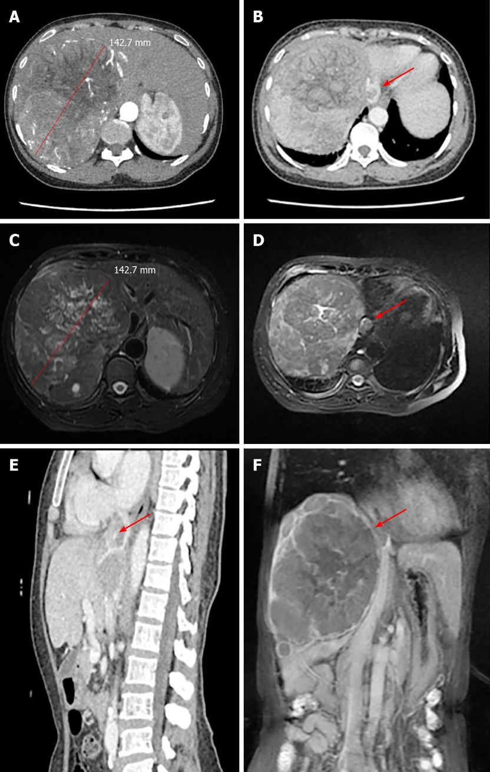
Figure 1 Preoperative imaging studies. A: Liver-enhanced computed tomography (CT) showing the diameter of the tumor lesion in the liver; B: The tumor thrombus was detected in the supra-hepatic inferior vena cava (red arrow); C: Magnetic resonance imaging (MRI) showing the diameter of the tumor lesion in the liver; D: The tumor thrombus was detected in the supra-hepatic inferior vena cava (red arrow); E and F: The sagittal plane was reconstructed by CT (E) and MRI (F) and shows the position of the tumor thrombus (red arrow).

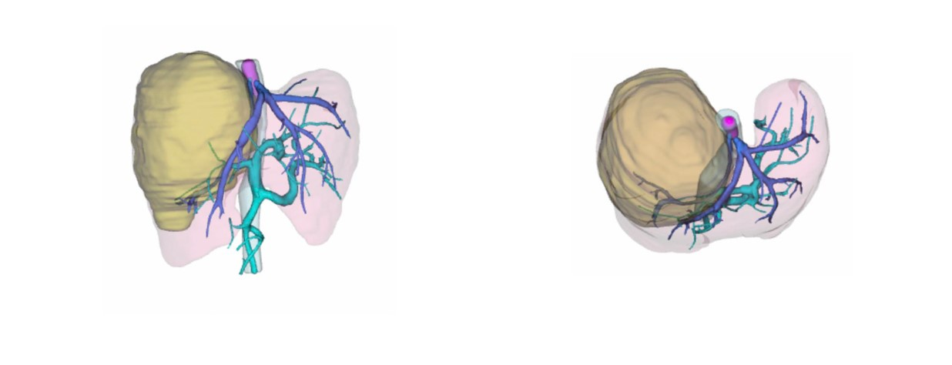
Figure 2 The three-dimensional reconstruction of this patient was performed by using computed tomography scanning images. The tumor and thrombus are shown in yellow and pink, while the hepatic vein and portal vein are shown in deep and light blue, respectively.

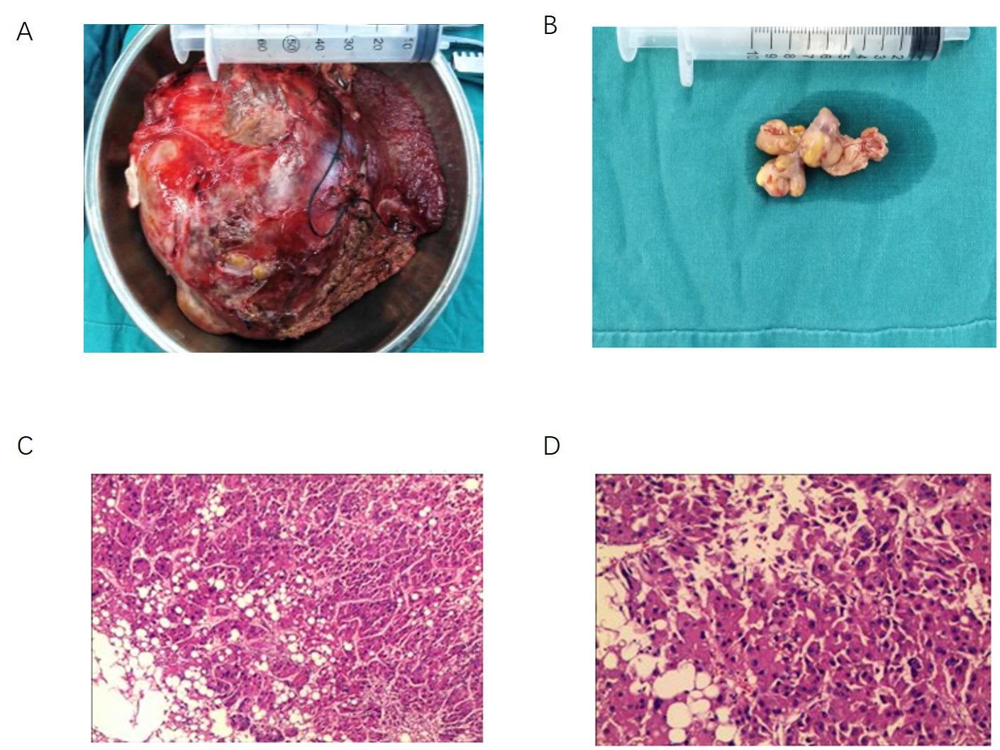
Figure 3 Operative findings. A and B: The tumor lesion and tumor thrombus; C and D: Pathological confirmation of the tumor lesion and tumor thrombus.

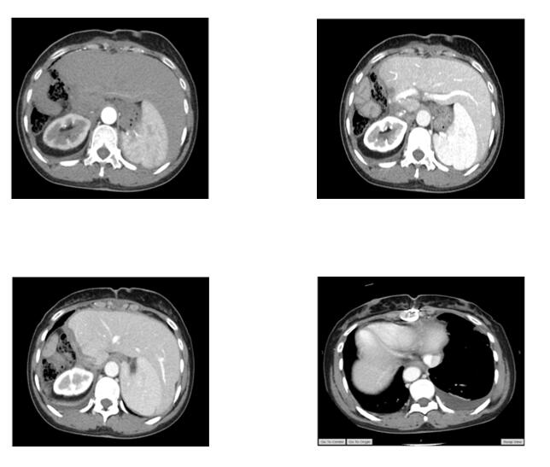

Figure 4 The computed tomography scan at 6 mo after the surgery.

