Name of journal: World Journal of Gastrointestinal Endoscopy
ESPS Manuscript NO: 27147
Manuscript type: Case Report

Same site submucosal tunneling for a repeat per oral endoscopic myotomy: a safe and feasible option

Wehbeh AN et al. Same site tunneling for repeat POEM

Antonios N Wehbeh, Parit Mekaroonkamol, Qiang Cai

Antonios N Wehbeh, Department of Internal Medicine, Emory University School of Medicine, Atlanta, GA 30322, United States

Parit Mekaroonkamol, Qiang Cai, Department of Internal Medicine, Division of Digestive Diseases, Emory University School of Medicine, Atlanta, GA 30322, United States

Author contributions: Wehbeh AN and Mekaroonkamol P conducted the literature review; Wehbeh AN, Mekaroonkamol P and Cai Q drafted and edited the manuscript, and approved the final version submitted; Cai Q captured the images and is the guarantor of the article.

Institutional review board statement: We submitted a review request to our IRB but based on our institutional policy, a case report of less than 6 patients does not require an IRB review.

Informed consent statement: Patient gave informed consent prior to getting the procedure done.

Conflict-of-interest statement: The authors declare no conflict of interest.

Open-Access: This article is an open-access article which was selected by an in-house editor and fully peer-reviewed by external reviewers. It is distributed in accordance with the Creative Commons Attribution Non Commercial (CC BY-NC 4.0) license, which permits others to distribute, remix, adapt, build upon this work non-commercially, and license their derivative works on different terms, provided the original work is properly cited and the use is non-commercial. See: http://creativecommons.org/licenses/by-nc/4.0/

Manuscript source: Invited manuscript

Correspondence to: Qiang Cai, MD, PhD, Professor of Medicine, Director of Advanced Endoscopy Fellowship, Division of Digestive Diseases, Emory University, 1365 Clifton Road, B1262 Atlanta, GA 30322, United States. qcai@emory.edu
Telephone: +1-404-7782714
Fax: +1-404-7782578

Received: May 13, 2016
Peer-review started: May 16, 2016
First decision: July 4, 2016
Revised: July 11, 2016
Accepted: July 29, 2016
Article in press:
Published online:

Abstract
Per oral endoscopic myotomy (POEM) is a novel endoscopic procedure for achalasia treatment. Due to its novelty and high success rates, a repeat procedure is usually not warranted, making the feasibility and safety of such approach unknown. We report the first case of a successful repeat POEM done at the same site of a previously uncompleted POEM. An 84 year old female with type 2 achalasia presented for a POEM procedure. The procedure was aborted at the end of tunneling and before myotomy due to hypotension, which later resolved spontaneously. POEM was re-attempted at the same site of the original tunnel 1 year afterward, and surprisingly we didn’t encounter any submucosal fibrosis. The procedure felt similar to a native POEM and a myotomy was performed uneventfully. Our case is the first to suggest that submucosal tunneling during a repeat POEM can be done at the same site. Hypotension during POEM is a rare complication that should be recognized as a potential result of tension capnothorax, it can however, be managed with close supportive care.

Key words: Per oral endoscopic myotomy; Achalasia; Myotomy; Submucosal tunnel; Repeat procedure; Submucosal fibrosis

© The Author(s) 2016. Published by Baishideng Publishing Group Inc. All rights reserved.

Core tip: Per oral endoscopic myotomy (POEM) is a novel method of treating achalasia. More is being learnt about potential complications as it increases in popularity. This is the first case of a repeat submucosal tunneling done at the same site of a prior POEM attempt which was aborted just before myotomy. No complications or difficulties were encountered during the second attempt. This may suggest that submucosal tunneling does not cause fibrosis, and that repeat POEM after a technically unsuccessful attempt could be done at the same site and orientation of the original tunnel.

Wehbeh AN, Mekaroonkamol P, Cai Q. Same site submucosal tunneling for a repeat peroral endoscopic myotomy: A safe and feasible option. World J Gastrointest Endosc 2016; In press

INTRODUCTION
Per oral endoscopic myotomy (POEM) is a novel endoscopic procedure for achalasia treatment. The principle techniques involve endoscopic submucosal tunneling followed by a myotomy^{[1]}. Overall, it has success rates reportedly ranging between 82% to 100% and can be safely performed with a small number of reported major complications^{[1-3]}. However, one of the complications that can occur is hemodynamic instability, which has been reported in up to 20% of patients in one study^{[4]}. Due to its novelty and the high success rates, repeat procedure is rarely warranted, making the feasibility and safety of such approach unknown. Here, we report the first case of a repeat submucosal tunneling successfully performed at the same site of a previous POEM procedure.

CASE REPORT
An 84-year-old female presented with progressive dysphagia to both solids and liquids and failure to thrive over several months. Her other medical problems included gastroesophageal reflux disease, hypertension, deep vein thrombosis, severe osteoarthritis of both hips, lower extremities contracture, and chronic low back pain. Initial laboratory work up was essentially unrevealing. Manometry study confirmed severe achalasia type 2. The decision was made to proceed with POEM procedure. During endoscopy, she was placed in supine position which was standard practice at our institution. Incision site was first injected with a premixed solution of saline and methylene blue (5 mL/500 m) followed by careful dissection to the submucosal layer using a triangle-tip knife. A submucosal tunnel was being made from the incision site to 2 cm distal to the cardia, but after a complete submucosal tunneling process just before myotomy (Figure 1), she developed severe hypotension and bradycardia. Consequently, the procedure was aborted. Chest x-ray revealed left apical pneumothorax, pneumomediastinum, pneumoperitoneum, and extensive subcutaneous emphysema. Her hypotension resolved with supportive care within minutes of aborting the procedure. A gastrograffin swallow study was obtained which did not show any evidence of contrast leakage, but it demonstrated a grossly distended esophagus consistent with achalasia, and postoperative edema with slow emptying at the gastroesophageal junction (Figure 2). Thereafter, she underwent an upper endoscopy for Botulinum injection every 2-3 mo but eventually her symptoms stopped responding to botulinum treatment. Repeat POEM was thus performed 1 year later. She was placed in the same supine position due to her medical comorbidities. A severely dilated sigmoid esophagus was observed (Figure 3a). The GE junction was tight, and some pressure was required to traverse the endoscope, consistent with known achalasia. Due to great difficulty orienting the endoscope on a different plane, submucosal incision was made at the exact same site (Figure 3c) of the original tunnel, and surprisingly we did not encounter any submucosal fibrosis or technical challenges. The repeat tunneling at the same submucosal plane was successfully completed and felt similar to a native POEM (Figure 4). A myotomy was quickly and uneventfully performed followed by mucosal closure with hemostatic clips (Figure 3). The length of the myotomy was 8 cm, which is the standard at our institution. At 4-wk follow up her symptoms remarkably improved, as shown by a decreased Eckhardt score from 9 to 4. Her reflux symptoms also remained stable on the same dose of omeprazole.

DISCUSSION
Our case is the first to highlight the feasibility and safety of performing a repeat POEM at a location where submucosal tunneling was previously performed. As discussed above, there are limited scenarios where repeat POEM would be considered. They include intraprocedural complications resulting in incomplete procedure, insufficient symptomatic relieve, and recurrent symptoms after an initial improvement^{[5]}. The question remains as whether it is feasible to repeat a POEM procedure, and if so what would the best approach be.
POEM on a site of prior endoscopic mucosal resection is considered relatively contraindicated due to fear of encountering fibrosis^{[2]}. Recent report on repeat POEM procedures opted to create submucosal tunnel at the opposite side of the scarred mucosectomy area due to concern for an obliterated submucosal space^{[5]}. However, this did not apply to our case, meaning that submucosal fibrosis does not necessarily result from a first POEM attempt. Although theoretically myotomy may lead to fibrosis, but this hasn’t been confirmed in the literature. In addition, myotomy is performed from 3 cm proximal to gastroesophageal junction and is therefore unlikely to impact the development of submucosal fibrosis in the proximal tunnel.
Moreover, the opposite site approach may not always be feasible due to different patient position and endoscopic orientation as in our case where patient position is very limited. Therefore, we opted for the same posterior approach as it allowed most flexible endoscopic maneuverability. Same site repeat POEM also preserves the opposite side of the esophagus for other potential procedures. Similar to our findings, double POEM was recently reported whereby tunneling was done more proximal to original tunnel to extend the myotomy^{[6]}.
Hypotension during POEM is a rare complication that should be recognized as a potential sign of tension capnothorax; it can however, be managed with close supportive care^{[7,8]}. Other commonly reported physical findings include subcutaneous emphysema, mediastinal emphysema, and aeroperitoneum without hemodynamic instability, all of which are believed to be normal physiologic reaction to the procedure^{[9]}.
In summary, this report suggests that should POEM need to be re-attempted, same site operation, including incision, submucosal tunneling and myotomy, may be a viable method.

COMMENTS
Case characteristics
An 84-year-old female with progressive dysphagia to both solids and liquids and failure to thrive.

Clinical diagnosis
She had severely dilated sigmoid esophagus and tight gastroesophageal junction upon passing gastroscope, consistent with manometry-proven achalasia type 2.

Differential diagnosis
Differential includes esophageal cancer causing pseudoachalasia, stricture, extrinsic compressive mass, and esophagogastric junction outflow obstruction.

Laboratory diagnosis
Laboratory testing on initial presentation was essentially unremarkable.

Imaging diagnosis
No imaging was required to make the diagnosis. Manometry study revealed panesophageal pressurization and elevated integrated resting pressure, diagnostic of achalasia type 2.

Pathological diagnosis
Biopsy was not required to establish the diagnosis.

Treatment
Per oral endoscopic myotomy (POEM) was performed twice: the first submucosal tunneling was completed without myotomy due to hemodynamic instability. The second attempt was successfully performed via the same site tunneling.

Related reports
Only 2 other reports on repeat POEM were found, but neither of them reports on performing repeat submucosal tunneling on the same site and orientation of the original tunnel.

Peer-review
POEM has been demonstrated to be safe and effective for treating achalasia, regardless of the previous treatment history, including previous POEM therapy. Generally, the opposite site approach was recommended to avoid the potential fibrosis. In the present case, POEM was performed at exactly the same site of a previous POEM procedure.
References
1 Bechara R, Ikeda H, Inoue H. Peroral endoscopic myotomy: an evolving treatment for achalasia. Nat Rev Gastroenterol Hepatol 2015; 12: 410-426 [PMID: 26035678 DOI: 10.1038/nrgastro.2015.87]
2 Stavropoulos SN, Modayil RJ, Friedel D, Savides T. The International Per Oral Endoscopic Myotomy Survey (IPOEMS): a snapshot of the global POEM experience. Surg Endosc 2013; 27: 3322-3338 [PMID: 23549760 DOI: 10.1007/s00464-013-2913-8]
3 Talukdar R, Inoue H, Nageshwar Reddy D. Efficacy of peroral endoscopic myotomy (POEM) in the treatment of achalasia: a systematic review and meta-analysis. Surg Endosc 2015; 29: 3030-3046 [PMID: 25539695 DOI: 10.1007/s00464-014-4040-6]
4 Kurian AA, Dunst CM, Sharata A, Bhayani NH, Reavis KM, Swanström LL. Peroral endoscopic esophageal myotomy: defining the learning curve. Gastrointest Endosc 2013; 77: 719-725 [PMID: 23394838 DOI: 10.1016/j.gie.2012.12.006]
5 Li QL, Yao LQ, Xu XY, Zhu JY, Xu MD, Zhang YQ, Chen WF, Zhou PH. Repeat peroral endoscopic myotomy: a salvage option for persistent/recurrent symptoms. Endoscopy 2016; 48: 134-140 [PMID: 26349067 DOI: 10.1055/s-0034-1393095]
6 Kumbhari V, Tieu AH, Azola A, Saxena P, Ngamruengphong S, El Zein MH, Khashab MA. Double peroral endoscopic myotomy for achalasia. Gastrointest Endosc 2015; 82: 953 [PMID: 26119650 DOI: 10.1016/j.gie.2015.05.036]
7 Phillips S, Falk GL. Surgical tension pneumothorax during laparoscopic repair of massive hiatus hernia: a different situation requiring different management. Anaesth Intensive Care 2011; 39: 1120-1123 [PMID: 22165368]
8 Tang A, Huddleston P, Attaluri P, Cruz A, Joseph S, Lavy D. Clinical cases of nonsurgical pneumoperitoneum: categorizing the disease and treatment options. Am Surg 2015; 81: E206-E208 [PMID: 25975311]
9 Ren Z, Zhong Y, Zhou P, Xu M, Cai M, Li L, Shi Q, Yao L. Perioperative management and treatment for complications during and after peroral endoscopic myotomy (POEM) for esophageal achalasia (EA) (data from 119 cases). Surg Endosc 2012; 26: 3267-3272 [PMID: 22609984 DOI: 10.1007/s00464-012-2336-y]
P-Reviewer: Liu DL S-Editor: Gong ZM
L-Editor: E-Editor:

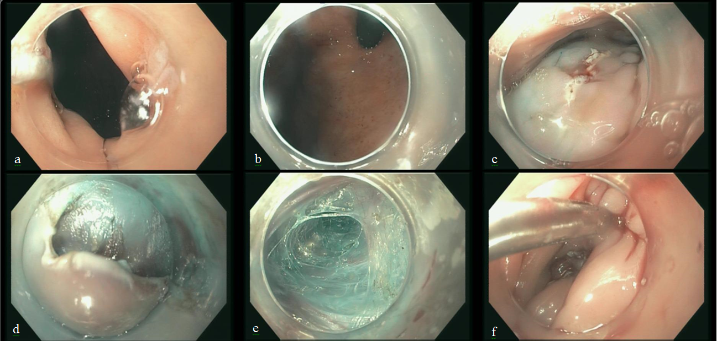
Figure 1 Endoscopic pictures from the first per oral endoscopic myotomy attempt showing: gastroesophageal junction (a), cardia before myotomy (b), mucosotomy site(c), initial dissetion site (d), creating the submucosal tunnel (E), and closure of mucosotomy (F).

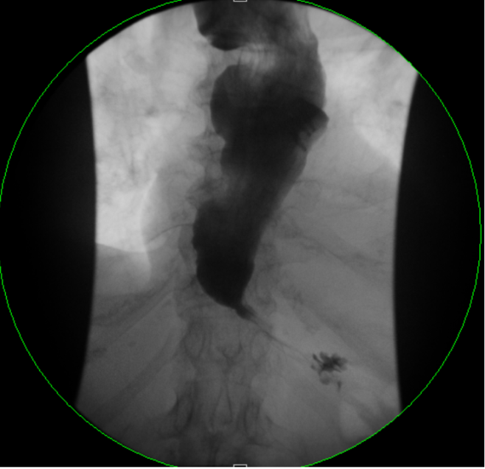
Figure 2 Gastrograffin swallow study obtained after the index per oral endoscopic myotomy attempt showing a grossly distended esophagus consistent with achalasia, and postoperative edema with slow emptying at the gastroesophageal junction. No evidence of contrast leakage is seen.

Figure 3 Endoscopic pictures taken from the repeat per oral endoscopic myotomy showing: sigmoid esophagus (A), cardia before myotomy (B), mucosa of previous dissection site (C), Mucosal bleb (D), submucosal tunneling (E), initial myotomy (F), completed myotomy (G), cardia after submucosal tunnneling (H), closure of mucosotomy (I).

Figure 4 Comparison of submucosal tunnel of the index (A) and repeat (B) per oral endoscopic myotomy.

