Ms. wjg/20XX CASE REPORT
Distant metastasis in choroidal melanoma with spontaneous corneal perforation and intratumoral calcification: A case report

Tso-Wen Wang, Hung-Wei Liu, Youn-Shen Bee

Tso-Wen Wang, Youn-Shen Bee, Department of Ophthalmology, Kaohsiung Veterans General Hospital, Kaohsiung 813, Taiwan
Hung-Wei Liu, Department of Pathology, Kaohsiung Veterans General Hospital, Kaohsiung 813, Taiwan
Youn-Shen Bee, Yuh-Ing Junior College of Health Care and Management, Kaohsiung 807, Taiwan.
Youn-Shen Bee, National Defense Medical Center, Taipei 114, Taiwan.
Author contributions: Wang TW reviewed the literature and contributed to manuscript drafting; Liu HW performed the pathological diagnosis, edited the manuscript, and contributed to developing the figures; Bee YS contributed to the surgical treatment of the patient, critical revision of the article for important intellectual content, and final approval of the article; all authors have read and approved the final manuscript.
Corresponding author: Youn-Shen Bee, MD, PhD, Associate Professor, Doctor, Surgeon, Department of Ophthalmology, Kaohsiung Veterans General Hospital, Kaohsiung 813, Taiwan. ysbee@vghks.gov.tw
Telephone: +886-7-3468217 Fax: +886-7-3468054

Received: June 11, 2019
Peer-review started: June 19, 2019
First decision: September 23, 2019
Revised: September 30, 2019
Accepted: September 30, 2019
Article in press: September 30, 2019
Published online: December 6, 2019

Abstract
BACKGROUND
Uveal melanoma is the most common primary intraocular malignancy in adults, but the incidence is relatively low in Asian populations. Spontaneous corneal perforation and intratumoral calcification as presentations of choroidal melanoma are rare, and reports regarding these presentations have been limited. Even after complete surgical treatment, the prognosis of choroidal melanoma is usually poor if distant metastasis is present. We present a case of choroidal melanoma with unique presentations and early distant metastasis to the liver.

CASE SUMMARY
A 63-year-old Asian woman presented to our hospital with complaint of pain and brownish discharge from her left eye for 3 d. Image studies revealed intratumoral calcification within the left eye with eyeball rupture. Enucleation of the left eye was performed without incidence on the following day and pathological examination confirmed the diagnosis of choroidal melanoma. Systemic surveillance revealed no metastatic diseases. However, the patient was lost to follow-up 3 mo after surgery. At 1.5 years after the operation, she presented to our emergency department with complaint of dull epigastric pain that radiated to the back for 1 d. Imaging studies revealed a large mass at the upper abdomen abutting the pancreatic neck and body as well as several nodular lesions in the liver. Fine needle biopsy was performed and findings confirmed liver and pancreatic metastases.

CONCLUSION
This case highlights the importance of continued follow-up of patients with choroidal melanoma.

Key words: Uveal melanoma; Choroidal melanoma; Corneal perforation; Calcification; Enucleation; Liver metastasis; Case report

Wang TW, Liu HW, Bee YS. Distant metastasis in choroidal melanoma with spontaneous corneal perforation and intratumoral calcification: A case report. World J Clin Cases 2019; 7(23): 4044-4051 URL: https://www.wjgnet.com/2307-8960/full/v7/i23/4044.htm DOI: https://dx.doi.org/10.12998/wjcc.v7.i23.4044

Core tip: Although early metastasis of choroidal melanoma is rare, increasing primary tumor size and stage and extraocular extension of choroidal melanoma elevate the risk of metastasis. At initial diagnosis of choroidal melanoma, systemic surveillance can allow early detection of metastatic disease. Even after complete surgical excision, patients should be educated about the importance of continued follow-up monitoring, including physical examination, liver function testing, liver ultrasonography, and positron emission tomography-computed tomography scan or magnetic resonance imaging of the abdomen. Unfortunately, current treatment for metastatic disease is limited and the prognosis is usually poor.

INTRODUCTION
Uveal melanoma is the most common primary intraocular malignancy in adults. Most uveal melanomas originate in the choroid (90%), followed by the ciliary body (7%), and the iris (2%)^{[1]}. According to a study of 1352 uveal melanoma cases conducted by Hu et al^{[2]}, the incidence of uveal melanomas was 0.38 per million per year in Asians, which is significantly lower than that reported in Caucasians (6.02 per million per year)^{[2]}. Since the clinical presentation of uveal melanomas varies from asymptomatic to vision loss depending on the size and location of the tumor, it may be difficult for affected patients to detect the disease and seek medical attention early on. Currently, treatments of uveal melanomas include surgical excision and radiotherapy. However, distant metastasis, especially to the liver, is common in these cases and is associated with poor prognosis. Therefore, systemic surveillance initiated as soon as uveal melanoma is diagnosed is important.
In the present report, we describe rare clinical presentations and management of a case of choroidal melanoma. In addition, to highlight the importance of continued follow-up of patients with choroidal melanoma, we report the unfavorable outcome of this case with early liver metastasis.

CASE PRESENTATION
Chief complaints
A 63-year-old Asian woman presented to our emergency department with complaint of pain and brownish discharge from her left eye over the prior 3 d.

History of present illness
The patient had been blind in the left eye for approximately 20 years, but never sought medical attention for her eye. She denied surgical history or experiencing trauma to the eye prior to visiting our emergency department.

History of past illness
The patient had a medical history of type 2 diabetes mellitus controlled with oral hypoglycemic agents.

Physical examination
Visual acuity of no light perception was noted in the left eye. Ophthalmologic examination of the left eye revealed a 4 mm x 4 mm fixed dark brown-black subconjunctival mass with dilated and tortuous sentinel vessels at the nasal lower region. In addition, dark brown-black material with uveal tissue protruding from the perforated cornea and flattened anterior chamber was noted (Figure 1).

Laboratory examinations
Serum laboratory testing showed no abnormal results. Electrocardiogram and chest X-ray were normal.

Imaging examinations
B-scan ultrasonography showed heterogeneous echogenicity throughout the left eyeball (Figure 2A). Computed tomography (CT) scan of the orbits showed a high-density lesion in the left eye representing calcification in the vitreous cavity, choroid, and uveal tissue (Figure 2B). The lesion was confined to the left eyeball without obvious orbital extension or brain involvement. In addition, there was a gas bubble in the left eye indicating eyeball rupture.

FINAL DIAGNOSIS
The patient underwent enucleation of the left eyeball with silicone implant (20 mm) placement and removal of pigmented conjunctival tissue on the following day. Histopathological examination revealed that the enucleated eyeball was occupied by a 17 mm × 16 mm-sized tumor. Involvement of ciliary body, iris, anterior chamber, and cornea was present. The cut end of the optic nerve was free from malignancy but an additional 4 mm x 4 mm-sized extrascleral tumor adhering to the nasal lower part of the left eyeball was found. Therefore, staging of pT4d was determined according to the American Joint Committee on Cancer (AJCC) Staging Manual, 8th edition^{[3]}. Histological examination revealed total loss of retinal tissue with tumor adjacent to the sclera, uveal tissue contained in the region of the perforated cornea, and an area of fibrosis-containing ossification in the tumor. Markedly atypical proliferation of epithelioid-shaped cells was found in the tumor. The cells were heavily pigmented and contained abundant cytoplasm and prominent nucleoli. Immunohistochemistry (IHC) results of the neoplastic cells were positive for melanin-A and Sry-related HMg-Box gene 10 (SOX-10) immunostaining with no aberrant loss of BRCA1-associated protein 1 (BAP1) expression (Figure 3). Pathological diagnosis of epithelioid cell type of choroidal melanoma of the left eye was confirmed.

TREATMENT
A hematology oncologist and a radiation oncologist were consulted for further systemic surveillance and treatment plan. Positron Emission Tomography-CT (PET-CT) scan with F-18 Fluorodeoxyglucose (FDG) from head to pelvis was performed and showed FDG-avid lymph nodes in the carotid, submandibular, and posterior cervical spaces of the neck bilaterally. Since the hilum of the FDG-avid lymph nodes was intact, reactive inflammation rather than metastasis in bilateral lymph nodes in the neck was considered (N0), and no definite evidence of FDG-avid tumor was noted elsewhere (M0) (Figure 4A). Adjuvant radiation therapy was not recommended by the radiation oncologist because the surgical margin was free and there was no evidence of other extraocular extension.

OUTCOME AND FOLLOW-UP
Unfortunately, the patient was lost to follow-up 3 mo after surgery. After 1.5 years following surgery, she presented to our emergency department with complaint of dull epigastric pain that radiated to the back for 1 d and poor appetite for 2 to 3 wk. CT scan of the abdomen done at a district hospital showed suspected pancreatic cancer with liver metastasis, and she was referred to our hospital for further management. Tests for liver function and tumor markers including alpha-fetoprotein, carcinoembryonic antigen and CA 19-9 were within normal limits.
Magnetic resonance imaging (MRI) of the abdomen showed a large mass-like lesion at the upper abdomen abutting the pancreatic neck and body with maximal diameter of at least 9.5 cm. Several nodular lesions in the liver with left portal vein involvement were also noted (Figure 4B). Endoscopic ultrasonography with fine needle aspiration was performed. Histological examination showed sheets of epithelioid and spindle neoplastic cells arranged in a solid pattern with occasional prominent nucleoli and eosinophilic cytoplasm that exhibited stromal reaction and abundant melanin pigment. IHC results of neoplastic cells revealed positive melanin-A and SOX-10 immunostaining and no aberrant loss of BAP1 expression (Figure 5). With consideration of both the morphology and immunophenotype, a diagnosis of metastatic melanoma with liver and pancreatic involved was confirmed.

DISCUSSION
To the best of our knowledge, this is the first case report that discusses choroidal melanoma with presentation of spontaneous corneal perforation. Histopathological examination showed tumor cells protruding through the corneal perforation without invasion to adjacent cornea layers. Perry et al^{[4]} reported a case of choroidal melanoma that protruded through the perforating corneal ulcer wound because of spontaneous expulsive choroidal hemorrhage. However, in our case, there was no evidence of corneal thinning, corneal ulcer, or choroidal hemorrhage. The patient denied experiencing trauma or any surgical history before presenting to our hospital. Therefore, the definite cause of spontaneous corneal perforation remained undetermined.
Intratumoral calcification is a rare presentation of choroidal melanoma, although it is commonly seen in retinoblastomas and choroidal osteomas. Previous case reports^{[5-7]} indicated destructive therapeutic interventions, such as fractional transpupillary thermotherapy or brachytherapy, might cause intratumoral calcification. Chan et al^{[8]} and Csakany et al^{[9]} reported cases of choroidal melanoma with spontaneous calcification. The former case had calcification and the presence of osteocytes but the latter case had pure calcification. Both cases showed no evidence of tumor regression or necrosis, making the definite mechanism of spontaneous calcification unknown. In our case, however, tumor necrosis was noted. Tumor necrosis in choroidal melanoma is not uncommon. In a potential mechanism proposed by Thareja et al^{[10]}, when the tumor outgrows its blood supply, it leaves a watershed area in the center and causes hypoxia and later ischemic tumor necrosis. Afterward, cytokines are released, causing tumor swelling with further necrosis. Consequently, dystrophic calcification might occur in the necrotic tissue after an extended period of time. Although currently no study has discussed the interval between tumor necrosis and calcification, we believe there was enough time for pathological change in our patient, who had been blind for approximately 20 years but had not sought medical attention. Therefore, we report this case to highlight the possibility of calcification due to tumor necrosis in choroidal melanoma.
Extrascleral extension is also rare in choroidal melanoma. Routes of extrascleral extension previously described include via aqueous outflow vessels or emissary canals carrying posterior ciliary nerves, arteries, and vortex veins^{[11,12]}. However, it may be difficult for pathologists to precisely cut the eyeball specimen at the point where tumor cells exit the eye, especially when the extrascleral extension is large. In addition, a solitary metastatic tumor was noted in the orbital area but did not adhere to eyeball, creating difficulty for pathologists to differentiate these two kinds of tumors and determine the correct pathological stage. In the AJCC Cancer Staging Manual, 8th edition, stage N1b was added for distinguishing cases of choroidal melanoma with extrascleral extension, typically adherent to the eye, with those in whom the tumor has spread regionally to the orbital area but was not contiguous with the eye with the primary tumor^{[3]}. In our case, an additional 4 mm x 4 mm-sized extrascleral tumor adhering to the lower nasal part of the left eyeball was found. Although we didn’t find the exiting route for the tumor cell, we highly suspected that the extrascleral extension of the tumor extended via the vortex vein based on its location. Therefore, the pathological stage was determined to be T4d based on the clinical evidence.
It is worth mentioning that our case had an early distant metastasis (within 1.5 years of completion of enucleation). Early metastasis of choroidal melanoma is rare. Usually the median time to detection of distant metastasis from the diagnosis was approximate 2 to 3 years according to several previous studies^{[13,14]}. Currently, there is only a case report of early liver metastasis from choroidal melanoma (tumor size of 10 mm × 8.0 mm, spindle cell type, pT2cNx, within 8 mo of completion of enucleation and 3-dimensional conformal radiation therapy) by Mandal et al^{[15]} It has been shown that increasing original tumor size and stage and extraocular extension elevate the risk of metastasis. In the study of 8033 patients by Shields et al^{[16]}, each increasing millimeter of thickness added approximately 5% increase in risk for metastasis at 10 years [from 6% (0-1.0 mm thickness) to 51% (> 10.0 mm thickness)]. For large melanoma (> 8.0 mm), the estimated risk for metastasis at 1, 3, 5, and 10 years was 5.3%, 22.3%, 35.0%, and 49.2%, respectively. Shields et al^{[17]} furthermore focused on 1311 patients with large melanoma (> 10.0 mm thickness) and analyzed the estimated the risk for metastasis at 1, 3, 5, and 7 years. In the groups of > 16.0 mm thickness, which was the maximal range in all groups, the risk was 20%, 57%, 66%, and 66%, respectively. In addition, histologic factors including epithelioid type of melanoma, high mitotic activity, inflammatory infiltration, increased HLA expression, and loss of nuclear immunostaining for BAP1 protein predicted unfavorable prognosis^{[18,19]}. In the present case, epithelioid type of melanoma with a size of 17 mm × 16 mm suggested high risk of metastasis and unfavorable prognosis.
With PET-CT imaging, early detection of metastasis is possible. However, there is no test that can identify microscopic metastatic tumors, and up to 50% of patients eventually develop metastases, typically involving the liver^{[20]}. In our case, no obvious sign of metastasis was found on initial whole-body PET-CT imaging, and unfortunately the patient missed follow-up examinations that would have included physical examination, liver function tests, liver ultrasonography, and PET-CT scan or MRI of the abdomen^{[21]}. These examinations are strongly suggested for early detection of distant metastasis because prognosis is poor once metastasis occurs. One-year survival of patients was reported to be 15%, and reported median survival varied from 4 to 15 mo^{[22]}. Current treatment options for metastatic disease included immunotherapy, such as antibodies targeting the cytotoxic T-lymphocyte antigen-4, antibodies targeting the programmed cell death 1, and MEK inhibitor. However, all of the above-mentioned treatments have shown relatively low response rates. In liver metastasis, although evidence was limited, hepatic resection, regional chemotherapy such as hepatic intra-arterial chemotherapy, hepatic arterial chemoembolization, and localized radioembolization using yttrium-90-labelled microspheres might improve outcome.

CONCLUSION
Even though early metastasis of choroidal melanoma is rare^{[15]}, large tumor size increases the risk for metastasis^{[16]}. Spontaneous tumor rupture or tumor involvement outside of the globe are likely to increase the likelihood of future distant metastasis. Regular follow-up with an ophthalmologist and oncologist is needed for each case. Current treatment for metastatic disease is limited and the prognosis is usually poor. Therefore, it is important for ophthalmologists to ensure that the patient receives sufficient information about the prognosis, the benefits and risks of treatment, and further follow-up plan at the time of diagnosis of choroidal melanoma.

REFERENCES
1 Shields CL, Kaliki S, Furuta M, Mashayekhi A, Shields JA. Clinical spectrum and prognosis of uveal melanoma based on age at presentation in 8,033 cases. Retina 2012; 32: 1363-1372 [PMID: 22466491 DOI: 10.1097/IAE.0b013e31824d09a8]
2 Hu DN, Yu GP, McCormick SA, Schneider S, Finger PT. Population-based incidence of uveal melanoma in various races and ethnic groups. Am J Ophthalmol 2005; 140: 612-617 [PMID: 16226513 DOI: 10.1016/j.ajo.2005.05.034]
3 Kivelä T, Simpson E, Grossniklaus H, Jager M, D. Singh A, M. Caminal J, C. Pavlick A, Kujala E, Coupland S, Finger P. Uveal Melanoma. In: Amin MB, Edge S, Greene F, Byrd DR, Brookland RK, Washington MK, Gershenwald JE, Compton CC, Hess KR, Sullivan DC, Jessup JM, Brierley JD, Gaspar LE, Schilsky RL, Balch CM. AJCC Cancer Staging Manual (8th edition). Springer International Publishing: American Joint Commission on Cancer, 2017: 805-817
4 Perry HD, Hsieh RC, Evans RM. Malignant melanoma of the choroid associated with spontaneous expulsive choroidal hemorrhage. Am J Ophthalmol 1977; 84: 205-208 [PMID: 888890 DOI: 10.1016/0002-9394(77)90853-4]
5 Lambert SR, Char DH, Howes E Jr, Crawford JB, Wells J. Spontaneous regression of a choroidal melanoma. Arch Ophthalmol 1986; 104: 732-734 [PMID: 3707414 DOI: 10.1001/archopht.1986.01050170122036]
6 Kellner U, Foerster MH, Bornfeld N. Calcification-like echographic patterns in uveal melanomas treated with brachytherapy. Br J Ophthalmol 1993; 77: 827 [PMID: 8110686 DOI: 10.1136/bjo.77.12.827]
7 Kiratli H, Bilgiç S. Calcification in choroidal melanoma after transpupillary thermotherapy. Am J Ophthalmol 2001; 132: 939-941 [PMID: 11730670 DOI: 10.1016/s0002-9394(01)01186-2]
8 Chan TK, Atta HR, Scott GB. Ossification in choroidal melanoma. Br J Ophthalmol 1995; 79: 705-706 [PMID: 7662642 DOI: 10.1136/bjo.79.7.705]
9 Csákány B, Tóth J. Spontaneous calcification of a choroidal melanoma. Acta Ophthalmol 2009; 87: 575-576 [PMID: 18547275 DOI: 10.1111/j.1755-3768.2008.01231.x]
10 Thareja S, Rashid A, Grossniklaus HE. Spontaneous Necrosis of Choroidal Melanoma. Ocul Oncol Pathol 2014; 1: 63-69 [PMID: 27175363 DOI: 10.1159/000366559]
11 Coupland SE, Campbell I, Damato B. Routes of extraocular extension of uveal melanoma: risk factors and influence on survival probability. Ophthalmology 2008; 115: 1778-1785 [PMID: 18554722 DOI: 10.1016/j.ophtha.2008.04.025]
12 Burris CKH, Papastefanou VP, Thaung C, Restori M, Arora AK, Sagoo MS, Cohen VML. Detection of extrascleral extension in uveal melanoma with histopathological correlation. Orbit 2018; 37: 287-292 [PMID: 29313397 DOI: 10.1080/01676830.2017.1423083]
13 Gragoudas ES, Seddon JM, Egan KM, Glynn RJ, Goitein M, Munzenrider J, Verhey L, Urie M, Koehler A. Metastasis from uveal melanoma after proton beam irradiation. Ophthalmology 1988; 95: 992-999 [PMID: 2845324 DOI: 10.1016/s0161-6420(88)33091-5]
14 Koutsandrea C, Moschos MM, Dimissianos M, Georgopoulos G, Ladas I, Apostolopoulos M. Metastasis rates and sites after treatment for choroidal melanoma by proton beam irradiation or by enucleation. Clin Ophthalmol 2008; 2: 989-995 [PMID: 19668458 DOI: 10.2147/opth.s4006]
15 Mandal S, Chaudhuri T, Devleena M, Sil S. Choroidal melanoma of left eye with very early liver metastasis. J Cancer Res Ther 2015; 11: 957-960 [PMID: 26881555 DOI: 10.4103/0973-1482.157349]
16 Shields CL, Furuta M, Thangappan A, Nagori S, Mashayekhi A, Lally DR, Kelly CC, Rudich DS, Nagori AV, Wakade OA, Mehta S, Forte L, Long A, Dellacava EF, Kaplan B, Shields JA. Metastasis of uveal melanoma millimeter-by-millimeter in 8033 consecutive eyes. Arch Ophthalmol 2009; 127: 989-998 [PMID: 19667335 DOI: 10.1001/archophthalmol.2009.208]
17 Shields CL, Sioufi K, Robbins JS, Barna LE, Harley MR, Lally SE, Say EAT, Mashayekhi A, Shields JA. LARGE UVEAL MELANOMA (≥10 MM THICKNESS): Clinical Features and Millimeter-by-Millimeter Risk of Metastasis in 1311 Cases. The 2018 Albert E. Finley Lecture. Retina 2018; 38: 2010-2022 [PMID: 29528980 DOI: 10.1097/IAE.0000000000002144]
18 Berus T, Halon A, Markiewicz A, Orlowska-Heitzman J, Romanowska-Dixon B, Donizy P. Clinical, Histopathological and Cytogenetic Prognosticators in Uveal Melanoma - A Comprehensive Review. Anticancer Res 2017; 37: 6541-6549 [PMID: 29187428 DOI: 10.21873/anticanres.12110]
19 Dogrusöz M, Jager MJ, Damato B. Uveal Melanoma Treatment and Prognostication. Asia Pac J Ophthalmol (Phila) 2017; 6: 186-196 [PMID: 28399342 DOI: 10.22608/APO.201734]
20 Kujala E, Mäkitie T, Kivelä T. Very long-term prognosis of patients with malignant uveal melanoma. Invest Ophthalmol Vis Sci 2003; 44: 4651-4659 [PMID: 14578381 DOI: 10.1167/iovs.03-0538]
21 Weis E, Salopek TG, McKinnon JG, Larocque MP, Temple-Oberle C, Cheng T, McWhae J, Sloboda R, Shea-Budgell M. Management of uveal melanoma: a consensus-based provincial clinical practice guideline. Curr Oncol 2016; 23: e57-e64 [PMID: 26966414 DOI: 10.3747/co.23.2859]
22 Carvajal RD, Schwartz GK, Tezel T, Marr B, Francis JH, Nathan PD. Metastatic disease from uveal melanoma: treatment options and future prospects. Br J Ophthalmol 2017; 101: 38-44 [PMID: 27574175 DOI: 10.1136/bjophthalmol-2016-309034]

Informed consent statement: Informed written consent was obtained from the patient for publication of this report and any accompanying images.

Conflict-of-interest statement: The authors declare that they have no conflict of interest.

CARE Checklist (2016) statement: The authors have read the CARE Checklist (2016), and the manuscript was prepared and revised according to CARE Checklist (2016).

Open-Access: This article is an open-access article which was selected by an in-house editor and fully peer-reviewed by external reviewers. It is distributed in accordance with the Creative Commons Attribution Non Commercial (CC BY-NC 4.0) license, which permits others to distribute, remix, adapt, build upon this work non-commercially, and license their derivative works on different terms, provided the original work is properly cited and the use is non-commercial. See: http://creativecommons.org/licenses/by-nc/4.0/

Manuscript source: Unsolicited manuscript

Specialty type: Medicine, Research and Experimental
Country of origin: Taiwan
Peer-review report classification
Grade A (Excellent): 0
Grade B (Very good): B
Grade C (Good): 0
Grade D (Fair): 0
Grade E (Poor): 0
P-Reviewer: Inan U S-Editor: Zhang L L-Editor: A E-Editor: Ma YJ

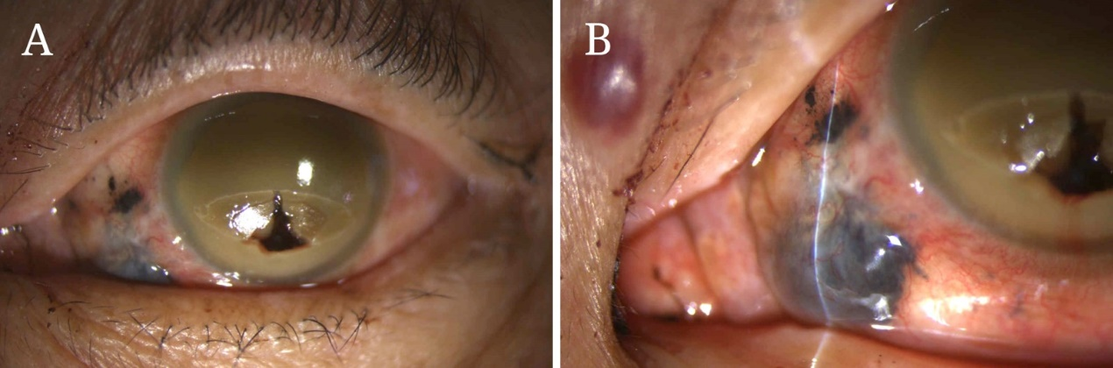
Figure 1 External view of the left eye. A: Gross view of the left eyeball. Uveal tissue prolapsed throughout the perforated corneal zone was noted (X 10); B: A 4 mm x 4 mm fixed dark brown-black subconjunctival mass with dilated and tortuous sentinel vessels at the nasal lower region of the eyeball was noted (X 16).

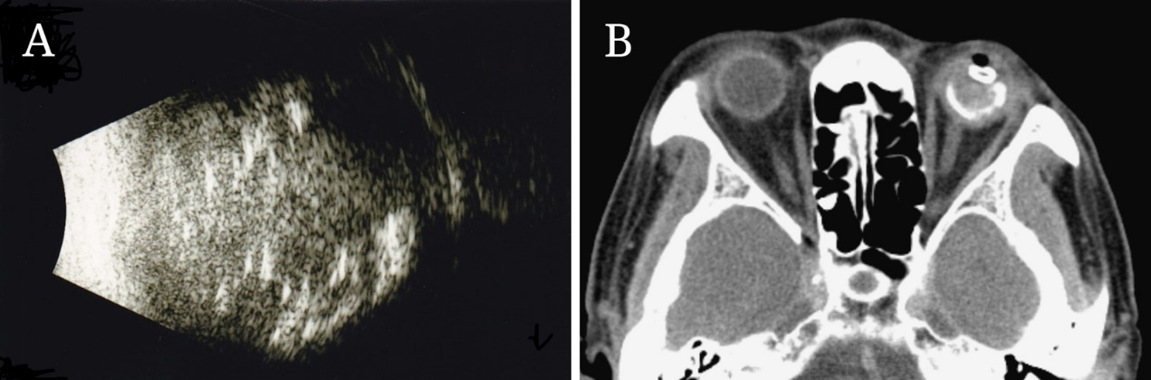
Figure 2 Initial radiological appearance of the tumor in the left eye. A: B-scan revealed heterogenous echogenicity throughout the left eyeball; B: Computed tomography scan of the orbit showed a high-density lesion within the left eye without orbital extension.

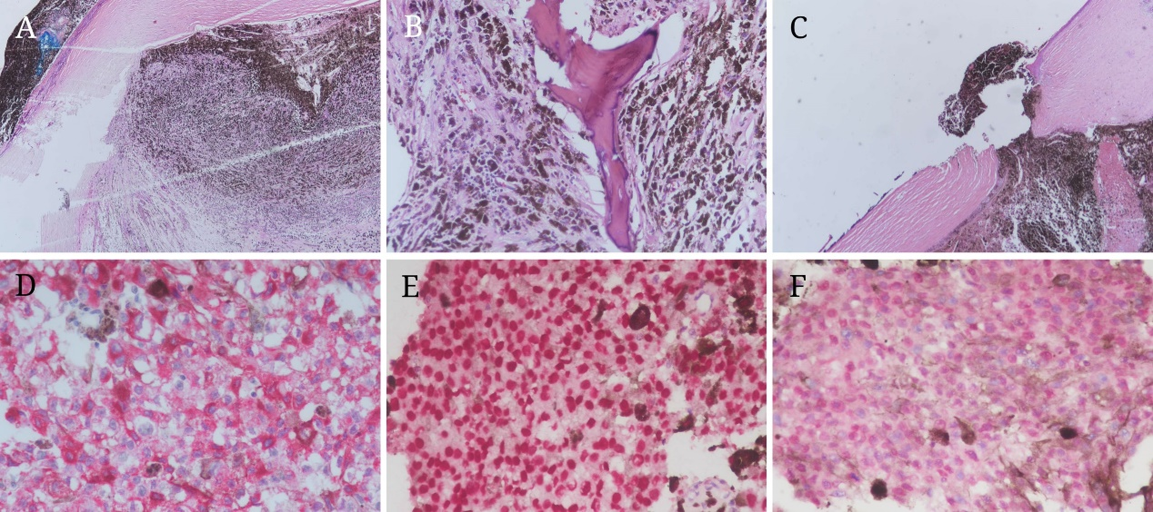
Figure 3 Histological findings of the resected tumor specimens. A: Tumor cells occupied the entire eyeball (X 40); B: Ossification was noted in the tumor (X 200); C: Uveal tissue confined in the region of the perforated cornea was noted. Intact cornea layers and no corneal thinning or corneal ulcer was noted (X 40); D: Immunohistochemistry (IHC) results revealed diffusely positive melanin-A immunostaining in the cytoplasm of primary tumor cells (Red chromogen, X 400); E: IHC results revealed diffusely positive SOX-10 immunostaining in the nuclei of primary tumor cells (Red chromogen, X 400); F: Primary epithelioid tumor cells showed strong nuclear labeling for BAP1 expression (Red chromogen, X 400).

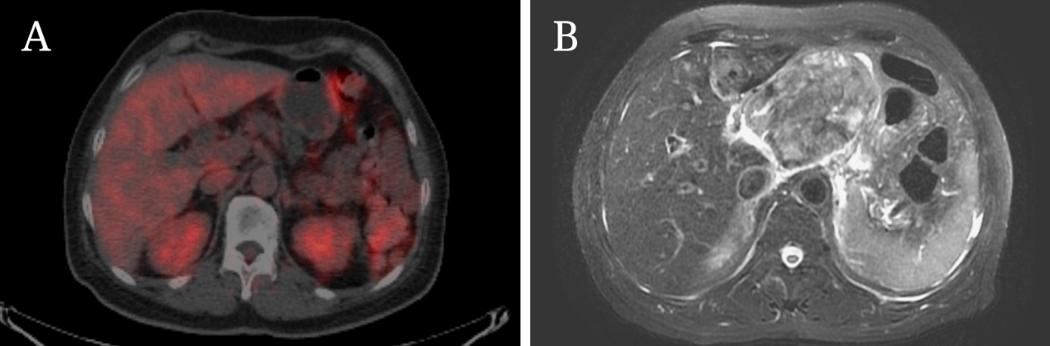
Figure 4 Images from abdominal positron emission tomography-computed tomography (PET-CT) scans and magnetic resonance imaging (MRI). A: PET-CT scan at initial presentation revealed no definite Fluorodeoxyglucose-avid tumor in the abdomen; B: MRI of the abdomen at 1.5 years after enucleation revealed a large mass at the upper abdomen abutting the pancreatic neck and body with maximal diameter of at least 9.5 cm.

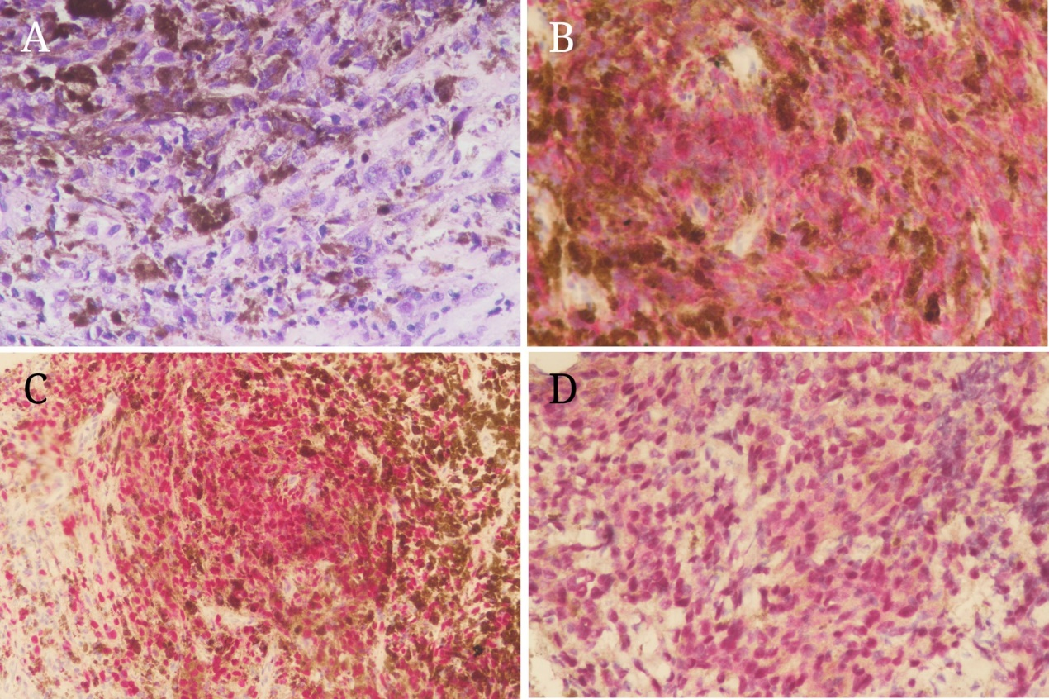
Figure 5 Histological findings of the fine needle aspiration specimens. A: Specimen from the fine needle aspiration of liver tumor showed sheets of epithelioid and spindle neoplastic cells arranged in a solid pattern with occasional prominent nucleoli and eosinophilic cytoplasm that exhibited stromal reaction and abundant melanin pigment (X 400); B: Immunohistochemistry (IHC) results revealed diffusely positive melanin-A immunostaining in the cytoplasm of metastatic neoplastic cells (Red chromogen, X 400); C: IHC results revealed diffusely positive SOX-10 immunostaining in the nuclei of metastatic neoplastic cells (Red chromogen, X 400); D: The epithelioid metastatic tumor cells showed strong nuclear labeling for BAP1 expression (Red chromogen, X 400).

