Name of Journal: World Journal of Clinical Cases
Manuscript NO: 89766
Manuscript Type: EDITORIAL

Tumor deposits in axillary adipose tissue in patients with breast cancer: Do they matter?

Mubarak M et al. Tumor deposits in breast cancer

Muhammed Mubarak, Rahma Rashid, Shaheera Shakeel

Muhammed Mubarak, Rahma Rashid, Department of Pathology, Sindh Institute of Urology and Transplantation, Karachi 74200, Sindh, Pakistan

Shaheera Shakeel, Department of Histopathology, Sindh Institute of Urology and Transplantation, Karachi 74200, Sindh, Pakistan

Author contributions: All authors contributed equally to the preparation of this manuscript; Mubarak M conceived the idea; Mubarak M and Rashid R did literature search; Mubarak M wrote the preliminary draft; Mubarak M, Rashid R, and Shakeel S critically reviewed and approved the manuscript.

Corresponding author: Muhammed Mubarak, MD, Professor, Department of Pathology, Sindh Institute of Urology and Transplantation, Chand Bibi Road, Dewan Farooq Medical Complex, Karachi, Karachi 74200, Sindh, Pakistan. drmubaraksiut@yahoo.com

Received: November 13, 2023
Revised: January 10, 2024
Accepted: January 31, 2024
Published online:

Abstract
Tumor deposits (TDs) are defined as discrete, irregular clusters of tumor cells lying in the soft tissue adjacent to but separate from the primary tumor, and are usually found in the lymphatic drainage area of the primary tumor. By definition, no residual lymph node structure should be identified in these tumor masses. At present, TDs are mainly reported in colorectal cancer, with a few reports in gastric cancer. There are very few reports on breast cancer (BC). For TDs, current dominant theories suggest that these are the result of lymph node metastasis of the tumor with complete destruction of the lymph nodes by the tumor tissue. Even some pathologists classify a TD as two lymph node metastases for calculation. Some pathologists also believe that TDs belong to the category of disseminated metastasis. Therefore, regardless of the origin, TDs are an indicator of poor prognosis. Moreover, for BC, sentinel lymph node biopsy is generally used at present. Whether radical axillary lymph node dissection should be adopted for BC with TDs in axillary lymph nodes is still inconclusive. The present commentary of this clinical issue has certain guiding significance. It is aimed to increase the awareness of the scientific community towards this under-recognized problem in BC pathology.

Key Words: Breast cancer; Tumor deposits; Lymph node metastasis; Staging

Mubarak M, Rashid R, Shakeel S. Tumor deposits in axillary adipose tissue in patients with breast cancer: Do they matter? World J Clin Cases 2024; In press

Core Tip: In this editorial, we comment on a case report by Li et al published in the recent issue of the World Journal of Clinical Cases. According to the authors of this article, the objective of presenting this case was to bring to attention the detection and reporting of tumor deposits (TDs) in breast cancer. TDs are being increasingly detected and reported in many other types of surgically resected cancers, but in this editorial article, we will focus specifically on the significance of TDs in primary breast carcinoma.

INTRODUCTION
In this editorial, we comment on a case report by Li et al^{[1]} published in the recent issue of the World Journal of Clinical Cases. According to the authors of this article, the objective of presenting this case was to bring to attention the detection and reporting of tumor deposits (TDs) in breast cancer (BC). TDs are being increasingly detected and reported in many other types of surgically resected cancers, but in this editorial article, we will focus specifically on the significance of TDs in primary BC.
TDs are defined as discrete, irregular clusters of tumor cells lying in the soft tissue adjacent to but separate from the primary tumor (PT), and are usually found in the draining lymphatic area of the PT. By convention, no remaining lymph node (LN) structure should be discernible in these TDs. These can only be diagnosed on histopathological examination (Figures 1-3). These are an important prognostic feature in a variety of malignant tumors. Their origin, classification, and significance are still not completely understood. Moreover, their definitions have also changed, particularly in colorectal cancer (CRC). They are often thought to be derived from metastasis by the lymphatic route, but origins from venous and perineural pathways of tumor spread have also been suggested. Some pathologists even classify a TD as two LN metastases (LNMs) for calculation. Other pathologists believe that TDs belong to the category of disseminated metastases. In the vast majority of cases of TDs, the origin is not discernible at the time of their detection. Regardless of their origin, development, or evolution, TDs serve as an indicator of poor prognosis.
TDs were first described by Gabriel et al^{[2]} in 1935 in CRC. However, these were not given due importance for staging or prognostic purposes for CRC or other tumor types for a considerable time. The interest in TDs was revived around the late 1990s and early 2000s when several studies were conducted on the significance of TDs in CRCs and gastric cancer (GC) reporting a significant adverse effect on prognosis^{[3-6]}. TDs have also been detected in many other malignant tumors, particularly of the gastrointestinal tract^{[7-10]}. More recently, these have also been studied in head and neck cancers^{[11]}.
In GC and CRC, TDs in the LN drainage area have been identified as independent prognostic factors. In CRC, TDs have been incorporated into the TNM staging system^{[12]}. However, the categorization, and incorporation in staging, of TDs have changed considerably in each TNM Edition since their original description in TNM 5, and the terminology remains controversial. Currently, these are assigned N1c in the absence of associated LNMs^{[13]}. Currently, TDs are not included in the clinical or pathological staging of any other cancer including BC.
BC is the most common malignant tumor in women throughout the world^{[14]}. BC staging is performed using the TNM staging system and is a major determinant of prognosis. According to the most recent TNM staging updates, invasive tumor masses within axillary fat distinct from identifiable LN structure, are designated as regional LNMs (pN)^{[15]}. However, such lesions appear to be analogous to TDs of carcinomas of other tissues described in the literature, and they may represent TDs of BCs. In BC, very few studies have been done on this pathological lesion.
Li et al^{[1]} have done a commendable job in reporting this case of isolated TD in the axillary area in a 70-year-old female patient with primary BC. However, given the clinical course and follow-up of this particular patient, TD does not fulfill the role of a prognostic marker in this case as the follow-up is short and no adverse outcome occurred till the last follow-up in this patient. However, they have succeeded in provoking thoughts and consideration of this lesion in BC through their case study and literature review.
In an interesting study on TDs in BC, Durak et al^{[16]} retrospectively reviewed 145 cases of BC, detected and managed between 2001 and 2006 at a single center for determining the frequency of TDs. TDs were found in 42 (29%) of cases. After exclusion of TDs from the number of metastatic LNs, the pN stage of nine patients changed. On multivariate exploration, the presence of TDs was independently and significantly associated with distant metastases. The probability of distant metastases was 3.3-fold higher in patients with TDs. TDs were also associated with shortened patient survival time as compared to those patients without TDs, although this was not statistically significant. The results from the study by Durak et al^{[16]} show that TDs are found in a significant proportion of patients with BC and that their presence should alert the clinician regarding the possibility of distant metastases. They concluded that the presence of TDs, the study of which is neither time-consuming nor requires additional sophisticated tests, should be included in the pathology reports for possible use in clinical practice and future research. There is a need for more such studies, particularly multicenter studies, to reflect better on the importance of TDs in BC patients.
In another large single-center study, Mamtani et al^{[17]} studied the clinical significance of extranodal TDs (ETDs) in 1114 consecutive patients with T1T2cN0 invasive BCs. Overall, 113 (10.1%) patients had ETDs in this study. It was found that among T1-T2cN0 patients with sentinel LNMs, ETDs in axillary fat were strongly associated with ≥ 4 positive non-sentinel lymph nodes at axillary LN dissection (ALND). They concluded that even among the patients who may otherwise meet the criteria for the omission of ALND, the detection of ETDs in axillary fat warrants consideration of ALND.
More similar studies are warranted by other investigators on patients with BC to delineate the long-term prognosis of TDs in this type of malignancy. At the same time, a modified Delphi process can also be initiated to streamline the diagnostic approach to TDs detection in BCs as in CRCs^{[18]}.

CONCLUSION
In summary, in this era of precision diagnostics and personalized medicine, the interest has been rekindled in TDs in many types of malignant tumors including BC. There is a need to report these and perform large, multicenter, prospective studies to detect their clinical significance in improving patient care.

REFERENCES
1 Li T, Zhang WH, Liu J, Mao YL, Liu S. Isolated axillary tumor deposit consistent with primary breast carcinoma: A case report. World J Clin Cases 2023; 11: 7718-7723 [PMID: 38078126 DOI: 10.12998/wjcc.v11.i31.7718]
2 Gabriel WB, Dukes C, Bussey HJR. Lymphatic spread in cancer of the rectum. Br J Surg 1935; 1: 395-413 [DOI: 10.1002/bjs.1800239017]
3 Nagtegaal ID, Knijn N, Hugen N, Marshall HC, Sugihara K, Tot T, Ueno H, Quirke P. Tumor Deposits in Colorectal Cancer: Improving the Value of Modern Staging-A Systematic Review and Meta-Analysis. J Clin Oncol 2017; 35: 1119-1127 [PMID: 28029327 DOI: 10.1200/JCO.2016.68.9091]
4 Kobayashi T, Ishida M, Miki H, Hatta M, Hamada M, Hirose Y, Sekimoto M. Significance of desmoplastic reactions on tumor deposits in patients with colorectal cancer. Oncol Lett 2023; 25: 1 [PMID: 36419753 DOI: 10.3892/ol.2022.13587]
5 Pu H, Pang X, Fu J, Zheng R, Chen Y, Zhang D, Fang X. Significance of tumor deposits combined with lymph node metastasis in stage III colorectal cancer patients: a retrospective multi-center cohort study from China. Int J Colorectal Dis 2022; 37: 1411-1420 [PMID: 35595975 DOI: 10.1007/s00384-022-04149-z]
6 Zheng P, Lai C, Yang W, Chen Z. Prognostic Significance of Tumor Deposits in Combination with Lymph Node Metastasis in Stage III Colon Cancer: A Propensity Score Matching Study. Am Surg 2020; 86: 164-170 [PMID: 32167047]
7 Mirkin KA, Kulaylat AS, Hollenbeak CS, Messaris E. Prognostic Significance of Tumor Deposits in Stage III Colon Cancer. Ann Surg Oncol 2018; 25: 3179-3184 [PMID: 30083832 DOI: 10.1245/s10434-018-6661-9]
8 Liang Y, Wu L, Liu L, Ding X, Wang X, Liu H, Meng J, Xu R, He D, Liang H. Impact of extranodal tumor deposits on prognosis and N stage in gastric cancer. Surgery 2019; 166: 305-313 [PMID: 31221435 DOI: 10.1016/j.surg.2019.04.027]
9 Liang Y, Chang S, Guo H, Man Q, Zang F, Gao S. Presence of tumor deposits is an indicator of poor prognosis in patients with pancreatic ductal adenocarcinoma. Am J Cancer Res 2023; 13: 1970-1984 [PMID: 37293176]
10 Zhou M, Yang W, Zou W, Yang J, Zhou C, Zhang Z, Wang Y, Zhang J, Wang Y, Li G, Zhang Z, Xia F. Prognostic significance of tumor deposits in radically resected gastric cancer: a retrospective study of a cohort of 1915 Chinese individuals. World J Surg Oncol 2022; 20: 304 [PMID: 36138439 DOI: 10.1186/s12957-022-02773-1]
11 González-Vallejo L, Blanco-Sainzdelamaza J, Querejeta-Ayerra A, Chiesa-Estomba C. Extracapsular nodal extension and tumor deposits in head and neck squamous cell carcinoma. Cancer Rep (Hoboken) 2023; 6: e1897 [PMID: 37700458 DOI: 10.1002/cnr2.1897]
12 Chen P, Zuo ZL, Feng LB, Chen XL, Hu XY, Liu Q, Xia D. Questioning the staging of tumor deposits of colorectal cancer in the eighth edition of the TNM classification: validation by prognosis. Int J Clin Exp Pathol 2019; 12: 4309-4318 [PMID: 31933832]
13 Delattre JF, Selcen Oguz Erdogan A, Cohen R, Shi Q, Emile JF, Taieb J, Tabernero J, André T, Meyerhardt JA, Nagtegaal ID, Svrcek M. A comprehensive overview of tumour deposits in colorectal cancer: Towards a next TNM classification. Cancer Treat Rev 2022; 103: 102325 [PMID: 34954486. DOI: 10.1016/j.ctrv.2021.102325]
14 Sapna F, Athwal PSS, Kumar M, Randhawa S, Kahlon S. Therapeutic Strategies for Human Epidermal Receptor-2 Positive Metastatic Breast Cancer: A Literature Review. Cureus 2020; 12: e9522 [PMID: 32905036 DOI: 10.7759/cureus.9522]
15 Teichgraeber DC, Guirguis MS, Whitman GJ. Breast Cancer Staging: Updates in the AJCC Cancer Staging Manual, 8th Edition, and Current Challenges for Radiologists, From the AJR Special Series on Cancer Staging. AJR Am J Roentgenol 2021; 217: 278-290 [PMID: 33594908 DOI: 10.2214/AJR.20.25223]
16 Durak MG, Canda T, Yilmaz B, Seker NS, Kokkoz SE, Alicikus ZA, Akturk N, Gorken IB, Ellidokuz H, Sevinc AI, Saydam S, Sarioglu S. Prognostic Importance of Tumor Deposits in the Ipsilateral Axillary Region of Breast Cancer Patients. Pathol Oncol Res 2019; 25: 577-583 [PMID: 30368727 DOI: 10.1007/s12253-018-0515-4]
17 Mamtani A, Barrio AV, Goldman DA, Wen HY, Vincent A, Morrow M. Extranodal Tumor Deposits in the Axillary Fat Indicate the Need for Axillary Dissection Among T1-T2cN0 Patients with Positive Sentinel Nodes. Ann Surg Oncol 2020; 27: 3585-3592 [PMID: 32488512 DOI: 10.1245/s10434-020-08632-1]
18 Lord A, Brown G, Abulafi M, Bateman A, Frankel W, Goldin R, Gopal P, Kirsch R, Loughrey MB, Märkl B, Moran B, Puppa G, Rasheed S, Shimada Y, Snaebjornsson P, Svrcek M, Washington K, West N, Wong N, Nagtegaal I. Histopathological diagnosis of tumour deposits in colorectal cancer: a Delphi consensus study. Histopathology 2021; 79: 168-175 [PMID: 33511676 DOI: 10.1111/his.14344]

Footnotes
Conflict-of-interest statement: All authors declare that they have no conflict-of-interest.

Open-Access: This article is an open-access article that was selected by an in-house editor and fully peer-reviewed by external reviewers. It is distributed in accordance with the Creative Commons Attribution NonCommercial (CC BY-NC 4.0) license, which permits others to distribute, remix, adapt, build upon this work non-commercially, and license their derivative works on different terms, provided the original work is properly cited and the use is non-commercial. See: https://creativecommons.org/Licenses/by-nc/4.0/

Provenance and peer review: Invited article; Externally peer reviewed.
Peer-review model: Single blind

Peer-review started: November 13, 2023
First decision: January 9, 2024
Article in press:

Specialty type: Pathology
Country/Territory of origin: Pakistan
Peer-review report’s scientific quality classification
Grade A (Excellent): 0
Grade B (Very good): B
Grade C (Good): C
Grade D (Fair): 0
Grade E (Poor): 0

P-Reviewer: Gu GL, China; Jiang L, China S-Editor: Liu JH L-Editor: A P-Editor:
Figure Legends
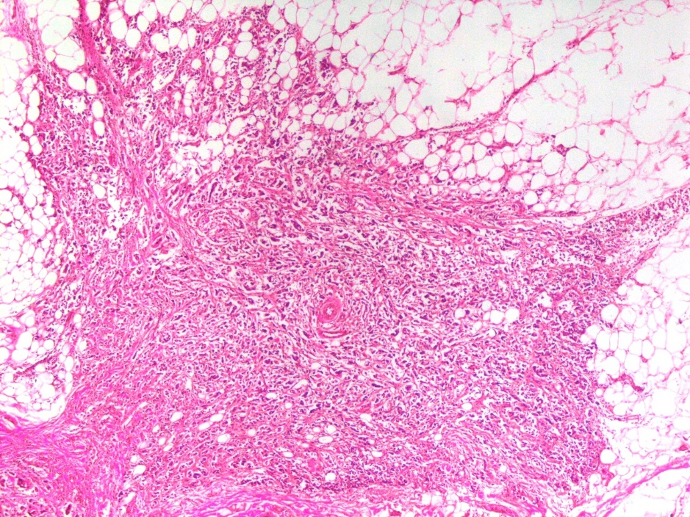
Figure 1 An irregular mass of tumor tissue in the axillary adipose tissue. There is no lymphoid tissue at the periphery or within the tumor mass. This will qualify for designation of tumor deposits in axillary fat (H&E, × 40).
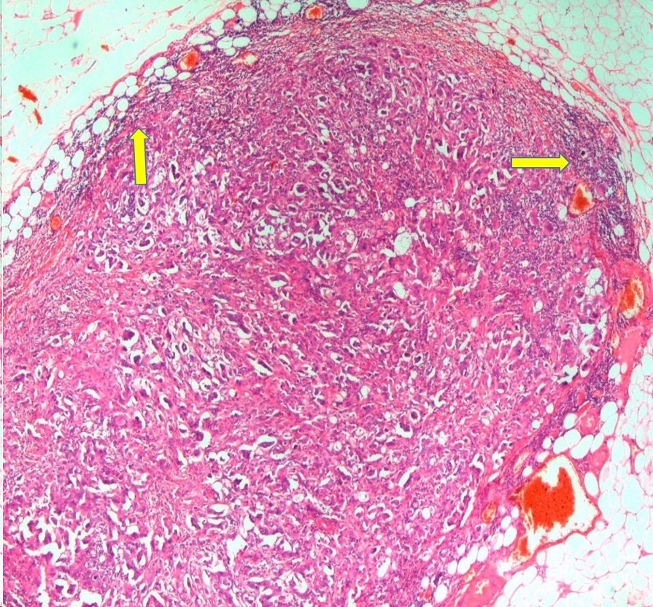
Figure 2 In this case, the tumor mass is exhibiting ovoid or reniform configuration consistent with lymph node metastasis. Focally, some lymphoid tissue can be seen at the periphery of the tumor mass (arrows). This will not qualify for the designation of tumor deposits (H&E, × 40).
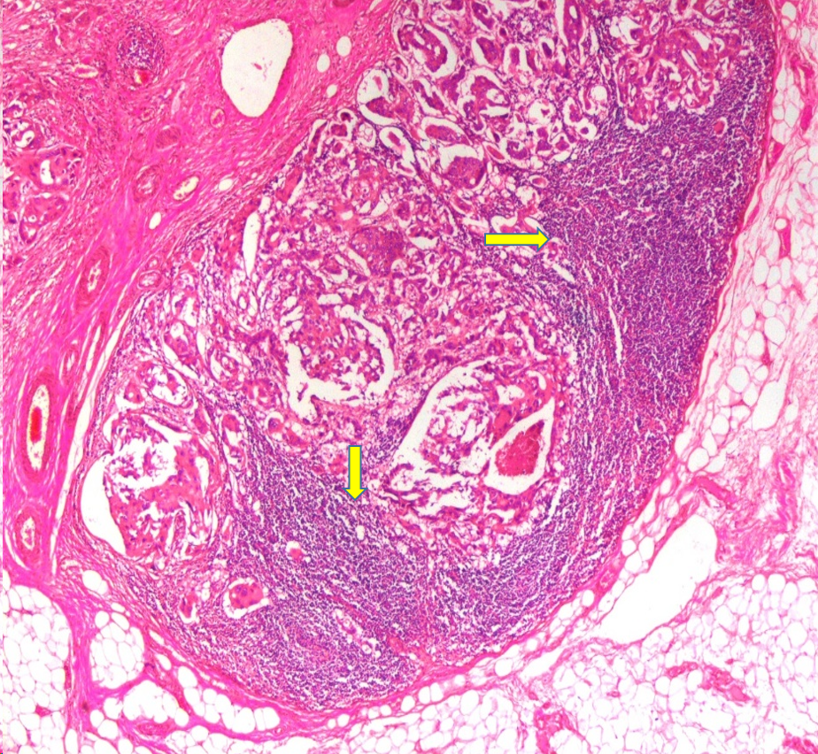
Figure 3 Another example of lymph node metastasis in the axilla. A variably thick rim of lymphoid tissue can be seen at the periphery of the tumor mass (arrows). This will also not qualify for tumor deposits designation (H&E, ×40).

