Name of Journal: World Journal of Radiology
ESPS Manuscript NO: 22393
Manuscript Type: Minireviews

Imaging in pulmonary hydatid cysts

Garg MK et al. Pulmonary hydatid cyst

Mandeep K Garg, Madhurima Sharma, Ajay Gulati, Ujjwal Gorsi, Ashutosh N Aggarwal, Ritesh Agarwal, Niranjan Khandelwal

Mandeep K Garg, Madhurima Sharma, Ajay Gulati, Ujjwal Gorsi, Niranjan Khandelwal, Department of Radiodiagnosis and Imaging, Post Graduate Institute of Medical Education and Research, Chandigarh 160012, India

Ashutosh N Aggarwal, Ritesh Agarwal, Department of Pulmonary Medicine, Post Graduate Institute of Medical Education and Research, Chandigarh 160012, India

Author contributions: All authors equally contributed to this paper with conception and design of the study, literature review and analysis, drafting and critical revision and editing, and final approval of the final version.

Conflict-of-interest statement: None.

Open-Access: This article is an open-access article which was selected by an in-house editor and fully peer-reviewed by external reviewers. It is distributed in accordance with the Creative Commons Attribution Non Commercial (CC BY-NC 4.0) license, which permits others to distribute, remix, adapt, build upon this work non-commercially, and license their derivative works on different terms, provided the original work is properly cited and the use is non-commercial. See: http://creativecommons.org/licenses/by-nc/4.0/

Correspondence to: Dr. Mandeep K Garg, Additional Professor, Department of Radiodiagnosis and Imaging, Post Graduate Institute of Medical Education and Research, Sector 12, Chandigarh 160012, India. gargmandeep@hotmail.com
Telephone: +91-172-2756380
Fax: +91-172-2744401

Received: September 25, 2015
Peer-review started: October 3, 2015
First decision: October 27, 2015
Revised: March 5, 2016
Accepted: March 22, 2016
Article in press:
Published online:
Abstract
Hydatid disease is a zoonosis that can involve almost any organ in the human body. After the liver, the lungs are the most common site for hydatid disease in adults. Imaging plays a pivotal role in the diagnosis of the disease, as clinical features are often nonspecific. Classical radiological signs of pulmonary hydatid cysts have been described in the literature, aiding in the diagnosis of the disease. However, complicated hydatid cysts can prove to be a diagnostic challenge at times due to their atypical imaging features. Radiography is the initial imaging modality. Computed tomography can provide a specific diagnosis in complicated cases. Ultrasound is particularly useful in peripheral lung lesions. The role of magnetic resonance imaging largely remains unexplored.

Key words: Pulmonary; Hydatid; Cyst; Radiography; Computed tomography

© The Author(s) 2016. Published by Baishideng Publishing Group Inc. All rights reserved.

Core tip: The lungs are the second-most common site for hydatid disease in adults. The classical radiological signs of pulmonary hydatid cysts have been described in the literature. In this article, we have comprehensively reviewed the various radiological signs and presentations of pulmonary hydatid cysts. We have also described atypical imaging manifestations of the disease. Radiologist should be familiar with the spectrum of the imaging findings in pulmonary hydatid cysts.

Garg MK, Sharma M, Gulati A, Gorsi U, Aggarwal AN, Agarwal R, Khandelwal N. Imaging in pulmonary hydatid cysts. World J Radiol 2016; In press

INTRODUCTION
Hydatid disease is caused by Echinococcus tapeworms in the larval stage. In humans, Echinococcus granulosus is responsible for the most common type of hydatid disease^{[1,2]}. Although hydatid disease has been known to exist in humans for almost 2000 years^{[3]}, Rudolphy in 1808 first used the term “hydatid” to describe echinococcosis^{[4]}. “Hydatid” is a Greek word (literal meaning: watery vesicle)^{[5]}, which aptly describes the characteristic of the disease. Hydatid disease is endemic in sheep-rearing countries, particularly in the Mediterranean region, Africa, South America, the Middle East, Australia, and New Zealand^{[1,6,7]}. The liver is the most common organ to be involved in adults (75%), followed by the lungs (15%)^{[1,6,7]}, while in the pediatric population, the lungs are the most common site of involvement^{[8,9]}.
Uncomplicated hydatid cysts of the lungs are usually asymptomatic, while complicated cysts present with nonspecific clinical features like coughing, chest pain, and hemoptysis. Imaging thus plays a pivotal role in the diagnosis of the disease. Although typical imaging findings have been well described in the literature, radiologists should also be aware of atypical imaging findings that can occur secondary to complications.

ETIOPATHOGENESIS
A definitive host for E. Granulosus is dogs (or other carnivores), which harbor adult worms in their small bowel. Eggs released by the worms are excreted in feces^{[1,2,6,7]}. Excreted ova are ingested by an intermediate host (most commonly sheep). When in the intestines of an intermediate host, ova develop into hexacanth embryos and reach the liver through portal circulation. Embryos in the liver develop into cysts^{[1,2,6]}. Humans are accidental hosts and become part of this lifecycle through contact with a definitive host or the ingestion of water or vegetables contaminated with echinococcus ova^{[1,2,6]}.
The hydatid cyst wall is composed of three layers: the outermost layer, known as the pericyst, is formed by the protective response of the host tissue; the acellular middle laminated layer (occasionally called the ectocyst) allows for the passage of nutrients; the innermost germinal layer (known as the endocyst), produces scolices toward the inner side and laminated membrane on the outer side^{[1,2,6]}. Hydatid cysts contain many daughter vesicles resembling bunches of grapes.
The lungs are the most common site in the pediatric population and the second-most common site in adults. Lung hydatid cysts have certain peculiar characteristics compared to cysts in other locations. First, the lungs facilitate the cysts’ growth due to negative pressure and the compressible nature of the lungs^{[1,10-12]}. As a result, hydatid cysts grow in the lungs three times faster than in the liver ^{[10]}. In addition, calcification (occurring in only 0.7% of cases) ^{[13]} and daughter cyst formation in lung hydatids are very rare^{[2,14,15]}.

CLINICAL FEATURES AND COMPLICATIONS
Most pulmonary hydatid cysts are acquired in childhood and remain asymptomatic for a long period of time. Uncomplicated hydatid cysts are usually diagnosed incidentally on chest X-rays^{[16]}. Chest pain, dyspnea, dry coughing, and hemoptysis can occur due to the mass effect caused by larger cysts. Acute-onset chest pain, coughing, hemoptysis and anaphylactic reactions may suggest cyst ruptures^{[13,17-21]}. The expectoration of membranes and hydatid sand is diagnostic of a ruptured hydatid and has been described in 31%-38% of cases^{[22,23]}.
A hydatid cyst rupture is the most common complication occurring in up to 49% of cases. Ruptures may be contained (by detachment of the pericyst from the endocyst), communicating (with the bronchus) and direct (rupture of all membranes with spillage of contents)^{[24]}. All hydatid cysts carry the risk of rupture and are classified as complicated hydatid cysts. The degeneration of cyst membranes is responsible for ruptures, which in turn is determined by several factors, such as the age, chemical reactions, and defense mechanisms of the host^{[25]}. Moreover, the risk of rupture increases with the size and number of cysts^{[26]}. Antihelminthic therapy and percutaneous aspiration are also known to cause cyst ruptures and fatal complications^{[27]}. Cyst ruptures can occur into bronchus (manifesting as coughing with sputum containing hydatid sand and membrane fragments)^{[27]} or the pleural cavity (manifesting as pneumothorax, effusion, and emphysema)^{[28]}. Occasionally pleural seeding from live scolex during a rupture can cause secondary pleural disease^{[29]}. Rarely, a cyst can rupture into the vena cava and present as a recurrent pulmonary embolism^{[30]}.
Infection is the most common complication of cyst ruptures^{[14]}, clinically presenting with lung abscess features^{[1]}. On rare occasions, a pulmonary hydatid cyst can also involve the thoracic wall^{[24]}.

IMAGING FEATURES: THE LUNGS ARE THE SECOND-MOST COMMON SITE FOR HYDATID CYSTS IN ADULTS
The lower lobes are the most common location in the lungs (in 60% of cases) with the right basal lobe being more common^{[1,13,17,19]}. In 30% of cases, there is more than one cyst, and they can be bilateral in 20% of cases^{[1,13]}. X-ray and computed tomography (CT) are the usual imaging modalities used. Ultrasound can be beneficial in peripheral lesions and to assess pleura.

Radiography
An uncomplicated hydatid cyst appears as a well-defined homogenous radio-opacity on a chest X-ray^{[8,31,32]} (Figure 1A). Differential diagnoses on a chest X-ray include fluid-filled cysts, benign tumors, carcinoma, metastases, and inflammatory masses^{[20,33,34]}. The appearance of cysts has been compared to cannon balls in AP projection and to rugby balls in lateral projection^{[32]}. Cysts can assume polycyclic configuration due to pressure from adjacent structures^{[18]}. Notching can also occur in cysts with deep notching, giving them a bilobed appearance^{[18]}. The loss of a spherical shape on an X-ray with the appearance of a small depression (resulting in a reniform shape) may imply a bronchial rupture and has been called the “slot sign”^{[12]}. Simple hydatid cysts are sharply demarcated from adjacent lung parenchyma. However, atelectatic and reactive changes in the adjacent lung can cause the loss of sharp margins of cysts on an X-ray, thereby mimicking pneumonia or carcinoma^{[35,36]}. Multiple large masses in the lungs are pathognomic for hydatid cysts^{[36]} (Figure 1B). As described earlier, calcification is very rare.
Hydatid cysts can erode a bronchus with the introduction of air between the pericyst and the endocyst appearing as a radiolucent rim around the cyst on an X-ray known as the “crescent sign”^{[36]} (Figure 2). However, this sign is not specific for hydatid cysts and can be seen in mycetoma, blood clots, carcinoma, and Rasmussen aneurysm^{[37]}. With the introduction of more air, the endocyst shrinks and ruptures with the introduction of air into the endocyst. At this stage, an air fluid level is seen in the endocyst with a radiolucent rim between the pericyst and the endocyst, known as the “cumbo sign” or the “double arch sign”^{[33,35,36,38]}. With further collapse of the endocyst, the membranes floating in the remaining fluid are known as the “water lily sign” or the “camolette sign”^{[35,36,38]}. With the rupture of the endocyst, daughter cysts may appear as round radio-opacities at the bottom of cysts, giving them a “rising sun” appearance^{[18]}. With coughing out the membranes, the pericyst can become empty (the “dry cyst sign”), appearing as air-filled cysts on X-rays^{[18]}. With a superadded infection, an air fluid level can appear in hydatid cysts, mimicking a lung abscess (Figure 3). All these signs have been summarized in Table 1.
The classical radiographic signs described above are not always present in complicated hydatid cysts. Thus, complicated cysts can be difficult to diagnose on routine radiography, and CT is usually required to establish the morphology of the disease.

CT
CT features of uncomplicated hydatid cysts: Uncomplicated hydatid cysts appear as well-circumscribed fluid attenuation lesions with homogenous content and smooth, hyperdense walls. Unlike hydatid cysts of the liver, calcification and daughter cyst formation are rare in lung hydatids^{[2,13-15]}. Intact hydatid cysts can be difficult to differentiate from other pulmonary cysts^{[23]}. Associated hydatid cysts with calcification and daughter cysts can also be seen in liver, thereby providing clue to the diagnosis (Figure 4).

CT features due to contained ruptures of the endocyst: Bronchial erosion caused by the cysts can cause the appearance of crescents of air between the pericyst and the endocyst (the crescent sign). Occasionally, air may dissect through the posterior aspect of membranes without anterior extension. This causes the appearance of air crescents along the posterior aspect of lesions, known as the “inverse crescent sign”^{[18,39]}. Blebs of air can be seen between the pericyst and the endocyst, which implies impending ruptures and are called “signet ring signs”^{[39]}. Small intracystic air foci can be seen at the periphery of cysts, between the pericyst and the endocyst (“air bubble signs”), which can cause the shrinkage of the endocyst and ruptures^{[16,40]} (Figure 5).

CT features due to complete ruptures of the endocyst: Due to the continuous accumulation of air between the pericyst and the endocyst, the endocyst ruptures with the collapse of membranes. An air fluid level within the endocyst and the crescent of air between the endocyst and the pericyst results in an onion peel appearance or the “cumbo sign”^{[18]}. After the expectoration of cyst fluid, collapsed membranes can be seen within the cyst, known as the “whirl” or the “serpent sign”^{[18,21]} (Figures 6 and 7B). With complete collapse, the crumpled endocyst appears as a wavy membrane floating on fluid, known as the “water lily” sign^{[13,18,21]} (Figure 8). The detached and crumpled endocyst may settle in the most dependant part of the cavity, resulting in a “mass within the cavity”^{[16]} or the “incarcerated membrane” sign^{[12]}. After the complete expectoration of the cyst fluid and membranes, the cyst appears only air filled, known as the “dry cyst sign”^{[12,18]}.

CT features due to pleural ruptures: The most common imaging finding after a pleural rupture of a hydatid cyst is hydrothorax or hydropneumothorax. Occasionally, membranes can be seen floating in pleural effusion^{[12]}. It should be noted that pleural thickening and effusion can also occur secondary to a reactive inflammatory response^{[29]} (Figure 7).

CT features due to infection: Increases in the size and number of pulmonary hydatid cysts increase the risk of infection^{[26]}. A superadded infection is the most common complication of a ruptured hydatid cyst^{[14]}. Increases in the cyst wall thickness with enhancement (the “ring enhancement” sign) (Figure 5) and the density of content are seen in cases of superadded infection of hydatid cysts^{[16,41]}. In addition, the appearance of air bubbles (the “air bubble sign”) (Figures 5 and 7A) and an air fluid level within the cyst also indicate infection^{[41]}.

Other complications: Rarely, hydatid cysts can invade the thoracic wall. On CT, a cystic lesion can be seen in the thoracic wall showing communication with a lung cyst (Figure 9)^{[24]}. Sometimes cysts can rupture into the inferior vena cava and lead to recurrent pulmonary embolism. Occasionally, cysts can directly extend into the pulmonary artery (Figure 10). Various CT signs in pulmonary hydatid cysts have been summarized in Table 2.

Ultrasonography in hydatid cysts
Ultrasound can prove useful in cases of peripheral hydatid cysts located along the chest wall. Recently, the “wall sign” has been described in pulmonary hydatid cysts, which refers to a double-layered wall in univesicular cysts and a double-layered septum in cases of multivesicular cysts^{[42]}. It has been reported that the wall sign has a specificity of nearly 100% for diagnosing pulmonary hydatid cysts^{[42]}. Thus, ultrasound can prove a useful modality, particularly in the pediatric population, as it is an easily available and non-ionizing modality.

Magnetic resonance imaging in hydatid cysts
Magnetic resonance imaging (MRI) is rarely used for the imaging of pulmonary hydatid cysts. T2-weighted imaging can very well demonstrate the cystic nature of the lesions, with the pericyst appearing as a T2 hypointense rim^{[43]}. Although CT is the imaging modality of choice, MRI can be particularly useful in the pediatric population in which the radiation dose remains a major concern.
Differential diagnosis: On chest radiograph, differential diagnoses of uncomplicated hydatid cysts include inflammatory masses, fluid-filled cysts, benign tumors, carcinoma, and metastases^{[20,33,34]}. Besides hydatid cysts, a radiographic crescent sign can be seen in aspergilloma, cavitating malignancy, blood clots, and Rasmussen’s aneurysm^{[37]}.
On CT, uncomplicated hydatid cysts may be difficult to distinguish from other cystic lesions. An infected hydatid cyst with an air fluid level can be difficult to distinguish from a lung abscess. Air-filled hydatid cysts with no content (“dry cysts”) have to be differentiated from other cavitatory lesions, such as aspergilloma, necrotic lung malignancies, and tubercular cavities^{[40]}.

CONCLUSION
Hydatid disease is a manifestation of larval infestation by the echinococcus tapeworm, common in various endemic regions. In adults, the lungs are second-most common organ to be involved by hematogenous dissemination. Uncomplicated pulmonary hydatid cysts are most commonly diagnosed incidentally on imaging. Though a variety of signs have been described on imaging, complicated hydatid cysts can present with atypical imaging findings. CT is the imaging modality of choice, especially in complicated hydatid cysts, and can provide an accurate diagnosis by demonstrating the internal characteristics and morphology of the lesion. Thus, radiologists should be well aware of the typical and atypical imaging features of the disease.

REFERENCES
- Beggs I. The radiology of hydatid disease. AJR Am J Roentgenol 1985; 145: 639-648 [PMID: 3895873 DOI: 10.2214/ajr.145.3.639]
- Lewall DB. Hydatid disease: biology, pathology, imaging and classification. Clin Radiol 1998; 53: 863-874 [PMID: 9867269 DOI: 10.1016/S0009-9260(98)80212-2]
- Mowlavi G, Kacki S, Dupouy-Camet J, Mobedi I, Makki M, Harandi MF, Naddaf SR. Probable hepatic capillariosis and hydatidosis in an adolescent from the late Roman period buried in Amiens (France). Parasite 2014; 21: 9 [PMID: 24572211]
- Aletras H, Symbas PN: Hydatid disease of the lung. In: Shields TW, LoCicero J, Ponn RB (eds.), General Thoracic Surgery, 5th ed. Philadelphia: Lippincott Williams & Wil‐ kins; 2000: 1113-1122
- Milicevic M. Hydatid disease. In: Blugmart LH, editor. Surgery of the liver and biliary tract. 2nd ed. Edinburgh: Churchill Livingstone; 1994: 1121-1150
- Pumarola A, Rodriguez-Torres A, García Rodriguez JA, Piedrola Angulo G. Microbiología y parasitología médica. 2nd ed. Barcelona, Spain: Salvat; 1990
- King CH. Cestodes (tapeworms). In: Mandell GL, Bennett JE, Dolin R. Principles and practice of infectious diseases. 4th ed. New York, NY: Churchill Livingstone, 1995: 2544–2553
- Haliloglu M, Saatci I, Akhan O, Ozmen MN, Besim A. Spectrum of imaging findings in pediatric hydatid disease. AJR Am J Roentgenol 1997; 169: 1627-1631 [PMID: 9393178 DOI: 10.2214/ajr.169.6.9393178]
- Solak H, Yeniterzi M, Yüksek T, Anil N, Göktoğan T, Ceran S. The hydatid cyst of the lung in children and results of surgical treatment. Thorac Cardiovasc Surg 1990; 38: 45-47 [PMID: 2309229 DOI: 10.1055/s-2007-1013991]
- Abbassioun K, Amirjamshidi A. Diagnosis and management of hydatid cyst of the central nervous system. Part 1. General considerations and hydatid disease of the brain. Neurosurg Quart 2001; 11: 1-9 [DOI: 10.1097/00013414-200103000-00001]
- Balci AE, Eren N, Eren S, Ulkü R. Ruptured hydatid cysts of the lung in children: clinical review and results of surgery. Ann Thorac Surg 2002; 74: 889-892 [PMID: 12238856 DOI: 10.1016/S0003-4975(02)03785-2]
- Ramos G, Orduña A, García-Yuste M. Hydatid cyst of the lung: diagnosis and treatment. World J Surg 2001; 25: 46-57 [PMID: 11213156 DOI: 10.1007/s002680020007]
- Jerray M, Benzarti M, Garrouche A, Klabi N, Hayouni A. Hydatid disease of the lungs. Study of 386 cases. Am Rev Respir Dis 1992; 146: 185-189 [PMID: 1626801 DOI: 10.1164/ajrccm/146.1.185]
- Khuroo MS. Hydatid disease: current status and recent advances. Ann Saudi Med 2002; 22: 56-64 [PMID: 17259768]
- Reeder MM, Palmer PES. The radiology of tropical diseases with epidemiological, pathological and clinical correlation. Baltimore: Williams &Wilkins; 1981
- Pedrosa I, Saíz A, Arrazola J, Ferreirós J, Pedrosa CS. Hydatid disease: radiologic and pathologic features and complications. Radiographics 2000; 20: 795-817 [PMID: 10835129 DOI: 10.1148/radiographics.20.3.g00ma06795]
- Bakir F. Serious complications of hydatid cyst of the lung. Am Rev Respir Dis 1967; 96: 483-493 [PMID: 6039101]
- Balikian JP, Mudarris FF. Hydatid disease of the lungs. A roentgenologic study of 50 cases. Am J Roentgenol Radium Ther Nucl Med 1974; 122: 692-707 [PMID: 4458447]
- Doğan R, Yüksel M, Cetin G, Süzer K, Alp M, Kaya S, Unlü M, Moldibi B. Surgical treatment of hydatid cysts of the lung: report on 1055 patients. Thorax 1989; 44: 192-199 [PMID: 2705149 DOI: 10.1136/thx.44.3.192]
- Saksouk FA, Fahl MH, Rizk GK. Computed tomography of pulmonary hydatid disease. J Comput Assist Tomogr 1986; 10: 226-232 [PMID: 3950150]
- von Sinner WN. New diagnostic signs in hydatid disease; radiography, ultrasound, CT and MRI correlated to pathology. Eur J Radiol 1991; 12: 150-159 [PMID: 2037004 DOI: 1016/0720-048X(91)90119-G]
- Uccheddu A, Cois A, Gromo C, Dessena M, Cagetti M. [Acute complications of pulmonary hydatidosis. Apropos 44 cases]. G Chir 1993; 14: 431-435 [PMID: 8136236]
- Kervancioglu R, Bayram M, Elbeyli L. CT findings in pulmonary hydatid disease. Acta Radiol 1999; 40: 510-514 [PMID: 10485240 DOI: 10.3109/02841859909175576]
- Turgut AT, Altinok T, Topçu S, Koşar U. Local complications of hydatid disease involving thoracic cavity: imaging findings. Eur J Radiol 2009; 70: 49-56 [PMID: 18291609 DOI: 10.1016/j.ejrad.2008.01.002]
- Peleg H, Best LA, Gaitini D. Simultaneous operation for hydatid cysts of right lung and liver. J Thorac Cardiovasc Surg 1985; 90: 783-787 [PMID: 4058049]
- Moreno González E, Rico Selas P, Martínez B, García García I, Palma Carazo F, Hidalgo Pascual M. Results of surgical treatment of hepatic hydatidosis: current therapeutic modifications. World J Surg 1991; 15: 254-263 [PMID: 2031363 DOI: 10.1007/BF01659061]
- Kuzucu A, Soysal O, Ozgel M, Yologlu S. Complicated hydatid cysts of the lung: clinical and therapeutic issues. Ann Thorac Surg 2004; 77: 1200-1204 [PMID: 15063234 DOI: 10.1016/j.athoracsur.2003.09.046]
- Turgut AT, Altin L, Topçu S, Kiliçoğlu B, Aliinok T, Kaptanoğlu E, Karademir A, Koşar U. Unusual imaging characteristics of complicated hydatid disease. Eur J Radiol 2007; 63: 84-93 [PMID: 17275238 DOI: 10.1016/j.ejrad.2007.01.001]
- Ozvaran MK, Ersoy Y, Uskul B, Unver E, Yalcin E, Baran R, Morice RC. Pleural complications of pulmonary hydatid disease. Respirology 2004; 9: 115-119 [PMID: 14982612 DOI: 10.1111/j.1440-1843.2003.00518.x]
- Polat P, Kantarci M, Alper F, Suma S, Koruyucu MB, Okur A. Hydatid disease from head to toe. Radiographics 2003; 23: 475-494; quiz 536-537 [PMID: 12640161 DOI: 10.1148/rg.232025704]
- Aytac A, Yurdakul Y, Ikizler C, Olga R, Saylam A. Pulmonary hydatid disease: report of 100 patients. Ann Thorac Surg 1977; 23: 145-151 [PMID: 836103 DOI: 10.1016/S0003-4975(10)64088-X]
- Larbaoui D. [Hydatid cyst of the lung]. Rev Pneumol Clin 1989; 45: 49-63 [PMID: 2678406]
- Kegel RF, Fatemi A. The ruptured pulmonary hydatid cyst. Radiology 1961; 76: 60-64 [PMID: 13752186 DOI: 10.1148/76.1.60]
- Aggarwal S, Kumar A, Mukhopadhyay S, Berry M. A new radiologic sign of ruptured pulmonary hydatid cyst. AJR Am J Roentgenol 1989; 152: 431-432 [PMID: 2783523]
- Reeder MM. RPC of the month from the AFIP. Radiology 1970; 95: 429-437 [PMID: 5439456 DOI: 10.1148/95.2.429]
- Schlanger PM, Schlanger H. Hydatid disease and its roentgen picture. Am J Roentgenol Radium Ther 1948; 60: 331-347 [PMID: 18884083]
- Felson B. Chest Roentgenology. W. B. Saunders Company, Philadelphia; 1973
- McPhail JL, Arora TS. Intrathoracic hydatid disease. Dis Chest 1967; 52: 772-781 [PMID: 6064981 DOI: 10.1378/chest.52.6.772]
- Koul PA, Koul AN, Wahid A, Mir FA. CT in pulmonary hydatid disease: unusual appearances. Chest 2000; 118: 1645-1647 [PMID: 11115453 DOI: 10.1378/chest.118.6.1645]
- Erdem CZ, Erdem LO. Radiological characteristics of pulmonary hydatid disease in children: less common radiological appearances. Eur J Radiol 2003; 45: 123-128 [PMID: 12536091 DOI: 10.1016/S0720-048X(02)00054-2]
- Köktürk O, Oztürk C, Diren B, Unsal M, Ayla K. "Air bubble": a new diagnostic CT sign of perforated pulmonary hydatid cyst. Eur Radiol 1999; 9: 1321-1323 [PMID: 10460366 DOI: 10.1007/s003300050840]
- El Fortia M, El Gatit A, Bendaoud M. Ultrasound wall-sign in pulmonary echinococcosis (new application). Ultraschall Med 2006; 27: 553-557 [PMID: 17160760 DOI: 10.1055/s-2006-927232]
- Singh S, Gibikote SV. Magnetic resonance imaging signal characteristics in hydatid cysts. Australas Radiol 2001; 45: 128-133 [PMID: 11380355 DOI: 10.1046/j.1440-1673.2001.00892.x]

P-Reviewer: Avcu S, Sverzellati N, van Beek EJ S-Editor: Kong JX L-Editor: E-Editor:
A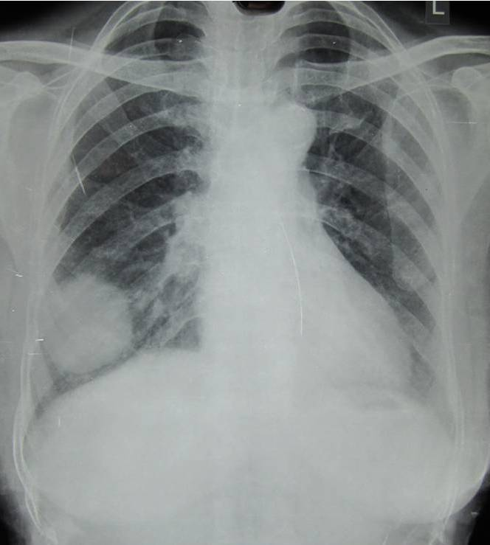
B 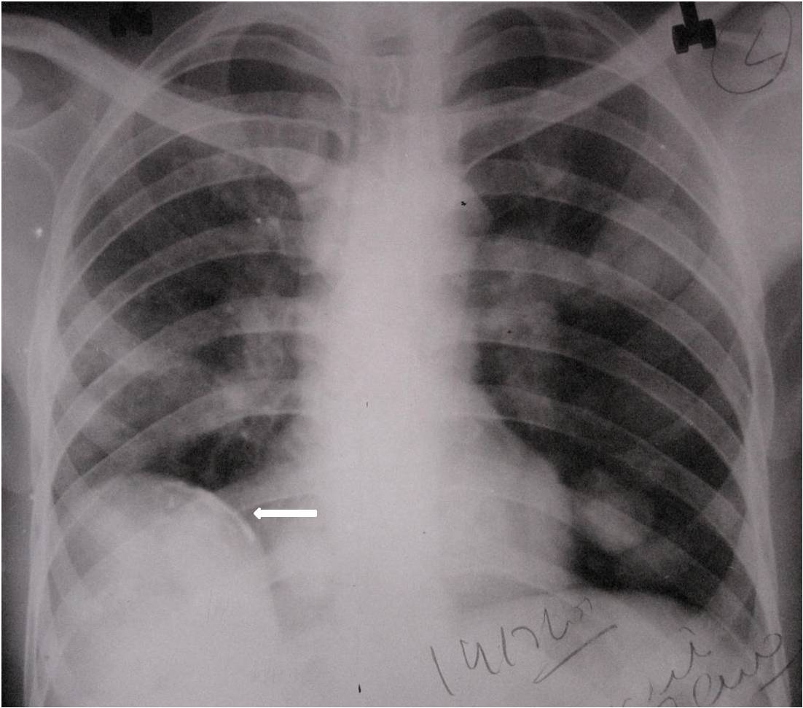
Figure 1 Uncomplicated hydatid cyst. A: Posteroanterior (PA) view of chest X-ray showing well defined round radio-opacity in right lower zone; B: Chest X-ray showing multiple well defined round opacities in left lung. Also note presence of calcified cyst in liver (arrow in B), which makes diagnosis of hydatid cyst almost certain.

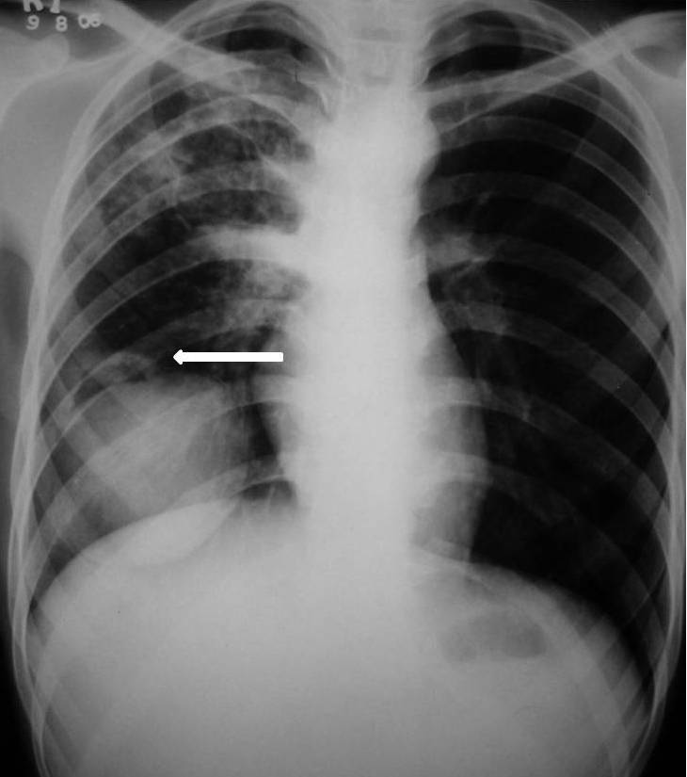
Figure 2 Air crescent sign: Chest X-ray showing well defined round radio-opacity in right lower zone with presence of a radiolucent rim at its superior aspect (arrow). This sign is however not specific for hydatid cyst and can be seen in mycetoma, bronchogenic carcinoma, blood clot and pulmonary artery aneurysm.

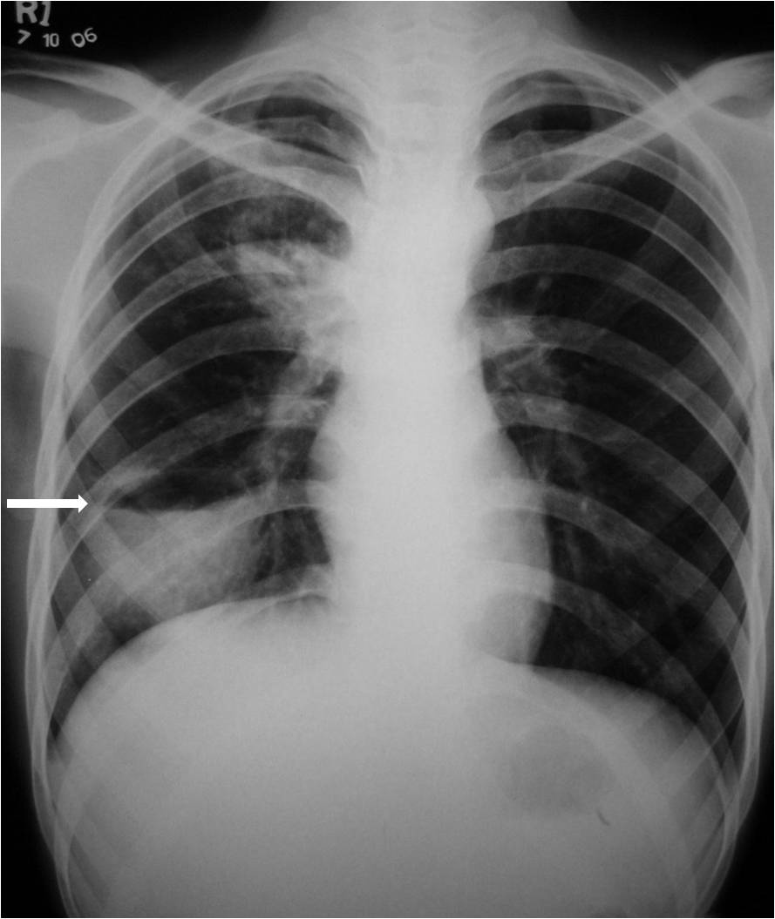
Figure 3 Complicated hydatid cyst: Chest radiograph of a patient who was a known case of hydatid cyst and presented with fever. Air fluid level can be seen in the cyst (arrow) suggesting superimposed infection. Pyogenic lung abscess is the most common differential diagnosis for this radiological picture and computed tomography may be required to establish the diagnosis.

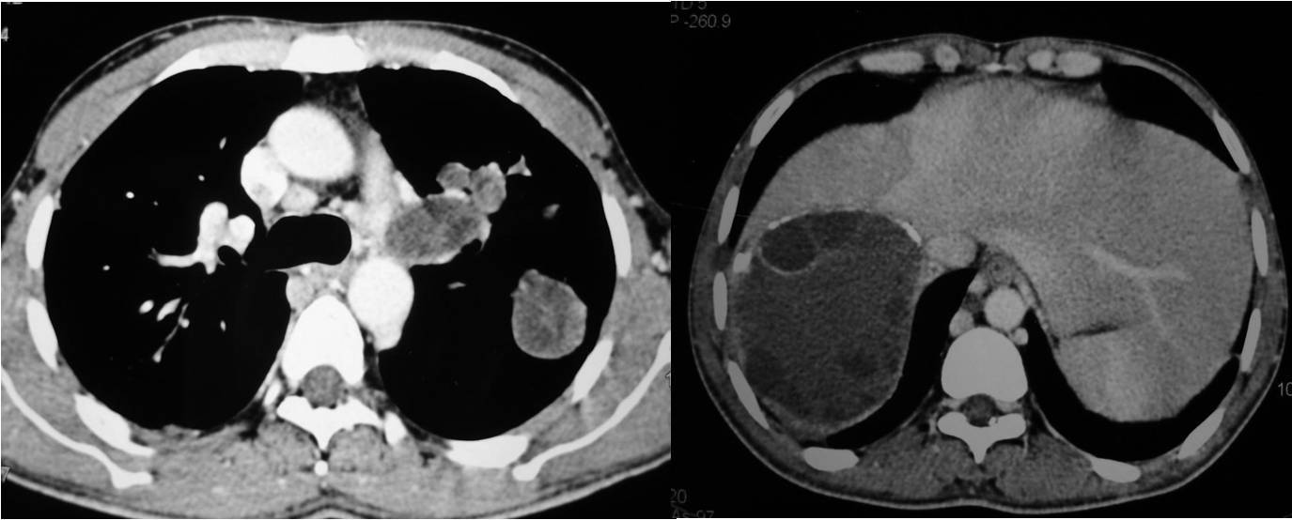
Figure 4 Hydatid cyst on computed tomography. Axial contrast enhanced computed tomography showing multiple hydatid cysts in left lung and liver (same patient as in Figure 1B). Note peripheral calcification and daughter cysts in liver cyst.

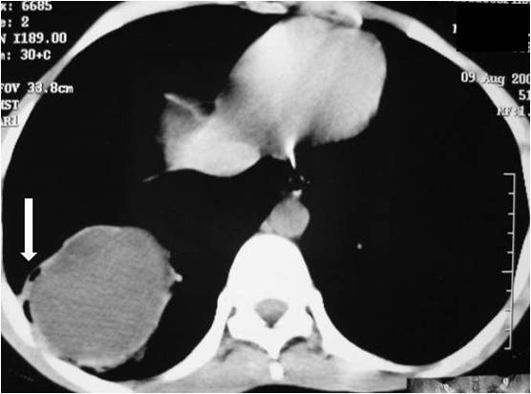
Figure 5 Axial contrast enhanced computed tomography images showing well defined cystic lesion with small air foci at periphery of the lesion (air bubble sign). Also note presence of mildly thickened wall with contrast enhancement (ring enhancement sign). This was a case of infected hydatid cyst.

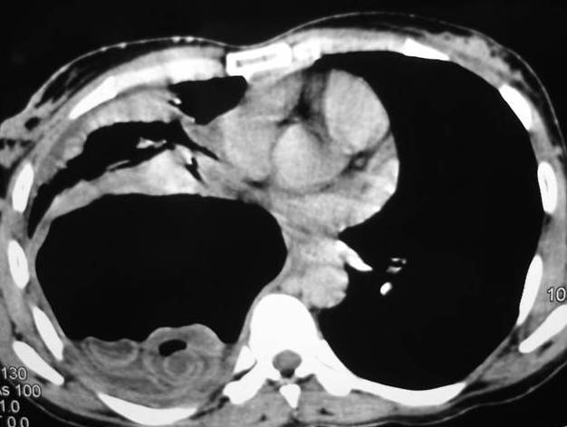
Figure 6 Axial computed tomography image in a case of ruptured hydatid cyst showing air and fluid with multiple curvilinear hyperattenuating membranes in dependant part (whirl sign).

A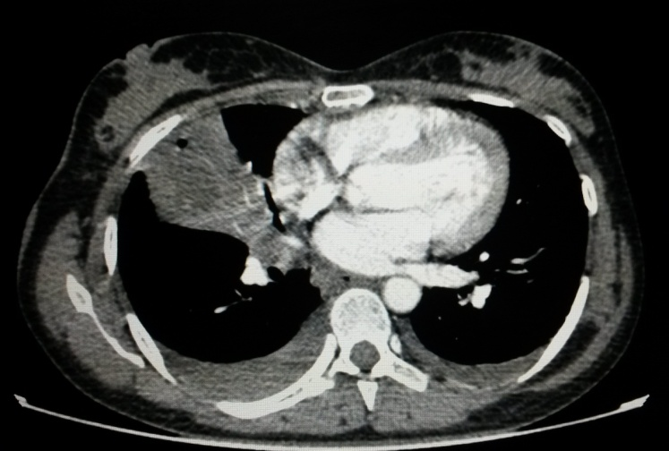
B 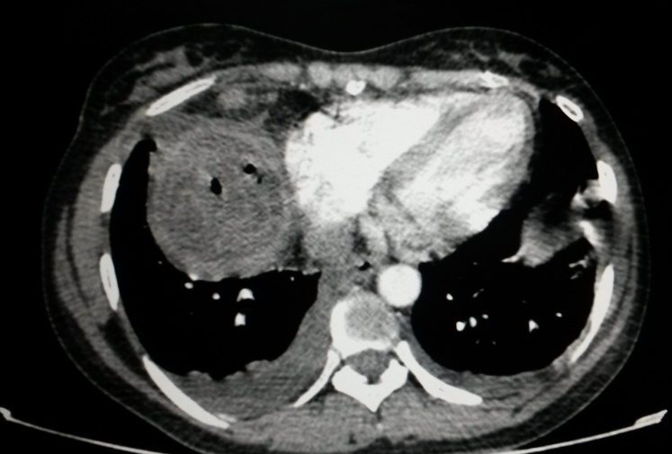
Figure 7 Complicated hydatid cyst showing ill defined wall with small air focus and consolidation in adjacent lung parenchyma (A) and posteroinferior to this cyst (B). B showed air foci with serpingenous hyperattenuating membranes (“serpent sign”). Also note presence of mild bilateral pleural effusion, which was likely reactive.

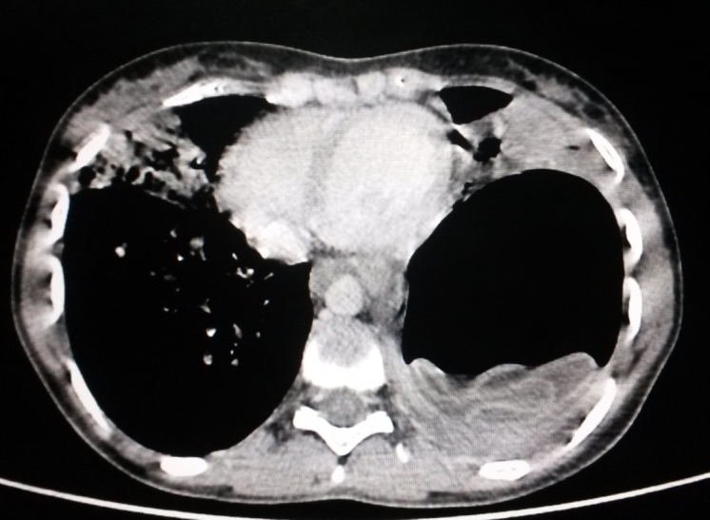
Figure 8 “Water lily” sign on computed tomography. Axial computed tomography image in a case of ruptured hydatid cyst showing air fluid level with crumpled endocyst appearing as floating membrane at air fluid interface.

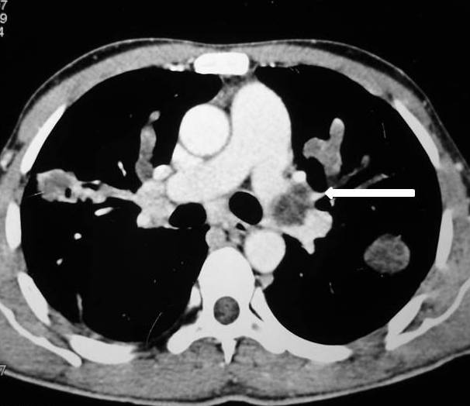
Figure 9 Axial contrast enhanced computed tomography showing hydatid cyst in left main pulmonary artery (arrow).

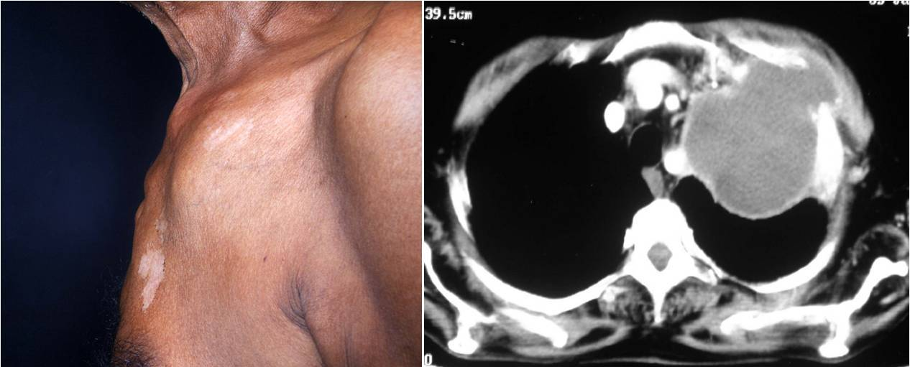
Figure 10 A 55 years old male patient presented with swelling in left anterior chest wall. Contrast enhanced computed tomography of the chest revealed hydatid cyst in left lung extending into left anterior chest wall.

Table 1 Classical signs of pulmonary hydatid cyst on chest X-ray
Uncomplicated hydatid cyst | Complicated hydatid cyst
Well circumscribed round radio-opacity (resembling canon ball on AP and rugby ball on lateral projection)  Polycyclic and bilobed appearance  Slot sign (impending rupture) | Crescent sign  Cumbo or double arch sign  Water lily or camelotte sign  Rising sun sign  Dry cyst sign

Table 2 Computed tomography signs described in pulmonary hydatid cyst
Signs of contained rupture
Crescent sign
Inverse crescent sign
Signet ring sign¹
Air bubble sign²
Signs of cyst rupture
Cumbo sign
Serpent sign
Swirl sign
Water lily sign
Mass within a cavity sign
Incarcerated membranes sign
Dry cyst sign
Signs of cyst infection
Air bubble sign²
Ring enhancement sign
Air fluid level
¹Indicated impending rupture; ²Can be seen in contained rupture as well as superadded infection.

