Name of journal: World Journal of Radiology
ESPS Manuscript NO: 8854
Columns: Review

MRI in central nervous system infections: A Simplified patterned approach

Rangarajan K et al. Patterned approach to CNS infections

Krithika Rangarajan, Chandan J Das, Atin Kumar, Arun Kumar Gupta

Krithika Rangarajan, Chandan J Das, Atin Kumar, Arun Kumar Gupta, Department of Radiodiagnosis, All India Institute of Medical Sciences, Ansari Nagar East, New Delhi 110029, India

Author contributions: Rangarajan K and Das CJ wrote most of the manuscript text as well as edited the images; Kumar A and Gupta AK provided valuable inputs, edited the manuscript and approved the content.

Correspondence to: Chandan J Das, MD, Department of Radiodiagnosis, All India Institute of Medical Sciences, Ansari Nagar, Room number 60, New Delhi 110029, India. dascj@yahoo.com
Telephone: +91-11-26594868

Received: January 9, 2014 Revised: July 13, 2014
Accepted: July 27, 2014

Published online:

Abstract
Recognition and characterization of central nervous system (CNS) infections poses a formidable challenge to the neuro-radiologist. Imaging plays a vital role, the lesions typically being relatively inaccessible to tisue sampling. The results of an accurate diagnosis are endlessly rewarding, given the availability of excellent pharmacological regimen. The availability of numerous magnetic resonance (MR) sequences which provide functional and molecular information is a powerful tool in the hands of the radiologist. However, the plethora of sequences and the possibilities on each sequence is also intimidating, and often confusing as well as time consuming. While a large number of reviews have already described in detail the possible imaging findings in each infection, we intend to classify infections based on their imaging characteristics. In this review we describe an algorithm for first classifying the imaging findings into patterns based on basic MR sequences (T1, T2 and enhancement pattern with Gadolinium), and then sub-classify them based on more advanced molecular and functional sequences (Diffusion, Perfusion, Suseptibility imaging, MR Spectroscopy). This patterned approach is intended as a guide to radiologists in-training and in-practice for quickly narrowing their list of differentials when faced with a clinical challenge. The entire content of the article has also been summarised in the form of flow-charts for the purpose of quick reference.

© 2014 Baishideng Publishing Group Inc. All rights reserved.

Key words: Central nervous system; Infection; Magnetic resonance imaging; Magnetic resonance spectroscopy; Perfusion weighted magnetic resonance imaging; Diffusion weighted magnetic resonance imaging

Core tip: The plethora of magnetic resonance sequences available with the radiologist today provides a wealth of information about anatomical, pathological, physiological, functional and molecular aspects of the brain. While this provides an opportunity to transform patient management, the vast number of possibilities can be bewildering, particularly for the radiologist in-training. It is often easy to get lost in the details while forgetting the larger picture. In this article we first classify the infections into broad imaging patterns, and subsequently sub-classify them based on more advanced sequences (molecular and functional imaging). The flow-charts in the article are intended as a source of quick reference to the radiologist when faced with a clinical challenge.

Rangarajan K, Das CJ, Kumar A, Gupta AK. MRI in central nervous system infections: A Simplified patterned approach. World J Radiol 2014; In press

INTRODUCTION
Central nervous system (CNS) infections are a significant cause of mortality and morbidity world-wide. This is particularly true owing to its association with conditions of immunological compromise and the increasing incidence of human immunodeficiency virus (HIV) infection is further adding to the problem ^{[1]}. Today with the availability of excellent antimicrobials, many of these disorders are potentially treatable, making early recognition imperative. Like in other disorders of the CNS, non-invasive imaging based diagnosis is the key as possibility of a tissue diagnosis by means of fine needle aspiration cytology (FNAC) or biopsy is difficult. Early diagnosis will also help to minimize long term complications related to the disease and its treatment.
The primary imaging modality, like in most CNS disorders is magnetic resonance imaging (MRI)^{[2]}. Coming to an exact etiological agent on the basis of conventional MRI sequences with Gadolinium enhancement is always difficult due to overlapping imaging characteristics. With the possibility of molecular and functional imaging with newer MRI techniqueshowever, the radiologist today is better equipped to handle this dilemma. Though the use of such multiple MRI sequences adds lots of information to narrow the differential possibilities, this vast information is difficult to recall when faced with a clinical problem.
The purpose of this review is to provide a rational MRI approach to narrow the list of differentials, to quickly classify and characterize CNS infections. The flow-charts presented in this review guides the radiologist to first recognize the pattern of findings on routine MRI sequences and subsequently narrow the differential diagnosis based on the addition of other MR parameters such as diffusion weighted imaging (DWI) and MR spectroscopy (MRS).

CLASSIFICATION
Most infections in the CNS may be classified in one of the following categories based on their T1, T2 and contrast enhancement characteristics (Figure 1) as follows (an image demonstrating a typical lesion in each category has been provided in Figures 2-5): Ring enhancing lesions (Figure 2), Basal ganglia space occupying lesions (Figure 3), Grey matter hyperintensities (Figure 4), White matter hyperintensities (Figure 5).

RING ENHANCING LESIONS
Peripheral ring-like enhancement is a common finding in CNS imaging. Ring enhancing lesions on conventional MRI sequences have a long list of differentials ranging from infectious processes to high grade necrotic neoplasm. Glioblastoma multiforme represents the most important condition. Abscesses are usually associated with a thin smooth rim, in contrast to the nodular irregular rim seen in Glioblastoma multiforme. Satellite lesions are commonly seen in abscesses, unlike necrotic neoplasm^{[1]}. Recent work by some investigators has suggested a role for susceptibilityweighted imaging (SWI) in this differentiation. They found that a smooth, complete rim of susceptibility is seen in abscesses in contrast to incomplete irregular rims seen in necrotic neoplasm^{[3]}.
All mature abscesses whether bacterial, fungal or pyogenic are hypointense on T1, hyperintense on T2 and show ring enhancement following intravenous Gadolinium injection. Further differentiation of abscesses for possible etiological cause may be made as follows.

DIFFUSSION WEIGHTED IMAGING
Diffussion weighted imaging (DWI) explores the molecular characteristic of diffusivity of particles within a region. It is based on the application of two gradients at a set interval of time, in such a way that only a molecule that experiences both gradients at the same position (does not exhibit motion between the two gradients) produces signal. Therefore regions of the brain that show “restricted diffusion” are hyperintense on DWI. This restricted diffusion appears as hyperintense area on DWI and needs to be corroborated with computer generated apparent diffusion coefficient (ADC) maps which show corresponding hypointense area. This corroboration rules out T2-shine through effect. Bacterial as well as tubercular abscesses show central diffusion restriction^{[4,5]} due to highly viscous necrotic tissue within (Figure 6). Fungal abscesses show intracavitary projections. The wall of abscess and the projections may demonstrate diffusion restriction^{[5,6]}, though no restriction is seen in the abscess core (Figure 7).
DWI plays an important role in the differentiation of these abscesses from necrotic neoplasms, which usually demonstrate high ADC values within the core^{[7]}.

MR SPECTROSCOPY
Spectroscopy provides information about metabolic alterations within a voxel by exploiting changes in the microenvironment produced by unique chemical characteristics of specific metabolites. Thus using this technique it is possible to infer the presence of a microorganism, based on the expected products of the microrganism’s metabolism reflected in the metabolic signature.
The characteristic of the spectrum in bacterial abscesses is the presence of amino acid peak at 0.9 parts per million (ppm) [inverted peak at an time of echo (TE) 136 ms] representing valine, leucine and isoleucine (Figure 8)^{[2]}. The detection of succinate (2.4 ppm) and acetate (1.92 ppm) is proposed to indicate anaerobic organisms^{[2]}.
Tuberculosis is characterised by lipid peaks at 0.9, 1.3, 2.0 and 2.8 ppm. The presence of lipids in the absence of other amino acids, lactate and succinate is strongly suggestive of tubercular abscess (Figure 9)^{[5,8]}. 0.9, 1.3, 2.0, 2.8, and 3.7 peaks correspond to specific chemical groups within metabolites found in these infections- 0.9 corresponds to a terminal methyl group, 1.3 to a methylene group, 2.0 and 2.8 to specific groups in fatty acyl chains and 3.7 to phosphosereine.
While lactate, acetate and succinate can all be seen in fungal abscesses, the presence of multiple signals between 3.6 and 3.8 ppm (representing Trehalose) has been seen in some forms of fungal abscesses (Figure 10)^{[5]}. The absence of choline peak on MRS provides important supportive evidence for an infective etiology as compared to neoplasms which show increased choline^{[7,9]}.

MR ANGIOGRAPHY
Tubercular vasculitis results in extensive infarction due to inflammation of vessels coursing through the basal exudates (Figure 11)^{[10]}. Vascular involvement with formation of aneurysms is seen in fungal infections. These aneurysms are seen as irregular dilatation of vessel wall on MRA.

SUSCEPTIBILITY WEIGHTED IMAGING
The principle underlying susceptibility weighted imaging (SWI) is the alteration of local magnetic field by substances that show paramagnetic properties. This is a gradient sequence, so molecules in the vicinity of a paramagnetic substance dephase rapidly, thus do not contribute to signal production. Voxels containing molecules with different magnetic susceptibilities are imaged when they are exactly out-of-phase, such that the whole voxel appears to be of low signal intensity^{[2]}. This is seen as an area of “blooming”. The presence of haemorrhage is often a clue to underlying fungal cause of infection (Figure 12) due to its angioinvasive nature ^{[11]}.
The presence of a complete, smooth hypointense rim on SWI favours a diagnosis of an abscess against a necrotic neoplasm. A brief summary of approach to a peripherally enhancing lesion is presented as a flowchart (Figure 13).

BASAL GANGLIA SPACE OCCUPYING LESIONS
A number of CNS lesions are seen characteristically involving the region of basal ganglia. The differential diagnosis in this category includes cryptococcosis, toxoplasmosis and primary CNS lymphoma. Cryptococcosis usually does not show enhancement after gadolinium injection.Further charecterisation often requires additional sequences.

DWI
Toxoplasmosis does not usually show significant restriction of diffusion, though a wide range of ADC value have been encountered^{[2,12]}. A proposed explanation is the lack of viscous contents within these lesions. Peripheral areas may show hyperintensity due to the presence of haemorrhage^{[13]}. Lymphoma which usually are highly cellular, shows restricted diffusion^{[2,12]}, helping differentiation from toxoplasmosis (Figure 14). The paucity of intercellular spaces results in a decreased diffusivity of water molecules within these lesions. Cryptococcosis is also known to show restricted diffusion within the pseudocysts^{[2]} owing to the viscosity of gelatinous material. Cryptococcomas have been shown to exhibit peripheral diffusion restriction akin to a necrotic brain tumour^{[14]}, though often they may not show any restricted diffusion^{[12]} (Figure 15).

MRS
Presence of peak between 3.6 to 3.8 ppm (trehalose) has been observed in cryptococcosis (which is a fungus)^{[5]} (Figure 10). Toxoplasma lesions (Figure 16) show markedly elevated lipid and lactate with diminished levels of all other metabolites^{[2]}. Lymphoma (Figure 17) shows mild to moderate increase in lipid and lactate with markedly elevated choline peak^{[2]}.

MR perfusion
Toxoplasmosis shows normal or decreased cerebral blood volume (CBV). Primary CNSlymphoma on the other hand shows elevated CBV^{[12]}.

SWI
Presence of hemorrhage (blooming on gradient echo sequences) points towards toxoplasmosis, as lymphoma rarely showhemorrhage before treatment^{[12,15]} (Figure 18). A brief summary of the approach to space occupying lesions in the basal ganglia is presented as a flowchart in Figure 19.

GREY MATTER HYPERINTENSITY
T2/ FLAIR hyperintensity involving the grey matter may be seen in encephalitis as well as infarction. This differentiation is aided by diffusion and perfusion sequences (Table 1).

Diffusion and perfusion
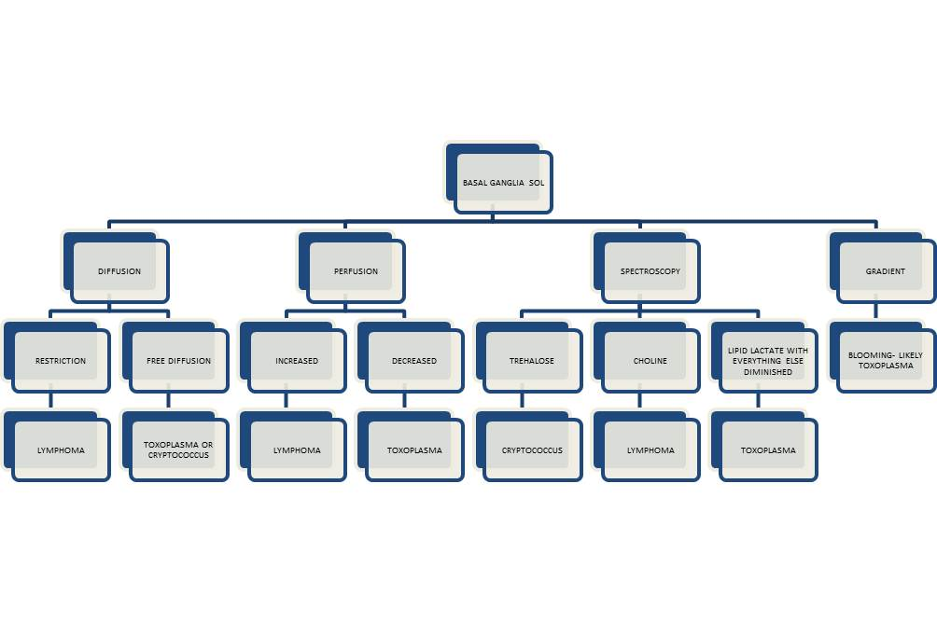
Reduced diffusion with increased perfusion points to an infective etiology. Reduced diffusion with decreased perfusion characterizes ischemic events.The further characterization of infection is typically based on characteristic neuro-anatomic location of the lesion on T2/ FLAIR/ DWI (Figure 20)^{[2,16]}. Prion disease can also show similar imaging manifestation. The imaging appearance of these encephalitis may be fairly non-specific. The dengue virus has been reported to show imaging features similar to Japanese encephalitis^{[17]} in regions where this virus is common. Cytomegalovirus can also show non-specific manifestations, though the predominant involvement of grey matter (more than white matter) is an important differentiating feature^{[1]}. The presence of a pencil-thin rim of enhancement in the subependymal region is considered to be a specific finding^{[1]}. Approach to lesions presenting with hyperintensity predominantly involving the Grey matteris presented as a flowchart in Figure 21.

WHITE MATTER HYPERINTENSITIES
The major diagnostic considerations are HIV encephalopathy (HIVE) and progressive multifocal leukoencephalopathy (PML) (Figure 22). Though both entities have characteristic imaging features on conventional MR sequences (Table 2), they may be difficult to differentiate due to overlapping features.

Magnetization transfer
Magnetization transfer (MT) reduction is seen in both PML and HIVE. In PML, it is due to demyelination whereas in HIVE it is primarily related to gliosis. Thus larger reduction in MT has been observed in PML as compared to HIVE^{[18]}.The major role of MT sequence in this setting is in early detection of disease.

Diffusion and diffusion tensor imaging
Fractional anisotropy (FA) is seen to be reduced in HIVE and PML before the morphologic changes in conventional sequences^{[19]}. Reduced diffusion is seen in the periphery and free diffusion in the centre of PML lesions^{[12]} (Figure 23).

MRS
Reduction of N-acetylaspartate (NAA) is seen in HIVE even before the onset of symptoms. Raised choline and myoinositol is also seen in the spectra. A summary of suggested approach to these white matter lesions is presented as a flowchart in Figure 24.

CONCLUSION
Imaging features of CNS infections constitute a complex myriad. Their classification based on conventional MRI sequences, may provide a quick guide to narrowing the differential diagnosis followed by further sub-differentiation into single etiology using advanced MRI sequences and techniques.

REFERENCES
1 Aiken AH. Central nervous system infection. Neuroimaging Clin N Am 2010; 20: 557-580 [PMID: 20974376 DOI: 10.1016/j.nic.2010.07.011]
2 Whiteman ML, Bowen BC, Post MJ, Bell MD. Intracranial infections. In Scott W Atlas, editor. Magnetic Resonance Imaging of Brain and Spine. 3rd ed. Lippincott Williams and Wilkins: Philadelphia: 2002.p 1099-177
3 Toh CH, Wei KC, Chang CN, Hsu PW, Wong HF, Ng SH, Castillo M, Lin CP. Differentiation of pyogenic brain abscesses from necrotic glioblastomas with use of susceptibility-weighted imaging. AJNR Am J Neuroradiol 2012; 33: 1534-1538 [PMID: 22422181 DOI: 10.3174/ajnr.A2986]
4 Desprechins B, Stadnik T, Koerts G, Shabana W, Breucq C, Osteaux M. Use of diffusion-weighted MR imaging in differential diagnosis between intracerebral necrotic tumors and cerebral abscesses. AJNR Am J Neuroradiol 1999; 20: 1252-1257 [PMID: 10472982]
5 Luthra G, Parihar A, Nath K, Jaiswal S, Prasad KN, Husain N, Husain M, Singh S, Behari S, Gupta RK. Comparative evaluation of fungal, tubercular, and pyogenic brain abscesses with conventional and diffusion MR imaging and proton MR spectroscopy. AJNR Am J Neuroradiol 2007; 28: 1332-1338 [PMID: 17698537 DOI: 10.3174/ajnr.A0548]
6 Gaviani P, Schwartz RB, Hedley-Whyte ET, Ligon KL, Robicsek A, Schaefer P, Henson JW. Diffusion-weighted imaging of fungal cerebral infection. AJNR Am J Neuroradiol 2005; 26: 1115-1121 [PMID: 15891169]
7 Lai PH, Ho JT, Chen WL, Hsu SS, Wang JS, Pan HB, Yang CF. Brain abscess and necrotic brain tumor: discrimination with proton MR spectroscopy and diffusion-weighted imaging. AJNR Am J Neuroradiol 2002; 23: 1369-1377 [PMID: 12223380]
8 Gupta RK, Roy R, Dev R, Husain M, Poptani H, Pandey R, Kishore J, Bhaduri AP. Finger printing of Mycobacterium tuberculosis in patients with intracranial tuberculomas by using in vivo, ex vivo, and in vitro magnetic resonance spectroscopy. Magn Reson Med 1996; 36: 829-833 [PMID: 8946348]
9 Lai PH, Weng HH, Chen CY, Hsu SS, Ding S, Ko CW, Fu JH, Liang HL, Chen KH. In vivo differentiation of aerobic brain abscesses and necrotic glioblastomas multiforme using proton MR spectroscopic imaging. AJNR Am J Neuroradiol 2008; 29: 1511-1518 [PMID: 18499784 DOI: 10.3174/ajnr.A1130]
10 Trivedi R, Saksena S, Gupta RK. Magnetic resonance imaging in central nervous system tuberculosis. Indian J Radiol Imaging 2009; 19: 256-265 [PMID: 19881100 DOI: 10.4103/0971-3026.57205]
11 Jain KK, Mittal SK, Kumar S, Gupta RK. Imaging features of central nervous system fungal infections. Neurol India 2007; 55: 241-250 [PMID: 17921653]
12 Smith AB, Smirniotopoulos JG, Rushing EJ. From the archives of the AFIP: central nervous system infections associated with human immunodeficiency virus infection: radiologic-pathologic correlation. Radiographics 2008; 28: 2033-2058 [PMID: 19001657 DOI: 10.1148/rg.287085135]
13 Lee GT, Antelo F, Mlikotic AA. Best cases from the AFIP: cerebral toxoplasmosis. Radiographics 2009; 29: 1200-1205 [PMID: 19605667 DOI: 10.1148/rg.294085205]
14 Ho TL, Lee HJ, Lee KW, Chen WL. Diffusion-weighted and conventional magnetic resonance imaging in cerebral cryptococcoma. Acta Radiol 2005; 46: 411-414 [PMID: 16134319]
15 Trenkwalder P, Trenkwalder C, Feiden W, Vogl TJ, Einhäupl KM, Lydtin H. Toxoplasmosis with early intracerebral hemorrhage in a patient with the acquired immunodeficiency syndrome. Neurology 1992; 42: 436-438 [PMID: 1736179]
16 Ukisu R, Kushihashi T, Tanaka E, Baba M, Usui N, Fujisawa H, Takenaka H. Diffusion-weighted MR imaging of early-stage Creutzfeldt-Jakob disease: typical and atypical manifestations. Radiographics 2006; 26 Suppl 1: S191-S204 [PMID: 17050516 DOI: 10.1148/rg.26si065503]
17 Borawake K, Prayag P, Wagh A, Dole S. Dengue encephalitis. Indian J Crit Care Med 2011; 15: 190-193 [PMID: 22013316 DOI: 10.4103/0972-5229.84896]
18 Ernst T, Chang L, Witt M, Walot I, Aronow H, Leonido-Yee M, Singer E. Progressive multifocal leukoencephalopathy and human immunodeficiency virus-associated white matter lesions in AIDS: magnetization transfer MR imaging. Radiology 1999; 210: 539-543 [PMID: 10207441]
19 Pomara N, Crandall DT, Choi SJ, Johnson G, Lim KO. White matter abnormalities in HIV-1 infection: a diffusion tensor imaging study. Psychiatry Res 2001; 106: 15-24 [PMID: 11231096]

P-Reviewer: Asensi VC, Mueller WC, Radenovic L S-Editor: Wen LL
L-Editor: E-Editor:

Figure 1 Classification of abnormalities on conventional magnetic resonance imaging sequences in suspected central nervous system infections.

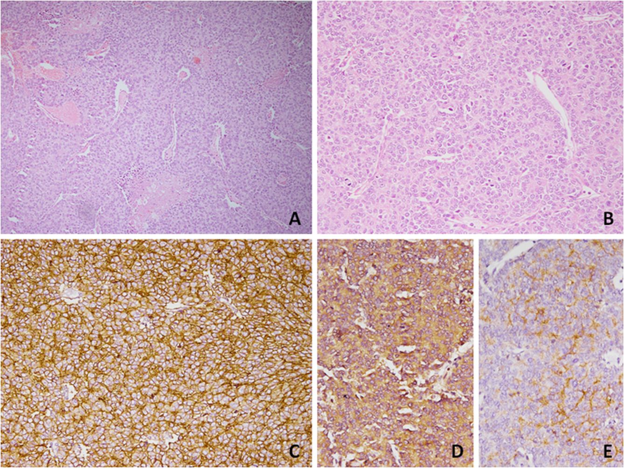
Figure 2 Ring enhancing lesions. T1 (A), T2 (B) and T1 (C) post gadolinium images from the magnetic resonance of an acutely ill child with fever. A ring enhancing lesion is seen in the right frontal lobe. This patient had a bacterial brain abscess. The differential diagnosis of this appearance would include a brain abscess of any etiology.

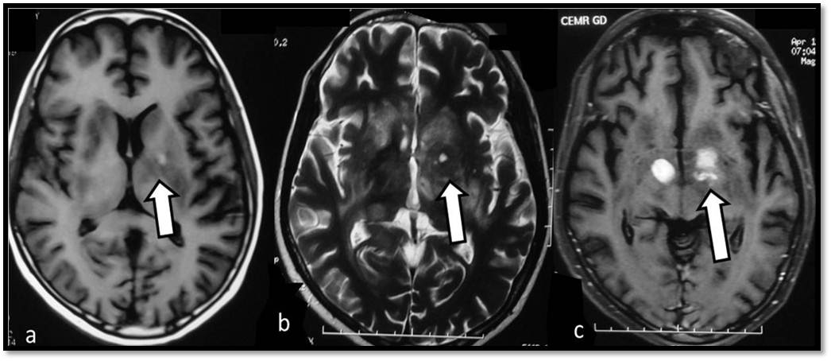
Figure 3 T1 (A), T2 (B) and Post gadolinium T1 (C) weighted images in an human immunodeficiency virus-positive patient with space occupying lesions in bilateral basal ganglia. Differentials for this appearance in such a patient would include Toxoplasmosis, Cryptococcosis as well as central nervous system (CNS) lymphoma. This patient had CNS lymphoma.

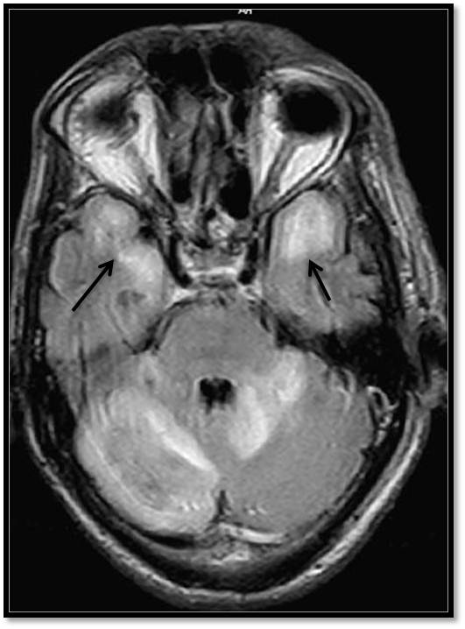

Figure 4 Fluid Attenuated Inversion Recovery Sequence in a patient with fever and altered sensorium shows hyperintensity predominantly in the grey matter of both temporal lobes and also in cerebellum. This patient was diagnosed with Japanese B Encephalitis. A similar picture may be seen in other viral encephalitis including herpes encephalitis.

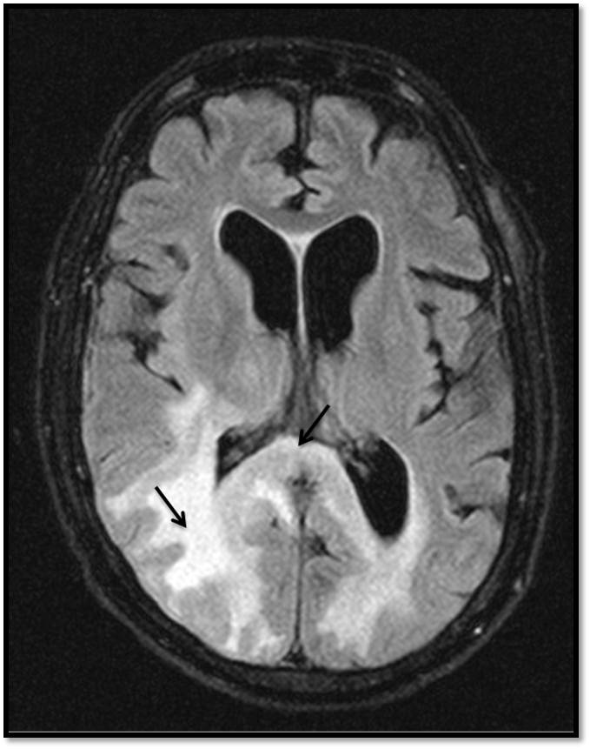
Figure 5 Fluid Attenuated Inversion Recovery Sequence image of a human immunodeficiency virus-positive patient shows hyperintensity predominantly involving the occipital white matter and splenium. The differential diagnosis for such an appearance would include human immunodeficiency virus encephalopathy, progressive multifocal leukoencephalopathy (PML) well as other demyelinating conditions. This patient had PML.

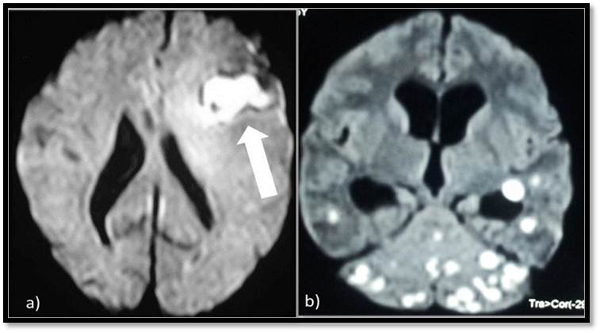
Figure 6 Diffusion weighted images show central restriction of diffusion in bacterial abscess (A) and tuberculomas (B).

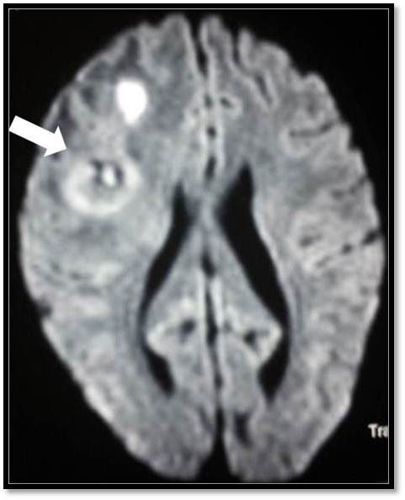
Figure 7 Diffusion weighted image in a diabetic patient shows diffusion restriction in the wall and intra-cavitary projection (arrow) in the centre of a fungal abscess.
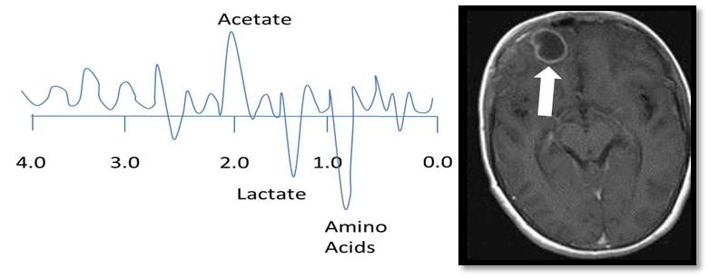
Figure 8 Representation of spectrum of metabolites in a bacterial abscess. Proton magnetic resonance spectroscopy obtained at a TE of 30 milliseconds shows the presence of amino acids. Succinate and acetate are seen in anaerobic abscesses.

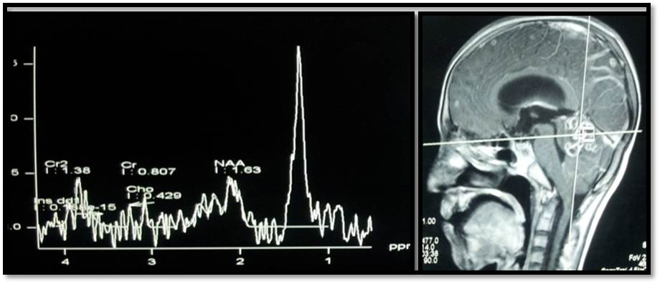
Figure 9 Proton spectroscopy at echo time of 135 ms from a tuberculoma shows a lipid peak at 1.3 ppm.

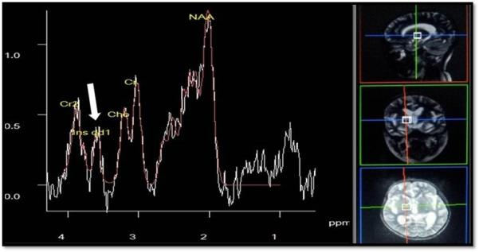
Figure 10 Proton magnetic resonance spectroscopy at TE of 30 ms shows multiple peaks between 3.6 and 3.8 ppm in the spectrum obtained from a cryptococcoma (fungus) representative oftrehalose peak.

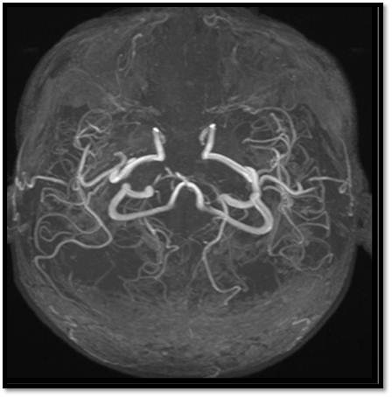
Figure 11 Time of Flight magnetic resonance angiography in a patient with tubercular meningitis. Bilateral anterior cerebral arteries are not seen whereas bilateral middle cerebral arteries aremarkedly attenuated suggesting vasculitis. The patient presented with extensive cerebral infarction.

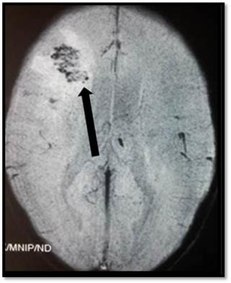
Figure 12 Foci of blooming (arrow) noted within the abscess is suggestive of haemorrhage and points to a fungal cause.

RULE OUT NEOPLASM
CHOLINE
Figure 13 Approach to ring enhancing lesions.

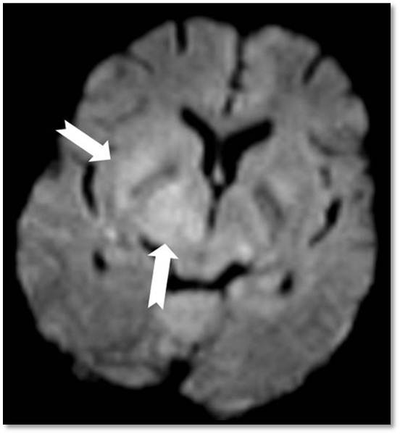
Figure 14 Diffusion weighted image from the Brain magnetic resonance imaging of an human immunodeficiency virus-positive patient with lymphoma shows restriction in the right lentiform nucleus and the thalamus.

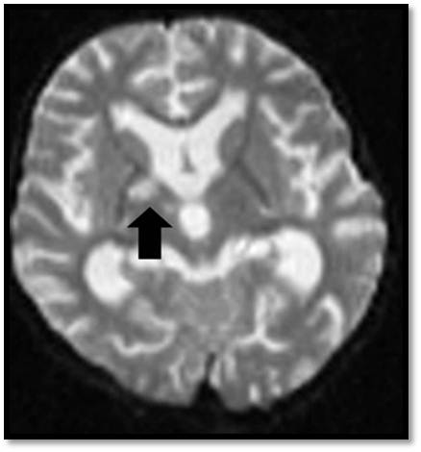
Figure 15 Apparent diffusion coefficient map showing free diffusion within a cryptococcoma (arrow) in a human immunodeficiency virus-positive patient.

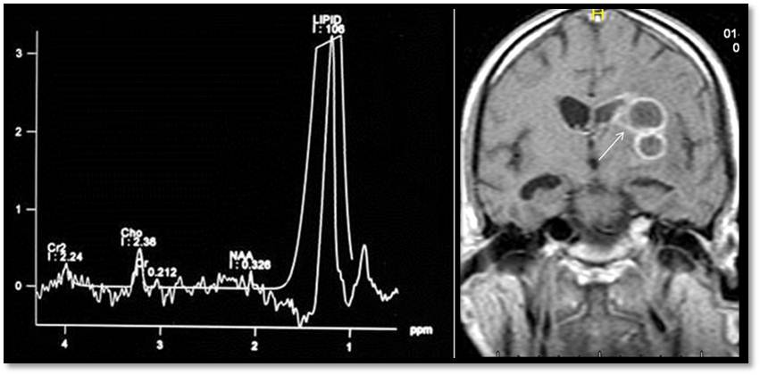
Figure 16 Proton magnetic resonance spectroscopy at echo time of 30 ms in a patient with toxoplasmosis shows a lipid lactate peak with diminished levels of all other metabolites.

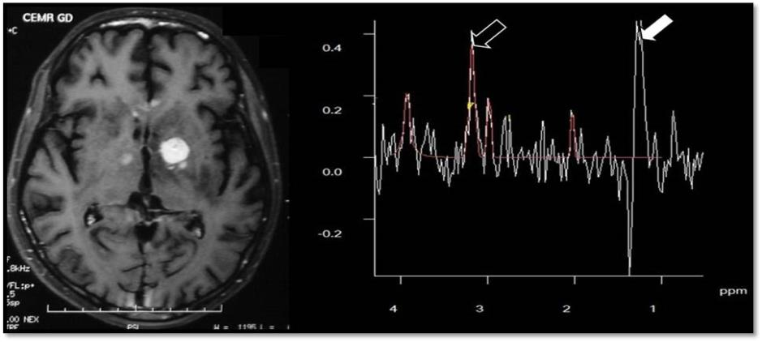
Figure 17 Proton magnetic resonance spectroscopy at echo time of 135 ms in a patient with primary central nervous system Lymphoma of basal ganglia showing elevated lipid, lactate (white arrow) and choline (open arrow).

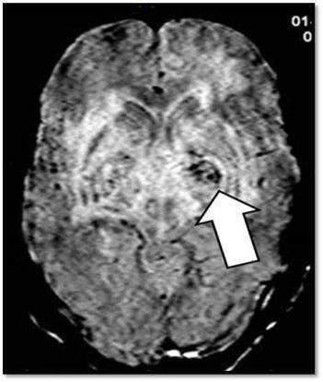
Figure 18 Gradient echo image in a patient with toxoplasmosis shows foci of blooming (arrow) suggestive of haemorrhage.

Figure 19 Approach to space occupying lesions in the basal ganglia.

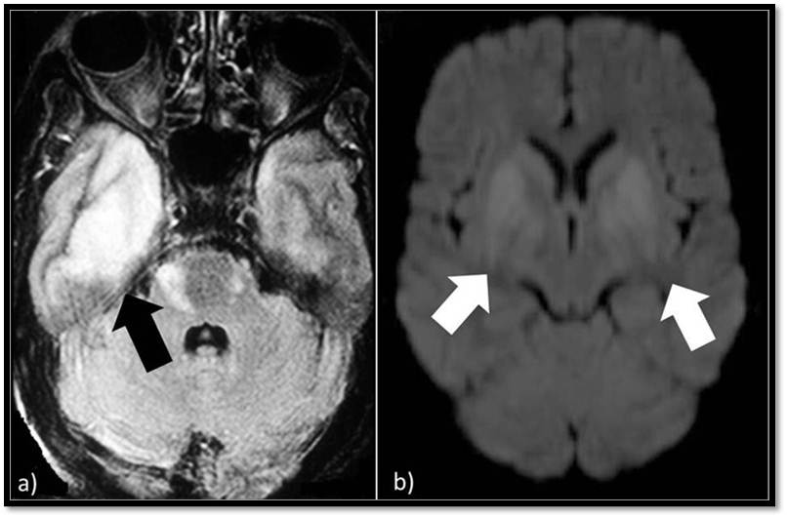
Figure 20 Fluid Attenuated Inversion Recovery Sequence hyperintensity (A) involving right temporal lobe (black arrow) in a patient with Herpes simplex virus encephalitis, diffusion weighted imaging (B) in a patient with Japanese encephalitis showing restricted diffusion in bilateral basal ganglia.

Figure 21 Approach to lesions presenting with hyperintensity predominantly involving the Grey matter.

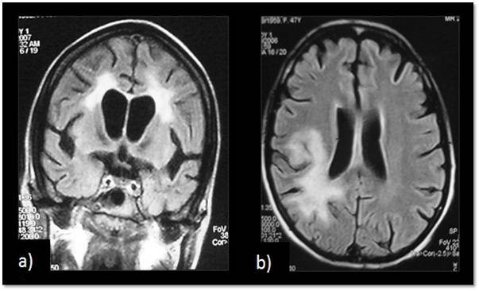
Figure 22 Fluid Attenuated Inversion Recovery Sequence image of a patient with (A) human immunodeficiency virus encephalopathy showing symmetrical periventricular white matter hyperintensity and (B) progressive multifocal leukoencephalopathy showing asymmetrical involvement of white matter, predominantly posterior subcortical white matter, with extension into the periventricularregion.

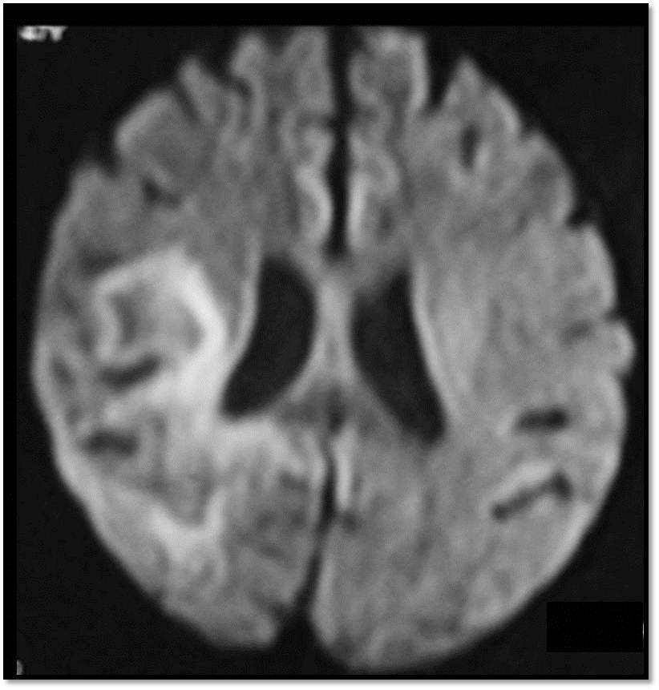
Figure 23 Diffusion weighted image in a patient with progressive multifocal leukoencephalopathy showing peripheral diffusion restriction.

Figure 24 Approach to lesions presenting with hyperintensity predominantly involving the white matter. PML: Progressive multifocal leukoencephalopathy; HIV: Human immunodeficiency virus.

Table 1 This differentiation is aided by diffusion and perfusion sequences
 | Diffusion | Perfusion
Infection | Restricted | Increased
Infarction | Restricted | Decreased

Table 2 Role of additional sequences
 | T1 | T2 | T1 +contrast
HIV Encephalopathy | Isointense | Bilaterally symmetrical periventricular white matter hyperintensities | No enhancement
PML | Hypointense | Asymmetrical lesions involving subcortical and periventricular white matter | Faint peripheral areas of enhancement may sometimes be seen

HIVE: Human immunodeficiency virus encephalopathy.

