Name of Journal: World Journal of Clinical Cases
Manuscript NO: 59213
Manuscript Type: CASE REPORT

Radical resection of hepatic polycystic echinococcosis complicated with hepatocellular carcinoma: A case report

Kalifu B et al. Hepatic cystic echinococcosis complicated with HCC

Baheti Kalifu, Yuan Meng, Yusufukadier Maimaitinijiati, Zhi-Gang Ma, Guang-Lei Tian, Jin-Guo Wang, Xiong Chen

Baheti Kalifu, Yuan Meng, Yusufukadier Maimaitinijiati, Zhi-Gang Ma, Guang-Lei Tian, Jin-Guo Wang, Xiong Chen, Department of Hepatobiliary Surgery, People’s Hospital of Xinjiang Uygur Autonomous Region, Urumqi 830001, Xinjiang Uygur Autonomous Region, China

Author contributions: Kalifu B and Maimaitinijiati Y designed and wrote the manuscript; Meng Y and Ma ZG performed the operation; Wang JG and Tian GL contributed to provision of study material; Chen X contributed to final approval of the version to be submitted; All authors have read and approve the final manuscript.

Supported by Project Plan of People’s Hospital of Xinjiang Uyghur Autonomous Region, No. 20190412 and No. 20190405.

Corresponding author: Xiong Chen, MD, PhD, Doctor, Department of Hepatobiliary Surgery, People’s Hospital of Xinjiang Uygur Autonomous Region, No. 91 Tianchi Road, Urumqi 830001, Xinjiang Uygur Autonomous Region, China. 1512237458@qq.com

Received: September 2, 2020
Revised: November 21, 2020
Accepted: December 6, 2020
Published online: January 26, 2021

Abstract
BACKGROUND
Hepatic cystic echinococcosis (CE) is an infectious zoonotic parasitic disease, and the insidious onset and slow progression of hepatic CE usually contributes to delayed diagnosis and treatment. Hepatocellular carcinoma (HCC) is the fourth most common malignant tumor. Co-existence of CE and HCC is fairly rare in clinical settings and the association between the two is still not well recognized. We report a case of hepatic CE complicated with HCC which are radically resected and raise some questions worth thinking about.

CASE SUMMARY
A 70-year-old man presented with upper abdominal pain. On admission, laboratory data showed that, except for hepatitis B surface antigen positivity, other indicators were normal, including alpha-fetoprotein. Computed tomography of the abdomen revealed a huge polycystic lesion in left liver lobe, without reinforcement after enhanced scanning and sized about 16.9 cm × 12.2 cm, which was considered a type II hydatid cyst. Multiple small solid lesions were also found adjacent to it, and thus it was highly suspected as a malignant tumor. After a multidisciplinary team discussion, the diagnosis of co-occurrence of hepatic CE and HCC was made. According to Romic classification, the case belongs to type IIb, and radical left hemi-hepatectomy was performed. Postoperative pathological examination revealed CE co-existence with well-differentiated HCC, consistent with the preoperative diagnosis.

CONCLUSION
With the combination of hepatitis B and obvious extrusion by large hydatid, the HCC risk of a patient might be higher.

Key Words: Hepatocellular carcinoma; Cystic echinococcosis; Radical resection; Co-existence; Parasitic disease; Case report; Hepatitis B

©The Author(s) 2021. Published by Baishideng Publishing Group Inc. All rights reserved.

Citation: Kalifu B, Meng Y, Maimaitinijiati Y, Ma ZG, Tian GL, Wang JG, Chen X. Radical resection of hepatic polycystic echinococcosis complicated with hepatocellular carcinoma: A case report. World J Clin Cases 2021; 9(3): 659-665
URL: https://www.wjgnet.com/2307-8960/full/v9/i3/659.htm
DOI: https://dx.doi.org/10.12998/wjcc.v9.i3.659

Core Tip: Hepatic cystic echinococcosis (CE) is an infectious zoonotic parasitic disease, hepatocellular carcinoma (HCC) is the fourth most common malignant tumor. Co-existence of CE and HCC is fairly rare in clinical settings and the association between the two is still not well recognized. We report a case of hepatic CE complicated with HCC which are radically resected, and present an opinion that with the combination of hepatitis B and obvious extrusion by large hydatid, the HCC risk of the patients might be higher.
INTRODUCTION
Cystic echinococcosis (CE) is caused by Echinococcus granulosus (E. granulosus), an infectious parasitic disease. Liver is the most affected organ due to the special life cycle of E. granulosus^{[1,2]}. In recent years, with the development of tourism and the movement of populations, hepatic CE has become a serious public health problem around the world. In endemic areas, the incidence of cystic hydatid disease is 1-200/100000 per year, and fatality rate has been reported as 2%-4%^{[3]}. Hepatocellular carcinoma (HCC) is the most frequent primary liver cancer, accounting for more than 85%-90% of them, and is a leading cause of cancer-related mortality^{[4]}. Although both are hepatic space-occupying diseases, it is rare to co-occur, due to their biological characteristics. There have been few reports concerning hepatic CE accompanied by HCC^{[5,6]}. Whether hydatid infection impacts the occurrence and progression of HCC is still unclear.
Here, we share a case of huge hepatic CE lesion complicated with HCC, and present some controversial issues with detailed discussion.

CASE PRESENTATION
Chief complaints
A 70-year-old man presented to The Department of Hepatobiliary Surgery, People’s Hospital of Xinjiang Uygur Autonomous Region, with complaint of upper abdominal pain for 2 wk.

History of present illness
The patient had upper abdominal pain for 2 wk, and no another special discomfort symptom.

History of past illness
The patient had no significant past illness.

Personal and family history
The patient had no significant personal and family history.

Physical examination
The physical examination was significant for pain in the right upper quadrant upon palpation.

Laboratory examinations
All laboratory testing, including glutamic-pyruvic transaminase, glutamic-oxalacetic transaminase, gamma-glutamyl transpeptidase, and alpha-fetoprotein, was normal, except for positivity for hepatitis B surface antigen.

Imaging examinations
Computed tomography of the abdomen revealed a huge polycystic lesion in left liver lobe, without reinforcement after enhanced scanning, sized about 16.9 cm × 12.2 cm (Figure 1), which was considered a type II hydatid cyst^{[7]}. Multiple small solid lesions were also found adjacent to it, and thus it was highly suspected as malignant tumor.

MULTIDISCIPLINARY EXPERT CONSULTATION
After a multidisciplinary team discussion, the preoperative diagnosis was made of co-occurrence of hepatic polycystic echinococcosis and HCC. According to Romic classification^{[8]}, the case was type IIb. The postoperative pathological examination revealed CE co-existence with well-differentiated HCC (Figure 2), consistent with the preoperative diagnosis.

FINAL DIAGNOSIS
Co-occurrence of hepatic polycystic echinococcosis and HCC.

TREATMENT
Radical left hemi-hepatectomy was performed (Figure 3).

OUTCOME AND FOLLOW-UP
The patient recovered and was discharged on the eighth day after the operation and no treatment was received after discharge. The magnetic resonance imaging conducted at 3 mo after surgery showed no significant recurrence of the lesion (Figure 4).

DISCUSSION
Hepatic CE and HCC are both liver space-occupying diseases with high incidence, whereas the concomitant presence of hepatic CE and HCC is a fairly rare scenario, leaving evidence-based options of treatments unavailable worldwide. Based on the World Health Organization Informal Working Group on Echinococcosis (known as WHO-IWGE) international classification^{[7]}, the current case belongs to the type II hydatid cysts, for which radical resection is recommended to be performed in the guideline. The BCLC staging system is the method currently used to stage HCC and widely accepted as a therapeutic guidance. For the current patient, there were more than three tumors with the size of 35 mm, and the case was considered as intermediate-staged HCC (stage B); furthermore, the lesions were located in the same lobe of the liver. Hemihepatectomy is advised by the European Association for the Study of the Liver clinical practice guideline^{[9]} and the American guideline (2018)^{[10]} for such cases. By applying the guidelines for both diseases, the radical left hemihepatectomy was performed and albendazole therapy for CE and HCC adjuvant therapy were not recommended after surgery. In addition, entecavir was administered since the hepatitis B surface antigen test was positive.
To our knowledge, there are few studies on co-infection of CE and HCC and the association between the two is still not well recognized. There are 25 cases reported concerning concomitant HCC and echinococcal cysts in the scientific literature worldwide and 20 of them have provided sufficient data for review analysis. The patients represent 12 males and 8 females, aged from 27 years to 82 years, with an average age of 67. Fifteen of them had underlying chronic liver diseases. It has been reported that CE infection may lead to the development of liver carcinoma^{[11,12]}. By contrast, van Knapen^{[13]} put forward the hypothesis that echinococcus infection could suppress tumor growth. Recently, Bo et al^{[14]} reported 13 patients with co-existence of hepatic CE and HCC, being the report with the largest number of cases at present. Those authors consider that E. granulosus may elicit a protective effect against the development and progression of HCC.
The most common cause of HCC is liver cirrhosis caused by hepatitis and other causes^{[15]}. Although our case showed evidence of hepatitis B, there was no cirrhosis or elevation of alpha-fetoprotein. In addition, the tumors were located in the hydatid peripheral normal liver tissues, and there was no tumor in the right lobe of the liver. Therefore, we speculate that a chronic inflammatory reaction of liver tissue around the cyst, especially in the extruded area, may have led to increased risk of HCC development.

CONCLUSION
Based on the case and literature review described herein, the current knowledge may raise a hypothesis that human CE may induce the development of HCC, and increased cyst size and hepatitis B may increase the risk of such. When there is combination of hepatitis B and obvious extrusion by a large hydatid, the HCC risk of the patients might be higher. Nonetheless, further studies are needed to clarify the assumption.

REFERENCES
1 Wen H, Vuitton L, Tuxun T, Li J, Vuitton DA, Zhang W, McManus DP. Echinococcosis: Advances in the 21st Century. Clin Microbiol Rev 2019; 32 [PMID: 30760475 DOI: 10.1128/CMR.00075-18]
2 Kern P, Menezes da Silva A, Akhan O, Müllhaupt B, Vizcaychipi KA, Budke C, Vuitton DA. The Echinococcoses: Diagnosis, Clinical Management and Burden of Disease. Adv Parasitol 2017; 96: 259-369 [PMID: 28212790 DOI: 10.1016/bs.apar.2016.09.006]
3 Deplazes P, Rinaldi L, Alvarez Rojas CA, Torgerson PR, Harandi MF, Romig T, Antolova D, Schurer JM, Lahmar S, Cringoli G, Magambo J, Thompson RC, Jenkins EJ. Global Distribution of Alveolar and Cystic Echinococcosis. Adv Parasitol 2017; 95: 315-493 [PMID: 28131365 DOI: 10.1016/bs.apar.2016.11.001]
4 Global Burden of Disease Cancer Collaboration., Fitzmaurice C, Allen C, Barber RM, Barregard L, Bhutta ZA, Brenner H, Dicker DJ, Chimed-Orchir O, Dandona R, Dandona L, Fleming T, Forouzanfar MH, Hancock J, Hay RJ, Hunter-Merrill R, Huynh C, Hosgood HD, Johnson CO, Jonas JB, Khubchandani J, Kumar GA, Kutz M, Lan Q, Larson HJ, Liang X, Lim SS, Lopez AD, MacIntyre MF, Marczak L, Marquez N, Mokdad AH, Pinho C, Pourmalek F, Salomon JA, Sanabria JR, Sandar L, Sartorius B, Schwartz SM, Shackelford KA, Shibuya K, Stanaway J, Steiner C, Sun J, Takahashi K, Vollset SE, Vos T, Wagner JA, Wang H, Westerman R, Zeeb H, Zoeckler L, Abd-Allah F, Ahmed MB, Alabed S, Alam NK, Aldhahri SF, Alem G, Alemayohu MA, Ali R, Al-Raddadi R, Amare A, Amoako Y, Artaman A, Asayesh H, Atnafu N, Awasthi A, Saleem HB, Barac A, Bedi N, Bensenor I, Berhane A, Bernabé E, Betsu B, Binagwaho A, Boneya D, Campos-Nonato I, Castañeda-Orjuela C, Catalá-López F, Chiang P, Chibueze C, Chitheer A, Choi JY, Cowie B, Damtew S, das Neves J, Dey S, Dharmaratne S, Dhillon P, Ding E, Driscoll T, Ekwueme D, Endries AY, Farvid M, Farzadfar F, Fernandes J, Fischer F, G/Hiwot TT, Gebru A, Gopalani S, Hailu A, Horino M, Horita N, Husseini A, Huybrechts I, Inoue M, Islami F, Jakovljevic M, James S, Javanbakht M, Jee SH, Kasaeian A, Kedir MS, Khader YS, Khang YH, Kim D, Leigh J, Linn S, Lunevicius R, El Razek HMA, Malekzadeh R, Malta DC, Marcenes W, Markos D, Melaku YA, Meles KG, Mendoza W, Mengiste DT, Meretoja TJ, Miller TR, Mohammad KA, Mohammadi A, Mohammed S, Moradi-Lakeh M, Nagel G, Nand D, Le Nguyen Q, Nolte S, Ogbo FA, Oladimeji KE, Oren E, Pa M, Park EK, Pereira DM, Plass D, Qorbani M, Radfar A, Rafay A, Rahman M, Rana SM, Søreide K, Satpathy M, Sawhney M, Sepanlou SG, Shaikh MA, She J, Shiue I, Shore HR, Shrime MG, So S, Soneji S, Stathopoulou V, Stroumpoulis K, Sufiyan MB, Sykes BL, Tabarés-Seisdedos R, Tadese F, Tedla BA, Tessema GA, Thakur JS, Tran BX, Ukwaja KN, Uzochukwu BSC, Vlassov VV, Weiderpass E, Wubshet Terefe M, Yebyo HG, Yimam HH, Yonemoto N, Younis MZ, Yu C, Zaidi Z, Zaki MES, Zenebe ZM, Murray CJL, Naghavi M. Global, Regional, and National Cancer Incidence, Mortality, Years of Life Lost, Years Lived With Disability, and Disability-Adjusted Life-years for 32 Cancer Groups, 1990 to 2015: A Systematic Analysis for the Global Burden of Disease Study. JAMA Oncol 2017; 3: 524-548 [PMID: 27918777 DOI: 10.1001/jamaoncol.2016.5688]
5 Sygut A, Górski A, Dziki A. [A case of coexistence of primary cancer of the liver and hepatic echinococcosis]. Wiad Lek 1987; 40: 826-828 [PMID: 2825436]
6 Kato T, Seino Y, Takada K, Maruya M, Okubo S, Nakamura H, Inoue Y, Meguro T, Horita S, Oshikiri T, Yamada H, Miyasaka Y, Fujita M, Morita T, Yoshida T, Chikai K. [A resectable case of hepatocellular carcinoma complicated with hepatic alveolar echinococcosis]. Nihon Shokakibyo Gakkai Zasshi 2003; 100: 587-592 [PMID: 12772575]
7 WHO Informal Working Group. International classification of ultrasound images in cystic echinococcosis for application in clinical and field epidemiological settings. Acta Trop 2003; 85: 253-261 [PMID: 12606104 DOI: 10.1016/S0001-706X(02)00223-1]
8 Romic B, Romic I, Petrovic I, Romic M, Romic R, Romic M, Mance M, Pavlek G; -. A Synchronous Occurrence of Hepatocellular Carcinoma and Echinoccocal Liver Cyst - Can Parasite Promote Carcinogenesis? Literature Review and Classification Proposal. Chirurgia (Bucur) 2016; 111: 297-303 [PMID: 27604665]
9 European Association for the Study of the Liver; European Association for the Study of the Liver. EASL Clinical Practice Guidelines: Management of hepatocellular carcinoma. J Hepatol 2018; 69: 182-236 [PMID: 29628281 DOI: 10.1016/j.jhep.2018.03.019]
10 Marrero JA, Kulik LM, Sirlin CB, Zhu AX, Finn RS, Abecassis MM, Roberts LR, Heimbach JK. Diagnosis, Staging, and Management of Hepatocellular Carcinoma: 2018 Practice Guidance by the American Association for the Study of Liver Diseases. Hepatology 2018; 68: 723-750 [PMID: 29624699 DOI: 10.1002/hep.29913]
11 Li H, Song T, Shao Y, Wen H. Cystic echinococcosis accompanied by hepatocellular carcinoma in a female herdsman. Int J Clin Exp Med 2015; 8: 2985-2988 [PMID: 25932268]
12 Oikonomopoulou K, Yu H, Wang Z, Vasiliou SK, Brinc D, Christofi G, Theodorou M, Pavlou P, Hadjisavvas A, Demetriou CA, Kyriacou K, Diamandis EP. Association between Echinococcus granulosus infection and cancer risk - a pilot study in Cyprus. Clin Chem Lab Med 2016; 54: 1955-1961 [PMID: 27327131 DOI: 10.1515/cclm-2016-0125]
13 van Knapen F. Echinococcus granulosus infection and malignancy. Br Med J 1980; 281: 195-196 [PMID: 7407519 DOI: 10.1136/bmj.281.6234.195]
14 Bo R, Yasen A, Shao Y, Zhang W, Lin R, Jiang T, Wen H, Xiao H, Aji T. Co-existence of hepatocellular carcinoma and cystic echinococcosis. Infect Agent Cancer 2020; 15: 5 [PMID: 32010203 DOI: 10.1186/s13027-020-0275-0]
15 El-Serag HB. Hepatocellular carcinoma. N Engl J Med 2011; 365: 1118-1127 [PMID: 21992124 DOI: 10.1056/NEJMra1001683]

Footnotes
Informed consent statement: All study participants, or their legal guardian, provided informed written consent prior to study enrollment.

Conflict-of-interest statement: The authors declare that they have no conflicts of interest.

CARE Checklist (2016) statement: The authors have read the CARE Checklist (2016), and the manuscript was prepared and revised according to the CARE Checklist (2016).

Open-Access: This article is an open-access article that was selected by an in-house editor and fully peer-reviewed by external reviewers. It is distributed in accordance with the Creative Commons Attribution NonCommercial (CC BY-NC 4.0) license, which permits others to distribute, remix, adapt, build upon this work non-commercially, and license their derivative works on different terms, provided the original work is properly cited and the use is non-commercial. See: http://creativecommons.org/Licenses/by-nc/4.0/

Manuscript source: Unsolicited manuscript

Peer-review started: September 2, 2020
First decision: November 8, 2020
Article in press: December 6, 2020

Specialty type: Medicine, research and experimental
Country/Territory of origin: China
Peer-review report’s scientific quality classification
Grade A (Excellent): 0
Grade B (Very good): 0
Grade C (Good): C, C
Grade D (Fair): D
Grade E (Poor): 0

P-Reviewer: El-Hawary AK, Hashimoto N S-Editor: Huang P L-Editor: Filipodia P-Editor: Li JH

Figure Legends
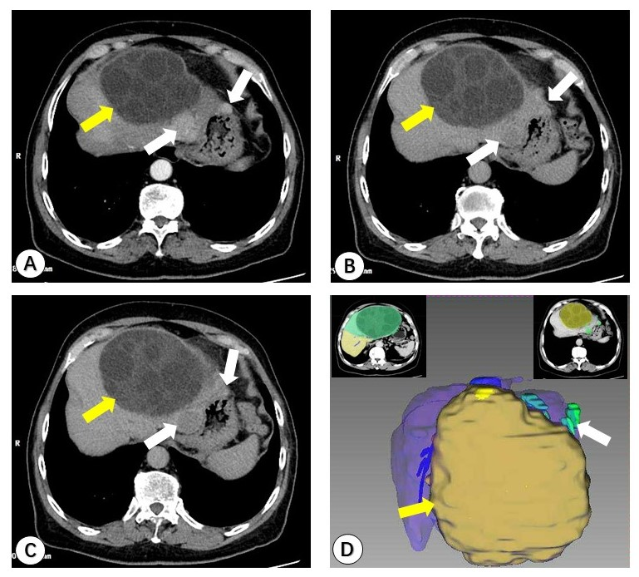
Figure 1 Preoperative images. A polycystic cystic echinococcosis (CE) lesion complicated with multiple hepatocellular carcinoma (HCC) nodules in the left lobe of liver (orange arrow represents hepatic CE lesion; white arrow represents HCC lesions). A: Computed tomography (CT) in the arterial phase showing obvious enhancement of the HCC lesions; B: The portal phase of CT revealed a washed-out pattern of the HCC lesions; C: A delayed CT scan showed HCC lesions without significantly retention; D: IQQA-Liver system three-dimensional reconstruction image.
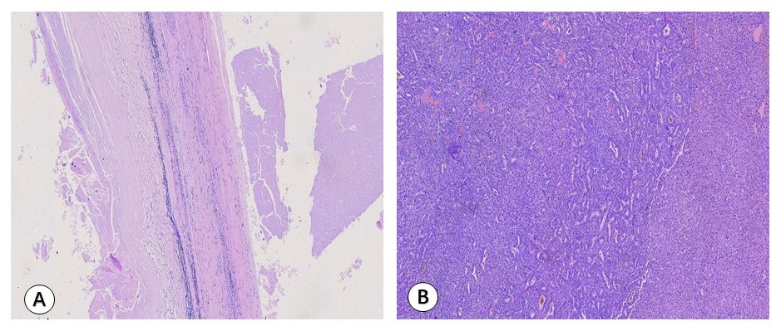
Figure 2 Microscopic histopathology images (× 100). A: Section of specimens showed complete cyst wall structure, consistent with histopathological characteristics of cystic echinococcosis; B: Multiple highly differentiated cancer cells are found in the section specimens.
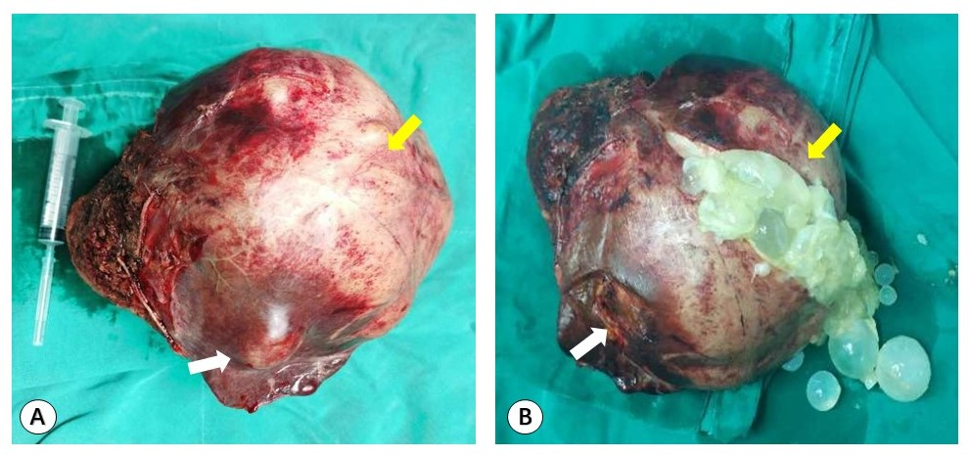
Figure 3 Intraoperative photos. A and B: The yellow arrows represent hepatic cystic echinococcosis lesions and the white arrows represent hepatocellular carcinoma lesions.
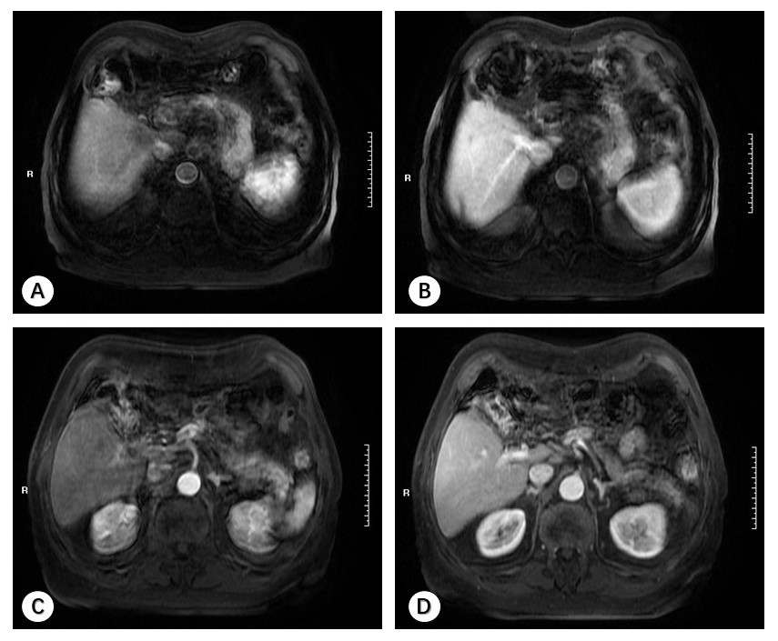
Figure 4 Magnetic resonance images 3 mo after surgery, showing no significant recurrence lesion (A-D).

Published by Baishideng Publishing Group Inc
7041 Koll Center Parkway, Suite 160, Pleasanton, CA 94566, USA
Telephone: +1-925-3991568
E-mail: bpgoffice@wjgnet.com
Help Desk: https://www.f6publishing.com/helpdesk
https://www.wjgnet.com

© 2021 Baishideng Publishing Group Inc. All rights reserved.

