STROBE Statement
We have downloaded the ’STROBE Statement‘ and checked the list of items that should be included in reports of observational studies.
We have completed the checklist to make sure that the manuscript meets the requirements of the STROBE Statement.
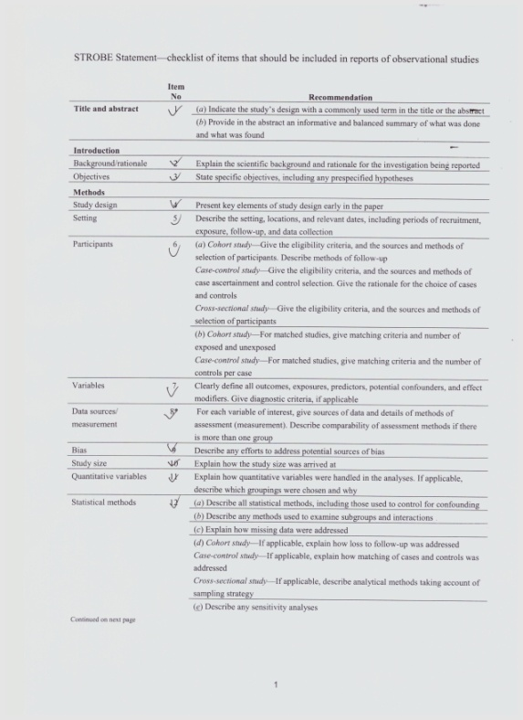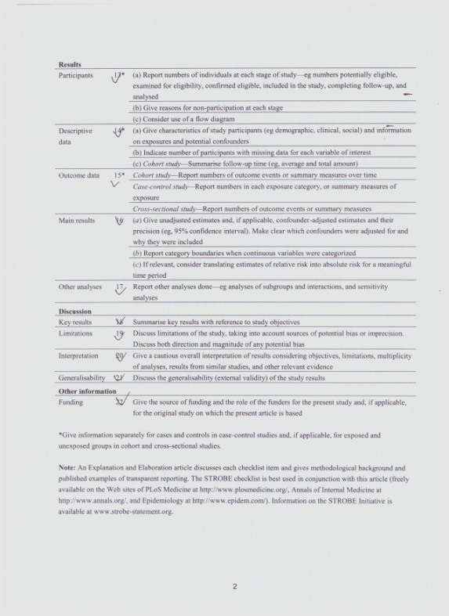
Chang-Ju Zhu
Address: Department of Emergency, the First Affiliated Hospital of Zhengzhou University, No.1 Eastern Jianshe Road, Zhengzhou 450052, Henan, China.
Email: zhuchangju98@163.com
Phone: +86-371-13939062157
Fax: +86-371-66975140

