Name of Journal: World Journal of Clinical Cases
Manuscript NO: 49318
Manuscript Type: CASE REPORT

Squamous cell carcinoma of the nail bed: a case report

Li PF et al. Nail bed SCC

Peng-Fei Li, Hui Lu*, Ning Zhu*
*Address Correspondance to:
Contributed equally

Peng-Fei Li, Department of Plastic and Aesthetic Center, The First Affiliated Hospital, School of Medicine, Zhejiang University, Hangzhou 310000, Zhejiang Province, China

Ning Zhu, Department of Ophthalmology, The First Affiliated Hospital, School of Medicine, Zhejiang University, Hangzhou 310000, Zhejiang Province, China

Hui Lu, Department of Orthopedics, The First Affiliated Hospital, School of Medicine, Zhejiang University, Hangzhou 310000, Zhejiang Province, China

ORCID number: Peng-Fei Li (0000-0001-6548-9829); Ning Zhu (0000-0002-3721-0293); Hui Lu (0000-0002-5921-1043).

Author contributions: Li PF drafted the manuscript and participated in the analysis of the study; Lu H helped carry out surgical intervention and care for the patient; Zhu N and Lu H participated in the design and coordination of the study, performed the analysis, and helped revise the manuscript; All authors read and approved the final manuscript.

Supported by the National Natural Science Foundation of China, No. 81702135; Zhejiang Medical Association Clinical Scientific Research Program, No. 2013ZYC-A19 and 2015ZYC-A12; Zhejiang Medicine and Hygiene Research Program, No. 2016KYB101 and 2015KYA100; Zhejiang Traditional Chinese Medicine Research Program, No. 2016ZA124 and 2017ZB057.

Informed consent statement: Informed written consent was obtained from the patient for publication of this report and any accompanying images.

Conflict-of-interest statement: The authors declare that they have no conflicts of interest.

CARE Checklist (2016) statement: The authors have read the CARE Checklist (2013), and the manuscript was prepared and revised according to the CARE Checklist (2016).

Open-Access: This article is an open-access article that was selected by an in-house editor and fully peer-reviewed by external reviewers. It is distributed in accordance with the Creative Commons Attribution Non Commercial (CC BY-NC 4.0) license, which permits others to distribute, remix, adapt, build upon this work non-commercially, and license their derivative works on different terms, provided the original work is properly cited and the use is non-commercial. See: http://creativecommons.org/licenses/by-nc/4.0/

Manuscript source: Unsolicited manuscript

Correspondence author: Ning Zhu, MD, Attending Doctor, Department of Ophthalmology, The First Affiliated Hospital, School of Medicine, Zhejiang University, No. 79 Qingchun Road, Hangzhou, Zhejiang Province 310003, China. Zhuning200118@zju.edu.cn
Hui Lu, MD, Attending Doctor, Department of Orthopedics, The First Affiliated Hospital, School of Medicine, Zhejiang University, No. 79 Qingchun Road, Hangzhou, Zhejiang Province 310003, China. huilu@zju.edu.cn
Telephone: +86-571-87236121

Received: May 31, 2019
Peer-review started: June 4, 2019
First decision: August 1, 2019
Revised: August 24, 2019
Accepted: September 11, 2019
Article in press:
Published online:

Abstract
BACKGROUND
Squamous cell carcinoma (SCC) of the nail bed is a poorly reported malignant subungual tumor. Because it presents with nonspecific symptoms and signs, it is frequently misdiagnosed by dermatologists or surgeons. A delay in diagnosis and/or wrong treatment might increase the possibility of disease progression. Thus, new perspectives are needed to assist dermatologists and surgeons with diagnosing and treating SCC. This rare case presented with a 2-year delay in the diagnosis of SCC teaches a valuable lesson.

CASE SUMMARY
A 62-year-old female presented with a non-healing subungual growth in the nail bed of the right middle finger for 2 years. The lesion was first medicated with iodine by the patient herself without any relief. Twenty months later, a dermatologist diagnosed the lesion as paronychia and treated it with nail avulsions repeatedly with no obvious alleviation. A lesionectomy confirmed the lesion was SCC. An extended excision of the tumor with amputation of the distal interphalangeal joint was subsequently performed. A biopsy of sentinel lymph nodes was negative. Due to the result of preoperative positron emission tomography-computed tomography scanning, sweeping of axillary lymph nodes was considered dispensable and was skipped. At the 2-year follow-up, the patient showed a quick recovery and no sign of recurrence.

CONCLUSION
Our successful diagnosis and treatment of the case highlights the need for additional attention to long-standing non-healing lesions of the nail bed and the necessity for discreet evaluation and customization of surgical interventions.

Key words: Squamous cell carcinoma; Nail bed lesion; Customized treatment; Malignant subungual tumor; Case report

© The Author(s) 2019. Published by Baishideng Publishing Group Inc. All rights reserved.

Core tip: Squamous cell carcinoma of the nail bed is a malignant subungual tumor that is poorly reported. Considering its nonspecific symptoms and signs, it is usually misdiagnosed by dermatologists or surgeons. We present herein, a rare case of squamous cell carcinoma in the nail bed in which the diagnosis was delayed by belated medical help and misdiagnosis. Our successful diagnosis and treatment of the case highlights the need for additional attention to long-standing non-healing lesions of the nail bed and the necessity for discreet evaluation and customization of surgical interventions.

Li PF, Lu H, Zhu N. Squamous cell carcinoma of the nail bed: a case report. World J Clin Cases 2019; In press

INTRODUCTION
Squamous cell carcinoma (SCC) of the nail bed is a poorly reported low-grade malignant tumor that preferentially involves the digits of hands^{[1,2]}. Risk factors for the development of SCC include trauma, chronic paronychia, chronic actinic damage, X-ray irradiation, burns, and chemical or virus exposure among others^{[3]}. Its resemblance to various common nail disorders and the lack of specific clinical signs or symptoms lead to frequent misdiagnoses or a long delay in finding a diagnosis^{[4]}. A delay in diagnosis and/or wrong treatment might increase the possibility of disease progression. We report a case of SCC of the nail bed in which diagnosis was delayed by 2 years. It highlights a necessity for dermatologists or surgeons to be sensitive to specific clinical conditions and for customized treatment for patients.

CASE PRESENTATION
Chief complaints
A 62-year-old female patient presented in our clinic complaining of a painful, non-healing subungual growth at the lateral nail fold of the right middle finger for 2 years.

History of present illness
There was no history of trauma or other possible causes. Initially, though the growth occurred along with intermittent pain, it did not attract the patient’s attention. She self-medicated the lesion with iodine without any relief. Four months prior to our visit, she consulted a dermatologist who treated her twice for chronic paronychia by nail avulsion and corresponding medication. Granulated tissue recurred along with deformity of the nail plate.

History of past illness
The patient had a medical history of hypertension that was well-controlled by oral medication (Aprovel; irbesartan).

Physical examination
Examination revealed a subungual growth with granulated tissue overlying the ulnar side of the nail plate. Other nails of both the hands and feet were normal (Figure 1).

Laboratory examinations
Blood and urine analysis were normal. The electrocardiogram and chest X-ray were also normal.

Histological examinations
With the suspicion of SCC, pyoderma gangrenosum, and amelanotic melanoma, total nail avulsion along with excision of the growth and lateral nail fold of the right middle fingernail was performed and sent for histopathological examination. The result reported the lesion was SCC (Figure 2).

FINAL DIAGNOSIS
The final diagnosis of the presented case was SCC of the nail bed of the right middle finger.

TREATMENT
Further physical examination showed no evidence of lymphadenopathy at the adjacent elbow or axilla or any cutaneous lesions suggestive of metastasis. An X-ray of the right middle finger showed no abnormalities. A type-B ultrasound detected multiple lymph nodes in both axillae. Positron emission tomography-computed tomography scanning showed no sign of metastasis or local inflammatory response in the right middle finger. The patient was then subjected to disarticulation of the distal interphalangeal joint followed by rotator advancement flap. With the aid of nanocarbon, sentinel lymph nodes were removed for intraoperative frozen section, which were negative. Further sweeping of axillary lymph nodes was skipped.

OUTCOME AND FOLLOW-UP
The patient responded favorably and was discharged 3 d later due to relatively minor injuries. No adverse events were observed. At the 2-year follow-up, there was no sign of tumor recurrence.

DISCUSSION
SCC of the nail bed is a rare disease, or at least it has been poorly reported^{[1,2]}. Potential risk factors of SCC include trauma, chronic paronychia, chronic actinic damage, X-ray irradiation, burns, and chemical or virus exposure among others^{[3]}. Its myriad of unspecific symptoms ranging from chronic intermittent pain, nail deformity, subungual growth, ulcers, and complicated infections^{[1,5]}, frequently lead to misdiagnoses, like chronic paronychia, onychomycosis, pyogenic granuloma, subungual wart, subungual glomus tumor, and enchondroma^{[5-7]}.
It was reported 40 years before that the delay in diagnosis of SCC of the nail bed was 4 years on average^{[4]}, which is a huge hazard for a patient’s well-being. Although conditions might be improved nowadays, practitioners should remain vigilant. Thus, we appeal that careful physical examination, assisting tests, and detailed history deserve much more attention when dealing with suspicious malignant lesions. Moreover, a biopsy of a non-healing ulcer lasting more than 1 mo should be considered a necessity. In this particular case, the patient self-medicated the lesion for 20 mo before seeking medical help, which warns us of the importance of popularizing medical inspection. Together with the Departments of Plastic Surgery and Dermatology, the Department of Hand Surgery in our hospital has initiated various ways in popularizing the importance of medical inspection for delayed lesions by distributing brochures, welfare lectures, and multimedia notification messages. We believe these measures can advance the timing of medical treatment, and we propose other hospitals do the same.
For surgical treatment, specific surgical planning depends on the extent of digit involvement and distal metastasis, which is highly related with the time of definite diagnosis^{[1]}. Mohs micrographic surgery is an ideal model, providing a high possibility of curing the disease and maximally preserves the surrounding healthy tissue^{[8]}. Nevertheless, for specific patients, customized treatment plans should be projected. As for our patient, after the histopathological examination proved the lesion was SCC, careful evaluation was performed for further surgical intervention. Although results from X-ray and positron emission tomography-computed tomography scans were negative, possible metastasis cannot be easily ignored because multiple lymph nodes in both axillae were detectable by type-B ultrasound. Considering the patient’s prognosis and quality of life postoperatively, we decided to disarticulate the distal interphalangeal joint, which was a complete and relatively less progressive treatment as well as a biopsy of sentinel lymph nodes with the assistance of nanocarbon to assess whether sweeping of axillary lymph nodes was necessary.

Diagnostic points
For any locally infected lesions not responding to topical therapies, a diagnosis of malignant lesions must be excluded^{[9-11]}. A history of atypical infection may delay diagnosis in what otherwise would be a presumed malignant process.

CONCLUSION
Our successful diagnosis and treatment of this case highlight the need for additional attention to long-standing non-healing lesions of the nail bed and the necessity for discreet evaluation and customization of surgical interventions.

REFERENCES
1 Vashisht D, Singh PY, Tewari R, Baveja S. Squamous cell carcinoma of nail bed: A great mimicker. Med J Armed Forces India 2018; 74: 190-192 [PMID: 29692492 DOI: 10.1016/j.mjafi.2017.01.004]
2 Tambe SA, Patil PD, Saple DG, Kulkarni UY. Squamous Cell Carcinoma of the Nail Bed: The Great Mimicker. J Cutan Aesthet Surg 2017; 10: 59-60 [PMID: 28529427 DOI: 10.4103/JCAS.JCAS_35_16]
3 Frankel DH. Squamous cell carcinoma of the skin. Hosp Pract (Off Ed) 1992; 27: 99-102, 105-106 [PMID: 1737826]
4 Carroll RE. Squamous cell carcinoma of the nail bed. J Hand Surg Am 1976; 1: 92-97 [PMID: 1018082 DOI: 10.1016/S0363-5023(76)80002-0]
5 Meesiri S. Subungual squamous cell carcinoma masquerading as chronic common infection. J Med Assoc Thai 2010; 93: 248-251 [PMID: 20302009]
6 Lu H, Chen LF, Chen Q. Rupture of a subungual glomus tumor of the finger. BMC Cancer 2018; 18: 505 [PMID: 29720134 DOI: 10.1186/s12885-018-4377-7]
7 Lu H, Chen Q, Yang H, Shen H. Enchondroma in the distal phalanx of the finger: An observational study of 34 cases in a single institution. Medicine (Baltimore) 2016; 95: e4966 [PMID: 27661057 DOI: 10.1097/MD.0000000000004966]
8 Goldminz D, Bennett RG. Mohs micrographic surgery of the nail unit. J Dermatol Surg Oncol 1992; 18: 721-726 [PMID: 1644945 DOI: 10.1111/j.1524-4725.1992.tb02006.x]
9 McGarry K, McBride M, Lewis H. Arm amputation secondary to squamous cell carcinoma: exotic expeditions leading to a delayed diagnosis? BMJ Case Rep 2018; 2018 [PMID: 29326376 DOI: 10.1136/bcr-2017-223880]
10 Ryu TH, Kye H, Choi JE, Ahn HH, Kye YC, Seo SH. Features Causing Confusion between Basal Cell Carcinoma and Squamous Cell Carcinoma in Clinical Diagnosis. Ann Dermatol 2018; 30: 64-70 [PMID: 29386834 DOI: 10.5021/ad.2018.30.1.64]
11 Que SKT, Zwald FO, Schmults CD. Cutaneous squamous cell carcinoma: Incidence, risk factors, diagnosis, and staging. J Am Acad Dermatol 2018; 78: 237-247 [PMID: 29332704 DOI: 10.1016/j.jaad.2017.08.059]

P-Reviewer: Koukourakis GV S-Editor: Zhang L
L-Editor: Filipodia E-Editor:
Specialty type: Medicine, Research and Experimental
Country of origin: China
Peer-review report classification
Grade A (Excellent): 0
Grade B (Very good): 0
Grade C (Good): C
Grade D (Fair): 0
Grade E (Poor): 0

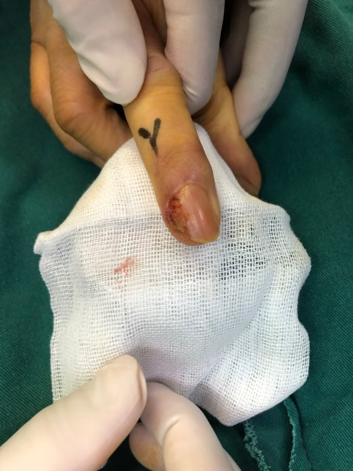
Figure 1 Subungual growth over right middle fingernail bed.
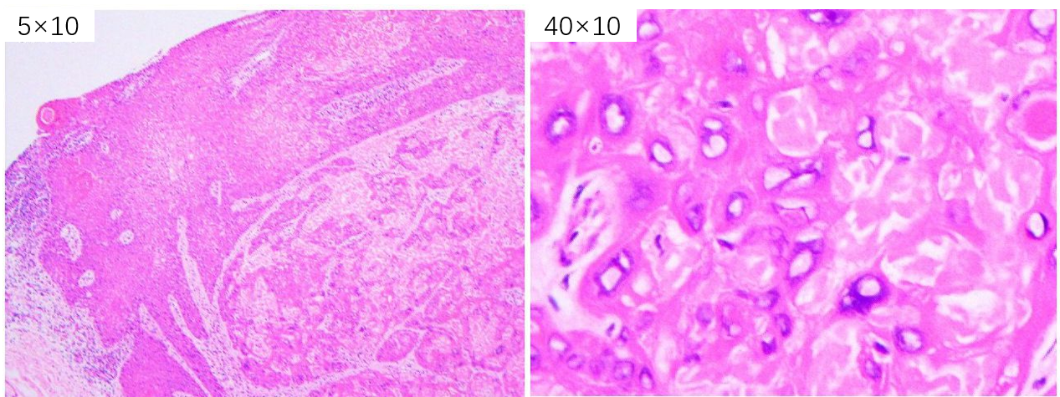
Figure 2 Biopsy shows atypical cells with altered nuclear cytoplasmic ratio.

