Name of Journal: World Journal of Gastroenterology
Manuscript NO: 87136
Manuscript Type: REVIEW

Age-specific causes of upper gastrointestinal bleeding in children

Kocic M et al. UGIB in children

Marija Kocic, Petar Rasic, Vuk Marusic, Dragan Prokic, Djordje Savic, Maja Milickovic, Ivana Kitic, Tanja Mijovic, Adrijan Sarajlija

Marija Kocic, Dragan Prokic, Ivana Kitic, Department of Gastroenterology, Hepatology and Nutrition, Mother and Child Health Care Institute of Serbia “Dr. Vukan Cupic”, Belgrade 11000, Serbia

Petar Rasic, Djordje Savic, Maja Milickovic, Tanja Mijovic, Department of Abdominal Surgery, Mother and Child Health Care Institute of Serbia “Dr. Vukan Cupic”, Belgrade 11000, Serbia

Vuk Marusic, Institute of Epidemiology, Faculty of Medicine, University of Belgrade, Belgrade 11000, Serbia

Dragan Prokic, Djordje Savic, Maja Milickovic, Ivana Kitic, Adrijan Sarajlija, Faculty of Medicine, University of Belgrade, Belgrade 11000, Serbia

Adrijan Sarajlija, Pediatric Day Care Hospital Department, Mother and Child Health Care Institute of Serbia “Dr. Vukan Cupic”, Belgrade 11000, Serbia

Adrijan Sarajlija, Faculty of Medicine, University of Eastern Sarajevo, Foča 73300, Bosnia and Herzegovina

Author contributions: Kocic M, Rasic P, Marusic V, Prokic D, Savic D, and Sarajlija A significantly contributed to the conceptualization, design, and data consolidation of the study; Rasic P, Marusic V, and Sarajlija A critically revised the article; Kocic M, Rasic P, Marusic V, Milickovic M, Kitic I, and Mijovic T conducted the literature search, data collection, and manuscript drafting; and all authors approved the final manuscript and agree to be accountable for all aspects of the work.

Corresponding author: Petar Rasic, MD, Surgeon, Department of Abdominal Surgery, Mother and Child Health Care Institute of Serbia “Dr. Vukan Cupic”, Radoja Dakica 6-8, Belgrade 11000, Serbia. perasrv@yahoo.com

Received: July 25, 2023
Revised: November 5, 2023
Accepted: December 1, 2023
Published online:

Abstract
The etiology of upper gastrointestinal bleeding (UGIB) varies by age, from newborns to adolescents, with some of the causes overlapping between age groups. While particular causes such as vitamin K deficiency and cow’s milk protein allergy are limited to specific age groups, occurring only in neonates and infants, others such as erosive esophagitis and gastritis may be identified at all ages. Furthermore, the incidence of UGIB is variable throughout the world and in different hospital settings. In North America and Europe, most UGIBs are non-variceal, associated with erosive esophagitis, gastritis, and gastric and duodenal ulcers. In recent years, the most common causes in some Middle Eastern and Far Eastern countries are becoming similar to those in Western countries. However, variceal bleeding still predominates in certain parts of the world, especially in South Asia. The most severe hemorrhage arises from variceal bleeding, peptic ulceration, and disseminated intravascular coagulation. Hematemesis is a credible indicator of a UGI source of bleeding in the majority of patients. Being familiar with the most likely UGIB causes in specific ages and geographic areas is especially important for adequate orientation in clinical settings, the use of proper diagnostics tests, and rapid initiation of the therapy. The fundamental approach to the management of UGIB includes an immediate assessment of severity, detecting possible causes, and providing hemodynamic stability, followed by early endoscopy. Unusual UGIB causes must always be considered when establishing a diagnosis in the pediatric population because some of them are unique to children. Endoscopic techniques are of significant diagnostic value, and combined with medicaments, may be used for the management of acute bleeding. Finally, surgical treatment is reserved for the most severe bleeding.

Key Words: Upper gastrointestinal bleeding; Age-specific; Epidemiology; Pediatric; Unusual cause

Kocic M, Rasic P, Marusic V, Prokic D, Savic D, Milickovic M, Kitic I, Mijovic T, Sarajlija A. Age-specific causes of upper gastrointestinal bleeding in children. World J Gastroenterol 2023; In press

Core Tip: This review provides general and comprehensive epidemiological data, overviewing the most common causes of upper gastrointestinal bleeding (UGIB) in children, in different age groups. The relevant literature in English on pediatric UGIB was searched until 2022, with special reference to age-related causes, unusual and rare causes, and risk factors. The literature search was performed using Medline via PubMed database (www.pubmed.gov), Google Scholar (www.scholar.google.com) and Cochrane Database, using the following terms: “neonates and infants” and “upper gastrointestinal bleeding”; “children” and “upper gastrointestinal bleeding”; “children” and “upper gastrointestinal bleeding” and “unusual causes”; “infants and children” and “upper gastrointestinal hemorrhage” and “unusual causes”.

INTRODUCTION
Upper gastrointestinal bleeding (UGIB) represents one of the most urgent conditions in the pediatric population. The etiologies of UGIB vary by age, from newborns to adolescents, with substantial overlap between age groups^{[1]}. The origin of UGIB in children can be traced to any location from the esophagus to the ligament of Treitz, which represents the point of transition between the foregut and midgut^{[1,2]} (Figure 1). Approximately 20% of all GI bleeding in children arises at those sites^{[3]}. A significant share of patients with UGIB has a benign clinical course since approximately 80% present with self-limited bleeding^{[2]}. About three-fourths (73%) of the patients present with hematemesis, followed by melena (21% of patients) and coffee-ground emesis (6% of patients)^{[1,4]}. Nevertheless, some patients may also experience abdominal pain, nausea, dyspepsia, or vertigo^{[4,5]}. Furthermore, hematochezia might be a rare sign of UGIB, except in neonates and infants who have rapid passage through the GI tract^{[3]}.
Differential diagnosis of UGIB is based on age, clinical presentation, and the amount of bleeding^{[6]}. It must also include non-GI sources such as ingested maternal blood, epistaxis, and hemoptysis as well as food-mimicking hematemesis, coffee ground emesis, or melena^{[1,5]}. Certain types of food may confuse children and parents due to a very similar appearance to blood in vomitus (e.g., red food coloring, red candies, fruit-flavored drinks, fruit juices, and beets). Similarly, the melena-like appearance of the stool may be caused by some drugs like bismuth subsalicylate or iron supplements and food such as grape juice, spinach, beets, or blueberries^{[6]}.
Therefore, the anamnesis obtained from parents and the affected patient, if possible, must include information about associated signs and symptoms, dietary habits, and medicament use, and the attempt to quantify the bleeding. Large-volume UGIB might be encountered in non-steroidal anti-inflammatory drug (NSAID)-induced gastritis, but more frequently in variceal bleeding, both in young children and adolescents^{[6,7]}.
The initial approach in the treatment of patients with significant GI bleeding should be the establishment of adequate oxygen support, placement of central or peripheral intravenous catheters, hemodynamic stabilization, transfusion of blood and blood products, as well as correction of any underlying coagulopathies^{[5]}. Endoscopy per se, is both a diagnostic and therapeutic procedure that is especially important in an emergency setting^{[8,9]}. The frequency of endoscopic therapeutic interventions is especially high in patients with esophageal varices or bulbar peptic ulcer hemorrhage^{[8]}.

EPIDEMIOLOGICAL CHARACTERISTICS OF UGIB IN CHILDREN
There is a relative paucity of data regarding the exact incidence of UGIB in children. Based on the study conducted in France in 2010, the incidence of UGIB in the pediatric population is 1-2 per 10000 children^{[10]}. The risk of UGIB is especially high in some subpopulations such as critical care patients. Critical illness alone may be a risk factor for stress-related GI ulceration and bleeding related to systemic hypoxemia, low gastric pH, impaired splanchnic perfusion, and dysregulated mucosal cytoprotection^{[11]}. Besides, the use of medications such as NSAIDs, aspirin, corticosteroids, and selective serotonin reuptake inhibitors may be additional risk factors for severe UGIB^{[1,5]}. Moreover, other comorbidities such as cerebral palsy increase the risk of erosive esophagitis primarily due to a higher prevalence of gastroesophageal reflux^{[4]}. Few studies have provided critical care statistics related to UGIB in children^{[11-15]}. The cumulative incidence of UGIB in the pediatric critical care population of Canada was shown to be 10.2%^{[12]}. Moreover, a prospective cohort study from Thailand, which included 110 pediatric intensive care unit (PICU) patients, who required mechanical ventilation longer than 48 h, revealed that the incidence of UGIB was 51.8%, among which 3.6% of the cases presented with clinically significant bleeding^{[13]}. According to the Belgian literature review published in 2011, the incidence of significant UGIB in children admitted to the PICU was 0.4%-1.6%^{[14]}. However, an earlier prospective comparative study from 1992 conducted in a PICU of a tertiary care university-based facility in the United States found that the prevalence of UGIB was as high as 25%^{[15]}.
UGIB may be a life-threatening condition in cases of large blood volume loss, and worldwide mortality rates in children reach up to 15%^{[1,4]}. A study from the United States showed that the overall mortality of PICU patients was 4.8%, with significantly higher mortality observed in patients with UGIB than in those without (16% vs 1.3%; P < 0.001)^{[15]}. To reduce the risk of GI bleeding in children hospitalized in the PICU for critical asthma, stress ulcer prophylaxis (SUP) is commonly prescribed. A retrospective, multicenter cohort study conducted in the United States from 2010 to 2019 included children 3 years to 17 years of age admitted to the PICU for critical asthma. Of the 30177 children, 10387 (34.4%) received SUP throughout the 10-year period. Gastritis was noted in 32 (0.1%) subjects, and rates did not differ for patients who had and had not received SUP (0.11% vs 0.1% respectively; P = 0.706). Moreover, no episodes of major GI bleeding events were documented for the entire study sample regardless of SUP exposure^{[16]}. These data raise a question of a need for the routine use of SUP in this population and advocate the consideration of a more individualized approach to the prevention of GI bleeding.

MOST COMMON CAUSES OF UGIB IN THE PEDIATRIC POPULATION
Various factors influence the occurrence of UGIB in different regions and countries around the world^{[1,2,10,17]}. According to the literature, the origin of the UGIB in the pediatric population differs in developing and developed countries^{[1-3,8,18-22]}. Based on causes, the UGIB may be classified into two major groups: Variceal and non-variceal^{[5]}. Previously reported data from a study conducted in the Middle East in 2012, suggested that the most common cause of UGIB is esophageal varices (in 39% of patients with UGIB)^{[23]}. Similarly, data from India in 1996 also indicated variceal bleeding as the most common UGIB, affecting 95% of patients. The majority (92%) of these cases occurred due to extrahepatic portal vein obstruction (EHPVO)^{[22]}. However, the data obtained from an Iranian study conducted 2012-2014 indicated that the most common etiologies of UGIB among all patients admitted for GI bleeding were prolapse gastropathy syndrome (PGS) and esophagitis, with rates of 18.6% and 15.9%, respectively, followed by esophageal varices, gastritis, and coagulopathy, with frequency of 7.1% for each^{[18]}. Moreover, a large cross-sectional study from Turkey from 2020 showed that the most common causes of UGIB were esophagitis (47%), peptic ulcer (18.1%), and esophageal varices (11.1%)^{[8]}. In China, a 10-year retrospective multicenter cohort study conducted 2003-2012 reported erosive gastritis as the most frequent endoscopic finding in children with UGIB (33.5%), followed by duodenal ulcer (23.2%). The same study showed that the prevalence of erosive gastritis decreased with children’s age (correlation coefficient = -0.787), while duodenal ulcer showed an increasing trend regarding age (correlation coefficient = 0.958)^{[21]}.
According to the literature, the most common causes of UGIB in North America and Europe are PGS (12.7%), gastric erosions and ulcers (10.8%), erosive esophagitis (9.5%), and duodenal erosions/ulcers (8.2%), whereas less common are esophageal varices (6.3%) and Mallory-Weiss tear (3.8%)^{[3,4]}. A retrospective cohort, single-institution study conducted in the United Kingdom 2009-2014 by Nasher et al^{[20]} included 32 patients with UGIB, with an average age at presentation of 5.9 ± 5.5 years in males and 8.2 ± 6.0 years in females. Over one-half (59.3%) of patients underwent an upper GI endoscopy procedure, which identified esophageal varices and esophagitis (occurring in 26% of patients each) as the most common findings, followed by gastritis/duodenitis (identified in 15.8% of patients). Duodenal ulcer was found in 2 patients who had evidence of Helicobacter pylori (H. pylori) on biopsy and in 1 with a previous history of NSAID intake. Furthermore, 1 patient had a rare cause of UGIB, a gastric vascular malformation^{[20]}. Moreover, a 7-year retrospective cohort study conducted from 2007 to 2013 in the northeast of Romania which included 103 patients with UGIB showed that erosive gastritis was the most common cause of UGIB (occurring in 33.9% of included patients). The other causes comprised esophagitis (14.6%), duodenitis (11.6%), duodenal ulcer (10.7%), gastric ulcer (5.8%), esophageal varices (4.8%) and Mallory-Weiss syndrome (1.9%), whereas 16.5% of patients had multicausal UGIB. Furthermore, the particular bleeding source was determined in 34.9% of patients, a possible one in 39.8%, while in 25.2% the source has not been ascertained. Finally, in the same study, NSAID consumption and H. pylori infection were documented in 17.5% and 36.9% of patients, respectively^{[19]}.

CAUSES OF UGIB IN NEONATES
The most common causes of UGIB in newborns include coagulation disorders such as vitamin K deficiency, cow’s milk protein allergy (CMPA), stress-related gastritis, sepsis, and trauma related to nasogastric tube placement^{[1,3,5,6,24]} (Table 1). CMPA is a common food allergy both in neonates and infants, with an incidence estimated as 1.8%-7.5% in the 1st year of life^{[25]}. Since there is no specific diagnostic test, the diagnosis of CMPA is primarily established by clinical evaluation and the elimination diet is the preferable treatment option^{[26]}.
UGIB in neonates in the neonatal ICU (NICU) setting is not uncommon. A retrospective-prospective cohort study conducted in Finland in 2000 which included 189 newborns treated in the NICU found that approximately 20% of patients had signs of GI bleeding. Mechanical ventilation was determined to be the crucial risk factor [odds ratio (OR) = 4.06; 95% confidence interval: 1.21-12.3], with 53% of mechanically ventilated patients having gastric mucosal lesions^{[27]}.
Furthermore, vitamin K deficiency must always be considered in neonates having UGIB. Vitamin K deficiency bleeding is usually categorized into three major groups: Early-onset (1st 24 h of life), classical (2nd to 7th d), and late-onset (2nd to 12th wk). Special attention should be given to the late-onset form, which exerts a greater burden in low- and middle-income countries where the median incidence is 80/100000, compared with high-income countries where the median incidence is significantly lower, 8.8/100000^{[28]}. Besides, all neonates with hematemesis should also be screened for other bleeding disorders such as maternal thrombocytopenic purpura, hemophilia, and Von Willebrand disease, which are well-known risk factors for possible GI bleeding. Furthermore, the large amount of UGIB in newborns may also be caused by gastric erosion due to the placement of a nasogastric tube, sepsis, and/or disseminated intravascular coagulation^{[5]}. When major UGIB occurs in neonates, parenteral vitamin K and proton pump inhibitors administration are recommended empirically^{[29]}. Moreover, it is very important to initially exclude ingestion of blood of maternal origin that may be swallowed during delivery or from cracked nipples, which can be perceived as UGIB. Therefore, alkali denaturation testing (known as the Apt test) should be performed whenever available to distinguish maternal from fetal blood^{[30]}. If maternal blood ingestion is excluded, another source of UGIB should be sought in this age group.
Finally, preterm infants represent a delicate pediatric population, in whom bright red blood in nasogastric aspirate may be a presenting sign of necrotizing enterocolitis (NEC)^{[3]}, although the source of hemorrhage caused by NEC is mostly located in the lower GI tract^{[31,32]}. NEC usually develops in preterm infants with usual onset between 2 wk and 3 wk of life. On the other hand, full-term infants comprise about 10% of all babies with NEC, and in this subgroup NEC may appear within the 1st wk of life^{[33]}. Because of insufficient reliable data due to inconsistencies in diagnosis and/or data collection of different studies, the precise incidence of NEC is undetermined^{[32]}. When diagnosed, NEC must be treated rapidly with nasogastric decompression, proper antimicrobial therapy, and other supportive measures. If there is a suspicion of advanced NEC, surgical treatment is necessary^{[3]}.

CAUSES OF UGIB IN INFANCY
In younger infants, during the early months of life, the causes of UGIB are related to reflux and erosive esophagitis, PGS, CMPA, and stress-related gastritis^{[1,3,17,18,25]} (Table 2). Gastritis with subsequent mucosal bleeding and stress ulcers are especially common causes of UGIB in infants hospitalized in PICU^{[3,27]}. Less frequent causes include caustic and foreign body ingestion, coagulation disorders, medication-induced bleeding (mostly caused by NSAIDs), and rarely peptic ulcers and esophageal varices^{[5,17,34]}. The presence of melena, particularly in the youngest children, points to significant GI hemorrhage^{[10,20]}. The source of bleeding in these patients usually can be identified by flexible endoscopy, though drug-induced ulceration should be suspected from detailed medical history data and usually does not require endoscopic confirmation. An age-related retrospective study, which was conducted 2000-2010 in Iran and included children and adolescents aged 0-18 years, showed that erosive esophagitis was the most common cause of GI bleeding in all patients. This was also the most common finding in patients less than 1-year-old, with a prevalence of 37%, followed by gastritis (25.9%)^{[17]}. On the other hand, the same study identified peptic ulcer disease (PUD) as a cause of UGIB in only 7.4% of infants, which significantly differed from older children. In concordance with these findings are the results from a national case-crossover study, conducted in France over a 2-year period, where a similar prevalence of the most common UGIB causes in this age group was reported^{[10]}.

CAUSES OF UGIB IN TODDLERS
The most common causes of UGIB in children from 1-year-old to 3-years-old include reflux and erosive esophagitis, gastritis, caustic ingestions, peptic ulcer (Figure 2A), esophageal varices, vomiting-induced bleeding similar to ones from Mallory-Weiss tear (Figure 2B), and PGS^{[1,3,4,18]} (Table 3). PGS represents a retrograde prolapse of a part of gastric mucosa from the proximal stomach into the distal esophagus^{[35]}. A study by Cleveland et al^{[4]} found the erosion caused by prolapse of a portion of the gastric cardia along the lesser curvature found in PGS represents a more common source of bleeding than PUD or nonspecific gastritis in children.
It is well known that NSAIDs (including aspirin) and corticosteroids can increase the risk of UGIB, causing impairment of the gastric mucosal barrier by reduction and alteration of mucous secretion and promoting tissue fragility^{[5,36]}. A group of French researchers performed a national case-crossover study with a total of 177 children with UGIB involved. The study reported that UGIB in one-third of the cases occurred due to exposure to NSAIDs at doses used for analgesic or antipyretic purposes. According to the age group, the observed risk was more than four times higher in children up to 7-years-old (OR = 14.1) than in patients 8-years-old to 16-years-old (OR = 3.4)^{[10]}. Although gastric ulcers have been associated with the chronic use of NSAIDs, reports from a single center in the United States over a 1-year period described UGIB in patients aged 16 mo to 36 mo (median age of 23.5 ± 9.0 mo) who developed hematemesis within 24 h after receiving just one or two age- and weight-appropriate doses of ibuprofen. In each of those patients, esophagogastroduodenoscopy demonstrated an antral gastric ulcer^{[36]}.
Furthermore, it is reported that the consumption of NSAIDs combined with infection with H. pylori is associated with a higher risk of gastroduodenal ulceration and bleeding^{[19]}. A study from Tunis showed that the severity of gut mucosal damage in a population with a high prevalence of H. pylori infection is correlated with NSAID level intake, especially in children younger than 24 mo. However, the presence of H. pylori infection did not worsen gut mucosal injury severity in patients receiving NSAIDs^{[37]}.
Foreign body ingestion represents a significant risk factor for major complications, including UGIB. The occurrence of UGIB in these patients was shown to be time-related regarding the diagnosis establishment. Ingestion of a button battery is especially hazardous because it often results in secondary complications such as mucosal erosions, bleeding, gastric outlet obstruction, mediastinitis, or abscess formation^{[34,38]}. Even in the case of a button battery lodging in the esophagus only transiently, severe erosion and ongoing necrosis of the esophagus and surrounding tissues may occur after the removal. Therefore, batteries that are in the esophagus must be removed within 2 h to avoid potentially fatal complications such as perforation and, the most severe one, aorto-esophageal fistula formation and subsequent bleeding^{[34]}. Exsanguination from aorto-esophageal fistula has been reported in infants and toddlers^{[39]}.
Severe UGIB bleeding may be caused by esophageal varices rupture, which develops as a result of portal hypertension^{[40,41]}. The most frequent causes of portal hypertension and its complications in children are EHPVO (Figure 2C) and liver cirrhosis. Liver cirrhosis in infancy is most commonly caused by biliary atresia (BA) and metabolic disorders, whereas in older children, the most common causes are alpha-1-antitrypsin deficiency, autoimmune hepatitis, primary sclerosing cholangitis, and Wilson’s disease^{[42]}. In patients with BA, esophageal varices may develop earlier compared to other causes of cirrhosis in children, with the median age of the first bleeding at 17 mo^{[43]}. The management of variceal bleeding comprises both prophylaxis and acute emergency treatment and includes the use of drugs (e.g., propranolol, vasopressin, and somatostatin), endoscopic procedures (e.g., periodic surveillance endoscopies, endoscopic sclerotherapy, and band ligation), interventional radiology (e.g., transjugular intrahepatic portosystemic shunt), and surgery (e.g., portosystemic shunting)^{[44]}.

CAUSES OF UGIB IN CHILDREN OLDER THAN 3-YEARS-OLD
In children older than 3-years-old, bleeding most commonly arises from Mallory-Weiss tear, reflux and erosive esophagitis, erosive gastritis (Figure 3A), chronic PUD, caustic ingestions, esophageal varices, gastric varices (Figure 3B), and foreign body ingestion^{[1,4,5,24]}. Besides, younger children and adolescents may experience bleeding from severe coagulopathy due to hematological disorders such as leukemia and idiopathic thrombocytopenic purpura^{[3]} (Table 4).
PUD in children is similar to that in adults; however, there are some differences, especially in the prevalence of etiologies, clinical presentation, and complications. PUD is usually categorized as primary when associated with H. pylori and hypersecretory conditions including Zollinger-Ellison syndrome (ZES), short-bowel syndrome, cystic fibrosis, hyperparathyroidism, etc. Primary PUD is more often found in the duodenum, whereas secondary ulcers are more frequently localized in the stomach. On the other hand, secondary PUD is usually associated with systemic disease and drug ingestion and comprises stress ulcers, drug-induced ulcers, ulcers associated with infections other than H. pylori, Crohn’s disease (CD) ulcers, ulcers associated with foreign body ingestion, etc.^{[45]}. A retrospective analysis performed in a single Endoscopy Center in China in 2021 included 173 children who were found to have upper GI ulcer. Primary ulcer was found in 148 (85.6%) patients and secondary in 25 (14.4%) patients. Of those with secondary ulcers, foreign body in the digestive tract was the most common cause, and was observed in 17 children (68%), followed by Henoch-Schönlein purpura (HSP) in 5 children (20.0%) and CD in 3 children (12.0%)^{[46]}.
H. pylori infection has been found in 50% of the world’s population (approximately in 70% of the population in developing countries and 30%-40% in developed countries)^{[47]} (Figure 3C). In children, the majority of H. pylori infections are asymptomatic, regardless of being associated with microscopic gastric inflammation^{[48]}. Spontaneous eradication of the infection is noted mainly in infants and young children, and it decreases with age^{[49]}. Besides, due to a rising resistance of H. pylori to antimicrobials and lack of symptom improvement in the absence of PUD, testing for H. pylori presence and application of eradication therapy are recommended only for the subset of patients with a high suspicion of PUD^{[47]}. Therapy should be based on antibiotic resistance profiles and tailored accordingly using sufficiently high doses and treatment durations of 10-14 d, to achieve an initial eradication success rate of ≥ 90%^{[48]}. In case of unknown susceptibility, high-dose triple therapy with proton pump inhibitors, amoxicillin, and metronidazole for 14 d is recommended as first-line therapy^{[48]}. In a retrospective cohort study from the Middle East (conducted 1993-2002), which included 521 patients younger than 18-years-old who presented with UGIB, 24 (5%) children were diagnosed by endoscopy with PUD. The average age was 15 (range: 5-18 years). Primary PUD was found in 79% of the children, and according to the available histopathological data, the main finding was antral gastritis highly associated with H. pylori^{[50]}. Moreover, a retrospective cohort study conducted in Japan in 1995-2001, which included 283 patients aged 9 mo to 16 years, showed that the prevalence of H. pylori was highest in children with nodular (antral) gastritis (98.5%) and duodenal PUD (83%). H. pylori infection strongly correlated with gastric and duodenal ulcers in the age group of 10-years-old to 16-years-old compared to children 9-years-old or younger, in whom this correlation was not identified (OR = 12.1 vs 4.1 for duodenal ulcer, and OR = 8.2 vs 0.7 for gastric ulcer). Besides, researchers identified a low frequency of hematemesis or tarry stools (occurring in 9% of all patients), suggesting that there was no association with significant acute GI blood loss in the majority of patients^{[51]}. Moreover, it has been reported that several hematological diseases may be associated with H. pylori infection, such as iron deficiency anemia, immune thrombocytopenia, and vitamin B12 deficiency, which can lead to additional GI disorders and subsequent UGIB^{[52]}.
EHPVO represents an important cause of portal hypertension in developing countries, and some data suggest that it is responsible for the occurrence of up to 80% of portal hypertension in children^{[53]}. It commonly presents as incidental splenomegaly on physical examination (in 43.3% of cases) and in 40% as UGIB manifested as hematemesis and/or melena due to gastroesophageal varices^{[41]}. Gastroesophageal varices caused by portal hypertension as a consequence of EHPVO were shown to be the most common source of significant UGIB in children above 3-years-old in South Asian countries^{[22,54]}. A retrospective cohort study from India, conducted from 2002 to 2012, found 30 patients with EHPVO (5-years-old to 14-years-old). The peculiarity of these results was that delivery at home, which was one of the risk factors, was reported in all 30 cases, while the other risk factors, umbilical sepsis and a history of cow dung application over the umbilical cord were identified in 27% and 6.7% of patients, respectively. Almost 75% of all patients in that study had UGIB. Endoscopy findings revealed esophageal varices in all enrolled patients, gastric varices in 38.5%, and portal hypertensive gastropathy in 20%^{[55]}.
BA is a common cause of portal hypertension in older children as well as in children 3-years-old or younger. A cross-sectional multicentric study conducted between May 2006 and December 2009, as a part of the Childhood Liver Disease Research and Education Network, enrolled a total of 163 patients with BA (aged 1-25 years). The 43/163 (26.3%) patients with portal hypertension had complications, and 19.6% manifested with esophageal varices bleeding. Among the 32 patients with esophageal varices bleeding, most (34.4%) had their first bleeding episode between 6-years-old and 10-years-old, followed by equal portions (21.8% each) between birth and 2-years-old, between 2-years-old and 5-years-old, and ≥ 10-years-old^{[40]}.

UNUSUAL CAUSES OF UGIB
Unusual causes of UGIB (Table 5) are as clinically challenging in pediatric patients as in their adult counterparts. The incidence of unusual etiologies could be higher in pediatric practice since most of the rare diseases initially present during childhood. Unusual causes comprise various congenital anomalies, acquired diseases, and unusual foreign body ingestion.

Unusual UGIB causes affecting the esophagus
UGIB is reported as a very rare clinical presentation in patients with alimentary tract duplications, including in newborns, infants, and older children^{[56-58]}. The esophagus is, after the ileum, the second most common spot of occurrence of these congenital anomalies^{[56,59]}. Alimentary tract duplications are usually diagnosed in infancy and childhood, with 60% of patients presenting at ages younger than 2 years^{[60]}. The majority of esophageal duplications are related to the right side of the esophagus and do not communicate with its lumen^{[61]}. However, they may sometimes contain gastric epithelium which can provoke peptic ulceration, intra-cystic hemorrhage, and fistulation into the esophagus, presenting with hematemesis or melena^{[62]}.
Furthermore, it is not uncommon for eosinophilic gastrointestinal diseases (EGIDs) to initially present with GI bleeding^{[63]}. Eosinophilic esophagitis (EoE) (Figure 3D), with an estimated prevalence of 10 to 57 per 100000, is the most common type of EGIDs, a group of chronic GI disorders, characterized by GI symptoms and pathological eosinophilic infiltration of various parts of the GI tract, without secondary causes of tissue eosinophilia^{[64]}. Ozdogan et al^{[63]} reported on 3 patients aged 8, 10, and 12 years who had hematemesis as the initial sign of EoE.

Unusual UGIB causes affecting the stomach
Gastric duplications (GDs) comprise only 7% of all GI duplications^{[59]}. These congenital anomalies are commonly located in the region of the greater curvature. The cystic type comprises around 80% of GDs and they do not communicate with the gastric lumen, unlike the remaining 20% representing tubular GDs which are contiguous with the stomach and usually communicate with the gastric lumen. According to the study by Li et al^{[65]} which included 319 patients with GD, vomiting and abdominal pain were the most common manifestations of these anomalies. GI hemorrhage was shown to be the third most common symptom, occurring in 16.3% of children.
Eosinophilic gastritis is even rarer than EoE, with a prevalence estimated at 6.6 per 100000^{[66]}. Ozdogan et al^{[63]} reported on 2 patients aged 7 and 14 years with eosinophilic gastritis who initially presented with hematemesis.
Some gastric tumors may also lead to GI bleeding. Gastrointestinal stromal tumors (GISTs) are an extremely rare cause of UGIB, described in several case series and reports^{[67]}. They are most commonly located in the stomach and the median age at diagnosis is reported to be between 60 years and 69 years^{[68]}. Patients 16-years-old or younger represent only 1.4%, and those less than 21-years-old represent 2.5% of all gastric GIST patients^{[67,69]}. Authors from the United States have reported on a case of an 11-year-old girl who presented with anemia and guaiac-positive stool 1 mo after tonsillectomy. Because her anemia was thought to be secondary to blood loss from her tonsillectomy, iron therapy was started. Since 2 wk thereafter her hemoglobin decreased again, esophagogastroduodenoscopy was performed and demonstrated 7-8 large submucosal masses in the antrum and distal body of the stomach, with deep ulceration in one of the masses. Endoscopic ultrasound-guided fine needle aspiration confirmed the diagnosis of epithelioid GIST^{[69]}.
Furthermore, there are scarcely reported cases of primary gastric lymphomas in children. Authors from Korea reported on a case of a 10-year-old patient with a family history of gastric adenocarcinoma, who presented with recurrent hematemesis and melena. Esophagogastroduodenoscopy revealed diffuse antral ulcers, while a tissue biopsy showed a diffuse large B cell non-Hodgkin lymphoma^{[70]}. Other rare gastric tumors such as Schwannoma causing GI bleeding have been reported anecdotally in toddlers and adolescents^{[71,72]}. Moreover, Corasaniti et al^{[73]} reported on a case of a young infant who presented with bilious vomiting, melena, and anemia due to a giant gastric polyp, histologically proven to be focal foveolar hyperplasia.
Bezoars (including trichobezoars, phytobezoars, pharmacobezoars, lactobezoars, etc.) are indigestible conglomerations trapped in the GI tract^{[74]}. They are most commonly located in the stomach, although they may be observed in the esophagus, duodenum, and other segments of the bowel^{[75]}. Trichobezoars (Figure 3E) are associated with trichotillomania and trichophagia in psychiatric patients. Bhatia et al^{[76]} reported on 24 cases of trichotillomania attending the psychiatry outpatient department and found that the majority of cases (54.2%) belonged to the age group of 6-years-old to 10-years-old. In 2021, LaGrandeur et al^{[77]} reported on a case of a seemingly healthy school-aged girl who presented with recidivant hematemesis, in whom a gastric trichobezoar was revealed during endoscopy.

Unusual UGIB causes affecting the duodenum
Duplications of duodenum contain gastric mucosa in up to 20% of cases. This could lead to intracystic hemorrhage or perforation of the cyst with subsequent GI bleeding and peritonitis^{[56]}. Diagnostics of the alimentary tract duplication rely on ultrasonography, GI contrast study, computed tomography, and magnetic resonance imaging. Additional testing including scintigraphy may be useful in detecting ectopic gastric mucosa^{[61]}.
Varices in the duodenum are rarely present as a cause of UGIB, in comparison to varices located in the esophagus and stomach which are well-known complications of portal hypertension. Duodenal varices are mostly reported in adult patients. Hiçsönmez et al^{[78]} reported on a curious case of a 12-year-old girl with severe bleeding from duodenal varices secondary to EHPVO and subsequent cavernous transformation of the portal vein.
Duodenal trauma (Figure 3F) in the pediatric population is infrequent, comprising 2%-10% of blunt abdominal trauma cases and only 0.14%-0.16% of all injured children per year^{[79,80]}. Bicycle accidents are the most frequent cause of blunt trauma, representing between 5% and 14% of total closed abdominal injuries. A case study from Spain in 2019 described an adolescent boy with duodenal perforation after being injured by a bicycle handlebar, presenting with hematemesis, abdominal pain, and swelling and tenderness in the upper right abdominal quadrant and epigastrium. An exploratory laparotomy revealed perforation in the posterior wall of the third part of the duodenum and the patient was treated with the resection of the third portion of the duodenum and Roux-en-Y duodenojejunostomy^{[81]}.
Some unexpected, potentially dangerous foreign bodies used in everyday life may lead to severe GI damage. Nguyen et al^{[82]} reported on a case of a 6-year-old girl who presented with abdominal pain, coffee-ground emesis, and melena due to uncooked pasta lodged in the duodenum and creating an erosion.
Hemobilia is a rare cause of UGIB both in adults and children. The bleeding from and into the biliary tract usually follows trauma to the hepatobiliary-pancreatic system^{[83]}. Some of the rare causes of hemobilia reported in the pediatric population are parasitic infestation with Ascaris lumbricoides, liver abscess (occurring predominately in African and Asian regions), GD, pancreatitis, choledochal cyst, gall bladder polyps, and Von Willebrand disease^{[83,84]}.

Unusual UGIB causes affecting distinct locations
Dieulafoy’s lesions are vascular malformations comprising abnormally enlarged arteries with the potential for massive GI bleeding. These anomalies, which are thought to be congenital, account for 1%-5.8% of all cases of acute UGIB and are most commonly located at the lesser curvature of the stomach^{[85-87]}. However, they were shown to be extragastric in 33% of cases, affecting the duodenum, colon, esophagus, rectum, or jejuno-ileum^{[86]}. Dieulafoy’s lesions are more common in males than females (2:1 ratio), and the mean age at presentation is within the 5th decade of life (range: 50-70 years)^{[88]}. This disorder may be underdiagnosed in any age group, and there are only several sporadic cases and case series available in the literature, comprising children of ages from preterm neonates to 18-years-old^{[89-92]}. The signs and symptoms are related to blood loss, either due to intermittent or massive acute GI hemorrhage. Melena is the most common form of presentation, followed by hematemesis, hemoptysis, hematochezia, and iron deficiency anemia. In most severe cases, bleeding from Dieulafoy’s lesions may lead to hemodynamic instability^{[93]}. Since these lesions have a major potential for life-threatening hemorrhage, they should be included in the differential diagnosis of massive UGIB in all age groups.
ZES is an extremely rare condition caused by gastrin-producing tumors (gastrinomas), with an overall incidence of 0.1-3 per 1000000. Only 2% of gastrinoma cases occur in the pediatric population^{[94]}. These tumors are usually located in the duodenal wall or in the pancreas. Hypergastrinemia causes non-healing or recurrent ulcers in 85% of cases localized in the duodenum. However, these ulcers may also appear in the stomach, jejunum, or multiple locations^{[95]}. Authors from India reported on a case of a 12-year-old boy with a refractory peptic ulcer caused by gastrinoma in the pancreatic head. Upper GI endoscopy displayed multiple linear ulcers both in the mid and lower parts of the esophagus involving the gastroesophageal junction, as well as multiple superficial ulcers in the antrum and three parts of the duodenum^{[94]}. Also, Zaatar et al^{[96]} reported on a 7-year-old boy who presented with mild to moderate iron deficiency anemia, with fasting hypergastrinemia (serum gastrin of 200-500 pg/mL). Investigation revealed a positive stool guaiac test and elevated gastric acid secretion, while endoscopy showed multiple small gastric fundal ulcerations and severe gastritis. However, the investigation towards ZES produced negative findings.
Peutz-Jeghers syndrome is an autosomal dominant inherited disorder, occurring with an incidence of 1 to 50000-200000, characterized by GI hamartomas and mucocutaneous pigmentations due to melanin deposition^{[97,98]}. This rare disorder usually presents with painless rectal bleeding. Nevertheless, authors from Indonesia reported in 2022 on the case of a 5-year-old patient who presented with abdominal pain, dark-red bloody stools, and anemia due to bleeding from scar ulcers in the duodenal region and erosive inflammation of the upper and lower GI tract along with multiple polyps. The patient had multiple black spots on the lips and mucous membranes (conjunctiva and buccal mucosa) and a family history of similar symptoms, which led to the diagnosis of Peutz-Jeghers syndrome^{[98]}.
The inflammation in CD may affect any part of the GI tract. Whilst in lower GI it commonly manifests as hematochezia, CD is rarely associated with UGIB. Though it has been rarely reported, when found on endoscopy, the source of UGIB bleeding in patients with CD is commonly a secondary deep ulcer or multiple ulcers^{[46,99]}.
HSP is considered the most common type of vasculitis in children, affecting 9-22 children per 100000 annually^{[100]}. Although over two-thirds of patients with HSP have GI symptoms during acute illness, these symptoms are usually transient. Most patients (90%) with HSP are children younger than 10 years, with a peak incidence in the 6th year of life^{[101]}. However, it can be also diagnosed in infants, adolescents, and adults^{[100,102]}. HSP has been shown to present with a milder course in infants and children younger than 2 years^{[102,103]}. Authors from Taiwan retrospectively analyzed 158 children with HSP from 1987 to 1998. A total of 104 boys and 54 girls (male:female = 1.9:1; ranging in age from 2-13 years) were enrolled in that study. The main GI manifestations included abdominal pain (88%), GI bleeding (75%), and vomiting (25%). Hematemesis, leukocytosis (> 20000/cm³), high C-reactive protein (> 50 mg/L), and hemorrhagic erosive duodenitis were found to correlate with prolonged hospitalization^{[104]}. A retrospective study conducted in China from 2017 to 2019, analyzed 99 children who had GI bleeding as a complication of HSP. The age at onset ranged from 2-16 years, and the majority (72%) of patients were males. Among all patients with HSP and GI bleeding, 37 had hematemesis, 71 had hematochezia, and 9 had both symptoms. No significant difference was found in sex and age distributions between those who had mild and those who had severe bleeding (P > 0.05)^{[105]}. Furthermore, authors from Italy conducted a retrospective study 1998-2002, which included 95 boys and 55 girls diagnosed with HSP, and concluded that males were affected more often than females (male:female = 1.8:1)^{[101]}. The age and sex distributions showed that most patients (91%) were less than 10-years-old, which is in concordance with previous reports. Out of 77 (51%) children who had GI involvement, GI bleeding was present in 27 children (18%). Among these patients, GI bleeding was revealed by fecal occult blood test and/or melena in 23 (15%), while 3 (2%) had melena alone and 1 had hematemesis.

Obscure GI bleeding
Obscure GI bleeding is a type of bleeding that persists or recurs without an obvious etiology despite upper endoscopy and colonoscopy evaluation^{[24]}. Since it is usually caused by small bowel lesions, it does not represent UGIB. Small bowel capsule endoscopy has a high diagnostic yield and safety in the investigation of obscure GI bleeding and it has been strongly recommended by the European Society of Gastrointestinal Endoscopy as the first-line investigation^{[106]}. Nevertheless, some authors suggest that it may be appropriate to consider an endoscopic second look before performing a capsule endoscopy^{[107]}.

CONCLUSION
In the pediatric population, the etiology of UGIB is diverse and mostly age-related. Since there is a significant etiologic overlap between the age groups, the differential diagnosis must take into account a wide variety of conditions, including rare causes. Even if the hemorrhage is non-life threatening, UGIB is distressing for children and their families. Therefore, all cases of GI bleeding require prompt and thorough investigation based on the use of existing diagnostic algorithms with the utmost goal being discernment of the origin of hemorrhage. Clinically significant UGIB is commonly caused by variceal bleeding in low- and middle-income countries, whereas non-variceal etiology is more common in high-income countries.
We emphasize that a properly taken anamnesis is very important for differentiating the true cause of bleeding from conditions mimicking hematemesis and melena. The information about dietary habits, medicaments use, other underlying diseases, and the possibility of foreign body ingestion are crucial leads to the right diagnosis. The identification of unusual causes of UGIB avoids delay in the diagnosis of rare and potentially treatable conditions. Finally, exact and timely recognition of the cause of UGIB in the pediatric population may significantly preclude morbidity and mortality. Therefore, we have created a comprehensive diagnostic-therapeutic flow-chart that, combined with the information provided in the Tables of this article, may help clinicians in the initial management of the child with UGIB (Figure 4).

REFERENCES
1 Owensby S, Taylor K, Wilkins T. Diagnosis and management of upper gastrointestinal bleeding in children. J Am Board Fam Med 2015; 28: 134-145 [PMID: 25567834 DOI: 10.3122/jabfm.2015.01.140153]
2 El Mouzan MI, Abdullah AM, Al-Mofleh IA. Yield of endoscopy in children with hematemesis. Trop Gastroenterol 2004; 25: 44-46 [PMID: 15303474]
3 Rodgers BM. Upper gastrointestinal hemorrhage. Pediatr Rev 1999; 20: 171-174 [PMID: 10233176 DOI: 10.1542/pir.20.5.171]
4 Cleveland K, Ahmad N, Bishop P, Nowicki M. Upper gastrointestinal bleeding in children: an 11-year retrospective endoscopic investigation. World J Pediatr 2012; 8: 123-128 [PMID: 22573422 DOI: 10.1007/s12519-012-0350-8]
5 Boyle JT. Gastrointestinal bleeding in infants and children. Pediatr Rev 2008; 29: 39-52 [PMID: 18245300 DOI: 10.1542/pir.29-2-39]
6 Chawla S, Seth D, Mahajan P, Kamat D. Upper gastrointestinal bleeding in children. Clin Pediatr (Phila) 2007; 46: 16-21 [PMID: 17164504 DOI: 10.1177/1084713806297151]
7 Wilkins T, Khan N, Nabh A, Schade RR. Diagnosis and management of upper gastrointestinal bleeding. Am Fam Physician 2012; 85: 469-476 [PMID: 22534226]
8 Polat E, Bayrak NA, Kutluk G, Civan HA. Pediatric upper gastrointestinal bleeding in children: etiology and treatment approaches. J Emerg Pract Trauma 2020; 6: 59-62 [DOI: 10.34172/jept.2020.10]
9 Villanueva C, Miñana J, Ortiz J, Gallego A, Soriano G, Torras X, Sáinz S, Boadas J, Cussó X, Guarner C, Balanzó J. Endoscopic ligation compared with combined treatment with nadolol and isosorbide mononitrate to prevent recurrent variceal bleeding. N Engl J Med 2001; 345: 647-655 [PMID: 11547718 DOI: 10.1056/NEJMoa003223]
10 Grimaldi-Bensouda L, Abenhaim L, Michaud L, Mouterde O, Jonville-Béra AP, Giraudeau B, David B, Autret-Leca E. Clinical features and risk factors for upper gastrointestinal bleeding in children: a case-crossover study. Eur J Clin Pharmacol 2010; 66: 831-837 [PMID: 20473658 DOI: 10.1007/s00228-010-0832-3]
11 Ali T, Harty RF. Stress-induced ulcer bleeding in critically ill patients. Gastroenterol Clin North Am 2009; 38: 245-265 [PMID: 19446257 DOI: 10.1016/j.gtc.2009.03.002]
12 Chaïbou M, Tucci M, Dugas MA, Farrell CA, Proulx F, Lacroix J. Clinically significant upper gastrointestinal bleeding acquired in a pediatric intensive care unit: a prospective study. Pediatrics 1998; 102: 933-938 [PMID: 9755268 DOI: 10.1542/peds.102.4.933]
13 Deerojanawong J, Peongsujarit D, Vivatvakin B, Prapphal N. Incidence and risk factors of upper gastrointestinal bleeding in mechanically ventilated children. Pediatr Crit Care Med 2009; 10: 91-95 [PMID: 19057446 DOI: 10.1097/PCC.0b013e3181936a37]
14 Colle I, Wilmer A, Le Moine O, Debruyne R, Delwaide J, Dhondt E, Macken E, Penaloza A, Piessevaux H, Stéphenne X, Van Biervliet S, Laterre PF. Upper gastrointestinal tract bleeding management: Belgian guidelines for adults and children. Acta Gastroenterol Belg 2011; 74: 45-66 [PMID: 21563653]
15 Cochran EB, Phelps SJ, Tolley EA, Stidham GL. Prevalence of, and risk factors for, upper gastrointestinal tract bleeding in critically ill pediatric patients. Crit Care Med 1992; 20: 1519-1523 [PMID: 1424693 DOI: 10.1097/00003246-199211000-00007]
16 Roberts AR, Roddy M, Wilsey MJ, McKinley SD, Sanchez-Teppa B, Sochet AA. Stress Ulcer Prophylaxis for Critical Asthma. Pediatrics 2022; 149 [PMID: 35229158 DOI: 10.1542/peds.2021-054527]
17 Rafeey M, Shoaran M, Majidy H. Diagnostic endoscopy and clinical characteristics of gastrointestinal bleeding in children: a 10-year retrospective study. Iran Red Crescent Med J 2013; 15: 794-797 [PMID: 24616788 DOI: 10.5812/ircmj.7075]
18 Jafari SA, Kiani MA, Kianifar HR, Mansooripour M, Heidari E, Khalesi M. Etiology of gastrointestinal bleeding in children referred to pediatric wards of Mashhad hospitals, Iran. Electron Physician 2018; 10: 6341-6345 [PMID: 29629057 DOI: 10.19082/6341]
19 Gimiga N, Olaru C, Diaconescu S, Miron I, Burlea M. Upper gastrointestinal bleeding in children from a hospital center of Northeast Romania. Minerva Pediatr 2016; 68: 189-195 [PMID: 27125439]
20 Nasher O, Devadason D, Stewart RJ. Upper Gastrointestinal Bleeding in Children: A Tertiary United Kingdom Children's Hospital Experience. Children (Basel) 2017; 4 [PMID: 29099778 DOI: 10.3390/children4110095]
21 Yu Y, Wang B, Yuan L, Yang H, Wang X, Xiao Y, Mei H, Xu C. Upper Gastrointestinal Bleeding in Chinese Children: A Multicenter 10-Year Retrospective Study. Clin Pediatr (Phila) 2016; 55: 838-843 [PMID: 26467562 DOI: 10.1177/0009922815611642]
22 Yachha SK, Khanduri A, Sharma BC, Kumar M. Gastrointestinal bleeding in children. J Gastroenterol Hepatol 1996; 11: 903-907 [PMID: 8912124 DOI: 10.1111/j.1440-1746.1996.tb00270.x]
23 Hassoon AJ, AlMaeeni AA, Matloub HY. Upper gastrointestinal bleeding in children. J Fac Med Baghdad 2012; 54: 223-227 [DOI: 10.32007/jfacmedbagdad.543722]
24 Romano C, Oliva S, Martellossi S, Miele E, Arrigo S, Graziani MG, Cardile S, Gaiani F, de'Angelis GL, Torroni F. Pediatric gastrointestinal bleeding: Perspectives from the Italian Society of Pediatric Gastroenterology. World J Gastroenterol 2017; 23: 1328-1337 [PMID: 28293079 DOI: 10.3748/wjg.v23.i8.1328]
25 Høst A. Frequency of cow's milk allergy in childhood. Ann Allergy Asthma Immunol 2002; 89: 33-37 [PMID: 12487202 DOI: 10.1016/S1081-1206(10)62120-5]
26 Mousan G, Kamat D. Cow's Milk Protein Allergy. Clin Pediatr (Phila) 2016; 55: 1054-1063 [PMID: 27582492 DOI: 10.1177/0009922816664512]
27 Kuusela AL, Mäki M, Ruuska T, Laippala P. Stress-induced gastric findings in critically ill newborn infants: frequency and risk factors. Intensive Care Med 2000; 26: 1501-1506 [PMID: 11126263 DOI: 10.1007/s001340051346]
28 Sankar MJ, Chandrasekaran A, Kumar P, Thukral A, Agarwal R, Paul VK. Vitamin K prophylaxis for prevention of vitamin K deficiency bleeding: a systematic review. J Perinatol 2016; 36 Suppl 1: S29-S35 [PMID: 27109090 DOI: 10.1038/jp.2016.30]
29 Green DS, Abdel-Latif ME, Jones LJ, Lui K, Osborn DA. Pharmacological interventions for prevention and treatment of upper gastrointestinal bleeding in newborn infants. Cochrane Database Syst Rev 2019; 7: CD011785 [PMID: 31265739 DOI: 10.1002/14651858.CD011785.pub2]
30 Crook M. Haemoglobin in stools from neonates: measurement by a modified Apt-test. Med Lab Sci 1991; 48: 346-347 [PMID: 1811126]
31 Bellodas Sanchez J, Kadrofske M. Necrotizing enterocolitis. Neurogastroenterol Motil 2019; 31: e13569 [PMID: 30793842 DOI: 10.1111/nmo.13569]
32 Zani A, Pierro A. Necrotizing enterocolitis: controversies and challenges. F1000Res 2015; 4 [PMID: 26918125 DOI: 10.12688/f1000research.6888.1]
33 Maayan-Metzger A, Itzchak A, Mazkereth R, Kuint J. Necrotizing enterocolitis in full-term infants: case-control study and review of the literature. J Perinatol 2004; 24: 494-499 [PMID: 15229620 DOI: 10.1038/sj.jp.7211135]
34 Jayachandra S, Eslick GD. A systematic review of paediatric foreign body ingestion: presentation, complications, and management. Int J Pediatr Otorhinolaryngol 2013; 77: 311-317 [PMID: 23261258 DOI: 10.1016/j.ijporl.2012.11.025]
35 Kim JS, Kim HK, Cho YS, Chae HS, Kim BW, Kim JI, Han SW, Choi KY. Prolapse gastropathy syndrome may be a predictor of pathologic acid reflux. World J Gastroenterol 2008; 14: 5601-5; discussion 5604 [PMID: 18810781 DOI: 10.3748/wjg.14.5601]
36 Berezin SH, Bostwick HE, Halata MS, Feerick J, Newman LJ, Medow MS. Gastrointestinal bleeding in children following ingestion of low-dose ibuprofen. J Pediatr Gastroenterol Nutr 2007; 44: 506-508 [PMID: 17414151 DOI: 10.1097/MPG.0b013e31802d4add]
37 Boukthir S, Mazigh SM, Kalach N, Bouyahya O, Sammoud A. The effect of non-steroidal anti-inflammatory drugs and Helicobacter pylori infection on the gastric mucosa in children with upper gastrointestinal bleeding. Pediatr Surg Int 2010; 26: 227-230 [PMID: 19823852 DOI: 10.1007/s00383-009-2492-x]
38 Leinwand K, Brumbaugh DE, Kramer RE. Button Battery Ingestion in Children: A Paradigm for Management of Severe Pediatric Foreign Body Ingestions. Gastrointest Endosc Clin N Am 2016; 26: 99-118 [PMID: 26616899 DOI: 10.1016/j.giec.2015.08.003]
39 Hamilton JM, Schraff SA, Notrica DM. Severe injuries from coin cell battery ingestions: 2 case reports. J Pediatr Surg 2009; 44: 644-647 [PMID: 19302876 DOI: 10.1016/j.jpedsurg.2008.10.110]
40 Shneider BL, Abel B, Haber B, Karpen SJ, Magee JC, Romero R, Schwarz K, Bass LM, Kerkar N, Miethke AG, Rosenthal P, Turmelle Y, Robuck PR, Sokol RJ; Childhood Liver Disease Research and Education Network. Portal hypertension in children and young adults with biliary atresia. J Pediatr Gastroenterol Nutr 2012; 55: 567-573 [PMID: 22903006 DOI: 10.1097/MPG.0b013e31826eb0cf]
41 Peter L, Dadhich SK, Yachha SK. Clinical and laboratory differentiation of cirrhosis and extrahepatic portal venous obstruction in children. J Gastroenterol Hepatol 2003; 18: 185-189 [PMID: 12542604 DOI: 10.1046/j.1440-1746.2003.02943.x]
42 Pinto RB, Schneider AC, da Silveira TR. Cirrhosis in children and adolescents: An overview. World J Hepatol 2015; 7: 392-405 [PMID: 25848466 DOI: 10.4254/wjh.v7.i3.392]
43 Duché M, Ducot B, Tournay E, Fabre M, Cohen J, Jacquemin E, Bernard O. Prognostic value of endoscopy in children with biliary atresia at risk for early development of varices and bleeding. Gastroenterology 2010; 139: 1952-1960 [PMID: 20637201 DOI: 10.1053/j.gastro.2010.07.004]
44 Gugig R, Rosenthal P. Management of portal hypertension in children. World J Gastroenterol 2012; 18: 1176-1184 [PMID: 22468080 DOI: 10.3748/wjg.v18.i11.1176]
45 Dohil R, Hassall E. Peptic ulcer disease in children. Baillieres Best Pract Res Clin Gastroenterol 2000; 14: 53-73 [PMID: 10749089 DOI: 10.1053/bega.1999.0059]
46 Wang EH, Sun M. [Upper gastrointestinal ulcer in children: a clinical analysis of 173 cases]. Zhongguo Dang Dai Er Ke Za Zhi 2022; 24: 372-376 [PMID: 35527410 DOI: 10.7499/j.issn.1008-8830.2201003]
47 Korotkaya Y, Shores D. Helicobacter pylori in Pediatric Patients. Pediatr Rev 2020; 41: 585-592 [PMID: 33139411 DOI: 10.1542/pir.2019-0048]
48 Jones NL, Koletzko S, Goodman K, Bontems P, Cadranel S, Casswall T, Czinn S, Gold BD, Guarner J, Elitsur Y, Homan M, Kalach N, Kori M, Madrazo A, Megraud F, Papadopoulou A, Rowland M; ESPGHAN, NASPGHAN. Joint ESPGHAN/NASPGHAN Guidelines for the Management of Helicobacter pylori in Children and Adolescents (Update 2016). J Pediatr Gastroenterol Nutr 2017; 64: 991-1003 [PMID: 28541262 DOI: 10.1097/MPG.0000000000001594]
49 Aguilera Matos I, Diaz Oliva SE, Escobedo AA, Villa Jiménez OM, Velazco Villaurrutia YDC. Helicobacter pylori infection in children. BMJ Paediatr Open 2020; 4: e000679 [PMID: 32818155 DOI: 10.1136/bmjpo-2020-000679]
50 El Mouzan MI, Abdullah AM. Peptic ulcer disease in children and adolescents. J Trop Pediatr 2004; 50: 328-330 [PMID: 15537716 DOI: 10.1093/tropej/50.6.328]
51 Kato S, Nishino Y, Ozawa K, Konno M, Maisawa S, Toyoda S, Tajiri H, Ida S, Fujisawa T, Iinuma K. The prevalence of Helicobacter pylori in Japanese children with gastritis or peptic ulcer disease. J Gastroenterol 2004; 39: 734-738 [PMID: 15338366 DOI: 10.1007/s00535-004-1381-2]
52 Santambrogio E, Orsucci L. Helicobacter pylori and hematological disorders. Minerva Gastroenterol Dietol 2019; 65: 204-213 [PMID: 30994322 DOI: 10.23736/S1121-421X.19.02580-7]
53 Sarin SK, Kapoor D. Non-cirrhotic portal fibrosis: current concepts and management. J Gastroenterol Hepatol 2002; 17: 526-534 [PMID: 12084024 DOI: 10.1046/j.1440-1746.2002.02764.x]
54 Wani ZA, Bhat RA, Bhadoria AS, Maiwall R. Extrahepatic portal vein obstruction and portal vein thrombosis in special situations: Need for a new classification. Saudi J Gastroenterol 2015; 21: 129-138 [PMID: 26021771 DOI: 10.4103/1319-3767.157550]
55 Jain M, Jain J, Passi GR, Jain K, Jain S. Profile of extrahepatic portal venous obstruction among children in Central India. Clin Exp Hepatol 2017; 3: 209-211 [PMID: 29260002 DOI: 10.5114/ceh.2017.71446]
56 Dipasquale V, Barraco P, Faraci S, Balassone V, De Angelis P, Di Matteo FM, Dall'Oglio L, Romano C. Duodenal Duplication Cysts in Children: Clinical Features and Current Treatment Choices. Biomed Hub 2020; 5: 152-164 [PMID: 32884929 DOI: 10.1159/000508489]
57 Merrot T, Anastasescu R, Pankevych T, Tercier S, Garcia S, Alessandrini P, Guys JM. Duodenal duplications. Clinical characteristics, embryological hypotheses, histological findings, treatment. Eur J Pediatr Surg 2006; 16: 18-23 [PMID: 16544221 DOI: 10.1055/s-2006-923798]
58 Arbell D, Lebenthal A, Blashar A, Shmushkevich A, Gross E. Duplication cyst of the duodenum as an unusual cause of massive gastrointestinal bleeding in an infant. J Pediatr Surg 2002; 37: E8 [PMID: 11987108 DOI: 10.1053/jpsu.2002.32294]
59 Surridge CA, Goodier MD. Gastric duplication cyst: A cause of rectal bleeding in a young child. Afr J Paediatr Surg 2014; 11: 267-268 [PMID: 25047323 DOI: 10.4103/0189-6725.137340]
60 Ildstad ST, Tollerud DJ, Weiss RG, Ryan DP, McGowan MA, Martin LW. Duplications of the alimentary tract. Clinical characteristics, preferred treatment, and associated malformations. Ann Surg 1988; 208: 184-189 [PMID: 3401062 DOI: 10.1097/00000658-198808000-00009]
61 Stringer MD. Gastrointestinal Duplications. In: Puri P, Höllwarth ME. Pediatric surgery (Springer Surgery Atlas Series). Berlin, Heidelberg: Springer-Verlag, 2006: 239-256
62 Peiper M, Lambrecht W, Kluth D, Hüneke B. Bleeding esophageal duplication detected in utero. Ann Thorac Surg 1995; 60: 1790-1791 [PMID: 8787482 DOI: 10.1016/0003-4975(95)00558-7]
63 Ozdogan E, Caglayan LD, Mizikoglu O, Arikan C. Upper Gastrointestinal Bleeding as the First Presentation of Eosinophilic Gastrointestinal Disease. JPGN Rep 2020; 1: e017 [PMID: 37206599 DOI: 10.1097/PG9.0000000000000017]
64 Redd WD, Dellon ES. Eosinophilic Gastrointestinal Diseases Beyond the Esophagus: An Evolving Field and Nomenclature. Gastroenterol Hepatol (N Y) 2022; 18: 522-528 [PMID: 36397988]
65 Li Y, Li C, Wu H, Wang Q, Gao ZD, Yang XD, Jiang KW, Ye YJ. Clinical features of gastric duplications: evidence from primary case reports and published data. Orphanet J Rare Dis 2021; 16: 368 [PMID: 34412674 DOI: 10.1186/s13023-021-01992-1]
66 Pesek RD, Rothenberg ME. Eosinophilic gastrointestinal disease below the belt. J Allergy Clin Immunol 2020; 145: 87-89.e1 [PMID: 31669097 DOI: 10.1016/j.jaci.2019.10.013]
67 Miettinen M, Lasota J, Sobin LH. Gastrointestinal stromal tumors of the stomach in children and young adults: a clinicopathologic, immunohistochemical, and molecular genetic study of 44 cases with long-term follow-up and review of the literature. Am J Surg Pathol 2005; 29: 1373-1381 [PMID: 16160481 DOI: 10.1097/01.pas.0000172190.79552.8b]
68 Waidhauser J, Bornemann A, Trepel M, Märkl B. Frequency, localization, and types of gastrointestinal stromal tumor-associated neoplasia. World J Gastroenterol 2019; 25: 4261-4277 [PMID: 31435178 DOI: 10.3748/wjg.v25.i30.4261]
69 Laroche GD, Conway JD, Fortunato JE. Endoscopic ultrasound for diagnosis and surveillance of gastrointestinal stromal tumors in an 11-year-old child. J Pediatr Gastroenterol Nutr 2013; 57: e12-e13 [PMID: 22785413 DOI: 10.1097/MPG.0b013e318267c135]
70 Choe BK, Kim JY, Hwang JB, Kim HS, Jung HR, Kang YN. A case of primary gastric lymphoma in a child. J Pediatr Hematol Oncol 2006; 28: 296-299 [PMID: 16772880 DOI: 10.1097/01.mph.0000212911.37512.6a]
71 Jokić R, Đuričić SM, Antić J, Fratrić I. Combined laparoscopic-endoscopic "rendez-vous" procedure in a case of gastric schwannoma in a toddler. Srp Arh Celok Lek 2022; 150 [DOI: 10.2298/SARH210412002J]
72 Gisser JM, Blanchard SS, Parry RL, Redline RW, Chelimsky G. A rare cause of upper gastrointestinal bleeding in children: gastric schwannoma. Curr Pediatr Rev 2009; 5 [DOI: 10.2174/157339609787587546]
73 Corasaniti L, Bondioni MP, Salemme M, Villanacci V, Alberti D. Focal Foveolar Hyperplasia: A Rare Cause of Upper Gastrointestinal Bleeding in Infancy. J Pediatr Gastroenterol Nutr 2016; 62: e18-e21 [PMID: 26799280 DOI: 10.1097/MPG.0000000000000385]
74 Iwamuro M, Okada H, Matsueda K, Inaba T, Kusumoto C, Imagawa A, Yamamoto K. Review of the diagnosis and management of gastrointestinal bezoars. World J Gastrointest Endosc 2015; 7: 336-345 [PMID: 25901212 DOI: 10.4253/wjge.v7.i4.336]
75 Gökbulut V, Kaplan M, Kaçar S, Akdoğan Kayhan M, Coşkun O, Kayaçetin E. Bezoar in upper gastrointestinal endoscopy: A single center experience. Turk J Gastroenterol 2020; 31: 85-90 [PMID: 32141815 DOI: 10.5152/tjg.2020.18890]
76 Bhatia MS, Singhal PK, Rastogi V, Dhar NK, Nigam VR, Taneja SB. Clinical profile of trichotillomania. J Indian Med Assoc 1991; 89: 137-139 [PMID: 1748781]
77 LaGrandeur W, Zukowski M. Large Trichobezoar in School-Aged Girl Presenting to the Emergency Department with Hematemesis. J Emerg Med 2021; 61: e167-e169 [PMID: 34565634 DOI: 10.1016/j.jemermed.2021.07.040]
78 Hiçsönmez A, Karagüzel G, Tanyel FC. Duodenal varices causing intractable gastrointestinal bleeding in a 12-year-old child. Eur J Pediatr Surg 1994; 4: 176-177 [PMID: 8086396 DOI: 10.1055/s-2008-1066095]
79 Gutierrez IM, Mooney DP. Operative blunt duodenal injury in children: a multi-institutional review. J Pediatr Surg 2012; 47: 1833-1836 [PMID: 23084193 DOI: 10.1016/j.jpedsurg.2012.04.013]
80 Huang CL, Lee JY, Chang YT. Early laparoscopic repair for blunt duodenal perforation in an adolescent. J Pediatr Surg 2012; 47: E11-E14 [PMID: 22595602 DOI: 10.1016/j.jpedsurg.2011.12.019]
81 Mendoza-Moreno F, Furtado-Lobo I, Pérez-González M, Díez-Gago MDR, Medina-Reinoso C, Díez-Alonso M, Hernández-Merlo F, Noguerales-Fraguas F. Duodenal Rupture after Blunt Abdominal Trauma by Bicycle Handlebar: Case Report and Literature Review. Niger J Surg 2019; 25: 213-216 [PMID: 31579380 DOI: 10.4103/njs.NJS_31_18]
82 Nguyen PC, Garcia-Careaga M, Bass D. Gastrointestinal bleeding. Clin Pediatr (Phila) 2005; 44: 641-643 [PMID: 16151574 DOI: 10.1177/000992280504400716]
83 Bairagi A, Aronson DC. Nontraumatic Hemobilia in Children. European J Pediatr Surg Rep 2015; 3: 23-26 [PMID: 26171310 DOI: 10.1055/s-0034-1372462]
84 Awasthy N, Juneja M, Talukdar B, Puri AS. Hemobilia complicating a liver abcess. J Trop Pediatr 2007; 53: 278-279 [PMID: 17387101 DOI: 10.1093/tropej/fmm009]
85 Joarder AI, Faruque MS, Nur-E-Elahi M, Jahan I, Siddiqui O, Imdad S, Islam MS, Ahmed HS, Haque MA. Dieulafoy's lesion: an overview. Mymensingh Med J 2014; 23: 186-194 [PMID: 24584397]
86 Baxter M, Aly EH. Dieulafoy's lesion: current trends in diagnosis and management. Ann R Coll Surg Engl 2010; 92: 548-554 [PMID: 20883603 DOI: 10.1308/003588410X12699663905311]
87 Morowitz MJ, Markowitz R, Kamath BM, von Allmen D. Dieulafoy's lesion and segmental dilatation of the small bowel: an uncommon cause of gastrointestinal bleeding. J Pediatr Surg 2004; 39: 1726-1728 [PMID: 15547843 DOI: 10.1016/j.jpedsurg.2004.07.027]
88 Garg R. Bleeding from a gastric Dieulafoy lesion. Emerg Med J 2007; 24: 520 [PMID: 17582061 DOI: 10.1136/emj.2006.040667]
89 Stockwell JA, Werner HA, Marsano LS. Dieulafoy's lesion in an infant: a rare cause of massive gastrointestinal bleeding. J Pediatr Gastroenterol Nutr 2000; 31: 68-70 [PMID: 10896074 DOI: 10.1097/00005176-200007000-00015]
90 Karamanoukian H, Wilcox D, Hatch E, Sawin R, Glick P. Dieulafoy's disease in infants. Pediatr Sur Int 1994; 9: 585-586 [DOI: 10.1007/BF00179690]
91 Driver CP, Bruce J. An unusual cause of massive gastric bleeding in a child. J Pediatr Surg 1997; 32: 1749-1750 [PMID: 9434017 DOI: 10.1016/S0022-3468(97)90524-8]
92 Salakos C, Kafritsa P, de Verney Y, Sageorgi A, Zavras N. Massive Gastric Hemorrhage due to Dieulafoy's Lesion in a Preterm Neonate: A Case Report and Literature Review of the Lesion in Neonates. Case Rep Pediatr 2015; 2015: 937839 [PMID: 26167323 DOI: 10.1155/2015/937839]
93 Malik TF, Anjum F. Dieulafoys Lesion Causing Gastrointestinal Bleeding. 2023 Apr 27. In: StatPearls [Internet]. Treasure Island (FL): StatPearls Publishing; 2023 Jan- [PMID: 32965938]
94 Nath AL, Saxena NA, Kulkarni BK, Borwankar SS, Lahoti HN, Oak SN. Zollinger-Ellison Syndrome in a 12-year-old Child. J Indian Assoc Pediatr Surg 2017; 22: 168-169 [PMID: 28694576 DOI: 10.4103/0971-9261.207623]
95 Petersen GL, Finnerup NB, Nørskov KN, Grosen K, Pilegaard HK, Benedetti F, Price DD, Jensen TS, Vase L. Placebo manipulations reduce hyperalgesia in neuropathic pain. Pain 2012; 153: 1292-1300 [PMID: 22503337 DOI: 10.1016/j.pain.2012.03.011]
96 Zaatar R, Younoszai MK, Mitros F. Pseudo-Zollinger--Ellison syndrome in a child presenting with anemia. Gastroenterology 1987; 92: 508-512 [PMID: 3792786 DOI: 10.1016/0016-5085(87)90149-1]
97 Daniell J, Plazzer JP, Perera A, Macrae F. An exploration of genotype-phenotype link between Peutz-Jeghers syndrome and STK11: a review. Fam Cancer 2018; 17: 421-427 [PMID: 28900777 DOI: 10.1007/s10689-017-0037-3]
98 Ermaya YS, Rahmawanti D, Rosalina I, Prasetyo D. Clinical Manifestation of Peutz-Jeghers Syndrome in Children with Gastrointestinal Bleeding: A Case Report. Arch Pediatr Gastroenterol Hepatol Nutr 2022; 1: 28-34 [DOI: 10.58427/apghn.1.1.2022.28-34]
99 Berg DF, Bahadursingh AM, Kaminski DL, Longo WE. Acute surgical emergencies in inflammatory bowel disease. Am J Surg 2002; 184: 45-51 [PMID: 12135718 DOI: 10.1016/S0002-9610(02)00879-6]
100 Rostoker G. Schönlein-henoch purpura in children and adults: diagnosis, pathophysiology and management. BioDrugs 2001; 15: 99-138 [PMID: 11437679 DOI: 10.2165/00063030-200115020-00004]
101 Trapani S, Micheli A, Grisolia F, Resti M, Chiappini E, Falcini F, De Martino M. Henoch Schonlein purpura in childhood: epidemiological and clinical analysis of 150 cases over a 5-year period and review of literature. Semin Arthritis Rheum 2005; 35: 143-153 [PMID: 16325655 DOI: 10.1016/j.semarthrit.2005.08.007]
102 Reamy BV, Williams PM, Lindsay TJ. Henoch-Schönlein purpura. Am Fam Physician 2009; 80: 697-704 [PMID: 19817340]
103 Amitai Y, Gillis D, Wasserman D, Kochman RH. Henoch-Schönlein purpura in infants. Pediatrics 1993; 92: 865-867 [PMID: 8233754 DOI: 10.1542/peds.92.6.865]
104 Chao HC, Kong MS, Lin SJ, Huang JL. Gastrointestinal manifestation and outcome of Henoch-Schonlein purpura in children. Chang Gung Med J 2000; 23: 135-141 [PMID: 15641216]
105 Yang Y, Shu J, Mu J, He Q, Chen F, Hu Y, Zhen X. Clinical analysis of 99 children with Henoch-Schönlein purpura complicated with overt gastrointestinal bleeding. Clin Rheumatol 2022; 41: 3783-3790 [PMID: 35941339 DOI: 10.1007/s10067-022-06323-8]
106 Pennazio M, Spada C, Eliakim R, Keuchel M, May A, Mulder CJ, Rondonotti E, Adler SN, Albert J, Baltes P, Barbaro F, Cellier C, Charton JP, Delvaux M, Despott EJ, Domagk D, Klein A, McAlindon M, Rosa B, Rowse G, Sanders DS, Saurin JC, Sidhu R, Dumonceau JM, Hassan C, Gralnek IM. Small-bowel capsule endoscopy and device-assisted enteroscopy for diagnosis and treatment of small-bowel disorders: European Society of Gastrointestinal Endoscopy (ESGE) Clinical Guideline. Endoscopy 2015; 47: 352-376 [PMID: 25826168 DOI: 10.1055/s-0034-1391855]
107 Innocenti T, Dragoni G, Roselli J, Macrì G, Mello T, Milani S, Galli A. Non-small-bowel lesions identification by capsule endoscopy: A single centre retrospective study. Clin Res Hepatol Gastroenterol 2021; 45: 101409 [PMID: 32245690 DOI: 10.1016/j.clinre.2020.03.011]

Footnotes
Conflict-of-interest statement: All the authors report no relevant conflicts of interest for this article.

Open-Access: This article is an open-access article that was selected by an in-house editor and fully peer-reviewed by external reviewers. It is distributed in accordance with the Creative Commons Attribution NonCommercial (CC BY-NC 4.0) license, which permits others to distribute, remix, adapt, build upon this work non-commercially, and license their derivative works on different terms, provided the original work is properly cited and the use is non-commercial. See: https://creativecommons.org/Licenses/by-nc/4.0/

Provenance and peer review: Invited article; Externally peer reviewed.
Peer-review model: Single blind

Peer-review started: July 25, 2023
First decision: October 23, 2023
Article in press:

Specialty type: Gastroenterology & Hepatology
Country/Territory of origin: Serbia
Peer-review report’s scientific quality classification
Grade A (Excellent): 0
Grade B (Very good): B
Grade C (Good): C, C
Grade D (Fair): 0
Grade E (Poor): 0

P-Reviewer: Liu J, China; Tan Y, China; Ueda H, Japan S-Editor: Wang JJ L-Editor: A P-Editor:
Figure Legends
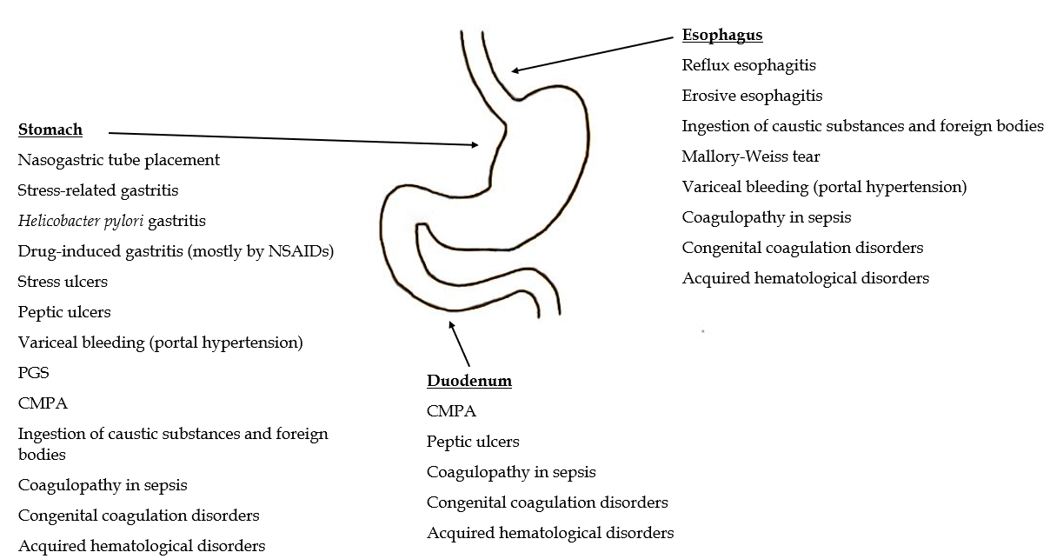
Figure 1 Anatomic locations of upper gastrointestinal bleeding in children, with corresponding common causes. CMPA: Cow’s milk protein allergy; NSAIDs: Non-steroidal anti-inflammatory drugs; PGS: Prolapse gastropathy syndrome.

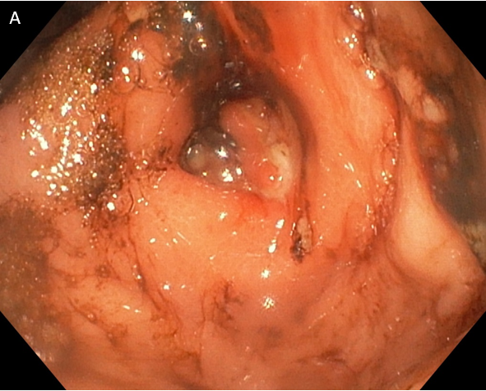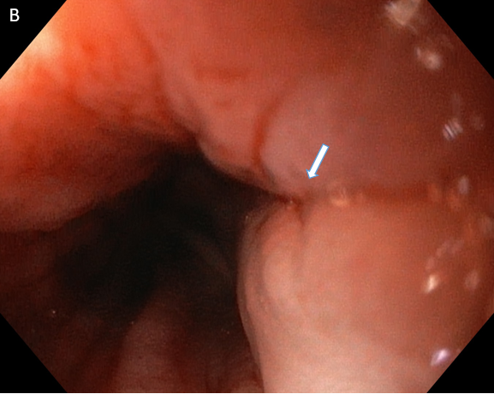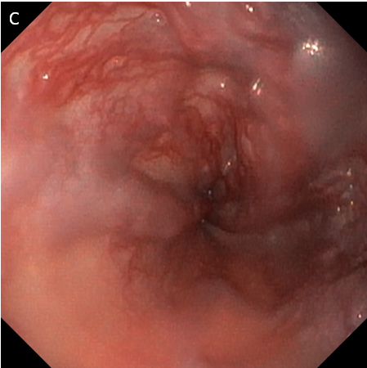
Figure 2 The most common causes of upper gastrointestinal bleeding in children from 1-year-old to 3-years-old. A: Gastric ulcer in a 3-year-old boy who presented with hematemesis; B: Mallory-Weiss tear in a 3-year-old boy; C: Esophageal varices grade II in a 2-year-old boy with extrahepatic portal vein obstruction after cardiac surgery.

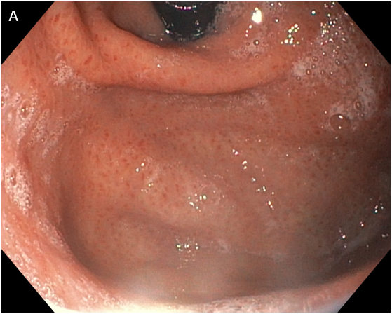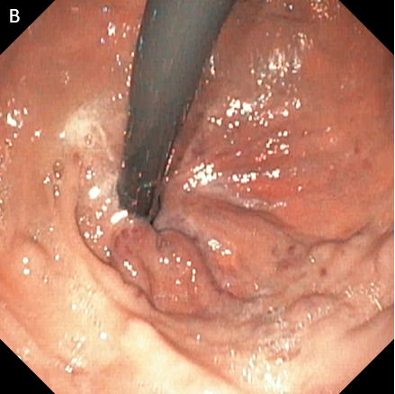
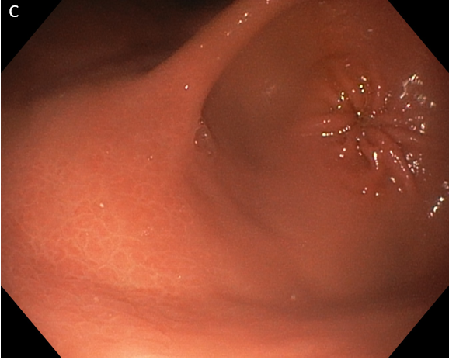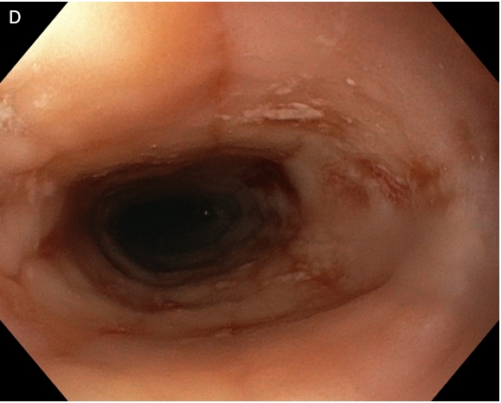
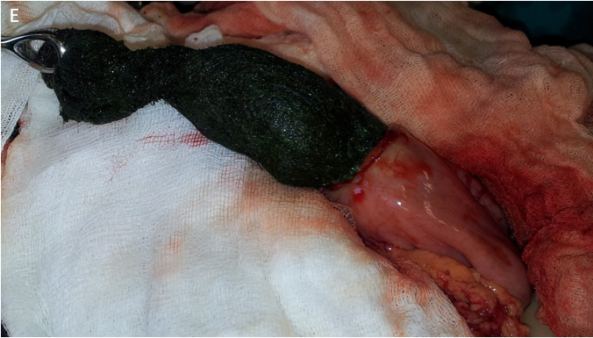
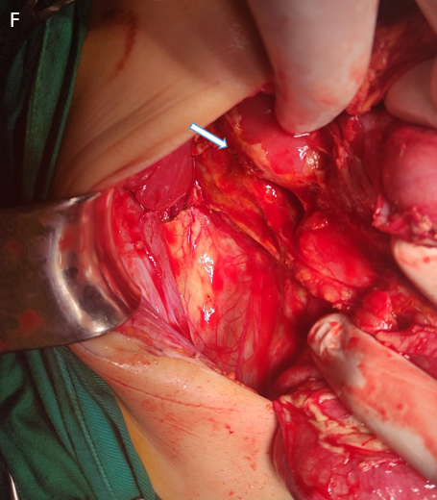
Figure 3 Causes of upper gastrointestinal bleeding in children older than 3-years-old. A: Erosive gastritis in a 14-year-old girl with cerebral palsy; B: Gastroesophageal varices type 2 in a 6-year-old girl with chronic liver disease due to extrahepatic portal vein obstruction; C: Macronodular gastritis in a 16-year-old girl due to Helicobacter pylori infection; D: Eosinophilic esophagitis in a 16-year-old boy; E: Gastric trichobezoar in a 9-year-old boy; F: Traumatic perforation of the duodenum as a consequence of a handlebar injury in a 6-year-old boy. The patient was referred to the hospital two days after injury and the surgery was performed on the day of admission.

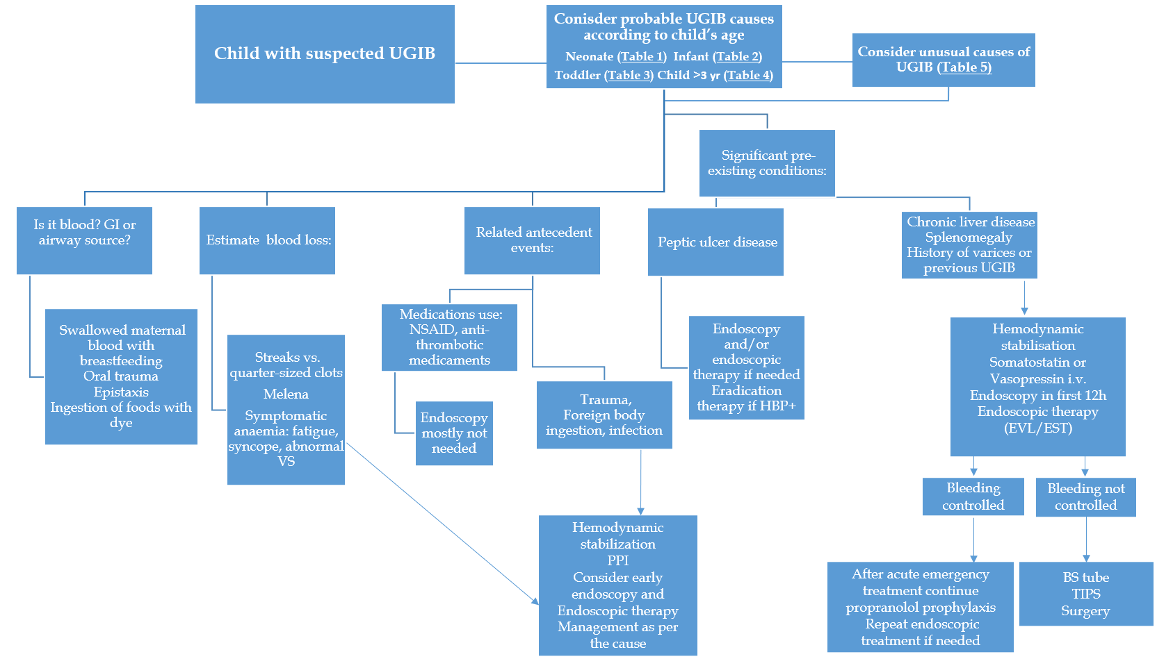
Figure 4 Clinical approach to children with upper gastrointestinal bleeding. BS: Blakemore Sengstaken; EST: Endoscopic sclerotherapy; EVL: Esophageal varices ligation; GI: Gastrointestinal; PPI: Proton pump inhibitor; TIPS: Transjugular intrahepatic portosystemic shunt; UGIB: Upper gastrointestinal bleeding; VS: Vital signs; NSAIDs: Non-steroidal anti-inflammatory drugs.

Table 1 Common causes of upper gastrointestinal bleeding in neonates^{[1,3,5,24]}
Cause | Bleeding source location
Swallowed blood | Non-GI bleeding
Nasogastric tube placement | Stomach
Stress-related gastritis | Stomach
CMPA | Stomach, duodenum
NEC | Lower GI tract
Vitamin K deficiency | Distinct locations
DIC | Distinct locations
Congenital coagulation disorders¹ | Distinct locations
¹Hemophilia, Von Willebrand disease, etc.
CMPA: Cow’s milk protein allergy; DIC: Disseminated intravascular coagulation; GI: Gastrointestinal; NEC: Necrotizing enterocolitis.

Table 2 Common causes of upper gastrointestinal bleeding in infants^{[1,3,5,17,26]}
Cause | Bleeding source location
Erosive esophagitis | Esophagus
Reflux esophagitis | Esophagus
Ingestion of caustic substances and foreign bodies | Esophagus, stomach
Erosive gastritis | Stomach
Stress ulcers | Stomach
Drug-induced gastritis (most commonly by NSAIDs) | Stomach
PGS | Stomach
CMPA | Stomach, duodenum
CMPA: Cow’s milk protein allergy; NSAIDs: Non-steroidal anti-inflammatory drugs; PGS: Prolapse gastropathy syndrome.

Table 3 Common causes of upper gastrointestinal bleeding in toddlers^{[1,4,18]}
Cause | Bleeding source location
Erosive esophagitis | Esophagus
Mallory-Weiss tear | Esophagus
Ingestion of caustic substances and foreign bodies | Esophagus, stomach
Variceal bleeding associated with portal hypertension | Esophagus, stomach
Erosive gastritis | Stomach
Peptic ulcers | Stomach
PGS | Stomach
Drug-induced gastritis (most commonly by NSAIDs) | Stomach
NSAIDs: Non-steroidal anti-inflammatory drugs; PGS: Prolapse gastropathy syndrome.

Table 4 Common causes of upper gastrointestinal bleeding in children ages > 3 yr^{[1,4,5,24,50]}
Cause | Bleeding source location
Erosive esophagitis | Esophagus
Reflux esophagitis | Esophagus
Mallory-Weiss tear | Esophagus
Variceal bleeding associated with portal hypertension | Esophagus, stomach
Erosive gastritis | Stomach
Stress ulcers | Stomach
Drug-induced gastritis (most commonly by NSAIDs) | Stomach
Helicobacter pylori gastritis | Stomach
Peptic ulcers | Stomach, duodenum
Acquired hematological disorders (ITP, leukemia, etc) | Distinct locations
ITP: Idiopathic thrombocytopenic purpura; NSAIDs: Non-steroidal anti-inflammatory drugs.

Table 5 Unusual causes of upper gastrointestinal bleeding in children, based on age
Cause | Age of onset | Bleeding source location
Esophageal duplications^{[60,62]} | All ages | Esophagus
Eosinophilic esophagitis^{[63]} | Children ≥ 3 yr | Esophagus
Gastric duplications^{[65]} | All ages | Stomach
Eosinophilic gastritis | Children ≥ 3 yr | Stomach
Gastric GIST^{[69]} | Children ≥ 3 yr | Stomach
Lymphoma^{[70]} | Children ≥ 3 yr | Stomach
Schwannomas^{[71,72]} | Toddlers, children ≥ 3 yr | Stomach
Focal foveolar hyperplasia^{[73]} | Infants | Stomach
Bezoar^{[77]} | Children ≥ 3 yr | Stomach
Duplications of duodenum^{[56,60]} | All ages | Duodenum
Duodenal varices^{[78]} | Children ≥ 3 yr | Duodenum
Blunt duodenal trauma^{[81]} | Children ≥ 3 yr | Duodenum
Food as a foreign body | Children ≥ 3 yr | Duodenum
Hemobilia^{[83,84]} | All ages | Biliary tract
Dieulafoy’s lesions^{[89-92]} | All ages | Distinct locations
Peptic ulcers in ZES^{[94]} | Children ≥ 3 yr | Distinct locations
Peutz-Jeghers syndrome^{[98]} | Children ≥ 3 yr | Distinct locations
Crohn’s disease^{[99]} | Children ≥ 3 yr | Distinct locations
HSP^{[101,104,105]} | Toddlers, children ≥ 3 yr | Distinct locations
GIST: Gastrointestinal stromal tumor; HSP: Henoch-Schönlein purpura; ZES: Zollinger-Ellison syndrome.

