Name of Journal: World Journal of Gastrointestinal Oncology
ESPS Manuscript NO: 30025
Manuscript Type: Case Report

Heavily calcified gastrointestinal stromal tumors: pathophysiology and implications of a rare clinicopathologic entity

Salati M et al. Unusual presentation of GIST

Massimiliano Salati, Giulia Orsi, Luca Reggiani Bonetti, Fabrizio Di Benedetto, Giuseppe Longo, Stefano Cascinu

Massimiliano Salati, Giulia Orsi, Stefano Cascinu, Department of Medical and Surgical Sciences for Children and Adults, Division of Medical Oncology, University Hospital of Modena and Reggio Emilia, 41124 Modena, Italy

Luca Reggiani Bonetti, Department of Diagnostic Medicine and Public Health, Division of Pathology, University Hospital of Modena and Reggio Emilia, 41124 Modena, Italy

Fabrizio Di Benedetto, Hepato-Pancreato-Biliary Surgery and Liver Transplantation Unit, University Hospital of Modena and Reggio Emilia, 41124 Modena, Italy

Giuseppe Longo, Azienda Ospedaliero-Universitaria Policlinico di Modena, 41124 Modena, Italy

Author contributions: Reggiani Bonetti L reported the pathological findings; Di Benedetto F provided the surgical care; Salati M, Orsi G, Longo G and Cascinu S performed the research, analyzed the literature data and wrote the paper; all authors read and approved the final manuscript.

Institutional review board statement: This case report was exempt from the Institutional
Review Board standards of the University Hospital of Modena and Reggio Emilia.

Informed consent statement: The patient involved in this study gave written informed consent authorizing use and disclosure of protected health information.

Conflict-of-interest statement: None of the authors have any conflicts of interests to declare.

Open-Access: This article is an open-access article which was selected by an in-house editor and fully peer-reviewed by external reviewers. It is distributed in accordance with the Creative Commons Attribution Non Commercial (CC BY-NC 4.0) license, which permits others to distribute, remix, adapt, build upon this work non-commercially, and license their derivative works on different terms, provided the original work is properly cited and the use is non-commercial. See: http://creativecommons.org/licenses/by-nc/4.0/

Manuscript source: Unsolicited manuscript

Correspondence to: Massimiliano Salati, MD, Department of Medical and Surgical Sciences for Children and Adults, Division of Medical Oncology, University Hospital of Modena and Reggio Emilia, via del Pozzo, 41124 Modena, Italy. maxsalati@live.it
Telephone: +39-33-94624778
Fax: +39-05-84222647

Received: September 5, 2016
Peer-review started: September 7, 2016
First decision: September 29, 2016
Revised: October 19, 2016
Accepted: December 13, 2016
Article in press:
Published online:
Abstract
Gastrointestinal stromal tumors (GISTs) are the most common mesenchymal neoplasms of the gastrointestinal tract, and are characterized by a broad spectrum of clinical, histological and molecular features at presentation. Although focal and scattered calcifications are not uncommon within the primary tumor mass, heavy calcification within a GIST is rarely described in the literature and the clinical-biological meaning of this feature remains unclear. Cases with such an atypical presentation are challenging and may be associated with diagnostic pitfalls. Herein, we report a gastric GIST with the unusual presentation of prominent calcifications that was identified incidentally on imaging during a post-trauma diagnostic work-up. The patient underwent laparoscopic surgery with a radical resection of the mass, which was subsequently characterized by histological analysis as spindle-shaped tumor cells, positive for CD117/c-KIT, CD34 and DOG1, and with calcified areas. Given the intermediate risk of recurrence, no adjuvant therapy was recommended and the patient underwent regular follow-up for 22 months, with no evidence of relapse. Our case can be considered of interest because of the rarity of clinical presentation and the uniquely large size of the GIST at diagnosis (longest diameter exceeding 9 cm). In closing, we discuss the pathophysiology and clinical implications of calcifications in GISTs by reviewing the most up-to-date relevant literature.

Key words: Gastrointestinal stromal tumor; Calcification; Stomach; Atypical presentation; Computed tomography

© The Author(s) 2016. Published by Baishideng Publishing Group Inc. All rights reserved.

Core tip: Gastrointestinal stromal tumors (GISTs) are heterogeneous neoplasms that may present with a wide range of clinicopathologic characteristics upon diagnosis; among these, massive calcification is an infrequently occurring feature of GIST presentation. By reporting on such a rare clinical case and reviewing the available literature, this manuscript discusses major diagnostic challenges as well as the pathophysiologic and clinical implications related to a heavily calcified mass diagnosed as GIST.

Salati M, Orsi G, Bonetti LR, Di Benedetto F, Longo G, Cascinu S. Heavily calcified gastrointestinal stromal tumors: pathophysiology and implications of a rare clinicopathologic entity. World J Gastrointest Oncol 2016; In press

INTRODUCTION
Gastrointestinal stromal tumors (GISTs) are the most common type of mesenchymal neoplasm of the gastrointestinal tract (GIT), where they account for roughly 0.1% to 3.0% of all tumors^{[1]}. GISTs were only recently recognized as distinct clinicopathologic entities. Postulated to arise from the interstitial cells of Cajal throughout the entire GIT, the reported GISTs have mainly involved the stomach (60%-70%), with involvement of the small intestine (20%-30%), colon and rectum (5%) and esophagus (< 1%) in fewer cases^{[2]}.
The discovery that virtually all GISTs stain positively for c-KIT and/or DOG1 has facilitated their differential diagnosis from other mesenchymal tumors (i.e., leiomyoma, leiomyosarcoma)^{[3,4]}. Due to their slow-growing behavior, GISTs remain asymptomatic for a long period, having in some cases reached a huge size by the time of diagnosis. The most frequently reported symptoms are vague, depending on tumor size and location, and include nausea, vomiting, abdominal discomfort and early satiety; however, an acute abdomen caused by tumor rupture into the peritoneal cavity or gastrointestinal obstruction may represent the first dramatic presentation of a GIST^{[5]}. When studied by imaging, a GIST typically appears as a large, well-defined soft tissue mass with heterogeneous enhancement, reflecting the frequent occurrence of hemorrhagic necrosis and cystic degeneration within.
Although the majority of GISTs present as localized masses amenable to radical surgical resection, at least 50% of them recur locally or spread diffusely throughout the peritoneum and/or the liver, and the malignant potential of GIST varies greatly. Hence, determining the risk of disease recurrence, as assessed by available risk-stratification tools, is helpful in identifying patients most likely to benefit from an adjuvant treatment^{[6-8]}. Size, mitotic activity and primary tumor size are the most reliable predictive factors for risk of relapse after complete surgery.
Discovery of the crucial role played by the oncogenic activating mutations of c-KIT (80%) and PDGFA-R (5%-10%) in the molecular pathogenesis of GISTs^{[9,10]}, along with the clinical availability of multitarget tyrosine kinase inhibitors such as imatinib, sunitinib and regorafenib^{[11]}, led to dramatic improvement in the outcome of a tumor which, until recently, was regarded as resistant to conventional chemotherapies. Current reports put the disease control rate at up to 85% and the median overall survival of nearly 5 years for patients with unresectable or metastatic GIST receiving frontline imatinib^{[12]}. Moreover, studies of imatinib in the adjuvant setting have shown that it improves the rate of relapse-free survival, as compared with placebo, and that 3 y of therapy gives better rates of relapse-free survival and overall survival than 1 y of therapy in high-risk patients^{[13-14]}.

CASE REPORT
An otherwise healthy 60-year-old woman was admitted to the emergency department with complaint of right-sided chest pain following a car accident in September 2014. The patient was hemodynamically stable and, with the exception of tenderness on the right hemithorax, had unremarkable findings upon physical examination. A total body contrast-enhanced computed tomography (CT) scan was promptly performed and revealed a 7th and 10th right rib fracture, without signs of visceral injury.
Surprisingly, a large mass, measuring 6.5 cm, arising from the external wall of the gastric antrum and projecting into the abdominal cavity, was incidentally identified on imaging (Figure 1). The mass appeared hyperdense, well-circumscribed, heterogeneously enhanced and with prominent calcifications within; there was neither evidence nor loco-regional nor of distant spread. Hence, laparoscopic surgery was ordered to perform a radical resection of the mass. Gross pathology examination of the resected specimen showed it to be exophytic, lobulated, yellowish-gray and extensively calcified, with necrotic-cystic zones measuring 9.3 cm × 5.5 cm (Figure 2).
Microscopic pathology examination revealed a population of spindle-shaped tumor cells (Figure 3A-B) and calcified areas (Figure 3C-D), with positive staining for CD117/c-KIT, CD34 and DOG1 (Figure 3E). In addition, Ki67–MIB1 immunostaining indicated a low proliferative rate (count rate < 1%) (Figure 3E). Molecular testing identified the c-KIT gene as wild-type but the PDGFRA gene as mutated (an exon 18 point mutation). The mass was diagnosed accordingly as GIST of gastric origin.
Recovery from the surgical resection was uneventful and prompt. Based on the estimated intermediate risk of recurrence, made according to the modified National Institutes of Health Criteria^{[15]} (gastric site, size of 5-10 cm, mitosis count of < 5 per 50 high power fields, no tumor rupture), only regular follow-up was recommended. To date, the patient has been followed-up for 22 mo and shown no evidence of relapse.

DISCUSSION
Circumscribed patchy calcifications may occur within the primary mass of large GISTs, and the reported series have indicated a wide variability among these (10% to 50%)^{[16]}. Contrariwise, coarse and extensive calcifications represent an uncommon radiological finding, and only a few cases of these have been reported in the literature^{[17-23]}. Indeed, our search of the MEDLINE/PubMed database identified only 8 cases of extensively calcified GISTs (Table 1).
From a clinical standpoint, when facing a calcified intra-abdominal juxta-gastric mass, various differential diagnoses should be ruled out. For example, diffuse and punctate calcifications may accompany mucin-producing adenocarcinoma of the stomach^{[24,25]}. In the pancreas, solid pseudopapillary tumors and mucinous cystic neoplasms may develop peripheral curvilinear wall calcification, whereas serous cystadenomas may have central calcification within the central fibrous scar^{[26]}. Finally, an ingested foreign body in the stomach may mimic gastric calcification.
From a pathogenetic standpoint, several mechanisms have been implicated in calcific deposition. The most acknowledged process is dystrophic calcification, which typically involves degenerated tissues that are characterized by necrosis, inflammation and hemorrhage, as frequently occurs in GISTs. In such a relatively alkaline background, the binding of denatured proteins to both phosphate and calcium ions is ultimately responsible for the formation of calcium phosphate precipitates. On the other hand, the diffuse punctate calcification pattern that is typical of mucin-forming gastric adenocarcinomas seems to be linked instead to calcium salt precipitates with glycoprotein in an alkaline matrix^{[27]}. Metastatic calcifications occurring in the context of malignant hypercalcemia, as well as granulomatous tissue engulfed by the tumor, represent rarer causes of calcification. More recently, a unique case of osseous metaplasia with mature bone formation was described in a newly diagnosed gastric GIST^{[28]}.
Among the proposed theories, however, the production of multiple cell mediators-such as PDGF, the receptor of which is frequently mutated in GISTs, and the bone morphogenic protein, which is produced by pluripotent stromal cells committed towards the osteoblastic linage-are thought to play a crucial role in the regulation of ectopic bone formation^{[28]}. Intriguingly, several clinical reports have demonstrated the appearance of calcification in metastatic sites of GIST following treatment with imatinib^{[29]}. The underlying mechanism, which is still far from being fully elucidated, is likely to be different from that occurring in the primary mass, as is suggested by the absence of inflammation or necrosis in the specimen obtained from liver metastasis^{[30]}. It is also interesting that this morphologic change has been hypothesized as predictive of tumor response. Finally, examples of osseous differentiation have also been observed in cases of treated GIST, suggesting that under imatinib suppression, GIST cells may become able to mediate the cell cycle and to express a gene signature associated with other differentiated cell phenotypes, thereby providing a mechanism of acquired drug resistance^{[31]}.
Following early evidence that indicated solitary calcification could be an aggressive feature^{[32]}, researchers continue to investigate the potential relevance of calcification in predicting the malignant potential of GISTs. However, a study by Kim et al^{[33]} found no CT features, other than size, to be correlated with biological behavior and prognosis of GIST. This finding was confirmed very recently by Chen et al^{[34]}; specifically, that retrospective analysis of 110 patients who underwent endoscopic ultrasonography identified tumor size as an independent risk factor for malignancy (P ≤ 0.0001) but not for calcification (P = 0.667).
Although no conclusions can be drawn regarding the predictive value of calcification in GIST because of the limited cases reported and the retrospective nature of the analyses, heavily calcified tumors appear to have a less aggressive course, as shown by their low mitotic rate (Table 1). With regard to our case, a relatively indolent behavior and the alleged long history of disease probably contributed to the development of calcification.
In conclusion, to the best of our knowledge, we have presented herein the largest (> 9 cm) heavily calcified GIST ever described in the literature. Our case is noteworthy because of the rarity of clinical presentation in general and the unique size at diagnosis for this patient in particular. Finally, our case and review of the literature indicates that a diagnosis of GIST should be considered when large calcified masses are identified in the GIT, and even more so when in the stomach.

COMMENTS
Case characteristics
An otherwise healthy 60-year-old woman was admitted to the emergency department with complaint of right-sided chest pain following a car accident.

Clinical diagnosis
Upon admission, the patient was hemodynamically stable and only showed tenderness on the right hemithorax upon physical examination, the findings of which were otherwise unremarkable.

Differential diagnosis
Mucin-producing adenocarcinoma of the stomach; pancreatic solid pseudopapillary tumor and mucinous cystic neoplasm; pancreatic cystadenoma; ingested foreign body in the stomach.

Laboratory diagnosis
All laboratory findings were within normal limits.

Imaging diagnosis
In addition to a 7th and 10th right rib fracture, computed tomography (CT) scan revealed a large mass, measuring 6.5 cm, arising from the external wall of gastric antrum and projecting into the abdominal cavity.

Pathological diagnosis
Gastrointestinal stromal tumor (GIST) of gastric origin.

Treatment
Complete laparoscopic surgical excision of the mass.

Related reports
Circumscribed patchy calcifications may occur within the primary mass of large GISTs, and the reported series have indicated a wide variability among these (10% to 50%). Contrariwise, coarse and extensive calcifications represent an uncommon radiological finding, and only a few cases of these have been reported in the literature.

Term explanation
Gastrointestinal stromal tumors are the most common mesenchymal neoplasms of the gastrointestinal tract (GIT), where they account for roughly 0.1% to 3.0% of all tumors. GISTs were only recently recognized as distinct clinicopathologic entities. Postulated to arise from the interstitial cells of Cajal throughout the entire GIT, the reported GISTs have mainly involved the stomach (60%-70%), with involvement of the small intestine (20%-30%), colon and rectum (5%) and esophagus (< 1%) in fewer cases.

Experiences and lessons
The authors’ case is noteworthy because of the rarity of clinical presentation of calcified GISTs and the unique large size of the tumor at diagnosis. A diagnosis of GIST should be considered when large calcified masses are identified in the GIT, and even more so when in the stomach.

Peer-review
This article offers an interesting overview of calcified GISTs, discussing the pathophysiology and clinical implication of calcifications in GISTs by reviewing the most up-to-date relevant literature. While the case reported is not the first that describes a massively calcified GIST, the incidental diagnosis and unique size of the mass are peculiar and noteworthy.

REFERENCES
1 Goettsch WG, Bos SD, Breekveldt-Postma N, Casparie M, Herings RM, Hogendoorn PC. Incidence of gastrointestinal stromal tumours is underestimated: results of a nation-wide study. Eur J Cancer 2005; 41: 2868-2872 [PMID: 16293410 DOI: 10.1016/j.ejca.2005.09.009]
2 Miettinen M, Lasota J. Gastrointestinal stromal tumors (GISTs): definition, occurrence, pathology, differential diagnosis and molecular genetics. Pol J Pathol 2003; 54: 3-24 [PMID: 12817876]
3 Kindblom LG, Remotti HE, Aldenborg F, Meis-Kindblom JM. Gastrointestinal pacemaker cell tumor (GIPACT): gastrointestinal stromal tumors show phenotypic characteristics of the interstitial cells of Cajal. Am J Pathol 1998; 152: 1259-1269 [PMID: 9588894]
4 West RB, Corless CL, Chen X, Rubin BP, Subramanian S, Montgomery K, Zhu S, Ball CA, Nielsen TO, Patel R, Goldblum JR, Brown PO, Heinrich MC, van de Rijn M. The novel marker, DOG1, is expressed ubiquitously in gastrointestinal stromal tumors irrespective of KIT or PDGFRA mutation status. Am J Pathol 2004; 165: 107-113 [PMID: 15215166 DOI: 10.1016/S0002-9440(10)63279-8]
5 Misawa S, Takeda M, Sakamoto H, Kirii Y, Ota H, Takagi H. Spontaneous rupture of a giant gastrointestinal stromal tumor of the jejunum: a case report and literature review. World J Surg Oncol 2014; 12: 153 [PMID: 24885725 DOI: 10.1186/1477-7819-12-153]
6 Miettinen M, Sobin LH, Lasota J. Gastrointestinal stromal tumors of the stomach: a clinicopathologic, immunohistochemical, and molecular genetic study of 1765 cases with long-term follow-up. Am J Surg Pathol 2005; 29: 52-68 [PMID: 15613856 DOI: 10.1097/01.pas.0000146010.92933.de]
7 Miettinen M, Makhlouf H, Sobin LH, Lasota J. Gastrointestinal stromal tumors of the jejunum and ileum: a clinicopathologic, immunohistochemical, and molecular genetic study of 906 cases before imatinib with long-term follow-up. Am J Surg Pathol 2006; 30: 477-489 [PMID: 16625094 DOI: 10.1097/00000478-200604000-00008]
8 Miettinen M, Kopczynski J, Makhlouf HR, Sarlomo-Rikala M, Gyorffy H, Burke A, Sobin LH, Lasota J. Gastrointestinal stromal tumors, intramural leiomyomas, and leiomyosarcomas in the duodenum: a clinicopathologic, immunohistochemical, and molecular genetic study of 167 cases. Am J Surg Pathol 2003; 27: 625-641 [PMID: 12717247 DOI: 10.1097/00000478-200305000-00006]
9 Hirota S, Isozaki K, Moriyama Y, Hashimoto K, Nishida T, Ishiguro S, Kawano K, Hanada M, Kurata A, Takeda M, Muhammad Tunio G, Matsuzawa Y, Kanakura Y, Shinomura Y, Kitamura Y. Gain-of-function mutations of c-kit in human gastrointestinal stromal tumors. Science 1998; 279: 577-580 [PMID: 9438854 DOI: 10.1126/science.279.5350.577]
10 Heinrich MC, Corless CL, Duensing A, McGreevey L, Chen CJ, Joseph N, Singer S, Griffith DJ, Haley A, Town A, Demetri GD, Fletcher CD, Fletcher JA. PDGFRA activating mutations in gastrointestinal stromal tumors. Science 2003; 299: 708-710 [PMID: 12522257 DOI: 10.1126/science.1079666]
11 Heinrich MC, Corless CL, Demetri GD, Blanke CD, von Mehren M, Joensuu H, McGreevey LS, Chen CJ, Van den Abbeele AD, Druker BJ, Kiese B, Eisenberg B, Roberts PJ, Singer S, Fletcher CD, Silberman S, Dimitrijevic S, Fletcher JA. Kinase mutations and imatinib response in patients with metastatic gastrointestinal stromal tumor. J Clin Oncol 2003; 21: 4342-4349 [PMID: 14645423 DOI: 10.1200/JCO.2003.04.190]
12 Gastrointestinal Stromal Tumor Meta-Analysis Group (MetaGIST). Comparison of two doses of imatinib for the treatment of unresectable or metastatic gastrointestinal stromal tumors: a meta-analysis of 1,640 patients. J Clin Oncol 2010; 28: 1247-1253 [PMID: 20124181 DOI: 10.1200/JCO.2009.24.2099]
13 Dematteo RP, Ballman KV, Antonescu CR, Maki RG, Pisters PW, Demetri GD, Blackstein ME, Blanke CD, von Mehren M, Brennan MF, Patel S, McCarter MD, Polikoff JA, Tan BR, Owzar K. Adjuvant imatinib mesylate after resection of localised, primary gastrointestinal stromal tumour: a randomised, double-blind, placebo-controlled trial. Lancet 2009; 373: 1097-1104 [PMID: 19303137 DOI: 10.1016/S0140-6736(09)60500-6]
14 Joensuu H, Eriksson M, Sundby Hall K, Hartmann JT, Pink D, Schütte J, Ramadori G, Hohenberger P, Duyster J, Al-Batran SE, Schlemmer M, Bauer S, Wardelmann E, Sarlomo-Rikala M, Nilsson B, Sihto H, Monge OR, Bono P, Kallio R, Vehtari A, Leinonen M, Alvegård T, Reichardt P. One vs three years of adjuvant imatinib for operable gastrointestinal stromal tumor: a randomized trial. JAMA 2012; 307: 1265-1272 [PMID: 22453568 DOI: 10.1001/jama.2012.347]
15 Joensuu H. Risk stratification of patients diagnosed with gastrointestinal stromal tumor. Hum Pathol 2008; 39: 1411-1419 [PMID: 18774375 DOI: 10.1016/j.humpath.2008.06.025]
16 Levy AD, Remotti HE, Thompson WM, Sobin LH, Miettinen M. Gastrointestinal stromal tumors: radiologic features with pathologic correlation. Radiographics 2003; 23: 283-304, 456; quiz 532 [PMID: 12640147 DOI: 10.1148/rg.232025146]
17 Kim HS, Sung JY, Park WS, Kim YW. Gastrointestinal stromal tumors of the stomach with extensive calcification: report of two cases. Intern Med 2012; 51: 2555-2558 [PMID: 22989826 DOI: 10.2169/internalmedicine.51.8182]
18 Ong K, Singaporewalla RM, Tan KB. Extensive calcification within a gastrointestinal stromal tumour: a potential diagnostic pitfall. Pathology 2006; 38: 451-452 [PMID: 17008287 DOI: 10.1080/00313020600924922]
19 Rana R, Nikolaidis P, Miller F. Calcified gastrointestinal stromal tumor of the sigmoid colon mimicking inspissated barium on CT. AJR Am J Roentgenol 2006; 187: W322-W323 [PMID: 16928913 DOI: 10.2214/AJR.06.0035]
20 Izawa N, Sawada T, Abiko R, Kumon D, Hirakawa M, Kobayashi M, Obinata N, Nomoto M, Maehata T, Yamauchi S, Kouro T, Tsuda T, Kitajima S, Yasuda H, Tanaka K, Tanaka I, Hoshikawa M, Takagi M, Itoh F. Gastrointestinal stromal tumor presenting with prominent calcification. World J Gastroenterol 2012; 18: 5645-5648 [PMID: 23112561 DOI: 10.3748/wjg.v18.i39.5645]
21 Yu CC, Wu CC, Hwang JI, Wang J, Chang CS. Thick calcification from a GIST of the stomach penetrating into pericolic soft tissue--report of a case. World J Surg Oncol 2011; 9: 45 [PMID: 21527041 DOI: 10.1186/1477-7819-9-45]
22 Yoshida H, Mamada Y, Taniai N, Mizuguchi Y, Nakamura Y, Nomura T, Okuda T, Uchida E, Fukuda Y, Watanabe M, Tajiri T. Spurt bleeding from a calcificated gastrointestinal stromal tumor in the stomach. J Nippon Med Sch 2005; 72: 304-307 [PMID: 16247232 DOI: 10.1272/jnms.72.304]
23 Testroote M, Hoornweg M, Rhemrev S. Rectal GIST presenting as a submucosal calculus. Dig Dis Sci 2007; 52: 1047-1049 [PMID: 17268837 DOI: 10.1007/s10620-006-9160-y]
24 Dickson AM, Schuss A, Goyal A, Katz DS. Radiology-Pathology Conference: Calcified untreated gastric cancer. Clin Imaging 2004; 28: 418-421 [PMID: 15531142 DOI: 10.1016/j.clinimag.2004.04.001]
25 Balestreri L, Canzonieri V, Morassut S. Calcified gastric cancer--CT findings before and after chemotherapy. Case report and discussion of the pathogenesis of this type of calcification. Clin Imaging 1997; 21: 122-125 [PMID: 9095387 DOI: 10.1016/S0899-7071(96)00010-1]
26 Choi JY, Kim MJ, Kim JH, Kim SH, Lim JS, Oh YT, Chung JJ, Yoo HS, Lee JT, Kim KW. Solid pseudopapillary tumor of the pancreas: typical and atypical manifestations. AJR Am J Roentgenol 2006; 187: W178-W186 [PMID: 16861508 DOI: 10.2214/AJR.05.0569]
27 Ichiishi E, Kogawa T, Takeda S, Yanagida K, Yoshikawa T, Kondo M. Eight cases of gastric tumors with calcification. Intern Med 1995; 34: 1038-1042 [PMID: 8563087 DOI: 10.2169/internalmedicine.34.1038]
28 Giorlandino A, Caltabiano R, Gurrera A, Lanzafame S. Gastrointestinal stromal tumour of the stomach with osseous differentiation: a case report. Pathologica 2014; 106: 345-347 [PMID: 25845053]
29 Warakaulle DR, Gleeson F. MDCT appearance of gastrointestinal stromal tumors after therapy with imatinib mesylate. AJR Am J Roentgenol 2006; 186: 510-515 [PMID: 16423961 DOI: 10.2214/AJR.04.1516]
30 Joensuu H, Roberts PJ, Sarlomo-Rikala M, Andersson LC, Tervahartiala P, Tuveson D, Silberman S, Capdeville R, Dimitrijevic S, Druker B, Demetri GD. Effect of the tyrosine kinase inhibitor STI571 in a patient with a metastatic gastrointestinal stromal tumor. N Engl J Med 2001; 344: 1052-1056 [PMID: 11287975 DOI: 10.1056/NEJM200104053441404]
31 Agaram NP, Besmer P, Wong GC, Guo T, Socci ND, Maki RG, DeSantis D, Brennan MF, Singer S, DeMatteo RP, Antonescu CR. Pathologic and molecular heterogeneity in imatinib-stable or imatinib-responsive gastrointestinal stromal tumors. Clin Cancer Res 2007; 13: 170-181 [PMID: 17200352 DOI: 10.1158/1078-0432.CCR-06-1508]
32 Ghanem N, Altehoefer C, Furtwängler A, Winterer J, Schäfer O, Springer O, Kotter E, Langer M. Computed tomography in gastrointestinal stromal tumors. Eur Radiol 2003; 13: 1669-1678 [PMID: 12835984 DOI: 10.1007/s00330-002-1803-6]
33 Kim HC, Lee JM, Kim KW, Park SH, Kim SH, Lee JY, Han JK, Choi BI. Gastrointestinal stromal tumors of the stomach: CT findings and prediction of malignancy. AJR Am J Roentgenol 2004; 183: 893-898 [PMID: 15385278 DOI: 10.2214/ajr.183.4.1830893]
34 Chen TH, Hsu CM, Chu YY, Wu CH, Chen TC, Hsu JT, Yeh TS, Lin CJ, Chiu CT. Association of endoscopic ultrasonographic parameters and gastrointestinal stromal tumors (GISTs): can endoscopic ultrasonography be used to screen gastric GISTs for potential malignancy? Scand J Gastroenterol 2016; 51: 374-377 [PMID: 26489709 DOI: 10.3109/00365521.2015.1095350]

P-Reviewer: Aoyagi K, de Bree E, Li CF, Marin JJG
S-Editor: Qiu S L-Editor: E-Editor:

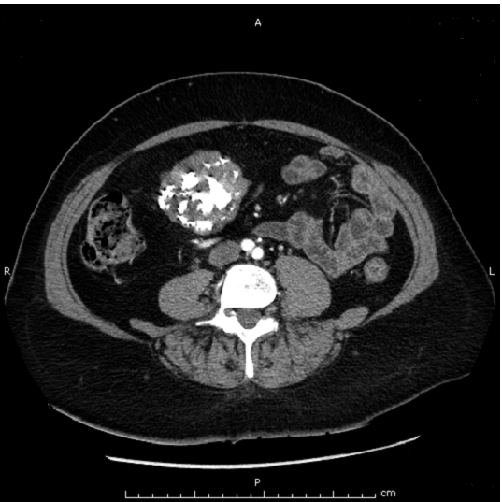

Figure 1 Axial contrast-enhanced computed tomography scan showing a well-defined heterogeneously enhanced gastric mass with coarse and diffuse calcifications.

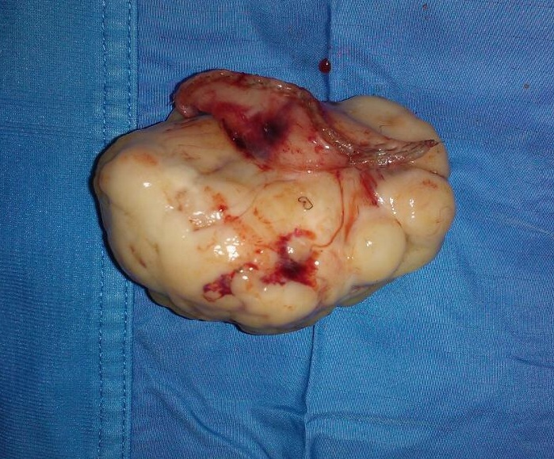

Figure 2 Macroscopic presentation of the resected mass, consisting of an exophytic and yellowish-gray tumor.

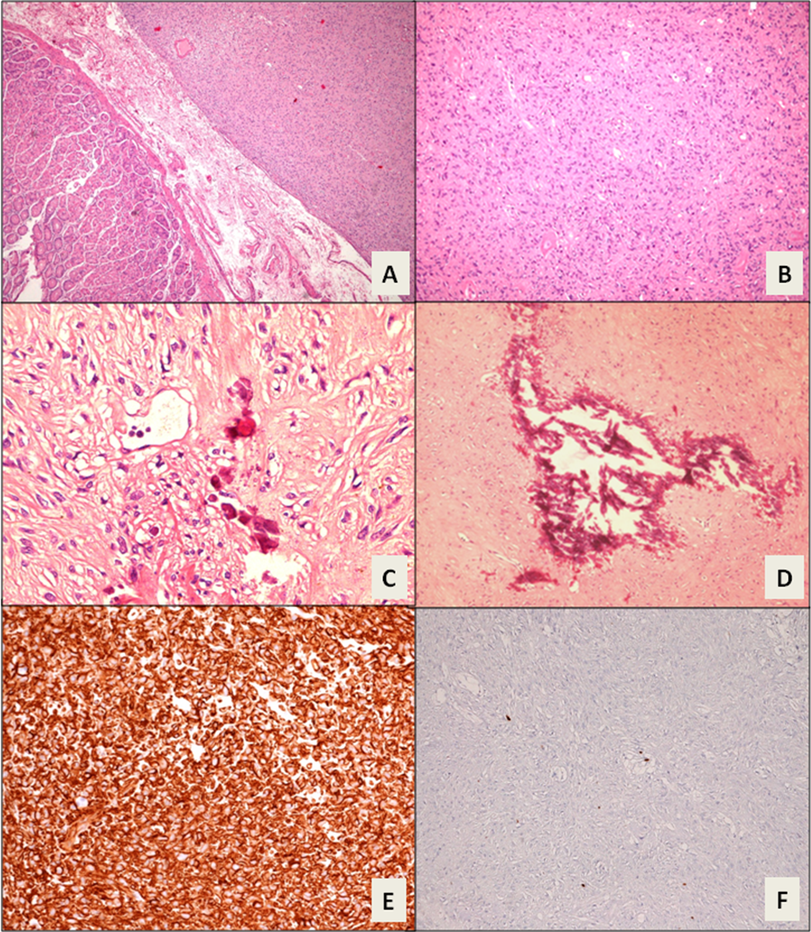

Figure 3 Histologic appearance of the tumor. A and B: Interlacing bundles of spindle cells with unremarkable mitotic activity (H and E stain; magnification × 10); C and D: Calcified areas (H and E stain; magnification × 20); E: Intense immunoreactivity for DOG1 (Immunohistochemistry stain; magnification × 20); F: Inconspicuous Ki67-MIB1 label index (count rate < 1%; immunohistochemistry stain; magnification × 20).

Table 1 Selected features of the reported cases of extensively calcified gastrointestinal stromal tumors

Ref. | Year | Age, Sex | Site | Size (mm) | Mitotic index  (HPF) | IHC pattern | Calcification pattern | Clinical presentation | Risk¹
Izawa et al^{[19]} | 2012 | 61 y, female | Stomach | 32 × 23 × 23 | < 5/50 | KIT⁺, CD34⁺, S-100⁻, desmin⁻, SMA⁻ | Peripheral ring | Epigastric discomfort | Low
Kim et al^{[16]} | 2012 | 53 y, male  69 y, female | Stomach  Stomach | 80 × 75 × 50  62 × 55 × 42 | < 5/50  < 5/50 | KIT⁺, CD34⁺,  S-100⁻, desmin⁻, SMA⁻  KIT⁺, CD34⁺, S-100⁻, desmin⁻, SMA⁻ | Extensively calcified  Extensively calcified | Epigastric pain  Epigastric pain | Intermediate  Intermediate
Yu et al^{[20]} | 2011 | 81 y, female | Stomach | 60 | < 5/50 | KIT⁺, CD34⁺, S-100⁻, desmin⁻ | Semicircular plate | Abdominal pain, hematemesis | Intermediate
Ong et al^{[17]} | 2006 | 94 y, female | Rectum | 25 × 15 × 15 | < 5/50 | KIT⁺, CD34⁺, S-100⁻, desmin⁻ | Entirely | Rectal bleeding | Low
Yoshida et al^{[21]} | 2005 | 77 y, male | Stomach | 28 × 26 × 26 | < 5/50 | KIT⁺, CD34⁺, vimentin⁺, S-100⁻, desmin⁻, SMA⁻ | Patchy | Chest discomfort, loss of consciousness | Low
Testroote et al^{[23]} | 2007 | 53 y, male | Rectum | 31 × 23 × 18 | < 5/50 | KIT⁺, CD34⁺, SMA focally positive | Entirely | Abdominal pain, constipation | Low
Rana et al^{[18]} | 2006 | 62 y, female | Colon | 39 × 56 | NA | KIT⁺, CD34⁺ | Multiple shadowing | Abdominal pain | NA
¹Risk is expressed according to the modified NIH classification system^{[15]}. HPF: High-power field; IHC: Immunohistochemistry.

