Name of Journal: World Journal of Clinical Cases
Manuscript NO: 54512
Manuscript Type: CASE REPORT

Two sequential surgeries in infant with multiple floor of the mouth dermoid cysts: A case report

Liu NN et al. Multiple floor of mouth dermoid cysts

Nan-Nan Liu, Xin-Yue Zhang, Yan-Yan Tang, Zhi-Ming Wang

Nan-Nan Liu, Xin-Yue Zhang, Yan-Yan Tang, Zhi-Ming Wang, Department of Stomatology, Shengjing Hospital of China Medical University, Shenyang 110004, Liaoning Province, China

Author contributions: Liu NN and Wang ZM contributed to the design of the article; Liu NN, Zhang XY and Tang YY contributed to the literature review, drafting and editing; All authors approved the final draft submitted.

Supported by 345 Talent Project of Shengjing Hospital; and Natural Science Foundation of Liaoning Province, No. 20170541042.

Corresponding author: Zhi-Ming Wang, DDS, MD, PhD, Chief Doctor, Surgeon, Department of Stomatology, Shengjing Hospital of China Medical University, No. 36 Sanhao Street, Heping District, Shenyang 110004, Liaoning Province, China. wangzm@sj-hospital.org

Received: February 2, 2020
Revised: May 23, 2020
Accepted: June 4, 2020
Published online: July 6, 2020
Abstract
BACKGROUND
Multiple intraoral dermoid cysts of large magnitude generally appear in the second or third decade of life. They are rare in infants and are usually solitary. In this case, a large mass was identified in utero during prenatal exams.

CASE SUMMARY
We introduce a rare case on multiple dermoid cysts in the floor of the mouth of an infant who underwent two surgeries for this. Preoperative magnetic resonance imaging confirmed a large well-circumscribed cystic lesion that originated at the former midline region in the floor of the mouth in which a suspicious lesion of minute size was likely compressed by the bulkier mass and overlooked. Therefore, the infant underwent two surgeries by an intraoral approach within 9 mo. At 5 mo after the second operation, a routine follow-up ultrasound showed evidence of an additional cyst. No further surgery was planned because the tumor had no immediate effect.

CONCLUSION
This report demonstrates the importance of carefully analyzing preoperative imaging to avoid multiple operations for a seemingly isolated oral cyst.

Key words: Multiple; Dermoid cysts; Floor of the mouth; Infant; Case report; Recurrent

Liu NN, Zhang XY, Tang YY, Wang ZM. Two sequential surgeries in infant with multiple floor of the mouth dermoid cysts: A case report. World J Clin Cases 2020; 8(13): 2885-2892 URL: https://www.wjgnet.com/2307-8960/full/v8/i13/2885.htm DOI: https://dx.doi.org/10.12998/wjcc.v8.i13.2885

Core tip: Herein, we describe an infant subjected to surgery on two occasions for multiple dermoid cysts within the floor of the mouth and perform a systematic review of the literature. The multiple lesions were squeezed so much that they are ignored, which lead to two sequential surgeries.
INTRODUCTION
Multiple dermoid cysts in the floor of mouth are atypical and rare. In head and neck locations, such growths are usually solitary and most often involve orbital regions^{[1]}. They generally appear in the second or third decade of life, given the heightened degree of epithelial activity during this period. Although rare in infants, these cysts may develop at any age^{[2]}. A majority are congenital, slow-growing and benign, attributable to mesenchymal entrapment of first and second branchial arch cells during weeks 3-4 of embryonic life. Their gradual enlargement may displace or elevate the tongue, causing dysphagia, dysphonia or even dyspnea^{[3]}. Acquired cysts are secondarily inflicted via accidental or surgical implantation of epithelial cells^{[4]}.
Dermoid cysts are largely treated by surgical resection. The approach is dictated by location of tumor relative to mylohyoid muscle: intraoral (supramylohyoid) versus extraoral (inframylohyoid)^{[5]}. Despite the cosmetic advantage of intraoral incisions, boosting its popularity, inherent anatomic complexities have hampered its standardization to date. The safety/efficacy of transoral excision also remains to be proven in this setting^{[6]}. Herein, we report a rare instance of two surgical interventions in an infant with multiple dermoid cysts arising from the floor of the mouth.

CASE PRESENTATION
Chief complaints
A 1-mo-old female infant presented with a large swelling in the floor of the mouth followed by dysphagia since birth.

History of present illness
At week 24 of pregnancy, this lesion had been detected in utero (1.9 cm × 1.8 cm) during a routine prenatal examination. It further enlarged to 2.0 cm × 3.0 cm by week 34. Postnatally, there was visible upward displacement of the infant’s tongue by a mass that nearly filled the oral cavity, gradually interfering with swallowing and breathing. At 28 d of age, the newborn was referred to our hospital for treatment.

History of past illness
At admission, her medical history was otherwise unremarkable.

Personal and family history
The patient had no personal or family history of other diseases.

Physical examination upon admission
Physical examination revealed a large-sized cystic mass protruding from the floor of the mouth. Upon bimanual palpation, the soft and non-tender growth expanded to roughly 3.0 cm × 3.0 cm (Figure 1). Mouth closure was not feasible. The infant’s tongue was forced backwards and upwards in the oral cavity. The parents acknowledged swallowing difficulties but denied difficulty in breathing or signs of hypoxia during the previous month.

Laboratory examinations
Laboratory results including complete blood count, electrolytes and coagulation panels were within normal limits with a white blood count of 7.8 × 10⁹/L, red blood cell count of 4.0 × 10¹²/L and hemoglobin of 150 g/L.

Imaging examinations
Preoperative magnetic resonance imaging (MRI) confirmed a well-circumscribed cystic lesion (3.3 cm × 2.8 cm × 2.9 cm) of high signal intensity that originated at the former midline region in the floor of the mouth pushing the root of the tongue backwards (Figure 1).

FINAL DIAGNOSIS
The final diagnosis of the presented case is multiple dermoid cysts of the floor of the mouth.

TREATMENT
The infant was subjected to surgery on July 3, 2018. Given a predominantly supramylohyoid location, we elected an intraoral approach. However, the bulky cyst prevented direct oral intubation, calling for puncture (5 mL syringe) and withdrawal of clear fluid (about 10 mL). Oral intubation was smoothly executed thereafter (Figure 2), and general anesthesia was satisfactorily achieved. A horizontal incision was then made across the protuberance parallel to the dental arch above the caruncula and orifice of submandibular gland duct. The cyst was seated just beneath the mucous membrane. Its wall was dissected bluntly from surrounding tissues, carefully guarding submandibular gland duct, lingual nerve, hypoglossal nerve and other vital anatomic structures against injury. The resected lesion measured 2.0 cm × 2.0 cm (emptied of liquid content). It remained intact with some whitish keratin inside (Figure 2). To prevent postoperative complications (i.e. hemorrhage and floor of the mouth edema) that may cause upper respiratory tract obstruction, hemostasis was ensured, and drainage strips were placed before closing the incision. After surgery, patient monitoring was conducted in the pediatric intensive care unit.
On postoperative day 2, the infant’s vital signs were stable, and there was no obvious hemorrhage or edema at the floor of the mouth, which allowed her to return to our ward. However, mild edema developed at the incision site on postoperative day 3 (Figure 3) and persisted, failing to subside appreciably after 3 d of dexamethasone treatment. An MRI study of the tongue obtained 1 wk later in follow-up showed two small cystic lesions beneath the tongue, approximately 0.8 cm × 1.0 cm × 0.5 cm and 1.2 cm × 0.5 cm × 0.5 cm (Figure 3). In reviewing the preoperative MRI, we identified a suspicious lesion of minute size (white arrow, Figures 1B and 1D), which was likely compressed by the bulkier mass and overlooked. Once the sizeable cyst was removed, the other rapidly enlarged. On postoperative day 9, the patient was discharged for further observation. Histologic sections revealed a keratinizing stratified squamous epithelial lining complete with sebaceous adnexa, confirming a dermoid cyst at the floor of the mouth (Figure 2).
At 9 mo later, the parents and child revisited our department. Physical examination of the infant revealed a normal mouth opening with slight tongue elevation. A mass (2.0 cm × 2.0 cm) was palpable bimanually, present within the tongue muscle near the midline in the floor of the mouth. This lesion was less resilient with poor mobility. MRI in advance of a second surgery showed another lesion of high signal intensity (1.8 cm × 1.0 cm × 2.1 cm) present beneath the tongue muscle at midline (Figure 4). On February 14, 2019, surgery was again performed, reproducing the incision used earlier. A second cyst was found, deeply embedded in the mylohyoid muscle at the floor of the mouth requiring careful separation. We similarly withdrew some clear fluid to reduce its size. The fully excised lesion measured 1.5 cm × 1.0 cm including the capsule. Cross sections indicated that the content was sebum (Figure 4). The final pathologic diagnosis was also dermoid cyst.

OUTCOME AND FOLLOW-UP
At 5 mo after the second operation, the third cyst (1.5 cm × 0.9 cm × 1.0 cm) was found in the same location. However, this lesion had not impacted the child's eating, swallowing or breathing. Other than follow-up monitoring, no further operations have been planned.

DISCUSSION
There are three major theories at present to explain the origins of dermoid cysts^{[7]}. The first (as in this infant) is a congenital basis. Indeed, this condition was initially detected during the mother’s routine prenatal examinations. At an early stage of embryonic development, the first and second branchial arches bilaterally join at midline. Epithelial remnants may become entrapped in doing so, or remnants of odd nodules forming the body of tongue and floor of mouth floor may persist giving rise to dermoid cysts^{[8]}. The second theory accounts for acquired lesions, which are linked to traumatic or iatrogenic events or occlusion of a sebaceous gland duct^{[9]}. The third theory is the rather remote possibility that such midline cervical growths represent cystic thyroglossal duct variants^{[7]}.
Dermoid cysts may occur in any region of the body, especially in the midline, where fusion of embryonic elements takes place. Ovarian and sacral regions are the most common locations for these growths, which seldom involve the head and neck (< 0.01%). On the other hand, the oral cavity and the lateral one-third of eyebrows are likely sites of head and neck development^{[10]}.
Cysts found at midline in the floor of the mouth are generally categorized in two ways. Based on histopathologic features, there is a spectrum of cystic teratomas, including epidermoid, dermoid and teratoid cysts, which are all closely related^{[11]}. However, epidermoid and teratoid lesions are actually histologic variants of dermoid cysts^{[5]}. The walls of true dermoid cysts are keratinizing and perhaps hair-bearing, harboring visible follicles and sebaceous or sweat glands, whereas epidermoid cysts have stratified squamous epithelial linings (usually cornified) devoid of cutaneous appendages. In both dermoid and epidermoid cysts, the content is typically a mix of keratin and oily sebaceous material. The walls of teratoid cysts and teratomas are often lined by stratified squamous and ciliated respiratory epithelia and incorporate a variety of ectodermal, endodermal and mesodermal elements^{[12]}. This infant presented with true dermoid cysts, each having demonstrable sebaceous glands within the wall.
On an anatomic basis, midline cysts are classifiable as supramylohyoid, transmylohyoid (also known as perimylohyoid) and inframylohyoid, according to the topographic relation between cyst and muscle. The mylohyoid muscle separates sublingual spaces from submental and submandibular compartments^{[13]}; supramylohyoid cysts may be further classified as above geniohyoid or between geniohyoid and mylohyoid^{[14]}. The first cyst removed from this infant occurred at the supramylohyoid level, whereas the second was deep within the muscle itself. It is thus understandable that the small, compressed second and third cysts were so easily overlooked.
Imaging often plays an important role in surgical planning. In terms of soft tissue pathology, MRI is reportedly superior to other imaging modalities because there is good contrast between normal and diseased constituents, and no radiation exposure is entailed^{[15,16]}. This is especially important in children, which prompted our use of MRI to delineate locations and magnitudes of cysts in this pediatric patient. Prior to the first surgery, the MRI study revealed a noticeable, bulky and well-defined cyst of hyperintense signal in T2-weighted phase, as well as a minute but suspect lesion of moderate signal intensity at the floor of the mouth (see white arrows, Figures 1B and 1D). Unfortunately, the more glaring findings on imaging sometimes overshadow other features or serve as distractions. We thus focused solely on the sizeable cyst, never suspecting that the minor lesion might be related or represent an independent threat. In resecting the large lesion, we felt that all adjacent tissues had been removed.
Faced with unanticipated postoperative edema, a follow-up MRI indicated two small, equal-sized cysts at the same surgical site. We then carefully reviewed the preoperative MRI, locating a tiny lesion (behind the large cyst) that was apparently left behind. A second preoperative MRI also showed two lesions, one large and one small. The small cyst sat in front of the large cyst, both closely aligned as possible arms of a single lesion. Had our resection been more thorough, such a recurrence may not have taken place. However, we found and resected one lesion only during the second surgery, encountering no other. At 5 mo later, a follow-up ultrasonic tomography confirmed the persistence of another small lesion. Consequently, it seems likely that the small cysts were compressed by the sizeable mass first resected, making it difficult to locate the other lesions in MRI studies or intraoperatively.
Nasotracheal intubation during the first operation and use of a tongue stitch for retraction during the second procedure proved helpful in our patient. These maneuvers generally provide clearer operative fields in the small mouths of pediatric patients^{[17]}. The choice of surgical approach (intraoral vs extraoral) for tumors at the floor of the mouth is made individually, based on size and anatomic location of each lesion^{[18]}.
Surgical excision is an effective treatment for dermoid cysts^{[19]}, although care must be taken to limit trauma during procedures and ensure hemostasis at completion by placing drainage strips at that time. Intravenous dexamethasone injection may also relieve edema in the first 48 hours, and close observation of the respiratory tract is essential for 6-48 hours postoperatively. If swelling at the floor of the mouth is sudden and rapidly worsens, immediate operative exploration is mandatory to halt potential bleeding and prevent asphyxia.
Many authors have found marsupialization through transoral incision to be sufficient for large dermoid cysts, thus reducing operative time and minimizing damage to vital structures^{[20]}. However, recurrence rates vary greatly when using this strategy. Marsupialization is in fact usually reserved for ranulas, which (unlike dermoid cysts) have no true epithelial linings^{[21]}.
Recurrence or malignant transformation (to squamous cell carcinoma) is exceedingly rare in this setting, and postoperative infections are unlikely^{[22]}. Recurrent dermoid cysts are linked to cyst remnants on genial tubercle or hyoid bone, and malignant degeneration has only been reported in sporadic instances of teratoids^{[23]}. The two recurrences herein to some extent reflect an inability to locate multiple lesions intraoperatively. It is worth considering whether a large dermoid cyst shares multiple lesions that may be compressed, warranting greater attention before and during surgery. Our patient will be followed regularly, checking for enlargement or signs of aggressive (i.e. malignant) behavior.

CONCLUSION
On the whole, dermoid cysts usually occur as a solitary mass. It is rare to find the condition identified during routine prenatal examinations like this case. Even more remarkable is the presence of multiple cysts in this infant’s floor of mouth. Unfortunately, the largest lesion compressed two smaller ones, making them difficult to locate by imaging or during surgery. Therefore, it is of great importance to analyze preoperative imaging carefully and to consider the potential for multiplicity in a seemingly isolated midline cyst of oral cavity.

References
1 Voss JO, Buehling S, Thieme N, Doll C, Hauptmann K, Heiland M, Adolphs N, Raguse JD. Sublingual cysts of different entities in an infant - A case report and literature review. Int J Pediatr Otorhinolaryngol 2018; 113: 260-265 [PMID: 30173998 DOI: 10.1016/j.ijporl.2018.07.055]
2 Ueno T, Takayama R, Osada SI, Saeki H. Epidermoid Cyst Arising on the Body of the Tongue: Case Report and Literature Review. J Nippon Med Sch 2018; 85: 343-346 [PMID: 30568062 DOI: 10.1272/jnms.JNMS.2018_85-56]
3 Schwanke TW, Oomen KP, April MM, Ward RF, Modi VK. Floor of mouth masses in children: proposal of a new algorithm. Int J Pediatr Otorhinolaryngol 2013; 77: 1489-1494 [PMID: 23859226 DOI: 10.1016/j.ijporl.2013.06.016]
4 MacNeil SD, Moxham JP. Review of floor of mouth dysontogenic cysts. Ann Otol Rhinol Laryngol 2010; 119: 165-173 [PMID: 20392029 DOI: 10.1177/000348941011900304]
5 El-Hakim IE, Alyamani A. Alternative surgical approaches for excision of dermoid cyst of the floor of mouth. Int J Oral Maxillofac Surg 2008; 37: 497-499 [PMID: 18272345 DOI: 10.1016/j.ijom.2007.12.004]
6 Kim JP, Lee DK, Moon JH, Park JJ, Woo SH. Transoral Dermoid Cyst Excision: A Multicenter Prospective Observational Study. Otolaryngol Head Neck Surg 2018; 159: 981-986 [PMID: 30149779 DOI: 10.1177/0194599818791772]
7 Dutta M, Saha J, Biswas G, Chattopadhyay S, Sen I, Sinha R. Epidermoid cysts in head and neck: our experiences, with review of literature. Indian J Otolaryngol Head Neck Surg 2013; 65: 14-21 [PMID: 24427609 DOI: 10.1007/s12070-011-0363-y]
8 Teszler CB, El-Naaj IA, Emodi O, Luntz M, Peled M. Dermoid cysts of the lateral floor of the mouth: A comprehensive anatomo-surgical classification of cysts of the oral floor. J Oral Maxillofac Surg 2007; 65: 327-332 [PMID: 17236944 DOI: 10.1016/j.joms.2005.06.022]
9 Ramanathan M, Balasundharam S, Christabel A, Murali P, Pandem S. Simultaneous Occurrence of a Midline Sublingual Dermoid Cyst with Respiratory Epithelium and Submental Dermoid Cyst in a Paediatric Patient: A Case Report and Review of Literature. J Maxillofac Oral Surg 2018; 17: 188-192 [PMID: 29618884 DOI: 10.1007/s12663-016-0972-9]
10 Lenghel LM, Băciuţ G, Băciuţ M, Rotaru H, Bran S, Dinu C, Botar-Jid C, Gersak M, Dudea SM. The ultrasonographic diagnosis of cystic cervical lesions: a pictorial essay. Med Ultrason 2016; 18: 240-246 [PMID: 27239661 DOI: 10.11152/mu.2013.2066.182.cys]
11 Lin HW, Silver AL, Cunnane ME, Sadow PM, Kieff DA. Lateral dermoid cyst of the floor of mouth: unusual radiologic and pathologic findings. Auris Nasus Larynx 2011; 38: 650-653 [PMID: 21334151 DOI: 10.1016/j.anl.2011.01.002]
12 Kumar NG, Arora SS, Kumar I, Pandher PK, Balwan R. Dermoid Cysts of the Maxillofacial Region: Case Series. J Maxillofac Oral Surg 2019; 18: 238-244 [PMID: 30996545 DOI: 10.1007/s12663-018-1129-9]
13 Regis DM, Cunha JLS, Sánchez-Romero C, da Cruz Ramos MAC, de Albuquerque RLC, Bezerra BT. Diagnosis, management, and follow-up of extensive dermoid cyst of the submental region. Autops Case Rep 2019; 9: e2019095 [PMID: 31372357 DOI: 10.4322/acr.2019.095]
14 Kusuyama Y, Takeuchi N, Wakabayashi K, Yura Y. Dermoid Cyst of the Lateral Neck Included Within the Submandibular Gland. J Craniofac Surg 2016; 27: e33-e34 [PMID: 26669652 DOI: 10.1097/SCS.0000000000002300]
15 Edwards RM, Chapman T, Horn DL, Paladin AM, Iyer RS. Imaging of pediatric floor of mouth lesions. Pediatr Radiol 2013; 43: 523-535 [PMID: 23429804 DOI: 10.1007/s00247-013-2620-6]
16 La'porte SJ, Juttla JK, Lingam RK. Imaging the floor of the mouth and the sublingual space. Radiographics 2011; 31: 1215-1230 [PMID: 21918039 DOI: 10.1148/rg.315105062]
17 Shashidhar A, Sadashiva N, Prabhuraj AR, Narasingha Rao K, Tiwari S, Saini J, Shukla D, Devi BI. Ruptured intracranial dermoid cysts: A retrospective institutional review. J Clin Neurosci 2019; 67: 172-177 [PMID: 31088770 DOI: 10.1016/j.jocn.2019.04.025]
18 Findik Y, Topal O, Senturk MF, Baykul T. Extraoral approach of the surgical treatment of sublingual epidermoid cyst: A case report. J Pak Med Assoc 2017; 67: 796-798 [PMID: 28507376]
19 Hills SE, Maddalozzo J. Congenital lesions of epithelial origin. Otolaryngol Clin North Am 2015; 48: 209-223 [PMID: 25439555 DOI: 10.1016/j.otc.2014.09.014]
20 Longo F, Maremonti P, Mangone GM, De Maria G, Califano L. Midline (dermoid) cysts of the floor of the mouth: report of 16 cases and review of surgical techniques. Plast Reconstr Surg 2003; 112: 1560-1565 [PMID: 14578785 DOI: 10.1097/01.PRS.0000086735.56187.22]
21 Puricelli E, Barreiro BOB, Quevedo AS, Ponzoni D. Occurrence of dermoid cyst in the floor of the mouth: the importance of differential diagnosis in pediatric patients. J Appl Oral Sci 2017; 25: 341-345 [PMID: 28678954 DOI: 10.1590/1678-7757-2016-0411]
22 Dillon JR, Avillo AJ, Nelson BL. Dermoid Cyst of the Floor of the Mouth. Head Neck Pathol 2015; 9: 376-378 [PMID: 25351706 DOI: 10.1007/s12105-014-0576-y]
23 Zielinski R, Zakrzewska A. Submental epidermoid cysts in children. Open Med (Wars) 2015; 10: 77-81 [PMID: 28352681 DOI: 10.1515/med-2015-0013]
Footnotes
Informed consent statement: Informed written consent was obtained from the patient for publication of this report and any accompanying images.

Conflict-of-interest statement: The authors declare that they have no conflict of interest.

CARE Checklist (2016) statement: The authors have read the CARE Checklist (2016), and the manuscript was prepared and revised according to the CARE Checklist (2016).

Open-Access: This article is an open-access article that was selected by an in-house editor and fully peer-reviewed by external reviewers. It is distributed in accordance with the Creative Commons Attribution NonCommercial (CC BY-NC 4.0) license, which permits others to distribute, remix, adapt, build upon this work non-commercially, and license their derivative works on different terms, provided the original work is properly cited and the use is non-commercial. See: http://creativecommons.org/licenses/by-nc/4.0/

Manuscript source: Unsolicited manuscript

Peer-review started: February 2, 2020
First decision: May 21, 2020
Article in press: June 4, 2020

Specialty type: Medicine, Research and Experimental
Country/Territory of origin: China
Peer-review report’s scientific quality classification
Grade A (Excellent): A
Grade B (Very good): 0
Grade C (Good): C
Grade D (Fair): 0
Grade E (Poor): 0

P-Reviewer: Aydin M, Galiatsatos A S-Editor: Dou Y L-Editor: Filipodia E-Editor: Xing YX
Figure Legends
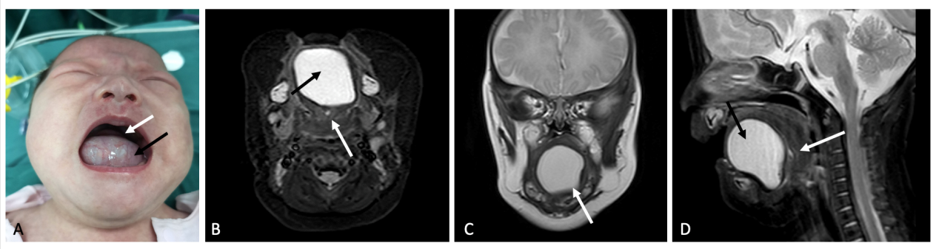
Figure 1 Status of infant prior to first surgery. A: Large-sized cystic mass protruding from mouth (white arrow: raised tongue in retracted position; black arrow: cystic mass); B: Magnetic resonance imaging in axial plane showing large (black arrow) and small suspect (white arrow) lesions; C: View in coronal plane of well-circumscribed cystic lesion (4.0 cm × 3.8 cm × 3.9 cm) with high signal; D: View in sagittal plane of large (black arrow) and tiny suspect (white arrow) lesions.
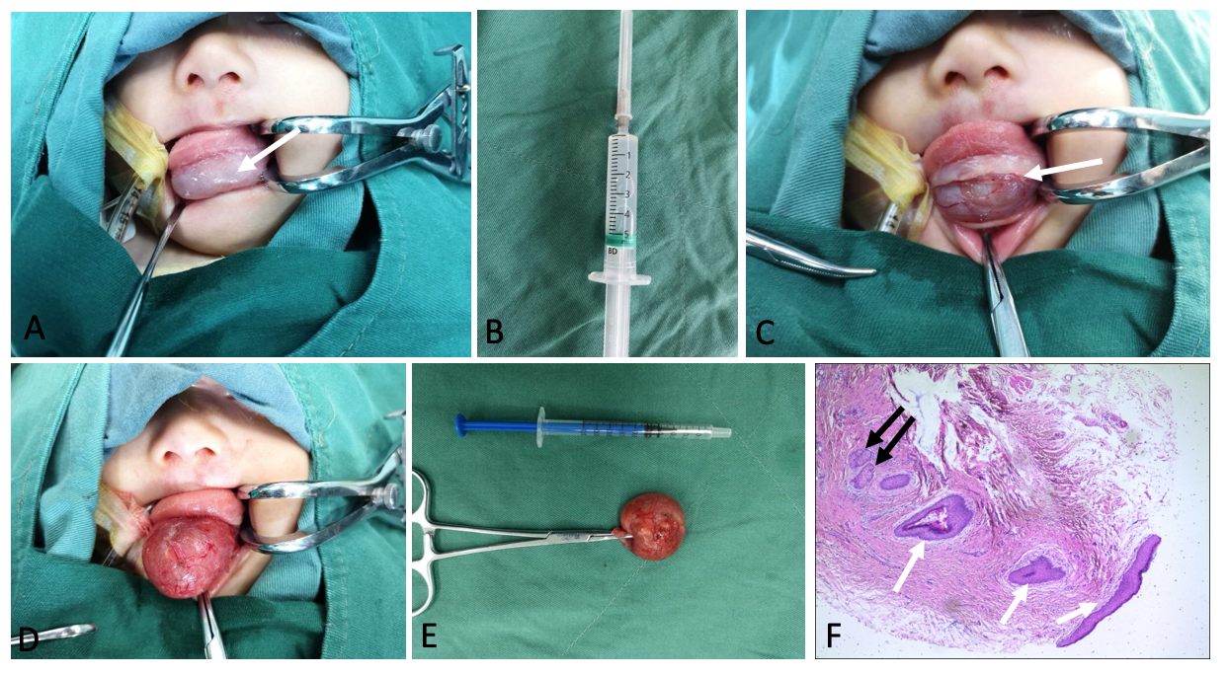
Figure 2 Infant during first surgery. A: Contracted lesion and lowered tongue after clear fluid (10 mL) aspirated, enabling oral intubation (white arrow at shrunken mass); B: Clear fluid withdrawn; C: Horizontal incision made; D: Careful blunt dissection of cyst from surrounding tissues; E: Resected cyst, roughly 2.0 cm × 2.0 cm with wall intact; F: Histologic section of cyst wall [note keratinizing stratified squamous epithelial lining (white arrows) and sebaceous glands (black arrows)].
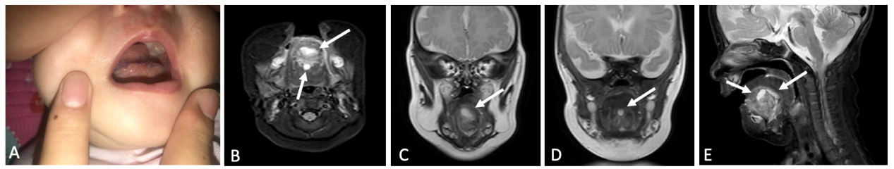
Figure 3 Infant after first surgery (day 3). A: Slight edema at the floor of the mouth incision; B: Postoperative magnetic resonance imaging showing two cystic lesions (white arrows) under tongue (0.8 cm × 1.0 cm × 0.5 cm and 1.2 cm × 0.5 cm × 0.5 cm); C and D: View of each lesion in coronal plane (white arrow); E: Both lesions in sagittal plane (white arrows).
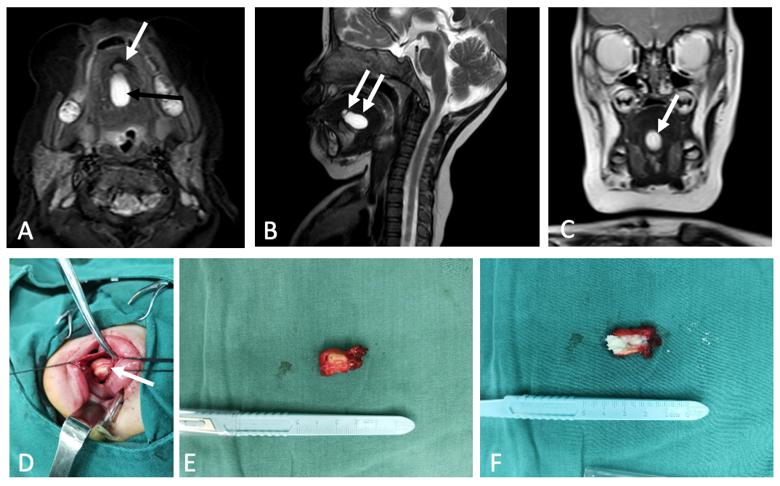
Figure 4 Infant during second surgery. A: Second preoperative magnetic resonance imaging of large mass (black arrow, 2.0 cm × 1.5 cm) midline floor of the mouth with high signal intensity and tiny suspect lesion (white arrow); B: Magnetic resonance imaging (sagittal plane) showing large high-signal (wide arrow) and tiny suspect (narrow arrow) lesions; C: Magnetic resonance imaging (coronal plane) of one lesion only; D: Completely encapsulated mass; E: Fully excised lesion (2.0 cm × 1.0 cm); F: Cross section with keratin content.

