Name of Journal: World Journal of Clinical Cases
Manuscript NO: 58366
Manuscript Type: CASE REPORT

Prostatic carcinosarcoma seven years after radical prostatectomy and hormonal therapy for prostatic adenocarcinoma: A case report

Huang X et al. Prostatic carcinosarcoma after prostatectomy of adenocarcinoma

Xiao Huang, Song-Liang Cai, Li-Ping Xie

Xiao Huang, Song-Liang Cai, Li-Ping Xie, Department of Urology, The First Affiliated Hospital, School of Medicine, Zhejiang University, Hangzhou 310030, Zhejiang Province, China

Author contributions: Huang X analyzed the data and wrote the manuscript; Cai SL performed the surgery and collected the data; Xie LP contributed to manuscript reviewing; all authors have read and approved the final manuscript.

Supported by the Natural Science Foundation of Zhejiang Province, China, No. LY19H050008.

Corresponding author: Xiao Huang, MD, PhD, Chief Doctor, Professor, Surgeon, Department of Urology, The First Affiliated Hospital, School of Medicine, Zhejiang University, No. 79 Qingchun Road, Hangzhou 310030, Zhejiang Province, China. xiaohuang69@zju.edu.cn

Received: January 10, 2021
Revised: February 28, 2021
Accepted: June 16, 2021
Published online:

Abstract
BACKGROUND
Prostatic carcinosarcoma is a very rare and highly aggressive tumor. It may occur after androgen deprivation therapy (ADT) for adenocarcinoma even after a 7-year interval.

CASE SUMMARY
A 66-year-old man presented with recurrent symptoms of gross hematuria and urinary retention. The patient had a previous history of combined radical prostatectomy and ADT for prostate cancer 7 years prior. He received total pelvic exenteration for a recurrent pelvic carcinosarcoma. Pathology and immunostaining revealed a carcinosarcoma of prostatic origin with focal spindled cells and bizarre giant cells. The patient subsequently underwent transverse colostomy for carcinosarcoma recurrence and bowel obstruction 3 mo later. Five months after the diagnosis of prostatic carcinosarcoma, the patient died of multiple organ metastases.

CONCLUSION
Prostatic carcinosarcoma after adenocarcinoma is exceedingly rare. ADT mediated transformation and dedifferentiation of the epithelial components may be the origin of this malignancy.

Key Words: Prostate cancer; Adenocarcinoma; Carcinosarcoma; Sarcomatoid carcinoma; Radical prostatectomy; Androgen deprivation therapy; Case report

Huang X, Cai SL, Xie LP. Prostatic carcinosarcoma seven years after radical prostatectomy and hormonal therapy for prostatic adenocarcinoma: A case report. World J Clin Cases 2021; In press

Core Tip: This is an unusual case of delayed occurrence of prostatic carcinosarcoma 7 years after radical prostatectomy and androgen deprivation therapy (ADT) for prostatic adenocarcinoma. It is very uncommon for a patient to have both neoplasms. ADT mediated transformation and dedifferentiation of the epithelial component may be the origin of this malignancy.

INTRODUCTION
Adenocarcinoma of the prostate is a very common cancer in men worldwide, whereas prostatic sarcoma is rare, with an overall prevalence of 0.1% and greater prevalence at younger ages. It is very rare for an elderly patient to have both neoplasms^{[1]}. When these occur together as a carcinosarcoma, about 50% of the patients have a history of prostatic adenocarcinoma with radiation or androgen deprivation therapy (ADT)^{[2-4]}. We encountered a patient with an unusual delay of prostatic carcinosarcoma occurrence 7 years after radical prostatectomy and ADT for prostatic adenocarcinoma.

CASE PRESENTATION
Chief complaints
A 66-year-old married Asian man, who was retired from the Livestock Bureau, presented with recurrent symptoms of gross hematuria and urinary retention.

History of present illness
The patient’s medical history was significant for prostatic adenocarcinoma [stage T2a, Gleason score 3 + 4; total prostate-specific antigen (PSA): 16 ng/mL] with no familial history of prostate cancer. Bone and chest computed tomography (CT) scans were unremarkable. He had undergone an open radical prostatectomy 7 years ago. Pathological results confirmed an adenocarcinoma (Gleason score 3 + 4) involving 65% of the right side of the prostate volume. The surgical margins were negative for the tumor and there was no extracapsular extension. All lymph nodes from the bilateral obturator area were negative for metastasis. Because the patient’s PSA level was 0.4 ng/mL at 2 wk after the surgery, he underwent one year of continuous ADT with goserelin and flutamide, which reduced the PSA level to 0.002 ng/mL at the end of treatment. Then the PSA level was monitored every 3 mo over 4 years, and each time the results were below 0.2 ng/mL. Unfortunately, the patient stopped returning for follow-up 2 year prior for unknown reasons.

History of past illness
Aside from the prostatic adenocarcinoma, the patient had an illness-free previous medical history.

Personal and family history
No familial history of cancer and other illness.

Physical examination
The patient had a large fixed rectal mass by digital rectal examination.

Laboratory examinations
PSA was 1.857 ng/mL.

Imaging examinations
Preoperative pelvic CT imaging demonstrated an approximately 15 cm × 9 cm × 8 cm-large tumor mass with central necrosis distorting the bladder neck, which could only be recognized by a catheter balloon (Figure 1). Magnetic resonance imaging showed a large tumor mass occupying the majority of the pelvic cavity with no evidence of rectal metastasis (Figure 2). Both bone scans and chest X-rays were negative for metastases.

FINAL DIAGNOSIS
Transrectal biopsy showed a poorly differentiated carcinosarcoma. Surgical pathology demonstrated that the tumor tissue had extensive hemorrhage and central necrosis. The whole bladder wall was invaded at one site. Increased nucleoli and mitotic figures and adenoid structures were seen. Immunostaining confirmed the final pathology as prostatic carcinosarcoma with focal spindled cells and bizarre cells (Figure 3): Cytokeratin (partially positive), epithelial membrane antigen (-), vimentin (+), PSA (less than 30% positive), desmin (-), CD117 (-), S-100 (-), CD34 (-), and BCL-2 (-).

TREATMENT
The patient received total pelvic exenteration with ureterostomy for urinary diversion. Nevertheless, the patient subsequently underwent transverse colostomy for carcinosarcoma recurrence and bowel obstruction 3 mo later.

OUTCOME AND FOLLOW-UP
Five months after the diagnosis of prostatic sarcoma, the patient died of multiple organ metastases.

DISCUSSION
Prostatic carcinosarcoma is an exceedingly rare and aggressive malignant tumor that may develop many years after original presentation with prostatic adenocarcinoma. The average diagnosis age is about 66 years or more in all published cases^{[3,5,6]}. McGee et al^{[3]} found that in fewer than 100 patients, 58% had a previous history of prostatic adenocarcinoma. Most patients (61%) had a previous treatment history of radiation, ADT, or combination thereof. Only 3% of patients had a history of radical prostatectomy. Many theories or hypotheses have been developed regarding the origin of prostate carcinosarcoma, especially transformation of adenocarcinoma into sarcoma^{[4,7]}. Although a variety of hypotheses have been presented regarding the biphasic nature of these tumors, carcinosarcomas seem to represent the best example of the epithelial-mesenchymal transition and dedifferentiation in human cancers, in which the two parts of the tumor are genomically related to one another^{[8]}. As more than half of carcinosarcoma cases have been diagnosed after the diagnosis of adenocarcinoma, it is logical to think that sarcomatous components arise secondarily through metaplastic phenomena or transformation within the adenocarcinoma itself^{[7]}. Prior reports in the literature have raised the possibility that treatments especially radiation or hormonal therapy may influence the subsequent development of sarcomatoid carcinomas^{[4,6]}. Our patient had no history of radiation. However, ADT therapy alone may also lead to the development of a sarcomatous component. However, some investigators discount the role of ADT because of the majority of patients treated with ADT without developing these uncommon carcinosarcomas^{[2,5]}. Thus, the reason for this exceedingly rare ADT mediated adenocarcinoma to carcinosarcoma transformation may lie in individual differences.
Patients with carcinosarcoma often have a normal or lower serum PSA level than that of those with adenocarcinoma. This malignant neoplasm may also contain multiple sarcomatoidentities^{[3,9]}. The most commonly found was osteosarcoma (50%), followed by chondrosarcoma (33%) and leiomyosarcoma (17%). Cases of rhabdomyosarcoma, malignant fibrous histiocytoma, fibrosarcoma, spindle cell sarcoma, angiosarcoma, and undifferentiated sarcoma have also been reported^{[5,6,10]}. As previously reported, the prognosis of prostatic carcinosarcoma is extremely poor, with a 20% risk of death 1 year after diagnosis. Radical surgery or pelvic exenteration seems to be the best treatment for patients with prostatic carcinosarcoma. Many patients develop subsequent metastatic disease and a local bulky tumor burden^{[2,6,10]}.

CONCLUSION
Carcinosarcoma of the prostate is a very rare and highly aggressive tumor. ADT mediated transformation and dedifferentiation of the epithelial component may be the origin of this malignancy. Radical surgery is the most viable option for treatment. If the disease has spread beyond the prostatic tissue, the patient typically will not survive for more than 6 mo. The prognosis is dismal regardless of histological or clinical findings.

REFERENCES
1 Haddad JR, Reyes EC. Carcinosarcoma of the prostate with metastasis of both elements: case report. J Urol 1970; 103: 80-83 [PMID: 5415727 DOI: 10.1016/s0022-5347(17)61896-2]
2 Dundore PA, Cheville JC, Nascimento AG, Farrow GM, Bostwick DG. Carcinosarcoma of the prostate. Report of 21 cases. Cancer 1995; 76: 1035-1042 [PMID: 8625205 DOI: 10.1002/1097-0142(19950915)76:6<1035::aid-cncr2820760618>3.0.co;2-8]
3 McGee SM, Boorjian SA, Karnes RJ. Carcinosarcoma of the prostate replacing the entire lower genitourinary tract. Urology 2009; 74: 540-541 [PMID: 19589566 DOI: 10.1016/j.urology.2009.04.057]
4 Poblet E, Gomez-Tierno A, Alfaro L. Prostatic carcinosarcoma: a case originating in a previous ductal adenocarcinoma of the prostate. Pathol Res Pract 2000; 196: 569-572 [PMID: 10982020 DOI: 10.1016/s0344-0338(00)80029-1]
5 Subramanian VS, Coburn M, Miles BJ. Carcinosarcoma of the prostate with multiple metastases: case report and review of the literature. Urol Oncol 2005; 23: 181-183 [PMID: 15907718 DOI: 10.1016/j.urolonc.2004.11.010]
6 Hansel DE, Epstein JI. Sarcomatoid carcinoma of the prostate: a study of 42 cases. Am J Surg Pathol 2006; 30: 1316-1321 [PMID: 17001164 DOI: 10.1097/01.pas.0000209838.92842.bf]
7 Kubosawa H, Matsuzaki O, Kondo Y, Takao M, Sato N. Carcinosarcoma of the prostate. Acta Pathol Jpn 1993; 43: 209-214 [PMID: 8493872 DOI: 10.1111/j.1440-1827.1993.tb01134.x]
8 Pang A, Carbini M, Moreira AL, Maki RG. Carcinosarcomas and Related Cancers: Tumors Caught in the Act of Epithelial-Mesenchymal Transition. J Clin Oncol 2018; 36: 210-216 [PMID: 29220296 DOI: 10.1200/JCO.2017.74.9523]
9 Rogers CG, Parwani A, Tekes A, Schoenberg MP, Epstein JI. Carcinosarcoma of the prostate with urothelial and squamous components. J Urol 2005; 173: 439-440 [PMID: 15643196 DOI: 10.1097/01.ju.0000149969.76999.7c]
10 Furlan SR, Kang DJ, Armas A. Prostatic carcinosarcoma with lung metastases. Case Rep Oncol Med 2013; 2013: 790790 [PMID: 24294528 DOI: 10.1155/2013/790790]

Footnotes
Informed consent statement: Informed written consent was obtained from the patient for publication of this report and any accompanying images.

Conflict-of-interest statement: The authors declare that they have no conflicts of interest to report.

CARE Checklist (2016) statement: The authors have read the CARE Checklist (2016), and the manuscript was prepared and revised according to the CARE Checklist (2016).

Open-Access: This article is an open-access article that was selected by an in-house editor and fully peer-reviewed by external reviewers. It is distributed in accordance with the Creative Commons Attribution NonCommercial (CC BY-NC 4.0) license, which permits others to distribute, remix, adapt, build upon this work non-commercially, and license their derivative works on different terms, provided the original work is properly cited and the use is non-commercial. See: http://creativecommons.org/Licenses/by-nc/4.0/

Manuscript source: Unsolicited manuscript

Peer-review started: January 10, 2021
First decision: February 11, 2021
Article in press:

Specialty type: Urology and nephrology
Country/Territory of origin: China
Peer-review report’s scientific quality classification
Grade A (Excellent): 0
Grade B (Very good): B
Grade C (Good): C, C
Grade D (Fair): D
Grade E (Poor): 0

P-Reviewer: Ichihara K, Scaggiante B, Sha S S-Editor: Zhang H L-Editor: Wang TQ P-Editor:
Figure Legends
Figure 1 Preoperative pelvic computed tomography image demonstrating a 15 cm × 9 cm × 8 cm-large tumor mass with central necrosis distorting the bladder neck, which could only be recognized by a catheter balloon.
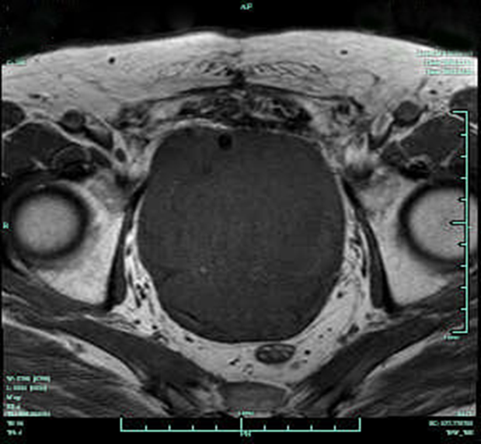
Figure 2 Preoperative pelvic magnetic resonance image showing a large tumor mass occupying the majority of the pelvic cavity with no evidence of rectal metastasis.
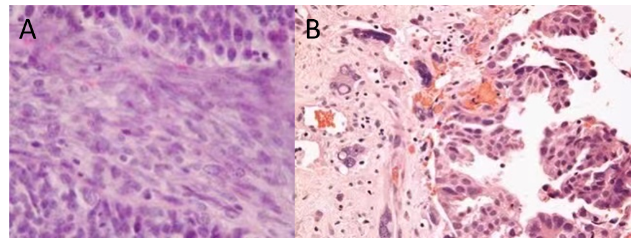
Figure 3 Hematoxylin–eosin staining. A: Image showing the pelvic tumor with sarcomatous-component spindled cells (original magnification, × 400); B: Image showing the pelvic tumor with sarcomatous-bizarre cells (original magnification, × 400).

