Name of Journal: World Journal of Psychiatry
Manuscript NO: 46152
Manuscript Type: ORIGINAL ARTICLE

Observational Study
Problematic Internet use in drugs addicts under treatment in public rehab centers

Baroni S et al. Problematic Internet use in drug addicts

Stefano Baroni, Donatella Marazziti, Federico Mucci, Elisa Diadema, Liliana Dell’Osso

Stefano Baroni, Donatella Marazziti, Federico Mucci, Elisa Diadema, Liliana Dell’Osso, Dipartimento di Medicina Clinica e Sperimentale, Section of Psychiatry, University of Pisa, Pisa 56100, Italy

ORCID number: Stefano Baroni (0000-0001-7688-5069); Donatella Marazziti (0000-0002-4021-5829); Federico Mucci (0000-0002-9746-8237); Elisa Diadema (0000-0002-9489-1195); Liliana Dell’Osso (0000-0001-6141-4993).

Author contributions: Baroni S and Marazziti D planned and organized the implementation of the study, contributed to the creation of the interactive platform on external server, carried out statistical analyses, and wrote the manuscript; Dell’Osso L planned and organized and supervised the implementation of the study and wrote the manuscript; Mucci F and Diadema E contributed to the implementation of the study, checked the arriving questionnaires, organized the data for statistical analyses, and wrote the manuscript; All authors approved the final form of the manuscript.

Supported by A grant from “Regione Calabria”, Italy.

Institutional review board statement: The study was approved by the Ethics Committee of Pisa University.

Informed consent statement: The study was approved by the Ethics Committee of Pisa University, and the participants decided to take part in it on a voluntary basis and in an anonymous way, so that it was not possible to identify them.

Conflict-of-interest statement: None.

Open-Access: This article is an open-access article that was selected by an in-house editor and fully peer-reviewed by external reviewers. It is distributed in accordance with the Creative Commons Attribution Non Commercial (CC BY-NC 4.0) license, which permits others to distribute, remix, adapt, build upon this work non-commercially, and license their derivative works on different terms, provided the original work is properly cited and the use is non-commercial. See: http://creativecommons.org/licenses/by-nc/4.0/

Manuscript source: Invited manuscript

Corresponding author: Donatella Marazziti, MD, PhD, Adjunct Professor, Dipartimento di Medicina Clinica e Sperimentale, Section of Psychiatry, University of Pisa, Via Roma 67, Pisa 56100, Italy. dmarazzi@psico.med.unipi.it
Telephone: +39-50-2219768
Fax: +39-50-2219787

Received: April 26, 2018
Peer-review started: April 26, 2018
First decision: June 15, 2018
Revised: January 30, 2019
Accepted: May 14, 2019
Article in press:
Published online:

Abstract
BACKGROUND
Problematic Internet use (PIU) or Internet addiction has been recognized to be a behavioral addiction characterized by excessive or poorly controlled preoccupations, urges, or behaviors regarding computer use and Internet access that leads to impairment or distress resembling substance abuse.

AIM
To investigate the prevalence and characteristics of Internet use and abuse in a group of drug addicts from Southern Italy, by means of a specific questionnaire [“Questionario sull’Utilizzo delle Nuove Tecnologie” (QUNT)].

METHODS
All subjects (183) were heavy smokers, almost 50% of them used heroin and/or opioid compounds, 30% alcohol, 10% cannabis, 8% cocaine, and 5% were polydrug users. Almost 10% of the individuals were also suffering from gambling disorder.

RESULTS
Time spent online was more than 4 hours a day in the total sample, with a slight prevalence of male subjects. Cocaine and cannabis users spent more than 6 hours online, significantly more than opioid and alcohol abusers. Distribution of the QUNT factors was not different in both sexes. Cocaine users showed higher scores at the “loss of control”, “pornography addiction”, and “addiction to social networks”, for the stimulant effect of this substance. Moreover, 15 out of the total 17 cocaine users were pathological gamblers. Positive and statistically significant relationships were observed between some QUNT factors and body mass index.

CONCLUSION
These findings indicate that PIU is less common in subjects taking sedative substances, such as heroin/opioids and alcohol, than in subjects taking stimulants. Alternatively, it may be used as a “stimulant” trigger in cocaine and cannabis users. Flattening effect of abuse drugs is noted on possible sex-related differences in QUNT items. We noted a sort of “protective” effect of a love relationship and/or living together with a partner, as those engaged subjects showed lower scores on different items than single subjects or those living alone. The relationship between time spent online (and related sedentary lifestyle) and body mass index would suggest that Internet use might be a contributing factor to increasing weight gain and obesity amongst adolescents and young adults worldwide. Our findings also highlighted the specific vulnerability of drug addicts who use stimulants, rather than sedative compounds, to other kinds of behavioral addictions, such as pathological gambling.

Key words: Internet; Problematic Internet use; Behavioral addictions; Drug abuse; Rehab centers

© The Author(s) 2019. Published by Baishideng Publishing Group Inc. All rights reserved.

Core tip: This study investigated the characteristics of Internet use and problematic Internet use (PIU) in drug addicts through a specific questionnaire. The findings indicated that PIU is more common in subjects taking cocaine and cannabis than in subjects taking opioids or alcohol, and they were also affected by pathological gambling. This suggests a favoring role of stimulant drugs in behavioral addictions. The relationship between time spent online and body mass index indicates that Internet use might be a factor that promotes weight gain and obesity. Addiction prevention should take into consideration PIU, which currently represents a worldwide epidemic.

Baroni S, Marazziti D, Mucci F, Diadema E, Dell’Osso L. Problematic Internet use in drugs addicts under treatment in public rehab centers. World J Psychiatr 2019; In press

INTRODUCTION
New technologies, when used appropriately, undoubtedly constitute a resource that can greatly improve the quality of an individual’s life. The Internet is probably one of the biggest revolutions of the last few years because it has transformed the way of communicating, exchanging information, participating in real-time events thousands of kilometers away, and finding easily and rapidly any kind of information^{[1,2]}. In the same way, it should be noted that the mismatched use of the Internet constitutes, especially where predisposing psychopathological factors are present, a real risk for a subject’s mental health, as it may become a problem out of his/her control.
In particular, the abuse of the Internet represents the most dangerous and probable threat that may cause serious impairment to the social, psychological, working, and emotional individual adjustments. Over the last 15 years, the number of Internet users has increased by 1000%^{[3]} , as documented by the Internet World Stats, Pigdom, a society that features up to date world Internet usage, population statistics, and other issues^{[3]}; and studies on abuse of the Internet have proliferated. This problem is not yet well understood, and research on its etiology is still at its beginning^{[4]}.
Problematic Internet use (PIU) or Internet addiction is a behavioral addiction^{[5]} that can be defined as “use of the Internet that creates psychological, social, school, and/or work difficulties in a person’s life”^{[6]}.
Increasing literature on PIU led the American Psychiatric Association to include Internet Gaming Disorder in section 3 of the Diagnostic and Statistical Manual for Mental Disorders (DSM-5), but the current opinion is that more data are needed before incorporating it in the manual as a condition with a nosological dignity^{[7-9]}. In 2008, Block^{[7]} suggested four diagnostic criteria essential to a possible diagnosis of PIU as an addictive behavior, as follows: “Excessive Internet use associated with a loss of sense of time; withdrawal, including feelings of anger, depression and tension when Internet is not accessible; tolerance, including the need for better computer equipment, more software, or more hours of use… and adverse consequences, including arguments, lying, poor school/work or vocational achievement, social isolation, and fatigue”^{[7]}.
Generally, PIU subjects are not aware that they have a problem^{[10-12]} that may progressively impair family, school, work, or social life^{[13]} or lead to severe social withdrawal^{[12,14]} and even suicide^{[12,15-17]}. Several studies have documented the negative consequences of PIU, but the literature does not reflect a consistent conceptualization of this behavior^{[18,19]}. Specifically, it is unclear whether PIU should be classified as a type of behavioral addiction^{[19]}, an impulse control disorder, a subtype of obsessive-compulsive disorder^{[20-24]}, or an impaired way of coping with stress^{[25-27]}.
The most common symptoms of PIU are similar to those of substance use disorders (SUDs) according to DSM-5^{[28]} including unpredictable behavior and mood^{[14,15]}, craving, excessive concerns about Internet activities, and inability to reduce its use^{[29,30]}. Some researchers made some parallelisms with behavioral addictions, including pathological gambling^{[22,31]}. Again, neurobiological studies indicate that PIU shares with SUDs several neurobiological characteristics^{[15,32-34]}. Although PIU has been found frequently comorbid with other psychiatric disorders^{[35]}, the literature on the relationship between PIU and SUDs is meager.
The same is true for data on PIU prevalence and characteristics in our country. Therefore, the present study aimed at exploring these phenomena in a peculiar population constituted by individuals following a rehab program for drug addictions in public centers (Servizio Tossicodipendenze, SERT) through a questionnaire called “Questionario sull’Utilizzo delle Nuove Tecnologie” (QUNT) that we had created for this purpose.

MATERIALS AND METHODS
Self-assessment questionnaire
A specific interactive platform and website (http://dronet.araneus.it/questionario) on new technologies were created on an external server. The platform allowed access to the self-assessment questionnaire only via the Internet.
At the same time, a self-assessment questionnaire referred to the acronym QUNT was developed. The QUNT consists of two sections, one for demographic data and another consisting of 101 items (Appendix 1). Forty-five out of the total 101 items had five possible answers, according to a Likert five-point scale with 1 indicating “completely false” and 5 indicating “completely true”; three items were multiple-choice questions; ten were focused on the use of “instant messaging” (with five possible answers, according to a Likert five-point scale with 1 indicating “completely false” and 5 indicating “completely true”), and 42 items on the use of “social networks” (instant messaging: Whatsapp, telegram, Skype, and social networks: Facebook, twitter and Instagram) (with five possible answers, according to a Likert five-point scale with 1 indicating “completely false” and 5 indicating “completely true”). The item #101 was actually a question on the satisfaction/utility or not with the questionnaire. The items considered of greater relevance were put together in order to identify factors built according to a priori criteria extrapolated from the data available in the scientific literature^{[6,26,29]}. These factors were “time spent online” (item 2, 3, 4, 5, 6, 7, 25, 33), “social withdrawal” (item 8, 10, 18, 22, 30, 35), “abstraction from reality” (item 11, 13, 24), “loss of control” (item 19, 20, 32, 36), “addiction to pornography” (item 26, 27), “ludopathy” (item 40 a-1, 41, 42, 43), and “addiction to social networks” (49, 50, 51, 52, 53, 54, 55, 56, 57). The “addiction to social networks” factor was further divided into the following sub-factors: “Addiction to Facebook” (item 60 a.d, 61-75), “addiction to twitter” (item 76-86), and “addiction to Instagram” (item 86-97). The factor scores were calculated as the sum of the scores obtained in each item divided by the maximum score in percentage. As the cut-off point to identify the possible presence of PIU, answer 4 was chosen (between 4 and 6 hr/d) or 5 (> 6 hr/d) of item 2 “time spent online”, in agreement with current literature, although controversies do exist^{[8]}. In no way was it possible to identify the participants whose anonymity was warranted.

Data collection procedure
The link for QUNT was communicated to the offices in charge of the territorial outpatient’s services for drug-addicted individuals, SERTs, located in the Calabria region, in order to ask their patients to fill it in. A total of 1500 subjects were asked to fill in the questionnaire on a voluntary basis. The present study was approved by the Ethics Committee at Pisa University.

Statistical analysis
The independent t-test was applied to compare the mean scores of the factors on the basis of these variables: Sex (M/F); single (yes/no living together (yes/no). One-way analysis of variance followed by Bonferroni’s test for post-hoc was used to assess the comparisons of body mass index (BMI) categories. The χ² analysis was used to compare categorical variables. All statistics were carried out by the Statistical Package for Social Sciences (SPSS), version 22 (Armonk, NY, United States)^{[36]}.

RESULTS
Characteristics of the study population
The returned questionnaires numbered 183, of which 148 (80.87%) were from men and 35 (19.13%) were from women, out of the total 1500 invitations. The majority of the subjects (86, 47%) had completed 8 years of school, 73 (39.9%) high school, 14 (7.7%) 5 years of primary school, and 10 (5.5%) had graduated. Ninety-two (50.3%) subjects were single, 64 (14.8%) were married, and 27 (14.8%) were involved in a love relationship. The mean length of attendance at the public rehab center was between 1 and 60 mo (mean ± standard deviation (SD): 32 ± 20).

Types of substance abuse and/or behavioral addiction
The most used abused drugs used were heroin or opioids (n = 88, 48.1%), alcohol (n = 55, 30.1%), cannabis (n = 20, 9.8%), cocaine (n = 17, 7.7%), and amphetamines (n = 3, 1.6%). Polydrug abuse (amphetamine, cannabis, cocaine, ecstasy) was present in nine (4.9%) individuals, while gambling disorder was diagnosed in 18 (9.3%). All 183 subjects were heavy smokers (Table 1).
The smartphone was found to be the most common device utilized by all subjects to access the Internet. The time spent online was similar in men and women, 4.12 ± 2.9 h. Interestingly, the time spent online by 30% of cocaine and 25% of cannabis users was significantly higher (> 6 h) than that of the other groups. According to the setpoint a priori defined by us, they were affected by PIU.

QUNT factors and gender
The distribution of the QUNT factors was not different in the two sexes; however, men using cannabis showed a trend towards higher scores (mean ± SD) at the following factors: “Social withdrawal” (2.44 ± 0.38 vs 2.23 ± 0.39, P < 0.001) and “abstraction from reality” (3.12 ± 1.74 vs 2.24 ± 0.46, P < 0.001). Cocaine users showed a higher score than the other subjects at the “loss of control” (3.64 ± 1.12 vs 2.51 ± 0.36, P < 0.001), “pornography addiction” (3.59 ± 1.44 vs 2.54 ± 0.41, P < 0.001), and “addiction to social networks” (3.22 ± 0.98 vs 2.66 ± 0.76, P < 0.001).

QUNT factors and affective relationship
The analysis of the difference in QUNT factors regarding being single (n = 92) or involved in a love relationship (n = 91) showed that single subjects had higher scores at the following factors (mean ± SD): “Time spent online” (2.95 ± 0.47 vs 2.17 ± 0.44, P < 0.001); “social withdrawal” (1.40 ± 0.35 vs 1.34 ± 0.32, P < 0.001); “abstraction from reality” (1.90 ± 0.40 vs 1.56 ± 0.62, P < 0.001); “addiction to pornography” (3.12 ± 0.88 vs 1.99 ± 0.79, P < 0.001); and “addiction to social networks” (2.89 ± 1.08 vs 2.06 ± 0.33, P < 0.001).
The analysis of the differences between partners living (72) or not living together (17) with the partner showed some significant differences. The following factors showed higher scores in subjects who did not live with the partner vs those who lived with the partner: ”Time spent online” (3.03 ± 0.53 vs 2.16 ± 0.76, P < 0.001), “addiction to pornography” (3.15 ± 0.99 vs 2.33 ± 0.71, P < 0.001), “ludopathy” (3.42 ± 1.08 vs 2.96 ± 0.66, P < 0.001), and “addiction to social networks” (2.99 ± 0.91 vs 2.01 ± 0.44, P < 0.001).

QUNT factors and BMI
The total sample was then subdivided according to the BMI values. Fifteen subjects had a BMI between 18 and 20 (normal weight, NW), 79 between 20 and 25 (overweight, OW), 70 between 25 and 30 (first degree of obesity, OB1), and 13 greater than 30 (second degree of obesity, OB2). The categories OB1 and OB2 were merged in the category “Obese” (OB). The comparisons of QUNT factor scores in the four BMI categories are reported in Table 2, which shows that the greater the BMI the greater the score. Moreover, as shown in Figure 1, as BMI increased the percentage scores of the five factors, “time spent online”, “social withdrawal”, “abstraction from reality”, “ludopathy”, and “addiction to social network”, also trended upward. Finally, fifteen of the total cocaine users were also pathological gamblers (mainly online gamers) and showed a significantly higher score at the “ludopathy” factor (3.20 ± 0.45 vs 2.86 ± 0.51, P < 0.001).

DISCUSSION
The present study reports the results of a collaborative survey investigating the prevalence and characteristics of Internet use by new technologies (PCs, smartphones and tablets), as well as of PIU, amongst subjects undergoing a program of rehabilitation in public rehab centers in a region from southern Italy. According to our knowledge, this is the first study carried out in this peculiar adult population, as previously only samples of adolescents were investigated^{[37]}.
Several subjects received the invitation from their psychiatrists/psychologists to fill in a questionnaire, the so-called QUNT, which was developed by us for this specific purpose. The specificity of the QUNT, as compared with those utilized in different studies, is that it is very detailed in order to assess the variety of individual features of both Internet use and PIU. The item “time spent online” was considered crucial to identify PIU when it was > 4 hours a day (answer 4 and 5).
About 10% of the subjects returned the QUNT correctly filled in, so it was valid for analysis. This can be ascribed to the peculiar personality of drug addicts, especially chronic ones that represent the majority of our sample, and it would indicate both a low propensity to collaborative studies and compliance as well as amotivation^{[38]}. The most used device (100% of subjects) to access the Internet was the smartphone. There was a high preponderance of men over women, which reflects the distribution of sexes in public rehab centers in Italy, in agreement with national data showing that the ratio male:female is 4:1^{[39]}.
All subjects were heavy smokers, almost 50% of them used heroin and/or opioid compounds, 30% alcohol, 10% cannabis, 8% cocaine, and 5% were polydrug users. Only three subjects were amphetamine users and, therefore, were not included in the statistical analyses. Almost 10% of individuals were also suffering from gambling disorder, while the presence of other psychiatric disorders was set as an exclusion criterion.
The time spent online was quite high, more than 4 hr/d in the total sample, with a slight, albeit not significant prevalence in male subjects. Cocaine and cannabis users spent more than 6 hr/d online, significantly more than opioid and alcohol abusers. Therefore, they were probably affected by PIU, according to the setpoint defined by us (answer 4 or 5 of item # 2) and literature data^{[12,40-42]}. Taken together, these findings indicate that PIU is less common in subjects taking sedative substances, such as heroin/opioids and alcohol. Alternatively, it may be used as a “stimulant” trigger in cocaine and cannabis users. This is supported by the high prevalence of pathological gaming amongst cocaine abusers, in agreement with literature data^{[43-45]}.
The analysis of the distribution of the QUNT factors showed no sex-related differences but a slight trend towards higher scores at the “social withdrawal” and “abstraction from reality” items in men. This is in contrast with a previous study carried out in healthy subjects that revealed significant differences between men and women. This is possibly related to the flattening effects of abused drugs that tend to “minimize” sex differences^{[46]}. As compared with the other groups, cocaine users showed higher scores at the “loss of control”, “pornography addiction”, and “addiction to social networks”. This is not surprising given the stimulant effect of this substance^{[47]}.
Our findings confirmed the “protective” effects of a love relationship and/or living together with a partner^{[48]}, as single subjects or those living alone with no family support showed higher scores on different items, specifically “time spent online”, “social withdrawal”, “abstraction from reality”, “addiction to pornography”, and “addiction to social networks”. This clearly indicates that Internet was mainly used for passing time or recreation.
Not surprisingly, those subjects who spent more time online, as shown by the higher score of the “time spent online”, “social withdrawal”, “abstraction from reality”, and “addiction to social network” factors, had a higher BMI. Therefore, the excessive use of the Internet can be considered another factor that increases sedentary behaviors^{[49]}, and it may be particularly risky in drug addicts, subjects already exposed to different medical diseases^{[50]}. Reduced sleeping time and disrupted circadian rhythms due to PIU are other factors that may increase the probability of metabolic, medical, and psychiatric disorders^{[11,16,51]} as well as the disruption of work, family, social, or school performance^{[52,53]}.
Finally, the majority (15 out of the total 17) of cocaine users were also pathological gamblers (mainly online gamers), and showed a significantly higher score at the “ludopathy” factor. This would suggest a specific vulnerability of drug addicts to other kinds of addictions, especially if they use stimulants rather than sedative drugs^{[43]}. Our study has some limitations that should be acknowledged. The QUNT questionnaire was not validated, although this is quite common in studies in this field^{[12,40-42]}. The prevalence of PIU was inferred from one item only, but it was a corollary of the main objective of the study exploring primarily the characteristics of Internet use. Similarly, no information was gathered on emotional distress or disturbed behaviors that are currently under investigation.
Taken together, our results suggest that the excessive use of Internet through smartphones is very common in drug addicts, as shown by their time spent online, and that PIU is very common in these individuals, especially in those taking cocaine and cannabis. The relationship between time spent online (and related sedentary lifestyle) and BMI would suggest that Internet use might be a contributing factor for increased weight gain and obesity amongst adolescents and young adults worldwide^{[49,54]}. Our findings would suggest specific vulnerability of drug addicts, mainly if they use stimulants rather than sedative compounds, not only to other kinds of pharmacologicals but also to behavioral addictions, such as PIU or pathological gaming. Prevention of addictions should take into consideration the novel, and still poorly unexplored, domain of behavioral addictions and especially of PIU that today represents a worldwide epidemic^{[12,54-56]}.

ARTICLE HIGHLIGHTS
Research background
Problematic Internet use (PIU) is a novel behavioral addiction characterized by excessive Internet use that is becoming an increasing problem worldwide. Although no agreement exists on precise diagnostic criteria, PIU is considered a behavioral addiction sharing with substance use disorders (SUDs) and other addictions several features and perhaps neurobiological underpinnings.

Research motivation
Unfortunately, no information is available on the prevalence of PIU amongst drug-addicted subjects, in spite of the given evidence, and these individuals tend to be affected by polydrug use and also by behavioral addictions, as if the presence of one or more addictions would represent a sort of vulnerability towards a worsening of the clinical picture through the onset of other kinds of these disorders.

Research objectives
The investigation of the possible existence and prevalence of PIU amongst drug-addicts under treatment in rehab centers would permit the implementation of specific treatments to prevent the onset of other kind of addictions that could worsen the clinical picture and the rehabilitation programs.

Research methods
A specific questionnaire to be filled online, the so-called Questionario sull’Utilizzo delle Nuove Tecnologie (QUNT), was developed to explore the prevalence and characteristics of both Internet use and PIU. The QUNT consists of two sections, one for demographic data and another consisting of 101 items grouped in factors built according to a priori criteria extrapolated from the data available in scientific literature. All subjects who volunteered to participate in the study (n = 183) reported that the QUNT was useful and were satisfied with it. The factor scores were calculated as the sum of the scores obtained in each item divided by the maximum score in percentage. As the cut-off point to identify the possible presence of PIU, answer 4 was chosen (between 4 and 6 hr/d) or 5 (> 6 hr/d) of item 2 “time spent online”.

Research results
The time spent online was more than 4 hr/d in the total sample, with a slight, although not significant, prevalence amongst male subjects. Cocaine and cannabis users spent more than 6 hours online, significantly more than opioid and alcohol users. The distribution of the QUNT factors was not different in both sexes. Cocaine users showed higher scores at the “loss of control”, “pornography addiction”, and “addiction to social networks”, probably because of the stimulant effect of this substance. Moreover, 15 out of the total 17 cocaine users were also pathological gamblers. Positive and statistically significant relationships were also observed between some QUNT factors and body mass index. These results, while showing that PIU is common amongst stimulant drug abusers, require to be replicated in larger samples from other countries. Nevertheless, they underline the risk of behavioral addictions in drug addicts, a problem that should be taken into account when planning prevention and intervention strategies.

Research conclusions
The new findings of this study are represented by the large percentage of PIU amongst drug addicts, especially if they use cocaine or cannabis. This suggests that PIU is less common in subjects taking sedative substances, such as heroin/opioids and alcohol, and that it may be a “stimulant” trigger in cocaine and cannabis users, as supported by the high prevalence of pathological gaming amongst cocaine abusers. Further, PIU is more frequent in single subjects or subjects living alone, which stresses the protective effects of loving or social relationships in general against the onset of addictions. Those subjects who spent more time online, as shown by the higher score of the “time spent online”, “social withdrawal”, “abstraction from reality”, and “addiction to social network” factors, had a higher body mass index. Therefore, the excessive use of the Internet can be considered another factor increasing sedentary behaviors that may be particularly risky in drug addicts, subjects already exposed to different medical diseases. Reduced sleeping time and disrupted circadian rhythms due to PIU are other factors that may increase the probability of metabolic, medical, and psychiatric disorders as well as the impairment of work, family, social, or school performance.

Research perspectives
The findings of the present study indicate that behavioral addictions, such as PIU, can broaden polydrug use, especially in subjects taking stimulants or cannabis. In addition, PIU may be considered another factor increasing negative life habits, already impaired in drug addicts, while promoting sedentarity and maladjustments in different individual’s domain. Future studies should take into consideration the impact of PIU on drug addicts by means of specific instruments to assess it, in order to prevent, not only its detrimental consequences, but also those related to a broadening of addictive behaviors.

ACKNOWLEDGEMENTS
We thank all the accountable managers of the SERT from Calabria for their fruitful collaboration.

REFERENCES
1 Valkenburg PM, Peter J. Online communication among adolescents: an integrated model of its attraction, opportunities, and risks. J Adolesc Health 2011; 48: 121-127 [PMID: 21257109 DOI: 10.1016/j.jadohealth.2010.08.020]
2 Ryan T, Chester A, Reece J, Xenos S. The uses and abuses of Facebook: A review of Facebook addiction. J Behav Addict 2014; 3: 133-148 [PMID: 25317337 DOI: 10.1556/JBA.3.2014.016]
3 Miniwatts Marketing Group. Internet world stats: usage and population statistics. 2017. Available from: URL: http://www.internetworldstats.com/stats.htm
4 King DL, Delfabbro PH. Internet gaming disorder treatment: a review of definitions of diagnosis and treatment outcome. J Clin Psychol 2014; 70: 942-955 [PMID: 24752874 DOI: 10.1002/jclp.22097]
5 Christakis DA, Moreno MM, Jelenchick L, Myaing MT, Zhou C. Problematic internet usage in US college students: a pilot study. BMC Med 2011; 9: 77 [PMID: 21696582 DOI: 10.1186/1741-7015-9-77]
6 Beard KW, Wolf EM. Modification in the proposed diagnostic criteria for Internet addiction. Cyberpsychol Behav 2001; 4: 377-383 [PMID: 11710263 DOI: 10.1089/109493101300210286]
7 Block JJ. Issues for DSM-V: internet addiction. Am J Psychiatry 2008; 165: 306-307 [PMID: 18316427 DOI: 10.1176/appi.ajp.2007.07101556]
8 American Psychiatric Association. Diagnostic and statistical manual of mental disorders: DSM-5. 5th ed. Arlington, VA: American Psychiatric Association, 2013 [DOI: 10.1176/appi.books.9780890425596]
9 Kuss DJ, Griffiths MD, Karila L, Billieux J. Internet addiction: a systematic review of epidemiological research for the last decade. Curr Pharm Des 2014; 20: 4026-4052 [PMID: 24001297 DOI：10.2174/13816128113199990617]
10 Young KS. Internet addiction: Symptoms, evaluation, and treatment. In: Vande-Creek L, Jackson T, editors. Innovations in Clinical Practice: A Source Book. Sarasota, FL: Professional Resource Press, 1999: 19-31
11 Spada MM. An overview of problematic internet use. Addict Behav 2014; 39: 3-6 [PMID: 24126206 DOI: 10.1016/j.addbeh.2013.09.007]
12 Li W, O'Brien JE, Snyder SM, Howard MO. Characteristics of internet addiction/pathological internet use in U.S. university students: a qualitative-method investigation. PLoS One 2015; 10: e0117372 [PMID: 25647224 DOI: 10.1371/journal.pone.0117372]
13 Dong G, Lu Q, Zhou H, Zhao X. Precursor or sequela: pathological disorders in people with Internet addiction disorder. PLoS One 2011; 6: e14703 [PMID: 21358822 DOI: 10.1371/journal.pone.0014703]
14 Wei HT, Chen MH, Huang PC, Bai YM. The association between online gaming, social phobia, and depression: an internet survey. BMC Psychiatry 2012; 12: 92 [PMID: 22839747 DOI: 10.1186/1471-244X-12-92]
15 Yen JY, Ko CH, Yen CF, Chen CS, Chen CC. The association between harmful alcohol use and Internet addiction among college students: comparison of personality. Psychiatry Clin Neurosci 2009; 63: 218-224 [PMID: 19335391 DOI: 10.1111/j.1440-1819.2009.01943.x]
16 Lam LT, Peng Z, Mai J, Jing J. The association between internet addiction and self-injurious behaviour among adolescents. Inj Prev 2009; 15: 403-408 [PMID: 19959733 DOI: 10.1136/ip.2009.021949]
17 Sun P, Johnson CA, Palmer P, Arpawong TE, Unger JB, Xie B, Rohrbach LA, Spruijt-Metz D, Sussman S. Concurrent and predictive relationships between compulsive internet use and substance use: findings from vocational high school students in China and the USA. Int J Environ Res Public Health 2012; 9: 660-673 [PMID: 22690154 DOI: 10.3390/ijerph9030660]
18 Weinstein A, Feder LC, Rosenberg KP, Dannon P. Internet addiction disorder: Overview and controsersies In: Rosenberg KP, Feder LC, editors. Behavioral addictions: Criteria, evidence, and treatment. Cambridge (MA): Academic Press, 2014: 99-118
19 Starcevic V. Is Internet addiction a useful concept? Aust N Z J Psychiatry 2013; 47: 16-19 [PMID: 23293309 DOI: 10.1177/0004867412461693]
20 Van Rooij AJ, Prause N. A critical review of "Internet addiction" criteria with suggestions for the future. J Behav Addict 2014; 3: 203-213 [PMID: 25592305 DOI: 10.1556/JBA.3.2014.4.1]
21 van Rooij AJ, Schoenmakers TM, van de Eijnden RJ, van de Mheen D. Compulsive Internet use: the role of online gaming and other internet applications. J Adolesc Health 2010; 47: 51-57 [PMID: 20547292 DOI: 10.1016/j.jadohealth.2009.12.021]
22 Tao R, Huang X, Wang J, Zhang H, Zhang Y, Li M. Proposed diagnostic criteria for internet addiction. Addiction 2010; 105: 556-564 [PMID: 20403001 DOI: 10.1111/j.1360-0443.2009.02828.x]
23 Zhang L, Amos C, McDowell WC. A comparative study of Internet addiction between the United States and China. Cyberpsychol Behav 2008; 11: 727-729 [PMID: 18991530 DOI: 10.1089/cpb.2008.0026]
24 Shapira NA, Lessig MC, Goldsmith TD, Szabo ST, Lazoritz M, Gold MS, Stein DJ. Problematic internet use: proposed classification and diagnostic criteria. Depress Anxiety 2003; 17: 207-216 [PMID: 12820176 DOI: 10.1002/da.10094]
25 Chakraborty K, Basu D, Vijaya Kumar KG. Internet addiction: consensus, controversies, and the way ahead. East Asian Arch Psychiatry 2010; 20: 123-132 [PMID: 22348866]
26 Caselli G, Soliani M, Spada MM. The effect of desire thinking on craving: an experimental investigation. Psychol Addict Behav 2013; 27: 301-306 [PMID: 22486331 DOI: 10.1037/a0027981]
27 Carli V, Durkee T, Wasserman D, Hadlaczky G, Despalins R, Kramarz E, Wasserman C, Sarchiapone M, Hoven CW, Brunner R, Kaess M. The association between pathological internet use and comorbid psychopathology: a systematic review. Psychopathology 2013; 46: 1-13 [PMID: 22854219 DOI: 10.1159/000337971]
28 Li W, O'Brien JE, Snyder SM, Howard MO. Diagnostic Criteria for Problematic Internet Use among U.S. University Students: A Mixed-Methods Evaluation. PLoS One 2016; 11: e0145981 [PMID: 26751569 DOI: 10.1371/journal.pone.0145981]
29 Lortie CL, Guitton MJ. Internet addiction assessment tools: dimensional structure and methodological status. Addiction 2013; 108: 1207-1216 [PMID: 23651255 DOI: 10.1111/add.12202]
30 Marazziti D, Presta S, Baroni S, Silvestri S, Dell'Osso L. Behavioral addictions: a novel challenge for psychopharmacology. CNS Spectr 2014; 19: 486-495 [PMID: 24589040 DOI: 10.1017/S1092852913001041]
31 Lee HW, Choi JS, Shin YC, Lee JY, Jung HY, Kwon JS. Impulsivity in internet addiction: a comparison with pathological gambling. Cyberpsychol Behav Soc Netw 2012; 15: 373-377 [PMID: 22663306 DOI: 10.1089/cyber.2012.0063]
32 Kim SH, Baik SH, Park CS, Kim SJ, Choi SW, Kim SE. Reduced striatal dopamine D2 receptors in people with Internet addiction. Neuroreport 2011; 22: 407-411 [PMID: 21499141 DOI: 10.1097/WNR.0b013e328346e16e]
33 Kühn S, Gallinat J. Brains online: structural and functional correlates of habitual Internet use. Addict Biol 2015; 20: 415-422 [PMID: 24612094 DOI: 10.1111/adb.12128]
34 Petry NM, Rehbein F, Gentile DA, Lemmens JS, Rumpf HJ, Mößle T, Bischof G, Tao R, Fung DS, Borges G, Auriacombe M, González Ibáñez A, Tam P, O'Brien CP. An international consensus for assessing internet gaming disorder using the new DSM-5 approach. Addiction 2014; 109: 1399-1406 [PMID: 24456155 DOI: 10.1111/add.12457]
35 Ko CH, Yen JY, Yen CF, Chen CS, Chen CC. The association between Internet addiction and psychiatric disorder: a review of the literature. Eur Psychiatry 2012; 27: 1-8 [PMID: 22153731 DOI: 10.1016/j.eurpsy.2010.04.011]
36 IBM Statistical Package for Social Sciences (SPSS). Version 22.0. Armonk, NY: IBM Corp, 2013
37 Rücker J, Akre C, Berchtold A, Suris JC. Problematic Internet use is associated with substance use in young adolescents. Acta Paediatr 2015; 104: 504-507 [PMID: 25662370 DOI: 10.1111/apa.12971]
38 Meyer PJ, King CP, Ferrario CR. Motivational Processes Underlying Substance Abuse Disorder. Curr Top Behav Neurosci 2016; 27: 473-506 [PMID: 26475159 DOI: 10.1007/7854_2015_391]
39 Istituto Superiore di Sanità. Indagine sulle caratteristiche e sull’operatività dei servizi e delle strutture per il trattamento del disturbo da gioco di azzardo. 2017. Available from: URL: http://old.iss.it/binary/ogap/cont/Indagine_sulle_caratteristiche_e_sull_operativita_768_.pdf
40 Durkee T, Kaess M, Carli V, Parzer P, Wasserman C, Floderus B, Apter A, Balazs J, Barzilay S, Bobes J, Brunner R, Corcoran P, Cosman D, Cotter P, Despalins R, Graber N, Guillemin F, Haring C, Kahn JP, Mandelli L, Marusic D, Mészáros G, Musa GJ, Postuvan V, Resch F, Saiz PA, Sisask M, Varnik A, Sarchiapone M, Hoven CW, Wasserman D. Prevalence of pathological internet use among adolescents in Europe: demographic and social factors. Addiction 2012; 107: 2210-2222 [PMID: 22621402 DOI: 10.1111/j.1360-0443.2012.03946.x]
41 Canan F, Ataoglu A, Ozcetin A, Icmeli C. The association between Internet addiction and dissociation among Turkish college students. Compr Psychiatry 2012; 53: 422-426 [PMID: 22000475 DOI: 10.1016/j.comppsych.2011.08.006]
42 Ni X, Yan H, Chen S, Liu Z. Factors influencing internet addiction in a sample of freshmen university students in China. Cyberpsychol Behav 2009; 12: 327-330 [PMID: 19445631 DOI: 10.1089/cpb.2008.0321]
43 Hall GW, Carriero NJ, Takushi RY, Montoya ID, Preston KL, Gorelick DA. Pathological gambling among cocaine-dependent outpatients. Am J Psychiatry 2000; 157: 1127-1133 [PMID: 10873922 DOI: 10.1176/appi.ajp.157.7.1127]
44 Worhunsky PD, Potenza MN, Rogers RD. Alterations in functional brain networks associated with loss-chasing in gambling disorder and cocaine-use disorder. Drug Alcohol Depend 2017; 178: 363-371 [PMID: 28697386 DOI: 10.1016/j.drugalcdep.2017.05.025]
45 Dufour M, Nguyen N, Bertrand K, Perreault M, Jutras-Aswad D, Morvannou A, Bruneau J, Berbiche D, Roy É. Gambling Problems Among Community Cocaine Users. J Gambl Stud 2016; 32: 1039-1053 [PMID: 26983825 DOI: 10.1007/s10899-016-9594-x]
46 Koob GF, Le Moal M. Drug abuse: hedonic homeostatic dysregulation. Science 1997; 278: 52-58 [PMID: 9311926 DOI: 10.1126/science.278.5335.52]
47 Tucker J. The healing power of love. J Fam Health 2015; 25: 23-26 [PMID: 26012202 DOI: 10.1083/jcb1625rr3]
48 McCreary AC, Müller CP, Filip M. Psychostimulants: Basic and Clinical Pharmacology. Int Rev Neurobiol 2015; 120: 41-83 [PMID: 26070753 DOI: 10.1016/bs.irn.2015.02.008]
49 Hoare E, Milton K, Foster C, Allender S. The associations between sedentary behaviour and mental health among adolescents: a systematic review. Int J Behav Nutr Phys Act 2016; 13: 108 [PMID: 27717387 DOI: 10.1186/s12966-016-0432-4]
50 Sridhar GR, Sanjana NS. Sleep, circadian dysrhythmia, obesity and diabetes. World J Diabetes 2016; 7: 515-522 [PMID: 27895820 DOI: 10.4239/wjd.v7.i19.515]
51 Catena-Dell'Osso M, Rotella F, Dell'Osso A, Fagiolini A, Marazziti D. Inflammation, serotonin and major depression. Curr Drug Targets 2013; 14: 571-577 [PMID: 23531160 DOI: 10.2174/13894501113149990154]
52 Derbyshire KL, Lust KA, Schreiber LR, Odlaug BL, Christenson GA, Golden DJ, Grant JE. Problematic Internet use and associated risks in a college sample. Compr Psychiatry 2013; 54: 415-422 [PMID: 23312879 DOI: 10.1016/j.comppsych.2012.11.003]
53 Senormancı O, Saraçlı O, Atasoy N, Senormancı G, Koktürk F, Atik L. Relationship of Internet addiction with cognitive style, personality, and depression in university students. Compr Psychiatry 2014; 55: 1385-1390 [PMID: 24889340 DOI: 10.1016/j.comppsych.2014.04.025]
54 Vandelanotte C, Sugiyama T, Gardiner P, Owen N. Associations of leisure-time internet and computer use with overweight and obesity, physical activity and sedentary behaviors: cross-sectional study. J Med Internet Res 2009; 11: e28 [PMID: 19666455 DOI: 10.2196/jmir.1084]
55 Frangos CC, Frangos CC, Sotiropoulos I. Problematic Internet Use among Greek university students: an ordinal logistic regression with risk factors of negative psychological beliefs, pornographic sites, and online games. Cyberpsychol Behav Soc Netw 2011; 14: 51-58 [PMID: 21329443 DOI: 10.1089/cyber.2009.0306]
56 Carbonell X, Chamarro A, Oberst U, Rodrigo B, Prades M. Problematic Use of the Internet and Smartphones in University Students: 2006-2017. Int J Environ Res Public Health 2018; 15: pii: E475 [PMID: 29518050 DOI: 10.3390/ijerph15030475]

P-Reviewer: Hosak L, Seeman MV S-Editor: Ji FF L-Editor: Filipodia E-Editor:

Specialty type: Psychiatry
Country of origin: Italy
Peer-review report classification
Grade A (Excellent): 0
Grade B (Very good): 0
Grade C (Good): C, C
Grade D (Fair): 0
Grade E (Poor): 0

Table 1 Types of substance abuse and/or behavioral addiction

 | n (%)
Heroin or opioids | 88 (48.1)
Alcohol | 55 (30.1)
Cannabis | 20 (9.8)
Cocaine | 17 (7.7)
Amphetamines | 3 (1.6)
Polydrug abuse | 9 (4.9)
Gambling disorder | 18 (9.3)
Smokers | 183 (100)

Table 2 Comparisons of Questionario sull’Utilizzo delle Nuove Tecnologie factor scores in the four body mass index categories
Factors | UW | NW | OW | OB | F | P value | Post-hoc comparison:  Significant differences  at P < 0.05
Time spent online | 53.44 ±  13.68 | 53.80 ±  13.12 | 54.91 ±  12.71 | 55.83 ±  14.10 | 3.87 | 0.009 | OW > UW
Social withdrawal | 25.39 ±  6.35 | 27.55 ±  7.61 | 28.73 ±  8.94 | 30.81 ±  10.14 | 9.91 | < 0.001 | OW > UW; OB > UW;  OB > NW
Abstraction from reality | 32.33 ±  10.02 | 34.90 ±  10.13 | 35.11 ±  12.98 | 36.11 ±  13.44 | 2.69 | 0.045 | None
Loss of control | 28,10 ±  9.11 | 29.79 ±  10.11 | 31.04 ±  12.49 | 31.21 ±  10.87 | 1.95 | 1.98 | None
Addiction to pornography | 43.32 ±  12.28 | 41.95 ±  13.70 | 41.34 ±  11.03 | 42.09 ±  13.45 | 1.55 | 0.250 | None
Ludopathy | 33.26 ±  13.17 | 36.23 ±  10.85 | 39.88 ±  22.91 | 41.16 ±  22.39 | 4.28 | 0.005 | OW > NW
Addiction to instant messaging | 54.05 ±  18.33 | 56.02 ±  16.47 | 56.24 ±  18.36 | 55.60 ±  17.09 | 1.72 | 0.197 | None
Addiction to social networks | 41.60 ±  12.61 | 42.13 ±  13.15 | 41.80 ±  12.19 | 44.14 ±  18.90 | 1.81 | 0.187 | None

UW: Underweight; NW: Normal weight; OW: Overweight; OB: Obesity.

A B
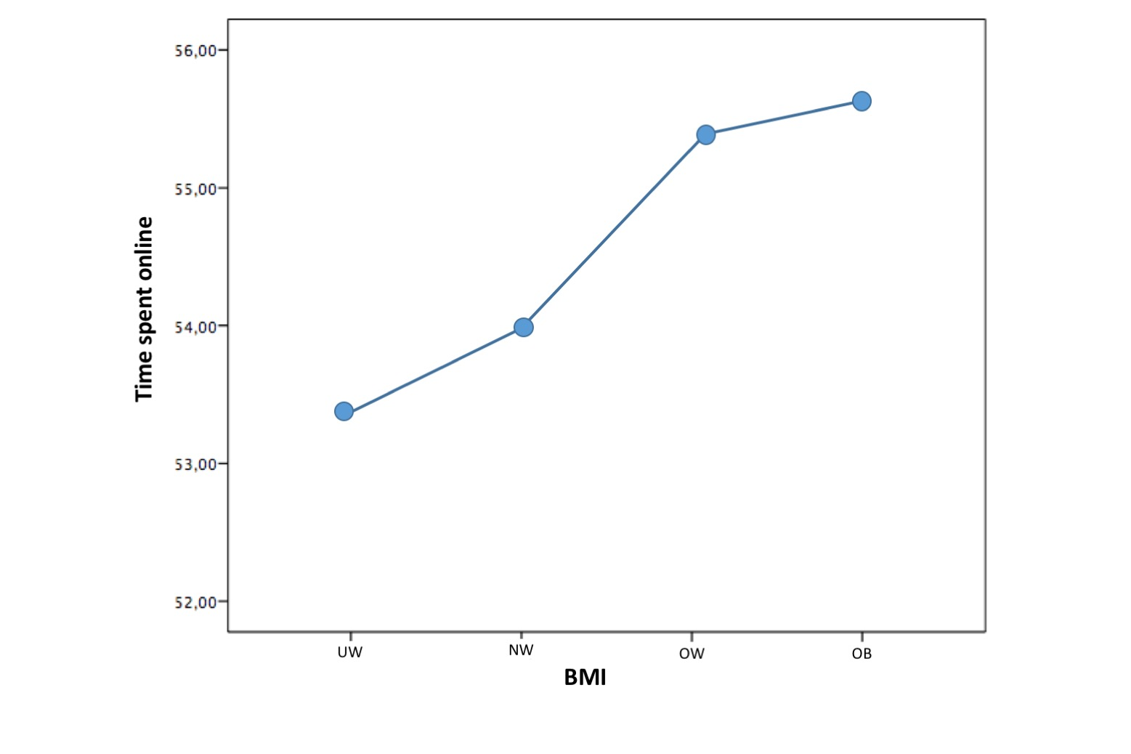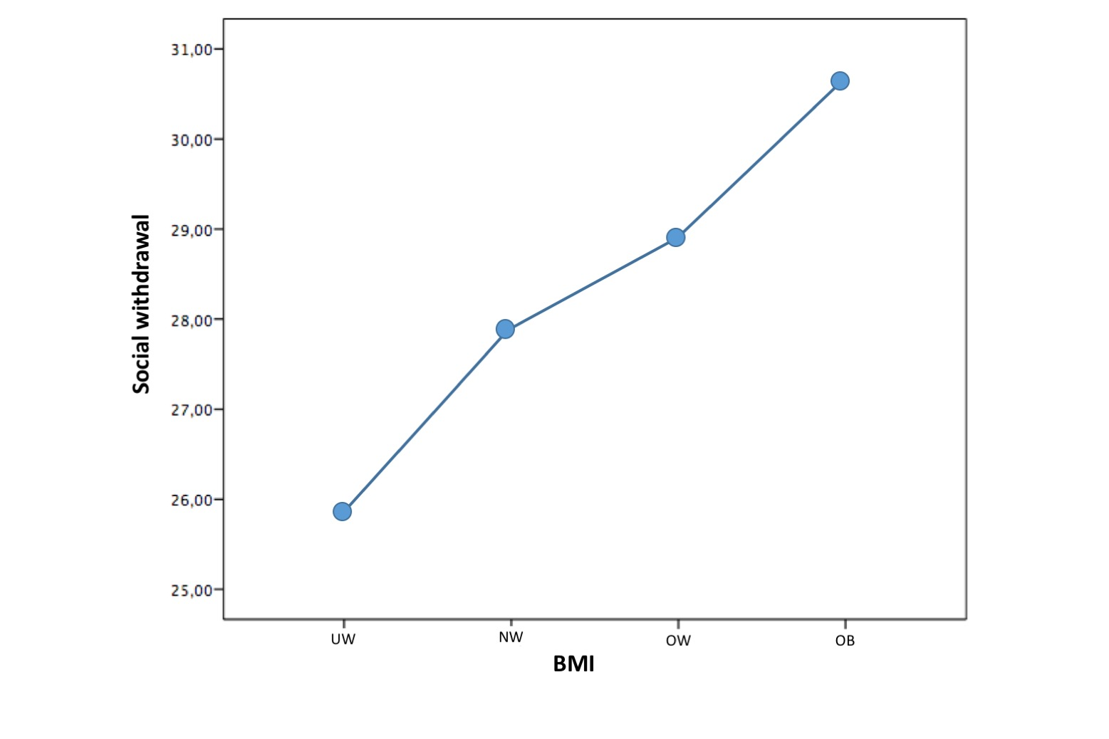
C D
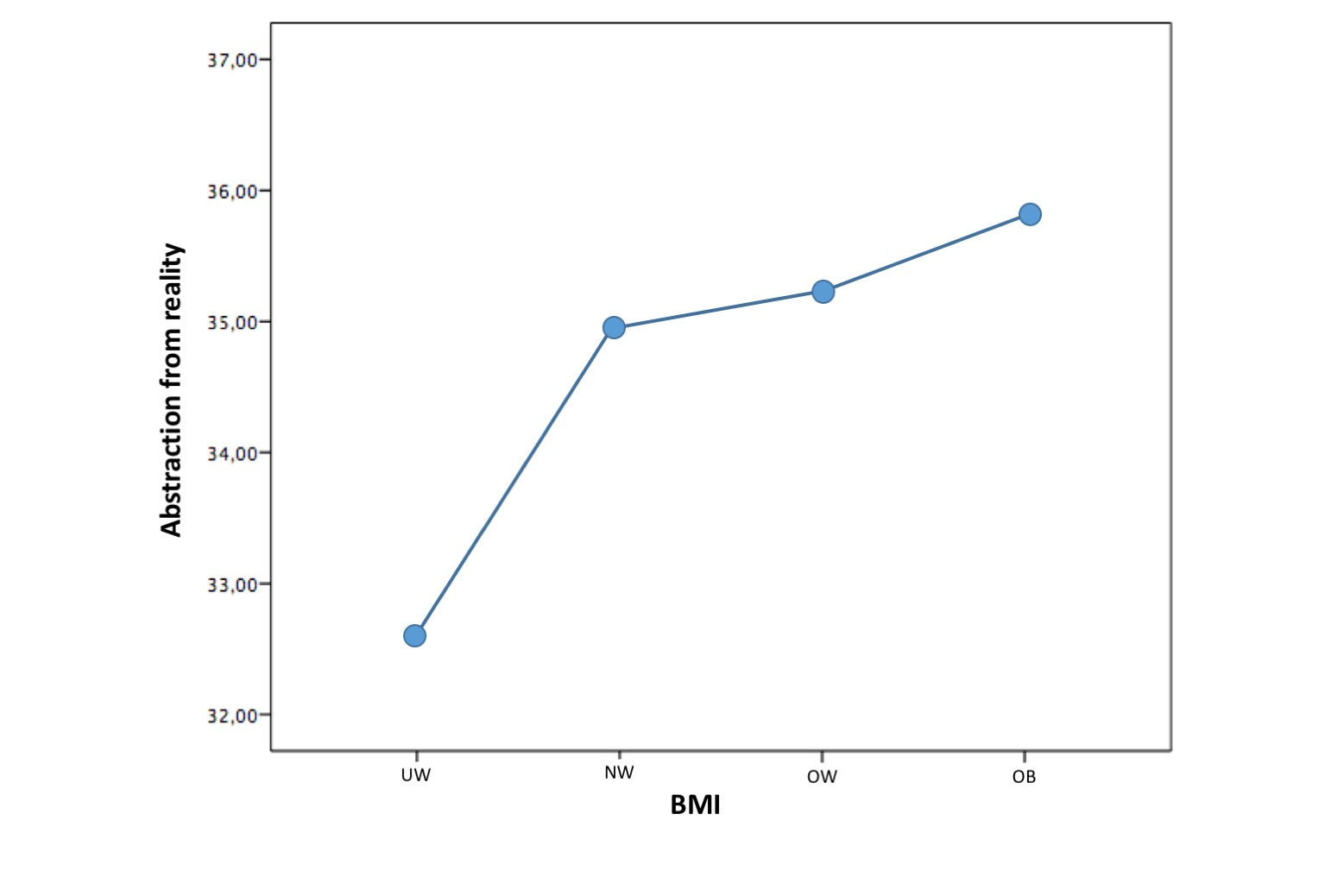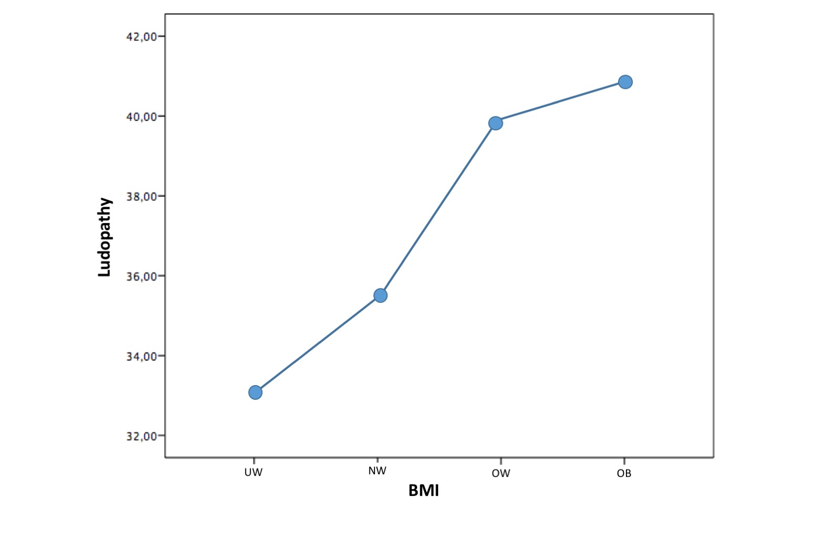
E
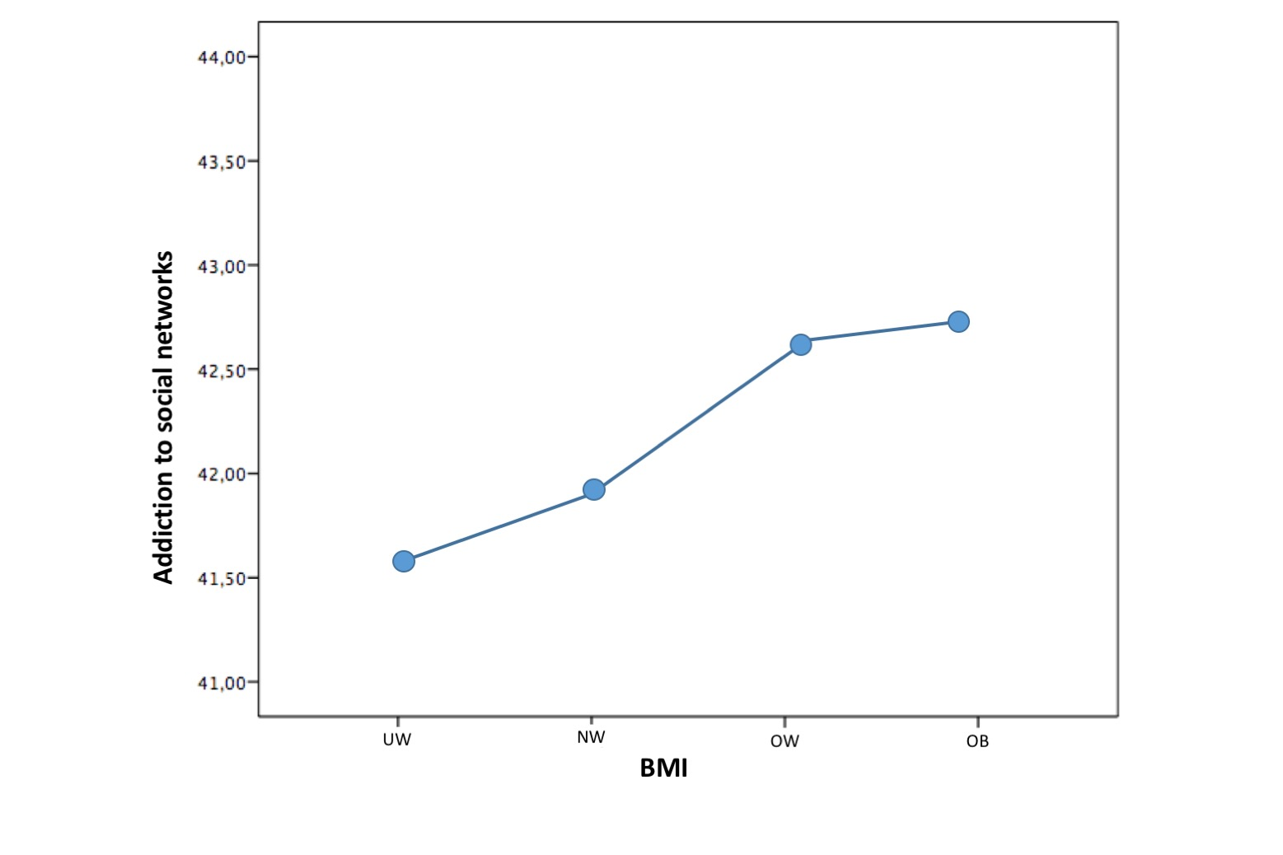

Figure 1 Trend of the percentage scores of some Questionario sull’Utilizzo delle Nuove Tecnologie factors and body mass index. A: Time spent online; B: Social withdrawal; C: Abstraction from reality; D: Ludopathy; E: Addiction to social networks. BMI: Body mass index; UW: Underweight; NW: Normal weight; OW: Overweight; OB: Obesity.

