Name of Journal: World Journal of Clinical Oncology
Manuscript NO: 89352
Manuscript Type: META-ANALYSIS

Transarterial chemoembolization plus stent placement for hepatocellular carcinoma with main portal vein tumor thrombosis: A meta-analysis

Sui WF et al. Therapy for HCC with main PVTT

Wei-Fan Sui, Jian-Yun Li, Jian-Hua Fu

Wei-Fan Sui, Jian-Yun Li, Jian-Hua Fu, Department of Interventional Radiology, Zhenjiang First People's Hospital, Zhenjiang 212000, Jiangsu Province, China

Author contributions: Fu JH designed the research study; Li JY and Sui WF performed the research; Sui WF analyzed the data and wrote the manuscript; all authors have read and approved the final manuscript.

Corresponding author: Jian-Hua Fu, Doctor, Director, Department of Interventional Radiology, Zhenjiang First People’s Hospital, No. 8 Dianli Road, Zhenjiang 212000, Jiangsu Province, China. suiweifan@126.com

Received: October 29, 2023
Revised: January 5, 2024
Accepted: February 4, 2024
Published online:

Abstract
BACKGROUND
Portal vein tumor thrombus is an important indicator of poor prognosis in patients with hepatocellular carcinoma. Transarterial chemoembolization is recommended as the standard first-line therapy for unresectable hepatocellular carcinoma. Portal vein stent placement is a safe and effective therapy for promptly restoring flow and relieving portal hypertension caused by tumor thrombus.

AIM
To assess the clinical significance of transarterial chemoembolization plus stent placement for the treatment of hepatocellular carcinoma with main portal vein tumor thrombosis.

METHODS
We searched English and Chinese databases, assessed the quality of the included studies, analyzed the characteristic data, tested heterogeneity, explored heterogeneity, and tested publication bias.

RESULTS
In total, eight clinical controlled trials were included. The results showed that the pressure in the main portal vein after stent placement was significantly lower than that with no stent placement. The cumulative stent patency and survival rates at 6 and 12 mo were lower in the transarterial chemoembolization + stent placement group than in the transarterial chemoembolization + stent placement + brachytherapy/radiotherapy group. The survival rates of patients treated with transarterial chemoembolization + stent placement for 6 and 12 mo were higher than those of patients treated with transarterial chemoembolization alone.

CONCLUSION
For Chinese patients with hepatocellular carcinoma with main portal vein tumor thrombosis, transarterial chemoembolization plus stenting is effective. Transarterial chemoembolization + stent placement is more effective than transarterial chemoembolization alone. Transarterial chemoembolization + stent placement + brachytherapy/radiotherapy is more effective than transarterial chemoembolization + stenting.

Key Words: Hepatocellular carcinoma; Transarterial chemoembolization; Portal vein tumor thrombus; Stent; Meta-analysis

Sui WF, Li JY, Fu JH. Transarterial chemoembolization plus stent placement for hepatocellular carcinoma with main portal vein tumor thrombosis: A meta-analysis. World J Clin Oncol 2024; In press

Core Tip: Portal vein tumor thrombus (PVTT) as an important indicator of poor prognosis existed in 44% of patients with hepatocellular carcinoma (HCC). Transarterial chemoembolization (TACE) is recommended as the standard first-line therapy in unresectable hepatocellular carcinoma. Some Chinese scholars have found that TACE combined with portal vein stent placement is safe and could prolong the survival time in HCC patients with PVTT.

INTRODUCTION
Hepatocellular carcinoma (HCC) is one of the most common malignancies worldwide^{[1]}. It is the fourth most common malignant tumor and the third most common cause of cancer-related death in China^{[2]}. Portal vein tumor thrombus (PVTT), an important indicator of poor prognosis, occurs in 44% of patients with HCC^{[3]}. PVTT decreases the blood supply to the normal liver and cause deterioration of liver function, gastrointestinal bleeding, and tumor recurrence^{[4]}. HCC with PVTT is regarded as technically unresectable.
Transarterial chemoembolization (TACE) is recommended as the standard first-line therapy for unresectable HCC^{[5]}. However, PVTT limits the effect of TACE and leads to liver failure because of portal vein obstruction. Three-dimensional conformal radiotherapy (3-DCRT) and I¹²⁵ seeds have been shown to improve survival in HCC patients with main PVTT but not in those with worsened liver function^{[6,7]}. However, the obstruction of the portal vein cannot be relieved immediately by 3-DCRT or I¹²⁵ seeds alone.
Portal vein stent placement is a safe and effective therapy for promptly restoring flow and relieving portal hypertension caused by tumor thrombus. It prolonged survival in patients with HCC and main PVTT^{[8]}. Several Chinese scholars have shown that TACE combined with portal vein stent placement is safe and can prolong the survival time of HCC patients with main PVTT^{[9,10]}. However, clinical trials with large samples for demonstrating the clinical significance of TACE plus stent placement for HCC patients with main PVTT are currently lacking, and no systematic analysis on the clinical significance of TACE plus stent placement for HCC patients with main PVTT in the Chinese population has been performed. Hence, this study aimed to carry out a meta-analysis to assess the clinical significance of TACE plus stent placement for Chinese patients with HCC and main PVTT.

MATERIALS AND METHODS
Search strategy
We performed a comprehensive literature search by using English-language databases, including PubMed, the Cochrane Library, and Excerpt Medica Database, and Chinese databases, including the Chinese National Knowledge Infrastructure (CNKI), Wanfang Data, and CQVIP, up to 2019.
We used the following search terms in the field for title/abstract and/or keywords: “Hepatocellular carcinoma”, ‘‘transarterial chemoembolization’’ or ‘‘TACE’’ or “chemoembolization”, “portal vein tumor thrombus”, and “stent”. All the data were available from published papers.

Study selection
The studies selected met the following inclusion criteria: (1) Original research; (2) human participants; (3) the study had clinical results, such as stent patency rates and survival rates; and (4) the study showed the clinical value of TACE plus stent placement for HCC patients with main PVTT.

Data extraction and study quality assessment
Two authors screened the titles and abstracts of potentially eligible studies independently and examined the full-text articles to determine whether they could be included. One author independently extracted the data, including author, country, publication year, design, treatment, and patient number. All the included studies were assessed for quality through the Cochrane Collaboration tool^{[11]}.

Data analysis
Review Manager 5.3 was used to analyze the data. For all analyses, P < 0.05 was considered to indicate statistical significance. Heterogeneity was assessed by using the chi-square test and I² statistic^{[12,13]}. The I² statistic was applied to further assess heterogeneity (25% ≤ I² ≤ 50% indicated low heterogeneity; 50% < I² ≤ 75% indicated moderate heterogeneity). An I² ≥ 75% indicated significant heterogeneity.
Subgroup analysis was performed to explore the source of heterogeneity.
Publication bias was evaluated using funnel plots^{[13]}. When a funnel plot was asymmetrical, interpretation of the results was assessed critically. Otherwise, no publication bias existed.

RESULTS
Search strategy
We included eight studies in this meta-analysis. Two studies were published in English^{[14,15]}. Six studies were of Chinese descent^{[9,10,16-19]} (Figure 1).

Data extraction and study quality assessment
The extracted data included author, publication year, nation, study design, number of patients, and therapies used in the experimental and control groups (Table 1).
The quality of the included studies was assessed. The tool included seven bias metrics, namely, random sequence generation (selection bias), allocation concealment (selection bias), blinding of participants and personnel (performance bias), blinding of outcome assessment (detection bias), incomplete outcome data (attrition bias), selective reporting (reporting bias), and other bias. A summary and graphs of the risk of bias were constructed based on the investigators’ judgments about each risk of bias item for each included study and are presented as percentages (Figure 2).

Data analysis
We compared the changes in main portal vein pressure before and after the operation (Figure 3). The pressure in the main portal vein after stent placement was significantly lower than that before stent placement (P < 0.00001), suggesting that stent placement decreased the main portal vein pressure. Heterogeneity existed in these results (I² = 63%).
We compared the cumulative stent patency rates at 6 and 12 mo (Figure 4). The cumulative stent patency rates at 6 and 12 mo were lower in the TACE + stent placement group than in the TACE + stent placement + brachytherapy/radiotherapy group (P < 0.00001), suggesting that stents without brachytherapy/radiotherapy were more obstructed by main PVTT. Heterogeneity did not exist in these results (I² = 0%).
We also compared the survival rates at 6 and 12 mo (Figure 5). The overall survival (OS) rates at 6 and 12 mo were lower in the TACE + stent placement group than in the TACE + stent placement + brachytherapy/radiotherapy group (P < 0.00001), suggesting that TACE + stent placement + brachytherapy/radiotherapy could prolong overall survival better than TACE + stent placement. Heterogeneity existed in these results (I² = 85%, 27%).
To explore the source of heterogeneity, we performed a subgroup analysis of the overall survival rates at 6 and 12 mo (Figure 6). The results showed that the source of heterogeneity was the different therapies: TACE + stent placement + brachytherapy/radiotherapy could prolong overall survival better than TACE + stent therapy, and TACE + stent placement could prolong overall survival better than TACE alone (P < 0.00001).
To assess publication bias, funnel plots were generated, and no publication bias was found (Figure 7).

DISCUSSION
PVTT is recognized as one of the most significant causes of recurrence and metastasis in HCC patients. The prognosis of HCC patients with PVTT is poor. The portal vein is the main nutrient vessel for the liver. It can be invaded by a tumor thrombus, which causes extensive intrahepatic metastases. When portal vein occlusion is accompanied by tumor thrombus, liver function fails, and the possibility of esophageal gastrointestinal bleeding increases, which is lethal for HCC patients.
Surgical resection can cure PVTT, but the high rate of recurrence after surgery and the high surgical requirements limit its use^{[20]}. 3-DCRT was also used for PVTT. The liver is sensitive to radiation and can tolerate 30 Gy/3-4 wk. However, to cure PVTT, the radiation dose must be above 40 Gy, which can cause external radiation to the liver and body^{[21]}. Because of the tumor thrombus in the hepatic artery, TACE can lead to necrosis of the tumor and tumor thrombus. However, the effect of TACE on tumor thrombi is less than that on tumors because TACE indirectly affects tumor thrombi.
According to our meta-analysis, TACE plus a main portal vein stent decreased the pressure in the main portal vein. Furthermore, for HCC patients with main PVTT, TACE plus portal vein stenting improved the survival rate compared with TACE alone. TACE + stent placement + brachytherapy/radiotherapy could improve the stent patency and survival rates better than TACE + stenting. Several studies have shown that portal vein stents serve as palliative remedies for malignant portal vein obstructions and could interrupt the infiltration and ingrowth of tumor thrombi in the portal vein to some degree^{[8,22]}, which is consistent with our meta-analysis. However, within a short period, owing to the mesh of the stent, the tumor thrombus might regrow into the stent, leading to reoccurrence and restenosis of the portal vein. Fortunately, TACE + stent placement + brachytherapy/radiotherapy is a practical superior treatment for HCC with main PVTT^{[14,23]}. Because the stent pressed the tumor thrombus, 3-DCRT minimized the likelihood of treating PVTT exactly, which reduced the damage to the normal liver and benefited liver function. I¹²⁵ seeds were close to the tumor tissue to deliver continuous irradiation, which restrained the ability of the tumor thrombus to proliferate by damaging the DNA tumor cells. Consequently, the efficiency of TACE + stent placement + brachytherapy/radiotherapy may be better than TACE + stenting and TACE alone for HCC patients with main PVTT. In the future, we can pay more attention to comparing the efficiency of TACE + stent placement + brachytherapy/radiotherapy and TACE + stent placement + radiotherapy for HCC patients with main PVTT.
There were several limitations in our meta-analysis: (1) Fifty randomized controlled trials were not included in the selected studies, which may have induced bias and affected our assessment of the management of HCC patients with main PVTT; (2) there was a lack of sufficient statistical data from multiple medical centers available to evaluate the efficacy of different therapies for patients with HCC and main PVTT; and (3) potential publication bias cannot be ignored, although our results showed no significant publication bias.

CONCLUSION
In summary, for HCC patients with main PVTT in the Chinese population, TACE + stent surgery is effective. The therapeutic benefits of TACE + stent placement are better than those of TACE alone. TACE + stent placement + brachytherapy/radiotherapy is more effective than TACE + stent placement.

ARTICLE HIGHLIGHTS
Research background
Portal vein tumor thrombus (PVTT) has been recognized as an important indicator of poor prognosis for hepatocellular carcinoma (HCC) patients. HCC with main PVTT limits the effect of transarterial chemoembolization (TACE).

Research motivation
Portal vein stent placement is a safe and effective therapy for promptly restoring flow and relieving portal hypertension caused by tumor thrombus. The efficacy and safety of TACE combined with portal vein stent placement have been proved by some Chinese scholars. No meta-analysis on the clinical significance of TACE plus stent placement for HCC with main PVTT was performed

Research objectives
This study aimed to carry out a meta-analysis to assess the clinical significance of TACE plus stent placement for HCC with main PVTT.

Research methods
We searched English and Chinese databases, assessed the quality of the included studies, analyzed the characteristic data, explored heterogeneity, and tested publication bias.

Research results
The results showed that the pressure in the main portal vein after stent placement was significantly lower than that with no stent placement. The cumulative stent patency and survival rates at 6 and 12 mo were lower in the transarterial chemoembolization + stent placement group than in the transarterial chemoembolization + stent placement + brachytherapy/radiotherapy group. The survival rates of patients treated with transarterial chemoembolization + stent placement for 6 and 12 mo were greater than those of patients treated with transarterial chemoembolization alone.

Research conclusions
Transarterial chemoembolization + stenting is safe. Transarterial chemoembolization + stent placement is more effective than transarterial chemoembolization alone. Transarterial chemoembolization + stent placement + brachytherapy/radiotherapy is more effective than transarterial chemoembolization + stenting.

Research perspectives
Tyrosine kinase inhibitors and immune therapies have been proved safe and effective. Adding tyrosine kinase inhibitors and immune therapies will improve the value of this study.

REFERENCES
1 Torre LA, Bray F, Siegel RL, Ferlay J, Lortet-Tieulent J, Jemal A. Global cancer statistics, 2012. CA Cancer J Clin 2015; 65: 87-108 [PMID: 25651787 DOI: 10.3322/caac.21262]
2 Chen W, Zheng R, Baade PD, Zhang S, Zeng H, Bray F, Jemal A, Yu XQ, He J. Cancer statistics in China, 2015. CA Cancer J Clin 2016; 66: 115-132 [PMID: 26808342 DOI: 10.3322/caac.21338]
3 Kim JY, Chung SM, Choi BO, Kay CS. Hepatocellular carcinoma with portal vein tumor thrombosis: Improved treatment outcomes with external beam radiation therapy. Hepatol Res 2011; 41: 813-824 [PMID: 21696524 DOI: 10.1111/j.1872-034X.2011.00826.x]
4 Okuda K, Ohtsuki T, Obata H, Tomimatsu M, Okazaki N, Hasegawa H, Nakajima Y, Ohnishi K. Natural history of hepatocellular carcinoma and prognosis in relation to treatment. Study of 850 patients. Cancer 1985; 56: 918-928 [PMID: 2990661 DOI: 10.1002/1097-0142(19850815)56:4<918::aid-cncr2820560437>3.0.co;2-e]
5 Cabibbo G, Tremosini S, Galati G, Mazza G, Gadaleta-Caldarola G, Lombardi G, Antonucci M, Sacco R. Transarterial chemoembolization and sorafenib in hepatocellular carcinoma. Expert Rev Anticancer Ther 2014; 14: 831-845 [PMID: 24850249 DOI: 10.1586/14737140.2014.920694]
6 Sugiyama S, Beppu T, Ishiko T, Takahashi M, Masuda T, Hirata T, Imai K, Hayashi H, Takamori H, Kanemitsu K, Hirota M, Murakami R, Baba Y, Oya N, Yamashita Y, Baba H. Efficacy of radiotherapy for PV and IVC tumor thrombosis in unresectable HCC. Hepatogastroenterology 2007; 54: 1779-1782 [PMID: 18019717 DOI: 10.1016/j.radonc.2007.07.005]
7 Lee DS, Seong J. Radiotherapeutic options for hepatocellular carcinoma with portal vein tumor thrombosis. Liver Cancer 2014; 3: 18-30 [PMID: 24804174 DOI: 10.1159/000343855]
8 Yamakado K, Tanaka N, Nakatsuka A, Matsumura K, Takase K, Takeda K. Clinical efficacy of portal vein stent placement in patients with hepatocellular carcinoma invading the main portal vein. J Hepatol 1999; 30: 660-668 [PMID: 10207808 DOI: 10.1016/s0168-8278(99)80197-4]
9 Xiang B, Xiang H. Effect Analysis of TACE Combined with Portal Vein Stent Implantation Treating Primary Liver Cancer with Portal Vein Tumor Thrombus. Shiyong Aizheng Zazhi 2017; 32: 1494-1497
10 Zhang L, Lu LG, Li Y, Shao PJ, Hu BS, Wei ZG, He X, Yu XY, Luo XN. Portal vein stent placement combined with TACE for the treatment of hepatocellular carcinoma associated with tumor thrombus in portal vein. Jieru Fangshexue Zazhi 2011; 20: 968-973
11 Higgins JP, Altman DG, Gøtzsche PC, Jüni P, Moher D, Oxman AD, Savovic J, Schulz KF, Weeks L, Sterne JA; Cochrane Bias Methods Group; Cochrane Statistical Methods Group. The Cochrane Collaboration's tool for assessing risk of bias in randomised trials. BMJ 2011; 343: d5928 [PMID: 22008217 DOI: 10.1136/bmj.d5928]
12 Higgins JP, Thompson SG. Quantifying heterogeneity in a meta-analysis. Stat Med 2002; 21: 1539-1558 [PMID: 12111919 DOI: 10.1002/sim.1186]
13 Egger M, Davey Smith G, Schneider M, Minder C. Bias in meta-analysis detected by a simple, graphical test. BMJ 1997; 315: 629-634 [PMID: 9310563 DOI: 10.1136/bmj.315.7109.629]
14 Chuan-Xing L, Xu H, Bao-Shan H, Yong L, Pei-Jian S, Xian-Yi Y, Xiao-Ning L, Li-Gong L. Efficacy of therapy for hepatocellular carcinoma with portal vein tumor thrombus: chemoembolization and stent combined with iodine-125 seed. Cancer Biol Ther 2011; 12: 865-871 [PMID: 22037354 DOI: 10.4161/cbt.12.10.17676]
15 Zhang XB, Wang JH, Yan ZP, Qian S, Du SS, Zeng ZC. Hepatocellular carcinoma with main portal vein tumor thrombus: treatment with 3-dimensional conformal radiotherapy after portal vein stenting and transarterial chemoembolization. Cancer 2009; 115: 1245-1252 [PMID: 19156918 DOI: 10.1002/cncr.24139]
16 Wang CG, Wang XL, Gong GQ, Chen G, Zeng ZC, Qiu WL, Lin GL, Chen Y, Li GP. [The preliminary study of metallic stent implantation in combination with three-dimensional conformal radiation therapy in the treatment of hepatocellular carcinoma patients with portal vein tumor thrombus]. Zhonghua Gan Zang Bing Za Zhi 2009; 17: 417-421 [PMID: 19567018 DOI: 10.21203/rs.3.rs-88313/v1]
17 Wu LL, Luo JJ, Yan ZP, Wang JH, Wang XL, Zhang XB, Fang ZT, Zhang W. [Comparative study of portal vein stent and TACE combined therapy with or without endovascular implantation of iodine-125 seeds strand for treating patients with hepatocellular carcinoma and main portal vein tumor thrombus]. Zhonghua Gan Zang Bing Za Zhi 2012; 20: 915-919 [PMID: 23522253 DOI: 10.3760/cma.j.issn.1007-3418.2012.12.009]
18 Zhang XB, Wang JH, Yan ZP, Qian S, Du SS, Zeng ZC. Hepatocellular carcinoma complicated by mare portal vein tumor thrombus:treated by portal vein slenting, transarterial chemoembolizalion and 3-dimemional conformal radiotherapy. Zhonghua Fangshexue Zazhi 2008; 24: 1311-1315 [DOI: 10.3321/j.issn:1005-1201.2008.12.018]
19 Zhang ZH, Liu QX, Zhang W, Ma JQ, Wang JH, Luo JJ, Liu LX, Yan ZP. Combined endovascular brachytherapy, sorafenib, and transarterial chemobolization therapy for hepatocellular carcinoma patients with portal vein tumor thrombus. World J Gastroenterol 2017; 23: 7735-7745 [PMID: 29209114 DOI: 10.3748/wjg.v23.i43.7735]
20 Shi J, Lai EC, Li N, Guo WX, Xue J, Lau WY, Wu MC, Cheng SQ. Surgical treatment of hepatocellular carcinoma with portal vein tumor thrombus. Ann Surg Oncol 2010; 17: 2073-2080 [PMID: 20131013 DOI: 10.1245/s10434-010-0940-4]
21 Dawson LA, Ten Haken RK, Lawrence TS. Partial irradiation of the liver. Semin Radiat Oncol 2001; 11: 240-246 [PMID: 11447581 DOI: 10.1053/srao.2001.23485]
22 Yamakado K, Nakatsuka A, Tanaka N, Fujii A, Terada N, Takeda K. Malignant portal venous obstructions treated by stent placement: significant factors affecting patency. J Vasc Interv Radiol 2001; 12: 1407-1415 [PMID: 11742015 DOI: 10.1016/s1051-0443(07)61699-6]
23 Ishikura S, Ogino T, Furuse J, Satake M, Baba S, Kawashima M, Nihei K, Ito Y, Maru Y, Ikeda H. Radiotherapy after transcatheter arterial chemoembolization for patients with hepatocellular carcinoma and portal vein tumor thrombus. Am J Clin Oncol 2002; 25: 189-193 [PMID: 11943901 DOI: 10.1097/00000421-200204000-00019]

Footnotes
Conflict-of-interest statement: All the authors report no relevant conflicts of interest for this article.

PRISMA 2009 Checklist statement: The authors have read the PRISMA 2009 Checklist, and the manuscript was prepared and revised according to the PRISMA 2009 Checklist.

Open-Access: This article is an open-access article that was selected by an in-house editor and fully peer-reviewed by external reviewers. It is distributed in accordance with the Creative Commons Attribution NonCommercial (CC BY-NC 4.0) license, which permits others to distribute, remix, adapt, build upon this work non-commercially, and license their derivative works on different terms, provided the original work is properly cited and the use is non-commercial. See: https://creativecommons.org/Licenses/by-nc/4.0/

Provenance and peer review: Unsolicited article; Externally peer reviewed.
Peer-review model: Single blind

Peer-review started: October 29, 2023
First decision: December 22, 2023
Article in press:

Specialty type: Oncology
Country/Territory of origin: China
Peer-review report’s scientific quality classification
Grade A (Excellent): 0
Grade B (Very good): 0
Grade C (Good): 0
Grade D (Fair): D
Grade E (Poor): 0

P-Reviewer: Elshimi E, Egypt S-Editor: Gong ZM L-Editor: Wang TQ P-Editor:
Figure Legends
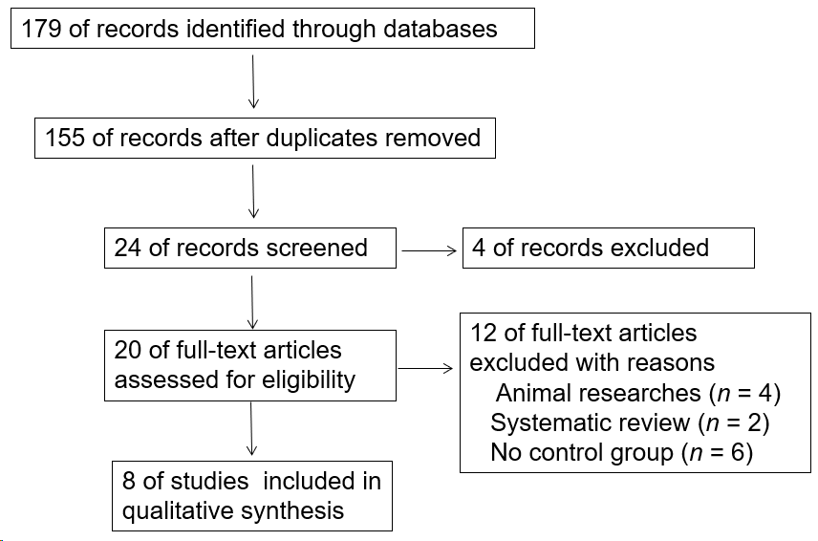
Figure 1 Flowchart of the meta-analysis.
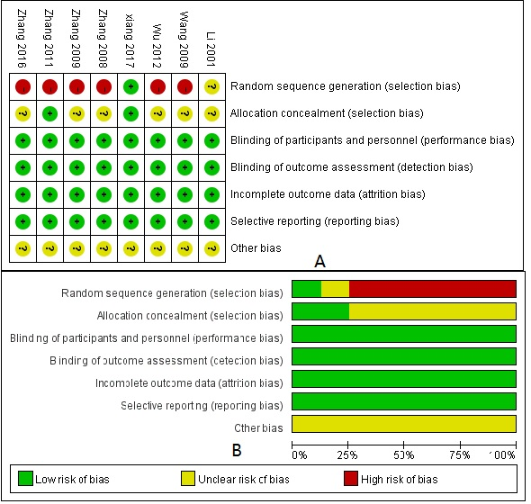
Figure 2 Risk of bias summary and bias graph. A: Review authors’ judgements about each risk of bias item for each included study; B: Review authors' judgements about each risk of bias item presented as percentages across all included studies. −: High risk; +: Low risk; ?: Unclear risk.
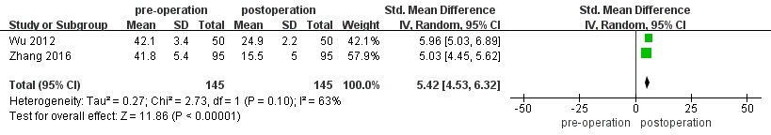
Figure 3 Forest plot of changes of main portal vein pressure.
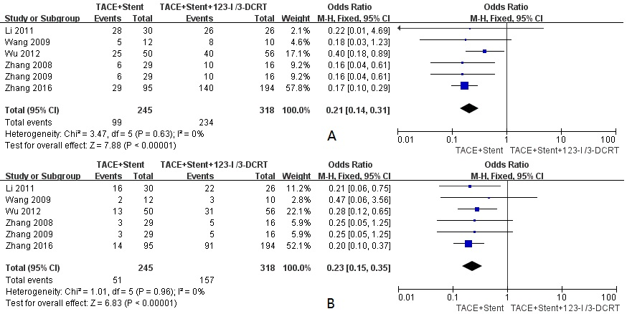
Figure 4 Forest plots of cumulative stent patency rates at 6 and 12 mo. A: 6 m; B: 12 mo.
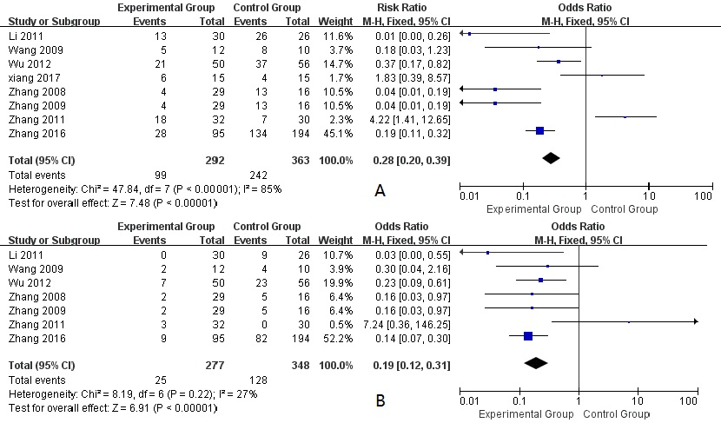
Figure 5 Forest plots of survival rates at 6 and 12 mo. A: 6 mo; B: 12 mo.

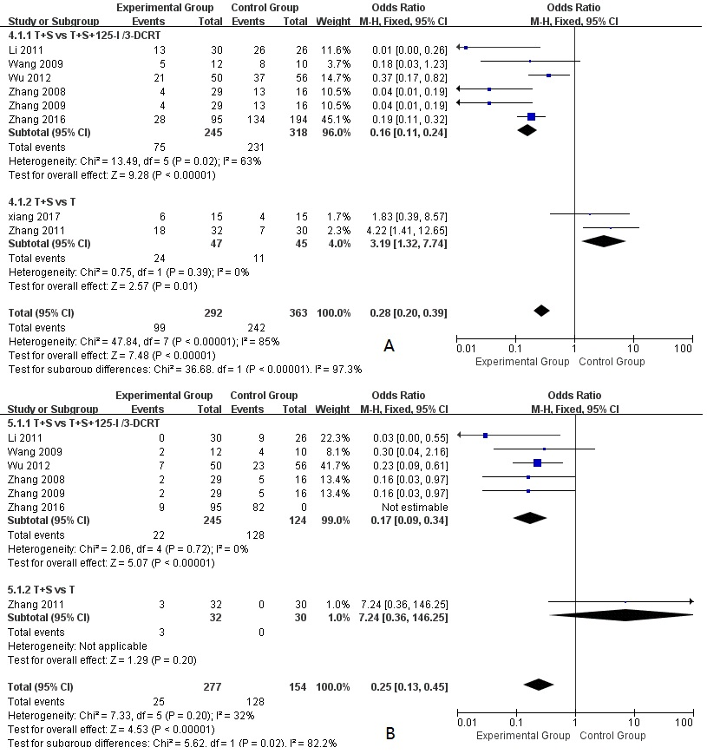
Figure 6 Forest plots of subgroup analysis. A: 6 mo; B: 12 mo.
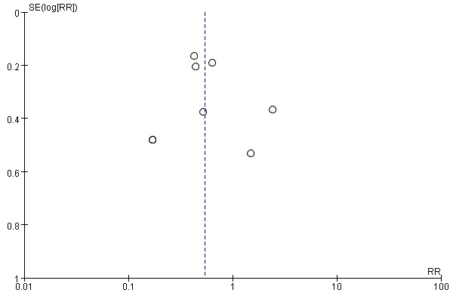
Figure 7 Funnel plot of included studies.

Table 1 Characteristics of included studies
Ref. | Nation | Design | Number of patients (M/F) |  |  | Therapy
 |  |  | Experimental group | Control group | Experimental group |  | Control group
Li et al^{[14]}, 2011 | China | NG | 23/7 | 17/9 | TACE + stenting |  | TACE + stenting + I¹²⁵
Wang et al^{[16]}, 2009 | China | Retrospective study | 12/0 | 9/1 | TACE + stenting |  | TACE + 3-DCRT
Wu et al^{[17]}, 2012 | China | Retrospective study | 43/7 | 51/5 | TACE + stenting |  | TACE + stenting + I¹²⁵
Xiang et al^{[9]}, 2017 | China | Prospective study | 9/6 | 8/7 | TACE + stenting |  | TACE
Zhang et al^{[18]}, 2008 | China | Retrospective study | 28/1 | 15/1 | TACE + stenting |  | TACE + stenting + 3-DCRT
Zhang et al^{[15]}, 2009 | China | Retrospective study | 28/1 | 15/1 | TACE + stenting |  | TACE + stenting + 3-DCRT
Zhang et al^{[10]}, 2011 | China | Retrospective study | 23/7 | 22/8 | TACE + stenting |  | TACE
Zhang et al^{[19]}, 2016 | China | Retrospective study | 83/12 | 178/16 | TACE + stenting |  | TACE + stenting + I¹²⁵
NG: Not given.

