Name of Journal: World Journal of Gastrointestinal Surgery
Manuscript NO: 84437
Manuscript Type: CASE REPORT

Laparoscopy-assisted gastrectomy for advanced gastric cancer patients with situs inversus totalis: Two case reports and review of literature

Liu HB et al. LAG for advanced GC with SIT

Hong-Bo Liu, Xiao-Peng Cai, Zhao Lu, Bin Xiong, Chun-Wei Peng

Hong-Bo Liu, Xiao-Peng Cai, Zhao Lu, Bin Xiong, Chun-Wei Peng, Department of Gastrointestinal Surgery, Hubei Key Laboratory of Tumor Biological Behaviors & Hubei Cancer Clinical Study Center, Wuhan Peritoneal Cancer Clinical Medical Center, Zhongnan Hospital of Wuhan University, Wuhan 430070, Hubei Province, China

Hong-Bo Liu, School of Nursing, Wuhan University, Wuhan 430070, Hubei Province, China

Author contributions: Liu HB and Peng CW contributed to manuscript writing and editing, and data collection; Cai XP and Lu Z contributed to data analysis; Xiong B and Peng CW contributed to conceptualization and supervision; all authors have read and approved the final manuscript.

Supported by National Natural Science Foundation of China, No. 81401515; Zhongnan Hospital of Wuhan University Science Technology and Innovation Seed Fund, No. znpy2018030; “351Talent Project (Luojia Young Scholars)” of Wuhan University.

Corresponding author: Chun-Wei Peng, MD, PhD, Doctor, Department of Gastrointestinal Surgery, Hubei Key Laboratory of Tumor Biological Behaviors & Hubei Cancer Clinical Study Center, Wuhan Peritoneal Cancer Clinical Medical Center, Zhongnan Hospital of Wuhan University, No. 169 Donghu Road, Wuchang District, Wuhan 430070, Hubei Province, China. whupengcw@whu.edu.cn

Received: March 20, 2023
Revised: July 1, 2023
Accepted: July 25, 2023
Published online:

Abstract
BACKGROUND
Situs inversus totalis (SIT) is a rare condition in which the positions of abdominal and thoracic organs present a “mirror image” of the normal ones in the median sagittal plane. Although minimally invasive surgery has evolved to achieve laparoscopic gastrectomy for gastric cancer (GC) patients with SIT, it is difficult to perform lymphadenectomy (LND) in such a transposed anatomical condition. Herein, we report the cases of two patients with SIT who successfully underwent laparoscopy-assisted gastrectomy (LAG) with D2 LND.

CASE SUMMARY
Case 1: A 65-year-old man was admitted for intermittent abdominal pain and distension, occasional belching, and acid reflux for 4 mo. He was diagnosed with GC (cT3N1-2M0) with SIT. Before surgery, he had undergone four cycles of neoadjuvant chemotherapy and immunotherapy. Then, the patient was evaluated as having a partial response, and laparoscopy-assisted distal gastrectomy with D2 LND and Billroth II reconstruction were performed. The operation was performed successfully within 240 min with an estimated blood loss of 50 mL and no severe complications. The patient was discharged on postoperative day (POD) 9. Case 2: A 55-year-old man was admitted for upper abdominal distension with pain and discomfort after eating for 3 mo. He was diagnosed with GC (cT3N1M0) with SIT. He had a history of hypertension for more than 10 years; however, his blood pressure was well-controlled via regular medication. We performed laparoscopy-assisted total gastrectomy with D2 LND and Roux-en-Y reconstruction. The operation was performed successfully within 168 min with an estimated blood loss of 50 mL and no severe complications. The patient was discharged on POD 10.

CONCLUSION
LAG with D2 LND could be considered an accessible, safe, and curative procedure for advanced GC patients with SIT.

Key Words: Situs inversus totalis; Laparoscopy-assisted gastrectomy; Advanced gastric cancer; Surgery modality; Lymphadenectomy; Case report

Liu HB, Cai XP, Lu Z, Xiong B, Peng CW. Laparoscopy-assisted gastrectomy for advanced gastric cancer patients with situs inversus totalis: Two case reports and review of literature. World J Gastrointest Surg 2023; In press

Core Tip: Laparoscopic surgery in situs inversus totalis (SIT) patients with gastric cancer (GC) is exceedingly rare and challenging. We report the cases of two advanced GC patients with SIT who successfully underwent laparoscopy-assisted gastrectomy with D2 lymphadenectomy. In this report, we share our experience and review the literature in the previous 11 years to summarize the general consensus on laparoscopic radical gastrectomy in patients with SIT.

INTRODUCTION
Situs inversus totalis (SIT), a rare autosomal recessive disorder characterized by a complete congenital mirror-image malposition of the thoracic and abdominal organs, has an incidence of about 1/10000-1/20000^{[1]}. Due to the inverted anatomical disposition of organs in patients with SIT, surgeons are required to adopt unfamiliar operating habits, which also increases the difficulty of identifying anatomical structures. Despite the rarity of encountering this anomaly, focusing on SIT may compensate for the lack of experience in surgery.
Laparoscopic radical gastrectomy has been performed in specialized centers in recent years for its minimal invasiveness and association with uneventful recovery. However, this operation is still challenging due to the change in traditional operating habits and increased difficulty in identifying anatomical structures under the local visual field, which are also difficulties encountered in patients with SIT. Moreover, no tactility can be of significant influence during surgery, making it more complicated to implement laparoscopic radical gastrectomy in patients with SIT. In light of such patients, it is still worth summarizing experience and exploring the most feasible ways of optimizing surgery.
In this report, we present the cases of two patients having advanced gastric cancer (GC) with SIT, both of whom underwent laparoscopy-assisted gastrectomy and standard D2 lymphadenectomy (LND). We also review the literature to discuss the current surgical strategies for GC patients with SIT.

CASE PRESENTATION
Chief complaints
Case 1: A 65-year-old Chinese man presented with intermittent abdominal pain and distension, occasional belching, and acid reflux with no obvious cause.

Case 2: A 55-year-old Chinese man presented with upper abdominal distension with pain and discomfort after eating.

History of present illness
Case 1: In April 2022, the patient presented at a local hospital with intermittent abdominal pain and distension, occasional belching, and acid reflux of no obvious etiology for 4 mo, all of which were unrelated to eating. He denied nausea, vomiting, hematemesis, black stool, diarrhea, and constipation. Upper gastrointestinal endoscopy identified poor motility of the gastric antrum, with a large ulcer covered with black scabs and blood clots. Furthermore, tissue biopsy with histopathology revealed the presence of poorly or moderately differentiated adenocarcinoma. The patient did not receive any anti-tumor treatment before hospitalization. Since the onset of the disease, his spirit, appetite, sleep, physical strength, and weight did not change significantly. The patient was admitted to our hospital for further treatment.

Case 2: In December 2019, the patient visited a local hospital for postprandial upper abdominal distension with pain and discomfort for 3 mo. He denied nausea, vomiting, hematemesis, black stool, diarrhea, and constipation. Also, the self-administered gastric protective medicine was ineffective. Upper gastrointestinal endoscopy identified a gastric cardia ulcer, which tissue biopsy identified as poorly differentiated adenocarcinoma and partly signet-ring cell carcinoma. The patient did not receive any anti-tumor treatment before hospitalization. Since the onset of the disease, his spirit, appetite, sleep, and physical strength did not change significantly, except for his weight which decreased slightly. Then, the patient was admitted to our hospital for further treatment.

History of past illness
Case 1: The patient denied any history of a chronic illness. He had no history of abdominal surgery.

Case 2: The patient acknowledged a history of hypertension for ten more years that was properly controlled with regular medication. He had no history of abdominal surgery.

Personal and family history
Case 1: The patient denied any family history of malignant tumors.

Case 2: The patient denied any family history of malignant tumors.

Physical examination
Case 1: Physical examination revealed an apical heartbeat on the right side.

Case 2: Physical examination revealed mild lower abdominal tenderness and an apical heartbeat on the right side.

Laboratory examinations
Case 1: No obvious abnormal tumor markers were observed.

Case 2: Carbohydrate antigen CA199 level was 365.2 (normal range: 0–37.0) U/mL.

Imaging examinations
Case 1: The detailed imaging results are presented in Figure 1. Abdominal contrast-enhanced computed tomography (CT) revealed mirror transposition of all organs (Figure 1A) and thickening of the antral wall (Figure 1B). Besides, positron emission tomography-CT performed in a local hospital revealed increased metabolism in the gastric antrum and surrounding lymph nodes. No abnormal course of vascularity was found in this process.

Case 2: Abdominal contrast-enhanced CT revealed mirror transposition of all organs (Figure 1G), localized thickening of the cardia and smaller curvature of the stomach, and increased numbers of peri-gastric small lymph nodes (Figure 1H). No abnormal course of vascularity was found in this process.

FURTHER DIAGNOSTIC WORK-UP
Case 1
A preoperative pathological examination was performed. The analysis of the biopsy segment resected from the gastric antrum ulcer revealed poorly to moderately differentiated adenocarcinoma (cT3N1-2M0). Immunohistochemical analyses revealed that the tumor cells tested positive for MSH2 and MSH6 and negative for HER-2, MLH1, and PMS2, which signifies a loss of MMR expression.

Case 2
No preoperative pathological examination was performed.

FINAL DIAGNOSIS
Case 1
The patient was diagnosed with adenocarcinoma of the gastric antrum (cT3N1-2M0) with SIT.

Case 2
The patient was diagnosed with gastric cardia malignancy (cT3N1M0) with SIT.

TREATMENT
Case 1
Before surgery, four cycles of neoadjuvant chemotherapy with the S-1 and oxaliplatin (SOX) regimen (oxaliplatin 230 mg on day 1, tegafur 60 mg twice daily on days 1–14, and sintilimab 200 mg once every 3 wk) and immunotherapy was given. The preoperative (after neoadjuvant chemotherapy) pathologic biopsies are presented in Figure 1D.
Laparoscopy-assisted distal gastrectomy with standard D2 LND and Billroth II reconstruction were performed. During surgery, the surgeon stood on the right side of the patient (opposite to the usual side for patients undergoing laparoscopic gastrectomy). A 10-mm trocar was created 10 mm below the umbilicus, and carbon dioxide was injected into the peritoneal cavity at 10 mmHg. The other four trocars were placed in the bilateral subcostal and lateral abdominal area, arranged in a “U” shape (Figure 1C). No implantation metastasis or vascular variants were found (Figure 2).
The procedure lasted for 240 min, and the estimated blood loss was 50 mL. A total of 34 lymph nodes were retrieved. The lesion was located in the antrum, and there were enlarged lymph nodes; also, there was no visible invasion of the serous layer. The final pathological stage was ypT0N0M0. None of the 34 retrieved lymph nodes (Figure 1E and F) showed metastasis.

Case 2
The patient accepted laparoscopy-assisted total gastrectomy with standard D2 LND and Roux-en-Y reconstruction. The position of the surgeon and placement of trocars were the same as those in Case 1. No implantation metastasis or vascular variants were found.
The procedure lasted for 168 min, and the estimated blood loss was 50 mL. A total of 34 lymph nodes were retrieved. The lesion was located at the bottom of the gastric body and cardia, and it measured 2.5 × 2.3 × 0.3 cm. It was identified as poorly differentiated adenocarcinoma invading nerves, vasculature, and fibroadipose tissue in the serous membrane of the stomach wall. The final pathological stage was pT3N3aM0. Eleven of the 34 retrieved lymph nodes showed metastasis (Figure 1I).

OUTCOME AND FOLLOW-UP
Case 1
We implemented enhanced recovery after surgery on the patient, and his postoperative course was uneventful. The patient was able to resume drinking water on postoperative day (POD) 3 and eating liquid food on POD 5. Thereafter, he was discharged on POD 9. Eight months after the operation, he is doing well without recurrence.

Case 2
Without any complication, the patient was discharged on POD 10. Notably, the patient was administered six cycles of postoperative adjuvant chemotherapy with the SOX regimen. The patient had metastasis of supraclavicular lymph nodes in the twelfth postoperative month; however, there has been no sign of local recurrence.

DISCUSSION
Literature review
SIT may be caused by a genetic mutation; however, its specific mechanism remains unknown. A study conducted by Reish et al^{[2]} suggested that the homozygous NME7 mutation results in the deletion of amino acids essential for its interaction with the γ-TuRC, which is associated with the impaired left-right asymmetry that manifests as SIT. Although the majority of patients with SIT lead normal lives, a subset of individuals (15%–25%) exhibit accompanying respiratory anomalies (Kartagener syndrome), cardiovascular anomalies (Fallot tetralogy), and digestive anomalies^{[3]}. In addition to these malformations, patients with SIT may also be at an increased risk of cancer due to malfunction of the KIF3 complex^{[4]}. Reports indicate that SIT can be associated with multiple cancers^{[5]}, including lung cancer, esophageal cancer, gallbladder cancer, and colon cancer^{[6-9]}. In recent years, laparoscopic radical surgery, including laparoscopic cholecystectomy, laparoscopic colectomy, laparoscopic fundoplication, and laparoscopic gastric band surgery, has increasingly been adopted for cancer patients with SIT^{[10]}.
In 1936, Allen^{[11]} described the first case of gastrectomy in a GC patient with SIT. In 2003, the first case of laparoscopic gastrectomy performed on a GC patient with SIT was reported^{[12]}, followed by the first case of laparoscopic gastrectomy combined with D2 LND in 2015^{[10]}.
In terms of our surgery and summary, we searched PubMed for previously reported cases of GC with SIT in which the patients underwent gastrectomy within the last 11 years (from January 1, 2012 to February 31, 2023). The terms used for topic searches of PubMed were “situs inversus totalis” AND “gastric cancer” or “situs inversus totalis” AND “gastrectomy”. Two cases^{[13,14]} in which gastrectomy was introduced as previous surgery and a case^{[15]} in which a non-cancer patient underwent prophylactic gastrectomy were excluded. Consequently, a total of 33 cases were identified, including the two cases that we had previously introduced (from 30 articles). The detailed profiles of the patients in the reported cases are presented in Table 1. Among the patients in the included cases, 22 were men and 11 were women; the patients were aged 40–84 years. According to the articles identified, modified surgical procedures to cope with anatomical malposition are what surgeons concentrate on the most, including the surgery modality, extent of LND, and position of the surgeon.

Surgery modality
Surgical modality selection is a significant concern when treating GC in patients with SIT. Minimally invasive surgery is usually preferred due to its less invasive nature and shorter associated recovery time. However, in 8 of the 33 cases collected from PubMed, the patients underwent open gastrectomy. Surgeons performing open surgery claimed that they took the patient's high body fat and anatomical difficulties of total visceral inversion into consideration comprehensively. Furthermore, laparotomy could provide not only a broader field of vision but also a pathway to insert an applicator for intraoperative radiotherapy^{[16]}. In contrast, laparoscopic surgery is helpful for visualizing vessels and nerves due to the magnified operating field^{[17]}. The application of radical laparoscopic surgery in patients with SIT may have several benefits (such as reduced trauma, milder postoperative pain, and shorter recovery times) compared to traditional open surgical procedures. From our perspectives, identifying anatomical structures may prove problematic; however, an experienced surgeon may overcome this challenge to a certain extent. So, we opted for laparoscopic surgery in our two cases. Nonetheless, laparoscopic gastrectomy requires much expertise, and each patient should be evaluated on an individual basis. The choice of surgical modality should depend on the doctor's technique and the patient's physical condition.
Robotic surgery has been a promising approach for GC patients with SIT. The first case of a GC patient with SIT treated by robotic-assisted distal gastrectomy was reported in 2012^{[18]}, and ten cases have been reported so far. Robotic surgery can reduce the errors caused by the cooperation of multiple operators in laparoscopic surgery^{[19]}. Yoshimoto et al^{[20]} concluded that compared to conventional laparoscopic surgery, robotic surgery has two main advantages: (1) It circumvents the need to consider the standing position; and (2) The operator can handle the devices with the nondominant hand with almost the same accuracy as the dominant hand. Although robotic surgery can sew faster and remove deep lymph nodes more easily, it lacks tactility and takes longer^{[21]}. Long-term and short-term comparative studies have shown that robotic gastrectomy is as acceptable as laparoscopic gastrectomy in surgical and oncologic outcomes for normal GC patients^{[22,23]}. Further evidence is needed to fully evaluate the efficacy of robotic surgery in GC patients with SIT.

Extent of LND
Regional LND is an essential requirement for radical gastrectomy, with D2 surgery being widely recognized as the standard surgical procedure for advanced GC. D2 LND is performed under an extrasac that originates from the anterior transverse mesenteric lobe to the pancreatic capsule. We performed complete resection of the anterior transverse mesangial lobe, greater omentum, pancreatic capsule, and hepatogastric ligaments, ligation of the blood vessels involved at the root, and thorough removal of the corresponding second station lymph nodes according to the tumor site. Therefore, it is crucial to differentiate the relevant important blood vessels (including hepatoduodenal ligaments, abdominal trunk, common hepatic artery (CHA), splenic artery initiation, superior mesenteric vein, etc.). However, in the case of SIT, the occurrence of vascular anomalies is not common. Out of the 33 cases that are reviewed in the literature, 10 involving vascular anomalies have been described. The most common anomaly observed was that the CHA exited from the superior mesenteric artery, with three cases reported. The solution proposed by Fujita et al^{[24]} re-confirmed the anatomical landmarks of LND in the suprapancreatic area as the upper borders of the pancreas, portal vein, and left gastric artery from the celiac axis. Therefore, during the preoperative evaluation period, sufficient imaging examination is necessary to detect the normal anatomy and variations in the branching pattern of the celiac trunk, which could significantly reduce the duration of surgery and the intraoperative blood loss. With the advent of imaging technology, the three-dimensional reconstruction image of CT angiography (3DCTA) has been widely used to confirm surgical anatomy. Several studies have reported that 3DCTA adequately demonstrates vascular anomalies. In our cases, a contrast-enhanced CT scan was performed, and no abnormal course of vascularity was found in this process.

Position of the surgeon
The appropriate surgical positioning for surgeons during GC surgery in patients with SIT has been a topic of ongoing debate. To this day, there is still no definitive conclusion on the optimal standing position of the surgeon during this type of surgery. The surgical positioning of the surgeon may be related to the surgical modality. In open surgeries, the surgeon’s position was reported in five out of eight cases, with four of them being performed on the patient's left side (the usual side). These surgical procedures were carried out according to the principle of precise manipulation of local lymph nodes and smooth transition of the cleaned area. The optimal positioning for the surgeon during laparoscopic gastrectomy in patients with SIT is still controversial. It is natural to think that it is better for the surgeon to stand in the reverse position due to the left-right reversal of the positions of organs. Out of 15 counted laparoscopic gastrectomy cases, 11 were performed on the patient's right side (opposite to the usual side). However, a few surgeons hold a different view, as they believe that standing on the opposite side from where they normally stand would require them to dissect with their nondominant hand, leading to inevitable difficulties. Nevertheless, we still chose to stand on the opposite side. Thanks to our sophisticated skills and well-coordinated team, the procedure was smooth and without complications.
Robotic surgery provides a new solution to this obstacle. In robotic gastrectomy, the robotic arm performs most of the operation, enabling the surgeon to perform the operation without changing their position or experiencing any confusion resulting from the patient's reversed anatomy. This technology may overcome the difficulties encountered in laparoscopic gastrectomy for patients with SIT, and it could be considered a safe and effective surgical approach.
Furthermore, we summarize the clinical features, estimated blood loss, surgery time, and prognoses of 31 reported cases of GC with SIT. The majority of cases occurred in middle-aged and elderly men, and these cases were reported in Japan, China, and Korea (15, 10, and 6 cases, respectively). However, there is a paucity of studies on the correlation and regional differences between GC and SIT. The main treatment methods were surgical resection, reconstruction, and chemotherapy, which effectively improved patients’ survival. Combining the experiences of others and ours, our suggestion is that, first of all, a sufficient preoperative imaging evaluation is recommended as it can help predict abnormal anatomical positions and vascular directions. Contrast-enhanced abdominal CT can help the surgeon initially predict the abnormal anatomical positions and vascular directions, and this helps to clarify the problem and avoid accidental injury during surgery. Second, the operation should be performed patiently and carefully. Careful confirmation of the patient’s anatomy and vascular location can mitigate intraoperative complications. After postoperative discussions, we all agreed on the fact that the main difficulties facing surgery are the patient’s vascular anatomy and precision of manipulation. Finally, it is obvious that an experienced surgical team is a necessity. A sophisticated surgeon and a well-coordinated team can alleviate the awkwardness caused by abnormal anatomical positions, enabling the operation to be completed smoothly.

CONCLUSION
In conclusion, laparoscopic gastrectomy with D2 LND should be considered an accessible, safe, and curative procedure for advanced GC with SIT.

REFERENCES
1 Eitler K, Bibok A, Telkes G. Situs Inversus Totalis: A Clinical Review. Int J Gen Med 2022; 15: 2437-2449 [PMID: 35264880 DOI: 10.2147/ijgm.S295444]
2 Reish O, Aspit L, Zouella A, Roth Y, Polak-Charcon S, Baboushkin T, Benyamini L, Scheetz TE, Mussaffi H, Sheffield VC, Parvari R. A Homozygous Nme7 Mutation Is Associated with Situs Inversus Totalis. Hum Mutat 2016; 37: 727-731 [PMID: 27060491 DOI: 10.1002/humu.22998]
3 Aziret M, Karaman K, Ercan M, Bostancı EB, Akoğlu M. Laparoscopic sleeve gastrectomy on a morbidly obese patient with situs inversus totalis: A case study and systematic review of the literature. Obes Res Clin Pract 2017; 11: 144-151 [PMID: 28034698 DOI: 10.1016/j.orcp.2016.12.003]
4 Haruki T, Maeta Y, Nakamura S, Sawata T, Shimizu T, Kishi K, Miyasaka S, Maeta H, Morimoto K, Taniguchi I. Advanced cancer with situs inversus totalis associated with KIF3 complex deficiency: report of two cases. Surg Today 2010; 40: 162-166 [PMID: 20107958 DOI: 10.1007/s00595-009-4005-x]
5 Liu XS, Wu RM, Wan HB, Chen YJ, Tan F, Zeng DB, Yang Y, Pei ZJ. Situs Inversus Totalis on (18)F-FDG PET/CT: A Case Report and a Literature Review. Front Med (Lausanne) 2022; 9: 840795 [PMID: 35355611 DOI: 10.3389/fmed.2022.840795]
6 Chen LJ, Qiu X, Sun H, Xu PF, Yin FM, Xu LJ. Two types of lung cancer with situs inversus totalis: a case report and review of the literature. J Int Med Res 2020; 48: 300060520944107 [PMID: 33106071 DOI: 10.1177/0300060520944107]
7 Feng Q, Yao J, Lu S. Gastrointestinal: Situs inversus totalis with esophageal cancer. J Gastroenterol Hepatol 2020; 35: 709 [PMID: 31770819 DOI: 10.1111/jgh.14904]
8 Rungsakulkij N, Tangtawee P. Fluorescence cholangiography during laparoscopic cholecystectomy in a patient with situs inversus totalis: a case report and literature review. BMC Surg 2017; 17: 43 [PMID: 28427402 DOI: 10.1186/s12893-017-0242-x]
9 Xu Q, Liu W, Lin C, Dang Y, Lin C. Transverse colon cancer with obstruction in a patient with situs inversus totalis: A case report and review of literature. Asian J Surg 2020; 43: 1186-1188 [PMID: 32994114 DOI: 10.1016/j.asjsur.2020.09.003]
10 Ye MF, Tao F, Xu GG, Sun AJ. Laparoscopy-assisted distal gastrectomy for advanced gastric cancer with situs inversus totalis: A case report. World J Gastroenterol 2015; 21: 10246-10250 [PMID: 26401091 DOI: 10.3748/wjg.v21.i35.10246]
11 Allen FRWK. A Case of Malignant Tumour of the Stomach in a Male with Transposition of the Viscera. Ind Med Gaz 1936; 71: 32 [PMID: 29012980]
12 Yamaguchi S, Orita H, Yamaoka T, Mii S, Sakata H, Hashizume M. Laparoscope-assisted distal gastrectomy for early gastric cancer in a 76-year-old man with situs inversus totalis. Surg Endosc 2003; 17: 352-353 [PMID: 12404047 DOI: 10.1007/s00464-002-4504-y]
13 Sumi Y, Tomono A, Suzuki S, Kuroda D, Kakeji Y. Laparoscopic hemicolectomy in a patient with situs inversus totalis after open distal gastrectomy. World J Gastrointest Surg 2013; 5: 22-26 [PMID: 23515492 DOI: 10.4240/wjgs.v5.i2.22]
14 Zhou P, Lan Y, Qin X, Huang X, Zeng F. Bilateral chylothorax and pericardial effusion following subtotal gastrectomy in a patient with situs inversus totalis. ANZ J Surg 2019; 89: E480-E481 [PMID: 30192067 DOI: 10.1111/ans.14783]
15 Sivakumar J, Crosthwaite G. Prophylactic laparoscopic total gastrectomy in a patient with situs inversus totalis. J Surg Case Rep 2021; 2021: rjaa475 [PMID: 34025963 DOI: 10.1093/jscr/rjaa475]
16 Xue W, Li Y, Zhao Z, Li W, Wang S, Zhang M, Liu T, Wang M. Solitary adrenal metastasis from advanced gastric cancer invading duodenal bulb with situs inversus totalis: A case report. Medicine (Baltimore) 2019; 98: e15244 [PMID: 30985730 DOI: 10.1097/md.0000000000015244]
17 Sumi Y, Maehara R, Matsuda Y, Yamashita K, Nakamura T, Suzuki S, Kuroda D, Kakeji Y. Laparoscopy-assisted distal gastrectomy in a patient with situs inversus totalis. JSLS 2014; 18: 314-318 [PMID: 24960499 DOI: 10.4293/108680813x13693422521953]
18 Kim HB, Lee JH, Park DJ, Lee HJ, Kim HH, Yang HK. Robot-assisted distal gastrectomy for gastric cancer in a situs inversus totalis patient. J Korean Surg Soc 2012; 82: 321-324 [PMID: 22563541 DOI: 10.4174/jkss.2012.82.5.321]
19 Abbey E, Yang F, Qi L, Wu JJ, Tong L, Zhen Z. Situs inversus totalis patients with gastric cancer: Robotic surgery the standard of treatment?-A case report. Int J Surg Case Rep 2021; 81: 105818 [PMID: 33887833 DOI: 10.1016/j.ijscr.2021.105818]
20 Yoshimoto T, Yoshikawa K, Tokunaga T, Nishi M, Takasu C, Kashihara H, Nakasu C, Shimada M. Robotic-assisted total gastrectomy in a patient with gastric cancer associated with situs inversus totalis: With video. Asian J Endosc Surg 2021; 14: 297-300 [PMID: 32875706 DOI: 10.1111/ases.12860]
21 Dai HB, Wang ZC, Feng XB, Wang G, Li WY, Hang CH, Jiang ZW. Case report about a successful full robotic radical gastric cancer surgery with intracorporeal robot-sewn anastomosis in a patient with situs inversus totalis and a two-and-a-half-year follow-up study. World J Surg Oncol 2018; 16: 41 [PMID: 29499701 DOI: 10.1186/s12957-018-1311-z]
22 Shen W, Xi H, Wei B, Cui J, Bian S, Zhang K, Wang N, Huang X, Chen L. Robotic vs laparoscopic gastrectomy for gastric cancer: comparison of short-term surgical outcomes. Surg Endosc 2016; 30: 574-580 [PMID: 26208497 DOI: 10.1007/s00464-015-4241-7]
23 Obama K, Kim YM, Kang DR, Son T, Kim HI, Noh SH, Hyung WJ. Long-term oncologic outcomes of robotic gastrectomy for gastric cancer compared with laparoscopic gastrectomy. Gastric Cancer 2018; 21: 285-295 [PMID: 28639136 DOI: 10.1007/s10120-017-0740-7]
24 Fujita S, Etoh T, Kono Y, Fujishima H, Suzuki K, Ninomiya S, Ueda Y, Shiroshita H, Shiraishi N, Inomata M. Laparoscopic distal gastrectomy for advanced gastric cancer with situs inversus totalis: a case report. Surg Case Rep 2022; 8: 182 [PMID: 36163524 DOI: 10.1186/s40792-022-01532-4]
25 Pan K, Zhong D, Miao X, Liu G, Jiang Q, Liu Y. Situs inversus totalis with carcinoma of gastric cardia: a case report. World J Surg Oncol 2012; 10: 263 [PMID: 23227934 DOI: 10.1186/1477-7819-10-263]
26 Fujikawa H, Yoshikawa T, Aoyama T, Hayashi T, Cho H, Ogata T, Shirai J, Oshima T, Yukawa N, Rino Y, Masuda M, Tsuburaya A. Laparoscopy-assisted distal gastrectomy for an early gastric cancer patient with situs inversus totalis. Int Surg 2013; 98: 266-270 [PMID: 23971782 DOI: 10.9738/intsurg-d-13-00054.1]
27 Min SH, Lee CM, Jung HJ, Lee KG, Suh YS, Shin CI, Kim HH, Yang HK. Laparoscopic distal gastrectomy in a patient with situs inversus totalis: a case report. J Gastric Cancer 2013; 13: 266-272 [PMID: 24511424 DOI: 10.5230/jgc.2013.13.4.266]
28 Zhu H, Yang K, Hu JK. Gastrectomy for gastric carcinoma with situs inversus totalis: case report and literature review. Hippokratia 2015; 19: 360-362 [PMID: 27703309]
29 Isobe T, Ogata S, Kaku H, Hashimoto K, Kizaki J, Matono S, Ishikawa H, Murakami N, Kinugasa T, Aoyagi K, Akagi Y. A Patient with Advanced Gastric Cancer and Situs Inversus Totalis: Report of a Case. Kurume Med J 2015; 61: 73-76 [PMID: 26460309 DOI: 10.2739/kurumemedj.MS64006]
30 Morimoto M, Hayakawa T, Kitagami H, Tanaka M, Matsuo Y, Takeyama H. Laparoscopic-assisted total gastrectomy for early gastric cancer with situs inversus totalis: report of a first case. BMC Surg 2015; 15: 75 [PMID: 26087838 DOI: 10.1186/s12893-015-0059-4]
31 Suh BJ. A Case of Gastric Cancer with Situs Inversus Totalis. Case Rep Oncol 2017; 10: 130-135 [PMID: 28203176 DOI: 10.1159/000456539]
32 Kigasawa Y, Takeuchi H, Kawakubo H, Fukuda K, Nakamura R, Takahashi T, Wada N, Kitagawa Y. Laparoscopy-assisted distal gastrectomy in a case of gastric cancer with situs inversus totalis: a case report. Asian J Endosc Surg 2017; 10: 47-50 [PMID: 27739194 DOI: 10.1111/ases.12326]
33 Alhossaini R, Hyung WJ. Robotic Assisted Distal Gastrectomy for Gastric Cancer in a Patient with Situs Inversus Totalis: with Video. J Gastrointest Surg 2017; 21: 2144-2145 [PMID: 28900793 DOI: 10.1007/s11605-017-3576-x]
34 Cao Y, Li J, Shen L, Wang J, Xia Z, Tao K, Wang G, Cai K. Gastric cancer in a situs inversus totalis patient with multiple intestinal and vessel variations related to gastrectomy surgery: A case report and literature review. Medicine (Baltimore) 2017; 96: e8209 [PMID: 28953685 DOI: 10.1097/md.0000000000008209]
35 Gündeş E, Çetin DA, Aday U, Çiyiltepe H, Bozdağ E, Senger AS, Gülmez S, Değer KC, Uzun O, Polat E. Gastric cancer with situs inversus totalis: does it really create difficulties for surgeons? Prz Gastroenterol 2018; 13: 47-51 [PMID: 29657611 DOI: 10.5114/pg.2018.74563]
36 Namikawa T, Tsuda S, Fujisawa K, Iwabu J, Uemura S, Tsujii S, Maeda H, Kitagawa H, Kobayashi M, Hanazaki K. Superficial Spreading-type Gastric Cancer with Situs Inversus Totalis. In Vivo 2018; 32: 685-689 [PMID: 29695579 DOI: 10.21873/invivo.11294]
37 Shibata K, Kawamura H, Ichikawa N, Shibuya K, Yoshida T, Ohno Y, Homma S, Taketomi A. Laparoscopic total gastrectomy for advanced gastric cancer in a patient with situs inversus totalis. Asian J Endosc Surg 2018; 11: 39-42 [PMID: 28677888 DOI: 10.1111/ases.12404]
38 Ojima T, Nakamura M, Nakamori M, Yamaue H. Robotic distal gastrectomy with D2 Lymphadenectomy for gastric cancer in a patient with situs inversus totalis. Surg Oncol 2019; 30: 98-99 [PMID: 31500795 DOI: 10.1016/j.suronc.2019.06.007]
39 Namikawa T, Maeda M, Yokota K, Tanioka N, Iwabu J, Munekage M, Uemura S, Maeda H, Kitagawa H, Nagata Y, Kobayashi M, Hanazaki K. Laparoscopic Distal Gastrectomy for Synchronous Gastric Cancer and Gastrointestinal Stromal Tumor With Situs Inversus Totalis. In Vivo 2021; 35: 913-918 [PMID: 33622883 DOI: 10.21873/invivo.12331]
40 Takeno A, Masuzawa T, Katsuyama S, Murakami K, Kawai K, Katsura Y, Ohmura Y, Kagawa Y, Takeda Y, Hata T, Murata K. Robotic-assisted proximal gastrectomy using the double-flap technique for early gastric cancer with situs inversus totalis: a case report. Surg Case Rep 2021; 7: 172 [PMID: 34337695 DOI: 10.1186/s40792-021-01262-z]
41 Sagawa H, Ito S, Hayakawa S, Ueno S, Okubo T, Tanaka T, Ogawa R, Takahashi H, Matsuo Y, Mitsui A, Kimura M, Takiguchi S. Robotic distal gastrectomy for gastric cancer in a patient with situs inversus totalis and a vascular anomaly. Int Cancer Conf J 2022; 11: 253-260 [PMID: 36186219 DOI: 10.1007/s13691-022-00554-x]
42 Katano K, Inaki N, Yamaguchi T, Saito H, Shimada M, Terai S, Okamoto K, Moriyama H, Kinoshita J, Nakamura K, Ninomiya I. Robot-assisted transhiatal lower esophagectomy and proximal gastrectomy for Siewert type II advanced esophagogastric junction cancer with situs inversus totalis: a case report. Surg Case Rep 2022; 8: 40 [PMID: 35286497 DOI: 10.1186/s40792-022-01393-x]
43 Lamture Y, Gharde P, Gajbhiye V, Nagtode T, Mastud K, Kulkarni V, Patel D. Adenocarcinoma of the Stomach With Situs Inversus Totalis: A Rare Case. Cureus 2022; 14: e31538 [PMID: 36540458 DOI: 10.7759/cureus.31538]
44 Doden K, Watanabe T, Yoshimura T, Shibata S, Yamagishi Y, Kimura K, Iwaki Y, Kawaguchi M, Kato H, Inaki N. Indocyanine green fluorescence imaging-guided laparoscopy-assisted distal gastrectomy for early gastric cancer in a patient with situs inversus totalis: A case report with video. Asian J Endosc Surg 2023; 16: 95-100 [PMID: 35799403 DOI: 10.1111/ases.13105]
45 Huang S, Lin W, Qiu X. Three-dimensional laparoscopic treatment of situs inversus totalis combined with gastric cancer: Case report with review of literature. J Minim Access Surg 2023; 19: 147-151 [PMID: 36722540 DOI: 10.4103/jmas.jmas_311_21]
46 Lee IY, Lee D, Lee CM. Case Report: Single-port laparoscopic total gastrectomy for gastric cancer in patient with situs inversus totalis. Front Oncol 2023; 13: 1094053 [PMID: 36741026 DOI: 10.3389/fonc.2023.1094053]

Footnotes
Informed consent statement: Informed written consent was obtained from both patients for the publication of this case report.

Conflict-of-interest statement: All the authors report no relevant conflicts of interest for this article.

CARE Checklist (2016) statement: The authors have read the CARE Checklist (2016), and the manuscript was prepared and revised according to the CARE Checklist (2016).

Open-Access: This article is an open-access article that was selected by an in-house editor and fully peer-reviewed by external reviewers. It is distributed in accordance with the Creative Commons Attribution NonCommercial (CC BY-NC 4.0) license, which permits others to distribute, remix, adapt, build upon this work non-commercially, and license their derivative works on different terms, provided the original work is properly cited and the use is non-commercial. See: https://creativecommons.org/Licenses/by-nc/4.0/

Provenance and peer review: Unsolicited article; Externally peer reviewed.

Peer-review model: Single blind

Peer-review started: March 20, 2023
First decision: June 17, 2023
Article in press:

Specialty type: Gastroenterology and hepatology
Country/Territory of origin: China
Peer-review report’s scientific quality classification
Grade A (Excellent): 0
Grade B (Very good): B, B
Grade C (Good): C, C
Grade D (Fair): 0
Grade E (Poor): 0

P-Reviewer: Kumar M, India; Park BK, South Korea; Shah OJ, India; Uhlmann D, Germany S-Editor: Lin C L-Editor: Wang TQ P-Editor:

Figure Legends
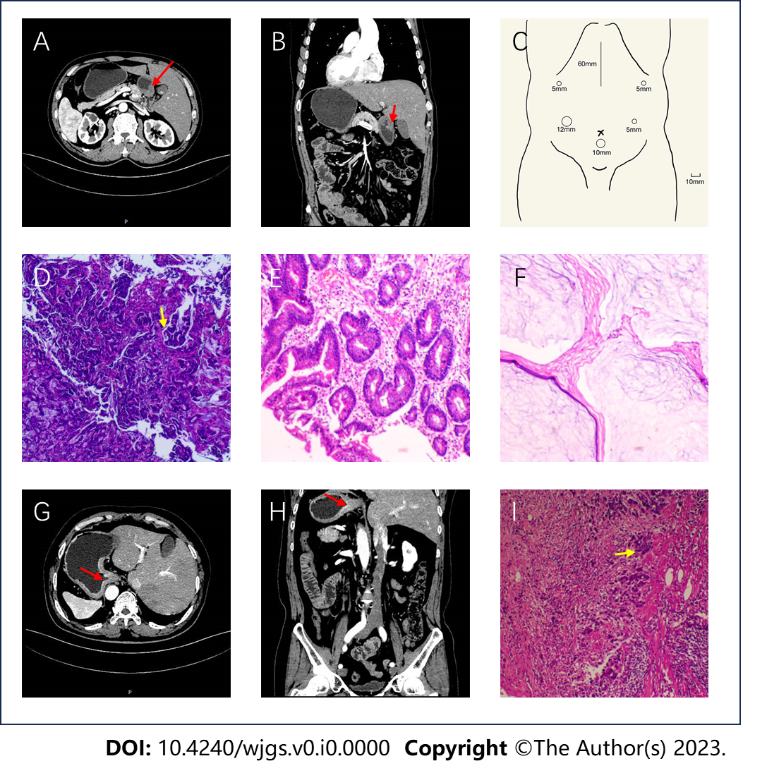
Figure 1 Imaging and pathological features of the two patients. A–F: Case 1; A: Computed tomography (CT) image showing the inverse positioning of intra-abdominal organs; B: CT image showing antral wall thickening; C: Sites of trocar placement. A 12-mm trocar was placed in the right hypochondriac region, and the other three 5-mm trocars were placed (one each) in the right subcostal region, the right lateral abdominal region, and the left lateral abdominal region; D: Preoperative (after neoadjuvant chemotherapy) pathologic biopsies showing that tumor nests still existed; E: Postoperative pathologic biopsies showing that there were no nidi; F: Postoperative pathologic biopsies showing no nidi; G–I: Case 2; G: CT image showing the inverse positioning of all intra-abdominal organs; H: CT image revealing the thickening of the cardia and smaller curvature of gastric tissue and enlarged peri-gastric small lymph nodes; I: Postoperative pathologic biopsies showing that nidi still existed.

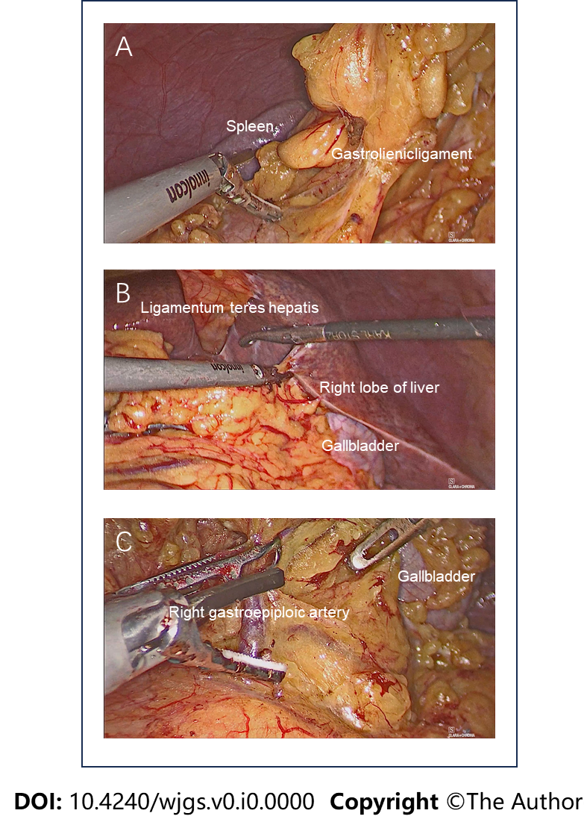
Figure 2 Images of surgery. A: The surgical field showing that the spleen in the right side of the patient; B: The surgical field showing that the gallbladder and right lobe of the liver in the left side of the patient; C: The key procedure during surgery: Dissecting station 6 lymph nodes.

Table 1 Reported cases of gastric cancer patients with situs inversus totalis in the previous 11 years
Ref. | Age, gender | Abnormal course of vascularity | Surgery modality | Reconstruction | Extent of LND | Surgeon position (trocars placement for robotic surgery) | Operation time (min) | Blood loss (mL) | Discharged on POD | Remarks
Pan et al^{[25]}, 2012 | 52, M | NA | OPG | Billroth Ⅰ | D2 | NA | NA | NA | 15 | Complication: Mechanical obstruction
Kim et al^{[18]}, 2012 | 47, M | NA | LADG  (robotic-assisted) | Billroth Ⅱ | D1+ β | Usual side | 300 | NA | 8
Fujikawa et al^{[26]}, 2013 | 60, F | ALHA from CA | LADG | Billroth Ⅰ | D1+ | Opposite | 234 | 5 | 8
Min et al^{[27]}, 2013 | 52, M | CHA from SMA, 2 branches from LGA | LADG | Billroth Ⅰ | D1+ | Usual side | 220 | 100 | 8 | Abdominal surgery history: Right inguinal hernia repair
Min et al^{[27]}, 2013 | 68, M | None | TLDG | Billroth Ⅰ | D1+ | Usual side | 117 | 50 | 5 | Comorbidities: Chronic kidney disease and hypothyroidism
Sumi et al^{[17]}, 2014 | 42, M | LHA from SMA | LADG | Billroth Ⅰ | D1+ No. 7, 8a, 9 | Opposite | 313 | 90 | 10
Zhu et al^{[28]}, 2015 | 66, F | None | ODG | Billroth Ⅰ | D2 | Usual side | NA | NA | NA
Isobe et al^{[29]}, 2015 | 79, F | LHA from AO | OTG splenectomy cholecystectomy | Roux-en-Y | D2 | NA | 288 | 150 | 19
Ye et al^{[10]}, 2015 | 60, F | None | LADG | Billroth Ⅱ | D2 | Opposite | 230 | 50 | 8
Morimoto et al^{[30]}, 2015 | 58, M | None | LATG | Roux-en-Y | D1+ No. 7, 8a, 9 | Opposite (except for No. 5, 7, 8a, 9) | 359 | 90 | 7
Suh^{[31]}, 2017 | 50, M | None | ODG | NA | D2 | NA | 180 | NA | 10
Kigasawa et al^{[32]}, 2017 | 40, M | None | LADG | Billroth Ⅰ | D1+ | Opposite | 284 | 40 | NA
Alhossaini and Hyung^{[33]}, 2017 | 52, F | None | TLDG (robotic-assisted) | gastroduodenostomy | D1+ No. 7, 8, 9 | Opposite | 195 | 30 | 5
Cao et al^{[34]}, 2017 | 60, M | RHA from SMA bridged by GDA, LGA from ALHA | TLTG  (robotic-assisted) | Roux-en-Y | D2 | NA | NA | NA | 8
Gündeş et al^{[35]}, 2018 | 72, F | None | ODG | Billroth Ⅱ enteroenterostomy | D1 | Usual side | 150 | 100 | 8
Namikaw et al^{[36]}, 2018 | 66, F | None | OTG | Roux-en-Y | D2 | Usual side | 375 | 380 | 14
Dai et al^{[21]}, 2018 | 53, M | NA | TLDG (total robotic) | Billroth Ⅱ | D2 | Usual side | 180 | 50 | 5
Shibata et al^{[37]}, 2018 | 79, M | RGEA above RGEV | TLTG | Roux-en-Y | D2 (without splenectomy) | Usual side | 232 | 110 | 10
Xue et al^{[16]}, 2019 | 61, M | NA | ODG | Billroth Ⅱ | D2 | Usual side | NA | NA | 14 | Abdominal surgery history: Rectal cancer resection
Ojima et al^{[38]}, 2019 | 80, F | None | LADG (total robotic) | Billroth Ⅰ | D2 | Usual side | 260 | 20 | 14
Namikawa et al^{[39]}, 2021 | 74, M | CHA from SMA | TLDG | Roux-en-Y | D2 | Opposite | 335 | 20 | 12 | Comorbidity: Emphysema
Abbey et al^{[19]}, 2021 | 69, M | None | LADG (robotic-assisted)  intestinal adhesiolysis | Roux-en-Y | D2 | Usual side | 205 | 20 | 15
Takeno et al^{[40]}, 2021 | 71, F | None | LAPG (robotic-assisted) | Esophagogastrostomy | D1+ | Usual side | 448 | 45 | 10
Yoshimoto et al^{[20]}, 2021 | 84, M | NA | LATG (robotic-assisted) | Roux-en-Y | D2 | Opposite | NA | 30 | 13
Fujita et al^{[24]}, 2022 | 67, M | CHA from SMA | LADG | Roux-en-Y | D2 | Usual side | 446 | 3 | 14
Sagawa et al^{[41]}, 2022 | 64, M | LGA from LHA | TLDG (total robotic) | Billroth Ⅰ | D1+ | Usual side | 286 | 44 | 7
Katano et al^{[42]}, 2022 | 62, M | Lack of CHA, PHA from SMA, ALHA from LGA, 2 branches from LGV, 3 branches from LGA | TLPG (robotic-assisted) lower esophagectomy | Esophagogastrostomy | D2 (including lower mediastinal LND) | Opposite | 296 | NA | 11
Lamture et al^{[43]}, 2022 | 48, F | NA | ODG | Billroth Ⅱ anastomosis of a part of the transverse colon | NA | Opposite | NA | NA | NA
Doden et al^{[44]}, 2023 | 74, M | None | LADG | Billroth Ⅰ | D1+ | Opposite | 220 | 100 | 10
Huang et al^{[45]}, 2023 | 58, M | None | LADG  (3D) | Billroth Ⅱ | D2 | Opposite | 220 | 10 | 8
Lee et al^{[46]}, 2023 | 79, F | NA | TLTG (single-port) | Roux-en-Y | D1+ | Opposite | 269 | NA | 14
Present case 1 | 55, M | None | LATG | Roux-en-Y | D2 | Opposite | 168 | 50 | 10 | Comorbidity: Hypertension
Present case 2 | 65, M | None | LADG | Billroth Ⅱ | D2 | Opposite | 240 | 50 | 9
POD: Postoperative day; LND: Lymphadenectomy; M: Male; F: Female; NA: Not available; ALHA: Accessory left hepatic artery; CA: Celiac artery; CHA: Common hepatic artery; SMA: Superior mesenteric artery; LGA: Left gastric artery; LHA: Left hepatic artery; AO: Aorta; RHA: Right hepatic artery; GDA: Gastroduodenal artery; RGEA: Right gastroepiploic artery; RGEV: Right gastroepiploic vein; PHA: Proper hepatic artery; LGV: Left gastric vein; ODG: Open distal gastrectomy; OPG: Open proximal gastrectomy; OTG: Open total gastrectomy; LADG: Laparoscopy-assisted distal gastrectomy; LATG: Laparoscopy-assisted total gastrectomy; LAPG: Laparoscopy-assisted proximal gastrectomy; TLDG: Total laparoscopy distal gastrectomy; TLPG: Total laparoscopy proximal gastrectomy; TLTG: Total laparoscopy gastrectomy.

