Name of Journal: World Journal of Gastroenterology
Manuscript NO: 91014
Manuscript Type: ORIGINAL ARTICLE

Retrospective Study
Evaluating the influence of sarcopenia and myosteatosis on clinical outcomes in gastric cancer patients undergoing immune checkpoint inhibitor

Deng GM et al. Sarcopenia and myosteatosis in gastric cancer

Gui-Ming Deng, Hai-Bin Song, Zhong-Ze Du, Ying-Wei Xue, Hong-Jiang Song, Yuan-Zhou Li

Gui-Ming Deng, Hai-Bin Song, Zhong-Ze Du, Ying-Wei Xue, Hong-Jiang Song, Department of Gastrointestinal Surgery, Harbin Medical University Cancer Hospital, Harbin 150081, Heilongjiang Province, China

Yuan-Zhou Li, Department of Radiology, Harbin Medical University Cancer Hospital, Harbin 150081, Heilongjiang Province, China

Co-first authors: Gui-Ming Deng and Hai-Bin Song.

Co-corresponding authors: Hong-Jiang Song and Yuan-Zhou Li.

Author contributions: Deng GM and Song HB contributed equally to this work; Deng GM, Song HB, Du ZZ, Xue YW, Song HJ and Li YZ designed the research study; Deng GM, Song HB, Du ZZ and Li YZ performed the research; Xue YW, Song HJ and Li YZ provided data and funding for the experiment; Deng GM and Song HB analyzed the data and wrote the manuscript; all authors have read and approve the final manuscript.

Corresponding author: Yuan-Zhou Li, PhD, Professor, Department of Radiology, Harbin Medical University Cancer Hospital, No. 150 Haping Road, Nangang District, Harbin 150081, Heilongjiang Province, China. 830667@hrbmu.edu.cn

Received: December 20, 2023
Revised: January 16, 2024
Accepted: February 1, 2024
Published online: February 28, 2024

Abstract
BACKGROUND
The development and progression of gastric cancer (GC) are closely linked to the nutritional status of patients. Although immunotherapy has been demonstrated to be clinically effective, the relationships of sarcopenia and myosteatosis with the use of immune checkpoint inhibitors (ICIs) in patients with gastric cancer remain to be characterized.

AIM
To assess the effects of sarcopenia and myosteatosis on the clinical outcomes of patients with GC undergoing treatment with an ICI.

METHODS
We performed a retrospective study of patients who were undergoing immunotherapy for GC. For the evaluation of sarcopenia, the optimal cut-off value for the skeletal muscle index was established using receiver operating characteristic analysis of data obtained from pre-treatment computed tomography images at the L3 vertebral level. Myosteatosis was defined using the mean skeletal muscle density (SMD), with a threshold value of < 41 Hounsfield units (HU) for patients with a body mass index (BMI) < 25 kg/m² and < 33 HU for those with a BMI ≥ 25 kg/m². The log-rank test was used to compare progression-free survival (PFS) and overall survival (OS), and a Cox proportional hazard model was used to identify prognostic factors. Nomograms were developed to predict the PFS and OS of patients on the basis of the results of multivariate analyses.

RESULTS
We studied 115 patients who were undergoing ICI therapy for GC, of whom 27.4% had sarcopenia and 29.8% had myosteatosis. Patients with sarcopenia or myosteatosis had significantly shorter PFS and OS than those without these conditions. Furthermore, both sarcopenia and myosteatosis were found to be independent predictors of PFS and OS in patients with GC administering an ICI. The prediction models created for PFS and OS were associated with C-indexes of 0.758 and 0.781, respectively.

CONCLUSION
The presence of sarcopenia or myosteatosis is a reliable predictor of the clinical outcomes of patients with GC who are undergoing treatment with an ICI.

Key Words: Gastric cancer; Sarcopenia; Myosteatosis, Immune checkpoint inhibitor; Prognostic factor; Overall survival; Progression-free survival

©The Author(s) 2024. Published by Baishideng Publishing Group Inc. All rights reserved.

Citation: Deng GM, Song HB, Du ZZ, Xue YW, Song HJ, Li YZ. Evaluating the influence of sarcopenia and myosteatosis on clinical outcomes in gastric cancer patients undergoing immune checkpoint inhibitor. World J Gastroenterol 2024; 30(8): 863-880
URL: https://www.wjgnet.com/1007-9327/full/v30/i8/863.htm
DOI: https://dx.doi.org/10.3748/wjg.v30.i8.863

Core Tip: We performed a retrospective study to evaluate the use of sarcopenia and myosteatosis for the prediction of the prognosis of patients with gastric cancer who are being treated with an immune checkpoint inhibitor (ICI). We studied 115 patients with complete sets of clinical data and imaging information and analyzed their muscle cross-sectional area at the L3 Level. We determined the optimal cut-off area value to identify sarcopenia, and myosteatosis was defined using mean skeletal muscle densities of < 41 Hounsfield units (HU) for patients with a body mass index (BMI) < 25 kg/m² and < 33 HU for those with a BMI ≥ 25 kg/m². We found that muscle loss and muscle steatosis are independent predictors of the outcomes of patients with gastric cancer being treated with an ICI.

INTRODUCTION
Gastric cancer (GC) is the fifth most prevalent cancer globally and is a major global health concern^{[1]}. Although the global incidence and mortality rate associated with GC are decreasing, particularly because of advancements in preventive measures, such as a reduction in the prevalence of Helicobacter pylori and improvements in food preservation and storage, East Asia retains high incidence and mortality rates^{[2-7]}. The therapeutic options for GC are expanding, with the inclusion of immune checkpoint inhibitors (ICIs) alongside conventional chemotherapy and targeted agents^{[8]}. For instance, navulizumab in combination with chemotherapy is now a first-line treatment for GC, and pembrolizumab in combination with trastuzumab and chemotherapy is the first-line treatment for patients with HER2-positive GC^{[9,10]}. The advent of ICIs has prompted extensive research aimed at identifying prognostic factors for the success of ICI therapy, and parameters including programmed cell death protein 1 (PD-1)/programmed death ligand 1 (PD-L1) expression, microsatellite instability (MSI), tumor mutational load (TMB), and Epstein-Barr virus (EBV) infection status, have been considered. However, the assessment of these parameters is often expensive and complex^{[11-13]}. Consequently, there is a compelling need for straightforward, cost-effective predictors of the prognosis of patients with advanced GC who are undergoing ICI therapy.
Sarcopenia, which is commonly recognized in patients with cancer, is characterized by the gradual depletion of skeletal muscle and its degeneration. This condition has detrimental effects on metabolism and immunity, resulting in compromised tolerance of, and a poor prognosis associated with, various cancer treatments, including chemotherapy, targeted therapy, and immunotherapy^{[14,15]}. Skeletal muscle mass represents a quantitative and objective measure of the nutritional status of a patient and has been shown to be of prognostic value in patients with a range of cancers, such as GC, hepatocellular carcinoma, and esophageal carcinoma^{[16-21]}.
In addition to muscle loss, the presence of myosteatosis, which is characterized by increases in inter- and intramuscular fat content, is also of relevance^{[22]}. This pathological change often accompanies excessive muscle loss and is exacerbated by factors such as aging and obesity, which lead to metabolic abnormalities that can affect the outcomes of treatments^{[23,24]}. Myosteatosis has been shown to be associated with inferior overall survival (OS) in patients with several types of cancer, including hepatocellular carcinoma, GC, and colorectal cancer^{[25]}.
In the present study, we used cross-sectional computed tomography (CT) images obtained at the level of the third lumbar vertebra (L3) to evaluate the sarcopenia and myosteatosis of patients with GC who were undergoing immunotherapy, with the aim of investigating the prognostic value of the presence of these conditions with respect to the clinical outcomes of the patients.

MATERIALS AND METHODS
Participants
Patients diagnosed with GC who underwent immunotherapy with an ICI between February 2016 and October 2022 at our institution were eligible for inclusion in the study. A comprehensive set of data, including demographics, clinical attributes, tumor characteristics (tumor size and stage), laboratory parameters, L3 skeletal muscle area, and mean CT radiodensities, were extracted from the medical records of each participant. The institutional review board provided approval for this analysis, and the requirement for informed consent was waived owing to its retrospective nature. Patients undergoing ICI immunotherapy with a PD-1 blocking antibody, including anti-PD-1 and anti-PD-L1 antibodies, with combination therapy including one of these, or with an ICI in conjunction with chemotherapy and/or other agents in phase III clinical trials, were included in the study. The exclusion criteria comprised prior immunotherapy and the inability to undergo pre-treatment CT examination.

Data collection
The primary endpoints of the study were progression-free survival (PFS) and OS. The timing of these endpoints was determined through telephone follow-up, and the final follow-up consultation was held in December 2022. PFS was defined as the difference between the timing of random assignment to a clinical trial and that of disease progression, which was primarily assessed using enhanced CT. If no evidence of disease progression was identified, the final date of follow-up was used to calculate PFS. OS was calculated as the difference between the timing of the commencement of immunotherapy and the death of the patient.

Evaluation of sarcopenia and myosteatosis
Sarcopenia and myosteatosis were evaluated by a radiologist with over a decade of experience and no knowledge of the clinical outcomes of the participants. The CT data for the participants were imported into 3D Slicer (version 4.10.2, www.slicer.org) to measure the cross-sectional area of the skeletal muscle at the L3 level and the mean skeletal muscle density [SMD, in Hounsfield units (HU)] across the entire muscle region. Skeletal muscle was identified and quantified using HU thresholds ranging from −29 to 150^{[26]}. The L3 muscle region included the psoas major, erector spinae, quadratus lumborum, transversus abdominis, internal and external abdominal oblique muscles, and rectus abdominis. The cross-sectional area was automatically calculated by adding the data for each tissue pixel together and multiplying this by the pixel surface area (Figure 1). Skeletal muscle index (SMI) was calculated as the total L3 skeletal muscle area (cm²) divided by the square of the participant’s height (m²). Given the lack of established diagnostic criteria for sarcopenia, the optimal cut-off value was determined using receiver operating characteristic (ROC) analysis, and participants with an SMI below this threshold were classified as having sarcopenia. The optimal cut-off value for SMI was calculated to be 27.36 for men and 31.10 for women. Myosteatosis was defined using a mean SMD < 41 HU for participants with a BMI < 25 kg/m² and < 33 HU for those with a BMI ≥ 25 kg/m²^{[27]}.

Statistical analysis
Data are presented as mean ± SD for normally distributed continuous data or median for non-normally distributed continuous data. Categorical data were analyzed using Pearson’s chi-square or Fisher’s exact tests, and continuous datasets for participants with or without sarcopenia and myosteatosis were compared using Student’s t-test or the Mann–Whitney U-test, as appropriate. Kaplan–Meier survival curves were used to evaluate survival outcomes, and Cox’s regression analysis was used to identify potential prognostic factors for PFS and OS in univariate analyses. Cox’s regression analysis and the parameters that were significant on univariate analysis were then used to identify independent prognostic factors associated with OS and PFS. Multivariate logistic regression analyses were then performed to construct models for the prediction of 1-, 3-, and 5-year OS and PFS. We used the R statistical package (version 4.1.3, R Foundation for Statistical Computing, Vienna, Austria) and SPSS (version 25.0, IBM, Inc., Armonk, NY, United States) to analyze the data. A two-sided P-value < 0.05 was considered to represent statistical significance.

RESULTS
Characteristics and laboratory parameters of participants with or without sarcopenia and myosteatosis
A total of 115 patients with GC who were undergoing ICI treatment were included in the study [89 (77.4%) men and 26 (32.6%) women]. Of these, 29 (25.2%) had stage III GC and 86 (74.8%) had stage IV GC. When we compared the participants with or without sarcopenia, we found that the former were significantly older (P < 0.001), had a lower BMI (P < 0.001), and were predominantly male (P < 0.001). The participants with myosteatosis tended to be older than those without (P = 0.001) (Table 1).
Analysis of the laboratory indices showed that participants with sarcopenia had lower creatinine (Crea) concentrations (P = 0.004) than those without. In addition, the participants with myosteatosis had higher globulin (GLOB) concentrations (P = 0.047), lactate dehydrogenase (LDH) activities (P = 0.012), and D-dimer (DDi) concentrations (P = 0.002), and lower pre-albumin (PALB) concentrations (P = 0.010) than those without (Table 2).

Results of the univariate and multivariate Cox’s regression analyses
Univariate analysis identified BMI, total protein (TP), PALB, eosinophil count (Eosi), carbohydrate antigen 724 (CA724) concentration, carbohydrate antigen 125II (CA125II) concentration, sarcopenia, and myosteatosis as potential prognostic factors for OS. Similarly, BMI, alkaline phosphatase (ALP) activity, total bilirubin (TBIL) concentration, indirect bilirubin (IDBIL) concentration, PALB, lymphocyte count (Lym), Eosi, CA724, CA125, TNM stage, sarcopenia, and myosteatosis were identified as potential prognostic factors for PFS. All these potential prognostic factors were then included in multivariate analyses. In these, TP, Eosi, CA724, CA125, sarcopenia, and myosteatosis were found to be independent prognostic factors for OS; ALP, Eosi, CA724, CA125, TNM stage, sarcopenia, and myosteatosis were found to be independent prognostic factors for PFS (Table 3).

Effects of sarcopenia and myosteatosis on survival
The participants with sarcopenia had significantly shorter PFS (median, 15.40 months vs 26.20 months, P < 0.001) and OS (median, 25.97 months vs 38.78 months, P < 0.001) than those without (Figure 2). Similarly, the participants with myosteatosis had shorter PFS (median, 16.43 months vs 24.30 months, P = 0.011) and OS (median, 21.43 months vs 33.57 months, P = 0.001) than those without (Figure 3).
Given that 74.8% of the participants had stage IV GC, a subgroup analysis was conducted, and this yielded results that confirmed the adverse effects of sarcopenia and myosteatosis on both PFS (P = 0.002 vs P = 0.011, respectively) and OS (P < 0.001 vs P = 0.005, respectively) in this subset of participants (Figures 4 and 5).

Nomograms
We used multivariate Cox regression analysis to construct an optimized prediction model for PFS. In addition to the presence of sarcopenia and myosteatosis, ALP, Eosi, CA724, CA125, and TNM stage were identified to be predictors of PFS, and we used these variables to construct a nomogram for PFS (Figure 6A). Similarly, for OS, the predictive model constructed included sarcopenia and myosteatosis, as well as TP, Eosi, CA724, and CA125 (Figure 7A). Both the predictive models for PFS and OS exhibited good C-indexes of 0.758 and 0.781, respectively. First-year calibration curves showed a close alignment of the observed outcomes and those predicted using the presence of sarcopenia or myosteatosis (Figures 6B and 7B). To validate the predictive utility of these parameters, the nomograms were subjected to area under the curve (AUC) analysis for 1- and 3-year intervals, yielding AUC values of 0.769 and 0.850 for PFS, and 0.843 and 0.904 for OS, respectively (Figures 6C and 7C). In addition, decision curve analysis (DCA) including diverse threshold probabilities demonstrated that the net benefit for the prediction of PFS was maximal within the range 0.040–0.978, peaking at 0.282. Similarly, for OS, the optimal DCA threshold was within the range 0.022–0.900, peaking at 0.260 (Figures 6D and 7D). This meticulous analysis affirmed the robustness and clinical utility of the predictive models for the outcomes of patients undergoing ICI therapy.

DISCUSSION
GC is highly prevalent but often presents with non-specific clinical features, resulting in a delay to diagnosis and the administration of ineffective treatments, especially in older patients^{[28,29]}. Systemic chemotherapy has been the primary approach to the treatment of advanced GC, but it yields limited survival benefits, with a median survival of approximately 1 year^{[30,31]}. In recent years, ICIs have emerged as promising therapeutic options for patients with advanced cancer, showing efficacy and safety in clinical trials. Some ICIs, such as pembrolizumab, avelumab, sindilizumab, tirilizumab, and ipilimumab, have been approved for administration in combination with targeted therapies for advanced GCs^{[32-34]}. Notably, nabulizumab in combination with chemotherapy yielded excellent outcomes in the Chinese subgroup of the CheckMate 649 clinical trial^{[12]}. To date, parameters such as PD-1/PD-L1 expression, MSI, TMB, and EBV infection status have been used to identify suitable candidates for ICI therapy, but the nutritional status of the patients has a significant effect on their treatment outcomes^{[11-13]}. Malnutrition and the related symptoms negatively affect the prognosis and the quality of life of patients with cancer. Therefore, we conducted a study using CT-derived data to assess the muscle status of patients with GC undergoing immunotherapy, and especially of those who were negative for prognostic markers such as PD-1 and PD-L1.
Sarcopenia, which reflects malnutrition and involves chronic inflammation, is common in patients with cancer, and features muscle loss and a decrease in fat mass^{[35]}. It significantly impacts quality of life, induces anxiety and depression, and results in poorer clinical outcomes^{[36,37]}. Furthermore, patients with sarcopenia may experience more severe toxic side effects during chemotherapy, owing to alterations in body composition and muscle loss caused by tumor-specific therapy^{[38-40]}. In the present study, sarcopenia in patients with GC who were undergoing ICI therapy was shown to be associated with both PFS and OS. A previous study similarly showed that sarcopenia is associated with shorter PFS and OS in patients with microsatellite-stable GC being treated with a PD-1 inhibitor^{[41]}. In 2021, Kim et al^{[42]} also studied patients with advanced GC who were being treated with navulizumab and pabolizumab. They divided the patients into those with or without sarcopenia and discussed the prognostic value of the neutrophil-to-lymphocyte ratio between the groups^{[42]}, but did not evaluate the relationship between sarcopenia and prognosis.
Myosteatosis is characterized by excessive fat accumulation in skeletal muscle and is often used to describe low muscle mass in patients^{[43]}. It has predictive value in patients with various diseases and is consistently associated with poor prognoses, including for colon, liver, and pancreatic cancer^{[44-47]}. Several previous studies of the relationship between immunotherapy and myosteatosis have generated important findings. In patients with metastatic melanoma who were being treated with nivolumab, low SMD was found to be associated with shorter OS^{[48]}, and another study of patients being treated with ipilimumab revealed that patients with high SMD experienced more immunity-related adverse events but superior objective responses to treatment, whereas low SMD was found to be associated with a worse prognosis^{[49]}. The skeletal muscle microenvironment plays a critical role in skeletal muscle repair, and this involves monocytes, neutrophils, and lymphocytes. Myosteatosis, which reflects low muscle mass, is associated with impaired muscle repair, leading to compromised immunity^{[50]}. This, in turn, may result in poorer responsiveness to immunotherapy, a higher risk of toxic side effects, and poorer clinical outcomes. However, the specific mechanisms involved and the variations in the effects of myosteatosis in patients with various types of cancer warrant further investigation.
Accumulating evidence indicates the involvement of immune cell mitochondria in the effects of ICIs, as well as in the development of sarcopenia and myosteatosis. Previous studies have shown that cancer cells can appropriate the mitochondria of immune cells, thereby facilitating their survival within the immune microenvironment, the evasion of immune surveillance, and resistance to therapeutic interventions^{[51]}. The commandeering of mitochondria from immune cells, and particularly T cells, has been shown to increase the expression of PD-1, which contributes to its anti-tumor effects^{[52]}. Moreover, compromised mitochondrial function can lead to the overexpression of PD-1 in T cells^{[53]}, and the inhibition of the hijacking of mitochondria by immune cells has been demonstrated to improve anti-tumor responses in mice with mammary cancer that were treated with an anti-PD-1 antibody^{[54]}. Notably, a previous study has also shown that muscle loss and muscle fat degeneration are indicative of poor mitochondrial function in muscle cells, which can be extrapolated to other normal human cells, including immune cells^{[55]}. Consequently, the presence of sarcopenia and muscle steatosis may present challenges for successful therapy with ICIs.
There are several important considerations regarding studies of the prognostic implications of sarcopenia and myosteatosis. For instance, there is no well-established value of SMI that can be used in the diagnosis of sarcopenia, and therefore in most studies, ROC-derived cut-off values have been used^{[22]}. This approach, in combination with the use of differing cut-off values in patients with different types of cancer, may affect the identified relationships between muscle-related conditions and clinical outcomes. In the case of myosteatosis, mean SMD is an objective index, but some studies have shown variations in mean SMD according to whether measurements were made using unenhanced contrast-enhanced CT images or those obtained during the arterial or portal venous phases of enhancement. Thus, the CT protocol used can introduce bias into SMD measurements. To minimize such bias, we consistently obtained images during the portal-venous phase. In future investigations of the relationships between muscle conditions and cancer, two key challenges should be addressed: the standardization of CT protocols and the optimal diagnostic criteria for sarcopenia and myosteatosis.
In the present study, we found that 27.4% of patients with GC who were undergoing ICI treatment had sarcopenia, 29.8% had myosteatosis, and 10.5% of those with sarcopenia also had concurrent myosteatosis. Furthermore, Kaplan–Meier analysis demonstrated that patients with sarcopenia and/or myosteatosis had shorter PFS and OS. Multivariate analysis identified TP, Eosi, CA724, CA125, sarcopenia, and myosteatosis as independent prognostic factors for OS; and TBIL, DBIL, Eosi, CA125, sarcopenia, and myosteatosis were found to independently affect PFS. We were able to develop models that can accurately predict the prognosis of patients undergoing ICI treatment, with C-indexes of 0.758 for PFS and 0.781 for OS. In the future, the accuracy of the prediction may be improved by using multidimensional integrated analyses based on CT radiomics, body composition, markers of inflammation, and gene expression.
Although valuable insights have been provided by the present study, certain limitations should also be acknowledged. First, it was a retrospective, single-center study, and therefore the results require corroboration by multicenter prospective studies. Second, the inclusion of patients treated with a range of ICI regimens introduced variability regarding treatment efficacy, and therefore the results may need validation using a cohort undergoing a uniform treatment regimen. However, to date, there have been few studies of the prognostic implications of sarcopenia and myosteatosis in patients with GC who are undergoing ICI therapy, and the present study has provided novel insight into the prediction of the prognosis of such patients and has improved understanding of the relevance of these muscle conditions to the outcomes of immunotherapy.

CONCLUSION
Sarcopenia and myosteatosis, which reflect the body’s response to trophic inflammation, are useful predictors of the prognosis of patients with GC who are undergoing treatment with ICI. The clinical course of patients with sarcopenia and myosteatosis has the potential to involve a number of unfavorable outcomes, including shorter PFS and OS. In summary, the evaluation of muscle mass by CT imaging has the potential to yield robust predictors of the prognosis of patients with GC being treated with ICIs.

ARTICLE HIGHLIGHTS
Research background
The evolution and progression of gastric cancer (GC) is closely associated with the nutritional status of patients. The laboratory indices currently used to assess the nutritional status of patients have limitations.

Research motivation
The presence or absence of sarcopenia and myosteatosis are objective indicators of the nutritional status of patients, and muscle mass status influences the effectiveness of immune checkpoint inhibitors (ICIs) therapy.

Research objectives
This study aims to investigate the effects of sarcopenia and sarcopenia on the clinical prognosis of patients with GC being treated with ICIs.

Research methods
We studied 115 patients with GC who underwent ICI therapy between 2016 and 2022. The third lumbar vertebrae skeletal muscle cross-sectional area and the mean skeletal muscle density were assessed using 3D Slicer. We then analyzed the relationships of sarcopenia and myosteatosis with the prognosis of the patients.

Research results
Patients exhibiting sarcopenia and/or myosteatosis demonstrated poorer clinical outcomes, and nomograms formulated on the basis of these conditions had substantial prognostic value.

Research conclusions
The presence of sarcopenia and/or myosteatosis was validated for the prediction of the clinical outcomes of patients with GC undergoing ICI therapy.

Research perspectives
Screening for sarcopenia and myosteatosis should help identify patients with advanced GC who would benefit from treatment with ICIs.

REFERENCES
1 Bray F, Ferlay J, Soerjomataram I, Siegel RL, Torre LA, Jemal A. Global cancer statistics 2018: GLOBOCAN estimates of incidence and mortality worldwide for 36 cancers in 185 countries. CA Cancer J Clin 2018; 68: 394-424 [PMID: 30207593 DOI: 10.3322/caac.21492]
2 Luo G, Zhang Y, Guo P, Wang L, Huang Y, Li K. Global patterns and trends in stomach cancer incidence: Age, period and birth cohort analysis. Int J Cancer 2017; 141: 1333-1344 [PMID: 28614909 DOI: 10.1002/ijc.30835]
3 Arnold M, Karim-Kos HE, Coebergh JW, Byrnes G, Antilla A, Ferlay J, Renehan AG, Forman D, Soerjomataram I. Recent trends in incidence of five common cancers in 26 European countries since 1988: Analysis of the European Cancer Observatory. Eur J Cancer 2015; 51: 1164-1187 [PMID: 24120180 DOI: 10.1016/j.ejca.2013.09.002]
4 Ferro A, Peleteiro B, Malvezzi M, Bosetti C, Bertuccio P, Levi F, Negri E, La Vecchia C, Lunet N. Worldwide trends in gastric cancer mortality (1980-2011), with predictions to 2015, and incidence by subtype. Eur J Cancer 2014; 50: 1330-1344 [PMID: 24650579 DOI: 10.1016/j.ejca.2014.01.029]
5 Howson CP, Hiyama T, Wynder EL. The decline in gastric cancer: epidemiology of an unplanned triumph. Epidemiol Rev 1986; 8: 1-27 [PMID: 3533579 DOI: 10.1093/oxfordjournals.epirev.a036288]
6 López MJ, Carbajal J, Alfaro AL, Saravia LG, Zanabria D, Araujo JM, Quispe L, Zevallos A, Buleje JL, Cho CE, Sarmiento M, Pinto JA, Fajardo W. Characteristics of gastric cancer around the world. Crit Rev Oncol Hematol 2023; 181: 103841 [PMID: 36240980 DOI: 10.1016/j.critrevonc.2022.103841]
7 Thrift AP, El-Serag HB. Burden of Gastric Cancer. Clin Gastroenterol Hepatol 2020; 18: 534-542 [PMID: 31362118 DOI: 10.1016/j.cgh.2019.07.045]
8 Azadeh P, Gholizadeh Pasha S, Yaghobi Joybari A, Abiar Z, Alahyari S, Taghizadeh-Hesary F. Survival Benefit of Induction Chemotherapy with Paclitaxel and Carboplatin Followed by Chemoradiation Versus Postoperative Treatment in Locally Advanced Gastric Cancer: A Retrospective Cohort Study. J Gastrointest Cancer 2023 [PMID: 38010493 DOI: 10.1007/s12029-023-00991-8]
9 Kang YK, Chen LT, Ryu MH, Oh DY, Oh SC, Chung HC, Lee KW, Omori T, Shitara K, Sakuramoto S, Chung IJ, Yamaguchi K, Kato K, Sym SJ, Kadowaki S, Tsuji K, Chen JS, Bai LY, Oh SY, Choda Y, Yasui H, Takeuchi K, Hirashima Y, Hagihara S, Boku N. Nivolumab plus chemotherapy vs placebo plus chemotherapy in patients with HER2-negative, untreated, unresectable advanced or recurrent gastric or gastro-oesophageal junction cancer (ATTRACTION-4): a randomised, multicentre, double-blind, placebo-controlled, phase 3 trial. Lancet Oncol 2022; 23: 234-247 [PMID: 35030335 DOI: 10.1016/S1470-2045(21)00692-6]
10 Shah MA, Kennedy EB, Alarcon-Rozas AE, Alcindor T, Bartley AN, Malowany AB, Bhadkamkar NA, Deighton DC, Janjigian Y, Karippot A, Khan U, King DA, Klute K, Lacy J, Lee JJ, Mehta R, Mukherjee S, Nagarajan A, Park H, Saeed A, Semrad TJ, Shitara K, Smyth E, Uboha NV, Vincelli M, Wainberg Z, Rajdev L. Immunotherapy and Targeted Therapy for Advanced Gastroesophageal Cancer: ASCO Guideline. J Clin Oncol 2023; 41: 1470-1491 [PMID: 36603169 DOI: 10.1200/JCO.22.02331]
11 Li K, Zhang A, Li X, Zhang H, Zhao L. Advances in clinical immunotherapy for gastric cancer. Biochim Biophys Acta Rev Cancer 2021; 1876: 188615 [PMID: 34403771 DOI: 10.1016/j.bbcan.2021.188615]
12 Takei S, Kawazoe A, Shitara K. The New Era of Immunotherapy in Gastric Cancer. Cancers (Basel) 2022; 14 [PMID: 35205802 DOI: 10.3390/cancers14041054]
13 Eso Y, Shimizu T, Takeda H, Takai A, Marusawa H. Microsatellite instability and immune checkpoint inhibitors: toward precision medicine against gastrointestinal and hepatobiliary cancers. J Gastroenterol 2020; 55: 15-26 [PMID: 31494725 DOI: 10.1007/s00535-019-01620-7]
14 Bozzetti F. Forcing the vicious circle: sarcopenia increases toxicity, decreases response to chemotherapy and worsens with chemotherapy. Ann Oncol 2017; 28: 2107-2118 [PMID: 28911059 DOI: 10.1093/annonc/mdx271]
15 Renehan AG, Tyson M, Egger M, Heller RF, Zwahlen M. Body-mass index and incidence of cancer: a systematic review and meta-analysis of prospective observational studies. Lancet 2008; 371: 569-578 [PMID: 18280327 DOI: 10.1016/S0140-6736(08)60269-X]
16 Wagner D, DeMarco MM, Amini N, Buttner S, Segev D, Gani F, Pawlik TM. Role of frailty and sarcopenia in predicting outcomes among patients undergoing gastrointestinal surgery. World J Gastrointest Surg 2016; 8: 27-40 [PMID: 26843911 DOI: 10.4240/wjgs.v8.i1.27]
17 Zheng ZF, Lu J, Xie JW, Wang JB, Lin JX, Chen QY, Cao LL, Lin M, Tu RH, Zheng CH, Huang CM, Li P. Preoperative skeletal muscle index vs the controlling nutritional status score: Which is a better objective predictor of long-term survival for gastric cancer patients after radical gastrectomy? Cancer Med 2018; 7: 3537-3547 [PMID: 29953752 DOI: 10.1002/cam4.1548]
18 Wang S, Zhang X, Chen Q, Jin ZC, Lu J, Guo J. A Novel Neutrophil-to-Lymphocyte Ratio and Sarcopenia Based TACE-Predict Model of Hepatocellular Carcinoma Patients. J Hepatocell Carcinoma 2023; 10: 659-671 [PMID: 37113464 DOI: 10.2147/JHC.S407646]
19 Fang P, Zhou J, Xiao X, Yang Y, Luan S, Liang Z, Li X, Zhang H, Shang Q, Zeng X, Yuan Y. The prognostic value of sarcopenia in oesophageal cancer: A systematic review and meta-analysis. J Cachexia Sarcopenia Muscle 2023; 14: 3-16 [PMID: 36415154 DOI: 10.1002/jcsm.13126]
20 Ferlay J, Colombet M, Soerjomataram I, Parkin DM, Piñeros M, Znaor A, Bray F. Cancer statistics for the year 2020: An overview. Int J Cancer 2021 [PMID: 33818764 DOI: 10.1002/ijc.33588]
21 Van Cutsem E, Sagaert X, Topal B, Haustermans K, Prenen H. Gastric cancer. Lancet 2016; 388: 2654-2664 [PMID: 27156933 DOI: 10.1016/S0140-6736(16)30354-3]
22 Ahn H, Kim DW, Ko Y, Ha J, Shin YB, Lee J, Sung YS, Kim KW. Updated systematic review and meta-analysis on diagnostic issues and the prognostic impact of myosteatosis: A new paradigm beyond sarcopenia. Ageing Res Rev 2021; 70: 101398 [PMID: 34214642 DOI: 10.1016/j.arr.2021.101398]
23 Kuk JL, Saunders TJ, Davidson LE, Ross R. Age-related changes in total and regional fat distribution. Ageing Res Rev 2009; 8: 339-348 [PMID: 19576300 DOI: 10.1016/j.arr.2009.06.001]
24 Goodpaster BH, Theriault R, Watkins SC, Kelley DE. Intramuscular lipid content is increased in obesity and decreased by weight loss. Metabolism 2000; 49: 467-472 [PMID: 10778870 DOI: 10.1016/s0026-0495(00)80010-4]
25 Aleixo GFP, Shachar SS, Nyrop KA, Muss HB, Malpica L, Williams GR. Myosteatosis and prognosis in cancer: Systematic review and meta-analysis. Crit Rev Oncol Hematol 2020; 145: 102839 [PMID: 31877534 DOI: 10.1016/j.critrevonc.2019.102839]
26 Peng YC, Wu CH, Tien YW, Lu TP, Wang YH, Chen BB. Preoperative sarcopenia is associated with poor overall survival in pancreatic cancer patients following pancreaticoduodenectomy. Eur Radiol 2021; 31: 2472-2481 [PMID: 32974690 DOI: 10.1007/s00330-020-07294-7]
27 Lee CM, Kang J. Prognostic impact of myosteatosis in patients with colorectal cancer: a systematic review and meta-analysis. J Cachexia Sarcopenia Muscle 2020; 11: 1270-1282 [PMID: 32483936 DOI: 10.1002/jcsm.12575]
28 Pennathur A, Gibson MK, Jobe BA, Luketich JD. Oesophageal carcinoma. Lancet 2013; 381: 400-412 [PMID: 23374478 DOI: 10.1016/S0140-6736(12)60643-6]
29 Qiu H, Cao S, Xu R. Cancer incidence, mortality, and burden in China: a time-trend analysis and comparison with the United States and United Kingdom based on the global epidemiological data released in 2020. Cancer Commun (Lond) 2021; 41: 1037-1048 [PMID: 34288593 DOI: 10.1002/cac2.12197]
30 Wagner AD, Syn NL, Moehler M, Grothe W, Yong WP, Tai BC, Ho J, Unverzagt S. Chemotherapy for advanced gastric cancer. Cochrane Database Syst Rev 2017; 8: CD004064 [PMID: 28850174 DOI: 10.1002/14651858.CD004064.pub4]
31 Högner A, Moehler M. Immunotherapy in Gastric Cancer. Curr Oncol 2022; 29: 1559-1574 [PMID: 35323331 DOI: 10.3390/curroncol29030131]
32 Muro K, Chung HC, Shankaran V, Geva R, Catenacci D, Gupta S, Eder JP, Golan T, Le DT, Burtness B, McRee AJ, Lin CC, Pathiraja K, Lunceford J, Emancipator K, Juco J, Koshiji M, Bang YJ. Pembrolizumab for patients with PD-L1-positive advanced gastric cancer (KEYNOTE-012): a multicentre, open-label, phase 1b trial. Lancet Oncol 2016; 17: 717-726 [PMID: 27157491 DOI: 10.1016/S1470-2045(16)00175-3]
33 Kang YK, Boku N, Satoh T, Ryu MH, Chao Y, Kato K, Chung HC, Chen JS, Muro K, Kang WK, Yeh KH, Yoshikawa T, Oh SC, Bai LY, Tamura T, Lee KW, Hamamoto Y, Kim JG, Chin K, Oh DY, Minashi K, Cho JY, Tsuda M, Chen LT. Nivolumab in patients with advanced gastric or gastro-oesophageal junction cancer refractory to, or intolerant of, at least two previous chemotherapy regimens (ONO-4538-12, ATTRACTION-2): a randomised, double-blind, placebo-controlled, phase 3 trial. Lancet 2017; 390: 2461-2471 [PMID: 28993052 DOI: 10.1016/S0140-6736(17)31827-5]
34 Janjigian YY, Kawazoe A, Yañez P, Li N, Lonardi S, Kolesnik O, Barajas O, Bai Y, Shen L, Tang Y, Wyrwicz LS, Xu J, Shitara K, Qin S, Van Cutsem E, Tabernero J, Li L, Shah S, Bhagia P, Chung HC. The KEYNOTE-811 trial of dual PD-1 and HER2 blockade in HER2-positive gastric cancer. Nature 2021; 600: 727-730 [PMID: 34912120 DOI: 10.1038/s41586-021-04161-3]
35 Janjigian YY, Shitara K, Moehler M, Garrido M, Salman P, Shen L, Wyrwicz L, Yamaguchi K, Skoczylas T, Campos Bragagnoli A, Liu T, Schenker M, Yanez P, Tehfe M, Kowalyszyn R, Karamouzis MV, Bruges R, Zander T, Pazo-Cid R, Hitre E, Feeney K, Cleary JM, Poulart V, Cullen D, Lei M, Xiao H, Kondo K, Li M, Ajani JA. First-line nivolumab plus chemotherapy vs chemotherapy alone for advanced gastric, gastro-oesophageal junction, and oesophageal adenocarcinoma (CheckMate 649): a randomised, open-label, phase 3 trial. Lancet 2021; 398: 27-40 [PMID: 34102137 DOI: 10.1016/S0140-6736(21)00797-2]
36 Evans WJ, Morley JE, Argilés J, Bales C, Baracos V, Guttridge D, Jatoi A, Kalantar-Zadeh K, Lochs H, Mantovani G, Marks D, Mitch WE, Muscaritoli M, Najand A, Ponikowski P, Rossi Fanelli F, Schambelan M, Schols A, Schuster M, Thomas D, Wolfe R, Anker SD. Cachexia: a new definition. Clin Nutr 2008; 27: 793-799 [PMID: 18718696 DOI: 10.1016/j.clnu.2008.06.013]
37 Nipp RD, Fuchs G, El-Jawahri A, Mario J, Troschel FM, Greer JA, Gallagher ER, Jackson VA, Kambadakone A, Hong TS, Temel JS, Fintelmann FJ. Sarcopenia Is Associated with Quality of Life and Depression in Patients with Advanced Cancer. Oncologist 2018; 23: 97-104 [PMID: 28935775 DOI: 10.1634/theoncologist.2017-0255]
38 Davis MP, Panikkar R. Sarcopenia associated with chemotherapy and targeted agents for cancer therapy. Ann Palliat Med 2019; 8: 86-101 [PMID: 30525762 DOI: 10.21037/apm.2018.08.02]
39 Kodera Y. More than 6 months of postoperative adjuvant chemotherapy results in loss of skeletal muscle: a challenge to the current standard of care. Gastric Cancer 2015; 18: 203-204 [PMID: 24820695 DOI: 10.1007/s10120-014-0381-z]
40 Daly LE, Ní Bhuachalla ÉB, Power DG, Cushen SJ, James K, Ryan AM. Loss of skeletal muscle during systemic chemotherapy is prognostic of poor survival in patients with foregut cancer. J Cachexia Sarcopenia Muscle 2018; 9: 315-325 [PMID: 29318756 DOI: 10.1002/jcsm.12267]
41 Ryan AM, Power DG, Daly L, Cushen SJ, Ní Bhuachalla Ē, Prado CM. Cancer-associated malnutrition, cachexia and sarcopenia: the skeleton in the hospital closet 40 years later. Proc Nutr Soc 2016; 75: 199-211 [PMID: 26786393 DOI: 10.1017/S002966511500419X]
42 Kim YY, Lee J, Jeong WK, Kim ST, Kim JH, Hong JY, Kang WK, Kim KM, Sohn I, Choi D. Prognostic significance of sarcopenia in microsatellite-stable gastric cancer patients treated with programmed death-1 inhibitors. Gastric Cancer 2021; 24: 457-466 [PMID: 32970267 DOI: 10.1007/s10120-020-01124-x]
43 Kim N, Yu JI, Lim DH, Lee J, Kim ST, Hong JY, Kang WK, Jeong WK, Kim KM. Prognostic Impact of Sarcopenia and Radiotherapy in Patients With Advanced Gastric Cancer Treated With Anti-PD-1 Antibody. Front Immunol 2021; 12: 701668 [PMID: 34305941 DOI: 10.3389/fimmu.2021.701668]
44 Lee K, Shin Y, Huh J, Sung YS, Lee IS, Yoon KH, Kim KW. Recent Issues on Body Composition Imaging for Sarcopenia Evaluation. Korean J Radiol 2019; 20: 205-217 [PMID: 30672160 DOI: 10.3348/kjr.2018.0479]
45 Stretch C, Aubin JM, Mickiewicz B, Leugner D, Al-Manasra T, Tobola E, Salazar S, Sutherland FR, Ball CG, Dixon E, Vogel HJ, Damaraju S, Baracos VE, Bathe OF. Sarcopenia and myosteatosis are accompanied by distinct biological profiles in patients with pancreatic and periampullary adenocarcinomas. PLoS One 2018; 13: e0196235 [PMID: 29723245 DOI: 10.1371/journal.pone.0196235]
46 Chen WZ, Shen ZL, Zhang FM, Zhang XZ, Chen WH, Yan XL, Zhuang CL, Chen XL, Yu Z. Prognostic value of myosteatosis and sarcopenia for elderly patients with colorectal cancer: A large-scale double-center study. Surgery 2022; 172: 1185-1193 [PMID: 35868905 DOI: 10.1016/j.surg.2022.05.031]
47 Lattanzi B, Nardelli S, Pigliacelli A, Di Cola S, Farcomeni A, D'Ambrosio D, Gioia S, Ginanni Corradini S, Lucidi C, Mennini G, Rossi M, Merli M, Riggio O. The additive value of sarcopenia, myosteatosis and hepatic encephalopathy in the predictivity of model for end-stage liver disease. Dig Liver Dis 2019; 51: 1508-1512 [PMID: 31601536 DOI: 10.1016/j.dld.2019.09.004]
48 Youn S, Reif R, Chu MP, Smylie M, Walker J, Eurich DT, Ghosh S, Sawyer MB. Myosteatosis is prognostic in metastatic melanoma treated with nivolumab. Clin Nutr ESPEN 2021; 42: 348-353 [PMID: 33745604 DOI: 10.1016/j.clnesp.2021.01.009]
49 Chu MP, Li Y, Ghosh S, Sass S, Smylie M, Walker J, Sawyer MB. Body composition is prognostic and predictive of ipilimumab activity in metastatic melanoma. J Cachexia Sarcopenia Muscle 2020; 11: 748-755 [PMID: 32053287 DOI: 10.1002/jcsm.12538]
50 VanderVeen BN, Murphy EA, Carson JA. The Impact of Immune Cells on the Skeletal Muscle Microenvironment During Cancer Cachexia. Front Physiol 2020; 11: 1037 [PMID: 32982782 DOI: 10.3389/fphys.2020.01037]
51 Behnam B, Taghizadeh-Hesary F. Mitochondrial Metabolism: A New Dimension of Personalized Oncology. Cancers (Basel) 2023; 15 [PMID: 37627086 DOI: 10.3390/cancers15164058]
52 Akbari H, Taghizadeh-Hesary F, Bahadori M. Mitochondria determine response to anti-programmed cell death protein-1 (anti-PD-1) immunotherapy: An evidence-based hypothesis. Mitochondrion 2022; 62: 151-158 [PMID: 34890822 DOI: 10.1016/j.mito.2021.12.001]
53 Houshyari M, Taghizadeh-Hesary F. Is Mitochondrial Metabolism a New Predictive Biomarker for Antiprogrammed Cell Death Protein-1 Immunotherapy? JCO Oncol Pract 2023; 19: 123-124 [PMID: 36469835 DOI: 10.1200/OP.22.00733]
54 Saha T, Dash C, Jayabalan R, Khiste S, Kulkarni A, Kurmi K, Mondal J, Majumder PK, Bardia A, Jang HL, Sengupta S. Intercellular nanotubes mediate mitochondrial trafficking between cancer and immune cells. Nat Nanotechnol 2022; 17: 98-106 [PMID: 34795441 DOI: 10.1038/s41565-021-01000-4]
55 Chen X, Ji Y, Liu R, Zhu X, Wang K, Yang X, Liu B, Gao Z, Huang Y, Shen Y, Liu H, Sun H. Mitochondrial dysfunction: roles in skeletal muscle atrophy. J Transl Med 2023; 21: 503 [PMID: 37495991 DOI: 10.1186/s12967-023-04369-z]

Footnotes
Institutional review board statement: This study was approved by the Ethics Committee of Harbin Medical University Cancer Hospital.

Informed consent statement: All study participants, or their legal guardian, provided informed written consent prior to study enrollment.

Conflict-of-interest statement: The authors declare no competing financial interests.

Data sharing statement: The material supporting the conclusion of this article has been included within the article.

Open-Access: This article is an open-access article that was selected by an in-house editor and fully peer-reviewed by external reviewers. It is distributed in accordance with the Creative Commons Attribution NonCommercial (CC BY-NC 4.0) license, which permits others to distribute, remix, adapt, build upon this work non-commercially, and license their derivative works on different terms, provided the original work is properly cited and the use is non-commercial. See: https://creativecommons.org/Licenses/by-nc/4.0/

Provenance and peer review: Unsolicited article; Externally peer reviewed.
Peer-review model: Single blind

Peer-review started: December 20, 2023
First decision: January 6, 2024
Article in press: February 1, 2024

Specialty type: Gastroenterology and hepatology
Country/Territory of origin: China
Peer-review report’s scientific quality classification
Grade A (Excellent): 0
Grade B (Very good): B
Grade C (Good): 0
Grade D (Fair): 0
Grade E (Poor): 0

P-Reviewer: Taghizadeh-Hesary F, Iran S-Editor: Gong ZM L-Editor: A P-Editor: Yu HG

Figure Legends
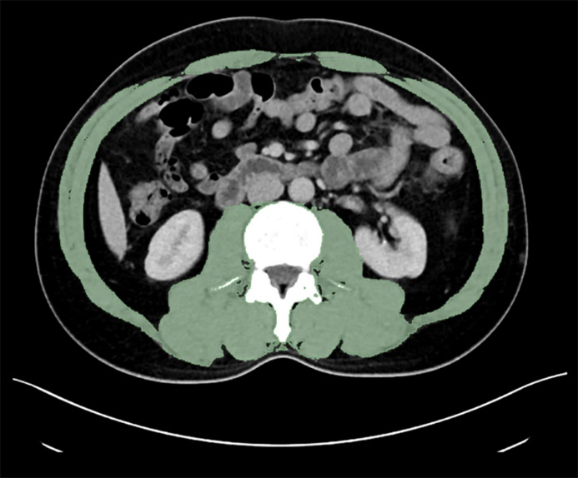
Figure 1 Example of a computed tomography image used for skeletal muscle measurements.

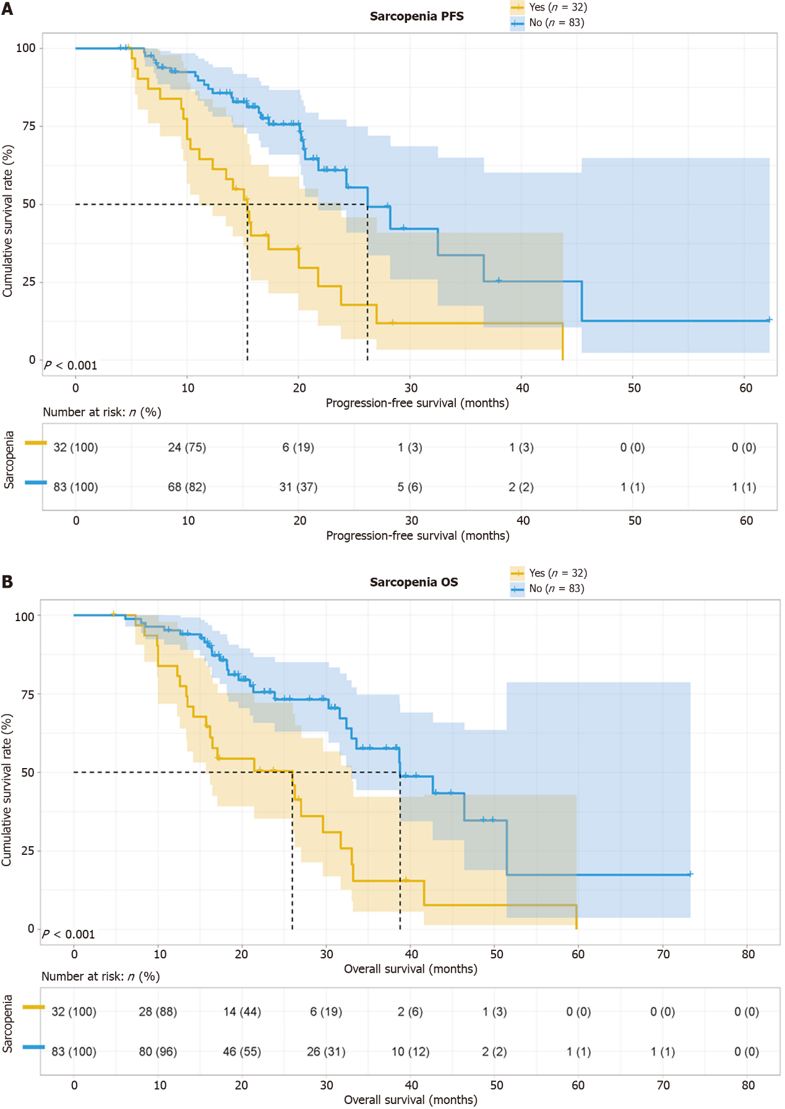Figure 2 Survival curves for (A) progression-free survival and (B) overall survival in the presence or absence of sarcopenia. PFS: Progression-free survival; OS: Overall survival.

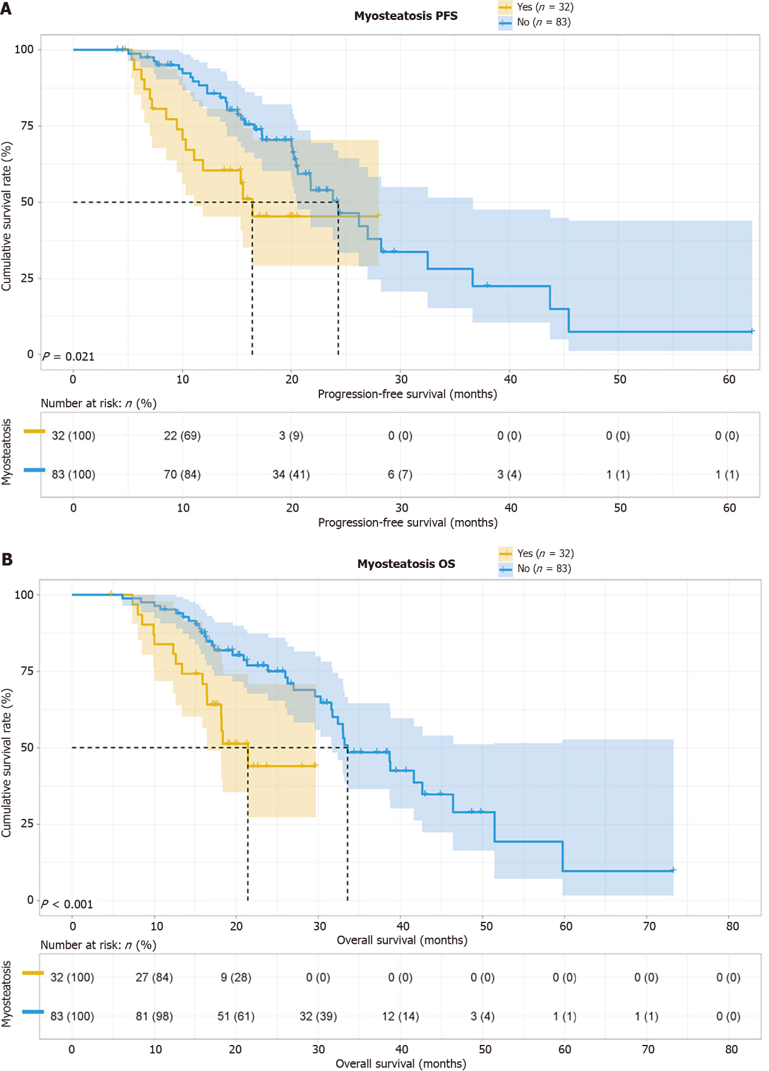Figure 3 Survival curves for (A) progression-free survival and (B) overall survival in the presence or absence of myosteatosis. PFS: Progression-free survival; OS: Overall survival.

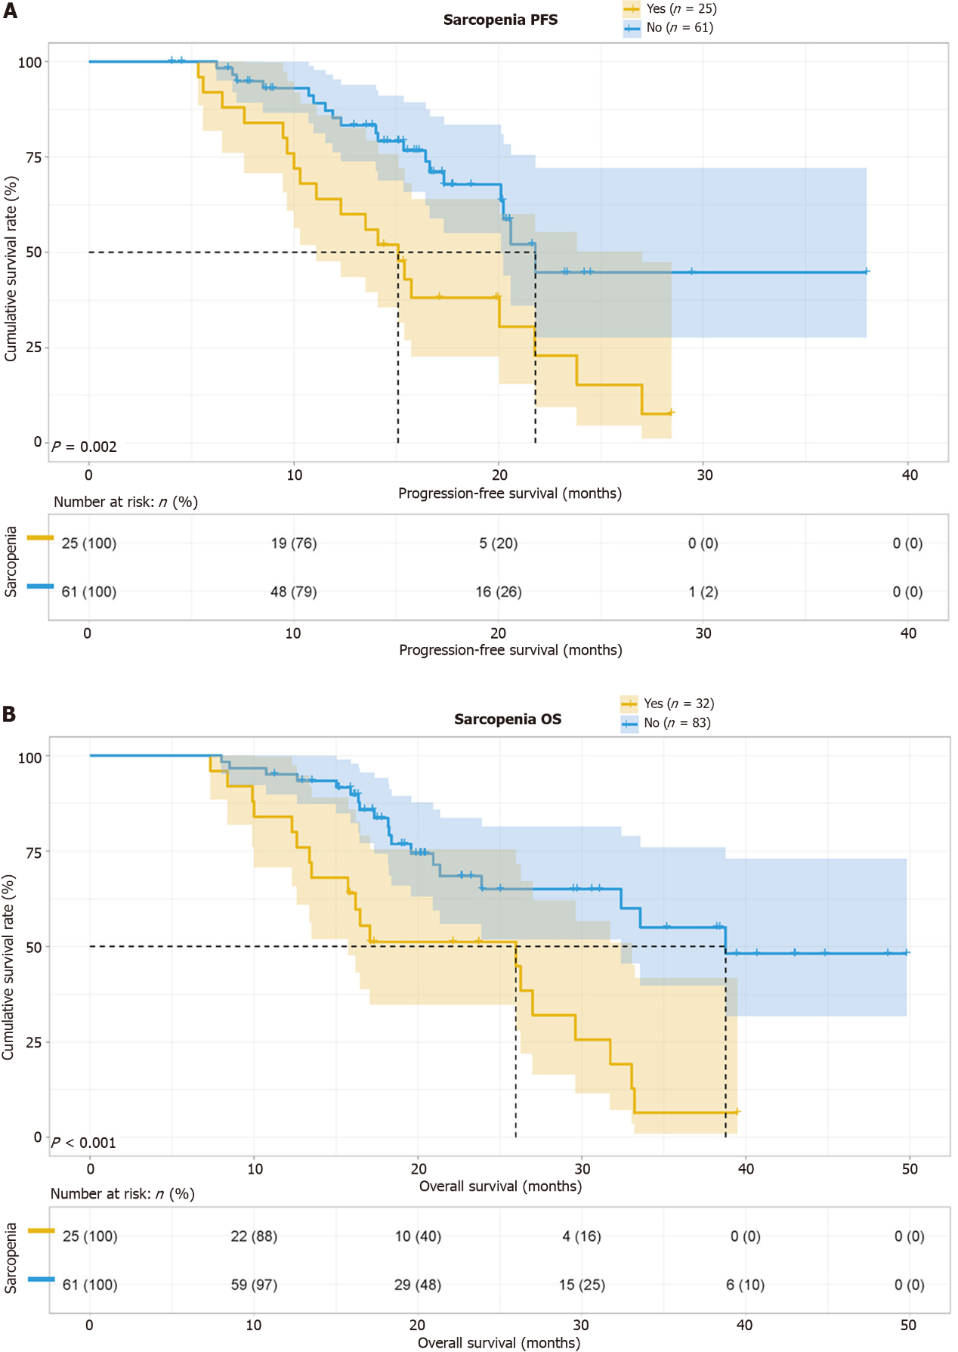Figure 4 Survival curves for (A) progression-free survival and (B) overall survival in participants with gastric cancer in the presence or absence of sarcopenia. PFS: Progression-free survival; OS: Overall survival.

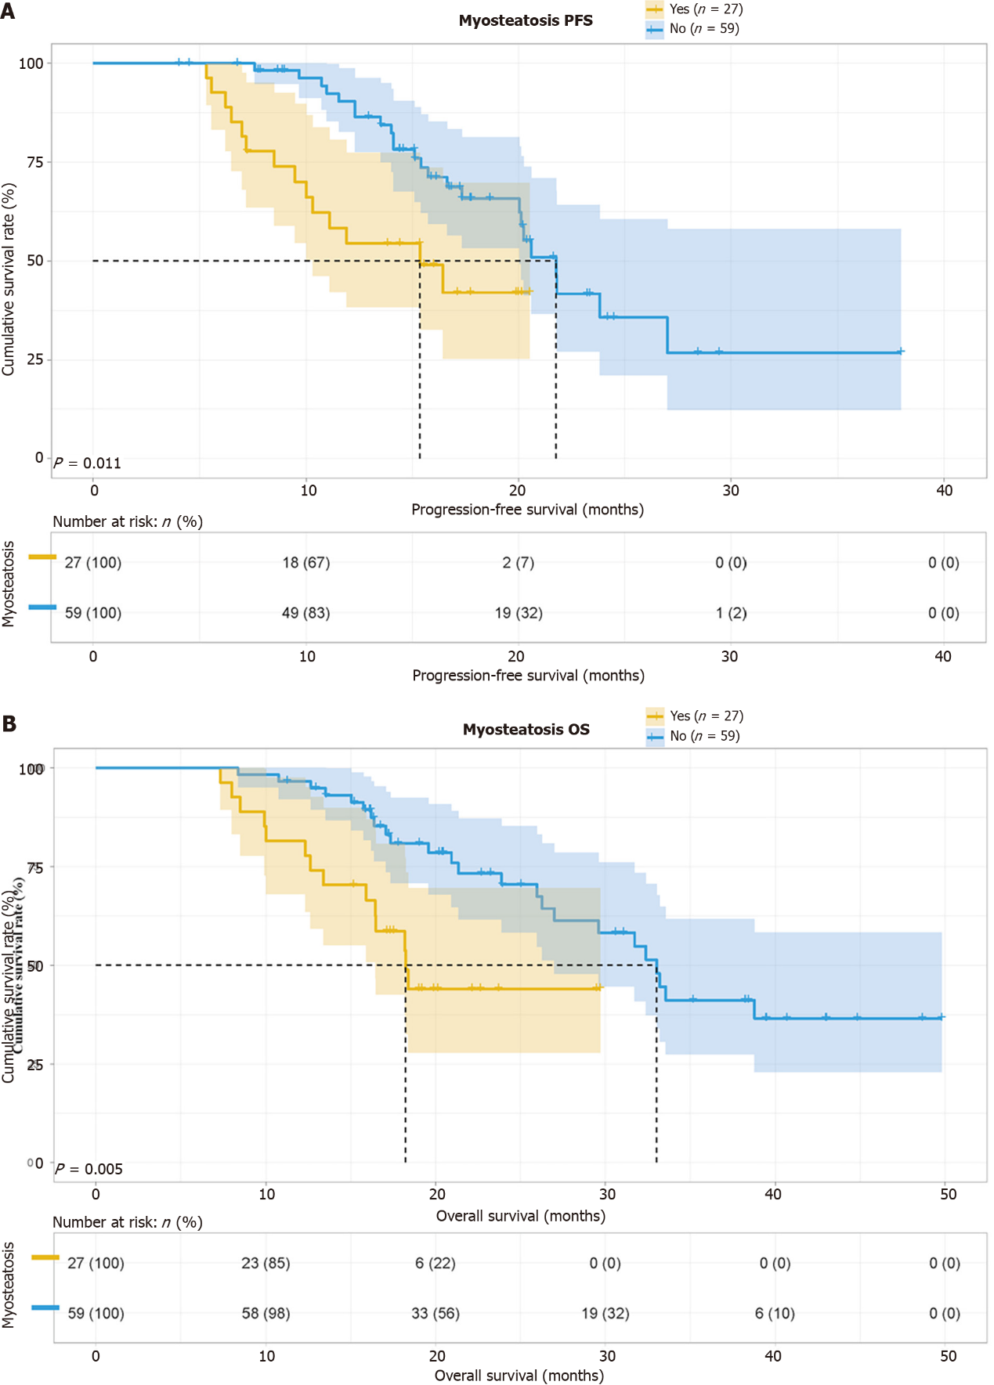Figure 5 Survival curves for (A) progression-free survival and (B) overall survival in participants with advanced gastric cancer in the presence or absence of myosteatosis. PFS: Progression-free survival; OS: Overall survival.

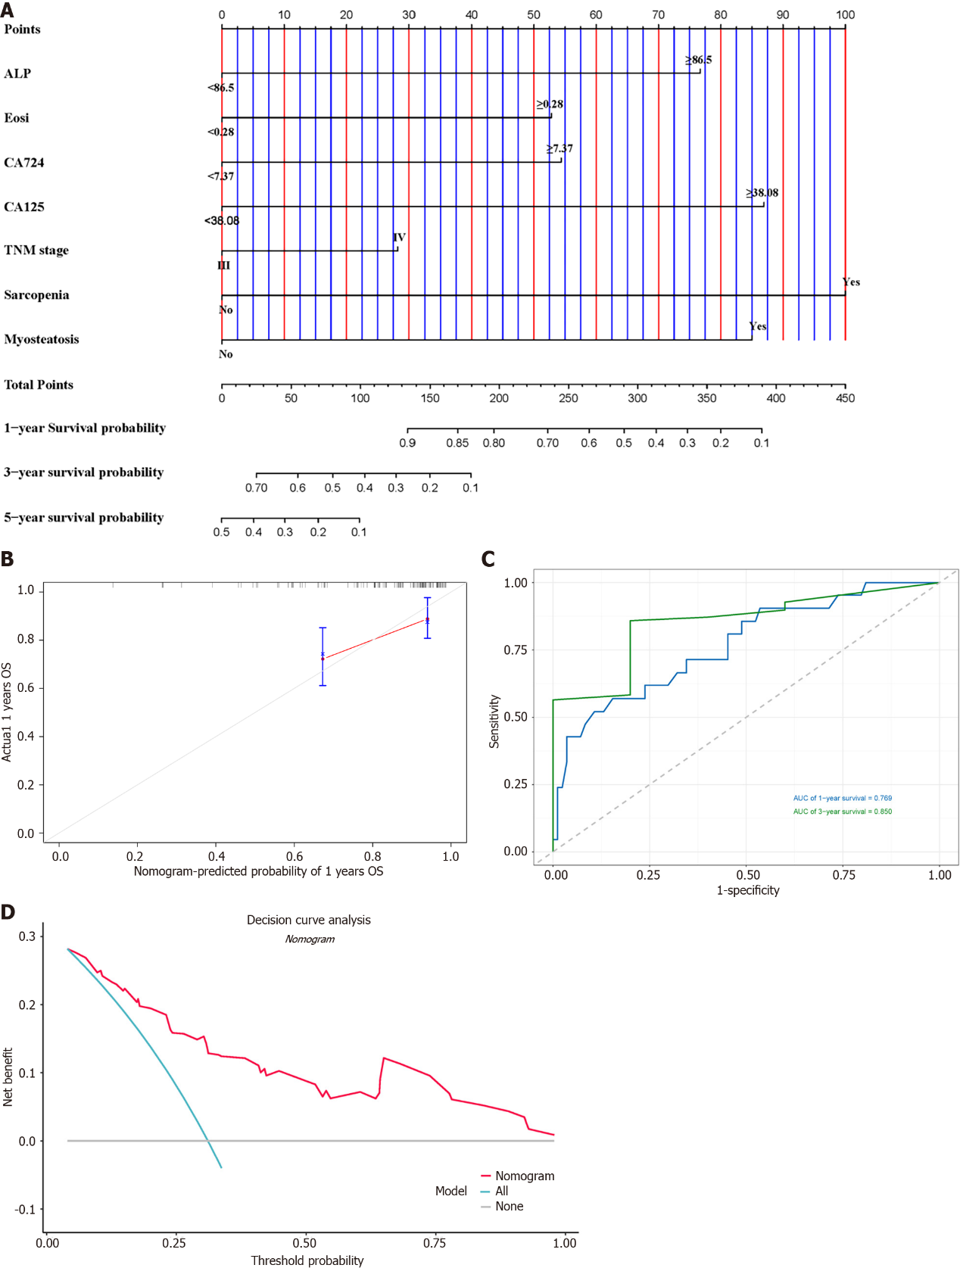Figure 6 Nomogram for progression-free survival. A: Nomogram for progression-free survival (PFS); B: One-year and 3-year area under the curves for PFS; C: Calibration curves for PFS; D: Decision curve analysis for PFS. AUC: Area under the curve; PFS: Progression-free survival; OS: Overall survival; ALP: Alkaline phosphatase; Eosi: Eosinophil count; CA724: Carbohydrate antigen 724; CA125: Carbohydrate antigen 125.

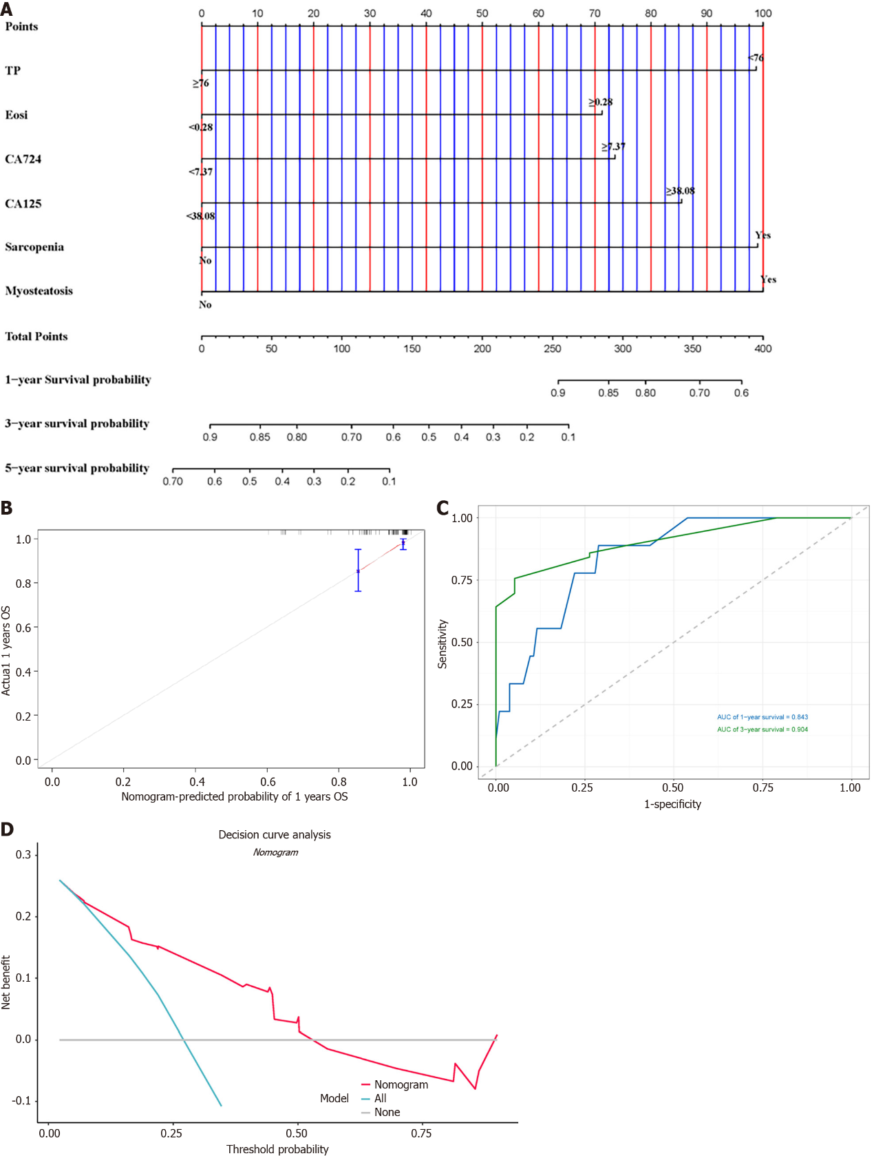Figure 7 Nomogram for overall survival. A: Nomogram for overall survival (OS); B: One-year and 3-year area under the curves for OS; C: Calibration curves for OS; D: Decision curve analysis for OS. AUC: Area under the curve; OS: Overall survival; TP: Total protein; Eosi: Eosinophil count; CA724: Carbohydrate antigen 724; CA125: Carbohydrate antigen 125.

Table 1 Participant characteristics
 | Sarcopenia |  |  | Myosteatosis
 | Yes (n = 32) | NO (n = 83) | P value | Yes (n = 32) | NO (n = 83) | P value
Item, mean (SD)
Age | 57.44 (11.18) | 57.40 (8.57) | < 0.001 | 62.31 (7.69) | 55.52 (9.24) | 0.001
BMI | 19.88 (4.39) | 22.75 (3.07) | < 0.001 | 22.04 (3.85) | 21.91 (3.85) | 0.986
Sex, n (%) |  |  | < 0.001 |  |  | 0.703
Male | 15 (46.9) | 74 (89.2) |  | 24 (75.0) | 65 (78.3)
Female | 17 (53.1) | 9 (10.8) |  | 8 (25.0) | 18 (21.7)
Primary tumor site, n (%) |  |  | 0.900 |  |  | 0.640
Upper 1/3 | 6 (18.8) | 13 (15.7) |  | 5 (15.6) | 14 (16.9)
Middle 1/3 | 7 (21.9) | 23 (27.7) |  | 6 (18.8) | 24 (28.9)
Low 1/3 | 18 (56.2) | 45 (54.2) |  | 20 (62.5) | 43 (51.8)
Whole | 1 (3.1) | 2 (2.4) |  | 1 (3.1) | 2 (2.4)
Pathology, n (%) |  |  | 0.166 |  |  | 0.344
Adenocarcinoma | 6 (18.8) | 22 (26.5) |  | 5 (15.6) | 23 (27.7)
Others¹ | 5 (15.6) | 4 (4.8) |  | 2 (6.3) | 7 (8.4)
Unknown | 21 (65.6) | 57 (68.7) |  | 25 (78.1) | 53 (63.9)
TNM stage, n (%) |  |  | 0.608 |  |  | 0.141
Ⅲ | 7 (21.9) | 22 (26.5) |  | 5 (15.6) | 24 (28.9)
Ⅳ | 25 (78.1) | 61 (73.5) |  | 27 (84.4) | 59 (71.1)
PD-1, n (%) |  |  | 0.281 |  |  | 0.698
Positive | 5 (15.6) | 5 (6.1) |  | 4 (12.5) | 6 (7.2)
Negative | 2 (6.3) | 7 (8.4) |  | 2 (6.3) | 7 (8.4)
Unknown | 25 (78.1) | 71 (85.5) |  | 26 (81.2) | 70 (84.4)
PD-L1, n (%) |  |  | 0.281 |  |  | 0.710
Positive | 5 (15.6) | 5 (6.1) |  | 4 (12.5) | 6 (7.2)
Negative | 2 (6.3) | 8 (8.4) |  | 2 (6.3) | 8 (9.6)
Unknown | 25 (78.1) | 70 (85.5) |  | 26 (81.2) | 69 (83.2)
AFP, n (%) |  |  | 0.702 |  |  | 0.221
< 2.92 ng/mL | 19 (59.4) | 46 (55.4) |  | 21 (65.6) | 44 (53.0)
≥ 2.92 ng/mL | 13 (40.6) | 37 (44.6) |  | 11 (34.4) | 39 (47.0)
CEA, n (%) |  |  | 0.933 |  |  | 0.315
< 4.24 ng/mL | 9 (28.1) | 24 (28.9) |  | 7 (21.9) | 26 (31.3)
≥ 4.24 ng/mL | 23 (71.9) | 59 (71.1) |  | 25 (78.1) | 57 (68.7)
CA199, n (%) |  |  | 0.859 |  |  | 0.295
< 17.63 U/L | 21 (65.6) | 53 (63.9) |  | 23 (71.9) | 51 (61.4)
≥ 17.63 U/L | 11 (34.4) | 30 (36.1) |  | 9 (28.1) | 32 (38.6)
CA724, n (%) |  |  | 0.704 |  |  | 0.955
< 4.40 U/L | 20 (62.5) | 55 (66.3) |  | 21 (65.6) | 54 (65.1)
≥ 4.40 U/L | 12 (37.5) | 28 (33.7) |  | 11 (34.4) | 29 (34.9)
CA125Ⅱ, n (%) |  |  | 0.811 |  |  | 0.756
< 21.94 U/L | 26 (81.3) | 69 (83.1) |  | 27 (81.9) | 68 (84.4)
≥ 21.94 U/L | 6 (18.8) | 14 (16.9) |  | 5 (18.1) | 15 (15.6)
Sarcopenia, n (%) |  |  |  |  |  | 0.057
Yes |  |  |  | 13 (59.4) | 19 (22.9)
No |  |  |  | 19 (40.6) | 64 (77.1)
Myosteatosis, n (%) |  |  | 0.057
Yes | 13 (40.6) | 19 (22.9)
NO | 19 (59.4) | 64 (77.1)
¹Others comprised mucinous carcinoma, signet ring cell carcinoma, and mixed carcinoma. BMI: Body mass index; CEA: Carcinoembryonic antigen; CA199: Carbohydrate antigen 199; CA724: Carbohydrate antigen 724; CA125II: Carbohydrate antigen 125II; PD-1: Programmed cell death protein 1; PD-L1: Programmed death ligand 1.
Table 2 Laboratory data for the participants, n (%)
Item, mean (SD) | Sarcopenia |  | P value | Myosteatosis |  | P value
 | Yes (n = 32) | NO (n = 83) |  | Yes (n = 32) | NO (n = 83)
ALT (U/L) | 20.31 (16.87) | 22.89 (21.41) | 0.404 | 20.07 (15.82) | 22.98 (21.70) | 0.660
AST (U/L) | 27.41 (23.12) | 25.99 (18.25) | 0.954 | 29.84 (28.16) | 25.05 (15.15) | 0.831
γ-GGT (U/L) | 66.22 (159.76) | 60.37 (88.60) | 0.378 | 97.19 (174.69) | 48.43 (72.81) | 0.067
ALP (U/L) | 115.02 (109.27) | 114.35 (67.34) | 0.216 | 116.33 (66.18) | 113.84 (85.98) | 0.651
TBIL (µmol/L) | 14.47 (9.57) | 14.44 (8.10) | 0.584 | 14.56 (9.70) | 14.40 (8.04) | 0.350
DBIL (µmol/L) | 3.69 (4.51) | 3.18 (2.43) | 0.476 | 3.49 (3.51) | 3.26 (3.00) | 0.627
IDBIL (µmol/L) | 10.79 (5.90) | 11.26 (6.19) | 0.554 | 11.08 (6.65) | 11.15 (5.90) | 0.438
TP (g/L) | 70.80 (7.83) | 68.31 (7.55) | 0.077 | 69.42 (7.63) | 68.84 (7.74) | 0.798
ALB (g/L) | 39.45 (4.70) | 38.61 (6.41) | 0.189 | 37.44 (4.50) | 39.38 (6.40) | 0.053
GLOB (g/L) | 31.30 (4.86) | 30.15 (5.00) | 0.184 | 31.93 (4.76) | 29.91 (4.96) | 0.047
PALB (g/L) | 200.44 (66.25) | 210.51 (65.47) | 0.640 | 182.16 (59.81) | 217.55 (65.33) | 0.010
Urea (mmol/L) | 5.75 (1.89) | 5.94 (1.63) | 0.501 | 6.31 (1.98) | 5.73 (1.56) | 0.182
CREA (µmol/L) | 72.00 (15.17) | 79.40 (16.50) | 0.013 | 78.78 (15.45) | 76.78 (16.83) | 0.375
UA (µmol/L) | 297.28 (88.63) | 316.28 (92.69) | 0.169 | 318.66 (92.09) | 308.04 (91.78) | 0.636
LDH (U/L) | 229.03 (204.48) | 233.55 (213.03) | 0.836 | 301.75 (274.39) | 205.52 (173.55) | 0.012
WBC (109/L) | 7.28 (3.82) | 7.59 (5.32) | 0.769 | 7.58 (3.60) | 7.48 (5.39) | 0.280
NEU (109/L) | 4.91 (3.57) | 4.72 (2.17) | 0.658 | 5.26 (3.36) | 4.59 (2.26) | 0.208
Lym (109/L) | 1.69 (0.58) | 1.60 (0.56) | 0.476 | 1.57 (0.53) | 1.65 (0.58) | 0.493
Mono (109/L) | 0.47 (0.22) | 0.53 (0.21) | 0.150 | 0.55 (0.18) | 0.49 (0.22) | 0.113
Eosi (109/L) | 0.12 (0.13) | 0.13 (0.11) | 0.173 | 0.13 (0.10) | 0.12 (0.12) | 0.364
Baso (109/L) | 0.03 (0.02) | 0.02 (0.01) | 0.145 | 0.03 (0.02) | 0.02 (0.01) | 0.276
Hb (g/L) | 124.03 (21.17) | 126.69 (27.63) | 0.575 | 121.03 (30.31) | 127.85 (23.97) | 0.245
RBC (1012/L) | 4.19 (0.66) | 4.45 (0.73) | 0.103 | 4.26 (0.80) | 4.42 (0.68) | 0.363
Plt (109/L) | 255.41 (98.83) | 256.23 (91.47) | 0.967 | 279.75 (110.41) | 246.84 (84.53) | 0.213
Fbg (g/L) | 3.67 (0.98) | 4.04 (2.78) | 0.902 | 4.78 (4.13) | 3.61 (1.14) | 0.051
DDi (mg/L) | 1.54 (2.90) | 1.28 (2.14) | 0.135 | 1.83 (3.18) | 1.17 (1.96) | 0.002
ALT: Alanine transaminase; AST: Aspartate aminotransferase; γ-GGT: γ-glutamyl transferase; ALP: Alkaline phosphatase; TBIL: Total bilirubin; DBIL: Direct bilirubin; IDBIL: Indirect bilirubin; TP: Total protein; ALB: Albumin; GLOB: Globulin; PALB: Pre-albumin; Urea: Urea nitrogen; CREA: Creatinine; UA: Uric acid; LDH: Lactate dehydrogenase; WBC: White blood cell count; NEU: Neutrophil count; Lym: Lymphocyte count; Mono: Monocyte count; Eosi: Eosinophil count; Baso: Basophil count; Hb: Hemoglobin; RBC: Red blood cell count; Plt: Platelet count; Fbg: Fibrinogen; DDi: D-dimer.

Table 3 Results of the univariate and multivariate analyses to identify parameters predictive of progression-free survival and overall survival
Parameters | OS |  |  |  | PFS
 | Univariate analysis |  | Multivariate analysis |  | Univariate analysis |  | Multivariate analysis
 | Hazard ratio (95%CI) | P value | Hazard ratio (95%CI) | P value | Hazard ratio (95%CI) | P value | Hazard ratio (95%CI) | P value
ALT (U/L) | 1.191 (0.680-2.088) | 0.541 |  |  | 1.312 (0.748-2.301) | 0.343
AST (U/L) | 3.316 (0.457-24.065) | 0.236 |  |  | 4.063 (0.560-29.469) | 0.165
γ-GGT (U/L) | 0.914 (0.522-1.601) | 0.753 |  |  | 0.907 (0.511-1.610) | 0.739
ALP (U/L) | 1.673 (0.933-2.998) | 0.084 |  |  | 1.962 (1.096-3.513) | 0.023 | 1.540 (0.722-3.282) | 0.264
TBIL (µmol/L) | 1.578 (0.861-2.893) | 0.140 |  |  | 2.108 (1.155-3.848) | 0.015 | 3.752 (1.104-12.750) | 0.034
DBIL (µmol/L) | 1.245 (0.705-2.197) | 0.450 |  |  | 1.337 (0.763-2.343) | 0.310
IDBIL (µmol/L) | 1.383 (0.785-2.434) | 0.261 |  |  | 1.870 (1.066-3.281) | 0.029 | 0.847 (0.276-2.603) | 0.772
TP (g/L) | 0.389 (0.165-0.917) | 0.031 | 0.310 (0.126-0.765) | 0.011 | 0.502 (0.214-1.179) | 0.114
ALB (g/L) | 0.985 (0.542-1.791) | 0.961 |  |  | 1.212 (0.667-2.201) | 0.528
GLOB (g/L) | 0.380 (0.118-1.223) | 0.105 |  |  | 0.345 (0.107-1.114) | 0.075
PALB (g/L) | 0.518 (0.293-0.915) | 0.024 | 0.757 (0.414-1.384) | 0.366 | 0.524 (0.299-0.919) | 0.024 | 0.560 (0.288-1.088) | 0.087
Urea (mmol/L) | 0.693 (0.362-1.328) | 0.269 |  |  | 0.711 (0.369-1.368) | 0.307
CREA (µmol/L) | 0.882 (0.486-1.600) | 0.679 |  |  | 1.007 (0.557-1.822) | 0.981
UA (µmol/L) | 0.571 (0.256-1.275) | 0.172 |  |  | 0.641 (0.284-1.446) | 0.284
LDH (U/L) | 1.094 (0.556-2.152) | 0.794 |  |  | 1.056 (0.543-2.051) | 0.873
WBC (10⁹/L) | 1.500 (0.835-2.696) | 0.175 |  |  | 1.450 (0.809-2.598) | 0.212
NEU (10⁹/L) | 1.352 (0.728-2.512) | 0.339 |  |  | 1.334 (0.719-2.475) | 0.360
Lym (10⁹/L) | 0.581 (0.323-1.043) | 0.069 |  |  | 0.555 (0.308-0.998) | 0.049 | 0.692 (0.345-1.391) | 0.301
Mono (10⁹/L) | 0.727 (0.418-1.262) | 0.257 |  |  | 0.730 (0.421-1.267) | 0.264
Eosi (10⁹/L) | 3.205 (1.520-6.758) | 0.002 | 2.398 (1.116-5.153) | 0.025 | 2.856 (1.374-5.936) | 0.005 | 3.022 (1.341-6.809) | 0.008
Baso (10⁹/L) | 1.151 (0.656-2.019) | 0.625 |  |  | 1.408 (0.797-2.489) | 0.239
Hb (g/L) | 1.062 (0.604-1.866) | 0.835 |  |  | 1.010 (0.576-1.772) | 0.973
RBC (10¹²/L) | 0.951 (0.542-1.667) | 0.860 |  |  | 0.946 (0.538-1.666) | 0.849
Plt (10⁹/L) | 0.578 (0.308-1.085) | 0.088 |  |  | 0.590 (0.314-1.110) | 0.102
Fbg (g/L) | 0.044 (0.000-12.949) | 0.282 |  |  | 0.44 (0.000-7.917) | 0.238
DDi (mg/L) | 1.906 (0.978-3.715) | 0.058 |  |  | 1.883 (0.978-3.627) | 0.058
AFP ng/mL | 0.830 (0.473-1.454) | 0.514 |  |  | 0.871 (0.496-1.529) | 0.631
CEA ng/mL | 1.507 (0.796-2.855) | 0.208 |  |  | 1.175 (0.622-2.219) | 0.620
CA199 U/L | 1.605 (0.927-2.780) | 0.091 |  |  | 1.756 (1.015-3.037) | 0.044 | 1.395 (0.719-2.706) | 0.325
CA724 U/L | 2.051 (1.176-3.578) | 0.011 | 2.459 (1.334-4.534) | 0.004 | 1.846 (1.055-3.228) | 0.032 | 1.951 (1.056-3.606) | 0.033
CA125 II U/L | 2.408 (1.294-4.482) | 0.006 | 2.763 (1.302-5.862) | 0.008 | 2.735 (1.445-5.179) | 0.002 | 2.419 (1.094-5.348) | 0.029
BMI (kg/m²) | 0.533 (0.309-0.921) | 0.024 | 1.165 (0.584-2.322) | 0.665 | 0.467 (0.268-0.815) | 0.007 | 1.232 (0.581-2.610) | 0.586
Age (< 53.50 vs ≥ 53.50) | 0.978 (0.550-1.737) | 0.939 |  |  | 1.276 (0.721-2.256) | 0.403
Sex (Male vs Female) | 1.288 (0.689-2.410) | 0.428 |  |  | 1.275 (0.682-2.385) | 0.447
TNM stage (Ⅲ vs Ⅳ) | 1.586 (0.820-3.067) | 0.170 |  |  | 2.044 (1.031-4.052) | 0.041 | 2.313 (1.007-5.317) | 0.048
Sarcopenia (Yes vs No) | 2.896 (1.670-5.021) | < 0.001 | 3.569 (1.808-7.045) | < 0.001 | 3.021 (1.737-5.253) | < 0.001 | 4.036 (1.959-8.316) | < 0.001
Myosteatosis (Yes vs No) | 2.662 (1.357-5.225) | 0.004 | 3.172 (1.471-6.839) | 0.003 | 2.104 (1.118-3.962) | 0.021 | 2.624 (1.256-5.483) | 0.010
ALT: Alanine transaminase; AST: Aspartate aminotransferase; γ-GGT: γ-glutamyl transferase; ALP: Alkaline phosphatase; TBIL: Total bilirubin; DBIL: Direct bilirubin; IDBIL: Indirect bilirubin; TP: Total protein; ALB: Albumin; GLOB: Globulin; PALB: Pre-albumin; Urea: Urea nitrogen; CREA: Creatinine; UA: Uric acid; LDH: Lactate dehydrogenase; WBC: White blood cell count; NEU: Neutrophil count; Lym: Lymphocyte count; Mono: Monocyte count; Eosi: Eosinophil count; Baso: Basophil count; Hb: Hemoglobin; RBC: Red blood cell count; Plt: Platelet count; Fbg: Fibrinogen; DDi: D-dimer; PFS: Progression-free survival; OS: Overall survival.

Published by Baishideng Publishing Group Inc
7041 Koll Center Parkway, Suite 160, Pleasanton, CA 94566, USA
Telephone: +1-925-3991568
E-mail: office@baishideng.com
Help Desk: https://www.f6publishing.com/helpdesk
https://www.wjgnet.com

© 2024 Baishideng Publishing Group Inc. All rights reserved.

