Name of Journal: World Journal of Gastrointestinal Oncology
Manuscript NO: 84819
Manuscript Type: ORIGINAL ARTICLE

Basic Study
Antitumor activity of miR-188-3p in gastric cancer is achieved by targeting CBL expression and inactivating the AKT/mTOR signaling

Lin JJ et al. miR-188-3p antitumor activity in gastric cancer

Jian-Jiao Lin, Bao-Hua Luo, Tao Su, Qiong Yang, Qin-Fei Zhang, Wei-Yu Dai, Yan Liu, Li Xiang

Jian-Jiao Lin, Tao Su, Qin-Fei Zhang, Yan Liu, Li Xiang, Department of Gastroenterology, The Second Affiliated Hospital of Chinese University of Hong Kong (Shenzhen Longgang District People's Hospital), Shenzhen 518172, Guangdong Province, China

Baohua Luo, Department of Urology, Hospital of Southern University of Science and Technology, Shenzhen 518055, Guangdong Province, China

Qiong Yang, Department of Gastroenterology, The Second Affiliated Hospital of the University of South China, Hengyang 421001, Hunan Province, China

Wei-Yu Dai, Department of Gastroenterology, Guangdong Provincial Key Laboratory of Gastroenterology, Nanfang Hospital, Southern Medical University, Guangzhou 510515, Guangdong Province, China

Author contributions: All authors contributed significantly to this work, whether in the conception, study design, execution, acquisition of data, analysis, and interpretation or in all these areas; Specifically, Lin JJ, Luo BH, and Xiang L designed and conceived the study. Su T, Yang Q performed in vitro experiments, Dai WY conducted in vitro experiments, and Zhang QF helped with data analysis; Liu Y and Lin JJ wrote the manuscript; All authors read and approved the final version of this manuscript.

Supported by the National Natural Science Funds of China, No. 81974448; Guangdong Medical Research Foundation, No. B2019126; and Shenzhen Science and Technology Innovation Commission, No. JCYJ20210324135005013.

Corresponding author: Li Xiang, PhD, Doctor, Department of Gastroenterology, The Second Affiliated Hospital of Chinese University of Hong Kong (Shenzhen Longgang District People's Hospital), No. 53 Aixin Road, Shenzhen 518172, Guangdong Province, China. shellyxiangli@163.com

Received: March 30, 2023
Revised: May 29, 2023
Accepted: July 7, 2023
Published online:

Abstract
BACKGROUND
Altered miR-188-3p expression has been observed in various human cancers.

AIM
To investigate the miR-188-3p expression, its roles, and underlying molecular events in gastric cancer.

METHODS
Fifty gastric cancer and paired normal tissues were collected to analyze miR-188-3p and CBL expression. Normal and gastric cancer cells were used to manipulate miR-188-3p and CBL expression through different assays. The relationship between miR-188-3p and CBL was predicted bioinformatically and confirmed using a luciferase gene reporter assay. A Kaplan-Meier analysis was used to associate miR-188-3p or CBL expression with patient survival. A nude mouse tumor cell xenograft assay was used to confirm the in vitro data.

RESULTS
MiR-188-3p was found to be lower in the plasma of gastric cancer patients, tissues, and cell lines compared to their healthy counterparts. It was associated with overall survival of gastric cancer patients (P < 0.001), tumor differentiation (P < 0.001), lymph node metastasis (P = 0.033), tumor node metastasis stage (I/II vs III/IV, P = 0.024), and American Joint Committee on Cancer stage (I/II vs III/IV, P = 0.03). Transfection with miR-188-3p mimics reduced tumor cell growth and invasion while inducing apoptosis and autophagy. CBL was identified as a direct target of miR-188-3p, with its expression antagonizing the effects of miR-188-3p on gastric cancer (GC) cell proliferation by inducing tumor cell apoptosis and autophagy through the inactivation of the Akt/mTOR signaling pathway. The in vivo data confirmed antitumor activity via CBL downregulation in gastric cancer.

CONCLUSION
The current data provides ex vivo, in vitro, and in vivo evidence that miR-188-3p acts as a tumor suppressor gene or possesses antitumor activity in GC.

Key Words: Gastric cancer; miR-188-3p; Tumor cell proliferation; Autophagy; AKT/mTOR signaling pathway; CBL expression

Lin J, Luo B, Su T, Yang Q, Zhang QF, Dai WY, Liu Y, Xiang L. Antitumor activity of miR-188-3p in gastric cancer is achieved by targeting CBL expression and inactivating the AKT/mTOR signaling. World J Gastrointest Oncol 2023; In press

Core Tip: Our study provided evidence for the antitumor activity of miR-188-3p in gastric cancer. We investigated the underlying molecular mechanisms by demonstrating that miR-188-3p inhibits gastric cancer progression and malignant behavior by suppressing Akt/mTOR signaling pathway activity and targeting CBL expression.

INTRODUCTION
Gastric cancer is a significant global health burden, ranking as the third most common cause of cancer-related mortality, with an estimated 783000 deaths worldwide in 2018^{[1-3]}. The incidence of gastric cancer varies considerably by region, with exceptionally high rates in China and Japan^{[3]}. Up to 90% of gastric adenocarcinoma cases are associated with H. pylori infection, while Epstein-Barr virus infection accounts for 10% of gastric cancer cases globally^{[3]}. Clinically, patients diagnosed with advanced-stage gastric cancer who undergo surgery or chemotherapy have a 5-year survival rate^{[4,5]} of only 18%. Further investigation into the molecular biology, pathogenesis, and etiology of gastric cancer could lead to the development of novel strategies and biomarkers for effective treatment, early diagnosis, prognosis prediction, and treatment outcome assessment in gastric cancer patients.
To this end, microRNA is a class of small single-stranded noncoding RNA molecules in the human genome that are 18-22 nucleotides long and regulates the expression of the target protein-coding mRNAs through RNA silencing and/or post-transcriptional gene regulation^{[6]}. In particular, miRNAs can bind to the three prime untranslated regions (3′-UTR) of the targeting mRNA to suppress their translation into protein or promote mRNA degradation and suppress gene expression^{[7]}. Some published studies have shown that altered mRNA expression and functions contribute to cancer development and progression^{[8-11]}. Several of these studies have also reported altered miR-188-3p expression in various human cancers, including gastric cancer^{[12-22]}. For example, miR-183-3p expression was reduced in non-small cell lung cancer vs. normal tissues, whereas miR-188-3p overexpression inhibited tumor cell proliferation and colony formation^{[14,16]}. MiR-183-3p expression was also reduced in human hepatocellular carcinoma compared to normal tissues. Upregulation of miR-188-3p inhibited tumor cell growth and migration^{[15]}. Moreover, another type of noncoding RNA, Circ_0109291, enhanced oral cancer cell resistance to cisplatin by inhibiting the miR-188-3p expression and inducing ABCB1 expression in vitro. By contrast, the miR-188-3p inhibitor could invert the suppressive effect of circ_0109291 silencing on tumor cell cisplatin resistance^{[17]}. However, another previous genome-wide miRNA analysis showed that detecting miR-188-3p expression could predict colorectal cancer prognosis and that miR-188-3p overexpression induced colorectal cancer cell migration in vitro and metastasis in vivo^{[18]}. In gastric cancer, a study of miR-188-3p showed that the expression thereof through Circ_0078607 silencing could suppress gastric cancer development^{[13]}. It has been shown that the role of epigenetic regulation could be as a promising therapeutic target in cancers, e.g., the onco-miRs could epigenetically regulate colon carcinogenesis and development of resistance, while targeting of such regulation was demonstrated as a promising therapeutic potential^{[23]}. This study further investigated the miR-188-3p expression, its roles, and underlying molecular events in gastric cancer ex vivo, in vitro, and in vivo. The results of this work provide further supporting data for miR-188-3p being used as a tumor marker and therapeutic strategy for the early detection, prediction of treatment outcome, and effective treatment of gastric cancer patients.

MATERIALS AND METHODS
Patients and specimens
This study examined 50 paired gastric cancer and adjacent non-tumor tissues from the Department of Surgery of Hospital of Nanfang Hospital, Southern Medical University, China, between January 2018 and December 2018. All patients were histologically diagnosed with gastric adenocarcinoma and classified according to the WHO grading system. The tumor stage using the tumor node metastasis (TNM) classification was based on the 2011 Union for International Cancer^{[24]}. After tumor resections, fresh patient tissue specimens were obtained from the surgical room, snap-frozen in liquid nitrogen, and stored at -80℃. In addition, plasma samples from 20 gastric cancer patients and 20 healthy controls were collected. This study was approved by the Ethics Committee of the Southern Medical University, and all participants provided written informed consent before enrolling in the study.

Quantitative reverse transcriptase-polymerase chain reaction
Total cellular RNA from tissues and cells was isolated using the Trizol reagent (Invitrogen, Carlsbad, CA, United States) and was reversely transcribed into cDNA with the M-MLV RT Kit (Promega, Madison, MI, United States) according to the manufacturers’ instructions. These cDNA samples were then subjected to amplify miR-188-3p and U6 expression using qPCR with specific RT and PCR primers (GeneCopoeia, Rockville, MD, United States) with the SYBR® Green PCR Master Mix (Toyobo, Osaka, Japan). The relative miR-188-3p level was compared with that of U6 using the 2-ΔΔCt method. The primer and probe sequences of miR-188-3p were 5'-CTCCCACATGCAGGGTTTG-'3, 5'-CTCAACTGGTGTCGTGGAGTC-3', and 5'-CACATGCAGGGTTTGCAAA -3'.

Cell lines and culture
The human immortalized normal gastric epithelial GES-1 and gastric carcinoma cell lines AGS, and HGC-27 were originally obtained from American Type Culture Collection (Manassas, VA, United States), while the gastric cancer SGC-7901, BGC-823, and MGC-803 cell lines were obtained from the Beijing Institute of Cancer Research (Beijing, China) and the gastric cancer MKN-28 and MKN-45 cell lines from the Japanese Collection of Research Bioresources Cell Bank (Osaka, Japan). These cells were grown in RPMI-1640 containing 10% fetal bovine serum (FBS) at 37°C in a humidified incubator supplemented with 5% CO₂.

Oligonucleotide transfection
The double-stranded Hsa-miR-188-3p mimics (5'-GUCCCACAUGCAGGGUUUGCA-3'), Hsa-miR-188-3p inhibitor (5'-UGCAAACCCUGCAUGUGGGAG-3'), and their corresponding negative controls (NC) were purchased from the Suzhou Jima Gene Co. (Suzhou, China). Gastric cancer BCG823 and AGS cells were seeded overnight and transiently transfected with the miR-188-3p mimics and their corresponding m-NC (miR-188-3p inhibitor) and i-NC controls using Lipofectamine 3000 (Invitrogen) for 48 h following the manufacturer’s protocol. The efficiency of miR-188-3p expression was assayed using quantitative reverse transcriptase-polymerase chain reaction (qRT-PCR). The resulting cells were subjected to the following assays.

Cell viability CCK-8 assay
To assess the changes in cell viability after miR-188-3p expression manipulation, we utilized the Cell Counting Kit-8 (CCK-8) kit from Dojindo Laboratories (Tokyo, Japan). In brief, the transfected cells were plated at a density of 1 × 5 cells/well in a 96-well plate and grown for up to 4 d. Every 24 h, a serum-free medium and 10 microliters of the CCK-8 solution were refreshed in each well, which were then further incubated for an additional 2 h. The optical density of each well was then measured to assess the cell viability using a microplate reader (Thermo Fisher Scientific, Waltham, MA, United States) at 450 nm. All experiments were performed in triplicate.

Colony formation assay
The gene-transfected cells were inoculated and cultured in a 6-well plate (200 cells/well) for 14 d. Afterward, the plate was washed with phosphate-buffered saline (PBS) three times, and cells were then fixed in ethanol for 30 s and stained with 1% crystal violet for 15 min. Cells were then rewashed using PBS. The plate was photographed, and the individual colonies containing ≥ 50 cells were counted and quantitated with the Image J software (National Institute of Health, Bethesda, MD, United States).

Tumor cell 5-ethynyl-2-deoxyuridine incorporation assay
Tumor cell growth was further evaluated using the 5-ethynyl-2-deoxyuridine (EdU) incorporation assay with an EdU kit (RiboBio, Guangzhou, China). Briefly, tumor cells were grown and incubated overnight with 50 μmol/L of the EdU reagent for 24 h and then evaluated for cell proliferation using the Cell-Light™ EdU Cell Proliferation Detection Kit following the manufacturer’s protocol. After that, the Hoechst 33342 reagent (RiboBio, Guangzhou, China) was used to visualize tumor cell nuclei, which were reviewed and photographed under an inverted fluorescence microscope (Olympus, Tokyo, Japan) for three random horizons of cells. The number of the EdU-positive cells vs the total cells in the picture were quantitated using the Image J software (National Institute of Health, Bethesda, MD, United States).

Flow cytometric Annexin V-PE apoptosis assay
A flow cytometric Annexin V-PE apoptosis assay kit from BD Biosciences (Franklin Lakes, NJ, United States) was obtained to assess the level of apoptosis and cell cycle distribution of gastric cancer cells after gene transfection. In brief, BGC-823 and AGS cells were grown and transfected with miR-188-3p mimics, m-NC, m-NC + Vector, miR-188-3p mimics + Vector, or miR-188-3p mimics + CBL with or without treatment with 2 µg/mL fluorouracil (5-FU) for 48 h. Cells were then harvested and washed three times with PBS and then resuspended in 500 µL of the flow buffer with the addition of 5 µL Annexin V-FITC and 10 µL PI. The samples were incubated for 15 min at room temperature, and then the level of cell apoptosis was evaluated using the BD FACS Canto II flow cytometer (BD Biosciences). The necrotic cells stained double positive for Annexin V and PI, while apoptotic cells were negative for Annexin V and PI staining and were quantified using the BD FACS Canto II software.

Plate cloning assay
After gene transfection, gastric cancer cell lines were plated into six-well plates (200 cells/well) and grown in the RPMI-1640 containing 10% FBS for two weeks at 37°C. At the end of the experiment, the cells were fixed with 4% paraformaldehyde for 30 min, washed three times with PBS, and stained with 1% crystal violet solution for 10 min to visualize cell nuclei. After that, cell colonies containing ≥ 50 cells were counted and analyzed. All experiments were conducted in triplicate.

Tumor cell migration and invasion assay
After gene transfection, tumor cells were seeded with a serum-free medium in the Transwells (Corning, Corning, NY, United States), which were pre-coated with or without 25 μg Matrigel (BD Biosciences) at a density of 2000 cells per chamber. The bottom chamber contained the growth medium supplemented with 20% FBS. The Transwells were incubated for 48 h at 37°C. After that, cells that remained on the topside of the filter were removed with cotton swabs, and the cells that migrated or invaded into the reverse side of the filter were fixed with 3.7% paraformaldehyde in PBS and stained for 10 min using 2% crystal violet. The number of cells was then counted and calculated in three typical microscopic fields (×20).

Western blot
Total cellular protein was extracted using a Protein Extraction kit from Invent Biotechnologies (Plymouth, MN, United States) and quantified using the bicinchoninic acid (BCA) protein assay kit (Cell Signaling Technology, Danvers, MA, United States). The resulting protein samples with 30 μg in each lane were loaded onto 8%-12% sodium dodecyl sulfate-polyacrylamide gel electrophoresis gels for electrophoresis to separate the proteins. Subsequently, the protein in the gel was transferred onto the nitrocellulose membranes. For Western blotting, the membranes were incubated in a 5% skimmed milk powder solution at room temperature for 1 h. Next, the membranes were incubated overnight with primary antibody solutions at 4°C. Afterward, the membranes were subjected to wash with Tris-based saline-Tween 20 (TBS-T) three times and then incubated with a secondary antibody at room temperature for 2 h. After being washed with TBS-T, the positive protein signals on the membranes were detected using the Enhanced chemiluminescence reagents (Cell Signaling Technology). The antibodies used were a mouse antibody against GAPDH, β-actin, or CBL (Santa Cruz Biotechnology, Santa Cruz, CA, United States), anti-LC3 and Beclin1 (Cell Signaling Technology, Danvers, MA, United States), and a rabbit antibody against mTOR, p-mTOR, Akt (C-terminal), or p-Akt (Ser473) (Cell Signaling Technology). The dilution of each antibody followed the manufacturers’ recommendations.

Bioinformatic analysis
To predict the mRNA target of miR-188-3p, we utilized the online tools of MiRDB (http://mirdb.org), TargetScan (http://www.targetscan.org/), miRPathDB (http://www. https://mpd.bioinf.uni-sb.de/), and TargetMiner (https://tools4mirs.org) to reveal potential targets, like CBL (Casitas B-lineage Lymphoma) and the miRNA-binding region.

Luciferase gene reporter assay
A gene reporter plasmid carrying a wild type or mutant CBL 3'-UTR was purchased from Genepharma (Shanghai, China). In brief, tumor cells after miR-188-3p mimics transfection were grown and transfected with the reporter plasmid containing a luciferase gene fused to the target sequence of the wild-type (WT) 3'-UTR or mutant 3’-UTR of CBL using Lipofectamine 3000 (Invitrogen) for 36 h. Tumor cells were then lysed, and the proteins were quantified using the BCA protein assay kit (Cell Signaling Technology) and analyzed using the Luciferase Reporter Assay System (Transgen Biotech, China). All experiments were conducted in triplicate.

Plasmid construction, lentiviral preparation, and cell infection
A lentivirus carrying miR-188-3p (UBI-MCS-SV40-EGFP-IRES-puromycin) and the red fluorescent protein gene was purchased from Gene Chem (Shanghai, China). Specifically, the plasmid carrying miR-188-3p was transfected into tumor cells and grown for 14 days to establish the puromycin-resistant cell population. Moreover, a lentivirus carrying CBL cDNA using the Ubi-MCS-3FLAG-CBh-CHERRY-IRES-puromycin vector and an Ubi-MCS-3FLAG-CBh-CHERRY-IRES-puromycin empty vector was also obtained from Gene Chem and used to establish a stably transfected cell population according to the manufacturer’s protocols. The stably transfected cell population was used for the in vivo assay in nude mice.

In vivo nude mouse assay
The in vivo study using nude mice was approved by the Experimental Animal Ethics Committee of Southern Medical University. In brief, 15 BALB/C mice of 4-6 wk of age were purchased from the Animal Research Center of Medical University and randomly divided into three groups (miR-188-3p-NC, miR-188-3p-mimics, and miR-188-3p mimics + CBL cDNA). To establish tumor cell xenografts, 1 × 10⁶ tumor cells were implanted into each nude mouse at the right inguinal region. Tumor volume was recorded every three days, and tumor mass was calculated using the following formula: tumor volume = ½ × length × width². After 30 d, the mice were sacrificed to resect gastric cancer cell xenografts.

Immunohistochemistry
Immunohistochemistry (IHC) analysis was conducted to evaluate CBL and Ki67 Levels in nude mouse tumor xenografts. The antibodies used were an anti-CBL (Santa Cruz Biotechnology) and anti-Ki67 (Cat. #ab15580; Abcam, Cambridge, MA, United States). In brief, nude mouse tumor xenograft tissues were processed, paraffin-embedded, and sectioned into 4 µm-thick tissue slides. Two independent investigators scored the tissue sections and quantified them with a semi-quantitative scoring system according to a previous study^{[25]}.

Statistical analysis
The data are expressed as mean ± mean standard error and analyzed statistically with the SPSS software (version 16.0; SPSS, Chicago, IL, United States). A Chi-square test or Pearson’s χ² test was conducted to associate the miR-188-3p level with the clinical characteristics of patients. A Student’s t-test or Fisher’s exact test was used to analyze differences between the two groups. The symbol "d" indicates that the data doesn’t have a statistically significant difference (P > 0.05), whereas "a", "b", and “c” indicate that the data possesses a statistically significant difference (P < 0.05, P < 0.01. and P < 0.001, respectively).

RESULTS
Reduced plasma miR-188-3p level in gastric cancer patients and tumor tissues and cells
The plasma level of miR-188-3p expression was first assayed using qRT-PCR in the plasma of gastric cancer patients. We found a significantly reduced miR-188-3p level compared to that of the plasma from healthy people (P < 0.01; Figure 1A).
Next, we assayed the miR-188-3p level in a normal GES-1 cell line and seven gastric cancer cell lines AGS, HGC-27, MKN-28, MKN-45, SGC-7901, MGC-803, and BGC-823. We found that miR-188-3p expression was lower in tumor cell lines than in GES-1 cells (Figure 1B). Furthermore, we assessed miR-188-3p expression in 50 paired noncancerous gastric mucosa (N) and gastric cancer tissues (T) using qRT-PCR. We found that 42 of 50 gastric cancer tissue samples exhibited a lower miR-188-3p expression than those of the adjacent normal tissues (Figure 1C).
To explore the effect of miR-188-3p on gastric cancer cells, we transfected the miR-188-3p mimics and inhibitors into gastric cancer cell lines and assessed the miR-188-3p level using qRT-PCR. Overall, we observed significant changes in miR-188-3p expression level in tumor cells (P < 0.01 and P < 0.001; Figure 1D and E).
Furthermore, we associated miR-188-3p expression with the survival time of patients and found that patients with a low miR-188-3p expressing gastric cancer survived much shorter than patients with high miR-188-3p expressing tumor, according to the Kaplan-Meier Plotter database data (http://kmplot.com/analysis/; P < 0.001; Figure 1F). We then associated miR-188-3p level with the clinicopathological characteristics and prognosis of gastric cancer patients. Our data showed that the miR-188-3p level was associated with gastric cancer differentiation (P < 0.001), lymph node metastasis (P = 0.033), TNM stage (I/II vs III/IV, P = 0.024), and American Joint Committee on Cancer (AJCC) stage (I/II vs III/IV, P = 0.03). However, there were no significant associations of miR-188-3p level with tumor size (10 cm or less vs 10 cm or more in size), gender, or age (60 years or younger vs 60 years or older; P > 0.05; Supplementary Table 1). The miR-188-3p level also predicted a better prognosis for gastric cancer patients (Supplementary Table 1). These data indicate that miR-188-3p may be a tumor suppressor or at least possess tumor suppressor activity in gastric cancer.

miR-188-3p inhibition of gastric cancer cell proliferation and invasion
We then assessed the effects of miR-188-3p on gastric cancer AGS and BGC-823 cells using miR-188-3p mimics and inhibitors and analyzed the change in tumor cell proliferation using the EdU incorporation assay. The tumor cell proliferation rate was dramatically inhibited after miR-188-3p mimics transfection compared to control cells (m-NC cells). Conversely, tumor cell growth rate was induced after the miR-188-3p inhibitor transfection (P < 0.001; Figure 2A and B). The proliferation rate of the miR-188-3p mimics and inhibitors in gastric cancer AGS and BGC-823 cell lines was also assessed using the plate cloning experiment. The data further confirmed the EdU assay data (P < 0.001; Figure 2C and D). Moreover, the CCK-8 data revealed that the miR-188-3p mimics significantly decreased cell viability of BGC-823 and AGS cells, whereas that of the miR-188-3p inhibitor increased cell viability of BGC 823 and ACG cells (Supplementary Figure 1A).
Furthermore, the gastric cancer cell invasion capacity was significantly decreased after miR-188-3p mimics transfection, whereas such a capacity was enhanced after the transfection of the miR-188-3p inhibitor (P < 0.01; Supplementary Figure 1B and C).

miR-188-3p induction of apoptosis and autophagy
Next, we performed a flow cytometric/Annexin V-PE/7-AAD assay and found that the miR-188-3p mimics increased apoptosis of BGC-823 cells from 11.2% (cells transfected with i-NC) to 23.3% (the miR-188-3p mimics transfection), and ACG cells from 12% to 35.7% (P < 0.01; Figure 3A and B).
Moreover, miR-188-3p mimics transfection into gastric cancer AGS and BGC-823 cells increased autophagy-related gene expression (Beclin1 and LC3-II/LC3-I). In contrast, miR-188-3p inhibitor transfection into gastric cancer cells showed the opposite effect, decreasing their expression compared with i-NC (P < 0.001; Figure 3C and D). Consistent with these results, Western blot data also confirmed that miR-188-3p could induce autophagic proteins (Beclin-1 and LC3 I/II; Figure 3E).

CBL as a direct target of miR-188-3p
To explore the mechanism of miR-188-3p action in gastric cancer cells, we first searched the TargetScan, miRPathDB, miRDB, and the TargetMiner databases for possible target genes of miR-188-3p. We found six genes using a Wern diagram. CBL (an oncogene in gastric cancer) was selected for confirmation using the luciferase gene reporter assay. As shown in Figure 4A, four target sites show that miR-188-3p can bind to the 3'-UTR of the CBL gene (Figure 4B). The luciferase gene reporter assay confirmed this prediction, showing that miR-188-3p could bind to the 3'-UTR region of the CBL gene (WT, P < 0.01 vs MUT, P > 0.05; Figure 4C and D). We then utilized the KM-Plotter database (http://kmplot.com) and TCGA dataset (http://xena.ucsc.edu/public) to associate CBL expression with the survival of gastric cancer patients and found that CBL expression indeed was associated with survival of gastric cancer patients (Figure 4E and F). Our IHC data also showed that CBL protein was localized in the tumor cell cytoplasm and was highly expressed in tumor tissues compared to the adjacent gastric tissues (Supplementary Figure 2A). The association between miR-188-3p and CBL expression in a case-wise comparison in gastric cancer tissues was negatively correlated (Supplementary Figure 2B)

CBL antagonization of miR-188-3p reduction of gastric cancer cell proliferation and induction of gastric cancer cell apoptosis and autophagy in vitro
To confirm the miR-188-3p regulation of CBL in tumor cells, we analyzed the molecular effect of miR-188-3p in regulating CBL-mediated gastric cancer cell proliferation. MiR-188-3p mimics-transfected AGS and BGC-823 cells enhanced tumor cell apoptosis compared with control cells (P < 0.05 and P < 0.001; Figure 5A and B). Expression of the autophagy-related genes LC3-II/LC3-I and Beclin1 also changed accordingly (P < 0.001; Figure 5C). The proliferation rate of gastric cancer cells after miR-188-3p mimics and CBL cDNA transfection was increased significantly compared to that of miR-188-3p mimics with vector-only control transfection (Figure 5D). These results indicate that CBL transfection could antagonize the inhibiting effects of miR-188-3p in gastric cancer cells. It can be concluded that miR-188-3p could negatively regulate CBL expression to promote gastric cancer cell autophagy and apoptosis.

miR-188-3p repressed gastric cancer cell autophagy by directly targeting CBL and Akt/mTOR signaling
Previous studies have demonstrated that the AKT/mTOR signaling pathway was related to autophagy occurrence^{[26-28]}. Therefore, we detected the expression of Akt and mTOR in our cell model system and found that the level of the phosphorylated proteins was lower than usual. By contrast, the level of becline1 protein was increased in CBL siRNA-transfected tumor cells (Figure 6A). In addition, miR-188-3p mimics transfection reduced the level of phosphorylated Akt and phosphorylated mTOR proteins in tumor cells in vitro. However, it increased the level of becline1 protein, whereas miR-188-3p inhibitor exhibited an inverse effect on gastric cancer cells (Figure 6B). Moreover, CBL overexpression antagonized the miR-188-3p-induced reduction of p-Akt and p-mTOR expression (Figure 6C).

miR-188-3p inhibition of tumor cell xenograft growth in vivo through CBL inhibition
To verify whether miR-188-3p inhibits gastric cancer cell growth in vivo, we implanted BGC-823 cells after miR-188-3p mimics, miR-188-3p/CBL cDNA, or m-NC transfection to establish a xenograft tumor model in nude mice. Our data revealed that miR-188-3p mimics transfection inhibited gastric cancer cell growth and that the tumor size of the miR-188-3p/CBL group was significantly greater than those of the m-NC and miR-188-3p groups (both P < 0.001; Figure 6D and E). Meanwhile, more ki67-positive and CBL-positive cells were observed in miR-188-3p/CBL cDNA-transfected gastric cancer cells (Supplementary Figure 3A and B). These findings illustrate that miR-188-3p inhibited tumor cell xenograft growth in vivo, whereas CBL expression antagonized inhibition of miR-188-3p-induced proliferation in vivo.

DISCUSSION
Gastric cancer morbidity and mortality account for the second- and third-highest death rates in China among all malignancies. Gastric cancer also has a poor clinical prognosis^{[5]} worldwide^{[2]}. However, the associated molecular mechanisms of this disease have not been well explained. Various high-throughput sequencing techniques have recently been used to analyze altered genome-wide miRNA gene expression in gastric cancer. These studies have revealed that aberrant expression of different miRNAs was present in gastric cancer and led to novel gastric cancer biomarker discovery and potential targets for gastric cancer treatment^{[29-31]}. In the current study, we focused on miR-188-3p and found a significant miR-188-3p downregulation in gastric cancer samples (plasma and tissues vs. normal controls). The expression of miR-188-3p was also associated with better patient prognosis and inversely associated with gastric cancer differentiation, metastasis to the lymph node, high TNM stages, and AJCC stage. Moreover, miR-188-3p expression inhibited gastric cancer cell growth but induced apoptosis and autophagy. Autophagy in cells can be a double-edged sword for multidrug resistance (MDR) of tumors; for example, it is involved in MDR development to protect cancer cells from chemotherapy drugs but can also kill MDR cancer cells with inactivated apoptotic pathways^{[32]}. Thus, autophagy also plays a dual role in tumorigenesis, tumor progression, and resistance to chemotherapy^{[33,34]}. In addition, autophagy can exert anticancer effects by eliminating damaged organelles and recycling degradation products in normal cells. Paradoxically, excessive autophagy can plunge cancer cells into "autophagic cell death" or "type II programmed cell death"^{[35,36]}.
Molecularly, miR-188-3p could target CBL and downregulate CBL expression, which was associated with the antitumor activity of miR-188-3p in vitro and in a nude mouse assay. In conclusion, our current study demonstrated the tumor suppression of miR-188-3p in gastric cancer. Further study will confirm the antitumor activity of miR-188-3p in gastric cancer as a biomarker of prognosis prediction and as a novel therapeutic target in gastric cancer. Indeed, as predicted, miR-188-3p has been shown to possess antitumor activity in most human cancers analyzed to date^{[12-22]}. However, Pichler et al^{[18]} reported that miR-188-3p expression enhanced colonic tumor cell migration and metastasis in colorectal cancer.
The Casitas B-lineage Lymphoma (CBL) family of genes is a class of highly conserved ubiquitin-protein ligases. A previous study showed that CBL gene mutations were implicated in human cancers, especially acute myeloid leukemia^{[37]}. Indeed, CBL was first evaluated as an oncogene in early B-lineage lymphoma^{[38]}. Other studies have shown that CBL is conducive to the survival and proliferation of many types of cells and plays an essential role in various human cancer developments, such as breast^{[39]} and kidney^{[40]} cancer. CBL alterations have also been associated with gastric cancer development^{[41,42]}, where apoptosis and migration are regulated by the Akt and mTOR signaling in gastric cancer cells^{[43-46]}. In the current study, we demonstrated that CBL is a direct target of miR-188-3p and that miR-188-3p-inhibited gastric cancer proliferation downregulated CBL expression in vitro and in vivo. CBL overexpression reduced the miR-188-3p antitumor activity in gastric cancer. Thus, our current data indicates that miR-188-3p antitumor activity in gastric cancer could act through the downregulation of CBL expression.
Furthermore, our current study also showed that the miR-188-3p anti-gastric cancer activity inactivated the AKT/mTOR signaling pathway and induced autophagy, which is a catabolic process in various cell activities^{[47]}. The mTOR compound is a crucial negative regulator of autophagy and regulates cell proliferation and protein synthesis^{[48,49]}. At the gene level, mTOR can phosphorylate and suppress the kinase complex during cell autophagy^{[50,51]}. A previous study has shown that tumor cell growth and autophagy were controlled after activation of the AKT/mTOR signaling pathway^{[52-55]}. Our current data confirmed these previous studies, showing that miR-188-3p induced gastric cancer cell autophagy and increased levels of the p-mTOR and p-Akt proteins to activate their signaling and promote tumor cell growth and invasion capacity.
Our study is an essential addition to the literature that supports the antitumor activity of miR-188-3p in gastric cancer. We explored the underlying molecular mechanisms by illustrating the miR-188-3p-based inhibition of gastric cancer and malignant behavior (progression) by inhibiting the activity of the Akt/mTOR signaling pathway and targeting CBL expression. Our present study also contained various limitations that should be discussed. First, the number of gastric cancer cases was small, and we cannot associate miR-188-3p expression with the treatment outcome of patients. Our in vitro experiments were also preliminary, and more in-depth investigation is needed to facilitate the actual role of miR-188-3p in gastric cancer. Thus, in our future work, we will assess the detection of miR-188-3p expression as a predictive biomarker for the prognosis and treatment outcome of gastric cancer. We will also assess the use of miR-188-3p as a novel therapeutic approach against gastric cancer.

CONCLUSION
This study demonstrated the anticancer activity of miR-188-3p through the downregulation of CBL expression in gastric cancer. Our findings provide novel insights into the molecular mechanisms underlying gastric cancer development and progression and may offer a new approach to controlling this disease.

ARTICLE HIGHLIGHTS
Research background
Altered miR-188-3p expression has been observed in various human cancers, while report of its role in gastric cancer needs further investigation.

Research motivation
Better understanding of miR-188-3p biology, functions, and molecular mechanism of action in gastric cancer could lead to develop novel strategies in control gastric cancer.

Research objectives
This study assessed miR-188-3p expression and functions in gastric cancer tissues and cells, respectively.

Research methods
Gastric cancer and normal tissues were obtained to detect miR-188-3p expression using quantitative reverse transcriptase-polymerase chain reaction and cell lines were used to manipulate miR-188-3p expression and functions in vitro using different assays. After that, miR-188-3p regulation of CBL expression was predicted bioinformatically and confirmed using a luciferase gene reporter assay. The Kaplan-Meier analysis was used to associate miR-188-3p or CBL expression with survival of gastric cancer patients. After that, we performed a nude mouse tumor cell xenograft assay to confirm the in vitro and ex vivo data.

Research results
miR-188-3p expression was low in plasma from gastric cancer patients, tissues, and cell lines compared to controls. Downregulated miR-188-3p expression was associated with clinicopathological data from patients. Furthermore, the ex vivo, in vitro, and in vivo data confirmed miR-188-3p directly targeted CBL, while overexpression of miR-188-3p inhibited CBL autophagy through the AKT/mTOR signaling pathway to promote the proliferation of gastric cancer.

Research conclusions
The current data provides ex vivo, in vitro, and in vivo evidence showing that miR-188-3p acts as a tumor suppressor gene or at least possesses antitumor activity in gastric cancer.

Research perspectives
These findings provide a novel insight into the molecular mechanism underlying gastric cancer development and progression and may offer a novel approach in control of this disease in future.

ACKNOWLEDGEMENTS
We want to thank the generous support of the Guangdong Provincial Key Laboratory of Gastroenterology, Department of Gastroenterology, Nanfang Hospital, Southern Medical University, Longgang District People’s Hospital, Shenzhen.

REFERENCES
1 Ferlay J, Soerjomataram I, Dikshit R, Eser S, Mathers C, Rebelo M, Parkin DM, Forman D, Bray F. Cancer incidence and mortality worldwide: sources, methods and major patterns in GLOBOCAN 2012. Int J Cancer 2015; 136: E359-E386 [PMID: 25220842 DOI: 10.1002/ijc.29210]
2 Bray F, Ferlay J, Soerjomataram I, Siegel RL, Torre LA, Jemal A. Global cancer statistics 2018: GLOBOCAN estimates of incidence and mortality worldwide for 36 cancers in 185 countries. CA Cancer J Clin 2018; 68: 394-424 [PMID: 30207593 DOI: 10.3322/caac.21492]
3 Wild CP, Weiderpass E, Stewart BW. World cancer report: Cancer research for cancer prevention. Chapter 5.4. Stomach cancer, still one of the main cancer types worldwide. International agency for research on cancer, lyon, france. 2020; 333-344
4 Rawla P, Barsouk A. Epidemiology of gastric cancer: global trends, risk factors and prevention. Prz Gastroenterol 2019; 14: 26-38 [PMID: 30944675 DOI: 10.5114/pg.2018.80001]
5 Chen W, Zheng R, Baade PD, Zhang S, Zeng H, Bray F, Jemal A, Yu XQ, He J. Cancer statistics in China, 2015. CA Cancer J Clin 2016; 66: 115-132 [PMID: 26808342 DOI: 10.3322/caac.21338]
6 Saliminejad K, Khorram Khorshid HR, Soleymani Fard S, Ghaffari SH. An overview of microRNAs: Biology, functions, therapeutics, and analysis methods. J Cell Physiol 2019; 234: 5451-5465 [PMID: 30471116 DOI: 10.1002/jcp.27486]
7 Bartel DP. MicroRNAs: target recognition and regulatory functions. Cell 2009; 136: 215-233 [PMID: 19167326 DOI: 10.1016/j.cell.2009.01.002]
8 Acunzo M, Romano G, Wernicke D, Croce CM. MicroRNA and cancer--a brief overview. Adv Biol Regul 2015; 57: 1-9 [PMID: 25294678 DOI: 10.1016/j.jbior.2014.09.013]
9 Vishnoi A, Rani S. MiRNA Biogenesis and Regulation of Diseases: An Overview. Methods Mol Biol 2017; 1509: 1-10 [PMID: 27826912 DOI: 10.1007/978-1-4939-6524-3_1]
10 Fabian MR, Sonenberg N, Filipowicz W. Regulation of mRNA translation and stability by microRNAs. Annu Rev Biochem 2010; 79: 351-379 [PMID: 20533884 DOI: 10.1146/annurev-biochem-060308-103103]
11 Banerjee S, Karunagaran D. An integrated approach for mining precise RNA-based cervical cancer staging biomarkers. Gene 2019; 712: 143961 [PMID: 31279709 DOI: 10.1016/j.gene.2019.143961]
12 Akçakaya P, Ekelund S, Kolosenko I, Caramuta S, Ozata DM, Xie H, Lindforss U, Olivecrona H, Lui WO. miR-185 and miR-133b deregulation is associated with overall survival and metastasis in colorectal cancer. Int J Oncol 2011; 39: 311-318 [PMID: 21573504 DOI: 10.3892/ijo.2011.1043]
13 Bian W, Liu Z, Chu Y, Xing X. Silencing of circ_0078607 prevents development of gastric cancer and inactivates the ERK1/2/AKT pathway through the miR-188-3p/RAP1B axis. Anticancer Drugs 2021; 32: 909-918 [PMID: 33929989 DOI: 10.1097/CAD.0000000000001083]
14 Yao J, Xu G, Zhu L, Zheng H. circGFRA1 Enhances NSCLC Progression by Sponging miR-188-3p. Onco Targets Ther 2020; 13: 549-558 [PMID: 32021297 DOI: 10.2147/OTT.S230795]
15 Luo Z, Fan Y, Liu X, Liu S, Kong X, Ding Z, Li Y, Wei L. MiR-188-3p and miR-133b Suppress Cell Proliferation in Human Hepatocellular Carcinoma via Post-Transcriptional Suppression of NDRG1. Technol Cancer Res Treat 2021; 20: 15330338211033074 [PMID: 34355586 DOI: 10.1177/15330338211033074]
16 Zhou L, Xing C, Zhou D, Yang R, Cai M. Downregulation of lncRNA FGF12-AS2 suppresses the tumorigenesis of NSCLC via sponging miR-188-3p. Open Med (Wars) 2020; 15: 986-996 [PMID: 33344773 DOI: 10.1515/med-2020-0219]
17 Gao F, Han J, Wang Y, Jia L, Luo W, Zeng Y. Circ_0109291 Promotes Cisplatin Resistance of Oral Squamous Cell Carcinoma by Sponging miR-188-3p to Increase ABCB1 Expression. Cancer Biother Radiopharm 2022; 37: 233-245 [PMID: 32758011 DOI: 10.1089/cbr.2020.3928]
18 Pichler M, Stiegelbauer V, Vychytilova-Faltejskova P, Ivan C, Ling H, Winter E, Zhang X, Goblirsch M, Wulf-Goldenberg A, Ohtsuka M, Haybaeck J, Svoboda M, Okugawa Y, Gerger A, Hoefler G, Goel A, Slaby O, Calin GA. Genome-Wide miRNA Analysis Identifies miR-188-3p as a Novel Prognostic Marker and Molecular Factor Involved in Colorectal Carcinogenesis. Clin Cancer Res 2017; 23: 1323-1333 [PMID: 27601590 DOI: 10.1158/1078-0432.CCR-16-0497]
19 Pei J, Zhang S, Yang X, Han C, Pan Y, Li J, Wang Z, Sun C, Zhang J. Long non-coding RNA RP11-283G6.5 confines breast cancer development through modulating miR-188-3p/TMED3/Wnt/β-catenin signalling. RNA Biol 2021; 18: 287-302 [PMID: 34130584 DOI: 10.1080/15476286.2021.1941608]
20 Shi W, Zhang C, Ning Z, Hua Y, Li Y, Chen L, Liu L, Chen Z, Meng Z. Long non-coding RNA LINC00346 promotes pancreatic cancer growth and gemcitabine resistance by sponging miR-188-3p to derepress BRD4 expression. J Exp Clin Cancer Res 2019; 38: 60 [PMID: 30728036 DOI: 10.1186/s13046-019-1055-9]
21 Meng F, Zhang S, Song R, Liu Y, Wang J, Liang Y, Wang J, Han J, Song X, Lu Z, Yang G, Pan S, Li X, Liu Y, Zhou F, Wang Y, Cui Y, Zhang B, Ma K, Zhang C, Sun Y, Xin M, Liu L. NCAPG2 overexpression promotes hepatocellular carcinoma proliferation and metastasis through activating the STAT3 and NF-κB/miR-188-3p pathways. EBioMedicine 2019; 44: 237-249 [PMID: 31176678 DOI: 10.1016/j.ebiom.2019.05.053]
22 Pei J, Zhang J, Yang X, Wu Z, Sun C, Wang Z, Wang B. TMED3 promotes cell proliferation and motility in breast cancer and is negatively modulated by miR-188-3p. Cancer Cell Int 2019; 19: 75 [PMID: 30976199 DOI: 10.1186/s12935-019-0791-4]
23 Sukocheva OA, Liu J, Neganova ME, Beeraka NM, Aleksandrova YR, Manogaran P, Grigorevskikh EM, Chubarev VN, Fan R. Perspectives of using microRNA-loaded nanocarriers for epigenetic reprogramming of drug resistant colorectal cancers. Semin Cancer Biol 2022; 86: 358-375 [PMID: 35623562 DOI: 10.1016/j.semcancer.2022.05.012]
24 Warneke VS, Behrens HM, Hartmann JT, Held H, Becker T, Schwarz NT, Röcken C. Cohort study based on the seventh edition of the TNM classification for gastric cancer: proposal of a new staging system. J Clin Oncol 2011; 29: 2364-2371 [PMID: 21537040 DOI: 10.1200/JCO.2010.34.4358]
25 Lin J, Zhu H, Hong L, Tang W, Wang J, Hu H, Wu X, Chen Y, Liu G, Yang Q, Li J, Wang Y, Lin Z, Xiao Y, Dai W, Huang M, Li G, Li A, Wang J, Xiang L, Liu S. Coexpression of HOXA6 and PBX2 promotes metastasis in gastric cancer. Aging (Albany NY) 2021; 13: 6606-6624 [PMID: 33535170 DOI: 10.18632/aging.202426]
26 Chen JF, Wu P, Xia R, Yang J, Huo XY, Gu DY, Tang CJ, De W, Yang F. STAT3-induced lncRNA HAGLROS overexpression contributes to the malignant progression of gastric cancer cells via mTOR signal-mediated inhibition of autophagy. Mol Cancer 2018; 17: 6 [PMID: 29329543 DOI: 10.1186/s12943-017-0756-y]
27 Ahumada-Castro U, Silva-Pavez E, Lovy A, Pardo E, Molgό J, Cárdenas C. MTOR-independent autophagy induced by interrupted endoplasmic reticulum-mitochondrial Ca(2+) communication: a dead end in cancer cells. Autophagy 2019; 15: 358-361 [PMID: 30351219 DOI: 10.1080/15548627.2018.1537769]
28 Zhang X, Wang S, Wang H, Cao J, Huang X, Chen Z, Xu P, Sun G, Xu J, Lv J, Xu Z. Circular RNA circNRIP1 acts as a microRNA-149-5p sponge to promote gastric cancer progression via the AKT1/mTOR pathway. Mol Cancer 2019; 18: 20 [PMID: 30717751 DOI: 10.1186/s12943-018-0935-5]
29 Wu JG, Wang JJ, Jiang X, Lan JP, He XJ, Wang HJ, Ma YY, Xia YJ, Ru GQ, Ma J, Zhao ZS, Zhou R. MiR-125b promotes cell migration and invasion by targeting PPP1CA-Rb signal pathways in gastric cancer, resulting in a poor prognosis. Gastric Cancer 2015; 18: 729-739 [PMID: 25240408 DOI: 10.1007/s10120-014-0421-8]
30 Jia J, Zhan D, Li J, Li Z, Li H, Qian J. The contrary functions of lncRNA HOTAIR/miR-17-5p/PTEN axis and Shenqifuzheng injection on chemosensitivity of gastric cancer cells. J Cell Mol Med 2019; 23: 656-669 [PMID: 30338929 DOI: 10.1111/jcmm.13970]
31 YiRen H, YingCong Y, Sunwu Y, Keqin L, Xiaochun T, Senrui C, Ende C, XiZhou L, Yanfan C. Long noncoding RNA MALAT1 regulates autophagy associated chemoresistance via miR-23b-3p sequestration in gastric cancer. Mol Cancer 2017; 16: 174 [PMID: 29162158 DOI: 10.1186/s12943-017-0743-3]
32 Li YJ, Lei YH, Yao N, Wang CR, Hu N, Ye WC, Zhang DM, Chen ZS. Autophagy and multidrug resistance in cancer. Chin J Cancer 2017; 36: 52 [PMID: 28646911 DOI: 10.1186/s40880-017-0219-2]
33 Amaravadi RK, Kimmelman AC, Debnath J. Targeting Autophagy in Cancer: Recent Advances and Future Directions. Cancer Discov 2019; 9: 1167-1181 [PMID: 31434711 DOI: 10.1158/2159-8290.CD-19-0292]
34 Mathew R, Karantza-Wadsworth V, White E. Role of autophagy in cancer. Nat Rev Cancer 2007; 7: 961-967 [PMID: 17972889 DOI: 10.1038/nrc2254]
35 Shimizu S. Autophagic Cell Death and Cancer Chemotherapeutics. In: K. Nakao, N. Minato and S. Uemoto. Innovative Medicine: Basic Research and Development. Tokyo, 2015 [DOI: 10.1007/978-4-431-55651-0_18]
36 Russell RC, Guan KL. The multifaceted role of autophagy in cancer. EMBO J 2022; 41: e110031 [PMID: 35535466 DOI: 10.15252/embj.2021110031]
37 Naramura M, Nadeau S, Mohapatra B, Ahmad G, Mukhopadhyay C, Sattler M, Raja SM, Natarajan A, Band V, Band H. Mutant Cbl proteins as oncogenic drivers in myeloproliferative disorders. Oncotarget 2011; 2: 245-250 [PMID: 21422499 DOI: 10.18632/oncotarget.233]
38 Langdon WY, Hartley JW, Klinken SP, Ruscetti SK, Morse HC 3rd. v-cbl, an oncogene from a dual-recombinant murine retrovirus that induces early B-lineage lymphomas. Proc Natl Acad Sci USA 1989; 86: 1168-1172 [PMID: 2784003 DOI: 10.1073/pnas.86.4.1168]
39 Wang Y, Chen L, Wu Z, Wang M, Jin F, Wang N, Hu X, Liu Z, Zhang CY, Zen K, Chen J, Liang H, Zhang Y, Chen X. miR-124-3p functions as a tumor suppressor in breast cancer by targeting CBL. BMC Cancer 2016; 16: 826 [PMID: 27842510 DOI: 10.1186/s12885-016-2862-4]
40 Ding M, Sun X, Zhong J, Zhang C, Tian Y, Ge J, Zhang CY, Zen K, Wang JJ, Zhang C, Wang C. Decreased miR-200a-3p is a key regulator of renal carcinoma growth and migration by directly targeting CBL. J Cell Biochem 2018; 119: 9974-9985 [PMID: 30171729 DOI: 10.1002/jcb.27326]
41 Dong Q, Liu YP, Qu XJ, Hou KZ, Li LL. Expression of c-Cbl, Cbl-b, and epidermal growth factor receptor in gastric carcinoma and their clinical significance. Chin J Cancer 2010; 29: 59-64 [PMID: 20038312]
42 Ito R, Nakayama H, Yoshida K, Matsumura S, Oda N, Yasui W. Expression of Cbl linking with the epidermal growth factor receptor system is associated with tumor progression and poor prognosis of human gastric carcinoma. Virchows Arch 2004; 444: 324-331 [PMID: 14991403 DOI: 10.1007/s00428-004-0982-8]
43 Qi HY, Qu XJ, Liu J, Hou KZ, Fan YB, Che XF, Liu YP. Bufalin induces protective autophagy by Cbl-b regulating mTOR and ERK signaling pathways in gastric cancer cells. Cell Biol Int 2019; 43: 33-43 [PMID: 30468278 DOI: 10.1002/cbin.11076]
44 Chen S, Wu J, Jiao K, Wu Q, Ma J, Chen D, Kang J, Zhao G, Shi Y, Fan D, Zhao G. MicroRNA-495-3p inhibits multidrug resistance by modulating autophagy through GRP78/mTOR axis in gastric cancer. Cell Death Dis 2018; 9: 1070 [PMID: 30341283 DOI: 10.1038/s41419-018-0950-x]
45 Hibdon ES, Razumilava N, Keeley TM, Wong G, Solanki S, Shah YM, Samuelson LC. Notch and mTOR Signaling Pathways Promote Human Gastric Cancer Cell Proliferation. Neoplasia 2019; 21: 702-712 [PMID: 31129492 DOI: 10.1016/j.neo.2019.05.002]
46 Wang J, Feng W, Dong Y, Mao X, Guo F, Luo F. MicroRNA-495 regulates human gastric cancer cell apoptosis and migration through Akt and mTOR signaling. Oncol Rep 2018; 40: 3654-3662 [PMID: 30272336 DOI: 10.3892/or.2018.6722]
47 Xu Z, Han X, Ou D, Liu T, Li Z, Jiang G, Liu J, Zhang J. Targeting PI3K/AKT/mTOR-mediated autophagy for tumor therapy. Appl Microbiol Biotechnol 2020; 104: 575-587 [PMID: 31832711 DOI: 10.1007/s00253-019-10257-8]
48 Sun Y, Jiang Y, Huang J, Chen H, Liao Y, Yang Z. CISD2 enhances the chemosensitivity of gastric cancer through the enhancement of 5-FU-induced apoptosis and the inhibition of autophagy by AKT/mTOR pathway. Cancer Med 2017; 6: 2331-2346 [PMID: 28857517 DOI: 10.1002/cam4.1169]
49 Tao W, Li Y, Zhu M, Li C, Li P. LncRNA NORAD promotes effort and inhibits apoptosis of gastric cancer by regulating mir-214 / akt/mtor axis. Onco Targets Ther 2019; 12 [DOI: 10.2147/ott.s216862]
50 Paquette M, El-Houjeiri L, Pause A. mTOR Pathways in Cancer and Autophagy. Cancers (Basel) 2018; 10 [PMID: 29329237 DOI: 10.3390/cancers10010018]
51 Kim YC, Guan KL. mTOR: a pharmacologic target for autophagy regulation. J Clin Invest 2015; 125: 25-32 [PMID: 25654547 DOI: 10.1172/JCI73939]
52 Lee HJ, Venkatarame Gowda Saralamma V, Kim SM, Ha SE, Raha S, Lee WS, Kim EH, Lee SJ, Heo JD, Kim GS. Pectolinarigenin Induced Cell Cycle Arrest, Autophagy, and Apoptosis in Gastric Cancer Cell via PI3K/AKT/mTOR Signaling Pathway. Nutrients 2018; 10 [PMID: 30096805 DOI: 10.3390/nu10081043]
53 Lu R, Yang Z, Xu G, Yu S. miR-338 modulates proliferation and autophagy by PI3K/AKT/mTOR signaling pathway in cervical cancer. Biomed Pharmacother 2018; 105: 633-644 [PMID: 29898430 DOI: 10.1016/j.biopha.2018.06.024]
54 Wang SS, Chen YH, Chen N, Wang LJ, Chen DX, Weng HL, Dooley S, Ding HG. Hydrogen sulfide promotes autophagy of hepatocellular carcinoma cells through the PI3K/Akt/mTOR signaling pathway. Cell Death Dis 2017; 8: e2688 [PMID: 28333142 DOI: 10.1038/cddis.2017.18]
55 Fan XJ, Wang Y, Wang L, Zhu M. Salidroside induces apoptosis and autophagy in human colorectal cancer cells through inhibition of PI3K/Akt/mTOR pathway. Oncol Rep 2016; 36: 3559-3567 [PMID: 27748934 DOI: 10.3892/or.2016.5138]

Footnotes
Institutional review board statement: This study protocols were by the Institutional Ethical Standards Committee of Nanfang Hospital (#NFEC-2019-010), Southern Medical University (Guangzhou, China). All experiments were performed in accordance with the relevant guidelines and regulations.

Informed consent statement: Informed consent statement was waived due to the retrospective nature of the study.

Institutional animal care and use committee statement: All animal procedures were reviewed and approved by the Experimental Animal Ethics Committee of The Second Affiliated Hospital of the Chinese University of Hong Kong, Shenzhen (Longgang District People's Hospital).

Conflict-of-interest statement: There is no conflict of interest in this study.

Data sharing statement: The datasets generated and analyzed during the present study are available from the corresponding author upon reasonable request.

ARRIVE guidelines statement: The authors have read the ARRIVE Guidelines, and the manuscript was prepared and revised according to the ARRIVE Guidelines.

Open-Access: This article is an open-access article that was selected by an in-house editor and fully peer-reviewed by external reviewers. It is distributed in accordance with the Creative Commons Attribution NonCommercial (CC BY-NC 4.0) license, which permits others to distribute, remix, adapt, build upon this work non-commercially, and license their derivative works on different terms, provided the original work is properly cited and the use is non-commercial. See: https://creativecommons.org/Licenses/by-nc/4.0/

Provenance and peer review: Unsolicited article; Externally peer reviewed.
Peer-review model: Single blind

Peer-review started: March 30, 2023
First decision: April 25, 2023
Article in press:

Specialty type: Oncology
Country/Territory of origin: China
Peer-review report’s scientific quality classification
Grade A (Excellent): 0
Grade B (Very good): 0
Grade C (Good): C, C, C, C
Grade D (Fair): 0
Grade E (Poor): 0

P-Reviewer: Kotelevets SM, Russia; Liu Q, China; Sukocheva OA, Australia S-Editor: Liu JH L-Editor: A P-Editor:
Figure Legends
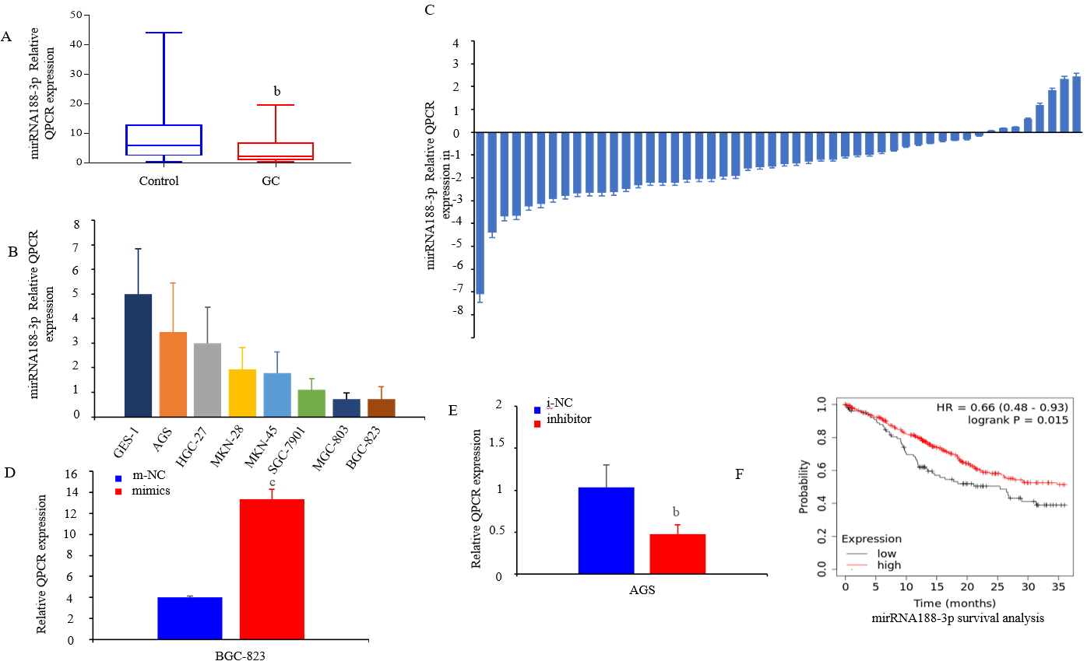
Figure 1 Expression of miR-188-3p in patients’ plasma and cell lines, and tissues of gastric cancer. A: Quantitative reverse transcriptase-polymerase chain reaction (qRT-PCR). The plasma from gastric cancer patients was processed for qRT-PCR analysis of the miR-188-3p level. The level of miR-188-3p was significantly lower in the plasma from gastric cancer patients than in that of the healthy people (^{b}P < 0.01); B: qRT-PCR. The GES-1, AGS, HGC-27, MKN-28, MKN-45, SGC-7901, MGC-803, BGC-823 cell lines were subjected to qRT-PCR analysis. The expression of miR-188-3p was highly expressed in all seven cell lines compared with that in GES-1 cells; C: qRT-PCR. Tissue samples from 50 paired gastric cancer and normal mucosa were processed for qRT-PCR analysis of miR-188-3p expression; D and E: Gene transfection and qRT-PCR assays. AGS and BGC-823 cells were subjected to transfection with miR-188-3p mimics, inhibitor, or their NC. RNA isolation and qRT-PCR analysis of miR-188-3p expression was then performed (^{b}P < 0.01); F: Kaplan-Meier survival analysis. We searched the Kaplan-Meier Plotter database data (http://kmplot.com/analysis) and performed a Kaplan-Meier analysis of the overall survival of patients stratified by miR-188-3p expression. We found that expression of miR-188-3p indicates better prognosis of gastric cancer patients. GC: Gastric cancer.
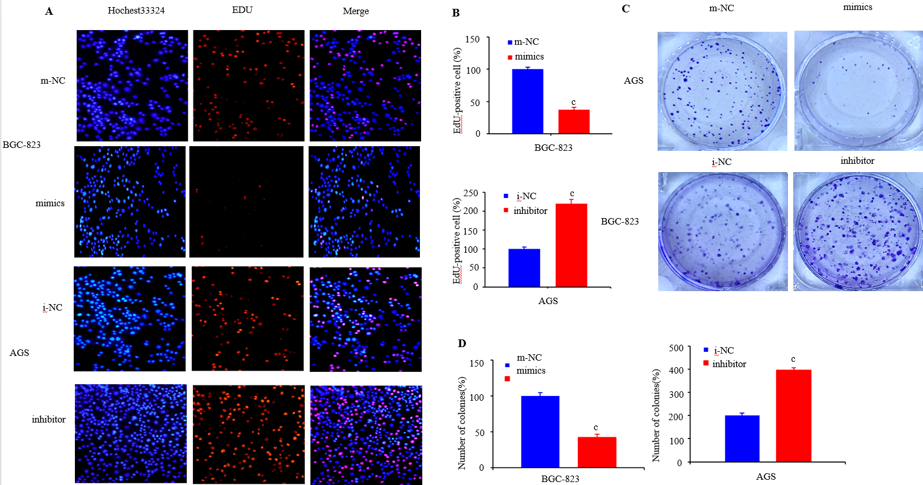
Figure 2 miR-188-3p inhibition of gastric cancer cell growth and invasion. A and B: 5-ethynyl-2-deoxyuridine (EdU) incorporation assay. AGS and BGC-823 cells were grown and transfected with miR-188-3p mimics, inhibitor, or their NC for 48 h. The EdU assay was then performed. The red fluorescence indicates EdU-positive cells, while the blue fluorescence indicates cell nuclei of all cells. The proliferation rate of tumor cells after transfection with miR-188-3p mimics was lower than that of tumor cells transfected with m-NC (^{c}P < 0.001 vs m-NC or i-NC); C and D: Plate cloning assay. AGS and BGC-823 cells were transfected with miR-188-3p mimics, inhibitor, or their NC and then assayed using the plate-cloning assay. ^{c}P < 0.001.
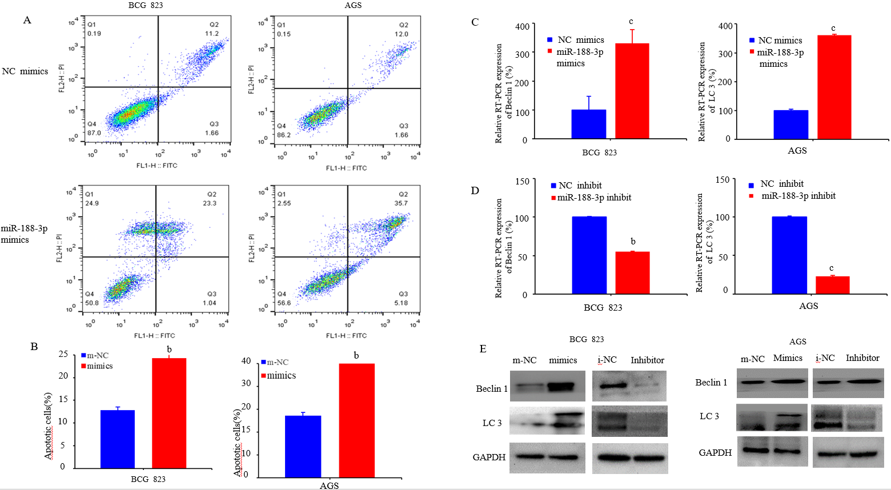
Figure 3 miR-188-3p induction of apoptosis and autophagy of gastric cancer cells. A and B: Flow cytometric/Annexin V-PE/7-AAD assay. AGS and BGC-823 cells were seeded in six-well plates for transfection with miR-188-3p mimics, inhibitor, or their NC and assayed for tumor cell apoptosis. ^{b}P < 0.01; C: qRT-PCR. AGS and BGC-823 cells were plated for transfection with miR-188-3p mimics, inhibitor, or their NC and the qRT-PCR assay was performed. ^{b}P < 0.01 and ^{c}P < 0.001; D: Western blot. AGS and BGC-823 cells were plated in 10 cm dishes for transfection with miR-188-3p mimics, inhibitor, or their NC and Western blot was conducted for the detection of Beclin-1 and LC3-II/LC3-I proteins.
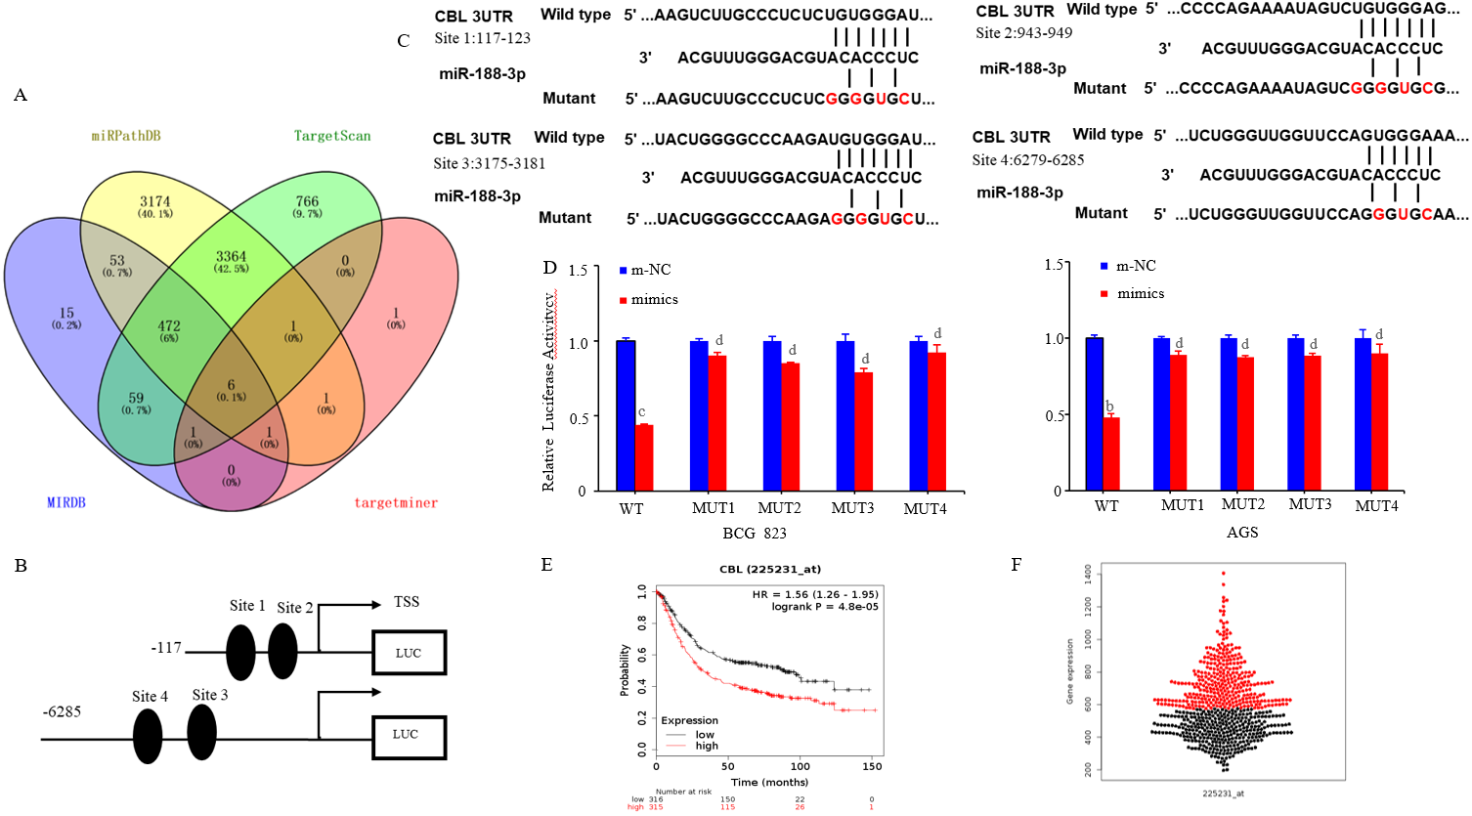
Figure 4 CBL as a direct target of miR-188-3p. A: Bioinformatic prediction of miR-188-3p gene targets. We searched the TargetScan, miRPathDB, miRDB and TargetMiner databases for possible target genes of miR-188-3p. We selected six genes and CBL (an oncogene in gastric cancer) for a confirmation study; B and C: The putative miR-188-3p-binding sites of the CBL 3′-UTR. nt, nucleotides; D: Luciferase gene reporter assay. AGS cells were seeded in six-well plates for transient transfection with miR-188-3p mimics and with the reporter plasmid containing a luciferase gene fused to the target sequence of the wild-type (WT) 3'-UTR or mutant 3’-UTR of CBL using Lipofectamine 3000 for 36 h. Tumor cells were then lysed and an equal amount of protein samples was analyzed using the Luciferase Reporter Assay System. wt, wild type; mut, mutant; site 1, the miR-188-3p motif spanning nt:117-123 nt; site 2, the motif spanning nt 943-949 nt in the CBL 3′-UTR; site 3, the motif spanning nt 3175-3181nt in the CBL 3′-UTR; site 4, the motif spanning nt 6279-6285 nt in the CBL 3′-UTR. ^{c}P < 0.001, ^{b}P < 0.01, and ^{d}P > 0.05; E and F: Kaplan-Meier survival analysis. We utilized data from the KM-Plotter database (http://kmplot.com) and TCGA dataset (http://xena.ucsc.edu/public), and performed overall survival analysis.

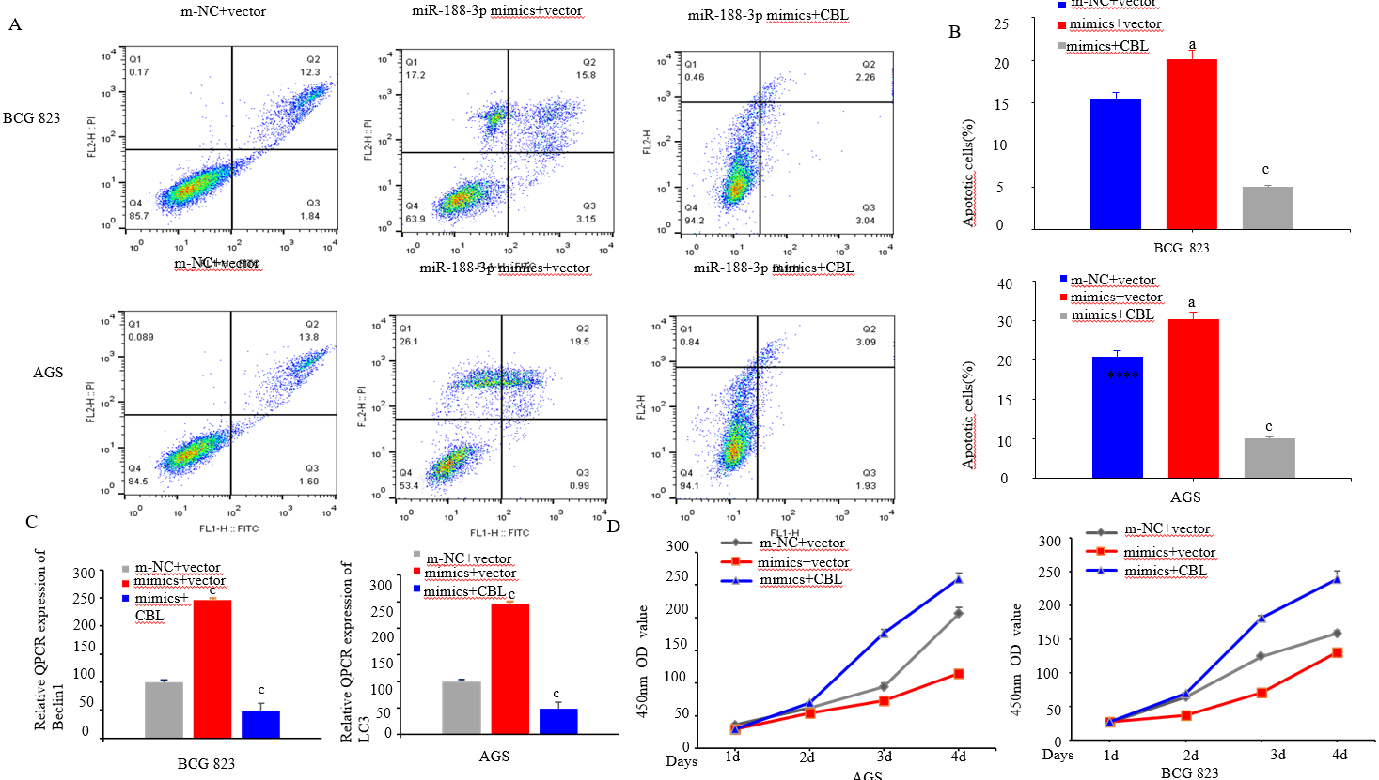
Figure 5 CBL antagonization of miR-188-3p reduced gastric cancer cell proliferation and induced gastric cancer cell apoptosis and autophagy in vitro. A and B: Flow cytometry. AGS and BGC-823 cells were transfected with miR-188-3p mimics, miR-188-3p/CBL cDNA, or m-NC, miR-188-3p mimics + vector-only, after which the flow cytometric apoptosis assay was performed. ^{c}P < 0.001; C: qRT-PCR. AGS and BGC-823 cells were transfected with miR-188-3p mimics, miR-188-3p/CBL cDNA, or m-NC, miR-188-3p mimics + vector-only, after which qRT-PCR analysis was conducted. ^{c}P < 0.001; D: CCK-8 assay. AGS and BGC-823 cells were seeded for transfection with miR-188-3p mimics, miR-188-3p/CBL cDNA, or m-NC, miR-188-3p mimics + vector-only, after which the CCK-8 assay was performed.
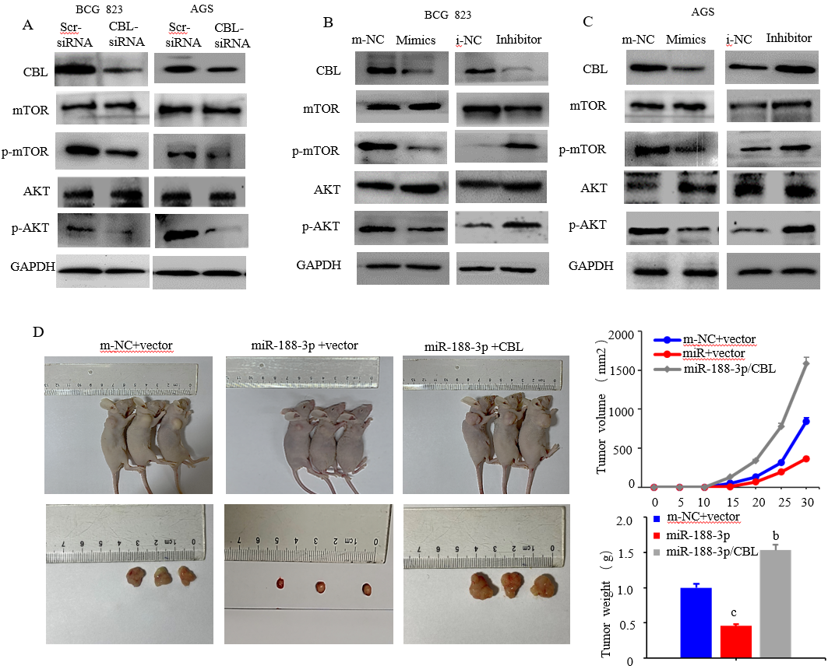
Figure 6 Effects of miR-188-3p expression on the regulation of gastric cancer cell proliferation via CBL downregulation. A: Western blot. BGC-823 cells were transfected with m-NC and vector, miR-188-3p/CBL cDNA, miR-188-3p mimics + vector-only and were then subjected to Western blotting. The expression of becline1 and phosphorylation of the Akt and mTOR proteins was decreased in gastric cancer cells after knockdown of CBL using CBL siRNA; B: Western blot. CBL, BGC-823 and AGS cells were seeded in 10 cm cell culture dishes for transfection with miR-188-3p mimic, inhibitor, or control (NC) plasmid, after which Western blot was performed; C: Nude mouse model of gastric cancer cell xenograft assay. The images of nude mouse tumor cell xenografts after injection with BGC-823/m-NC, BGC-823/miR-188-3p/CBL, or BGC-823/miR-188-3p cells; D: Tumor cell xenograft size. After tumor cell inoculation, tumor size was measured every 7 d in each group, m-NC vs miR-188-3p/CBL, ^{c}P < 0.001; miR-188-3p vs miR-188-3p/CBL cDNA, ^{c}P < 0.01.

