Name of Journal: World Journal of Gastrointestinal Oncology
Manuscript NO: 73206
Manuscript Type: ORIGINAL ARTICLE

Retrospective Study
Clinicopathological characterization of ten patients with primary malignant melanoma of the esophagus and literature review

Zhou SL et al. Clinicopathological characterization of PMME

Sheng-Li Zhou, Lian-Qun Zhang, Xue-Ke Zhao, Yue Wu, Qiu-Yu Liu, Bo Li, Jian-Jun Wang, Rui-Jiao Zhao, Xi-Juan Wang, Yi Chen, Li-Dong Wang, Ling-Fei Kong

Sheng-Li Zhou, Qiu-Yu Liu, Rui-Jiao Zhao, Ling-Fei Kong, Department of Pathology, Henan Provincial People’s Hospital, People’s Hospital of Zhengzhou University, People’s Hospital of Henan University, Zhengzhou 450003, Henan Province, China

Lian-Qun Zhang, Yue Wu, Department of Gastroenterology, Henan Provincial People’s Hospital, People’s Hospital of Zhengzhou University, People’s Hospital of Henan University, Zhengzhou 450003, Henan Province, China

Xue-Ke Zhao, Li-Dong Wang, State Key Laboratory of Esophageal Cancer Prevention and Treatment, Henan Key Laboratory for Esophageal Cancer Research, The First Affiliated Hospital, Zhengzhou University, Zhengzhou 450052, Henan Province, China

Bo Li, Department of Radiology, Henan Provincial People’s Hospital, People’s Hospital of Zhengzhou University, People’s Hospital of Henan University, Zhengzhou 450003, Henan Province, China

Jian-Jun Wang, Department of Thoracic Surgery, Henan Provincial People’s Hospital, People’s Hospital of Zhengzhou University, People’s Hospital of Henan University, Zhengzhou 450003, Henan Province, China

Xi-Juan Wang, Department of Pediatrics, Henan Provincial People’s Hospital, People’s Hospital of Zhengzhou University, People’s Hospital of Henan University, Zhengzhou 450003, Henan Province, China

Yi Chen, Clinical Research Service Center, Henan Provincial People’s Hospital, People’s Hospital of Zhengzhou University, People’s Hospital of Henan University, Zhengzhou 450003, Henan Province, China

Author contributions: Wang LD, Kong LF, and Zhou SL designed and wrote the paper; Li B, Zhang LQ, and Wang JJ performed data collection and interpretation and follow-up; Zhao XK and Wu Y contributed to data analysis; Wang XJ and Chen Y revised the manuscript; Liu QY and Zhao RJ reviewed the pathology results; all authors read and approved the final manuscript.

Corresponding author: Ling-Fei Kong, MD, PhD, Chief Doctor, Professor, Department of Pathology, Henan Provincial People’s Hospital, People’s Hospital of Zhengzhou University, People’s Hospital of Henan University, No. 7 Weiwu Road, Zhengzhou 450003, Henan Province, China. lfkong9@163.com

Received: December 2, 2021
Revised: April 24, 2022
Accepted: July 26, 2022
Published online:

Abstract
BACKGROUND
Primary malignant melanoma of the esophagus (PMME) is a rare malignant disease and has not been well characterized in terms of clinicopathology and survival.

AIM
To investigate the clinical features and survival factors in Chinese patients with PMME.

METHODS
The clinicopathological findings of ten cases with PMME treated at Henan Provincial People’s Hospital were summarized. Moreover, the English- and Chinese-language literature that focused on Chinese patients with PMME from 1980 to September 2021 was reviewed and analyzed. Univariate and multivariate analyses were employed to investigate the clinicopathologic factors that might be associated with survival.

RESULTS
A total of 290 Chinese patients with PMME, including ten from our hospital and 280 from the literature were enrolled in the present study. Only about half of the patients (55.8%) were accurately diagnosed before surgery. Additionally, 91.1% of the patients received esophagectomy, and 88 patients (36.5%) received adjuvant therapy after surgery. The frequency of lymph node metastasis (LNM) was 51.2% (107/209), and LNM had a positive rate of 45.3% even when the tumor was confined to the submucosal layer. The risk of LNM increased significantly with the pT stage [P < 0.001, odds ratio (OR): 2.47, 95% confidence interval (CI): 1.72-3.56] and larger tumor size (P = 0.006, OR: 1.21, 95%CI: 1.05-1.38). The median overall survival (OS) was 11.0 mo (range: 1-204 mo). The multivariate Cox analysis showed both the pT stage [P = 0.005, hazard ratio (HR): 1.70, 95%CI: 1.17-2.47] and LNM (P = 0.009, HR: 1.78, 95%CI: 1.15-2.74) were independent prognostic factors for OS. The median disease-free survival (DFS) was 5.3 mo (range: 0.8-114.1 mo). The multivariate analysis indicated that only the advanced pT stage (P = 0.02, HR: 1.93, 95%CI: 1.09-3.42) was a significant independent indicator of poor RFS in patients with PMME.

CONCLUSION
The correct diagnosis of PMME before surgery is low, and physicians should pay more attention to avoid a misdiagnosis or missed diagnosis. Extended lymph node dissection should be emphasized in surgery for PMME even though the tumor is confined to the submucosal layer. Both the LNM and pT stage are independent prognosis factors for OS, and the pT stage is the prognosis factor for DFS in patients with PMME.

Key Words: Primary malignant melanoma of the esophagus; Clinicopathological characteristics; Treatment; Recurrence; Survival

Zhou SL, Zhang LQ, Zhao XK, Wu Y, Liu QY, Li B, Wang JJ, Zhao RJ, Wang XJ, Chen Y, Wang LD, Kong LF. Clinicopathological characterization of ten patients with primary malignant melanoma of the esophagus and literature review. World J Gastrointest Oncol 2022; In press

Core Tip: Primary malignant melanoma of esophagus (PMME) is a rare malignant disease. We comprehensively analyzed the clinicopathological characteristics of 290 Chinese patients with PMME. Only about half of the patients were accurately diagnosed before surgery. The positive rate of lymph node metastasis (LNM) was 45.3% even the tumor confined to the submucosal layer. The median overall survival (OS) and disease-free survival were 11.0 mo and 5.3 mo, respectively. Cox analysis showed that both pT stage and LNM were the independent prognostic factors for OS, while only advanced pTNM stage was a significant independent indicator of poor RFS in patients with PMME.

INTRODUCTION
Primary malignant melanoma of the esophagus (PMME) is the most common non-epithelial malignancy in the esophagus^{[1]}, which comprises approximately 0.2% of all tumors of the esophagus^{[2]}. Until now, only several hundred cases of PMME have been reported in the literature, most as case reports^{[3]}. The limited sample size restricted research on the malignancy. Reports on Chinese PMME are limited, although some areas of China have a high incidence of esophageal cancer. Large studies on Chinese PMME were reported by Wang et al^{[4]} (n = 76), Dai et al^{[5]} (n = 70), Sun et al^{[6]} (n = 21), and Chen et al^{[7]} (n = 20). PMME has the following characteristics: Difficult to diagnosis, rapid progression, high rate of recurrence and metastasis, and poor prognosis. The median survival of PMME in China is 13.5 mo^{[5]}. To date, the diagnosis, treatment, and pathological staging of PMME follow the guidelines for esophageal cancer^{[5]}. Systematically analyzing the clinicopathologic features and the possible prognostic factors of PMME will improve the effectiveness of its diagnosis and treatment.
In this retrospective study, we presented ten cases of PMME encountered at Henan Provincial People’s Hospital, together with a systematic analysis of 280 Chinese patients with PMME collected from both the English- and Chinese-language literature, with the aim of analyzing the clinicopathological and prognostic characteristics of Chinese patients with PMME.

MATERIALS AND METHODS
Summary of ten cases in our hospital
The records of 12 patients with PMME were retrieved at Henan Provincial People’s Hospital from January 1990 to September 2021. Two patients were excluded because of a history of cutaneous melanoma. The clinical data of the remaining ten patients, including gender, age, symptoms, endoscopic and radiographic examination, tumor location, tumor size, operative time, tumor node metastasis (TNM) stage, and others were collected. All of the ten patients were confirmed by endoscopic biopsy and four of them received surgical treatment. None of them had a history of melanoma in the skin or other malignancy history.
The tumor diagnostic evaluation was reviewed and confirmed by two independent pathologists. In order to be consistent with the published literature, the clinical and pathological stages were reassessed according to the 7th edition of the Union for International Cancer Control (UICC) TNM classification system. Follow-ups were performed by telephone and the outpatient medical record system, and the complete follow-up data should include survival status, cause of death, and time of death.
The present study was approved by the Institutional Review Board of Henan Provincial People’s Hospital, and it conformed to the provisions of the Declaration of Helsinki. Written informed consent was obtained from all individuals before biopsy or surgery.

Review of the literature
A systematic literature review was performed in databases of China BioMedical Literature on Disc (CBMdisc), and Medical Literature Analysis and Retrieval System online (MEDLINE). Relevant publications were identified using the following terms and keywords: ‘‘Malignant melanoma of the esophagus’’ or ‘‘Malignant melanoma’’ and ‘‘Esophagus’’. The last search was updated on September 1, 2021. References of the retrieved articles were further reviewed to find other potential eligible studies. The title and abstract were first screened, followed by full text assessing for eligibility. Each step was independently conducted by two researchers, results were compared, and differences were resolved by consensus.

Inclusion and exclusion criteria
To be eligible for inclusion in this meta-analysis, the article must meet the following criteria: (1) Describing studies on PMME in Chinese population; (2) Providing detailed information of each patients, including gender and age; and (3) Providing pathology diagnosis. Articles were excluded due to the following reasons: (1) Studies were not focused on Chinese population; (2) Meta-analysis or reviews; (3) There was no detailed information of each patients; (4) Content repeats in different articles; and (5) Accompanied with other malignancies, including melanoma in other body parts simultaneously or heterogeneously.

Data extraction
Data from retrieved articles were independently collected by two reviewers. The following information was extracted from each study: First author, year of publication, and detailed information of each patients. In event of inconsistent evaluations, a third investigator was consulted to resolve the dispute and made the final decision.

Statistical analysis
Descriptive or frequency analysis was used for basic information analysis. Numerical variables are expressed as the mean ± SD. Statistical differences were evaluated by χ² test or t test. The effects of the clinicopathologic factors on lymph node metastasis (LNM) was evaluated using univariate and multivariate logistic-regression models. The Kaplan- Meier method was used to assess associations between clinicopathological characteristics and survival outcome. Univariate and multivariate analyses were performed using Cox regression. Hazard ratios (HRs) and 95% confidence intervals (CIs) were calculated. The log-rank test was used to compare survival curves. All statistical tests were two-sided. P values less than 0.05 were considered statistically significant. All statistical analyses were conducted using SPSS 21 (IBM Corporation, Waltham, NY, United States).

RESULTS
Clinicopathological characteristics of ten PMME patients at our hospital
The clinicopathological characteristics of ten PMME patients are summarized in Table 1. There were six men and four women. The ages ranged from 47 years to 80 years with a mean age of 62.2 ± 9.9 years. Although the mean age of female patients (68.3 ± 10.4 years) was much older than that of the male patients (58.0 ± 7.8 years), there was no statistical difference (P = 0.111). Eight of them presented with dysphagia as the main symptom (80%, 8/10), and the other two had retrosternal pain or bellyache. Six of them also had an esophagography and computerized tomography (CT) scan. The esophagography revealed mucosa destruction and an irregular filling defect of the esophageal lumen (Figure 1A). The CT scan showed polypoid masses in the esophagus (Figure 1B). There were one, six, and three patients having the masses located at the upper, middle, and lower portion of the esophagus, respectively.
All of the ten patients had a preoperative esophagoscopy and biopsy pathology. The endoscopy manifestations were polypoid or a protuberant mass (n = 7), ulcerative mass (n = 1), and superficial lesion (n = 2). About half of the patients had pigment deposition on the surface of the tumors (Figure 1C and D). Nine patients had an accurate preoperative diagnosis of PMME, but the remaining one who was initially diagnosed with poor differentiated carcinoma by biopsy pathology, was eventually diagnosed with PMME by postoperative pathology (Figure 1E and F). There were four patients who received surgery and two who received chemoradiotherapy only. A postoperative pathological examination of the four patients showed that the lesions of two cases were confined to the submucous layer (T1b), and two had lesions extended to the muscularis propria (T2). The mean number of lymph nodes dissected in surgery was 14.5 ± 6.1 (range: 6-19). Notably, none of the four patients had LNM.
Five of the six patients who received treatments at our hospital were successfully followed up. One was still alive until the last follow up, but the remaining four died because of recurrence or metastasis. The median survival time was 24.5 mo (range: 3-31.9 mo).

Characteristics of selected studies
The literature flowchart (Supplementary Figure 1) exhibits the entire selection process from the eligible studies. The search can be traced using the publication date from 1979 to September 2021. A total of 122 studies were collected using the inclusion and exclusion criteria, including 98 articles in Chinese and 24 in English. Finally, a total of 280 patients diagnosed with PMME were enrolled in the study. The main characteristics of the included studies^{[4,6-126]} as well as the corresponding clinicopathological features are summarized in the Supplementary Table 1. Finally, a total of 290 patients, including the ten cases recruited from our hospital and the 280 cases collected from the literature, were subjected to subsequent analysis. The clinicopathological characteristics are shown in Table 2.

Gender, age, and tumor location
Each case of the 290 cases had gender, age, tumor location, and pathology documents. There were 200 males and 90 females with a male-to-female ratio of 2.2:1. Their ages ranged from 26 to 84 years, with a mean age of 58.5 ± 9.7 years. No significant difference was found in age between male and female patients (male: 58.6 ± 9.1 years; female: 58.3 ± 11.1 years).
Most of the tumors (274/290, 94.6%) were located in the middle (n = 138) or lower (n = 136) of the esophagus, and only 16 cases (5.4%) had the tumors located in the upper esophagus. Interestingly, the tumors in female patients were prone to being located in the upper esophagus (62.5%, 10/16), and conversely, tumors in male patients were more often located in the both middle and lower esophagus (72.3%, 198/274, P = 0.003).

Symptoms and duration
There were 277 patients who had their main symptoms documented. The most common symptom was dysphagia (219, 79.1%), followed by retrosternal pain (31, 11.2%), bellyache (11, 4.0%), poor food intake with no obvious incentive (6, 2.2%), and hematemesis or melena (2, 0.7%), respectively. Eight (2.9%) patients were asymptomatic and had the tumors detected in the physical examination. The interval between the diagnosis of the disease and the onset of symptom occurrence was documented in 188 patients. The symptom duration ranged from 0.2-36 mo, with a median of 2.0 mo.

Imaging examination
Notably, there were 147 patients who had detailed information of upper gastrointestinal barium esophagogram and CT. For most of them, the esophagography revealed mucosa destruction, irregular filling defect, and narrowness of the esophageal lumen. The CT examination mainly showed bulky or polypoid and intraluminal obstructive masses in the esophagus.

Endoscopic biopsy and treatment
About 181 patients had preoperative endoscopy documents. The most common manifestation of the endoscopy was an irregular segmented, lobular, polypoid, or segmented intraluminal tumor mass. Half of the tumors had a rough, eroded, and friable and easily bleeding surface (87/181, 48.1%). Six patients failed to have the mucosa biopsy taken because it bled readily.
The detailed pathological results of the preoperative biopsy were described in 206 patients. Only 115 (55.8%) of the 206 patients were accurately diagnosed as having PMME. Biopsy pathology of the remaining cases were as follows: Poorly differentiated carcinoma (39/206, 18.9%), squamous cell carcinoma (15.5%, 32/206), adenocarcinoma (4.9%, 10/206), and high-grade dysplasia or nonneoplastic lesions (4.9%, 10/206).
Treatment was documented in 257 of the 290 patients (88.6%). The majority of the cases (234/257, 91.1%) accepted esophagogastrostomy or subtotal esophagectomy, and seven (2.7%) patients accepted endoscopic submucosal dissection (ESD). Besides surgery or ESD, 88 (88/241, 36.5%) patients also received adjuvant therapy, including radiotherapy, chemotherapy, and immunotherapy. There were 16 (6.2%) cases that only received adjuvant therapy without surgery.

Tumor number and size
Multiple tumors were defined as there was at least one satellite nodule or it was scattered with a black pigmented spot near the primary tumor. The tumor size of multiple tumors was calculated as the size of the primary tumor instead of the sum of multiple tumors. There were 71.9% of PMME masses that had a pigmented surface. Seventy-four (61.8%) cases had single tumors, and 46 (38.2%) had multiple tumors. The mean size was 5.2 ± 2.9 cm (range: 0.3-17.0 cm). The mean tumor size in males was significantly longer than that in female patients (P < 0.001, Figure 2A). Additionally, the tumor size was significantly correlated with tumor location (P < 0.001), and the mean tumor size was much shorter when the tumor was located in the upper thoracic esophagus (Figure 2B). No difference was found in tumor size between single and multiple tumors (single: 5.2 ± 2.8 cm; multiple: 5.3 ± 3.1 cm; P = 0.895).

Gross classification and TNM stage
There were 244 patients who had gross classification documents. The most common subtype was polypoid (194/244, 79.5%), followed by ulcerative (n = 29, 11.9%), superficial (n = 14, 5.7%), medullary (n = 6, 2.5%), and constrictive subtypes (n = 1, 0.4%).
There were 213 patients who had depth of tumor invasion documents. Pathological examination revealed that the tumors in 45.6% of the PMME patients were limited to submucosal layer, including 14 (6.6%) cases restricted to the mucosa (T1a) and 83 (39.0%) restricted to the submucosal layer (T1b). The number of patients with tumor extension to the muscularis propria (T2), fibrous membrane (T3), and outer membrane (T4) was 67 (31.4%), 40 (18.8%), and 9 (4.2%), respectively. No correlation was found between the tumor infiltration depth and clinical characteristics (P > 0.05; data not shown).
Totally, 209 patients had LNM documents. The mean number of lymph nodes dissected in surgery was 11.7 ± 8.9 (range: 1 to 43). The positive rate of LNM was 51.2% (102/209). The correlation between LNM and clinicopathological features is shown in Table 3. Significantly, no LNM was found when the tumor was confined to the mucous layer (T1a). The risk of LNM was significantly increased with the progression of the pT stage [P < 0.001, odds ratio (OR): 2.47, 95%CI: 1.72-3.56]. The size for the tumors with LNM was significantly larger than that of tumors without (P < 0.001, OR: 1.24, 95%CI: 1.09-1.42). A regression analysis found that the risk of LNM was associated with both the pT stage and tumor size (pT stage: P < 0.001, OR: 2.22, 95%CI: 1.47-3.33; tumor size: P = 0.006, OR: 1.21, 95%CI: 1.05-1.38).

Local recurrence and distant metastasis
Eighty-four patients had records for local recurrence and distant metastasis, and 16 cases were combined with distant metastasis in addition to local recurrence. The precise sites of the distant metastasis were well documented in 74 cases. A total of 94 PMME metastatic sites were affected in the 74 patients; 19 cases had two sites involved, and 5 had three sites involved synchronously or metachronously. Both the lung (n = 26, 27.7%) and liver (n = 24, 25.5%) were the sites most frequently involved, followed by the lymph nodes (including those of the enterocoelia, neck, mediastinum, and axilla, n = 19, 20.2%), brain (n = 8, 8.5%), bone (n = 6, 6.4%), and other locations. The detailed distant metastasis locations are shown in Figure 3.

Overall and disease-free survival
The follow-up data were documented in 179 patients. Three patients died of serious complications during the preoperative period. Two cases were lost after surgery at 12 and 33 mo, respectively. After excluding the five patients, the survival analysis was performed on the remaining 174 patients. There were 116 cases (65.9%) with cancer-specific deaths and 58 (32.9%) were still alive at the time that the articles were published. The median overall survival (OS) of 174 patients was 11.0 mo (range: 1-204 mo), and the 1-, 3-, and 5-year survival rates were 57%, 25%, and 12%, respectively (Figure 4A).
We compared the OS rate between the different clinicopathological characteristics of the PMME patients (Table 4). As shown in Figure 5A, patients at pT1b (n = 60) or advanced pT stages (n = 79) had a significantly worse prognosis than patients at T1a stage (n = 12, P = 0.01 and P = 0.001, respectively). Moreover, the prognosis of patients at the pT1b stage was much better compared with patients at advanced pT stage (P = 0.03, Figure 5A). In addition, the LNM-positive group had a significantly poorer prognosis compared with the LNM-negative group (P < 0.001, Figure 5C). As for the pathological tumor node metastasis (pTNM) stages, both the stage II and stage III/IV groups had a worse prognosis than the stage I group (P < 0.001, Figure 5E). Furthermore, patients with a superficial subtype had a significantly longer OS time than patients with other gross classifications (P = 0.02, Figure 5G). Male patients tended to have a worse prognosis compared with female patients (P = 0.08). A multivariate analysis demonstrated that both pT and LNM were independent prognostic factors for PMME patients (pT stage: P = 0.005, HR: 1.70, 95%CI: 1.17-2.47; LNM: P = 0.009, HR: 1.78, 95%CI: 1.15-2.74).
For disease-free survival (DFS), only 36 cases had detailed documents. The median DFS was 5.3 mo (range: 0.8-114.1 mo), and the 1-, 3-, and 5-year survival rates were 33%, 11%, and 6%, respectively (Figure 4B). Similar to the OS, the DFS of the patients at T1a was significantly better than that of patients at advanced pT stages (P = 0.01, Figure 5B). Patients at pTNM I had a better RFS compared with patients at pTNM II-IV (P = 0.02, Figure 5F). Furthermore, the DFS of patients with superficial subtype was significantly longer than patients with other gross classifications (P = 0.007, Figure 5H). Moreover, LNM-positive patients also tended to had a worse DFS than LNM-negative patients (P = 0.07; Figure 5D). Multivariate analysis demonstrated that only pT stage was the independent DFS prognostic factor for patients with PMME (P = 0.02, HR: 1.93, 95%CI: 1.09-3.42) (Table 4).

DISCUSSION
Primary mucosal melanomas can be found in the mucosal membranes of the respiratory, gastrointestinal, and genitourinary tracts^{[127-129]}. Distant metastasis is not uncommon in mucosal melanomas^{[127-129]}. PMME is a rare disease with aggressive behavior and poor prognosis. To date, the majority of the existing studies were case reports on the Asian population. It is difficult to conduct a comprehensive retrospective study of patients with PMME. In this study, we tried to investigate the present status of PMME in China by systematically analyzing the clinicopathologic and prognostic characteristics of 290 Chinese patients with PMME.
The male-to-female ratio of PMME was 2.2:1, and the mean age was 58.5 ± 9.7 years. The most common site was the middle and lower thoracic esophagus, which accounted for 94.5%. All of the features resembled those of esophageal squamous cell carcinoma (ESCC), a major form of esophageal malignancies in China. The male-to-female ratio of Japanese patients with PMME was 3.5:1, and the median age was 64.5 years^{[130]}, which was much higher than that of Chinese patients. In Western populations, male patients were only a little more than female ones with a male-to-female ratio of 1:3.1, and the mean age was 71.8 ± 13.6 years^{[131]}. This distinction suggested that there might be different tumorigeneses between the Asian and Western populations with PMME. Both the middle and lower esophagus were the most common location of PMME for the Asian and Western populations^{[130,131]}. Additionally, our results showed that the tumor masses of female patients were prone to being located in the upper esophagus compared with males, which prompted that an endoscopist should pay more attention to the upper thoracic esophagus of female patients to avoid missing an early lesion even though PMME is rare in the upper of the esophagus.
Polypoid lesions (79.5%) were the predominant gross classification of PMME, many of which are relatively soft, friable, and easily bleed. Sometimes, it was mistaken for phlebangioma under endoscopy^{[36,86,105]}. There were only 5% of patients with PMME who had superficial lesions. The physician and endoscopist might be unfamiliar with the manifestations of PMME at early stage. In one patient from Kunming City, China, who presented with retrosternal pain after eating for 7 d, the first endoscopy showed several black lesions scattered throughout the middle esophagus. He was misdiagnosed because the doctor was unfamiliar with PMME. After 8 mo, the second endoscopy showed a polypoid lesion. The patient died 3 mo after surgery because of systemic metastasis^{[48]}.
The pathognomonic endoscopic finding of PMME is pigmentation. Our results showed that about 71.9% of PMME masses had a pigmented surface, which was similar to a previous study^{[131]} showing that 26.9% of the lesions were amelanotic. These results suggested that the absence of pigmentation does not necessarily exclude PMME^{[3,132]}. PMME is always surrounded by satellite lesions. Our results showed that one third of patients had multiple lesions, which was a little higher than that in Japanese patients^{[3]}, perhaps because one third of Japanese patients had superficial lesions. Physicians and endoscopists should enhance their awareness of rare diseases of the esophagus, paying particular attention to early lesion, to avoid missed diagnosis and misdiagnosis.
In our study, only 55.8% of patients were clearly diagnosed by biopsy before surgery, which was similar to previous studies^{[5-7]}. The possible reasons for PMME misdiagnosis were as follows^{[5,6]}: (1) Limited biopsy tissue without enough immunohistochemical analysis; (2) Lacking experience in the diagnosis of PMME in clinical practice; (3) Some tumors had no pigmented surface or no melanin granules in the cytoplasm; and (4) The lesion tissue was not biopsied by endoscopy because it bled readily. An accurate diagnosis could be obtained by immunohistochemical analysis. Human melanoma black antibody 45 (HMB45), melanoma antigen protein (Melan-A), and S100 are the specific diagnostic indicators for melanoma.
Melanoma might be associated with cancer predisposition syndromes^{[133]}. In addition, a history of melanoma approximately increase the risk of subsequent melanoma^{[134]}. Thus, multiple imaging diagnostics were employed in PMME and other mucosal melanoma to evaluate primary tumor, metastasis, and treatment responses^{[127]}. Ultrasonography, endoscopic ultrasound, CT, magnetic resonance imaging, and positron emission tomography (PET) contribute to the information for diagnosis and management^{[127]}. PET/CT improves the diagnosis, staging, treatment evaluation, and surveillance of tumors. It is currently considered to be the most sensitive method for the identification of metastatic lesions of solid tumors and has a huge impact on patient management^{[127]}.
The tumor size of PMME had a wide range, and the mean value was 5.2 ± 2.7 cm, which was similar to Japanese patients^{[130]}. Previous studies^{[3,135,136]} considered that PMME is prone to spread longitudinally, and local recurrence is frequently found soon after surgery. Thus, PMME should be resected with adequate margins. Masses in male patients had a significantly larger tumor size than that in female patients. Men might endure symptoms longer than women before seeking medical care^{[137]}.
The overall LNM-positive rate in our study was 51.2%. Our results showed that nearly half of PMME were at early pT stage, which was different from ESCC - mainly at the advanced pT stage. There were 52.2% of Japanese patients with PMME limited to the submucosal layer^{[130]}. No LNM was found in patients at the pT1a stage in the present study and a previous study^{[50]}. Interestingly, the frequency of LNM increased sharply to 45.3% in our study when the primary tumor was at the pT1b stage. Dai et al^{[5]} found that the rate of LNM was as high as 54.2% among patients with pT1 tumors. The risk of LNM increased about 2.5 times along with the deeper depth of the tumor invasion. Previous studies^{[5,130]} also indicated that with a deeper tumor invasion, the probability of LNM was higher. PMME might metastasize through blood or lymph vessels at early stage. Extended lymph node dissection combined with radical esophagectomy should be emphasized even when the tumor is at the pT1b stage.
The median OS of patients with PMME was 11 mo and the 5-year OS was 12%, which were similar to those of the previous studies^{[5,7]}. Japanese patients with PMME have a relatively better survival with a 5-year OS of 25.3%^{[130]}. For the Western population with PMME, the 3-year OS was only 7.3%^{[131]}. It seems the Western population with PMME has a worse survival rate compared with the Asian population, which might be related to elder age of the diagnosed Western patients. Furthermore, PMME patients had poorer outcomes compared with common malignancies of the esophagus (ESCC, adenocarcinoma, and small cell carcinoma)^{[131]}. It is necessary to employ a multidisciplinary team to improve treatments and outcomes for patients with PMME^{[5]}.
Multivariate analysis showed that pT (depth of tumor invasion) is an independent prognostic factor for both OS and DFS in patients with PMME. Patients at pT1 had better OS, which was also found in previous studies focused on the Chinese^{[5]} and Japanese^{[130]} populations. As mentioned previously, LNM was extremely rare for the tumor at pT1a, and it increased rapidly for tumors at pT1b or the advanced pT stage.
LNM was also an independent prognostic factor for OS. Previous studies on Chinese^{[5,7,50]} and Japanese^{[130]} patients also suggested that LNM was strongly associated with a poor prognosis. However, no influence of LNM on prognosis was found in the Western population^{[131]}. Furthermore, Dai et al^{[5]} showed that ≥ 12 lymph nodes dissected was an independent factor for OS and DFS. A thorough lymph node dissection should be emphasized in the surgical treatment of PMME.
Patients at an advanced pTNM stage, including II-IV, had a significantly worse OS and DFS compared with patients at pTNM I. Similar results were also found in previous studies^{[4,5]}. Our results and others^{[4,5]} suggested that TNM stage of PMME according to the AJCC classification for esophageal cancer might discriminate the prognosis of patients with PMME. Although the TNM stage in accordance with the mucosal melanoma classification could also separate the survival curves, the difference was not statistically significant^{[6]}. Further study is needed to confirm the standard staging system of PMME^{[6]}.
Until now, treatment consensus on PMME had not been established because of its low prevalence. Surgery is still the primary option for resectable tumors. The median OS for patients who received immunotherapy besides surgery and chemoradiotherapy tended to be longer than patients who received surgery plus chemoradiotherapy or patients who only received surgery. However, there was no apparent difference in DFS between patients who received adjuvant therapy in addition to surgery and those who only received surgery. A comparison of the prognosis between surgery and adjuvant therapy was not conducted because there were only four patients successfully followed who only received adjuvant treatments. Many studies tried to seek optional treatments for patients with PMME. Dai et al^{[5]} indicated that adjuvant therapy could improve both DFS and OS of patients with PMME. Wang et al^{[4]} also suggested that postoperative chemotherapy could improve DFS. Additionally, PD-1 inhibitors might be a viable option for patients with PMME because the tumor has a dramatically high response rate to PD-1 checkpoint inhibitor monotherapy^{[4]}. Systemic treatment of PMME, including surgery, chemoradiotherapy, and immunotherapy, should be used to improve multidisciplinary treatments and outcomes for patients with PMME.
Male patients tend to have a worse prognosis compared with female patients. Previous studies indicated that male gender was an independent prognostic predictor of PMME^{[5,6,128]}. Our results also found that male patients had a larger tumor size compared with female patients. The serum estradiol significantly decreased in both male and female patients with ESCC or precancerous lesions^{[138]}; moreover, the expression of estrogen receptor in precursor lesions of the esophagus changed during the multistage process of esophageal carcinogenesis^{[139]}. All those phenomena suggested that estrogen might play an important role in esophageal malignancy.

CONCLUSION
PMME is a rare esophageal malignancy with a poor prognosis. Because of the low rate of correct diagnosis before surgery, physicians and endoscopists should develop their awareness of rare diseases of the esophagus, paying particular attention to early lesions. Extended lymph node dissection combined with radical esophagectomy should be stressed because of multifocality and high frequency of LNM — even the depth of the tumor invasion is limited to within the submucosal layer. Both the LNM and pT stage are independent prognostic factors for the OS, while only pT stage was identified to be an independent prognostic factor for the DFS of patients with PMME. Adjuvant treatment, particularly immunotherapy, might be used in clinical practice to improve multidisciplinary treatments and the prognosis of patients with PMME.

ARTICLE HIGHLIGHTS
Research background
Primary malignant melanoma of the esophagus (PMME) is a rare malignant disease. It has not been well characterized in terms of clinicopathology and survival.

Research motivation
The clinical features, survival, and prognostic factors of Chinese patients with PMME are not comprehensively analyzed until now.

Research objectives
This study aimed to investigate the clinical features, survival, and prognostic factors of Chinese patients with PMME.

Research methods
The clinicopathological findings of ten cases with PMME treated at our hospital and 280 cases from both the English- and Chinese-language literature which focused on Chinese patients with PMME were analyzed.

Research results
Only about half of the patients (55.8%) were accurately diagnosed before surgery. Lymph node metastasis (LNM) was easy to be found with a positive rate of 45.3% even when the tumor was confined in the submucosal layer. The risk of LNM was significantly raised along with the increase of pT stage (P < 0.001) and larger tumor size (P = 0.006). The median overall survival (OS) and disease-free survival (DFS) were 11 mo and 5.3 mo, respectively. Multivariate Cox analysis showed that both pT stage (P = 0.005) and LNM (P = 0.009) were independent prognostic factors for OS, but only advanced pT stage (P = 0.02) was identified to be a significant independent indicator of poor RFS in patients with PMME.

Research conclusions
Correct diagnosis of PMME before surgery is low. Both LNM and pT stage are the independent prognosis factors for OS, but only pT stage was identified to be an independent indicator for DFS of patients with PMME.

Research perspectives
Physicians and endoscopists should develop their awareness of rare diseases of the esophagus, paying particular attention to early lesions. Extended lymph node dissection combined with a radical esophagectomy should be stressed because of multifocality and a high frequency of LNM. Adjuvant treatment, particularly immunotherapy, might be used in clinical practice to improve multidisciplinary treatments and the prognosis of patients with PMME.

REFERENCES
1 Lam AK. Updates on World Health Organization classification and staging of esophageal tumors: implications for future clinical practice. Hum Pathol 2021; 108: 100-112 [PMID: 33157124 DOI: 10.1016/j.humpath.2020.10.015]
2 Lam KY, Law S, Wong J. Malignant melanoma of the oesophagus: clinicopathological features, lack of p53 expression and steroid receptors and a review of the literature. Eur J Surg Oncol 1999; 25: 168-172 [PMID: 10218460 DOI: 10.1053/ejso.1998.0621]
3 Schizas D, Mylonas KS, Bagias G, Mastoraki A, Ioannidi M, Kanavidis P, Hasemaki N, Karavokyros I, Theodorou D, Liakakos T. Esophageal melanoma: a systematic review and exploratory recurrence and survival analysis. Dis Esophagus 2019 [PMID: 31665346 DOI: 10.1093/dote/doz083]
4 Wang X, Kong Y, Chi Z, Sheng X, Cui C, Mao L, Lian B, Tang B, Yan X, Si L, Guo J. Primary malignant melanoma of the esophagus: A retrospective analysis of clinical features, management, and survival of 76 patients. Thorac Cancer 2019; 10: 950-956 [PMID: 30864295 DOI: 10.1111/1759-7714.13034]
5 Dai L, Wang ZM, Xue ZQ, He M, Yuan Y, Shang XQ, Chen KN; Chinese Cooperative Primary Malignant Melanoma of the Esophagus Group (CCPMMEG). Results of surgical treatment for primary malignant melanoma of the esophagus: A multicenter retrospective study. J Thorac Cardiovasc Surg 2020 [PMID: 32359897 DOI: 10.1016/j.jtcvs.2020.03.006]
6 Sun H, Gong L, Zhao G, Zhan H, Meng B, Yu Z, Pan Z. Clinicopathological characteristics, staging classification, and survival outcomes of primary malignant melanoma of the esophagus. J Surg Oncol 2018; 117: 588-596 [PMID: 29266237 DOI: 10.1002/jso.24905]
7 Chen H, Fu Q, Sun K. Characteristics and prognosis of primary malignant melanoma of the esophagus. Medicine (Baltimore) 2020; 99: e20957 [PMID: 32664098 DOI: 10.1097/MD.0000000000020957]
8 Ai L, Chen HX, Lu H. Primary malignant melanoma of esophagus: case report. Zhongguo Yixue Yingxiang Jishu 2021; 37: 511 [DOI: 10.13929/j.issn.1003-3289.2021.04.007]
9 Liu ZJ, Geng TT, Gao SM. Primary melanoma of lower esophagus: report of one case. Zhongguo Linchuang Yixue Yingxiang Zazhi 2020; 31: 70-71
10 Li J, Li X, Song QY, Ge QY, Zhang ZH. Primary malignant melanoma of esophagus: a clinicopathological analysis of 6 cases. Zhonghua Bingli Xue Zazhi 2020; 49: 1317-1319 [DOI: 10.3760/cma.j.cn112151-20200319-00235]
11 Lou J, Niu TT, Wang Y, Hou GQ. Primary malignant melanoma of esophagus with gastric metastasis: A case report. Guoji Yiyao Weisheng Daobao 2020; 26: 1122-1123
12 Sun XJ, Zhang W, Hua HY, Li P, Zhang PT. Clinical analysis of primary malignant melanoma of esophagus. Linchuang He Shiyan Yixue Zazhi 2019; 18: 480-483
13 Zhang RX, Li YY, Liu CJ, Wang WN, Cao Y, Bai YH, Zhang TJ. Advanced primary amelanotic malignant melanoma of the esophagus: A case report. World J Clin Cases 2019; 7: 3160-3167 [PMID: 31624769 DOI: 10.12998/wjcc.v7.i19.3160]
14 Li J. Primary esophageal malignant melanoma: a case report and literature review. Zhongguo Minkang Yixue 2019; 31: 129-130 [DOI: 10.3969/j.issn.1672-0369.2019.12.054]
15 Song YY, Zhu Y, Ding C. Three cases of primary malignant melanoma of the esophagus. Zhongguo Xiong Xinxueguan Waike Linchuang Zazhi 2019; 26: 192-194 [DOI: 10.7507/1007-4848.201804003]
16 Chen LX, Liu P, Gan MF. One case of primary malignant melanoma of the esophagus. Shiyong Zhongliu Zazhi 2019; 34: 265-267 [DOI: 10.13267/j.cnki.Syzlzz.2019.03.015]
17 Li HJ, Yang JQ. One case of primary malignant melanoma of the esophagus. Yunnan Yiyao 2019; 40: 190-191
18 Liu QH, Long ZQ, Huang WM, Shang XQ, Li J. Clinical analysis of 6 cases of malignant melanoma of the esophagus. Zhongguo Yiyao Daobao 2018; 15: 109-112
19 Ling C, Feng J, Li J, Liu Q. Primary malignant melanoma of the esophagus. Turk J Gastroenterol 2018; 29: 711-713 [PMID: 30289400 DOI: 10.5152/tjg.2018.18065]
20 Wei XJ, Zhang YN, Liu WH, Zheng XD, Zhang SH, Zhou XG. Primary malignant melanoma of esophagus. Zhonghua Bingli Xue Zazhi 2018; 47: 548-550 [DOI: 10.3760/CMA.J.ISSN.0529-5807.2018.07.015]
21 Liu YL, Zhou ZG, Yan HC. Two cases of primary malignant melanoma of the esophagus. Fangshe Xue Shijian 2017; 32: 302-304 [DOI: 10.13609/j.cnki.1000-0313.2017.03.021]
22 Wang FQ, Tan GM. Clinicopathological analysis of 5 cases of primary malignant melanoma of the esophagus. Linchuang Yu Bingli Xue Zazhi 2017; 37: 245-251 [DOI: 10.3978/j.issn.2095-6959.2017.02.005]
23 Zhao T, Kong FW, Wang H, Liu D, Wang CY, Luo JH, Zhang M, Wu WB. A long-term survivor with esophageal melanoma and pulmonary metastasis after single-stage esophagectomy and lobectomy: Case report and literature review. Medicine (Baltimore) 2017; 96: e7003 [PMID: 28538413 DOI: 10.1097/MD.0000000000007003]
24 Zheng ZG, Sun WY. Clinicopathological analysis of primary malignant melanoma of esophagus. Zhejiang Shiyong Yixue 2016; 21: 366-369 [DOI: 10.16794/j.cnki.cn33-1207/r.2016.05.020]
25 Gao S, Li J, Feng X, Shi S, He J. Characteristics and Surgical Outcomes for Primary Malignant Melanoma of the Esophagus. Sci Rep 2016; 6: 23804 [PMID: 27033424 DOI: 10.1038/srep23804]
26 Liu H, Yan Y, Jiang CM. Primary Malignant Melanoma of the Esophagus With Unusual Endoscopic Findings: A Case Report and Literature Review. Medicine (Baltimore) 2016; 95: e3479 [PMID: 27124046 DOI: 10.1097/MD.0000000000003479]
27 Qiu X, Zhai SH. One case of primary malignant melanoma of the esophagus. Fangshe Xue Shijian 2016; 31: 673-674 [DOI: 10.13609/j.cnki.1000-0313.2016.07.024]
28 Wang M, Chen J, Sun K, Zhuang Y, Xu F, Xu B, Zhang H, Li Q, Zhang D. Primary malignant melanoma of the esophagus treated by endoscopic submucosal dissection: A case report. Exp Ther Med 2016; 12: 1319-1322 [PMID: 27602062 DOI: 10.3892/etm.2016.3482]
29 Li HM, Yu JX, Yang HJ. Clinicopathological analysis of 5 cases of primary malignant melanoma of the esophagus. Zhongliu Jichu Yu Linchuang 2016; 29: 361-362 [DOI: 10.3969/j.issn.1673-5412.2016.04.029]
30 Zhu HM, Zhang M, Cai L, Zhao QC, Chen L. Primary malignant melanoma of the esophagus: one case report. Weichangbing Xue He Ganbing Xue Zazhi 2016; 25: 302-303
31 Zhang Y, Zhang M. The diagnosis of primary esophageal malignant melanoma. Zhongliu Xue Zazhi 2016; 22: 864-866 [DOI: 10.11735/j.issn.1671-170X.2016.10.B017]
32 Sun C, Chai HN, Zhu Y, Xu XL, Chen F. One case of primary malignant melanoma of the esophagus. Zhonghua Xiaohua Bing Yu Yingxiang Zazhi 2017; 7: 87-88 [DOI: 10.3877/cma.J.issn.2095-2015.2017.02.010]
33 Yu Q, Yuan S. Primary malignant melanoma of the esophagus with subtotal esophagectomy: a case report. Int J Clin Exp Med 2014; 7: 4519-4522 [PMID: 25550979]
34 Liu GJ, Wang B, Yu Z, Xia D, Xie SN, Liu F, Liu QY. Analysis of clinical characteristics and prognostic factors of 17 cases of primary malignant melanoma of the esophagus. Zhongguo Quanke Yixue 2015; 18: 3561-3565
35 Song X, Song H, Li HW. Analysis of clinical characteristics of 6 cases of primary malignant melanoma of the esophagus. Zhongliu Jichu Yu Linchuang 2015; 28: 539-540 [DOI: 10.3969/j.issn.1673-5412.2015.06.026]
36 Zhang YP, Wang YJ, Zhang ST, Li P. One case of primary malignant melanoma of the esophagus. Zhonghua Xiaohua Neijing Zazhi 2015; 32: 637-638
37 Zhao XJ, Xie H, Li AQ, Sheng JQ. Primary malignant melanoma of the esophagus: one case report. Weichangbing Xue He Ganbing Xue Zazhi 2015; 24: 666
38 Yang DY. One case of primary malignant melanoma of the esophagus. Zhongliu Yufang Yu Zhiliao 2014; 27: 159-160 [DOI: 10.3969/j.issn.1674-0904.2014.03.011]
39 Fan YY, Liu ZJ, Ye ZS, Zhou F, Yang XN, Hu YQ. Two cases of primary malignant melanoma of the esophagus. Zhonghua Xiaohua Zazhi 2014; 34: 414-415 [DOI: 10.3760/cma.J.issn.0254-1432.2014.06.016]
40 Zheng J, Mo H, Ma S, Wang Z. Clinicopathological findings of primary esophageal malignant melanoma: report of six cases and review of literature. Int J Clin Exp Pathol 2014; 7: 7230-7235 [PMID: 25400820]
41 Jiang W, Zou Z, Liu B. Primary malignant melanoma of the esophagus: A case report and review of the literature. Oncol Lett 2015; 9: 2036-2040 [PMID: 26137008 DOI: 10.3892/ol.2015.3014]
42 Hu YM, Yan JD, Gao Y, Xia QA, Wu Y, Zhang ZY. Primary malignant melanoma of esophagus: a case report and review of literature. Int J Clin Exp Pathol 2014; 7: 8176-8180 [PMID: 25550869]
43 Cheng DL, Liu P, Zhang J, Lin CY, Zeng M. One case of primary malignant melanoma of the esophagus. Zhongguo Xiong Xinxueguan Waike Linchuang Zazhi 2011; 27: 357-360 [DOI: 10.7507/1007-4848.20140170]
44 Xue JR, Sheng Y, Yan JD, Xin H, Gao N, Jiao J. One case of primary malignant melanoma of the esophagus. Zhongguo Shiyan Zhenduan Xue 2014; 18: 1897-1898
45 Zhang JF, Mo HY, Ma SF, Wei Zhi. Primary malignant melanoma of the esophagus: A clinicopathological study of 5 cases. Linchuang Yu Shiyan Bingli Xue Zazhi 2014; 30: 1090-1093 [DOI: 10.13315/j.cnki.Cjcep.2014.10.004]
46 Wu IC, Lee JY, Wu CC. A rare but unique tumor in the esophagus. Primary esophageal melanoma. Gastroenterology 2013; 144: 695, 856-857 [PMID: 23439234 DOI: 10.1053/j.gastro.2012.11.004]
47 Li YH, Li X, Zou XP. Primary malignant melanoma of the esophagus: a case report. World J Gastroenterol 2014; 20: 2731-2734 [PMID: 24627611 DOI: 10.3748/wjg.v20.i10.2731]
48 Lu ML, Huang H, Chang J, Li WH, Zhao GF, He HY, Tang P, Zheng MY, Niu YC, Fu W. Primary malignant melanoma of the esophagus: misdiagnosis and review of literature. Rev Esp Enferm Dig 2013; 105: 488-489 [PMID: 24274447 DOI: 10.4321/s1130-01082013000800008]
49 Yang L, Sun X, Meng X. A case of primary malignant melanoma of the esophagus. Dig Dis Sci 2013; 58: 3634-3636 [PMID: 23861110 DOI: 10.1007/s10620-013-2780-0]
50 Wang S, Tachimori Y, Hokamura N, Igaki H, Kishino T, Kushima R. Diagnosis and surgical outcomes for primary malignant melanoma of the esophagus: a single-center experience. Ann Thorac Surg 2013; 96: 1002-1006 [PMID: 23810175 DOI: 10.1016/j.athoracsur.2013.04.072]
51 Zhang L, Ma W, Li Y. Huge primary malignant melanoma of the esophagus: A case report and literature review. Thorac Cancer 2013; 4: 479-483 [PMID: 28920227 DOI: 10.1111/1759-7714.12063]
52 Liu Y, Chu XY, Xue ZQ, Ma KF. Malignant melanoma in esophagus: A clinical analysis of 9 cases. Jiefangjun Yixueyuan Xuebao 2013; 34: 142-144
53 Tang XB, Xu YG, Tang MX, Zhang J, Liu T. One case of primary malignant melanoma of the esophagus. Zhenduan Bingli Xue Zazhi 2013; 20: 156 [DOI: 10.3969/j.issn.1007-8096.2013.03.08]
54 Niu XW, He SL, Chen D, Yan D, Ma MJ, Han B, Zhang Y. One case of primary malignant melanoma of the esophagus. Zhongguo Zhongliu Linchuang 2012; 39: 614 [DOI: 10.3969/j.issn.1000-8179.2012.09.033]
55 Yang JY, Chen XL, Ji F. One case of primary malignant melanoma of the esophagus by endoscopic resection and literature review. Zhonghua Xiaohua Neijing Zazhi 2012; 29: 172-173 [DOI: 10.3760/cma.J.issn.1007-5232.2012.03.021]
56 Wang ZY, Yang WJ, Wu JL, Sun lW, Guo Y, Fu JL. One case of primary malignant melanoma of the esophagus. Zhonghua Linchuang Yishi Zazhi 2012; 6: 6620-6621
57 Lv S, Wang XL. One case of primary malignant melanoma of the esophagus. Xibei Guofang Yixue Zazhi 2013; 34: 318
58 Liu WP, Zhuang HX, Lai YD, Xu XN. Clinical characteristics primary malignant melanoma of digestive tract (Reports of 10cases). Zhongguo Neijing Zazhi 2011; 17: 543-547
59 Yu H, Huang XY, Li Y, Xie X, Zhou JL, Zhang LJ, Fu JH, Wang X. Primary malignant melanoma of the esophagus: a study of clinical features, pathology, management and prognosis. Dis Esophagus 2011; 24: 109-113 [PMID: 21040150 DOI: 10.1111/j.1442-2050.2010.01111.x]
60 Li B, Hu CJ. Li JR, Tang XB, Li HH. One case of primary malignant melanoma of the esophagus and literature review. Zhongguo Zhongliu Waike Zazhi 2012; 4: 123-125 [DOI: 10.3969/j.issn.1674-4136.2012.02.021]
61 Zhu J, Bai RZ, Weng Y, Cai M, Chang JH, Geng JQ. Two cases report of primary esophageal malignant melanoma and literature review. Zhonghua Linchuang Yishi Zazhi 2011; 5: 3371-3373
62 Tang Y, Jiang M, Hu X, Chen C, Huang Q. Difficulties encountered in the diagnosis of primary esophageal malignant melanoma by 18F-fluorodeoxyglucose positron emission tomography/computed tomography: a case report. Ann Palliat Med 2021; 10: 4975-4981 [PMID: 33966432 DOI: 10.21037/apm-21-649]
63 Tao JY, Liu HZ, Wang YX. One case of primary malignant melanoma of the esophagus. Zhongguo Yiliao Qianyan 2010; 5: 66
64 Hu J, Chang D, Gong M, Tian F. Clinicopathological characteristics and treatment of primary malignant melanoma of esophagus. Zhonghua Yixue Zazhi 2010; 90: 1785-1787
65 Ma K, Ye B, Liu XY, Sun KL, He J. 10 cases of primary malignant melanoma of the esophagus. Zhongguo Yikan 2010; 45: 53-55 [DOI: 10.3969/j.issn.1008-1070.2010.10.019]
66 Li GR, Dai JH, Chen GH, Miao FL, Zhang JZ. 3 cases of primary malignant melanoma of the esophagus. Shiyong Aizheng Zazhi 2010; 25: 81-82
67 Yang X, Qu J, Wang S. Primary malignant melanoma of the esophagus. Melanoma Res 2010; 20: 59-60 [PMID: 20010440 DOI: 10.1097/CMR.0b013e3283307c8a]
68 Cai ZX, Hong SF, Ye BN, Huang ZZ, Li DM. One case of primary malignant melanoma of the esophagus. Zhongguo Xiandai Yisheng 2009; 47: 132
69 Zhang H, Zhang SM, Xin DH, Cai ZG, Xu XP. A case of primary malignant melanoma of the esophagus report and literature review. Shiyong Aizheng Zazhi 2009; 124: 407-410
70 Zhuang YZ, Zhang ZY, Liao YQ. One case of primary malignant melanoma of the esophagus. Zhonghua Bingli Xue Zazhi 2009; 38: 60-61 [DOI: 10.3760/cma.j.issn.0529-5807.2009.01.016]
71 Yin ZW, Zhao J, Xin XD, Qin W, Han XD, Zhang YX. One case of primary malignant melanoma of the esophagus. Linchuang Fangshe Xue Zazhi 2009; 28: 434
72 Li L, Tian H, Wang SZ. Analysis of clinical characteristics of three cases of primary malignant melanoma of the esophagus. Zhongguo Laonian Xue Zazhi 2009; 29: 1703-1704
73 Lian JH, Han F, Hu F, Hu CG, Niu JJ. Three One cases of primary malignant melanoma of the esophagus and literature review. Zhongliu Yanjiu Yu Linchuang 2009; 21: 409-411 [DOI: 10.3760/cma.J.issn.1006-9801.2009.06.016]
74 Zhao SC, Xiong SJ, Zhuang WX, Gao F. One case of primary malignant melanoma of the esophagus. Zhonghua Xiaohua Neijing Zazhi 2009; 26: 302
75 Gong L, Zhao JY, Chen HC, Sun RL, Zhu SJ, Lan M, Zhang W. The clinicopathological observation of primary malignant melanoma of the esophagus. Xiandai Zhongliu Yixue 2008; 16: 1496-1499
76 Zhang BH, Wang JS, He JJ. A case of primary malignant melanoma of the esophagus report and literature review. Xiandai Zhongliu Yixue 2008; 16: 1524-1525
77 Shen C, Zhang LH, Zhang SL. One case of primary malignant melanoma of the esophagus. Fangshe Xue Shijian 2008; 23: 32
78 Tzung-Ju L, Tsai-Wang H, Shih-Chun L. Primary malignant melanoma of the esophagus. Ann Saudi Med 2008; 28: 458-460 [PMID: 19011307 DOI: 10.5144/0256-4947.2008.458]
79 Wang S, Thamboo TP, Nga ME, Zin T, Cheng A, Tan KB. C-kit positive amelanotic melanoma of the oesophagus: a potential diagnostic pitfall. Pathology 2008; 40: 527-530 [PMID: 18604743 DOI: 10.1080/00313020802197954]
80 Zhang AB. Analysis of clinical characteristics of primary malignant melanoma of the esophagus. Shiyong Linchuang Yiyao Zazhi 2008; 12: 118-120
81 Li J, Zhang YX, Li QJ. One case of primary malignant melanoma of the esophagus and literature review. Linchuang Yixue 2008; 28: 56-57
82 Liang WM, Wen BQ, Zhu J, Li P, Wang L, Xu JZ, Zhang XJ. One case of primary malignant melanoma of the esophagus by endoscopic resection. Xiandai Yiyao Weisheng 2008; 24: 1384
83 Jia H, Liang B, Feng CW. One case of primary malignant melanoma of the esophagus and cardia. Zhonghua Zhongliu Zazhi 2008; 30: 468
84 Chen GM, Cen XB, Liu H. One case of primary malignant melanoma of the esophagus. Xinan Yike Daxue Xuebao 2008; 03: 311
85 Gan YL, He XL, Shao GF. Clinicopathological analysis of primary malignant melanoma of esophagus. Xiandai Shiyong Yixue 2007; 19: 278-279
86 Liu F. One case of primary malignant melanoma of the esophagus. Zhongguo Wuzhen Xue Zazhi 2008; 8: 5285
87 Han XH, Chen M. One case of primary malignant melanoma of the esophagus. Linchuang Yu Shiyan Bingli Xue Zazhi 2006; 22: 124
88 Lan YZ, Li SH, Wang S, Zhou AH. One case of primary malignant melanoma of the esophagus. Zhonghua Xiaohua Neijing Zazhi 2006; 23: 149-150
89 Wang GJ, Li CQ, Li CP, Hou YG, Li F. Analysis of two cases of primary malignant melanoma of the esophagus. Shanxi Yiyao Zazhi 2006; 35: 456-457
90 Xia Y, Feng CN, Gao Q, Yao J, Wang Y, Zheng Q. One case of primary malignant melanoma of the esophagus. Waike Lilun Yu Shijian 2006; 11: 461
91 Ma XP, Wang Y, Li JJ. Primary esophageal malignant melanoma: A case report and literature review. Ningxia Yixue Zazhi 2005; 27: 684-685
92 Bao SL, Gao P. One case of primary malignant melanoma of the esophagus. Ningxia Yixue Zazhi 2004; 26: 325
93 Ding BG, Sun Y’E, Zhou NK, Yan M. Clinicopathological characteristics and treatment of primary malignant melanoma of esophagus- two cases report and literature review. Zhongguo Xiong Xinxueguan Waike Linchuang Zazhi 2003; 10: 226-228
94 Gao XJ, Zhang QG, Wang YJ, Liu HJ, Li W, Chen MH, Zhang LG, Tian D. Diagnosis and treatment of primary malignant melanoma of the esophagus. Binzhou Yixueyuan Xuebao 2003; 26: 374-375
95 Shi LQ, Lu QM, Zhang YL. Two cases of primary malignant melanoma of the esophagus. Shijie Huaren Xiaohua Zazhi 2003; 12: 2052
96 Lin CY, Cheng YL, Huang WH, Lee SC. Primary malignant melanoma of the oesophagus presenting with massive melena and hypovolemic shock. ANZ J Surg 2002; 72: 62-64 [PMID: 11906427 DOI: 10.1046/j.1445-2197.2002.02297.x]
97 Xu G, Chen DZ, Yang H. Clinicopathologic characteristics and histogenesis of primary malignant melanoma of the esophagus. Zhongguo Zhongliu Linchuang Yu Kangfu 2002; 9: 88-90 [DOI: 10.13455/j.cnki.cjcor.2002.02.050]
98 Kong P, Liu HL. One case of primary malignant melanoma of the esophagus. Shiyong Fangshe Xue Zazhi 2002; 18: 252-253
99 Ren YC. One case of primary malignant melanoma of the esophagus. Henan Daxue Xuebao (Yixueban) 2002; 21: 76
100 Li Y, Liu GY, Wang FH, Ye LX, Zhang H, Liu HG. One case of primary malignant melanoma of the esophagus. Zhonghua Xiaohua Neijing Zazhi 2002; 19: 97
101 Piao XX, Zhang Y, Piao DM, Jin YR. One case of primary malignant melanoma of the esophagus by endoscopic resection. Zhonghua Xiaohua Neijing Zazhi 2001; 18: 380
102 Zhong HC, Wang XP, Mei LY. Primary esophageal malignant melanoma: A case report and literature review. Huanan Guofang Yixue Zazhi 2000; 14: 65-67
103 Xu YH, Liu P, Zou WZ. One case of primary malignant melanoma of the esophagus. Zhenduan Bingli Xue Zahi 2001; 8: 165
104 Zhao XX, Shao L, Bei ZQ, Chen J, Shi CH, Zhang Q. Clinicopathological characteristics of two cases of primary malignant melanoma of the esophagus. Zhongliu Jichu Yu Linchuang 2001; 1: 76
105 Ren JJ, Ma S’E. The X-ray and pathological features of primary malignant melanoma of the esophagus. Yixue Yingxiang Xue Zazhi 1998; 3: 49-50
106 Li YZ, Tang YL, Li GP, Yan F. One case of primary malignant melanoma of the esophagus. Zhonghua Xiaohua Neijing Zazhi 1998; 4: 12
107 Zhao WZ, Xu J, Yang D. One case of primary malignant melanoma of the esophagus. Zhonghua Xiong Xinxueguan Waike Zazhi 1998; 14: 147
108 Chen JS, Shi LS, Zhan M, Wang H, Xu J. One case of primary malignant melanoma of the esophagus. Zhonghua Zhongliu Zazhi 1998; 20: 73
109 Shao ZQ, Yan MH, Li ZY. Two cases of primary malignant melanoma of the esophagus. Zhonghua Zhongliu Zazhi 1997; 19: 426
110 Wang R, Wang ZL, Chen Y, He M, Ping YM, Wang XL. Primary malignant melanoma of the esophagus (Reports of 3 cases). Hebei Yixue 1997; 19: 67-68
111 Duan XF, Gao XX, Tian D, Wang CY. One case of primary malignant melanoma of the esophagus. Zhonghua Zhongliu Zazhi 1997; 19: 266
112 Chen CZ, Wang CY, Wang ZH. One case of primary malignant melanoma of the esophagus and literature review. Shangdong Yixue Gaodeng Zhuanke Xuexiao Xuebao 1999; 21: 15-16
113 Cai KC, Zhang LX. One case of primary malignant melanoma of the esophagus. Jiefangjun Yixue Zazhi 1997; 22: 433
114 Liu AD, Shi YJ. One case of primary malignant melanoma of the esophagus. Zhonghua Xiaohua Neijing Zazhi 1997; 14: 4
115 Jiang B, Zheng B. One case of primary malignant melanoma of the esophagus. Shiyong Aizheng Zazhi 1999; 14: 5-6
116 Zhang LH, Pan YM, Tang YX, Zhang BG, Chen QF. Two cases of primary malignant melanoma of the esophagus. Tongji Yike Daxue Xuebao 1996; 25: 170
117 Guo KJ. One case of primary malignant melanoma of the esophagus. Shiyong Aizheng Zazhi 1997; 12: 104
118 Tong GW, Chen YR. One case of primary malignant melanoma of the esophagus. Aizheng 1997; 01: 70
119 Fu GZ, Chen G, Song SH, Yang CJ. Two cases of primary malignant melanoma of the esophagus. Tianjin Yiyao 1995; 23: 55-56
120 Zhang JJ, Hu L. One case of primary malignant melanoma of the esophagus. Zhonghua Bingli Xue Zazhi 1987; 16: 287
121 Gao ZX, Liu Y, Lv CY. Primary malignant melanoma of the esophagus (reports of one case). Tianjin Yiyao 1985; 06: 374
122 Wang JZ, Zhang YJ, Mao YQ, Zhang JQ, Tan YB. Analysis of clinical characteristics of one case of primary malignant melanoma of the esophagus and literature review. Tianjin Yiyao 1986; 11: 689-690
123 Li CL, Qian H. One case of primary malignant melanoma of the esophagus. Zhonghua Zhongliu Zazhi 1983; 01: 80
124 Wang GW. One case of primary malignant melanoma of the esophagus. Zhonghua Zhongliu Zazhi 1984; 03: 222
125 Zhu ZX, Wang GM. One case of primary malignant melanoma of the esophagus. Zhonghua Waike Zazhi 1984; 05: 294
126 Bao YH, Song ST, Yu SC, Li GM. One case of primary malignant melanoma of the esophagus. Beijing Yiyao 1981; 05: 320
127 Yde SS, Sjoegren P, Heje M, Stolle LB. Mucosal Melanoma: a Literature Review. Curr Oncol Rep 2018; 20: 28 [PMID: 29569184 DOI: 10.1007/s11912-018-0675-0]
128 Malaguarnera G, Madeddu R, Catania VE, Bertino G, Morelli L, Perrotta RE, Drago F, Malaguarnera M, Latteri S. Anorectal mucosal melanoma. Oncotarget 2018; 9: 8785-8800 [PMID: 29492238 DOI: 10.18632/oncotarget.23835]
129 Corvino A, Catalano O, Corvino F, Petrillo A. Rectal melanoma presenting as a solitary complex cystic liver lesion: role of contrast-specific low-MI real-time ultrasound imaging. J Ultrasound 2016; 19: 135-139 [PMID: 27298643 DOI: 10.1007/s40477-015-0182-1]
130 Makuuchi H, Takubo K, Yanagisawa A, Yamamoto S. Esophageal malignant melanoma: analysis of 134 cases collected by the Japan Esophageal Society. Esophagus 2015; 12: 158-169 [DOI: 10.1007/s10388-015-0484-6]
131 Chen J, Wen J, Xu X, Liu D, Huang L, Fan M. Primary malignant melanoma of the esophagus: a population-based study. Transl Cancer Res 2018; 7: 1253-1262 [DOI: 10.21037/tcr.2018.10.02]
132 Taniyama K, Suzuki H, Sakuramachi S, Toyoda T, Matsuda M, Tahara E. Amelanotic malignant melanoma of the esophagus: case report and review of the literature. Jpn J Clin Oncol 1990; 20: 286-295 [PMID: 2255105]
133 Vogt A, Schmid S, Heinimann K, Frick H, Herrmann C, Cerny T, Omlin A. Multiple primary tumours: challenges and approaches, a review. ESMO Open 2017; 2: e000172 [PMID: 28761745 DOI: 10.1136/esmoopen-2017-000172]
134 Bradford PT, Freedman DM, Goldstein AM, Tucker MA. Increased risk of second primary cancers after a diagnosis of melanoma. Arch Dermatol 2010; 146: 265-272 [PMID: 20231496 DOI: 10.1001/archdermatol.2010.2]
135 Bisceglia M, Perri F, Tucci A, Tardio M, Panniello G, Vita G, Pasquinelli G. Primary malignant melanoma of the esophagus: a clinicopathologic study of a case with comprehensive literature review. Adv Anat Pathol 2011; 18: 235-252 [PMID: 21490441 DOI: 10.1097/PAP.0b013e318216b99b]
136 Volpin E, Sauvanet A, Couvelard A, Belghiti J. Primary malignant melanoma of the esophagus: a case report and review of the literature. Dis Esophagus 2002; 15: 244-249 [PMID: 12444999 DOI: 10.1046/j.1442-2050.2002.00237.x]
137 Wang Y, Hunt K, Nazareth I, Freemantle N, Petersen I. Do men consult less than women? An analysis of routinely collected UK general practice data. BMJ Open 2013; 3: e003320 [PMID: 23959757 DOI: 10.1136/bmjopen-2013-003320]
138 Wang QM, Yuan L, Qi YJ, Ma ZY, Wang LD. Estrogen analogues: promising target for prevention and treatment of esophageal squamous cell carcinoma in high risk areas. Med Sci Monit 2010; 16: HY19-HY22 [PMID: 20581783]
139 Wang QM, Qi YJ, Jiang Q, Ma YF, Wang LD. Relevance of serum estradiol and estrogen receptor beta expression from a high-incidence area for esophageal squamous cell carcinoma in China. Med Oncol 2011; 28: 188-193 [PMID: 20195802 DOI: 10.1007/s12032-010-9457-8]

Footnotes
Institutional review board statement: This study was reviewed and approved by the Institute Research Ethics Committee of Henan Provincial People’s Hospital.

Informed consent statement: Patients enrolled in this study were not required to give informed consent to the study because the analysis used anonymous clinical data that were obtained after each patient agreed to treatment by written consent.

Conflict-of-interest statement: All the authors report no relevant conflicts of interest for this article.

Data sharing statement: Dataset available from the corresponding author at lfkong9@163.com.

Open-Access: This article is an open-access article that was selected by an in-house editor and fully peer-reviewed by external reviewers. It is distributed in accordance with the Creative Commons Attribution NonCommercial (CC BY-NC 4.0) license, which permits others to distribute, remix, adapt, build upon this work non-commercially, and license their derivative works on different terms, provided the original work is properly cited and the use is non-commercial. See: https://creativecommons.org/Licenses/by-nc/4.0/

Provenance and peer review: Unsolicited article; Externally peer reviewed.
Peer-review model: Single blind

Peer-review started: December 2, 2021
First decision: March 11, 2022
Article in press:

Specialty type: Oncology
Country/Territory of origin: China
Peer-review report’s scientific quality classification
Grade A (Excellent): 0
Grade B (Very good): B
Grade C (Good): C
Grade D (Fair): D
Grade E (Poor): 0

P-Reviewer: Corvino A, Italy; Dambrauskas Z, Lithuania; Gupta R, India S-Editor: Gao CC L-Editor: Wang TQ P-Editor:

Figure Legends
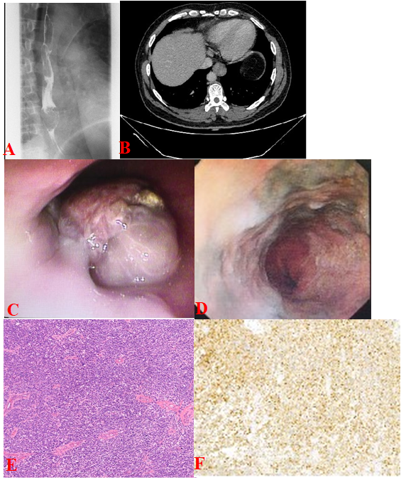
Figure 1 Imaging and microphotograph of primary malignant melanoma of the esophagus. A: Barium swallow examination showed an irregular filling defect on the lower third of the esophagus, causing mucosa destruction; B: Computed tomography showed an eccentric thickening in the lower third of the esophagus wall, with enhancement; C and D: Esophagoscopy revealed a nonpigmented polypoid tumor with hyperemia and erosion in the lower esophagus, and black lesion scattered on the wall of esophagus; E: Hematoxylin-eosin staining identified malignant melanoma cells in the lamina propria of the esophagus (× 100); F: Immunohistochemical staining with HMB45 (human melanoma black 45) antibody revealed positive tumor cells (× 100).
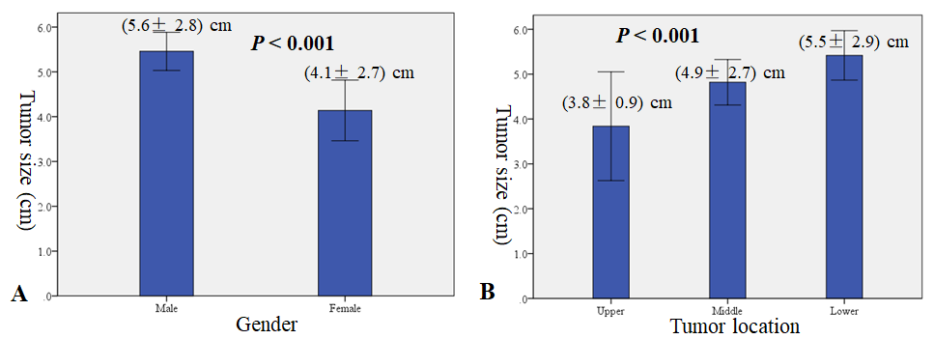
Figure 2 Correlation of tumor size with gender and tumor location. A: Gender; B: Tumor location.

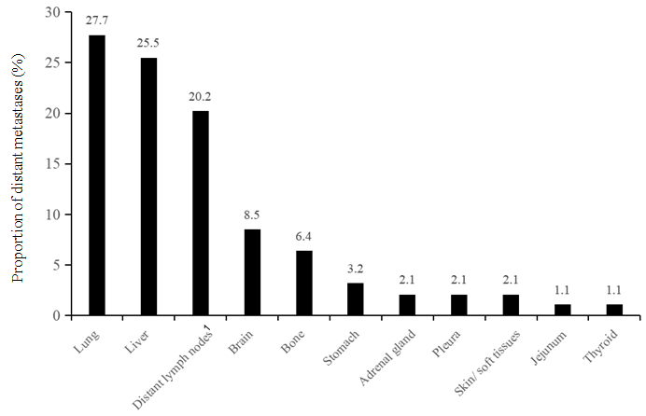
Figure 3 Site of metastasis in the study cohort. ¹Distant lymph nodes including those in the enterocoelia, neck, mediastinum, and axilla.
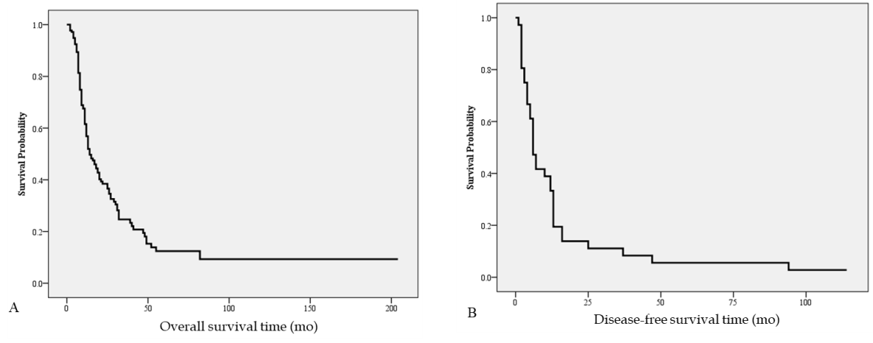
Figure 4 Survival of patients with primary malignant melanoma of the esophagus. A: Overall survival; B: Disease-free survival.
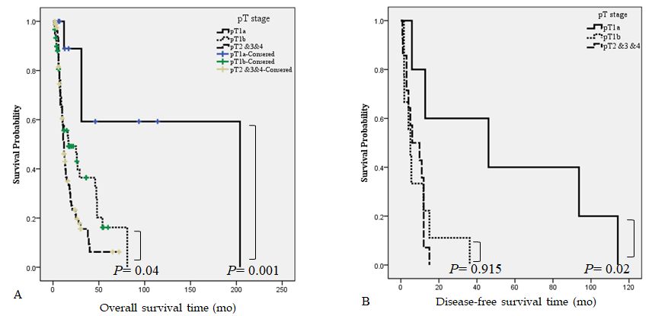
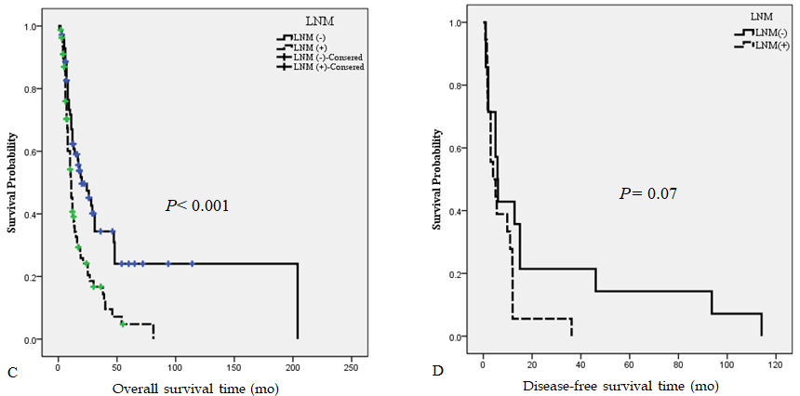
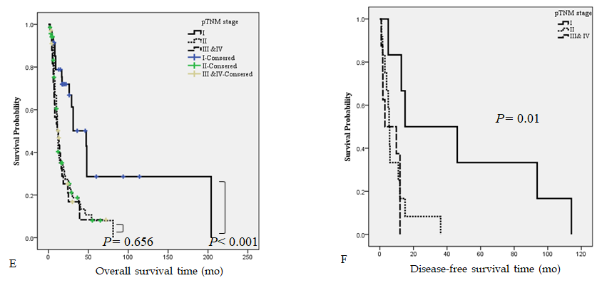
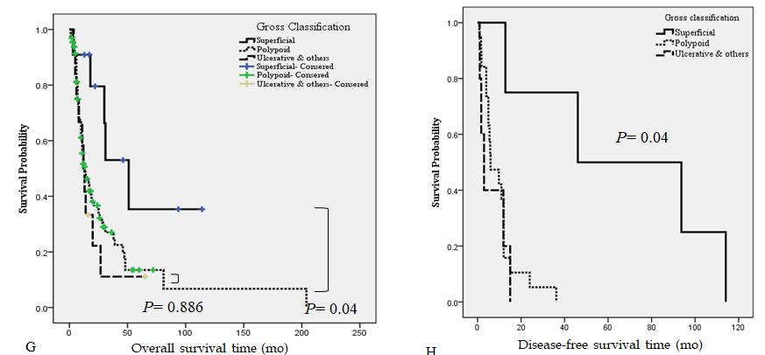
Figure 5 Kaplan-Meier curves for patients with primary malignant melanoma of the esophagus. A and B: Comparison between the cases with pT1a, pT1b, and pT2, 3, and 4. Patients at pT1a showed a much better overall survival (OS) and disease-free survival (DFS) than those at pT1b or pT2, 3, and 4. No significant difference was observed between groups at pT1b and pT2, 3, and 4 for OS or DFS; C and D: Comparison between the cases with (+) and without (-) lymph node metastasis (LNM). Patients with LNM (+) showed a lower OS than those with LNM (-); for DFS, the difference was only marginal (P = 0.07); E and F: Comparison between the cases with pTNM I, II, and III/IV. Patients at pTNM I showed a much better OS and DFS than those at II and III-IV. No significant difference was noted between groups at pTNM II and III-IV for OS or DFS; G and H: Comparison between the cases with superficial, polypoid, and other gross classifications. Groups with superficial subtype showed a better OS and DFS than those with other subtypes. No significant difference was noted between groups with polypoid and other subtypes for OS or DFS.

Table 1 Clinicopathological features of ten cases of primary malignant melanomas of the esophagus from Henan Provincial People’s Hospital
Case No. | Gender | Age (yr) | Chief complaint | Location | Gross classification | Tumor number | Preoperative diagnosis | Tumor length | Deep in depth | LNM | Treatment | Survival (mo)
1 | Male | 61 | Dysphagia | Middle | NA | 1 | PMME | NA | NA | NA | NA | FU loss
2 | Female | 59 | Dysphagia | Middle | NA | 1 | PMME | NA | NA | NA | NA | FU loss
3 | Male | 47 | Dysphagia | Lower | NA | 1 | PMME | NA | NA | NA | NA | FU loss
4 | Female | 60 | Dysphagia | Lower | NA | 1 | PMME | NA | NA | NA | NA | FU loss
5 | Female | 80 | Dysphagia | Middle | NA | 1 | PMME | NA | NA | NA | R + C | 31
6 | Male | 69 | Dysphagia | Middle | NA | 1 | PMME | NA | NA | NA | C | 51
7 | Male | 57 | Dysphagia | Upper | Ulcering | 1 | Poor differentiated carcinoma | 5 | DP | No | S | 18
8 | Female | 74 | Retrosternal pain | Lower | Polypoid | 2 | PMME | 5 | SM | No | S | FU loss
9 | Male | 62 | bellyache | Middle | Polypoid | 1 | PMME | 2.5 | DP | No | S | 3
10 | Male | 52 | Dysphagia and retrosternal pain | Middle | Polypoid | 1 | PMME | 4 | SM | No | S | 22 alive
PMME: Primary malignant melanoma of esophagus; NA: Not applicable; SM: Submucosal layer; MP: Muscularis propria; FU: Follow up; S: Surgery; C: Chemotherapy; R: Radiotherapy.

Table 2 Clinicopathologic characteristics of 290 primary malignant melanoma of esophagus patients
Characteristic | n | %
Gender
Male | 200 | 69.0
Female | 90 | 31.0
Age | 58.4 ± 9.7 yr
Symptoms
Dysphagia | 219 | 79.1
Restrosternal pain | 13 | 4.7
Dysphagia and restrosternal pain | 18 | 6.5
Bellyache | 11 | 4.0
No symptom found by physical examination | 8 | 2.9
Loss of appetite | 6 | 2.2
Hoematemesis or melena | 2 | 0.7
Censored | 13
Location
Upper | 16 | 5.4
Middle | 137 | 47.3
Lower | 137 | 47.3
Pigmentation
Yes | 141 | 71.9
No | 55 | 28.1
Censored | 94
Pathological diagnosis of biopsy
PMME | 115 | 55.8
ESCC | 32 | 15.5
Poorly differentiated carcinoma | 39 | 18.9
Esophageal adenocarcinoma | 10 | 4.9
High-grade dysplasia or non-neoplastic lesions | 10 | 4.9
Censored | 84
Treatment
Surgery | 153 | 58.8
Surgery and adjuvant treatment | 88 | 35.1
Adjuvant treatment | 16 | 6.1
Censored | 33
Tumor size (censored: n = 77) | 5.2 ± 2.9 cm
Tumor number
Single | 74 | 61.7
Multiple | 46 | 38.3
Censored | 170
Gross classification
Superficial elevated | 14 | 5.7
Polypoid | 194 | 77.9
Ulcerative and others | 36 | 14.4
Censored | 46
Depth of invasion
T1 | 97 | 45.6
T2 | 67 | 31.4
T3 and T4 | 49 | 23.0
Censored | 77
Lymph node metastasis
Yes | 107 | 51.2
No | 102 | 48.8
Censored | 81

Table 3 Correlation between lymph node metastasis and clinicopathological features
Feature | LNM- |  | LNM+ |  | P valve | Logistic regression analysis
 | n | % | n | % |  | P valve | OR (95%CI)
Gender
Male | 77 | 51.0 | 74 | 49.0 | 0.307
Female | 25 | 43.1 | 33 | 56.9
Age (yr) | 59.4 ± 8.9 |  | 57.2 ± 10.3 |  | 0.109
Location
Upper | 3 | 75.0 | 1 | 25.0 | 0.202
Middle | 52 | 53.6 | 45 | 46.4
Lower | 47 | 43.5 | 61 | 56.5
Tumor size (cm) | 4.6 ± 2.4 |  | 6.0 ± 3.0 |  | < 0.001 | 0.006 | 1.21 (1.05-1.38)
Tumor number
Single | 23 | 41.1 | 33 | 58.9 | 0.919
Multiple | 14 | 40.0 | 21 | 60.0
Censored | 67 | 54.5 | 56 | 46.5
Gross classification
Superficial elevated | 11 | 91.7 | 1 | 8.3 | 0.01 | 0.261
Polypoid | 68 | 46.6 | 78 | 53.4
Ulcerative and others | 14 | 45.2 | 17 | 54.8
Censored | 9 | 45 | 11 | 55
Infiltration depth
T1a | 14 | 100 | 0 | 0 | < 0.001 | < 0.001 | 2.22 (1.47-3.33)
T1b | 40 | 54.8 | 33 | 45.2
T2 | 30 | 48.4 | 32 | 51.6
T3 + T4 | 9 | 20.0 | 36 | 80.0
Censored | 9 | 60 | 6 | 40
LNM: Lymph node metastases; OR: Odds ratio; CI: Confidence interval.
Table 4 Univariate and multivariate analyses of predictive factors for overall survival and disease-free survival in patients with primary malignant melanoma of esophagus
Variable | Overall survival |  |  |  | Disease-free survival
 | Uni-P | Multi-P | HR | 95%CI | Uni-P | Multi-P | HR | 95%CI
Gender
Male vs female | 0.08 |  |  |  | 0.450
Age (yr)
< 55 vs ≥ 55 | 0.348 |  |  |  | 0.353
Tumor location
Upper vs middle vs lower | 0.647 |  |  |  | 0.385
Tumor number
Single vs multiple | 0.200 |  |  |  | 0.227
Tumor size (cm)
< 5.5 vs ≥ 5 | 0.282 |  |  |  | 0.124
Gross classification
Superficial vs polypoid vs ulcerative and others | 0.04 | 0.249 |  |  | 0.007 | 0.893
Depth of invasion
T1a vs T1b vs T2 and T3 and T4 | 0.001 | 0.005 | 1.70 | 1.17-2.47 | 0.02 | 0.02 | 1.93 | 1.09-3.42
LNM
No vs yes | < 0.001 | 0.009 | 1.78 | 1.15-2.74 | 0.07
pTNM stage
I vs II vs III and IV | < 0.001 | 0.349 |  |  | 0.02 | 0.540
Treatment
Surgery vs surgery plus adjuvant therapy | 0.433 |  |  |  | 0.02 | 0.698
LNM: Lymph node metastases; pTNM: Pathological tumor node metastasis; HR: Hazard ratio; CI: Confidence interval.

