Name of Journal: World Journal of Clinical Cases
Manuscript NO: 76292
Manuscript Type: CASE REPORT

Serratia fonticola and its role as a single pathogen causing emphysematous pyelonephritis in a non-diabetic patient: A case report

Villasuso-Alcocer V et al. Emphysematous pyelonephritis due to S. fonticola

Victor Villasuso-Alcocer, Juan P Flores-Tapia, Fernando Perez-Garfias, Andrea Rochel-Perez, Nina Mendez-Dominguez

Victor Villasuso-Alcocer, Scholar at Direccion General de Calidad y Educacion en Salud, Secretaría de Salud, Mexico 11570, Mexico

Juan P Flores-Tapia, Fernando Perez-Garfias, Andrea Rochel-Perez, Urology Department, Hospital Regional de Alta Especialidad de la Peninsula de Yucatan, Merida 97300, Yucatan, Mexico

Nina Mendez-Dominguez, Research and Learning, Hospital Regional de Alta Especialidad de la Peninsula de Yucatan, Merida 97130, Yucatan, Mexico

Author contributions: Mendez-Dominguez N and Flores-Tapia JP contributed to conceptualization; Flores-Tapia JP and Perez-Garfias F contributed to clinical management; Rochel-Perez A, Perez-Garfias F and Villasuso-Alcocer V contributed to review investigation; Rochel-Perez A and Villasuso-Alcocer V contributed to writing and original draft preparation; Mendez-Dominguez N and Flores-Tapia JP contributed to review and editing; Mendez-Dominguez N and Flores-Tapia JP contributed to project administration; all authors have read and agreed to the published version of the manuscript.

Corresponding author: Nina Mendez-Dominguez, DSc, MD, PhD, Doctor, Research Scientist, Research and Learning, Hospital Regional de Alta Especialidad de la Peninsula de Yucatan, Fraccionamiento Altabrisa, Street 7 Number 433 Merida, Merida 97130, Yucatan, Mexico. ninamendezdominguez@gmail.com

Received: March 15, 2022
Revised: April 15, 2022
Accepted: August 21, 2022
Published online: October 16, 2022

Abstract
BACKGROUND
Diagnosis of emphysematous pyelonephritis has been described around the world for some decades, frequently associated with Escherichia coli and other anaerobic, gas-forming bacteria and mostly in patients living with diabetes. We present a case report of emphysematous pyelonephritis in a non-diabetic patient caused by Serratia fonticola as well as a brief literature review to draw attention to this rare pathogen as a cause of pyelonephritis.

CASE SUMMARY
A 38-year-old female presented with fever, severe pain in the right flank and changes in urinary habits. She was admitted, and emphysematous pyelonephritis was confirmed by an abdominal computerized tomography and urine cultures; the latter showed Serratia fonticola as a single pathogen. After 3 d of being treated with piperacillin/tazobactam and percutaneous drainage she became afebrile, and the gas presence reduced.

CONCLUSION
Emphysematous pyelonephritis infections in non-diabetic patients are rare but can be severe and life-threatening. This case suggests that Serratia fonticola infection can occur in patients undergoing invasive or instrumented procedures.

Key Words: Serratia fonticola; Emphysematous pyelonephritis; Urinary tract infections; Nephrolithiasis; Case report

©The Author(s) 2022. Published by Baishideng Publishing Group Inc. All rights reserved.

Citation: Villasuso-Alcocer V, Flores-Tapia JP, Perez-Garfias F, Rochel-Perez A, Mendez-Dominguez N. Serratia fonticola and its role as a single pathogen causing emphysematous pyelonephritis in a non-diabetic patient: A case report. World J Clin Cases 2022; 10(29): 10600-10605
URL: https://www.wjgnet.com/2307-8960/full/v10/i29/10600.htm
DOI: https://dx.doi.org/10.12998/wjcc.v10.i29.10600

Core Tip: Serratia fonticola may still be rare as a human pathogen, either associated to asymptomatic conditions or merely a bystander among other agents, but its incidence may relate to severe cases when patients undergo invasive, instrumented procedures or underlying conditions, as presented in this case of the female who developed emphysematous pyelonephritis.

INTRODUCTION
Severe necrotizing infection caused by anaerobic, gas-forming bacteria in renal parenchyma generates a condition known as emphysematous pyelonephritis (EPN), frequently linked to Escherichia coli^{[1,2]}.
It has been stated that even when agent-related virulence factors, along with the underlying health condition of patients, may predispose them to EPN, diabetes mellitus with poor glycemic control has been independently associated with the odds of developing EPN^{[3]}. Furthermore, evidence in Escherichia coli urinary tract infections suggests that insulin treatment in infected patients with diabetes may downregulate infection, which is congruent with the role of glycemic control in EPN in urinary tract infections^{[4]}.
EPN is an unusual condition originally associated with patients with diabetes mellitus^{[5,6]} and commonly reported in single clinical case reports, although also more recently in at least one systematic review with meta-analysis^{[6]}. The present communication was aimed at providing insights into a case where a non-diabetic patient developed EPN due to a Serratia fonticola (S. fonticola) infection and the clinical manifestations derived from the pyelonephritis caused by this uncommon agent.

CASE PRESENTATION
Chief complaints
A 38-year-old illiterate housewife from rural southeast Mexico, with bilateral urolithiasis attended a urology consultation at a highly specialized public hospital in Yucatan Mexico, as she had had a fever between 38 ℃ and 40 ℃ for the previous 2 d, accompanied by severe pain in the right flank irradiating to the ipsilateral suprapubic region and reported changes in frequency and quality of urination.

History of present illness
She was admitted for in-hospital care, and abdominal computerized axial tomography was performed, along with blood and urine tests, including cultures. Tomography indicated the presence of gas in the right kidney indicating EPN Huang IV and confirmed the presence of a nonfunctional left kidney (Figure 1). Blood culture was unremarkable, while urine culture reported S. fonticola as a single pathogen, sensitive to most antibiotics but resistant to trimethoprim and nitrofurantoin.

History of past illness
Antecedents included that she debuted with symptomatic bilateral urinary lithiasis in 2015, and she was diagnosed with chronic kidney disease Class Kidney Diseases Global Outcomes 3A that same year. Left renal exclusion was confirmed using radiotracer mercaptoacetyltriglycine gammagraphy.

Personal and family history
In 2016 and 2017 second look percutaneous nephrolithotomy was performed, finding right ureteral stenosis due to lithiasis; JJ catheters were temporarily placed in the right kidney and removed after treatment.

Physical examination
Fever and right flank pain irradiating to the ipsilateral suprapubic region persisted.

Laboratory examinations
Diabetes and hypertension had been ruled out at every hospitalization, as the patient only registered normal values of fasting glucose and blood pressure. The patient was treated with piperacillin/tazobactam; a combined endoscopic intrarenal surgery was performed to place a metallic catheter and to treat with percutaneous drainage. After 3 d of antibiotic, she became afebrile. The gas presence due to anaerobic bacteria reduced according to imaging, and a new culture was performed on day 4, which was reported negative. Her white blood cell count improved markedly. However, after 8 d her fever relapsed, and new studies were performed, finding Pseudomonas aeruginosa as a single pathogen in her urine culture along with an increase in neutrophils and white blood cell count in general. She was therefore treated with meropenem (Figure 2).

Imaging examinations
After 10 d of treatment, with tomographic and laboratory evidence for the resolution of the acute signs and symptoms, she was discharged.

FINAL DIAGNOSIS
EPN due to urolithiasis with S. fonticola isolation with subsequent infection due to Pseudomonas aeruginosa.

TREATMENT
Percutaneous drainage and antibiotics

OUTCOME AND FOLLOW-UP
Between her discharge in 2018 and January 2021, the patient had two more hospitalizations related to urinary tract infections but none related to S. fonticola.

DISCUSSION
In previous studies, diabetes was present in 96%-98% of all patients with EPN^{[2,3]}, and renal calculi was an antecedent in approximately 7.84%^{[2]}. In general, gas-forming bacteria are the cause of emphysematous infections, but when it comes to pyelonephritis, the infection is attributed to Escherichia coli in more than 50% of cases and less often to other gram-negative bacteria^{[7]}. Diagnosis is made through clinical history and computerized axial tomography, the latter being the most precise tool to confirm diagnosis.
Before the 1990s, nephrectomies were considered the most effective form of intervention, as more conservative treatment had a mortality rate of 60%-80%^{[8]}. To date, mortality has reduced significantly and even though diabetes is still recognized as a factor increasing the propensity for proliferation of gas-forming pathogens^{[9]}, it is also recognized that diabetes is not a sine qua non condition. The management of patients is somewhat controversial. While some authors suggest that the nephrectomy could provide a better prognosis in subjects with two or more risk factors, other authors suggest that medical management and drainage are currently sufficient for treating these patients^{[7,10]}.
EPN can become a recurrent condition, as reported by Ramanathan et al^{[11]} in a three-case report communication. In the case of our patient EPN reappeared while the patient was still under clinical care, giving the opportunity to be treated promptly. Altogether, current evidence regarding EPN indicates that this condition is still potentially fatal, particularly when a timely diagnosis is not established or suboptimal treatment is provided^{[7]}. Katib et al^{[12]} in 2020 reported S. fonticola as a community-acquired urinary tract infection, affirming that globally this represented the third clinical case in which isolation of S. fonticola in an asymptomatic patient was reported. Therefore, the present case review may be the first reporting of a severe symptomatic infection due to S. fonticola causing EPN^{[13]}.
Community-acquired infections are susceptible to improvement with various antibiotics, but the evidence from a case in which biliary tract infection due to S. fonticola occurred in a hospital environment pointed to a particularly resistant variant^{[14]}.
Nephrectomy has been the treatment of choice when performed immediately to treat emphysematous nephritis and urosepsis^{[12]}. For the case we have presented, nephrectomy was not an option, as the patient had a single functional kidney. Percutaneous drainage has been linked to lower mortality than medical management or emergency nephrectomy, and therefore it was the treatment of choice^{[7,15]}.

S. fonticola, characteristics and peculiarities of clinical importance for human health
In 1979, Serratia spp. was identified as a member of the Enterobacteriae family. This study included the type, neotype and the genetic relationship of these strains by means of DNA-DNA hybridization and the relationship between them and the Serratia spp. strains known so far (S. marcescens, S. liquiefaciens, S. plymuthica and S. rubidaea)^{[16]}.
Serratia spp. belong to the Enterobacteriaceae family, which has been widely studied over the years, and there have been multiple changes to the number of species included in this family. Strains of this pathogen produce DNAase, gelatinase and lipase extracellularly, which means they can be easily differentiated from other Enterobacteriaceae genera^{[17]}.
S. fonticola is a peritrichous, motile rod-shaped gram-negative enterobacteria that was first isolated in water and soil. There are reports that show S. fonticola can also be isolated in plants, aquatic environments, bird feces, some mammals and reptile skin wounds. When isolated, its growth occurs within a nutrient agar medium at temperatures of 30-37 °C^{[16,18,19]}.
In 1990, it was identified as a human pathogen in a patient wound infection abscess localized on the thigh. Since then, S. fonticola has mainly been identified in open wounds (mostly due to trauma) and in the respiratory, gastrointestinal and urinary tracts. Recently, some reports have identified S. fonticola in the biliary tract^{[13,18,20]}.
Based on clinical practice, early identification of this pathogen is important due to its structure and characteristics, which makes it resistant to a wide range of antibiotics. This can be linked to the fact that S. fonticola harbors an inducible chromosomal B-lactamase AMPC and a FOMA-type, which not only generates resistance to antibiotics (including cephalosporins up to the third generation) but can also allow factors for antimicrobial resistance to be transmitted to other bacteria, thus increasing the risk of a rapid evolution from a sectorial infection to a polymicrobial bacteremia and even septicemia^{[13,21,22]}.
Usually, Serratia spp. are nosocomial pathogens that may colonize medical devices such as urinary catheters and bronchoscopes^{[23]}. However, in a study by Samonis et al^{[24]} where Serratia spp. was identified as a community-acquired infection, the predominant species was S. marcescens. S. fonticola was first described as a bystander in a patient in whom it was isolated along with other agents in a urine culture. The patient was a man with neurogenic bladder paraplegia due to a combat injury and related to urinary tract catheterization^{[14]}. Even though Serratia spp. have been linked to cases of nosocomial infections^{[25]} and uncomplicated urinary tract infection in more susceptible patients with underlying urinary conditions and/or chronic kidney disease, S. fonticola may also be linked to severe clinical manifestations, as in this case, which was exacerbated by impaired renal function and urolithiasis, leading to EPN.

CONCLUSION
S. fonticola may still be rare as a human pathogen, either linked to asymptomatic conditions or merely a bystander among other infective agents, but its incidence may lead to severe cases when patients undergo invasive, instrumented procedures or have underlying conditions, as presented here in this case of the female who developed EPN.

ACKNOWLEDGEMENTS
To nurses and medical staff at the Urology Department.

REFERENCES
1 Ubee SS, McGlynn L, Fordham M. Emphysematous pyelonephritis. BJU Int 2011; 107: 1474-1478 [PMID: 20840327 DOI: 10.1111/j.1464-410X.2010.09660.x]
2 Tseng CC, Wu JJ, Wang MC, Hor LI, Ko YH, Huang JJ. Host and bacterial virulence factors predisposing to emphysematous pyelonephritis. Am J Kidney Dis 2005; 46: 432-439 [PMID: 16129204 DOI: 10.1053/j.ajkd.2005.05.019]
3 Ho CH, Liu SP, Fan CK, Tzou KY, Wu CC, Cheng PC. Insulin Downregulated the Infection of Uropathogenic Escherichia coli (UPEC) in Bladder Cells in a High-Glucose Environment through JAK/STAT Signaling Pathway. Microorganisms 2021; 9 [PMID: 34946023 DOI: 10.3390/microorganisms9122421]
4 Rafiq N, Nabi T, Rasool S, Sheikh RY. A Prospective study of Emphysematous Pyelonephritis in Patients with Type 2 Diabetes. Indian J Nephrol 2021; 31: 536-543 [PMID: 35068760 DOI: 10.4103/ijn.IJN_411_19]
5 Nabi T, Rafiq N, Rahman MHU, Rasool S, Wani NUD. Comparative study of emphysematous pyelonephritis and pyelonephritis in type 2 diabetes: a single-centre experience. J Diabetes Metab Disord 2020; 19: 1273-1282 [PMID: 33553028 DOI: 10.1007/s40200-020-00640-y]
6 Desai R, Batura D. A systematic review and meta-analysis of risk factors and treatment choices in emphysematous pyelonephritis. Int Urol Nephrol 2022; 54: 717-736 [PMID: 35103928 DOI: 10.1007/s11255-022-03131-6]
7 Eswarappa M, Suryadevara S, John MM, Kumar M, Reddy SB, Suhail M. Emphysematous Pyelonephritis Case Series From South India. Kidney Int Rep 2018; 3: 950-955 [PMID: 29988992 DOI: 10.1016/j.ekir.2017.12.003]
8 Somani BK, Nabi G, Thorpe P, Hussey J, Cook J, N'Dow J; ABACUS Research Group. Is percutaneous drainage the new gold standard in the management of emphysematous pyelonephritis? Evidence from a systematic review. J Urol 2008; 179: 1844-1849 [PMID: 18353396 DOI: 10.1016/j.juro.2008.01.019]
9 Falagas ME, Alexiou VG, Giannopoulou KP, Siempos II. Risk factors for mortality in patients with emphysematous pyelonephritis: a meta-analysis. J Urol 2007; 178: 880-5; quiz 1129 [PMID: 17631348 DOI: 10.1016/j.juro.2007.05.017]
10 Lu YC, Chiang BJ, Pong YH, Huang KH, Hsueh PR, Huang CY, Pu YS. Predictors of failure of conservative treatment among patients with emphysematous pyelonephritis. BMC Infect Dis 2014; 14: 418 [PMID: 25074590 DOI: 10.1186/1471-2334-14-418]
11 Ramanathan V, Nguyen PT, Van Nguyen P, Khan A, Musher D. Successful medical management of recurrent emphysematous pyelonephritis. Urology 2006; 67: 623.e11-623.e13 [PMID: 16504262 DOI: 10.1016/j.urology.2005.09.059]
12 Katib AA, Dajam M, Alqurashi L. Serratia fonticola microbe presented as a community-acquired urinary tract infection (UTI): a case report. J Ideas Health 2020; 3: 226-227 [DOI: 10.47108/jidhealth.vol3.iss3.68]
13 Das D, Pal DK. Double J stenting: A rewarding option in the management of emphysematous pyelonephritis. Urol Ann 2016; 8: 261-264 [PMID: 27453644 DOI: 10.4103/0974-7796.184881]
14 Aljorayid A, Viau R, Castellino L, Jump RL. Serratia fonticola, pathogen or bystander? A case series and review of the literature. IDCases 2016; 5: 6-8 [PMID: 27347484 DOI: 10.1016/j.idcr.2016.05.003]
15 Ziegelmüller BK, Szabados B, Spek A, Casuscelli J, Stief C, Staehler M. Emphysematous pyelonephritis: Case report and literature overview. Urologia 2018; 85: 123-126 [PMID: 30117388 DOI: 10.1177/0391560317749428]
16 Gavini F, Ferragut C, Izard D, Trinel P, Leclerc H, Lefebvre B, Mossel D. Serratia fonticola, a New Species from Water. Int J Syst Evol Microbiol 1979; 29: 92-101 [DOI: 10.1099/00207713-29-2-92]
17 Farmer JJ 3rd, Davis BR, Hickman-Brenner FW, McWhorter A, Huntley-Carter GP, Asbury MA, Riddle C, Wathen-Grady HG, Elias C, Fanning GR. Biochemical identification of new species and biogroups of Enterobacteriaceae isolated from clinical specimens. J Clin Microbiol 1985; 21: 46-76 [PMID: 3881471 DOI: 10.1128/jcm.21.1.46-76.1985]
18 Müller HE, Steigerwalt AG, Brenner DJ. Isolation of Serratia fonticola from birds. Zentralbl Bakteriol Mikrobiol Hyg A 1986; 261: 212-218 [PMID: 3739460 DOI: 10.1016/s0176-6724(86)80038-4]
19 Kunimoto D, Rennie R, Citron DM, Goldstein EJ. Bacteriology of a bear bite wound to a human: case report. J Clin Microbiol 2004; 42: 3374-3376 [PMID: 15243122 DOI: 10.1128/JCM.42.7.3374-3376.2004]
20 Ruan J, Wang W, Zhang T, Zheng T, Zheng J, Yu S, Yu D, Huang Y. Establishment of a duplex real-time qPCR method for detection of Salmonella spp. and Serratia fonticola in fishmeal. AMB Express 2020; 10: 207 [PMID: 33236244 DOI: 10.1186/s13568-020-01144-x]
21 Bollet C, Gainnier M, Sainty JM, Orhesser P, De Micco P. Serratia fonticola isolated from a leg abscess. J Clin Microbiol 1991; 29: 834-835 [PMID: 1890188 DOI: 10.1128/jcm.29.4.834-835.1991]
22 van Hoek AH, Veenman C, van Overbeek WM, Lynch G, de Roda Husman AM, Blaak H. Prevalence and characterization of ESBL- and AmpC-producing Enterobacteriaceae on retail vegetables. Int J Food Microbiol 2015; 204: 1-8 [PMID: 25828704 DOI: 10.1016/j.ijfoodmicro.2015.03.014]
23 Hai PD, Hoa LTV, Tot NH, Phuong LL, Quang VV, Thuyet BT, Son PN. First report of biliary tract infection caused by multidrug-resistant Serratia fonticola. New Microbes New Infect 2020; 36: 100692 [PMID: 32528687 DOI: 10.1016/j.nmni.2020.100692]
24 Samonis G, Vouloumanou EK, Christofaki M, Dimopoulou D, Maraki S, Triantafyllou E, Kofteridis DP, Falagas ME. Serratia infections in a general hospital: characteristics and outcomes. Eur J Clin Microbiol Infect Dis 2011; 30: 653-660 [PMID: 21222011 DOI: 10.1007/s10096-010-1135-4]
25 Johnson A, Watson D, Dreyfus J, Heaton P, Lampland A, Spaulding AB. Epidemiology of Serratia Bloodstream Infections Among Hospitalized Children in the United States, 2009-2016. Pediatr Infect Dis J 2020; 39: e71-e73 [PMID: 32091494 DOI: 10.1097/INF.0000000000002618]

Footnotes
Informed consent statement: Written informed consent was obtained from the patient.

Conflict-of-interest statement: The authors declare no conflict of interest.

CARE Checklist (2016) statement: The authors have read the CARE Checklist (2016), and the manuscript was prepared and revised according to the CARE Checklist (2016).

Open-Access: This article is an open-access article that was selected by an in-house editor and fully peer-reviewed by external reviewers. It is distributed in accordance with the Creative Commons Attribution NonCommercial (CC BY-NC 4.0) license, which permits others to distribute, remix, adapt, build upon this work non-commercially, and license their derivative works on different terms, provided the original work is properly cited and the use is non-commercial. See: https://creativecommons.org/Licenses/by-nc/4.0/

Provenance and peer review: Unsolicited article; Externally peer reviewed.
Peer-review model: Single blind

Peer-review started: March 15, 2022
First decision: April 13, 2022
Article in press: August 21, 2022

Specialty type: Infectious diseases
Country/Territory of origin: Mexico
Peer-review report’s scientific quality classification
Grade A (Excellent): 0
Grade B (Very good): 0
Grade C (Good): C, C
Grade D (Fair): 0
Grade E (Poor): 0

P-Reviewer: Boopathy Vijayaraghavan KM, India; Yuksel S, Turkey S-Editor: Yan JP L-Editor: Filipodia P-Editor: Yan JP

Figure Legends
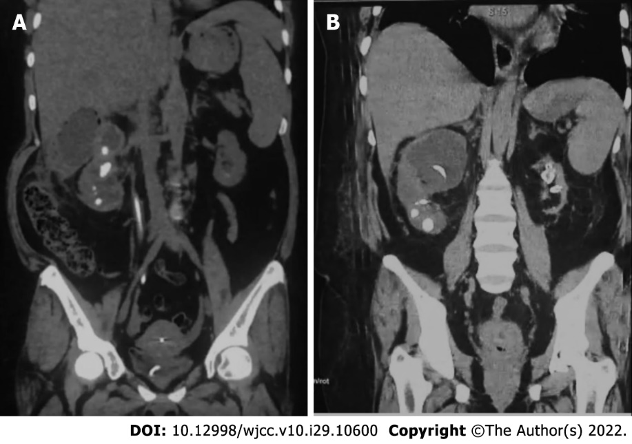
Figure 1 Tomography showing bilateral renal lithiasis and left renal exclusion. A: Gas accumulation in right kidney on day 1 of hospital stay; B: At discharge.

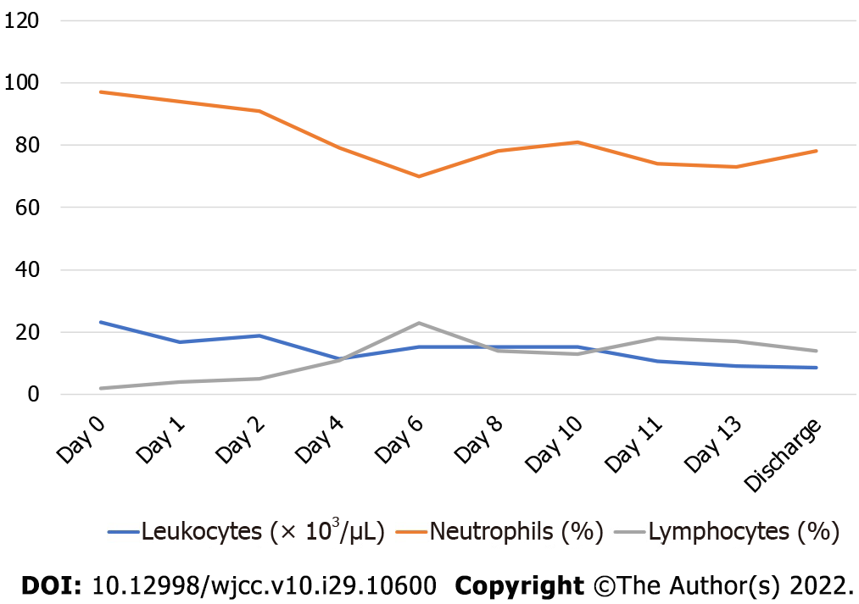
Figure 2 White cell count in a patient with Serratia fonticola related emphysematous pyelonephritis.

Published by Baishideng Publishing Group Inc
7041 Koll Center Parkway, Suite 160, Pleasanton, CA 94566, USA
Telephone: +1-925-3991568
E-mail: bpgoffice@wjgnet.com
Help Desk: https://www.f6publishing.com/helpdesk
https://www.wjgnet.com

© 2022 Baishideng Publishing Group Inc. All rights reserved.

