Name of Journal: World Journal of Clinical Cases
Manuscript NO: 70400
Manuscript Type: CASE REPORT

Small-cell carcinoma of the prostate with negative CD56, NSE, Syn, and CgA indicators: A case report

Shi HJ et al. Neuroendocrine-negative prostatic small-cell carcinoma

Hong-Jin Shi, Zhi-Nan Fan, Jin-Song Zhang, Bo-Bo Xiong, Hai-Feng Wang, Jian-Song Wang

Hong-Jin Shi, Zhi-Nan Fan, Jin-Song Zhang, Bo-Bo Xiong, Hai-Feng Wang, Jian-Song Wang, Department of Urology, The Second Affiliated Hospital, Kunming Medical University, Kunming 650000, Yunnan Province, China

Author contributions: Shi HJ and Fan ZN collected the data, reviewed the literature, and contributed to manuscript drafting; Xiong BB performed the histological analyses and interpretation; Zhang JS and Wang HF was responsible for the revision of the manuscript for important intellectual content; all authors issued final approval for the version to be submitted.

Supported by the National Natural Science Foundation of China, No. 81972395, and No. 82060464.

Corresponding author: Jin-Song Zhang, Doctor, Doctor, Department of Urology, The Second Affiliated Hospital, Kunming Medical University, No. 374 Dianmian Road, Kunming 650000, Yunnan Province, China. 945933392zjs@sina.com

Received: August 1, 2021
Revised: November 14, 2021
Accepted: December 31, 2021
Published online:

Abstract
BACKGROUND
Small-cell carcinoma of the prostate (SCCP) is a clinically rare malignant tumor, accounting for < 1% of all prostate tumors. However, negativity for all SCCP neuroendocrine markers is rare. Herein, we report a case of SCCP with completely negative neuroendocrine markers and explore its clinicopathologic features, thus improving the understanding of its clinical diagnosis and management.

CASE SUMMARY
We report the case of a 48-year-old patient with SCCP negative for common sensitive neuroendocrine-staining indicators. Dysuria was the first symptom, and rectal examination revealed a hard prostate, palpable nodules, diffuse prostate enlargement, no pressure pain, no blood staining in the finger sleeve, 1.33 ng/mL total prostate-specific antigen level, and a free-to-total prostate-specific antigen ratio of 0.21 ng/mL. Ultrasound suggested a prostate size of 5.3 cm × 5.8 cm × 5.6 cm, and magnetic resonance imaging suggested prostate cancer. The lower posterior bladder wall, rectal mesentery, and bilateral seminal vesicles were invaded, with multiple lymph node metastases in the pelvis. A whole-body bone scan suggested an abnormally active multiple bone metabolism and possible bone metastases. Head and lungs computed tomography revealed no significant nodal shadow. Following a pathological diagnosis of SCCP after a prostate puncture, with negative indicators of common sensitive neuroendocrine staining, chemotherapy was administered; the patient died 4-5 mo after SCCP diagnosis.

CONCLUSION
SCCP is a rare disease characterized by atypical clinical symptoms, limited treatment options, a short survival period, and a poor prognosis.

Key Words: Prostate cancer; Small cell carcinoma; Neuroendocrine tumor; Therapeutics; Diagnosis; Case report

Shi HJ, Fan ZN, Zhang JS, Xiong BB, Wang HF, Wang JS. Small-cell carcinoma of the prostate with negative CD56, NSE, Syn, and CgA indicators: A case report. World J Clin Cases 2021; In press

Core Tip: Small cell carcinoma of the prostate (SCCP) is a very rare type of prostate tumor, generally characterized by low differentiation, high malignancy, rapid growth, easy diffusion, and poor prognosis. Among SCCP types, mixed SCCP is relatively common, completely simple SCCP is rarely reported, and SCCP with negative neuroendocrine markers is even rarer. This study reports a rare case of SCCP with completely negative neuroendocrine markers, and it found SCCP to be characterized by atypical clinical symptoms, limited treatment options, a short survival period, and a poor prognosis, requiring pathological examination to confirm its diagnosis.

INTRODUCTION
Small-cell carcinoma of the prostate (SCCP) is one of the rarest types of prostate tumors. It is generally characterized by low differentiation, high malignancy, rapid growth, easy spread, and poor prognosis^{[1]}. It has been reported on a case-by-case basis in both domestic and international literature, with more cases of mixed SCCP than those of completely simple SCCP being reported^{[2]}. SCCP is generally characterized by neuroendocrine granules in the cytoplasm, and immunohistochemistry suggests at least one positive neuroendocrine marker, predominantly in small-cell neuroendocrine carcinoma of the prostate^{[3]}, whereas SCCP negativity for almost all neuroendocrine markers is even rarer. SCCP diagnosis and treatment have not yet been standardized internationally and are still being explored. Herein, we report the treatment of a patient with SCCP who was negative for almost all neuroendocrine markers. By reviewing the relevant literature from recent years, we analyzed and summarized SCCP diagnosis and treatment, aiming to deepen the understanding of this disease.

CASE PRESENTATION
Chief complaints
A 48-year-old man was admitted to our hospital on January 7, 2019, due to dysuria that lasted for 10 d.

History of present illness
A 48-year-old man was admitted to our hospital on January 7, 2019, due to dysuria that lasted for 10 d. No gross hematuria or acute urinary retention, and no treatment in other hospitals.

History of past illness
The patient had no history of surgery, trauma, or other diseases.

Personal and family history
There was no history of hereditary diseases. No family members had similar symptoms.

Physical examination
On rectal examination, the prostate was hard and diffusely enlarged, the nodules were palpable, no pressure pain was experienced, and the finger sleeve was not stained with blood.

Laboratory examinations
Laboratory tests revealed that the total prostate-specific antigen level and free-to-total prostate-specific antigen ratio were 1.33 ng/mL (reference range: 0-4 ng/mL) and 0.21 ng/mL (reference range: 0-0.944 ng/mL), respectively. Liver and kidney function was normal. Serum tumor markers were in the normal range.

Imaging examinations
B-mode ultrasound revealed a prostate size of 5.3 cm × 5.8 cm × 5.6 cm, echogenicity in the prostate was heterogeneous, and the envelope was not smooth.
Computed tomography (CT) imaging of the abdomen exhibited heterogeneous density within the prostate and heterogeneous enhancement after enhancement, suggesting possible prostate cancer, possible pelvic lymph node metastasis, pelvic floor fascia, and rectal wall and seminal vesicle invasion (Figure 1A).
Prostate magnetic resonance imaging confirmed mixed signals in the prostate, with possible prostate tumor invasion of the lower posterior bladder wall, rectal mesentery and bilateral seminal vesicles, and multiple lymph node metastases in the pelvis (Figure 1B-D).
Whole-body bone scan revealed multiple abnormalities in bone metabolism, with possible bone metastases (Figure 2), and CT of the head and lung suggested no obvious nodal shadow.
We strongly recommend that the patient use ⁶⁸Ga-PSMA PET/CT to look for small lesions around the prostate bed or extra-prostatic lymph node metastases. However, the patient and his family declined our offer due to the high cost.

Further diagnostic work-up
The patient was advised to initially undergo prostate puncture biopsy. The tumor cells appeared oval to spindle-shaped, with obvious heterogeneity and a mixture of oval and spindle-shaped cells (Figure 3). The immunophenotypes were as follows: CKPAN (foci +), KI67 (60%), AR (-), PSA (-), PSAP (-), P504S (-), CK5/6 (-), CKH (-), GATA3 (-), Vimentin (-), CEA (-), CK7 (-), CK20 (-), villin (-), NSE (-), Syn (-), CD56 (-), CgA (-), P40 (-), P63 (-), LCA (-), CD38 (-), CD138 (-), EMA (-), MUM1 (-), CD30 (-), Desmin (-), HMB45 (-), Melan-A (-), S100 (-), and MyoD1 (-) (Figure 4A and B). Hence, the initial diagnosis was small cell malignancy.

FINAL DIAGNOSIS
On combining the initial diagnosis with immunohistochemical markers, undifferentiated carcinoma was considered. On further combining with the adjuvant examination and clinical manifestations, the patient was finally diagnosed with advanced SCCP.

TREATMENT
The current treatment modality recommended radiotherapy; however, the patient and family declined radiotherapy and finally selected the etoposide combined with cisplatin (EP) chemotherapy regimen as follows: Cisplatin 80 mg on day 1 of chemotherapy as well as etoposide 100 mg on days 1-3 and 21-28 for one cycle, in a course of 6 cycles.

OUTCOME AND FOLLOW-UP
A repeat of CT imaging of the lung on February 14, 2019, revealed the following: multiple nodal shadows, suggesting possible SCCP metastasis (Figure 5A and B). Further CT imaging of the abdomen on March 17, 2019, suggested an irregular enlargement of SCCP, exhibiting a tendency to infiltrate, bilateral involvement of the inner segment of the ureteral bladder wall, dilatation and fluid retention in the urinary tract, multiple bone destruction in the pelvis (Figure 5C and D), and creatinine increase to 301 μmol/L, and the patient was treated with bilateral nephrostomy.
As the patient developed insensitivity to the EP regimen, EP was replaced with the gemcitabine combined with oxaliplatin (GEMOX) regimen, which was administered as follows: Gemcitabine 1 g on day 1 of chemotherapy as well as oxaliplatin 60 mg on days 1-5 and 21-28 in a course of 6 cycles. On April 25, 2019, the patient was admitted to the hospital for further chemotherapy, with routine blood work suggesting normal hemoglobin and central granulocytes, normal platelets, hemoglobin level of 48 g/L, and creatinine concentration of 156 μmol/L. After a blood transfusion, hemoglobin concentration rose to 110 g/L. The patient’s general condition was extremely poor (dyspnea, intolerable bone pain, and extreme wasting), and they could not tolerate further chemotherapy. The family decided to abandon the treatment, and the patient died of respiratory failure on May 20, 2019.

DISCUSSION
The lung is the most common site of small-cell carcinoma, and its most common site outside the lung is the prostate, accounting for approximately 3% of cases^{[4]}. SCCP is a rare malignancy in clinical practice, accounting for less than 1% of all prostate tumors^{[4]}. Despite having a low incidence, SCCP exhibits high malignancy and poor prognosis^{[5]}, and often metastasizes to tissues and organs, such as the brain, lung, liver, and bone via blood circulation^{[6]}. At present, three hypotheses regarding the origin of SCCP exist: (1) The abnormal differentiation of prostatic adenocarcinoma into small-cell carcinoma after endocrine therapy^{[7]}; (2) Derivation of the different types of adenocarcinoma and small-cell carcinoma of prostatic epithelium from pluripotent stem cells; and (3) Neuroendocrine cells in the prostatic epithelium. Prostatic neuroendocrine carcinoma includes prostate cancer with neuroendocrine differentiation, prostate carcinoid, prostatic small-cell neuroendocrine carcinoma, and prostatic large-cell neuroendocrine carcinoma, among others^{[1]}. The above hypotheses have a certain degree of validity, and additional molecular genetic studies have identified multiple mechanisms involved in the pathogenesis of SCCP^{[8]}, including TMPRSS2-ERG gene rearrangement; RB1 gene deletion; MYCN and AURK4 gene overexpression and amplification; Akt, β-catenin, and P13k gene inactivation; P53 signaling pathway inactivation; upregulation of the EZH2 gene; and down-regulation of DUSP1 expression, among others^{[9,10]}.
The early stage of SCCP is typical without specific clinical symptoms. As the tumor progresses, it may invade the bladder and rectum, potentially causing difficult urination, hematuria, and perineal discomfort. In addition, signs of metastases may appear, involving the brain, lung, bone, and lymph nodes^{[11]}. Very few patients produce ectopic endocrine hormones and exhibit paraneoplastic syndrome^{[2]}, including Cushing’s syndrome, neurological symptoms, and hypercalcemia, among others^{[12]}. In this case, the patient was 48 years old and predominantly exhibited lower urinary tract obstruction symptoms; therefore, it is necessary to maintain a suspicious mindset and perform a rectal examination in middle-aged men with combined lower urinary tract obstruction symptoms.
SCCP diagnosis relies mainly on pathological examination. Microscopically, cells are observed as small round shapes, arranged in sheets or nests, with little cytoplasm, and the nucleoli are unclear with visible nuclear fission^{[13]}. Immunohistochemistry is the main method of confirming SCCP diagnosis, and the typical sensitive neuroendocrine staining markers are NSE, Syn, CD56, and CgA^{[14]}, in addition to TTF-1, insulinoma-associated protein 1 (INSM1)^{[14]}, and FOXA2^{[15]}, among others. SCCP is a type of prostate neuroendocrine tumor that can be diagnosed provided one or more of the following indicators are positive: NSE, Syn, CD56, CgA, TTF-1, INSM1, and FOXA2. AR, PSA, PSAP, P504S, and other classical immune indicators of prostate adenocarcinoma are also widely expressed in poorly differentiated adenocarcinoma, whereas in SCCP, they are almost not expressed; therefore, they can be used to distinguish SCCP from poorly differentiated adenocarcinoma^{[16]}. The patient described in this paper exhibited negative NSE, Syn, CD56, CgA, AR, PSA, PSAP, and P504S indexes, and due to equipment limitations in the hospital pathology department, TTF-1, INSM1, and FOXA2 immune indexes were not assessed, rendering the final diagnosis rather limited. While the final diagnosis was SCCP (undifferentiated carcinoma), the author still considered neuroendocrine small-cell carcinoma based on current relevant tests and related examinations. Overall, the probability that the most sensitive immune indicators, such as NSE, Syn, CD56, and CgA, would be simultaneously negative in prostate neuroendocrine small-cell carcinoma was considerably low.
Currently, there is no unified standard treatment for SCCP. Clinically, the treatment plan of lung small-cell carcinoma is generally referred to, which is mainly combined with chemotherapy, supplemented by surgery and radiotherapy^{[3]}. Surgery is suitable for early-stage SCCP without metastasis or local progression. Relevant studies have concluded that for early-stage or locally progressive SCCP, early surgery and postoperative combined chemotherapy can effectively improve patient survival or even cure^{[17]}. However, SCCP progresses rapidly, and most patients are at an advanced stage, losing the opportunity for surgery, and palliative surgery potentially improves patients’ quality of life. Chemotherapy is based on the EP regimen, with an efficiency of up to 61.0%^{[18]}. If ineffective, other regimens can alternatively be used. In this case, the patient was not sensitive to the EP regimen; thus, it was subsequently replaced with the GEMOX regimen, which was unsatisfactory. Hence, the chemotherapy regimen for SCCP is still currently being explored. Radiotherapy combined with chemotherapy may improve the patient’s prognosis. Radiotherapy alone is ineffective and is generally used in patients with bone metastases to control pain symptoms caused by these metastases^{[19]}. In this case, the patient declined radiotherapy, and the patient and family accepted chemotherapy in consideration of the toxic reactions in the urinary tract and rectum caused by radiotherapy.
The application of ⁶⁸Ga-PSMA PET/CT in the whole diagnosis of prostate cancer has developed rapidly, which plays a vital role in assisting clinical tumor staging. It can accurately detect local lesions, lymph node metastasis, and distant metastasis in prostate cancer, with high sensitivity and specificity. It can be found that the advantage is especially significant at a low PSA value (< 0.5 ng/mL)^{[20]}. The patient described in this article refuses to undergo ⁶⁸Ga-PSMA PET/CT examination, when the patient's CT scan finds the lesions in the lung as a metastatic site, but we do not know about the function of the lesion. Parghane and Basu^{[21]} used Dual-tracer (⁶⁸Ga-PSMA and ¹⁸F-FDG) PET/CT in the case of metastatic SCCP, Interestingly, whereas metastatic SCCP transformed pelvic and penile lesions were nonavid with ⁶⁸Ga-PSMA but avid with ¹⁸F-FDG. Therefore, the role of new tracer ¹⁸F-FDG in metastatic SCCP should not be underestimated. The bone and pelvic lesions demonstrated a favorable response to a multimodal therapeutic approach (¹⁷⁷Lu-PSMA radioligand therapy and radiotherapy), a trend toward a decrease in PSA level^{[21]}. ¹⁷⁷Lu-PSMA radioligand therapy shows promising prospects for metastatic SCCP patients who progress after conventional therapy. For patients with metastatic SCCP patients that progress after chemotherapy, ¹⁷⁷Lu-PSMA radioligand therapy is expected to change the status quo of patients with short survival and poor quality of life^{[22]}. ⁶⁸GA-PSMA PET/CT is used to screen patients suitable for ¹⁷⁷Lu-PSMA radioligand therapy, and then ¹⁷⁷Lu-PSMA radioligand therapy for the suitable patients for targeted therapy, can intuitively and visually dynamic evaluation of efficacy. Tumor staging is carried out to realize the integration of diagnosis and treatment, which embodies the precision and personalized diagnosis and treatment concept of nuclear medicine. Despite urgent clinical needs, ¹⁷⁷Lu-PSMA radioligand therapy for metastatic SCCP has yet to be approved by FDA and the European Medicines Agency. However, with the accumulation of global research data, it is expected to become an extension and complement to the clinical routine treatment of metastatic SCCP.
In recent years, targeted therapies have emerged through continued research into the molecular mechanisms of SCCP. AURKA plays an important role in the treatment development of SCCP, and AURKA inhibitors (danusertib, CD532, and MLN8237) improve patient outcomes^{[6]}. Fifty percent of SCCP samples have been found to have fusion rearrangements of TMPRSS2-ERG. PARP1 inhibitor (olaparib) potentially improves the sensitivity of tumor cells to radiotherapy, thus improving the effect of chemoradiotherapy on SCCP^{[23]}. Researchers have continued to explore the molecular mechanisms of SCCP to establish a pathway for precision therapy.
The current patient was 48 years old and was admitted to the hospital with symptoms of dysuria. On combining the initial diagnosis with the medical history and relevant investigations, the patient was considered to have advanced primary SCCP, with negative CD56, NSE, Syn, and CgA indicators, which is a rare phenomenon. The treatment strategy was to consider the patient’s young age and use preoperative chemotherapy, await tumor shrinkage before surgery, and subsequently combine radiotherapy after surgery to improve the patient’s survival; however, the patient’s preoperative chemotherapy was not effective and failed to control tumor progression. A few studies have investigated SCCP with negative CD56, NSE, Syn, and CgA indicators, and whether it is insensitive to EP chemotherapy and effective with targeted therapy warrants full elucidation.

CONCLUSION
In summary, SCCP is a rare malignant tumor, and SCCP with negative CD56, NSE, Syn, and CgA indexes is even rarer, with no specific symptoms in the early stage. Further, it is often detected in its advanced stage, with diagnosis relying on pathological examination. An in-depth study of the molecular mechanism of SCCP may provide a new basis for the diagnosis and treatment of SCCP.

REFERENCES
1 Nadal R, Schweizer M, Kryvenko ON, Epstein JI, Eisenberger MA. Small cell carcinoma of the prostate. Nat Rev Urol 2014; 11: 213-219 [PMID: 24535589 DOI: 10.1038/nrurol.2014.21]
2 Rueda-Camino JA, Losada-Vila B, De Ancos-Aracil CL, Rodríguez-Lajusticia L, Tardío JC, Zapatero-Gaviria A. Small cell carcinoma of the prostate presenting with Cushing Syndrome. A narrative review of an uncommon condition. Ann Med 2016; 48: 293-299 [PMID: 27068390 DOI: 10.3109/07853890.2016.1168936]
3 Puca L, Vlachostergios PJ, Beltran H. Neuroendocrine Differentiation in Prostate Cancer: Emerging Biology, Models, and Therapies. Cold Spring Harb Perspect Med 2019; 9 [PMID: 29844220 DOI: 10.1101/cshperspect.a030593]
4 Hingorani R, Young J, Alweis R. Mixed adenocarcinoma and neuroendocrine prostate cancer: a case report. J Community Hosp Intern Med Perspect 2014; 4: 25176 [PMID: 25432647 DOI: 10.3402/jchimp.v4.25176]
5 Lopez-Barcons LA. Small-cell neuroendocrine carcinoma of the prostate: are heterotransplants a better experimental model? Asian J Androl 2010; 12: 308-314 [PMID: 20023690 DOI: 10.1038/aja.2009.68]
6 Monn MF, Cheng L. Emerging trends in the evaluation and management of small cell prostate cancer: a clinical and molecular perspective. Expert Rev Anticancer Ther 2016; 16: 1029-1037 [PMID: 27534689 DOI: 10.1080/14737140.2016.1226137]
7 Lotan TL, Gupta NS, Wang W, Toubaji A, Haffner MC, Chaux A, Hicks JL, Meeker AK, Bieberich CJ, De Marzo AM, Epstein JI, Netto GJ. ERG gene rearrangements are common in prostatic small cell carcinomas. Mod Pathol 2011; 24: 820-828 [PMID: 21336263 DOI: 10.1038/modpathol.2011.7]
8 Carneiro BA, Pamarthy S, Shah AN, Sagar V, Unno K, Han H, Yang XJ, Costa RB, Nagy RJ, Lanman RB, Kuzel TM, Ross JS, Gay L, Elvin JA, Ali SM, Cristofanilli M, Chae YK, Giles FJ, Abdulkadir SA. Anaplastic Lymphoma Kinase Mutation (ALK F1174C) in Small Cell Carcinoma of the Prostate and Molecular Response to Alectinib. Clin Cancer Res 2018; 24: 2732-2739 [PMID: 29559559 DOI: 10.1158/1078-0432.CCR-18-0332]
9 Kumar K, Ahmed R, Chukwunonso C, Tariq H, Niazi M, Makker J, Ihimoyan A. Poorly Differentiated Small-Cell-Type Neuroendocrine Carcinoma of the Prostate: A Case Report and Literature Review. Case Rep Oncol 2018; 11: 676-681 [PMID: 30483097 DOI: 10.1159/000493255]
10 Zhang Y, Zhang Y, Chen M, Liu C, Xiang C. DUSP1 is involved in the progression of small cell carcinoma of the prostate. Saudi J Biol Sci 2018; 25: 858-862 [PMID: 30108432 DOI: 10.1016/j.sjbs.2017.09.015]
11 Priemer DS, Montironi R, Wang L, Williamson SR, Lopez-Beltran A, Cheng L. Neuroendocrine Tumors of the Prostate: Emerging Insights from Molecular Data and Updates to the 2016 World Health Organization Classification. Endocr Pathol 2016; 27: 123-135 [PMID: 26885643 DOI: 10.1007/s12022-016-9421-z]
12 Elston MS, Crawford VB, Swarbrick M, Dray MS, Head M, Conaglen JV. Severe Cushing's syndrome due to small cell prostate carcinoma: a case and review of literature. Endocr Connect 2017; 6: R80-R86 [PMID: 28584167 DOI: 10.1530/EC-17-0081]
13 Weprin S, Yonover P. Small Cell Carcinoma of the Prostate: A Case Report and Brief Review of the Literature. Urol Case Rep 2017; 13: 61-62 [PMID: 28462157 DOI: 10.1016/j.eucr.2016.10.010]
14 Xin Z, Zhang Y, Jiang Z, Zhao L, Fan L, Wang Y, Xie S, Shangguan X, Zhu Y, Pan J, Liu Q, Huang Y, Dong B, Xue W. Insulinoma-associated protein 1 is a novel sensitive and specific marker for small cell carcinoma of the prostate. Hum Pathol 2018; 79: 151-159 [PMID: 29885405 DOI: 10.1016/j.humpath.2018.05.014]
15 Park JW, Lee JK, Witte ON, Huang J. FOXA2 is a sensitive and specific marker for small cell neuroendocrine carcinoma of the prostate. Mod Pathol 2017; 30: 1262-1272 [PMID: 28621319 DOI: 10.1038/modpathol.2017.44]
16 Wang W, Epstein JI. Small cell carcinoma of the prostate. A morphologic and immunohistochemical study of 95 cases. Am J Surg Pathol 2008; 32: 65-71 [PMID: 18162772 DOI: 10.1097/PAS.0b013e318058a96b]
17 Guo A, Wen S, Ma Y, Wei L, Liu A. Clinicopathological analysis on small cell carcinoma of the prostate in chinese patients. J Cancer 2014; 5: 797-803 [PMID: 25520757 DOI: 10.7150/jca.9388]
18 Papandreou CN, Daliani DD, Thall PF, Tu SM, Wang X, Reyes A, Troncoso P, Logothetis CJ. Results of a phase II study with doxorubicin, etoposide, and cisplatin in patients with fully characterized small-cell carcinoma of the prostate. J Clin Oncol 2002; 20: 3072-3080 [PMID: 12118020 DOI: 10.1200/JCO.2002.12.065]
19 Palmgren JS, Karavadia SS, Wakefield MR. Unusual and underappreciated: small cell carcinoma of the prostate. Semin Oncol 2007; 34: 22-29 [PMID: 17270662 DOI: 10.1053/j.seminoncol.2006.10.026]
20 Treglia G, Pereira Mestre R, Ferrari M, Bosetti DG, Pascale M, Oikonomou E, De Dosso S, Jermini F, Prior JO, Roggero E, Giovanella L. Radiolabelled choline versus PSMA PET/CT in prostate cancer restaging: a meta-analysis. Am J Nucl Med Mol Imaging 2019; 9: 127-139 [PMID: 31139496]
21 Parghane R, Basu S. Small Cell Transformation of Metastatic Prostate Adenocarcinoma Diagnosed by Dual-Tracer PET/CT (⁶⁸Ga-PSMA and ¹⁸F-FDG): Potential Clinical Utility in Therapeutic Decision Making and Treatment Monitoring. J Nucl Med Technol 2019; 47: 85-87 [PMID: 30139889 DOI: 10.2967/jnmt.118.215582]
22 Ahmadzadehfar H, Rahbar K, Kürpig S, Bögemann M, Claesener M, Eppard E, Gärtner F, Rogenhofer S, Schäfers M, Essler M. Early side effects and first results of radioligand therapy with (177)Lu-DKFZ-617 PSMA of castrate-resistant metastatic prostate cancer: a two-centre study. EJNMMI Res 2015; 5: 114 [PMID: 26099227 DOI: 10.1186/s13550-015-0114-2]
23 Chedgy EC, Vandekerkhove G, Herberts C, Annala M, Donoghue AJ, Sigouros M, Ritch E, Struss W, Konomura S, Liew J, Parimi S, Vergidis J, Hurtado-Coll A, Sboner A, Fazli L, Beltran H, Chi KN, Wyatt AW. Biallelic tumour suppressor loss and DNA repair defects in de novo small-cell prostate carcinoma. J Pathol 2018; 246: 244-253 [PMID: 30015382 DOI: 10.1002/path.5137]

Footnotes
Informed consent statement: Informed written consent was obtained from the patient for publication of this report and any accompanying images.

Conflict-of-interest statement: The authors declare that they have no conflict of interest.

CARE Checklist (2016) statement: The authors have read the CARE Checklist (2016), and the manuscript was prepared and revised according to the CARE Checklist (2016).

Open-Access: This article is an open-access article that was selected by an in-house editor and fully peer-reviewed by external reviewers. It is distributed in accordance with the Creative Commons Attribution NonCommercial (CC BY-NC 4.0) license, which permits others to distribute, remix, adapt, build upon this work non-commercially, and license their derivative works on different terms, provided the original work is properly cited and the use is non-commercial. See: https://creativecommons.org/Licenses/by-nc/4.0/

Provenance and peer review: Unsolicited article; Externally peer reviewed.
Peer-review model: Single blind

Peer-review started: August 1, 2021
First decision: November 7, 2021
Article in press:

Specialty type: Urology and nephrology
Country/Territory of origin: China
Peer-review report’s scientific quality classification
Grade A (Excellent): 0
Grade B (Very good): B
Grade C (Good): C
Grade D (Fair): 0
Grade E (Poor): 0

P-Reviewer: Dadgar H S-Editor: Liu JH L-Editor: A P-Editor:
Figure Legends
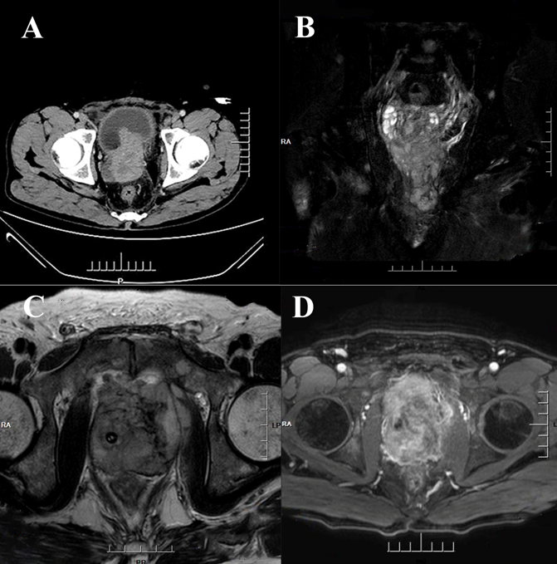
Figure 1 Computed tomography imaging and magnetic resonance imagining. A: Computed tomography imaging of the abdomen: Heterogeneous density within the prostate and heterogeneous enhancement after enhancement, suggesting possible prostate cancer, possible pelvic lymph node metastasis, pelvic floor fascia, and rectal wall and seminal vesicle invasion; B-D: Prostate magnetic resonance imagining: Mixed signals in the prostate, with possible prostate tumor invasion of the lower posterior bladder wall, rectal mesentery, and bilateral seminal vesicles, with multiple lymph node metastases in the pelvis.

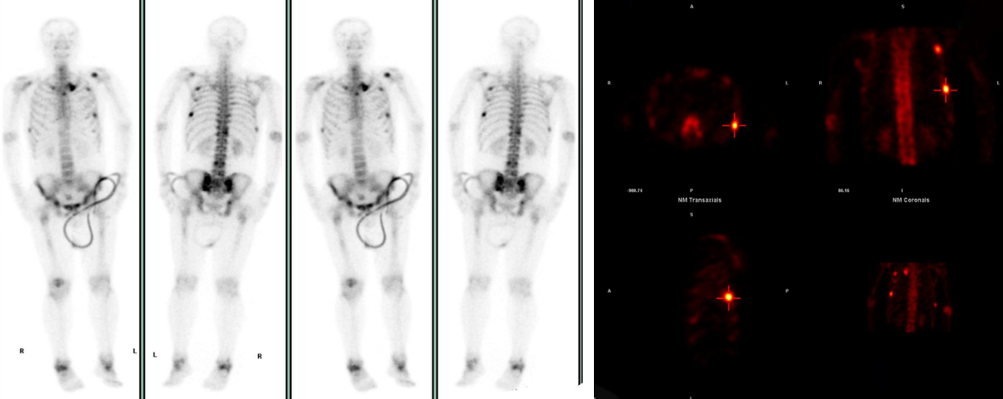
Figure 2 Whole-body bone scan: Abnormally active bone metabolism in the left sternoclavicular joint, multiple ribs, T12, L4, L5 vertebrae, and right acetabulum.
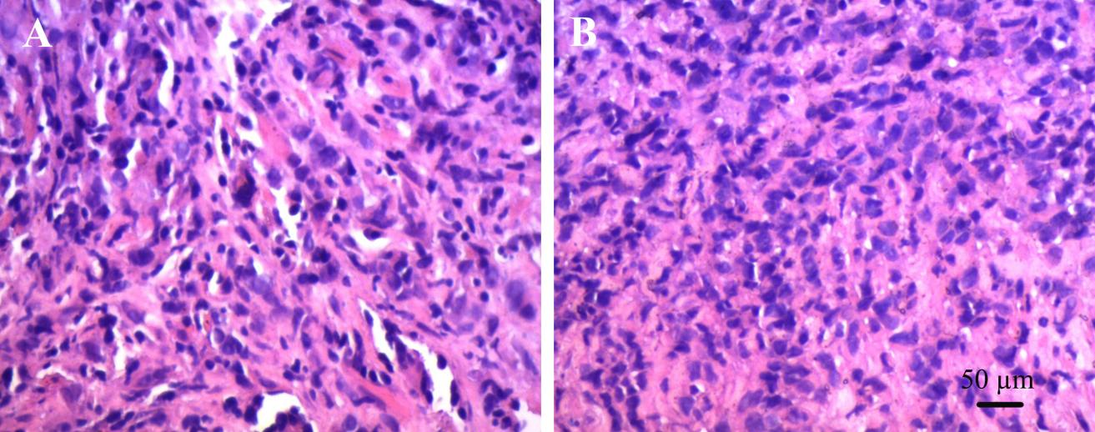
Figures 3 HE × 200 ×; tumor cells arranged in strips and sheets; tumor cells appear oval or spindle-shaped.
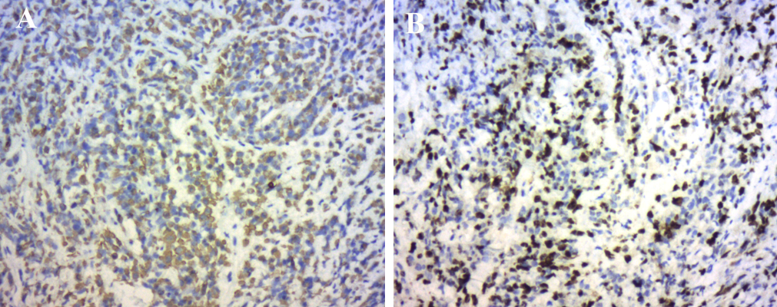
Figure 4 Immunohistochemical. A: SP method immunohistochemical staining for CK broadly focally positive; B: SP method immunohistochemical staining for Ki67 (50%+).
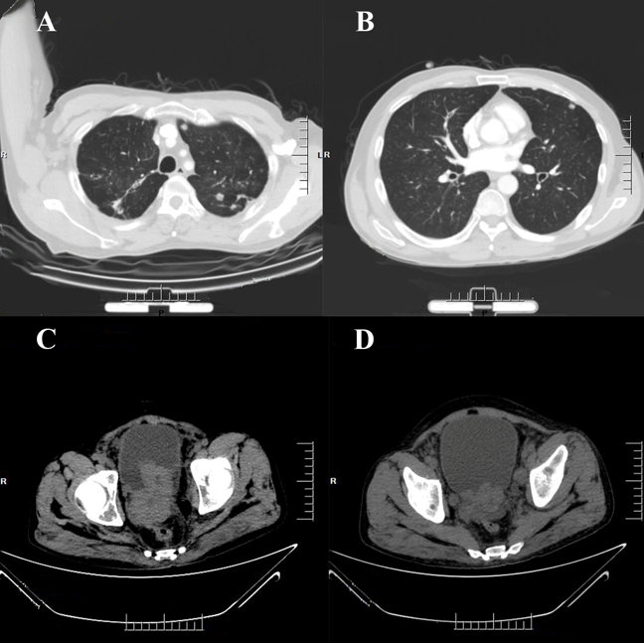
Figure 5 Computed tomography. A and B: Computed tomography (CT) imaging of the lung: Multiple nodular shadows in both lungs, with possible Small-cell carcinoma of the prostate metastases; C and D: CT imaging of the abdomen: An irregular enlargement of Small-cell carcinoma of the prostate showing a tendency to infiltrate, bilateral involvement of the inner segment of the ureteral bladder wall, dilatation and fluid retention in the urinary tract, and multiple bone destruction in the pelvis.

