Name of journal: World Journal of Radiology
ESPS Manuscript NO: 9140
Columns: CASE REPORT

Focal fatty change in the liver that developed after cholecystectomy

Osame A et al. The third inflow to the liver

Akinobu Osame, Toshimichi Mitsufuji, Shinichi Kora, Kengo Yoshimitsu, Daisuke Morihara, Hideo Kunimoto

Akinobu Osame, Toshimichi Mitsufuji, Shinichi Kora, Kengo Yoshimitsu, Department of Radiology, Faculty of Medicine, Fukuoka University, Fukuoka 814-0180, Japan

Daisuke Morihara, Hideo Kunimoto, Department of Gastroenterology, Faculty of Medicine, Fukuoka University, Fukuoka 814-0180, Japan

Author contributions: Osame A, Mitsufuji T, Kora S and Yoshimitsu K designed the report; Morihara D and Kunimoto H collected the patient’s clinical date; Osame A and Yoshimitsu K wrote the paper.

Correspondence to: Dr. Akinobu Osame, Department of Radiology, Faculty of Medicine, Fukuoka University, 7-45-1 Nanakuma, Jonan-ku, Fukuoka 814-0180, Japan. karisumachan@gmail.com

Telephone: +81-92-8011011 Fax: +81-92-9646652

Received: January 22, 2014 Revised: September 2, 2014
Accepted: October 31, 2014

Published online:

Abstract
Focal fatty change of the segment IV (S4) of the liver has been attributed to local systemic venous inflow replacing the portal venous supply, which could develop or be accentuated after gastrectomy. However, focal fatty change due to aberrant pancreaticoduodenal vein that developed after cholecystectomy has never been reported. We report a 30-year-old man with such a rare lesion, which was initially misdiagnosed as a hepatocellular carcinoma, but was confirmed on computed tomography during selective gastroduodenal arteriography. The lesion disappeared 12 mo later without any intervention.

© 2014 Baishideng Publishing Group Inc. All rights reserved.

Key words: Focal fatty liver; Cholecystectomy; Aberrant venous inflow

Core tip: We herein present a case with a history of chronic hepatitis C, who initially was misdiagnosed to have a well-differentiated hepatocellular carcinoma, but was finally diagnosed to have a focal fatty change due to aberrant pancreaticoduodenal vein that developed after cholecystectomy.

Osame A, Mitsufuji T, Kora S, Yoshimitsu K, Morihara D, Kunimoto H. Focal fatty change in the liver that developed after cholecystectomy. World J Radiol 2014; In press

INTRODUCTION
Various pseudolesion observed on CT during arterial portography (CTAP) have been reported and described; some of these have been attributed to venous drainage to the hepatic parenchyma other than portal venous blood (so-called “the third inflow”), such as aberrant right gastric vein (ARGV), cholecystic vein, aberrant pancreaticoduodenal vein (APDV), and epigastric/paraumbilical veins^{[1, 2]}. What should be noted is some of these focal fatty change may develop or be accentuated after gastrectomy due to alteration of the local venous blood flow around the region of the porta hepatis.
We herein present a case with a history of chronic hepatitis C (CHC), who initially was misdiagnosed to have a well-differentiated hepatocellular carcinoma (wHCC), but was finally diagnosed to have a focal fatty change due to APDV that developed after cholecystectomy. The nomenclature used in present report to describe hepatic segments is based on Couinaud’s system^{[3]}.

CASE REPORT
A 30-year-old man with a history of CHC was admitted to our hospital with a suspected diagnosis of wHCC. The patient had past history of acute lymphocytic leukemia at the age of six, which showed complete response to chemotherapy; blood transfusion was performed at that time, however, and liver dysfunction was found at the age of 15, which turned out to be due to CHC. Interferon therapy was then given, and sustained virological response was successfully achieved at the age of 25. During the clinico-radiological follow-up thereafter, he was found to have gallbladder polyps, and underwent cholecystectomy in our institution 6 mo before this admission. Pre-cholecystectomy multidetector-row CT (MDCT) and ultrasonography (US) of the liver had shown no liver mass (not shown).
On admission, laboratory data showed only slightly elevated transaminases, but otherwise were within normal limits. MDCT (Aquilion 64, Toshiba, Tokyo, Japan) demonstrated an ill-defined, irregularly shaped lesion of decreased attenuation in S4 measuring 13 mm in diameter, which showed poor enhancement after the injection of contrast medium (Figure 1). The lesion was seen as an echogenic area on US (not shown). On magnetic resonance (MR) imaging (1.5 T clinical unit, Intera Achieva Nova Dual, Philips, Eindhoven, Netherland), the lesion showed isointensity on T1- and T2-weighted images (T1WI, T2WI, respectively) and apparent signal reduction on the out-of-phase images as compared to in-phase images of chemical shift imaging (CSI), suggesting the presence of fat. On the dynamic phases after gadoxetate disodium (Primovist, Bayer-Schering Pharmacoceuticals, Berlin, Germany) administration, no to poor enhancement was observed. On hepatobiliary phase (HBP), the lesion showed diminished uptake of gadoxetate disodium, which was slightly smaller in size than the fatty area shown on CSI (Figure 2). Judging from these information, a diagnosis of wHCC with slight fatty change was made and surgical resection was planned. On CTAP via superior mesenteric artery, which was performed as a preoperative workup, demonstrated an ill-defined portal perfusion defect in S4, which was significantly larger in size than the fatty area shown on MDCT or MR imaging. CT during proper hepatic arteriography, on the other hand, revealed no significant abnormal vascular lesion at the corresponding area. Meticulous review of the venous phase of the celiac angiography suggested the presence of an APDV coursing toward S4 of the liver, and then, selective catheterization of GD artery was performed. The venous phase of computed tomography during selective gastroduodenal arteriography (CTGDA) was obtained, which confirmed that the portal perfusion defect located in S4 as seen on CTAP was a pseudolesion caused by APDV drainage (Figure 3). The patient was discharged without any specific intervention. Retrospective review of MDCT images, both before cholecystectomy and immediately before the admission, revealed the presence of this APDV (Figure 4).
Serial follow-up US and MR imaging (not shown) showed that the lesion gradually diminished in size and became faint in appearance, then disappeared completely at 20 moafter surgery, supporting the non-neoplastic nature of the lesion. The appearance of APDV remained unchanged on these follow-up images.

DISCUSSION
Couinaud reported the existence of vessels running parallel to the common bile duct and hepatic artery, just anterior to the portal vein and originating from the pancreaticoduodenal, right gastric and cholecystic veins, naming them the parabiliary venous system (PVS)^{[4]}. These veins usually join in the main trunk or major branches of the portal venous system but occasionally enter the liver directly around the porta hepatis (ARGV or APDV), sometimes resulting in isolated perfusion.
These aberrant venous inflows has been attributed to the presence of focal fatty change of the S4.
The pathogenesis of fatty infiltration in the liver is multifactorial. Some authors have speculated a mechanism related to the insulin level in the venous blood, as follows. It is considered that free fatty acids are the major substrates for hepatic triglyceride and ketone body synthesis. Insulin inhibits the oxidation of fatty acids to ketone bodies and promote esterification of fatty acids into triglycerides that accumulate in hepatocytes. The area mainly supplied from the pancreaticoduodenal vein directly entering the liver may be influenced by a high local concentration of insulin that inhibits the formation of ketone bodies, thus favoring accumulation of triglycerides in hepatocytes^{[5]}.
Pseudolesions due to APDV has been reported sporadically^{[2,6,5]}, but one report has suggested its incidence around 2%^{[7]}. In the presented case, S4 was shown as a defect of the portal venous supply on CTAP, while the venous phase of the GD arteriography showed an APDV running toward this segment along the course of the portal vein: CTGDA showed an APDV blood directly entering the defective area of portal venous supply. Because the area with decreased portal perfusion on CTAP was ill-defined and larger in size than the actual fatty area, this area was considered to be perfused both by APDV and portal venous blood reciprocally, and only the small area with the highest insulin concentration (presumably the entering point of APDV) became fatty.
One notable point in this particular case is that the focal fatty area in S4 was not seen 6 months before on CT, but became apparent after cholecystectomy. Similar phenomenon has been reported in patients with PVS who underwent gastrectomy^{[7]}, the mechanism of which may also be applicable to the current case as well. That is, before the cholecystectomy, the venous blood from the region of the head of the pancreas, which contains insulin that is known to have a steatogenic effect on hepatocytes, as mentioned earlier, is diluted by venous blood from the gall bladder that does not contain insulin before reaching S4 of the liver. After the cholecystectomy, this diluting blood flow disappeared and venous blood from the region of the pancreas head with highly concentrated insulin directly drained S4, where intense focal fatty change may occur^{[7]} (Figure 5). The reason why this focal fatty area became obliterated on the follow-up is unclear, but again, similar sequential change of focal fatty area has been reported in patients with PVS who underwent gastrectomy^{[7]}. The exact mechanism of this of this phenomenon, however, is still unknown and will require further investigation.
One limitation in this study is lack of pathological proof of fatty change at S4. We dared not to perform percutaneous biopsy of the lesion and decided to follow the patient, considering the difficulty in making the pathological diagnosis of wHCC only on the biopsy specimens^{[8]}. We believe the clinico-radiological data, namely CTGDA findings and non-progressive nature of the lesion on the follow-up, may sufficiently support the non-neoplastic etiology of the fatty area in S4 in this particular patient.
In conclusion, we presented a case with a focal fatty area in S4 of the liver, caused by APDV, that developed after cholecystectomy. Radiologists and clinicians need to be aware of this phenomenon and should not mistake these lesions for HCCs or metastases.

ACKNOWLEDGMENTS
We thank Professor Shotaro Sakisaka, Chair of Department of Gastroentrology, Faculty of Medicine, Fukuoka University, for providing clinical information of the patient in this report.

COMMENTS
Case characteristics
A 30-year-old man with a history of chronic hepatitis C (CHC) with a suspected diagnosis of well-differentiated hepatocellular carcinoma (wHCC).

Clinical diagnosis
Judging from clinical date, computed tomography and MR information, a diagnosis of wHCC with slight fatty change.

Differential diagnosis
Focal fatty change, metastasis.

Laboratory diagnosis
laboratory data showed only slightly elevated transaminases, but otherwise were within normal limits.

Imaging diagnosis
Multidetector-row CT and MRI findings sugested wHCC with slight fatty change. The venous phase of computed tomography during selective gastroduodenal arteriography was obtained, which confirmed that the portal perfusion defect located in S4 as seen on CT during arterial portography was a pseudolesion caused by aberrant pancreaticoduodenal vein drainage.

Treatment
The patient was discharged without any specific intervention.

Related reports
Focal fatty change may develop or be accentuated after gastrectomy due to alteration of the local venous blood flow around the region of the porta hepatis.

Term explanation
The third inflow: venous drainage to the hepatic parenchyma other than portal venous blood.

Experiences and lessons
Radiologists and clinicians need to be aware of this phenomenon and should not mistake these lesions for HCCs or metastases.

Peer review
The manuscript entitled Focal fatty change in the medial segment of the liver due to aberrant pancreatico-duodenal venous drainage that developed after cholecystectomy: A Case Report is well-presented and written. It is also a rare case which shows that it can cause confusion with HCC based on certain diagnostic procedures.

REFERENCES
1 Matsui O, Takahashi S, Kadoya M, Yoshikawa J, Gabata T, Takashima T, Kitagawa K. Pseudolesion in segment IV of the liver at CT during arterial portography: correlation with aberrant gastric venous drainage. Radiology 1994; 193: 31-35 [PMID: 8090916]
2 Yoshimitsu K, Honda H, Kuroiwa T, Irie H, Aibe H, Shinozaki K, Masuda K. Unusual hemodynamics and pseudolesions of the noncirrhotic liver at CT. Radiographics 2001; 21 Spec No: S81-S96 [PMID: 11598250 DOI: 10.1148/radiographics.21.suppl_1.g01oc06s81]
3 Couinaud C. Le Foie: etudes anastomoique et chirugicales. Paris: Masson, 1957
4 Couinaud C. The parabiliary venous system. Surg Radiol Anat 1988; 10: 311-316 [PMID: 3145573 DOI: 10.1007/BF02107904]
5 Fukukura Y, Fujiyoshi F, Inoue H, Sasaki M, Hokotate H, Baba Y, Nakajo M. Focal fatty infiltration in the posterior aspect of hepatic segment IV: relationship to pancreaticoduodenal venous drainage. Am J Gastroenterol 2000; 95: 3590-3595 [PMID: 11151897 DOI: 10.1111/j.1572-0241.2000.03298.x]
6 Nakayama T, Yoshimitsu K, Masuda K. Pseudolesion in segment IV of the liver with focal fatty deposition caused by the parabiliary venous drainage. Comput Med Imaging Graph 2000; 24: 259-263 [PMID: 10842050 DOI: 10.1016/S0895-6111(00)00021-5]
7 Yoshimitsu K, Irie H, Kakihara D, Tajima T, Asayama Y, Hirakawa M, Ishigami K, Noshiro H, Kakeji Y, Honda H. Postgastrectomy development or accentuation of focal fatty change in segment IV of the liver: correlation with the presence of aberrant venous branches of the parabiliary venous plexus. J Clin Gastroenterol 2007; 41: 507-512 [PMID: 17450035 DOI: 10.1097/01.mcg.0000225613.86846.cb]
8 Durand F, Regimbeau JM, Belghiti J, Sauvanet A, Vilgrain V, Terris B, Moutardier V, Farges O, Valla D. Assessment of the benefits and risks of percutaneous biopsy before surgical resection of hepatocellular carcinoma. J Hepatol 2001; 35: 254-258 [PMID: 11580148 DOI: 10.1016/S0168-8278(01)00108-8]

P-Reviewer: Sazci A S-Editor: Song XX L-Editor: E-Editor:

Figure 1A
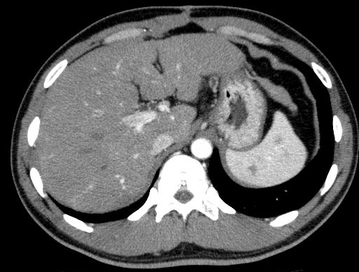

Figure 1B
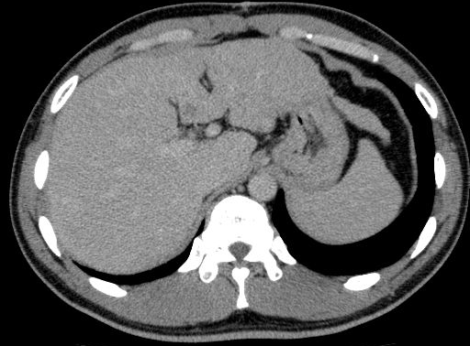
Figure 1 Multidetector-row computed tomography. A: Arterial phase shows an area of little enhancement (arrow) in segment IV; B: Equilibrium phase shows an area of hypodensity (arrow) as compared with surrounding liver parenchyma.
Figure 2A
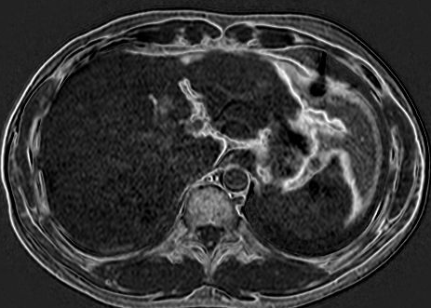

Figure 2B
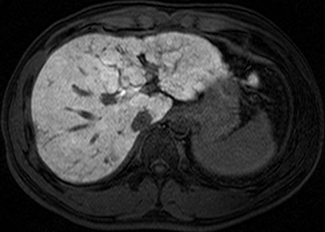
Figure 2 Gadoxetate disodium-enhanced magnetic resonance imaging. A: Subtraction chemical shift images before contrast enhancement shows high intensity of the lesion (arrow), suggesting the presence of small amount of fat; B: On hepatobiliary phase, an area of diminished uptake of gadoxetate disodium is seen (arrow), which was slightly smaller in size than the fatty area shown on A.

Figure 3A
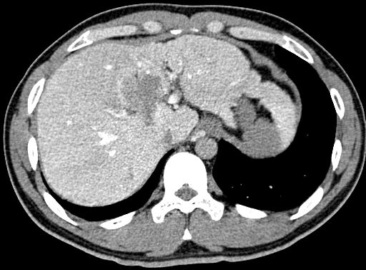

Figure 3B
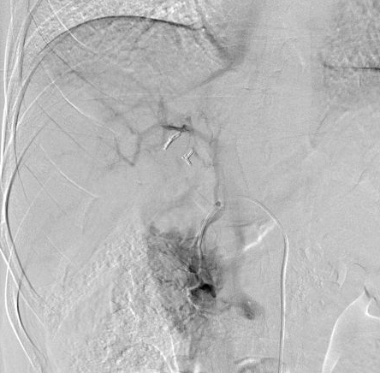
Figure 3C

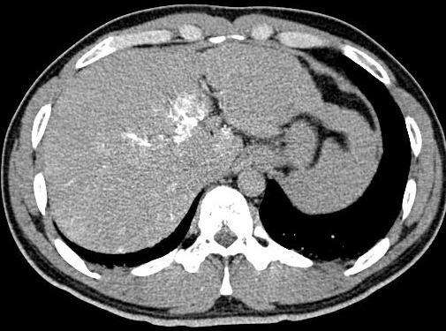
Figure 3 Angiography-assisted computed tomography. A: Computed tomography (CT) during arterial portography shows a portal venous perfusion defect in S4, which was significantly larger in size than the fatty area shown on CT or magnetic resonance imaging; B: Venous phase of gastroduodenal arteriogram shows an unusual vessel coursing towards the hepatic hilum, representing an aberrant pancreatico-duodenal vein; C: Venous phase of CT during gastroduodenal arteriogram shows that the venous blood from the region of the head of the pancreas directly drains the areas of portal perfusion defect as shown in 3A.

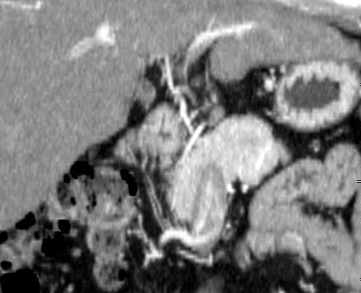
Figure 4 Curved reformation image of the arterial phase of computed tomography reconstructed along the aberrant vessel. The whole course of the aberrant pancreatico-duodenal vein is well demonstrated. The computed tomography data used here are the ones obtained before cholecystectomy.

B

A
S4
GB
Pancreas
Head
RGV
PDV
CV
S4
Pancreas
Head
RGV
PDV

Insulin-less flow
Insulin-rich flow

Figure 5 Schematic diagram showing the possible mechanism of the development of focal fatty change in S4 in the present case. A: Before cholecystectomy. Insulin-rich flow from the head of the pancreas may be diluted by venous blood that does not contain insulin. S4 of the liver may be normal in appearance, slightly enhanced, or slightly fatty, depending on the amount of blood flow and insulin conveyed to S4; B: After cholecystectomy. Because there is no more diluting blood flow from the gallbladder, insulin-rich flow from the head of the pancreas may directly reach S4 of the liver, where intense focal fatty change may occur.

