Name of Journal: World Journal of Gastrointestinal Oncology
Manuscript NO: 85245
Manuscript Type: ORIGINAL ARTICLE

Basic Study
Dopamine and cyclic adenosine monophosphate-regulated phosphoprotein with an apparent Mr of 32000 promotes colorectal cancer growth

He K et al. DARPP-32 promotes CRC growth

Kuan He, Chao-Zheng Xie, Ya Li, Zhen-Zhou Chen, Shi-Hao Xu, Si-Qi Huang, Jian-Guo Yang, Zheng-Qiang Wei, Xu-Dong Peng

Kuan He, Chao-Zheng Xie, Ya Li, Shi-Hao Xu, Si-Qi Huang, Jian-Guo Yang, Zheng-Qiang Wei, Xu-Dong Peng, Gastrointestinal Surgery, The First Affiliated Hospital of Chongqing Medical University, Chongqing 400000, China

Zhen-Zhou Chen, Gastrointestinal Surgery, The Third Affiliated Hospital of Chongqing Medical University, Chongqing 400000, China

Author contributions: He K conceived and designed the study; He K, Xie CZ, and Li Y performed the experimental tasks; He K and Chen ZZ collected the data; He K, Xu SH, Huang SQ, and Yang JG analyzed and interpreted the data; He K and Peng XD drafted the article; Wei ZQ and Peng XD critically revised the article; All authors have read and approved the final manuscript.

Supported by Chongqing Key Diseases Research and Application Demonstration Program, No. 2019ZX003; General Project of Chongqing Nature Science Foundation, No. cstc2021jcyj-msxmX0283.

Corresponding author: Xu-Dong Peng, PhD, Doctor, Gastrointestinal Surgery, The First Affiliated Hospital of Chongqing Medical University, No.1 Youyi Road, Yuzhong District, Chongqing 400000, China. 846393577@qq.com

Received: April 19, 2023
Revised: June 29, 2023
Accepted: July 29, 2023
Published online:

Abstract
BACKGROUND
Dopamine and cyclic adenosine monophosphate (cAMP)-regulated phosphoprotein with an apparent Mr of 32000 (DARPP-32) is a protein that is involved in regulating dopamine and cAMP signaling pathways in the brain. However, recent studies have shown that DARPP-32 is also expressed in other tissues, including colorectal cancer (CRC), where its function is not well understood.

AIM
To explore the effect of DARPP-32 on CRC progression.

METHODS
The expression levels of DARPP-32 were assessed in CRC tissues using both quantitative polymerase chain reaction and immunohistochemistry assays. The proliferative capacity of CRC cell lines was evaluated with Cell Counting Kit-8 and 5-ethynyl-2’-deoxyuridine assays, while apoptosis was measured by flow cytometry. The migratory and invasive potential of CRC cell lines were determined using wound healing and transwell chamber assays. In vivo studies involved monitoring the growth rate of xenograft tumors. Finally, the underlying molecular mechanism of DARPP-32 was investigated through RNA-sequencing and western blot analyses.

RESULTS
DARPP-32 was frequently upregulated in CRC and associated with abnormal clinicopathological features in CRC. Overexpression of DARPP-32 was shown to promote cancer cell proliferation, migration, and invasion and reduce apoptosis. DARPP-32 knockdown resulted in the opposite functional effects. Mechanistically, DARPP-32 may regulate the phosphoinositide 3-kinase (PI3K)/AKT signaling pathway in order to carry out its biological function.

CONCLUSION
DARPP-32 promotes CRC progression via the PI3K/AKT signaling pathway.

Key Words: Colorectal cancer; Dopamine and cyclic adenosine monophosphate-regulated phosphoprotein with an apparent Mr of 32000; Proliferation; Migration; Phosphoinositide 3-kinase; Akt

He K, Xie CZ, Li Y, Chen ZZ, Xu SH, Huang SQ, Yang JG, Wei ZQ, Peng XD. Dopamine and cyclic adenosine monophosphate-regulated phosphoprotein with an apparent Mr of 32000 promotes colorectal cancer growth. World J Gastrointest Oncol 2023; In press

Core Tip: Dopamine and cyclic adenosine monophosphate-regulated phosphoprotein with an apparent Mr of 32000 (DARPP-32) is frequently upregulated in colorectal cancer (CRC). Overexpression of DARPP-32 promoted cancer cell proliferation, migration, and invasion and reduced apoptosis. Mechanistic investigations revealed that DARPP-32 appeared to exert its oncogenic functions through regulation of the phosphoinositide 3-kinase/Akt signaling pathway, which is involved in cell survival and proliferation. These findings indicate that DARPP-32 plays an essential role in facilitating CRC tumorigenesis and progression. Therefore, DARPP-32 may represent a potential novel biomarker and therapeutic target for CRC treatment.

INTRODUCTION
Colorectal cancer (CRC) is one of the most common malignancies. According to the 2020 Global Oncology Yearbook, new cases of CRC rank third among all cancers^{[1]}. Recent years have seen continued advances in the early diagnosis and standardization of CRC. The 5-year survival rate of advanced CRC is less than 20%, and the prognosis is not good^{[2]}. A major cause of this poor survival rate is distant metastasis and drug resistance of tumor cells. Therefore, more novel biomarkers and targets need to be discovered for the better diagnosis and treatment of patients with CRC.
During transcription, dopamine and cyclic adenosine monophosphate-regulated phosphoprotein with an apparent Mr of 32000 (DARPP-32), also known as phosphoprotein phosphatase 1 (PP-1) regulatory subunit 1B, was initially discovered as a substrate of dopamine-activated protein kinase A (PKA) in the neostriatum of the brain^{[3]}. When the Thr34 residue is phosphorylated as catalyzed by PKA, DARPP-32 acts as an inhibitor of PP-1^{[4,5]}. By contrast, when the Thr75 residue is phosphorylated as catalyzed by cyclin-dependent kinase 5, DARPP-32 inhibits PKA and is able to prevent PKA from phosphorylating DARPP-32^{[6]}. DARPP-32 has been found in breast^{[7,8]}, gastric^{[9-11]} esophageal^{[12]}, lung^{[13]}, and prostate^{[14]} cancers. DARPP-32 is commonly increased in gastric carcinoma and promotes carcinoma vascular formation and carcinoma growth via angiopoietin-2 regulation^{[15]}. DARPP-32 isoforms are overexpressed to promote “bypass signaling” of the epidermal growth factor receptor (EGFR) in non-small cell lung cancer. The Erb-B2 receptor tyrosine kinase 3 allows tumor cells to evade apoptosis induced by EGFR tyrosine kinase inhibitor monotherapy by potentiating oncogenic Akt^{[16]}. Although DARPP-32 may act as an oncoprotein, its expression and molecular mechanisms in CRC cell proliferation and migration remain unclear.
This study investigated the role of DARPP-32 in CRC and its associated molecular mechanisms.

MATERIALS AND METHODS
Tissue samples
In total, 70 CRC samples and corresponding adjacent matched nonmalignant tissues were collected during surgeries performed at the First Affiliated Hospital of Chongqing Medical University (Chongqing, China). These samples were stored until use at –80 °C. Our study was approved by the Ethical Review Committee of the First Affiliated Hospital of Chongqing Medical University.

Cell culture
HT-29, LOVO, HCT116, and SW480 cell lines were provided by the central laboratory of the First Affiliated Hospital of Chongqing Medical University. The cell lines were cultured in high-glucose Dulbecco’s modified Eagle medium (DMEM) (GIBCO, Carlsbad, CA, United States) with 10% fetal bovine serum (Sigma-Aldrich, Taufkirchen, Germany) in 5% CO₂.

Immunohistochemistry assay
Shanghai Outdo Biotech Co., Ltd. (Shanghai, China) provided the tissue microarray (TMAs) that were used for immunohistochemistry (IHC). Briefly, tissue samples were treated with ethylenediamine tetraacetic acid to recover antigens, followed by incubation overnight at 4 °C with a 1: 100 dilution of anti-DARPP-32 antibody (sc-271111; Santa Cruz Biotechnology, Dallas, TX, United States). Then secondary antibodies (SA1055; Boster Biological Technology Co. Ltd., Wuhan, China) were added, and the mixture was incubated at 37 °C for 1 h. Finally, the samples were stained and photographed. A scale from 0 to 3 + was used to grade the staining intensity, with 0 denoting no staining, 1 denoting faint immunoreactivity, 2 denoting moderate immunoreactivity, and 3 denoting strong immunoreactivity. Scores for the percent positive were given as follows: 0 for 0%-5%, 1 + for 6%-25%, 2 + for 26%–50%, 3 + for 51%-75%, and 4 + for 76%-100%. The composite IHC score, which ranges from 0 to 7, is the result of adding the intensity and positivity ratio scores.

Quantitative polymerase chain reaction
Trizol reagent (Invitrogen, Carlsbad, CA, United States) was used to extract the total RNA. Using the PrimeScript™ RT Reagent Kit (TaKaRa Bio, Chengdu, China), cDNA was created. TB Green Premix Ex Taq™ II (TaKaRa Bio) was used for quantitative PCR (qPCR) according to the manufacturer’s protocol. The reverse transcription primers were: DARPP-32: forward 5′-GGGGCACCATCTCAAGT-3′ and reverse 5′-GCTCATCCTCCTCCTCTG-3′, and glyceraldehyde 3-phosphate dehydrogenase (GAPDH): forward 5′-CTTTGGTATCGTGGAAGGACTC-3′ and reverse 5′-GTAGAGGCAGGGATGATGTTCT-3′. DARPP-32 relative expression levels were normalized to those of GAPDH and calculated according to the 2^{-ΔΔCt} method^{[17]}. Transduction with lentiviral vectors and small interfering RNA (siRNA) transfection. Lentiviruses encoding DARPP-32 and control lentivirus were purchased from HanBio Biotechnology Co. Ltd. (Shanghai, China). Lentivirus was added to cells (2 × 10⁵) that had been grown in 6-well plates and incubated for 24 h. The medium was switched after 24 h. After 72 h, cells were examined by fluorescence microscopy using the TE2000-U microscope (Nikon, Tokyo, Japan) and the images were photographed. Puromycin (2 µg/mL; HanBio Biotechnology Co., Ltd.) was used to select the transduced cells for 1 wk and used in subsequent experiments. Synthesis of siRNAs targeting DARPP-32 was carried out by RiboBio (Guangzhou, China). The primers were sequenced using three different siRNAs as follows: DARPP-32 siRNA1, 5′-GGUGCUAGGUAGAAAGUUAGG-3′ (sense) and 5′-UAACUUUCUACCUAGCACCUC-3′ (antisense); DARPP-32 siRNA2, 5′-GAUAGUACUAGCAAGUAUACU-3′ (sense) and 5′-UAUACUUGCUAGUACUAUCUU-3′ (antisense); DARPP-32 siRNA3, 5′-AG AUAUGUAUCUUAUAUAAAC-3′ (sense) and 5′-UUAUAUAAGAUACAUAUCUUG-3′ (antisense). The working concentration of siRNA was 20 nM. HT-29 and LOVO cells were transfected for 48 h with siRNAs using Ribo FECT™ CP Reagent (RiboBio, Guangdong, China) in accordance with the manufacturer’s guidelines.

Ethynyl-2′-deoxyuridine incorporation assay
Cell viability was assessed with the ethynyl-2′-deoxyuridine (EdU) proliferation assay^{[18]}. Briefly, 100 μL of 50 μM EdU was added to each well for 2 h. Then the cells were stained with Apollo staining solution after being fixed in 4% formaldehyde in phosphate-buffered saline (PBS) for 30 min at room temperature. DNA was stained with Hoechst 33342 for 30 min. Samples were examined using the LSM 700 confocal microscope (Carl Zeiss, Jena, Germany).

Cell Counting Kit-8 assay
A total of 2000 cells per well of 96-well plates of transfected cells were plated, and the cells were cultured at 37 °C in 5% CO₂ for 0, 24, 48, and 72 h. Then Cell Counting Kit-8 (CCK-8) reagent was added to each well and incubated for an additional 1 h. Finally, the absorbance was measured at 450 nm with a microplate reader (Bio-Rad Laboratories, Hercules, CA, United States).
Apoptosis
Cellular apoptosis assays were performed by flow cytometry using the Annexin V-FITC Apoptosis Detection Kit (Beyotime, Beijing, China) in accordance with the manufacturer’s procedures. A flow cytometer (BD Biosciences, Franklin Lakes, NJ, United States) was used to analyze the cells.

Wound healing assay
In 6-well plates, transfected cells were grown to a confluence of about 75%-85%. To create wounds, the surface of a monolayer was scraped off with a sterile 10-μL pipette tip. PBS was used to gently wash the cells, and DMEM containing 1% serum was used to continue the culture. Lastly, the migration distance was photographed at 0 h and 48 h.

Transwell chamber assay
Transwell chambers (8 μm pore size) were used to assess cellular invasion. Complete medium (500 μL) was present in the bottom chamber. In the upper compartment, cells (5 × 10⁴) were seeded in 200 μL serum-free medium. For 48 h, the cells were incubated and then swabbed from the surface of the filter exposed to the upper chamber. Invasive cells on the opposite side of the filter were preserved with 4% formaldehyde and dyed with 0.1% crystalline purple and quantified by optical microscopy. For each insert, five random fields per filter were counted. The cells were positioned on the upper surface of the matrigel matrix-coated (BD Biosciences) transwell chamber. Cells were processed as previously described.

RNA sequencing analysis
RNA was extracted from SW480 cells with overexpression of DARPP-32 for RNA sequencing (RNA-seq) analysis. Total RNA isolation was carried out using the TRIzol reagent (Invitrogen Life Technologies), after which the concentration of the product was determined with the NanoDrop spectrophotometer (Thermo Fisher Scientific, Waltham, MA, United States). Then miRNA libraries were generated and sequenced on the NovaSeq 6000 platform (Illumina, San Diego, CA, United States) by Shanghai Personal Biotechnology Co. Ltd. (Shanghai, China). We used the R language ggplot2 package to draw volcano plots of differentially expressed genes, pheatmap package of R language for two-way clustering analysis of unions and samples of all comparison groups, and SangerBox website for Gene Ontology enrichment analysis and Kyoto Encyclopedia of Genes and Genomes (KEGG) pathway analysis of differential gene expression.

Western blot analysis
We used RIPA lysis buffer (Beyotime Biotech, Shanghai, China) to extract the cells and used the bicinchoninic acid kits (Beyotime Biotech) to detect the expression levels. The protein was separated on 10% sodium dodecyl sulfate-polyacrylamide gel electrophoresis. After separation, the protein was electrotransferred to a polyvinylidene difluoride membrane, and then blocked in 5% bovine serum albumin solution for 1 h. Then the membranes were incubated with primary antibodies (1:1000 dilutions) against DARPP-32 (ab40801; Abcam, Cambridge, United Kingdom), AKT (T55561S; Abmart, Shanghai, China), phosphorylated AKT (p-AKT, T40067S; Abmart), phosphoinositide 3-kinase (PI3K, ab191606; Abcam), p-PI3K (T40065S; Abmart), GAPDH (10494-1-AP; Proteintech, Wuhan, China), and β-tubulin (10094-1-AP; Proteintech). After an overnight incubation at 4 ℃, the membranes were incubated with secondary antibodies for 2 h at room temperature. Fusion software (Vilber Lourmat, Collégien, France) was used for densitometry analysis. GAPDH served as the loading control.

In vivo experiments
The Animal Care Committee of Chongqing Medical University approved the animal experiments, which were carried out in accordance with the ethics Committee of Chongqing Medical University guidelines and regulations for animal welfare. Hunan SJA Laboratory Animal Co. Ltd. (Hunan, China) provided the female BALB/c naked mice (5 wk old). 1 × 10⁷ cells were injected subcutaneously into the shoulders of mice (n = five per group). Tumor growth was monitored every 3 d for 4 wk. To determine the tumor volumes, the formula v (mm³) = a × b × c/2 was used, where a is length, b is width, and c is height. IHC tests were performed using tumor samples.
Statistical analysis
All statistical data analyses were performed with GraphPad Prism 9.0 (GraphPad Software, La Jolla, CA, United States) and the statistical program for social sciences 19.0 software (SPSS, Chicago, IL, United States). The mean ± standard deviation of three different experiments were used to represent all statistical data. Survival curves were generated using the Kaplan-Meier method and compared using the log-rank test. The distribution differences of the variables were analyzed using Pearson’s χ² test. Student’s t-test was used to evaluate how well the experimental and control groups could be distinguished from one another. P < 0.05 was considered statistically significant.

RESULTS
Expression and clinical relevance of DARPP-32 in CRC
Data on DARPP-32 expression from the Genotype-Tissue Expression and Cancer Genome Atlas Datasets were collected and analyzed using the Gene Expression Profiling Interactive Analysis Platform. The results revealed the significant overexpression of DARPP-32 in tumor samples compared to adjacent normal tissue samples from patients with CRC (Figure 1A). Next, we employed qPCR to measure the DARPP-32 mRNA expression in 70 fresh CRC tissues and matched nearby normal tissues. Comparing neighboring noncancerous tissues to CRC tissues, DARPP-32 mRNA expression in the latter was significantly higher (P < 0.05), consistent with the findings described in Figure 1B. The study of the associations between DARPP-32 expression and clinicopathological traits demonstrated that DARPP-32 upregulation was positively correlated with metastasis to lymph nodes (Table 1, patient clinical pathological data can be presented in Supplementary Table 1). TMA was used to investigate the relationship between DARPP-32 and CRC patient survival. Comparing the CRC group to the adjacent non-neoplastic group, DARPP-32 protein level was overexpressed (Figure 1C and D). By contrast, high DARPP-32 expression had no obvious relationship with tumor stage (Figure 1E). Although there was no significant difference in statistics, it can be seen from the Figure 1F that the prognosis of patients with high DARPP-32 expression was worse. In addition, DARPP-32 mRNA and protein expression in four human CRC cell lines (HCT116, SW480, HT29, and LOVO) and healthy colon mucosal epithelial cells from NCM460 were assessed using western blotting and RT-PCR. All four CRC cell lines had increased levels of DARPP-32 mRNA and protein expression than NCM460 cells (Figure 1G-I). These data suggest that DARPP-32 expression is markedly high in CRC.

DARPP-32 promotes CRC proliferation in vitro and in vivo
To learn more about how DARPP-32 helps colon cancer cells proliferate, DARPP-32 was overexpressed in HCT116 and SW480 cells by lentivirus transfection and silenced in HT-29 and LOVO cells using two separate siRNA duplexes. Overexpression of DARPP-32 was verified by western blotting (Figure 2A and B). DARPP-32 overexpression increased the proliferation of HCT116 and SW480 cells in EdU proliferation and CCK-8 assays (Figure 2C-G). By contrast, HT29 and LOVO cells transfected with siDARPP-32 (DARPP-32 siRNA) reduced the rates of cell proliferation (Figure 2E-K). The following phase involved using naked mice to examine how DARPP-32 affected tumor formation. Tumor formation was observed in naked mice injected with HCT116 negative control (NC) cells andHCT116-DARPP-32 cells. HCT116-DARPP-32 cells had a significantly larger mean tumor volume than those induced by the NC (Figure 3A and B). Compared to the control group, the IHC study results showed that HCT116-DARPP-32 enhanced Ki67 protein expression (Figure 3C). All of these findings suggest that DARPP-32 promotes CRC cell growth.

DARPP-32 reduces apoptosis of CRC cells
To determine whether DARPP-32 impacts the apoptosis of CRC cell lines, flow cytometry was used. The DARPP-32-overexpression groups decreased the proportion of apoptotic cells compared to the control group (Figure 4A and B). By contrast, siDARPP-32-transfected HT29 and LOVO cells displayed a substantial increase in apoptotic cells (Figure 4C and D). Together, these data suggest that DARPP-32 decreases CRC apoptosis.

DARPP-32 promotes CRC cell invasion and migration
We overexpressed DARPP-32 in HCT116 and SW480 cells and silenced it in HT29 and LOVO cells using two distinct siRNA duplexes to investigate the role of DARPP-32 in the invasion and migration of CRCs. Transwell cell invasion assays and wound healing cell migration assays were employed to evaluate cell invasion and migration. Compared to their equivalent NC, HCT116 and SW480 DARPP-32-overexpressing cells demonstrated a considerable increase in invasion and migration (Figure 5A-D). By contrast, siDARPP-32 transfected HT29 and LOVO cells significantly inhibited invasion and migration (Figure 5E-H). These findings indicate the possibility that DARPP-32 influences the proliferation, apoptosis, and migration of cells in CRC tumors, ultimately promoting their malignant development.

Effect of DARPP-32 on progression is partially dependent on the PI3K/AKT signaling pathway
RNA-seq was performed to study the potential mechanism of DARPP-32 in the progression of CRC, and the results were analyzed. The identification of 17048 differentially expressed genes in SW480 cells overexpressing DARPP-32 by RNA-seq revealed that 440 genes were downregulated and 947 genes were upregulated (Figure 6A and B). The PI3K-AKT signaling pathway was enriched in SW480 cells overexpressing DARPP-32, according to KEGG enrichment analysis (Figure 6C and D). Therefore, we investigated if DARPP-32 primarily contributes to cell survival via regulation of PI3K/AKT signaling. As shown in Figure 6E, p-PI3K and p-AKT (S473) protein levels were upregulated in DARPP-32-overexpressing cells but downregulated when DARPP-32 was silenced (Supplementary Figure 1). Additionally, the western blot analysis showed that the expression of p-AKT was decreased after treating HCT116 and SW480 cell lines with 20 μM LY294002 in the presence of overexpressed DARPP-32 (Supplementary Figure 2). Taken together, these data highlight that DARPP-32 can influence the PI3K/AKT signaling pathway, which could facilitate CRC cell proliferation and migration.

DISCUSSION
Recent decades have seen advances in the clinical management of CRC. Despite these accomplishments, the prognosis of CRC remains unsatisfactory^{[1]}. More effective treatment targets are urgently needed, and their impact on CRC advancement needs to be clarified. DARPP-32 overexpression has been correlated with numerous tumors, in particular gastric, breast, and prostate cancers, pointing to its potential role in carcinogenesis by inducing proliferation, invasion, and survival^{[19]}. DARPP-32 is highly expressed in CRC^{[20]}, but its specific mechanism is not clear. Here, we provide evidence that DARPP-32 is overexpressed in CRC tissue, and that high levels of DARPP-32 correlate with lymphatic metastasis. High expression of DARPP-32 also decreased apoptosis while promoting CRC cell motility, invasion, and proliferation. As a result of DARPP-32 silencing, CRC tumor cells are less likely to proliferate and migrate while undergoing apoptosis, which could prevent the emergence of malignant phenotypes.
We conducted enrichment analysis of KEGG data to investigate the probable mechanism of DARPP-32 in CRC. DARPP-32 overexpression resulted in significant enrichment of PI3K/AKT signaling. The PI3K/AKT signal transduction pathway is abnormally active in a number of tumorigenic processes and plays a significant role in carcinogenesis and development^{[21-24]}. AKT is one of the most highly hyperactive kinases in human malignancies. Alterations and genetic defects in all three AKT isoforms have been discovered in numerous types of cancers^{[25,26]}. The hallmarks of cancer cell proliferation, metabolism, survival, invasiveness, and angiogenesis are modulated by AKT. Tyrosine kinases and somatic mutations in particular signaling pathway components are now the most frequent causes of PI3K-AKT activation in human malignancies^{[27-30]}. Phosphatidylinositol 4,5-bisphosphate is transformed into phosphatidylinositol (3,4,5)-trisphosphate (PIP3) by the lipid kinase PI3K^{[31,32]}. PIP3 is an essential second messenger required for AKT to translocate to the plasma membrane, where it is phosphorylated and activated by phosphoinositide-dependent kinase-1 and phosphoinositide-dependent kinase-2^{[33,34]}. The present results indicate that overexpression of DARPP-32 upregulates the protein expression of p-PI3K and p-AKT, pointing to a potential function for DARPP-32 in increasing CRC progression via PI3K/AKT signaling. However, one limitation of this study is that it did not investigate the pro-oncogenic effects of DARPP-32 on normal colonic cell lines. Further research is needed to determine the precise mechanisms by which DARPP-32 controls CRC processes via the PI3K/AKT signaling pathway.

CONCLUSION
In CRC, DARPP-32 expression is unusually high. DARPP-32 is also necessary for the migration, apoptosis, and proliferation of CRC cells. These observations provide evidence that DARPP-32 promotes the progression of CRC via PI3K/AKT. This may provide a theoretical foundation for basic research in CRC.

ARTICLE HIGHLIGHTS
Research background
Colorectal cancer (CRC) is one of the most prevalent and deadly types of cancer worldwide. Despite advances in treatment options, the molecular mechanisms underlying CRC development and progression are not fully understood. Recently, dopamine and cyclic adenosine monophosphate (cAMP)-regulated phosphoprotein with an apparent Mr of 32000 (DARPP-32) has emerged as a potential player in CRC. DARPP-32 is known for its involvement in dopamine and cAMP signaling pathways in the brain, but its role in CRC remains largely unexplored. Understanding the function and molecular mechanisms of DARPP-32 in CRC could provide valuable insights into the pathogenesis of this disease and potentially uncover new therapeutic targets.

Research motivation
CRC is a significant health concern, and understanding the underlying molecular mechanisms driving its progression is crucial for developing effective treatments. The role of DARPP-32, a protein involved in dopamine and cAMP signaling, in CRC remains poorly understood. Investigating the function of DARPP-32 in CRC could reveal its potential as a therapeutic target and shed light on novel pathways involved in tumor development and progression.

Research objectives
We aimed to enhance our understanding of the involvement of DARPP-32 in CRC progression and potentially identify novel therapeutic targets for the treatment of this disease.

Research methods
Since the effect of DARPP-32 on colorectal neoplasia is unknown, this study combined bioinformatics analysis, quantitative polymerase chain reaction, western blotting, tissue microarrays, and a variety of in vitro and in vivo functional tests to investigate this effect.

Research results
We found that DARPP-32 was frequently upregulated in CRC and associated with abnormal clinicopathological features in CRC. Overexpression of DARPP-32 was shown to promote cancer progression. DARPP-32 knockdown resulted in the opposite functional effect. Mechanistically, DARPP-32 may regulate the phosphoinositide 3-kinase (PI3K)/AKT signaling pathway to carry out its biological function.

Research conclusions
The collective results demonstrate that DARPP-32 promotes CRC progression via the PI3K/AKT signaling pathway.

Research perspectives
Further investigation is needed to reveal the precise molecular mechanisms through which DARPP-32 regulates the PI3K/AKT signaling pathway in CRC. Identifying the specific downstream targets and upstream regulators of DARPP-32 will provide a deeper understanding of its role in cancer progression.

ACKNOWLEDGEMENTS
We would like to express our gratitude to Professor Chen LX from the experimental research center of the First Affiliated Hospital of Chongqing Medical University for providing the experimental platform.

REFERENCES
1 Sung H, Ferlay J, Siegel RL, Laversanne M, Soerjomataram I, Jemal A, Bray F. Global Cancer Statistics 2020: GLOBOCAN Estimates of Incidence and Mortality Worldwide for 36 Cancers in 185 Countries. CA Cancer J Clin 2021; 71: 209-249 [PMID: 33538338 DOI: 10.3322/caac.21660]
2 Siegel RL, Miller KD, Goding Sauer A, Fedewa SA, Butterly LF, Anderson JC, Cercek A, Smith RA, Jemal A. Colorectal cancer statistics, 2020. CA Cancer J Clin 2020; 70: 145-164 [PMID: 32133645 DOI: 10.3322/caac.21601]
3 Walaas SI, Aswad DW, Greengard P. A dopamine- and cyclic AMP-regulated phosphoprotein enriched in dopamine-innervated brain regions. Nature 1983; 301: 69-71 [PMID: 6296685 DOI: 10.1038/301069a0]
4 Hemmings HC Jr, Greengard P, Tung HY, Cohen P. DARPP-32, a dopamine-regulated neuronal phosphoprotein, is a potent inhibitor of protein phosphatase-1. Nature 1984; 310: 503-505 [PMID: 6087160 DOI: 10.1038/310503a0]
5 Bibb JA, Snyder GL, Nishi A, Yan Z, Meijer L, Fienberg AA, Tsai LH, Kwon YT, Girault JA, Czernik AJ, Huganir RL, Hemmings HC Jr, Nairn AC, Greengard P. Phosphorylation of DARPP-32 by Cdk5 modulates dopamine signalling in neurons. Nature 1999; 402: 669-671 [PMID: 10604473 DOI: 10.1038/45251]
6 Svenningsson P, Lindskog M, Ledent C, Parmentier M, Greengard P, Fredholm BB, Fisone G. Regulation of the phosphorylation of the dopamine- and cAMP-regulated phosphoprotein of 32 kDa in vivo by dopamine D1, dopamine D2, and adenosine A2A receptors. Proc Natl Acad Sci U S A 2000; 97: 1856-1860 [PMID: 10677546 DOI: 10.1073/pnas.97.4.1856]
7 Gu L, Waliany S, Kane SE. Darpp-32 and its truncated variant t-Darpp have antagonistic effects on breast cancer cell growth and herceptin resistance. PLoS One 2009; 4: e6220 [PMID: 19593441 DOI: 10.1371/journal.pone.0006220]
8 Hansen C, Greengard P, Nairn AC, Andersson T, Vogel WF. Phosphorylation of DARPP-32 regulates breast cancer cell migration downstream of the receptor tyrosine kinase DDR1. Exp Cell Res 2006; 312: 4011-4018 [PMID: 17027969 DOI: 10.1016/j.yexcr.2006.09.003]
9 Yun SM, Yoon K, Lee S, Kim E, Kong SH, Choe J, Kang JM, Han TS, Kim P, Choi Y, Jho S, Yoo H, Bhak J, Yang HK, Kim SJ. PPP1R1B-STARD3 chimeric fusion transcript in human gastric cancer promotes tumorigenesis through activation of PI3K/AKT signaling. Oncogene 2014; 33: 5341-5347 [PMID: 24276243 DOI: 10.1038/onc.2013.472]
10 Zhu S, Chen Z, Katsha A, Hong J, Belkhiri A, El-Rifai W. Regulation of CD44E by DARPP-32-dependent activation of SRp20 splicing factor in gastric tumorigenesis. Oncogene 2016; 35: 1847-1856 [PMID: 26119931 DOI: 10.1038/onc.2015.250]
11 Zhu S, Soutto M, Chen Z, Blanca Piazuelo M, Kay Washington M, Belkhiri A, Zaika A, Peng D, El-Rifai W. Activation of IGF1R by DARPP-32 promotes STAT3 signaling in gastric cancer cells. Oncogene 2019; 38: 5805-5816 [PMID: 31235784 DOI: 10.1038/s41388-019-0843-1]
12 Ebihara Y, Miyamoto M, Fukunaga A, Kato K, Shichinohe T, Kawarada Y, Kurokawa T, Cho Y, Murakami S, Uehara H, Kaneko H, Hashimoto H, Murakami Y, Itoh T, Okushiba S, Kondo S, Katoh H. DARPP-32 expression arises after a phase of dysplasia in oesophageal squamous cell carcinoma.Br J Cancer2004; 91: 119-123 [PMID: 15188007 DOI: 10.1038/sj.bjc.6601899]
13 Alam SK, Astone M, Liu P, Hall SR, Coyle AM, Dankert EN, Hoffman DK, Zhang W, Kuang R, Roden AC, Mansfield AS, Hoeppner LH. DARPP-32 and t-DARPP promote non-small cell lung cancer growth through regulation of IKKα-dependent cell migration. Commun Biol 2018; 1: 43 [PMID: 29782621 DOI: 10.1038/s42003-018-0050-6]
14 Beckler A, Moskaluk CA, Zaika A, Hampton GM, Powell SM, Frierson HF Jr, El-Rifai W. Overexpression of the 32-kilodalton dopamine and cyclic adenosine 3',5'-monophosphate-regulated phosphoprotein in common adenocarcinomas. Cancer 2003; 98: 1547-1551 [PMID: 14508844 DOI: 10.1002/cncr.11654]
15 Chen Z, Zhu S, Hong J, Soutto M, Peng D, Belkhiri A, Xu Z, El-Rifai W. Gastric tumour-derived ANGPT2 regulation by DARPP-32 promotes angiogenesis. Gut 2016; 65: 925-934 [PMID: 25779598 DOI: 10.1136/gutjnl-2014-308416]
16 Alam SK, Zhang Y, Wang L, Zhu Z, Hernandez CE, Zhou Y, Yang N, Lei J, Chen X, Zeng L, Klein MA, Hoeppner LH. DARPP-32 promotes ERBB3-mediated resistance to molecular targeted therapy in EGFR-mutated lung adenocarcinoma. Oncogene 2022; 41: 83-98 [PMID: 34675407 DOI: 10.1038/s41388-021-02028-5]
17 Rao X, Huang X, Zhou Z, Lin X. An improvement of the 2ˆ(-delta delta CT) method for quantitative real-time polymerase chain reaction data analysis. Biostat Bioinforma Biomath 2013; 3: 71-85 [PMID: 25558171]
18 Fang Z, Zhang L, Liao Q, Wang Y, Yu F, Feng M, Xiang X, Xiong J. Regulation of TRIM24 by miR-511 modulates cell proliferation in gastric cancer. J Exp Clin Cancer Res 2017; 36: 17 [PMID: 28114950 DOI: 10.1186/s13046-017-0489-1]
19 Belkhiri A, Zhu S, El-Rifai W. DARPP-32: from neurotransmission to cancer. Oncotarget 2016; 7: 17631-17640 [PMID: 26872373 DOI: 10.18632/oncotarget.7268]
20 Wang MS, Pan Y, Liu N, Guo C, Hong L, Fan D. Overexpression of DARPP-32 in colorectal adenocarcinoma. Int J Clin Pract 2005; 59: 58-61 [PMID: 15707466 DOI: 10.1111/j.1742-1241.2004.00305.x]
21 Chang L, Graham PH, Hao J, Ni J, Bucci J, Cozzi PJ, Kearsley JH, Li Y. Acquisition of epithelial-mesenchymal transition and cancer stem cell phenotypes is associated with activation of the PI3K/Akt/mTOR pathway in prostate cancer radioresistance. Cell Death Dis 2013; 4: e875 [PMID: 24157869 DOI: 10.1038/cddis.2013.407]
22 Ni J, Cozzi P, Hao J, Beretov J, Chang L, Duan W, Shigdar S, Delprado W, Graham P, Bucci J, Kearsley J, Li Y. Epithelial cell adhesion molecule (EpCAM) is associated with prostate cancer metastasis and chemo/radioresistance via the PI3K/Akt/mTOR signaling pathway. Int J Biochem Cell Biol 2013; 45: 2736-2748 [PMID: 24076216 DOI: 10.1016/j.biocel.2013.09.008]
23 Vo BT, Morton D Jr, Komaragiri S, Millena AC, Leath C, Khan SA. TGF-β effects on prostate cancer cell migration and invasion are mediated by PGE2 through activation of PI3K/AKT/mTOR pathway. Endocrinology 2013; 154: 1768-1779 [PMID: 23515290 DOI: 10.1210/en.2012-2074]
24 Chang L, Graham PH, Hao J, Bucci J, Cozzi PJ, Kearsley JH, Li Y. Emerging roles of radioresistance in prostate cancer metastasis and radiation therapy. Cancer Metastasis Rev 2014; 33: 469-496 [PMID: 24445654 DOI: 10.1007/s10555-014-9493-5]
25 Lin A, Piao HL, Zhuang L, Sarbassov dos D, Ma L, Gan B. FoxO transcription factors promote AKT Ser473 phosphorylation and renal tumor growth in response to pharmacologic inhibition of the PI3K-AKT pathway. Cancer Res 2014; 74: 1682-1693 [PMID: 24448243 DOI: 10.1158/0008-5472.CAN-13-1729]
26 Spangle JM, Roberts TM, Zhao JJ. The emerging role of PI3K/AKT-mediated epigenetic regulation in cancer. Biochim Biophys Acta Rev Cancer 2017; 1868: 123-131 [PMID: 28315368 DOI: 10.1016/j.bbcan.2017.03.002]
27 Sánchez-Alegría K, Flores-León M, Avila-Muñoz E, Rodríguez-Corona N, Arias C. PI3K Signaling in Neurons: A Central Node for the Control of Multiple Functions. Int J Mol Sci 2018; 19 [PMID: 30477115 DOI: 10.3390/ijms19123725]
28 Bilanges B, Posor Y, Vanhaesebroeck B. PI3K isoforms in cell signalling and vesicle trafficking. Nat Rev Mol Cell Biol 2019; 20: 515-534 [PMID: 31110302 DOI: 10.1038/s41580-019-0129-z]
29 Jafari M, Ghadami E, Dadkhah T, Akhavan-Niaki H. PI3k/AKT signaling pathway: Erythropoiesis and beyond. J Cell Physiol 2019; 234: 2373-2385 [PMID: 30192008 DOI: 10.1002/jcp.27262]
30 Zhang M, Zhang X. The role of PI3K/AKT/FOXO signaling in psoriasis. Arch Dermatol Res 2019; 311: 83-91 [PMID: 30483877 DOI: 10.1007/s00403-018-1879-8]
31 Ghigo A, Morello F, Perino A, Hirsch E. Phosphoinositide 3-kinases in health and disease. Subcell Biochem 2012; 58: 183-213 [PMID: 22403077 DOI: 10.1007/978-94-007-3012-0_6]
32 Yu X, Long YC, Shen HM. Differential regulatory functions of three classes of phosphatidylinositol and phosphoinositide 3-kinases in autophagy. Autophagy 2015; 11: 1711-1728 [PMID: 26018563 DOI: 10.1080/15548627.2015.1043076]
33 Osaki M, Oshimura M, Ito H. PI3K-Akt pathway: its functions and alterations in human cancer. Apoptosis 2004; 9: 667-676 [PMID: 15505410 DOI: 10.1023/B:APPT.0000045801.15585.dd]
34 Williams R, Berndt A, Miller S, Hon WC, Zhang X. Form and flexibility in phosphoinositide 3-kinases. Biochem Soc Trans 2009; 37: 615-626 [PMID: 19614567 DOI: 10.1042/BST0370615]
Footnotes
Institutional review board statement: The study was reviewed and approved by the Ethics Committee of the First Affiliated Hospital of Chongqing Medical University.

Institutional animal care and use committee statement: All animal experiments conformed to the internationally accepted principles for the care and use of laboratory animals (Chongqing Medical University; Protocol No. IACUC-CQMU-2022-0019, Committee on Management and Use of Laboratory Animals of Chongqing Medical University, Chongqing, China).

Informed consent statement: All study participants or their legal guardian provided informed written consent about personal and medical data collection prior to study enrolment.

Conflict-of-interest statement: The authors have no conflicts of interest to declare.

Data sharing statement: No additional data are available.

ARRIVE guidelines statement: The authors have read the ARRIVE guidelines, and the manuscript was prepared and revised according to the ARRIVE guidelines.

Open-Access: This article is an open-access article that was selected by an in-house editor and fully peer-reviewed by external reviewers. It is distributed in accordance with the Creative Commons Attribution NonCommercial (CC BY-NC 4.0) license, which permits others to distribute, remix, adapt, build upon this work non-commercially, and license their derivative works on different terms, provided the original work is properly cited and the use is non-commercial. See: https://creativecommons.org/Licenses/by-nc/4.0/

Provenance and peer review: Unsolicited article; Externally peer reviewed.
Peer-review model: Single blind

Peer-review started: April 19, 2023
First decision: June 20, 2023
Article in press:

Specialty type: Oncology
Country/Territory of origin: China
Peer-review report’s scientific quality classification
Grade A (Excellent): 0
Grade B (Very good): 0
Grade C (Good): C, C
Grade D (Fair): D
Grade E (Poor): 0

P-Reviewer: Cheng TH, Taiwan; Pan CH S-Editor: Qu XL L-Editor: Filipodia P-Editor:
Figure Legends
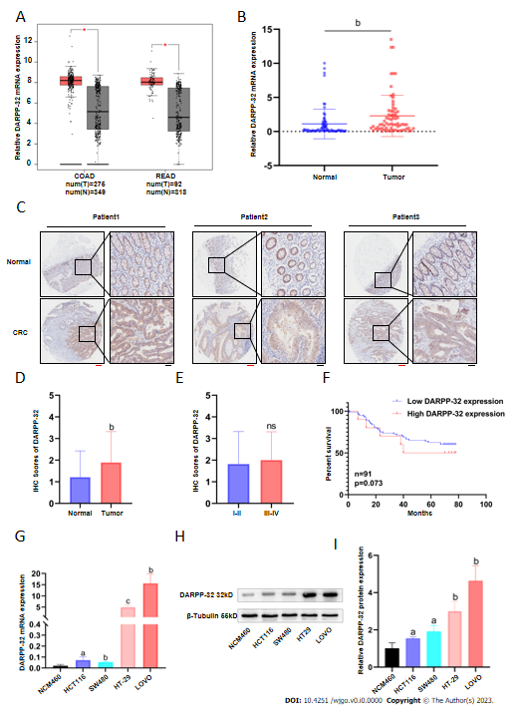
Figure 1 Expression and clinical relevance of dopamine and cyclic adenosine monophosphate regulated phosphoprotein with an apparent Mr of 32000 in colorectal cancer. A: Dopamine and cyclic adenosine monophosphate regulated phosphoprotein with an apparent Mr of 32000 (DARPP-32) mRNA level in primary human colorectal cancer (CRC) tumors (n = 376) and normal tissues (n = 667) were analyzed from the Gene Expression Profiling Interactive Analysis Database; B: DARPP-32 expression was validated in 70 pairs of CRC patient samples by polymerase chain reaction; C-E: Representative images and quantification of DARPP-32 staining in 94 CRC tissues and 86 normal tissues (red scale bars, 200 μm; black scale bars, 50 μm); F: Overall survival curves for CRC patients expressing DARPP-32 according to Kaplan-Meier curves; G-I: DARPP-32’s mRNA and protein levels in cell lines (NCM460, HCT116, SW480, HT-29, LOVO). ªP < 0.05; ^{b}P < 0.01; ^{c}P < 0.001.

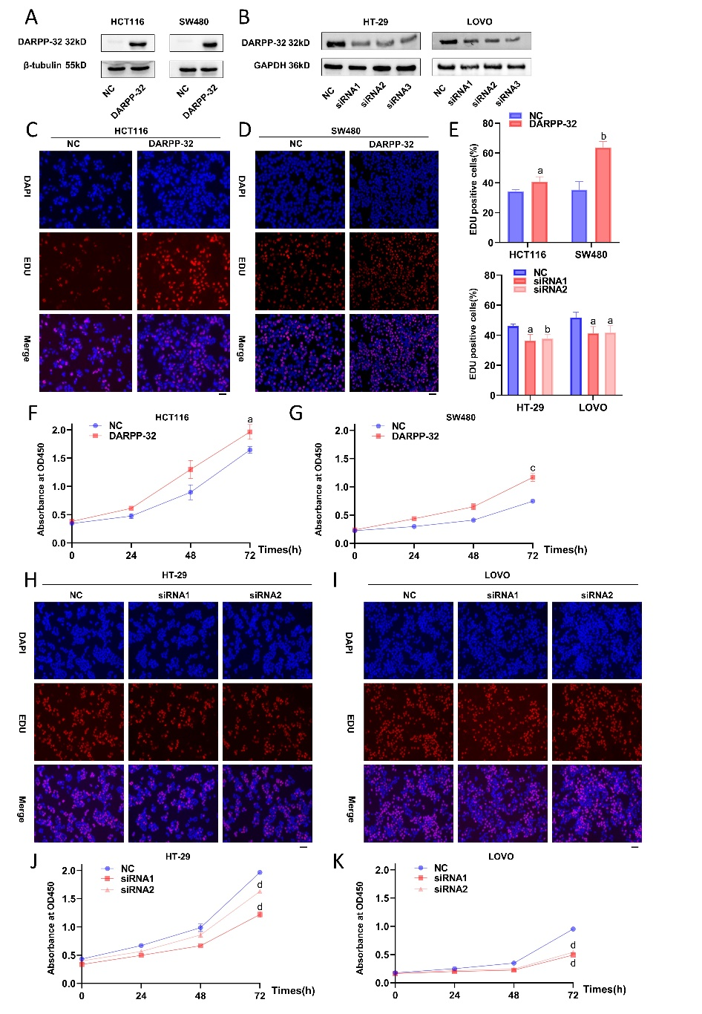
Figure 2 Dopamine and cyclic adenosine monophosphate regulated phosphoprotein with an apparent Mr of 32000 promotes colorectal cancer proliferation in vitro. A and B: Detecting the expression level of dopamine and cyclic adenosine monophosphate regulated phosphoprotein with an apparent Mr of 32000 (DARPP-32) by western blot analysis in HCT116/SW480 stable cell lines overexpressing DARPP-32 and in HT-29/LOVO cell lines with DARPP-32 knockdown; C-G: DARPP-32 overexpression promoted the growth of HCT116 and SW480 cells by ethynyl-2′-deoxyuridine (EdU) and Cell Counting Kit-8 (CCK-8) (black scale bars, 100 μm); H-K: Representative images of the proliferative capabilities of cells in HT-29 and LOVO cells with small interfering RNA (siRNA) knockdown of DARPP-32 detected by EdU and CCK-8 (black scale bars, 100 μm). ªP < 0.05; ^{b}P < 0.01; ^{c}P < 0.001; ^{d}P < 0.0001. GAPDH: Glyceraldehyde-3-phosphate dehydrogenase; NC: Negative control.

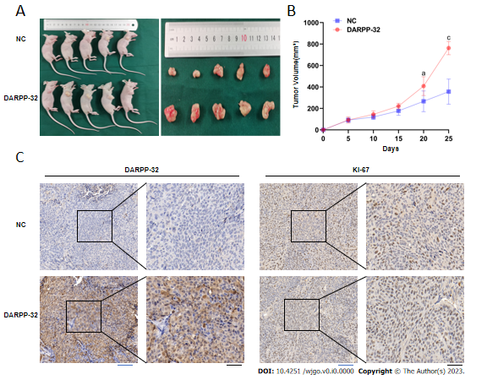
Figure 3 Dopamine and cyclic adenosine monophosphate regulated phosphoprotein with an apparent Mr of 32000 promotes colorectal cancer proliferation in vivo. A: Dopamine and cyclic adenosine monophosphate regulated phosphoprotein with an apparent Mr of 32000 (DARPP-32)-overexpressing HCT116 cells were subcutaneously implanted into the shoulders of naked mice (n = 5) to assess proliferative potential; B: After injection, carcinoma volumes were measured in the negative control (NC) group and DARPP-32 group; C: DARPP-32 and Ki67 immune staining were performed on tumor tissues from the NC and DARPP-32 groups by immunohistochemistry (blue scale bars, 100 μm; black scale bars, 50 μm). ªP < 0.05; ^{c}P < 0.001.

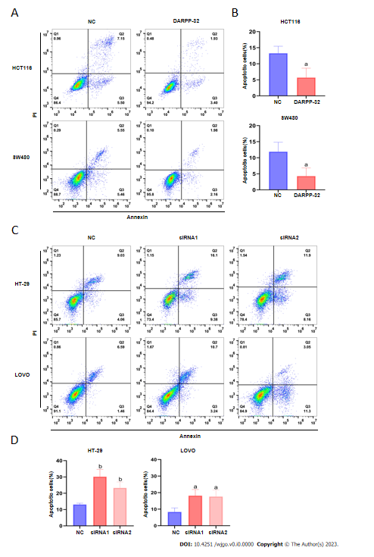
Figure 4 Dopamine and cyclic adenosine monophosphate regulated phosphoprotein with an apparent Mr of 32000 reduces apoptosis in colorectal cancer cells. A and B: The apoptotic capabilities of cells in HCT116 and SW480 cells with dopamine and cyclic adenosine monophosphate regulated phosphoprotein with an apparent Mr of 32000 (DARPP-32) overexpression detected by analysis of cellular apoptosis; C and D: The apoptotic capabilities of cells in HT-29 and LOVO cells with DARPP-32 knockdown small interfering RNA (siRNA) detected by analysis of cell apoptosis. ªP < 0.05; ^{b}P < 0.01. NC: Negative control.

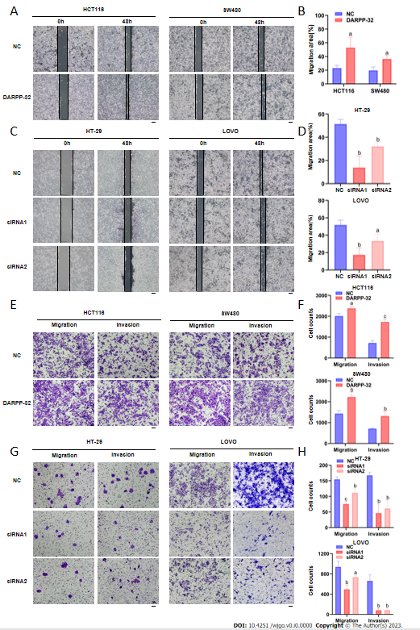
Figure 5 Dopamine and cyclic adenosine monophosphate regulated phosphoprotein with an apparent Mr of 32000 promotes colorectal cancer cell invasion and migration. A and B: By using the wound healing assay, dopamine and cyclic adenosine monophosphate regulated phosphoprotein with an apparent Mr of 32000 (DARPP-32) overexpression improved the ability of HCT116 and SW480 cells to migrate; C and D: By using a wound healing experiment, DARPP-32 knockdown reduced the ability of HT-29 and LOVO cells to migrate; E and F: Images illustrating the capacity for cell migration and invasion in HCT116 and SW480 cells where DARPP-32 overexpression was found in the transwell assay; G and H: Images illustrating the capacity for cell migration and invasion in HT-29 and LOVO cells where DARPP-32 knockdown was found in the transwell assay (black scale bars, 100 μm). ªP < 0.05; ^{b}P < 0.01; ^{c}P < 0.001. NC: Negative control.

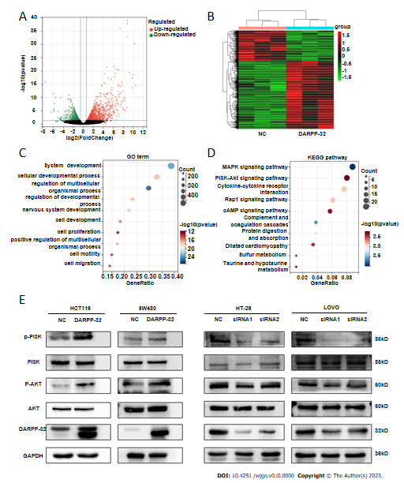
Figure 6 Effect of dopamine and cyclic adenosine monophosphate regulated phosphoprotein with an apparent Mr of 32000 on progression is partially dependent on the phosphoinositide 3-kinase/AKT signaling pathway. A: Our group examined the differences in mRNA expression between the normal control and dopamine and cyclic adenosine monophosphate regulated phosphoprotein with an apparent Mr of 32000 (DARPP-32) groups using RNA sequencing (RNA-seq) analysis; B: Heat map of a DARPP-32 downstream target assessed by RNA-seq analysis. Red indicates upregulation of the corresponding gene and green indicates downregulation; C: Bubbly graph of Gene Ontology enrichment terms; D: Analysis of the DARPP-32 level Kyoto Encyclopedia of Genes and Genomes data; E: Western blot analysis of DARPP-32, AKT, p-AKT, phosphoinositide 3-kinase (PI3K) and phosphorylated PI3K proteins in DARPP-32-overexpressing cells or DARPP-32 small interfering RNA (siRNA)-infected cells. Glyceraldehyde-3-phosphate dehydrogenase (GAPDH) served as a loading control. NC: Negative control.

Table 1 Relationship between dopamine and cyclic adenosine monophosphate regulated phosphoprotein with an apparent Mr of 32000 expression level and clinical pathological parameters of colorectal cancer
Characteristics | No. of patients | DARPP-32 |  | P value
 |  | High | Low
All cases | 70 | 54 | 16
Sex |  |  |  | 0.511
Male | 40 | 32 | 8
Female | 30 | 22 | 8
Age |  |  |  | 0.446
≥ 60 | 47 | 35 | 12
< 60 | 23 | 19 | 4
Tumor size in cm |  |  |  | 0.433
≤ 5 | 54 | 40 | 14
> 5 | 16 | 14 | 2
Tumor location |  |  |  | 0.454
Right colon | 21 | 17 | 4
Left colon | 19 | 16 | 3
Rectum | 30 | 21 | 9
Lymph node status |  |  |  | 0.03ª
Positive | 34 | 30 | 4
Negative | 36 | 24 | 12
T stage |  |  |  | 0.689
T1-2 | 13 | 11 | 2
T3 | 15 | 12 | 3
T4 | 42 | 31 | 11
TNM stage |  |  |  | 0.123
I-II | 32 | 22 | 10
III-IV | 38 | 32 | 6
Carcinoembryonic antigen |  |  |  | 1.00
Positive | 12 | 9 | 3
Negative | 58 | 45 | 13
Carbohydrate antigen 199 |  |  |  | 0.689
Positive | 18 | 15 | 3
Negative | 52 | 39 | 13
ªP < 0.05 vs DARPP-32 low-expression group. DARPP-32: Dopamine and cyclic adenosine monophosphate regulated phosphoprotein with an apparent Mr of 32000; TNM: Tumor-node-metastasis.

