Name of journal: World Journal of Meta-Analysis
ESPS Manuscript NO: 14764
Columns: Systematic Review

Meta-analysis of single strain probiotics for the eradication of helicobacter pylori and prevention of adverse events

McFarland LV et al. Single-strain probiotics for H. pylori infections

Lynne V McFarland, Peter Malfertheiner, Ying Huang, Lin Wang

Lynne V McFarland, Department of Medicinal Chemistry, University of Washington, Seattle, WA 98195, United States

Lynne V McFarland, Health Services Research and Development, VA Puget Sound Health Care System, Department of Veterans Affairs, Seattle, WA 98101, United States

Peter Malfertheiner, Universitatsklinikum Magdeburg AOR, 39120 Magdeburg, Germany

Ying Huang, Lin Wang, Children’s Hospital of Fudan University, Shanghai 201102, China

Authors contributions: McFarland LV, Malfertheiner P, Huang Y and Wang L reviewed, scored papers and were involved in the manuscript preparation; McFarland LV designed the study, did literature search and analyzed the data.

Conflict-of-interest: Lynne McFarland has received fees as a speaker (Biocodex, France and Lallemand, France) and is on the scientific advisory board of BioK+, Canada. Peter Malfertheiner has received speaker fees from Biocodex and is on the scientific advisor board of Danone. Ying Huang and Lin Wang have no conflicts of interest. No authors are employed by or have stock or equity in any company manufacturing probiotics.

Data sharing: No additional data are available.

Open-Access: This article is an open-access article which was selected by an in-house editor and fully peer-reviewed by external reviewers. It is distributed in accordance with the Creative Commons Attribution Non Commercial (CC BY-NC 4.0) license, which permits others to distribute, remix, adapt, build upon this work non-commercially, and license their derivative works on different terms, provided the original work is properly cited and the use is non-commercial. See: http://creativecommons.org/licenses/by-nc/4.0/

Corresponding to: Lynne V McFarland, PhD, Health Services Research and Development, VA Puget Sound Health Care System, Department of Veterans Affairs, Metropolitan Park West, 1100 Olive Way #1400, Seattle, WA 98101, United States. lvmcfarl@u.washington.edu

Telephone: +1-206-2771780
Fax: +1-206-7642935

Received: October 22, 2014
Peer-review started: October 24, 2014
First decision: December 26, 2014
Revised: January 3, 2015
Accepted: Janurary 15, 2015
Article in press:
Published online:

Abstract
AIM: To assess the efficacy and safety of single strain probiotics for the: (1) eradication of Helicobacter pylori (H. pylori); (2) prevention of adverse events; and (3) prevention of antibiotic-associated diarrhea associated with eradication therapy.

METHODS: We searched PubMed (1960-2014), EMBASE (1974-2014), Cochrane Database of Systematic Reviews (1990-2014), and ISI Web of Science (2000-2014). Additionally, we conducted a grey literature search including contact with National Institutes of Health Clinical Trials Registry, abstracts from annual infectious disease and gastroenterology meetings, experts in the field and correspondence with authors. Randomized controlled trials of H. pylori positive adults or children treated with eradication therapy and assessing the adjunctive therapy with a single strain of probiotics were included. The primary outcomes were the rates of eradication of H. pylori and frequency of patients with adverse events or antibiotic-associated diarrhea. Outcomes were pooled using fixed or random-effects models to calculate the relative risk and corresponding 95% confidence interval (95%CI) and weighted on study size. To explore possible explanations for heterogeneity, a priori subgroup analyses were conducted on daily probiotic dose, study population, and quality of the study. The overall quality of the evidence for each probiotic strain was assessed using the GRADE criteria.

RESULTS: A total of 25 randomized controlled trials (28 treatment arms, with a total of 3769 participants) assessed one of six single probiotic strains as adjunctive treatments to standard eradication therapy. Only one probiotic strain significantly improved H. pylori eradication rates: Saccharomcyes boulardii (S. boulardii) CNCM I-745 (pooled RR = 1.11, 95%CI: 1.07-1.16). Only one probiotic strain (S. boulardii CNCM I-745) significantly prevented any adverse reactions (pRR = 0.42, 95%CI: 0.28-0.62). Both S. boulardii CNCM I-745 and L. rhamnosus GG significantly reduced antibiotic-associated diarrhea (pRR = 0.47, 95%CI: 0.37-0.60 and pRR = 0.29, 95%CI: 0.17-0.48, respectively) associated with H. pylori eradication therapy. Meta-regression of sub-groups did not detect significant differences by dose, adult versus pediatric, symptom status, or study quality, but did find significant differences by the strain of probiotic. Potential mild publication bias was found for antibiotic-associated diarrhea, but not for eradication or adverse event outcomes. Analysis of the study quality illuminated areas for improvement in future studies (use of placebos, study size calculations, attrition reasons and discussion of limitations and generalizability).

CONCLUSION: The pooled evidence suggests that the adjunctive use of a few probiotic strains may improve H. pylori eradication rates and prevent the development of adverse events and antibiotic-associated diarrhea in those treated with standard eradication therapies. The type of probiotic strain was the most important factor in predicting efficacy.

Key words: Probiotics; H. pylori; Adverse reactions; Diarrhea; Saccharomyces boulardii; Lactobacillus rhamnosus; Safety; Meta-analysis; Randomized clinical trials

© The Author(s) 2015. Published by Baishideng Publishing Group Inc. All rights reserved.

Core tip: A meta-analysis was conducted (1960-2014) for randomized clinical trials testing single strained probiotics as an adjunct to standard Helicobacter pylori (H. pylori) eradication therapy. Of the single strains with multiple trials, only one significantly improved H. pylori eradication rates [Saccharomyces boulardii I-745 (pooled RR = 1.11, 95%CI: 1.07-1.16)], while two strains significantly reduced the rate of antibiotic-associated diarrhea [Saccharomyces boulardii I-745 (pooled RR = 0.47, 95%CI: 0.37-0.60) and Lactobacillus rhamnosus GG (pooled RR = 0.29, 95%CI: 0.17-0.48)]. None of the other four probiotic strains improved H. pylori therapy (C. butyricum, L. acidophilus, L. reuteri, L. casei).

McFarland LV, Malfertheiner P, Huang Y, Wang L. Meta-analysis of single strain probiotics for the eradication of helicobacter pylori and prevention of adverse events. World J Meta-Anal 2015; In press

INTRODUCTION
Helicobacter pylori (H. pylori) was first associated with chronic gastritis, duodenal and peptic ulcers by Marshall and Warren^{[1]} in 1984. Surveillance studies since that time have found H. pylori colonization is a global concern with a prevalence ranging from 70%-90% in developing countries and 25%-50% in developed countries^{[2]}. H. pylori is typically acquired during childhood from other humans and transmitted by the oral-oral or oral-fecal route or by ingestion of contaminated water. H. pylori infection in childhood may lead to chronic gastritis, but only 20% will develop clinical symptoms. ^{[2]} Prolonged carriage may result in an onset of symptoms in adults, which include dyspepsia, peptic or duodenal ulcers, gastric adenocarcinoma, B-cell lymphoma and rarely extragastric complications^{[3]}. Current guidelines from the Maastricht IV consensus for the eradication of H. pylori include triple therapy [typically two antibiotics and a proton-pump inhibitor (PPI) for 7-14 d], with eradication rates ranging from 71% to 81%, sequential therapy (with slightly improved H. pylori eradication rates from 85% to 84%) and, more recently, bismuth-based quadruple therapy (with 90% efficacy)^{[4-7]}. However, the common development of adverse events [such as antibiotic-associated diarrhea (AAD), nausea, etc.] from the eradication therapies cause many patients to prematurely discontinue their treatments, leading to plummeting eradication rates and the development of antibiotic resistance^{[8-10]}. The development of antibiotic resistant strains of H. pylori varies by country and type of antibiotic exposure (ranging 11%-29% for clarithromycin, 17%-86% for metronidazole, levofloxacin 14%-24%)^{[11,12]}. In addition, relapses of symptoms occur > 40% in patients within 32 wk after triple therapy eradication therapy^{[13]}. Recently several alternative treatments, including probiotics, have been tested to improve eradication rates, prevent the development of antibiotic resistant strains and to prevent the development of adverse events^{[14]}.
Probiotics (defined as living microbes, given in adequate doses, with proven health effects) have been shown to be effective in many diseases and may be useful as an adjunct to eradication therapy. Probiotics are known to be effective for the prevention of side-effects of antibiotic use, typically antibiotic-associated diarrhea^{[15]}. Several studies have also shown some probiotic strains (Saccharomyces boulardii, Lactobacillus acidophilus or mixtures of strains, etc.) have specific mechanisms of action against H. pylori, including inhibiting H. pylori attachment to mucosal cells^{[16-18]}, regulation of the immune response to H. pylori^{[19]}, or direct physiologic effects^{[20]}. Probiotics may also restore the normal microbiota disrupted by antibiotic exposure (causing diarrhea or colitis) and thus prevent H. pylori-associated adverse events^{[21,22]}.
Choosing the appropriate probiotic can be challenging as the choice must be matched to both probiotic strain and the disease being treated (or prevented), based on the strength of evidence-based clinical trials. Different mechanisms of action are strain-specific, therefore it is necessary to analyze the efficacy by similar probiotic strains whenever possible^{[23-25]}. Most meta-analyses of probiotics for H. pylori infections have not done this. Probiotics are also available as single strain products or in mixtures of two or more probiotic strains. This paper will focus only on single strains tested in at least two randomized, controlled trials.
The aims of this meta-analysis are to analyze the effectiveness of adjunctive single strain probiotics for the: (1) eradication of H. pylori; (2) reduction of adverse events; and (3) reduction of antibiotic-associated diarrhea commonly linked with eradication therapy.

MATERIALS AND METHODS
Study objectives
Primary aims: (1) To systematically assess whether single strain probiotics (given as an adjunct with H. pylori eradication therapy) could improve the eradication rate of H. pylori; and to systematically assess whether probiotics could reduce the frequency of: (2) any types of adverse events; or (3) antibiotic-associated diarrhea associated with H. pylori eradication therapy.

Secondary aims: To systematically assess if differences in effect were associated with specific sub-groups, defined by: daily dose effect of probiotics, type of study population (adult versus pediatric, asymptomatic versus symptomatic), study quality and strain of probiotic used.

Search strategy
As shown in Table 1, this meta-analysis followed PRISMA (Preferred Reporting Items for Systematic reviews and Meta-Analysis) statement guidelines^{[26]} and MOOSE guidelines using clearly delineated parameters, a priori inclusion and exclusion criteria and standardized data extraction tools^{[27,28]}. We undertook systematic searches of PubMed (1960-2014), EMBASE (1974-2014), Cochrane Database of Systematic Reviews (1990-2014), ISI Web of Science (2000-2014) and three on-line clinical trial registries: Cochrane Central Register of Controlled trials (http://www.cochrane.org), MetaRegister of Controlled Trials (http:www.controlled-trials.com/mrct) and National Institutes of Health (http://www.clinicaltrials.gov). We used bibliographies of all relevant studies to do a recursive search. Additionally, we conducted an extensive grey literature search including abstracts from annual infectious disease and gastroenterology meetings, probiotic product websites, experts in the field and communication with published authors on H. pylori infections. Search terms included: H. pylori, randomized controlled trial and probiotics and specific probiotic strains. Search strategies were broad-based initially, then narrowed to the disease and population of interest. Abstracts of all citations and retrieved studies were reviewed and rated for inclusion. Full articles were retrieved if probiotics were given to treat H. pylori infections or carriage or to prevent adverse events associated with H. pylori eradication therapies.

Inclusion and exclusion criteria
Inclusion criteria included randomized (well described or partially) controlled trials (RCT), blinded or open trials, in pediatric or adult populations (inpatient or outpatients), published in peer-reviewed journals or on clinical trial websites, or as meeting abstracts. All participants were required to have received H. pylori eradication therapy (double, triple, quadruple or sequential therapy) that included at least one antibiotic and one proton-pump inhibitor (PPI). Non-English language trials were translated and included whenever possible. Exclusion criteria included pre-clinical studies, safety, kinetic or formulation phase 2 studies, case reports or case series, duplicate reports, trials of unspecified types of probiotics, non-randomized trials, incomplete or no outcomes reported, or if translation could not be obtained. Trials which did not assess either H. pylori eradication rates or the incidence of adverse events were excluded. Probiotic strains with only one randomized controlled trial (lacking at least one other confirmatory trial) were also excluded. Randomized controlled trials testing probiotic products with a mixture of different probiotic strains were reviewed, but will be presented elsewhere.

Data extraction
Each article was reviewed and scored independently by at least two reviewers. One reviewer (LVM) screened all abstracts, extracted and scored all articles using pre-constructed and piloted, data extraction forms (see Table 2). Each of three other reviewers (PM, YH, LW) independently extracted data and assessed risk of bias from one-third of the articles (each sent different articles). Any disagreements were resolved by a third reviewer. For articles published in abstract form only or for any missing significant data in full articles, further information was sought by contacting authors or by the company manufacturing the probiotic product. Using a standardized data extraction form, we systematically collected the following data: authors, year of publication and journal, population data (age range, setting, types of eradication therapy given), study aims and outcomes, study methods (study design, eligibility criteria, sample size calculations, interim analysis, statistical methods used, recruitment methods, subgroup analysis done), randomization (method of randomization allocation, randomization method), degree of blinding (open, single or double), intervention data (probiotic strains used, daily dose, duration of treatment, duration of follow-up, type of control used, treatment concealment), results (balanced randomization achieved, attrition rate and reasons, comparison of treatment groups by demographics, etc., CONSORT flow-chart provided), outcome data [by group, intent-to-treat (ITT) or as-per-protocol (APP) analysis], safety data (adverse events reported by group), discussion points (limitations, generalizability and comparison of study results to published papers), clinical trial registration, location of protocol, and source of funding.

Interventions
Included trials had participants who were randomized to either an adjunctive probiotic group or a control group. The type of control group may have included either a placebo (blinded study) or no treatment (open study) in addition to the eradication therapy currently used as standard practice. The type of probiotic intervention included probiotics in any form (e.g., capsule, sachet, tablets, drink, etc.) given in conjunction with the H. pylori eradication therapy. Trials investigating non-specific probiotics or yogurts [e.g., articles not providing the probiotic strain(s) used] were excluded. Trials combining probiotics with prebiotics were included if the prebiotic dose was less than 2.5 grams per day, as this was judged to be of limited impact to alter the intestinal microflora^{[29,30]}. The most recent probiotic strain designations are presented in this study for those strains whose names have changed over time (older articles may have reported a different strain designation). The taxonomy of the probiotic strain type was confirmed by correspondence with authors or the manufacturing companies.

Outcomes and definitions
Three outcomes were assessed by this meta-analysis review: (1) eradication rates of H. pylori; (2) frequency of adverse events; and (3) frequency of AAD. The outcome for H. pylori eradication was defined by having a positive assay (pre-intervention) and a negative H. pylori assay done after the intervention was completed. H. pylori infection was diagnosed using at least one of the following assays: ¹⁴ C urea breath test (UBT), histology, serology, rapid urease test, stool test or culture^{[7]}. The outcome for adverse events (AE) included any symptoms associated with eradication therapy (nausea, bloating, vomiting, diarrhea, metallic taste) were grouped as “any AE”. The outcome for antibiotic-associated diarrhea (AAD) was defined as reported diarrhea or colitis, which developed during the intervention or during the follow-up periods.

Assessment of methodological quality
Quality components for each trial were assessed for selection, detection, performance, reporting and loss to follow-up bias. Each of the included studies was evaluated using 33 items collected with the standardized data extraction form. Each item was graded as: present, absent, or not applicable (for example studies done in countries not requiring clinical trial registration, CONSORT flow-chart not present if trial was published before this became a standard, etc.)^{[28]}. The overall quality score for the trial was calculated as the percent of items present divided by the total items present and absent (not applicable items were excluded from the calculation). Each of the 33 quality items were analyzed within one of six categories of potential of bias: study design bias (trial title, setting, early stoppage, background, study aims, prospective design, eligibility criteria, sample size calculation, interim analysis, statistical methods, recruitment methods, subgroup methods, probiotic well described by strain, daily dose and duration), selection bias (randomization allocation method, balanced groups resulted), detection bias (double blinded, treatments concealment), attrition bias (rates provided and reasons by each group), reporting bias (baseline group comparison, CONSORT flow-chart, intent to treat analysis done for each outcome, incidence of each outcome provided, adverse event data provided and sub-group analysis provided, if applicable) and miscellaneous sources of bias (limitations, generalizability and comparison with other studies in discussion, trial registration, location of protocol for access and source of funding, if appropriate). Trials were classified as high quality if > 75% of the quality items were present, moderate quality if 50%-75% were present and low quality of < 50% were present. Each trial was scored for the 33 items of quality independently by at least two reviewers and a kappa statistic was applied to test for the degree of concordance.
We also employed the GRADE (Grading of Recommendations, Assessment, Development and Evaluation) system for rating overall quality of evidence for each of the outcomes by probiotic strain or type (single strain compared to mixtures of strains)^{[31,32]}. Recommendation for use of each probiotic strain or mixture can be assessed by the overall strength of the evidence [“strong”, many randomized controlled trials show significant protection, more benefit than risk, cost-effective or “weak”, only case series or reports, limited number of small trials, etc.]. Quality of the evidence is graded as “high quality” (further research is unlikely to change our confidence in the estimate of the effect), or “moderate quality” (further research is likely to have an important impact on our confidence and may change the estimate of the effect), or “low quality” (further research is very likely to change our confidence in the estimate and may change the direction of the estimate of the effect).

Statistical analysis
The statistical methods of this study were reviewed by Lynne McFarland from University of Washington, who holds a PhD in Epidemiology. Statistical analysis was performed using Stata software version 12 (Stata Corporation, College Station, Texas) to calculate pooled relative risks (pRR), bias estimates and number-needed-to-treat statistics. Univariate analysis results were analyzed using χ² test or Fisher’s exact test for small cell sizes (< 5) with a significance level of P < 0.05. Meta-analysis was conducted for primary outcomes (e.g., eradication frequency of H. pylori or the rate of adverse events or AAD) using models to calculate the pooled relative risk and corresponding 95% confidence interval (95%CI) using the DerSimonian Laird method. Heterogeneity across trials was evaluated using Cochran Q test based on pooled relative risks by the Mantel-Haenazel method^{[33]}. If the studies were homogenous, a fixed effects model was used; if studies were heterogeneous, a random effect model was employed. A P-value < 0.05 is considered statistically significant and P-values between 0.05 and 0.1 had a significant trend. The models used in this analysis were weighted by sample size, as study quality did not improve the fit.
If significant heterogeneity was found, subgroup analyses were conducted to determine the potential sources of heterogeneity. To explore possible explanations for heterogeneity, a priori subgroup analyses were conducted on study population (adult versus pediatric and asymptomatic versus symptomatic), daily dose [≥ 1 × 10⁹ colony-forming units (cfu) per day or < 1 × 10⁹ cfu/d] and study quality. A meta-regression was done without the subgroup indicator and compared to a model with the subgroup indicator included. The difference in tau² estimates from the two models indicates the proportion of study heterogeneity explained by the subgroup covariate (between study variance).

Publication bias
To assess for publication bias, a funnel plot, as well as a weighted regression (Egger’s test) and a rank correlation test (Begg’s test for small study effects) were conducted^{[27,34]}. Funnel plots show graphically that as sample sizes of trials increase, the precision is estimating the underlying treatment effect increases, which results in the effect estimates (relative risks) from small trials scattering more widely at the bottom of the graph and narrower scattering among larger studies. In the absence of publication bias, the funnel plot resembles a symmetrical inverted funnel. Reporting bias (smaller studies showing no protective effect) often are not published, and are indicated by an asymmetrical appearance with a gap in the bottom left of a funnel plot^{[35,36]}.

RESULTS
Initial screening of data search
The literature review yielded 301 abstracts relating to probiotics and H. pylori that were screened for inclusion. Of those, 225 were excluded after initial screening according to our exclusion criteria (Figure 1): reviews (n = 143), pre-clinical animal models or phase two studies for pharmacokinetics, formulation or safety (n = 67), no control group (n = 6), not randomized (n = 5) or other miscellaneous reasons (n = 4). The literature search for probiotics and H. pylori infections found the earliest randomized, controlled efficacy trial was published in 2000. Literature from 1994-1999 only included early investigative studies (mechanism of action, dose-ranging and safety studies) and no clinical trials were found published before 1994.

Secondary screening of full articles
Of the 76 full articles or meeting abstracts retrieved, an additional 35 were excluded: just one RCT found, i.e., no confirmatory RCTs for probiotic strain found (n = 18), no H. pylori eradication therapy given with probiotic (n = 11), undefined probiotic product with no species and strain identification (n = 3), no H. pylori assays done (n = 1) and two RCTs assessed the burden of H. pylori reduced by probiotics but did not document eradication rates nor the frequency of adverse events. Of these trials assessing probiotics and H. pylori eradication and/or side effects, 25 (61%) were testing a single strain of probiotic and were included in this analysis and 16 (39%) used multiple strains of probiotics and will be addressed elsewhere. Data extraction was performed independently by co-authors on the remaining 25 RCTs. Examples of RCTs included in prior published meta-analyses, but excluded in our analysis, are shown in Table 3. Reasons for excluding RCTs included: other types of -outcomes were assessed^{[37-39]}, no concurrent H. pylori eradication therapy given^{[40-46]}, only one RCT for a specific strain was found^{[47-52]}.

Included trials
Of the 25 randomized controlled trials included^{[53-77]}, several had multiple treatment arms^{[53,57,65]}, resulting in 28 treatment arms, totaling 3769 participants. The sample sizes of the trials ranged from 12 to 991, with a mean number per trial of 68 ± 84 in probiotic arms and 66 ± 83 in control arms. Three articles were translated from their original languages into English: Chinese^{[62,63]} or Spanish^{[69]}. Only two articles were from published meeting abstracts^{[72,77]} with no subsequent full article publications found, the remaining were peer-reviewed full articles.

Patient population
The characteristics of the enrolled study populations by trial arm are presented in Table 4. Of the 28 treatment arms, most enrolled adult participants (n = 24, 86%) and four (14%) enrolled children and all trials included both genders. Race or ethnicity was not reported in most clinical trials. The trials were carried out in a wide array of countries: Italy (40%), Turkey (12%), China (12%), Japan (8%), South Korea (8%) and one trial each (4%) for the following: Greece, Iran, Poland, Romania and Venezuela. All treatment arms enrolled H. pylori positive participants who were either symptomatic (n = 21, 75%), or asymptomatic carriers (n = 5, 18%), or had a mixed population (n = 1) but one RCT did not report symptom status at enrollment.

Study design
Randomization: All 28 RCT were randomized, but only 12 (43%) provided the method used to randomize patients (e.g., computer random number generator, random block design).

Degree of blinding: Of the 28 treatment arms, only seven arms (25%) were double-blinded (used placebos that were of identical appearance as the probiotic formulation)^{[53,55,67,68,69,73]}, four arms (14%) were single blinded (either participants were unaware of the other treatment arm^{[61]} or outcome assessor was blinded)^{[56,57]}. Most, 17 (61%) of the treatment arms were open trials (no placebos and participants were aware that there was another treatment arm), as shown in Table 4.

H. pylori eradication therapy: All trials were required to use an H. pylori eradication therapy, which included at least one antibiotic and one proton-pump inhibitor (PPI) for both the probiotic and control group (Table 4). Of the 28 treatment arms, only 1 (4%) used double therapy (amoxicillin and omeprazole)^{[71]}. Most used triple therapy (n = 25, 89%), which most commonly included two antibiotics (amoxicillin and clarithyromycin) combined with a PPI (omeprazole). Less commonly used were quadruple therapy (n = 1 arm, 4%) or sequential therapy (n = 1 arm, 4%). Overall, the duration of eradication therapy ranged from one week (61% of treatment arms), to 10 d (3%), to two weeks (29%) or varied from 1-4 wk (7%).

Attrition: Attrition ranged from 0%-27% in the 28 treatment arms, usually due to drop-outs due to adverse events or loss to follow-up. Fourteen treatment arms (50%) reported no attrition, 10 (36%) had attrition frequencies from 1%-10% and only three (11%) reported higher attrition (11%-27%), while one trial did not document attrition rates. Of the 28 treatment arms, 24 (86%) used Intent-to-Treat (ITT) analysis and four (14%) used as-per-protocol (APP) analysis. However, only three of the trials reported how the ITT analysis incorporated the missing data (treated all missing outcomes as failures)^{[61,63,70]}.

Intervention
Details of the intervention for the 25 RCT (28 treatment arms) are given in Tables 5 and 6.

Type of probiotic strain(s): In the 28 treatment arms, six different single strain probiotic types were assessed (Tables 4-6) by at least two RCTs that met our eligibility criteria. The most commonly tested strain is Saccharomyces boulardii CNCM I-745, with 11 (39% of RCT arms). Lactobacillus rhamnosus GG was tested in five arms (18%), Clostridium butyricum 588 was tested in four arms (14%), L. reuteri ATCC 55730 and L. acidophilus Lb were each tested in two (7%) treatment arms and L. casei DG was tested in two treatment arms (7%), one strain of L. acidophilus could not be determined.
Newer strain designations for several probiotics and the retrospective review of older studies may have used different strain designations, but were, in fact, the same strain. The most recent strain designations are used in this study. The most current strain designation for S. boulardii is CNCM I-745, the registration number at the Pasteur Institute^{[78]}, but older studies also refer to this strain as S. boulardii lyo, or S. boulardii, with no strain designation. Clostridium butyricum 588 was also known as C. butyricum MIYAIRI. The strain of L. acidophilus in one study was referred to only by the brand name (Antibio, China) in the meeting abstract and correspondence with authors and manufacturers were unproductive, but this strain was included in the analysis to illustrate the importance of providing strain designations^{[72]}.

Probiotic dose: The daily dose of probiotics varied widely from 1 × 10⁶ to 2 × 10¹⁰ colony-forming units (cfu) per day. The a priori subgroup analyses on dose compared high dose probiotic (≥ 1 × 10⁹ cfu/d) versus low dose (<1 × 10⁹ cfu/d). Nineteen (68%) of the treatment arms used the higher daily dose of probiotics and nine (32%) used lower doses (Table 5). The daily dose was reported in all trials, but in some cases the dose was reported as mg/d not cfu/d and required conversion.

Formulation used: Most of the 28 treatment arms used a capsule formulation (12 arms, 43%), while six (21%) used sachets, six (21%) used tablets, two (7%) used liquid and the formulation was not reported in two (7%) of the studies.

Probiotic duration: The probiotics were typically administered as an adjunct for the same duration as the standard eradication therapy, but some RCT continued the probiotic/control intervention for an additional week. The most frequent duration of probiotic was for two weeks (16 arms, 57%), while five (18%) gave probiotics for only one week and four (14%) gave probiotics for three weeks. Two treatment arms gave probiotics for 10 days (7%) and one (4%) gave for 20 d. All trials reported duration of probiotic given (Table 5).

Length of follow-up: In most trials, participants were followed and tested for H. pylori presence 4-8 wk after the intervention treatments were discontinued. Of the 28 treatment arms, 21 (75%) had 1-7 wk of follow-up and four (14%) had longer follow-up times, while three (11%) did not report any follow-up times (Table 5).

Efficacy of adjunct probiotics for H. pylori eradication
Of the 28 treatment arms, 26 (93%) reported H. pylori eradication rates in their paper. A low amount of heterogeneity was found when all strains were pooled together (I² =2 5%, P = 0.12), thus a fixed effects model was used for this outcome. The overall pooled RR indicated that probiotics, in general, were effective for H. pylori eradication (pRR = 1.10, 95%CI: 1.06-1.14) with a number-needed-to-treat (NTT) of 14. However, as recommended by the literature^{[24,79]}, the efficacy should be assessed separately by probiotic strain, as shown by the forest plot (Figure 2). This figure shows that only S. boulardii I-745 (n = 10 treatment arms, pRR = 1.11, 95%CI: 1.07-1.16) was significantly effective as an adjunct for H. pylori eradication. None of the pooled RR from the other five strains (C. butyricum 588, L. rhamnosus GG, L. acidophilus Lb, L. reuteri 55730 or L. casei DG significantly improved H. pylori eradiation rates with standard therapy. Deletion of the trial with the unknown strain of L. acidophilus did not significantly affect the pooled RR estimates.

Sub-group analysis: Results from the meta-regression analysis for the adjunctive use of probiotics for H. pylori eradication did not find significant differences in associations between the study population (adult versus pediatric, P = 0.76), baseline disease state (asymptomatic carriage versus symptoms, P = 0.17), daily dose of probiotic (above or below 10⁹ cfu/d, P = 0.26), or study quality (P = 0.11). Only probiotic strain group showed significance, confirming the validity of analyzing efficacy by strain type. Sub-group analysis for duration probiotic given and by type of H. pylori eradication therapy was not possible, as most trials used similar durations and types of eradication therapy.

Efficacy of adjunct probiotics for prevention of any adverse reactions
Of the 28 treatment arms, 17 (61%) planned a priori to document any adverse events that might occur during the intervention and follow-up period (if done), while 11 (39%) did not document total adverse events during their trials (Table 6). Overall, the pooled RR showed a protective effect (pRR = 0.54, 95%CI: 0.42-0.70, NNT = 8), and as significant heterogeneity was found (I² = 56%, P = 0.003), random effects models were used for this outcome. The forest plot (Figure 3) shows that only S. boulardii I-745 (n = 7 treatment arms, pRR = 0.42, 95%CI: 0.28-0.62) significantly reduced the incidence of adverse events associated with standard H. pylori eradication therapies. L. acidophilus Lb and L. rhamnosus GG had no significant protective effect for adverse events and the other three strains of probiotics only had a single treatment arm evaluating adverse events.

Efficacy of adjunct probiotics for the prevention of antibiotic associated diarrhea
Of the 28 treatment arms, 20 (71%) planned a priori to document AAD during the intervention and follow-up period (if done), while eight (29%) did not document AAD outcomes (Table 6). Overall, the pooled RR showed a protective effect (pRR = 0.43, 95%CI: 0.35-0.53, NNT = 10), and as significant heterogeneity was not found (I² = 0, P = 0.88), fixed effects models were used to summarize AAD trials. The forest plot (Figure 4) shows that only S. boulardii I-745 (n = 9 treatment arms, pRR = 0.47, 95%CI: 0.37-0.60) and L. rhamnosus GG (n = 5 treatment arms, pRR = 0.29, 95%CI: 0.17-0.48) significantly reduced the incidence of AAD associated with H. pylori eradication therapy. The pooled RR from C. butyricum 588 and L. reuteri 55730 did not find a significant protective effect on AAD. Two strains (L. acidophilus Lb and L. casei DG) could not be assessed with pooled RRs due to insufficient trials with AAD outcome data.

Publication bias
A funnel plot analysis (Figure 5) provides no compelling indication of publication bias for trials evaluating H. pylori eradication outcomes, showing general symmetry of the funnel for the relationship between risk ratio and standard error. The funnel plot shows a lack of published small sized trials with an improved eradication rate. However, Egger’s regression test for small study effects (P = 0.71) and Begg’s rank test (P = 0.37) fail to suggest significant publication bias. No significant publication bias was found for the RCT assessing the prevention of all adverse reactions (Egger's regression P = 0.42 and Begg’s rank P = 0.74). Potential publication bias may be present in RCTs assessing AAD (Egger's regression P = 0.003 and Begg’s rank P = 0.025), as there were few outliers noted for small study sizes (Figure 6).

Quality of studies
Of the 25 RCTs, 3 (12%) were rated as high quality studies, 18 (72%) moderate quality and 4 (16%) were low quality trials. The concordance from the reviewers was acceptable (kappa = 0.62, P < 0.001) and any disagreements typically involved only 1-2 of the 33 items in the data extraction form. All disagreements were resolved. As shown in Figure 7, most trials had high quality study design (60%), but only 16% included sample size calculations, 76% failed to indicate 'randomized controlled trial' in the title and only 48% described how participants were recruited. There were a low number of trials with selection bias, as all were randomized, but only 40% described the method of randomization used. There was a high degree of detection bias due to the frequent used of open study designs (only 40% were double-blinded) and only 24% described the method of treatment concealment. Most (80%) of the trials reported their attrition rates, but only 65% provided the reasons for attrition by treatment groups. Reporting bias of the outcomes was generally high-moderate quality, but only 44% provided a consort figure describing study flow and only 56% provided a comparison of the two treatment groups at baseline. Other sources of bias were typically of poor quality due to the lack of trial registration or funding source descriptions. In the discussion section of the papers, although 84% compared their results to other studies, only 36% discussed limitations and few (8%) discussed generalizability of their results.

GRADE criteria
For the H. pylori eradication, we recommend the following adjunct probiotic strains: Saccharomyces boulardii CNCM I-745 (high quality and strong strength). For the prevention of adverse events associated with standard H. pylori eradication therapy, we recommend Saccharomyces boulardii CNCM I-745 (high quality and strong strength). For the prevention of antibiotic-associated diarrhea associated with standard H. pylori eradication therapy, we recommend the following adjunct probiotic strains: Saccharomyces boulardii CNCM I-745 (high quality and strong strength) and Lactobacillus rhamnosus GG (strong quality and strong strength). All other strains require additional multiple randomized, controlled trials before a recommendation can be provided.

DISCUSSION
Our meta-analyses found only one probiotic strain significantly improved H. pylori eradication rates: S. boulardii CNCM I-745 (pRR = 1.11, 95%CI: 1.07-1.15). Only one probiotic strain (S. boulardii CNCM I-745) significantly prevented any adverse events (pRR = 0.42, 95%CI: 0.28-0.62). Two probiotic strains significantly reduced antibiotic-associated diarrhea, S. boulardii CNCM I-745 and L. rhamnosus GG (pRR = 0.47, 95%CI: 0.37-0.60 and pRR = 0.29, 95% C.I. 0.17-0.48, respectively). The most promising probiotics strains for H. pylori infections also have documented mechanisms of action directed against H. pylori. S. boulardii produces a neuramindase that attacks sialic acid, an attachment receptor for H. pylori^{[18]} and also induces a morphologic change from the spiral form to a coccoid form of H. pylori^{[80]}. There is no direct evidence linking L. rhamnosus GG to specific anti-H. pylori actions. However, both S. boulardii CNCM I-745 and L rhamnosus GG have been shown to prevent AAD given for other infections^{[15,79,81-83]}.
Our findings are similar to other meta-analyses of probiotics for H. pylori infections, which differ by including fewer numbers of trials or did not examine all three outcomes (eradication, adverse reactions and AAD). Szajewska et al^{[84]} pooled five randomized trials with S boulardii and found significantly better H. pylori eradication (pRR = 1.13, 95%CI: 1.05-1.21) and significantly less AAD (pRR = 0.47, 95%CI: 0.32-0.69). Our meta-analysis confirms the robustness of this efficacy from 10 RCTs showing a mild (9%) increase in mean H. pylori eradication rates from 73% in control arms to 82% in S. boulardii arms, and a reduced rate of AAD in S. boulardii arms compared to control arms (8.5% and 21%, respectively). We could not find any other meta-analyses that limited their review to one probiotic strain for H. pylori infections.
Tactics for limiting heterogeneity due to the differences of strain-specific probiotic efficacies can be done at the beginning (inclusion criteria only allowing one strain to be included) or post-literature harvesting (by performing sub-group analysis by strain type). Tong et al^{[85]} reviewed 14 randomized trials from various probiotic strains and did a sub-group analysis by the type of probiotic and reported only one strain, L. rhamnosus GG, showed better H. pylori eradication rates odds ratio (OR) from four trials (pOR = 2.09, 95%CI: 1.28-3.4), although one of those trials was actually L. casei, not L. rhamnosus^{[85]}. Zou et al^{[86]} pooled eight trials for H. pylori eradication, but incorrectly combined different strains in their subgroup analyses. When Zou et al^{[86]} presented data for adverse event rates, they reported five RCT identified as “L. casei”, however the data presented was actually for eradication rates and three of the five studies used L. rhamnosus GG, while the two other studies used different L. casei strains (DN11400 and DG). One of the two pooled studies identified as “L. acidophilus” used a mixture of two different Lactobacilli strains^{[86]}. Some meta-analyses did not separate out probiotic strains using sub-group analysis and only presented summary risk estimates combining many different probiotic strains^{[87-89]}. Sachdeva et al^{[90]} did not find an effect by probiotic strain in their meta-regression analysis. Wang et al^{[90]} pooled 10 RCT using different mixtures containing Lactobacilli and/or Bifidobacterium and did a sub-group analysis on race, quality, symptoms, age and types of eradication therapy, but failed to analyze the strains of probiotics separately.
Other reviews and meta-analysis have also analyzed the effect of probiotics for the prevention of adverse events and AAD related to H. pylori eradication therapy, but typically have pooled different strains together into one group^{[85,87,89,91]}. Zou et al^{[86]} reported no significant effect of Lactobacilli probiotics on adverse events, but pooled together studies using L. rhamnosus GG (3 studies), L. acidophilus, L. casei, and L. reuteri (one study each) into the same group^{[86]}. As our meta-analysis shows a distinct strain specificity to both the efficacy of eradicating H. pylori and the prevention of adverse events (including AAD), future studies need to be aware that pooling similar probiotics by species is no longer appropriate and their outcomes need to analyzed by the same type of probiotic strain.
The quality of clinical trials in our analysis varied from a score of 0.32-0.89, which was not surprising as some of the trials were done before standardized randomized controlled trial guidelines were widely published and two trials with low quality scores were from meeting abstracts that never resulted in full article publications. The advantage of scoring trials on quality is the results allow an assessment of recommendations to improve future studies. Future trials would benefit from better study designs (use of placebos, study size calculations), more complete descriptions of their outcomes and discussion of limitations and generalizability.
A question that arises from discussions on how best to treat patients with H. pylori is whether probiotics alone are sufficient to treat these infections, or is adjunctive therapy with the standard antibiotic and PPI therapy more effective. The study by Gotteland et al^{[40]} tested S. boulardii alone or heat-killed L. acidophilus Lb alone versus triple therapy H. pylori eradication therapies and found S. boulardii alone or L. acidophilus alone was significantly poorer (12% and 6% eradication, respectively) than triple therapy used alone (66%, P < 0.05), thus strengthening the position that probiotics are most effective when combined with antibiotic-PPI eradication therapy^{[40]}. Most other studies testing probiotics alone (without the standard eradication therapies) have failed to show a significant effect of the probiotic^{[41,42,44]}, while a few found significant improvement of eradication rates using just a probiotic^{[45,46]}, although one study treated patients with either only a PPI (omeraprazole) or L. reuteri/PPI and did not use any antibiotics in the control group^{[46]}.
The results of the Maastricht IV/Florence Consensus, which involved 44 experts on H. pylori, reported the decreasing eradication rates of the triple therapy (only 70%) may be due to the development of resistance to clarithromycin and poor compliance due to adverse events associated with triple therapies^{[7]}. This group found better eradication rates using either sequential treatments [5 d of PPI and amoxicillin followed by 5 d of PPI, clarithromycin and metronidazole (or tinidazole)] or quadruple therapy (PPI with two antibiotics and bismuth). This group also recommended extending the duration of therapy from 7 d to 10-14 d. While eradication rates may improve with these regimes, the incidence of adverse events remains high. At the time of the meeting (2010), they did not recommend the use of probiotics, citing the poor quality of the studies due to mixing different species and strains in published meta-analyses, but they did recommend further studies. In recent years, more probiotic trials have been done and this meta-analysis does present the outcomes separated by probiotic species and strain.
It was difficult to assess the most effective combination of probiotic strain and type of H. pylori eradication therapy, as most trials used a similar eradication therapy. In our review of 28 treatment arms, over 89% used triple therapy and the most common combination was amoxicillin, clarithromycin and omeprazole (36% of all triple therapies), followed by amoxicillin, clarithromycin and lansoprazole (18%). Eradication rates did not significantly differ by the type of eradication therapy and probiotic strain given, but the lack of variation and studies using the same eradication therapy and probiotic strain limited our analysis. It is also difficult to recommend the best daily dose and duration of a probiotic. Our subgroup analysis did not show a significant effect of daily dose, and doses used in trials with the same strain often had similar daily doses. Other meta-analyses that have investigated the effect of the dose and duration of the probiotic regime have not found a significant effect^{[88]}.
Most of the trials (89%) had sufficient follow-up times (4-8 wk) to allow adverse events to occur, but 11% did not have any follow-up post-treatment. As only one trial followed patients for a prolonged time (one year), it is uncertain if the H. pylori eradication rates reported in the trials are transient or more permanent.
This systematic review has several strengths. We had specific outcomes selected a priori and the search strategy for this review was comprehensive including any relevant trials irrespective of language or publication status (i.e., we included published data from meeting abstracts, obtained pediatric specific data from authors, and translated three non-English trials). Additional strengths of the review include its application of the GRADE criteria for each of the outcomes^{[31]} and the rigorous evaluation of each of the subgroups (i.e., same probiotic strain, probiotic dose, study population, and risk of bias) using the 33 criteria for assessing subgroup credibility^{[92]}. The results of this meta-analysis may be generalizable to the global population, because we included a wide range of ages, countries and settings (inpatients and outpatients, adults and children were included). It should be noted however, that ethnicity and race data were not reported, nor were immunocompromised patients included in most of the trials, so the applicability of our results to these types of these populations is not known.
This review also has several limitations. While we did a more comprehensive search of the grey literature, we did not search all conference proceedings or dissertation abstracts. One of the main limitations for doing meta-analysis on probiotics is the limited number of probiotic strains that have data from multiple trials. Probiotic strain has been cited as the key indicator of efficacy for several diseases^{[23-25]}, but the limited number of trials on the same strain limits our ability draw robust conclusions on most of the strains used for all cited studies. We had to exclude 18 studies that only had one randomized controlled trial for a specific probiotic strain and, as a consequence, not all probiotic strains were included in this analysis. Another limitation is the changing designation of the probiotic strain over time. Older trials may refer to the same strain, but under a different strain type or the strain designation may not be provided in the published article. Other meta-analyses have grouped several strains of L. casei into one group (DG or DN114001 or Shirota), perhaps due to the lack of a current consensus on the taxonomy of these strains^{[93]}. We did include one L. acidophilus study into our analysis, but it should be noted that the strain designation could not be determined retrospectively. This makes a systematic review challenging, as the authors must retrospectively find the matching strain designations as they change over time to include or exclude studies from specific probiotic strain groups.
Recommendations for future research include multiple randomized, controlled trials on the same probiotic strain, allowing confirmation of single clinical trial results. Improvements in the quality of study design should include complete description of the probiotic intervention (strain designation, daily dose, duration, source, etc.), use of treatment concealment (double blinding), calculating sample size a priori to power a sufficiently large study to detect significant results, use of intent-to-treat analysis to account for patient attrition effects, the collection of adverse event data and having sufficient follow-up time after the treatments are discontinued. In our meta-analysis, only four the trials had sufficient follow-up times (> 8 wk) to capture prolonged eradication of H. pylori. Future clinical trials need to incorporate sufficient follow-up times in their study protocols. None of the RCT in this meta-analysis reported any adverse events associated with probiotic use, which has been substantiated in other papers^{[94-96]}, but adverse event data should be collected and assessed for future studies.
In conclusion, our meta-analyses found only one strain of probiotic is beneficial and safe in the eradication of H. pylori when combined with standard eradication therapy, and two strains of probiotics decreased the adverse events of eradication therapy (including AAD), which may improve compliance in infected patients.

COMMENTS
Background
Helicobacter pylori (H. pylori) infections are a global problem and may lead to the development of a wide range of symptoms from dyspepsia to gastric cancer. The current therapy of multiple antibiotics and a proton pump inhibitor is associated with high frequencies of adverse events, which reduces compliance and increases treatment failure rates. The addition of probiotics to the standard treatments may assist in improving compliance, but the correct choice of probiotic strain is paramount.

Research frontiers
Over the years, many randomized controlled trials have been done to evaluate the efficacy of probiotics as adjunctive therapy for the eradication of H. pylori and/or development of adverse events, but previous reviews have been flawed or incomplete and may have inappropriately combined different types of probiotics into one group and thus could not achieve a comprehensive conclusion.

Innovations and breakthroughs
This comprehensive meta-analysis has used current guidelines for evaluating probiotic efficacy separately by the type of probiotic (only single strain probiotic trials grouped together) and evaluated each of three outcomes (H. pylori eradication, reducing any adverse events, reducing antibiotic-associated diarrhea) separately to determine which single probiotic strain may be efficious for each of the three outcomes. A total of 25 randomized controlled trials (with 28 treatment arms) of single strain probiotics were assessed. Of the six different probiotic strains evaluated, only two (Saccharomyces boulardii CNCM I-745 and L. rhamnosus GG) were significantly associated with an improvement in at least one of the three outcomes.

Applications
These two probiotic strains can be used as adjunctive therapy to antibiotics used to treat H. pylori infections and may both improve compliance and reduce the development of adverse events, leading to better cure rates.

Terminology
Probiotics are living microbes (either fungal or bacterial), which when given at appropriate doses, can affect the health status of the host.

Peer review
The authors conducted a comprehensive literature review and data analysis on eradication of H. pylori by a single strain of probiotics. From literature collection to data analysis, it is all scientifically sound and the manuscript is well written.

REFERENCES
1 Marshall BJ, Warren JR. Unidentified curved bacilli in the stomach of patients with gastritis and peptic ulceration. Lancet 1984; 1: 1311-1315 [PMID: 6145023]
2 Papamichael K, Mantzaris GJ. Pathogenesis of Helicobacter pylori infection: colonization, virulence factors of the bacterium and immune and non-immune host response. Hospital Chronicles 2012; 7: 32-37
3 Malfertheiner P, Link A, Selgrad M. Helicobacter pylori: perspectives and time trends. Nat Rev Gastroenterol Hepatol 2014; 11: 628-638 [PMID: 25001975 DOI: 10.1038/nrgastro.2014.99]
4 Gatta L, Vakil N, Vaira D, Scarpignato C. Global eradication rates for Helicobacter pylori infection: systematic review and meta-analysis of sequential therapy. BMJ 2013; 347: f4587 [PMID: 23926315 DOI: 10.1136/bmj.f4587].]
5 Liang X, Xu X, Zheng Q, Zhang W, Sun Q, Liu W, Xiao S, Lu H. Efficacy of bismuth-containing quadruple therapies for clarithromycin-, metronidazole-, and fluoroquinolone-resistant Helicobacter pylori infections in a prospective study. Clin Gastroenterol Hepatol 2013; 11: 802-807.e1 [PMID: 23376004 DOI: 10.1016/j.cgh.2013.01.008]
6 Liou JM, Chen CC, Chen MJ, Chen CC, Chang CY, Fang YJ, Lee JY, Hsu SJ, Luo JC, Chang WH, Hsu YC, Tseng CH, Tseng PH, Wang HP, Yang UC, Shun CT, Lin JT, Lee YC, Wu MS. Sequential versus triple therapy for the first-line treatment of Helicobacter pylori: a multicentre, open-label, randomised trial. Lancet 2013; 381: 205-213 [PMID: 23158886 DOI: 10.1016/S0140-6736(12)61579-7.]
7 Malfertheiner P, Megraud F, O'Morain CA, Atherton J, Axon AT, Bazzoli F, Gensini GF, Gisbert JP, Graham DY, Rokkas T, El-Omar EM, Kuipers EJ. Management of Helicobacter pylori infection--the Maastricht IV/ Florence Consensus Report. Gut 2012; 61: 646-664 [PMID: 22491499]
8 Francavilla R, Zullo A, Vaira D. How often do you fail to take all of your medication? J Pediatr Gastroenterol Nutr 2012; 55: 338 [PMID: 22411268 DOI: 10.1097/MPG.0b013e318253c9ff]
9 Ierardi E, Giorgio F, Losurdo G, Di Leo A, Principi M. How antibiotic resistances could change Helicobacter pylori treatment: A matter of geography? World J Gastroenterol 2013; 19: 8168-8180 [PMID: 24363506 DOI: 10.3748/wjg.v19.i45.8168]
10 Wermeille J, Cunningham M, Dederding JP, Girard L, Baumann R, Zelger G, Buri P, Metry JM, Sitavanc R, Gallaz L, Merki H, Godin N. Failure of Helicobacter pylori eradication: is poor compliance the main cause? Gastroenterol Clin Biol 2002; 26: 216-219 [PMID: 11981460]
11 Megraud F, Coenen S, Versporten A, Kist M, Lopez-Brea M, Hirschl AM, Andersen LP, Goossens H, Glupczynski Y. Helicobacter pylori resistance to antibiotics in Europe and its relationship to antibiotic consumption. Gut 2013; 62: 34-42 [PMID: 22580412 DOI: 10.1136/gutjnl-2012-302254]
12 Yang JC, Lu CW, Lin CJ. Treatment of Helicobacter pylori infection: current status and future concepts. World J Gastroenterol 2014; 20: 5283-5293 [PMID: 24833858 DOI: 10.3748/wjg.v20.i18.5283.]
13 Schwizer W, Menne D, Schütze K, Vieth M, Goergens R, Malfertheiner P, Leodolter A, Fried M, Fox MR. The effect of Helicobacter pylori infection and eradication in patients with gastro-oesophageal reflux disease: A parallel-group, double-blind, placebo-controlled multicentre study. United European Gastroenterol J 2013; 1: 226-235 [PMID: 24917966 DOI: 10.1177/2050640613484020]
14 Ayala G, Escobedo-Hinojosa WI, de la Cruz-Herrera CF, Romero I. Exploring alternative treatments for Helicobacter pylori infection. World J Gastroenterol 2014; 20: 1450-1469 [PMID: 24587621 DOI: 10.3748/wjg.v20.i6.1450]
15 McFarland LV, Goh S. Preventing Pediatric Antibiotic-Associated Diarrhea and Clostridium difficile Infections with Probiotics: a meta-analysis. World J Meta-Anal 2013; 1: 102-120 [DOI: 10.13105/wjma.v1.i3.02]
16 Hongying F, Xianbo W, Fang Y, Yang B, Beiguo L. Oral immunization with recombinant Lactobacillus acidophilus expressing the adhesin Hp0410 of Helicobacter pylori induces mucosal and systemic immune responses. Clin Vaccine Immunol 2014; 21: 126-132 [PMID: 24285819 DOI: 10.1128/CVI.00434-13]
17 Myllyluoma E, Ahonen AM, Korpela R, Vapaatalo H, Kankuri E. Effects of multispecies probiotic combination on helicobacter pylori infection in vitro. Clin Vaccine Immunol 2008; 15: 1472-1482 [PMID: 18579692]
18 Sakarya S, Gunay N. Saccharomyces boulardii expresses neuraminidase activity selective for α2,3-linked sialic acid that decreases Helicobacter pylori adhesion to host cells. APMIS 2014; 122: 941-950 [PMID: 24628732 DOI: 10.1111/apm.12237]
19 Yang YJ, Sheu BS. Probiotics-containing yogurts suppress Helicobacter pylori load and modify immune response and intestinal microbiota in the Helicobacter pylori-infected children. Helicobacter 2012; 17: 297-304 [PMID: 22759330 DOI: 10.1111/j.1523-5378.2012.00941.x.]
20 Fujimura S, Watanabe A, Kimura K, Kaji M. Probiotic mechanism of Lactobacillus gasseri OLL2716 strain against Helicobacter pylori. J Clin Microbiol 2012; 50: 1134-1136 [PMID: 22205802 DOI: 10.1128/JCM.06262-11.]
21 Plummer SF, Garaiova I, Sarvotham T, Cottrell SL, Le Scouiller S, Weaver MA, Tang J, Dee P, Hunter J. Effects of probiotics on the composition of the intestinal microbiota following antibiotic therapy. Int J Antimicrob Agents 2005; 26: 69-74 [PMID: 15967639]
22 Myllyluoma E, Ahlroos T, Veijola L, Rautelin H, Tynkkynen S, Korpela R. Effects of anti-Helicobacter pylori treatment and probiotic supplementation on intestinal microbiota. Int J Antimicrob Agents 2007; 29: 66-72 [PMID: 17141481]
23 Azaïs-Braesco V, Bresson JL, Guarner F, Corthier G. Not all lactic acid bacteria are probiotics, ...but some are. Br J Nutr 2010; 103: 1079-1081 [PMID: 20230653 DOI: 10.1017/S0007114510000723]
24 Hill C, Guarner F, Reid G, Gibson GR, Merenstein DJ, Pot B, Morelli L, Canani RB, Flint HJ, Salminen S, Calder PC, Sanders ME. Expert consensus document. The International Scientific Association for Probiotics and Prebiotics consensus statement on the scope and appropriate use of the term probiotic. Nat Rev Gastroenterol Hepatol 2014; 11: 506-514 [PMID: 24912386 DOI: 10.1038/nrgastro.2014.66]
25 Rijkers GT, de Vos WM, Brummer RJ, Morelli L, Corthier G, Marteau P. Health benefits and health claims of probiotics: bridging science and marketing. Br J Nutr 2011; 106: 1291-1296 [PMID: 21861940 DOI: 10.1017/S000711451100287X]
26 Liberati A, Altman DG, Tetzlaff J, Mulrow C, Gøtzsche PC, Ioannidis JP, Clarke M, Devereaux PJ, Kleijnen J, Moher D. The PRISMA statement for reporting systematic reviews and meta-analyses of studies that evaluate health care interventions: explanation and elaboration. J Clin Epidemiol 2009; 62: e1-34 [PMID: 19631507 DOI: 10.1016/j.jclinepi.2009.06.006]
27 Egger M, Davey Smith G, Schneider M, Minder C. Bias in meta-analysis detected by a simple, graphical test. BMJ 1997; 315: 629-634 [PMID: 9310563]
28 Moher D, Hopewell S, Schulz KF, Montori V, Gøtzsche PC, Devereaux PJ, Elbourne D, Egger M, Altman DG. CONSORT 2010 explanation and elaboration: updated guidelines for reporting parallel group randomised trials. Int J Surg 2012; 10: 28-55 [PMID: 22036893 DOI: 10.1016/j.ijsu.2011.10.001]
29 Davis LM, Martínez I, Walter J, Hutkins R. A dose dependent impact of prebiotic galactooligosaccharides on the intestinal microbiota of healthy adults. Int J Food Microbiol 2010; 144: 285-292 [PMID: 21059476 DOI: 10.1016/j.ijfoodmicro.2010.10.007]
30 Gibson GR. Dietary modulation of the human gut microflora using prebiotics. Br J Nutr 1998; 80: S209-S212 [PMID: 9924286]
31 Guyatt GH, Oxman AD, Vist GE, Kunz R, Falck-Ytter Y, Alonso-Coello P, Schünemann HJ. GRADE: an emerging consensus on rating quality of evidence and strength of recommendations. BMJ 2008; 336: 924-926 [PMID: 18436948 DOI: 10.1136/bmj.39489.470347.AD]
32 Mustafa RA, Santesso N, Brozek J, Akl EA, Walter SD, Norman G, Kulasegaram M, Christensen R, Guyatt GH, Falck-Ytter Y, Chang S, Murad MH, Vist GE, Lasserson T, Gartlehner G, Shukla V, Sun X, Whittington C, Post PN, Lang E, Thaler K, Kunnamo I, Alenius H, Meerpohl JJ, Alba AC, Nevis IF, Gentles S, Ethier MC, Carrasco-Labra A, Khatib R, Nesrallah G, Kroft J, Selk A, Brignardello-Petersen R, Schünemann HJ. The GRADE approach is reproducible in assessing the quality of evidence of quantitative evidence syntheses. J Clin Epidemiol 2013; 66: 736-742; quiz 742.e1-5 [PMID: 23623694 DOI: 10.1016/j.jclinepi.2013.02.004]
33 Higgins JP, Thompson SG, Deeks JJ, Altman DG. Measuring inconsistency in meta-analyses. BMJ 2003; 327: 557-560 [PMID: 12958120]
34 Begg CB, Mazumdar M. Operating characteristics of a rank correlation test for publication bias. Biometrics 1994; 50: 1088-1101 [PMID: 7786990]
35 Peters JL, Sutton AJ, Jones DR, Abrams KR, Rushton L. Comparison of two methods to detect publication bias in meta-analysis. JAMA 2006; 295: 676-680 [PMID: 16467236]
36 Sterne JA, Egger M, Smith GD. Systematic reviews in health care: Investigating and dealing with publication and other biases in meta-analysis. BMJ 2001; 323: 101-105 [PMID: 11451790]
37 Boonyaritichaikij S, Kuwabara K, Nagano J, Kobayashi K, Koga Y. Long-term administration of probiotics to asymptomatic pre-school children for either the eradication or the prevention of Helicobacter pylori infection. Helicobacter 2009; 14: 202-207 [PMID: 19702850 DOI: 10.1111/j.1523-5378.2009.00675.x]
38 Gawrońska A, Dziechciarz P, Horvath A, Szajewska H. A randomized double-blind placebo-controlled trial of Lactobacillus GG for abdominal pain disorders in children. Aliment Pharmacol Ther 2007; 25: 177-184 [PMID: 17229242]
39 Francavilla R, Lionetti E, Castellaneta SP, Magistà AM, Maurogiovanni G, Bucci N, De Canio A, Indrio F, Cavallo L, Ierardi E, Miniello VL. Inhibition of Helicobacter pylori infection in humans by Lactobacillus reuteri ATCC 55730 and effect on eradication therapy: a pilot study. Helicobacter 2008; 13: 127-134 [PMID: 18321302 DOI: 10.1111/j.1523-5378.2008.00593.x]
40 Gotteland M, Poliak L, Cruchet S, Brunser O. Effect of regular ingestion of Saccharomyces boulardii plus inulin or Lactobacillus acidophilus LB in children colonized by Helicobacter pylori. Acta Paediatr 2005; 94: 1747-1751 [PMID: 16421034]
41 Miki K, Urita Y, Ishikawa F, Iino T, Shibahara-Sone H, Akahoshi R, Mizusawa S, Nose A, Nozaki D, Hirano K, Nonaka C, Yokokura T. Effect of Bifidobacterium bifidum fermented milk on Helicobacter pylori and serum pepsinogen levels in humans. J Dairy Sci 2007; 90: 2630-2640 [PMID: 17517703]
42 Cats A, Kuipers EJ, Bosschaert MA, Pot RG, Vandenbroucke-Grauls CM, Kusters JG. Effect of frequent consumption of a Lactobacillus casei-containing milk drink in Helicobacter pylori-colonized subjects. Aliment Pharmacol Ther 2003; 17: 429-435 [PMID: 12562457]
43 Takagi A, Uemura N, Inoue K, et al. Effect of L. gasseri on dyspeptic symptoms in subjects with H. pylori infection. Meeting abstract (#Mo1869), presented by Digestive Disease Week. Gastroenterol 2013; 144: S-679
44 Pantoflickova D, Corthésy-Theulaz I, Dorta G, Stolte M, Isler P, Rochat F, Enslen M, Blum AL. Favourable effect of regular intake of fermented milk containing Lactobacillus johnsonii on Helicobacter pylori associated gastritis. Aliment Pharmacol Ther 2003; 18: 805-813 [PMID: 14535874]
45 Gotteland M, Andrews M, Toledo M, Muñoz L, Caceres P, Anziani A, Wittig E, Speisky H, Salazar G. Modulation of Helicobacter pylori colonization with cranberry juice and Lactobacillus johnsonii La1 in children. Nutrition 2008; 24: 421-426 [PMID: 18343637 DOI: 10.1016/j.nut.2008.01.007]
46 Saggioro A, Caroli M, Girardi L, Chiozzini G, Pasini M. H. pylori eradication with Lactobacillus reuteri. A double-blind placebo-controlled study. Dig Live Dis 2005; 37 (Suppl 1): A88
47 Nista EC, Candelli M, Cremonini F, Cazzato IA, Zocco MA, Franceschi F, Cammarota G, Gasbarrini G, Gasbarrini A. Bacillus clausii therapy to reduce side-effects of anti-Helicobacter pylori treatment: randomized, double-blind, placebo controlled trial. Aliment Pharmacol Ther 2004; 20: 1181-1188 [PMID: 15569121]
48 Yaşar B, Abut E, Kayadıbı H, Toros B, Sezıklı M, Akkan Z, Keskın Ö, Övünç Kurdaş O. Efficacy of probiotics in Helicobacter pylori eradication therapy. Turk J Gastroenterol 2010; 21: 212-217 [PMID: 20931422]
49 Dajani AI, Hammour AMA, Yang DH, et al. Do probiotics improve eradication response to Helicobacter pylori on standard triple or sequential therapy? Saudi J Gastroenterol 2013; 19: 113-120 [DOI: 10.4103/1319-3767.111953]
50 Felley CP, Corthésy-Theulaz I, Rivero JL, Sipponen P, Kaufmann M, Bauerfeind P, Wiesel PH, Brassart D, Pfeifer A, Blum AL, Michetti P. Favourable effect of an acidified milk (LC-1) on Helicobacter pylori gastritis in man. Eur J Gastroenterol Hepatol 2001; 13: 25-29 [PMID: 11204805]
51 Sýkora J, Valecková K, Amlerová J, Siala K, Dedek P, Watkins S, Varvarovská J, Stozický F, Pazdiora P, Schwarz J. Effects of a specially designed fermented milk product containing probiotic Lactobacillus casei DN-114 001 and the eradication of H. pylori in children: a prospective randomized double-blind study. J Clin Gastroenterol 2005; 39: 692-698 [PMID: 16082279]
52 Sahagún-Flores JE, López-Peña LS, de la Cruz-Ramírez Jaimes J, García-Bravo MS, Peregrina-Gómez R, de Alba-García JE. [Eradication of Helicobacter pylori: triple treatment scheme plus Lactobacillus vs. triple treatment alone]. Cir Cir 2007; 75: 333-336 [PMID: 18158878]
53 Cremonini F, Di Caro S, Covino M, Armuzzi A, Gabrielli M, Santarelli L, Nista EC, Cammarota G, Gasbarrini G, Gasbarrini A. Effect of different probiotic preparations on anti-helicobacter pylori therapy-related side effects: a parallel group, triple blind, placebo-controlled study. Am J Gastroenterol 2002; 97: 2744-2749 [PMID: 12425542]
54 Duman DG, Bor S, Ozütemiz O, Sahin T, Oğuz D, Iştan F, Vural T, Sandkci M, Işksal F, Simşek I, Soytürk M, Arslan S, Sivri B, Soykan I, Temizkan A, Beşşk F, Kaymakoğlu S, Kalayc C. Efficacy and safety of Saccharomyces boulardii in prevention of antibiotic-associated diarrhoea due to Helicobacterpylori eradication. Eur J Gastroenterol Hepatol 2005; 17: 1357-1361 [PMID: 16292090]
55 Cindoruk M, Erkan G, Karakan T, Dursun A, Unal S. Efficacy and safety of Saccharomyces boulardii in the 14-day triple anti-Helicobacter pylori therapy: a prospective randomized placebo-controlled double-blind study. Helicobacter 2007; 12: 309-316 [PMID: 17669103]
56 Hurduc V, Plesca D, Dragomir D, Sajin M, Vandenplas Y. A randomized, open trial evaluating the effect of Saccharomyces boulardii on the eradication rate of Helicobacter pylori infection in children. Acta Paediatr 2009; 98: 127-131 [PMID: 18681892 DOI: 10.1111/j.1651-2227.2008.00977.x]
57 Song MJ, Park DI, Park JH, Kim HJ, Cho YK, Sohn CI, Jeon WK, Kim BI. The effect of probiotics and mucoprotective agents on PPI-based triple therapy for eradication of Helicobacter pylori. Helicobacter 2010; 15: 206-213 [PMID: 20557362]
58 Ozdil K, Calhan T, Sahin A, Senates E, Kahraman R, Yüzbasioglu B, Demirdag H, Demirsoy H, Sökmen MH. Levofloxacin based sequential and triple therapy compared with standard plus probiotic combination for Helicobacter pylori eradication. Hepatogastroenterology 2011; 58: 1148-1152 [PMID: 21937367 DOI: 10.5754/hge11075]
59 Chu Y, Zhu H, Zhou Y, Lv L, Huo J. Intervention study on Saccharomyces boulardii with proton pump inhibitor (PPI)-based triple therapy for Helicobacter pylori related peptic ulcer. African J Pharmacy Pharmacol 2012; 6: 2900-2904 [DOI: 10.5897/AJIPP12.400]
60 Zojaji H, Ghobakhlou M, Rajabalinia H, Ataei E, Jahani Sherafat S, Moghimi-Dehkordi B, Bahreiny R. The efficacy and safety of adding the probiotic Saccharomyces boulardiito standard triple therapy for eradication of H.pylori: a randomized controlled trial. Gastroenterol Hepatol Bed Bench 2013; 6: S99-S104 [PMID: 24834296]
61 Kyriakos N, Papamichael K, Roussos A, Theodoropoulos I, Karakoidas C, Smyrnidis A, Archavlis E, Lariou K, Mantzaris GJ. Lyophilized Form of Saccharomyces boulardii enhances the Helicobacter pylori eradication rates of omeprazole-triple therapy in patients with peptic ulcer disease or functional dyspepsia. Hosp Chronicles 2013; 8: 127-133 Available from: URL: http://www.hospitalchronicles.gr/index.php/hchr/article/view/538
62 Zhao HM, Ou-Yang HJ, Duan BP, Xu B, Chen ZY, Tang J, You JY. [Clinical effect of triple therapy combined with Saccharomyces boulardii in the treatment of Helicobacter pylori infection in children]. Zhongguo Dang Dai Er Ke Za Zhi 2014; 16: 230-233 [PMID: 24661511]
63 Guo JB, Yang PF, Wang MT, et al. [The application of clostridium to the eradication of Helicobacter pylori]. Chinese. Chin J Celiopathy 2004; 3: 163-165
64 Shimbo I, Yamaguchi T, Odaka T, Nakajima K, Koide A, Koyama H, Saisho H. Effect of Clostridium butyricum on fecal flora in Helicobacter pylori eradication therapy. World J Gastroenterol 2005; 11: 7520-7524 [PMID: 16437727]
65 Imase K, Takahashi M, Tanaka A, Tokunaga K, Sugano H, Tanaka M, Ishida H, Kamiya S, Takahashi S. Efficacy of Clostridium butyricum preparation concomitantly with Helicobacter pylori eradication therapy in relation to changes in the intestinal microbiota. Microbiol Immunol 2008; 52: 156-161 [PMID: 18402597]
66 Armuzzi A, Cremonini F, Ojetti V, Bartolozzi F, Canducci F, Candelli M, Santarelli L, Cammarota G, De Lorenzo A, Pola P, Gasbarrini G, Gasbarrini A. Effect of Lactobacillus GG supplementation on antibiotic-associated gastrointestinal side effects during Helicobacter pylori eradication therapy: a pilot study. Digestion 2001; 63: 1-7 [PMID: 11173893]
67 Armuzzi A, Cremonini F, Bartolozzi F, Canducci F, Candelli M, Ojetti V, Cammarota G, Anti M, De Lorenzo A, Pola P, Gasbarrini G, Gasbarrini A. The effect of oral administration of Lactobacillus GG on antibiotic-associated gastrointestinal side-effects during Helicobacter pylori eradication therapy. Aliment Pharmacol Ther 2001; 15: 163-169 [PMID: 11148433]
68 Szajewska H, Albrecht P, Topczewska-Cabanek A. Randomized, double-blind, placebo-controlled trial: effect of lactobacillus GG supplementation on Helicobacter pylori eradication rates and side effects during treatment in children. J Pediatr Gastroenterol Nutr 2009; 48: 431-436 [PMID: 19330931]
69 Padilla Ruiz M, Fernández Aguiar ME, Arce Nuñez M, Polo Amorín R. [Lactobacillus rhamnosus GG supplementation to reduce side-effects of anti-Helicobacter pylori treatment]. Rev Gastroenterol Peru 2013; 33: 121-130 [PMID: 23838939]
70 Canducci F, Armuzzi A, Cremonini F, Cammarota G, Bartolozzi F, Pola P, Gasbarrini G, Gasbarrini A. A lyophilized and inactivated culture of Lactobacillus acidophilus increases Helicobacter pylori eradication rates. Aliment Pharmacol Ther 2000; 14: 1625-1629 [PMID: 11121911]
71 De Francesco V, Stoppino V, Sgarro C, Faleo D. Lactobacillus acidophilus administration added to omeprazole/amoxycillin-based double therapy in Helicobacter pylori eradication. Dig Liver Dis 2000; 32: 746-747 [PMID: 11142590]
72 Yeom H, Shim K, Ryu K. Effect of Lactobacillus acidophilus on Helicobacter pylori treatment. Meeting Abstract M1271. Presented at Digestive Disease Week. Los Angeles, California, May 20-25, 2006
73 Lionetti E, Miniello VL, Castellaneta SP, Magistá AM, de Canio A, Maurogiovanni G, Ierardi E, Cavallo L, Francavilla R. Lactobacillus reuteri therapy to reduce side-effects during anti-Helicobacter pylori treatment in children: a randomized placebo controlled trial. Aliment Pharmacol Ther 2006; 24: 1461-1468 [PMID: 17032283]
74 Scaccianoce G, Zullo A, Hassan C, Gentili F, Cristofari F, Cardinale V, Gigliotti F, Piglionica D, Morini S. Triple therapies plus different probiotics for Helicobacter pylori eradication. Eur Rev Med Pharmacol Sci 2008; 12: 251-256 [PMID: 18727457]
75 Ojetti V, Bruno G, Ainora ME, Gigante G, Rizzo G, Roccarina D, Gasbarrini A. Impact of Lactobacillus reuteri Supplementation on Anti-Helicobacter pylori Levofloxacin-Based Second-Line Therapy. Gastroenterol Res Pract 2012; 2012: 740381 [PMID: 22690211 DOI: 10.1155/2012/740381]
76 Tursi A, Brandimarte G, Giorgetti GM, Modeo ME. Effect of Lactobacillus casei supplementation on the effectiveness and tolerability of a new second-line 10-day quadruple therapy after failure of a first attempt to cure Helicobacter pylori infection. Med Sci Monit 2004; 10: CR662-CR666 [PMID: 15567983]
77 Giovannone M, Barberani F, Boschetto S, Gigliozzi A, Tosoni M. Lactobacillus casei DG effectiveness on Helicobacter pylori eradication treatment-side effectis; a placebo-controlled, double-blind randomized pilot study. Meeting Abstract. Presented at Amer Gastroenterol Association Meeting, Washington DC, May 19-24, 2007
78 Dinleyici EC, Kara A, Ozen M, Vandenplas Y. Saccharomyces boulardii CNCM I-745 in different clinical conditions. Expert Opin Biol Ther 2014; 14: 1593-1609 [PMID: 24995675]
79 McFarland LV. Deciphering meta-analytic results: a mini-review of probiotics for the prevention of paediatric antibiotic-associated diarrhoea and Clostridium difficile infections. Benef Microbes 2014: 1-6 [PMID: 24889895]
80 Vandenplas Y, Brunser O, Szajewska H. Saccharomyces boulardii in childhood. Eur J Pediatr 2009; 168: 253-265 [PMID: 19096876 DOI: 10.1007/s00431-008-0879-7]
81 McFarland LV. Meta-analysis of probiotics for the prevention of antibiotic associated diarrhea and the treatment of Clostridium difficile disease. Am J Gastroenterol 2006; 101: 812-822 [PMID: 16635227]
82 Szajewska H, Ruszczyński M, Radzikowski A. Probiotics in the prevention of antibiotic-associated diarrhea in children: a meta-analysis of randomized controlled trials. J Pediatr 2006; 149: 367-372 [PMID: 16939749]
83 Johnston BC, Supina AL, Ospina M, Vohra S. Probiotics for the prevention of pediatric antibiotic-associated diarrhea. Cochrane Database Syst Rev 2007; 2: CD004827 [PMID: 17443557]
84 Szajewska H, Horvath A, Piwowarczyk A. Meta-analysis: the effects of Saccharomyces boulardii supplementation on Helicobacter pylori eradication rates and side effects during treatment. Aliment Pharmacol Ther 2010; 32: 1069-1079 [PMID: 21039671 DOI: 10.111/j.1365-2036.2010.04457.x]
85 Tong JL, Ran ZH, Shen J, Zhang CX, Xiao SD. Meta-analysis: the effect of supplementation with probiotics on eradication rates and adverse events during Helicobacter pylori eradication therapy. Aliment Pharmacol Ther 2007; 25: 155-168 [PMID: 17229240]
86 Zou J, Dong J, Yu X. Meta-analysis: Lactobacillus containing quadruple therapy versus standard triple first-line therapy for Helicobacter pylori eradication. Helicobacter 2009; 14: 97-107 [PMID: 19751434 DOI: 10.1111/j.1523-5378.2009.00716.x]
87 Li S, Huang XL, Sui JZ, Chen SY, Xie YT, Deng Y, Wang J, Xie L, Li TJ, He Y, Peng QL, Qin X, Zeng ZY. Meta-analysis of randomized controlled trials on the efficacy of probiotics in Helicobacter pylori eradication therapy in children. Eur J Pediatr 2014; 173: 153-161 [PMID: 24323343 DOI: 10.1007/s00431-013-2220-3]
88 Ritchie ML, Romanuk TN. A meta-analysis of probiotic efficacy for gastrointestinal diseases. PLoS One 2012; 7: e34938 [PMID: 22529959 DOI: 10.1371/journal.pone.0034938]
89 Zheng X, Lyu L, Mei Z. Lactobacillus-containing probiotic supplementation increases Helicobacter pylori eradication rate: evidence from a meta-analysis. Rev Esp Enferm Dig 2013; 105: 445-453 [PMID: 24274441]
90 Sachdeva A, Rawat S, Nagpal J. Efficacy of fermented milk and whey proteins in Helicobacter pylori eradication: a review. World J Gastroenterol 2014; 20: 724-737 [PMID: 24574746 DOI: 10.3748/wjg.v20.i3.724]
91 Wang ZH, Gao QY, Fang JY. Meta-analysis of the efficacy and safety of Lactobacillus-containing and Bifidobacterium-containing probiotic compound preparation in Helicobacter pylori eradication therapy. J Clin Gastroenterol 2013; 47: 25-32 [PMID: 23090045 DOI: 10.1097/MCG.0b013e318266f6cf]
92 Sun X, Briel M, Walter SD, Guyatt GH. Is a subgroup effect believable? Updating criteria to evaluate the credibility of subgroup analyses. BMJ 2010; 340: c117 [PMID: 20354011 DOI: 10.1136/bmj.c117]
93 Sato H, Torimura M, Kitahara M, Ohkuma M, Hotta Y, Tamura H. Characterization of the Lactobacillus casei group based on the profiling of ribosomal proteins coded in S10-spc-alpha operons as observed by MALDI-TOF MS. Syst Appl Microbiol 2012; 35: 447-454 [PMID: 23099260 DOI: 10.1016/j.syapm.2012.08.008]
94 McFarland LV. Systematic review and meta-analysis of Saccharomyces boulardii in adult patients. World J Gastroenterol 2010; 16: 2202-2222 [PMID: 20458757]
95 Hempel S, Newberry S, Ruelaz A, Wang Z, Miles JN, Suttorp MJ, Johnsen B, Shanman R, Slusser W, Fu N, Smith A, Roth B, Polak J, Motala A, Perry T, Shekelle PG. Safety of probiotics used to reduce risk and prevent or treat disease. Evid Rep Technol Assess (Full Rep) 2011; 200: 1-645 [PMID: 23126627]
96 Salminen MK, Tynkkynen S, Rautelin H, Saxelin M, Vaara M, Ruutu P, Sarna S, Valtonen V, Järvinen A. Lactobacillus bacteremia during a rapid increase in probiotic use of Lactobacillus rhamnosus GG in Finland. Clin Infect Dis 2002; 35: 1155-1160 [PMID: 12410474]

P-Reviewer: Wang Y, Zhang Z S-Editor: Ji FF L-Editor: E-Editor:

Table 1 Preferred reporting items for systematic reviews and meta-analyses checklist 2009^{[26]}
Item | Topic | Reported on page
Title
1 | Title includes systematic review or meta-analysis or both | 1
Abstract
2 | Structured abstract/summary background, objectives, data sources, eligibility criteria, participant, interventions, appraisal and synthesis methods, results, limitation, conclusions and implication of key findings, systematic review registration number | 3-4
Introduction
3 | Rationale for review, what is already known | 5-6
4 | Objectives: Specific questions addressed: (PICOS)-participants, interventions, comparisons, outcomes, study design | 7
Methods
5 | If review protocol (location and accessed URL, registration number) | na
6 | Eligibility criteria (study characteristics (PICOS, follow-up, etc.) and report characteristics (years searched, language, publication status), provide rationale | 7-8
7 | Information sources (databases with dates of coverage, contact with study authors to identify additional studies, date last searched) | 7
8 | Search strategy: Full search strategy for at least one database, including any limits used, such that it could be repeated | 7-8
9 | Study selection: (process for screening, eligibility) | 7-8
10 | Data collection process: Method of data extraction (piloted forms, independently, in duplicate) and any processes of obtaining and confirming data from investigators) | 8
11 | Data items: List and define all variables sought (e.g., PICOS, funding sources, etc.) and any assumptions | 8-9
12 | Risk of bias in individual studies: (Describe methods used for assessing risk of bias (at study or outcome level), how this info is to be used in any data synthesis) | 9-10
13 | Summary Measures: State principal summary outcome measures (RR or Difference in means) for pooled estimates of risk | 10
14 | Synthesis of results: Describe method of handling data and pooling data (measures of consistency with I² for each meta-analysis) | 10
15 | Risk for bias across studies: (publication bias) | 11
16 | Additional analysis: Any subgroup or sensitivity analysis, meta-regression and if pre-specified | 10
Results
17 | Study selection: N of RCT screened, # assessed for eligibility, reasons for exclusions, with flow diagram | 12, Figure 1
18 | Study characteristics (for each study: study size, PICOS, follow-up with citations) | Table 4
19 | Risk of bias within studies: Data on risk for bias and if there, any outcome level assessment (see #12, study quality) | 16-17
20 | Results of individual studies: simple summary data for txt arm, effect estimates and confidence intervals for each study, with forest plot | Figures 2-4  Tables 4-6
21 | Synthesis of results: data on each meta-analysis, pooled data, 95% CI and measures of consistency | Figures 2-4
22 | Risk of bias across studies: results of any assessment of risk across studies (see #15) | Figures 5-6
23 | Additional analysis data: if done (see #16, sub-groups) | 15
Discussion
24 | Summary of evidence: summarize main findings, strength of evidence for each main outcome. Relevance to key groups (providers, users, policy makers) | 17-21
25 | Limitations: limitations at study level and outcome level (risk of bias), at review-level (incomplete retrieval of identified research, reporting bias) | 20
26 | Conclusions: General interpretation of results compared to other evidence, implications for future research. | 21
Funding
27 | Funding: describe funding sources | 21

The PRISMA Statement. Available from: URL: http://prisma-statement.org/statement.htm. Accessed 7/25/2014.

Table 2 Standardized data extraction form
Reference:
First reviewer: ______ Second reviewer: _____

Study Design (methodological)
____ 1. □ Randomized or Controlled Trial in title?

Introduction/Aims
_____ 2. □ Background and rationale described: Yes/No
_____ 3. □ Aims given: 1º outcome(s): ___________
2º outcome(s): ___________
Study Population:
_____ 4. □ Setting (Inpatient or outpatient, number of sites, etc. or any of below):
Disease (condition) ____ PUD _____ Gastritis ____ Dyspepsia _____Mixed
or _____ asymptomatic carrier
Adult or pediatric, or mixed
Age range:
Country:
_____ 5. □ If recruitment/study stopped early (reason given?, na if not stopped early)

Methods
_____ 6. □ Prospective study design
_____ 7. □ Eligibility/exclusion criteria described
_____ 8. □ Sample size calculations given
_____ 9. □ Interim Analysis (yes/no or na, if not done)
_____ 10. □ Statistical methods described (yes/no)
_____ 11. □ Recruitment methods or population described, referred from hosp/clinic? (yes/no)
_____ 12. □ Subgroup analysis methods described a priori or na (if no-sub-group done)

Intervention:
_____ 13. □ Intervention well described (strain, dose, duration) (+1 if most done below)
Probiotic strain(s):
Daily dose (cfu/day):
Duration intervention period (txt time):
Duration follow-up (post-intervention):
Formulation (capsule, yogurt, milk/drink, sachet, tablet, other, not described)
Type of control (placebo, no placebo/eradication therapy only, other):

Hp eradication therapy given (double/triple/quadruple/sequential/none): Duration:

Randomization (selection bias)
_____ 14. □ Method to generate random numbers described (blocked, computer)
_____ 15. □ Balanced randomization allocation achieved (yes/no)
Probiotic group: n = _________ Control group: n =_________
Blinding (detection bias)
_____ 16. □ Blinded (single or double = +1 point) versus an open study (0 points)
_____ 17. □ Control concealment done (yes/no) [same appearance, taste, etc.]
Allocation concealment method described

Results: Attrition (attrition bias)
_____ 18. □ Attrition rates given by group (yes/no)
_____ 19. □ Reasons for attrition described by group (yes/no)

Outcomes (reporting bias)
_____ 20. □ Data or text comparing baseline of two groups (demographics, etc.)
_____ 21. □ Consort Flow-chart figure done (required post-2006)
Our Primary outcome: Hp eradication
_____ 22. □ Primary-Intention to treat analysis? (+1) vs As-per-protocol (excludes drop-outs) (0) ?
How was primary outcome assessed?
(___¹³ C-urea breath test, ___histology, ___ serology, __culture, ___other)
outcome | Probiotic-arm #1 | Probiotic-  arm #2 | Probiotic-  arm #3 | Probiotic-  arm #4 | Control | power
HP eradication
(Hp negative)
still Hp+
totals
P value:
_____23. □ Primary outcome data provided (see table below) (+1 if provided, 0 if not done)

Our secondary outcome: Prevention of Any Adverse Events
_____ 24. □ Was either AE or AAD Intention to treat analysis (+1) vs As-per-protocol (excludes
drop-outs) (0) ?
How were Adverse events assessed? ____Diary ____Survey Other:__________

_____ 25. □ Outcome data provided (see table below) (+1 if provided, 0 if not done)
 | Probiotic-arm #1 | Probiotic-  arm #2 | Probiotic-  arm #3 | Probiotic-  arm #4 | Control | power
Any AE:
No AEs noted
totals
P value:
Our Secondary outcome: Prevention of Antibiotic-associated diarrhea (AAD)
_____ 26. □ AAD data given per group (+1 if provided, 0 if not done)
 | Probiotic-arm #1 | Probiotic-  arm #2 | Probiotic-  arm #3 | Probiotic-  arm #4 | Control | power
AAD
No AAD
totals
P value:

or Description of Adverse Events:
Types of Adverse Events | Probiotic | Control | P value

Sub-group analysis (if done)
_____ 27. □ Sub-group analysis results presented? (n/a if not done)
What were they?_______________________________________
Other bias: Discussion:
_____ 28. □ Limitations discussed
Types of limitations found: ____________________________________
_____ 29. □ Generalisability discussed (yes/no)
_____ 30. □ Compare these results to other studies (yes/no)
_____ 31. □ Trial registration number/trial registry given (for United States or European studies. post-2006)
_____ 32. □ Location where protocol can be found described (post-2006)
_____ 33. □ Source of funding given (in acknowledgements, elsewhere, or if none)
______________________________________________

Quality score (of 33 items):
Reviewer #1 _____: ________# items present (#p), ______ #items absent (#a) _____#n/a (not applicable)
Total score (#p/#p + #a) = _________
Reviewer #2 _____: ________# items present (#p), ______ #items absent (#a) _____#n/a (not applicable)
Total score (#p/#p + #a) = _________
% agreement: __________%

Scoring: For each of 33 items: +1 if numbered item is present, 0 if absent, or na (not applicable).

Table 3 Excluded randomized controlled trials
Probiotic Strain | Reason for exclusion | Ref.
L. gasseri OLL2716 | Study quality poor for treatment arm | Boonyaritichaikij et al^{[37]} 2009
L. rhamnosus GG | No H. pylori assay done | Gawronska et al^{[38]} 2007
L. reuteri ATCC 55730 | Outcome was H. pylori burden | Francavilla et al^{[39]} 2008
S. boulardii I-745 or  L. acidophilus Lb | No eradication therapy given with probiotic | Gottleland et al^{[40]} 2005
Bifido. bifidum YIT4007 | No eradication therapy given with probiotic | Miki et al^{[41]} 2007
L. casei Shirota | No eradication therapy given with probiotic | Cats et al^{[42]} 2003
L. gasseri OLL2716 | No eradication therapy given with probiotic | Takagi et al^{[43]} 2013
L. johnsonii Lj1 | No eradication therapy given with probiotic | Pantoflickova et al^{[44]} 2003
L. johnsonii Lj1 | No eradication therapy given with probiotic | Gottleland et al^{[45]} 2008
L. reuteri ATCC 55730 | No eradication therapy given with probiotic | Saggioro et al^{[46]} 2005
Bacillus clausii nr | < 2 RCT with eradication therapy | Nista et al^{[47]} 2004
Bifido. animalis DN173010 | < 2 RCT with eradication therapy | Yasar et al^{[48]} 2010
Bifido infantis 2036 | < 2 RCT with eradication therapy | Dajani et al^{[49]} 2013
L. johnsonii Lc-1 | < 2 RCT with eradication therapy | Felley et al^{[50]} 2001
L. casei DN 114001 | < 2 RCT with eradication therapy | Sykora et al^{[51]} 2005
L. casei Shirota | < 2 RCT with eradication therapy | Sahagun-Flores et al^{[52]} 2007

nr: Strain not reported; RCT: Randomized controlled trials.

Table 4 Characteristics of enrolled populations in patients receiving eradication therapy by 28 treatment arms

Probiotic Strain | Country | Population | Symptoms | Blinding | Eradication  therapy | Duration eradication (days) | Ref.
S. boulardii I-745 | Italy | adults | asymptomatic | placebo | CTR | 7 | Cremonini et al^{[53]} 2002
S. boulardii I-745 | Turkey | adults | symptomatic | none | ACO | 14 | Duman et al^{[54]} 2005
S. boulardii I-745 | Turkey | adults | symptomatic | placebo | ACL | 14 | Cindoruk et al^{[55]} 2007
S. boulardii I-745 | Romania | pediatric | symptomatic | single | AC + O/E | 7-21 | Hurduc et al^{[56]} 2009
S. boulardii I-745 | South Korea | adults | symptomatic | single | ACO | 7 | Song et al^{[57]} 2010
S. boulardii I-745 +MPA | South Korea | adults | symptomatic | single | ACO | 7 | Song et al^{[57]} 2010
S. boulardii I-745 | Turkey | adults | symptomatic | none | ACL | 14 | Ozdil et al^{[58]} 2011
S. boulardii I-745 | China | adults | symptomatic | none | ACO | 14 | Chu et al^{[59]} 2012
S. boulardii I-745 | Iran | adults | symptomatic | none | ACO | 14 | Zojaji et al^{[60]} 2013
S. boulardii I-745 | Greece | adults | symptomatic | single | ACO | 14 | Kyriakos et al^{[61]} 2013
S. boulardii I-745 | China | pediatric | symptomatic | none | ACO | 14 | Zhao et al^{[62]} 2014

Clost. butyricum 588 | China | adults | symptomatic | none | AFO | 7 | Guo et al^{[63]} 2004
Clost. butyricum 588 | Japan | adults | symptomatic | none | ACL | 7 | Shimbo et al^{[64]} 2005
Clost. butyricum 588  (low dose) | Japan | adults | symptomatic | none | ACL | 7 | Imase et al^{[65]} 2008
Clost. butyricum 588  (high dose) | Japan | adults | symptomatic | none | ACL | 7 | Imase et al^{[65]} 2008
L. rhamnosus GG | Italy | adults | asymptomatic | none | CPT | 7 | Armuzzi et al^{[66]} 2001
L. rhamnosus GG | Italy | adults | asymptomatic | placebo | CRT | 7 | Armuzzi et al^{[67]} 2001
L. rhamnosus GG | Italy | adults | asymptomatic | placebo | CRT | 7 | Cremonini et al^{[53]} 2002
L. rhamnosus GG | Poland | pediatric | asymptomatic | placebo | ACO | 7 | Szajewska et al^{[68]} 2009
L. rhamnosus GG | Venezuela | adults | symptomatic | placebo | ACO | 7 | Padilla et al^{[69]} 2013

L. acidophilus Lb | Italy | adults | symptomatic | none | ACR | 7 | Canducci et al^{[70]} 2000
L. acidophilus Lb | Italy | adults | symptomatic | none | AO | 7-30 | DeFrancesco et al^{[71]} 2000
L. acidophilus nr | South Korea | adults | mixed | none | ACO | 7 | Yeom et al^{[72]} 2006
L. reuteri 55730 | Italy | pediatric | symptomatic | placebo | AO, COT | 15 | Lionetti et al^{[73]} 2006
L. reuteri 55730 | Italy | adults | symptomatic | none | ACT | 7 | Scaccianoce et al^{[74]} 2008
L. reuteri 55730 | Italy | adults | symptomatic | none | AELe | 7 | Ojetti et al^{[75]} 2012
L. casei DG | Italy | adults | symptomatic | none | ART (E/P) | 10 | Tursi et al^{[76]} 2004
L. casei DG | Italy | adults | nr | none | ACE | 7 | Giovaninone et al^{[77]} 2007

This strain is now designated: Saccharomyces boulardii CNCM I-745. Clostridium butyricum 588 (MIYAIRI). Placebo indicates double-blinded design, single indicates either just patient or outcome assessor was blinded and none indicates an open study. A: Amoxicillin; C: Clarithromycin; E: Esomeprazole; f: Furazolidone; L: Lansoprazole; Le: Levofloxacin; MPA: Mucoprotective agent; nr: Not reported in paper/abstract; O: Omeprazole; P: Pantoprazole; R: Randazole; T: Tindazole.

Table 5 Description of the Interventions and Helicobacter pylori eradication rates
Probiotic Strain | Daily dose (cfu/d) | Form | Duration treatment  (wk) | Follow-up post-  treatment  (wk) | H. pylori eradication probiotic  n (%) | H. pylori  eradication in controls  n (%) | Ref.
S. boulardii I-745 | 1 × 10¹⁰ | sachet | 2 | 5-7 | 17/20 (81) | 16/20 (80) | Cremonini 2002 ^{[53]}
S. boulardii I-745 | 1 × 10¹⁰ | capsule | 2 | 4 | nr | nr | Duman 2005 ^{[54]}
S. boulardii I-745 | 2 × 10¹⁰ | sachet | 2 | 6 | 44/62 (71) | 37/62 (60) | Cindoruk 2007 ^{[55]}
S. boulardii I-745 | 1 × 10¹⁰ | capsule | 4 | 4-6 | 45/48 (93.3) | 34/42 (80.9) | Hurduc 2009 ^{[56]}
S. boulardii I-745 | 2 × 10¹⁰ | capsule | 4 | 4 | 264/330 (80)ª | 237/331 (71.6) | Song 2010 ^{[57]}
S. boulardii I-745 +MPA | 2 × 10¹⁰ | capsule | 4 | 4 | 271/330 (82.1) ^{b} | 237/331 (71.6) | Song 2010 ^{[57]}
S. boulardii I-745 | 5 × 10⁹ | capsule | 2 | 5 | 71/98 (72) | 82/95 (86) ª | Ozdil 2011^{[58]}
S. boulardii I-745 | 5 × 10⁹ | sachet | 2 | 52 | 42/50 (84) ª | 32/50 (64) | Chu 2012 ^{[59]}
S. boulardii I-745 | 1 × 10¹⁰ | capsule | 2 | 8 | 70/80 (87.5) | 65/80 (81) | Zojaji 2013 ^{[60]}
S. boulardii I-745 | 6 × 10⁶ | capsule | 2 | 6 | 30/36 (83.4) ª | 20/34 (58.8) | Kyriakos 2013 ^{[61]}
S. boulardii I-745 | 1 × 10¹⁰ | capsule | 2 | 4 | 102/120 (85)^{c} | 91/120 (75.8) | Zhao 2014 ^{[62]}

Clost. butyricum 588 | 1 × 10⁷ | tablet | 1 | 4 | 44/47 (94) | 44/50 (88) | Guo 2004 ^{[63]}
Clost. butyricum 588 | 3 × 10⁷ | tablet | 2 | 6 | 17/18 (94) | 13/17 (76) | Shimbo 2005 ^{[64]}
Clost. butyricum 588  (low dose) | 6 × 10⁷ | tablet | 1 | 0 | 7/ 7 (100) | 6/ 7 (87) | Imase 2008 ^{[65]}
Clost. butyricum 588  (high dose) | 1.2 × 10⁸ | tablet | 1 | 0 | 4/ 5 (80) | 6/ 7 (87) | Imase 2008 ^{[65]}
L. rhamnosus GG | 1.2 × 10¹⁰ | sachet | 2 | 6 | 48/60 (80) | 46/60 (76.6) | Armuzzi 2001^{[66]}
L. rhamnosus GG | 1.2 × 10¹⁰ | sachet | 2 | 6 | 25/30 (83) | 24/30 (80) | Armuzzi 2001 ^{[67]}
L. rhamnosus GG | 1.2 × 10¹⁰ | sachet | 2 | 5-7 | 16/21 (76) | 16/20 (80) | Cremonini 2002 ^{[53]}
L. rhamnosus GG | 2 × 10⁹ | capsule | 1 | 6 | 23/34 (69) | 22/32 (68) | Szajewska 2009 ^{[68]}
L. rhamnosus GG | 1.2 × 10¹⁰ | liquid | 2 | 0 | nr | nr | Padilla 2013 ^{[69]}

L. acidophilus Lb | 1.5 × 10¹⁰ | capsule | 1.4 | 6 | 52/60 (87) ª | 42/60 (70) | Canducci 2000 ^{[70]}
L. acidophilus Lb | 2 × 10¹⁰ | capsule | 2 | 4-6 | 30/47 (64) | 26/37 (70) | DeFrancesco 2000 ^{[71]}
L. acidophilus nr | 2 × 10⁸ | nr | 2 | 4-8 | 19/23 (83) | 21/22 (95.5) | Yeom 2006 ^{[72]}
L. reuteri 55730 | 1 × 10⁸ | tablet | 2.9 | 8 | 17/20 (85) | 16/20 (80) | Lionetti 2006 ^{[73]}
L. reuteri 55730 | 2 × 10⁸ | tablet | 1 | 4-6 | 9/17 (53) | 10/16 (62) | Scaccianoce 2008 ^{[74]}
L. reuteri 55730 | 3 × 10⁸ | liquid | 2 | 6 | 36/45 (80) ª | 27/45 (60) | Ojetti 2012 ^{[75]}
L. casei DG | 1.6 × 10¹⁰ | capsule | 1.4 | 4 | 33/35 (94.3) | 30/35 (85.7) | Tursi 2004 ^{[76]}
L. casei DG | 2 × 10¹⁰ | nr | 4 | 6 | 22/30 (73) | 21/30 (70) | Giovaninone 2007^{[77]}

ªP < 0.05, ^{b}P < 0.01, ^{c} Trend, 0.05 ≤ P < 1.0. This strain is now designated: Saccharomyces boulardii CNCM I-745, nr: Not reported. Numbers in table given as frequency and percent (%).

Table 6 Prevention of adverse events associated with Helicobacter pylori eradication therapy in 28 treatment arms with adjunct probiotics

Probiotic Strain | Any adverse  events in probiotic | Any adverse events in controls | Antibiotic associated diarrhea in probiotic | Antibiotic associated diarrhea in controls | Ref.
S. boulardii I-745 | 3/21 (14) ^{b} | 12/20 (60) | 1/21 ( 5) ª | 6/20 (30) | Cremonini et al^{[53]} 2002
S. boulardii I-745 | 3/204 (1.5) | 3/180 (1.7) | 14/204 (6.9) ^{b} | 28/180 (15.6) | Duman et al^{[54]} 2005
S. boulardii I-745 | 14/62 (23) ^{b} | 37/62 (60) | 9/62 (14.5) ª | 19/62 (30.6) | Cindoruk et al^{[55]} 2007
S. boulardii I-745 | 4/48 ( 8) ª | 13/42 (31) | nr | nr | Hurduc et al^{[56]} 2009
S. boulardii I-745 | 48/330 (14) | 63/331 (19) | 9/330 ( 3.3) ª | 20/331 (6) | Song et al^{[57]} 2010
S. boulardii I-745 +MPA | 30/330 ( 9) ^{b} | 63/331 (19) | 11/330 ( 3) | 20/331 ( 6) | Song et al^{[57]} 2010
S. boulardii I-745 | nr | nr | nr | nr | Ozdil et al^{[58]} 2011
S. boulardii I-745 | 8/50 (16) ^{b} | 34/50 (68) | 3/50 (6) | 8/50 (16) | Chu et al^{[59]} 2012
S. boulardii I-745 | nr | nr | 10/80 (12.5) ª | 21/80 (26) | Zojaji et al^{[60]} 2013
S. boulardii I-745 | nr | nr | 1/36 (2.8) ª | 7/34 (20.6) | Kyriakos et al^{[61]} 2013
S. boulardii I-745 | nr | nr | 27/120 (22.5) ^{b} | 47/120 (39.1) | Zhao et al^{[62]} 2014

Clost. butyricum 588 | 6/47 (12.8) ª | 15/50 (30) | nr | nr | Guo et al^{[63]} 2004
Clost. butyricum 588 | nr | nr | 1/18 ( 6) | 2/17 (11.8) | Shimbo et al^{[64]} 2005
Clost. butyricum 588  (low dose) | nr | nr | 1/ 7 (14) | 3/ 7 (43) | Imase et al^{[65]} 2008
Clost. butyricum 588  (high dose) | nr | nr | 0/ 5 (0) | 3/ 7 (43) | Imase et al^{[65]} 2008
L. rhamnosus GG | 26/60 (43) ª | 37/60 (62) | 8/60 (13.2) ^{b} | 29/60 (48.2) | Armuzzi et al^{[66]} 2001
L. rhamnosus GG | 12/30 (40) ª | 20/30 (66.6) | 1/30 ( 3.3) ^{b} | 8/30 (26.6) | Armuzzi et al^{[67]} 2001
L. rhamnosus GG | 3/21 (15) ^{b} | 12/20 (60) | 1/21 ( 5) | 6/20 (30) | Cremonini et al^{[53]} 2002
L. rhamnosus GG | 18/35 (51) | 13/32 (41) | 2/34 ( 6) | 6/30 (20) | Szajewska et al^{[68]} 2009
L. rhamnosus GG | 10/29 (34) | 10/30 (33) | 4/29 (13.8) | 6/30 (20) | Padilla et al^{[69]} 2013

L. acidophilus Lb | 6/60 (10) | 6/60 (10) | nr | nr | Canducci et al^{[70]} 2000
L. acidophilus Lb | nr | nr | nr | nr | DeFrancesco et al^{[71]} 2000
L. acidophilus nr | 4/27 (15) | 5/26 (19) | nr | nr | Yeom et al^{[72]} 2006
L. reuteri 55730 | 0/20 (0) | 0/20 (0) | nr | nr | Lionetti et al^{[73]} 2006
L. reuteri 55730 | 1/17 (5.9) ^{c} | 4/15 (26.7) | 0/17 (0) ª | 2/15 (13) | Scaccianoce et al^{[74]} 2008
L. reuteri 55730 | nr | nr | 10/45 (22) ^{b} | 26/45 (58) | Ojetti et al^{[75]} 2012
L. casei DG | 5/35 (14.3) ª | 13/35 (37) | 0/35 (0) | 3/35 (8.6) | Tursi et al^{[76]} 2004
L. casei DG | nr | nr | nr | nr | Giovaninone et al^{[77]} 2007

ªP < 0.05, ^{b}P < 0.01, ^{c}Trend, 0.05 ≤ P < 1.0. This strain is now designated: Saccharomyces boulardii CNCM I-745. nr: Not reported in paper/abstract. Numbers in table given as frequency and percent (%).

Other sources
(n=12)
Database search
(n=289)

Initial screening: abstracts/articles (n=301)
Excluded (N=225):
-reviews (n=143)
-preclinical/safety/kinetics/formulation
(n=67)
-no control group (n=6)
-not randomized (n=5)
-not related (n=2)
-citation not found (n=1)
-commentary (n=1)

Secondary screening of full articles of randomized controlled trials (RCT)
(n=76)

Excluded (N=35):
-no confirmatory RCT for strain (n=18)
-no eradication therapy (n=11)
-undefined probiotic strains (n=3)
-no study outcomes used (n=2)
-H pylori not assayed (n=1)

Potential eligible RCT scored
(n=41, 47 treatment arms)

Excluded (n=16)
RCT of probiotic mixtures
(n=16 RCT, 19 treatment arms)

Included in this analysis
(n=25 RCT, 28 treatment arms)

Figure 1 Flow chart of included and excluded trials for Helicobacter pylori eradication/adverse events.

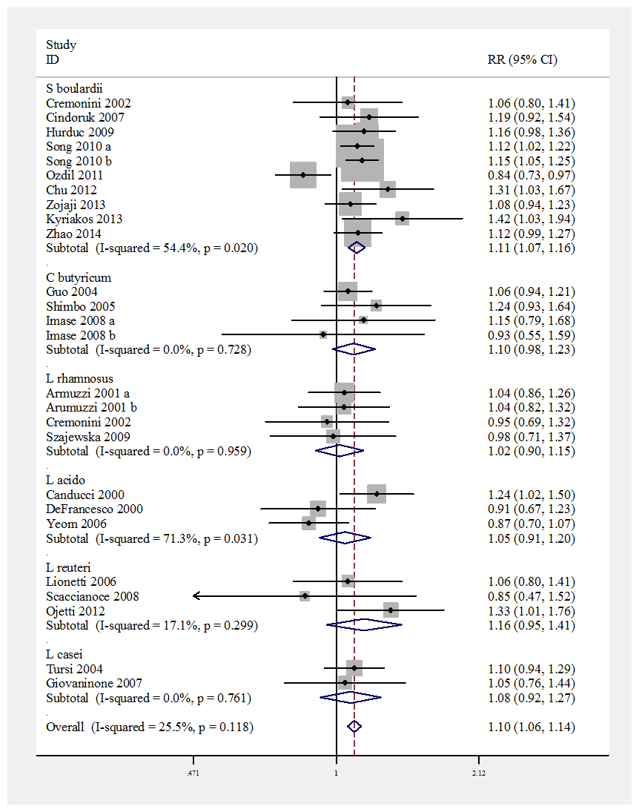

Figure 2 Forest plot of Helicobacter pylori eradication by probiotic strain.

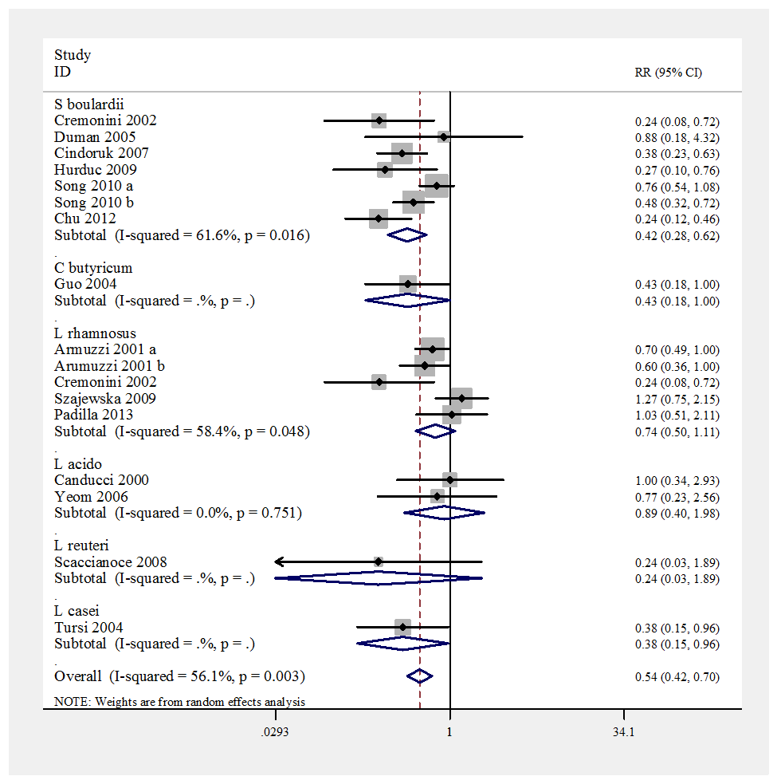

Figure 3 Forest plot of any adverse effects by probiotic strain.

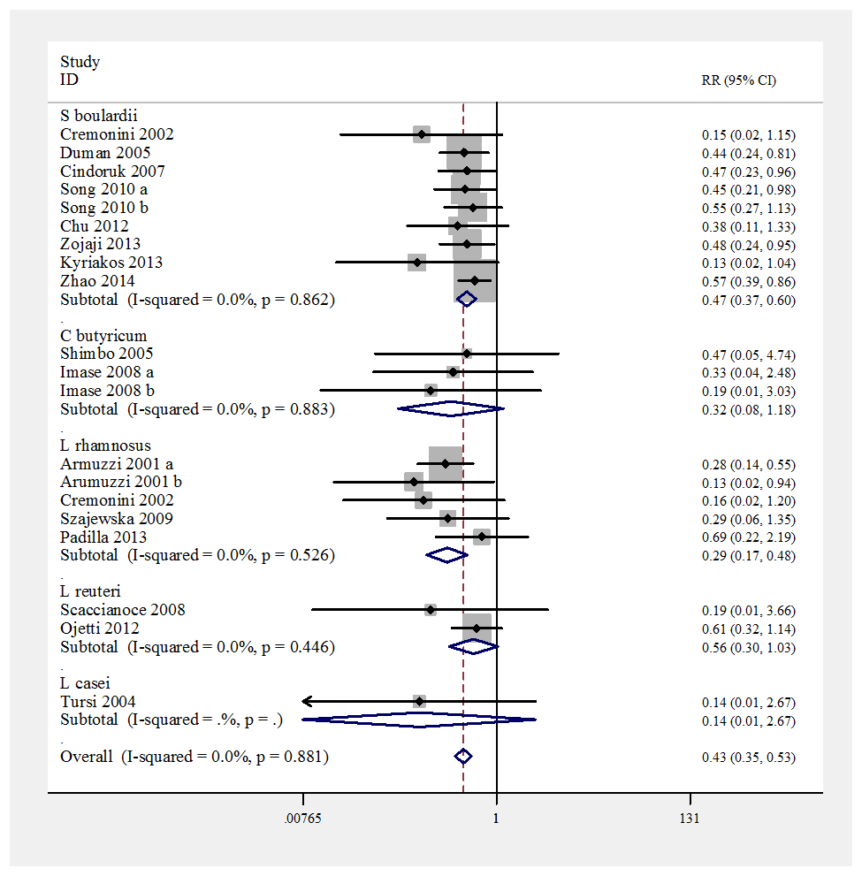

Figure 4 Forest plot of prevention of antibiotic-associated diarrhea by probiotic strain.

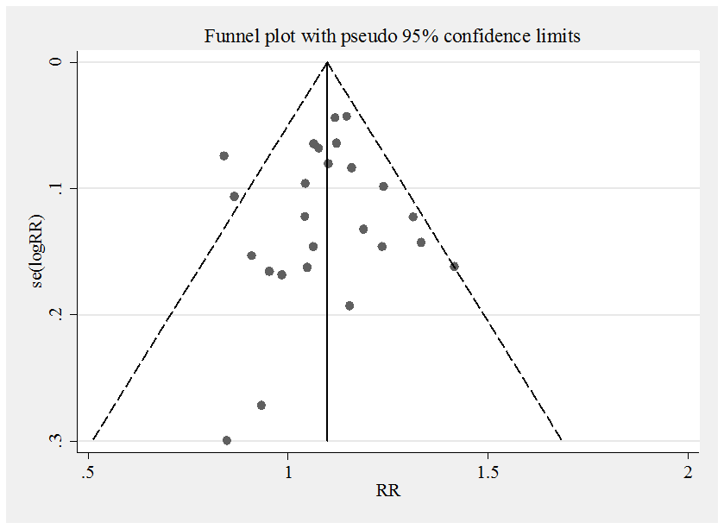

Figure 5 Funnel plot for publication bias assessment from for Helicobacter pylori eradication and probiotics.

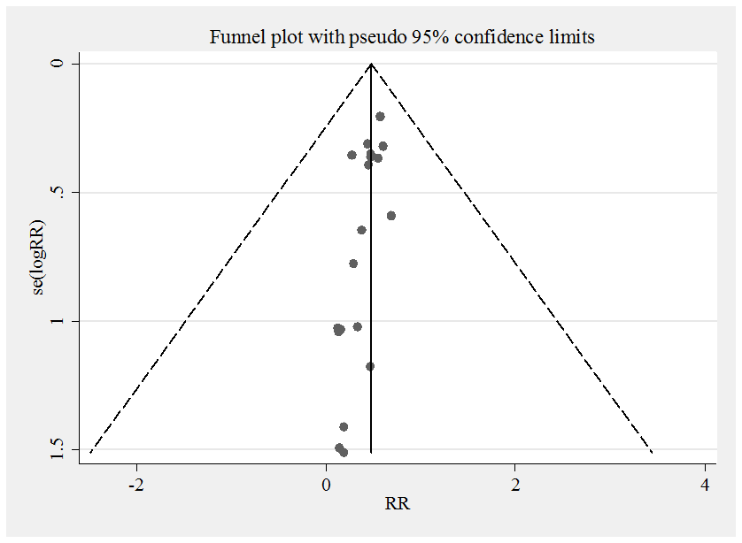

Figure 6 Funnel plot for publication bias assessment from for prevention of antibiotic associated diarrhea and probiotics.

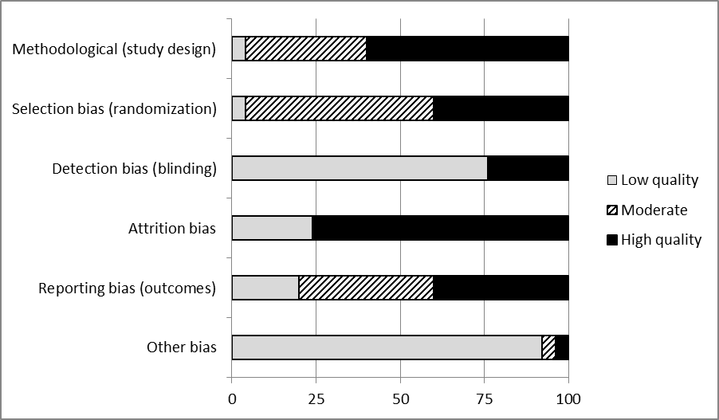

Figure 7 Frequency of study quality based on six different types of potential bias. High quality, low bias (76%-100% quality items within category present), moderate quality and moderate bias (51%-75% items present), low quality, high bias (0%-50% items present)

