Name of journal: World Journal of Gastrointestinal Endoscopy
ESPS Manuscript NO: 12122
Columns: Case Report

Role of preoperative endoscopic ultrasound-guided fine-needle tattooing of a pancreatic head insulinoma

Leelasinjaroen P et al. EUS-FNT of a pancreatic head insulinoma

Pornchai Leelasinjaroen, Wuttiporn Manatsathit, Richard Berri, Mohammed Barawi, Frank G Gress

Pornchai Leelasinjaroen, Wuttiporn Manatsathit, Department of Medicine, St. John Hospital and Medical Center, Detroit, MI 48236, United States

Richard Berri, Department of Surgery, St. John Hospital and Medical Center, Detroit, MI 48236, United States

Mohammed Barawi, Division of Gastroenterology, Department of Medicine, St. John Hospital and Medical Center, Detroit, MI 48236, United States

Frank G Gress, Division of Digestive Diseases, Columbia University Medical Center, New York, NY 10032, United States

Author contributions: Leelasinjaroen P and Manatsathit W researched/reviewed the current literature and wrote the paper; Barawi M performed the endoscopic procedure, provided the endoscopic image and reviewed manuscript; Berri R performed surgery provided the intraoperative images and reviewed manuscript; Gress FG reviewed manuscript.

Correspondence to: Pornchai Leelasinjaroen, MD, Resident Physician, Department of Medicine, St. John Hospital and Medical Center, 22101 Moross Rd, Detroit, MI 48236, United States. tee_pornchai@yahoo.com

Telephone: +1-734-2723147 Fax: +1-313-3437271

Received: June 23, 2014 Revised: August 8, 2014
Accepted: September 04, 2014

Published online:

Abstract
Although insulinomas are rare, they are the most common pancreatic neuroendocrine tumor, with an incidence of four cases per million population. Insulinomas are generally benign indolent intrapancreatic tumors. Surgical resection remains the main option for treatment. However, up to 67% of a pancreatic head insulinomas are nonpalpable, thus surgical resection of the nonplapable insulinoma in this area could become problematic resulting in prolonged surgical time, increased risk of pancreatic duct injury and need for pancreaticoduodenectomy. Endoscopic ultrasound-guided fine- needle tattooing (EUS-FNT), has been shown to have a crucial role for localization of pancreatic body and tail lesions, facilitating laparoscopic distal pancreatectomy and helping surgeons identify the location of the tumor. EUS-FNT might have a role for preoperative localization of pancreatic head insulinomas which are likely to be nonpalpable. We report a case of preoperative EUS-FNT for localization of a nonplapable pancreatic head insulinoma. This report demonstrates that EUS-FNT of pancreatic head insulinomas may facilitate surgical resection, reduce operative time and decrease surgical complications.

© 2014 Baishideng Publishing Group Inc. All rights reserved.

Key words: Insulinoma; Endosonography; Endoscopic ultrasound-guided fine-needle tattooing; Pancreas; Neuroendocrine tumors

Core tip: Preoperative endoscopic ultrasound-guided fine- needle tattooing (EUS-FNT) pancreatic body and tail lesion has shown to decrease operative time and facilitate laparoscopic distal pancreatectomy. We reported that preoperative EUS-FNT can effectively help localizing non-palpable pancreatic head insulinoma, especially in deep pancreatic parenchymal tissue. EUS-FNT helps precisely localizing the tumor and avoiding pancreatic duct and vascular injury from surgery. Furthermore this technique may help in preserving normal pancreatic tissue, reducing operative time and most importantly minimizing risks of pancreaticoduodenectomy. EUS-FNT represents a safe and useful role for the preoperative localization and surgical planning of the pancreatic head insulinoma.

Leelasinjaroen P, Manatsathit W, Berri R, Barawi M, Gress FG. Role of preoperative endoscopic ultrasound-guided fine-needle tattooing of a pancreatic head insulinoma. World J Gastrointest Endosc 2014; In press

INTRODUCTION
Endoscopic ultrasound (EUS) is a widespread imaging technique providing highly accurate localization of several pancreatic lesions. Endoscopic ultrasound-guided fine-needle tattooing (EUS-FNT) has been shown to have a role for localization of pancreatic body and tail lesions, facilitating laparoscopic distal pancreatectomy and helping surgeons identify the location of the tumor^{[1,2]}. Although EUS-FNT has been widely used for localizing pancreatic lesions in the body and tail, the role of EUS-FNT for pancreatic head lesions has never been established or reported. We report a case of preoperative EUS-FNT for localization of a nonpalpable pancreatic head insulinoma.

CASE REPORT
A 70-year-old female, with history of hypertension and Parkinson’s disease, presented to the hospital with neuroglycopenic symptoms, including confusion and weakness. A serum glucose level ranged between 22-65 mg/dL (normal: 73-107 mg/dL). She had persistent episodes of hypoglycemia which required aggressive intravenous dextrose replacement and ICU monitoring. Laboratory evaluation showed a C-peptide of 7.7 ng/mL (1.1-4.4 ng/mL), Insulin level of 20.9 MCiU/mL (0-20 MCiU/mL), Proinsulin of 19.9 pmol/L (3-20 pmol/L) and urine sulfonylurea screening was negative. Computer tomographic of the abdomen and pelvis with pancreas protocol revealed a 1.7 cm × 1.2 cm × 1.6 cm hypervascular lesion in the head of the pancreas located just medial to the gastroduodenal artery (GDA) and lateral to the superior mesenteric vein (SMV) (Figure 1). Endoscopic ultrasound (EUS) revealed a 15.5 mm hypoechoic, homogeneous tumor lesion in the head of pancreas. The tumor was adjacent to GDA and close to the pancreatic duct. EUS-guided fine-needle aspiration (EUS-FNA) biopsy was performed to confirm the diagnosis. Considering the location of the tumor in relation to the SMV and GDA, EUS-FNT was performed using a 22-gauge needle (Echo-Tip, Wilson-Cook). Two mL of sterile carbon-based ink (Spot; GI supply, Camp hill, PA) was injected slowly beginning in the center of the lesion and continuing until the needle exited the pancreas (Figure 2). Two days later, the patient underwent exploratory laparotomy. Intraoperatively, the insulinoma was nonpalpable and located deep in the pancreatic parenchyma between GDA and SMV. This was confirmed by intraoperative ultrasound. During dissection with bi-polar cautery between the GDA and the SMV, the preoperative tattooing was easily identified. The insulinoma was meticulously dissected with the guidance of the tattoo marker to preserve the pancreatic duct located posteriorly. During the procedure, the patient was given 10% dextrose water intravenously and blood sugar was checked every 15 min in order to prevent hypoglycemia. Finally, enucleation of the 2 cm pancreatic head insulinoma was performed without complication (Figure 3). Preoperative random insulin levels decreased significantly to10.6 MCiU/mL compared with preoperative insulin level of 23.8 MCiU/mL. Pathologic evaluation of the resected tumor revealed a pancreatic neuroendocrine tumor, consistent with an insulinoma. The patient had an uneventful postoperative hospitalization and remained euglycemic during outpatient follow-up at 6 mo.

DISCUSSION
After an insulinoma is diagnosed based on clinical and laboratory findings, surgical resection still remains the treatment of choice in the patient without metastasis. The type of surgical resection, which includes open or laparoscopic enucleation, pancreaticoduodenectomy and distal pancreatectomy are dictated by the location of the insulinoma. Therefore, methods for localizing insulinomas are very important. The preoperative localization of insulinoma which include CT, MRI and EUS, has a very high sensitivity 98%-100% especially after the widespread use of EUS^{[3,4]}. In contrast, the rate of intraoperative detection, including intraoperative palpation and intraoperative ultrasound (IOUS) varies between studies, ranging from 83%-98%^{[3,5-8]}. Hence, preoperative localization of the insulinoma is preferable and crucial for surgical planning and minimizing unnecessary surgery^{[3]}. EUS, provides not only diagnosis by FNA biopsy but also localization of the tumor and has a sensitivity to detect neuroendocrine tumors ranging from 86% to 94%^{[9,10]}. In general, EUS is recommended in patients with a high clinical index of suspicion where CT or MRI failed to localize tumor^{[3]}. EUS-FNT accurately localizes small pancreatic tumors, facilitates identification of pancreatic lesions intraoperatively, and decreases operative time^{[11,12]}. This was confirmed by studies that showed preoperative EUS-FNT of pancreatic body and tail lesions decreased operative time for laparoscopic distal pancreatectomy^{[1,2]}. Although EUS-FNT has been widely used for localizing pancreatic lesions in the body and tail, the role of EUS-FNT for pancreatic head lesions has never been established or reported.
Even though surgery can a have minimal invasive approach, surgical resection of the insulinoma in the pancreatic head still may require an exploratory laparotomy and a pancreaticoduodenectomy (Whipple procedure) due to the structural complexity of this area. Thirty percent of insulinomas are located in the head and uncinate process of the pancreas^{[3,13]}. There are reports that up to 67% of pancreatic head insulinomas are nonpalpable and 80% of nonpalpable insulinomas were located in pancreatic head^{[3,7]}. This can result in a dilemma when intraoperative tumor localization fails and causes the need for unnecessary or extended blind resections. In 4 out of 61 patients from a case series, with and without preoperative EUS localization, a second operation was required to remove a tumor that was unidentifiable intraoperatively during the first operation^{[3]}. Another study also showed that in 1 out of 26 patients, who underwent laparoscopic distal pancreatectomy(LDP) without EUS-FNT, required a second operation to remove the unidentifiable insulinoma by IOUS^{[2]}. EUS-FNT appears to have a role for preoperative localization of pancreatic head insulinoma particularly in cases when a mass could not be palpable and identifiable even with IOUS during surgery.
EUS-FNA complications, include pancreatitis and infection, occur in approximate 0%-2.2%^{[14,15]}. EUS-FNT is technically feasible and safe for pancreatic body and tail lesions. There is only a case of mild pancreatitis reported after EUS-FNT in a case series^{[1,2]}. Since this is the first case report of EUS-FNT performed in the pancreatic head, our case demonstrates the safety of EUS-FNT in pancreatic head area. There was no evidence of pancreatitis or infection after the EUS-FNT procedure and during the intraoperative period.
Our report is the first to describe the use of EUS-FNT for the preoperative localization of a nonpalpable pancreatic head insulinoma. This case differs from previously described reports in the literature in several ways. First, the insulinoma, that we localized, was intraoperatively nonpalpable and located in the head of pancreas. Second, the patient had a moderate to large size tumor (1.55 cm) which was located very close to a major vessel and the pancreatic duct. EUS-FNT can play a role in precisely localizing the tumor margin, in the pancreatic head area, which can help facilitate surgery in nonpalpable insulinoma intraoperatively and helps avoid pancreatic duct and local vascular injury while preserving normal pancreatic tissue. Furthermore, it can help reduce operative time and most importantly decreases the chance for the need to perform pancreaticoduodenectomy.
In conclusion, EUS-FNT represents a useful and safe technique for the preoperative localization and surgical planning of the pancreatic head insulinomas. Further studies will need to be performed to confirm the efficacy and safety of EUS-FNT in the pancreatic head and confirm whether EUS-FNT of these pancreatic head lesions will be able to decrease the rate of pancreaticoduodenectomy and facilitate successful minimal invasive resection.

COMMENTS
Case characteristics
A 70-year-old female presented with neuroglycopenic symptoms and was found to have a pancreatic head insulinoma.

Clinical diagnosis
The patient who has insulinoma could present with either neuroglycopenic symptoms or adrenergic manifestations included shakiness, anxiety, nervousness, palpitations and sweating. Physical examination is usually unremarkable.

Differential diagnosis
Sulfonylurea-induced hypoglycemia, Insulin autoimmune hypoglycemia, Noninsulinoma pancreatogenous hypoglycemia syndrome (NIPHS), other pancreatic neoplasms.

Laboratory diagnosis
Laboratory evaluation showed a C-peptide of 7.7 ng/mL (1.1-4.4 ng/mL), Insulin level of 20.9 MCiU/mL (0-20 MCiU/mL), Proinsulin of 19.9 pmol/L (3-20 pmol/L) and urine sulfonylurea screening was negative suggesting diagnosis of the insulinoma.

Imaging diagnosis
Computed tomography and Endoscopic ultrasound revealed a hypervascular lesion in the pancreatic head located just medial to the gastroduodenal artery and lateral to the superior mesenteric vein.

Pathological diagnosis
Pathologic evaluation of the resected tumor revealed a pancreatic neuroendocrine tumor. Immunohistochemistry staining is positive for synaptophysin, chromogranin and insulin, consistent with an insulinoma.

Treatment
The patient underwent exploratory laparotomy and enucleation of the 2 cm pancreatic head insulinoma without complication.

Related reports
Endoscopic ultrasound-guided fine-needle tattooing (EUS-FNT) has been shown to have a role for localization of pancreatic body and tail lesions, facilitating laparoscopic distal pancreatectomy and helping surgeons identify the location of the tumor.

Term explanation
Sterile carbon-based ink (GI Spot), is endoscopic non india-ink marker, contains high purity suspended carbon particles providing safe, proven, permanent endoscopic tattooing

Experiences and lessons
This report demonstrates that EUS-FNT of pancreatic head insulinomas facilitate surgical resection, may reduce operative time and decrease surgical complications.

Peer review
It is an interesting case.

REFERENCES
1 Lennon AM, Newman N, Makary MA, Edil BH, Shin EJ, Khashab MA, Hruban RH, Wolfgang CL, Schulick RD, Giday S, Canto MI. EUS-guided tattooing before laparoscopic distal pancreatic resection (with video). Gastrointest Endosc 2010; 72: 1089-1094 [PMID: 21034909 DOI: 10.1016/j.gie.2010.07.023]
2 Newman NA, Lennon AM, Edil BH, Gilson MM, Giday SA, Canto MI, Schulick RD, Makary MA. Preoperative endoscopic tattooing of pancreatic body and tail lesions decreases operative time for laparoscopic distal pancreatectomy. Surgery 2010; 148: 371-377 [PMID: 20554299 DOI: 10.1016/j.surg.2010.04.008]
3 Nikfarjam M, Warshaw AL, Axelrod L, Deshpande V, Thayer SP, Ferrone CR, Fernández-del Castillo C. Improved contemporary surgical management of insulinomas: a 25-year experience at the Massachusetts General Hospital. Ann Surg 2008; 247: 165-172 [PMID: 18156937 DOI: 10.1097/SLA.0b013e31815792ed]
4 McLean AM, Fairclough PD. Endoscopic ultrasound in the localisation of pancreatic islet cell tumours. Best Pract Res Clin Endocrinol Metab 2005; 19: 177-193 [PMID: 15763694 DOI: 10.1016/j.beem.2004.11.012]
5 Boukhman MP, Karam JH, Shaver J, Siperstein AE, Duh QY, Clark OH. Insulinoma--experience from 1950 to 1995. West J Med 1998; 169: 98-104 [PMID: 9735690]
6 Proye C, Boissel P. Preoperative imaging versus intraoperative localization of tumors in adult surgical patients with hyperinsulinemia: a multicenter study of 338 patients. World J Surg 1988; 12: 685-690 [PMID: 2854328]
7 Norton JA. Intraoperative methods to stage and localize pancreatic and duodenal tumors. Ann Oncol 1999; 10 Suppl 4: 182-184 [PMID: 10436817]
8 Norton JA, Shawker TH, Doppman JL, Miller DL, Fraker DL, Cromack DT, Gorden P, Jensen RT. Localization and surgical treatment of occult insulinomas. Ann Surg 1990; 212: 615-620 [PMID: 2241318]
9 McLean AM, Fairclough PD. Endoscopic ultrasound in the localisation of pancreatic islet cell tumours. Best Pract Res Clin Endocrinol Metab 2005; 19: 177-193 [PMID: 15763694 DOI: 10.1016/j.beem.2004.11.012]
10 Anderson MA, Carpenter S, Thompson NW, Nostrant TT, Elta GH, Scheiman JM. Endoscopic ultrasound is highly accurate and directs management in patients with neuroendocrine tumors of the pancreas. Am J Gastroenterol 2000; 95: 2271-2277 [PMID: 11007228 DOI: 10.1111/j.1572-0241.2000.02480.x]
11 Gress FG, Barawi M, Kim D, Grendell JH. Preoperative localization of a neuroendocrine tumor of the pancreas with EUS-guided fine needle tattooing. Gastrointest Endosc 2002; 55: 594-597 [PMID: 11923783 DOI: 10.1067/mge.2002.122580]
12 Farrell JJ, Sherrod A, Parekh D. EUS-guided fine-needle tattooing for preoperative localization of early pancreatic adenocarcinoma. Gastrointest Endosc 2009; 69: 176-177 [PMID: 18599051 DOI: 10.1016/j.gie.2008.03.1069]
13 Galbut DL, Markowitz AM. Insulinoma: diagnosis, surgical management and long-term follow-up. Review of 41 cases. Am J Surg 1980; 139: 682-690 [PMID: 6258453 DOI: 10.1016/0002-9610(80)90363-3]
14 Al-Haddad M, Wallace MB, Woodward TA, Gross SA, Hodgens CM, Toton RD, Raimondo M. The safety of fine-needle aspiration guided by endoscopic ultrasound: a prospective study. Endoscopy 2008; 40: 204-208 [PMID: 18058615 DOI: 10.1055/s-2007-995336]
15 Fisher L, Segarajasingam DS, Stewart C, Deboer WB, Yusoff IF. Endoscopic ultrasound guided fine needle aspiration of solid pancreatic lesions: Performance and outcomes. J Gastroenterol Hepatol 2009; 24: 90-96 [PMID: 19196396 DOI: 10.1111/j.1440-1746.2008.05569.x]

P-Reviewer: Akyuz F, Appetecchia M, Bloomston M, Tonelli F S-Editor: Ji FF L-Editor: E-Editor:

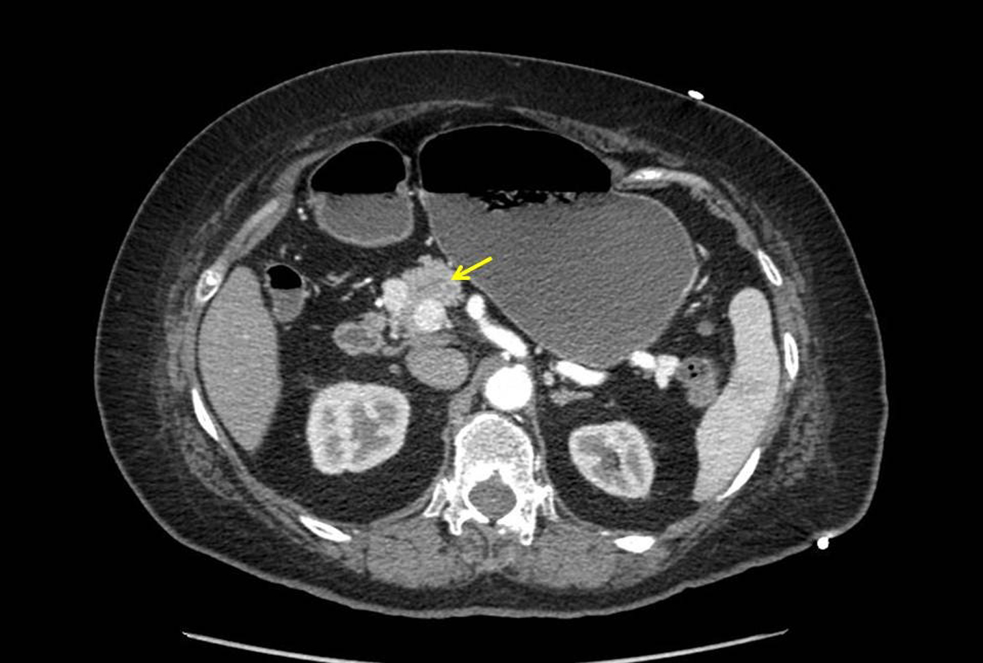
Figure 1 Computer tomographic of the abdomen and pelvis with pancreas protocol showed a 1.7 cm × 1.2 cm × 1.6 cm solid mass in the superior and right lateral margin of the head pancreas. The mass was hyperdense to the pancreas on early arterial phase imaging and became isodense with washout on more delayed phase images.
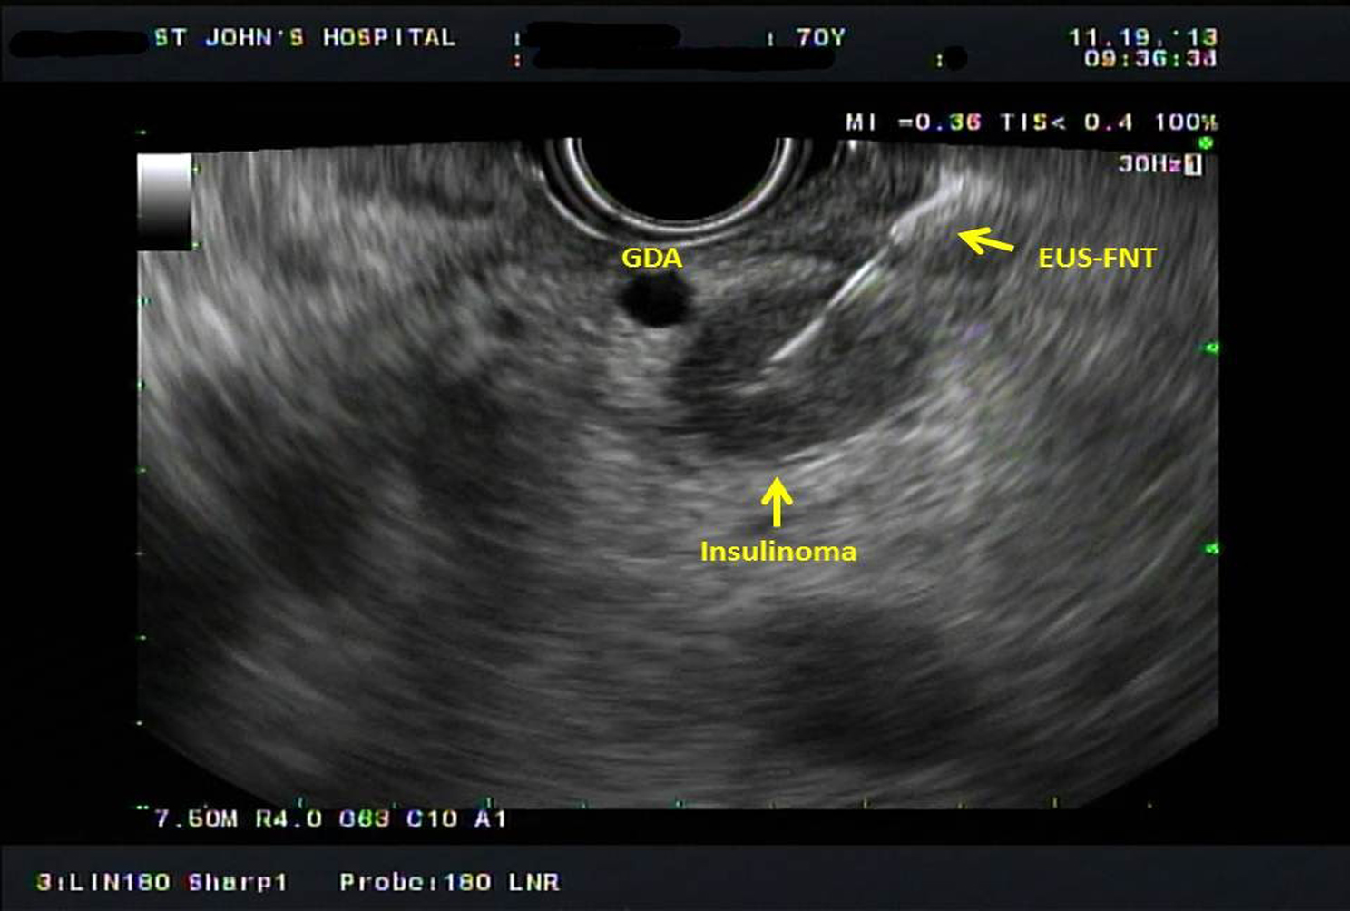
Figure 2 Endoscopic ultrasound-guided fine- needle tattooing image of a 15.5-mm hypoechoic mass located at pancreatic head adjacent to gastroduodenal artery.
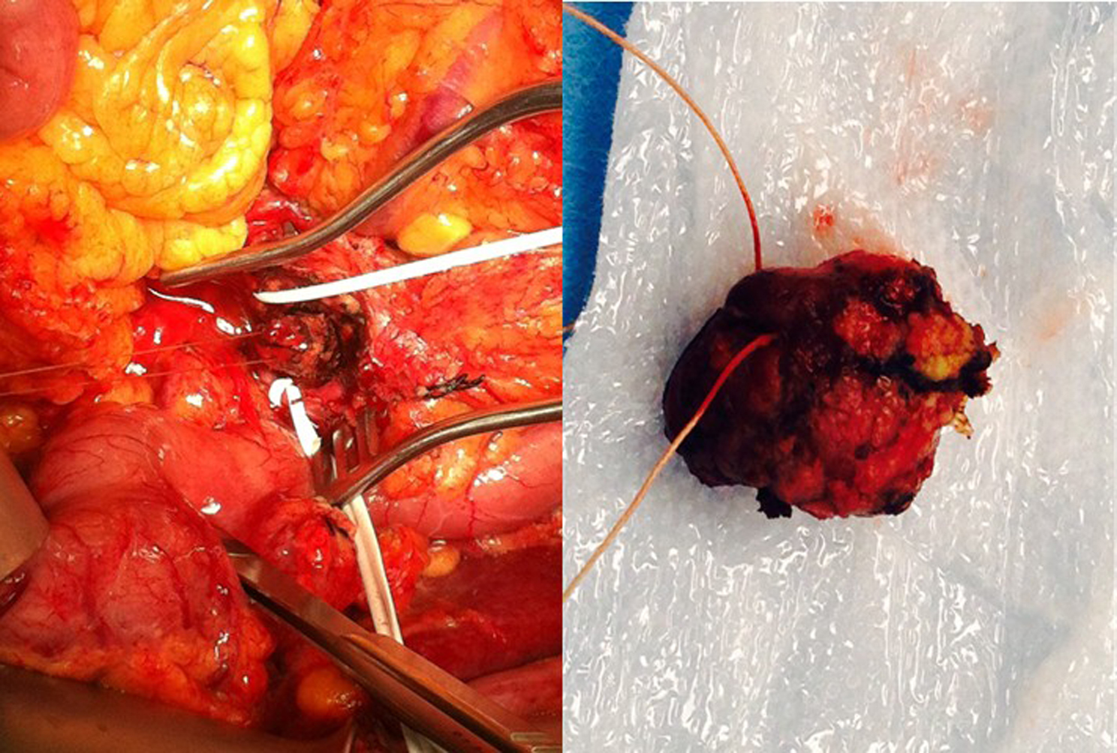
Figure 3 The tattooed insulinoma, located between gastroduodenal artery and superior mesenteric vein, was identified during operation (left). The 2 cm Insulinoma was enucleated without complication (right).

