Name of Journal: World Journal of Clinical Cases
Manuscript NO: 67175
Manuscript Type: CASE REPORT

Mucormycosis–resurgence of a deadly opportunist during COVID-19 pandemic: Four case reports

Upadhyay S et al. Post-COVID oral mucormycosis

Shalini Upadhyay, Tanisha Bharara, Manisha Khandait, Ankit Chawdhry, Bharat Bhushan Sharma

Shalini Upadhyay, Tanisha Bharara, Manisha Khandait, Department ofMicrobiology, SGT University, Gurugram 122505, Haryana, India

Ankit Chawdhry, Department ofOral and maxillofacial surgery, SGT University, Gurugram 122505, Haryana, India

Bharat Bhushan Sharma, Department ofRadiology, SGT University, Gurugram 122505, Haryana, India

Author contributions: Upadhyay S, Bharara T and Khandait M reviewed the literature and contributed to manuscript drafting; Upadhyay S, and Bharara T performed the microbiological analyses and interpretation; Chowdhry A was the oral and maxillofacial surgeon who took the history and performed detailed analysis of the cases; Sharma B analyzed and interpreted the imaging findings; Khandait M and Bharara T performed the revision of the manuscript for important intellectual content; All authors have read and approve the final manuscript.

Corresponding author: Tanisha Bharara, MBBS, MD, Assistant Professor, Department ofMicrobiology, SGT University, Budhera Gurgaon, Gurugram 122505, Haryana, India. tanishabharara.med@gmail.com

Received: April 17, 2021
Revised: August 6, 2021
Accepted: November 5, 2021
Published online: December 26, 2021

Abstract
BACKGROUND
Coronavirus disease 2019 (COVID-19) patients who suffer severe infection or comorbidities have an increased riskof developing fungal infections. There is a possibility that such infections are missed or misdiagnosed, in which case patients may suffer higher morbidity and mortality. COVID-19 infection, aggressive management strategies and comorbidities like diabetes render patients prone to opportunistic fungal infections. Mucormycosis is one of the opportunistic fungal infectionsthatmay affect treated COVID patients.

CASE SUMMARY
We present a case series of four adult males who were diagnosed with mucormycosis post-COVID-19 recovery. All the patients had diabetes and ahistory of systemic corticosteroids for treatment of COVID-19. The mean duration between diagnosis of COVID-19 and development of symptoms of mucor was 15.5 ± 14.5 (7–30) d. All patients underwent debridement and were started on antifungal therapy. One patient was referred to a higher center for further management, but the others responded well to treatment and showed signs of improvement at the last follow-up.

CONCLUSION
Early diagnosis and management of mucormycosis with appropriate and aggressive antifungals and surgical debridement can improve survival.

Key Words: Zygomycetes; Fungal infection; COVID-19 co-infection; Diabetes mellitus; Case series; Case report

©The Author(s) 2021. Published by Baishideng Publishing Group Inc. All rights reserved.

Citation: Upadhyay S, Bharara T, Khandait M, Chawdhry A, Sharma BB. Mucormycosis - resurgence of a deadly opportunist during COVID-19 pandemic: Four case reports. World J Clin Cases 2021; 9(36): 11338-11345
URL: https://www.wjgnet.com/2307-8960/full/v9/i36/11338.htm
DOI: https://dx.doi.org/10.12998/wjcc.v9.i36.11338

Core Tip: Mucormycosis usually indicates a serious underlying medical condition such as diabetes. Furthermore, the immune dysregulation post coronavirus disease 2019, and widespread use of immunosuppressants and broad-spectrum antibiotics may lead to enhanced susceptibility to a number of secondary opportunistic infections such asmucormycosis. Clinical suspicion along with prompt microbiological diagnosis are indispensable to a positive case outcome.
INTRODUCTION
Severe acute respiratory syndrome coronavirus-2 (SARS-CoV-2) is known to infect alveolar epithelial cells (pneumonia and acute respiratory distress syndrome) as well as monocytes/macrophages leading to a cytokine storm (multiorgan failure and death)^{[1]}. The cytokine storm seen in severe cases has led to increased use of steroids and other immunosuppressive therapy in moderate-to-severe cases. Coronavirus disease 2019 (COVID-19) infection, aggressive management strategies and comorbidities such asdiabetes mellitus (DM) render patients prone to opportunistic fungal infections^{[2,3]}.
Mucormycosis is a deadly and rapidly progressive fungal infection of humans. The usual presentation is rhinocerebral mucormycosis^{[4]}. Oral mucormycosis is an unusual manifestation of the disease mainly affecting immunocompromised patients such as those with DM, corticosteroid treatment, leukemia, lymphoma, human immunodeficiency virus (HIV) infectionetc.^{[3,5,6]}. Although there are few publications on fungal co-infections associated with COVID-19, it is pertinent to point out that there is a high chance of missed or misdiagnosis in these cases.
To analyze mucor infections in COVID-19 patients, we searched PubMed, Scopus and Web of Science, using the keywords ‘‘mucor’’, ‘‘mucormycosis’’, ‘‘opportunistic fungal infection’’, ‘‘oral fungal infections’’, ‘‘post COVID infection’’, ‘‘COVID-19’’ or ‘‘SARS-CoV-2’’ (up to April 16, 2021). Through this report,we provide an insight into clinical features, laboratory diagnosis and significance of timely management of post-COVID mucormycosis infection through a series of four cases who presented to the outpatient department of our hospital.

CASE PRESENTATION
Chief complaints
All the cases presented to the department of oral and maxillofacial surgery with chief complaints of pain, swelling and pus discharge from their oral cavity.

History of present illness
Case 1:a 39-year-old manpresented to the outpatient department (OPD) complaining of pain and mobility in the teeth of the upper jaw region for thepast 2 mo. The patient gave a history of extraction of a tooth in the upper jaw 2 mo previously, after which he developed a nonhealing painful lesion. The pain gradually spread to the entire left maxilla (Figure 1A).

Case 2:a 57-year-old manpresented to the OPD with gingival swelling and multiple draining sinuses on right and left anterior maxilla and right side of the palate for the past 1 wk (Figure 1B). The patient presented to the OPD with the same complaints 1wk previously and was prescribed antibiotics, however, he did not obtainany relief.

Case 3:A 45-year-old man presented to the OPD with chief complaints of pain, bleeding and ulcers in the gums.

Case 4:a 55-year-old man presented to the OPD with chief complaints of pus discharge and bleeding from the gums (Figure 1C).

History of past illness
All four patients had a history of uncontrolled DM. All the cases gave a past history of suffering from COVID-19 that dated back 2–3 mo. Case 1 suffered from COVID-19 3mo back.Case 2 was hospitalized for 17 d for treatment of COVID-19. He developed the mucosal lesions 9 d after recovery from COVID-19. Case 3 tested positive for SARS-CoV-2 3 mo back, andhe recovered from the viral infection after 15 d of treatment. He noticed the presenting lesions 1 wk after recovery from COVID-19 infection. Case 4 was apparently well 2 mo back when he tested positive for SARS-CoV-2 through RT-PCR. He recovered from the viral infection after 10 d of treatment. The patient developed the present lesions 16 d afterrecovery from COVID-19.

Physical examination
All the patients were afebrile at presentation. In Case 1, bothmaxilla showed the presence of pus-discharging sinuses. The patient’s mouth opening was found to be adequate. Case 2 showed gingival swelling and multiple draining sinuses on both anterior maxilla and also the right side of the palate. Case 3 demonstratedgingival swelling and multiple draining sinuses on both anterior maxilla and theright side of the palate. However, his mouth opening was inadequate. Case 4 had multiple sinus formation on gingiva and discoloration of the hard palate was observed (Figure 1C). On palpation,a maxillary fragment was mobile.

Laboratory examinations
Blood chemistry, arterial blood gas analysis, urinalysis, electrocardiographyand chest X-ray were normal in all four cases.

Further diagnostic work-up: All fourcases tested negative for HIV antibody, hepatitis B surface antigen, and hepatitis virus antibody. Complete blood count, liver function test and kidney function test were within normal ranges.

Microbiological identification of the causative agent: The tissues/pus samples from the lesions were analyzed by direct microscopy and culture (Figure 2). The potassium hydroxide (KOH) mount of direct specimens showed broad aseptate hyaline hyphae. The tissue specimens from maxillary sinuses of all the cases showed granulomatous reaction with thick, broad fungal hyphae suggestive of Mucor spp.The specimens were cultured on Sabouraud dextrose agar (SDA) and culture tubes were incubated at 37ºC and 25ºC. After 5–10 d of incubation, there was cottony white growth on SDA. Lactophenol cotton blue (LPCB) staining showed broad aseptate hyphae in all four cases.

Imaging examinations
Case 1: Noncontrast computed tomography (NCCT) of paranasal sinuses (PNSs) showed bony defects involving the left side of the alveolar process of the maxilla, and the anterior medial and lateral walls of the left maxillary sinus showed thinning and attenuation/erosion. Findings revealed residual/recurrent fungal sinusitis.

Case 2:NCCT of the PNSs showed bony septa in the right frontal sinus withmucosal thickening and air locules (Figure 3). The right osteomeatal complex was obliterated with adjacent bone erosion and erosion of the medial wall of the right maxillary sinus.

Case 3:Imaging could not be performed as he was referred to a higher center before the investigation could be performed.

Case 4: NCCT of the PNSs showed bony erosion involving both sides of the alveolar process of the maxilla.

MULTIDISCIPLINARY EXPERT CONSULTATION
Ankit Chowdhry, MDS, Post Graduate student, Department of Oral and Maxillofacial Surgery, SGT University
Case 1: Surgical debridement of the left maxilla, bullectomy and left ethmoidectomy was performed under general anesthesia.

Case 2:The patient was started on amoxicillin–clavulanic acid (500/125 mg 12 h) and liposomal amphotericin B (5 mg/kg in 10% dextrose).

Case 3:The patient was started on liposomal amphotericin-B (5 mg/kg in 10% dextrose). Since the patient needed extensive surgery, he was referred to a higher center for further management.

Case 4: The patient was started on liposomal amphotericin B (5 mg/kg in 10% dextrose).

Tanisha Bharara, MD, Assistant Professor, Department of Microbiology, SGT University and Shalini Upadhyay, MD, Assistant Professor, Department of Microbiology, SGT University
The microbiological analysis of pus and tissue specimens showed fungal hyphae in KOH mount. The growth on SDA and LPCB appearance wassuggestive of Mucor spp.

Manisha Khandait, MD, Professor and Head, Department of Microbiology, SGT University
Mucormycosis should be treated with liposomal amphotericin B.

Bharat Bhushan Sharma, MD, Professor and Head, Department of Radiodiagnosis, SGT University
NCCT of PNSswassuggestive of structural changes due to mucormycosis.

FINAL DIAGNOSIS
The final diagnosis of the four cases was post-COVID oral mucormycosis.

TREATMENT
All the patients were started on intravenous infusion of liposomal amphotericin B at aninitial dose of 5 mg/kg diluted in 10% dextrose. Cases 1 and 3 needed additional surgical intervention. The cases were followed up for clinical and radiological resolution of active disease.

OUTCOME AND FOLLOW-UP
Cases 1, 2and 4responded well to treatment. Case 3could not be followed up as he was referred to a higher center.

DISCUSSION
We report a series of four cases of oral mucormycosis among male patients with DM. Mucormycosis sometimes appears as a diabetes-defining illness and remains one of the most devastating complications in uncontrolled DM. India contributes to 40% of the global burden of this deadly opportunistic infection, with an estimated prevalence of > 100 cases per million population^{[4]}. All patients in this study hadDMand similar oral lesions, andwere diagnosed with the help of laboratory tests and NCCT. Two of the patients needed surgical debridement and all four were treated with liposomal amphotericin B. The patients showed improvement in their lesions. One of the patients who had extensive lesions was referred to a higher center for further care.
Huang et al^{[7]}reported a case of oral mucormycosis and extensive maxillary osteonecrosis secondary to dental extraction in a 40-year-old immunocompromised patient. The author emphasized early recognition and aggressive treatment of such patients in order to prevent morbidity and mortality^{[8]}. Fogarty et al^{[9]}and Kumar et al^{[10]} also reported development of oral mucormycosis among elderly immunocompromised men. Various cases of oral mucormycosis reported so far are summarized in Table 1^{[11-17]}.
Another peculiar finding observed in our study was that all the patients gave a past history of COVID-19. SARS-CoV-2 is capable of infecting not only intraepithelial cells within the lungs, but also causes an abortive infection of the macrophages and dendritic cells. This leads to a storm of proinflammatory cytokines thatrenders the patient prone to opportunistic infections such asmucormycosis^{[1]}. Invasive mucormycosis has not only been reported in severe cases but even in mild-to-moderate COVID. Although a few cases of oral mucormycosis have been reported in the literature, this is one of the first case series reported among COVID-19 patients.
Mucormycosis suggests the presence of a pre-existing immunosuppressive condition such as diabetes, leukemia, lymphoma, renal failure, immunosuppressive therapy, malnutrition, viral infection and severe burns. Hyperglycemia due to uncontrolled diabetes is the strongest risk factor for development of mucormycosis. It leads to polymorphonuclear dysfunction, defective chemotaxis and dysregulated intracellular killing. In ketoacidosis, free iron becomes readily available in the serum, which is efficiently taken up by Mucorfor its growth and virulence. The association between DM and COVID is a known fact^{[18]}. Corticosteroid use in severe COVID-19 patients with diabetes further impairs the functioning of neutrophils, thus making these patients highly susceptible to development of mucormycosis^{[3,5,17,18]}.
Inhalation of fungalspores or direct wound contamination are the two most common causes oforal mucormycosis^{[19,20]}. The most common form of this disease ismaxillofacial. Early symptoms of this disease include facial cellulitis, periorbital edema and nasal inflammation, followed by widespread tissue necrosis^{[21]}. Failure of prompt medical and surgical intervention may lead to cerebral spread, cavernous sinus thrombosis, septicemia and multiple organ failure,resulting in high morbidity and mortality^{[22]}.
Suspicion of mucormycosis is based on laboratory and imaging findings, risk factors and disease progression while on any antibacterial or antifungal therapy that does not cover Mucorinfection. The pathognomonic feature of mucormycosis is tissue necrosis manifesting as a necrotic lesion, eschar or black discharge in the nasal or oral cavity^{[23]}.
Rapid diagnostic methods include biopsy, KOH mount and Calcofluor stain. Since it is difficult to routinely culture Mucor, biopsy is preferred for confirmation of diagnosis^{[2,21,23]} (Figure 4). Management includes antifungal therapy, surgical debridement, diagnosisand treatment ofthe underlying predisposing factors, and adjuvant therapy. Amphotericin B is the standard treatment for invasive mucormycosis^{[24]}. Posaconazole or isavuconazole may be preferred in COVID-19 patients with acute on chronic renal failure. Isavuconazole shortens the QT interval, which may be affected by hydroxychloroquine and azithromycin therapy commonly used in COVID-19 patients^{[25]}. Adjuvant therapy like caspofungin, deferasirox, statins, aspirin, and hyperbaric oxygen may be added as adjunctive treatment^{[26]}.
Clinical suspicion, meticulous diagnosis, coordination between different medical departments and timely intervention werethe strengths of our study. Limitation of the study werethat antifungal susceptibility testing and further molecular characterization of the isolated fungal pathogen could not be done due to limitation of resources.

CONCLUSION
Clinicians should be familiar with presentations of rare opportunistic fungal infections and keep a high index of suspicion in post-COVID patients with DM. A multidisciplinary approach facilitating early diagnosis, aggressive surgical intervention, medical treatment with amphotericin B and controlling DM are the mainstay for improving the outcome of patients with mucormycosis in post-COVID patients. The incidence of oral mucormycosis may increase, either as co-infection or as a sequela of COVID-19. Therefore, urgent reporting of any new information is of importance to keep the scientific community abreast with what all can go wrong post-COVID infection, which till now is unexplored territory.

REFERENCES
1 Chakravarti A, Upadhyay S, Bharara T, Broor S. Current understanding, knowledge gaps and a perspective on the future of COVID-19 Infections: A systematic review. Indian J Med Microbiol 2020; 38: 1-8 [PMID: 32719202 DOI: 10.4103/ijmm.IJMM_20_138]
2 Song G, Liang G, Liu W. Fungal Co-infections Associated with Global COVID-19 Pandemic: A Clinical and Diagnostic Perspective from China. Mycopathologia 2020; 185: 599-606 [PMID: 32737747 DOI: 10.1007/s11046-020-00462-9]
3 Corzo-León DE, Chora-Hernández LD, Rodríguez-Zulueta AP, Walsh TJ. Diabetes mellitus as the major risk factor for mucormycosis in Mexico: Epidemiology, diagnosis, and outcomes of reported cases. Med Mycol 2018; 56: 29-43 [PMID: 28431008 DOI: 10.1093/mmy/myx017]
4 Prakash H, Chakrabarti A. Global Epidemiology of Mucormycosis. J Fungi (Basel) 2019; 5 [PMID: 30901907 DOI: 10.3390/jof5010026]
5 Moorthy A, Gaikwad R, Krishna S, Hegde R, Tripathi KK, Kale PG, Rao PS, Haldipur D, Bonanthaya K. SARS-CoV-2, Uncontrolled Diabetes and Corticosteroids-An Unholy Trinity in Invasive Fungal Infections of the Maxillofacial Region? A Retrospective, Multi-centric Analysis. J Maxillofac Oral Surg 2021: 1-8 [PMID: 33716414 DOI: 10.1007/s12663-021-01532-1]
6 Ahmadikia K, Hashemi SJ, Khodavaisy S, Getso MI, Alijani N, Badali H, Mirhendi H, Salehi M, Tabari A, Mohammadi Ardehali M, Kord M, Roilides E, Rezaie S. The double-edged sword of systemic corticosteroid therapy in viral pneumonia: A case report and comparative review of influenza-associated mucormycosis versus COVID-19 associated mucormycosis. Mycoses 2021; 64: 798-808 [PMID: 33590551 DOI: 10.1111/myc.13256]
7 Huang JS, Kok SH, Lee JJ, Hsu WY, Chiang CP, Kuo YS. Extensive maxillary sequestration resulting from mucormycosis. Br J Oral Maxillofac Surg 2005; 43: 532-534 [PMID: 16024140 DOI: 10.1016/j.bjoms.2005.05.012]
8 Sen M, Lahane S, Lahane TP, Parekh R, Honavar SG. Mucor in a Viral Land: A Tale of Two Pathogens. Indian J Ophthalmol 2021; 69: 244-252 [PMID: 33463566 DOI: 10.4103/ijo.IJO_3774_20]
9 Fogarty C, Regennitter F, Viozzi CF. Invasive fungal infection of the maxilla following dental extractions in a patient with chronic obstructive pulmonary disease. J Can Dent Assoc 2006; 72: 149-152 [PMID: 16545177]
10 Kumar JA, Babu P, Prabu K, Kumar P. Mucormycosis in maxilla: Rehabilitation of facial defects using interim removable prostheses: A clinical case report. J Pharm Bioallied Sci 2013; 5: S163-S165 [PMID: 23956598 DOI: 10.4103/0975-7406.114322]
11 Kalaskar RR, Kalaskar AR, Ganvir S. Oral mucormycosis in an 18-month-old child: a rare case report with a literature review. J Korean Assoc Oral Maxillofac Surg 2016; 42: 105-110 [PMID: 27162751 DOI: 10.5125/jkaoms.2016.42.2.105]
12 Mehta S, Pandey A. Rhino-Orbital Mucormycosis Associated With COVID-19. Cureus 2020; 12: e10726 [PMID: 33145132 DOI: 10.7759/cureus.10726]
13 Werthman-Ehrenreich A. Mucormycosis with orbital compartment syndrome in a patient with COVID-19. Am J Emerg Med 2021; 42: 264.e5-264.e8 [PMID: 32972795 DOI: 10.1016/j.ajem.2020.09.032]
14 Hanley B, Naresh KN, Roufosse C, Nicholson AG, Weir J, Cooke GS, Thursz M, Manousou P, Corbett R, Goldin R, Al-Sarraj S, Abdolrasouli A, Swann OC, Baillon L, Penn R, Barclay WS, Viola P, Osborn M. Histopathological findings and viral tropism in UK patients with severe fatal COVID-19: a post-mortem study. Lancet Microbe 2020; 1: e245-e253 [PMID: 32844161 DOI: 10.1016/S2666-5247(20)30115-4]
15 Placik DA, Taylor WL, Wnuk NM. Bronchopleural fistula development in the setting of novel therapies for acute respiratory distress syndrome in SARS-CoV-2 pneumonia. Radiol Case Rep 2020; 15: 2378-2381 [PMID: 32983308 DOI: 10.1016/j.radcr.2020.09.026]
16 Monte Junior ESD, Santos MELD, Ribeiro IB, Luz GO, Baba ER, Hirsch BS, Funari MP, de Moura EGH. Rare and Fatal Gastrointestinal Mucormycosis (Zygomycosis) in a COVID-19 Patient: A Case Report. Clin Endosc 2020; 53: 746-749 [PMID: 33207116 DOI: 10.5946/ce.2020.180]
17 Mekonnen ZK, Ashraf DC, Jankowski T, Grob SR, Vagefi MR, Kersten RC, Simko JP, Winn BJ. Acute Invasive Rhino-Orbital Mucormycosis in a Patient With COVID-19-Associated Acute Respiratory Distress Syndrome. Ophthalmic Plast Reconstr Surg 2021; 37: e40-e80 [PMID: 33229953 DOI: 10.1097/IOP.0000000000001889]
18 Pasero D, Sanna S, Liperi C, Piredda D, Branca GP, Casadio L, Simeo R, Buselli A, Rizzo D, Bussu F, Rubino S, Terragni P. A challenging complication following SARS-CoV-2 infection: a case of pulmonary mucormycosis. Infection 2020 [PMID: 33331988 DOI: 10.1007/s15010-020-01561-x]
19 Lim S, Bae JH, Kwon HS, Nauck MA. COVID-19 and diabetes mellitus: from pathophysiology to clinical management. Nat Rev Endocrinol 2021; 17: 11-30 [PMID: 33188364 DOI: 10.1038/s41574-020-00435-4]
20 Garg D, Muthu V, Sehgal IS, Ramachandran R, Kaur H, Bhalla A, Puri GD, Chakrabarti A, Agarwal R. Coronavirus Disease (Covid-19) Associated Mucormycosis (CAM): Case Report and Systematic Review of Literature. Mycopathologia 2021; 186: 289-298 [PMID: 33544266 DOI: 10.1007/s11046-021-00528-2]
21 Corchuelo J, Ulloa FC. Oral manifestations in a patient with a history of asymptomatic COVID-19: Case report. Int J Infect Dis 2020; 100: 154-157 [PMID: 32882435 DOI: 10.1016/j.ijid.2020.08.071]
22 Venkatesh D, Dandagi S, Chandrappa PR, Hema KN. Mucormycosis in immunocompetent patient resulting in extensive maxillary sequestration. J Oral Maxillofac Pathol 2018; 22: S112-S116 [PMID: 29491619 DOI: 10.4103/jomfp.JOMFP_163_17]
23 Nilesh K, Vande AV. Mucormycosis of maxilla following tooth extraction in immunocompetent patients: Reports and review. J Clin Exp Dent 2018; 10: e300-e305 [PMID: 29721234 DOI: 10.4317/jced.53655]
24 Walsh TJ, Skiada A, Cornely OA, Roilides E, Ibrahim A, Zaoutis T, Groll A, Lortholary O, Kontoyiannis DP, Petrikkos G. Development of new strategies for early diagnosis of mucormycosis from bench to bedside. Mycoses 2014; 57 Suppl 3: 2-7 [PMID: 25475924 DOI: 10.1111/myc.12249]
25 CDC (Centers for Disease Control and Prevention). Fungal diseases, Treatment for Mucormycosis. [cited 16 April 2021] Available from: https://www.cdc.gov/fungal/diseases/mucormycosis/treatment.html#:~:text=Mucormycosis%20is%20a%20serious%20infection,mouth%20(posaconazole%2C%20isavuconazole)
26 ASA and APSF Joint Statement on Elective Surgery and Anesthesia for Patients after COVID-19 Infection. [cited 15 April 2021] Available from: https://www.asahq.org/about-asa/newsroom/news-releases/2020/12/asa-and-apsf-joint-statement-on-elective-surgery-and-anesthesia-for-patients-after-covid-19-infection
Footnotes
Informed consent statement: All study participants, or their legal guardian, provided informed written consent prior to study enrollment.

Conflict-of-interest statement: The authors declare that they have no conflict of interest.

CARE Checklist (2016) statement: The authors have read the CARE Checklist (2016), and the manuscript was prepared and revised according to the CARE Checklist (2016).

Open-Access: This article is an open-access article that was selected by an in-house editor and fully peer-reviewed by external reviewers. It is distributed in accordance with the Creative Commons Attribution NonCommercial (CC BY-NC 4.0) license, which permits others to distribute, remix, adapt, build upon this work non-commercially, and license their derivative works on different terms, provided the original work is properly cited and the use is non-commercial. See: http://creativecommons.org/Licenses/by-nc/4.0/

Provenance and peer review: Unsolicited article; Externally peer reviewed.
Peer-review model: Single blind

Peer-review started: April 17, 2021
First decision: July 15, 2021
Article in press: November 5, 2021

Specialty type: Infectious diseases
Country/Territory of origin: India
Peer-review report’s scientific quality classification
Grade A (Excellent): 0
Grade B (Very good): 0
Grade C (Good): C
Grade D (Fair): 0
Grade E (Poor): 0

P-Reviewer: Bhatt KP S-Editor: Ma YJ L-Editor: Kerr C P-Editor: Ma YJ
Figure Legends
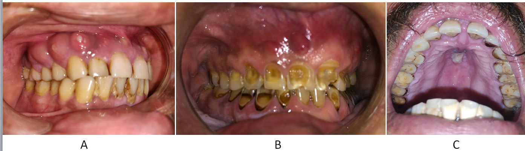
Figure 1 Clinical picture of oral mucormycosis. A: Multiple lesion on gingiva (Case 1); B: Erythema and multiple pus discharging sinuses on gingiva (Case 2); C: Discoloration of hard palate (Case 4).
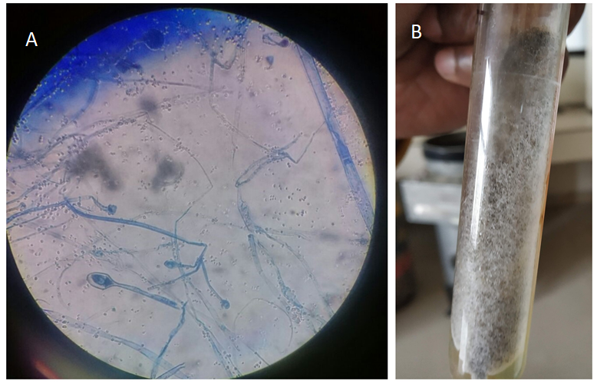
Figure 2 Staining and culture characteristics of mucormycosis. A: Broad ribbon like aseptate hyphae seen on lactophenol cotton blue staining; B: Whitish grey cottony growth on Sabouraud’s dextrose agar.
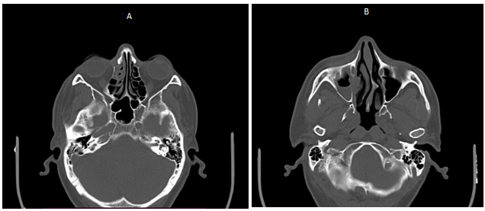
Figure 3 Noncontrast computed tomography of paranasal sinuses. A: Axial section showing mucosal thickening and bone remodeling involving ethmoidal sinus on right side; B: Axial section showing mucosal thickening on right maxillary sinus with remodeling of medial wall.
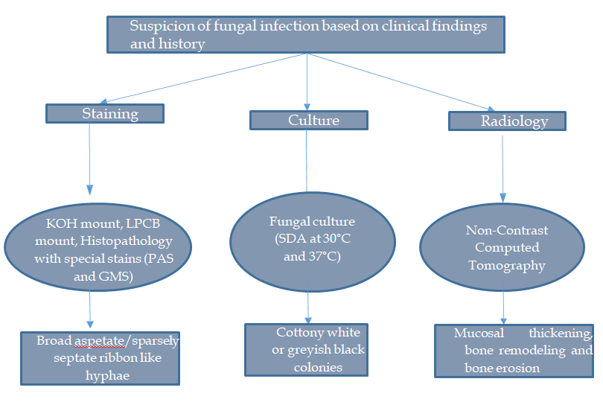
Figure 4 Flow chart for diagnosis of mucormycosis^{[21,23]}.KOH: Potassium hydroxide; LPCB: Lactophenol cotton blue; PAS: Periodic acid–Schiff; GMS: Grocott-Gomori's methenamine silver; SDA: Sabouraud dextrose agar.
Table 1 summary of cases of mucormycosis associated with coronavirus disease 2019
Ref. | Country | Age (yr)/sex | Site | Comorbidities | Outcome
Mehta et al^{[11]} | India | 60/Male | Rhino-orbito-cerebralmucormycosis | Uncontrolled diabetes | Death
Werthman et al^{[12]} | United States | 33/Female | Rhino-orbito-cerebralmucormycosis | Diabetes, asthma,  hypertension | Death
Hanley et al^{[13]} | United Kingdom | 22/Male | Disseminated (involving the hilarlymph nodes, heart, brain, andkidney)/NA | Pancreatitis | Death
Placik et al^{[14]} | Arizona | 49/ Male | Pulmonarymucormycosis | None | Death
Monte et al^{[15]} | Brazil | 86/Male | Gastrointestinalmucormycosis | Hypertension | Death
Mekonnen et al^{[16]} | United States | 60/Male | Rhino-orbitalmucormycosis | Diabetes, asthma,  hypertension,  hyperlipidaemia | Death
Pasero et al^{[17]} | Italy | 66/Male | Sinopulmonary mucormycosis | Lymphopenia, Hypertension | Death
This case | India | 4 males, 49 ± 10 (39–57) | Oral mucormycosis | Diabetes mellitus | 3 alive, one lost to follow up

Published by Baishideng Publishing Group Inc
7041 Koll Center Parkway, Suite 160, Pleasanton, CA 94566, USA
Telephone: +1-925-3991568
E-mail: bpgoffice@wjgnet.com
Help Desk: https://www.f6publishing.com/helpdesk
https://www.wjgnet.com

© 2021 Baishideng Publishing Group Inc. All rights reserved.

