Name of Journal: World Journal of Gastroenterology
Manuscript NO: 74989
Manuscript Type: ORIGINAL ARTICLE

Basic Study
Intracellular alpha-fetoprotein mitigates hepatocyte apoptosis and necroptosis by inhibiting endoplasmic reticulum stress

Chen YF et al. Intracellular AFP mitigates hepatocyte injury

Yun-Fen Chen, Si-Ying Liu, Qi-Jiao Cheng, Yu-Jiao Wang, Shuang Chen, Yi-Yang Zhou, Xia Liu, Zhi-Gang Jiang, Wei-Wei Zhong, Yi-Huai He

Yun-Fen Chen, Si-Ying Liu, Qi-Jiao Cheng, Shuang Chen, Yi-Yang Zhou, Xia Liu, Yi-Huai He, Department of Infectious Diseases, The Affiliated Hospital of Zunyi Medical University, Zunyi 563000, Guizhou Province, China

Yu-Jiao Wang, Department of General Medicine, The Affiliated Hospital of Zunyi Medical University, Zunyi 563000, Guizhou Province, China

Zhi-Gang Jiang, School of Public Health, Zunyi Medical University, Zunyi 563099, Guizhou Province, China

Wei-Wei Zhong, Department of Endoscopy, Jingmen No.1 People’s Hospital, Jingmen 448000, Hubei Province, China

Author contributions: Chen YF, Liu SY, and Cheng QJ contributed equally to this work; Chen YF, Liu SY, Cheng QJ, and He YH conceived and designed research; Chen YF, Liu SY, Wang YJ, Chen S, Zhou YY, and Liu X collected data and conducted research; Jiang ZG, Chen YF, and Zhong WW analyzed and interpreted data; Chen YF, Liu SY, and Cheng QJ wrote the initial paper; He YH and Zhong WW revised the paper; He YH had primary responsibility for final content; all authors read and approved the final manuscript.

Supported by the National Natural Science Foundation of China, No. 81560110; Tian Qing Liver Disease Research Fund Project of the Chinese Foundation for Hepatitis Prevention and Control, No. TQGB20200001; and the Science and Technology Planning Projects of Guizhou Province and Zunyi City, No. QKH·ZC^{[2019]} 2803, No. QKHJC-ZK^{[2022]}YB642, No. QKH·PTRC^{[2017]}5733-013, No. gzwjkj2020-1-041, No. ZSKHSZ^{[2020]}230, and No. ZMC·YZ^{[2018]}38.

Corresponding author: Yi-Huai He, MM, Director, Department of Infectious Diseases, The Affiliated Hospital of Zunyi Medical University, No. 201 Dalian Street, Zunyi 563000, Guizhou Province, China. 993565989@qq.com

Received: January 13, 2022
Revised: March 22, 2022
Accepted: May 13, 2022
Published online: July 14, 2022

Abstract
BACKGROUND
Endoplasmic reticulum (ER) stress contributes to the pathogenesis of chronic liver diseases, but how hepatocytes respond to ER stress has not been clarified. Alpha-fetoprotein (AFP) is secreted by hepatoma cells and elevated levels of serum AFP are associated with development of liver malignancies.

AIM
To investigate whether and how AFP could regulate ER stress and hepatocyte injury.

METHODS
The distribution of AFP and the degrees of ER stress in liver tissues and liver injury were characterized by histology, immunohistochemistry, and Western blot in biopsied human liver specimens, two mouse models of liver injury and a cellular model. The levels of AFP in sera and the supernatants of cultured cells were quantified by chemiluminescence.

RESULTS
High levels of intracellular AFP were detected in liver tissues, particularly in the necrotic areas, from patients with chronic liver diseases and mice after carbon tetrachloride (CCl₄) administration or induction of ER stress, but not from the controls. The induced intracellular AFP was accompanied by elevated activating transcription factor-6 (ATF6) expression and protein kinase R-like ER kinase (PERK) phosphorylation in mouse livers. ER stress induced AFP expression in LO2 cells and decreased their viability. ATF6, but not PERK, silencing mitigated the ER-stress-induced AFP expression in LO2 cells. Conversely, AFP silencing deteriorated the ER stress-mediated LO2 cell injury and CCl₄ administration-induced liver damages by increasing levels of cleaved caspase-3, the C/enhancer binding protein homologous protein expression, mixed lineage kinase domain-like pseudokinase and PERK phosphorylation, but decreasing ATF6 expression.

CONCLUSION
ER stress upregulated intra-hepatocyte AFP expression by activating ATF6 during the process of liver injury and intracellular AFP attenuated hepatocyte apoptosis and necroptosis by alleviating ER stress.

Key Words: Alpha-fetoprotein; Endoplasmic reticulum stress; Necroptosis; Apoptosis; Liver injury

©The Author(s) 2022. Published by Baishideng Publishing Group Inc. All rights reserved.

Citation: Chen YF, Liu SY, Cheng QJ, Wang YJ, Chen S, Zhou YY, Liu X, Jiang ZG, Zhong WW, He YH. Intracellular alpha-fetoprotein mitigates hepatocyte apoptosis and necroptosis by inhibiting endoplasmic reticulum stress. World J Gastroenterol 2022; 28(26): 3201-3217
URL: https://www.wjgnet.com/1007-9327/full/v28/i26/3201.htm
DOI: https://dx.doi.org/10.3748/wjg.v28.i26.3201

Core Tip: During the process of liver injury, alpha-fetoprotein (AFP) expression was up-regulated in hepatocytes, especially in the necrotic areas, but it did not increase the serum AFP level. Endoplasmic reticulum (ER) stress induced intracellular AFP expression through activating activating transcription factor-6 and the up-regulated intracellular AFP expression attenuated hepatocyte apoptosis and necroptosis by feedback-down-regulating ER stress.

INTRODUCTION
Chronic liver diseases, such as chronic hepatitis B (CHB), affect many patients, especially in East Asia, such as China. However, the pathogenesis of chronic liver diseases remains unclear. Although human liver has powerful capacity to compensate the disease-related liver injury, how hepatocytes respond and defense against these diseases has not been clarified. Hence, it is of great significance to clarify it for the management of patients with chronic liver diseases.
Alpha-fetoprotein (AFP) is a protein with similar biological function to albumin and secreted mainly by embryonic tissue cells physiologically and malignant hepatocytes pathologically after birth. Elevated levels of serum AFP have been considered as a reliable biomarker for prediction of birth defect and diagnosis of liver cancer, teratoma, renal cell carcinoma, and pancreatic cancer^{[1]} although moderate serum AFP levels can be temporarily detected in individuals with aberrant liver regeneration, hepatitis, and chronic liver disease. Furthermore, low levels of serum AFP have been continually observed in patients with liver cirrhosis and positively correlated with the degrees of liver inflammation and fibrosis^{[2,3]}. The low and moderate levels of serum AFP are likely from the activation and proliferation of liver precursor cells, including oval cells, hepatic progenitor cells, in response to severe liver damages, particularly in liver failure^{[4-6]}. While hepatocyte proliferation usually compensates for mild and moderate liver injury, liver precursor cells can differentiate into hepatocytes and bile duct cells, promoting liver regeneration. The activated liver precursor cells can secrete AFP and high levels of serum AFP have been suggested to be a biomarker of better prognosis of liver failure^{[7,8]}. However, it is unclear whether chronic liver injury can induce AFP expression and secretion in differentiated mature hepatocytes, and how the induced AFP modulates the pathogenic process of chronic liver diseases.
It is notable that endoplasmic reticulum (ER) stress contributes to the pathogenesis of chronic liver diseases^{[9,10]} and is regulated by inositol requiring enzyme-1 and activating transcription factor-6 (ATF6) and protein kinase R-like ER kinase (PERK)/eukaryotic translational initiation factor 2 alpha (eIF2α) signaling^{[11,12]}. Aberrant ER stress can activate cell injury reactions, such as apoptosis and necroptosis by activating the C/enhancer binding protein (EBP)-homologous protein (CHOP) pathway, caspase-3 cleavage and mixed lineage kinase domain-like pseudokinase (MLKL) phosphorylation^{[13,14]}. Our previous study has shown that ER stress inhibits the AFP secretion in hepatoma cells and the increase in the levels of intracellular AFP feedback attenuates the ER stress-related apoptosis and necroptosis in hepatoma cells^{[15]}. However, it is unknown how ER stress can regulate AFP expression and secretion, and how intracellular AFP can modulate the ER stress-induced liver injury during the pathogenic process of chronic liver diseases.
In this research, we focus on whether intracellular AFP exists in hepatocytes during the liver injury, its regulatory relationship with ER stress, and its role in hepatocyte injury through clinical research, in vivo and in vitro experiments.

MATERIALS AND METHODS
Clinical samples
A total of 34 biopsied liver specimens were collected from CHB patients, eight surgical liver specimens were obtained from patients with hepatic trauma, and another eight surgical liver specimens were obtained from patients with hepatocellular carcinoma (HCC) in the Department of Infectious Diseases, or Hepatobiliary Surgery, the Affiliated Hospital of Zunyi Medical University since 2012. The patients with CHB were diagnosed, according to the Guidelines for Prevention and Treatment of Chronic Hepatitis B revised in 2019^{[16]}. Individual patients were excluded if she/he had current infectious disease, autoimmune liver disease, liver malignant tumor, alcoholic liver disease, drug-induced liver disease, multiple organ dysfunction syndrome, obvious bleeding tendency, deep jaundice, obvious ascites, or another situation not suitable for liver biopsy. Their demographic and clinical data are shown in Table 1. The experimental protocol was approved by the Ethics Committee of Affiliated Hospital of Zunyi Medical University (ZYFYLS^{[2018]} 28).

Establishment of liver injury in mice
Male BALB/c mice (25.0 g ± 3.0 g) were purchased from the Animal Center of Zunyi Medical University (Guizhou Province, China; SYXK[Qin] 2021-0004). The mice were maintained in a specific pathogen-free facility with a controlled temperature (20 °C-24 °C), a 12-h light/dark cycle and allowed free access to food and water ad libitum. The experimental protocol was established, according to the Animal Care and Research guidelines^{[17]} and approved by the Animal Experiment Ethics Committee of Zunyi Medical University (LS^{[2020]} 2-231).
To induce liver injury by carbon tetrachloride (CCl₄) administration, the mice were randomized using a random number table into the healthy control group (NC; untreated), solvent control group (olive oil, 5 mL/kg, intraperitoneally, i.p.) and CCl₄ group (1 mL/kg mixed with 4 mL of olive oil, i.p.) (n = 12 per group). The mice in the solvent and CCl₄ group were administrated with solvent or CCl₄ once or twice per week for 8 wk. Their peripheral blood samples were collected 24 h after the last dose, euthanized and their liver tissues were dissected.
To induce ER stress-related liver injury, the mice were randomized into the healthy NC (untreated), solvent control (phosphate buffer saline, PBS, 10 mL/kg) and tunicamycin (TM; an inhibitor of protein glycosylation) groups (2 mg/kg in the same volume of PBS, i.p.; Sigma) once (n = 12 per time point group). One or two days later, their peripheral blood samples were collected, euthanized and their liver tissues were dissected.
To test the role of AFP in the CCl₄-induced liver injury, the mice were randomized and treated intravenously with 1×10¹⁰ recombinant serotype 8 adeno-associated virus (rAAV8) for expression of control short hairpin RNA (shRNA) or Afp-specific shRNA (Table 2, Genechem, Beijing, China). Six weeks after infection, the levels of AFP expression in the livers of mice were analyzed by Western blot to confirm Afp silencing. The mice with control shRNA or Afp-specific shRNA were administrated with olive oil or CCl₄ as the control shRNA + olive oil, CCl₄ (control shRNA + CCl₄), Afp shRNA + olive oil, or Afp shRNA + CCl₄ (Afp shRNA + CCl₄). Their peripheral blood samples were collected, euthanized and their livers were dissected at 36 h (n = 12 per group) post CCl₄ administration, based on our preliminary studies.

Cell lines and culture
Human hepatocyte LO2 and hepatoma HepG2 cell lines were obtained from the Type Culture Collection of the Chinese Academy of Sciences (Shanghai, China) and identified by STR. The cells were cultured in RPMI-1640 containing 10% fetal bovine serum, 100 Units/mL of penicillin and 100 μg/mL of streptomycin at 37 °C in a 5% CO₂ incubator. To induce ER stress, LO2 cells were treated with, or without (NC group), solvent control group (dimethyl sulfoxide, DMSO) and 0.5 μmol/L thapsigargin (TG; an inhibitor of intracellular calcium balance) in DMSO (Sigma, TG group) for 12 h, 24 h and 48 h, respectively.
In addition, LO2 cells (1.2 × 10⁶ cell/well) were cultured in 6-well plates overnight and transfected with plasmids for control shRNA, PERK-specific shRNA and ATF6-specific shRNA (Beijing Genechem) using lipofectamine 3000 (Fisher). Two days later, the cells were treated with vehicle DMSO or TG for 24 h. Additionally, LO2 cells were transfected with plasmid for the expression of control shRNA or AFP-specific shRNA (Beijing Genechem) for 48 h and treated with DMSO or TG for 36 h, respectively.

Western blot analysis
LO2, HepG2 cells, or individual liver samples were homogenized in immunoprecipitation assay lysis buffer (R0010, Solarbio, Beijing, China). After centrifugation, individual liver lysates (40 μg) were separated in sodium dodecyl sulfate polyacrylamide gel on 10% gels and transferred to polyvinylidene fluoride membranes (Millipore, Billerica, MA, United States). The membranes were blocked with 5% skim dry milk in TBST (Tris-HCl buffer salt solution + Tween 20) and probed with mouse monoclonal antibodies (mAb) against AFP (sc-130302; Santa Cruz Biotechnology, Santa Cruz, CA, United States), ATF6 (sc-166659, 1:1000, Santa Cruz Biotechnology), GAPDH (sc-166545, 1:10000, Santa Cruz Biotechnology), CHOP (GADD153, sc-71136, 1:10000, Santa Cruz Biotechnology), eIF2α (sc-133132, 1:10000, Santa Cruz Biotechnology), phosphorylated PERK (p-PERK, MA5-15033, 1:1000, Thermofisher Scientific, United States), and PERK (sc-377400, 1:10000, Santa Cruz Biotechnology), or rabbit monoclonal antibodies against cleaved caspase-3 (9664, 1:10000, Cell Signaling Technology), and phosphorylated eIF2α (p-eIF2α, 3398, 1:10000, Cell Signaling Technology), or rabbit polyclonal antibodies against phosphorylated MLKL (p-MLKL, PA5-105677, 1:2000, Thermofisher Scientific), and MLKL (PA5-34733, 1:3000, Thermofisher Scientific). After reaction with horseradish peroxidase (HRP)-conjugated anti-mouse or anti-rabbit IgG, the immunocomplexes were visualized with enhanced chemiluminescent reagents. Quantity One software (Bio-Rad, Hercules, CA, United States) was used to determine the relative levels of each targeted protein to the control (standardized as 1)^{[18]}.

Pathological analysis of liver tissue
Fresh liver tissues (5 mm × 5 mm in size from each mouse or 1 mm × 30 mm in size from one patient) were fixed in 4% paraformaldehyde for ≥ 24 h, paraffin-embedded and cut. The liver tissue sections (5 μm) were dewaxed, rehydrated and routine-stained with hematoxylin and eosin (H&E). The sections were examined under a light microscope (OLYMPUS CX31) using CaseViewer 2.4 software (3DHISTECH, Hungary). The necrotic areas in the liver were analyzed by Image-Pro Plus 6.0 (Media Cybernetics, United States)^{[19]}. The Histology Activity Index-Knodell scores were determined by two pathologists blindly^{[20]}.

Immunohistochemistry
The liver tissue sections were dewaxed, rehydrated and blocked with 3% of bovine serum albumin for 20 min. The sections were incubated with mAb against AFP (sc-130302, 1:250) at 4 °C overnight and the bound antibodies were detected with HRP-conjugated anti-mouse IgG, followed by visualizing with diaminobenzidine. The intensity of anti-AFP staining was evaluated by Image Pro Plus 6.0^{[19]}.

TUNEL assay
The effect of Afp silencing on the frequency of apoptotic hepatocytes in liver sections was determined by terminal deoxynucleotidyl transferase (TdT)-mediated deoxyribonucleotide derivative digoxigenin (dUTP) nick end labeling (TUNEL) using a specific kit (Roche, 11684817910), according to the manufacturer’s instruction. Briefly, the paraffin-embedded liver sections were dehydrated, permeabilized, and incubated with a mixture of TdT and dUTP at 1:14 in a humidified chamber for 2 h at 37 °C. The labeled cells were detected with detection solution and after being washed, the sections were counterstained with 4′, 6-diamidino-2-phenylindole. The TUNEL signals were examined under a fluorescent microscope. The apoptotic cells were defined by nuclear green staining while non-apoptotic cells with blue nuclear staining. Five visual fields in each section were randomly selected and the percentages of apoptotic cells in each section were calculated using the formula of positive cells/total cells × 100%.

Analysis of AFP levels
AFP levels in the supernatant of cultured cells and mouse serum samples were measured by chemiluminescence immunoassay on the Beckman Coulter Auto Analyzer (Model DX1800; 04481798190, Roche Diagnostics GmbH) as previously described^{[21]}. Samples were centrifuged to remove the remaining cells and possible cell debris before testing the AFP concentration.

Alanine aminotransferase and total bilirubin levels
The levels of serum alanine aminotransferase (ALT), total bilirubin (TBil) were two commonly used measures of liver injury, and analyzed by an auto-analyzer (AU5800, Beckman Coulter, United States)^{[22]}.

Cell viability assay
The impact of specific gene silencing or ER stress on LO2 cell viability was determined using the cell counting kit-8 (CCK-8; Cat. No. 40203ES60; Yeasen Biotechnology, Shanghai, China), per the product instruction. Briefly, LO2 cells (5000 cells/100 μL medium/well in 96-well plates) were treated with, or without, TG for 48 h (5 replicates per sample). During the last one-hour culture, the cells were exposed to CCK-8 and the absorbance of individual wells was detected at a wavelength of 450 nm (Bio-Rad, CA, United States). The relative cell viability (%) = (OD value of the treatment group-OD value of the blank group)/(OD value of the control group-OD value of the blank group) × 100.

Statistical analysis
Data are representative images or expressed as the mean ± SD of each group from 3 separate experiments. The difference of normally distributed values among groups was analyzed by one-way ANOVA and post hoc Tukey’s method. The difference between groups was analyzed by Student’s t-test. Survival rates were estimated using the Kaplan-Meier method and analyzed by the log-rank test. A P-value less than 0.05 was considered statistically significant.

RESULTS
AFP expression is induced in the liver of patients with chronic liver injury
To explore the potential role of AFP in the progression of chronic hepatocyte injury, we analyzed AFP expression in liver tissues of patients with CHB (n = 34), controls (liver trauma; n = 8), and those with HCC (positive controls, n = 8). While there were healthy hepatocytes without degeneration and necrosis in the control liver tissues there were many hepatocytes undergoing degeneration and necrosis (Figure 1A). Immunohistochemistry indicated positive anti-AFP staining in the liver tissues from patients with HCC or CHB, but little in the controls. Interestingly, the positively stained anti-AFP was particularly in the regions with hepatocyte degeneration and necrosis of the liver tissues from CHB patients. Further Western blot displayed significantly increased levels of AFP expression in the livers from HCC or CHB patients, relative to that in the controls (P < 0.01, Figure 1B). Such data indicated that AFP expression was induced in hepatocytes, associated with hepatocyte degeneration and necrosis in humans during the process of hepatocyte injury.

Induction of liver injury enhances AFP expression and ER stress in the liver of mice following CCl₄ administration
Next, we tested whether AFP expression could be induced in the liver of mouse model of CCl₄-induced hepatocyte injury. As expected, CCl₄ administration significantly elevated serum ALT (P < 0.05; Figure 2A), TBil (P < 0.05; Figure 2B) levels, accompanied by increased areas of liver tissue necrosis in mice, relative to the NC and the control groups (olive oil) of mice (P < 0.05; Figure 2C), particularly in the livers of mice following administration with CCl₄ for 8 wk. There were similarly low levels of serum AFP detected in the different groups of mice (about 0.61 ng/mL, Figure 2D). In contrast, Western blot revealed that CCl₄ administration obviously up-regulated AFP expression in the livers of mice in a trend of time-dependence (P < 0.05; Figure 2E). Further immunohistochemistry exhibited that the up-regulated AFP expression was mainly accumulated in the injured liver areas (Figure 2F). Finally, CCl₄ administration significantly enhanced the relative levels of PERK phosphorylation and ATF6 expression (P < 0.05; Figure 2G), the hallmarks of enhancing ER stress in the livers of mice. Collectively, CCl₄ administration induced hepatocyte injury and ER stress, and up-regulated AFP expression, but not its secretion in mice.

ER stress up-regulates AFP expression in hepatocytes
Given that up-regulated AFP expression was associated with enhanced ER stress, we tested whether induction of ER stress could up-regulate AFP expression in TM-injected mice. Compared with the NC and vehicle controls, significantly elevated levels of serum ALT (P < 0.05; Figure 3A) and TBil (P < 0.05; Figure 3B) were detected in mice at 24 h and 48 h post TM injection, implicating that induction of ER stress induced liver damages in mice. Consistently, Western blot revealed that TM injection obviously up-regulated ATF6, and AFP expression and PERK phosphorylation in the livers of mice, relative to that of the controls (P < 0.05; Figure 3C). Interestingly, there were damaged liver areas with strong anti-AFP staining in the mice with TM injection (Figure 3D). However, there were similar levels of serum AFP in the different groups of mice (< 0.61 ng/mL, Figure 3E). Furthermore, while there was no detectable AFP in the supernatants of cultured human non-tumor hepatocyte LO2 cells, even after treatment with TG, the levels of AFP in the supernatants of cultured HepG2 cells increased in a time-dependent manner (Figure 3F). Moreover, TG treatment significantly decreased the viability of LO2 cells at 24 h and 48 h post treatment (P < 0.05, Figure 3G), but TG treatment significantly enhanced the relative levels of AFP and ATF6 expression and PERK phosphorylation in LO2 cells (P < 0.05, Figure 3H). Thus, induction of ER stress induced hepatocyte injury and AFP expression.

ATF6 silencing mitigates the TG-induced AFP expression in LO2 cells
To understand how ER stress promoted AFP expression, we transfected LO2 cells with PERK or ATF6-specific shRNA. We found that PERK silencing significantly reduced the viability of LO2 cells (P < 0.05), and deteriorated the TG-induced damages in LO2 cells (P < 0.01; Figure 4A). While PERK silencing significantly reduced the levels of PERK protein expression in both regular cultures and TG-treated LO2 cells, and mitigated the relative levels of TG-enhanced eIF2α phosphorylation in LO2 cells, PERK silencing failed to significantly alter AFP protein expression in LO2 cells regardless of TG treatment (Figure 4B). In contrast, ATF6 silencing significantly reduced the viability of LO2 cells, but enhanced the TG-induced damages in LO2 cells (P < 0.01; Figure 4C). Moreover, transfection with ATF6 shRNA not only significantly inhibited ATF6 expression, but also attenuated the relative levels of AFP expression in both regular cultures and TG-treated LO2 cells (P < 0.01; Figure 4D). Hence, ATF6 silencing mitigated the TG-induced AFP expression in LO2 cells.

AFP silencing increases the TG-induced hepatocyte apoptosis and necroptosis in LO2 cells
To understand the importance of AFP in ER stress-induced hepatocyte injury, we further explored the impact of AFP silencing on the ER stress-induced hepatocyte injury in vitro. Compared with the control LO2 cells, transfection with AFP-specific shRNA, but not the control shRNA, dramatically reduced AFP expression in LO2 cells (P < 0.01; Figure 5A), and deteriorated the TG-induced damages (P < 0.01), but it did not significantly alter the viability of LO2 cells (P > 0.05, Figure 5B). Furthermore, the AFP silencing significantly increased the levels of cleaved caspase-3 and MLKL phosphorylation regardless of TG treatment (P < 0.05, Figure 5C). Consistently, AFP silencing also significantly increased CHOP expression and PERK phosphorylation, but decreased ATF6 expression in LO2 cells (P < 0.01, Figure 5D). These results clearly indicated that AFP silencing enhanced spontaneous and TG-induced ER stress, apoptosis and necroptosis in LO2 cells.

AFP silencing deteriorates the CCl₄-induced liver injury in mice
Finally, we tested whether induction of Afp silencing could modulate the CCl₄-induced liver injury in mice. After intravenous administration with rAAV8 virus for the expression of control or Afp-specific shRNA for 6 wk, the levels of AFP expression in the liver tissues were reduced dramatically, confirming the Afp silencing (P < 0.01, Figure 6A). Both groups of mice were administrated with vehicle olive oil or CCl₄ and 36 h later, we found that Afp silencing increased serum ALT (P < 0.01, Figure 6B), and TBil levels (P < 0.01, Figure 6C), regardless of CCl₄ administration. Compared with the control mice, Afp silencing increased the percentages of necrotic areas in the livers of mice (P < 0.01, Figure 6D). Furthermore, Afp silencing decreased AFP expression, but remarkably increased the relative levels of cleaved caspase-3 expression, MLKL phosphorylation (P < 0.01, Figure 6E) and the percentages of apoptotic hepatocytes in the livers of both vehicle and CCl₄-treated mice (P < 0.01, Figure 6F). Finally, Afp silencing significantly increased CHOP expression and PERK phosphorylation, but decreased ATF6 expression in the livers of CCl₄-treated mice (P < 0.01; Figure 6G). Therefore, Afp silencing enhanced ER stress and liver injury induced by CCl₄ in mice.

DISCUSSION
In this study, we investigated AFP expression, its regulatory mechanism, and its effect on hepatocyte injury during the process of liver injury. We detected high levels of AFP expression in the livers, particularly in the areas of hepatocyte necrosis, of patients with CHB, but not in those with hepatic trauma. Similarly, high levels of AFP expression were observed in the livers of mice following CCl₄ administration and ER stress induction. The induced AFP expression was accompanied by liver injury in those patients and mice. Interestingly, there was no significant difference in the levels of serum AFP in those experimental patients and mice, compared to the controls. Moreover, induction of ER stress in human non-tumor hepatocyte LO2 cells also induced AFP expression, hepatocyte apoptosis and necroptosis, but failed to detect AFP in the supernatants of cultured cells. These indicated that during chronic liver diseases, ER stress and other inducers triggered hepatocyte apoptosis and necroptosis and stimulated AFP expression, but limited its secretion, leading to increased levels of intracellular AFP in hepatocytes. These novel data extended our previous study on hepatoma cells^{[15]}, and support the notion that AFP can be induced during the process of chronic liver diseases^{[7,23]}. Our findings may shed light on the liver responses to ER stress in the pathogenic process of chronic liver diseases.
Low levels of serum AFP are detected in patients with chronic liver disease, and are positively correlated with the degrees of liver damages^{[8,24]}. Although high levels of AFP expression were detected in mouse livers, we did not detect abnormally high levels of serum AFP in liver-injured mice, consistent with our observation in hepatoma cells^{[15]}. These indicated that ER stress induced intracellular AFP expression by limiting its secretion. Given that healthy hepatocytes do not express AFP in adults it is possible that ER stress-induced hepatocyte injury may also induce compensative hepatocyte proliferation to repair liver damages in these models. However, the induced intracellular AFP is unlikely from the proliferation and differentiation of liver precursor cells. We are interested in further investigating how ER stress limits the secretion of AFP in hepatocytes during the process of chronic liver diseases.
AFP expression is regulated in a manner of tissue-specific and time-restriction^{[25]}. Previous studies have shown that AFP expression is regulated by transcription factors, such as hepatocyte nuclear factor-1 (HNF1), ACCAAT-enhancer binding protein (C/EBP) and NF-1 and their enhancers^{[26-28]}. Furthermore, the mutation in the AFP promoter region can increase the binding affinity of HNF1, leading to sustained increase in the levels of AFP expression^{[29]}. Moreover, the AFP promoter activity is also regulated by the competitive modulation of these transcription factors, activators and inhibitors^{[30]}. In this study, we explored how ER stress induced AFP expression in hepatocytes. ER stress mainly enhances eIF2α activation and regulates the expression of target molecules through ATF4, ATF6, and XBP1 to enhance cell ability to eliminate and degrade misfolded proteins^{[11]}. We found that ATF6, but not PERK, silencing significantly mitigated the ER stress-induced AFP expression in LO2 cells. These data suggest that ATF6 may promote AFP expression in hepatocytes under an ER stress condition.
Functionally, AFP can act as a carrier to maintain plasma colloidal osmotic pressure and transport bilirubin, estrogen, fatty acids, retinoids, steroids and progesterone to regulate hormone homeostasis^{[31]}. Second, AFP can induce immune cell apoptosis and down-regulates the gene expression of a variety of inflammatory factors, inhibiting autoimmunity and aberrant inflammation by protecting the fetus from maternal immune attack and attenuating the immune clearance of tumors^{[32,33]}. Furthermore, AFP can enhance the malignant behavior of hepatoma cells by inhibiting their apoptosis and autophagy^{[34,35]}. Accordingly, AFP can promote the survival and growth of a variety of tumor and non-tumor cells^{[36,37]}. AFP can reduce the tumor necrosis factor alpha (TNF-α)-mediated damages of liver cancer cells or hepatocytes, and promotes their proliferation^{[38,39]}. Studies have found that AFP can enhance the expression of p53, c-fos, c-jun, N-ras and hepatocyte growth factor receptor by binding to its receptors to activate the cyclic adenosine 3’, 5’-monophosphate (cAMP)-protein kinase A (PKA) pathway and induce Ca²⁺ influx. This process increases intracellular cAMP and PKA, and promotes the proliferation, differentiation and regeneration of hepatocytes. In this study, Afp silencing deteriorated the ER stress-mediated apoptosis and necroptosis of LO2 cells in vitro. Preferable liver Afp silencing also aggravated the CCl₄-induced liver damages, hepatocyte apoptosis, and necroptosis in mice. The results suggest that the induced AFP expression in the liver by ER stress may enhance the resistance of hepatocytes to apoptosis and necroptosis stimulators, alleviating liver injury. Interestingly, we found that AFP silencing also exacerbated the ER stress, but lowed ATF6 expression in LO2 cells and in hepatocytes of liver tissues in mice, consistent with our previous observation^{[15]}. These findings suggest that intracellular AFP induced by the ATF6 signaling may feedback-attenuate the ER stress-induced hepatocyte apoptosis and necroptosis, partially by up-regulating ATF6 expression. Given that AFP is not a transcription factor for the ATF6 expression the ER stress-induced AFP expression may through signal-crosstalk induce the ATF6-specific transcription factor and activator expression, indirectly inducing ATF6 expression in hepatocytes in a condition of ER stress.
We have reported that ATF6 is important for hepatocyte apoptosis and programmed necrosis^{[40]}. It is possible that intracellular AFP may interact with intracellular proteins, transcription factors, kinases, co-activators and cell cycle regulators, such as PTEN to activate the PI3K/AKT/mTOR signaling to support the hepatocyte survival^{[41]}. In addition, intracellular AFP may also interact with the apoptosis-related signaling to enhance apoptosis resistance by up-regulating Bcl-2 expression^{[35]}. However, how intracellular AFP mitigates the ER stress-induced hepatocyte injury remains to be further examined.

CONCLUSION
ER stress induced intracellular AFP expression through activating ATF6 and the induced intracellular AFP feedback-attenuated the ER stress-induced hepatocyte injury. Thus, our findings may shed lights on the molecular regulation by which hepatocytes respond to ER stress, promoting compensative liver repair following ER stress-induced liver injury.

ARTICLE HIGHLIGHTS
Research background
Endoplasmic reticulum (ER) stress plays an important role in the pathogenesis of chronic liver diseases, but how hepatocytes respond to ER stress has not been clarified. Alpha-fetoprotein (AFP) is secreted by hepatoma cells and elevated levels of serum AFP are associated with development of liver malignancies.

Research motivation
Anti-injury response is an important force for hepatocytes to resist liver injury mediated by various reasons, which has a close relationship to the progress and prognosis of liver injury. Studying the anti-injury mechanism of hepatocytes is important for the diagnosis and treatment of liver injury in the clinic.

Research objectives
To investigate whether and how AFP could regulate ER stress and hepatocyte injury.

Research methods
The distribution of AFP and the degrees of ER stress in liver tissues were characterized by histology, immunohistochemistry, and Western blot in biopsied human liver specimens, two mouse models of liver injury and a cellular model. The levels of AFP in sera and the supernatants of cultured cells were quantified by chemiluminescence.

Research results
ER stress induces liver injury and increases intracellular AFP expression in hepatocytes. ER stress up-regulates intracellular AFP expression by up-regulating activating transcription factor-6 (ATF6). Upregulated AFP feedback attenuates ER stress, forming a regulatory loop. Upregulated AFP mitigates the ER stress-induced hepatocyte apoptosis and necroptosis.

Research conclusions
ER stress upregulated intracellular AFP expression in hepatocytes by up-regulating ATF6 during the process of liver injury and intracellular AFP feedback-attenuated hepatocyte apoptosis and necroptosis by alleviating ER stress.

Research perspectives
Intracellular AFP induced by ER stress alleviates hepatocyte apoptosis and necroptosis by activating ATF6.

REFERENCES
1 Galle PR, Foerster F, Kudo M, Chan SL, Llovet JM, Qin S, Schelman WR, Chintharlapalli S, Abada PB, Sherman M, Zhu AX. Biology and significance of alpha-fetoprotein in hepatocellular carcinoma. Liver Int 2019; 39: 2214-2229 [PMID: 31436873 DOI: 10.1111/liv.14223]
2 Fouad R, Elsharkawy A, Abdel Alem S, El Kassas M, Alboraie M, Sweedy A, Afify S, Abdellatif Z, Khairy M, Esmat G. Clinical impact of serum α-fetoprotein and its relation on changes in liver fibrosis in hepatitis C virus patients receiving direct-acting antivirals. Eur J Gastroenterol Hepatol 2019; 31: 1129-1134 [PMID: 30896550 DOI: 10.1097/MEG.0000000000001400]
3 Tai WC, Hu TH, Wang JH, Hung CH, Lu SN, Changchien CS, Lee CM. Clinical implications of alpha-fetoprotein in chronic hepatitis C. J Formos Med Assoc 2009; 108: 210-218 [PMID: 19293036 DOI: 10.1016/S0929-6646(09)60054-1]
4 Fausto N, Campbell JS. The role of hepatocytes and oval cells in liver regeneration and repopulation. Mech Dev 2003; 120: 117-130 [PMID: 12490302 DOI: 10.1016/s0925-4773(02)00338-6]
5 Vessey CJ, de la Hall PM. Hepatic stem cells: a review. Pathology 2001; 33: 130-141 [PMID: 11358043]
6 Kuhlmann WD, Peschke P. Hepatic progenitor cells, stem cells, and AFP expression in models of liver injury. Int J Exp Pathol 2006; 87: 343-359 [PMID: 16965562 DOI: 10.1111/j.1365-2613.2006.00485.x]
7 Wang X, Shen C, Yang J, Yang X, Qin S, Zeng H, Wu X, Tang S, Zeng W. Alpha-Fetoprotein as a Predictive Marker for Patients with Hepatitis B-Related Acute-on-Chronic Liver Failure. Can J Gastroenterol Hepatol 2018; 2018: 1232785 [PMID: 29854714 DOI: 10.1155/2018/1232785]
8 Huang GQ, Xie YY, Zhu PW, Wang XD, Lin Z, Wang Y, Ye JP, Wang YM, Chen YX, Jin XZ, Van Poucke S, Chen YP, Zheng MH. Stratified alpha-fetoprotein pattern accurately predicts mortality in patients with acute-on-chronic hepatitis B liver failure. Expert Rev Gastroenterol Hepatol 2018; 12: 295-302 [PMID: 29300103 DOI: 10.1080/17474124.2018.1424540]
9 Malhi H, Kaufman RJ. Endoplasmic reticulum stress in liver disease. J Hepatol 2011; 54: 795-809 [PMID: 21145844 DOI: 10.1016/j.jhep.2010.11.005]
10 Zhong W, Wang X, Rao Z, Pan X, Sun Y, Jiang T, Wang P, Zhou H, Wang X. Aging aggravated liver ischemia and reperfusion injury by promoting hepatocyte necroptosis in an endoplasmic reticulum stress-dependent manner. Ann Transl Med 2020; 8: 869 [PMID: 32793713 DOI: 10.21037/atm-20-2822]
11 Hetz C. The unfolded protein response: controlling cell fate decisions under ER stress and beyond. Nat Rev Mol Cell Biol 2012; 13: 89-102 [PMID: 22251901 DOI: 10.1038/nrm3270]
12 Jäger R, Bertrand MJ, Gorman AM, Vandenabeele P, Samali A. The unfolded protein response at the crossroads of cellular life and death during endoplasmic reticulum stress. Biol Cell 2012; 104: 259-270 [PMID: 22268789 DOI: 10.1111/boc.201100055]
13 Zhao XC, Livingston MJ, Liang XL, Dong Z. Cell Apoptosis and Autophagy in Renal Fibrosis. Adv Exp Med Biol 2019; 1165: 557-584 [PMID: 31399985 DOI: 10.1007/978-981-13-8871-2_28]
14 Grootjans S, Vanden Berghe T, Vandenabeele P. Initiation and execution mechanisms of necroptosis: an overview. Cell Death Differ 2017; 24: 1184-1195 [PMID: 28498367 DOI: 10.1038/cdd.2017.65]
15 Chen H, Chen GM, Liu YJ, Rao JX, Zhou SZ, Chen S, Chen PT, Yang FW, Cheng QJ, He YH. Alpha-fetoprotein/endoplasmic reticulum stress signaling mitigates injury in hepatoma cells. Neoplasma 2021; 68: 983-993 [PMID: 34374292 DOI: 10.4149/neo_2021_210205N180]
16 Chinese Society of Infectious Diseases, Chinese Medical Association; Chinese Society of Hepatology, Chinese Medical Association. The guidelines of prevention and treatment for chronic hepatitis B (2019 version). Zhonghua Gan Zang Bing Za Zhi 2019; 27: 938-961 [PMID: 31941257 DOI: 10.3760/cma.j.issn.1007-3418.2019.12.007]
17 Simmonds RC. Bioethics and Animal Use in Programs of Research, Teaching, and Testing. In: Weichbrod RH, Thompson GAH, Norton JN, editors. Management of Animal Care and Use Programs in Research, Education, and Testing. Boca Raton (FL), 2018: 35-62
18 Chen G, Yang X, He Y, Tang Y, Tian R, Huang W, Chen H, Yang F, Li Y, Lin S. Inhibiting alpha subunit of eukaryotic initiation factor 2 dephosphorylation protects injured hepatocytes and reduces hepatocyte proliferation in acute liver injury. Croat Med J 2019; 60: 532-544 [PMID: 31894919 DOI: 10.3325/cmj.2019.60.532]
19 Tian RD, Chen YQ, He YH, Tang YJ, Chen GM, Yang FW, Li Y, Huang WG, Chen H, Liu X, Lin SD. Phosphorylation of eIF2α mitigates endoplasmic reticulum stress and hepatocyte necroptosis in acute liver injury. Ann Hepatol 2020; 19: 79-87 [PMID: 31548168 DOI: 10.1016/j.aohep.2019.05.008]
20 Knodell RG, Ishak KG, Black WC, Chen TS, Craig R, Kaplowitz N, Kiernan TW, Wollman J. Formulation and application of a numerical scoring system for assessing histological activity in asymptomatic chronic active hepatitis. Hepatology 1981; 1: 431-435 [PMID: 7308988 DOI: 10.1002/hep.1840010511]
21 Huang H, Zheng XL, Zheng JS, Pan J, Pu XY. Rapid analysis of alpha-fetoprotein by chemiluminescence microfluidic immunoassay system based on super-paramagnetic microbeads. Biomed Microdevices 2009; 11: 213-216 [PMID: 18923903 DOI: 10.1007/s10544-008-9226-z]
22 Lippi G, Dipalo M, Musa R, Avanzini P, Ferrarini C, Pattini A, Aloe R. Evaluation of the analytical performances of the novel Beckman Coulter AU5800. Clin Biochem 2012; 45: 502-504 [PMID: 22296728 DOI: 10.1016/j.clinbiochem.2012.01.015]
23 Kakisaka K, Kataoka K, Onodera M, Suzuki A, Endo K, Tatemichi Y, Kuroda H, Ishida K, Takikawa Y. Alpha-fetoprotein: A biomarker for the recruitment of progenitor cells in the liver in patients with acute liver injury or failure. Hepatol Res 2015; 45: E12-E20 [PMID: 25376981 DOI: 10.1111/hepr.12448]
24 Yang N, Li Z, Yan M, Xiao W, Zhang W, Long Y, Cheng Y, Ming K, Xu B. Evaluation of Serum Alpha-Fetoprotein Level in Chronic Hepatitis C Patients. Clin Lab 2019; 65 [PMID: 30775893 DOI: 10.7754/Clin.Lab.2018.180607]
25 Zhang H, Cao D, Zhou L, Zhang Y, Guo X, Li H, Chen Y, Spear BT, Wu JW, Xie Z, Zhang WJ. ZBTB20 is a sequence-specific transcriptional repressor of alpha-fetoprotein gene. Sci Rep 2015; 5: 11979 [PMID: 26173901 DOI: 10.1038/srep11979]
26 Lee K. [Regulation of human alpha-fetoprotein gene by C/EBPalpha]. Hokkaido Igaku Zasshi 2004; 79: 377-387 [PMID: 15373210]
27 Jose-Estanyol M, Danan JL. A liver-specific factor and nuclear factor I bind to the rat alpha-fetoprotein promoter. J Biol Chem 1988; 263: 10865-10871 [PMID: 2455718]
28 Sakata N, Kaneko S, Ikeno S, Miura Y, Nakabayashi H, Dong XY, Dong JT, Tamaoki T, Nakano N, Itoh S. TGF- β Signaling Cooperates with AT Motif-Binding Factor-1 for Repression of the α -Fetoprotein Promoter. J Signal Transduct 2014; 2014: 970346 [PMID: 25105025 DOI: 10.1155/2014/970346]
29 Jeon Y, Choi YS, Jang ES, Kim JW, Jeong SH. Persistent α-Fetoprotein Elevation in Healthy Adults and Mutational Analysis of α-Fetoprotein Promoter, Enhancer, and Silencer Regions. Gut Liver 2017; 11: 136-141 [PMID: 27609486 DOI: 10.5009/gnl16069]
30 Bois-Joyeux B, Danan JL. Members of the CAAT/enhancer-binding protein, hepatocyte nuclear factor-1 and nuclear factor-1 families can differentially modulate the activities of the rat alpha-fetoprotein promoter and enhancer. Biochem J 1994; 301 ( Pt 1): 49-55 [PMID: 7518671 DOI: 10.1042/bj3010049]
31 Terentiev AA, Moldogazieva NT. Structural and functional mapping of alpha-fetoprotein. Biochemistry (Mosc) 2006; 71: 120-132 [PMID: 16489915 DOI: 10.1134/s0006297906020027]
32 Wang X, Wang Q. Alpha-Fetoprotein and Hepatocellular Carcinoma Immunity. Can J Gastroenterol Hepatol 2018; 2018: 9049252 [PMID: 29805966 DOI: 10.1155/2018/9049252]
33 Meng W, Bai B, Bai Z, Li Y, Yue P, Li X, Qiao L. The immunosuppression role of alpha-fetoprotein in human hepatocellular carcinoma. Discov Med 2016; 21: 489-494 [PMID: 27448785]
34 Wang S, Zhu M, Wang Q, Hou Y, Li L, Weng H, Zhao Y, Chen D, Ding H, Guo J, Li M. Alpha-fetoprotein inhibits autophagy to promote malignant behaviour in hepatocellular carcinoma cells by activating PI3K/AKT/mTOR signalling. Cell Death Dis 2018; 9: 1027 [PMID: 30301886 DOI: 10.1038/s41419-018-1036-5]
35 Li M, Li H, Li C, Zhou S, Guo L, Liu H, Jiang W, Liu X, Li P, McNutt MA, Li G. Alpha fetoprotein is a novel protein-binding partner for caspase-3 and blocks the apoptotic signaling pathway in human hepatoma cells. Int J Cancer 2009; 124: 2845-2854 [PMID: 19267404 DOI: 10.1002/ijc.24272]
36 Terentiev AA, Moldogazieva NT. Alpha-fetoprotein: a renaissance. Tumour Biol 2013; 34: 2075-2091 [PMID: 23765762 DOI: 10.1007/s13277-013-0904-y]
37 Yang X, Zhang Y, Zhang L, Zhang L, Mao J. Silencing alpha-fetoprotein expression induces growth arrest and apoptosis in human hepatocellular cancer cell. Cancer Lett 2008; 271: 281-293 [PMID: 18657899 DOI: 10.1016/j.canlet.2008.06.017]
38 Semenkova LN, Dudich EI, Dudich IV, Shingarova LN, Korobko VG. Alpha-fetoprotein as a TNF resistance factor for the human hepatocarcinoma cell line HepG2. Tumour Biol 1997; 18: 30-40 [PMID: 8989923 DOI: 10.1159/000218013]
39 Cavin LG, Venkatraman M, Factor VM, Kaur S, Schroeder I, Mercurio F, Beg AA, Thorgeirsson SS, Arsura M. Regulation of alpha-fetoprotein by nuclear factor-kappaB protects hepatocytes from tumor necrosis factor-alpha cytotoxicity during fetal liver development and hepatic oncogenesis. Cancer Res 2004; 64: 7030-7038 [PMID: 15466196 DOI: 10.1158/0008-5472.CAN-04-1647]
40 Huang MY, Wan DW, Deng J, Guo WJ, Huang Y, Chen H, Xu DL, Jiang ZG, Xue Y, He YH. Downregulation of RIP3 Improves the Protective Effect of ATF6 in an Acute Liver Injury Model. Biomed Res Int 2021; 2021: 8717565 [PMID: 34778458 DOI: 10.1155/2021/8717565]
41 Mizejewski GJ. Alpha-fetoprotein structure and function: relevance to isoforms, epitopes, and conformational variants. Exp Biol Med (Maywood) 2001; 226: 377-408 [PMID: 11393167 DOI: 10.1177/153537020122600503]

Footnotes
Institutional review board statement: The study was reviewed and approved by the Ethics Committee of Affiliated Hospital of Zunyi Medical University (ZYFYLS^{[2018]} 28).

Institutional animal care and use committee statement: All procedures involving animals were reviewed and approved by the Animal Experiment Ethics Committee of Zunyi Medical University (LS^{[2020]} 2-231).

Conflict-of-interest statement: There are no conflicts of interest to report.

Data sharing statement: The datasets generated and analyzed during the current study are available from the corresponding author on reasonable request.

ARRIVE guidelines statement: The authors have read the ARRIVE guidelines, and the manuscript was prepared and revised according to the ARRIVE guidelines.

Open-Access: This article is an open-access article that was selected by an in-house editor and fully peer-reviewed by external reviewers. It is distributed in accordance with the Creative Commons Attribution NonCommercial (CC BY-NC 4.0) license, which permits others to distribute, remix, adapt, build upon this work non-commercially, and license their derivative works on different terms, provided the original work is properly cited and the use is non-commercial. See: https://creativecommons.org/Licenses/by-nc/4.0/

Provenance and peer review: Unsolicited article; Externally peer reviewed.
Peer-review model: Single blind

Peer-review started: January 13, 2022
First decision: March 8, 2022
Article in press: May 13, 2022

Specialty type: Gastroenterology and hepatology
Country/Territory of origin: China
Peer-review report’s scientific quality classification
Grade A (Excellent): A
Grade B (Very good): 0
Grade C (Good): C
Grade D (Fair): 0
Grade E (Poor): 0

P-Reviewer: Kai K, Japan; Salgado LP, United States S-Editor: Chen YL L-Editor: A P-Editor: Yuan YY

Figure Legends
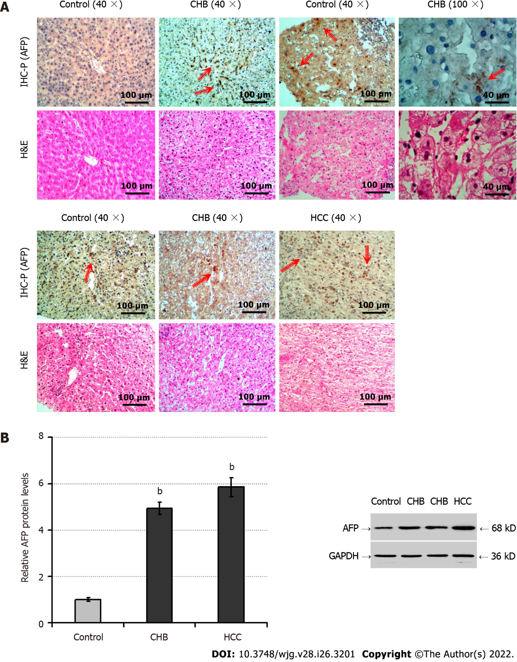
Figure 1 The intrahepatic levels of alpha-fetoprotein protein are elevated in injured livers. A: Immunohistochemistry and hematoxylin and eosin (H&E) staining analyzed alpha-fetoprotein (AFP) expression and pathological changes, respectively, in liver tissues of patients with chronic hepatitis B (CHB, n = 34), trauma (n = 8) or hepatocellular carcinoma (HCC, the positive control group, n = 8). The upper panels display immunohistochemical staining, and the lower panels exhibit H&E staining in sequential tissue sections. The positive expression of AFP was stained with brownish yellow by immunohistochemistry and indicated by the arrows; B: The relative levels of AFP protein expression were analyzed by Western blot in the liver specimens indicated. H&E: Hematoxylin and eosin; IHC-P: Immunohistochemistry-paraffin; AFP: Alpha-fetoprotein; HCC: Hepatocellular carcinoma; CHB: Chronic hepatitis B. ^{b}P < 0.01, compared with the control group.

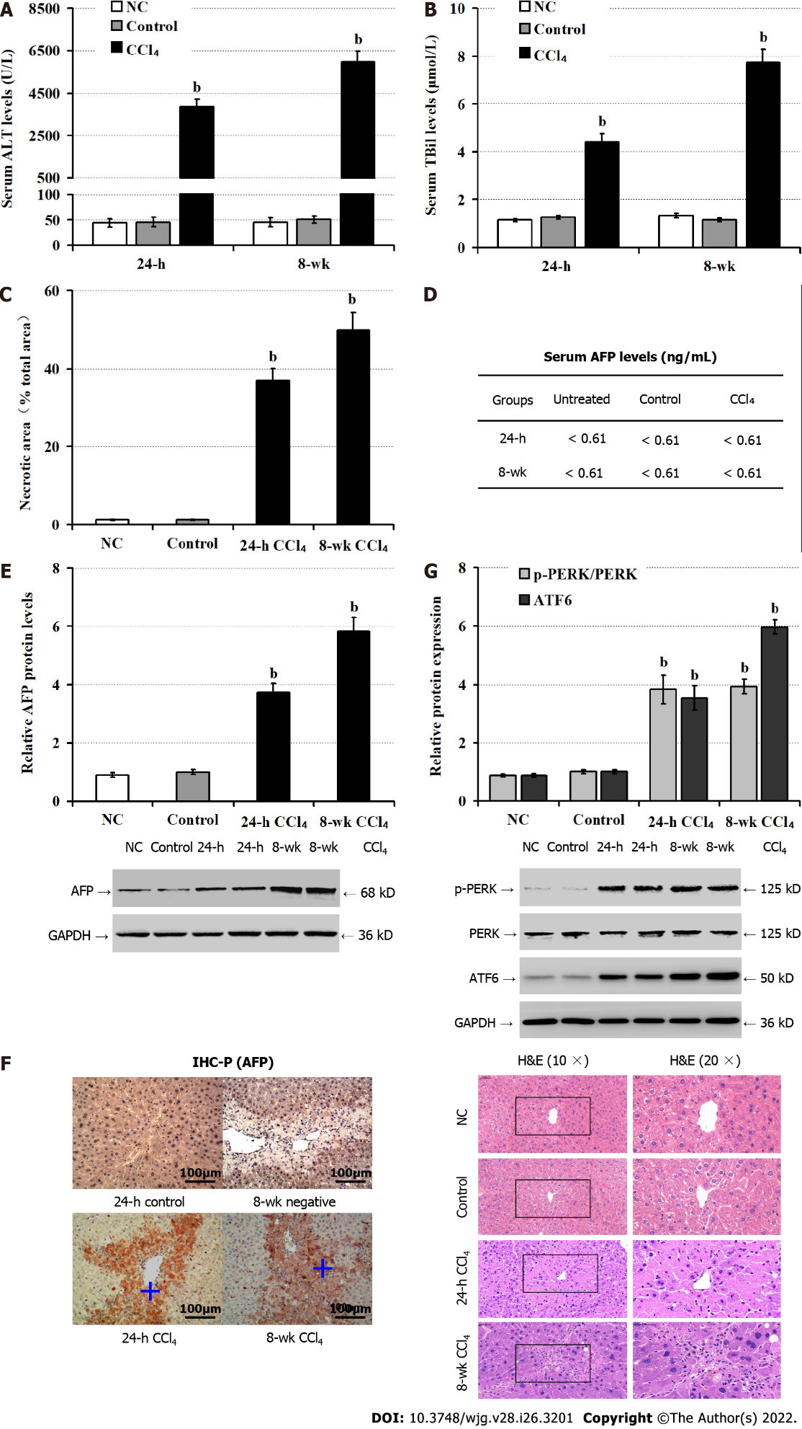
Figure 2 Administration with carbon tetrachloride induces alpha-fetoprotein expression, endoplasmic reticulum stress and liver injury in mice. Male BALB/c mice were untreated (NC), or administrated with olive oil (control) or carbon tetrachloride (CCl₄) for 24 h, or 8 wk. A: Serum alanine aminotransferase levels; B: Serum total bilirubin levels; C: Hematoxylin and eosin staining analysis of pathological changes in mouse liver tissues at 24-h and 8-wk post CCl₄; D: Chemiluminescence immunoassay of serum alpha-fetoprotein (AFP) levels; E: Western blot analysis of the relative levels of AFP expression in liver tissues of mice; F: Immunohistochemical staining of AFP expression in liver tissue of mice at 24-h post CCl₄, the positive expression of AFP was stained with brownish yellow and indicated by a plus sign; G: Western blot analysis of the relative levels of protein kinase R-like endoplasmic reticulum kinase phosphorylation and activating transcription factor-6 expression in liver tissues of mice. AFP: Alpha-fetoprotein; ALT: Alanine aminotransferase; ATF6: Activating transcription factor-6; CCl₄: Carbon tetrachloride; H&E: Hematoxylin and eosin; PERK: Protein kinase R-like endoplasmic reticulum kinase; TBil: Total bilirubin. ^{b}P < 0.01 compared with the control group.

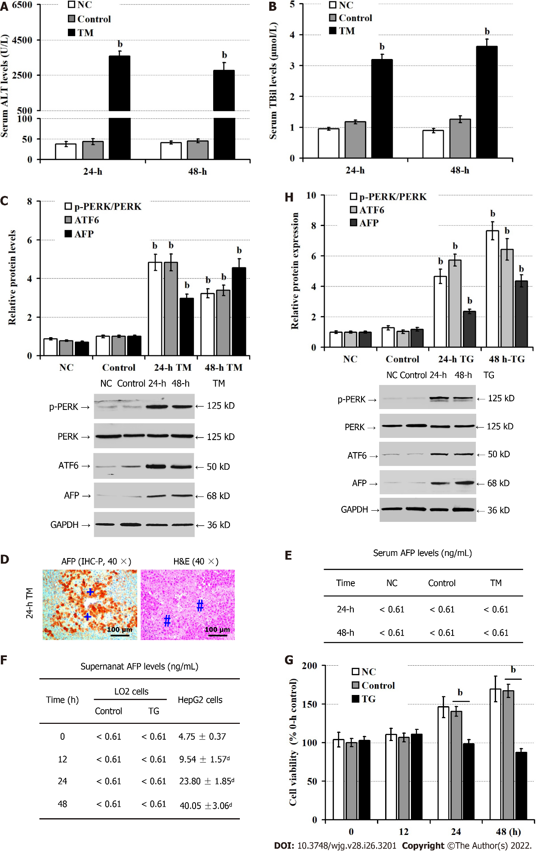
Figure 3 Endoplasmic reticulum stress up-regulates alpha-fetoprotein expression in hepatocytes. Male BALB/c mice were untreated (NC), or treated with phosphate buffer saline (control) or TM for 24 h or 48 h. LO2 cells were untreated (NC), or treated with dimethyl sulfoxide (control) or thapsigargin (TG) for 24 h, and 48 h. A: Serum alanine aminotransferase levels; B: Serum total bilirubin levels; C: Western blot analysis of the relative levels of proteins; D: Immunohistochemical analysis of alpha-fetoprotein (AFP) expression and hematoxylin and eosin staining analysis of liver injury in mice at 24 h post endoplasmic reticulum stress. The positive expression of AFP was stained with brownish yellow and indicated by a plus sign. Hash sign indicates the area of necrosis; E: Chemiluminescence immunoassay of serum AFP levels in mice; F: The levels of AFP in the supernatants of cultured cells; G: Cell counting kit-8 analysis of the cell viability; H: Western blot analysis of the relative levels of p-protein kinase R-like endoplasmic reticulum kinase, ATF6 and AFP expression in LO2 cells. AFP: Alpha-fetoprotein; ALT: Alanine aminotransferase; ATF6: Activating transcription factor-6; CCl₄: Carbon tetrachloride; CCK-8: Cell counting kit-8; DMSO: Dimethyl sulfoxide; H&E: Hematoxylin and eosin; IHC-P: Immunohistochemistry-paraffin; PBS: Phosphate buffer saline; p-PERK: Phosphorylated protein kinase R-like endoplasmic reticulum kinase; TBil: Total Bilirubin; TM: Tunicamycin; TG: Thapsigargin. ^{b}P < 0.01, compared with the control group; ^{d}P < 0.01, compared with the 0 h group in HepG2 cells.

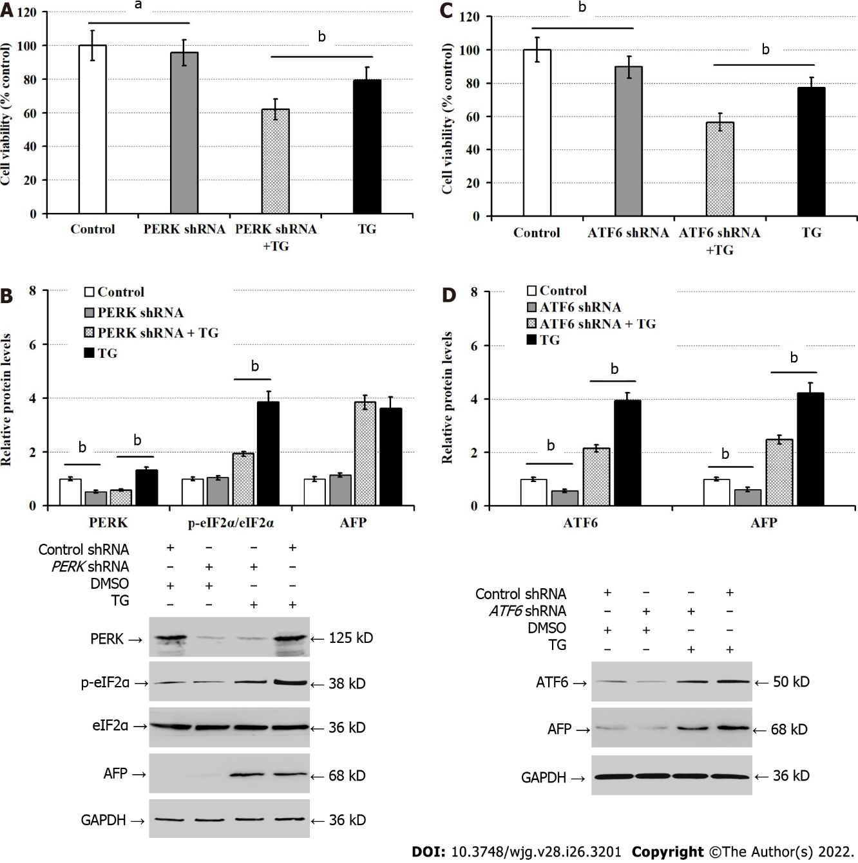
Figure 4 Activating transcription factor-6 silencing inhibits the expression of alpha-fetoprotein induced by thapsigargin in vitro. LO2 cells were transfected with control shRNA, protein kinase R-like endoplasmic reticulum kinase (PERK)-shRNA, or activating transcription factor-6 (ATF6)-shRNA for 48 h, and treated with dimethyl sulfoxide (control) or thapsigargin for 24 h. A: Cell counting kit-8 (CCK-8) analysis of cell viability; B: Western blot analysis of p-PERK, phosphorylated eukaryotic translational initiation factor 2 alpha, and alpha-fetoprotein expression; C: CCK-8 analysis of cell viability; D: Western blot analysis of the relative levels of ATF6 and AFP protein expression. AFP: Alpha-fetoprotein; ATF6: Activating transcription factor-6; CCK-8: Cell counting kit-8; DMSO: Dimethyl sulfoxide; p-eIF2α: Phosphorylated eukaryotic translational initiation factor 2 alpha; p-PERK: Phosphorylated protein kinase R-like endoplasmic reticulum kinase; TG: Thapsigargin. ªP < 0.05, ^{b}P < 0.01, compared with these two groups.
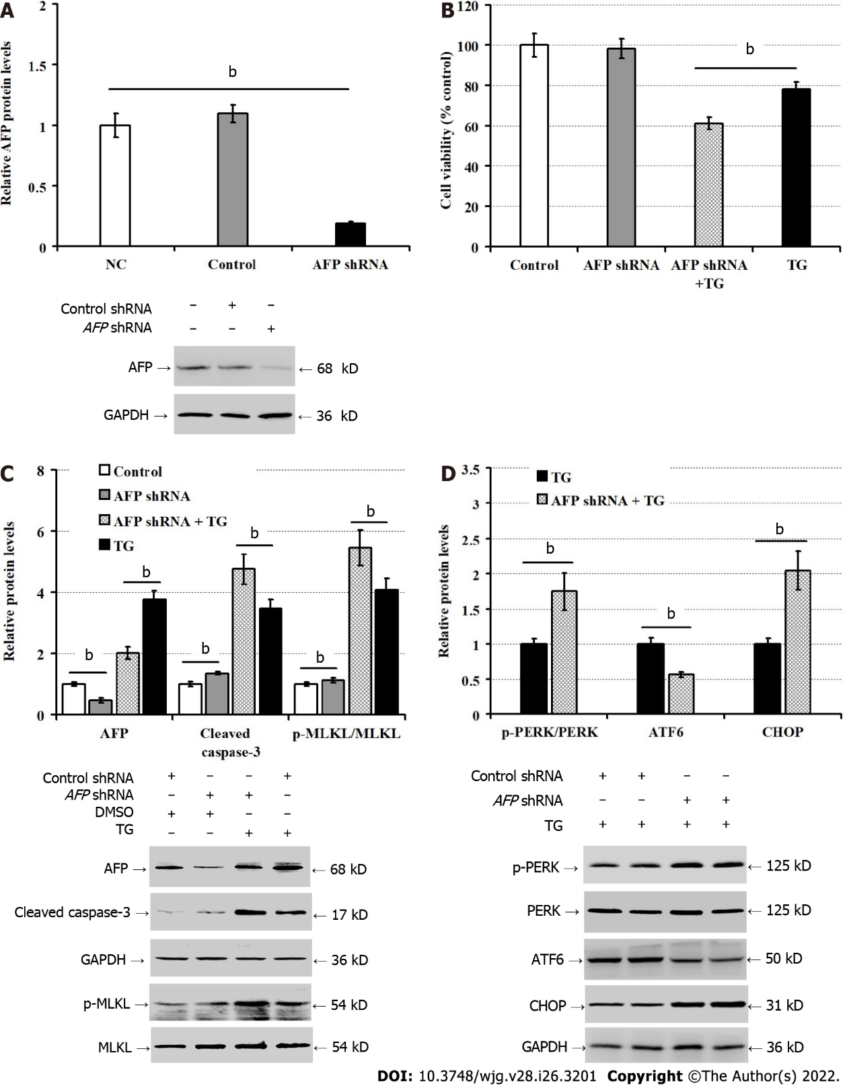
Figure 5 Silencing of alpha-fetoprotein exacerbates the thapsigargin-induced LO2 cell injury. A: Western blot determined alpha-fetoprotein silencing in LO2 cells; B: Cell counting kit-8 analysis of LO2 cell viability; C: Western blot for the relative levels of indicated protein expression in LO2 cells; D: Western blot for the relative levels of endoplasmic reticulum stress-related protein. AFP: Alpha-fetoprotein; CCK-8: Cell counting kit-8; ER: Endoplasmic reticulum; TG: Thapsigargin; p-MLKL: Phosphorylated mixed lineage kinase domain-like pseudokinase; p-PERK: Phosphorylated protein kinase R-like endoplasmic reticulum kinase. Data are typical images or expressed as the mean ± SD of each group from 3 separate experiments. ^{b}P < 0.01 compared with these two groups.
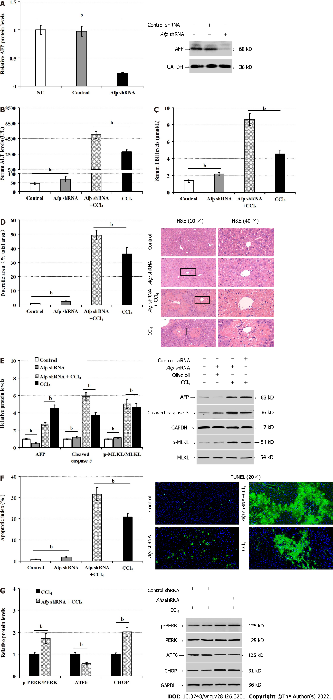
Figure 6 Silencing of alpha-fetoprotein increases liver injury in mice following CCl₄ administration. A: Western blot for the protein levels of alpha-fetoprotein (AFP) in the liver tissues of mice; B: Serum alanine aminotransferase levels; C: Serum levels of total bilirubin; D: Liver sections stained by hematoxylin and eosin and measurements of necrotic areas in mice; E: Western blot for the relative levels of AFP, cleaved caspase-3, and phosphorylated mixed lineage kinase domain-like pseudokinase expression in the liver tissues; F: TUNEL analysis of hepatocyte apoptosis; G: The relative levels of phosphorylated protein kinase R-like ER kinase, activating transcription factor-6 and C/enhancer binding protein homologous protein protein in liver tissues. AFP: Alpha-fetoprotein; ALT: Alanine aminotransferase; ATF6: Activating transcription factor-6; CCl₄: Carbon tetrachloride; CHOP: C/enhancer binding protein homologous protein; H&E: Hematoxylin and eosin; p-MLKL: Phosphorylated mixed lineage kinase domain-like pseudokinase; p-PERK: Phosphorylated protein kinase R-like ER kinase; TBil: Total bilirubin; TUNEL: Terminal deoxynucleotidyl transferase-mediated dUTP nick end labeling. ^{b}P < 0.01 compared with these two groups.

Table 1 The demographic and clinical data of subjects
Group | CHB | Control | HCC
n | 34 | 8 | 8
Age (years; 25%, 75%) | 41.00 (35.00, 48.75) | 32.50 (28.25, 41.85) | 47.00 (40.25, 53.42)
ALT (U/L; 25%, 75%) | 137.50 (59.00, 221.50) | 31.5000 (14.5000, 63.1725) | 48.50 (39.00, 65.25)
TBil (μmol/L; 25%, 75%) | 16.300 (11.500, 24.225) | 10.80 (9.42, 20.58) | 20.6 (14.5, 32.5)
AFP (ng/mL; 25%, 75%) | 4.5400 (2.9850, 13.1725) | 2.02 (1.05, 4.75) | 179.80 (14.65, 207.53)
CHB: Chronic hepatitis B; HCC: Hepatocellular carcinoma; AFP: Alpha-fetoprotein; ALT: Serum alanine aminotransferase; TBil: Total bilirubin.

Table 2 The sequences of short hairpin RNAs
Insert content |  |  | 5’-3’
Mouse | Afp shRNA | Target sequence | GCATCCATTGCAAAGGAATTA
 |  | shRNA sequence | GCATCCATTGCAAAGGAATTACGAATAATTCCTTTGCAATGGATGC
 | Control shRNA | shRNA sequence | AAACGTGACACGTTCGGAGAACGAATTCTCCGAACGTGTCACGTTT
Human | PERK shRNA | Target sequence | GCACTTTAGATGGGAGAATTG
 |  | shRNA sequence | GCACTTTAGATGGGAGAATTGCGAACAATTCTCCCATCTAAAGTGC
 | Control shRNA | shRNA sequence | AAACGTGACACGTTCGGAGAACGAATTCTCCGAACGTGTCACGTTT
 | ATF6 shRNA | Target sequence | GCAGGTCCTCCTGTTATTAGA
 |  | shRNA sequence | GCAGGTCCTCCTGTTATTAGACGAATCTAATAACAGGAGGACCTGC
 | Control shRNA | shRNA sequence | AAACGTGACACGTTCGGAGAA CGAATTCTCCGAACGTGTCACGTTT
 | AFP shRNA | Target sequence | GCTTCCATATTGGATTCTTAC
 |  | shRNA sequence | GCTTCCATATTGGATTCTTAC CGAAGTAAGAATCCAATATGGAAGC
 | Control shRNA | shRNA sequence | AAACGTGACACGTTCGGAGAA CGAATTCTCCGAACGTGTCACGTTT
AFP: Alpha-fetoprotein; ATF6: Activating transcription factor-6; PERK: Protein kinase R-like ER kinase; shRNA: Short hairpin RNA.

Published by Baishideng Publishing Group Inc
7041 Koll Center Parkway, Suite 160, Pleasanton, CA 94566, USA
Telephone: +1-925-3991568
E-mail: bpgoffice@wjgnet.com
Help Desk: https://www.f6publishing.com/helpdesk
https://www.wjgnet.com

© 2022 Baishideng Publishing Group Inc. All rights reserved.

