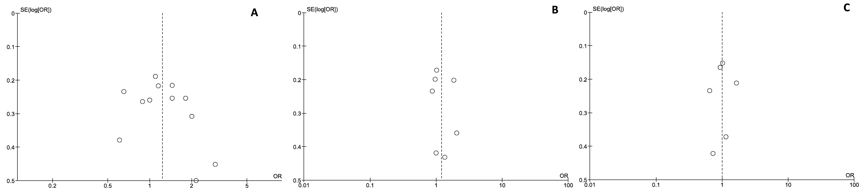Supplementary Fig.1. Funnel plots of meta-analyses of highest versus lowest category of CRP (A), IL-6 (B), and TNF-alpha (C) and risk of colorectal adenoma.

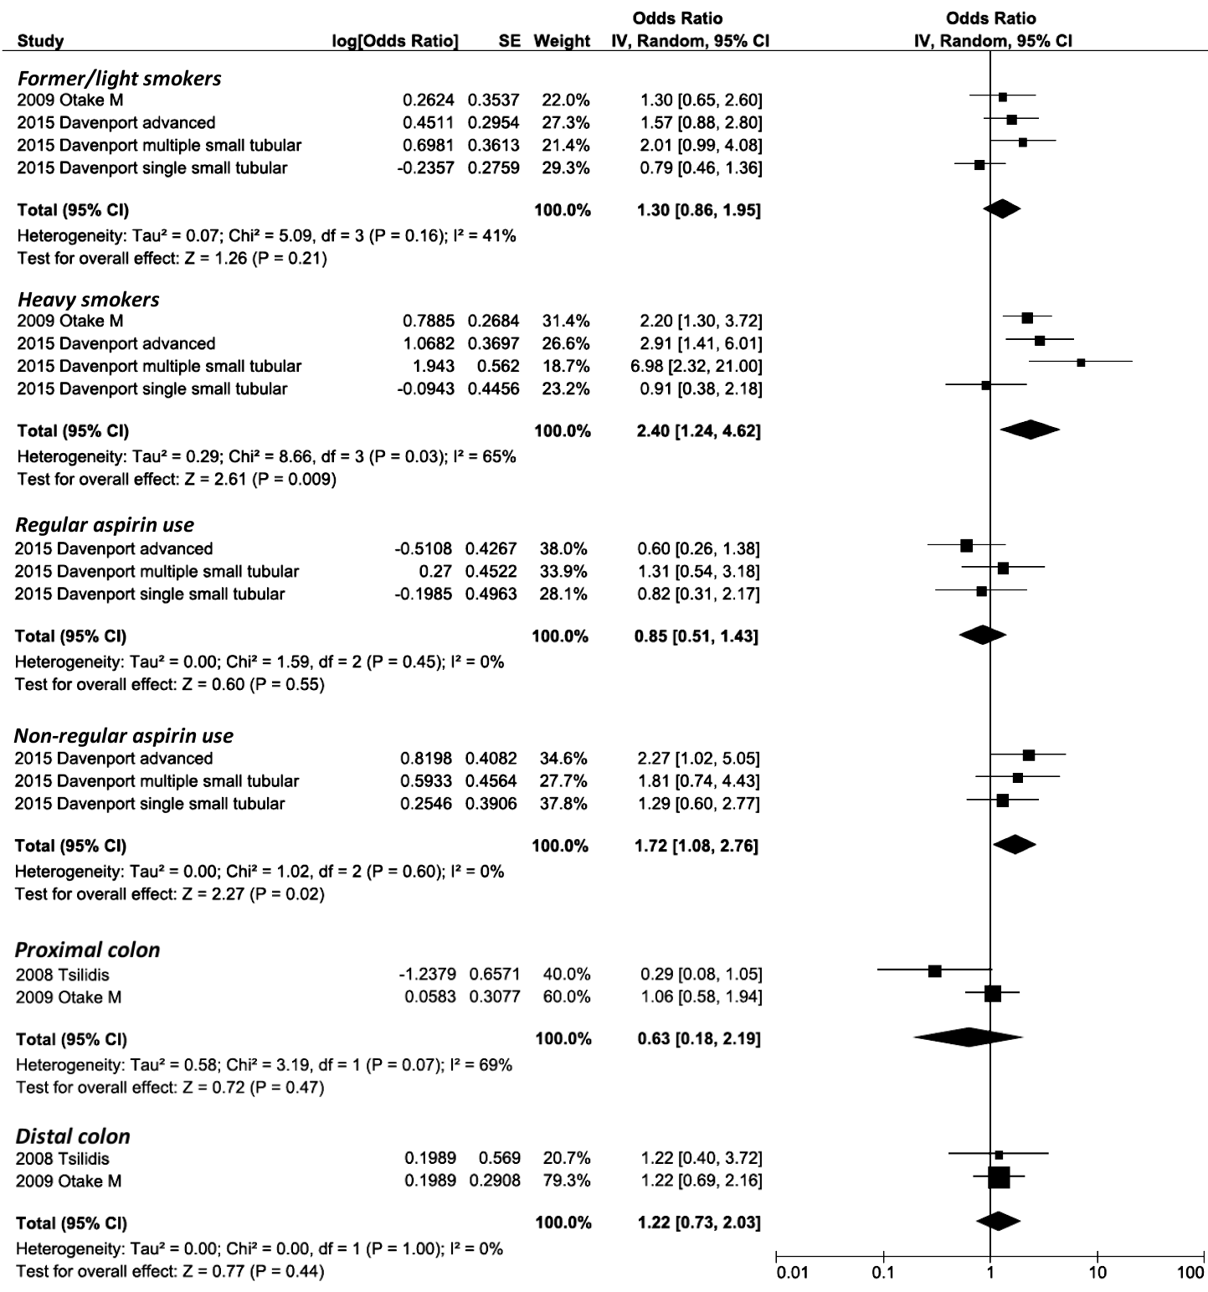Supplementary Fig.2. Meta-analysis of highest versus lowest category of CRP and risk of colorectal adenoma by smoking status, aspirin use, and adenoma localization.

Supplementary Table 1. MOOSE Checklist: Circulating levels of CRP, IL-6 and TNF-alpha and risk of colorectal adenomas - A Meta-Analysis.
Criteria |  | Brief description of how the criteria were handled in the meta-analysis
Reporting of background should include
√ | Problem definition | Inflammatory plays and important role in colorectal carcinogenesis. Existing summary of evidence rely on colorectal cancer risk but findings on colorectal adenomas have not been examined yet.
√ | Hypothesis statement | Higher levels of CRP, IL-6 and TNF-alpha may be associated with increased risk of colorectal adenomas.
√ | Description of study outcomes | Colorectal adenomas, which precedes the majority of colorectal cancers.
√ | Type of exposure or intervention used | Circulating levels of inflammatory markers (CRP, IL-6, TNF-alpha)
√ | Type of study designs used | We included observational studies that have been  reported the association between the circulating  CRP, IL-6 and TNF-alpha and colorectal adenoma risk.
√ | Study population | No restrictions.
Reporting of search strategy should include
√ | Qualifications of searchers | The credentials of the two investigators GG and JG were indicated in the author list.
√ | Search strategy, including time period included in the synthesis and keywords | Search was done to include studies published through March, 2016. Search process is presented in Figure 1. Search strategy is presented in Supplementary Table 2.
√ | Databases and registries searched | PubMed and Embase
√ | Search software used, name and version, including special features | No search software was used.
√ | Use of hand searching | We hand-searched the reference lists of studies included in the meta-analysis.
√ | List of citations located and those excluded, including justifications | Details of the literature search process are presented on the Figure 1.
√ | Method of addressing articles published in languages other than English | We restricted language to English.
√ | Method of handling abstracts and unpublished studies | No relevant abstract or unpublished studies were found.
√ | Description of any contact with authors | None.
Reporting of methods should include
√ | Description of relevance or appropriateness of studies assembled for assessing the hypothesis to be tested | Inclusion and exclusion criteria are presented in the method section.
√ | Rationale for the selection and coding of data | Studies providing all data required for meta-analysis were included. Data extraction is described in method section.
√ | Assessment of confounding | Meta-analysis was performed by using most fully adjusted ORs and its 95 % CI, only one included study presented crude ORs. In addition, we conducted subgroup analyses and meta-regression by adjustment for potential confounders and these results were presented in Table 2.
√ | Assessment of study quality, including blinding of quality assessors; stratification or regression on possible predictors of study results | Study quality was assessed using Newcastle-Ottawa Scale (Supplementary Table 3.). Subgroup analysis was performed.
√ | Assessment of heterogeneity | Heterogeneity was tested by Q test and I² statistic.
√ | Description of statistical methods in sufficient detail to be replicated | Description is presented in method section.
√ | Provision of appropriate tables and graphics | We included two tables and four figures.
Reporting of results should include
√ | Graph summarizing individual study estimates and overall estimate | Figure 2 for CRP, Figure 3 for Il-6, and Figure 4 for TNF-alpha.
√ | Table giving descriptive information for each study included | Descriptive information is available in Table 1.
√ | Results of sensitivity testing | We tested sensitivity analysis. One study was found to affect the summary results (Gunter, 2011)
√ | Indication of statistical uncertainty of findings | 95% confidence intervals were presented for all summary estimates, and the publication bias was tested.
Reporting of discussion should include
√ | Quantitative assessment of bias | Heterogeneity between the studies was evaluated and the publication bias was tested.
√ | Justification for exclusion | No studies were excluded.
√ | Assessment of quality of included studies | Assessment of quality using Newcastle-Ottawa Scale did not show any significant differences among the included studies.
Reporting of conclusions should include
√ | Consideration of alternative explanations for observed results | Alternative explanations are considered in the discussion.
√ | Generalization of the conclusions | Circulating CRP, IL-6 and TNF-alpha were not significantly associated with the increased risk of CRA. Only circulating CRO was significantly associated with risk of advanced CRA.
√ | Guidelines for future research | Future studies estimating pre-diagnostic serum/plasma markers of inflammation and sequent adenoma incidence are needed to better assess the role of chronic inflammation in malignancy development
√ | Disclosure of funding source | Founding source is disclosed in the acknowledgement section.

Supplementary Table 2. Search strategy.
CRP | ((("c-reactive protein"[MeSH Terms] OR ("c-reactive"[All Fields] AND "protein"[All Fields]) OR "c-reactive protein"[All Fields] OR "c reactive protein"[All Fields]) OR ("c-reactive protein"[MeSH Terms] OR ("c-reactive"[All Fields] AND "protein"[All Fields]) OR "c-reactive protein"[All Fields] OR "c reactive protein"[All Fields]) OR CRP[All Fields] OR (inflammatory[All Fields] AND ("cytokines"[MeSH Terms] OR "cytokines"[All Fields])) OR (inflammatory[All Fields] AND ("Markers"[Journal] OR "markers"[All Fields]))) AND (("adenoma"[MeSH Terms] OR "adenoma"[All Fields]) OR ("adenoma"[MeSH Terms] OR "adenoma"[All Fields] OR "adenomas"[All Fields]) OR ("polyps"[MeSH Terms] OR "polyps"[All Fields] OR "polyp"[All Fields]) OR ("polyps"[MeSH Terms] OR "polyps"[All Fields]) OR serrated[All Fields])) AND (colorectal[All Fields] OR ("colon"[MeSH Terms] OR "colon"[All Fields]) OR "rectal"[All Fields]))
IL-6 | ((("interleukin-6"[MeSH Terms] OR "interleukin-6"[All Fields] OR "il 6"[All Fields]) OR ("interleukin-6"[MeSH Terms] OR "interleukin-6"[All Fields] OR "interleukin 6"[All Fields]) OR IL6[All Fields] OR interleukin6[All Fields] OR (inflammatory[All Fields] AND ("cytokines"[MeSH Terms] OR "cytokines"[All Fields])) OR (inflammatory[All Fields] AND ("Markers"[Journal] OR "markers"[All Fields]))) AND (("adenoma"[MeSH Terms] OR "adenoma"[All Fields]) OR ("adenoma"[MeSH Terms] OR "adenoma"[All Fields] OR "adenomas"[All Fields]) OR ("polyps"[MeSH Terms] OR "polyps"[All Fields] OR "polyp"[All Fields]) OR ("polyps"[MeSH Terms] OR "polyps"[All Fields]) OR serrated[All Fields])) AND (colorectal[All Fields] OR ("colon"[MeSH Terms] OR "colon"[All Fields]) OR "rectal"[All Fields]))
TNF-alpha | ((("tumor necrosis factors"[MeSH Terms] OR ("tumor"[All Fields] AND "necrosis"[All Fields] AND "factors"[All Fields]) OR "tumor necrosis factors"[All Fields] OR ("tnf"[All Fields] AND "alpha"[All Fields]) OR "tnf alpha"[All Fields] OR "tumor necrosis factor-alpha"[MeSH Terms] OR ("tumor"[All Fields] AND "necrosis"[All Fields] AND "factor-alpha"[All Fields]) OR "tumor necrosis factor-alpha"[All Fields] OR ("tnf"[All Fields] AND "alpha"[All Fields])) OR ("tumour necrosis factor"[All Fields] OR "tumor necrosis factor-alpha"[MeSH Terms] OR ("tumor"[All Fields] AND "necrosis"[All Fields] AND "factor-alpha"[All Fields]) OR "tumor necrosis factor-alpha"[All Fields] OR ("tumor"[All Fields] AND "necrosis"[All Fields] AND "factor"[All Fields]) OR "tumor necrosis factor"[All Fields]) OR TNF[All Fields] OR (inflammatory[All Fields] AND ("cytokines"[MeSH Terms] OR "cytokines"[All Fields])) OR (inflammatory[All Fields] AND ("Markers"[Journal] OR "markers"[All Fields]))) AND (("adenoma"[MeSH Terms] OR "adenoma"[All Fields]) OR ("adenoma"[MeSH Terms] OR "adenoma"[All Fields] OR "adenomas"[All Fields]) OR ("polyps"[MeSH Terms] OR "polyps"[All Fields] OR "polyp"[All Fields]) OR ("polyps"[MeSH Terms] OR "polyps"[All Fields]) OR serrated[All Fields])) AND (colorectal[All Fields] OR ("colon"[MeSH Terms] OR "colon"[All Fields]) OR "rectal"[All Fields]))

Supplementary Table 3. Assessment of the quality of studies included in the meta-analysis using The Newcastle-Ottawa Scale (NOS).
First author, year | 1. Is the case definition adequate? One point if histological confirmation or medical record-derived diagnosis | 2. Representativeness of the cases: One point if consecutive or obviously representative | 3. Selection of Controls: One point if community controls, drawn from the same community as reference group | 4. Definition of Controls: One point if negative colonoscopy, healthy | 5a. Comparability of controls: One point if study controls for age and gender (matching or adjustment in the analysis) | 5b. Comparability of controls: One point for at least four additional factor the study controls for | 6. Ascertainment of exposure: One point if marker measured in fasting, morning samples, blinded as to case-control status | 7. Same method of ascertainment for cases and controls: One point if same method of marker measurement | 8. Non-Response rate: One point if same response rate is reported | NOS score
Kim, 2008 | 1 | 1 | 1 | 1 | 1 | 0 | 1 | 1 | 1 | 8
Tsilidis, 2008 | 1 | 1 | 1 | 1 | 1 | 1 | 0 | 1 | 1 | 8
Otake, 2009 | 1 | 1 | 1 | 1 | 1 | 1 | 1 | 1 | 1 | 9
Ognjanovic, 2010 | 1 | 1 | 1 | 1 | 1 | 0 | 1 | 1 | 1 | 8
Otake, 2010 | 1 | 1 | 1 | 1 | 0 | 0 | 1 | 1 | 1 | 7
Yamaji, 2010 | 1 | 1 | 1 | 1 | 1 | 1 | 1 | 1 | 1 | 9
Gunter, 2011 | 1 | 1 | 1 | 1 | 1 | 1 | 0 | 1 | 1 | 8
Sasaki, 2012 | 1 | 1 | 1 | 1 | 1 | 1 | 1 | 1 | 1 | 9
Vaughn, 2013 | 1 | 1 | 1 | 1 | 1 | 1 | 1 | 1 | 1 | 9
Kong, 2014 | 1 | 1 | 1 | 1 | 1 | 0 | 0 | 1 | 1 | 7
Basavaraju, 2015 | 1 | 1 | 1 | 1 | 1 | 1 | 1 | 1 | 1 | 9
Davenport, 2015 | 1 | 1 | 1 | 1 | 1 | 0 | 0 | 1 | 1 | 7
Henry, 2015 | 1 | 1 | 1 | 1 | 1 | 0 | 1 | 1 | 1 | 8
Song, 2016 | 1 | 1 | 1 | 1 | 1 | 1 | 1 | 1 | 1 | 9

