Name of Journal: World Journal of Gastroenterology
Manuscript NO: 58562
Manuscript Type: ORIGINAL ARTICLE

Observational Study
Association between ADAMTS13 activity–VWF antigen imbalance and the therapeutic effect of HAIC in patients with hepatocellular carcinoma

Takaya H et al. A biomarker for HAIC treatment

Hiroaki Takaya, Tadashi Namisaki, Kei Moriya, Naotaka Shimozato, Kosuke Kaji, Hiroyuki Ogawa, Koji Ishida, Yuki Tsuji, Daisuke Kaya, Hirotestu Takagi, Yukihisa Fujinaga, Norihisa Nishimura, Yasuhiko Sawada, Hideto Kawaratani, Takemi Akahane, Masanori Matsumoto, Hitoshi Yoshiji

Hiroaki Takaya, Tadashi Namisaki, Kei Moriya, Naotaka Shimozato, Kosuke Kaji, Hiroyuki Ogawa, Koji Ishida, Yuki Tsuji, Daisuke Kaya, Hirotetsu Takagi, Yukihisa Fujinaga, Norihisa Nishimura, Yasuhiko Sawada, Hideto Kawaratani, Takemi Akahane, Hitoshi Yoshiji, Department of Gastroenterology, Nara Medical University, Kashihara, Nara 634-8522, Japan

Masanori Matsumoto, Department of Blood Transfusion Medicine, Nara Medical University, Kashihara, Nara 634-8522, Japan

Author contributions: Takaya H, Namisaki T, Moriya K, Shimozato N, Kaji K, Ogawa H, Ishida K, Tsuji Y, Kaya D, Takagi H, Fujinaga Y, Nishimura N, Sawada Y, Kawaratani H, and Akahane T performed data analysis; Takaya H, Namisaki T, Matsumoto M, and Yoshiji H wrote the manuscript.

Corresponding author: Hiroaki Takaya, MD, PhD, Assistant Professor, Department of Gastroenterology, Nara Medical University, 840 Shijo-cho, Kashihara, Nara 634-8522, Japan. htky@naramed-u.ac.jp

Received: August 4, 2020
Revised: October 9, 2020
Accepted: November 13, 2020
Published online:

Abstract
BACKGROUND
Prediction of HAIC treatment response is important for improving the prognosis in patients with hepatocellular carcinoma (HCC). The progression of HCC is related to hypercoagulability and angiogenesis. It is known that ADAMTS13 and von Willebrand factor (VWF) are related to hypercoagulability. In addition, previous study reported that the association between ADAMTS13 and VWF, and angiogenesis via vascular endothelial growth factor (VEGF). Recently, ADAMTS13 and VWF have been associated with the prognosis in patients with various kinds of cancer undergoing chemotherapy.

AIM
To investigate whether ADAMTS13 and VWF become useful biomarkers of treatment response in HCC patients before the initiation of HAIC treatment.

METHODS
Seventy-two patients were enrolled in this study. ADAMTS13 activity (ADAMTS13:AC), VWF antigen (VWF:Ag) and VEGF levels were determined via enzyme-linked immunosorbent assay. Univariable and multivariable analyses were performed to determine the predictive factors of treatment response in patients with HCC undergoing HAIC treatment.

RESULTS
ADAMTS13:AC levels in HCC patients with stable disease (SD) + partial response (PR) of HAIC treatment were significantly higher than those with progressive disease (PD) (P < 0.05). In contrast, VWF:Ag/ADAMTS13:AC ratio and VEGF levels in HCC patients with SD + PR were significantly lower than those with PD (both P < 0.05). Patients with high VWF:Ag/ADAMTS13:AC ratio (> 2.7) had higher VEGF levels than those with low ratio (≤ 2.7). Multivariable analysis revealed that VWF:Ag/ADAMTS13:AC ratio was a predictive factor of HAIC treatment response.

CONCLUSION
VWF:Ag/ADAMTS13:AC ratio may become a useful biomarker of treatment response in HCC patients before the initiation of HAIC treatment.

Key Words: ADAMTS13; Von Willebrand factor; Vascular endothelial growth factor; Biomarkers; Hepatocellular carcinoma; HAIC

Takaya H, Namisaki T, Moriya K, Shimozato N, Kaji K, Ogawa H, Ishida K, Tsuji Y, Kaya D, Takagi H, Fujinaga Y, Nishimura N, Sawada Y, Kawaratani H, Akahane T, Matsumoto M, Yoshiji H. Association between ADAMTS13 activity–VWF antigen imbalance and the therapeutic effect of HAIC in patients with hepatocellular carcinoma. World J Gastroenterol 2020; In press

Core Tip: The prediction of HAIC treatment response is needed to improve the prognosis in patients with hepatocellular carcinoma (HCC). Von Willebrand factor antigen (VWF:Ag)/ADAMTS13 activity (ADAMTS13:AC) ratio was significantly lower in HCC patients with stable disease + partial response than those with progressive disease. VWF:Ag/ADAMTS13:AC ratio become a useful biomarker to predict HAIC treatment response.

INTRODUCTION
Hepatocellular carcinoma (HCC) has one of the highest mortality rates of any cancer^{[1,2]}. In Japan, HCC management follows the consensus-based clinical practice guidelines of the Japan Society of Hepatology (JSH)^{[3]}. JSH recommends that advanced HCC patients with vascular invasion or more than four tumors should undergo chemotherapy such as HAIC or molecular-targeted drugs^{[3]}. However, it is important to predict HAIC response before deciding on the appropriate chemotherapy protocol for improving the prognosis in patients with HCC.
ADAMTS13 is a metalloproteinase that is exclusively produced from hepatic stellate cells adjacent to endothelial cells (ECs)^{[4-8]}. It specifically cleaves multimeric von Willebrand factor (VWF) between the Tyr1605 and Met1606 residues in the A2 domain^{[4-7]}. VWF is synthesized in vascular ECs and released into the plasma as unusually large multimers^{[9]}. During ADAMTS13 enzyme–VWF substrate imbalance, VWF is improperly cleaved, resulting in the accumulation of multimers and the induction of platelet thrombi formation in the microvasculature under high shear-stress conditions^{[10]}. In other words, ADAMTS13 enzyme–VWF substrate balance is related to hypercoagulability. Furthermore, the blood coagulation cascade is related to cancer progression^{[11,12]}, and our previous study has reported that ADAMTS13 enzyme–VWF substrate imbalance becomes worse based on HCC progression^{[13,14]}.
Angiogenesis plays an important role in HCC progression^{[15]}. A recent study has reported that ADAMTS13 enzyme–VWF substrate imbalance is related to angiogenesis^{[16]} as well as hypercoagulability and is associated with the prognosis in patients with various kinds of cancer undergoing chemotherapy^{[14,17]}.
In the present study, we investigated the relationship between ADAMTS13 enzyme–VWF substrate balance and HCC in patients undergoing HAIC treatment. In addition, we sought to determine whether ADAMTS13 and VWF may become predictive biomarkers of treatment response in HCC patients before starting HAIC treatment.

MATERIALS AND METHODS
Patients
This retrospective observational study included patients with HCC who underwent HAIC treatment from December 2009 to March 2019. Patients with HCC had no vascular invasion or less than four tumors were excluded. A total of 72 patients with HCC were included in this study. HAIC treatment was performed according to the Moriya method^{[18,19]}, which features a bi-monthly protocol that is simple and easy to manage. The patients underwent dynamic computed tomographic scanning or dynamic magnetic resonance imaging at various points, namely before starting HAIC treatment, 1 mo after commencement of the treatment, and every 2 mo thereafter. HAIC treatment responses were evaluated according to modified response evaluation criteria in solid tumors. This study had no patient with infection, uncontrolled hepatic encephalopathy, ascites, or gastroesophageal varices. This study was approved by the local ethics committee in Nara Medical University and was performed according to the ethical standards laid down in the Declaration of Helsinki. Informed consent was obtained from all patients included in the study.

Determination of ADAMTS13 activity and VWF antigen levels
We collected blood samples from each patient at the time of admission, during their hospital stay, or during regular outpatient treatment before starting HAIC treatment. The plastic tubes with 0.38% sodium citrate was used to store these samples. We centrifuged these samples at 3000 ×g at 4 ℃ for 15 min to prepare the plasma and stored the plasma at −80 ℃ until analysis. Plasma ADAMTS13 activity (ADAMTS13:AC) was determined using a sensitive chromogenic enzyme-linked immunosorbent assay (ELISA) (Kainos Laboratories Inc., Tokyo, Japan)^{[20]} to show a normal value of 99% ± 22%. Plasma VWF antigen (VWF:Ag) levels were measured via sandwich ELISA using a rabbit anti-human VWF polyclonal antiserum (Dako, Glostrup, Denmark). The normal VWF:Ag value is 102% ± 33%^{[21]}.

VEGF measurements
VEGF levels were determined using a commercially available kit (Immunoassay Kits, RayBiotech Inc., United States). The detection limit of VEGF was < 10 pg/mL.

Statistical analysis
The Mann–Whitney U-test and the Fisher’s exact test were performed to analyze differences between study groups and categorical data, respectively. Univariable and multivariable analysis were performed to evaluate HAIC response for HCC. Logistic regression analysis was performed to determine independent response factors, and data were expressed as median (interquartile range). A two-tailed P-value of < 0.05 was considered significant. Analyses were conducted using EZR (Saitama Medical Center, Jichi Medical University, Japan), a graphical user interface of R version 2.13.0 (The R Foundation for Statistical Computing, Vienna, Austria), and a modified version of R commander (version 1.6-3) that includes statistical functions that are frequently used in biostatistics^{[22]}.

RESULTS
Clinical characteristics of the HCC patients
Table 1 showed the clinical characteristics of HCC patients. The median period of HAIC treatment was 121 (range 41–218) d and the median age of HCC patients was 70.5 (range 64.2–76.1) years. Of the study population (57 males, 15 females), 17 patients had hepatitis B virus infection, 36 had hepatitis C virus infection, 10 had alcohol abuse, 4 had non-alcoholic steatohepatitis, and 5 had others. The median maximum tumor size was 3.3 (range 2.2–5.0) cm. Tumors numbering 1, 2, 3, 4, or > 4 were 9, 5, 6, 2, and 50, respectively. Thirty-one patients had vascular invasion and no patient had distant metastasis. Serum alpha-fetoprotein (AFP), des-γ-carboxy prothrombin, and lens culinaris agglutinin-reactive fraction of AFP levels were 95.3 (17.9–1162.5) ng/mL, 359.5 (58.0–5277.5) mAU/mL, and 33.7% (7.7%–73.4%), respectively. We investigated the HAIC treatment response between stable disease (SD) + partial response (PR) and progressive disease (PD). No significant differences were observed in HCC patients’ characteristics between SD + PR and PD, except for treatment periods.

Plasma ADAMTS13:AC and VWF:Ag levels
ADAMTS13:AC levels in HCC patients with SD + PR were significantly higher than those with PD (P < 0.05) (Figure 1A). VWF:Ag levels were no different between patients with SD + PR and PD (Figure 1B). The ratio of VWF:Ag to ADAMTS13:AC (VWF:Ag/ADAMTS13:AC ratio) in patients with SD + PR was significantly lower than those with PD (P < 0.05) (Figure 1C).

Plasma VEGF levels
VEGF levels in HCC patients with SD + PR were significantly lower than those with PD (P < 0.05) (Figure 2A). Patients were categorized into two groups according to receiver operating characteristic (ROC) cut-off VEGF: Low, ≤ 100 and high, > 100. Patients with high VEGF levels also had higher platelet levels than those with low VEGF (Figure 2B). Patients were categorized into two groups according to ROC cut-off VWF:Ag/ADAMTS13:AC ratio: Low, ≤ 2.7 and high, > 2.7. Patients with high VWF:Ag/ADAMTS13:AC ratio had higher VEGF levels than those with low ratio (Figure 2C).

Predictive factors for HAIC response
Patients were categorized into two groups according to ROC cut-off. Univariable analysis showed that HAIC treatment response is associated with prothrombin time (PT), VEGF, and VWF:Ag/ADAMTS13:AC ratio (Table 2). To determine the predictive factors of HAIC response, multivariable analysis was performed using PT, VEGF, and VWF:Ag/ADAMTS13:AC ratio, with these factors showing P < 0.05 in univariable analysis. VWF:Ag/ADAMTS13:AC ratio was significantly associated with HAIC treatment response via multivariable analysis (Table 2). ROC analysis showed that VWF:Ag/ADAMTS13:AC ratio is sensitivity of 53.7%, specificity of 87.1%, and area under the curve of 0.715.

DISCUSSION
We suggests that VWF:Ag/ADAMTS13:AC ratio is a potential biomarker for HAIC treatment response in the present study. It is well-known that this ratio is related to the coagulation cascade^{[10]}, which in turn plays an important role in the cancer development, including HCC^{[11,12]}. Previous studies have reported that ADAMTS13 enzyme–VWF substrate imbalance is associated with cancer progression, prognosis of patients with various kinds of cancer, and response to chemotherapy^{[17,23]}. Our previous study reported that VWF:Ag^{[7]} and VWF:Ag/ADAMTS13:AC ratio^{[13]} are predictive and detective factors of HCC in patients with cirrhosis, respectively. Moreover, a study has reported that the association between ADAMTS13:AC and VWF:Ag, and the treatment efficiency of molecular-targeted drugs^{[14]}.
It is well-known that angiogenesis is related to the pathophysiology of HCC development^{[15]} and that VEGF plays an important role in angiogenesis^{[15]}. Recently, studies have reported that VWF reduces VEGF-dependent angiogenesis via multiple intracellular and extracellular pathways involving integrin avβ3 and angiopoietin-2^{[16,24,25]} and that ADAMTS13 cleaves VWF and promotes VEGFR-2 phosphorylation, as the result, induces angiogenesis. This in turn results in enhancement of VEGF expression^{[26]}. Xu have reported that the important role of ADAMTS13 enzyme–VWF substrate balance in the regulation of blood vessel formation^{[16]}. A previous study has reported that HAIC treatment decreases VEGF levels in patients with advanced HCC^{[27]}. Therefore, VWF:Ag/ADAMTS13:AC ratio may be associated with HAIC treatment response via VEGF and angiogenesis.
Furthermore, anti-platelet therapy inhibits VEGF that induces HCC development^{[28]}. A recent study has reported that anti-platelet therapy for cirrhotic patients prevents HCC development^{[29]} and prolongs survival time in hepatitis B virus mouse model of chronic liver disease^{[28]}. ADAMTS13 enzyme–VWF substrate imbalance induces platelet thrombi formation^{[10]}. In other words, ADAMTS13 enzyme–VWF substrate imbalance, VEGF, angiogenesis, and hypercoagulability are closely related to the cancer progression, including HCC. A previous study has found that VEGF is associated with HAIC treatment response and prognosis^{[30]}. Our study reported the association between VWF:Ag/ADAMTS13:AC ratio and HAIC treatment response; however, our analysis indicated that VEGF is not a predictive factor of HAIC treatment response. VWF:Ag/ADAMTS13:AC ratio may become a more useful to predict HAIC treatment response than VEGF.
Our study has some limitations that include a small sample size and short observation. Cirrhotic patients with advanced HCC occasionally develop thrombosis or inflammation (e.g., portal thrombosis, and bacterial overgrowth and translocation). When VWF:Ag/ADAMTS13:AC ratio is used as a biomarker of HAIC treatment response, thrombosis and inflammation may affect the values^{[4,23,31]}. In addition, VWF:Ag/ADAMTS13:AC ratio has high specificity but moderate sensitivity to predict HAIC treatment response. Therefore, we should continue to investigate high-sensitivity biomarkers.

CONCLUSION
In summary, VWF:Ag/ADAMTS13:AC ratio is an independent predictive factor for response in patients with HCC undergoing HAIC treatment.

ARTICLE HIGHLIGHTS
Research background
Predicting HAIC treatment response is important for improving the prognosis of hepatocellular carcinoma (HCC) patients.

Research motivation

ADAMTS13 and von Willebrand factor (VWF) have been associated with the prognosis in patients with various kinds of cancer receiving chemotherapy.

Research objectives
The present study was investigated whether ADAMTS13 and VWF become useful biomarkers of treatment response in HCC patients before the initiation of HAIC treatment.

Research methods
Multivariable analysis was performed to determine the predictive factors of HAIC treatment response in patients with HCC.

Research results
VWF antigen (VWF:Ag)/ADAMTS13 activity (ADAMTS13:AC) ratio predicted HAIC treatment response in multivariable analysis.

Research conclusions
VWF:Ag/ADAMTS13:AC ratio may be a useful biomarker of treatment response in patients with HCC before HAIC treatment.

Research perspectives
VWF:Ag/ADAMTS13:AC ratio has high specificity to predict HAIC treatment response. On the other hand, this biomarker has moderate sensitivity. Therefore, we should continue to investigate high-sensitivity biomarkers.

ACKNOWLEDGMENTS
This work was helped by Ms. Yoshie Nakai, Prof. Masahito Uemura, and Professor Hiroshi Fukui.

REFERENCES
1 Llovet JM, Zucman-Rossi J, Pikarsky E, Sangro B, Schwartz M, Sherman M, Gores G. Hepatocellular carcinoma. Nat Rev Dis Primers 2016; 2: 16018 [PMID: 27158749 DOI: 10.1038/nrdp.2016.18]
2 Zhu RX, Seto WK, Lai CL, Yuen MF. Epidemiology of Hepatocellular Carcinoma in the Asia-Pacific Region. Gut Liver 2016; 10: 332-339 [PMID: 27114433 DOI: 10.5009/gnl15257]
3 Kudo M, Matsui O, Izumi N, Iijima H, Kadoya M, Imai Y, Okusaka T, Miyayama S, Tsuchiya K, Ueshima K, Hiraoka A, Ikeda M, Ogasawara S, Yamashita T, Minami T, Yamakado K; Liver Cancer Study Group of Japan. JSH Consensus-Based Clinical Practice Guidelines for the Management of Hepatocellular Carcinoma: 2014 Update by the Liver Cancer Study Group of Japan. Liver Cancer 2014; 3: 458-468 [PMID: 26280007 DOI: 10.1159/000343875]
4 Takaya H, Kawaratani H, Kubo T, Seki K, Sawada Y, Kaji K, Okura Y, Takeda K, Kitade M, Moriya K, Namisaki T, Mitoro A, Matsumoto M, Fukui H, Yoshiji H. Platelet hyperaggregability is associated with decreased ADAMTS13 activity and enhanced endotoxemia in patients with acute cholangitis. Hepatol Res 2018; 48: E52-E60 [PMID: 28628948 DOI: 10.1111/hepr.12926]
5 Takaya H, Uemura M, Fujimura Y, Matsumoto M, Matsuyama T, Kato S, Morioka C, Ishizashi H, Hori Y, Fujimoto M, Tsujimoto T, Kawaratani H, Toyohara M, Kurumatani N, Fukui H. ADAMTS13 activity may predict the cumulative survival of patients with liver cirrhosis in comparison with the Child-Turcotte-Pugh score and the Model for End-Stage Liver Disease score. Hepatol Res 2012; 42: 459-472 [PMID: 22292786 DOI: 10.1111/j.1872-034X.2011.00950.x]
6 Takaya H, Yoshiji H, Kawaratani H, Sakai K, Matsumoto M, Fujimura Y, Fukui H. Decreased activity of plasma ADAMTS13 are related to enhanced cytokinemia and endotoxemia in patients with acute liver failure. Biomed Rep 2017; 7: 277-285 [PMID: 28894574 DOI: 10.3892/br.2017.945]
7 Takaya H, Kawaratani H, Tsuji Y, Nakanishi K, Saikawa S, Sato S, Sawada Y, Kaji K, Okura Y, Shimozato N, Kitade M, Akahane T, Moriya K, Namisaki T, Mitoro A, Matsumoto M, Fukui H, Yoshiji H. von Willebrand factor is a useful biomarker for liver fibrosis and prediction of hepatocellular carcinoma development in patients with hepatitis B and C. United European Gastroenterol J 2018; 6: 1401-1409 [PMID: 30386613 DOI: 10.1177/2050640618779660]
8 Uemura M, Tatsumi K, Matsumoto M, Fujimoto M, Matsuyama T, Ishikawa M, Iwamoto TA, Mori T, Wanaka A, Fukui H, Fujimura Y. Localization of ADAMTS13 to the stellate cells of human liver. Blood 2005; 106: 922-924 [PMID: 15855280 DOI: 10.1182/blood-2005-01-0152]
9 Moake JL, Turner NA, Stathopoulos NA, Nolasco LH, Hellums JD. Involvement of large plasma von Willebrand factor (vWF) multimers and unusually large vWF forms derived from endothelial cells in shear stress-induced platelet aggregation. J Clin Invest 1986; 78: 1456-1461 [PMID: 3491092 DOI: 10.1172/JCI112736]
10 Furlan M, Robles R, Galbusera M, Remuzzi G, Kyrle PA, Brenner B, Krause M, Scharrer I, Aumann V, Mittler U, Solenthaler M, Lämmle B. von Willebrand factor-cleaving protease in thrombotic thrombocytopenic purpura and the hemolytic-uremic syndrome. N Engl J Med 1998; 339: 1578-1584 [PMID: 9828245 DOI: 10.1056/NEJM199811263392202]
11 Nierodzik ML, Kajumo F, Karpatkin S. Effect of thrombin treatment of tumor cells on adhesion of tumor cells to platelets in vitro and tumor metastasis in vivo. Cancer Res 1992; 52: 3267-3272 [PMID: 1596884]
12 Snyder KM, Kessler CM. The pivotal role of thrombin in cancer biology and tumorigenesis. Semin Thromb Hemost 2008; 34: 734-741 [PMID: 19214911 DOI: 10.1055/s-0029-1145255]
13 Takaya H, Namisaki T, Kitade M, Kaji K, Nakanishi K, Tsuji Y, Shimozato N, Moriya K, Seki K, Sawada Y, Saikawa S, Sato S, Kawaratani H, Akahane T, Noguchi R, Matsumoto M, Yoshiji H. VWF/ADAMTS13 ratio as a potential biomarker for early detection of hepatocellular carcinoma. BMC Gastroenterol 2019; 19: 167 [PMID: 31638892 DOI: 10.1186/s12876-019-1082-1]
14 Takaya H, Namisaki T, Shimozato N, Kaji K, Kitade M, Moriya K, Sato S, Kawaratani H, Akahane T, Matsumoto M, Yoshiji H. ADAMTS13 and von Willebrand factor are useful biomarkers for sorafenib treatment efficiency in patients with hepatocellular carcinoma. World J Gastrointest Oncol 2019; 11: 424-435 [PMID: 31139312 DOI: 10.4251/wjgo.v11.i5.424]
15 Yoshiji H, Kuriyama S, Yoshii J, Ikenaka Y, Noguchi R, Hicklin DJ, Wu Y, Yanase K, Namisaki T, Kitade M, Yamazaki M, Tsujinoue H, Masaki T, Fukui H. Halting the interaction between vascular endothelial growth factor and its receptors attenuates liver carcinogenesis in mice. Hepatology 2004; 39: 1517-1524 [PMID: 15185292 DOI: 10.1002/hep.20218]
16 Randi AM. Angiogenesis and the ADAMTS13-VWF balance. Blood 2017; 130: 1-2 [PMID: 28684444 DOI: 10.1182/blood-2017-05-781260]
17 Guo R, Yang J, Liu X, Wu J, Chen Y. Increased von Willebrand factor over decreased ADAMTS-13 activity is associated with poor prognosis in patients with advanced non-small-cell lung cancer. J Clin Lab Anal 2018; 32: [PMID: 28374895 DOI: 10.1002/jcla.22219]
18 Moriya K, Namisaki T, Sato S, Furukawa M, Douhara A, Kawaratani H, Kaji K, Shimozato N, Sawada Y, Saikawa S, Takaya H, Kitagawa K, Akahane T, Mitoro A, Yamao J, Yoshiji H. Bi-monthly hepatic arterial infusion chemotherapy as a novel strategy for advanced hepatocellular carcinoma in decompensated cirrhotic patients. Clin Mol Hepatol 2019; 25: 381-389 [PMID: 31405269 DOI: 10.3350/cmh.2019.0037]
19 Moriya K, Namisaki T, Sato S, Douhara A, Furukawa M, Kawaratani H, Kaji K, Kitade M, Shimozato N, Sawada Y, Seki K, Saikawa S, Takaya H, Akahane T, Mitoro A, Okura Y, Yamao J, Yoshiji H. Efficacy of bi-monthly hepatic arterial infusion chemotherapy for advanced hepatocellular carcinoma. J Gastrointest Oncol 2018; 9: 741-749 [PMID: 30151271 DOI: 10.21037/jgo.2018.05.13]
20 Kato S, Matsumoto M, Matsuyama T, Isonishi A, Hiura H, Fujimura Y. Novel monoclonal antibody-based enzyme immunoassay for determining plasma levels of ADAMTS13 activity. Transfusion 2006; 46: 1444-1452 [PMID: 16934083 DOI: 10.1111/j.1537-2995.2006.00914.x]
21 Matsumoto M, Kawaguchi S, Ishizashi H, Yagi H, Iida J, Sakaki T, Fujimura Y. Platelets treated with ticlopidine are less reactive to unusually large von Willebrand factor multimers than are those treated with aspirin under high shear stress. Pathophysiol Haemost Thromb 2005; 34: 35-40 [PMID: 16293984 DOI: 10.1159/000088546]
22 Kanda Y. Investigation of the freely available easy-to-use software 'EZR' for medical statistics. Bone Marrow Transplant 2013; 48: 452-458 [PMID: 23208313 DOI: 10.1038/bmt.2012.244]
23 Pépin M, Kleinjan A, Hajage D, Büller HR, Di Nisio M, Kamphuisen PW, Salomon L, Veyradier A, Stepanian A, Mahé I. ADAMTS-13 and von Willebrand factor predict venous thromboembolism in patients with cancer. J Thromb Haemost 2016; 14: 306-315 [PMID: 26589836 DOI: 10.1111/jth.13205]
24 Starke RD, Ferraro F, Paschalaki KE, Dryden NH, McKinnon TA, Sutton RE, Payne EM, Haskard DO, Hughes AD, Cutler DF, Laffan MA, Randi AM. Endothelial von Willebrand factor regulates angiogenesis. Blood 2011; 117: 1071-1080 [PMID: 21048155 DOI: 10.1182/blood-2010-01-264507]
25 Lenting PJ, Casari C, Christophe OD, Denis CV. von Willebrand factor: the old, the new and the unknown. J Thromb Haemost 2012; 10: 2428-2437 [PMID: 23020315 DOI: 10.1111/jth.12008]
26 Lee M, Keener J, Xiao J, Long Zheng X, Rodgers GM. ADAMTS13 and its variants promote angiogenesis via upregulation of VEGF and VEGFR2. Cell Mol Life Sci 2015; 72: 349-356 [PMID: 24950743 DOI: 10.1007/s00018-014-1667-3]
27 Matsui D, Nagai H, Mukozu T, Ogino YU, Sumino Y. VEGF in patients with advanced hepatocellular carcinoma receiving intra-arterial chemotherapy. Anticancer Res 2015; 35: 2205-2210 [PMID: 25862879]
28 Sitia G, Aiolfi R, Di Lucia P, Mainetti M, Fiocchi A, Mingozzi F, Esposito A, Ruggeri ZM, Chisari FV, Iannacone M, Guidotti LG. Antiplatelet therapy prevents hepatocellular carcinoma and improves survival in a mouse model of chronic hepatitis B. Proc Natl Acad Sci USA 2012; 109: E2165-E2172 [PMID: 22753481 DOI: 10.1073/pnas.1209182109]
29 Lee M, Chung GE, Lee JH, Oh S, Nam JY, Chang Y, Cho H, Ahn H, Cho YY, Yoo JJ, Cho Y, Lee DH, Cho EJ, Yu SJ, Lee DH, Lee JM, Kim YJ, Yoon JH. Antiplatelet therapy and the risk of hepatocellular carcinoma in chronic hepatitis B patients on antiviral treatment. Hepatology 2017; 66: 1556-1569 [PMID: 28617992 DOI: 10.1002/hep.29318]
30 Niizeki T, Sumie S, Torimura T, Kurogi J, Kuromatsu R, Iwamoto H, Aino H, Nakano M, Kawaguchi A, Kakuma T, Sata M. Serum vascular endothelial growth factor as a predictor of response and survival in patients with advanced hepatocellular carcinoma undergoing hepatic arterial infusion chemotherapy. J Gastroenterol 2012; 47: 686-695 [PMID: 22382631 DOI: 10.1007/s00535-012-0555-6]
31 Samuelson Bannow BT, Konkle BA. Laboratory biomarkers for venous thromboembolism risk in patients with hematologic malignancies: A review. Thromb Res 2018; 163: 138-145 [PMID: 29407626 DOI: 10.1016/j.thromres.2018.01.037]

Footnotes
Institutional review board statement: Informed consent for the use of resected tissue was obtained from all patients. The study protocol was approved by the Ethics Committee of Nara Medical University.

Informed consent statement: All study participants or their legal guardians provided informed written consent prior to study enrollment.

Conflict-of-interest statement: The authors declare that they have no conflicts of interest.

Data sharing statement: Informed consent for data sharing was not obtained but the presented data are anonymized and the risk of identification is low.

STROBE statement: The authors have read the STROBE Statement—checklist of items, and the manuscript was prepared and revised according to the STROBE Statement—checklist of items.

Open-Access: This article is an open-access article that was selected by an in-house editor and fully peer-reviewed by external reviewers. It is distributed in accordance with the Creative Commons Attribution NonCommercial (CC BY-NC 4.0) license, which permits others to distribute, remix, adapt, build upon this work non-commercially, and license their derivative works on different terms, provided the original work is properly cited and the use is non-commercial. See: http://creativecommons.org/Licenses/by-nc/4.0/

Manuscript source: Unsolicited manuscript

Peer-review started: August 4, 2020
First decision: September 30, 2020
Article in press:

Specialty type: Gastroenterology and hepatology
Country/Territory of origin: Japan
Peer-review report’s scientific quality classification
Grade A (Excellent): 0
Grade B (Very good): B
Grade C (Good): C
Grade D (Fair): 0
Grade E (Poor): 0

P-Reviewer: Ekpenyong CE, Srivastava M S-Editor: Fan JR L-Editor: P-Editor:
Figure Legends
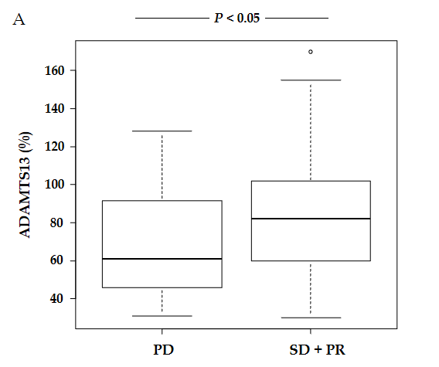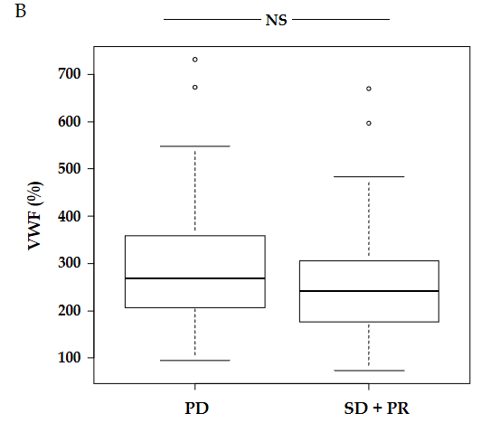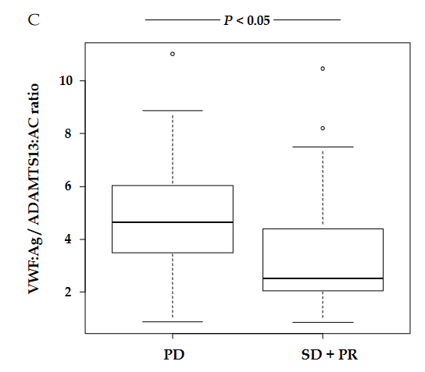

Figure 1 Plasma ADAMTS13:AC and VWF:Ag levels in patients with hepatocellular carcinoma receiving hepatic arterial infusion chemotherapy treatment. A: ADAMTS13 activity (ADAMTS13:AC) levels were significantly higher in hepatocellular carcinoma patients receiving hepatic arterial infusion chemotherapy treatment with stable disease (SD) + partial response (PR) than in those with progressive disease (PD) (P < 0.05); B: VWF antigen (VWF:Ag) levels were not different between patients with SD + PR and PD; C: VWF:Ag/ADAMTS13:AC ratio was significantly lower in patients with SD + PR than in those with PD (P < 0.05). SD: Stable disease; PR: Partial response; PD: Progressive disease; ADAMTS13: A disintegrin-like and metalloproteinase with thrombospondin type 1 motifs 13; ADAMTS13:AC: ADAMTS13 activity; VWF: Von Willebrand factor; VWF:Ag: VWF antigen; VWF:Ag/ADAMTS13:AC ratio: Ratio of VWF:Ag to ADAMTS13:AC.
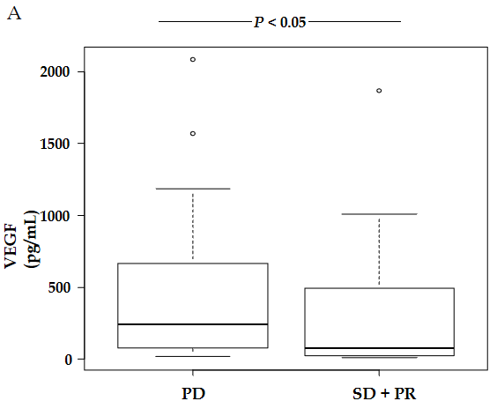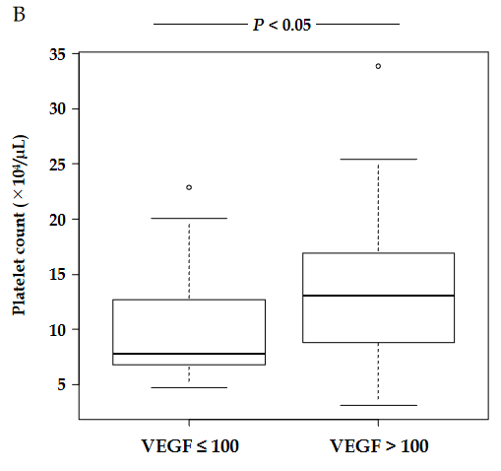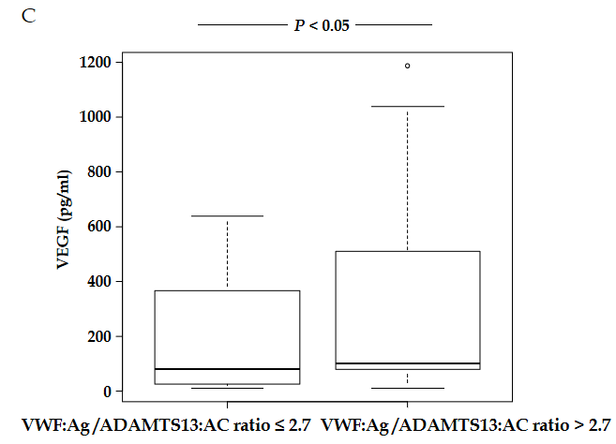

Figure 2 Plasma vascular endothelial growth factor levels in patients with hepatocellular carcinoma receiving hepatic arterial infusion chemotherapy treatment. A: Vascular endothelial growth factor (VEGF) levels were significantly lower in hepatocellular carcinoma patients with stable disease + partial response than in those with progressive disease (P < 0.05); B: Patients with high VEGF levels (> 100) had higher platelet levels than those with low VEGF levels (≤ 100) (P < 0.05); C: Patients with high Von Willebrand factor antigen (VWF:Ag)/ADAMTS13 activity (ADAMTS13:AC) ratio (> 2.7) had higher VEGF levels than those with low VWF:Ag/ADAMTS13:AC ratio (≤ 2.7). VEGF: Vascular endothelial growth factor; SD: Stable disease; PR: Partial response; PD: Progressive disease; ADAMTS13: A disintegrin-like and metalloproteinase with thrombospondin type 1 motifs 13; ADAMTS13:AC: ADAMTS13 activity; VWF: Von Willebrand factor; VWF:Ag: VWF antigen; VWF:Ag/ADAMTS13:AC ratio: Ratio of VWF:Ag to ADAMTS13:AC.

Table 1 Hepatocellular carcinoma patients’ characteristics between stable disease + partial response and progressive disease with hepatic arterial infusion chemotherapy

Variable | Total (n = 72) | SD + PR (n = 41) | PD (n = 31) | P value
Age (yr) | 70.5 (64.2–76.1) | 72.0 (66.4–76.4) | 67.8 (58.9–75.1) | NS
Sex (male/female) | 57/15 | 32/9 | 25/6 | NS
Etiology (HBV/HCV/alcohol/NASH/others) | 17/36/10/4/5 | 6/23/5/4/3 | 11/13/5/0/2 | NS
Albumin (g/dL) | 3.2 (3.0–3.6) | 3.3 (3.0–3.6) | 3.2 (3.0–3.7) | NS
Prothrombin time (%) | 76.0 (60.5–85.3) | 78.0 (57.0–86.0) | 73.0 (63.5–83.0) | NS
Total bilirubin (mg/dL) | 1.2 (0.8–2.1) | 1.2 (0.7–2.1) | 1.2 (0.8–2.2) | NS
Platelet count (× 10⁴/mm³) | 10.4 (7.1–14.9) | 10.8 (7.0–13.2) | 10.1 (7.6–17.1) | NS
AFP (ng/mL) | 95.3 (17.9–1162.5) | 101.0 (21.2–931.5) | 87.1 (13.2–1349.2) | NS
DCP (mAU/mL) | 359.5 (58.0–5277.5) | 348 (42.3–1542.8) | 609.0 (88.2–279.4) | NS
AFP-L3% (%) | 33.7 (7.7–73.4) | 34.3 (6.9–73.4) | 22.2 (8.1–68.8) | NS
Maximum tumor size (cm) | 3.3 (2.2–5.0) | 3.0 (2.0–5.0) | 3.5 (2.9–3.5) | NS
Tumor number (1/2/3/4/> 4) | 9/5/6/2/50 | 5/4/3/2/27 | 4/1/3/0/23 | NS
Vascular invasion (present/absent) | 31/41 | 20/21 | 11/20 | NS
Treatment period (days) | 121 (41–218) | 191(120–311) | 40.0 (26–61) | < 0.05
Data are expressed as median (interquartile range). P values represent comparisons between SD + PR and PD with hepatic arterial infusion chemotherapy. SD: Stable disease; PR: Partial response; PD: Progressive disease; HBV: Hepatitis B virus; HCV: Hepatitis C virus; NASH: Non-alcoholic steatohepatitis; AFP: Alpha-fetoprotein; DCP: Des-γ-carboxy prothrombin; AFP-L3%: Lens culinaris agglutinin-reactive alpha-fetoprotein.
Table 2 Predictive factors for response of hepatic arterial infusion chemotherapy in patients with hepatocellular carcinoma

Variable | Univariable analysis |  | Multivariable analysis
 | OR (95%CI) | P value | OR (95%CI) | P value
Age > 65 yr | 2.61 (0.905–7.5) | 0.076
Sex (male vs female) | 0.853 (0.268–2.72) | 0.788
Albumin > 2.8 g/dL | 1.40 (0.404–4.85) | 0.596
Prothrombin time > 80% | 2.68 (1.010–7.10) | 0.0469 | 1.98 (0.654–5.96) | 0.227
Total bilirubin > 2 mg/dL | 0.896 (0.317–2.53) | 0.836
Platelet count > 20 × 10⁴/µL | 1.57 (0.268–9.16) | 0.618
AFP > 50 ng/mL | 0.523 (0.194–1.41) | 0.199
DCP > 20 mAU/mL | 0.381 (0.0938–1.55) | 0.177
AFP-L3% > 20% | 1.33 (0.491–3.62) | 0.572
VEGF > 100 pg/mL | 0.223 (0.0802–0.618) | 0.0039 | 0.370 (0.127–1.07) | 0.0677
Maximum tumor size > 2.3 cm | 0.414 (0.130–1.32) | 0.137
Tumor number > 2 | 1.07 (0.261–4.35) | 0.928
Vascular invasion (present/absent) | 1.73 (0.665–4.51) | 0.261
ADAMTS13:AC > 75% | 1.25 (0.355–4.41) | 0.727
VWF:Ag > 260% | 0.711 (0.279–1.81) | 0.476
VWF:Ag/ADAMTS13:AC > 2.7 | 0.141 (0.0418–0.476) | 0.0016 | 0.176 (0.0493–0.631) | 0.00766
OR: Odds ratio; CI: Confidence interval; AFP: Alpha-fetoprotein; DCP: Des-γ-carboxy prothrombin; AFP-L3%: Lens culinaris agglutinin-reactive alpha-fetoprotein; VEGF: Vascular endothelial growth factor; ADAMTS13: A disintegrin-like and metalloproteinase with thrombospondin type 1 motifs 13; ADAMTS13:AC: ADAMTS13 activity; VWF: Von Willebrand factor; VWF:Ag: VWF antigen; VWF:Ag/ADAMTS13:AC ratio: Ratio of VWF:Ag to ADAMTS13:AC.

