Name of Journal: World Journal of Gastrointestinal Oncology
Manuscript NO: 88756
Manuscript Type: ORIGINAL ARTICLE

Observational Study
Computed tomography radiogenomics: A potential tool for prediction of molecular subtypes in gastric stromal tumor

Yin XN et al. CT radiogenomics predicts molecular subtypes of GIST

Xiao-Nan Yin, Zi-Hao Wang, Li Zou, Cai-Wei Yang, Chao-Yong Shen, Bai-Ke Liu, Yuan Yin, Xi-Jiao Liu, Bo Zhang

Xiao-Nan Yin, Zi-Hao Wang, Chao-Yong Shen, Bai-Ke Liu, Yuan Yin, Gastric Cancer Research Center, West China Hospital, Sichuan University, Chengdu 610041, Sichuan Province, China

Li Zou, Department of Paediatric Surgery, West China Hospital of Sichuan University, Chengdu 610041, Sichuan Province, China

Cai-Wei Yang, Xi-Jiao Liu, Department of Radiology, West China Hospital, Sichuan University, Chengdu 610041, Sichuan Province, China

Bo Zhang, Department of Gastrointestinal Surgery, Sichuan University West China Hospital, Chengdu 610041, Sichuan Province, China

Co-first authors: Xiao-Nan Yin and Zi-Hao Wang.

Author contributions: Yin XN and Wang ZH equally contributed to this article; Yin XN, Wang ZH, Zou L, Yang CW, Shen CY, Liu BK, Yin Y, Liu XJ, and Zhang B participated in all stages of manuscript preparation, and read and approved the final version prior to submission.

Supported by the National Natural Science Foundation of China Program Grant, No. 82203108; China Postdoctoral Science Foundation, No. 2022M722275; Beijing Bethune Charitable Foundation, No. WCJZL202105; and Beijing Xisike Clinical Oncology Research Foundation, No. Y-zai2021/zd-0185.

Corresponding author: Xi-Jiao Liu, PhD, Doctor, Department of Radiology, West China Hospital, Sichuan University, No. 37 Guoxue Lane, Wuhou District, Chengdu 610041, Sichuan Province, China. Bless_jiao@163.com

Received: October 8, 2023
Revised: January 23, 2024
Accepted: February 25, 2024
Published online:

Abstract
BACKGROUND
Preoperative knowledge of mutational status of gastrointestinal stromal tumors (GISTs) is essential to guide the individualized precision therapy.

AIM
To develop a combined model that integrates clinical and contrast-enhanced computed tomography (CE-CT) features to predict gastric GISTs with specific genetic mutations, namely KIT exon 11 mutations or KIT exon 11 codons 557-558 deletions.

METHODS

A total of 231 GIST patients with definitive genetic phenotypes were divided into a training dataset and a validation dataset in a 7:3 ratio. The models were constructed using selected clinical features, conventional CT features, and radiomics features extracted from abdominal CE-CT images. Three models were developed: Model_{CT sign}, model_{CT sign + rad}, and model CT_{sign + rad + clinic}. The diagnostic performance of these models was evaluated using receiver operating characteristic (ROC) curve analysis and the Delong test.

RESULTS
The ROC analyses revealed that in the training cohort, the area under the curve (AUC) values for model_{CT sign}, model_{CT sign + rad}, and model_{CT sign + rad + clinic} for predicting KIT exon 11 mutation were 0.743, 0.818, and 0.915, respectively. In the validation cohort, the AUC values for the same models were 0.670, 0.781, and 0.811, respectively. For predicting KIT exon 11 codons 557-558 deletions, the AUC values in the training cohort were 0.667, 0.842, and 0.720 for model_{CT sign}, model_{CT sign + rad}, and model_{CT sign + rad + clinic}, respectively. In the validation cohort, the AUC values for the same models were 0.610, 0.782, and 0.795, respectively. Based on the decision curve analysis, it was determined that the model_{CT sign + rad + clinic} had clinical significance and utility.

CONCLUSION
Our findings demonstrate that the combined model_{CT sign + rad + clinic} effectively distinguishes GISTs with KIT exon 11 mutation and KIT exon 11 codons 557-558 deletions. This combined model has the potential to be valuable in assessing the genotype of GISTs.

Key Words: Gastrointestinal stromal tumor; Radiomics; Gene mutation; Computed tomography; Model

Yin XN, Wang ZH, Zou L, Yang CW, Shen CY, Liu BK, Yin Y, Liu XJ, Zhang B. Computed tomography radiogenomics: A potential tool for prediction of molecular subtypes in gastric stromal tumor. World J Gastrointest Oncol 2024; In press

Core Tip: In this study, we developed and validated a radiomics model to predict the genotypes of gastric gastrointestinal stromal tumors (GISTs) using contrast-enhanced computed tomography images. Our findings demonstrated that the radiomics model exhibited a satisfactory performance in distinguishing gastric GISTs with KIT exon 11 mutations and GISTs with KIT exon 11 codons 557-558 deletions. Among the different models evaluated, the combined model_{CT sign + rad + clinic} demonstrated the highest predictive accuracy. This model holds promise as an effective and noninvasive approach to guide personalized treatment decisions prior to surgery.

INTRODUCTION
Gastrointestinal stromal tumor (GIST) is the most common mesenchymal tumor of the gastrointestinal tract, with an annual incidence ranging from 6 to 22 cases per million individuals^{[1,2]}. The stomach is the primary site of GIST onset, accounting for 60%-65% of cases^{[3]}. Prior to the year 2000, advanced GISTs had no effective medical therapy due to their poor response to chemotherapy and radiotherapy. However, the identification of activating KIT mutations in GISTs led to the rapid development of the first tyrosine kinase inhibitor (TKI), imatinib, which significantly improved clinical outcomes for GIST patients^{[4,5]}. In addition to KIT mutations, mutations in other genes such as PDGFRA, NF-1, BRAF, KRAS, and PIK3CA, as well as SDH deficiency, have been discovered in GISTs^{[1,6]}. The presence of specific driver oncogenic genes in GISTs has made it a paradigm for precision medicine treatment.
The majority of GISTs harbor KIT mutations (80%) or PDGFRA mutations (5%-10%)^{[7,8]}. Testing for KIT and PDGFRA mutations is crucial for defining GIST pathological diagnosis, predicting tumor prognosis, and guiding TKI therapy. Studies have shown that patients with PDGFRA mutations have a better prognosis compared to those with KIT mutations^{[9]}. Among GIST patients with KIT exon 11 mutations, those with deletion or insertion-deletion mutations have a worse prognosis than those with point or repeat mutations. In addition, the presence of multiple codon deletion mutations or deletions affecting codons 557-558 on KIT exon 11 has been linked to an aggressive biological phenotype and an unfavorable prognosis^{[10,11]}. It has been clinically observed that GISTs exhibit different response rates to imatinib depending on their mutation status. GISTs with KIT exon 11 mutations have a higher response rate and recurrence-free survival to standard imatinib therapy compared to exon 9 tumors. Most PDGFRA mutations respond to imatinib, with the exception of D842V. Therefore, predicting the mutation status of tumors is crucial for managing GISTs. However, currently, tumor mutation status can only be obtained after surgical resection or conventional invasive biopsy, making preoperative genotyping of GISTs more challenging.
Contrast-enhanced computed tomography (CE-CT) is routinely used in clinical practice for the detection and evaluation of GISTs. Recent advancements in CT image acquisition have enabled the acquisition of high-quality isotropic images that provide rich data beyond general morphological information. Radiomics, an emerging quantitative imaging method, can convert high-throughput medical imaging features into quantitative data. It has been extensively applied for differential diagnosis, prognostic prediction, prediction of biological behavior, treatment outcomes, and tumor genetics^{[12-15]}. Previous studies have demonstrated that radiomics features can predict the malignant potential and prognosis of GIST^{[16-19]}. Radiogenomics, a promising paradigm, integrates clinical imaging with molecular and genomic imaging. However, there have been limited studies on radiomics for predicting the mutational status of GISTs^{[20-22]}.
In 2021, the primary outcomes of our research were published^{[21]}. The study revealed associations between GISTs with KIT exon 11 mutations and CE-CT images. CT radiogenomics showed promising potential in predicting the KIT exon 11 mutation status of GISTs. This study focuses specifically on gastric GISTs and aims to develop a prediction model for genotypes using CE-CT images.

MATERIALS AND METHODS
Patients
This retrospective study obtained ethical approval from the Research Ethics Board of West China Hospital, Sichuan University, China [Number: 2022(449)], and informed consent was waived due to the nature of the study. The inclusion criteria were as follows: (1) Patients who underwent CE-CT examination at our hospital within 30 d prior to surgery or biopsy; (2) patients diagnosed with primary gastric GISTs confirmed by pathological examination; and (3) patients with definitive genetic analysis results. The exclusion criteria were as follows: (1) Patients who received preoperative antitumoral treatment; (2) patients with tumor rupture; and (3) patients with inadequate CE-CT image quality, such as severe motion artifact or portal phase image thickness exceeding 5 mm. A total of 231 patients from May 2010 to December 2021 were included in the study (Figure 1). Mutation analysis was performed on the coding sequence of the KIT gene (exon 9, 11, 13, and 17) and the PDGFRA gene (exon 12, 14, and 18) using Sanger sequencing. Clinical information and pathology results were also collected.

CT imaging acquisition
All CT examinations were performed using three different CT scanners: A 64-slice CT scanner (Philips Medical system, Eindhoven, The Netherlands), a 128-slice CT scanner (SOMATOM Definition AS +, Siemens Healthcare, Germany), and a dual-source CT system (Somatom Definition Flash, Siemens Healthcare, Germany). Prior to the CT examination, patients were required to fast for at least 6 h and ingest 600-1000 mL of water. The CT scanning range encompassed the entire abdomen. The parameters for the CT examinations were as follows: Tube voltage of 120 kV, tube current ranging from 145 to 200 mAs, slice thickness of 2-5 mm, slice interval of 2 mm, field of view ranging from 35 cm to 50 cm, matrix size of 512 × 512, rotation time of 0.5 s, and pitch of 1.0. In all patients, an iodinated contrast agent (1.2-1.5 mL/kg) was intravenously injected using a syringe pump. Enhanced images were acquired during the arterial phase triggered at a threshold of 170 hounsfield units, and the portal venous phase was captured 30 s after the trigger.

CT imaging analysis
The CT images were independently reviewed by two radiologists who were blinded to the clinicopathological data. Discrepancies between the two radiologists were resolved through consensus. The following CT features were evaluated using Syngo Imaging Workplaces (VersionVB35A, Siemens AG, Erlangen, Germany): Tumor location, size, shape (regular or irregular), margin (well-defined or ill-defined), growth pattern (exophytic, endophytic, or mixed), density (hypodensity, isodensity, or hyperdensity), enhancement pattern and degree (mild, moderate, or marked), presence of internal low attenuation areas (necrosis, gas, or cystic degeneration), calcification, superficial ulceration, presence of intra-tumoral vessels, infiltration of adjacent mesangial fat, invasion of adjacent organs, distant metastasis, and lymphadenopathy. The CT attenuation value was measured by delineating the region of interest (ROI) along the tumor edge on each consecutive slice covering the entire lesion, excluding vessels, gas, and necrotic areas. Tumor necrosis was defined as an irregular area within the tumor with a CT attenuation value < 20 HU in each phase and an enhancement increase of less than 10 HU among the three phases. Cystic degeneration was characterized as a region with a smooth and well-defined border and a density similar to water (CT attenuation value of 0-20 HU).

Radiomic analysis
All CE-CT images were collected and exported to the ITK-SNAP software (version 3.6.0, http://www.itk-snap.org) for manual segmentation of the ROI. For each patient, the portal vein phase images were reviewed, and the two largest cross-section slices were selected. ROIs were delineated over the solid portion of the entire lesion, excluding gas, calcification, vessels, and necrotic areas. The segmentation procedure was independently performed by two radiologists.
The Intelligence Foundry (Version 1.2, General Electric) was utilized to extract radiomics features from the lesions. A total of 554 features, comprising Original features, Co-occurrence of Local Anisotropic Gradient Orientations features, and Wavelet and local binary pattern (Wavelet-LBP) features, were extracted using PyRadiomic^{[23]}. The reproducibility of the features was evaluated by calculating intra- and inter-class correlation coefficients (ICCs). Radiomics features that exhibited ICC values exceeding 0.75 in both intra- and inter-observer comparisons were selected for further feature analysis.
The entire dataset was randomly divided into training and internal validation datasets in a 7:3 ratio. The training dataset was exclusively used for feature selection and modeling. The feature preprocessing, feature selection, and modeling methods were as follows.
Based on the features identified through the ICC analysis, features with a variance less than 1.0 were excluded. Outlier values greater than the third quartile plus twice the interquartile range were converted to the 95th percentile, while values less than the first quartile minus twice the interquartile range were converted to the 10th percentile. To address the class imbalance in the training dataset, the synthetic minority oversampling technique was employed, with 200% oversampling and 150% undersampling^{[24]}. Subsequently, all features were normalized and standardized using the Z-Score method. The feature importance was evaluated using random forest (RF) based on the mean decrease of Gini calculated for all decision trees in the RF model. The top three important features were selected and used to construct the RF model^{[25,26]}.

Statistical analysis
Statistical analysis was conducted using SPSS software (Version 19, Chicago, IL, United States) and R software (Version 3.6.3; http://www.Rproject.org). All statistical significance levels were two-sided, and a significance level of P < 0.05 was considered statistically significant. To compare the significant differences between different genotype groups in both the training and validation cohorts, the Mann-Whitney U test or independent sample t-test was employed. Fisher's exact test or chi-square test was utilized to identify significant differences between different groups of continuous variables. The discrimination performance of the models was evaluated using receiver operating characteristic (ROC) curves. The area under the ROC curve (AUC) was used as a comprehensive measure of performance. Specificity, sensitivity, and positive and negative predictive values were used to assess model performance at specific thresholds, which were determined by maximizing the Youden index. The Delong test was employed to compare the AUC of paired models. Internal validation was estimated by performing regular bootstrapping with 1000 bootstrap samples^{[27]}. The goodness-of-fit of the model was assessed using the Hosmer-Lemeshow test, with a P-value greater than 0.05 indicating agreement between the observed and predicted values. Model calibration was visualized using calibration curve analysis, and the clinical net benefit of the model was evaluated using decision curve analysis (DCA).

RESULTS
Clinicopathological characteristics
The clinicopathological characteristics of all 231 patients included in our study are listed in Table 1. Among the 231 cases of GISTs, 192 exhibited the KIT exon 11 mutation, while 39 were characterized as wild type (23 cases), PDGFRA exon 18 mutation (12 cases), KIT exon 9 mutation (2 cases), KIT exon 17 mutation (1 case), or PDGFRA exon 14 mutation (1 case). Within the group of patients with the KIT exon 11 mutation, 56 individuals had exon 11 deletions involving codons 557-558.
Based on the results of the univariate analysis, gender, age, mitotic count, and risk classification did not show significant differences between the group with the KIT exon 11 mutation and the group with other types of gene mutations (P > 0.05 for all). However, a significant difference was observed in the mitotic count and risk classification between the group with KIT exon 11 codons 557-558 deletion and the group without deletions in codons 557-558 (P < 0.01).

CT features analysis
The primary analysis of the subjective CT features is presented in Table 2. In the univariate analysis, significant differences were observed in tumor shape, enhancement degree, and cystic change between the group with the KIT exon 11 mutation and the group with other types of gene mutations (P < 0.05). The CT features that showed statistical significance in the univariate analysis were included in the multivariate regression analysis. The results demonstrated that enhancement degree served as an independent predictor for the presence of the KIT exon 11 mutation. Moreover, notable disparities in CT features were observed between the group characterized by KIT exon 11 codons 557-558 deletion and the group lacking deletions in codons 557-558. Tumor size, tumor shape, margin, growth pattern, enhancement pattern, necrosis, intra-tumoral vessel presence, infiltration of adjacent mesangial fat, invasion of adjacent organs, and distant metastasis displayed significant differences between these two groups, as indicated by the univariate analysis. The multivariate regression analysis revealed that tumor size, tumor shape, and growth pattern were independent predictors for the presence of KIT exon 11 codons 557-558 deletion (P < 0.05).

Diagnostic performance of models
A set of 190 radiomic features, exhibiting ICC values exceeding 0.75 in intra- and inter-individual comparisons, was utilized for constructing the diagnostic model.

For KIT exon 11 mutation: Three CT features (gas, growth pattern, and density in arterial phase), three radiomic features (original_firstorder_Median, original_firstorder_InterquartileRange, and original_firstorder), and six clinic features (age, size, CD34, Ki-67, mitoses, and tissue-type) were extracted to build three models: Model_{CT sign}, model_{CT sign + rad}, and model_{CT sign + rad + clinic}. The combined model was developed using logistic regression, incorporating the model scores generated by each independent model. In the model_{CT sign + rad}, the Radscore was calculated as (4.58) × rad + (1.565) × ctsign + (-2.906). In the model_{CT sign + rad + clinic}, the Radscore was calculated as (4.364) × rad + (1.76) × ctsign + (5.207) × clinic + (-5.665). The training cohort exhibited AUC values of 0.743, 0.818, and 0.915 for the three models, while the validation cohort showed AUC values of 0.670, 0.781, and 0.811, respectively (Figure 2A and B). The corrected AUC values, obtained by subtracting the average optimism from the apparent AUC of the CE-CT and radiomics models, were 0.690 and 0.805, indicating relatively stable results. The diagnostic performance of the three models is presented in Table 3. Notable disparities were noted among all paired diagnostic metrics for the three models in both the training and validation cohorts. The diagnostic accuracy of model_{CT sign + rad + clinic} was significantly higher than that of model_{CT sign} and model_{CT sign + rad}. DCA demonstrated that model_{CT sign + rad + clinic} yielded the highest overall net benefit compared to model_{CT sign} or model_{CT sign + rad} in predicting the KIT exon 11 mutation in the training cohort across a wide range of threshold probabilities (Figure 2C). However, similar results were not observed in the validation set (Figure 2D).

For deletions in KIT exon 11 codons 557-558: One CT feature (shape), three radiomic features (wavelet_HLH_lbp_3D_k_firstorder_TotalEnergy, original_firstorder_Energy, and original_girlm_RunVariance), and three clinic features (Ki-67, mitoses, and tumor-size) were extracted to build three models: Model_{CT sign}, model_{CT sign + rad}, and model_{CT sign + rad + clinic}. In the model_{CT sign + rad}, the Radscore was calculated as (7.907) × rad + (4.535) × ctsign + (-3.937). In the model_{CT sign + rad + clinic,} the Radscore was calculated as (5.898) × rad + (2.636) × ctsign + (3.599) × clinic + (-4.11). The training cohort exhibited AUC values of 0.667, 0.842, and 0.872 for the three models, while the validation cohort showed AUC values of 0.61, 0.782, and 0.795, respectively (Figure 3A and B). The corrected AUC values, obtained by subtracting the average optimism from the apparent AUC of the CE-CT and radiomics models, were 0.773 and 0.751, indicating relatively stable results. The diagnostic performance of the three models is presented in Table 4. Notable variances were identified among all paired diagnostic metrics for the three models in both the training and validation cohorts. The diagnostic accuracy of model_{CT sign + rad + clinic} was significantly higher than that of model_{CT sign} and model_{CT sign + rad}. DCA demonstrated that model_{CT sign + rad + clinic} produced the highest overall net benefit compared to model_{CT sign} in predicting the deletions in KIT exon 11 codons 557-558 in both the training and validation cohorts across the entire risk threshold range (Figure 3A and B). However, DCA showed no significant differences between model_{CT sign + rad + clinic} and model_{CT sign + rad} in both the training and validation cohorts (Figure 3C and D).

DISCUSSION
Approximately 80% of GISTs harbor KIT mutations, while 5%-10% exhibit PDGFRA mutations. The presence and specific type of KIT and PDGFRA mutations are associated with the prognosis and clinical response to targeted therapy in GISTs^{[9,28]}. Currently, mutation testing is typically performed on surgically resected tissue samples. However, some GIST patients are unable to undergo surgical resection at the time of initial diagnosis. For these patients, fine-needle biopsy samples provide adequate material for pathological examination but are insufficient for genetic analysis. Moreover, genetic testing is not routinely conducted in all hospitals due to its high cost. Therefore, there is an urgent need to establish a noninvasive, accurate, and cost-effective preoperative method for identifying the mutation status of GISTs.
CT is extensively employed in the detection, postoperative surveillance, and evaluation of treatment effectiveness in GISTs. Recent studies have identified several CT features associated with the differential diagnosis and high-risk categorization of GISTs, including tumor size, location, margin characteristics, hemorrhage, necrosis, heterogeneous enhancement, and adjacent organ invasion^{[29-31]}. However, these conventional CT features rely on subjective analysis and the experience of radiologists, resulting in variability and lack of reproducibility. Radiomics, on the other hand, enables the extraction of high-throughput quantitative features from medical images using specific data characterization algorithms. This approach effectively reduces intra- and inter-observer variability. Importantly, radiomics has been widely applied in tumor diagnosis, prognosis prediction, and gene mutation analysis^{[32-36]}.
Several prior studies have reported the satisfactory performance of CT-based radiomics in the diagnosis and prediction of the malignant potential of GISTs^{[17,37-39]}. Starmans et al^{[40]} documented that the radiomics model achieved an AUC of 0.77 in distinguishing GISTs from non-GISTs, yielding results comparable to those of radiologists but with reduced observer dependence. Furthermore, radiomics studies in GISTs have primarily focused on predicting malignant potential and prognosis. These investigations have demonstrated the robust predictive effect and generalizability of radiomics in assessing the malignant potential of GISTs, thereby aiding clinicians in preoperative decision-making. However, there is a paucity of radiomics studies pertaining to genotype prediction. Xu et al^{[41]} were the first to attempt differentiation of GISTs with and without KIT exon 11 mutations using CT texture analysis in a study cohort comprising 69 GISTs, with a validation group of 17 GISTs. They identified that the textural parameter standard deviation independently predicted GISTs without KIT exon 11 mutations, achieving AUC values of 0.726-0.750 in the study group and 0.904-0.962 in the validation group. Nonetheless, the relatively small sample sizes in this study may have impacted the accuracy of the findings. Starmans et al^{[40]} also evaluated radiomics for predicting KIT mutational status in 123 patients with GISTs, reporting AUC values of 0.52 for KIT and 0.56 for KIT exon 11 mutation. These findings did not support the predictive value of the radiomics model in genetic features, likely due to study limitations. The remaining two studies both demonstrated the effective differentiation of GISTs with KIT exon 11 mutations using radiomics based on CT images^{[20,21]}. However, the patient populations in these studies encompassed GISTs throughout the entire gastrointestinal tract, including the stomach, intestine, and colorectum, potentially introducing certain biases. It is well-known that GISTs at different sites exhibit distinct recurrence risks, with intestinal GISTs carrying a worse prognosis than gastric GISTs. Furthermore, genotypes have been closely associated with specific tumor locations, with KIT exon 11 mutations being most common in GISTs at all sites, while KIT exon 9 mutations are prevalent in intestinal GISTs, and PDGFRA exon 18 mutations are common in gastric GISTs^{[42]}.
Our study was derived from a large-scale imaging dataset and represents the first CT radiogenomics investigation specifically focused on gastric GISTs. The results revealed that the diagnostic accuracy of model_{CT sign + rad + clinic} for predicting KIT exon 11 mutation was significantly higher than that of model_{CT sign} and model_{CT sign + rad}, with AUC values of 0.915 in the training cohort and 0.811 in the validation cohorts. The DCA curves demonstrated that model_{CT sign + rad + clinic} exhibited superior predictive effectiveness compared to model_{CT sign} and model_{CT sign + rad} in the training cohorts, highlighting the clinical benefit of the combined model in distinguishing gastric GISTs with KIT exon 11 mutation.
Regarding deletions in KIT exon 11 codons 557-558 of gastric GISTs, the diagnostic accuracy of model_{CT sign + rad + clinic} was statistically higher than that of model_{CT sign} and model_{CT sign + rad model}, with AUC values of 0.872 in the training cohort and 0.795 in the validation cohorts. The clinical benefits analysis revealed that the combined model outperformed model_{CT sign} and model_{CT sign + rad} in predicting the KIT exon 11 mutation. In the validation cohort, the sensitivity and specificity of model_{CT sign + rad + clinic} for predicting the KIT exon 11 mutation were 83.0% and 81.1%, respectively, surpassing the performance of model_{CT sign} and model_{CT sign + rad}. The clinical benefit of the combined model was further confirmed by the DCA curves. These findings highlight the excellent predictive ability of model_{CT sign + rad + clinic} for determining the KIT mutation status of gastric GISTs, suggesting its potential value in guiding noninvasive clinical decision-making prior to surgery.
However, it is important to acknowledge certain limitations in our study. Firstly, it was a retrospective study, and as such, potential selection bias could not be completely eliminated. Secondly, despite the large sample size, this study was conducted at a single center, and further validation through multicenter studies is warranted. Thirdly, due to the small sample size, we did not subdivide GISTs without KIT exon 11 mutation, which is crucial for clinicians to differentiate specific types of gene mutations before surgery, such as KIT exon 9 mutation and PDGFRA exon 18 mutation, as the treatment response varies.

CONCLUSION
In conclusion, our study demonstrated that the radiomics model based on CE-CT images exhibited satisfactory performance in distinguishing gastric GISTs with KIT exon 11 mutation and GISTs with KIT exon 11 codons 557-558 deletions. The combined model_{CT sign + rad + clinic} demonstrated the highest predictive value, offering a potentially valuable and noninvasive approach to guide personalized treatment decisions prior to surgery.

ARTICLE HIGHLIGHTS
Research background
The assessment of KIT and PDGFRA mutations plays a vital role in establishing the pathological diagnosis of gastrointestinal stromal tumors (GISTs), predicting tumor prognosis, and guiding the administration of tyrosine kinase inhibitor therapy. For patients who are ineligible for genetic analysis, possessing information regarding the mutational status of GISTs is of paramount importance for the purpose of customizing personalized precision therapy.

Research motivation
Currently, tumor mutation status can only be obtained after surgical resection or conventional invasive biopsy, making preoperative genotyping of GISTs more challenging.

Research objectives
To develop and validate a radiomic model to predict the genotypes of gastric GISTs using contrast-enhanced computed tomography (CE-CT) images.

Research methods
The models for predicting GISTs with KIT exon 11 mutations or KIT exon 11 codons 557-558 deletions were constructed using selected clinical features, conventional CT features, and radiomics features extracted from abdominal CE-CT images. Three models were developed: Model_{CT sign}, model_{CT sign + rad}, and model_{CT} _{sign + rad + clinic}. The diagnostic performance of these models was evaluated using receiver operating characteristic (ROC) curve analysis and the Delong test.

Research results
The ROC analyses demonstrated the performance of different models in predicting KIT exon 11 mutation and KIT exon 11 codons 557-558 deletions. In the training cohort, the models_{CT sign,} model_{CT sign + rad}, and model_{CT sign + rad + clinic} achieved area under the curve (AUC) values of 0.743, 0.818, and 0.915, respectively, for predicting KIT exon 11 mutation. In the validation cohort, the corresponding AUC values were 0.670, 0.781, and 0.811. For predicting KIT exon 11 codons 557-558 deletions, the AUC values in the training cohort were 0.667, 0.842, and 0.72 for model_{CT sign}, model_{CT sign + rad}, and model_{CT sign + rad + clinic}, respectively. In the validation cohort, the AUC values for the same models were 0.610, 0.782, and 0.795. Furthermore, the decision curve analysis confirmed the clinical significance and utility of the CT sign + rad + clinic model.

Research conclusions
Our study demonstrated that the radiomics model based on CE-CT images exhibited satisfactory performance in distinguishing gastric GISTs with KIT exon 11 mutation and GISTs with KIT exon 11 codons 557-558 deletions.

Research perspectives
This study focuses specifically on gastric GISTs and aims to develop a prediction model for genotypes using CE-CT images.

REFERENCES
1 Blay JY, Kang YK, Nishida T, von Mehren M. Gastrointestinal stromal tumours. Nat Rev Dis Primers 2021; 7: 22 [PMID: 33737510 DOI: 10.1038/s41572-021-00254-5]
2 Søreide K, Sandvik OM, Søreide JA, Giljaca V, Jureckova A, Bulusu VR. Global epidemiology of gastrointestinal stromal tumours (GIST): A systematic review of population-based cohort studies. Cancer Epidemiol 2016; 40: 39-46 [PMID: 26618334 DOI: 10.1016/j.canep.2015.10.031]
3 Corless CL, Barnett CM, Heinrich MC. Gastrointestinal stromal tumours: origin and molecular oncology. Nat Rev Cancer 2011; 11: 865-878 [PMID: 22089421 DOI: 10.1038/nrc3143]
4 Klug LR, Khosroyani HM, Kent JD, Heinrich MC. New treatment strategies for advanced-stage gastrointestinal stromal tumours. Nat Rev Clin Oncol 2022; 19: 328-341 [PMID: 35217782 DOI: 10.1038/s41571-022-00606-4]
5 Pierotti MA, Tamborini E, Negri T, Pricl S, Pilotti S. Targeted therapy in GIST: in silico modeling for prediction of resistance. Nat Rev Clin Oncol 2011; 8: 161-170 [PMID: 21364689 DOI: 10.1038/nrclinonc.2011.3]
6 Dermawan JK, Rubin BP. Molecular Pathogenesis of Gastrointestinal Stromal Tumor: A Paradigm for Personalized Medicine. Annu Rev Pathol 2022; 17: 323-344 [PMID: 34736340 DOI: 10.1146/annurev-pathol-042220-021510]
7 Boikos SA, Pappo AS, Killian JK, LaQuaglia MP, Weldon CB, George S, Trent JC, von Mehren M, Wright JA, Schiffman JD, Raygada M, Pacak K, Meltzer PS, Miettinen MM, Stratakis C, Janeway KA, Helman LJ. Molecular Subtypes of KIT/PDGFRA Wild-Type Gastrointestinal Stromal Tumors: A Report From the National Institutes of Health Gastrointestinal Stromal Tumor Clinic. JAMA Oncol 2016; 2: 922-928 [PMID: 27011036 DOI: 10.1001/jamaoncol.2016.0256]
8 Corless CL, Schroeder A, Griffith D, Town A, McGreevey L, Harrell P, Shiraga S, Bainbridge T, Morich J, Heinrich MC. PDGFRA mutations in gastrointestinal stromal tumors: frequency, spectrum and in vitro sensitivity to imatinib. J Clin Oncol 2005; 23: 5357-5364 [PMID: 15928335 DOI: 10.1200/jco.2005.14.068]
9 Rossi S, Gasparotto D, Miceli R, Toffolatti L, Gallina G, Scaramel E, Marzotto A, Boscato E, Messerini L, Bearzi I, Mazzoleni G, Capella C, Arrigoni G, Sonzogni A, Sidoni A, Mariani L, Amore P, Gronchi A, Casali PG, Maestro R, Dei Tos AP. KIT, PDGFRA, and BRAF mutational spectrum impacts on the natural history of imatinib-naive localized GIST: a population-based study. Am J Surg Pathol 2015; 39: 922-930 [PMID: 25970686 DOI: 10.1097/PAS.0000000000000418]
10 Joensuu H. Risk stratification of patients diagnosed with gastrointestinal stromal tumor. Hum Pathol 2008; 39: 1411-1419 [PMID: 18774375 DOI: 10.1016/j.humpath.2008.06.025]
11 Joensuu H, Rutkowski P, Nishida T, Steigen SE, Brabec P, Plank L, Nilsson B, Braconi C, Bordoni A, Magnusson MK, Sufliarsky J, Federico M, Jonasson JG, Hostein I, Bringuier PP, Emile JF. KIT and PDGFRA mutations and the risk of GI stromal tumor recurrence. J Clin Oncol 2015; 33: 634-642 [PMID: 25605837 DOI: 10.1200/JCO.2014.57.4970]
12 Hong JH, Jung JY, Jo A, Nam Y, Pak S, Lee SY, Park H, Lee SE, Kim S. Development and Validation of a Radiomics Model for Differentiating Bone Islands and Osteoblastic Bone Metastases at Abdominal CT. Radiology 2021; 299: 626-632 [PMID: 33787335 DOI: 10.1148/radiol.2021203783]
13 Kirienko M, Sollini M, Corbetta M, Voulaz E, Gozzi N, Interlenghi M, Gallivanone F, Castiglioni I, Asselta R, Duga S, Soldà G, Chiti A. Radiomics and gene expression profile to characterise the disease and predict outcome in patients with lung cancer. Eur J Nucl Med Mol Imaging 2021; 48: 3643-3655 [PMID: 33959797 DOI: 10.1007/s00259-021-05371-7]
14 Li L, Kan X, Zhao Y, Liang B, Ye T, Yang L, Zheng C. Radiomics Signature: A potential biomarker for the prediction of survival in Advanced Hepatocellular Carcinoma. Int J Med Sci 2021; 18: 2276-2284 [PMID: 33967603 DOI: 10.7150/ijms.55510]
15 Schniering J, Maciukiewicz M, Gabrys HS, Brunner M, Blüthgen C, Meier C, Braga-Lagache S, Uldry AC, Heller M, Guckenberger M, Fretheim H, Nakas CT, Hoffmann-Vold AM, Distler O, Frauenfelder T, Tanadini-Lang S, Maurer B. Computed tomography-based radiomics decodes prognostic and molecular differences in interstitial lung disease related to systemic sclerosis. Eur Respir J 2022; 59 [PMID: 34649979 DOI: 10.1183/13993003.04503-2020]
16 Chen T, Ning Z, Xu L, Feng X, Han S, Roth HR, Xiong W, Zhao X, Hu Y, Liu H, Yu J, Zhang Y, Li Y, Xu Y, Mori K, Li G. Radiomics nomogram for predicting the malignant potential of gastrointestinal stromal tumours preoperatively. Eur Radiol 2019; 29: 1074-1082 [PMID: 30116959 DOI: 10.1007/s00330-018-5629-2]
17 Chen Z, Xu L, Zhang C, Huang C, Wang M, Feng Z, Xiong Y. CT Radiomics Model for Discriminating the Risk Stratification of Gastrointestinal Stromal Tumors: A Multi-Class Classification and Multi-Center Study. Front Oncol 2021; 11: 654114 [PMID: 34168985 DOI: 10.3389/fonc.2021.654114]
18 Wang C, Li H, Jiaerken Y, Huang P, Sun L, Dong F, Huang Y, Dong D, Tian J, Zhang M. Building CT Radiomics-Based Models for Preoperatively Predicting Malignant Potential and Mitotic Count of Gastrointestinal Stromal Tumors. Transl Oncol 2019; 12: 1229-1236 [PMID: 31280094 DOI: 10.1016/j.tranon.2019.06.005]
19 Zhao Y, Feng M, Wang M, Zhang L, Li M, Huang C. CT Radiomics for the Preoperative Prediction of Ki67 Index in Gastrointestinal Stromal Tumors: A Multi-Center Study. Front Oncol 2021; 11: 689136 [PMID: 34595107 DOI: 10.3389/fonc.2021.689136]
20 Liu B, Liu H, Zhang L, Song Y, Yang S, Zheng Z, Zhao J, Hou F, Zhang J. Value of contrast-enhanced CT based radiomic machine learning algorithm in differentiating gastrointestinal stromal tumors with KIT exon 11 mutation: a two-center study. Diagn Interv Radiol 2022; 28: 29-38 [PMID: 35142612 DOI: 10.5152/dir.2021.21600]
21 Liu X, Yin Y, Wang X, Yang C, Wan S, Yin X, Wu T, Chen H, Xu Z, Li X, Song B, Zhang B. Gastrointestinal stromal tumors: associations between contrast-enhanced CT images and KIT exon 11 gene mutation. Ann Transl Med 2021; 9: 1496 [PMID: 34805358 DOI: 10.21037/atm-21-3811]
22 Palatresi D, Fedeli F, Danti G, Pasqualini E, Castiglione F, Messerini L, Massi D, Bettarini S, Tortoli P, Busoni S, Pradella S, Miele V. Correlation of CT radiomic features for GISTs with pathological classification and molecular subtypes: preliminary and monocentric experience. Radiol Med 2022; 127: 117-128 [PMID: 35022956 DOI: 10.1007/s11547-021-01446-5]
23 van Griethuysen JJM, Fedorov A, Parmar C, Hosny A, Aucoin N, Narayan V, Beets-Tan RGH, Fillion-Robin JC, Pieper S, Aerts HJWL. Computational Radiomics System to Decode the Radiographic Phenotype. Cancer Res 2017; 77: e104-e107 [PMID: 29092951 DOI: 10.1158/0008-5472.CAN-17-0339]
24 Chawla NV, Bowyer KW, Hall LO, Kegelmeyer WP. Smote: Synthetic minority over-sampling technique. J AI Res 2002; 16: 321-357 [DOI: 10.48550/arXiv.1106.1813]
25 Breiman L. Random Forests. Machine Learning 2001; 45: 5-32 [DOI: 10.1023/A:1010933404324]
26 Rokach L. Decision Forest: Twenty years of research. Information Fusion 2016; 27: 111-125 [DOI: 10.1016/j.inffus.2015.06.005]
27 Steyerberg EW, Harrell FE Jr, Borsboom GJ, Eijkemans MJ, Vergouwe Y, Habbema JD. Internal validation of predictive models: efficiency of some procedures for logistic regression analysis. J Clin Epidemiol 2001; 54: 774-781 [PMID: 11470385 DOI: 10.1016/s0895-4356(01)00341-9]
28 Heinrich MC, Maki RG, Corless CL, Antonescu CR, Harlow A, Griffith D, Town A, McKinley A, Ou WB, Fletcher JA, Fletcher CD, Huang X, Cohen DP, Baum CM, Demetri GD. Primary and secondary kinase genotypes correlate with the biological and clinical activity of sunitinib in imatinib-resistant gastrointestinal stromal tumor. J Clin Oncol 2008; 26: 5352-5359 [PMID: 18955458 DOI: 10.1200/JCO.2007.15.7461]
29 Chen Z, Yang J, Sun J, Wang P. Gastric gastrointestinal stromal tumours (2-5 cm): Correlation of CT features with malignancy and differential diagnosis. Eur J Radiol 2020; 123: 108783 [PMID: 31841880 DOI: 10.1016/j.ejrad.2019.108783]
30 Xu JX, Ding QL, Lu YF, Fan SF, Rao QP, Yu RS. A scoring model for radiologic diagnosis of gastric leiomyomas (GLMs) with contrast-enhanced computed tomography (CE-CT): Differential diagnosis from gastrointestinal stromal tumors (GISTs). Eur J Radiol 2021; 134: 109395 [PMID: 33310552 DOI: 10.1016/j.ejrad.2020.109395]
31 Zhou C, Duan X, Zhang X, Hu H, Wang D, Shen J. Predictive features of CT for risk stratifications in patients with primary gastrointestinal stromal tumour. Eur Radiol 2016; 26: 3086-3093 [PMID: 26699371 DOI: 10.1007/s00330-015-4172-7]
32 Balana C, Castañer S, Carrato C, Moran T, Lopez-Paradís A, Domenech M, Hernandez A, Puig J. Preoperative Diagnosis and Molecular Characterization of Gliomas With Liquid Biopsy and Radiogenomics. Front Neurol 2022; 13: 865171 [PMID: 35693015 DOI: 10.3389/fneur.2022.865171]
33 Harding-Theobald E, Louissaint J, Maraj B, Cuaresma E, Townsend W, Mendiratta-Lala M, Singal AG, Su GL, Lok AS, Parikh ND. Systematic review: radiomics for the diagnosis and prognosis of hepatocellular carcinoma. Aliment Pharmacol Ther 2021; 54: 890-901 [PMID: 34390014 DOI: 10.1111/apt.16563]
34 Lu J, Li X, Li H. A radiomics feature-based nomogram to predict telomerase reverse transcriptase promoter mutation status and the prognosis of lower-grade gliomas. Clin Radiol 2022; 77: e560-e567 [PMID: 35595562 DOI: 10.1016/j.crad.2022.04.005]
35 Sohn B, An C, Kim D, Ahn SS, Han K, Kim SH, Kang SG, Chang JH, Lee SK. Radiomics-based prediction of multiple gene alteration incorporating mutual genetic information in glioblastoma and grade 4 astrocytoma, IDH-mutant. J Neurooncol 2021; 155: 267-276 [PMID: 34648115 DOI: 10.1007/s11060-021-03870-z]
36 Staal FCR, van der Reijd DJ, Taghavi M, Lambregts DMJ, Beets-Tan RGH, Maas M. Radiomics for the Prediction of Treatment Outcome and Survival in Patients With Colorectal Cancer: A Systematic Review. Clin Colorectal Cancer 2021; 20: 52-71 [PMID: 33349519 DOI: 10.1016/j.clcc.2020.11.001]
37 Shao M, Niu Z, He L, Fang Z, He J, Xie Z, Cheng G, Wang J. Building Radiomics Models Based on Triple-Phase CT Images Combining Clinical Features for Discriminating the Risk Rating in Gastrointestinal Stromal Tumors. Front Oncol 2021; 11: 737302 [PMID: 34950578 DOI: 10.3389/fonc.2021.737302]
38 Wang M, Feng Z, Zhou L, Zhang L, Hao X, Zhai J. Computed-Tomography-Based Radiomics Model for Predicting the Malignant Potential of Gastrointestinal Stromal Tumors Preoperatively: A Multi-Classifier and Multicenter Study. Front Oncol 2021; 11: 582847 [PMID: 33968714 DOI: 10.3389/fonc.2021.582847]
39 Zhang QW, Zhou XX, Zhang RY, Chen SL, Liu Q, Wang J, Zhang Y, Lin J, Xu JR, Gao YJ, Ge ZZ. Comparison of malignancy-prediction efficiency between contrast and non-contract CT-based radiomics features in gastrointestinal stromal tumors: A multicenter study. Clin Transl Med 2020; 10: e291 [PMID: 32634272 DOI: 10.1002/ctm2.91]
40 Starmans MPA, Timbergen MJM, Vos M, Renckens M, Grünhagen DJ, van Leenders GJLH, Dwarkasing RS, Willemssen FEJA, Niessen WJ, Verhoef C, Sleijfer S, Visser JJ, Klein S. Differential Diagnosis and Molecular Stratification of Gastrointestinal Stromal Tumors on CT Images Using a Radiomics Approach. J Digit Imaging 2022; 35: 127-136 [PMID: 35088185 DOI: 10.1007/s10278-022-00590-2]
41 Xu F, Ma X, Wang Y, Tian Y, Tang W, Wang M, Wei R, Zhao X. CT texture analysis can be a potential tool to differentiate gastrointestinal stromal tumors without KIT exon 11 mutation. Eur J Radiol 2018; 107: 90-97 [PMID: 30292279 DOI: 10.1016/j.ejrad.2018.07.025]
42 Lasota J, Miettinen M. Clinical significance of oncogenic KIT and PDGFRA mutations in gastrointestinal stromal tumours. Histopathology 2008; 53: 245-266 [PMID: 18312355 DOI: 10.1111/j.1365-2559.2008.02977.x]

Footnotes
Institutional review board statement: The study was reviewed and approved by the Research Ethics Board of West China Hospital, Sichuan University [approval No. 2022(449)].

Informed consent statement: The informed consent was waived by the Research Ethics Board of West China Hospital, Sichuan University.

Conflict-of-interest statement: The authors have declared that no competing interests exist.

Data sharing statement: All data analyzed during this study are included in this published article.

STROBE statement: The authors have read the STROBE Statement—checklist of items, and the manuscript was prepared and revised according to the STROBE Statement—checklist of items.

Open-Access: This article is an open-access article that was selected by an in-house editor and fully peer-reviewed by external reviewers. It is distributed in accordance with the Creative Commons Attribution NonCommercial (CC BY-NC 4.0) license, which permits others to distribute, remix, adapt, build upon this work non-commercially, and license their derivative works on different terms, provided the original work is properly cited and the use is non-commercial. See: https://creativecommons.org/Licenses/by-nc/4.0/

Provenance and peer review: Unsolicited article; Externally peer reviewed.
Peer-review model: Single blind

Peer-review started: October 8, 2023
First decision: January 15, 2024
Article in press:

Specialty type: Gastroenterology & hepatology
Country/Territory of origin: China
Peer-review report’s scientific quality classification
Grade A (Excellent): 0
Grade B (Very good): 0
Grade C (Good): C
Grade D (Fair): 0
Grade E (Poor): 0

P-Reviewer: Dimofte GM, Romania S-Editor: Chen YL L-Editor: A P-Editor:
Figure Legends
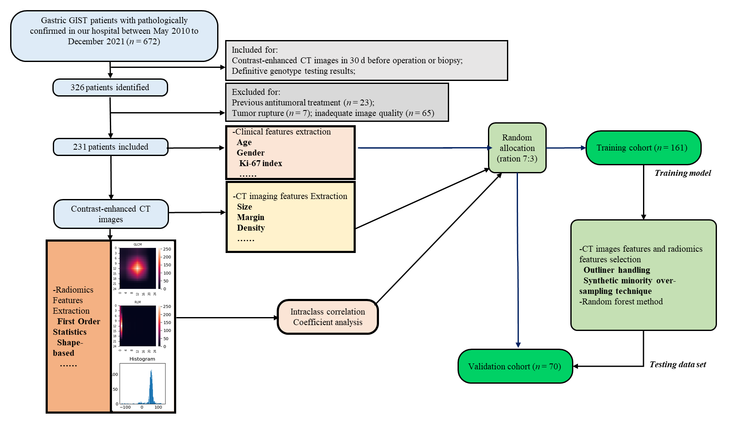
Figure 1 Study workflow. GIST: Gastrointestinal stromal tumor; CT: Computed tomography.
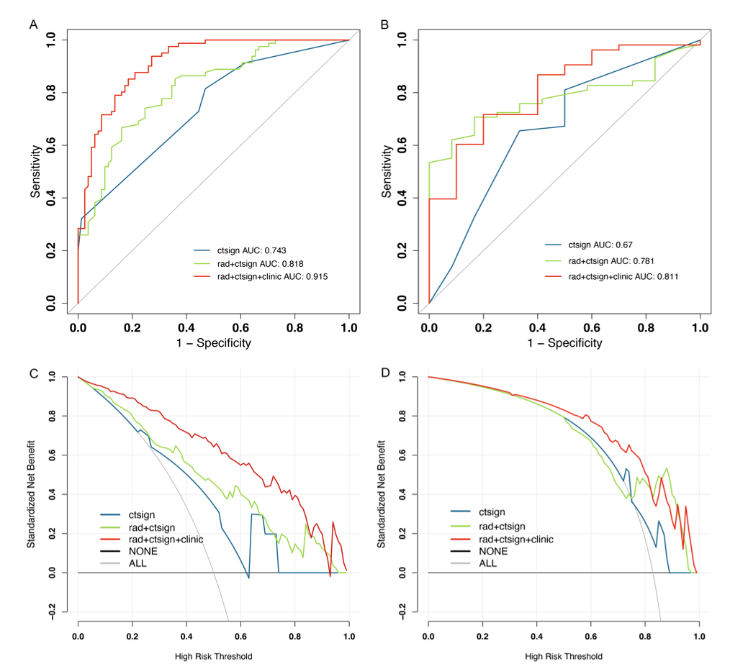
Figure 2 The discrimination ability of the radiomics model and its decision curve analysis for prediction of KIT exon 11 mutation. A-D: The discrimination ability of three models in the training data (A) and the validation cohort (B). The decision curve analysis for the radiomics models in the training data (C) and the validation cohort (D). AUC: Area under the curve.
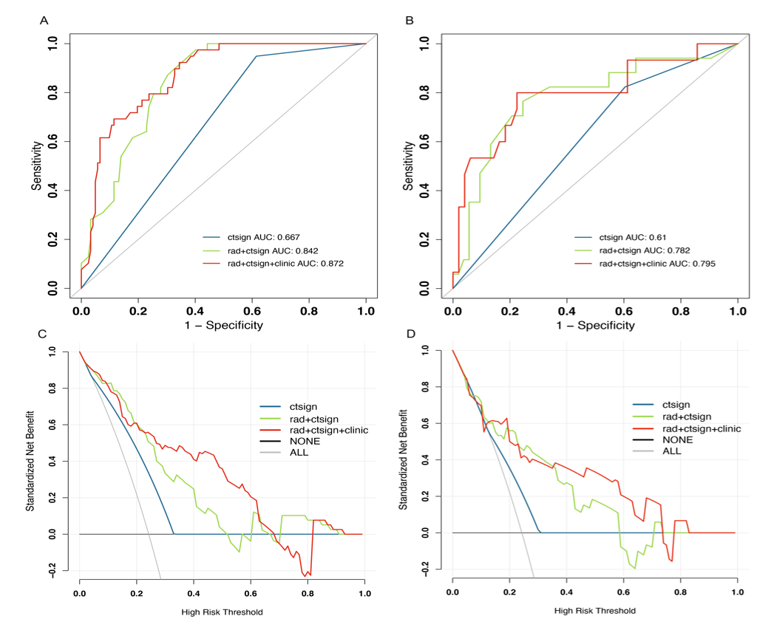
Figure 3 The discrimination ability of the radiomics model and its decision curve analysis for prediction of KIT exon 11 codons 557-558 deletions. A-D: The discrimination ability of three models in the training data (A) and the validation cohort (B). The decision curve analysis for the radiomics models in the training data (C) and the validation cohort (D). AUC: Area under the curve.

Table 1 Clinicopathological characteristics of gastrointestinal stromal tumor patients included in this study, n (%)
Characteristics | KIT exon 11 mutation (n = 192) | Without KIT exon 11 mutation (n = 39) | P value | KIT exon 11 mutation with deletions involving codons 557-558 (n = 56) | KIT exon 11 mutation without deletions involving codons 557-558 (n = 136) | P value
Gender (male) | 97 (50.5) | 24 (61.5) | 0.223 | 32 (57.1) | 65 (47.8) | 0.268
Age | 55.7 ± 11.5 | 53.8 ± 13.4 | 0.360 | 53.9 ± 13.5 | 56.4 ± 10.6 | 0.222
Mitosis
≤ 5/50 HPF | 91 (47.4) | 24 (61.5) | 0.117 | 11 (19.6) | 80 (58.8) | < 0.010
> 5/50 HPF | 101 (52.6) | 15 (38.5) |  | 45 (80.4) | 56 (41.2)
Risk classification
Very low | 2 (1.0) | 0 (0) | 0.851 | 0 (0) | 2 (1.5) | < 0.010
Low | 43 (22.4) | 10 (25.7) |  | 4 (7.1) | 39 (28.7)
Intermediate | 59 (30.8) | 13 (33.3) |  | 7 (12.5) | 52 (38.2)
High | 88 (45.8) | 16 (41.0) |  | 45 (80.4) | 43 (31.6)
Table 2 The computed tomography features of gastrointestinal stromal tumor patients included in this study, n (%)
Characteristics | KIT exon 11 mutation (n = 192) | Without KIT exon 11 mutation (n = 39) | P value | KIT exon 11 mutation with deletions involving codons 557-558 (n = 56) | KIT exon 11 mutation without deletions involving codons 557-558 (n = 136) | P value
Size (mm) | 51 (11-224) | 45 (10-201) | 0.682 | 69 (31-224) | 42.5 (11-188) | < 0.010
Shape
Regular | 66 (34.4) | 7 (17.9) | 0.044 | 5 (8.9) | 61 (44.9) | < 0.010
Irregular | 126 (65.6) | 32 (82.1) |  | 51 (91.1) | 75 (55.1)
Margin
Well-defined | 168 (87.5) | 23 (84.6) | 0.625 | 44 (78.6) | 124 (91.2) | 0.016
Ill-defined | 24 (12.5) | 6 (15.4) |  | 12 (21.4) | 12 (8.8)
Growth pattern
Endophytic | 64 (33.3) | 6 (15.4) | 0.083 | 12 (21.4) | 52 (38.2) | 0.010
Exophytic | 87 (45.3) | 22 (56.4) |  | 25 (44.6) | 62 (45.6)
Mixed | 41 (21.4) | 11 (28.2) |  | 19 (33.9) | 22 (16.2)
Density
Hypodensity | 175 (91.1) | 34 (87.2) | 0.647 | 50 (89.3) | 125 (91.9) | 0.750
Isodensity | 15 (7.8) | 4 (10.3) |  | 5 (8.9) | 10 (7.4)
Hyperdensity | 2 (1.0) | 1 (2.6) |  | 1 (1.8) | 1 (0.7)
Pattern of enhancement
Homogeneous | 48 (25.0) | 5 (12.8) | 0.099 | 5 (8.9) | 43 (31.6) | 0.001
Heterogeneous | 144 (75.0) | 34 (87.2) |  | 51 (91.1) | 93 (68.4)
Degree of enhancement
Mild | 71 (37.0) | 11 (28.2) | 0.018 | 20 (35.7) | 51 (37.5) | 0.063
Moderate | 75 (39.1) | 10 (25.6) |  | 28 (50.0) | 47 (34.6)
Marked | 46 (24.0) | 18 (46.2) |  | 8 (14.3) | 38 (27.9)
Necrosis | 121 (63.0) | 28 (71.8) | 0.296 | 43 (76.8) | 78 (57.4) | 0.011
Gas | 33 (17.2) | 4 (10.3) | 0.282 | 14 (25.0) | 19 (14.0) | 0.066
Cystic change | 6 (3.1) | 4 (10.3) | 0.046 | 0 (0) | 6 (4.4) | 0.110
Calcification | 23 (12.0) | 2 (5.1) | 0.209 | 8 (14.3) | 15 (11.0) | 0.528
Superficial ulceration | 55 (28.6) | 10 (25.6) | 0.704 | 19 (33.9) | 36 (26.5) | 0.299
Intra-tumoral vessel | 86 (44.8) | 14 (35.9) | 0.307 | 34 (60.7) | 52 (38.2) | 0.004
Adjacent mesangial fat infiltration | 40 (20.8) | 9 (23.1) | 0.755 | 20 (35.7) | 20 (14.7) | 0.001
Adjacent organ invasion | 29 (15.1) | 7 (17.9) | 0.655 | 14 (25.0) | 15 (11.0) | 0.014
Lymphadenopathy | 14 (7.3) | 3 (7.7) | 0.930 | 6 (10.7) | 8 (5.9) | 0.242
Distant metastasis | 4 (2.1) | 2 (5.1) | 0.276 | 3 (5.4) | 1 (0.7) | 0.042
Table 3 Predictive performance of different model for KIT exon 11 mutation
Models | Model_{CT sign} |  | Model_{CT sign + rad} |  | Model_{CT sign + rad + clinic}
Cohort | Training | Validation | Training | Validation | Training | Validation
AUC | 0.743 | 0.670 | 0.818 | 0.781 | 0.915 | 0.811
Accuracy | 0.673 | 0.643 | 0.753 | 0.714 | 0.833 | 0.794
Sensitivity | 0.815 | 0.672 | 0.667 | 0.690 | 0.938 | 0.830
Specificity | 0.531 | 0.500 | 0.840 | 0.833 | 0.728 | 0.600
NPV | 0.741 | 0.240 | 0.716 | 0.357 | 0.922 | 0.400
PPV | 0.635 | 0.867 | 0.806 | 0.952 | 0.776 | 0.917
CT: Computed tomography; AUC: Area under the curve; NPV: Negative predictive value; PPV: Positive predictive value.
Table 4 Predictive performance of different model for KIT exon 11 codons 557-558 deletions
Models | Model_{CT sign} |  | Model_{CT sign + rad} |  | Model_{CT sign + rad + clinic}
Cohort | Training | Validation | Training | Validation | Training | Validation
AUC | 0.667 | 0.610 | 0.842 | 0.782 | 0.872 | 0.795
Accuracy | 0.522 | 0.500 | 0.689 | 0.700 | 0.720 | 0.766
Sensitivity | 0.949 | 0.824 | 0.974 | 0.824 | 0.923 | 0.667
Specificity | 0.385 | 0.396 | 0.598 | 0.660 | 0.656 | 0.796
NPV | 0.959 | 0.875 | 0.986 | 0.927 | 0.964 | 0.886
PPV | 0.330 | 0.304 | 0.437 | 0.438 | 0.462 | 0.500
CT: Computed tomography; AUC: Area under the curve; NPV: Negative predictive value; PPV: Positive predictive value.

