Name of Journal: World Journal of Clinical Cases
Manuscript NO: 73000
Manuscript Type: ORIGINAL ARTICLE

Retrospective Study
Risk factors and optimal predictive scoring system of mortality for children with acute paraquat poisoning

Song Y et al. Scoring system of acute paraquat poisoning

Yue Song, Hua Wang, Yu-Hong Tao

Yue Song, Hua Wang, Yu-Hong Tao, Department of Pediatrics, West China Second University Hospital, Sichuan University, Chengdu 610041, Sichuan Province, China

Yue Song, Hua Wang, Yu-Hong Tao, Key Laboratory of Birth Defects and Related Diseases of Women and Children, Ministry of Education, Sichuan University, Chengdu 610041, Sichuan Province, China

Author contributions: Song Y and Wang H designed the study, made the review, and wrote the manuscript; Song Y, Wang H, and Tao YH made the literature search, made table, and reviewed the manuscript; all authors read and approved the final manuscript.

Corresponding author: Yu-Hong Tao, PhD, Chief Doctor, Department of Pediatrics, West China Second University Hospital, Sichuan University, No. 20 Renmin Road, Chengdu 610041, Sichuan Province, China. hxtyh@sina.com

Received: November 6, 2021
Revised: December 31, 2021
Accepted: March 25, 2022
Published online: May 26, 2022

Abstract
BACKGROUND
There is no suitable scoring system that can be used to predict mortality in children with acute paraquat intoxication (APP).

AIM
To optimize a predictive scoring system for mortality in children with APP.

METHODS
A total of 113 children with APP from January 1, 2010 to January 1, 2020 were enrolled in this study. These patients were divided into survivors and non-survivors. We compared the clinical characteristics between the two groups and analyzed the independent prognostic risk factors. The survival rates of patients with different values of the pediatric critical illness score (PCIS) were assessed using kaplan-meier survival analysis. The best scoring system was established by using the area under the receiver operating characteristic curve analysis.

RESULTS
The overall mortality rate was 23.4%. All non-survivors died within 20 days; 48.1% (13/27) died within 3 days, and 70.3% (19/27) died within 7 days. Compared to survivors, the non-survivors were older, had higher white blood cell count, alanine aminotransferase (ALT), aspartate aminotransferase, serum creatinine, blood urea nitrogen, glucose, and pediatric early warning score, and had lower platelet count, albumin, Serum sodium (Na⁺) and PCIS. ALT and PCIS were the independent prognostic risk factors for children with APP. The survival rate of children classified as extremely critical patients (100%) was lower than that of children classified as critical (60%) or noncritical (6.7%) patients. The specificity of ALT was high (96.51%), but the sensitivity was low (59.26%). The sensitivity and specificity of ALT combined with PCIS were high, 92.59% and 87.21%, respectively. The difference in mortality was significantly higher for ALT combined with PCIS (area under the receiver operating characteristic: 0.937; 95%CI: 0.875-0.974; P < 0.05).

CONCLUSION
In our study, ALT and PCIS were independent prognostic risk factors for children with APP. ALT combined with PCIS is an optimal predictive mortality scoring system for children with APP.

Key Words: Acute paraquat poisoning; Children; Pediatric critical illness score; Alanine aminotransferase; Prognosis

©The Author(s) 2022. Published by Baishideng Publishing Group Inc. All rights reserved.

Citation: Song Y, Wang H, Tao YH. Risk factors and optimal predictive scoring system of mortality for children with acute paraquat poisoning. World J Clin Cases 2022; 10(15): 4799-4809
URL: https://www.wjgnet.com/2307-8960/full/v10/i15/4799.htm
DOI: https://dx.doi.org/10.12998/wjcc.v10.i15.4799

Core Tip: The mortality rate of children with acute paraquat intoxication (APP) was high. Early and accurate prediction of mortality is very important for children with APP in clinical decision-making. However, there is no scoring system that can be used to predict the mortality of children with APP. In our study, we discovered that alanine aminotransferase (ALT) and the pediatric critical illness score (PCIS) were independent prognostic risk factors for children with APP. ALT combined with the PCIS is an optimal predictive mortality scoring system for children with APP.

INTRODUCTION
Paraquat (PQ) is a widely used herbicide worldwide. Since paraquat began to be used in agriculture in 1962, the number of patients with acute paraquat intoxication has gradually increased^{[1]}. With the participation of reduced coenzyme II-cytochrome P450 reductase, xanthine oxidase and other enzymes, PQ produces a single cationic free radical PQ⁺ in vivo, and PQ⁺ rapidly reoxidizes into PQ²⁺. PQ²⁺ receives electrons from coenzyme II and generates superoxide anions, which then produce peroxynitrite by combining with nitric oxide free radicals. These highly reactive oxygen species and peroxynitrite lead to mitochondrial dysfunction and apoptosis through lipid peroxidation and the activation of nuclear factor-κB, which results in multiple organ damage^{[2-4]}. In the absence of specific antidotes, the mortality rate in children with acute paraquat intoxication (APP) was 14.38%-63.6%^{[5-7]}. Therefore, the early and accurate prediction of mortality is very important in clinical decision-making for children with APP.
At present, several scoring systems have been used to predict the mortality of adult patients with APP, such as the sequential organ failure assessment^{[8]}, severity index of paraquat poisoning (SIPP)^{[9]}, acute physiology and chronic health evaluation II^{[10]}, early warning score (EWS)^{[11]}, and modified EWS^{[12]}. However, the predictive powers of the above scoring systems are different, and most importantly, they are unsuitable for children.
There is no scoring system that can be used to predict mortality in children with APP. Because of the simple calculation and available indices, the pediatric critical illness score (PCIS) and pediatric EWS (PEWS) are scoring tools widely used for critically ill children^{[13-16]}. However, there is no report in which the PCIS and PEWS were used to predict the prognosis of children with APP. Our study aimed to investigate the performance of the PCIS, the PEWS, as well as a single clinical index for predicting mortality in children with APP and to provide a theoretical basis for clinical application.

MATERIALS AND METHODS
Patients
We performed a single-center, retrospective, observational study, which was approved by the ethics committee of the West China Second University Hospital, Sichuan University.
Pediatric patients with APP enrolled in this study were < 18 years old and were admitted to our hospital between January 1, 2010 and January 1, 2020. The inclusion criteria were as follows: (1) A diagnosis of APP^{[17]}; and (2) first visit to the hospital with no history of special treatment, such as gastric lavage and hemodialysis. The diagnostic criteria of APP were as follows: (1) The children or family members could provide the history of paraquat exposure; (2) for those who denied paraquat exposure, evidence was found to the contrary, including black–green residue on the skin, an empty paraquat bottle, vomiting, oral mucosal erosion with unknown causes; and (3) blood or urine was positive for paraquat. The exclusion criteria were as follows: (1) Complicated with chronic diseases; (2) other drug exposure; (3) death within 24 h of admission; and (4) discharge against medical advice.

Data collection
Age, sex, time to blood purification and consultation and related symptoms (vomiting, abdominal pain, oral ulcer and gastrointestinal bleeding) were collected at admission. Routine laboratory tests, including routine blood tests, blood gas, liver function, renal function and electrolytes, were performed. The PCIS^{[18]} (Table 1) and PEWS^{[19]} (Table 2) were calculated within 24 h after admission. Patients with the score of > 80 were considered noncritical, 71-80 critical, and ≤ 70 extremely critical. All children were followed up for at least 90 days.

Treatment
Routine blood tests, liver function, renal function, electrolytes, random blood glucose and chest computed tomography tests were performed upon admission. Routine treatments (vomiting induction, oral activated carbon and diuresis) were adapted. Some critically ill children were administered methylprednisolone 15 mg/(kg/d) for 3 d. The patients with infective symptoms were given anti-infective drugs, and those with respiratory failure were given oxygen inhalation or mechanical ventilation. Some critically ill children were treated with hemoperfusion 3-5 times or plasma exchange 3-4 times. Hemodialysis or continuous renal replacement therapy was used for patients with multiple organ dysfunction.

Statistical analysis
All statistical analyses were conducted using IBM SPSS statistics version 21 (IBM Corp & licensors 1989, 2011). Continuous variables are presented as the mean ± SD or median (interquartile range) [mean (P₂₅, P₇₅)]. Categorical variables were expressed as percentages. The two groups were compared using student’s t-tests, chi-square tests, wilcoxon tests, and mann–whitney U tests. Multivariable logistic regression model was computed to identify whether variables were associated with unfavorable outcomes. The receiver operator characteristic [area under the receiver operating characteristic (AUROC)] curve was used to predict probability of mortality. We analyzed the survival rate of children with different PCIS by kaplan–meier survival analysis. P < 0.05 was considered statistically significant.

RESULTS
Comparison of clinical characteristics between survivors and non-survivors
In total, 113 patients were included. During the 90-day follow-up, the overall mortality rate was 23.4% (27/113). All non-survivors died within 20 d; 48.1% (13/27) died within 3 d, and 70.3% (19/27) died within 7 d. The causes of poisoning were suicide (22.1%) and accidental ingestion (77.9%).
Among the 113 children, 96 (85%), 15 (13.3%) and 2 (1.8%) were categorized as noncritical (PCIS > 80 points), critical (PCIS 71-80 points) and extremely critical (PCIS ≤ 70 points), respectively, and the mortality rates were 16.7% (16/96), 60% (9/15), and 100% (2/2), respectively. As shown in Figure 1, the survival rate of children classified as extremely critical patients (100%) was significantly lower than that of children classified as critical (60%) or noncritical (6.7%) patients (P < 0.05).
Compared to survivors, the non-survivors were older (8.11 ± 4.72 vs. 11.48 ± 2.99 years); had higher white blood cell count, serum creatinine (Scr), blood urea nitrogen (BUN), alanine aminotransferase (ALT), aspartate aminotransferase, glucose, and PEWS; and had lower platelet count, albumin, Serum sodium (Na⁺) and PCIS (Table 3) (all P < 0.05).
The median time to consultation in survivors and non-survivors was 22.5 (8.75, 48) and 20 (8, 48) hours, respectively. In addition, there was no significant difference between the survivors and non-survivors in the time to consultation < 6 h, 6-24 h, and > 24 h subgroups.

Prognostic risk factors for children with APP
In order to explore the prognostic risk factors for children with APP, we selected variables with P < 0.1 in the univariate analysis to perform a multivariable logistic regression analysis. The indices of Scr, BUN, Na⁺, Serum potassium (K⁺), hemoglobin, abdominal pain, vomiting, and gastrointestinal bleeding were included in the PCIS system and were not introduced into the multivariable logistic regression analysis. ALT and PCIS were independent prognostic risk factors for those children with APP (P < 0.05) (Table 4).

Predictive scoring system development of mortality for children with APP
Because the multiple logistic regression analysis revealed that ALT and PCIS were independent prognostic risk factors for children with APP, we further analyzed the predictive performance of ALT, PCIS and ALT combined with PCIS for mortality in children with APP. Table 5 and Figure 2 show the predictive power of ALT, PCIS and ALT combined with PCIS. The specificity of ALT was high (96.51%), but its sensitivity was low (59.26%). The sensitivity and specificity of PCIS and ALT combined with PCIS were high, 92.30% vs. 92.59% and 82.21% vs. 87.21%, respectively. The difference in-outcomes was significantly higher for ALT combined with PCIS (AUROC: 0.937; 95%CI: 0.875-0.974) than for PCIS (AUROC: 0.905; 95%CI: 0.836-0.952) and ALT (AUROC: 0.814; 95%CI: 0.730-0.881) (all P < 0.05). Thus, ALT combined with the PCIS was the optimal scoring system.

DISCUSSION
The early prediction of mortality is important in clinical decision-making for patients with APP. Previous studies have indicated that plasma paraquat concentration can effectively predict the mortality of patients with APP^{[20,21]}. However, Gil et al^{[21]} found that some patients with low paraquat concentration in plasma still had poor outcomes. The reasons are as follows. The plasma paraquat concentration reached a peak value within 0.5-2 h after ingestion^{[22]}, and the half-life is 5 h^{[23]}. The concentration of paraquat in plasma decreased obviously in the early stage, and the survival expectations would decrease from 70% to 30% for a delay of 1 h^{[23]}. The time of detecting paraquat concentration in plasma had an impact on the accuracy of paraquat measurements. In addition, most children with APP accidentally ingested paraquat; therefore, clinicians cannot estimate the dose of paraquat they ingested. Paraquat measurement was unavailable in almost all primary hospitals. Therefore, the paraquat concentration in plasma was not included in the prognostic risk factor analysis of children with APP. In addition, clinical indices such as serum lactic acid^{[24]}, K^{+[25]}, blood amylase^{[26]} and peripheral blood monocyte count^{[27]} were considered to be effective in predicting the prognosis of patients with APP. Paraquat binds to plasma protein after entering the bloodstream and is quickly distributed to many organs, resulting in multiple organ damage^{[28]}. Therefore, using a single index to predict the mortality of APP patients is inaccurate, while the combination of multiple indicators is more comprehensive and reasonable^{[29]}.
The poisoning severity score^{[30,31]} and pediatric logistic organ dysfunction (PELOD) score^{[32]} can be used to predict the prognosis of children with APP. Nevertheless, complex calculations and the availability of indices (such as PO₂/FiO₂) in the general ward limit their application in clinical work. In addition, the SIPP^{[9]} and clinical classification of APP^{[33]} have good predictive ability for the prognosis of children with APP. Due to the unavailability of ingestion doses and paraquat concentrations, the clinical classification of APP and SIPP was not adopted in this study.
The EWS is widely used in adult patients. However, the vital signs and physiological indices of children of different ages vary widely, and there is a long compensation period before rapid deterioration due to disease. Therefore, the PEWS was established according to the physiological and pathological characteristics of children. The PEWS includes three parts: Consciousness, respiratory status and cardiovascular status. The PEWS is easy to administer and calculate. Nevertheless, multivariate logistic analysis suggested that the PEWS was not an independent risk factor for mortality in children with APP; therefore, the PEWS cannot be used to predict mortality in children with APP. The reasons are as follows: (1) The PEWS comprises physical signs and a few parameters but no objective laboratory indices; and (2) repeated evaluations by doctors and nurses and the anxiety and panic of parents may affect the vital signs of the children, resulting in a decrease in the predictive efficacy of the PEWS^{[34]}.
PCIS comprises heart rate, blood pressure, breathing rate, PaO₂, pondus hydrogenii, Na⁺, K⁺, BUN/Scr, hemoglobin, and digestive system symptoms, and the PCIS system can evaluate the condition of children with APP more comprehensively and objectively than the PEWS system. PCIS is widely used to evaluate the severity and prognosis of critically ill children^{[13,15]}. The PCIS system was first used to predict the prognosis of children with APP, as shown in our study. Our study showed that the survival rate of children classified as extremely critical patients (PCIS ≤ 70 points) was significantly higher than that of children classified as critical (PCIS 71-80 points) and noncritical (PCIS > 80 points) patients. In addition, the AUROC of PCIS was 0.905 (95%CI: 0.836-0.952), with a high sensitivity of 92.3% and a high specificity of 82.21%. A recent study showed that there was no significant difference among the AUROC curves for PCIS, PRISM IV and PELOD-2 in predicting the prognosis of children in pediatric intensive care units^{[35]}. Thus, PCIS can be used to predict the prognosis of children with APP.
The liver is the main source of endogenous antioxidants and plays an important role in metabolism and detoxification. The liver is considered to be the main target of exogenous organism-mediated oxidative damage^{[36]}. Oxidative damage to the liver was observed in rats after a single oral administration of 150 mg/kg paraquat for 20 h^{[37]}. Yang et al^{[38]} found that 46.52% of paraquat patients suffered from hepatic complications. Metabolic disorders or insufficient antioxidants induced by liver injury are associated with poor outcome after paraquat intoxication. In our study, the multiple regression analysis revealed that ALT was an independent risk factor for mortality in children with APP. The AUROC of ALT was 0.814 (95%CI: 0.730-0.881), the sensitivity was 96.51%, and the specificity was 51.26%. In addition, Zhang et al^{[39]} found that ALT and BUN reflect organ injuries and paraquat excretion capability of patients, and the two parameters are negatively correlated with the urine-to-plasma paraquat ratio. Therefore, we combined ALT with the original PCIS system and evaluated its predictive ability for mortality in children with APP. Our study showed that ALT combined with PCIS had optimal predictive ability, with the AUROC of 0.921 (95%CI: 0.854-0.963) and a high sensitivity of 87.21% and specificity of 92.59%. It is suggested that ALT combined with PCIS has a good predictive ability for mortality in children with APP.

Strengths and limitations of this study
The early and accurate prediction of mortality can help clinicians with clinical decision-making and treatment of children with acute paraquat intoxication. However, there are few articles about acute paraquat poisoning in children, and there is no suitable scoring system that can be used to predict the mortality of these patients. In this study, we studied the risk factors and optimal predictive scoring system of mortality for children with acute paraquat poisoning. To date, this is the first article on the predictive score of acute paraquat poisoning in children. Of course, a limited number of children with APP were included in our study. The results of this study need to be further verified by large-sample and multicenter research.

CONCLUSION
The mortality rate in children with APP was high. ALT and PCIS were independent prognostic risk factors for children with APP. ALT combined with PCIS is an optimal predictive scoring system for mortality in children with APP.

ARTICLE HIGHLIGHTS
Research background
The mortality rate in children with acute paraquat intoxication (APP) was 14.38%-63.6%, the early and accurate prediction of mortality is very important in clinical decision-making for children with APP.

Research motivation
The mortality rate in children with APP was high. The early prediction of mortality is important in clinical decision-making for patients with APP. Therefore, our aim is to optimize a predictive scoring system for mortality in children with APP.

Research objectives
Our aim is to optimize a predictive scoring system for mortality in children with APP, and help doctors to make clinical decisions.

Research methods
We compared the clinical characteristics between the two groups and analyzed the independent prognostic risk factors. The survival rates were assessed using kaplan-meier survival analysis. The best scoring system was established by using the area under the receiver operating characteristic curve analysis.

Research results
Alanine aminotransferase (ALT) and pediatric critical illness score (PCIS) were independent prognostic risk factors for children with APP. The survival rate of children classified as extremely critical patients was significantly lower than that of children classified as critical or noncritical patients. The sensitivity and specificity of ALT combined with PCIS were high.

Research conclusions
ALT and PCIS were independent prognostic risk factors for children with APP. ALT combined with PCIS is an optimal predictive mortality scoring system for children with APP.

Research perspectives
The results of this study need to be further verified by large-sample and multicenter research.

ACKNOWLEDGEMENTS
We thank the doctors at the Department of pediatrics of West China Second University Hospital for their help with data collection.

REFERENCES
1 Lee WJ, Cha ES, Park ES, Kong KA, Yi JH, Son M. Deaths from pesticide poisoning in South Korea: trends over 10 years. Int Arch Occup Environ Health 2009; 82: 365-371 [PMID: 18600341 DOI: 10.1007/s00420-008-0343-z]
2 Gil HW, Hong JR, Jang SH, Hong SY. Diagnostic and therapeutic approach for acute paraquat intoxication. J Korean Med Sci 2014; 29: 1441-1449 [PMID: 25408572 DOI: 10.3346/jkms.2014.29.11.1441]
3 Xu L, Xu J, Wang Z. Molecular mechanisms of paraquat-induced acute lung injury: a current review. Drug Chem Toxicol 2014; 37: 130-134 [PMID: 24392656 DOI: 10.3109/01480545.2013.834361]
4 Sun B, Chen YG. Advances in the mechanism of paraquat-induced pulmonary injury. Eur Rev Med Pharmacol Sci 2016; 20: 1597-1602 [PMID: 27160134]
5 Lee EY, Hwang KY, Yang JO, Hong SY. Predictors of survival after acute paraquat poisoning. Toxicol Ind Health 2002; 18: 201-206 [PMID: 12974543 DOI: 10.1191/0748233702th141oa]
6 Hsieh YW, Lin JL, Lee SY, Weng CH, Yang HY, Liu SH, Wang IK, Liang CC, Chang CT, Yen TH. Paraquat poisoning in pediatric patients. Pediatr Emerg Care 2013; 29: 487-491 [PMID: 23528512 DOI: 10.1097/PEC.0b013e31828a347e]
7 Elenga N, Merlin C, Le Guern R, Kom-Tchameni R, Ducrot YM, Pradier M, Ntab B, Dinh-Van KA, Sobesky M, Mathieu D, Dueymes JM, Egmann G, Kallel H, Mathieu-Nolf M. Clinical features and prognosis of paraquat poisoning in French Guiana: A review of 62 cases. Medicine (Baltimore) 2018; 97: e9621 [PMID: 29642226 DOI: 10.1097/MD.0000000000009621]
8 Sawada Y, Yamamoto I, Hirokane T, Nagai Y, Satoh Y, Ueyama M. Severity index of paraquat poisoning. Lancet 1988; 1: 1333 [PMID: 2897577 DOI: 10.1016/s0140-6736(88)92143-5]
9 Xu S, Hu H, Jiang Z, Tang S, Zhou Y, Sheng J, Chen J, Cao Y. APACHE score, Severity Index of Paraquat Poisoning, and serum lactic acid concentration in the prognosis of paraquat poisoning of Chinese Patients. Pediatr Emerg Care 2015; 31: 117-121 [PMID: 25654678 DOI: 10.1097/PEC.0000000000000351]
10 Huang NC, Hung YM, Lin SL, Wann SR, Hsu CW, Ger LP, Hung SY, Chung HM, Yeh JH. Further evidence of the usefulness of Acute Physiology and Chronic Health Evaluation II scoring system in acute paraquat poisoning. Clin Toxicol (Phila) 2006; 44: 99-102 [PMID: 16615662 DOI: 10.1080/15563650500514251]
11 Siddiqui S, Chua M, Kumaresh V, Choo R. A comparison of pre ICU admission SIRS, EWS and q SOFA scores for predicting mortality and length of stay in ICU. J Crit Care 2017; 41: 191-193 [PMID: 28575814 DOI: 10.1016/j.jcrc.2017.05.017]
12 Mitsunaga T, Hasegawa I, Uzura M, Okuno K, Otani K, Ohtaki Y, Sekine A, Takeda S. Comparison of the National Early Warning Score (NEWS) and the Modified Early Warning Score (MEWS) for predicting admission and in-hospital mortality in elderly patients in the pre-hospital setting and in the emergency department. PeerJ 2019; 7: e6947 [PMID: 31143553 DOI: 10.7717/peerj.6947]
13 Yang YW, Wu CH, Ko WJ, Wu VC, Chen JS, Chou NK, Lai HS. Prevalence of acute kidney injury and prognostic significance in patients with acute myocarditis. PLoS One 2012; 7: e48055 [PMID: 23144725 DOI: 10.1371/journal.pone.0048055]
14 Piano S, Rosi S, Maresio G, Fasolato S, Cavallin M, Romano A, Morando F, Gola E, Frigo AC, Gatta A, Angeli P. Evaluation of the Acute Kidney Injury Network criteria in hospitalized patients with cirrhosis and ascites. J Hepatol 2013; 59: 482-489 [PMID: 23665185 DOI: 10.1016/j.jhep.2013.03.039]
15 Sampaio MC, Máximo CA, Montenegro CM, Mota DM, Fernandes TR, Bianco AC, Amodeo C, Cordeiro AC. Comparison of diagnostic criteria for acute kidney injury in cardiac surgery. Arq Bras Cardiol 2013; 101: 18-25 [PMID: 23752340 DOI: 10.5935/abc.20130115]
16 Benediktsson S, Frigyesi A, Kander T. Routine coagulation tests on ICU admission are associated with mortality in sepsis: an observational study. Acta Anaesthesiol Scand 2017; 61: 790-796 [PMID: 28681428 DOI: 10.1111/aas.12918]
17 Fengjun J, Wen Z, Taoning W, Yaying Y, Kai K, Liu M. Analysis of risk factors for prognosis of patients with acute paraquat intoxication. Zhonghua Wei Zhong Bing Ji Jiu Yi Xue 2015; 27: 906-910 [PMID: 27132458]
18 An K, Wang Y, Li B, Luo C, Wang J, Luo C, Chen J. Prognostic factors and outcome of patients undergoing hematopoietic stem cell transplantation who are admitted to pediatric intensive care unit. BMC Pediatr 2016; 16: 138 [PMID: 27544347 DOI: 10.1186/s12887-016-0669-8]
19 Monaghan A. Detecting and managing deterioration in children. Paediatr Nurs 2005; 17: 32-35 [PMID: 15751446 DOI: 10.7748/paed2005.02.17.1.32.c964]
20 Proudfoot AT, Stewart MS, Levitt T, Widdop B. Paraquat poisoning: significance of plasma-paraquat concentrations. Lancet 1979; 2: 330-332 [PMID: 89392 DOI: 10.1016/s0140-6736(79)90345-3]
21 Gil HW, Kang MS, Yang JO, Lee EY, Hong SY. Association between plasma paraquat level and outcome of paraquat poisoning in 375 paraquat poisoning patients. Clin Toxicol (Phila) 2008; 46: 515-518 [PMID: 18584363 DOI: 10.1080/15563650701549403]
22 Pond SM, Rivory LP, Hampson EC, Roberts MS. Kinetics of toxic doses of paraquat and the effects of hemoperfusion in the dog. J Toxicol Clin Toxicol 1993; 31: 229-246 [PMID: 8492337 DOI: 10.3109/15563659309000391]
23 Novaes RD, Gonçalves RV, Marques DC, Cupertino Mdo C, Peluzio Mdo C, Leite JP, Maldonado IR. Effect of bark extract of Bathysa cuspidata on hepatic oxidative damage and blood glucose kinetics in rats exposed to paraquat. Toxicol Pathol 2012; 40: 62-70 [PMID: 22021167 DOI: 10.1177/0192623311425059]
24 Liu XW, Ma T, Li LL, Qu B, Liu Z. Predictive values of urine paraquat concentration, dose of poison, arterial blood lactate and APACHE II score in the prognosis of patients with acute paraquat poisoning. Exp Ther Med 2017; 14: 79-86 [PMID: 28672896 DOI: 10.3892/etm.2017.4463]
25 Liu ZQ, Wang HS, Gu Y. Hypokalemia is a biochemical signal of poor prognosis for acute paraquat poisoning within 4 hours. Intern Emerg Med 2017; 12: 837-843 [PMID: 27395362 DOI: 10.1007/s11739-016-1491-x]
26 Huang C, Bai L, Xue X, Peng L, Jiang J, Zhang X. Hyperamylasemia as an early predictor of mortality in patients with acute paraquat poisoning. J Int Med Res 2020; 48: 300060520910037 [PMID: 32223576 DOI: 10.1177/0300060520910037]
27 Zhao Y, Song YQ, Gao J, Feng SY, Li Y. Monocytes as an Early Predictor for Patients with Acute Paraquat Poisoning: A Retrospective Analysis. Biomed Res Int 2019; 2019: 6360459 [PMID: 31428640 DOI: 10.1155/2019/6360459]
28 Minakata K, Suzuki O, Horio F, Saito S, Harada N. Increase in production of ascorbate radical in tissues of rat treated with paraquat. Free Radic Res 2000; 33: 179-185 [PMID: 10885625 DOI: 10.1080/10715760000300731]
29 Hu L, Li H, Cai Z, Lin F, Hong G, Chen H, Lu Z. A new machine-learning method to prognosticate paraquat poisoned patients by combining coagulation, liver, and kidney indices. PLoS One 2017; 12: e0186427 [PMID: 29049326 DOI: 10.1371/journal.pone.0186427]
30 Chartier C, Penouil F, Blanc-Brisset I, Pion C, Descatha A, Deguigne M. Pediatric cannabis poisonings in France: more and more frequent and severe. Clin Toxicol (Phila) 2021; 59: 326-333 [PMID: 32840407 DOI: 10.1080/15563650.2020.1806295]
31 von Fabeck K, Boulamery A, Glaizal M, de Haro L, Simon N. Buprenorphine poisoning in children: a 10-year-experience of Marseille Poison Center. Fundam Clin Pharmacol 2020; 34: 265-269 [PMID: 31675453 DOI: 10.1111/fcp.12518]
32 Duan Y, Wang Z. To explore the characteristics of fatality in children poisoned by paraquat--with analysis of 146 cases. Int J Artif Organs 2016; 39: 51-55 [PMID: 26953897 DOI: 10.5301/ijao.5000471]
33 Dinis-Oliveira RJ, Duarte JA, Sánchez-Navarro A, Remião F, Bastos ML, Carvalho F. Paraquat poisonings: mechanisms of lung toxicity, clinical features, and treatment. Crit Rev Toxicol 2008; 38: 13-71 [PMID: 18161502 DOI: 10.1080/10408440701669959]
34 Brown SR, Martinez Garcia D, Agulnik A. Scoping Review of Pediatric Early Warning Systems (PEWS) in Resource-Limited and Humanitarian Settings. Front Pediatr 2018; 6: 410 [PMID: 30671424 DOI: 10.3389/fped.2018.00410]
35 Zhang Z, Huang X, Wang Y, Li Y, Miao H, Zhang C, Pan G, Zhang Y, Zhu X, Chen W, Li J, Su D, Bi Y, Chen Z, Jin B, Miao H, Kong X, Cheng Y, Chen Y, Yan G, Yan W, Lu G. Performance of Three Mortality Prediction Scores and Evaluation of Important Determinants in Eight Pediatric Intensive Care Units in China. Front Pediatr 2020; 8: 522 [PMID: 33014927 DOI: 10.3389/fped.2020.00522]
36 Zeinvand-Lorestani H, Nili-Ahmadabadi A, Balak F, Hasanzadeh G, Sabzevari O. Protective role of thymoquinone against paraquat-induced hepatotoxicity in mice. Pestic Biochem Physiol 2018; 148: 16-21 [PMID: 29891368 DOI: 10.1016/j.pestbp.2018.03.006]
37 Konstantinova SG, Russanov EM. Studies on paraquat-induced oxidative stress in rat liver. Acta Physiol Pharmacol Bulg 1999; 24: 107-111 [PMID: 11098297]
38 Yang CJ, Lin JL, Lin-Tan DT, Weng CH, Hsu CW, Lee SY, Lee SH, Chang CM, Lin WR, Yen TH. Spectrum of toxic hepatitis following intentional paraquat ingestion: analysis of 187 cases. Liver Int 2012; 32: 1400-1406 [PMID: 22672665 DOI: 10.1111/j.1478-3231.2012.02829.x]
39 Zhang S, Song S, Luo X, Liu J, Liu M, Li W, Cao T, Li N, Zeng C, Zhang B, Cai H. Prognostic value of liver and kidney function parameters and their correlation with the ratio of urine-to-plasma paraquat in patients with paraquat poisoning. Basic Clin Pharmacol Toxicol 2021; 128: 822-830 [PMID: 33411948 DOI: 10.1111/bcpt.13555]

Footnotes
Institutional review board statement: The study was approved by the Ethics Committee of the West China Second University Hospital, Sichuan University. Approval No: 2020(004).

Informed consent statement: Informed written consent was obtained from the patient for publication of this report.

Conflict-of-interest statement: We have no financial relationships to disclose.

Data sharing statement: No additional data are available.

Open-Access: This article is an open-access article that was selected by an in-house editor and fully peer-reviewed by external reviewers. It is distributed in accordance with the Creative Commons Attribution NonCommercial (CC BY-NC 4.0) license, which permits others to distribute, remix, adapt, build upon this work non-commercially, and license their derivative works on different terms, provided the original work is properly cited and the use is non-commercial. See: https://creativecommons.org/Licenses/by-nc/4.0/

Provenance and peer review: Unsolicited article; Externally peer reviewed.
Peer-review model: Single blind

Peer-review started: November 6, 2021
First decision: December 27, 2021
Article in press: March 25, 2022

Specialty type: Pediatrics
Country/Territory of origin: China
Peer-review report’s scientific quality classification
Grade A (Excellent): 0
Grade B (Very good): B, B
Grade C (Good): 0
Grade D (Fair): 0
Grade E (Poor): 0

P-Reviewer: Bianchi F, Spain; Wierzbicka A, Poland S-Editor: Guo XR L-Editor: A P-Editor: Guo XR

Figure Legends
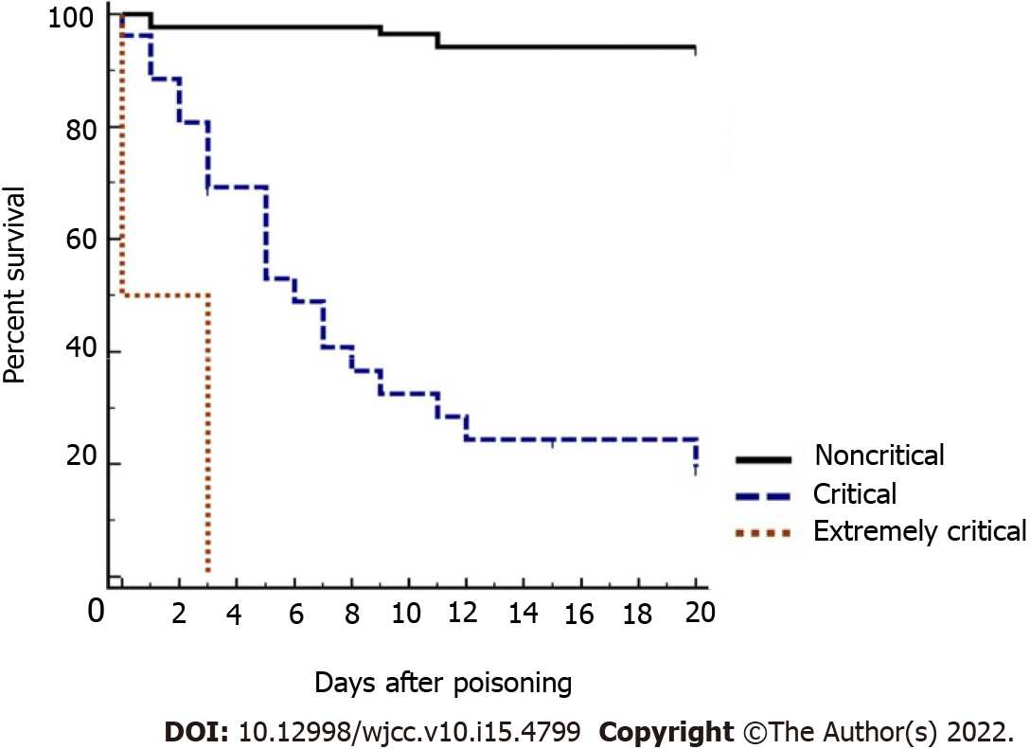
Figure 1 The survival curves for different pediatric critical illness score. A score of > 80 is classified as noncritical, 71-80 critical, and ≤ 70 extremely critical. All the non-survivors died within 20 d.

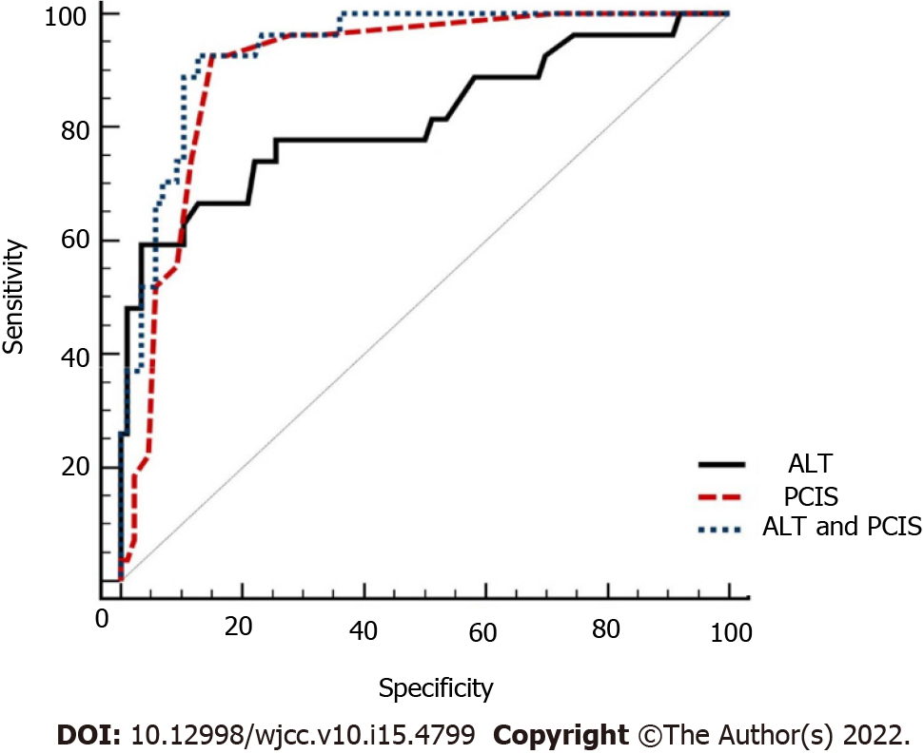
Figure 2 Comparison of the receiver operating characteristic curves for alanine aminotransferase, pediatric critical illness score, and alanine aminotransferase and pediatric critical illness score. ALT: Alanine aminotransferase; PCIS: Pediatric critical illness score.

Table 1 Pediatric critical illness score
Parameter | Age < 1 yr | Age ≥ 1 yr | Scores
Heart rate (beats/min) | < 80 or > 180 | < 60 or > 160 | 4
 | 80-100 or 160-180 | 60-80 or 140-160 | 6
 | Others | Others | 10
Blood pressure (systolic) [kPa (mmHg)] | < 7.5 (55) or > 17.3 (130) | < 8.7 (65) or > 20 (150) | 4
 | 7.5-8.7 (55-65) or 13.3-17.3 (100-130) | 8.7-10 (65-75) or 17.3-20 (130-150) | 6
 | Others | Others | 10
Breathing rate (breaths/min) | < 20 or > 70 or irregular breathing | < 15 or > 60 or irregular breathing | 4
 | 20-25 or 40-70 | 15-20 or 35-60 | 6
 | Others | Others | 10
PaO₂ [kPa (mmHg)] (no oxygen inhalation) | < 6.7 (50) |  | 4
 | 6.7-9.3 (50-70) |  | 6
 | Others |  | 10
pH | < 7.25 or > 7.55 |  | 4
 | 7.25-7.30 or 7.50-7.55 |  | 6
 | Others |  | 10
Na⁺ (mmol/L) | < 120 or > 160 |  | 4
 | 120-130 or 150-160 |  | 6
 | Others |  | 10
K ⁺ (mmol/L) | < 3.0 or > 6.5 |  | 4
 | 3.0-3.5 or 5.5-6.5 |  | 6
 | Others |  | 10
Scr (μmol/L) | > 159 |  | 4
 | 106-159 |  | 6
 | Others |  | 10
BUN (mmol/L) | > 14.3 |  | 4
 | 7.1-14.3 |  | 6
 | Others |  | 10
Hb (g/L) | < 60 |  | 4
 | 60-90 |  | 6
 | Others |  | 10
Digestive system symptoms | Stress ulcer bleeding and intestinal paralysis |  | 4
 | Stress ulcer bleeding |  | 6
 | Others |  | 10
pH: Pondus hydrogenii; Na⁺: Serum sodium; K⁺: Serum potassium; Scr: Serum creatinine; BUN: Blood urea nitrogen; Hb: Hemoglobin.

Table 2 The pediatric early warning score
 | 0 | 1 | 2 | 3
Behavior | Playing; alert; appropriate; at baseline | Sleeping; fussy but consolable | Irritable/inconsolable | Lethargic; confused; reduced response to pain
Cardiovascular status | Pink cap refill 1-2 s | Gray; cap refill 3 s | Gray; cap refill 4 s; tachycardia of 20 beats/min above the normal rate | Gray; mottled; cap refill 5 s; tachycardia of 30 beats/min above the normal rate; bradycardia
Respiratory status | Within normal parameters | Greater than 10 breaths/min above normal parameters; accessory muscle use; 30% FiO₂; 3 liters/minute | Greater than 20 breaths/min above normal parameters; retractions; 40% FiO₂; 6 liters/minute; tracheostomy- and ventilator- dependent | Below normal parameters with retractions; grunting; 50% FiO₂; 8 liters/minute
FiO₂: Fraction of inspiration O₂.

Table 3 Comparison of clinical characteristics between survivors and non-survivors (n = 113)
Variable | Survivors | Non-survivors | P value
Age (yr), n (%) |  |  | 0.003
≤ 3 yr | 22 (25.6) | 0 (0.0)
3-6 yr (not including 3 yr) | 12 (13.4) | 3 (11.1)
6-12 yr (not including 6 yr) | 27 (31.2) | 10 (37.0)
> 12 yr | 25 (29.1) | 14 (51.9)
Sex, n (%) |  |  | 0.039
Female | 41 (47.7) | 19 (70.4)
Male | 45 (52.3) | 8 (29.6)
Cause of intoxication, n (%) |  |  | 0.585
Accidental | 68 (79.1) | 20 (74.1)
Suicide | 18 (20.9) | 7 (25.9)
Time to blood purification, n (%) |  |  | 0.185
< 6 h | 3 (5.0) | 2 (8.7)
6-12 h | 12 (20.0) | 7 (30.4)
12-24 h (not including 12 h) | 13 (21.7) | 5 (21.7)
> 24 h | 32 (53.3) | 9 (39.1)
Time to consultation, n (%) |  |  | 0.191
< 6 h | 28 (32.6) | 11 (40.7)
6-24 h | 22 (25.6) | 6 (22.2)
> 24 h | 36 (41.9) | 10 (37.1)
Vomiting, n (%) | 30 (34.9) | 19 (70.4) | 0.001
Abdominal pain, n (%) | 14 (16.3) | 9 (33.3) | 0.055
Oral ulcer, n (%) | 32 (37.2) | 16 (66.7) | 0.043
Gastrointestinal bleeding, n (%) | 3 (3.5) | 5 (18.5) | 0.001
WBC count (× 10⁹/L) | 11.27 ± 4.57 | 15.45 ± 7.15 | 0.007
PLT count (× 10⁹/L) | 267.79 ± 102.52 | 222.48 ± 79.15 | 0.038
ALT [M (P₂₅, P₇₅)] | 32.5 (25, 42) | 99 (41, 494) | < 0.001
AST [M (P₂₅, P₇₅)] | 28 (20, 40) | 108 (38, 295) | < 0.001
Albumin (g/L) | 44.34 ± 5.33 | 40.54 ± 6.23 | 0.002
Glucose (mmol/L) | 6.60 ± 3.43 | 6.75 ± 1.31 | 0.805
Na⁺ (mmol/L) | 137.04 ± 4.84 | 133.84 ± 6.49 | 0.024
K⁺ (mmol/L) | 3.72 ± 0.58 | 3.70 ± 0.668 | 0.882
Scr (mmol/L) | 74.17 ± 74.70 | 441.04 ± 267.86 | < 0.001
BUN (mmol/L) | 7.62 ± 6.65 | 23.06 ± 14.99 | < 0.001
PEWS, n (%) |  |  | < 0.001
0 | 66 (78.6) | 9 (33.3)
1 | 12 (14.0) | 9 (33.3)
2 | 5 (5.8) | 3 (11.1)
3 | 1 (1.1) | 3 (11.1)
4 | 1 (1.1) | 0 (0.0)
≥ 5 | 1 (1.1) | 3 (11.1)
PCIS | 95.57 ± 6.33 | 83.85 ± 7.74 | < 0.001
≤ 70, n (%) | 0 (0.0) | 2 (7.4)
71-80, n (%) | 6 (69.8) | 9 (33.3)
> 80, n (%) | 80 (93.0) | 16 (59.3)
ALT: Alanine aminotransferase; AST: Aspartate aminotransferase; WBC: White blood cell; PLT: Platelet; Scr: Serum creatinine; BUN: Blood urea nitrogen; PCIS: Pediatric critical illness score; PEWS: Pediatric early warning score; Na⁺: Serum sodium; K⁺: Serum potassium.

Table 4 Analysis of mortality due to paraquat poisoning using multivariate logistic regression (n = 113)
Variables | β Coefficient | SE | Odds ratio (95%CI) | P value
ALT | 0.024 | 0.010 | 1.024 (1.003-1.045) | 0.022
PCIS | -0.151 | 0.046 | 0.860 (0.785-0.942) | 0.001
ALT: Alanine aminotransferase; PCIS: Pediatric critical illness score; SE: Standard error; CI: Confidence interval.

Table 5 Predictive value of risk factors for mortality in children with acute paraquat poisoning (n = 113)
Predictive factors | Sensitivity (%) | Specificity (%) | AUROC (95%CI) | Youden index | P value
ALT | 59.26 | 96.51 | 0.814 (0.730-0.881) | 0.557 | < 0.001
PCIS | 92.30 | 82.21 | 0.905 (0.836-0.952) | 0.774 | < 0.001
ALT and PCIS | 92.59 | 87.21 | 0.937 (0.875-0.974) | 0.798 | < 0.001
ALT: Alanine aminotransferase; PCIS: Pediatric critical illness score; AUROC: Area under the receiver operating characteristic; CI: Confidence interval.

Published by Baishideng Publishing Group Inc
7041 Koll Center Parkway, Suite 160, Pleasanton, CA 94566, USA
Telephone: +1-925-3991568
E-mail: bpgoffice@wjgnet.com
Help Desk: https://www.f6publishing.com/helpdesk
https://www.wjgnet.com

© 2022 Baishideng Publishing Group Inc. All rights reserved.

