Name of Journal: World Journal of Clinical Cases
Manuscript NO: 61394
Manuscript Type: CASE REPORT

Solitary bone plasmacytoma of the upper cervical spine: A case report

Li RJ et al. Mini-invasive surgery for SBP

Ren-Jie Li, Xue-Feng Li, Wei-Min Jiang

Ren-Jie Li, Xue-Feng Li, Wei-Min Jiang, Department of Orthopaedic Surgery, The First Affiliated Hospital of Soochow University, Suzhou 215000, Jiangsu Province, China

Author contributions: Li RJ, Li XF and Jiang WM participated in the diagnosis and performed the surgery; Li RJ wrote the manuscript; Li XF revised the manuscript; All authors read and approved the manuscript.

Corresponding author: Wei-Min Jiang, DO, PhD, Chief Doctor, Doctor, Full Professor, Department of Orthopaedic Surgery, The First Affiliated Hospital of Soochow University, No. 899 Pinghai Street, Suzhou 215000, Jiangsu Province, China. jwm858188@sina.com

Received: December 10, 2020
Revised: January 18, 2021
Accepted: January 27, 2021
Published online:

Abstract
BACKGROUND
Solitary bone plasmacytoma (SBP) of the upper cervical spine is a rare diagnosis. The exact role of surgery for SBP remains unclear.

CASE SUMMARY
We present the first case of SBP of the C2. A 69-year-old Chinese woman presented with severe neck pain and limitation of rotative activity for 2 mo. She underwent anterior one-stage debridement combined with cement augmentation in the C2 to reconstruct stability of the spine. The patient did not receive postoperative radiotherapy. She now remains disease free with no neck pain or neurological deficit after follow-up of 3 years.

CONCLUSION
Anterior one-stage debridement combined with cement augmentation of the upper cervical spine may be an alternative treatment for SBP.

Key Words: Solitary bone plasmacytoma; Multiple myeloma; Cervical spine; Surgical treatment; Mini-invasive surgery; Case report

Li RJ, Li XF, Jiang WM. Solitary bone plasmacytoma of the upper cervical spine: A case report. World J Clin Cases 2021; In press

Core Tip: We present a case of solitary bone plasmacytoma on the C2 with follow-up of 3 years. The patient underwent anterior one-stage debridement combined with cement augmentation. The results of this case provide a choice for surgical treatment of solitary bone plasmacytoma. They also show that radical surgery without radiotherapy is a rational choice for treating solitary bone plasmacytoma with spinal instability.

INTRODUCTION
Multiple myeloma (MM) presents as a malignant tumor with abnormal proliferation of plasma cells with major clinical manifestations of anemia, bone pain, hypercalcemia and renal insufficiency. When myeloma cells infiltrate the bone marrow, the balance of bone resorption and destruction is destroyed. It commonly affects the spine, presenting as either a solitary plasmacytoma or part of a systemic disease. The level of the cervical spine is the location of 10%-17% of neoplastic disease of the vertebral column, including MM^{[1]}. Solitary bone plasmacytoma (SBP) is defined as a localized tumor in the bone comprised by a single clone of plasma cells. The diagnosis of SBP is currently based on histopathological examination through tissue biopsy and radiological confirmation^{[2]}. SBP is a rare diagnosis for which the primary treatment is local radiotherapy. The exact role of surgery for SBP remains unclear^{[3-5]}. Although MM is a common disease when compared to other plasma cell neoplasms, SBP in the vertebral body is a rare condition with little published literature^{[3]}. Meanwhile, the upper cervical spine (C1/2) has a unique function and biomechanical and anatomical characteristics. Lesions in this region mainly present with pain from instability rather than neurological deficit from cord compression.
Here, we report a 69-year-old woman with SBP of the upper cervical spine to improve our understanding of the clinical manifestations and to report successful radical surgery of SBP.

CASE PRESENTATION
Chief complaints
A 69-year-old Chinese woman presented with severe neck pain and limitation of rotative activity for 2 mo.

History of present illness
The patient noticed intermittent neck discomfort 10 years ago, which improved after rest and became aggravated after activity. Two months ago, the neck pain aggravated suddenly.

History of past illness
The patient complained about neck discomfort for > 10 years but did not go to the hospital or take any medication. There was no significant change in body weight for 10 years.

Personal and family history
She denied any personal or family history of other diseases.

Physical examination
Physical examination revealed localized tenderness on the cervical spine. The strength of both upper limbs was normal, while the sensation of both hands decreased. No sensory loss of the lower extremities was noted, and muscular tension was normal. Pathological signs were negative, and no hyperactivity of tendon reflex was found. The spinal instability neoplastic score was 8.

Laboratory examinations
Hemoglobin, calcium and creatinine were normal. C2 biopsy showed multilobe mature plasma cells with no histopathology. No tumor cells were found in the bone marrow 1 year postoperatively (Figure 1).

Imaging examinations
X-rays showed mild cervical kyphosis and cystic lesions in (CK1) C2. Computed tomography (CT) reconstruction revealed bone destruction in the pedicle of C2 with absence of the posterior wall. Magnetic resonance imaging showed a high signal mass on the right side of the C2 with clear margin. No lymph node metastasis was found in the magnetic resonance imaging. Cervical disc herniation could be found in C4-6, while no garrulous blade or swollen discs were observed toward the spinal cord in C2 (Figures 2 and 3). Single photon emission CT/CT showed high bright signal intensity in C2 and the teeth (Figure 4).

FINAL DIAGNOSIS
According to clinical symptoms, imaging findings and postoperative biopsy, SBP was diagnosed.

TREATMENT
CT revealed severe bone destruction in the (CK1) C2, causing instability of the cervical spine. The patient was asked to wear a neck brace and forbidden to get out of bed. She underwent anterior one-stage debridement combined with cement augmentation in C2 to reconstruct stability of the spine. Methylprednisolone was given intravenously in the first 3 d after surgery, and dexamethasone was used in the last 4 d. The patient was reviewed in the hematology department every 6 mo. This patient did not receive postoperative radiotherapy.

OUTCOME AND FOLLOW-UP
The cervical activity of the patient was restored to normal, and neck pain was significantly relieved. Postoperative X-rays and CT showed that the bone cement filled well, and no leakage occurred during the 3 years of follow up (Figure 5). X-rays showed good stability, and the patient remained disease free with no neurological deficit at 3 years postoperatively. The serum markers of MM were normal at the 3-year follow-up.

DISCUSSION
In patients with plasma cell dysplasia, SBP is a rare condition with a cumulative incidence of 5%^{[6]}. As long as there is initial bone involvement, it can still be classified as SBP, even if soft tissue extension occurs^{[7]}. SBP can be diagnosed by biopsy demonstrating monoclonal plasma cell infiltration of a single lesion. The median age at diagnosis of SBP is 10 years younger than that of MM^{[3]}. To date, the treatment choices of tumors in the upper cervical spine are controversial, especially in terms of the surgical approaches, extent and reconstruction. The most common symptom may be pain, but other neurological symptoms may be caused by nerve compression^{[8-10]}.
Molloy et al^{[4]} reported that treatment of SBP involving the spine is medical, including radiotherapy, chemotherapy or both modalities. However, instability is the main reason for pain, which can only be relieved completely by surgery. Yang et al^{[11]} recommended aggressive resection of upper cervical spine tumor to reduce mortality. Huang et al^{[12]} reported four cases of cervical SBP that showed unsatisfactory outcomes after surgical treatment due to spinal instability and neurological deficits in the cervical spine. They demonstrated that the vertebral body was reconstructed by a titanium mesh cage filled with iliac crest combined with an anterior titanium plate for lesions in the (CK1) C2. Von der Hoeh et al^{[3]} reported that surgery combined with radiotherapy are necessary because of spinal instability in SBP. They demonstrated that total spondylectomy and postoperative radiotherapy minimized the risk of local recurrence and reduced the risk of conversion to MM. Molloy et al^{[4]} argued that spinal stability was not an issue in SBP because the vertebral body had compensated for the osteolytic defects by thickening its cortices. Some researchers^{[13-15]} believe that the posterior approach is preferred for this region, and lesions of C1 or C2 are needed to be fused into the occiput for the spinal stability (CK2)^{[3]}.
To date, the recommended treatment of SBP is local radiotherapy without surgery. However, CT reconstruction revealed bone destruction in the C2 (CK4) with absence of the posterior wall and involvement of the pedicle (CK5), and adjuvant therapy cannot maintain the spinal stability. Once neck trauma occurs, it can easily lead to cervical cord compression. Generally speaking, adjuvant therapy such as radiotherapy should be carried out after surgery rather than before. Von der Hoeh et al^{[3]} reported a similar case in 2014 with the diagnosis of SBP with a 1 year history of low back pain. He chose to perform a total spondylectomy in the lumbar spine. Postoperative local radiotherapy was performed with the rationale of improving the prognosis regarding local recurrence and decreasing the risk of progression to MM. After 4 years of follow-up, laboratory and imaging diagnostics showed no pathologic recurrence. In the present case, the spinal instability neoplastic score was 8, and surgical intervention is recommended when the score ranges from 7 to 18^{[16]}. The patient underwent anterior one-stage debridement combined with cement augmentation, with the advantages of less trauma and blood loss. A definitive surgical excision alone was considered because of the small size of the tumor and a clear margin. In addition, no lymph node metastases were found in the magnetic resonance imaging.
Meanwhile, the patient’s own decision was necessary for the choice of treatment. After the surgery, the shape of the vertebral body and immediate spinal stability were restored by filling with bone cement. Temperature elevation caused by bone cement played a role in the destruction of tumor cells^{[17]}. It can be seen that no leakage of bone cement occurred, and the shape of the C2 was maintained. Normal laboratory examinations indicated no pathological recurrence or progression to MM. This case provides evidence that surgical treatment of SBP can be successful and shows that radical surgery without radiotherapy is a rational choice for treating SBP with spinal instability. However, follow-up of 3 years is limited and further follow-up is needed.

CONCLUSION
Anterior one-stage debridement combined with cement augmentation without radiotherapy of the upper cervical spine may be an alternative choice for treatment of SBP.

REFERENCES
1 Cawley DT, Butler JS, Benton A, Altaf F, Rezajooi K, Kyriakou C, Selvadurai S, Molloy S. Managing the cervical spine in multiple myeloma patients. Hematol Oncol 2019; 37: 129-135 [PMID: 30334279 DOI: 10.1002/hon.2564]
2 Soutar R, Lucraft H, Jackson G, Reece A, Bird J, Low E, Samson D; Working Group of the UK Myeloma Forum; British Committee for Standards in Haematology; British Society for Haematology. Guidelines on the diagnosis and management of solitary plasmacytoma of bone and solitary extramedullary plasmacytoma. Clin Oncol (R Coll Radiol) 2004; 16: 405-413 [PMID: 15487132 DOI: 10.1016/j.clon.2004.02.007]
3 von der Hoeh NH, Tschoeke SK, Gulow J, Voelker A, Siebolts U, Heyde CE. Total spondylectomy for solitary bone plasmacytoma of the lumbar spine in a young woman: a case report and review of literature. Eur Spine J 2014; 23: 35-39 [PMID: 23989739 DOI: 10.1007/s00586-013-2922-2]
4 Molloy S, Kyriakou C. Expert's comment concerning Grand Rounds case entitled "total spondylectomy for solitary bone plasmacytoma of the lumbar spine in a young woman. A case report and review of the literature" (by N. von der Hoeh, S.K. Tschoeke, J. Gulow, A. Voelker, U. Siebolts and C.-E. Heyde). Eur Spine J 2014; 23: 40-42 [PMID: 24037464 DOI: 10.1007/s00586-013-2957-4]
5 Patchell RA, Tibbs PA, Regine WF, Payne R, Saris S, Kryscio RJ, Mohiuddin M, Young B. Direct decompressive surgical resection in the treatment of spinal cord compression caused by metastatic cancer: a randomised trial. Lancet 2005; 366: 643-648 [PMID: 16112300 DOI: 10.1016/S0140-6736(05)66954-1]
6 Dores GM, Landgren O, McGlynn KA, Curtis RE, Linet MS, Devesa SS. Plasmacytoma of bone, extramedullary plasmacytoma, and multiple myeloma: incidence and survival in the United States, 1992-2004. Br J Haematol 2009; 144: 86-94 [PMID: 19016727 DOI: 10.1111/j.1365-2141.2008.07421.x]
7 Pham A, Mahindra A. Solitary Plasmacytoma: a Review of Diagnosis and Management. Curr Hematol Malig Rep 2019; 14: 63-69 [PMID: 30788667 DOI: 10.1007/s11899-019-00499-8]
8 Phillips E, Levine AM. Metastatic lesions of the upper cervical spine. Spine (Phila Pa 1976) 1989; 14: 1071-1077 [PMID: 2588055 DOI: 10.1097/00007632-198910000-00008]
9 Nakamura M, Toyama Y, Suzuki N, Fujimura Y. Metastases to the upper cervical spine. J Spinal Disord 1996; 9: 195-201 [PMID: 8854273 DOI: 10.1097/00002517-199606000-00003]
10 Ibrahim A, Crockard A, Antonietti P, Boriani S, Bünger C, Gasbarrini A, Grejs A, Harms J, Kawahara N, Mazel C, Melcher R, Tomita K. Does spinal surgery improve the quality of life for those with extradural (spinal) osseous metastases? An international multicenter prospective observational study of 223 patients. Invited submission from the Joint Section Meeting on Disorders of the Spine and Peripheral Nerves, March 2007. J Neurosurg Spine 2008; 8: 271-278 [PMID: 18312079 DOI: 10.3171/SPI/2008/8/3/271]
11 Yang J, Jia Q, Peng D, Wan W, Zhong N, Lou Y, Cai X, Wu Z, Zhao C, Yang X, Xiao J. Surgical treatment of upper cervical spine metastases: a retrospective study of 39 cases. World J Surg Oncol 2017; 15: 21 [PMID: 28088217 DOI: 10.1186/s12957-016-1085-0]
12 Huang W, Cao D, Ma J, Yang X, Xiao J, Zheng W, Feng D, Wu Z, Huang Q, Chen D, Jia L. Solitary plasmacytoma of cervical spine: treatment and prognosis in patients with neurological lesions and spinal instability. Spine (Phila Pa 1976) 2010; 35: E278-E284 [PMID: 20228695 DOI: 10.1097/BRS.0b013e3181c9b431]
13 Rao G, Ha CS, Chakrabarti I, Feiz-Erfan I, Mendel E, Rhines LD. Multiple myeloma of the cervical spine: treatment strategies for pain and spinal instability. J Neurosurg Spine 2006; 5: 140-145 [PMID: 16925080 DOI: 10.3171/spi.2006.5.2.140]
14 Ahmadi SA, Slotty PJ, Munoz-Bendix C, Steiger HJ, Cornelius JF. Early surgical occipitocervical stabilization for plasma cell neoplasms at the craniocervical junction: systematic review and proposal of a treatment algorithm. Spine J 2016; 16: 91-104 [PMID: 26409418 DOI: 10.1016/j.spinee.2015.09.032]
15 Delank KS, Wendtner C, Eich HT, Eysel P. The treatment of spinal metastases. Dtsch Arztebl Int 2011; 108: 71-9; quiz 80 [PMID: 21311714 DOI: 10.3238/arztebl.2011.0071]
16 Fisher CG, DiPaola CP, Ryken TC, Bilsky MH, Shaffrey CI, Berven SH, Harrop JS, Fehlings MG, Boriani S, Chou D, Schmidt MH, Polly DW, Biagini R, Burch S, Dekutoski MB, Ganju A, Gerszten PC, Gokaslan ZL, Groff MW, Liebsch NJ, Mendel E, Okuno SH, Patel S, Rhines LD, Rose PS, Sciubba DM, Sundaresan N, Tomita K, Varga PP, Vialle LR, Vrionis FD, Yamada Y, Fourney DR. A novel classification system for spinal instability in neoplastic disease: an evidence-based approach and expert consensus from the Spine Oncology Study Group. Spine (Phila Pa 1976) 2010; 35: E1221-E1229 [PMID: 20562730 DOI: 10.1097/BRS.0b013e3181e16ae2]
17 Deramond H, Wright NT, Belkoff SM. Temperature elevation caused by bone cement polymerization during vertebroplasty. Bone 1999; 25: 17S-21S [PMID: 10458268 DOI: 10.1016/s8756-3282(99)00127-1]

Footnotes
Informed consent statement: Consent was obtained from the patient at the time of investigations.

Conflict-of-interest statement: The authors declare no conflicts of interest involved.

CARE Checklist (2016) statement: The authors have read the CARE Checklist (2016), and the manuscript was prepared according to CARE checklist (2016).

Open-Access: This article is an open-access article that was selected by an in-house editor and fully peer-reviewed by external reviewers. It is distributed in accordance with the Creative Commons Attribution NonCommercial (CC BY-NC 4.0) license, which permits others to distribute, remix, adapt, build upon this work non-commercially, and license their derivative works on different terms, provided the original work is properly cited and the use is non-commercial. See: http://creativecommons.org/Licenses/by-nc/4.0/

Manuscript source: Unsolicited manuscript

Peer-review started: December 10, 2020
First decision: January 17, 2021
Article in press:

Specialty type: Medicine, research and experimental
Country/Territory of origin: China
Peer-review report’s scientific quality classification
Grade A (Excellent): 0
Grade B (Very good): 0
Grade C (Good): C
Grade D (Fair): 0
Grade E (Poor): 0

P-Reviewer: Decker S S-Editor: Fan JR L-Editor: Filipodia P-Editor:
Figure Legends
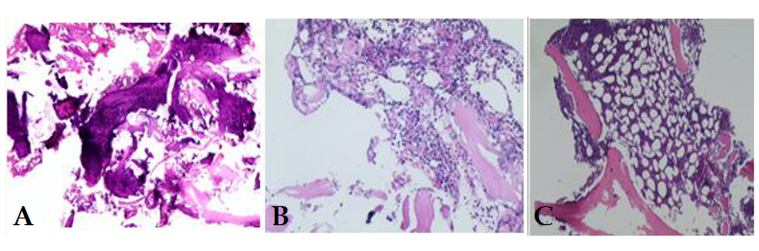
Figure 1 Laboratory examinations. A and B: C2 biopsy showed multilobe mature plasma cells with no histological pathologies; C: No tumor cells were found in the bone marrow 1 year postoperatively.
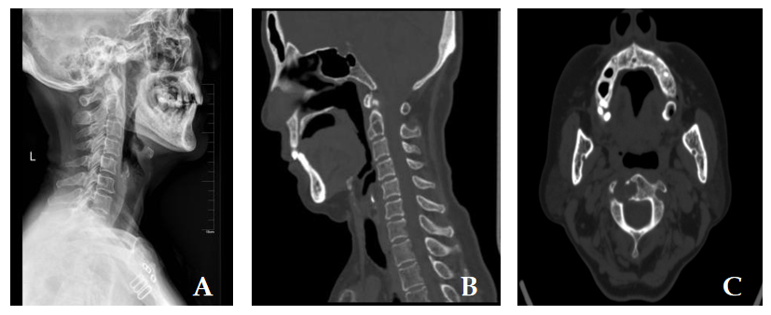
Figure 2 Sagittal X-ray. A: Mild cervical kyphosis and cystic lesions in the C2; B and C: Sagittal and plain computed tomography scan revealed bone destruction in the pedicle of C2. The posterior wall of the vertebrae was destroyed.
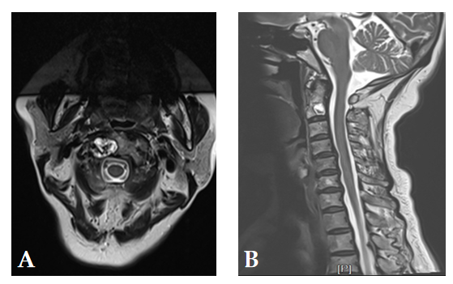
Figure 3 Magnetic resonance imaging. A: A high signal mass on the right side of C2 with an irregular boundary; B: Cervical disc herniation could be found in C4-6, while no garrulous blade or swollen discs were observed toward the spinal cord in C2.
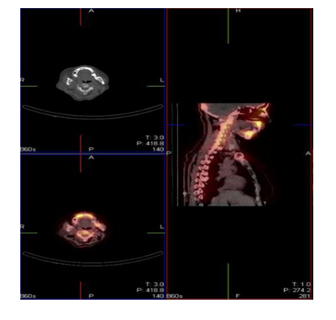
Figure 4 Single photon emission computed tomography/computed tomography showed high bright signal in the C2 and teeth.
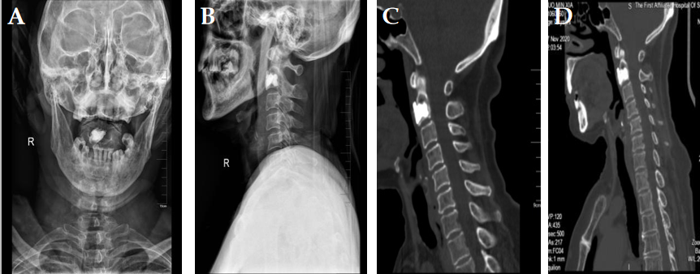
Figure 5 Postoperative X-rays and computed tomography showed that the bone cement filled well, and no leakage occurred during 3 years of follow-up. A and B: The anteroposterior and lateral X-ray was taken at 2 d after surgery; C and D: The two sagittal computed tomography scans were taken at 6 mo and 3 yr after surgery. They showed that no leakage of the bone cement occurred, and the shape of the C2 was maintained.

