Name of Journal: World Journal of Clinical Cases
ESPS Manuscript NO: 19755
Manuscript Type: Case Report

Lower gastrointestinal tract bleeding caused by dieulafoy-like lesion synchronous meckel diverticulum: A rare case report

Li SH et al. Dieulafoy-like lesion synchronous meckel diverticulum

Song-Hu Li, Guang-Yao Wu, Xiao-Dong Lin, Zong-Quan Wen, Mei-Ting Huang, Shao-Ping Yu, Hao Zhang

Song-Hu Li, Guang-Yao Wu, Xiao-Dong Lin, Zong-Quan Wen, Mei-Ting Huang, Shao-Ping Yu, Department of Gastroenterology, Dongguan Kanghua Hospital, Dongguan city, Dongguan 523080, Guangdong Province, China

Hao Zhang, Department of General Surgery, Dongguan Kanghua Hospital, Dongguan city, Dongguan 523080, Guangdong Province, China

Author contributions: Li SH, Wu GY contributed the main work of this article, they are both co-first authors; the study was guided by Yu SP; the endoscopy operation was performed by Wen ZQ, assisted by Lin XD; Zhang H performed the colectomy and exploring laparotomy; data were obtained by Li SH, Wu GY, Lin XD, Huang MT; data were analyzed by Wu GY; the report was written by Li SH and Wu GY; all authors approved the final version.

Institutional review board statement: This case report was exempt from the Ethics Committee of Dongguan Kanghua Hospital.

Informed consent statement: The patient involved in this study gave his written informed consent authorizing use and disclosure of his protected health information.

Conflict-of-interest statement: No conflicts of interest exist.

Open-Access: This article is an open-access article which was selected by an in-house editor and fully peer-reviewed by external reviewers. It is distributed in accordance with the Creative Commons Attribution Non Commercial (CC BY-NC 4.0) license, which permits others to distribute, remix, adapt, build upon this work non-commercially, and license their derivative works on different terms, provided the original work is properly cited and the use is non-commercial. See: http://creativecommons.org/licenses/by-nc/4.0/

Correspondence to: Shao-Ping Yu, MD, Department of Gastroenterology, Dongguan Kanghua Hospital, 1000# Dongguan Avenue, Dongguan city, Dongguan 523080, Guangdong Province, China. yushaopingmd@163.com
Telephone: +86-769-23095553
Fax: +86-769-23095553

Received: May 20, 2015
Peer-review started: May 20, 2015
First decision: July 29, 2015
Revised: August 16, 2015
Accepted: September 16, 2015
Article in press:
Published online:

Abstract
Meckel diverticulum is an embryonic remnant of the Gastrointestinal duct which cause symptoms < 5% in the 2% population. Painless bleeding and abdominal pain are the most often reported symptoms. Dieulafoy lesion/ dieulafoy-like lesion often cause upper gastrointestinal (GI) tract bleeding, but massive lower gastrointestinal bleeding is rare. We reported a 19-year-old male presented massive lower GI tract bleeding caused by Meckel diverticulum synchronous dieulafoy-like lesion.

Key words: Lower gastrointestinal tract; Bleeding; Ddieulafoy-like lesion; Meckel diverticulum; Endoscopy

© The Author(s) 2015. Published by Baishideng Publishing Group Inc. All rights reserved.

Core tip: Dieulafoy-like lesion often causes upper gastrointestinal (GI) tract bleeding, and meckel diverticulum is another common cause of GI tract bleeding. The two of them happened at the same person is rare. We observed a 19-year-old man complained of upper stomachache was admitted to hospital. He underwent left hemi-colectomy on day 5 after admitted. Pathology confirmed the diagnosis of dieulafoy-like lension of descending colon. The bleeding ceased for 2 d. But another attack came on day 3 after surgery. He underwent a second laparotomy which united endoscopy, a 2 cm × 1.5 cm meckel diverticulum in terminal ileum was detected. Resection was performed. Pathology revealed meckel diverticulum. He was fully recovered with no sign of bleeding in the next year’s following up.

Li SH, Wu GY, Lin XD, Wen ZQ, Huang MT, Yu SP, Zhang H. Lower gastrointestinal tract bleeding caused by dieulafoy-like lesion synchronous meckel diverticulum: A rare case report. World J Clin Cases 2015; In press
INTRODUCTION
A 19-year-old man was admitted to hospital due to upper stomachache for 6 d, hematochezia for 3 d and syncope twice. He had recurrent massive hematochezia and conservative therapy was inefficacy. He had left hemi-colectomy on day 5 after admitted. Pathology confirmed the diagnosis of dieulafoy-like lesion of descending colon. The bleeding ceased for 2 d. He had another attack of hematochezia on day 3 after surgery (day 7 after admitted). He underwent a second laparotomy which united colonoscopy, a 2 cm x 1.5 cm meckel diverticulum in terminal ileum was detected. Resection was performed. Pathology revealed meckel diverticulum, atopia gastric mucosa polyp accompany with chronic ulcer. He recovered well and was discharged 20 d later. The next year’s following up shows no sign of bleeding.

CASE REPORTE
A 19-year-old man was admitted to hospital due to upper stomachache for 6 d, hematochezia for 3 d and syncope twice. He looks pale and weak when admitted. Blood count reveals RBC 2.44 × 10¹²/L, Hb 71 g/L, HCT 0.20. There is no sign of abnormal of his colon except retention of fresh blood in the following day’s colonoscopy. Tc-99m pertechnetate scan in the third day revealed no positive sign either. The patient had a third time of hematochezia for about 300ml. Bleeding from the left hemicolon was highly suspected during the second colonoscopy, but exact bleeding point was not observed. He was treated with hemostasia to stop the bleeding and fluid infusion therapy. A fourth time hematochezia occured in day 5. Digital subtraction angiography supported bleeding from left hemi-colon (Figure 1). He was sent to OR for left hemi-colectomy. Pathology confirmed the diagnosis of dieulafoy-like lension of descending colon (Figure 2). The bleeding ceased for 2 d. On day 3 post colectomy (day 7 after admitted), he had the fifth hematochezia, discharged about 1000 mL of blood. Blood transfusion and blood coagulant were used to stop bleeding. Those treatments do not stop the bleeding. He underwent a second laparotomy united colonoscopy. During the surgery laparotomy united colonoscopy, a 2 cm × 1.5 cm meckel diverticulum in terminal ileum was detected (Figure 3). A wide base, smooth, about 0.6 cm × 0.6 cm hemispherical polyp beside it was observed, resection was performed meanwhile. Pathology reveals meckel diverticulum, atopic gastric mucosa polyp accompany with chronic ulcer. The patient recovered in 20 d with neither bleeding nor other complications and was discharged. There was no more hematochezia in the next year’s follow up.

DISCUSSION
Dieulafoy lesion/dieulafoy-like lesion is a cause of GI tract bleeding which cannot be ignore, most commonly results the proximal stomach bleeding, but very rare entity that can cause massive lower gastrointestinal track bleeding^{[1]}. Meckel diverticulum is an embryonic remnant of the gastrointestinal duct which is present in approximately 2% of the population and is estimated to cause symptoms < 5% of the time. It generally results in painless bleeding or abdominal pain^{[2]}. The technetium 99m pertechnetate scan is the best of choice for detecting Meckel diverticulum, with a reported sensitivity of 85% to 90% in the pediatric population^{[3]}. In adults, however, the sensitivity falls on to only 62%^{[4]}. It is an ideal noninvasive and sensitive way to detective meckel diverticulum. We performed surgery though this patient’s technetium 99m pertechnetate scan is negative and a meckel diverticulum was found. This case presented of massive lower gastrointestinal bleeding caused by descend colon dieulafoy-like lesion and small bowl meckel diverticulum at same time is a rare condition.

COMMENTS
Case characteristics
A 19-year-old man complained of upper stomachache was admitted to hospital.

Clinical diagnosis
Massive lower gastrointestinal bleeding caused by descend colon dieulafoy-like lesion and small bowl meckel diverticulum at same time..

Differential diagnosis
Tumor of the colon, ischemic colitis, Crohn’s disease, Ulcerative colonitis.

Laboratory diagnosis
Blood count reveals RBC 2.44 × 10¹²/L, Hb 71 g/L, HCT 0.20.

Imaging diagnosis
Tc-99m pertechnetate scan in the third day revealed no positive sign. Digital subtraction angiography supported bleeding from left hemi-colon.

Pathological diagnosis
Pathology confirmed the diagnosis of dieulafoy-like lension of descending colon at the first surgery. Pathology reveals meckel diverticulum, atopic gastric mucosa polyp accompany with chronic ulcer after the second surgery.

Treatment
Left hemi-colectomy and resection of the bowl with meckel diverticulum.

Related reports
Dieulafoy lesion of the colon is reported to be bleeding cause of lower GI tract bleeding, and so does meckel diverticulum.

Experiences and lessons
Massive lower gastrointestinal bleeding caused by descend colon dieulafoy-like lesion and small bowl meckel diverticulum at same time is a rare condition. Both of them may be missed at the first endoscopy examination. Repeated endoscopy examination may be needed when bleeding occurs over and over again.

Peer-review
This case is interesting.

REFERENCES
1 Abdulian JD, Santoro MJ, Chen YK, Collen MJ. Dieulafoy-like lesion of the rectum presenting with exsanguinating hemorrhage: successful endoscopic sclerotherapy. Am J Gastroenterol 1993; 88: 1939-1941 [PMID: 8237945]
2 Kline RM. Ruptured Meckel diverticulum mimicking mucositis in a patient receiving induction therapy for high-risk acute lymphoblastic leukemia. J Pediatr Hematol Oncol 2007; 29: 423-424 [PMID: 17551408 DOI: 10.1097/MPH.0b013e3180640d81]
3 Sfakianakis GN, Conway JJ. Detection of ectopic gastric mucosa in Meckel's diverticulum and in other aberrations by scintigraphy: ii. indications and methods--a 10-year experience. J Nucl Med 1981; 22: 732-738 [PMID: 6267233]
4 Schwartz MJ, Lewis JH. Meckel's diverticulum: pitfalls in scintigraphic detection in the adult. Am J Gastroenterol 1984; 79: 611-618 [PMID: 6087654]

P-Reviewer: Kim ST, Sergi C S-Editor: Tian YL
L-Editor: E-Editor:

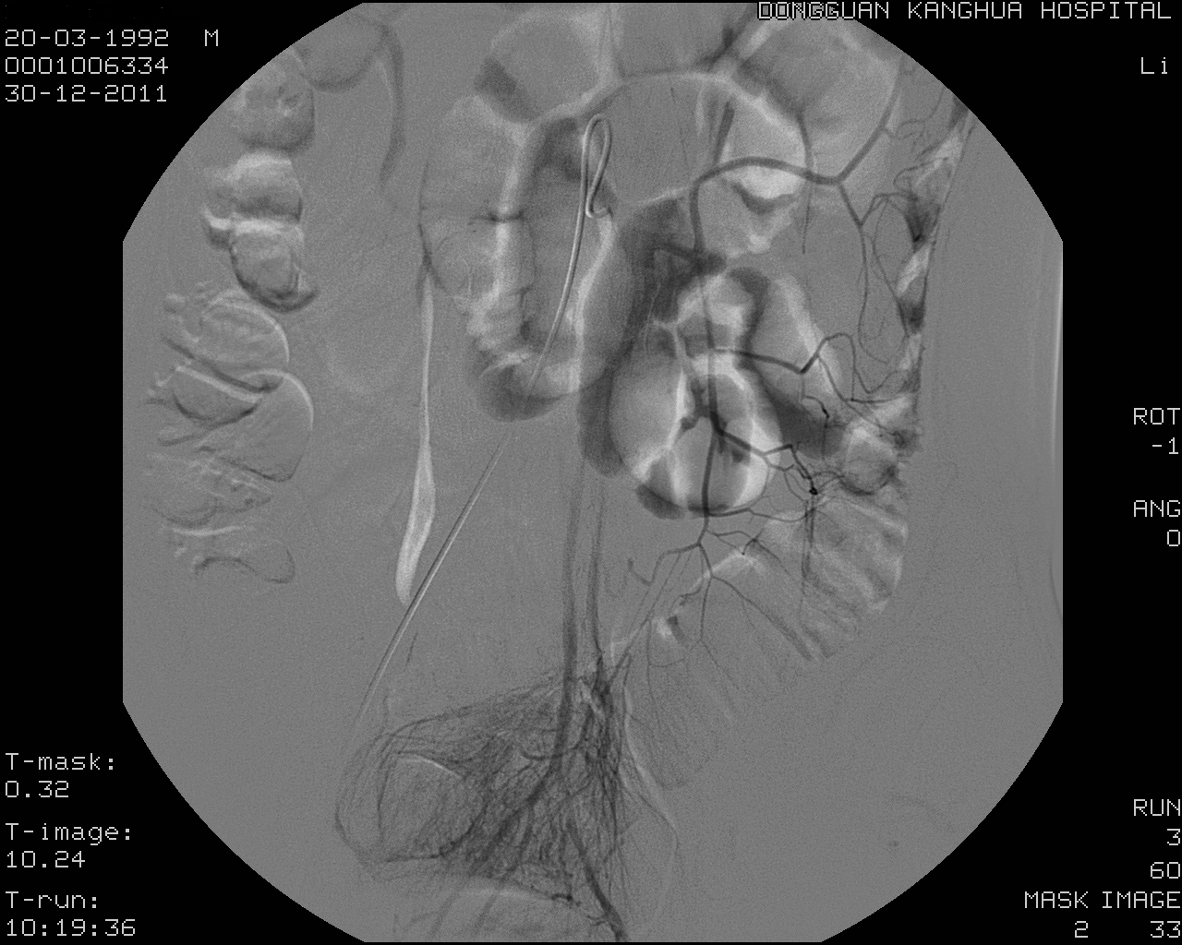

Figure 1 Digital subtraction angiography supported bleeding from left hemi-colon.

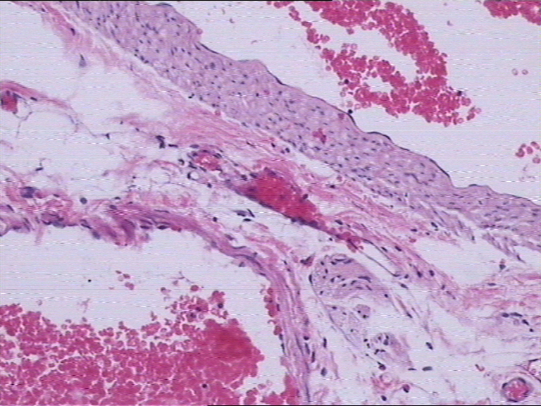

Figure 2 Pathology after left hemi-colectomy confirmed the diagnosis of dieulafoy-like lension of descending colon.

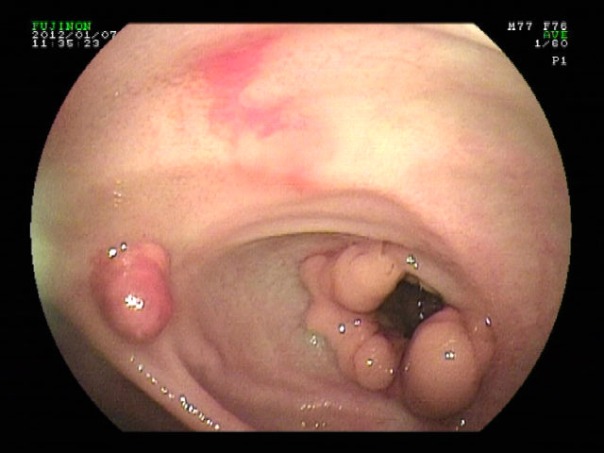
Figure 3 A 2 cm × 1.5 cm meckel diverticulum in terminal ileum was detected by colonoscopy during the second laparotomy which united endoscopy.

